Name: Grace Benewaa
Student Number:2435652
Course name: Psychology in Health and Social Care
Module: LCHS4010
Lecturer: Hellen Parsons

BIBLIOGRAPHY
Erikson`s Psychosocial Theory
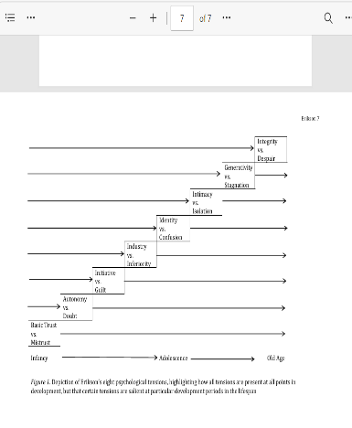
Erikson (1950,1963)
Maree(2022).-source
.
The psychosocial development theory of Erik Erikson: critical overview. The influence of theorists and pioneers on early childhood education, pp.119-133.

Maree (2022) critically examines Erikson`s psychosocial development theory, emphasizing it`s significance for human development, early stage to adulthood.
FINDINGS
Maree highlights that Erikson`s Theory is a framework which offers a model for understanding the stages of human development and each of the stages of the life span is define by a conflict that individual must overcome to achieve psychological growth. The stages commence from conception(birth) to late adulthood. Maree explains what happens at each stage of development highlighting on trust, autonomy, identity, intimacy, integrity and lifelong nature of development as shown in figure 1. The article critically analyses how Erikson`s theory supports identity formation, social competence, and emotional resilience in the stages of life. Older adult’s feelings when life is not up to expectation creating sense of despair and satisfaction when life goals are to expectancy. The article emphasizes strengths and weaknesses of this theory as stated despite its influence, some areas such as cultural variability requires exploration. In conclusion the article emphasizes both the theoretical foundations and practical applications of Erikson`s contribution.

Syed, M. and McLean, K.C., (2017). Erikson’s theory of psychosocial development. The SAGE encyclopaedia of intellectual and developmental disorders. London: SAGE.
The article compares Freud psychoanalytic theory of development to Erikson theory which they said Freud focus was limited to childhood. On the other hand, Erikson theory of life span development emphasis on the eight stages of life including sexual and social development. The article also stated that each life stage has its own life tensions emphasizing the general feelings and emotions at the older stage and from Erikson`s view, no aspect of development is ever actually complete as explained in figure 2 table below. The table explains the stages of Erikson theory and Freud theory
FIGURE 2
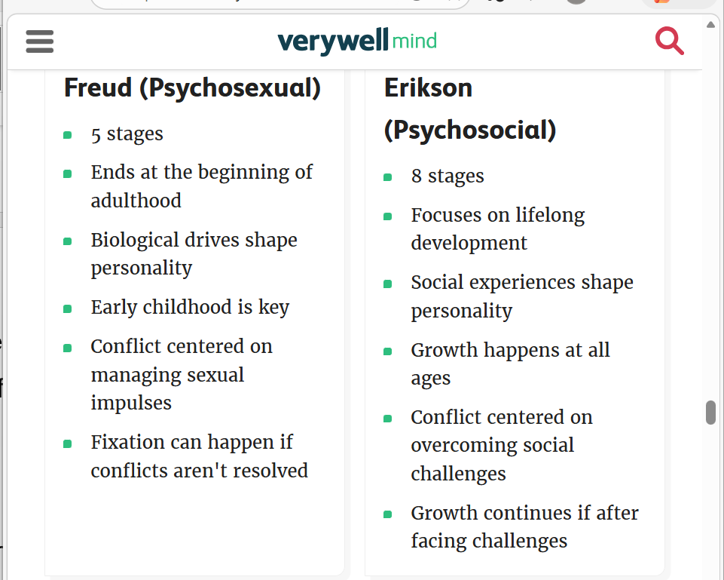

In health and social care Erikson`s theory is relevant to the elderly for at this stage the older adult is in a state of feeling a sense of satisfaction with life and ready even to face death if achievements and goals are achieved and despair if they feel sense of defeat, disappointment and not satisfied with life goals .The Feeling helps health professionals provide the necessary care they need for their wellbeing especially in care homes. For instance, counselling and giving reassurance.
At old adult stage, frailty sets in making older adults experience reduced mobility, stress and depression due to long term conditions or falls therefore applying this theory will help provide care tailored to their needs. According to office for national statistics UK., (2021) census over 0ne-sixth (18.6%,11.1 million) of the population over 65 years has acute frailty and this will increase to 25% in 20 years.
Applying Erikson`s theory help health care professional to manage the transition in the life of the elderly by re-assessing them and provide help. For instance, providing them with support workers to assist with daily routine (personal care, food and fluids) and appointments.
Considering Erikson`s theory, growth continues if after facing challenges, in health and social care, the adult face challenges like managing medications and finance, health professionals, social workers and family will put procedures in place to assist the individual and sometimes provide advocates.
At this stage the old adult needs safety therefore, safeguarding is essential.
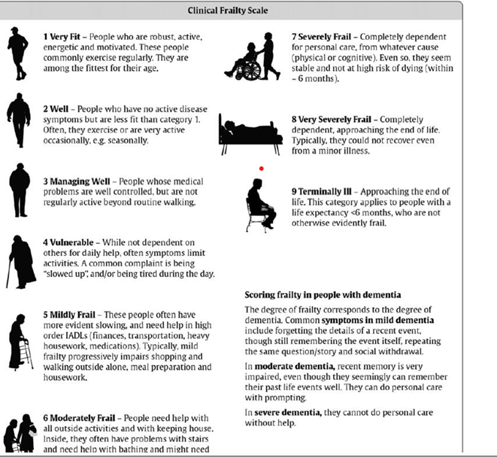
The chart above shows a frailty scale for the aged-NHS WEBSITE

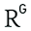

Section B: Havighurst`s Activity Theory
Gillespie, C.W.I. and Louw, J., 1993. Life satisfaction in old age and activity theory: should the debate be re-opened? Southern African Journal of Gerontology, 2(1), pp.25-30
ResearchGatzhttps://www.researchgate.net › publication
Satisfaction in Old Age: Activity or Disengagement?
This article emphasizes on the two vital aspects of human life, work and retirement. As individual ages, there is the need to shift roles and adapt into a new environment. This determines whether individual disengage, withdraw or engage and how this affects the individual wellbeing.
Findings
The article examines this process by using face-to-face interviews based on the activity and disengagement theory in Bangladesh. The result indicated most elderly prefer to engage in activities but on the contrary, others also prefer to withdraw for these reasons: give up their positions to the younger ones for they cannot compete with them during the activity level. Others see ageing as total freedom and others disengage to have enough time for themselves and others said disengagement is inevitable at old adult stage. Moreover, the findings show most prefer activities but growing old has withdrawn them.
The theory emphasises the quality of life of the elderly depends on their involvement in activities.

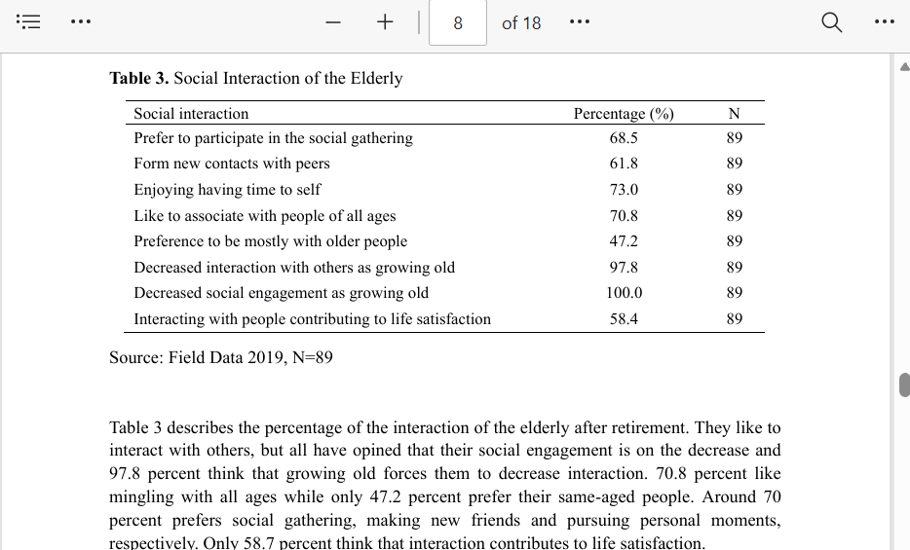.

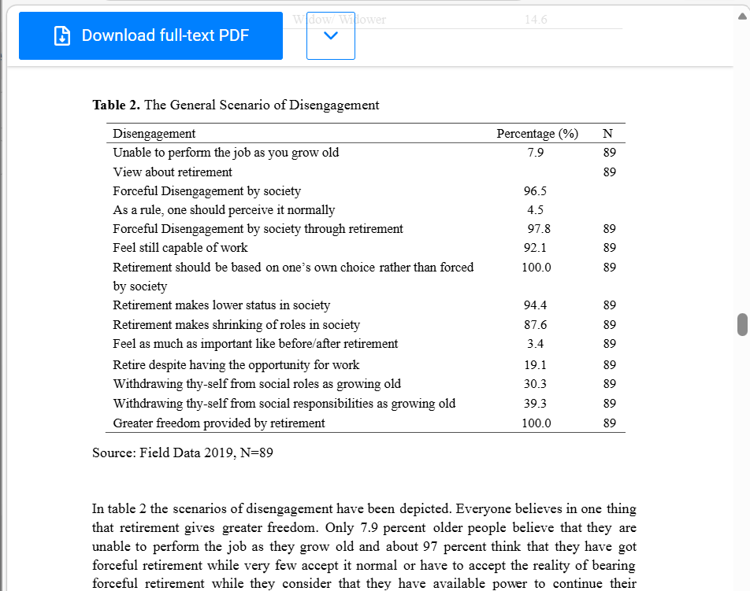

,

Lemon, Bruce W., Vern L. Bengtson, and James A. Peterson. "An exploration of the activity theory of aging: Activity types and life satisfaction among in-movers to a retirement community." Journal of gerontology 27, no. 4 (1972): 511-523
The article is about a critical examination of research finding the relationship between types of social activity and life satisfaction of an individual in a retirement community The main aim was to establish positive relationship between an activity and life satisfaction using the activity theory of the aged.
Findings
Researchers including Burgess (1954), Talmor and Kutner (1970) and Madox (1963) observes that the importance of social role participation in adjustment to old age and implied in theoretical orientation of most the research is the assumption that.
The social self emerges and sustains in most basic way through interaction with others. Structural constraints which limit or deny contacts with the environment tend to be demoralizing and alienating.
In health and social care, inclusion of activities enhances the physical wellbeing of the elderly, participating in activities prevents life threatening illness like heart disease, stroke, diabetes, and blood pressure in the aged. Deprivation can lead to mental deterioration. Langer and Rodin (1976) found out that the more active elderly living in a nursing homes lived longer than those who were less active. Activity reduces anxiety, depression and stress and increase thinking capacity in the aged. Activities help the elderly explore the environment by building social relationship with others. Activity builds the physical muscles of the aged preventing decline in mobility. Activity minimises Loneliness.

Pictures below 1 and 2 show activity and loneliness respectively.
Source: Baton Rouge clinic

# old 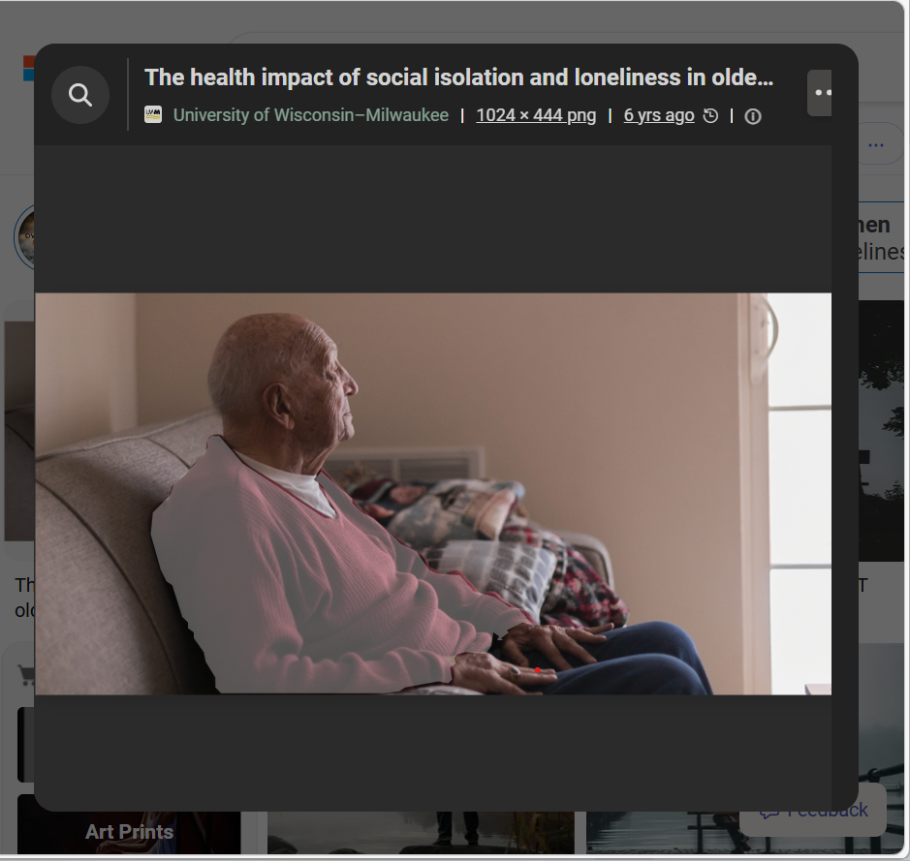

Part B-Report writing
Introduction
The report examines how Havighurst`s Activity Theory can support the wellbeing of the older adults in a care home. Havighurst`s theory emphasises the engagement of meaningful activity is essential for it helps build the physical, cognitive, and social development of the old adult. The report will include how this theory is applied to contribute to the wellbeing of the old adult living in a care home, a case scenario explaining the theory and a challenge health professional may face while applying the theory and suggest strategy to overcome. Overview of Havighurst activity theory
-successful ageing is associated with meaningful activity
-withdrawal from activity is inevitable; rather, it is often cause by barriers such as ill health, social exclusion, or lack of opportunity.
-activity is essential for wellbeing.
Relevance of application of Havighurst`s theory to improve psychological wellbeing of adult in residencia home.
Firstly, the theory is an activity base therefore physical activities like creative arts, (painting, knitting), register with community-based walking groups, gardening, music sections, exercises, supports the physical growth of the older adults preventing life threating illness like heart attacks, stoke and pulmonary diseases in a residential home. Secondly, in residential homes, the older adults experience role loss due to retirement, the theory encourages role continuity when the residents lead activities. Mobility improves when the resident participates in physical exercises like simple yoga. Applying activity theory brings out the skills in them nullifying the idea that older adults are disengage.
The activity builds their cognitive development, releasing stress, anxiety, and depression. It reduces isolation and builds relationship between the residents.

A case Scenario
Location: Graceland Residential Home
Resident: Peter Tourch
Background: Peter is a 76-year-old man who moved to the care home about six months ago. Peter experiencing mobility issues and loneliness due to the death of his spouse. Before peter moved, he was an active member of his community keep fit club, attending church. groups and regularly socialize with friends and family. Staff noticed that Peter felt isolated and disengaged for he missed his routines. Staff noticed he often stay in his room avoiding the communal areas causing decline in mobility and cognitive.
The home applied the activity theory by encouraging peter to participate in the home activities like exercises which aligns with his past interest. Mr peter appointed to lead a team of residents to pray and read the bible to fulfil a role align with the previous role. Mr peter with reassurance from the staff walks around the home and a bit down the streets to help with his mobility. With time peter became socially engaged and his mobility improved.
Care staff face challenges applying the activity theory in the old adult residential home. The common one is getting the residents to participate in the activity for sometimes they show no interest no matter what you do. To resolve this, staff must give them time” no rush” and with reassurance and encouragement the resident will engage in the activities.
The table above shows list of activities in residential home and a resident leading bible studies section.
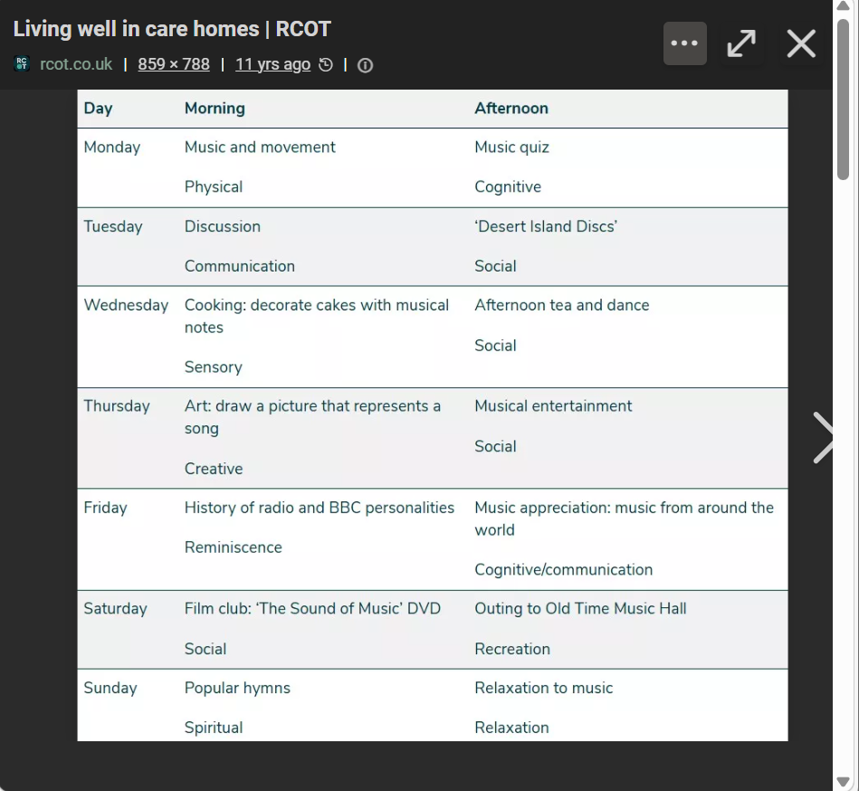
CONCLUSION
To conclude, application of activity theory in residential home is essential for wellbeing of the residents and social engagement of the individual to promote quality of life.The report has critically examined how relevant is the activity theory is in health and social care and to be precise in a residential home.

References
The psychosocial development theory of Erik Erikson: critical overview. The influence of theorists and pioneers on early childhood education, pp.119-133.
Syed, M. and McLean, K.C., (2017). Erikson’s theory of psychosocial development. The SAGE encyclopaedia of intellectual and developmental disorders. London: SAGE
Gillespie, C.W.I. and Louw, J., 1993. Life satisfaction in old age and activity theory: should the debate be re-opened? Southern African Journal of Gerontology, 2(1), pp.25-30
ResearchGatzhttps://www.researchgate.net › publication
Satisfaction in Old Age: Activity or Disengagement?

Lemon, Bruce W., Vern L. Bengtson, and James A. Peterson. "An exploration of the activity theory of aging: Activity types and life satisfaction among in-movers to a retirement community." Journal of gerontology 27, no. 4 (1972): 511-523
[PDF] springer.com
Physical activity in older age: perspectives for healthy ageing and frailty
Effect of physical activity on the risk of frailty: a systematic review and meta-analysis

