

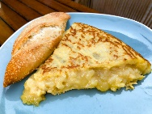

Protur Naisa Palm Hotel

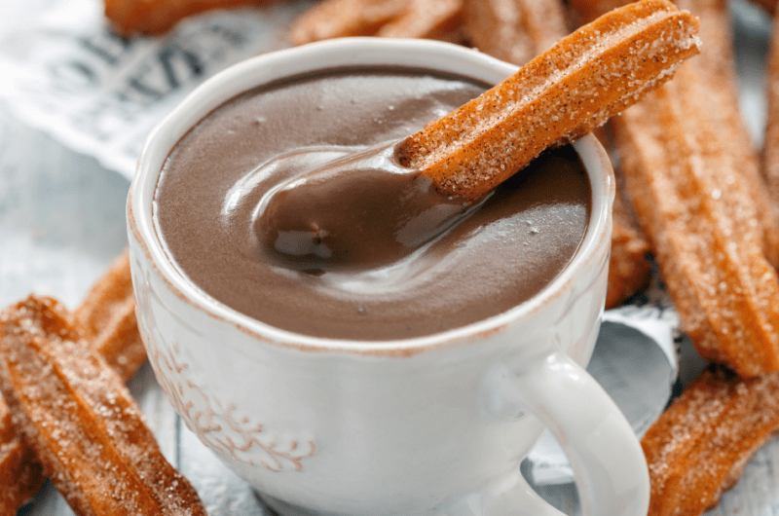
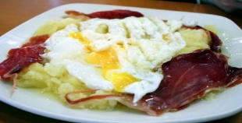

Tabla de Desayuno
Breakfast Board

El desayuno solo se sirve durante el horario de desayuno 8:00 a.m. a 11:00 a.m.
breakfast is only served during breakfast hours 8:00 a.m. to 11:00 a.m.
Precio(price) Precio no invitado (non-guest Price)
Huevo frito con Bacon………………………… $9.50 $10.00
Fried eggs with Bacon
Huevo Frito con Chorizo…………………………. $9.50 $10.00
Fried eggs with chorizo
Huevo frito con Salchicha………………………… $9.50 $10.00
Fried eggs with Sausage
Huevo revuelto con Bacon……………………… $11.00 $12.00
Scrambled eggs with Bacon
Huevo revuelto con Jamon………………………… $8.00 $8.50
Scrambled eggs with Ham
Crolssant de Almendra………………………………. $3.50 $3.50
Almond Croissant
Pan Con Tomate…………………………………………. $3.00 $3.50
Bread with Tomato
Ensaimadas………………………………………………. $3.00 $3.50
Fruit or sugar-coated sweet bread
Café con Leche………………………………………… $4.00 $4.70
Espresso with steamed milk
Zumo de naranja……………………………………... $2.50 $3.00
Orange Juice

