Design, conduct and report a research study to explore predictors of work motivation

Abstract
Over the years research has suggested that personality characteristics, even as little as one trait is enough to predict work motivation (Barrick & Mount, 1993). This study aimed to explore the potential predictors of work motivation through using The Big Five Questionnaire (John, Donahue & Kentle, 1991) and the Multi-dimensional Work Scale (Gagne et al, 2014). A multiple regression was used to analyse whether higher levels of conscientiousness and lower levels of neuroticism were predictors of work motivation. The findings from this study suggested that there was significant result between higher levels of conscientiousness and lower levels of neuroticism predicting work motivation. F(2,67)=1.03, p <.05.R² = .001.

Introduction

Between the 1960’s to 1990’s psychologists did not consider personality traits to be an effective predictor of performance in the workplace (Bajor & Baltes, 2002). This is because of general conclusions that were made by researchers, believing that personality tests were not adequate in their reliability and validity (Hurtz & Donovan, 2000). Schmitt (cited in Hurtz et al, 2000) even expressed that personality tests were one of the least valid types of selection processes within job applications. However, over the more recent years research has suggested more promising findings regarding reliability and validity by using the Big Five personality taxonomy. Bajor and Baltes (2002) also mention how it was by using the Big Five that researchers were able to determine exactly which personality traits were better predictors of performance in the workplace across a variety of jobs.
Barrick and Mount (1993) explain that some studies may indicate that just one aspect of personality trait is enough to predict job performance and work motivation. They also explain how conscientiousness includes positive qualities such as achievement and dependability therefore; is a valid predictor for motivation within all employment criteria; as employers tend to desire a need for achievement. Hurtz et al, (2000) agree with this as they mention conscientiousness is a dimension that has developed to be the most valid out of the Big Five scale.
According to Judge and Llies (2002) individuals who display neuroticism tend to show more negative traits such as anxiety which has the tendency to result in poor emotional control and regulation which prevents the individual from focusing their attention on the task. Within their study, Judge et al, (2002) focused on the relationship between the Big Five factor model, personality traits, performance and motivation. Amongst their findings, they showed that conscientiousness and neuroticism displayed the strongest correlation of predicting motivation.
Judge et al (2002) explains in more depth that conscientiousness and neuroticism are best predictors of performance in the workplace as well as being able to predict motivation. This is because, according to their study neuroticism correlated stronger with the motivation aspects, and conscientiousness happened to correlate stronger with actual job performance.
Opie and Henn (2013) mention a study conducted by Jeong et al, which also displayed an association between higher levels of conscientiousness and lower levels of neuroticism being linked to work engagement. Another study mentioned by Opie et al, (2013) explains a positive relationship between an individual burning out and higher levels of neuroticism. Therefore, Opie et al, (2013) conduct their current study based on previous literature of conscientiousness and neuroticism being commonly associated with working life.
This report will discuss a research study created by University students who are exploring whether higher levels of conscientiousness and lower levels of neuroticism are predictors of work motivation, using the Big Five Questionnaire (John, Donahue & Kentle, 1991) and Multi-dimensional Work Scale (Gagne et al, 2014).

Methods
Participants
The participants were students from the University of Wales Trinity Saint David which consisted of (10 females, 0 males) ranging in ages from 18 and 47 (M = 5, SD = 7.07). Participants were recruited via convenience through an email directing them to the Qualtrics program to complete the questionnaire. Participant requirements prior to involvement in the study were informed within the email that they must be students who work either part time or full time.
Design
This study was designed to explore the predictors of work motivation amongst University students that worked along-side their studying. The independent variables included in this study were traits of Neuroticism and Conscientiousness as well as the dependent variable being if work motivation was associated with these two personality traits. A multiple regression analysis was used to determine whether Neuroticism and Conscientiousness were predictors of work motivation.
Materials
The equipment used within this study was the program Qualtrics, for students to be able to access the questionnaire wherever convenient for the individual; rather than being limited to access in the University (see Appendix A). The questions included to explore the personality traits were selected from The Big Five Questionnaire (John, Donahue & Kentle, 1991). To investigate what motivated the students to work which was explored through the Multi-dimensional Work Scale (Gagne et al, 2014). The questions were in order of work motivation, neuroticism and conscientiousness. Participants were informed prior to signing up to complete the survey that this was a questionnaire based on work motivation however they were not told which personality characteristics were being explored until after completion. The participants who decided to sign up to participate within the study also gained one credit to go towards their research credits. An example of some of the questions included were as follows for work motivation; ‘I do little because I don’t think this work is worth putting efforts into’, then for neuroticism ‘can be tense’ and finally conscientiousness ‘does a thorough job’. Participants were expected to answer the following questions using a seven-point Likert scale for Work Motivation and a five-point Likert scale for The Big Five.
Procedure
When conducting the study, participants were required to access the survey on Qualtrics via a link within the email sent to them directly requesting their participation. Participants were then directed to the questionnaire. To start, the survey displayed a consent form (see Appendix B) prior to them beginning the questionnaire providing them with information regarding the study. They were also required to select that they consented to participating as well as being in payed employment. Once completed, participants were free to start. As previously mentioned, participants were required to answer questions on a seven-point Likert scale (1= not at all, 2= very little, 3= a little, 4= moderately, 5= strongly, 6= very strongly, 7= completely) for the Work Motivation questions (see Appendix C), however slightly different for The Big Five questions (see Appendix D) (1= disagree strongly, 2= disagree a little, 3= neither agree nor disagree, 4= agree a little, 5= agree strongly) as this made more sense given some of the questions included. Once completed, participants were thanked for their participation via text on screen and provided with an online debrief form at the end of the questionnaire explaining the purpose of the study as well as the researchers contact details; should they have had any questions (see Appendix E).

Results
The table below displays the mean and SD for all the variables included. A multiple regression was used to analyse whether lower levels of neuroticism and higher levels of conscientiousness were predictors of work motivation as there was more than one independent variable.
Table 1.
Descriptive statistics for all variables.
 | Mean | Std. Deviation | N
Work Motivation | 2.29 | 1.42 | 70
Neuroticism | 2.20 | .60 | 70
Conscientiousness | 2.39 | .62 | 70

As shown above, Table 1 displays that mean and standard deviations for all variables included in the analysis. As can be seen, the mean scores display a difference within the neuroticism and conscientiousness; with conscientiousness being higher. Both variables appearing to be related to work motivation. This would suggest that higher levels of conscientiousness and lower levels of neuroticism can predict work motivation. The results showed a significant result as can be seen by Table 2 below.
Table 2.
ANOVA table for all variables.
Model | Sum of Squares | df | Mean Square | F | Sig.
Regression | 4.126 | 2 | 2.063 | 1.030 | .362
Residual | 134.160 | 67 | 2.002
As shown in the Table 2 above, the significance value of the study displays too high a statistic for it to be a strong relationship that is not by chance given the number of participants. As the significant result in the ANOVA could suggest enough to report a significant result however this still was not enough to accept the hypothesis of higher conscientiousness and lower neuroticism predicting work motivation. However, within the coefficients table of the regression output, neuroticism scored a significance value of .166 followed by conscientiousness displaying a value of .780. Therefore, enabling the hypothesis to be accepted. F(2,67)=1.03, p <.05.R² = .001.

Discussion
To summarise these findings, the multiple regression analysis over all showed the two independent variables neuroticism and conscientiousness were significant. As highlighted above, there was a relationship between higher levels of conscientiousness and lower levels of neuroticism predicting work motivation. This is also providing similarity to the previous literature above by Opie et al, (2013). This did not come as a surprise due to the literature supporting the effectiveness of the Big Five scale (Bajor et al, 2002; Hurtz et al, 2000 & Judge et al, 2002).
Obvious limitations were found throughout the study regarding sample size as this was significantly less than a substantial amount to have reliable and valid results, as well as the study including zero male participants; therefore, potentially impacting the results tremendously. Having equal amounts of males participating in this study would have given an equal representation of how conscientiousness and neuroticism affects work motivation in both sexes. Should this study have been on Qualtrics for longer, there would have been more opportunity for additional participants to take part with more opportunity for those individuals to be male.
As well as the gender issue, another possible issue within this study is the variety of ages within such a small number of participants. Kanfer and Ackerman (2004) express that their study on age related motivation explains that changes in an individual’s characteristics can happen due to aging. This could impact their level of work motivation due to the level of importance of their vocational interests. Also, younger adults according to Kanfer et al, (2004) tend to prefer engaging in tasks that require more moderate levels of effort. This could have had an impact on the overall results as the population was not big enough for such a variety of ages and as effort is expected to decline with age, this could have made a difference in the levels of neuroticism and conscientiousness predicting the work motivation.
Although the study obtained a significant result within the higher levels of conscientiousness and lower levels of neuroticism predicting work motivation. As well as showing a relationship between the variables, it does not emphasize whether they are the strongest personality traits to influence work motivation as believed by Judge et al, (2002). This is since only the two independent variables, neuroticism and conscientiousness were included. Therefore, this report is unable to justify just how well these personality traits do predict work motivation as there were no other variables included to compare them to such as extraversion for example. Explaining that neuroticism and conscientiousness are significant, but that is not to say that there are no better predictors out there.
In conclusion, the findings from this study do provide some additional support to the previous literature as most of them only state the relationship between neuroticism and conscientiousness being predictors of work motivation, amongst the level of other predictors or personality characteristics within their studies. Future studies should just continue to focus on the relationship between the personality factors and their predictors of work motivation in larger populations, within all ages, in a variety of occupations as they appear to be supportive.

Reference List
Bajor, J., & Baltes, B. (2002). The relationship between selection optimization with compensation, conscientiousness, motivation and performance. Journal of Vocational Behaviour, 63(3), 347-367. doi: 10.1016/s0001-8791(02)00035-0
Barrick, M., & Mount, M. (1993). Autonomy as a moderator of the relationships between the Big Five personality dimensions and job performance. Journal of Applied Psychology, 78(1), 111-118. doi: 10.1037//0021-9010.78.1.111
Hurtz, G., & Donovan, J. (2000). Personality and job performance: The Big Five revisited. Journal of Applied Psychology, 85(6), 869-879. doi: 10.1037//0021-9010.85.6.869
Judge, T., & Llies, R. (2002). Relationship of personality of performance motivation: A meta-analytic review. Journal of Applied Psychology, 87(4), 797-807. doi: 10.1037//0021-9010.87.4.797
Kanfer, R., & Ackerman, P. (2004). Aging, Adult Development and Work Motivation. The Academy of Management Review, 29(3), 440. doi: 10.2307/20159053
Opie, T., & Henn, C. (2013). Work-family conflict and work engagement among mothers: Conscientiousness and neuroticism as moderators. SA Journal of Industrial Psychology, 39(1). doi: 10.4102/sajip.v39i1.1082

Appendices

Appendix A

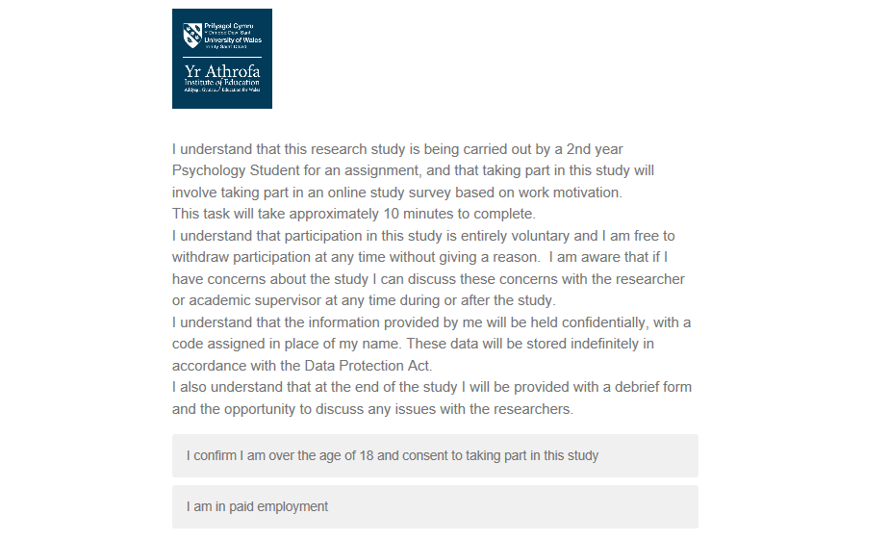
Appendix B
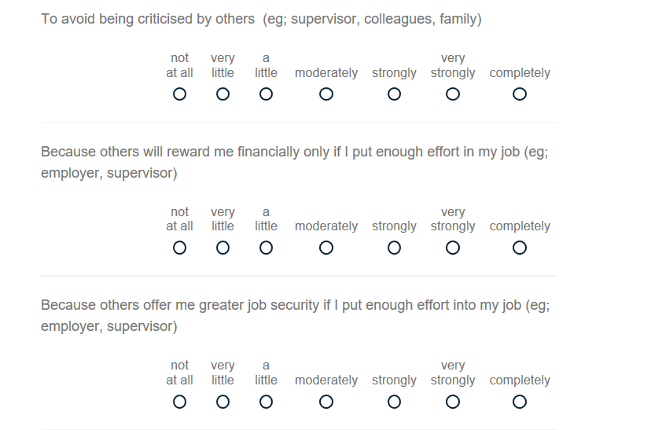
Appendix C

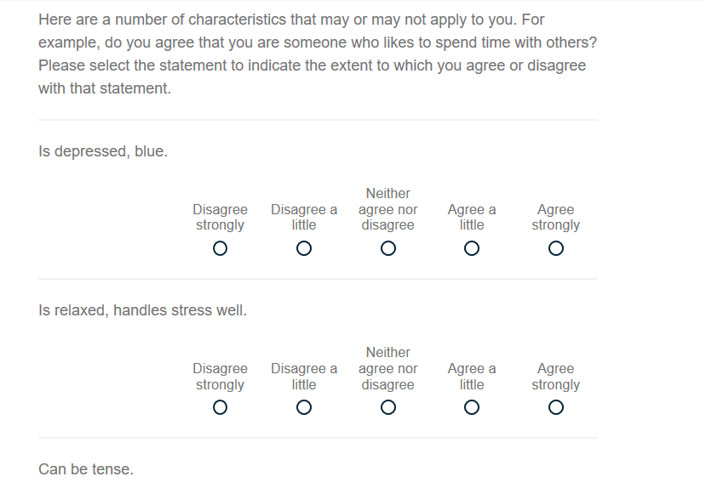
Appendix D

Appendix E

