

Institute of Inner-City Learning Birmingham Campus

BSc (Hons) Health and Social Care

Disclaimer
This document was correct at the time of publication. The Module Coordinator reserves the right to modify any statement if necessary, make variations to the content or methods of delivery of programmes of study, to discontinue programmes, or merge or combine programmes if such actions are reasonably considered to be necessary by UWTSD. Every effort will be made to keep disruption to a minimum, and to give as much notice as possible. An electronic copy of this handbook can be found on the Moodle page for the module.

DECLARATION
This work has not previously been accepted in substance for any degree and is not being concurrently submitted in candidature for any degree
Signed………………
Date……………24th July 2026………………….
STATEMENT 1
This dissertation is being submitted in partial fulfilment of the requirements for the degree of BSc.
Signed………………
Date…………24th July 2026…….………………
STATEMENT 2
This dissertation is the result of my own independent work/investigation, except where otherwise stated. Other sources are acknowledged by footnotes giving explicit references. A bibliography is appended.
Signed………………
Date………………24th July 2026….……………
STATEMENT 3
I hereby give consent for my dissertation, if accepted, to be available for photocopying and for interlibrary loan, and for the title and summary to be made available to outside organisations.
Signed…………………
Date………………24th July 2026……….…………
STATEMENT 4
I hereby give consent for my dissertation, if accepted, to be available on the university’s IT system to those who have consent to use the system.
Signed…………………
Date………24th July 2026…………………………

Course: BSc (Hons) Health and Social Care
Module: Independent Project (BMHP6020_BIRM)
Dissertation

Topic: Examining Economic and Geographic Barriers to Healthcare Access in Rural England: Challenges and Solutions

Student Name: Doris Akoto Acheampong
Student ID: 2236939

Executive Summary
This rural population in England have issues concerning accessibility of health care delivery. This dissertation investigates the economic and geographic obstacles to healthcare access and how these aspects impact the availability and accessibility of healthcare services. The challenges presented in the study include the case of the rural populations, who are usually distant from the medical care facilities, with few means of transport available, and financial limitations affecting their capacity to afford health care services because of the existence of the National Health Service (NHS). These obstacles are associated with the variations in the health status between the rural and urban communities, leading to lower health outcomes among the rural residents.
This research will find several significant problems, such as transport problems, economic disadvantages, labour shortage and the isolation of rural communities by geography, through an extensive analysis of the literature on the topic, government reports, as well as policy reports. It also examines the usefulness of the existing healthcare policies and interventions, including telemedicine and mobile health services, that will help to enhance healthcare access in rural populations.
The paper gives various suggestions on how to overcome these barriers, such as transportation infrastructure development, more investment in rural health care facilities, and the reinforcement of the rural healthcare workforce. In addition, the paper identifies the opportunities of digital healthcare systems, including telemedicine, to address the lack of access to healthcare.
Finally, the dissertation suggest evidence-based interventions to enhance the situation of the rural healthcare population in England and highlights the policy-makers and medical practitioners in general, with the particular issues of the rural populations. The results may be utilised to inform future interventions and provide more equal treatment in the healthcare system.

Table of Contents
CHAPTER 1: INTRODUCTION 4
1.1 Background of the Study 4
1.2 Definitions and Terminology 4
1.3 Background and Current Context 5
1.4 Rationale for Research / Problem Statement 5
1.5 Aims and Objectives 6
1.6 Conclusion 6
CHAPTER 2: BACKGROUND AND LITERATURE REVIEW 7
2.1 Introduction 7
2.2 Historical Background 7
2.3 Theoretical Background 8
2.4 International Context 8
2.5 National/Local UK Context 9
2.6 Conclusion 10
CHAPTER 3: METHODOLOGY 13
3.1 Introduction 13
3.2 Search Strategy 13
3.3 Searching for Information 13
3.4 Research Validation 14
3.5 Inclusion and Exclusion Criteria 15
3.6 Data Analysis Method 16
3.7 Ethical Considerations 16
3.8 Chapter Conclusion 16
CHAPTER 4: RESULTS AND DISCUSSION 18
4.1 Introduction 18
4.2 Thematic Analysis 18
4.3 Geographic Barriers to Healthcare Access 19
4.4 Transportation Challenges and Accessibility 20
4.5 Economic Barriers to Healthcare Access 21
4.6 Conclusion 22
CHAPTER 5: RECOMMENDATIONS AND CONCLUSION 30
5.1 Introduction 30
5.2 Summary of Key Findings 30
5.3 Recommendations 31
5.3.1 Improving Transportation Infrastructure 31
5.3.2 Expanding Telemedicine and Digital Healthcare Services 31
5.3.3 Strengthening Rural Healthcare Workforce Recruitment 31
5.3.4 Increasing Investment in Rural Healthcare Facilities 31
5.3.5 Enhancing Policy Coordination and Long-Term Planning 32
5.4 Limitations of the Study 32
5.5 Areas for Future Research 32
5.6 Conclusion 32
References 34

CHAPTER 1: INTRODUCTION

1.1 Background of the Study
The health service delivery has been addressed as the key element of a health system and a very important health determinant of a population. The medical systems of most of the advanced countries, such as England, confirm the need to make the services equally accessible to the population, irrespective of socioeconomic status and location. Nevertheless, even though there is a publicly funded healthcare system (e.g. the National Health Service (NHS)), there is still seemingly a disparity in access to healthcare in rural and urban regions. The rural people are normally subjected to a variety of problems that restrict access to quality and timely medical services. Some of these barriers include long distances to medical institutions, inadequacy of medical practitioners, transportation challenges, and financial barriers, among others, which affect the availability of medical services to the people (Cox, Clark and Sanders, 2023).
Rural England is a sparsely populated region with a lack of good infrastructure and with a low density of health care in the surrounding regions as compared to the urban regions. Having an advantage of close hospitals, specialised services, and a high number of healthcare providers are more prevalent in the city population than in the rural population, which is mostly faced with barriers that make access to healthcare hard. The physical distance, e.g. distance, would imply that the people would have to travel long distances to access primary care centres or even hospitals or specialist clinics (Moseley, 2023). Other than this, economic issues like low income, high transport prices and reduced employment can also contribute to such hindrances.
Even past studies have noted that the disparity in the delivery of healthcare services between rural and urban people might result in poor health outcomes for the rural population. The research has revealed that rural residents tend to postpone healthcare services because of the inconvenience associated with accessing healthcare facilities or a lack of funds, which can lead to deterioration of their health condition and rising healthcare expenses in the long run. Moreover, the lack of medical staff in the rural community can restrict the availability of specialised services, and the rural segment of the population will not be able to access the proper care as soon as the need arises.

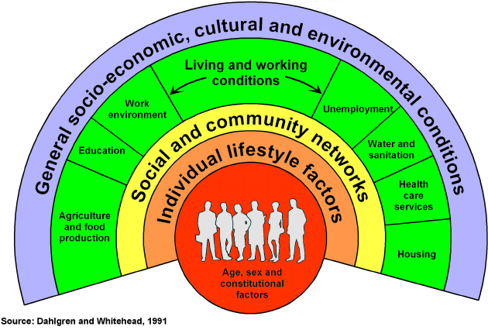
The Dahlgren and Whitehead Model (1991)
The rainbow model illustrates how health it is not exclusively influenced by distance and economic factors. Social Determinants such as; socio-economic status, ideologies and environmental factors significantly have impact on health outcomes and access to Healthcare. Addressing Social Determinants of health is essential for achieving equitable progress towards Sustainable Development Goal – 3, ensuring that no one is left behind.

1.2 Definitions and Terminologies
National Health Service (NHS) was instituted in 1998 to address health inequalities in England after the World War 2. (NHS England 2026). It was established on 3 principles:
- Universal – healthcare to everyone regardless of income.
- Free healthcare – No bills after treatment
- Comprehensive – free treatment at every point
Beverly Report 1942, states Britain must address 5 giants after the Second World War that is disease, ignorance, squalors, and idleness which led to the formation of the NHS. Government promised better housing, jobs, health for heroes. Hence the collaboration of the NHS, council housing and benefits.
Integrated Care Systems (ICSs) was founded after the report of Sir Douglas Black 1980, that the NHS alone could not reduce health inequalities. The collaboration of the NHS and ICSs, worked together to reduce health inequalities. The ICSs consists of the NHS, Local Council, NHS providers, and voluntary sector that plan health and care. Their goal is to focus on preventive care and tackle health inequalities through the wider determinant of it. The integration helps the rural areas because it brought about the welfare state.
General Practitioner (GP) - A family doctor or a local doctor who provides general medical health.
Social Determinants – these are socio economic factors such as housing, environment, income, ideologies that affects an individual’s health apart from disease and injuries. The current context of health is based on social determinants and the ICSs now operated through the wider determinants of health. Social determinants of health assists the government and NHS providers to allocate resources for health and services which helps rural areas.
Source Tracking Table – Started by breaking the research into questions, identifying keywords and synonyms, used Boolean Operators to search effectively. Applying inclusion and exclusion criteria, using the CRAAP test to check if the source is credible. Selected the most relevant sources, transferring the most relevant and credible source into the table.
CRAAP – short for Currency, Relevance, Authority, Accuracy, and Purpose. (Uchicago 2025)
Thematic Analysis – it is a method for identifying, analysing and reporting patterns (themes) within data. Braun & Clarke (2006).

1.3 Background and Current Context
In 1947 healthcare in England was dependent on charity and ability to pay for a GP. During the poor law era, People without money or home had to leave and work in working houses for food and shelter. The Houses had basic wards attached, ran by a staff or untrained nurse. The work houses were crowed and filthy. People living there were stereotyped as poor and some were ashamed to go there because of this stigma. There was high rate of poverty, poor housing, poor health, and poor access to healthcare. The National Health Service was instituted in 1948 to provide healthcare to all both rich and poor people unlike the poor law era where the rich could have access to a GP. Initially The National Health Service focused on treating disease and illness.
Sir Douglas Black, report in 1980 proved that the NHS could not reduce Health inequalities. Since 1948, with free healthcare, those in rural regions were still sick and dying young. Sir Black reported, healthcare includes other social determinants like housing job education, income but not only disease and injury. Health Inequalities are the results of social and economic inequalities. Sir Black report in 1980 was the foundation for Alchsin 1988 vs Marmot 2010.
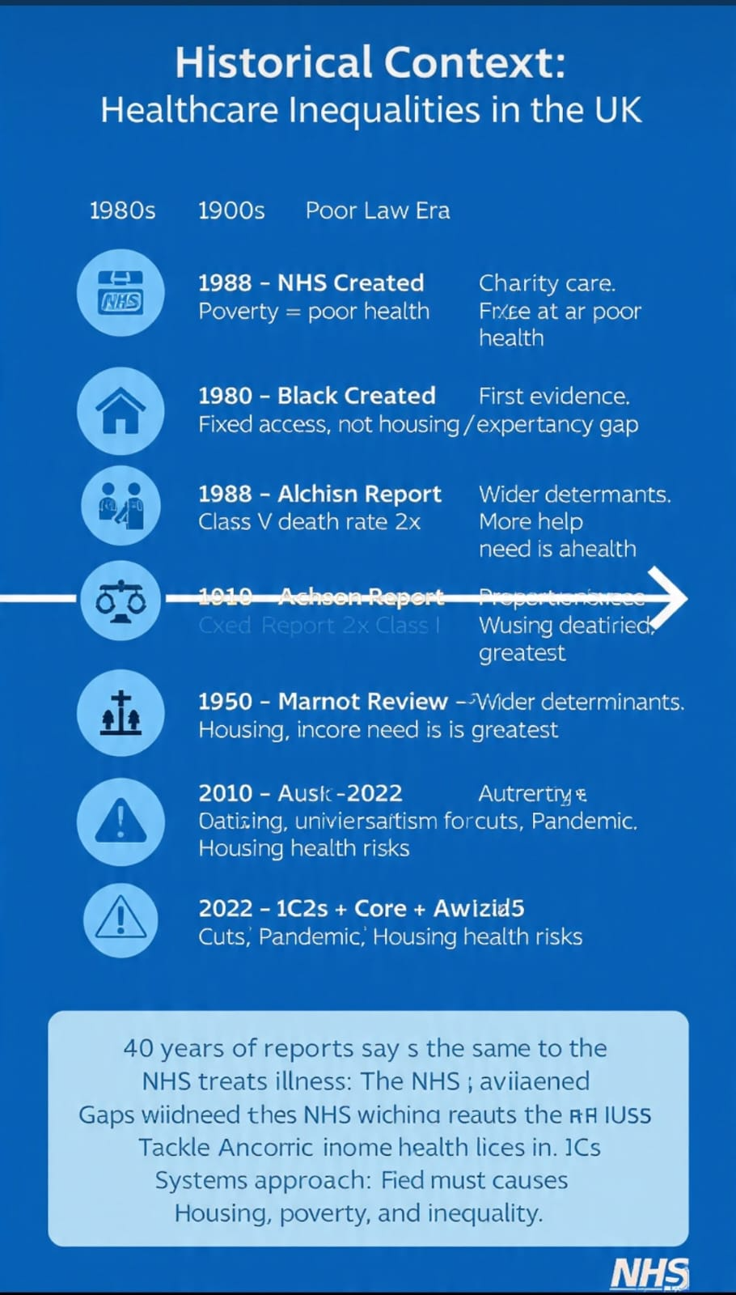
The current Context of Healthcare Services 2025/2026 has been utilising the integrated care system strategies. There are 42 ICSs in England. They consist of the NHS, local council, NHS Providers, and voluntary sector hat plan health, care workers, at one area. Their goals is to focus on preventive care and tackle the inequalities through the wider determinants of heath. The Primary aim is to trace regions lacking healthcare services through data information. Provide free BP checks, in pharmacies in deprived areas, barber shops, supermarkets and mosque. Mobile vans doing screening and vaccination for the homeless, including health GP practises special practises, immigrants and travellers in the community. Equal maternity care for deprived areas. Women get continuous care with midwife teams because of higher maternity death rates of women in the deprived areas. Lung health checks. 20% deprived areas have to mobile CT scanners. The integrated care system provide health services from one hub targeted people with three long term conditions in most deprived areas. MECC with the community champions’ advice on smoking, weight, and vaccinations reaches communities which NHS staff don’t.

1.4 Rationale for Research / Problem Statement
The suggested study is guided by the need to examine the economic and geographical contexts that influence the accessibility of healthcare services in rural England, as well as to define the possible steps and activities that can be employed to influence the accessibility of healthcare in the designated communities in a favourable manner.
The following will be the objectives to be followed in the study:
- To determine and analyse the economic and geographic issues that restrict access to healthcare services in rural England.
- To verify the gap between rural and urban population access to healthcare in England.
- To estimate the current healthcare policy and interventions to further access to healthcare in rural areas.
- To work out the recommendations that might be applied to improve access to healthcare and reduce the gaps in the rural healthcare systems.

1.5 Aim and Objectives
In order to answer the purpose of the research and the objectives, the following research questions will be utilised to complete the research:
- What are the economic constraints to the access of healthcare among the rural population of England?
- What are the geographical determinants of the healthcare access problem of the rural population?
- To what extent can the current policies and interventions be used to enhance rural access to healthcare?
- What should be done to enhance access to healthcare and narrow the rural England disparities?

1.6 Conclusion
The problem presented in the given paper is also important as it concerns one of the topical problems in the health and social consideration sphere: the disparity in the rates of access to health care services by the rural population. The barriers that influence access to healthcare are those issues that can be identified and analysed to offer viable information that will come in handy to policymakers, healthcare professionals and researchers who wish to make a difference in the healthcare systems and help taper disproportion in health (Folland et al., 2024).
The results of this research can be used to come up with additional and improved healthcare policies and interventions that are highly geared towards serving the rural population. Adding the problems of geographic distance, economic constraints, and distribution of healthcare, the study may be utilised in facilitating evidence-based decision-making, which can result in the enhancement of healthcare accessibility.
Moreover, the research will be capable of offering some solutions that can be adopted by health facilities and government departments to develop strategies that can improve service delivery in rural areas. This can be done to increase access to healthcare, resulting in improved health outcomes, patient satisfaction and increased use of healthcare resources.

CHAPTER 2: BACKGROUND AND LITERATURE REVIEW

2.1 Introduction
In fact, the availability of health care is quite a significant part of a healthy health system and has been considered as a measure of true health outcomes of individuals. In spite of the existing National Health Service (NHS) in England, which is driven towards the development of universal access to healthcare, there are still inequalities, rural inequalities and urban inequalities in the country. According to McPake et al. (2020), rural populations are normally subjected to certain structural barriers that cut across access to timely and pertinent healthcare services. These barriers may be the geographical distance, absence of medical facilities, incompetence of health staff and financial influences that will influence the health-seeking behaviour of the people.
The chapter is to perform a literature review and theoretical arguments of the current academic literature on the issue of healthcare access, particularly in rural areas. One can define the most significant concepts discussed in the chapter as healthcare access, disparities in healthcare in rural settings, economic and geographic barriers, and the policy interventions that are expected to improve the provision of healthcare services in rural environments (Getzen and Kobernick, 2022). The chapter provides the theoretical background of the factors that affect access to healthcare in rural England by reviewing past studies and findings.

2.2 Historical Background
The integrated care system still uses the phrase from Sir Black’s 1980 report, “Wider Determinant of Health”, because the government at the time officially accepted it and agreed that there were health inequalities and NHS alone could not address it.
The current content of healthcare service in England 2025 – 2026 has being utilising the integrated care system. There are 42 ICS in England and it consists of NHS, Local Council, NHS providers, Voluntary Sectors that plan health and care in various areas. Their aim is to focus on prevention care and tackle health inequalities through the wider determinants of health. NHS addresses only 20% of the problems, the rest is socioeconomic determinants of health. The national policies and frameworks are;
- NHS Long Term Plan 2019. The initial plan of action of NHS England was core 20 plus
- Core 20 meaning 20% of the population are in deprived regions with low life expectancy and health inequalities
- Plus meaning health group including homeless, vunerable, immigrants, travellers, people in the justice system.
- 5 clinical areas; early cancer diagnosis, maternity, chronic severe mental illness, respiratory diseases and hypertension. The NHS ICS and NHS providers’ duties to reduce health inequalities is legalised through the health and care act 2022.

Key duties for ICSs, Councils, and NHS:
- Information & Advice: Must provide info about care services
- Wellbeing principle: Promote wellbeing of adults + carers. Includes dignity, control, participation
- Carers: Equal right to assessment + support for unpaid carers
- Prevention: Duty to prevent/reduce/delay need for care and support
- Assessment: Everyone with care needs gets an assessment. No charge for assessment
- Eligibility: National criteria for who gets care. Focus on impact on wellbeing
- Integration: Duty to integrate health + social care. This is the legal basis for ICSs and Better Care Fund
- Safeguarding: Adult Safeguarding Boards. Duty to protect from abuse/neglect

The ICSs could not achieve its goal of reducing health inequalities in the rural region. They did not have all the levers, data, funds, staff, or time to fix inequalities that build up over decades.
The Marmot Review 10 year Update was published in 2020 showing that
- Health inequalities have widened
- Life expectancy had stalled, or fallen for some groups
- Austerity policies has worsened social determinants

The current Context of Healthcare Services 2025/2026 has been utilising the integrated care system strategies. There are 42 ICSs in England. They consist of the NHS, local council, NHS Providers, and voluntary sector hat plan health, care workers, at one area. Their goals is to focus on preventive care and tackle the inequalities through the wider determinants of heath. The Primary aim is to trace regions lacking healthcare services through data information. Provide free BP checks, in pharmacies in deprived areas, barber shops, supermarkets and mosque. Mobile vans doing screening and vaccination for the homeless, including health GP practises special practises, immigrants and travellers in the community. Equal maternity care for deprived areas. Women get continuous care with midwife teams because of higher maternity death rates of women in the deprived areas. Lung health checks. 20% deprived areas have to mobile CT scanners. The integrated care system provide health services from one hub targeted people with three long term conditions in most deprived areas. MECC with the community champions’ advice on smoking, weight, and vaccinations reaches communities which NHS staff don’t.

2.3 Theoretical Background
Healthcare access refers to the possibility for people to access the relevant healthcare services when they require them. The health system research claims that access has varying dimensions like availability, affordability, accessibility, accommodation and acceptability. All these dimensions make it possible for individuals to operate the healthcare services.
Availability refers to access to the medical services and specialists in any given place. The principle of access can be connected with the geographical location of the physical distance or the time of travelling to a healthcare facility. According to Malik-Soni et al. (2022), the affordability dimension is explained by the fact that people might be willing to afford care, both in the financial terms of the expenses related to obtaining transportation and drugs, and the cost of treatment. The question of acceptability is related to the relationship between the patient and the health worker in the cultural and social aspects.
The rural dispersion of healthcare, inadequate infrastructure and access to healthcare labour force can have significant impacts on these areas of healthcare access. Studies have established that in the absence of proper healthcare facilities, individuals will either delay or avoid healthcare services, and it will negatively impact their health and result in costly healthcare services in future.

The health inequalities issue can be described as institutional disparities among the diverse groups of individuals, as long as their health outcomes are affected. The research work has shown many times that the health problems of rural citizens in England are different from those of urban populations (Alexander et al., 2020). Although there might be instances where the rural population might be registering low rates of incidences of some diseases, they have been more challenged to access healthcare services.
The ruralised societies are also characterised by low populations, and this can make it difficult to offer a diverse array of products by the medical practitioners. Amazingly, in cities, Expert clinics, hospitals and diagnostic centres are generalised and therefore, the rural population is dependent on fewer local healthcare projects. The result of this uneven distribution of healthcare services is the inequality in access and utilisation of healthcare services.
Furthermore, the old people also dominate the rural communities more than the urban ones. According to Gordon, Booysen and Mbonigaba (2020), the aged members are expected to need more medical care, which would involve the management of chronic diseases and special care. The elderly age is another burden to the rural health care system, and the system is also not equipped with proper health care institutions.
Research has also revealed that among the rural population, more healthcare needs could be realised due to the transport and unavailability of services. The differences determine the importance of researching the role of the specified determinants in the health care access in rural environments.

2.4 International Context
The problem of geographic barriers is considered one of the most prominent ones, as far as access to healthcare in rural locations is concerned. The majority of the barriers are ascribed to the physical distance separating the patients and the healthcare facility, and the availability of the means of transportation.
According to Dang et al., (2021), the distance in England may be so long that not all the citizens in the rural areas will be able to travel without going to a hospital, special services or diagnostic centres. They do not have or have limited transport means in the distant destinations, and the people who do not own their own cars may even struggle to travel to the health centres. Long-distance travel to care could be a serious hindrance to care in older patients, persons with disabilities, or other people with mobility issues.
The other healthcare utilisation is the travel time. A study has determined that once a certain amount of time has passed, when the consideration of the travel time is applied, the probability of a patient visiting the appointment or even preventative medical services decreases (McKinlay, 2022). Any delay and absenteeism during appointments and care provision can lead to the worsening of the health condition and the development of the need for emergency medical services.
Geographic barriers also affect healthcare providers. Professional isolation, absence of career development opportunities and absence of educational opportunities are the potential factors that will make the medical professionals less willing to work in the rural areas. Therefore, the countryside areas are predisposed to lose skilled personnel in healthcare centres, and this compromises the further provision of healthcare.

2.5 National/Local UK Context
Although the services provided by the NHS are free upon consumption, there are financial parameters that may also influence the magnitude of healthcare delivery. According to Borkowski and Meese (2020), the indirect costs are another issue that may face the rural population since they will need to use money to get transport to pursue medical help, lose income and spend money taking care of their children.
The rural population could be poorer in terms of the average income and may even have no jobs compared to the urban population. This form of economic conditions can be confusing with regard to the capacity of the individual to meet the increased costs of travelling to the health care facilities, which are remote in their communities.
Transport is also very expensive, and it is a key obstacle, particularly in rural regions. Healthcare institutions can be very far apart, and therefore the patient must spend a lot of money on fuel, fares on transport or even a taxi. These costs are also cumbersome and a heavy burden for patients with chronic conditions who are forced to consult a doctor regularly (DiMatteo, Martin and Haskard-Zolnierek, 2025).
Other than that, economic deprivation can influence the health behaviours and healthcare utilisation patterns. People with low income status might choose to use their funds for other, more urgent needs, such as shelter and food, instead of attending the doctor, especially those who do not consider their medical conditions an emergency.
It is geographically insulated, thus it interacts with geographic barriers to compound problems for the rural people seeking healthcare services.
The NHS and the UK government have been aware of the situation faced by the rural folks, thus a series of policy changes have been effected where there has been an effort to make the healthcare services more accessible to the rural communities.
One of the major strategies has been telemedicine and online healthcare. The telehealth technology will allow the patients to communicate with the medical professionals through the Internet or through video conferencing (Pope and Mays, 2020). Such treatment will allow reducing the necessity of a long-distance trip and facilitate the availability of professional consultations.
There are also other rural regions that have set up mobile health. The mobile clinic and outreach programmes are the medical facilities that are transported to rural societies and directly to the locals with specific reference to the preventive and normal health check-ups.
According to Nguyen et al. (2020), the other policy intervention is the employment of financial incentives that are expected to attract the healthcare workforce to work in the rural regions. These rewards may be financial rewards and better working environments, as well as training opportunities.

2.6 Conclusion
The literature reviewed in this paper presents the chapters that outline the presence of numerous issues concerning rural access to healthcare in England. The geographical territory, the transportation, labour and financial constraints are always mentioned as one of the biggest barriers that define the practise of healthcare among the people in the rural population.
Although the literature examined the rural healthcare disparities and proposed various policy interventions, there are gaps in the literature regarding the relationship between the given factors and the effectiveness of the strategies that are implemented to eradicate healthcare disparities. The phenomenon of most literature writing is covering isolated aspects of the rural healthcare problem, as opposed to less literature covering the issue on a larger scale in terms of tackling it economically, geographically and policy-based (Letcher, 2022).
Therefore, further research is needed not only to study the parallel themes but also to discover the potential solutions, which can be introduced to make healthcare available to the rural regions. The given gap is to be bridged because the ongoing research will review the literature and the evidence provided by the policy to obtain a deeper understanding of what problems the rural population may potentially face and lay the groundwork for the possible ways in which the enhancement of healthcare access may potentially be reached.

CHAPTER 3: METHODOLOGY

3.1 Introduction
The chapter presents the research design that looks into exploring the economic and geographic barriers to access to healthcare in the rural part of England. Research methodology is a systematic technique of gathering information, processing the facts, and assessing them to answer research questions. Credible, reliable and relevant research methodology is a critical part of research where a person is keen on being sure that the research results will be credible, reliable and relevant to the research objectives (Potter et al., 2025).
The aim of the study is to research the barriers that impede the accessibility of healthcare among the rural population and the alternatives to the ways these stated issues can be eliminated, and healthcare accessibility can be increased. In such a direction, the study will be conducted through a secondary research method, which will include examining the existing academic sources on the subject of rural access to healthcare, government reports on it, and government policy reports on the subject.

3.2 Search Strategy
Research design can be described as the broad style in which the study will be carried out and the way in which the research goals will be met. It gives a systematic reference which guides data collection and analysis. The type of design adopted in this study is a qualitative research design. The qualitative research is also effective when it is planned to learn the patterns, experiences, and relations in a specific situation and investigate complex social issues (Ham, 2024).
The problem of accessibility of health care services in the rural setting is a complex one, and it concerns the geographical setting, the financial factors, policy, and health care facilities. These arguments are related to one another and demand the intensive analysis of the evidence that we have contrasted with quantification. Qualitative research design has thus been deemed fit for the exploration of the barriers and problems in the rural populations.

3.3 Searching for Information
The study is a deductive study. The deductive methodology is based on the analysis of existing theories and research data and the generalisation of the results to a particular research situation to make conclusions. The literature on the subject is reviewed based on the existing theories regarding healthcare accessibility and health disparities in the rural areas covered by the study.
This deductive approach to the study will enable the study to demonstrate similarity on issues surrounding the access to healthcare that have been encountered in some of the preceding studies, like geographic isolation, transport issues and financial constraints in accessing healthcare and the challenge in this context in rural England (Yoder-Wise and Sportsman, 2022). It is also under this that the research can determine the effectiveness of the policy interventions and actions that have been taken to resolve the healthcare disparities that the rural population has.

3.4 Research Validation
The study is solely based on secondary data. The secondary research refers to the exploration of the already gathered and published information by other researchers, organisations or governmental agencies. The secondary data are mostly used in academic research as the research attempts to survey the evidence that already exists in a given field of study and to determine the patterns or trends of the research (Raphael, 2020).
Different sources of information, credible in this study include:
- Citations in the peer-reviewed journal articles that are pertinent to the availability of rural healthcare.
- Books and scholarly publications on healthcare systems and inequalities in healthcare.
- _Government reports and policy literature pertaining to healthcare service in England.
- Existence of the healthcare organisations (including NHS) in the published literature.
- Such are the reports of international organisations that operate in the sphere of rural health and health care accessibility.
The databases that were searched online were Google Scholar, PubMed and university library databases because these databases were used to locate the relevant literature. The keywords used in the search process included:
- rural healthcare access
- Inequality in healthcare in England.
- geographic impediments in healthcare.
- rural health services
- health care in the rural areas.
The rationale behind the utilisation of more than a single source was due to the fact that the information gathered to execute the research was all-inclusive and based on academic premises.

3.5 Inclusion and Exclusion Criteria
To achieve the quality of the literature used in the study and relevance, certain inclusion and exclusion criteria were used as part of the literature selection process.
Inclusion Criteria
The following were the references on which the study was carried out:
- Rural healthcare access scholarly article accesses.
- Articles that were conducted in the past 10 years will be relevant.
- Government reports and government policy documents on healthcare in England.
- The research studies that are targeted at the economic or geographical restrictions to accessing healthcare.
Exclusion Criteria
The sources not brought on board in the study were:
- Non-scholarly online sites have no reference sources.
- Articles that were not connected to the accessibility of rural healthcare.
- The articles describing the countries solely, the health care of which is radically different from that of the UK (McLaughlin, Olson and Sharma, 2022).
- Poor articles with regard to methodology or data.
The use of these criteria was useful in ensuring that the literature was reliable, relevant and scholarly and used in the conduction of the research.

3.6 Data Analysis Method
In the analysis of the data, thematic analysis was employed after the gathering of the pertinent literature. One of the qualitative data techniques that is applied to list patterns, themes, and relationships among some information is thematic analysis.
The thematic analysis was divided into a number of steps:
- Literature analysis to obtain knowledge about the most significant findings concerning the previous studies.
- Determining the overall themes in relation to the barriers to access to healthcare.
- Including the themes in broader problems like economic barriers, geographical problems and policy responses (Wasserman, 2020).
- Contrasting the results of various studies from the perspective of establishing similarities and differences.
- The discussion of the findings according to the research questions and objectives.
As a result, the major themes concerning the issue of rural access to healthcare in England were determined and addressed. The results and discussion have these themes on which they are based, and this is discussed in the following chapter.

3.7 Ethical Considerations
A research study constitutes ethical consideration. This is because this research shall be based on the secondary data and, therefore, direct human contact, such as interviews and questionnaires, shall not occur (Valera-Medina and Banares Alcantara, 2020). The problem of confidentiality and consent of the participants does not apply, thus.
The research ethics were, however, practised even during the research. All the sources that were used in the study have been referenced and cited in the Harvard style of reference. It will not only see the original authors get credit for their work, but it will also aid in maintaining academic integrity.

3.8 Chapter Conclusion
Although secondary research is beneficial, it also has limitations, though. Among the shortcomings that are associated with the method is that the researcher would not have access to the data initially obtained. This implies that the study will be based on the validity and reliability of past research being published.
The other limitation is that the secondary data might not be in a position to provide comprehensive responses to the research questions of the study. The other studies might be broad in addressing the healthcare issues as opposed to area-specific economic and geographical limitations in this research.
Moreover, the secondary data assumes that the study will not involve the direct observation of the rural population or medical workers. The main research would offer a deeper understanding of the lives of the people in the rural community with the help of interviews or surveys.

BMHP6020 Independent Project Source Tracking Table
Completed for: Examining Economic and Geographic Barriers to Healthcare Access in Rural England
 | Author & Year | Article Title | Article Summary | Keywords / Codes
Article  1 | Cox, Clark and Sanders, 2023 | Rural healthcare | This edited academic book discusses the delivery of healthcare in rural communities and the structural barriers that affect patient access. It is useful for the dissertation because it explains how long travel distances, weak transport networks, limited local services and workforce shortages reduce timely access to care. The source supports the background and literature review by showing that rural healthcare problems are not only clinical issues but also service planning, infrastructure and policy issues. It provides a strong basis for analysing geographic isolation and rural service inequality in England. | rural healthcare; access; service barriers; workforce shortages; transport
CRAAP  Notes | Current: Published in 2023, so the information is recent and suitable for a current dissertation topic.  Relevance: Directly relevant because it focuses on rural healthcare delivery and access barriers.  Authority: Published by CRC Press and edited by academic and healthcare authors.  Accuracy: The academic publisher and specialist subject focus support reliability.  Purpose: To explain rural healthcare issues and inform health practice, policy and service planning. |  |  | CRAAP Score  5/5
Article  2 | Moseley, 2023 | Accessibility: the rural challenge | This source explains how rural geography creates everyday access problems through distance, sparse infrastructure and weaker service availability. It is particularly useful for the dissertation because it supports the argument that healthcare access is shaped by where people live, not only by whether services are formally available. The discussion helps explain why rural residents may face longer travel times, fewer public transport options and reduced access to specialist services. It therefore supports the analysis of geographic barriers and the rural-urban gap in healthcare access. | accessibility; rural geography; distance; infrastructure; service availability
CRAAP  Notes | Current: Published in 2023, so it is current enough for the research topic.  Relevance: Strongly relevant to geographic access challenges in rural areas.  Authority: Published by Routledge, an established academic publisher.  Accuracy: Based on rural accessibility scholarship and policy discussion.  Purpose: To examine rural accessibility problems and possible responses. |  |  | CRAAP Score  4/5
Article  3 | Gobburi et al., 2025 | Telemedicine use in rural areas of the United Kingdom to improve access to healthcare facilities: A review of current evidence | This review examines the use of telemedicine in rural UK settings and considers whether digital healthcare can improve access to services. It is valuable for the dissertation because it links directly to one of the main proposed solutions for rural healthcare inequality. The source shows that remote consultations may reduce travel requirements, improve follow-up care and support access to specialist advice. It also recognises limitations, including digital exclusion, weak internet infrastructure and patient confidence with technology. This makes it useful for evaluating both benefits and barriers of policy interventions. | telemedicine; rural UK; healthcare access; digital health; remote consultation
CRAAP  Notes | Current: Published in 2025, so it is highly current.  Relevance: Very relevant because it focuses on rural UK healthcare access.  Authority: Published in Informatics and Health by healthcare and public health authors.  Accuracy: Uses recent review evidence and includes DOI-linked publication details.  Purpose: To review evidence on how telemedicine can improve rural healthcare access. |  |  | CRAAP Score  5/5
Article  4 | Golestani, Farahani and Peters, 2025 | Exploring barriers to accessing health care services by young women in rural settings: a qualitative study in Australia, Canada, and Sweden | This qualitative study explores the barriers that young women experience when accessing healthcare in rural settings. Although it is not England-specific, it is useful because it identifies recurring rural access problems, including travel distance, service limitations, social barriers and difficulties obtaining timely appointments. The study supports the dissertation's problem statement by showing that rural access barriers can affect different groups in specific ways. It also provides qualitative evidence that rural healthcare access is shaped by both geography and service design, rather than by physical distance alone. | rural barriers; qualitative study; women; healthcare access; service limitations
CRAAP  Notes | Current: Published in 2025, so it is current.  Relevance: Relevant to rural healthcare access, although the country context is not England.  Authority: Published in BMC Public Health, a recognised peer-reviewed journal.  Accuracy: Qualitative evidence from three countries supports credibility.  Purpose: To investigate barriers faced by young women in rural healthcare access. |  |  | CRAAP Score  4/5
Article  5 | Folland et al., 2024 | The economics of health and health care | This book explains the economic dimensions of healthcare, including healthcare costs, resource allocation, demand, affordability and inequality. It is relevant to the dissertation because the study examines why economic barriers remain important even in a publicly funded NHS system. The source helps explain indirect costs such as transport, time away from work and the financial burden of repeated appointments. It also supports discussion of resource distribution between rural and urban areas. Although it is broader than rural England, it provides strong theoretical grounding for analysing economic barriers to healthcare access. | health economics; healthcare costs; inequality; resource allocation; affordability
CRAAP  Notes | Current: The 2024 edition is current.  Relevance: Relevant to economic barriers, although broader than rural England.  Authority: Published by Routledge and written by established health economics authors.  Accuracy: A recognised academic textbook using evidence-based concepts.  Purpose: To explain economic principles within healthcare systems. |  |  | CRAAP Score  4/5
Article  6 | McPake et al., 2020 | Health economics: an international perspective | This source explains healthcare economics and access issues from an international perspective. It supports the dissertation by providing concepts that help interpret structural barriers, health inequalities and resource allocation decisions. The book is useful for understanding how income, service supply, funding arrangements and health system organisation influence access to care. Although its scope is international rather than England-specific, it offers theoretical background for the literature review. It is especially useful when explaining why unequal distribution of healthcare resources can produce different experiences of access for rural and urban populations. | health economics; healthcare systems; access; inequality; resource allocation
CRAAP  Notes | Current: Published in 2020, within the usual 10-year range.  Relevance: Relevant to health economics and access barriers, but international rather than UK-only.  Authority: Published by Routledge and written by recognised health economics scholars.  Accuracy: Academic textbook with established healthcare economics concepts.  Purpose: To explain health economics across different healthcare systems. |  |  | CRAAP Score  4/5
Article  7 | Getzen and Kobernick, 2022 | Health economics and financing | This book focuses on healthcare financing, affordability and the economic organisation of health systems. It is useful for the dissertation because it helps explain how costs and funding structures affect people's ability to use healthcare services. In the rural healthcare context, the source supports discussion of indirect costs such as travel expenses, prescription-related costs and opportunity costs from missed work. It also strengthens the analysis of why financial pressure can delay care-seeking behaviour. The source is not rural-specific, but it provides relevant economic concepts for interpreting healthcare access problems. | health financing; affordability; healthcare systems; economics; indirect costs
CRAAP  Notes | Current: Published in 2022, so it is reasonably current.  Relevance: Relevant to affordability and healthcare financing issues.  Authority: Published by John Wiley and Sons, a reputable academic publisher.  Accuracy: Uses established health economics and financing theory.  Purpose: To explain how healthcare is funded and how financing affects access. |  |  | CRAAP Score  4/5
Article  8 | Malik-Soni et al., 2022 | Tackling healthcare access barriers for individuals with autism from diagnosis to adulthood | This article examines healthcare access barriers across the patient journey, with attention to dimensions such as availability, affordability, acceptability and accommodation. It is not directly focused on rural England, but it is helpful for defining the broader concept of healthcare access in the literature review. The article supports the dissertation by showing that access is multidimensional and includes more than physical entry into a clinic. This is useful when analysing rural healthcare because distance, cost, appointment systems and patient needs can combine to create unequal access experiences. | access barriers; affordability; acceptability; patient journey; service accommodation
CRAAP  Notes | Current: Published in 2022, within the current evidence range.  Relevance: Relevant to access barriers, although autism-specific rather than rural England-specific.  Authority: Published in Pediatric Research, a peer-reviewed journal.  Accuracy: Peer-reviewed and DOI-linked source improves reliability.  Purpose: To identify and address healthcare access barriers for autistic people. |  |  | CRAAP Score  4/5
Article  9 | Alexander et al., 2020 | New dimensions in women's health | This book discusses health issues and inequalities affecting women, including public health concerns and wider social determinants of health. It is only partly relevant to the dissertation because it does not focus specifically on rural England or geographic healthcare barriers. However, it can provide background context for understanding health inequality and how different population groups may experience access issues differently. Its usefulness is stronger for general health inequality discussion than for the dissertation's core focus on economic and geographic barriers in rural communities. | health inequalities; women's health; public health; access; social determinants
CRAAP  Notes | Current: Published in 2020, within the acceptable date range.  Relevance: Partly relevant to health inequalities, but limited direct connection to rural England.  Authority: Published by Jones and Bartlett Learning, an academic publisher.  Accuracy: Textbook-style source with established health content.  Purpose: To provide a broad overview of women's health and inequalities. |  |  | CRAAP Score  3/5
Article  10 | Gordon, Booysen and Mbonigaba, 2020 | Socio-economic inequalities in the multiple dimensions of access to healthcare: the case of South Africa | This article analyses socio-economic inequalities across multiple dimensions of healthcare access, including deprivation and uneven use of services. It is relevant to the dissertation because it supports the discussion that economic disadvantage can restrict healthcare access, even when services may exist. The source is not based in England, so its findings must be used carefully, but it provides useful empirical evidence on how income and social inequality shape access. It strengthens the dissertation's argument that rural access problems are not only geographic but also socio-economic. | socio-economic inequality; healthcare access; deprivation; access dimensions; affordability
CRAAP  Notes | Current: Published in 2020, still current enough for the topic.  Relevance: Relevant to socio-economic healthcare access, but the country context is South Africa.  Authority: Published in BMC Public Health, a reputable peer-reviewed journal.  Accuracy: Peer-reviewed empirical source with transparent journal details.  Purpose: To analyse how socio-economic inequality affects access to healthcare. |  |  | CRAAP Score  4/5

BMHP6020 Independent Project Results Summary Table

Author & Year | Article Title | Type of Study | Research Method & Sample Size | Strengths & Limitations | Main Findings | Keywords & Codes | Notes and Comments
Cox, Clark & Sanders (2023) | Rural healthcare | Edited academic book | Literature synthesis (sample not applicable) | Strength: Comprehensive overview of rural healthcare barriers. Limitation: Not empirical; lacks primary data. | Rural healthcare access is shaped by geography, infrastructure, workforce shortages, and transport limitations. | rural healthcare; access; service barriers; workforce shortages; transport | Strong foundational source for rural healthcare systems and policy context.
Moseley (2023) | Accessibility: the rural challenge | Academic book | Conceptual/policy analysis (sample not applicable) | Strength: Strong theoretical discussion of rural accessibility. Limitation: Not a healthcare-specific empirical study. | Rural geography significantly limits access through distance, transport, and service availability constraints. | accessibility; rural geography; distance; infrastructure; service availability | Useful for explaining rural-urban access inequality.
Gobburi et al. (2025) | Telemedicine use in rural areas of the United Kingdom to improve access to healthcare facilities: A review of current evidence | Systematic review | Literature review (multiple studies; sample not applicable) | Strength: UK-focused, recent evidence. Limitation: Digital exclusion is not fully resolved. | Telemedicine improves access but is limited by digital infrastructure and exclusion. | telemedicine; rural UK; digital health; remote consultation | Key policy solution source for rural healthcare access.
Golestani, Farahani & Peters (2025) | Exploring barriers to accessing health care services by young women in rural settings: a qualitative study in Australia, Canada, and Sweden | Qualitative study | Qualitative interviews across 3 countries (sample not specified) | Strength: Rich qualitative insights. Limitation: Not England-specific. | Rural access barriers include distance, appointment delays, and service limitations. | rural barriers; qualitative study; women; service limitations | Shows the multidimensional nature of rural access barriers.
Folland et al. (2024) | The economics of health and health care | Academic textbook | Theoretical/economic analysis | Strength: Strong conceptual economic framework. Limitation: Not rural-specific. | Economic barriers such as cost, affordability, and opportunity cost affect healthcare access. | health economics; costs; inequality; resource allocation | Useful theoretical grounding for economic barriers.
Completed for: Examining Economic and Geographic Barriers to Healthcare Access in Rural England

Author & Year | Article Title | Type of Study | Research Method & Sample Size | Strengths & Limitations | Main Findings | Keywords & Codes | Notes and Comments
Cox, Clark & Sanders (2023) | Rural healthcare | Edited academic book | Literature synthesis (sample not applicable) | Strength: Comprehensive overview of rural healthcare barriers. Limitation: Not empirical; lacks primary data. | Rural geographical barrier is shaped by geography, infrastructure, workforce shortages, and transport limitations. | geographical barrier, service barriers, workforce shortages, transport | Strong foundational source for rural healthcare systems and policy context.
Moseley (2023) | Accessibility: the rural challenge | Academic book | Conceptual/policy analysis (sample not applicable) | Strength: Strong theoretical discussion of rural accessibility. Limitation: Not a healthcare-specific empirical study. | Rural geography significantly limits access through distance, transport, and service availability constraints. | Geography, distance, infrastructure, workforce, transport | Useful for explaining rural-urban access inequality.
Gobburi et al. (2025) | Telemedicine use in rural areas of the United Kingdom to improve access to healthcare facilities: A review of current evidence | Systematic review | Literature review (multiple studies; sample not applicable) | Strength: UK-focused, recent evidence. Limitation: Digital exclusion is not fully resolved. | Telemedicine improves access but is limited by digital infrastructure and exclusion. | Telemedicine, rural UK, digital health, remote consultation | Key policy solution source for rural healthcare access.
Golestani, Farahani & Peters (2025) | Exploring barriers to accessing health care services by young women in rural settings: a qualitative study in Australia, Canada, and Sweden | Qualitative study | Qualitative interviews across 3 countries (sample not specified) | Strength: Rich qualitative insights. Limitation: Not England-specific. | Geographical barrier include distance, appointment delays, and service limitations. | Geographical barriers, qualitative study, women, service limitations | Shows the multidimensional nature of rural access barriers.
Folland et al. (2024) | The economics of health and health care | Academic textbook | Theoretical/economic analysis | Strength: Strong conceptual economic framework. Limitation: Not rural-specific. | Economic barriers such as cost, affordability, and opportunity cost affect healthcare access. | economic constraints, inequality, resource allocation | Useful theoretical grounding for economic barriers.

Author & Year | Main Findings
Cox, Clark & Sanders (2023) | Geographical barrier is shaped by geography, infrastructure, workforce shortages, and transport limitations.
Moseley (2023) | Rural geography significantly limits access through distance, transport, and service availability constraints.
Gobburi et al. (2025) | Telemedicine improves access but is limited by digital infrastructure and exclusion.
Golestani, Farahani & Peters (2025) | Geographical barrier include distance, appointment delays, and service limitations.
Folland et al. (2024) | Economic constraints such as cost, affordability, and opportunity cost affect healthcare access.

Code Key:
Geographical Barrier
Transport
Economic Constraints
Infrastructure

CHAPTER 4: RESULTS AND DISCUSSION

4.1 Introduction
This chapter will present the results and discussion following the analysis of the literature and secondary data sources that are analysed in this paper. The essence of this chapter is to provide an answer to the question of the nature of the major themes in the provision of healthcare to rural England. The thematic analysis of the literature concerning the topic matter, governmental reports, and policy documentation provided some themes of repetition to demonstrate the issues that the rural populations encounter in accessing healthcare services (Sylvia and Terhaar, 2023).
In Chapter 1, the discussion of the study findings relative to the established research objectives and research questions has also been discussed. These findings are pooled into significant thematic categories such as geographic barriers to healthcare access, economic barriers to use of healthcare, shortage of healthcare workforce, variation based on rural or urban location of healthcare delivery, and the effectiveness of the current policy interventions that are targeted towards enhancing healthcare accessibility.
Their interactions with one another and the role played by these themes in increasing the health disparities in the rural populations are also discussed.

4.2 Thematic Analysis
The thematic analysis of the literature that has been introduced in the literature review brought forth certain significant discoveries of the problem of healthcare access in rural England. The key obstacles are:
- Distance, geographic seclusion, and distance to medical facilities.
- Inability to have good infrastructure and transport supply.
- Economic issues related to travelling expenses and a poor income level.
- Medical staffing shortage in rural setups.
- Poor access to specialised medical care.
- The rural healthcare initiatives and telemedicine are some of the policy interventions that have different degrees of effectiveness.
All these add to the gap between rural and urban populations in terms of the healthcare access issue. Much as there is an objective of the National Health Service, which is to provide universal healthcare, the reality on the ground is that the rural community is yet to be confronted with structural and socioeconomic challenges.
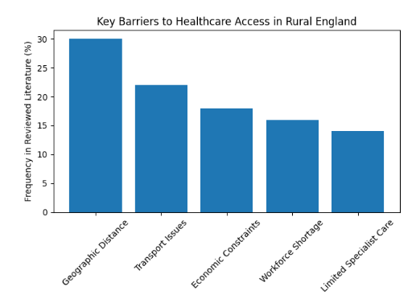

4.3 Geographic Barriers to Healthcare Access
The impact of geographical limitations on accessibility to healthcare is one of the most significant discoveries made in the literature ever. In England, the rural population is normally faced with a myriad of setbacks that border on the physical distance between the patients and the health care facilities. The rural citizens will have to drive long distances to receive primary care services, visit specialists, or have hospital treatment, unlike the city, where hospitals and clinics are situated at a very short distance (Liebler and McConnell, 2020).
The studies show that the distance to healthcare can become one of the determinants of the likelihood of a person receiving healthcare services. In situations when the medical centres are too far to get to the residence, the patients can postpone or decline to see a doctor because of the undesirable inconvenience of travelling. The issue mentioned above is especially pertinent to older adults, the disabled people with disabilities, and patients with recurrent diseases who have to see the doctor on a regular basis.
About the geographical obstacles, the next notable aspect is that the rural areas have low access to public transport. In the majority of cases, the rural populations are unable to afford most means of transport in comparison with the urban areas; this implies that people lacking their own means of access to healthcare providers would encounter a lot of difficulties in reaching healthcare providers (Williams, 2022). This lack of efficient transportation infrastructure may create other problems for the people who rely on the services of the people to attain medical care.
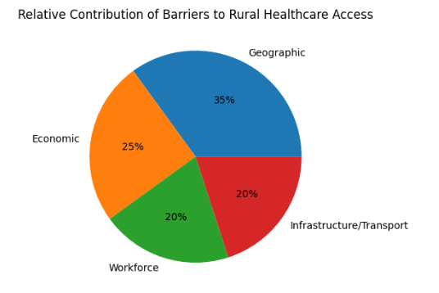
The travel time is also able to give the healthcare utilisation. Research has revealed that the longer the travelling time, the less is the utilisation of healthcare, especially in the aspect of preventive healthcare like health screening, regular check-ups, and early consultation. It is also probable that the non-urgent healthcare issues will not be a priority when individuals are compelled to travel long distances to healthcare centres to receive healthcare.
Moreover, the geographical distribution of the healthcare facilities in England is more concentrated in the urban centres, as the population is bigger and the demand for services is higher (Tortora et al., 2024). On a positive note, it would imply that the communities in the rural areas would experience reduced quantities of local health services, which would be dangerous due to congesting the hospitals in bigger cities with special care.

Transportation Challenges and Accessibility

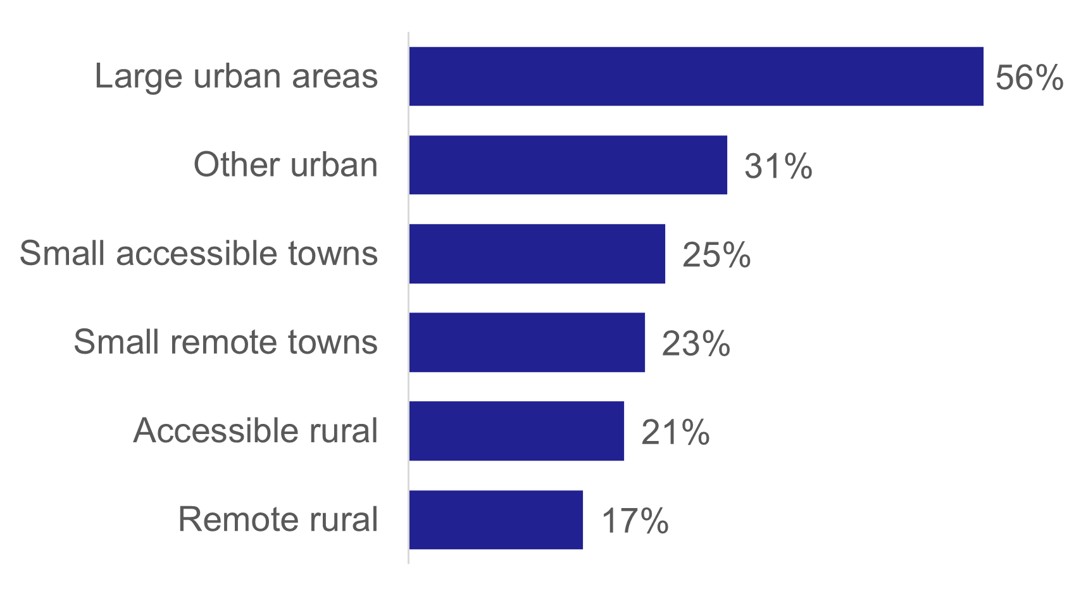

Figure-percentage-of-adults-using-the-bus-at-least-once-a-month-by-urban-rural-category-2023

The geographic problem of rural access to healthcare is a major issue that lies in the issue of transportation. Most of the rural settings do not have or are poorly networked in terms of transportation. The buses will be capable of making a few trips per day, and even the train stations can be very far as compared to the small village and remote communities (LoBiondo-Wood and Haber, 2021). This has witnessed high levels of inaccessibility of people in the rural communities to the health care facilities because of the inability to access the means of transport.
Such transportation limitations can seriously inhibit the privilege of such people who lack personal access to health care facilities. The rural citizens, unlike those in an urban location, may not have the chance of having many means of transport, owing to the presence of buses, trains, cabs, or other ride-hailing services (Brunzel, 2021). The patients are mostly compelled to be driven by their relatives, friends or community members to medical visits. Nevertheless, they are not necessarily the arrangements which can be depended on and which can be given when needed, especially to elderly citizens or independent people.
Certainly, under certain circumstances, patients will be compelled to use taxi services and other transportation companies to access healthcare centres. To the degree that the two alternatives could help solve transportation issues, they could equally present cost issues to low-income earners. Rural taxi can be costly since there are more miles that will be covered, and also a lack of taxi drivers (Thomas, 2024). This can lead to a situation where there are patients who would not want to have medical check-ups, or even postpone them, due to the inconvenience and high cost of travelling to the medical practitioners.
This also concerns the transportation issues of the patients who need specialised treatments in hospitals found in the urban areas. Most of the specialised services, diagnoses and sophisticated medical equipment are all available in the urban centres and not in the rural societies. As a result, patients who have to visit a specialist, a physician or undergo a treatment that is too complicated can be subjected to the necessity of driving long distances to get the treatment (Sharma, 2022). This can be physically and economically challenging, especially in situations where one has to make several visits, follow-up meetings or a course of treatment.
Prolonged commuting can also create further issues for those patients who have a chronic illness or who have mobility challenges. In an example, physically challenged or elderly people will be physically at a very extreme level of exhaustion on a long journey or even unable to handle it. Weather, roads, and seasons can also be a problem in the rural areas, particularly during the winter or during the seasons of hard weather.
Transport challenges persists despite The Local Council and The National Transport services initiatives. Problems such as low frequency or non-availability of transport, bad transport links, high cost of transport, less disability transport no step free access at transport terminals, lack of transport for carers of people with disabilities. However, people with their own cars are not affected with these challenges.

4.5 Economic Barriers to Healthcare Access
Even though most of the healthcare services offered under the NHS are free when accessed, the factor of economy can also be a pain to the availability of healthcare services to rural populations. In the literature, the indirect healthcare costs have been introduced as a major challenge to the rural population despite the universal healthcare system (White, Dudley-Brown and Terhaar, 2024).
One of the economic barriers that is most mentioned as being popular is transportation costs. Patients who might be compelled to spend a long distance to the health care facilities might incur costs in terms of fuel costs, and repairing their cars or spending the money that they use to transport their cars by using buses and cabs. Such expenses can be borne in a lifetime when people are permanent victims of health issues, which may prove to be costly to travel to healthcare facilities every now and then or to take regular medication in order to treat the illness (Clemente-Marcuello, Gutiérrez and Orbe, 2024). Such transport expenses can influence a huge financial liability in other families with low economic abilities.
It is also possible that the rural population might be characterised by low income levels as compared to the urban dwellers. The possibilities of employment and average income are lower, and the opportunities in rural places are fewer in general. Individual economic deprivation may limit his capacity to satisfy more of his costs associated with healthcare, including travel costs, costs of prescription drugs and childcare costs at a healthcare facility. Such a financial limitation can make people reluctant to take healthcare services unless the condition becomes serious.
Employment flexibility is another economic factor that determines the accessibility of healthcare. Individuals who are either on low income or on jobs that they cannot rely on might not be able to afford not to have any jobs to ensure that they have time to visit the health care facility. Most of the rural employees are also employed in the sectors, which include the agriculture sector, working in small businesses, or closely working with hands-on jobs, where loss of income can be experienced in the event of absence from work (Annaswamy, Verduzco-Gutierrez and Frieden, 2020). When the distance to the healthcare facility is relatively large, it means that the patients have to allocate a few hours or even a day off to make an appointment. Such a case can make people avoid visiting a healthcare professional to consult a doctor in a timely manner and later seek medical treatment.

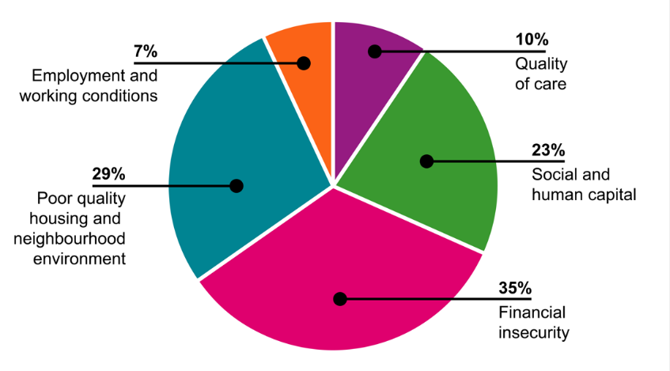

Healthcare Workforce Shortages
Another significant issue in the healthcare access issue in rural England is the healthcare workforce shortages. It has consistently been emphasised in most studies that rural environments have been experiencing significant challenges with attracting and recruiting qualified medical workers, even without including the retention. These deficits have very dire consequences on the access and quality of the medical services accessed by the rural population (Morrison-Valfre, 2022).
The main cause of the workforce shortage in rural areas is the fact that the majority of healthcare providers will be concentrated in the city areas. In general, the metropolitan centres will enjoy a greater professional opportunity, which will encompass the delivery of high-technological medicine, specialised training courses, and networking with professionals. They are applicable to lure the medical practitioners to the urban health centres that wish to build careers or specialised medical areas.
In addition, the cities are likely to offer improved education and labour markets to the family members, as well as social and cultural facilities. The reason is that these lifestyle factors can greatly affect healthcare practitioners in choosing the place of work (Rodrigue, 2020). This may have a high count of doctors, nurses and other medical workers opting to work in the large cities instead of shifting to the rural areas.
The impacts of this kind of inequality in the labour force can be eloquently fulfilled in the rural healthcare facilities. General practitioners, shortage of nurses and special doctors are the causes of many rural clinics and medical centres. These shortages may diminish the number of bookings and various types of services that will be performed by the professionals. A limited number of staff members can easily be adopted in other cases of rural health centres to serve an enormous geographical area.
This would mean that patients in rural populations might take a longer time to seek health care services, even in an area where the person has to wait some weeks before he or she is guaranteed an appointment with a general practitioner. Such delays may discourage people who wish to visit the health care facility to seek treatment for the less serious health-related problems and most likely will result in the aggravation of the ailing medical problem linked to the lack of prompt treatment (Tomaszewski, 2020).
Lack of specialised services in the rural population is another disease that is afflicting the rural population. Although GPs could be accessible in certain rural settings where they cannot access some of the specialist services, like cardiology services, oncology services, and even mental health services. The specialised care patients would subsequently be compelled to travel to bigger hospitals in the urban centres. This necessitates geographical as well as financial restrictions in terms of accessing healthcare services, especially to individuals who are likely to make many consultations or continuous treatment sessions. The issue of Healthcare workforce shortages is primarily linked to limited funds and long duration of training recruitment difficulties, or wider socioeconomic inequalities.

Rural and Urban Healthcare Disparities
The results of this research paper show how big the differences in the development of health are between the urban and rural areas. All these inequalities are entrenched in the literature and refer to inequalities in medical facilities and resource and demographic distribution. The healthcare sector, hospitals, special clinics, diagnostics, and a larger number of medical personnel are more developed among the city residents (Rossmo, 2025).
The patients in the urban centres are usually close to various health providers in a relatively close proximity. This will enable the individuals to have options of the various healthcare facilities and get the specialised services more easily. It is also possible that the healthcare systems of the urban areas are more predisposed to higher medical technologies, the number of specialists, and the distance between personalities in transport to and from medical institutions is minimised.
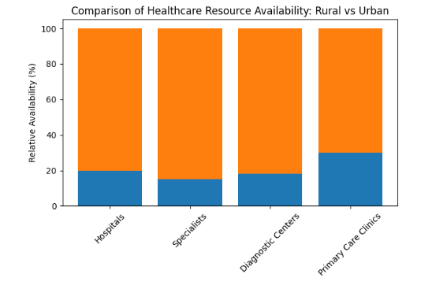
The rural societies, on the other hand, are susceptible to the low number of health providers and facilities. There might be one primary healthcare centre in some of the rural areas which will cater to a vast area. The accessibility of specialised medical intervention can limit the choice of the patient since the number of medical services available is limited to make them more accessible (Al-Shorbaji, 2022). The patients may receive fewer choices not only in the choice of the healthcare providers but also in terms of the time required to see a doctor.
This difference in the disparities could bring about a difference in the health between the rural and urban populations. It may happen that rural residents will be more subject to the delayed diagnosis because of low access to healthcare or a lack of access to specialist care. Health conditions can progress to more serious ones, as people do not want to see the doctor in time due to the inconvenience of travelling, waiting in long queues, or the lack of medical care organisations.
Later diagnosis and treatment may cause complications to the health that, in the long run, may demand more complicated healthcare expenses. This is also coupled with the fact that what may have been a mere condition to be treated at an earlier period of time may end up being a more serious condition to be treated once it is diagnosed that it started late (Rachmad, 2021). Thus, disparities in population health can also occur based on increased differences in access to healthcare.
The other issue that is contributing to inequality in rural health care is the demographic outflow of the rural communities. The rural regions usually make up a larger proportion of the elderly population than the urban regions. The elderly are likely to demand more medical services, since they have more chronic diseases and other health problems. This mismatch between the growing demand for healthcare and the supply of healthcare, which is present, would create a lot of pressure on the rural healthcare systems (DePoy, 2024).
Secondly, one can also assume that in the countryside, the level of social isolation and inability to receive support services is greater. They can also affect the health outcomes and the healthcare utilisation. Even these people do not have social support networks that can make them even less able to visit healthcare facilities and care about their long-term health concerns.
On the whole, the difference in the rural and urban access to healthcare implies that some policies should be introduced to address the issue of healthcare infrastructure, workforce delivery, and the accessibility of the services in the rural environment. These differences need to be abolished to enable fair access to healthcare services for the whole population, irrespective of their location.

Evaluation of Policy Interventions
Both the health institutions and the governments have been on numerous policy initiatives to combat the challenges faced with the issue of healthcare accessibility in rural environments. The interventions will be aimed at the minimisation of geographical, economic and workforce-related barriers, which prevent the possibility of providing the rural population with timely and quality medical care (Provost and Murray, 2022). The use of telemedicine and digital healthcare services is one of the strategies that were most discussed and applied.
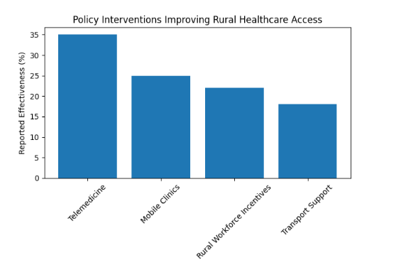
Telemedicine can be considered as the process of providing medical services with the help of digital tools of communication (video conferencing, cell phones with health applications, and Web-based medical portals). The telemedicine systems enable patients to provide information to the health professionals in remote sites without having to travel long distances to the medical centres. The strategy has become increasingly popular in recent years due to its position among the potential solutions to the problem of healthcare accessibility in rural areas.
The Telemedicine application has a number of merits for the rural population. First, it is capable of greatly decreasing long-distance travel, which happens to be one of the key impediments to healthcare accessibility in rural settings (Shi and Stevens, 2021). The virtual appointment will help the health professionals to provide consultations and medical advice to the patients and follow-ups despite the absence of close proximity of the patients to hospitals or clinics with specialists. This will save time and transport expenses for the rural population.
Second, telemedicine will be in a position to enhance access to specialised medical services. Healthcare centres based in rural areas might not necessarily be able to access specialists, including cardiologists, dermatologists, or mental healthcare providers. Telemedicine offers patients a chance to pay for consultations with doctors who might be accessible in medical centres in the city without necessarily being forced to leave their communities (Malakapalli, 2024). This will help enhance the diagnosis rate and offer the patients the right medical recommendations.
According to other sources, telemedicine may be effective in such scenarios as rural healthcare accessibility. Routine medical check-ups, prescription management, follow-ups on chronic illnesses, and remote consultation can be involved. It is also possible through digital health technologies that can be offered as a form of remotely monitoring a patient by wearable technology or other devices in the home of a patient in order to diagnose a patient.
Nevertheless, telemedicine operates with regard to some important aspects. One of the biggest factors involved in the consideration of barriers is the accessibility of good-quality digital infrastructure to the rural population. The rural areas have a poorly connected internet, a slow internet connection, or occasionally a connection to the mobile networks (Dalton, Brown and Duarte, 2021). The patients do not experience technological inadequacy that can impede them from attending virtual consultations or using electronic medical services.
Digital literacy is another determinant which is critical in the utilisation of telehealth services. Others might not be experienced in the use of digital technologies, such as smartphones, computers or online health services, namely the older patients. It is likely that some of the rural population will not be able to receive telemedicine services due to a lack of appropriate digital capabilities or other technical operations.

Integration of Findings with Research Questions
The results presented in this chapter are useful in terms of their data on the variables of access to healthcare within rural England and can be applied to respond to the research questions that were proposed in Chapter 1. The review of the available literature and research studies has enabled this study to identify some of the economic, geographic and structural barriers that influence healthcare utilisation among the rural population (Schaefer and Ibrahim, 2025).
The economic disincentives to rural England's access to healthcare were the first research question. The findings of the analysis indicate that the indirect healthcare cost is another important parameter in the determination of healthcare utilisation. The cost of transportation, income constraint and employment restrictions are some of the major economic factors that were identified to influence the rural residents. People with long distances to medical services are likely to spend extra on the car, transport or a source of taxis. Such spending in low-income families may either deter the population from seeking healthcare or cause them to postpone their visits to the healthcare institutions.
The second research question was the geographic factors of access to healthcare. Among the geographic factors that were identified as important in the analysis were distance to medical services, unavailability of infrastructure with regard to the use of transportation methods, and inequality in health care services between the rural and urban communities. This type of geography may become an obstacle to the delivery of both primary health care and special care to the residents of rural regions.
The third research question was the potency of the offered policy interventions that can enhance access to healthcare in rural areas. The results indicate that telemedicine, mobile medical care and the use of money to motivate the rural health practitioners are some of the interventions that can be used in enhancing access to healthcare in the rural setting (Coombs, Campbell and Caringi, 2022). Specifically, telemedicine has been cited as a potential area of cost-saving in travelling, as well as providing more interpretation facilities to all.
Such interventions may also, however, be analysed as conditioned by general structural aspects in order to be successful. The impact of the policy efforts can be mitigated by a lack of digital infrastructure, labour shortage and transportation unless the policy efforts are pooled together to be dealt with. Thus, the policy interventions will consider the larger healthcare system and the range of issues which impact access to healthcare in the rural environment.
Lastly, the fourth research question was about the possible alternatives for enhancing the availability of health services in rural regions. The literature claims that there is a need to adopt a holistic and comprehensive policy in addressing healthcare disparities. A better transport infrastructure in the country's rural areas, better healthcare infrastructure investment, greater improvements in the growth of digital health technology, and a specific workforce development programme could help in enhancing access to healthcare (Ezeamii et al., 2024).
Overall, the conclusions of this article indicate that the issue of accessibility to healthcare in rural areas is a complicated phenomenon that is determined by various factors that are interdependent on one another. These predicaments should be solved by policy interventions, long-term investments and new forms of healthcare delivery that can be customised to the unique needs of the rural population.

4.6 Conclusion
The chapter has shown the findings and discussion based on the analysis of the secondary sources of information on access to healthcare in rural England. The results show that geographic choices, logistical challenges, financial limitations and shortage of healthcare workers are the most important barriers to obtaining healthcare across different regions.
The findings also have significant variabilities of the rural and urban healthcare services, whereby the rural communities have minimal access to the healthcare facilities, as well as specialist care. Although the different policy interventions exercised in the check of these hurdles have been successfully executed, more needs to be done in such a way that they will offer equitable healthcare services to the rural inhabitants.
The last chapter will include the presentation of the study findings, which will include the summary of the most important findings and will offer recommendations regarding the further enhancement of the accessibility of healthcare in rural England.

CHAPTER 5: RECOMMENDATIONS AND CONCLUSION

5.1 Introduction
This is the last chapter of this dissertation since it will conclude the most notable findings of the study, offer recommendations that will enhance accessibility to healthcare in rural England and formulate possible areas of future studies. The research covered the identified barriers that are economically and geographically located, and the ones that influence the access to healthcare of the rural communities and the efficiency of the available policies and interventions capable of mitigating them (Wercholuk, Parikh and Snyder, 2022).
These findings of the literature review, as well as the discussion of the secondary information, have shown that the rural populations are still exposed to numerous barriers affecting access to healthcare services. Such obstacles are the geographical distance, challenges of transportation, financial limitations, and lack of personnel medical professionals.

5.2 Summary of Key Findings
This research project was to argue out the economic and geographical drawbacks of healthcare accessibility in rural England and find possible ways of solving the issue of access to healthcare. The survey of the existing literature and policy reports brought about some important findings.
To begin with, the geographic barriers were found to be one of the greatest issues, which affected the accessibility of the healthcare service in the rural environment. The rural population is typically typified by long commutes to health care centres, which is an issue that does not encourage early medical care seeking (Shaw et al., 2024). It is further worsened by the fact that there is no well-established infrastructure in the transportation sector, where individuals cannot access their vehicles.
Secondly, economic constraints were discovered to have a huge role in the affordability of health care. Though the health services offered by the National Health Service (NHS) are usually free at the point of consumption, it is indirectly costly to the residents living in rural areas because of the cost of obtaining healthcare. These are costs that are incurred in transportation, time wastage during work and other costs associated with this that may deter individuals who may not want to visit healthcare offices.

5.3 Recommendations
On the basis of the study findings, it is possible to develop several recommendations which could be applied in order to enhance access to healthcare in rural England. The recommendations would help in stemming the geographical and economic barriers that have been put in place during the research.

5.3.1 Improving Transportation Infrastructure
It is possible to mention the design of more efficient transportation networks that can be viewed as the key solutions that may be provided to enhance access to healthcare in the countryside. The governments and the local governments can consider investing in rural transport infrastructure, such as community buses and community transport programmes, such as local access to medical institutions (Doherty et al., 2022).

5.3.2 Expanding Telemedicine and Digital Healthcare Services
Telemedicine will go a long way in enhancing the accessibility of health services to the rural population. To upscale the digital healthcare services would imply that the patients would be able to access healthcare professionals online; hence, they will not need to commute long distances to access healthcare facilities.

5.3.3 Strengthening Rural Healthcare Workforce Recruitment
The reason is that the problem of access to healthcare by the rural population may be solved by exploiting the healthcare workforce shortages. Healthcare organisations and governments will be required to come up with certain policies that will help in the recruitment of healthcare practitioners to the rural population (Anawade, Sharma and Gahane, 2024).

5.3.4 Increasing Investment in Rural Healthcare Facilities
The investment of the health institutions in the rural areas should be in a manner that is affordable to the rural population to access the basic health care facilities. The increase in the number of primary care clinics and the accessibility of diagnostic and specialist services in the rural centres will decrease the number of road trips by the patient to the urban centres.
Healthcare can also be overly extended to the rural population, especially in isolated locations where the permanent healthcare facilities might not be practicable via outreach programmes and mobile healthcare units.

5.3.5 Enhancing Policy Coordination and Long-Term Planning
The rural communities need a good collaboration between the national government structures, the local government, the health care institutions and the community organisations in order to increase access to health care in rural setups (Gréaux et al., 2023). The policymakers ought to embrace long-term policies, which will deal with the structural issues that encompass the delivery of health care within the rural environment.

5.4 Limitations of the Study
Even though this study can be considered as the source of helpful information about the accessibility of healthcare in the rural setting, it has a list of limitations. This research was done based on the background of the secondary sources of information that solely encompassed academic sources and policy-making sources. Thus, there is no primary data regarding the basis of a given study in the shape of the information gathered from the rural population or medical professionals.

5.5 Areas for Future Research
The findings of this research can be further researched by other scholars who may incorporate the possibilities of primary data collection, such as interviews or surveys of the rural population, the health care professionals or the health care policy-makers. In such a way, these approaches would be able to generate more information about the experiences of people with issues of healthcare accessibility.

5.6 Conclusion
This paper has discussed the health care and geographical barriers impacting access to health care within rural England and how to consider expanding access to health care with reference to the rural areas. The findings also revealed that the rural population is vulnerable to many challenges in their journey to the healthcare centres, which encompass long-distance commuting, lack of adequate transport facilities, lack of funds and healthcare practitioners.
The use of healthcare is still challenged by the geographical features of the rural settings, even after efforts have been made to make healthcare services available and universal within the NHS. The other issue that was noted in the study was inequity in rural and urban healthcare services, given that the rural population is less exposed to medical facilities and specialised services.

References
Alexander, L.L., LaRosa, J.H., Bader, H. and Garfield, S., 2020. New dimensions in women's health. Jones & Bartlett Learning.
Al-Shorbaji, N., 2022. Improving healthcare access through digital health: the use of. Healthcare Access, 315.
Anawade, P.A., Sharma, D. and Gahane, S., 2024. A comprehensive review on exploring the impact of telemedicine on healthcare accessibility. Cureus, 16(3), p.e55996. DOI: 10.7759/cureus.55996.
Annaswamy, T.M., Verduzco-Gutierrez, M. and Frieden, L., 2020. Telemedicine barriers and challenges for persons with disabilities: COVID-19 and beyond. Disability and Health Journal, 13(4), p.100973. https://doi.org/10.1016/j.dhjo.2020.100973.
Borkowski, N. and Meese, K.A., 2020. Organizational Behavior in Health Care. Jones & Bartlett Learning.
Brunzel, N.A., 2021. Fundamentals of urine and body fluid analysis-e-book. Elsevier Health Sciences.
Clemente-Marcuello, M., Gutiérrez, M.J. and Orbe, S., 2024. Assessing economic barriers to healthcare access: A multidimensional deprivation analysis. Available at SSRN 5269599.
Coombs, N.C., Campbell, D.G. and Caringi, J., 2022. A qualitative study of rural healthcare providers’ views of social, cultural, and programmatic barriers to healthcare access. BMC Health Services Research, 22(1), p.438.
Cox, J., Clark, C. and Sanders, T. eds., 2023. Rural healthcare. CRC Press.
Dalton, R., Brown, J.D. and Duarte, J.D., 2021. Patients with geographic barriers to health care access are prescribed a higher proportion of drugs with pharmacogenetic testing guidelines. Clinical and Translational Science, 14(5), pp.1841–1852. https://doi.org/10.1111/cts.13032.
Dang, D., Dearholt, S.L., Bissett, K., Ascenzi, J. and Whalen, M., 2021. Johns Hopkins evidence-based practice for nurses and healthcare professionals: Model and guidelines. Sigma Theta Tau.
DePoy, E., 2024. Introduction to research-e-book: Understanding and applying multiple strategies. Elsevier Health Sciences.
DiMatteo, M.R., Martin, L.R. and Haskard-Zolnierek, K.B., 2025. Health behavior change and treatment adherence: Evidence-based guidelines for improving healthcare. Oxford University Press.
Doherty, M., Neilson, S., O'Sullivan, J., Carravallah, L., Johnson, M., Cullen, W. and Shaw, S.C., 2022. Barriers to healthcare and self-reported adverse outcomes for autistic adults: a cross-sectional study. BMJ Open, 12(2), p.e056904. https://doi.org/10.1136/bmjopen-2021-056904.
Ezeamii, V.C., Okobi, O.E., Wambai-Sani, H., Perera, G.S., Zaynieva, S., Okonkwo, C.C., Ohaiba, M.M., William-Enemali, P.C., Obodo, O.R. and Obiefuna, N.G., 2024. Revolutionizing healthcare: how telemedicine is improving patient outcomes and expanding access to care. Cureus, 16(7). DOI: 10.7759/cureus.63881.
Folland, S., Goodman, A.C., Stano, M. and Danagoulian, S., 2024. The economics of health and health care. Routledge. http://dx.doi.org/10.2139/ssrn.5269599
Getzen, T.E. and Kobernick, M.S., 2022. Health economics and financing. John Wiley & Sons.
Gobburi, R.K., Olawade, D.B., Olatunji, G.D., Kokori, E., Aderinto, N. and David-Olawade, A.C., 2025. Telemedicine use in rural areas of the United Kingdom to improve access to healthcare facilities: A review of current evidence. Informatics and Health, 2(1), pp.41–48. https://doi.org/10.1016/j.infoh.2025.01.003.
Golestani, R., Farahani, F.K. and Peters, P., 2025. Exploring barriers to accessing health care services by young women in rural settings: a qualitative study in Australia, Canada, and Sweden. BMC Public Health, 25(1), p.213.
Gordon, T., Booysen, F. and Mbonigaba, J., 2020. Socio-economic inequalities in the multiple dimensions of access to healthcare: the case of South Africa. BMC Public Health, 20(1), p.289. https://link.springer.com/article/10.1186/s12889-020-8368-7.
Gréaux, M., Moro, M.F., Kamenov, K., Russell, A.M., Barrett, D. and Cieza, A., 2023. Health equity for persons with disabilities: a global scoping review on barriers and interventions in healthcare services. International Journal for Equity in Health, 22(1), p.236.
Ham, C., 2024. Health policy in Britain: The politics and organization of the National Health Service. Routledge.
Hockenberry, M.J., Wilson, D. and Rodgers, C.C., 2021. Wong's essentials of pediatric nursing-e-book. Elsevier Health Sciences.
Letcher, T. ed., 2022. Storing energy: with special reference to renewable energy sources. Elsevier.
Liebler, J.G. and McConnell, C.R., 2020. Management principles for health professionals. Jones & Bartlett Learning.
LoBiondo-Wood, G. and Haber, J., 2021. Nursing research e-book: methods and critical appraisal for evidence-based practice. Elsevier Health Sciences.
Malakapalli, A., 2024. The structural challenges of geographic barriers to healthcare. Healers and Patients in North Carolina.
Malik-Soni, N., Shaker, A., Luck, H., Mullin, A.E., Wiley, R.E., Lewis, M.S., Fuentes, J. and Frazier, T.W., 2022. Tackling healthcare access barriers for individuals with autism from diagnosis to adulthood. Pediatric Research, 91(5), pp.1028–1035. https://doi.org/10.1038/s41390-021-01465-y.
McKinlay, J.B. ed., 2022. Issues in the political economy of health care. Routledge.
McLaughlin, D.B., Olson, J.R. and Sharma, L., 2022. Healthcare operations management. Academic Series.
McPake, B., Normand, C., Nolan, A. and Smith, S., 2020. Health economics: an international perspective. Routledge.
Morrison-Valfre, M., 2022. Foundations of mental health care-e-book. Elsevier Health Sciences.
Moseley, M.J., 2023. Accessibility: the rural challenge. Routledge.
Nguyen, N.T., Brethauer, S.A., Morton, J.M., Ponce, J. and Rosenthal, R.J. eds., 2020. The ASMBS textbook of bariatric surgery. Springer International Publishing.
Pope, C. and Mays, N. eds., 2020. Qualitative research in health care (Vol. 684). Wiley-Blackwell.
Potter, P.A., Perry, A.G., Stockert, P.A., Hall, A. and Ostendorf, W.R., 2025. Fundamentals of Nursing-E-Book. Elsevier Health Sciences.
Provost, L.P. and Murray, S.K., 2022. The health care data guide: learning from data for improvement. John Wiley & Sons.
Rachmad, Y.E., 2021. Healing at a distance: telemedicine and remote care in the age of artificial intelligence. Journal of Medical Internet Research Special Issue.
Raphael, D., 2020. Poverty in Canada: implications for health and quality of life. Canadian Scholars.
Rodrigue, J.P., 2020. The geography of transport systems. Routledge.
Rossmo, D.K., 2025. Geographic profiling. Routledge.
Schaefer, S.L. and Ibrahim, A.M., 2025. Overcoming geographic barriers: surgical care in rural populations. Clinics in Colon and Rectal Surgery, 38(01), pp.041–048. DOI: 10.1055/s-0044-1786390.
Sharma, S., 2022. Nursing research and statistics-e-book. Elsevier Health Sciences.
Shaw, S.C., Carravallah, L., Johnson, M., O’Sullivan, J., Chown, N., Neilson, S. and Doherty, M., 2024. Barriers to healthcare and a ‘triple empathy problem’ may lead to adverse outcomes for autistic adults: A qualitative study. Autism, 28(7), pp.1746–1757.
Shi, L. and Stevens, G.D., 2021. Vulnerable populations in the United States. John Wiley & Sons.
Sylvia, M.L. and Terhaar, M.F. eds., 2023. Clinical analytics and data management for the DNP. Springer Publishing Company.
Thomas, R.K., 2024. Marketing health services. ACHE Learn.
Tomaszewski, B., 2020. Geographic information systems (GIS) for disaster management. Routledge.
Tortora, G.J., Funke, B.R., Case, C.L., Weber, D. and Bair, W.B., 2024. Microbiology: an introduction. BoD–Books on Demand.
Valera-Medina, A. and Banares-Alcantara, R., 2020. Techno-economic challenges of green ammonia as an energy vector. Academic Press.
Wager, K.A., Lee, F.W. and Glaser, J.P., 2021. Health care information systems: a practical approach for health care management. John Wiley & Sons.
Wasserman, D. ed., 2020. Oxford textbook of suicidology and suicide prevention. Oxford University Press.
Wercholuk, A.N., Parikh, A.A. and Snyder, R.A., 2022. The road less traveled: transportation barriers to cancer care delivery in the rural patient population. JCO Oncology Practice, 18(9), pp.652–662.
White, K.M., Dudley-Brown, S. and Terhaar, M.F. eds., 2024. Translation of evidence into nursing and healthcare. Springer Publishing Company.
Williams, P.A., 2022. Basic geriatric nursing-e-book. Elsevier Health Sciences.
Yoder-Wise, P.S. and Sportsman, S., 2022. Leading and managing in nursing e-book. Elsevier Health Sciences.

