THE GLOBAL BUSINESS ENVIRONMENT

ASSESSMENT 1

ENVIRONMENTAL ANALYSIS OF AN INDUSTRY

ZARA

By Anca Ghizela Hotca
(2021006/BABM Level4T1G2/29.03.2021)

Tutor’s name: John Malagila

Table of Contents
Introduction 3
Discussion 3
1) Analysis of impact on pandemic and major forces in the fashion industry 3
2) Opportunities and challenges upon the key players 8
Conclusion 9
References 11

Introduction
The UK fashion industry is well known for its creativity and performance to satisfy the needs and wants of its customers. It has earned nearly £26 billion and has earned the tag of the largest industry in the UK. It provides 800,000 jobs to the economic development of the country. But in the middle of 2020, an attack of coronavirus and pandemic will make the industry vulnerable to sustain in the business sector.
The present report focuses on the identification of the impact of COVID-19 upon Zara in the UK. Major forces that interfere with the business process of Zara in the pandemic situation is also going to be discussed in this task. Analysis of impact of pandemic upon Zara are identified with help of different internal and external framework like PESTLE model and SWOT framework. With help of porter’s value chain, primary and secondary activities of the organization in response to pandemic situation have been identified.
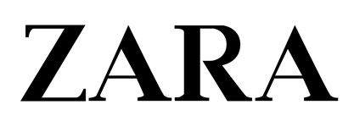
Figure 1: ZARA Logo
(Source: Inditex, 2021)

Discussion

1) Analysis of the impact of COVID-19 pandemic and major forces on the fashion industry
Different types of framework are going to be used to understand the impact of COVID-19 upon the Zara. These are as follows:
PESTLE
With the help of the PESTLE model, the external environmental impact of COVID upon Zara business can be identified; this framework is as follows:
Political factor (T):
The UK has political stability, but Brexit in 2016 and COVID in the year 2020 largely impacted Zara’s operation processes. As mentioned by Rosamond (2019), Brexit has reopened the debate for the future economic growth of the UK. Brexit had shook the financial condition of Zara since 2016 while Covid-19 has hindered the condition further by creating shortages of raw manufacturing material and increasing operation cost. Post-Brexit trade agreements have erected £35billion devastation in the UK fashion industry that has also affected the growth of Zara (Textile Today, 2021). Amidst COVID, the situation had also gone devastated for Zara to hold large numbers of customers due to labour shortage and high power of suppliers.
Economic factor (O):
Economic growth in the UK has helped to mitigate the impact of COVID-19 upon the financial performance of the fashion industry. The monthly GDP has increased by 1.2% during December 2020 (ONS, 2021). It means the purchasing power of customers has increased that helped Zara to keep their selling princess constant. Services grew by 1.7% following the ease of restriction upon the trade.
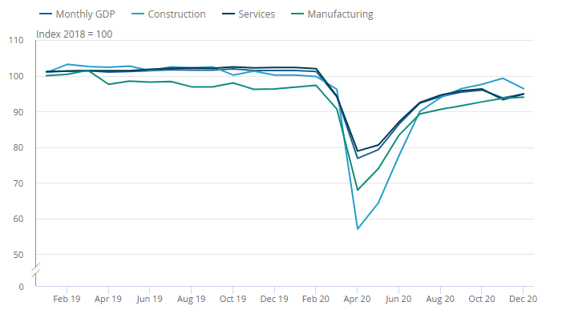
Figure 2: Monthly GDP increase in the UK in December 2020
(Source: ONS, 2021a)
Social factor (O):
Social distancing and locked down conditions make it impossible for Zara to open their physical stores. As stated by Zhang (2020), customers focus more on the sustainability of fast fashion products during a pandemic. Overall purchase intention of consumers through the online shopping channel and social media have increased that act as an opportunity for Zara.
Technological factor (O):
Advancements in technology have helped Zara to innovate new fashionable items for their consumers. Zara uses big data that have helped them to satisfy customers’ needs and helped to make a personalized shopping experience for their customers. In addition to this, extensive forms of social media and Instagram are used for communicating messages regarding fashionable items to its customers.
Legal factor (T):
During the pandemic situation, the UK government has announced the lockdown and shut down all physical stores. Strong legislation has applied for all the physical features, including fashion houses. In such a situation, Zara could not offer a wide range of products to its customers via physical stores where customers can feel and touch the products.
Environmental factor (O):
Environmental factors act as the opportunity for Zara to continue their business process even during pandemic situations. As stated by Goworek (2018), the management of sustainability in the fashion industry is necessary for the achievement of success in the fashion business. The UK has green production technology along with strong environmental policies that helped Zara to manage waste and minimize the impact of pandemic upon the production process.
Porter's Value chain
With the help of Porter's value chain, activities of business organization can be broken down into smaller forms (Ruan, 2020). In this respect, the value chain can be used to identify the activities of Zara during a pandemic period. The framework for Zara is as follows:
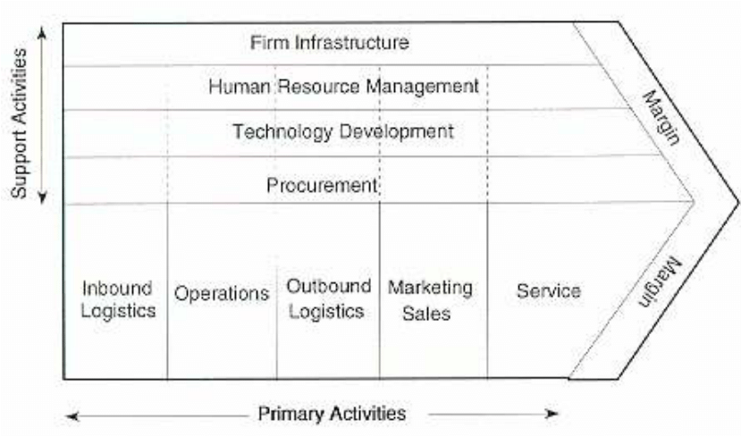
Figure 3: Porter’s Value Chain
(Source: Influenced by Ruan, 2020)
Under porter's value chain, there are primary and secondary activities that are strongly followed by Zara. The activities are as follows:
Primary activities
Inbound logistics
It is very important to develop effective relationships with suppliers of Zara for running the fashion operation smoothly. As stated by Aftab (2018), Zara has an integrated supply chain strategy that helps in total control over their operation. In the pandemic period, it was not possible to keep the connection as a continuous process as the overall price and power of suppliers have increased that increased the operating cost of Zara.
Operation
Zara follows modernized techniques to deliver its product to customers. Zara is capable enough to process the material into the ultimate products and offer it to its customers by coordination and integration of the supply chain. For example, raw wool is often collected from suppliers for making woollen clothes and winter wear for customers.
Outbound logistics
Zara has efficient outbound logistics that allow them to deliver products to its customers. Some outbound logistics of the company are warehousing, order processing, transportation, delivery and order scheduling process.
Sales and marketing
The sales and marketing process of Zara runs through both the online store and physical stores. It has been identified that Zara has a total of 2250 stores (Statista, 2021). In the pandemic period of overall sales activities have increased via the social media platform and online stores. High-quality, fashionable items are provided by this organization at an affordable cost.
Services
Both pre-sale service and post-sale service are provided by Zara. After-sale service like warranty and guarantee of services provided to customers. Customer loyalty programs are often established in different stores of Zara (Inditex, 2021). But in the pandemic situation and social distancing rule, the organization could not provide customers with loyalty programs from physical stores.
Secondary activities
Firm infrastructure
Zara has different types of units in both physical and online stores. These units include the accounting department, sales department, customer service department, manufacturing department and HR department. Zara has strong control over the infrastructure of their organization that have helped them to manage operational activities even in the COVID-19 situation.
HRM
The HR department of Zara is responsible for the selection, recruitment, training, and orientation of best-suited candidates. Zara has a strong leadership team, responsible for the motivation and training of staff for the improvement of the skill and capacities.
Technology
Self-check-in and self-checkout technology are strongly present in Zara that have helped them to reduce time and cost for customers services. Radiofrequency identification (RFID) technology has been successfully used by Zara for the improvement of product security (Aabed, 2017). In addition to this, innovative technology like the digital logistic supply chain has helped them to manage and control large supply chains and satisfy the needs of their stakeholders.
Procurement
This is the process that determines the purchase of input that ranges from different forms of machinery, equipment, raw material, suppliers, and other forms of items required to produce fashionable items. Hence, Zara needs to focus on an effective form of procurement process so that it can help them to cope with the COVID pandemic situation.
Identification of the impact of pandemic
From the overall industry forces, it has been identified that Zara has been greatly impacted by the COVID 19 as their production process has hindered. It has been identified that Zara is forced to shut down their 1200 numbers of stores during the COVID-19 pandemic situation. It has been identified that 16% of total outlets of Zara have been forced to be shut down in the pandemic situation. In that situation, Zara has made major changes in the operation process. They have permanently shifted to the online retail store until the pandemic crisis is over. As per The British Fashion Council, it has been identified that COVID 19 recession has wiped out the overall profit margin of the UK fashion industry. The UK fashion industry incorporates 4.8% of the total GDP of the country. The industry provides 890000 numbers of direct jobs to people. But in the pandemic period, it was not possible to support all employees economically. Overall GDP has also fallen from GBP 35 billion to GBP 26 billion, which means the purchasing capacity of people has also decreased.
Poor purchase capacity does not allow Zara to easily share high-quality, fashionable items to customers at a very cheaper rate. In addition to this, legal and political factors have put a threat to the UK fashion industry. With the effective organizational infrastructure, selling and marketing princess, Zara becomes able to cope with the change. As stated by Brydges (2018), the needs and demand of consumers have changed, which has helped the fashion industry to achieve transition in the sustainable business process. It has been identified that social distancing and locked down conditions make it impossible for Zara to open their physical stores. As a result of this, consumers who focus more on the physical shop are lost from Zara. Moreover, the constant shift of the online marketing process has helped Zara to make their firm more digitized.

2) Opportunities and challenges upon the key players
From the environmental forces, certain opportunities and threats are identified. The threats are somewhat responsible for the poor performance of Zara during this pandemic, and opportunities might help Zara to regain its strength in the post covid era. These opportunities and threats can be identified with the help of the SWOT framework as indicated in Table 2 below:
Strength  - Skilled workforce  - Quality of customers’ service  - High financial margin along with the 12% rise in profit (Szajna-Hopgood, 2019).  - Strong brand name | Opportunity  - Online customer service channels  - Digital technology for logistic and supply chain management  - 1.2% GDP growth in December 2020 in the UK (ONS, 2021b)  - The positive attitude of customer towards the fashion brand  - Environmental sustainability
Weakness  - Reduction of purchase capacity of the customer during a pandemic and lockdown period (Butu et al. 2020)  - Changing demand of consumers | Threat  - Pandemic situation  - High competition in only marketing channel  - Strong legislation process  - Political upsurge
Table 2: SWOT analysis of Zara
(Source: Developed by author)
Analysis:
From overall SWOT analysis, environmental analysis and value chain analysis, certain opportunities and threats for key players in the industry have been identified. Key competitors of Zara are Gucci, Burberry, Louis Vuitton. And Hugo Boss can get both opportunity and challenge from the forces identified above sections. These opportunities and challenges are as follows:
Opportunities:
Competitors can grow their fashion business effectively by lowering the price of fashionable items below the standard margin. Similarly, Zara has accessed an opportunity to increase its customer base via an extensive form of online business. As the purchasing capacity of consumers has been decreased, it would be easy for the key players of Zara to easily implement a lower price strategy for future growth. Key players in the fashion industry can also get ideas about the extensive form of the online shopping process that consumers prefer during the pandemic situation.
Challenges:
In a pandemic situation, most fashion business closes their physical store and focuses on online business. In addition to this, increased market competition can negatively affect the performance of Zara and its key competitors also. Thus, there might be a challenge to attract large customers at a highly competitive online platform. In addition to this, business sustainability and the positive attitude of customers towards Zara due to their brand name can create a challenging situation for key market players.
In such a changing position during the COVID-19 situation, some firms were able to adapt better due to their skilled workforce and strategic decision-making process. As mentioned by D'Adamo and Lupi (2021), it has been suspected that post covid situation would help in the achievement of sustainability. Fashion business organizations that have a high skilled force, capital and financial resources can adopt the changes. In addition to this, fashion businesses that have innovative technology are expected to achieve high-end growth in the post covid era than others that do not have many human resources, effective strategic planning and financial resources.

Conclusion
From the overall discussion, it can be concluded that COVID-19 have badly implicated the overall growth of the UK fashion industry. There have been 240,000 direct jobs along with the loss of a total of 25% revenue. Not only financial loss but also various numbers of physical stores have been closed. Zara has also been forced to close physical stores. Strong legislation and social distancing do now allow Zara to provide opportunities for physical stores to customers to touch and feel the products. In addition to this, the demand of consumers has also changed due to the reduced form of purchase capacity. In such a situation, Zara focuses more on the online platform so that they can attract large customers and hold their brand reputation.

References
Aabed, A., 2017. Supply chain in the readymade garments industry (Zara case study). International Design Journal, 7(4), pp.245-253.
Aftab, M.A., Yuanjian, Q., Kabir, N. and Barua, Z., 2018. Super responsive supply chain: The case of Spanish fast fashion retailer Inditex-Zara. International Journal of Business and Management, 13(5), p.212.
Brydges, T., Retamal, M. and Hanlon, M., 2020. Will COVID-19 support the transition to a more sustainable fashion industry?. Sustainability: Science, Practice and Policy, 16(1), pp.298-308.
Butu, A., Brumă, I.S., Tanasă, L., Rodino, S., Dinu Vasiliu, C., Doboș, S. and Butu, M., 2020. The impact of COVID-19 crisis upon the consumer buying behavior of fresh vegetables directly from local producers. Case study: the quarantined area of suceava county, Romania. International journal of environmental research and public health, 17(15), p.5485.
Chaudhuri, S., 2020. Zara Owner to Close 1,200 Stores as It Outlines Post-Coronavirus Future. Available at: https://www.wsj.com/articles/zara-to-close-1-200-stores-as-it-outlines-post-coronavirus-future-11591794618. [Accessed on 23rd March 2021]
D’Adamo, I. and Lupi, G., 2021. Sustainability and resilience after COVID-19: A circular premium in the fashion industry.
Goworek, H., Oxborrow, L., Claxton, S., McLaren, A., Cooper, T. and Hill, H., 2018. Managing sustainability in the fashion business: Challenges in product development for clothing longevity in the UK. Journal of Business Research.
Inditex, 2021. About us. Available at: https://www.inditex.com/about-us/our-brands/zara [Accessed on 23rd March 2021]
Just-style, 2021. UK fashion industry to be “hit” twice as hard in COVID 19 recession. Available at: https://www.just-style.com/news/uk-fashion-industry-to-be-hit-twice-as-hard-in-covid-19-recession_id139187.aspx [Accessed on 23rd March 2021]
Nakano, M., 2019. Supply Chain Management: Strategy and Organization. Springer.
ONS, 2021a. Coronavirus and the impact on output in the UK economy: December 2020. Available at: https://www.ons.gov.uk/economy/grossdomesticproductgdp/articles/coronavirusandtheimpactonoutputintheukeconomy/december2020[Accessed on 23rd March 2021]
ONS, 2021b. GDP first quarterly estimate, UK - Office for National Statistics. [online] Ons.gov.uk. Available at: <https://www.ons.gov.uk/economy/grossdomesticproductgdp/bulletins/gdpfirstquarterlyestimateuk/octobertodecember2020> [Accessed 8 April 2021].
Szajna-Hopgood, A., 2019. Zara owner Inditex posts 12% rise in profit. Available at: https://www.retailgazette.co.uk/blog/2019/12/zara-owner-inditex-posts-12-rise-in-profit/ [Accessed on 23rd March 2021]
Rosamond, B., 2019. Brexit and the politics of UK growth models. New political economy, 24(3), pp.408-421.
Ruan, S., 2020, April. Research on Strategic Cost Management of Enterprises Based on Porter’s Value Chain Model. In Journal of Physics: Conference Series (Vol. 1533, No. 2, p. 022056). IOP Publishing.
Statista, 2021. Number of Zara and Zara Home stores worldwide 2020, by region in UK. Available at:https://www.statista.com/statistics/674434/number-of-zara-stores-worldwide-by-region/#:~:text=As%20of%202019%2C%20there%20were,the%20planet%20as%20of%202018. [Accessed on 23rd March 2021]
Textile Today, 2021. Brexit impact in UK fashion industry. Available at: https://www.textiletoday.com.bd/brexit-impact-uk-fashion-industry/ [Accessed on 23rd March 2021]
Zhang, B., Zhang, Y. and Zhou, P., 2021. Consumer attitude towards sustainability of fast fashion products in the UK. Sustainability, 13(4), p.1646.

