

Programme: BA Business Management

Module Title: Community Engagement
Lecture Name: Tanja Nathan

Name: Andreea Constantin
Student number: 1913092

Table of Contents
Part A: Organisational Analysis 3
Introduction 3
Vodafone 4
Vodafone’s customers and what they want 5
Vodafone’s SWOT analysis 5
Roles of employees in Vodafone 6
Training and developments and its importance 7
HRM role and it’s important to Vodafone 7
Skills required to carry out the role of HRM 8
The training and development requirement needs to consider 9
Conclusion 10
Part B: Reflective Evaluation 11
Introduction 11
The nature and purpose of reflective practice with reference to Gibbs Reflective Model 12
Nature and purpose 12
Gibb’s Reflective cycle 12
Personal experience and what I have learned 14
My experience 14
What I have learned? 14
Relationship between relevant theories and experience 15
Conclusion 17
References 18

Part A: Organisational Analysis

Introduction
Vodafone is a UK based multinational telecommunications company which started its operation in 1991. The company operates its operation worldwide. An organisation hires an employee to fill a specific post in the organisation. This means that an employee must have to play a role in the organisation in which the employee works. An individual can choose the job role which the individual wants to play and this will help the individual to perform the role effectively. Here, details about the company, a SWOT analysis, the role of employees in the company and the importance of training and development will be analysed. The role which I want to play in the company and why I want to do it will also be analysed.

Vodafone
Vodafone operates in the telecommunications industry. The company operates its business operation in 25 countries and in 47 countries the company has partners. Vodafone runs its business operates from London, UK (Vodafone.com, 2020). More than 98996 people work in the business and in 2019 the company net loss was €7.644 billion. The main product of the company includes line telephone, broadband, internet television and mobile phone etc. The company is not doing well and for that its employee effectiveness and productivity must have to be improved. The organisation structure which Vodafone is used is functional organisational structure. By using this organisational structure the management of the company groups its employee based on the set of skills which its employee has. This means each employee of the business will be assigned work based on skills which the employee has (Ang, 2011). This is an effective structure for the company as it can help the business to achieve its goal.
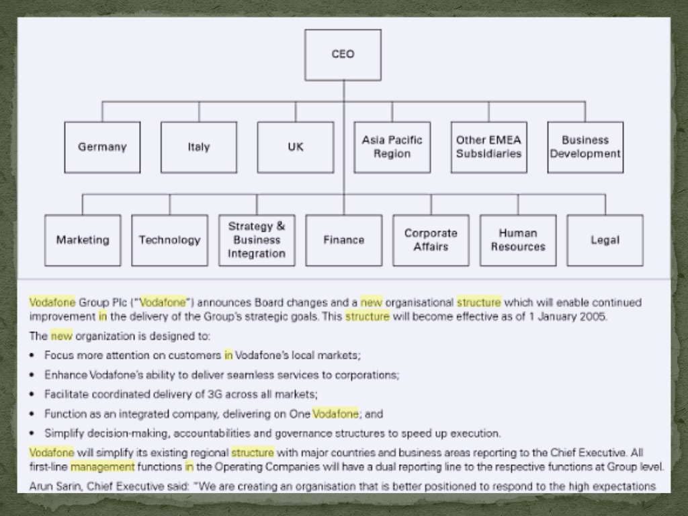
Figure: Vodafone organisational structure
Source: Ang (2011)
The mission of Vodafone is to empower people and communities by accelerating the development of telecommunications to create value and adding more job. The vision of the company is providing the best quality service to its customers to achieve customer satisfaction. Its values include “Speed, digital, trust, bold and passion (Sanghavi, 2015). The goals of Vodafone includes: achieving sustainable success, ensure health and safety and achieve success through customer satisfaction.

Figure: Vodafone values
Source: Vodafone.com (2020)

Vodafone’s customers and what they want
Customers are the most important aspect for an organisation to achieve success as customer satisfaction is important for an organisation. The main customers of the company include 625 million mobile customers, 27 million broadband customers and 22 million TV customers. The company has its mobile operation in 25 countries and has a partnership in another 47 countries. It provides fixed broadband service to 19 markets (Vodafone.com, 2020). So the main customers of the company are mobile user, broadband user and TV user. The customers of Vodafone want to have to best quality service at a low cost. Like all other customers, the needs and wants of Vodafone’s customers are the same and this might be the reason for the fall of Vodafone as the company was not able to provide best quality service at low cost.

Vodafone’s SWOT analysis
Strengths: Brand equity is the most important strength of the company as the company has 625 million mobile user and other customers as well. Effective marketing strategy is another important strength for the company (Narendhra, 2011). Other strength includes a huge product portfolio, a strong presence in the Asian market and effective technological innovation.
Weaknesses: Declining customer base in Europe is the main problem for the company which the company needs to solve immediately. Weak position in the UK is another weakness which causing a net loss for Vodafone. The Asian customers are now switching product and that will cause a huge problem for Vodafone.
Opportunities: Increasing customer engagement can help the company to increase its market share. The company should focus on digital marketing and technological innovation. These will help the company to increase its customer satisfaction rate and will help the company to achieve success.
Threats: Competition is the most important threat for the company as for this the company’s market share is decreasing. Regulatory threats are different country is another threat to Vodafone (Curwen, 2017). Brexit and Corona Virus create huge threats for the company and the global economic recession will reduce its profit further.

Roles of employees in Vodafone
Employees are one of the most important assets of an organisation. The role which Vodafone employees play in the company includes:
Improve customer satisfaction and loyalty: This is the most important role of the employees of Vodafone (Lee and Yang, 2015). If the employees of the business can satisfy its customer and made them loyal then the profitability goal of the company can be achieved by this.
Improve customer experience: Research suggests that if customers have good experience with an organisation then the customer will come back to the organisation over and over again and this will help Vodafone to achieve success.
Establish effective communication: Establishing effective communication with the customer and other employees of the business is an effective role (Felgate, 2020). This helps the company to understand what customers’ needs and wants are.
Provide information: Information is the key to effective decision making and it is the responsibility of the organisation employee to provide information. Effective decision making can help Vodafone to achieve success.

Training and developments and its importance
The process which an organisation used to help employees to achieve certain skills so that employees can perform specific roles is training and development (Flude and Sieminski, 2013). The employees which Vodafone hires may or may not have all the necessary skill to perform a job. This process helps the employee of the business to achieve the necessary skill to perform a job effectively. This is also required to improve organisational productivity.
Better utilisation of resources is the most important aspect of training and development for Vodafone. This also helps the company to reduce waste and establish control. The profitability of the company can also be increased by this process because this can improve the productivity of the employee. Help to achieve a competitive advantage, reduce employee turnover and develop positive attitude among employee are some of the importance of training and development for Vodafone.

HRM role and it’s important to Vodafone
Managing human resource in an organisation is important as this related to the success of the company. Vodafone to achieve success and improve its profitability must have to ensure that its HR is effective. The employee productivity of the company is not satisfactory and for that reason, I choose the role of HRM in the organisation so that the employee productivity of the company can be increased. This role is among the most important role in an organisation. The importance of this role includes:
HR policy formulation: Effective formulation HR policy can help Vodafone to make sure its employee productivity (Dessler, 2020). The HR manager of Vodafone formulates HR policy which will help the company to make the best use of its employee.
Implementation of HR policy: It is the responsibility of HRM to formulate policy and at the same time implement the policy in the organisation. Without the effective implementation of HR policy, Vodafone will not be able to increase its productivity.
Understand employee needs: HR manager of Vodafone manage its employee and to do that effectively the HRM must have to understand what the organisation employee wants. This will helps to improve employee satisfaction rate which is important to achieve organisational goal.
The utilisation of HR: Effective utilisation of HR can be ensured by the HRM. This will help the company to ensure that every employee of the business works for the organisational goal achievement (Ivancevich and Konopaske, 2013). Vodafone must have to utilise its HR to improve its financial condition.
Hire the right person: Hiring the right person for the job is important to build a skilled workforce. HRM do that and if this can be done effectively than it will help Vodafone to increase its productivity which is important for the business to improve its profitability.

Figure: Importance of HRM
Source: Author

Skills required to carry out the role of HRM
There are certain skills which every HR manager must-have. Without having these skills an HR manager will not be able to perform the duty effectively. Some of these roles include:
Communication skills: This is the most effective skill and most important as well which every HR manager needs to have. An HR manager needs to establish effective communication with all the employee and other managers so that the employee of Vodafone understands what the company wants from them.
Organisation skills: This is another effective skill which the HR manager of Vodafone needs to have. This skill will enable the HR manager of the company to organise the employee in a way which will ensure employee productivity (Lee and Yang, 2015). This will also ensure Vodafone sustainability.
Decision-making skills: Effective decision making skill of an HR manager will help to hire and employee skilled employee in the business. This skill includes deciding the number of employees which the business need, the role which an employee will play and how the employee is performing.
Training and development: Providing training and development to the employee of Vodafone is another important skill which every HR manager should have (Flude and Sieminski, 2013). This skill will help the company to improve the skills of its employee so that employees can perform a specific task effectively.
Apart from these other skills required to perform the role of HR manager includes budgeting skills, motivation skills, emphatic skills, research skill and IT skill. The combination of all these skills will enable an HR manager to perform the duties effectively.

The training and development requirement needs to consider
The HR manager also needs training and development to perform the role of HRM effectively in Vodafone. Some of the important training and development which every HRM must have to participate includes:
On-boarding training: To manage the employee of the business effectively an HR manager first has to understand about the company, its culture and the role which the manager has to play. Without having this knowledge an HR manager might not be able to perform the role of HR manager effectively (Felgate, 2020). That is why this is essential training and development requirement for an HR manager.
Technical skills development training: Participating in this type of training is important for an HR manager to perform the role effectively. Some important technical skill for the HR manager includes risk assessment, select the right employee etc. Having this skill will help the HR manager to perform the job effectively.
Soft skills development training: For an HR manager this is the type of skill which is must to have. Soft skills include communication skills, problem-solving skills, leadership skill, time management, presentation and conflict resolution (Ivancevich and Konopaske, 2013). This training program will enable the HR manager to achieve these skills and perform duties effectively.

Conclusion
Vodafone is not doing well as the company market share is decreasing and over a few years, the company is suffering from loss. The company mission is to provide the best quality service to its customer which the company is not able to do recently. Though the company has the opportunity to improve its position competition is the main problem for the company in doing so. Reducing market share in Europe and the USA is threatening the company existence and the management of Vodafone needs to take action to solve the problem. HRM is an important role for Vodafone and this can help the business to improve its employee productivity. Over, Vodafone is not performing well and it threatening its sustainability.

Part B: Reflective Evaluation

Introduction
Learning from experience is one of the most effective ways of learning. This can help an individual to analyse what the individual has done and in this process understood the areas in which the individual can improve skill. In this reflective evaluation, I will analyse the nature and purpose of reflective purpose along with theoretical model can be used for reflective learning. I will also analyse what I had learned from part A and the relationship between theories of reflective practice and experiences.

The nature and purpose of reflective practice with reference to Gibbs Reflective Model

Nature and purpose
Reflective learning is an effective way of learning which an individual can use for learning from experience. The purpose of reflective practise is to gather knowledge and takes action to improve the knowledge which the individual does not have by evaluating experience (Ryan, 2012). This type of practice is dysfunctional and often remains incomplete and it is one of the most important nature of the reflective practice. It helps an individual to understand the skill which the individual has and the area in which the individual have to develop. Because when an individual look back then he will be able to understand what he had done right and what not? This enables the individual to take action to improve the area in which the individual is not good. It is the nature of human being to highlight only good about himself and in case of reflective learning, this also happens (Kets, 2010). Selectiveness is another important nature of reflective practice as we often select on what we want to reflect. These nature can be understood easily by analysing Gibbs reflective cycle.

Gibb’s Reflective cycle
Graham Gibbs developed “Gibb’s Reflective Cycle” in 1988 to build a structure to learn from experience. There are 6 stages of this cycle and each stage help a learner to evaluate the experience of the learner. The stages are:
Description: In this stage of the cycle the experience or the event is been analysed in detail. This analyse what happened, when did it happen and where did it happen? By answering these questions one can easily reflect on the event which the learner experience (Hargreaves and Preece, 2013). For example, in the previous part, I analyse Vodafone and its business situation and analysing this is experience.
Feelings: This is the second stage of the cycle where an individual has the opportunity to analyse the feelings which the individual have about the experience. I have a good and positive feeling about part A because form that I have learned a lot about Vodafone and I also learn what required to perform the job of HRM.
Evaluation: This is the stage where I can analyse the good and bad things which had happened to me during the process (Ghaye, 2011). This stage is about to analyse the things which had gone well as well as the thing which is not. Because of this learner can analyse both good and bad things that happened to him.
Analysis: This fourth stage of the cycle is the most important stage of reflective practice because it analyses the reason for which things happen. There are things which had gone well and things which are not, this stage enables to find out the reason for which things is been considered as good and bad.
Conclusion: This stage is about the things which the learner learns from the process. This also enables to find out how the process of learning could have been better (Dawson, 2015). What else the learner could have done is also identified in this stage.
Action plan: This is the last stage of the cycle where the leaner identified the thing which he would have been different if he had the chance to do it again. This also helps to understand the skill which needs to be developed.

Figure: Gibb’s Reflective Cycle
Source: Dawson (2015)

Personal experience and what I have learned

My experience
The previous task of this module was about Vodafone. A detailed analysis of the company is been presented there which includes size, customer and function of the company. The role which the employee of the business plays to achieve an organisational goal, the importance of training and development for the organisation and I role which I won't play in the business along with the requirement to play the role in the business was understood by form this.
My experience was very positive about part A because I learned a lot form that. From that, I had learned about an organisation which was good at a time and now losing its sustainability which helps me to understand the importance of customers (Cottrell, 2017). I always wanted to become an HR manager and for that, I choose the role of HRM and wanted to play the role in the organisation. There I had to analyse why the role is important for Vodafone and the responsibilities which an individual has to play to perform the role effectively. This was a great experience for me as because of this I now know what I have to do to become an HR manager. This does not mean that all the things while conducting part A has gone well for me. There are things did not go well for me like there is not enough information available on the internet which I could use for my analysis. To solve the problem I had to work very hard. Overall, it was a great experience for me which I think will be helpful in my future career.

What I have learned?
People can learn to form everything and by conducting part A, I also learned. Here I will discuss the things which I have learned and skill which I developed in this process of learning.
Communication: Communication is one of the most effective skills which every student needs to have to achieve success in both academic and professional life. From this module, I learned how to communicate effectively both verbally and in writing (Pianpeng and Koraneekij, 2016). To conduct the assignment we have been asked to use reliable information and I was not able to decide which information is reliable and which are not. For that, I spoke with ten teachers to find out that and understood I am not good at verbal communication. So I started to practice and by the end of the assignment, I was able to develop this skill. I was also able to present and write the assignment effectively which demonstrate that I have well-written communication skill.
Research skill: This is an effective skill to analyse or find the information required to perform a job. To do the assignment I had to use relevant information about Vodafone and for that, I started to research on the information which is available on the internet. In this way, I was able to find a reliable source of information from where I can use information. In this way, my communication skill has been developed.
Problem-solving skill: This is an important academic and employability skill which helps an individual to solve the problem. While doing the assignment I face different problem like which information is reliable and which is not. To solve the problem I conduct detailed research about it and was able to solve the problem. In this way, I was able to achieve problem-solving skill.
Time management skill: Managing time effectively is important in term of achieving success. Before this, I face the problem of time management and for that, I decided to develop this skill of mine in this task. To achieve that I prepare a routine which includes this task along with other tasks which I also have to do (Hargreaves and Preece, 2013). I tried to follow the routine tine precisely and fail to do so. To achieve this skill was important for me and for that I join an online available in LinkedIn. There I have learned how time can be managed effectively and in this process, I was able to manage time effectively.

Relationship between relevant theories and experience
There are different theories of reflective learning which can be used for reflective practice. Some of these theories will be analysed here along with the experience of mine.
Atkins and Murphy: In 1993, Atkins and Murphy developed a theory of reflective practice which has five stages. Those stages include “awareness, describe the situation, analyse knowledge and feeling, evaluate the relevance of knowledge and identify any learning” (Dawson, 2015). This is an effective reflective learning theory that can be used to identify the learning from experience. For example, this will help me to create awareness about what I have done and also help me describe the situation which is, in this case, is analysing Vodafone. Then I will be able to analyse my feelings and found out the knowledge which I have gathered in this process. The last stage of this will enable me to identify the lesson which I have learned. This will become a positive experience I decided to use for reflective learning.
Rolfe reflective model: This is another effective model of reflective learning which helps to find out the answer to what, so what and now what. The first stage is about describing the event which has occurred. The next step is about analysing the theory and knowledge which I have gathered in the process. This is the stage where I have the opportunity to analyse the lesson which I have learned from the process, what are the things which have gone well for me and the things which are not gone well for me (Burns and Sinfield, 2016). The last stage is about what action I can take to make thing better. The purpose of reflective learning is to analyse the lesson which I have learned and the areas in which I can develop my skills.

Figure: Rolfe reflective cycle
Source: Burns and Sinfield (2016)
John’s reflective model: This reflective model asks some specific questions to the learner which helps the learner to reflect on the lesson which the individual learns from the process. For example, this model will ask me a question about the things which I have learned from this and aspect which was good and bad for me (Ghaye, 2011). By answering the question I will be able to understand what I have done and what was good for me. Io will also able to identify the action which I need to take to develop in the area in which I am not good.

Conclusion
I have learned a lot from the process of reflective learning. This helps me to understand the nature and purpose of reflective practice and the models which I can use for reflective practice. It was a positive experience for me as I have learned a lot from the process which I think will help in my future career. The skills which I have developed in this process include communication, research, time management and problem-solving. These are important employability and study skill which will help me to achieve success in academic and professional life.

References
Ang, R. (2011). Vodafone Global Telecommunications: Optimizing Operations. SSRN Electronic Journal,.
Burns, T. and Sinfield, S. (2016). Essential study skills, the complete guide to success at university. London: Sage.
Cottrell, S. (2017). Critical Thinking Skills: Effective Analysis, Argument and Reflection. Basingstoke, Palgrave
Curwen, P. (2017). Vodafone shops in the bazaar. info, 9(5).
Dawson P. (2015). Personal and Professional development for Business studies. Sage Publications
Dawson P. (2015). Personal and Professional development for Business studies. Sage Publications
Dessler, G. (2020). Human Resource Management. New York: Pearson.
Felgate, Y. (2020). Human resource management moral competencies. SA Journal of Human Resource Management, 18.
Flude, M. and Sieminski, S. (2013). Education, Training And The Future Of Work II. Hoboken: Taylor and Francis.
Ghaye, T. (2011). Is reflective practice ethical? (The case of the reflective portfolio). Reflective Practice, 8(2), pp.151-162.
Hargreaves, E. and Preece, S. (2013). The value of the personal in teachers’ professional learning: a case study. Professional Development in Education, 40(1), pp.130-146.
Hargreaves, E. and Preece, S. (2013). The value of the personal in teachers’ professional learning: a case study. Professional Development in Education, 40(1), pp.130-146.
Ivancevich, J. and Konopaske, R. (2013). Human Resource Management. New York, NY: McGraw-Hill Irwin.
Kets de Vries, M. (2010). Reflections on leadership and career development. Chichester: Jossey-Bass.
Lee, H. and Yang, T. (2015). Employee Goal Orientation, Work Unit Goal Orientation and Employee Creativity. Creativity and Innovation Management, 24(4), pp.659-674.
Narendhra, V. (2011). Hutchinson Essar - Vodafone – A Case Study. Indian Journal of Applied Research, 1(10), pp.116-118.
Pianpeng, T. and Koraneekij, P. (2016). Development of a Model of Reflection Using Video Based on Gibbs’s Cycle in Electronic Portfolio to Enhance Level of Reflective Thinking of Teacher Students. International Journal of Social Science and Humanity, 6(1), pp.26-31.
Ryan, M. (2012). Reflections on learning, life and work. Rotterdam: Sense Publishers.
Sanghavi, D. (2015). Vodafone Transfer Pricing Decision: A Mistake of Judgment. SSRN Electronic Journal,.
Vodafone.in. (2020). Vodafone - Prepaid | Postpaid | International Roaming | Buy New Connection. [online] Available at: <https://www.vodafone.in/> [Accessed 11 April 2020].

