

Programme: MSc Public Health and Social Care in Practice

Module: Population Health and Digital Health Promotion

Module code: LCHS7009

Student name: Elena Draghici

Student ID: 2214911

Lecturer: Dr Ping Wu

Blog 1

Scrolling for Support: Can Social Media Improve Young People’s Mental Health?


Figure 1: Illustration showing people using digital devices (n,d).

Why Young People’s Mental Health Is a Public Health Concern
UK youth mental health problems have become a significant public health cause for concern in the UK. The new data suggests 1 in 6 13-24-year-olds likely suffer from a mental health illness (NHS Digital, 2023). Anxiety, depression, and stress are increasingly prevalent mental states that can negatively affect social life, academic functioning, and long-term well-being (Public Health England, 2021).
- Rapidly advancing digital technology is also shaping how young people can access health information.
- Because young people use social media sites like YouTube, Instagram, and TikTok so frequently, these platforms have emerged as crucial avenues for health promotion initiatives (Naslund et al., 2020).
- As a result, health organisations are increasingly using these platforms to raise awareness about mental health and encourage help-seeking behaviour.
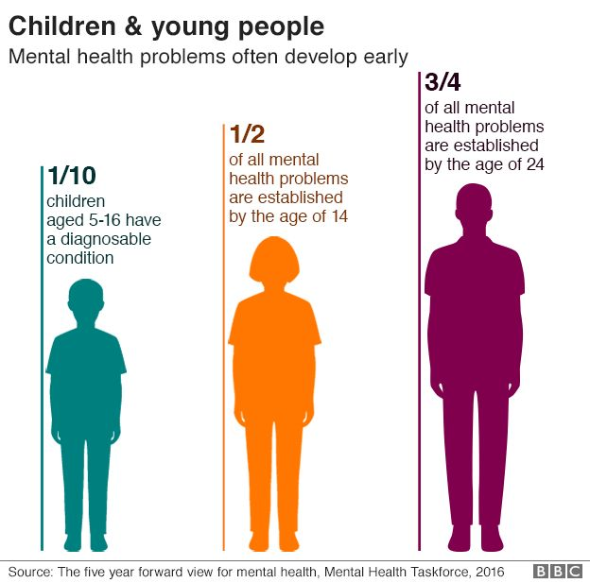
Figure 2: Mental health issues among young people have become an increasing public health concern in the UK (BBC News, 2017).

How Social Media Is Used in Mental Health Promotion
- Campaigns to promote digital health are now frequently delivered through social media platforms.
- For instance, the NHS Every Mind Matters campaign encourages people to enhance their mental health by offering social media content, brief videos, and online guidance (NHS, 2023).
- Through formats including brief movies, infographics, and interactive postings, these platforms allow businesses to quickly disseminate information and engage younger audiences.
- Educational posts about coping mechanisms, stress-reduction tactics, and where to find expert assistance are examples of digital campaigns.
- Young people can exchange experiences and lessen feelings of loneliness through peer support communities made possible by social media (Robinson et al., 2016).
Campaigns: Learn more about digital mental health campaigns.

Evidence of Effectiveness
- The use of social media tools is one of the most effective social media measures to reduce stigma and increase awareness of mental health issues.
- Naslund et al. (2020) found that online campaigns dealing with mental health can increase people's awareness about mental health issues in addition to encouraging young people to seek help.
- Likewise, Robinson et al. (2016) stated digital platforms can help promote mental health by reaching big audiences and encouraging interaction through interactive content.

Advantages and Limitations of Social Media

There are several health-promoting benefits of social media:

- Broad appeal to youth
- Cheaper than more traditional promotion
- Attractive and interactive content
- Rapid dissemination of health information
But there are huge restrictions, too:
- People on social media platforms could be subjected to misinformation, cruel comparisons, and cyberbullying, all of which can have a detrimental impact on mental health (O'Reilly et al., 2018).
- Not all young people have equal access to digital tools, leading to digital health disparities.

Addressing the Challenges
- Digital interventions must ensure that the material is reliable, evidence-based, and provided by reputable institutions to maximise the benefits of social media for mental health promotion.
- Collaboration between health professionals, educators and technology companies can also help improve digital literacy and ensure safe online environments for young people.
🎥 Video: Understanding mental health changes faced by young people

Conclusion
Social media has risen to be a powerful digital tool to educate young people on mental health challenges. Technology offers many opportunities for participation and education, but false information and digital inequalities must be handled carefully. Proper use of social media can also help raise awareness of mental health issues and promote the well-being of youth.
References
BBC News (2017) Young people most likely to have poor mental health [online image/article]. Available at: https://www.bbc.co.uk/news/health-41125009 (Accessed: 13 March 2026).
Department for Education (2023). Promoting Children and Young People’s Emotional Health and Well-being. GOV.UK. Available at: https://www.gov.uk/government/publications/promoting-children-and-young-peoples-emotional-health-and-wellbeing. (Accessed: 16 March 2026).
Mental Health Innovations. (2021). Mental Health Innovations joins the Better Health - Every Mind Matters campaign. Available at: https://mentalhealthinnovations.org/news-and-information/latest-news/mental-health-innovations-joins-better-health-every-mind-matters-campaign/. (Accessed: 12 March 2026).
Naslund, J. A., Bondre, A., Torous, J., & Aschbrenner, K. A. (2020). Social Media and Mental Health: Benefits, Risks, and Opportunities for Research and Practice. Journal of technology in behavioural science, 5(3), 245–257. Available at: https://doi.org/10.1007/s41347-020-00134-x (Accessed: 14 March 2026).
NHS (2021). Every Mind Matters. Available at: https://www.nhs.uk/every-mind-matters. (Accessed: 10 March 2026).
NHS Digital (2023). Mental health of children and young people in England, 2023: wave 4 follow-up to the 2017 survey. [online] NHS Digital. Available at: https://digital.nhs.uk/data-and-information/publications/statistical/mental-health-of-children-and-young-people-in-england/2023-wave-4-follow-up. (Accessed: 15 March 2026).
O'Reilly, M., Dogra, N., Whiteman, N., Hughes, J., Eruyar, S., & Reilly, P. (2018). Is social media bad for mental health and well-being? Exploring the perspectives of adolescents. Clinical child psychology and psychiatry, 23(4), 601–613. https://doi.org/10.1177/1359104518775154 (Accessed: 11 March 2026).
Robinson, J., Cox, G., Bailey, E., Hetrick, S., Rodrigues, M., Fisher, S., & Herrman, H. (2016). Social media and suicide prevention: a systematic review. Early intervention in psychiatry, 10(2), 103–121. https://doi.org/10.1111/eip.12229 (Accessed: 13 March 2026).

Blog 2

MindConnect: A Digital Platform to Promote Mental Wellbeing Among Young People
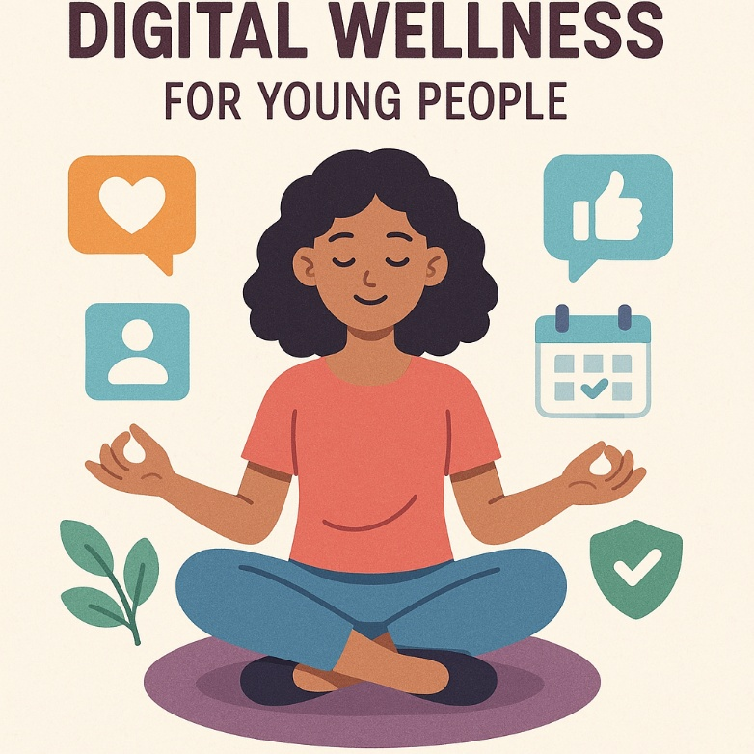

Figure 1: Digital wellness illustration (Solar Tuition, 2025)

Mental Health Challenges Among Young People
- In the UK, youth mental health problems remain a significant public health concern.
- About one in six young people aged 13-24 has a probable mental health problem, says NHS Digital (2023).
- Conditions like anxiety, depression and loneliness negatively affect academic performance, relationships and long-term wellness (Public Health England, 2021).
- Despite the existence of mental health services, stigma, lengthy wait times, and a lack of knowledge about accessible resources are some challenges faced by many young people wishing to obtain treatment (O'Reilly et al., 2018).
- Digital platforms create opportunities to provide engaging and accessible mental health promotion interventions, as younger generations are increasingly relying on digital technology in their daily lives.
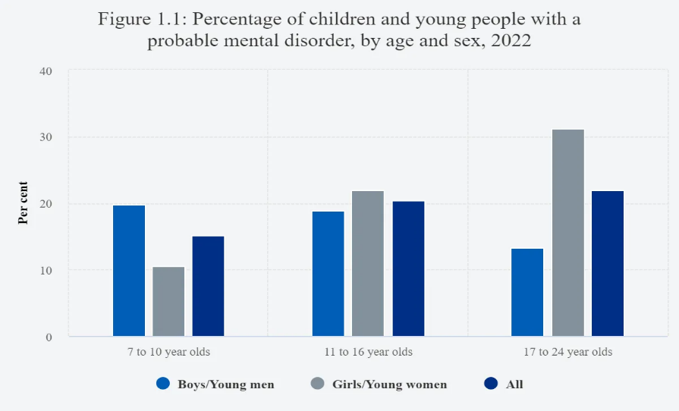

Figure 2. Mental Health of Young People in England 2022

Designing a Digital Technology: MindConnect

- The solutions to these problems are proposed by using a digital platform called MindConnect.
- MindConnect is a mobile application that provides convenient digital health promotion tools tailored towards youth mental health.

A collection of features meant to create awareness and encourage healthy practices would comprise the platform:
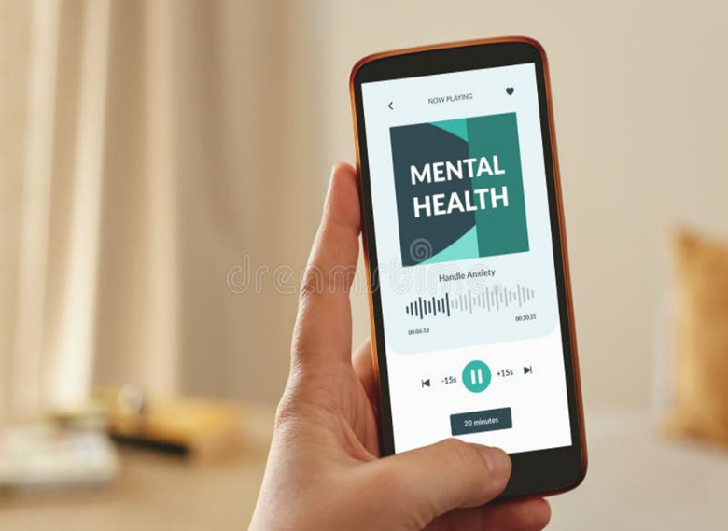

• Daily mood monitoring, which enables users to keep an eye on their emotional health

• Quick films about mental health and advice on coping mechanisms

• AI chatbot assistance that provides prompt advice and directs users to expert services

• Forums for peer conversation where young people can help one another and exchange experiences
• Connections to expert services, like NHS mental health resources

How MindConnect Promotes Mental Health
- By raising awareness, promoting introspection, and offering easily accessible information about coping mechanisms, MindConnect supports mental health.
- Digital platforms can reach a big number of young people and provide help in settings where young people already spend a lot of time online (Naslund et al., 2020).
- The mood tracking tool encourages people to identify emotional trends and seek assistance when necessary.
- Additional goals of educational videos and interactive content include enhancing mental health knowledge and lowering the stigma attached to getting help.
🎥 Video: https://www.youtube.com/watch?v=gUoc-cYClQM

Potential Advantages and Shortfalls

The recommended application of the digital platform has some advantages for health promotion:
• Easy access to mental health support
• Awareness of mental health
• Encouragement of early help-seeking behaviour
• Engagement using interactive digital tools
There may be limitations, however:
- Professional mental health care cannot be replaced by digital interventions, which can give rise to privacy, data protection, and disinformation concerns (O'Reilly et al., 2018).
- It might also happen that disparities in digital health result from some young people lacking equitable access to cell phones or internet connectivity.

Addressing the Challenges
- For this kind of thing to break through these limitations, MindConnect needs to be formed in tandem with medical experts and mental health groups to guarantee that the data is precise and supported by evidence.
- Finally, to preserve the privacy of users, strong data safety protocols must also be put in place
- Furthermore, partnerships with community organisations and educational institutions may provide access for youth who might be excluded from the digital world.

Conclusion
There are promising solutions proposed for mental health promotion of youth through digital technologies. The MindConnect platform, envisioned, hopes to serve as a platform to increase awareness and create healthy habits and to provide easily accessible help. The benefits of digital mental health therapies can be maximised with appropriate planning and cooperation with medical professionals, though fears over privacy and inequalities still exist.

References
Department for Education (2023). Promoting Children and Young People’s Emotional Health and Well-being. GOV.UK. Available at: https://www.gov.uk/government/publications/promoting-children-and-young-peoples-emotional-health-and-wellbeing. (Accessed: 20 March 2026).
NHS Digital (2022). Available at: https://digital.nhs.uk/data-and-information/publications/statistical/mental-health-of-children-and-young-people-in-england/2022-follow-up-to-the-2017-survey/part-1---mental-health. (Accessed: 18 March 2026).
Naslund, J. A., Bondre, A., Torous, J., & Aschbrenner, K. A. (2020). Social Media and Mental Health: Benefits, Risks, and Opportunities for Research and Practice. Journal of technology in behavioural science, 5(3), 245–257. Available at: https://doi.org/10.1007/s41347-020-00134-x (Accessed: 12 March 2026).
NHS (2021). Every Mind Matters. Available at: https://www.nhs.uk/every-mind-matters. (Accessed: 10 March 2026).
NHS Digital (2023). Mental health of children and young people in England, 2023: wave 4 follow-up to the 2017 survey. [online] NHS Digital. Available at: https://digital.nhs.uk/data-and-information/publications/statistical/mental-health-of-children-and-young-people-in-england/2023-wave-4-follow-up. (Accessed: 13 March 2026).
O'Reilly, M., Dogra, N., Whiteman, N., Hughes, J., Eruyar, S., & Reilly, P. (2018). Is social media bad for mental health and well-being? Exploring the perspectives of adolescents. Clinical child psychology and psychiatry, 23(4), 601–613. https://doi.org/10.1177/1359104518775154 (Accessed: 15 March 2026).
Robinson, J., Cox, G., Bailey, E., Hetrick, S., Rodrigues, M., Fisher, S., & Herrman, H. (2016). Social media and suicide prevention: a systematic review. Early intervention in psychiatry, 10(2), 103–121. https://doi.org/10.1111/eip.12229 (Accessed: 11 March 2026).

