
Assignment 1 - portfolio
Kai Llewelyn

2408796
UWTSD
Construction Skills

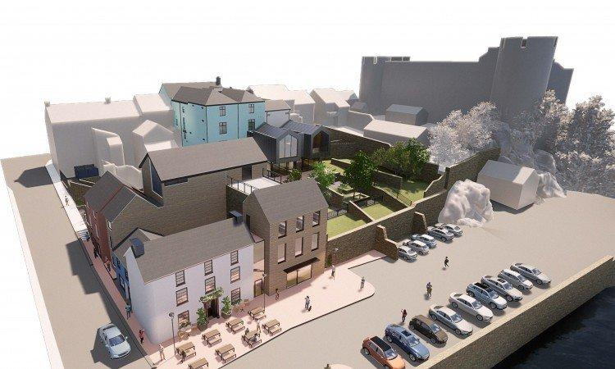

Above Photograph Taken From Western Telegraph ‘South Quay regeneration scheme phase two plans slammed’ - South Quay regeneration scheme phase two plans slammed | Western Telegraph Written By Bruce Sinclair, Via ‘X’, March 14th. [Accessed 01.12.2024]

Contents
- Introduction
- Overview
- Phase One
- Phase Two
- Conclusion
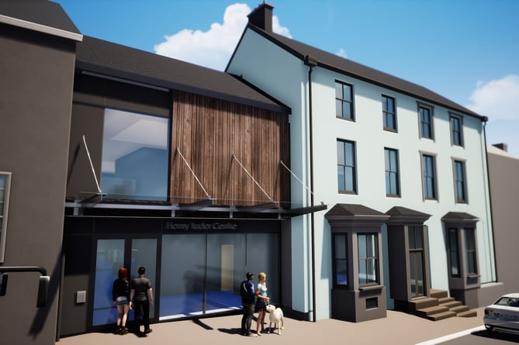

Above Photograph Taken From ‘The Narberth & Whitland Observer’ ( Pembroke South Quay social care hub advances with multi-million pound grant | narberth-and-whitland-today.co.uk ) A Report Completed By An Observer on Wednesday 28th August 2024, 17:00pm. [Accessed 01.12.2024]

- Introduction
Within this report I will be looking into a scheme I am currently involved with:
South Quays, Pembroke.
The client for this scheme is Pembrokeshire County Council (PCC). And the scheme is valued at just under £20 Million.
Currently on site we are still in the demolition and groundworks aspects of work, however the structural steel frame is programmed for install is early 2025.
The site is small for its value, and therefore is programmed accurately due to the amount of labour that is able to work at one time, therefore taking longer to carry out works in comparison to other sites.
Previously, Lloyd & Gravell were employed as the main contractor to carry out the works (2023), however the work proved to be too challenging for them as a medium sized firm, and therefore Andrew Scott Ltd (ASL) were appointed to follow on.
This purpose of this report is to outline what the eye doesn’t see during a construction project, with the interesting history and surroundings of the site, it is vital all elements of the project are looked into with detail.




- The Site: South Quays Regeneration Scheme.
We at Andrew Scott Ltd are employed by PCC as the main contractor on the scheme, employed under the 2013 NEC Option A contract. The site is located approximately 30 metres from Pembroke’s Castle, and therefore many of the surrounding structures are listed.
This has so far proven to be a problem for us during both the groundworks and demolition stages. Listed building are structures that have either special architecture or history aspects.
They are protected by a company called CADW (Government Agency) whom must be contacted before carrying out any works. As by law, if you do take down or heavily damage a listed structure, you can be subject to imprisonment.
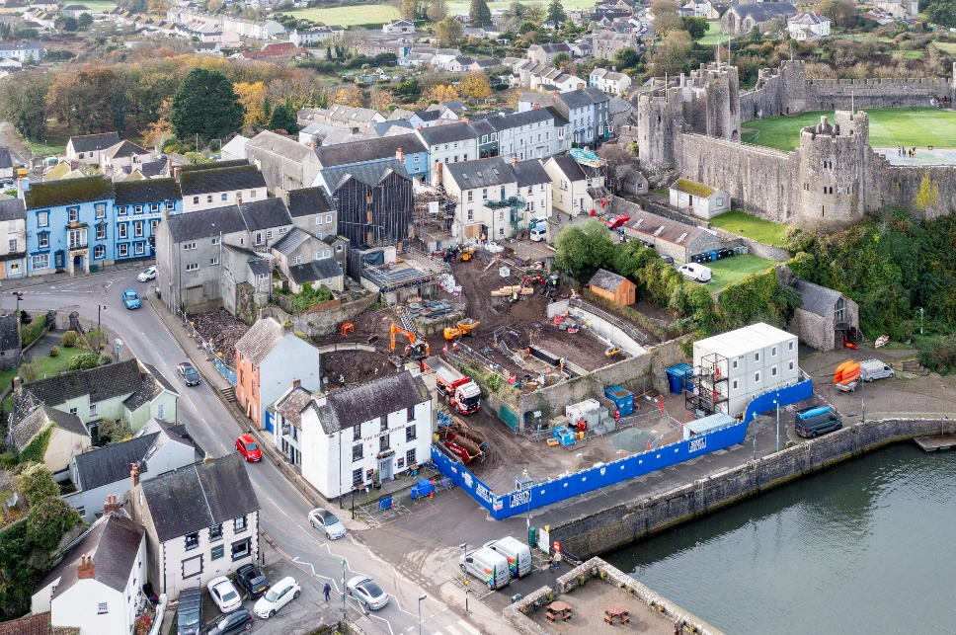
The sites programme runs from May 2024 to May 2026 (24 Months). This project was sitting in pre-construction for over 12 months due to the complexity of the architecture and listed buildings, The structural steel frame took over 6 months alone, due to the site being small and having to be dropped in using a tower crane.
Photograph taken from South Quay Progress Capture 1 - 14th November 2024 Drone Photographs ‘Behind The Lens Media’ 14th November 2024. [Accessed 01.12.2024]
The complexity of the site has taken a financial effect on all parties involved with the site, having to input more personnel to meet deadlines set by the clients.
Phase 2 was originally scheduled to start at the point of phase 1 finishing, however ASL were discounted for both phases to run alongside one another.
Phase 1
During phase one of this scheme, we must demolish, refurbish and build new. There will be a new café, library and public visitor centre.
Currently in the demolition of the existing building and foundations, we have a number of listed walls, which need to be preserved and built around. PCC want to ensure these walls remain, and therefore a feature can be made out of these upon completion.
All excavation works must be watched over by an archaeologist due to the history of the site and its surroundings. This has proved tough for the site team, as a number of site stoppages have been put in place due findings of animal bones, old coins and clothing buttons.
Due to the poor quality of materials below ground, piling foundations must be used, in order to take the loadbearing of the steel structure. These piles are taken down to bedrock level, reaching levels of 15m.
Due to the new structure being built off existing walls and floors, it is important health, and safety is the main priority.
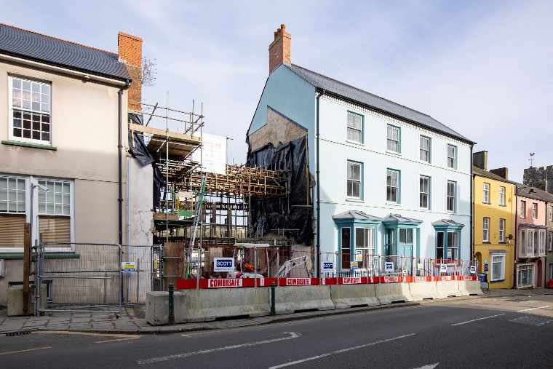
The first of the new builds is built between two existing properties, however the party walls adjacent to these properties were deemed unsafe by the structural engineer (Roger Casey Associates) and therefore had to be temporary propped using steel. This temporary propping was valued at £23,000.00.
Photograph taken from South Quay Progress Capture 1 - 14th November 2024 Drone Photographs ‘Behind The Lens Media’ 14th November 2024. [Accessed 01.12.2024]
The building process is built up using both precast concrete and structural steel frame, both these options are manufactured off site, therefore speed up the construction process.
From ground level up to the roof the building is steel, the roof finish is zinc cladding, which is an expensive material, and can only be fixed by specialist contractors.

Phase 2
During phase two we will be building a new social enterprise training centre along with a social day care centre.
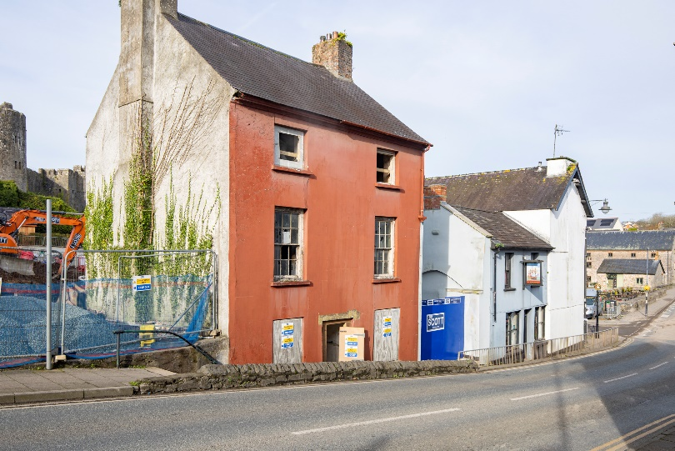
As photographed on the right, there is an existing building in the middle of phase twos area. This buildings external walls are listed, and therefore must be made safe to build around and retained. Again, similarly to phase 1, temporary propping must be used to ensure the building is safe to work both in and around.
Photograph taken from South Quay Progress Capture 1 - 14th November 2024 Drone Photographs ‘Behind The Lens Media’ 14th November 2024.
The roof, internal floors and walls must be taken out, and built back in, to do so, the site team will be removing from the top and building back up from the bottom, this was deemed the safest method to carry out the works.
This phase is also constructed using a structural steel frame, this building process was deemed the most time and cost-effective way of building.
The floors within the new structure are timber, constructed alongside precast concrete beams. [Accessed 01.12.2024]
The original design for phase 2 was a timber frame build due to the cost effectiveness of the materials used. This however had to be changed to steel due to the load bearing of the new structure.
Due to the change in level from phase 1, phase 2 ground levels will need to be built up in the future in order for the drainage to be able to flow in the correct direction, and not hold on site. This was a key element the designers outlined during pre-construction.
Phase 2 has the inclusion of a lift, which is located at the corner point of the exiting listed building as stated above.
Due to the building being listed, this was complex to overcome, and the eventual outcome was that the corner of the building was to be removed brick by brick, otherwise removing the lift which wasn’t appropriate for disabled users when functioning and built.

- Conclusion
As discussed above, there have been many obstacles to overcome during construction up to this point, and I’m sure there will be many more to come.
Currently valued at the £20 million mark, I do believe this figure will increase due to added design and engineering works throughout with what could be found beneath ground.
All in all, this project is set to be a great landmark within Pembrokeshire and will attract lots of tourists around the area throughout the summer months.
This build will also open up many job opportunities and will add to the local areas social value.

