2020 SCHOOL PROSPECTUS

“From the ashes, a fire shall be woken, A light from the shadows shall spring…” — J.R.R. Tolkien, The Fellowship of the Ring

Contents
Pages:

Head Teachers Promise ………………………….. 4
Who is Phoenix? ………………………….. 5-7 Our Five School Visions ………………………….. 8
What is our Pedagogy ………………………….. 9-14 A Typical Day at Phoenix ………………………….. 15-16
Why play based Learning? ………………………….. 17
Why mindfulness? ………………………….. 18-19
Curriculum ………………………….. 20
Assessment ………………………….. 21-22 Phoenix or Traditional ………………………….. 23-24
Schooling
Conclusion ………………………….. 25-26 References ………………………….. 27-29

Head Teachers Promise


“Hi, I am Heather Mcinally and I am the one leading our great school. My promise to you at Phoenix International School is that just like the Lord of the Rings quote on the pervious page we shall awaken the fire within all of our students. From the fact that on one of our first pages of our prospectus we have a Lord of the Rings quote, you might already be guessing we are not your traditional International school. We aim to awake the fire within our learners whether that may be in academia, music, art, politics or anything within their imagination.
We encourage our learners to be individuals – not just another student. We want every person to go on from us with a well-rounded perspective of the world. We want to have a learning environment like no other.
We are striving to be the ‘Phoenix’ of Education, constantly evolving and being reborn for the times. Here at Phoenix we are trying to be a place for alternative education and not a ‘one size fits all’ place of education.

As a school who is inclusive, we do not tolerate discrimination of any kind against anyone within our school. It is our mission to make our school a safe haven regardless of gender, sexuality or race.
Phoenix is the first school of its kind, but we are sure it will not be the last”

Who is Phoenix International School?


(Capri A, 2018)

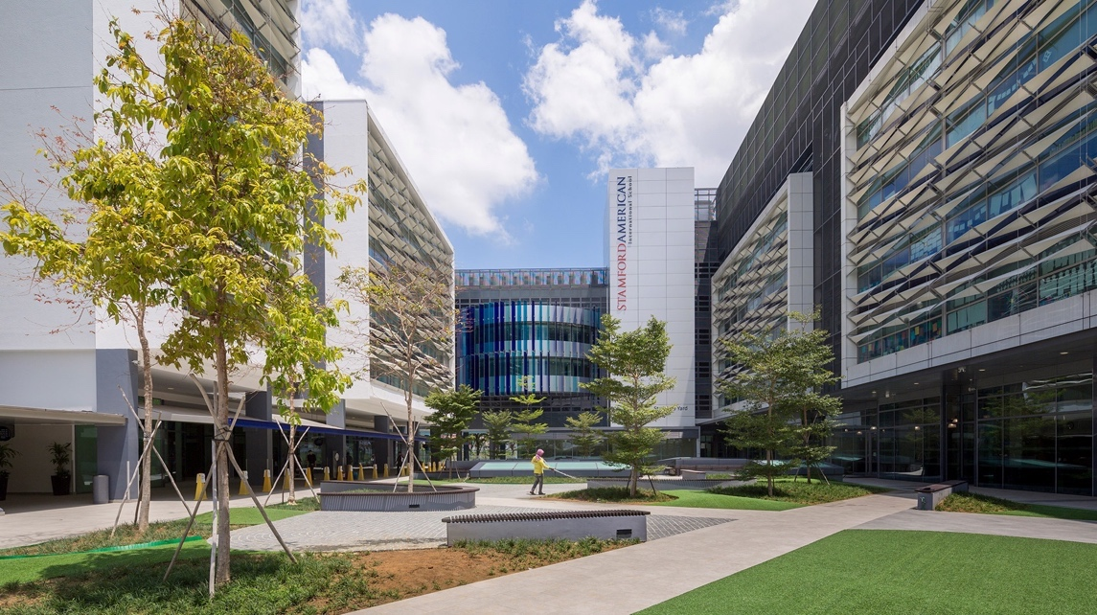

(SEO, 2020)

Set in the heart of Singapore we are a mixed gender international school based in Singapore liberal approach to learning. Being in a up and coming city such as Singapore allows us to be bold and forward thinking when it comes to education.

Our school is a unique learning environment with something to suit everybody. We understand that not everyone wants to become doctors or aerospace engineers but we also recognise that some do. We understand that some people want to become entertainers, farmers or artists. To cater to all of the realms of possibilities we have created our pathways as seen below.

Academic based learning | Phoenix based learning
This pathway will allow learners to still gain qualifications such as IGCSE’s and ALEVELS which will allow them to go onto university. Even though this is the academic pathway there is still phoenix-based learning underpinned the learning experience. The academic based learners will have 2 hours each day to focus on their academic subjects and join the rest of the school for the other days. This pathway does mean an extra day in school on a Friday to focus on academia. | Phoenix based learning is a blend between Maria Montessori’s approach, Howard Gardner's multiple intelligence theory and an inspiration from A.S Neill. This learning style is far more catered towards learners who do not want to go down the traditional education path. It is a lot more based on the individual rather than the many and is more of a holistic approach to learning which will we learn more about in the prospectus.

We support learners from ages from the ages of 2+ to 20 years. Most schools will stop supporting their learners after the age of 18, but here at phoenix we feel it is important to carry on that support for a little longer. Whether that be because certain circumstances have meant you are not quite ready to leave us or just that you feel you would benefit from a few extra years within our community - everyone is welcome.

Following our school visions of individuality and confidence, we have a non-uniform policy. We believe both our learners and guides should be able to express themselves through what they wear as they would outside of the school walls. Everyone whether that be staff or learners should feel comfortable and confident when coming into our school and therefore wear what makes you feel good. As simple as that.

Compared to traditional schools within Singapore we are challenging the normal educational structure (Goh and Gopinathan, 2008) illustrated that in the recent years the Singapore government has put an emphasis on education within the country, however this is in response to the ever growing economy of Singapore which is emerging. Therefore, although the government are offering more courses than ever and new pedagogy this is in turn to create a set of students with the skills needed to thrive in the Singapore that they want to see which is a business-driven country.

However, where does that leave the learners who do not fit into that category and want to take a path away from the future that their government wants them to have. This only highlights the need for an institution like us set in Singapore. As an independent school we do not need to compete in league tables or with other schools as we put our learners first.

Our Five School Visions

Trust – We trust our learners and guides to undertake their own journey within the school

Confidence – This is something which we aim to build in every single learner in order for them to become confident and empowered individuals

Respect – We want to create an environment where there is respect among everyone within our school whether that be adult to child or vice versa

Individuality – We see each leaner as an individual with specific needs which we cater to

Acceptance – We have people from a wide variety of different cultures and express themselves in different ways and we do not tolerate any discrimination against this

All of our visions tie into our underlying pedagogy which we follow our Phoenix which we will go into detail of on the next pages.

What is our Pedagogy?

Our pedagogy was formed by our headteacher and is called Phoenix based learning. When creating Phoenix based learning our founder took parts of theories which she thought would make a new, innovative and foreword thinking school. She wanted a school in which it was totally child centred and a tailored learning experience for each child. Recognising that not one learning method fit all children a blended approach was taken from three theorists: Howard Gardner, Maria Montessori and A.S Neill. From blending these three theorists the Phoenix International School has formed a one of a kind education type.

Our key points to our pedagogy are:

- Not one type of pedagogy fits all learners

- Our learning spaces should be fit to purpose and have the tools which the learners need to explore the topic

- Our teachers are guides not there to tell the learners what to do

- Children centred and catered to fit around them

Let’s delve a little deeper into our pedagogy and where it has come from.

Firstly, lets focus on our inspiration from Howard Gardner. (Gardner, 1983) had a theory of multiple intelligences the idea behind this was that there are 8 different intelligences that one can possess. Therefore, a Phoenix we believe there must be multiple ways to educate to nurture these intellectual needs. Gardner highlights 8 different intelligences and within our school we recognize this theory and have built our vision upon this.

An example:

We have a child come to our school and take a complete shine our music sessions and excelling in this area. We can recognize that learner is very musically-rhythmically intelligent as (Gardner, 1983) would suggest. We would then make sure the learner was able to access and thrive in that area.

A way that we are able to allow learners to explore things outside of the classroom is that Fridays are a non-school day. On non-school day’s the learners must engage in things outside the classroom, but in something which is helping them learn and explore for example: a musically intelligent learner could go to the Singapore opera or a naturalist learner could spend time in an allotment. Our aim is to allow our learners to see that being academically intelligence is not the only path that they have to follow.

Below is a diagram to show you the 8 different intelligences that (Gardner, 1983) recognised. We are able to allow our learners to explore these intelligences through the wide range of activities and subjects we offer at Phoenix.

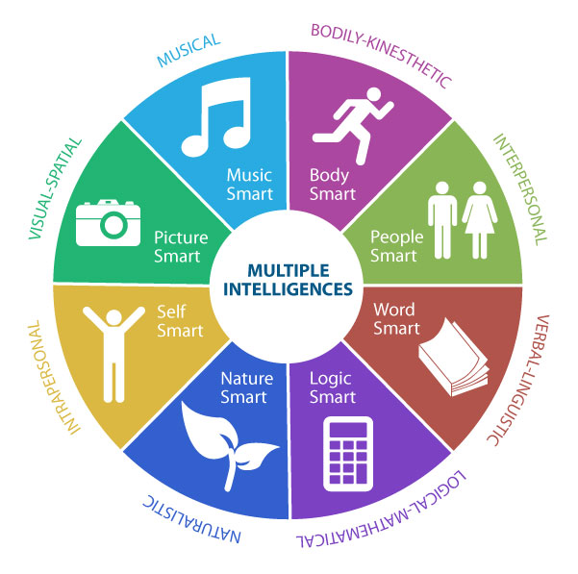

(Multiple Intelligences. Ostwald-Kowald, 2015)

The next part of Phoenix learning is evolved from Maria Montessori’s educational philosophy.

(AMI, 2020) highlights three key components to ensuring a Montessori style education is successful they are:

- Developing the child as a whole – therefore ensuring that the child has a range of skills such as social, creative, problem solving, critical thinking and having interpersonal skills

- The teachers are guides – ensuring that the children are guides rather than telling the children what to do. Allowing freedom and self-exploration.

- A tailored learning space – this is making sure that the learning spaces are custom to what the child needs for what they are discovering.

(Montessori, 1988) highlights the importance of materials within the classroom environment which are engaging to the child and the way to utilize these tools is through self-directed methods. Everything from figuring out how to use the tool through to packing it away is a learning process which the child is learning from. The fact that the learner is using self-directed learning ensures that they will grow and develop into a confident and independent adult.

(Marshall, 2017) highlights that a key element to Montessori style learning is allowing children to make mistakes and correct them. This creates a child who is able to learn from mistakes in the future rather than be defeated from them. The fact that again this is done with minimal teacher support is reinforcing the independence that we are teaching the children.

Our educators at Phoenix International School are called guides. This name was adopted from the Montessori theory as we also believe that our educators are there to guide our learners on their journey throughout the school. Therefore, our learners do not heavily rely on the teacher’s presence and can be forward thinkers. This is really highlighted within the older years within the school where the learners are almost solely self-instructed from 9am to 3:30pm.

In the Phoenix International School this is underpinned in all of our learning as we try to encourage self-exploration and learning from ages 2 right the way through to 18 years +. Our learning spaces are tailored to what will be happening in that place and relevant tools will be there for the learners to incorporate into their experience.

The final theorist that we took influence from was (Neill, 1968) whom had a progressive style of education. This involved putting the child at the center of the education system in a very free movement and liberal school. (Taylor and Francis, 1992) highlights that the Summerhill, which is the school which A.S Neil created, is a school which is democratic. This allows the school to fully be geared to what the children think and feel, which is something we are trying to replicate within the Phoenix International school. By allowing our learners to make the choices within the school and choices which will affect their future we hope to create a freer and positive environment like Summerhill.

Allowing our learners to have a free roaming experience for 4 hours a day in which they can pick and choose what they would like to be learning about or doing is reinforcing the idea of them making the decisions. Although our school does not fully incorporate ‘free schooling’ in all of our sessions throughout the day it is a huge part of our school ethos.

(Summerhill School, 2020) highlights how within the democracy of a Summer Hill School both pupils and staff are equals and there is no hierarchy. This creates a more welcoming and friendly environment which makes for a more enriched learning environment. The fact everyone is on the same level creates the chance to build a true and healthy relationship between adult and child. Here at Phoenix we strive for the same. We want our guides to be people that our learners feel they can speak to and seek direction rather than people who are seen in a position of power. In traditional school’s it seems that teachers are seen as exactly this and have an almost god complex in which they rule over the children. At Phoenix International School we believe this is not the way to fully engage and gain the trust of our learners and therefore take a more friendly and welcoming approach.

A “Typical” day in the life of a Phoenix learner – if there is such thing as a typical day in our school

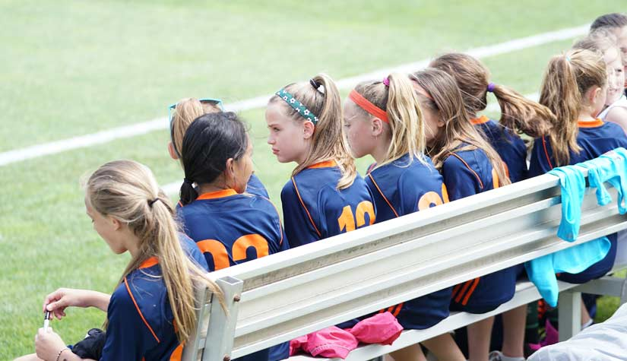

(Corefulness, 2020)

9am – Registration (form groups are not age specific)

9:30 – Mindfulness half hour

10:00 – Class one

Years 2-7 | Academic Learners | Skills based learners
Play Based Learning | This will be time split into 2 different subjects of the learner’s choice | There will be a range of different areas, tasks etc which can be freely explored in this time

12:00 – Lunch

13:00 – Class 2

Years 2-7 | Academic Learners | Skills based learners
Play Based Learning | Holistic Learning | Holistic Learning

15:00 – Reflection

15:30 – Co Curriculum activities

17:00 - Home time

In the next few pages we will go into some depth about some of our more unconventional daily routines which you may not see in your ‘typical school’.

Why play based learning?

(UNICEF, 2018) highlights that from the moment you are born until you are eight years old is very important as this is the time in which you build foundations in all key areas. These include cognitive, social and emotional skills which allow a good base to help you evolve into adult life. Therefore, at Phoenix we have a strong focus on the ages 2-7, however in a slightly different approach as most schools.

In traditional settings schools tend to start formal education aged 5 which some people believe benefits the learning experience as they are starting as soon as possible. However, when you look at countries such as Sweden (Sweden Education, 2019) states that children begin schooling aged 6 which is later than most countries, however then go on to tell us that their PISA scores were above the OECD average. This suggests to us that there may be little negative affect on beginning traditional schooling later, although within our school traditional schooling is an optional activity.

As elicited by the (LEGO foundation, 2017) a child who does not have a grasp of basic skills such as plus and minus does not have a chance at understanding how to do an equation and here at phoenix, we believe the same. Therefore, we take a strong learning through play approach in the first 7 years at Phoenix. Learning through play is a concept in which children learn through discovery and interactions. (Vygotsky, 1978) suggested the importance of children learning through play and how beneficial it is to development. Something which we have ensured we have blended into our education here with up to 4 hours of learning through play a say age 2-7.

We believe that learning through play allows our learner to become independent and strong thinkers. As for the first 7 years of their learning experience they are not being led but instead they are the ones leading.

Why do our learners have mindfulness half hour each day?

Each and every one of our pupils no matter what age undertake half an hour of meditation a day. We believe that meditation is vital to the wellbeing of our learners and has a positive impact upon our learner experience. Although meditation in schooling environments is a relatively new concept it is one, we have embraced.

(Weare, 2012) demonstrated the positive effects that mindfulness has on children even with it being such a under studied field. Studies showed that mindfulness can reduce a range of problems which young people may face such as anxieties and depression, self-esteem issues, challenging behaviors and many other common problems which may develop during schooling ages.

Not only that but it has been suggested that mindfulness could have a direct link to the development of a young person’s cognitive skills which is vital in order for our leaners to be all-rounders. Nevertheless, with the trend of mindfulness in schools growing it is no wonder that there is ever growing research to support the use of mindfulness in schools. There is a host of research which focuses on everything from the effect on learning to the effect on mental health.

When you reflect upon the fact that mental health is on the rise in young people with (Loh, 2020) reporting that in Singapore ‘one in seven Singaporeans above 18 encountered in their life anxiety, moods and alcohol related challenges’ there is still a distinct lack of mental health help and strategies in place within the traditional schooling environment. However, at Phoenix we have dedicated half an hour each day into trying to prevent these issues being proactive rather than reactive. Following the previous evidence of mindfulness helping people with mental health problems it is also a benefit to those learners who already may be struggling. Only highlighting why our 30 minutes mindfulness session a day is as important as our 4 hours of learning time.

Curriculum

Phoenix International School is an independent establishment and therefore does not follow a set curriculum as a state funded school would have to. In our school we believe in children led curriculum and offer a wide range of activities and subjects for the learner to explore. We offer a range of sports activities, farming, gardening, cooking, music, dance, mixed media art, photography and many more. If we do not offer something which your child is interested in we can work with them to bring that onto our curriculum.

For our academic pathway we also offer the choice of undertaking up to 8 IGCSE exams and 4 A-levels. We are able to cater to any subject choice which a learner may choose, with no timetable clash worries or not enough teachers to go around.

We like to ensure, or curriculum is a loose as possible and can them be student led to the individual rather than a dictation of what the pupil should undertake. Unlike traditional schooling our learners have freedom and unlimited choices when making vital decisions which will affect their future.

(Curtis, 2014) elicits the disadvantages of a traditional schooling approaches to curriculum and describes it as a ‘cookie-cutter’ approach. This highlights the fact that schools have adopted an approach which is one size fits all when it comes to curriculum. It seems as if traditional schooling loses sight of the person as an individual and groups all of the children together. Following our look into (Gardener, 1983) on the previous pages it is clear that children do not fit into the category of one type of intelligence. This suggests to us that there should be more than one type of curriculum for children who do not fit the typical academic intelligence mould. Which is why we have created a curriculum that completely challenges the norm and changes it in our opinion, for the better.

Assessment

Academic pathway | Phoenix learning pathway
This pathway allows the option to take the I- GCSE’s and A-levels  However, we do not believe in constant standardized testing throughout the year. Instead we will utilise end of year exams rather than constant testing throughout the year; therefore, leaving practice examinations etc down to the learner. We will track progress through class contributions and work that is produced.  We as a school believe constant testing does not benefit the learners and in fact hinders them. Compared to traditional schools we take a much more relaxed stance on constant assessments throughout the year. | This pathway does not have any type of examinations throughout your career with us.  We base how a person is doing upon their development as a person. Their guides will look at things such as their social skills, their ability to critically think, how they solve skills, their interpersonal skills and other criteria’s which are not related to academia in any sense.  Your progress is never compared to others as each individual is looked at on a one to one basis. Whereas in a traditional setting, children can be compared against each other not only in academic terms, but developmentally.

Although our methods may seem relaxed and depending on the learners themselves to take control of their learning this is something which is underpinned in everything our school stands for. We have allowed our learners to be independent in confident throughout our pedagogy from the age of 2. However, in traditional schooling this is not always the case. (Curtis, 2014) highlights the detrimental effects that continuous assessment can have upon not only one pupil the school as a whole. The result of over assessing children can leave less time for the children to learn no material and fully explore subjects and in turn this means that children are learning the material just to be prepared for the assessments.

Not only this but most importantly the children’s health and well-being can be affected with it being suggested that increased assessments can have a huge effect on not only the children’s mental health with increased stress and anxiety, but also the teachers. As many of the teachers have unrealistic targets to meet in regard to grades, a lot of the time to better the schools within league tables. If both the teachers and the children are stressed this may create an unhealthy learning environment in which not much actual learning is taking place. This may result in demotivation all round and a cycle within the school which is hard to break.

At Phoenix International school we purposely do not undertake constant assessment in order to avoid ‘teaching for testing’ or causing unnecessary stress or anxieties upon both our learners and guides. Here is where we stand out from other institutions as we are putting the learner first rather than where we stand on a league table of results.

Phoenix International School or a Traditional School?

We have to ask ourselves are traditional schools setting children to fail. (Postman & Weingarten, 1971) suggested over 40 years ago that traditional schools were out of date. They highlighted how schools had not changed much of their format and had not been updated to fit with the change of times. This is still relevant today with schooling remaining unchanged in many areas of the world. While we see dramatic progression in areas such as technology and innovation it seems that education is being left behind. Postman and Weingarten believed the importance of keeping up with the progression of the world around us which is something which the Phoenix International school was built upon. Ever growing and changing with the times and needs of the future.

(Gatto, 1992) again highlights the problems which are hidden behind the traditional type schooling. He suggests a range of problems which are within our current education system, however as someone who had been a teacher within a traditional type school for some 20 years, he has unique perspective from inside the system. Gatto highlights that traditional schools are contradictory with curriculum which is not relevant to real life experiences. Something which we have ensured we excel at here at Phoenix International School in order to avoid our learners entering the world of work unprepared.

Moreover, (Gatto, 1992) outlines that traditional schools rely too heavily on reward and punishment which is reinforcing behaviours which may be detrimental to the development of the child. Upon relying on rewards and punishment there is a chance that this could be reinforcing emotional dependency onto the children from a very young age. Not to mention an intellectual dependency as the pupils are spoon fed the information and helped too much throughout their time at school. This does not allow them to be able to problem solve or critically think for themselves. As a consequence, to this when going into the adult world traditional schooling has not served its purpose to prepare the person as a whole for life. Instead traditional schooling has conditioned thoughts, ideas and behaviours which do not translate to the wider world outside of the school environment.

Traditional schools do not have the flexibility and ability to adapt as we do. The reason that our school was set up was to break away from the traditional style of schooling and create a new innovative style which had room to move with the times. We have purposely looked at the criticisms of traditional schooling and found ways to help to combat the problems that have continually been highlighted.

Conclusion

When creating our school, we wanted to ensure we had a unique, fresh and evolving outlook on education. We ensured we did this by looking into the past and seeing what the downfall of traditional education for has been the past 100+ years. One common theme underpinning majority of the critics and one that stood out the most to us was that traditional schools are not student led, when students are the sole reason schools exist. This is when we knew that a student led school was the future of education.

We want an environment where young people are empowered by the decisions they are making, which in the long run will have a direct effect to their future. Taking inspiration from three theorists Howard Gardner, Maria Montessori and A.S Neill we created a blended learning style which would be known as Phoenix style learning. This style ensured that the learner was at the forefront of everything that we do as a school and that each learner was seen as an individual and not a number.

Our Phoenix style learning recognised that children are all individuals with individual needs and that not one form of pedagogy can fit them all. We allow Gardner’s 8 intelligences to be explored and ensure that we have the tools/resources needed to aid the learners in investigating their strengths and weaknesses. We also ensure that our teachers our guides through each learner’s experience recognising that they are there to help and aid them through the process one step at a time.

We adopted a free learning environment inspired from A.S Neill in which the learners have 4 hours a day of free learning. This is time where they choose what they want to learn and reign free exploring for themselves. This only reiterates our learner led approach and how we allow our students to think and make choices for themselves.

We hope that you can gain a small insight into how special and unique our school is and although it may seem ‘radical’ it is a step into the future of education.

Reference list:

Capri, A (2018) Available at: https://www.forbes.com/sites/alexcapri/2018/09/21/5-reasons-why-the-worlds-tech-firms-are-moving-to-singapore/#9728bf92aa01 (Accessed 20th October 2020)

Corefulness, 2020 Available at: https://corefulness.com/corefulness-schools/ (Accessed 20th October 2020)

Curtis et al (2014) Education Studies: An Issues Based Approach: Third Edition. Exeter: Learning Matters.

Gardener, H (1983) Frames of Mind: The Theory of Multiple Intelligences. New York, Basic Books.

Goh, C. B. and S. Gopinathan (2008) Education in Singapore: Development since 1965 pp. 80-108, The World Bank, Washington, DC.

Loh, M (2020) With youth mental health issues on the rise, Govt calls for ideas Available at: https://www.todayonline.com/singapore/youth-mental-health-issues-rise-govt-calls-ideas (Accessed 20th October 2020)

Marshall, C (2017) Montessori education: a review of the evidence base doi:10.1038/s41539-017-0012-7

Montessori, M (1988) The Discovery of the Child Clio Press, Oxford, UK

NEILL, A.S. (1968) Summerhill (London, Penguin)

Neill. A.S. Summerhill (2020) Available at: http://www.summerhillschool.co.uk/ (Accessed 20th October 2020)

Ostwald-Kowald, T. (2014) Understanding Your Students Learning Style: The Theory of Multiple Intelligences Available at: http://www.connectionsacademy.com/blog/posts/2013-01-18/Understanding-Your-Student-s-Learning-Style-The-Theory-of-Multiple-Intelligences.aspx (Accessed 20th October 2020)

Postman, N. And Weingartner, C (1971) Teaching as a Subversive Activity. Hammondsworth: Penguin
SEO, (2020) Available at: https://www.seocompetitors.com/stamford-american-international-school-singapore/ (Accessed 20th October 2020)

Sweden Education (2019) EDUCATION IN SWEDEN Available at: https://sweden.se/society/education-in-sweden/ (Accessed: 16th October 2020)

Tolkien, J.R.R. (1994) The Fellowship of the Ring. New York: Houghton Mifflin Company.

UNICEF (2018) Learning through play Available at: https://www.unicef.org/sites/default/files/2018-12/UNICEF-Lego-Foundation-Learning-through-Play.pdf (Accessed: 16th October 2020)

Vygotsky, L. S. (1978). Mind in society: The development of higher psychological processes. Cambridge, MA: Harvard University Press

Weare, K (2012) Evidence for the Impact of Mindfulness on Children and Young people Available at: https://mindfulnessinschools.org/wp-content/uploads/2013/02/MiSP-Research-Summary-2012.pdf (Accessed: 16th October 2020)

Zosh, J et al. (2017) Learning through play: a review of the evidence Available at: https://www.legofoundation.com/media/1063/learning-through-play_web.pdf (Accessed: 16th October 2020)

