Engineering Technical Report
Workshop and Practice (ACHA4011)

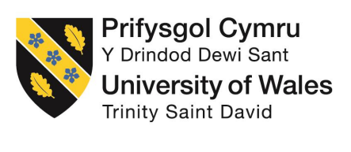

Emily Dawes
2303927
3/12/2023

Contents

2 Introduction: 3
3 Chapter 1 – Health & Safety with Risk Assessments: 4
3.1 RISK ASSESSMENT 5
4 Chapter 2 – Engineers Role in Society: 7
4.1 IMechE 7
4.2 Engineering council / RAE 7
5 Chapter 3 – Problem Solving: 8
5.1 An issue found during development: 8
5.2 An issue found once on the market: 8
5.3 A supplier issue in the production process: 8
6 Chapter 4 – Team Structure: 9
7 Chapter 5 – Personal Development Plan: 10
8 Conclusion: 11
9 References 12

Introduction:

In chapter 1, you will find a report on health and safety with the relevant legislations for the task that was undertaken. It will include the PPE required for the task and a risk assessment matrix showing the risks that could possibly occur and how big the risk level actually is. Secondly, in chapter 2, the report written there is about an engineer’s role towards society. It will include their responsibilities towards one another, others around them and the environment. Then, in chapter 3, there is a report about problem solving and what you need to do when finding either a problem during development, once in it on the market or if there is a supplier issue while in the production process. Flow diagrams are included to support how the problems were resolved. Next, in chapter 4, there is a review on working in a team. It includes the positive and negative points that occurred while doing so. Also, team structure was recorded and researched to see if there was a more appropriate approach to the task given. Finally, chapter 5, a development plan has been created showing short term (0 – 5 years) and long term (5 – 10 years) goals. It will include the goal itself, the objective, the resources required to reach the final goal, what measurements need to be made and the target date for when the goal is successfully achieved.

Chapter 1 – Health & Safety with Risk Assessments:
When an engineer is undertaking a dynamometer test, they need to ensure that all relevant legislations are followed. There are many risks that come with this task including: the vehicle coming of the rolling road, exhaust emission, noise pollution and fire. It is an engineer’s responsibility to ensure that these risks are limited to happening. Engineer’s have a role to make sure that the area in which this test is being taken is secure and well operational. To achieve a safe work area, smaller tests must be made beforehand i.e., noise testing.
For example, an engineer needs to make sure that vehicle is securely held in place, to prevent it coming off the rolling road, using suitable ratchet straps. Hooks are located at each corner of the car; this is so the straps have 4 points in which the car is being held to the ground securely. Once the car is held in place it is crucial that they ensure that the dynamometer is set correctly. When the test is ready engineers must place safety barriers around the area to prevent spectators from being in a potential danger zone, this must be made clear.
Engineers must ensure that the area is well ventilated, following LEV legislation (HSE, 2017). To follow this an engineer must ensure that the extractor is operating correctly and that there is nothing blocking at any point throughout the pipe. When ready to start they must make sure that the entrance to the pipe is over the exhaust, to prevent the harmful gasses filling the room.
When preforming a dynamometer test it is an engineer’s duty to ensure that all persons witnessing are provided with the correct ear protection, this is to limit any potential damage. It is their responsibility to ensure that the ear defenders are being worn correctly. Before running the official test, an engineer should do a few test-runs to find the highest decibel rate and the average over the tests taken, this is so they can check to see whether the ear defenders are suitable. They also need to ensure that all ear protection is in suitable condition, meaning the rubber on them is not perished. Engineer’s must ensure that their employees have the correct information and training on how to use and maintain the ear defenders (HSE, 2023).
Before taking the test, it is essential engineers provide information and instructions on where the fire exits and assembles are and what to do if a fire occurs. It is an engineer’s duty to ensure that the correct fire extinguishers are at hand and operational. In case of a fire an engineer should try and identify what the fuel of the fire is so that they can use the correct fire extinguisher to then put it out rather than spreading it, yet if the fire is out of control, it is essential to evacuate the building, do a head count at the assembly point and call the fire brigade.

RISK ASSESSMENT

Fixed Dynamometer Testing
Company Name: |  |  | University of Wales Trinity Saint David
Location: |  |  | UWTSD SA1 Campus
Assessed by: |  |  | Emily Dawes |  |  | Designation: | Student reviewer
Legend: Likelihood and severity: 1=Low 2=Medium 3=High
Risk Rating (LxS): 1-3=Low 4-6=Medium (See additional control measures) 9=Unacceptable-Do not proceed
SIGNIFICANT HAZARDS IDENTIFIED: Give a brief description of what could be reasonably expected to cause significant harm and how that may arise. |  |  |  |  |  |  |  | RISK ASSESSMENT
 |  |  |  |  |  |  |  | UNCONTROLLED |  |  | CONTROLLED
 |  |  |  |  |  |  |  | L | S | RR | L | S | CR
Unplanned release of vehicle |  |  |  |  |  |  |  | 3 | 3 | 9 | 1 | 3 | 3
Exhaust emissions |  |  |  |  |  |  |  | 3 | 3 | 9 | 1 | 3 | 3
Excessive noise |  |  |  |  |  |  |  | 3 | 2 | 6 | 2 | 2 | 4
Fire |  |  |  |  |  |  |  | 3 | 3 | 9 | 1 | 3 | 3
PERSONS AT RISK |  |  |  | Y/N | DETAIL
Testers |  |  |  | Y | Those present active in testing
Student witnesses |  |  |  | Y | Those present witnessing test
Members of the public |  |  |  | N | Excluded
Others |  |  |  | N | None planned. Excluded
Control Measures:
1 | Ensure all 4 corners of vehicle are secured with certificated straps. In date pullout testing for load points.
2 | Ensure all non-driving wheels and chocked
3 | Ensure rolling road is set up correctly for FWD or RWD vehicle.
4 | Ensure LEV is on and operable.
5 | Ensure collection hood is placed at exhaust source.
6 | Where local exhaust ventilation (LEV) is not available, provide good general ventilation.
7 | Where local exhaust ventilation (LEV) is in place, ensure plant is certified in date and inspected by a competent person HSG 258 (third edition)
8 | Exclude any unnecessary persons from the test area.
9 | Ensure all authorised persons are wearing suitable ear protection, rated appropriately to the noise level.
10 | Provide and record regular noise level testing.
11 | Reduce fuel present. No refuelling in bay.
12 | Ensure appropriate fire extinguishers (Cream/Foam or Blue/Dry Powder) are at hand, are full/unused, in date and tested and are operational training
13 | Ensure Fire plan in place, fire exits are understood and are clear.
Remember: |  | Always check in your safety manual for safety procedures and systems of work. Refer to other generic risk assessments for activities connected with this activity.

RISK ASSESSMENT
Working in dusty environments
ADDITIONAL CONTROL MEASURES: (Review at workplace & add any additional specific controls required) - Pay particular attention to controlled risk scores above a 3 rating
- Ensure all ear defenders are in good condition and well fitted.
- Where there is communal use of ear defenders, supply sterilising wipes to clean down.
- Only testers allowed beyond safety barriers.

PERSONAL PROTECTIVE EQUIPMENT:
The following PPE will be required for the work activities stated. Ensure the correct TYPE of PPE is selected
Head Protection |  | Eye/ Face Protection |  | Hearing Protection |  | Hi-Vis Clothing |  | Gloves
Foot Protection |  | Safety Clothing |  | R.P.E. |  | Safety Harness

Chapter 2 – Engineers Role in Society:

IMechE
The IMechE code of conduct play a significant role towards an engineer’s perspective towards sustainability and the environment.
Engineers within the motorsport region have a duty to acknowledge the importance of the environment and how they are impacting it. They are required to comply with environmental regulations and needs (IMechE, 2021). The following factors are included in what an engineer should consider: their waste management, track development, the number of emissions that they produce and how energy efficient the car is. They have the responsibility to maintain a steady balance of the needs for the present day and future environment.
The code of conduct encourages engineers to find better alternatives solutions without causing an issue towards performance, this is to develop a higher standard of sustainability. This can include further research to enhance fuel efficiency and more appropriate technology which could lead to finding a more renewable energy source that can also reduce emissions.

Engineering council / RAE
The Engineering Council / RAE set standards for engineers to follow and what is expected of them and what they are responsible for.
An engineer has the role of which they need to consider the necessary needs to maintain a sustainable society. This requires them to understand the needs for society while still being practical (Engineering Council / RAE, 2023). Engineers must plan before taking action as the impacts could be long-lasting and potentially global because of this they must ensure that they are following all legislations and requirements given.
It is important as an engineer that they try to minimise the impacts that they have on the environment. To achieve this they should undertake a risk assessment before proceeding with the given task so that they can the measure the potential consequences without harming anyone or anything.

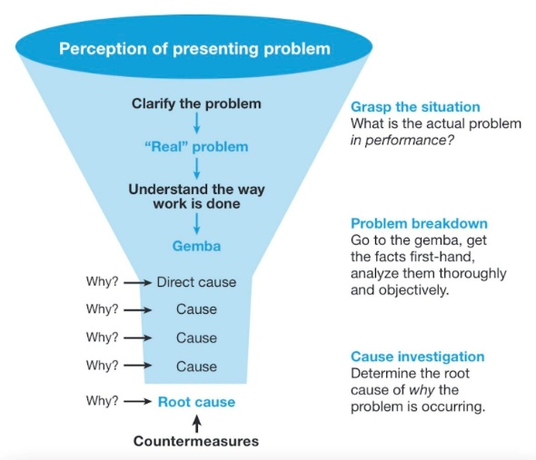
Chapter 3 – Problem Solving:

An issue found during development:
When there is an issue found during development an engineer should ask themselves the ‘5 whys’, this process is shown in figure 1 (Lean Enterprise Institute, 2000-2023). This technique is used to find the root cause of the issue that has occurred and to then prevent it from recurring in the future. Once they have found the root cause, they can then use trial and error to find a better alternative.
Figure 1

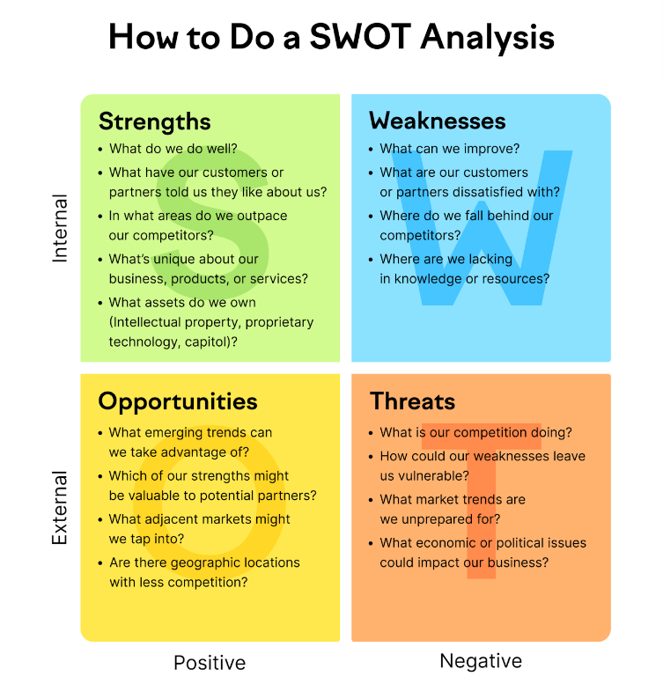
An issue found once on the market:
If an issue is found once on the market engineers could use SWOT analysis. It is used to evaluate all aspects from different angles. Some questions that an engineer may ask themselves are shown in figure 2 (Semrush Blog, 2008-2023). This problem-solving approach is useful in this situation as they can see the weaknesses as to why there is an issue and what threats there are towards the company itself. SWOT is favourable in this circumstance as it helps engineers make smarter decisions, plan better and to make more opportunities while limiting weaknesses.
Figure 2

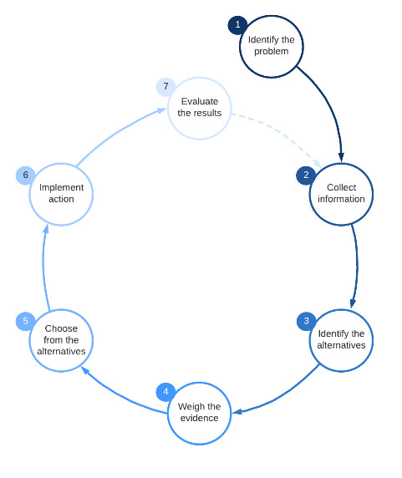
A supplier issue in the production process:
Figure 3
When an issue occurs with a supplier during the production process an engineer will have to make critical decisions. This requires them to identify the decision that may be made, such as whether or not they can rely on the current supplier. They then need to gather information to see if this is necessary. After doing this they will need to look for alternatives and weigh-up the pros and cons. Once finding a possible supplier an engineer will then need to take action. Engineers are then able to evaluate their decision to figure if the problem is resolved. These steps are shown in figure 3 (Lucidchart, 2023).

Chapter 4 – Team Structure:

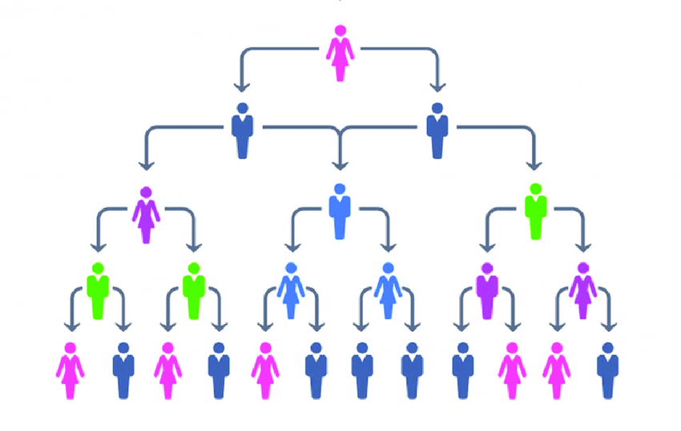
When I had previously worked in a team we used the hierarchical team structure, this method is used for the basis of most team structures (asana, 2023). The hierarchy is displayed as a pyramid, shown in figure 4 (ResearchGate, 2008-2023). This meant that we had 1 leader overlooking the whole group and giving us updates to how much progress we have made throughout. Although now and again someone would miss out on what was said previously, so extra time was lost either trying to catch that person up or by them carrying on with their previous task that is unnecessary. I feel like rather than having just one leader but instead we could all say what are strengths and weaknesses are before starting the project so that we can all focus on what we are good at so that we can get the job done quicker. Also, instead of having one person that we all had to report to we would all be able to communicate with each other on where we all were in our individual tasks. This method would also reduce confrontation as everyone would have been equal.
Figure 4

Chapter 5 – Personal Development Plan:

Personal Development Plan

Name – Emily Dawes
Degree – HND Automotive, Motorcycle & Motorsport Engineering
Previous Qualifications – BTEC Level 3 Diploma in Advanced Manufacturing Engineering
Previous Experience -
Long Term Goals (5 to 10 years)
To work within the WRC.

Short Term Goals (0 to 5 years)
Complete University and pass my degree.

Goal | Objective | Resources Required | Measurement | Target Date
Start a project car. | Buy a 2005 Subaru. | Money, time and space. |  | 1 – 3 years
Pass my degree. | Pass the first year. | Take notes during lectures (to look back on), ask someone if something does not make sense and revise (time). |  | 3 years
Work within the WRC. | Pass my degree. | Time and motivation. |  | 5 – 10 years
Get a full-time job. | Complete university. | My degree and CV. |  | 3 – 5 years

Conclusion:

In conclusion engineers have many roles and responsibilities, they are required to follow health and safety protocols, relevant legislations and must consider the code of conduct. It is important that they understand the impacts that they have on society and the environment and what they can do to reduce any negative effects. It is important that they record their progress and that communication is key, as if they do not then crucial information could be lost or forgotten about, leading to back tracking the target date and them having to retrace their steps as well as others.

References
Anon., n.d. [Online].
asana, 2023. Team structure: 10 effective ways to organize your team. [Online]
Available at: https://asana.com/resources/team-structure
[Accessed 1st December 2023].
Engineering Council / RAE, 2023. Guidance on Sustainability. [Online]
Available at: https://www.engc.org.uk/sustainability
[Accessed 1st December 2023].
HSE, 2017. Local exhaust ventilation (LEV): workplace fume and dust extraction. [Online]
Available at: https://www.hse.gov.uk/lev/
[Accessed 1st December 2023].
HSE, 2023. Hearing protection. [Online]
Available at: https://www.hse.gov.uk/noise/hearingprotection.htm
[Accessed 3rd December 2023].
IMechE, 2021. Code of Conduct Regulations. [Online]
[Accessed 23rd November 2023].
Lean Enterprise Institute, 2000-2023. 5 Whys. [Online]
Available at: https://www.lean.org/lexicon-terms/5-whys/
[Accessed 30th November 2023].
Lucidchart, 2023. 7 steps of the decision-making process. [Online]
Available at: https://www.lucidchart.com/blog/decision-making-process-steps
[Accessed 30th November 2023].
ResearchGate, 2008-2023. Hierarchical Organizations. [Online]
Available at: https://www.researchgate.net/figure/Hierarchical-diagram-representing-organisational-structure-more-power-less-instances-on_fig1_345373144
[Accessed 1st December 2023].
Semrush Blog, 2008-2023. SWOT Analysis: What It Is & How to Do It [Examples + Template]. [Online]
Available at: https://www.semrush.com/blog/swot-analysis-examples/
[Accessed 30th November 2023].

