

TITLE
“The impact of Brexit on supply chain management strategies of UK automotive businesses operating in the European Union”

Student Name: Md Anowar Hossain Student ID: 2332526

Supervisor Name: Dr Laila Maazouz
Date of Submission: March 14, 2025

Table of Contents
1. Introduction 3
1.1 Background 3
1.2 Rationale 4
1.3 Problem Statement 5
1.4 Aim and Objectives 5
2. Literature Review 7
2.1 Role of the EU in Supply Chain Management Strategies of Businesses 7
2.2 Impact of Brexit on the Supply Chain Management Strategies of Businesses Operating in the EU 7
2.3 Theoretical Framework: Porter’s Value Chain Theory 8
2.4 Literature Gap 9
3. Proposed Methodology 11
3.1 Research Philosophy 11
3.2 Research Approach 11
3.3 Methodological Choice 11
3.4 Research Strategy 11
3.5 Time Horizon 11
3.6 Data Collection 12
3.7 Data Analysis 12
3.8 Ethical Considerations 12
1.5 Research Timeline 13
References 14

1. Introduction
Brexit has greatly affected the UK and its trading partners’ trade and supply chain management (SCM) operations. European supply chain management-related costs have influenced firms in the UK belonging to the automotive industry to redesign their strategies (Du, Oleksandr Shepotylo and Yuan, 2025). This study examines the changes driven by Brexit in the current SCM processes, the modifications made, and the methods used to enhance the resiliency of SCM in the current arrangements.

1.1 Background
Before Brexit, the UK automotive industry had a strong trading connection with the EU as the free movement of goods and services enhanced the industry. It was also evident that about 42% of the export market of automotive products went to EU countries while 50% of the imported automobiles came from the EU (Bailey et al., 2023). The industry applied JIT manufacturing where sub-assemblies were imported as they were required thus minimizing storage costs. However, Brexit introduced several factors that distorted the above-mentioned model of cooperation and created obvious difficulties regarding the increase in delivery time, higher prices, and problems with regulation (Li et al., 2019).
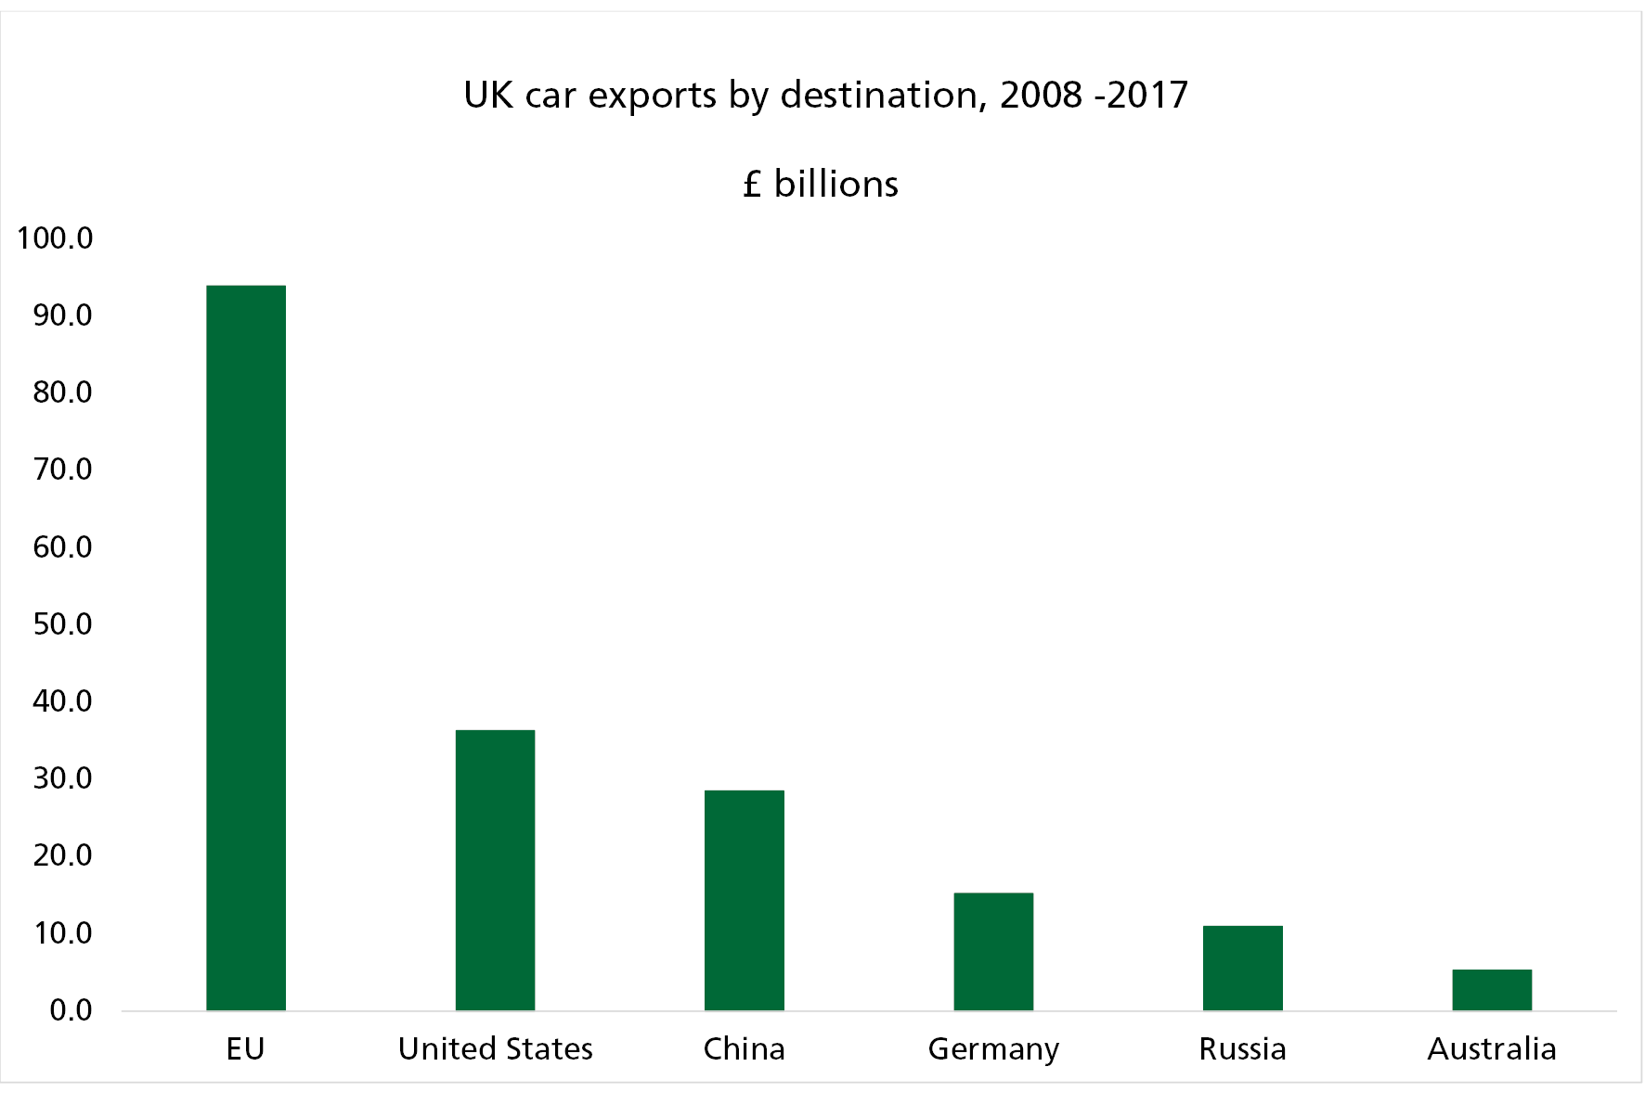
Figure 1: The impact of Brexit on the automotive sector https://publications.parliament.uk/pa/cm201719/cmselect/cmbeis/379/37908.htm
One of them is the disruption of customs checks and border controls. Before, goods could be shipped between the UK and the EU without any customs formalities but due to Brexit, a series of paperwork, origin declaration, and other compliance requirements are required. This means that there will be doubt in the cargo delivery times, which will halt the production of items that depend on consistent delivery of materials. It has also lengthened procedures and added to the costs that the business incurs in undertakings, relating to formalities and requirements of new trading regulations (Rosenthal, 2018).
The automotive supply chain has not been left behind by the effects of Brexit since this sector has been greatly affected by the financial implications of Brexit in the UK. Existing literature proves that Brexit costs about £7 billion every year to the UK-EU trade due to trade barriers (Thissen et al., 2019). Tariffs that govern the imports of automotive parts have been changing constantly, and firms have also had to grapple with delicate issues to do with VAT. In response, many businesses since the problem causes long lead times have opted to order and store raw materials and components that could take longer to get to avoid another nightmare situation, but this has added more costs to the business through storage (Jucyte, Kumar, and Ruan, 2021).
To address some of these challenges, a few automobile industries in the UK have acted by decentralizing their production lines to Europe to enable easy market access into the EU. It also makes sure that companies ought to be able to conduct their business deals without having to go through extensive customs formalities while operating within the rules of the European Union. However, such movements require capital investment and changes in the corporate structure, which might not be financially manageable in some companies. Therefore, many businesses have found a solution in the diversification of suppliers and digitalization of supply chains (De Ruyter et al., 2020).

1.2 Rationale
Brexit has brought about disruptions to Operations and SCM in UK automotive industries and therefore how the firms have prepared to counter the disruptions. Brexit has caused hurdles in the form of trade barriers, shifts in regulations and increases in costs, hence affecting supply chain costs and effectiveness (Moradlou et al., 2021). The European Union is still considered the largest trading partner within the UK since a total of 42% of exports and 50% of imports involve EU countries (Webb and Ward, 2025). However, the emerging barriers such as other new checkpoints, tariffs and documentation procedures have raised costs and hindered competitiveness.
Financially, it has been catastrophic for businesses especially since Britain decided to leave the European Union. As of 2017, the United Kingdom could have possibly been a victim of a loss of over £44 billion in public investment trading due to Brexit complications (Office for Budget Responsibility, 2022). The British Chambers of Commerce (2022) states that 77% of the importing companies in the UK suffer from higher costs because of new barriers in commodities importation. These increasing costs have made firms put in place measures such as shifting the supply chain from one country to another such as shifting from Asia to Europe; others approached supplier diversification and others approached digitalization...
Beyond costs, the disruption of supply chains has impacted operational stability in various ways. Organizations have experienced extended supply lead times, delayed component deliveries, and economic and legal risks that disrupted JIT manufacturing techniques. It is therefore important to establish how UK automotive businesses have adapted to resulting disruptions in supply chain resilience caused by Brexit. Thus, this research will add to the body of tax knowledge, and it will also be valuable in identifying and providing real-life solutions for dealing with the challenges (Bailey et al., 2023).

1.3 Problem Statement
The UK has been a gateway for foreign manufacturers who sought to access the EU market, but this role has been affected by Brexit. They include increased costs of production, delays in the supply chain, and regulatory problems that are not favourable to the business. Previous studies show that fifty-two per cent of UK business organizations felt the negative impact of Brexit on their supply chain as the cost of imports and exports was reported to have risen by thirty per cent (Spital and Aerssen, 2023).
This disruption has affected companies that rely on the just-in-time supply chain model forcing them to experience delivery delays of approximately two to three days. Furthermore, 49% of the firms in the UK showed their concern about new compliance requirements (Ye, Suleiman and Huo, 2022). Thus, the following strategies should be implemented by the firms to address the above-discussed impacts:

1.4 Aim and Objectives
Aim
This research aims to analyse the effect of Brexit on supply chain management (SCM) strategies of UK automotive businesses operating in the EU. It will specifically examine how Brexit-related trade barriers, regulatory changes, and logistical challenges have influenced supply chain decisions and strategic adaptations within the automotive sector.
Objectives
- To evaluate the role of the EU in shaping the SCM strategies of UK automotive businesses.
- To analyse the impact of Brexit on the SCM strategies of UK automotive businesses operating in the EU.
- To identify and recommend strategies to mitigate the adverse effects of Brexit on SCM strategies for UK automotive businesses operating in the EU.
Research Questions
- RQ1: What role has the EU played in shaping the SCM strategies of UK automotive businesses?
- RQ2: How has Brexit impacted the SCM strategies of UK automotive businesses operating within the EU, particularly in terms of trade barriers, logistics, and costs?
- RQ3: What approaches can UK automotive businesses adopt to mitigate the adverse impacts of Brexit on their SCM while maintaining seamless operations within the EU market?

2. Literature Review
Brexit has been described as a key factor that has affected the SCM strategies of UK automotive industries operating in the EU region. Due to new barriers in trade, changes in policies and cost elevation, SCM strategies have adapted in certain ways. This section discusses related literature concerning the position of the EU as a key supply chain influencer, some effects of Brexit, and theoretical perspectives constituting the basis of this study.

2.1 Role of the EU in Supply Chain Management Strategies of Businesses
Before Brexit, the UK automotive sector used to be heavily aligned with the EU markets, and it enjoyed low levels of tariffs, harmonised legislation, and efficient relationships on the supply chain. This meant to open free access to the common market and provide easier procedures for moving automotive components across the EU countries (Dimitrios Paraskevadakis and Adeyeri Ifeoluwa, 2022).
Regulatory convergence was another significant strength for UK businesses whereby automotive products complied with EU safety and emission regulations. Some of the following reasons are the regulatory consistency which led to cutting down costs and minimizing compliance expenses. EU financial support to transport infrastructure and enhancement of logistics networks, especially through the trans-European transport network (TEN-T), enhanced supply chain productivity (Europa.eu, 2021).
However, Brexit interrupted this environment, leading UK firms to question supplier partnerships, supply channels, and stock holdings. The firms have been able to experience high trade costs due to the use of many documents and clearances due to the loss of unrestricted market access. Numerous companies have had to look for needless suppliers, bring production processes closer to the home market, or set up distribution hubs in the EU to avoid borders and address legislation concerns (Thissen et al., 2020).

2.2 Impact of Brexit on the Supply Chain Management Strategies of Businesses Operating in the EU
Custom checks, longer borders, and newly arising trade barriers have severely affected the SCM of automotive organizations in the UK. Brexit entails that firms must present adequate documentation to ensure that they access the various services with reduced tariffs in line with the UK-EU Trade and Cooperation Agreement (TCA) (European Commission, 2020).
Regulatory divergence has become an issue for these UK firms due to the UK safety standards and emissions standards being different from those of the EU. In the past, there was one certification process, but Brexit has caused parties to have another layer of certification that has raised the administrative burden and extended the time needed to approve the products (Albachiara Boffelli et al., 2020).
There has been an increase in lead time for JIT manufacturing which was once popularised by car manufacturing industries. The growth of supply chain problems has led to inventory build-up to avoid some disruptions affecting the storage cost and flexibility of operations (Serohi, 2020).
Moreover, Brexit has resulted in labour shortages, especially in the transport sector and logistics, which have caused a rise in tender prices and an unfavourable impact on the supply of chain services. Another reason for slow and delayed SCM is the scarcity of HGV drivers and customs personnel, which is a considerable problem for automotive businesses in the UK (Ambedkar, 2024).
However, the continued disruption of Brexit across the UK and global supply chain has forced most organisations to develop strategic outlooks for SCM to address its risks. Some of the digital supply chain applications implemented in businesses include artificial intelligence in managing logistics and supply chain planning as well as the application of blockchain in supply chain tracing (Rauniyar et al., 2022). Some have moved some of their operations to the outside of the border of the United States to continue serving this market without interference.

2.3 Theoretical Framework: Porter’s Value Chain Theory
To measure the disruption that Brexit caused on SCM tactics, this present work adopts Porter’s Value Chain Theory and examines how firms gain competitive advantage through supply chain operations. According to Porter (1985), it was possible to differentiate between primary and support activities whereby the former includes activities such as inbound logistics, operations, and outbound logistics while the latter includes some activities such as procurement and infrastructure development.
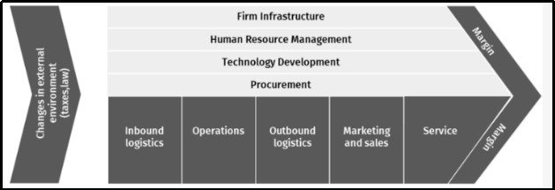
Figure 2: Value Chain Theory of Porter
https://www.mdpi.com/2076-3387/13/2/35
Brexit disrupts many aspects of the value chain including sourcing and purchasing, operations, marketing and sales and delivery. Inbound logistics have also been affected critically by some decisive factors which include customs entry formalities, higher tariffs and supply chain escalation (Rosenthal, 2018). Challenges flow from the regulatory environment changes that have impacted operations, scarcity of labour and higher compliance costs have also been realised. Outbound logistics have been affected by the borders and transportation constraints resulting in slow delivery procedures of products and increased costs of distribution (Jucyte, Kumar, and Ruan, 2021).
However, Porter’s Value Chain Theory is still considered not comprehensive enough to evaluate SCM strategies regarding geopolitical risks and policy-driven trade disruptions (Dale, 2022). To compare the strategies of UK automotive firms this study incorporates external threat factors including the trade barriers occasioned by Brexit in the application of its model.

2.4 Literature Gap
There is a research gap that has been identified in the current literature: how UK automotive organizations have positioned their SCM strategies amidst Brexit. There is, however, a general extensive literature review of macroeconomic effects, trade liberalisation and regulations, but at the micro level little emphasis is put on the actual operational changes undertaken.
Moreover, most of the existing literature focuses on the temporary effects of Brexit, whereas the long-term changes of SCM remain largely unexplored. There is also a shortage of research done at the sector level that covers the automotive sector which certainly has its peculiarities in terms of logistics and regulations because it is the sector that is fully integrated into the global supply chains.
This research will fill this gap by conducting a comprehensive examination of SCM post-Brexit changes, which are diversification of suppliers, digitalization, and regulations compliance. It will discuss past SCM experiences with trade barriers and the findings shall be of use in future planning and formulation of sound policies.

3. Proposed Methodology
This research methodology will be adopted to analyse the impact of Brexit on supply chain management (SCM) strategies of UK automotive businesses operating in the EU.

3.1 Research Philosophy
The study will adopt an interpretive philosophy, which will focus on understanding subjective business experiences rather than numerical data. Since Brexit has led to complex SCM disruptions, this approach will be suitable for analysing how businesses perceive and adapt to new trade barriers and regulatory challenges (Saunders et al., 2019). Interpretivism will allow for a detailed exploration of real-world strategies in the UK automotive sector.

3.2 Research Approach
An inductive research approach will be used to develop insights based on observed patterns rather than testing predefined hypotheses (Proudfoot, 2023). Since Brexit’s effects are still evolving, this approach will allow the study to explore how UK automotive businesses are modifying their SCM strategies, forming conclusions based on emerging trends and qualitative data.

3.3 Methodological Choice
A qualitative research method will be adopted to enable an in-depth exploration of Brexit’s impact on supply chains (Denzin and Lincoln, 2018). This method will allow for the analysis of business responses, supplier diversification, and regulatory adaptation, making it more suitable than a quantitative approach, which would focus on statistical trends.

3.4 Research Strategy
A case study strategy will be employed to examine real-world adaptations of UK automotive businesses in response to Brexit. This strategy will enable an in-depth investigation of how companies are restructuring their supply chains, providing insights into business resilience, supplier relations, and regulatory compliance (Eisenhardt and Graebner, 2007).

3.5 Time Horizon
This study will be cross-sectional in terms of time to investigate post-Brexit changes in the studied supply chain context that are more current (Saunders et al., 2019). It means that the study will allow presenting industry responses at a given time to identify more recent disruptions in trade, costs, and organizational changes in UK automotive organisations.

3.6 Data Collection
Secondary data will be in the form of articles, journals, industry reports, government publications and business cases. The use of this method will enable retrieval of methodologically approved data sources hence making the research exercise more efficient unlike relying on sources obtained from first-hand research which takes so much time (Johnston, 2017).

3.7 Data Analysis
The collected secondary data will be analyzed using thematic analysis to discover patterns and repeated themes (Braun and Clarke, 2006). The analysis of Brexit’s impact on SCM will be grouped into thematic areas including regulatory impacts, impact on supply chain structure, and impacts on supplier portfolio diversification, and this will help in coming up with a meaningful analysis of the impacts.

3.8 Ethical Considerations
Ethical consideration will involve issues to do with the citation of secondary sources, impartiality and credibility of data collected. Due to these reasons, the study will adhere to appropriate ethical research practices that will highly enhance the credibility of the work, thus contributing significantly to the development of SCM literature.

1.5 Research Timeline
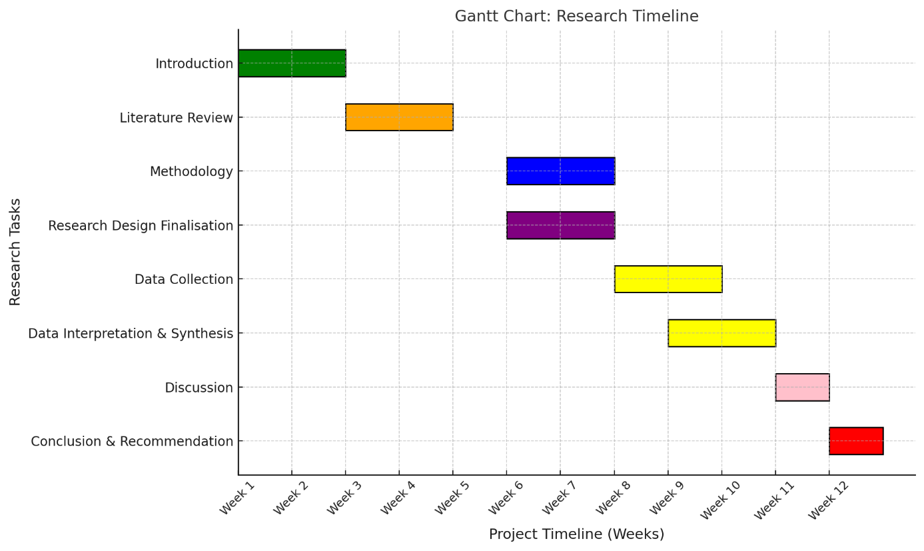
Figure 3: Gannt Chart (Source: Own)

References
Albachiara Boffelli, Golini, R., Guido Orzes and Stefano Dotti (2020). Open the box: A behavioural perspective on the reshoring decision-making and implementation process. Journal of Purchasing and Supply Management, [online] 26(3), pp.100623–100623. doi: https://doi.org/10.1016/j.pursup.2020.100623
Ambedkar, A. S. (2024). Brexit and Its Economic Impact on EU Trade Policies. Economic Review of the European Union, 7(2), 53-73.
Bailey, D., De Propris, L., De Ruyter, A., Hearne, D., and Ortega-Argilés, R. (2023). Brexit, trade and the UK advanced manufacturing sectors: a Midlands’ perspective. Contemporary Social Science, 18(2), 250–265. https://doi.org/10.1080/21582041.2023.2192700
Bailey, D., De Ruyter, A., Hearne, D., and Ortega-Argilés, R. (2023). Shocks, resilience and regional industry policy: Brexit and the automotive sector in two Midlands regions. Regional Studies, 57(6), 1141-1155.
Braun, V., and Clarke, V. (2006). Using thematic analysis in psychology. Qualitative Research in Psychology, 3(2), 77-101.
British Chambers of Commerce. (2022). Brexit Trade Deal Not Delivering - British Chambers of Commerce. [online] Available at: https://www.britishchambers.org.uk/news/2022/12/brexit-trade-deal-not-delivering/ [Accessed 14 Mar. 2025].
Dale, M. (2022). Time for Revitalisation of Value Chain Management: A Reassessment of Porter’s View on Procurement. Global Journal of Management and Business Research, [online] pp.1–11. doi: https://doi.org/10.34257/gjmbravol22is7pg1
De Ruyter, A., Hearne, D., Bailey, D., Henry, I., Li, D., and Eade, R. (2020). Regional Transport–a supply chain mapping exercise and Brexit exposure check of automotive, aerospace and rail value dependency in the WMCA region.
Denzin, N. K., and Lincoln, Y. S. (2018). The SAGE handbook of qualitative research. Sage.
Dimitrios Paraskevadakis and Adeyeri Ifeoluwa (2022). An industry-level analysis of the post-Brexit and post-Covid 19 Ro-Ro ferry market and critical maritime freight transport links between the UK and the EU. Journal of Shipping and Trade, [online] 7(1). doi: https://doi.org/10.1186/s41072-022-00127-4
Du, J., Oleksandr Shepotylo and Yuan, X. (2025). How did the Brexit uncertainty impact services exports of UK firms? Journal of International Business Policy. [online] doi: https://doi.org/10.1057/s42214-024-00202-6
Eisenhardt, K. M., and Graebner, M. E. (2007). Theory building from cases: Opportunities and challenges. Academy of Management Journal, 50(1), 25-32.
Europa.eu. (2021). Available at: https://eur-lex.europa.eu/legal-content/EN/TXT/HTML/?uri=CELEX:52021PC0812 [Accessed 14 Mar. 2025].
European Commission. (2020). The EU-UK Trade and Cooperation Agreement. [online] Available at: https://commission.europa.eu/strategy-and-policy/relations-united-kingdom/eu-uk-trade-and-cooperation-agreement_en [Accessed 14 Mar. 2025].
Johnston, M. P. (2017). Secondary data analysis: A method by which the time has come. Qualitative and Quantitative Methods in Libraries, 3(3), 619-626.
Jucyte, A., Kumar, V., and Ruan, X. (2021). Examining the Impact of Brexit on Supply Chain Risk Management: Evidence from the UK Manufacturing Sector. International Journal of Organizational Business Excellence, 4(1), 41-62.
Li, D., Shishank, S., de Ruyter, A., Ali, S., Bailey, D., Hearne, D., and Salh, S. (2019). Brexit and the auto industry: Understanding the issues for supply chain management. In Brexit Negotiations After Article 50: Assessing Process, Progress and Impact (pp. 173-191). Emerald Publishing Limited.
Moradlou, H., Reefke, H., Skipworth, H., and Roscoe, S. (2021). Geopolitical disruptions and the manufacturing location decision in multinational company supply chains: a Delphi study on Brexit. International Journal of Operations and Production Management, 41(2), 102-130.
Office for Budget Responsibility. (2022). The latest evidence on the impact of Brexit on UK trade - Office for Budget Responsibility. [online] Available at: https://obr.uk/box/the-latest-evidence-on-the-impact-of-brexit-on-uk-trade/ [Accessed 14 Mar. 2025].
Porter, M.E. (1985) Competitive Advantage. Creating and Sustaining Superior Performance. Free Press, New York, 557 p. - References - Scientific Research Publishing. [online] Available at: https://www.scirp.org/reference/referencespapers?referenceid=2038625 [Accessed 14 Mar. 2025].
Proudfoot, K. (2023). Inductive/deductive hybrid thematic analysis in mixed methods research. Journal of Mixed Methods Research, 17(3), 308-326.
Rauniyar, K., Wu, X., Gupta, S., Modgil, S. and Lopes de Sousa Jabbour, A.B. (2022). Risk management of supply chains in the digital transformation era: contribution and challenges of blockchain technology. Industrial Management and Data Systems, [online] 123(1), pp.253–277. doi: https://doi.org/10.1108/imds-04-2021-0235
Rosenthal, C. D. (2018). Strategic Supply Chain Management Implications of an Unregulated Brexit (Master's thesis, ISCTE-Instituto Universitario de Lisboa (Portugal)).
Saunders, M., Lewis, P., and Thornhill, A. (2019). Research methods for business students. Pearson.
Serohi, A., (2020). Sustainable supply chain of automobile sector: a literature review. Int J Supply Chain Manag, 9, pp.82-87.
Spital, T. and Aerssen, van (2023). The impact of Brexit on UK trade and labour markets. European Central Bank. [online]
Thissen, M., Oort, F. van, McCann, P., Ortega-Argilés, R. and Husby, T. (2019). The Implications of Brexit for UK and EU Regional Competitiveness. SSRN Electronic Journal. [online] doi: https://doi.org/10.2139/ssrn.3440574
Thissen, M., van Oort, F., McCann, P., Ortega-Argilés, R., and Husby, T. (2020). The implications of Brexit for UK and EU regional competitiveness. Economic Geography, 96(5), 397-421.
Webb, D. and Ward, M. (2025). Statistics on UK-EU trade. [online] House of Commons Library. Available at: https://commonslibrary.parliament.uk/research-briefings/cbp-7851/ [Accessed 14 Mar. 2025].
Ye, Y., Suleiman, M.A. and Huo, B. (2022). Impact of just-in-time (JIT) on supply chain disruption risk: the moderating role of supply chain centralization. Industrial Management and Data Systems, [online] 122(7), pp.1665–1685. doi: https://doi.org/10.1108/imds-09-2021-0552

