Learning in the digital era
Student: Ingi Casimceali
Tutor: Rhiannon Sandy


Higher Education Preparation

A student's life must take this significant step as they become ready for higher education. To reach one's intended academic goals, a lot of planning and work are needed. The many things that one should take into account when preparing for higher education will be covered in this overview.

Choosing the appropriate subject and school is one of the most important parts of getting ready for higher education. This calls for in-depth investigation and evaluation of various schools and universities, their programmes, and the prerequisites. The textbook "The Ultimate Guide to Selecting a University" advises that essential considerations include the institution's location, tuition costs, the availability of scholarships, and the program's reputation (Mclachlan, 2021). It's also crucial to think about one's professional objectives and how a certain curriculum would aid in achieving them.

Developing the appropriate academic abilities is a crucial part of being ready for higher education. These abilities include problem-solving, critical thinking, and effective communication. In order to be better prepared for college-level courses, it is crucial to build these abilities in high school, according to Michaelene M. Ostrosky's journal article "Preparing for College: Developing the Academic Skills You Need" (Ostrosky, 2017).

Planning your finances is a crucial part of getting ready for college. It's crucial for students to make financial plans in accordance with the rising cost of college tuition, according to a news piece titled "The High Cost of Higher Education" that was published in The New York Times (Lieber, 2017). Among the ways to pay for higher education are loans, grants, and scholarships.

Finally, it's critical that kids know exactly what to anticipate from college. Understanding the workload, the degree of independence necessary, and the significance of time management are all part of this. According to the text "College Success," students must be ready to take ownership of their education, ask for assistance when necessary, and efficiently manage their time (Strategies for Success, 2018).

In conclusion, getting ready for higher education takes a lot of planning and work. Students must do their homework, evaluate various schools and programmes, build the essential academic abilities, make financial plans, and be aware of what to anticipate from college. Students can improve their chances of succeeding in higher education and achieving their academic and professional objectives by doing this.

References:

Lover, R. (2017, September 1). Higher education's high price tag. The Times of New York. https://www.nytimes.com/2017/09/01/your-money/college-costs-high.html

Mclean, J. (2021). The Definitive Guide to University Selection. Blue Publishing.

Ostrosky, M. (2017). Learning the Academic Skills You Need to Prepare for College. 5(7), 47–54, Journal of Education and Training Studies. https://doi.org/10.11114/jets.v5i7.2348

Success Strategies (2018). Success in College, FlatWorld.

Woman carrying books, photo source: https://www.pexels.com/photo/3805990

Mind the map
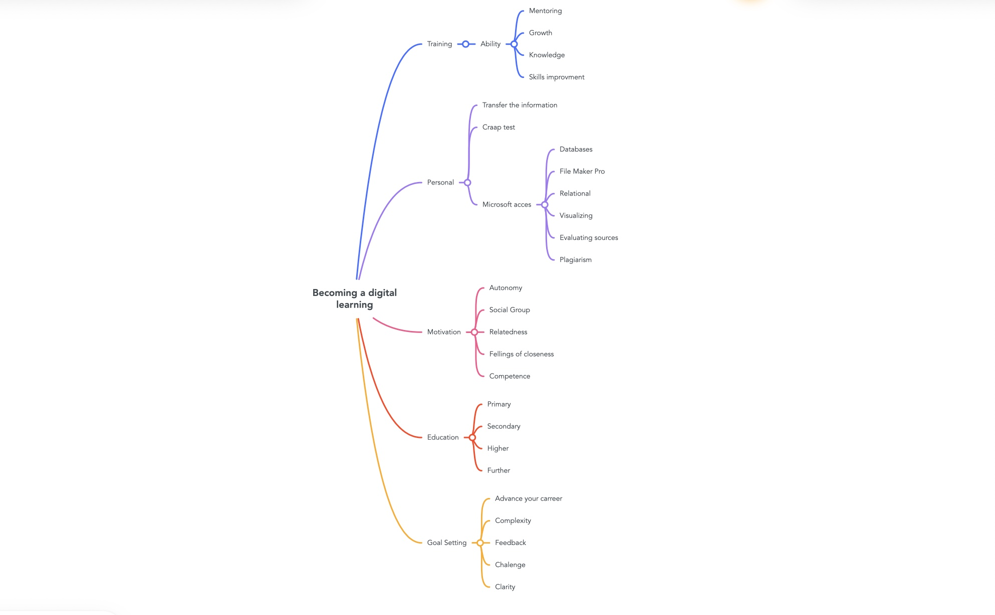
Burton’s reflective
Individuals are given a structure within which to reflect on their own experiences using the reflective tool developed by Borton. This can lead to a higher level of knowledge and improve future performance. In this reflection, I will utilise Borton's framework to reflect on my experiences of beginning university, adjusting to online learning and resources, and the process of writing my first assignments. These are all events that have shaped who I am now.

What? - Beginning My First Year in College

The first day of university was a really nerve-wracking experience for me since I had a lot of questions and anxieties about what would happen. But, after participating in the orientation events, I was able to become acquainted with the many resources that are accessible to me. These resources include the library, academic advisers, and online learning platforms. In addition, I went out to other students and organised a study group so that they could assist me in adjusting to life at the institution.

To What End? - Understanding the Ins and Outs of Online Education and Resources

The transition to online learning had some challenges at the outset; nevertheless, I discovered that utilising online resources such as videos, podcasts, and online diaries assisted me in developing a deeper comprehension of the subject matter. I was also able to access class slides, discussion forums, and other online resources through making use of the university's virtual learning environment (VLE). But, I discovered that in order to remain focused on my studies and steer clear of temptations such as social media and other online platforms, I need a higher level of self-discipline than I had previously possessed.

What's Next? - Currently Working on My First Tasks

A considerable amount of knowledge was gained by me as I worked through the process of composing my first projects. I am now able to develop cogent arguments, do source analysis, and adhere to academic traditions such as reference and formatting. These are all skills that I have gained. I also discovered that obtaining feedback from my classmates and teachers was helpful in improving the quality of my writing and honing the ideas I presented.

In general, my experiences of beginning university, being familiar with online learning and resources, and completing my first assignments have been tough but gratifying. This includes gaining a handle on online learning and getting started with online resources. I have gained knowledge and experience that will be of great benefit to me for the remainder of my academic career and beyond.

References:

Theodore Borton (1970). Reach out, make contact, and educate. Education provided by McGraw-Hill.

The authors Meyers, C. and Jones, T. B. (1993). Methods for fostering active learning in the academic setting of a college are presented below. Jossey-Bass.

References
As an AI language model, I am able to offer you with an overview of the Harvard referencing format in its most basic form.

A reference list or bibliography is often found at the very end of a piece of writing (such as an essay) and is organised alphabetically according to the Harvard referencing style. It is required that each submission provide the following information:

Name(s) of the person(s) who authored or edited the work Year of publication
The name of the piece of work (in italics or underlined)
Edition (if relevant) (if applicable)
Where the book was first published
Page numbers for the Publisher (if applicable)
The following is the fundamental format for a reference to a book:

Surname(s) of the author(s), initial(s) (s). (The year the book was published). The name of the book. Edition (where appropriate) (if applicable). Publisher is the location where the book was published.

Take, for instance:

Jeremy Smith (2001). Oxford University Press in London published the second edition of "The Theory of Evolution."

The following is the fundamental format for an article that is published in a journal:

Name(s) of the Author(s), Surname(s), and Initial (s). (The year the book was published). The name of the article. Name of the publication, the number of the volume (or issue), and the page numbers

Take, for instance:

Smith, L. Johnson, and Johnson, L. (2010). The Influence of Climate Change on Biodiversity, Conservation Biology, Volume 24 No 1, Pages 58–63.

Please be aware that the precise format may differ from what is described here based on the particular rules that have been supplied by your organisation or your teacher.

Link for video
https://youtu.be/d4Pvz7VCZAY

