Network Operating Systems and Security
Assignment 1
Worksheets Screenshots Lecturer: Terry Walcott BSc Cloud Computing – term 4
Ralitsa Nikolova (Student ID: 1806089)

Introduction
The current document is concerned with the Assignment Worksheets of Assignment 1 for Network Operating Systems and Security module. It contains screenshots of the completed Practical Tasks followed by a brief description.
This paper presents an independent work executed entirely by the author and no group work was conducted during the process.
For the purposes of this assignment, Oracle VM VirtualBox was used as a hypervisor which gave the possibility of installing four virtual machines – two servers and two client workstations.
The operating systems used on the two server machines is Windows Server 2008. They were configured to have two network adaptors each which created a public network connection between the two servers and a private network between a server and a corresponding client.
The two client machines had Windows 7 installed on them. They were configured with one network adapter each, which completed the connection between each client and its corresponding server.
An administrator account was created for each machine and log on credentials were given.

screenshots of Worksheets 1-5

WS 1: Building the NOS infrastructure using Active Directory (AD)

Task 1
- Installing Active Directory Domain Services on Server 1
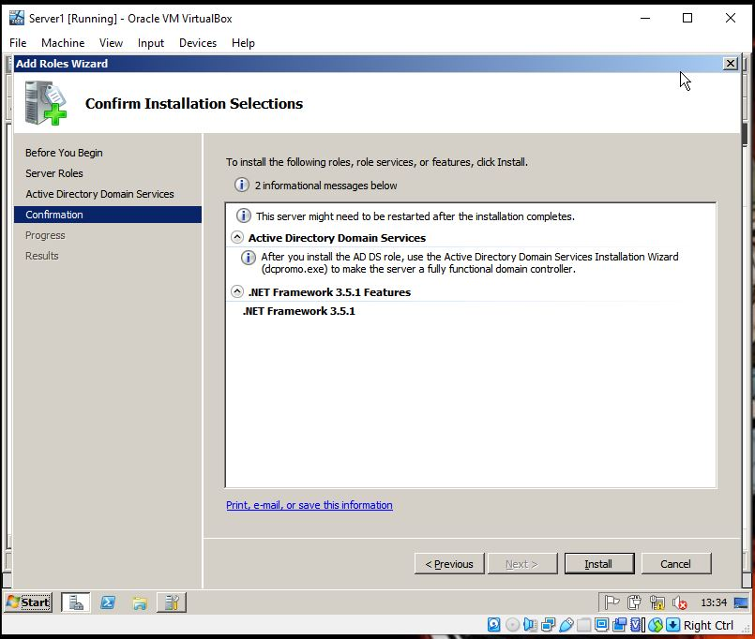
Figure 1

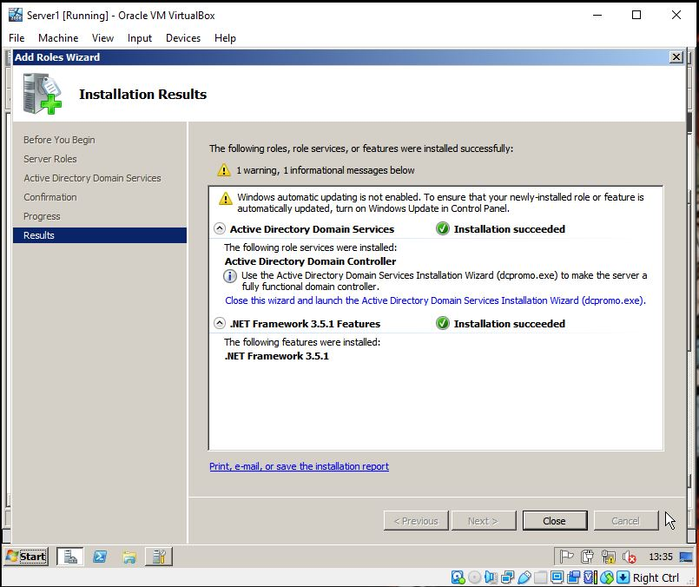
Figure 2

- IP configuration of Server1:
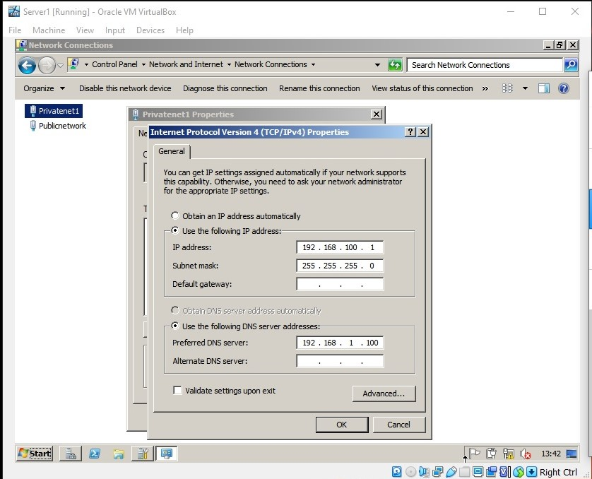
Figure 3
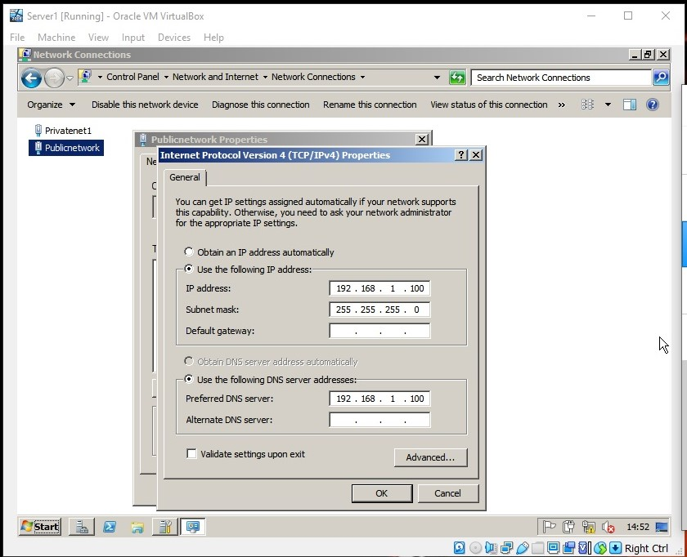
Figure 4
- Creating an Active Directory Domain
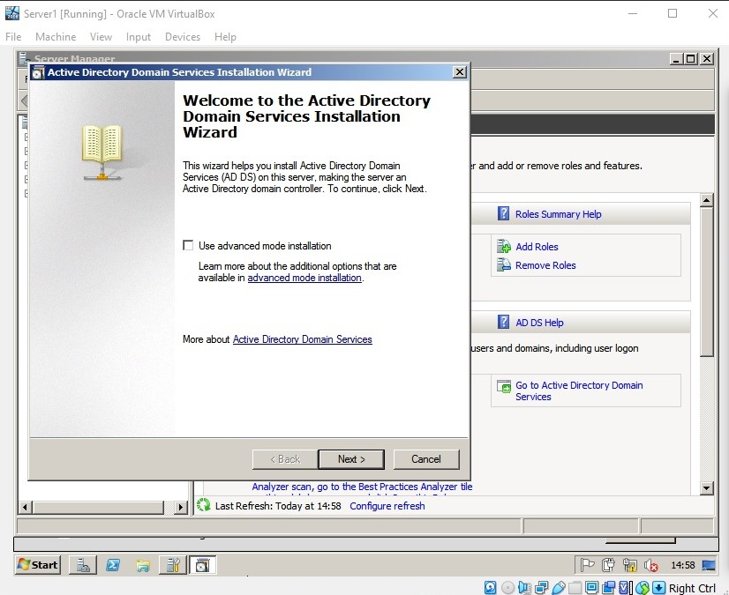
Figure 5
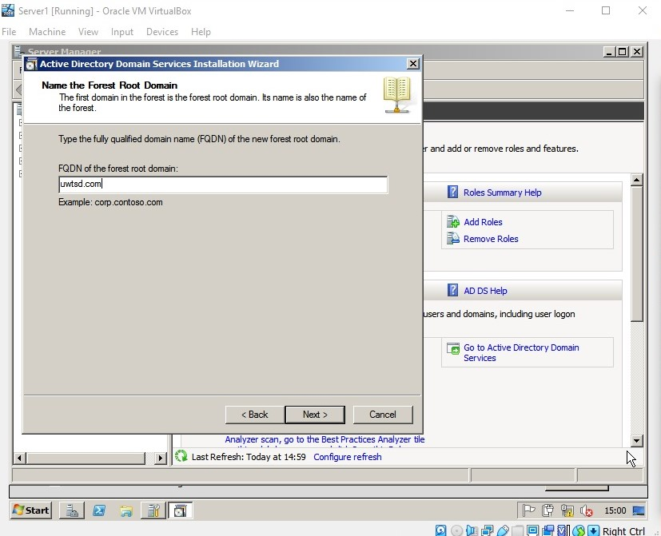
Figure 6
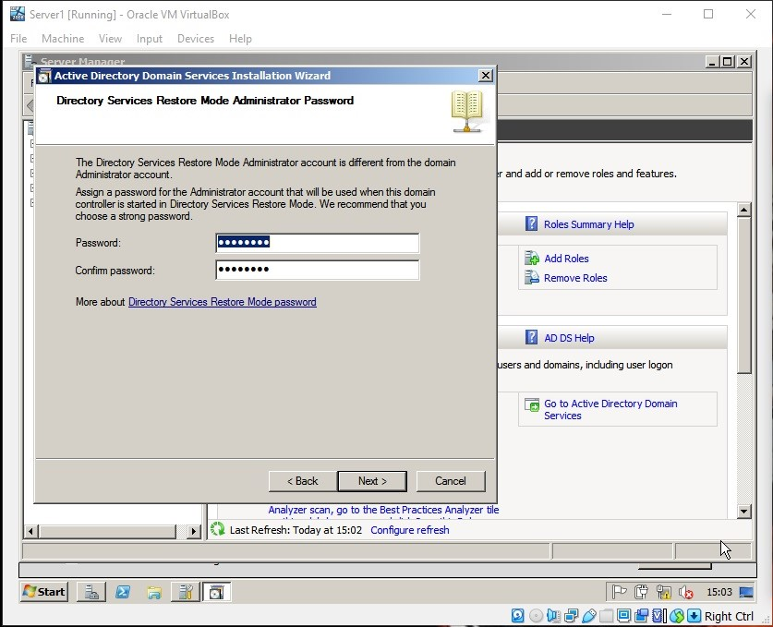
Figure 7
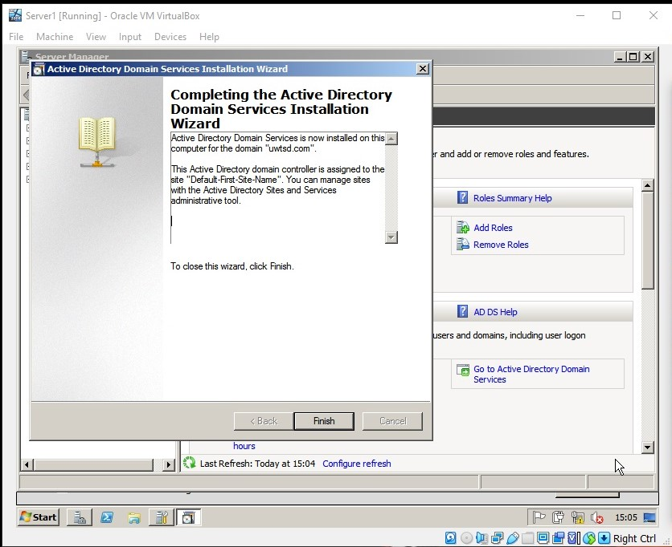
Figure 8
After completing Task 1, Server1 is configured as a Domain Controller. A root domain is created - uwtsd.com and an administrator password is given for administering the domain (Figure 7), which password is never used again during this exercise. The administrator password for the domain remained the one created for the logon account in the beginning of the exercise, despite the fact that a different one was assigned as shown in Figure 7.

Task 2
- Creating new object in AD
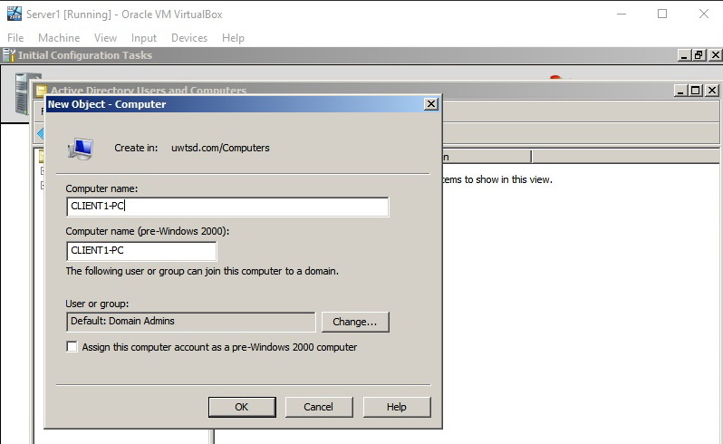
Figure 9
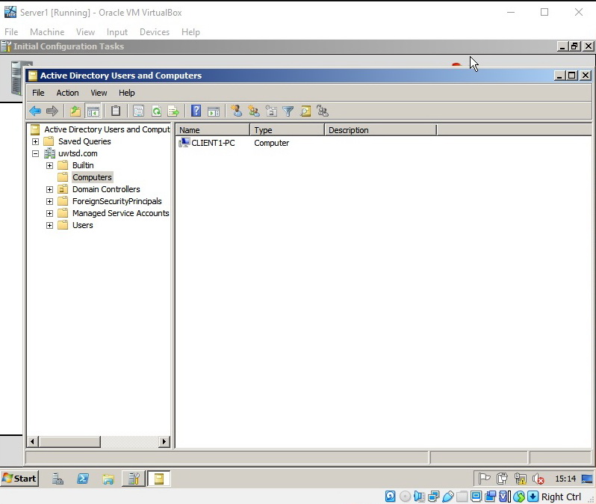
Figure 10
- Configuring the client’s machine and connecting it to the created domain
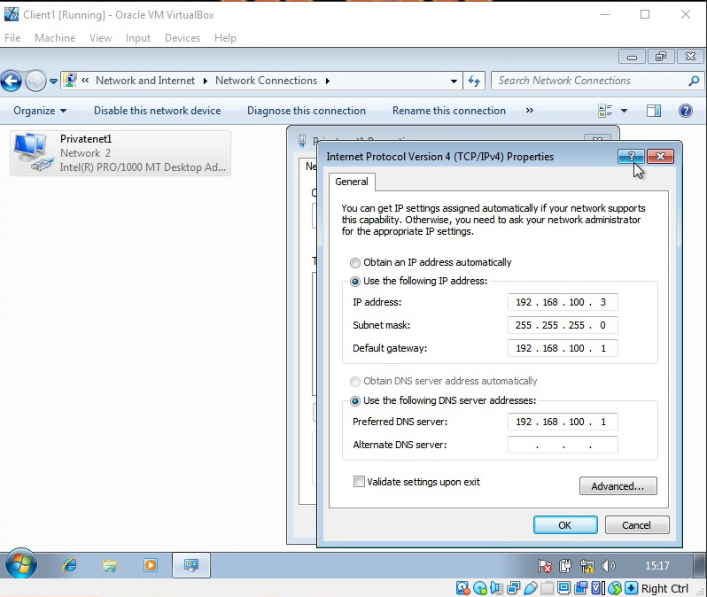
Figure 11
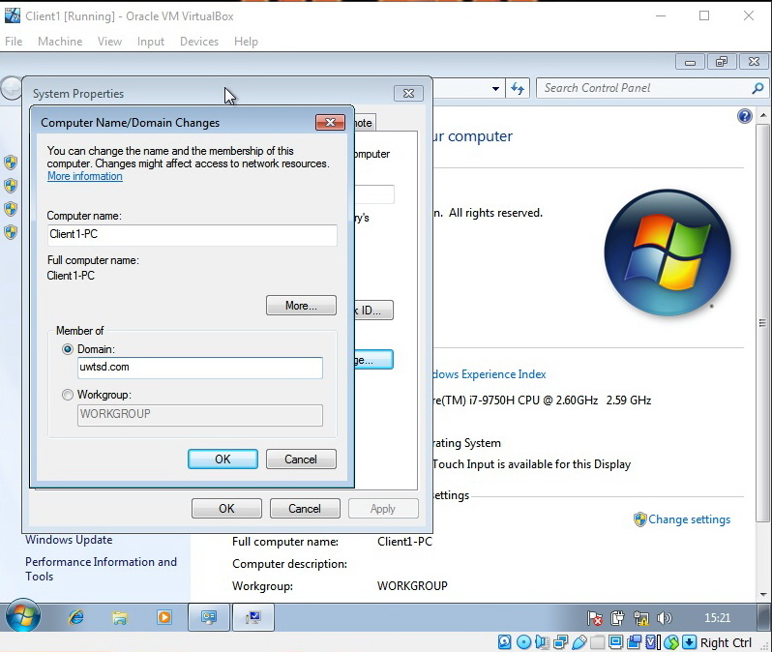
Figure 12
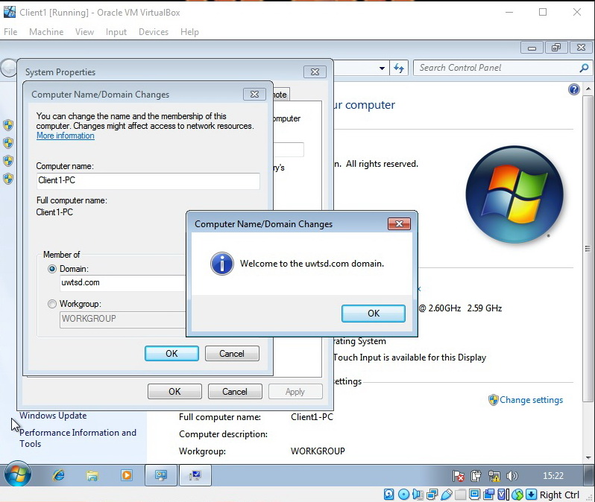
Figure 13
After completing Task 2 Client1 is successfully configured with the appropriate IP addresses and connected to the domain created in Task 1, by authenticating with the administrator username and password for Server1.
Both tasks ere completed with a side note that Server1 in this case plays the role of a gateway router as well as a DNS server.

WS 2: Resource Management in AD: Users, Computers and Groups

Task 1
- Creating parent and child organizational units:
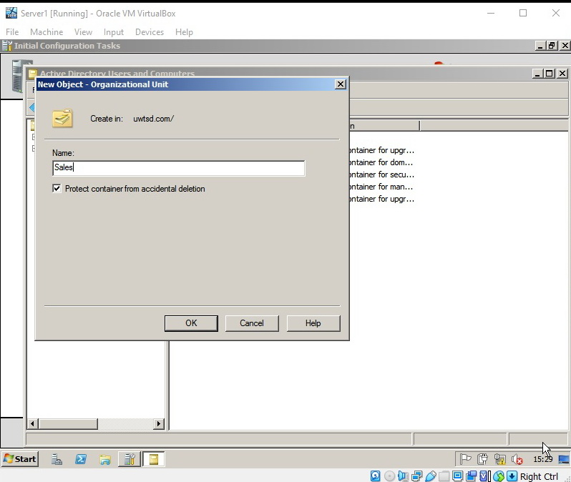
Figure 14
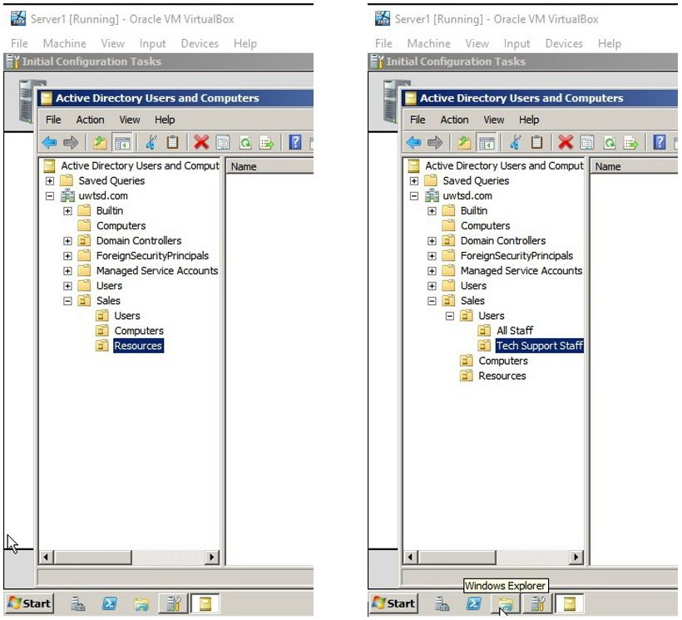
Figure 15

Task 2
- Configuring the password policy settings
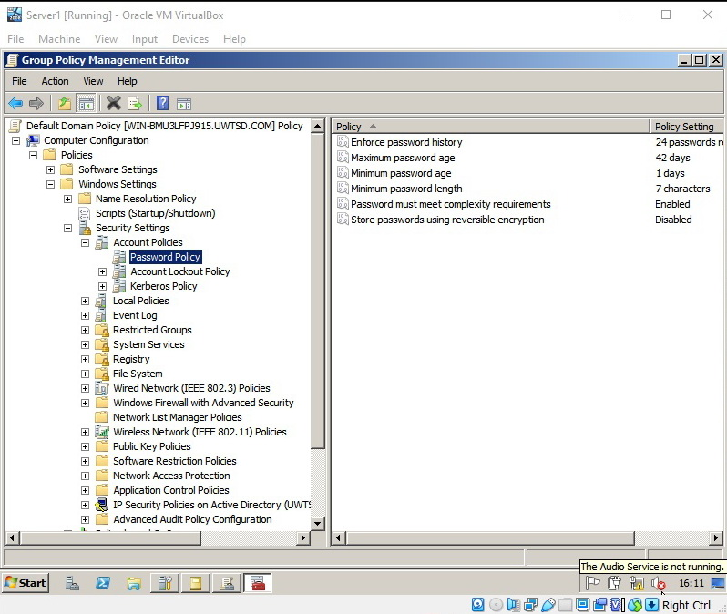
Figure 16
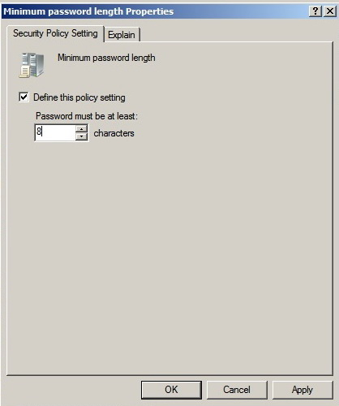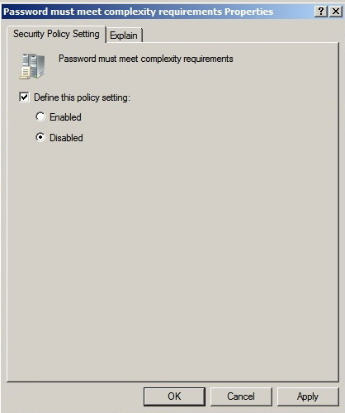
Figure 17
- Configuring the number of attempts for logon after which the account is going to lockout.
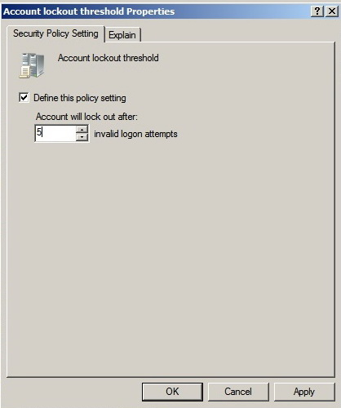
Figure 18
- Creating and configuring user accounts
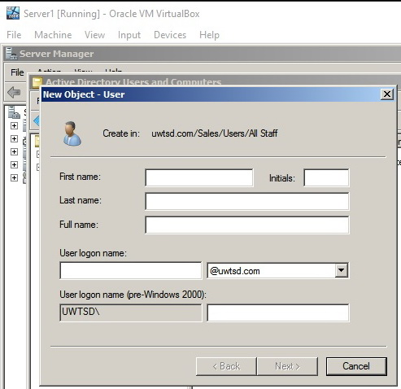
Figure 19
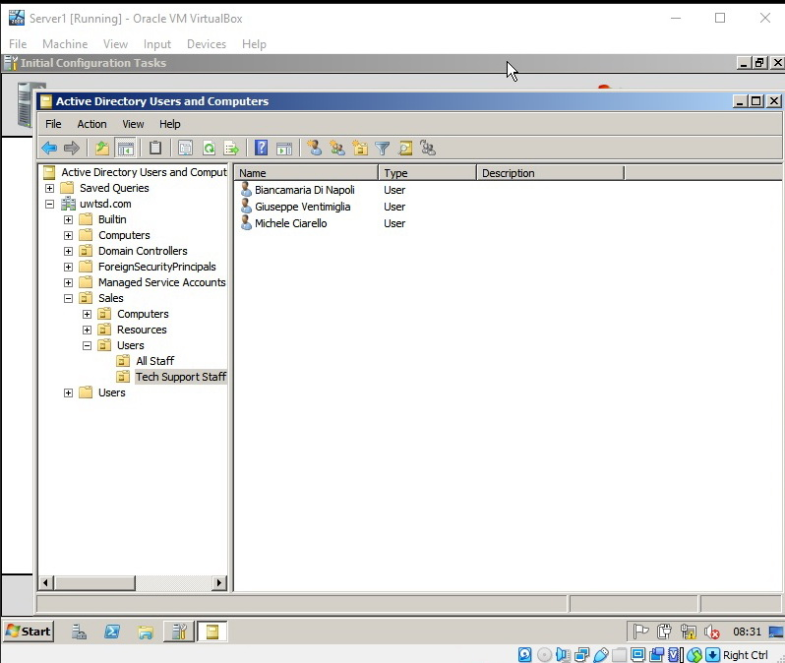
Figure 20
- Disabling a user account
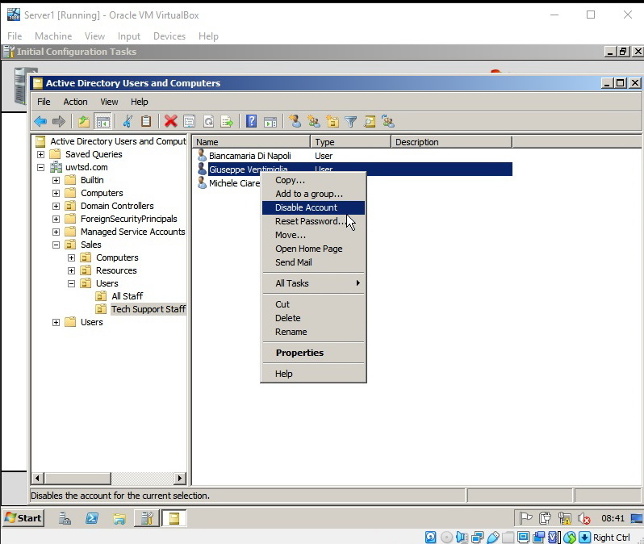
Figure 21
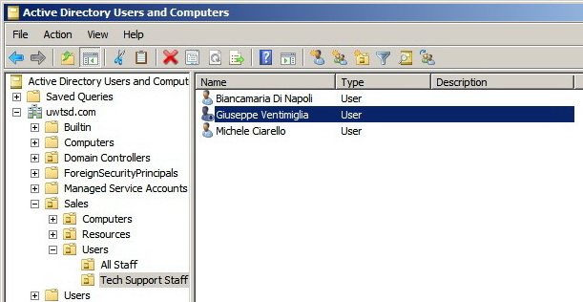
Figure 22

After disabling the account, when the user attempts to logon, he gets a message on the logon screen saying that this user account has been disabled.
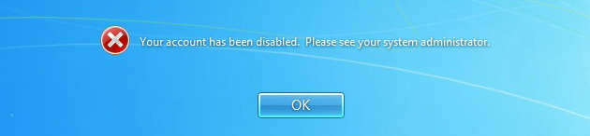

- Resetting a user’s password
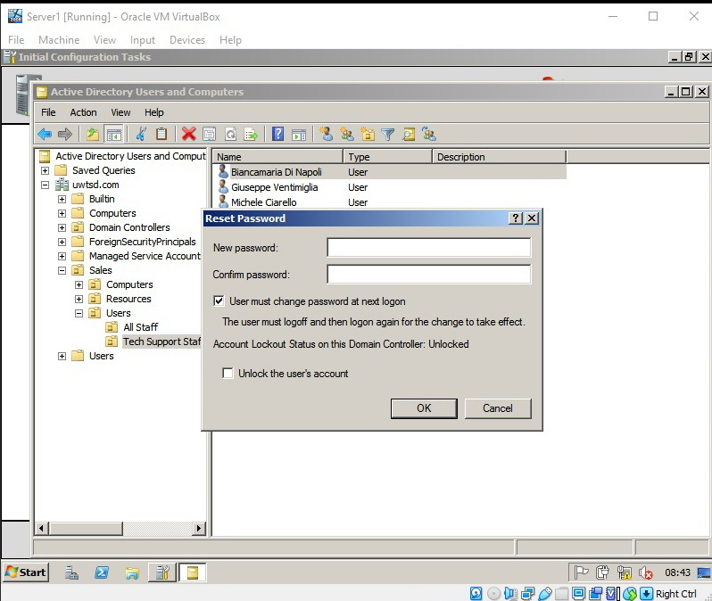
Figure 23
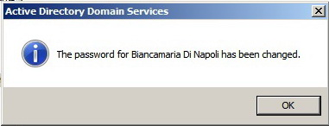
Figure 24
If the user tries to logon with his old password, he gets the following message:
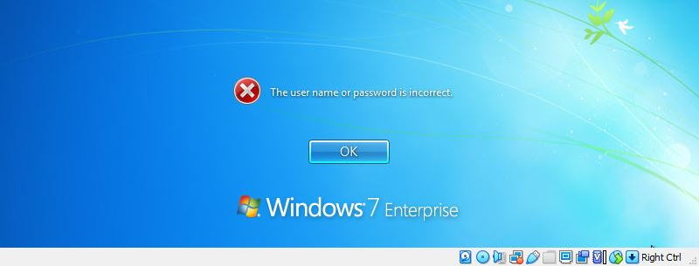
Figure 25
- Searching a user account in Active Directory
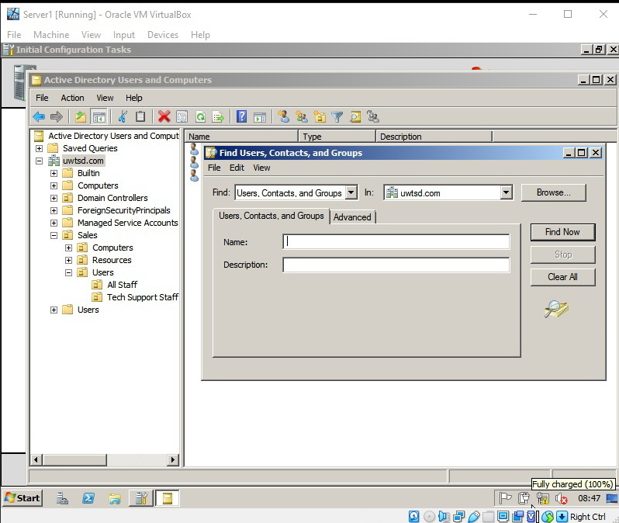
Figure 26
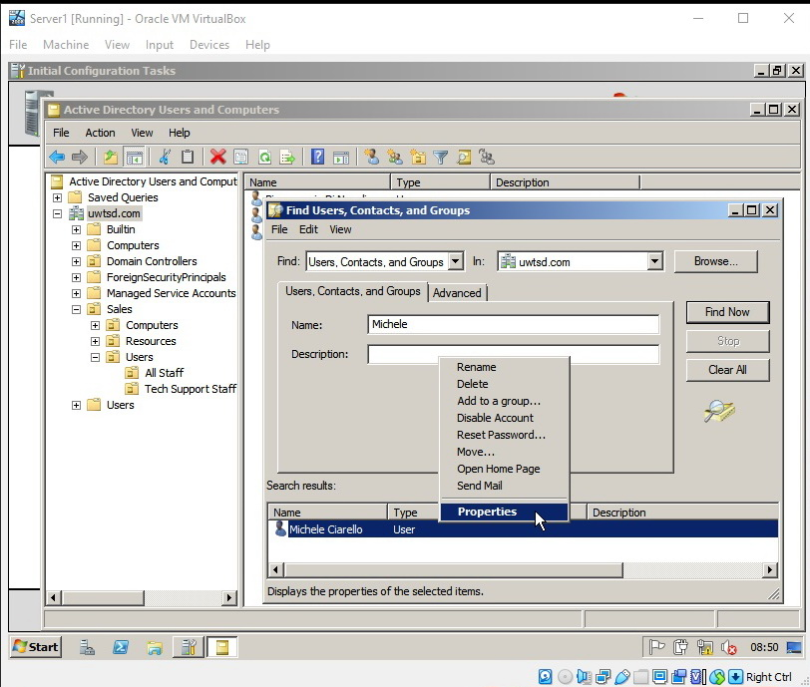
Figure 27
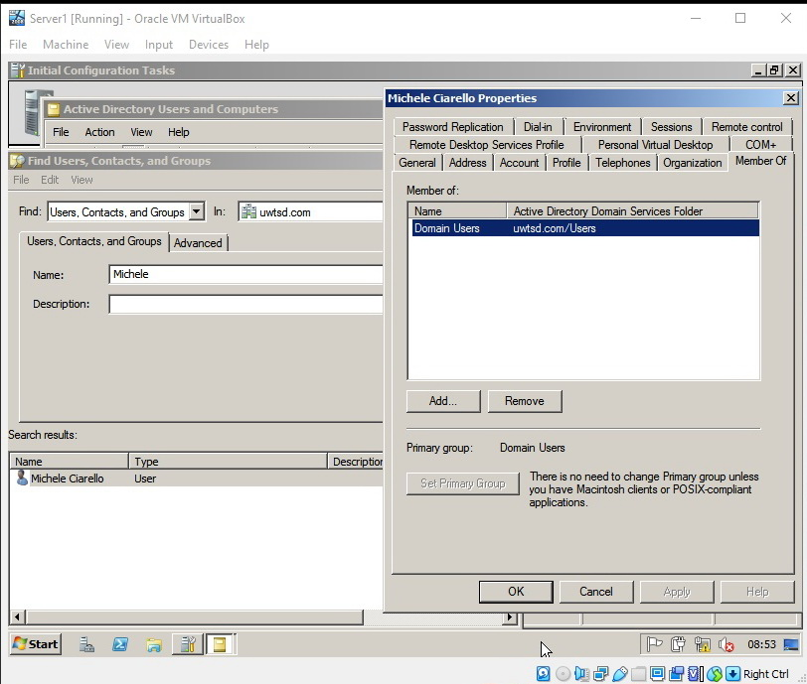
Figure 28
In the above figure it is visible that the user is a member of the Users OU in uwtsd.com domain but it is not visible that the user is actually a member of the child OU – Tech Support Staff, which can be seen in Figure 20.

- Creating new group objects in the child OUs – All Staff and Technical Staff, and adding user accounts to them.
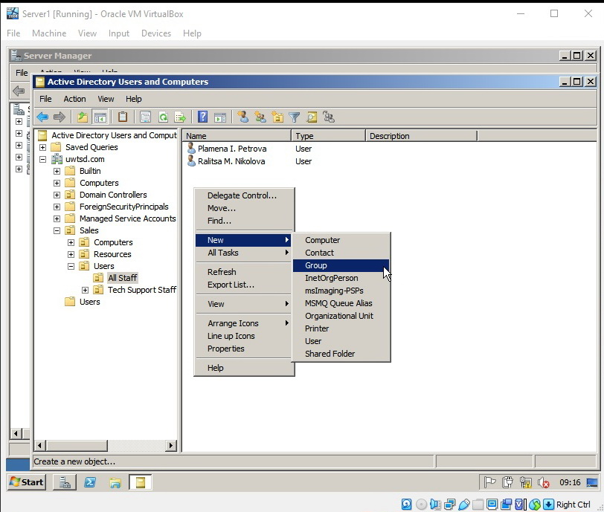
Figure 29
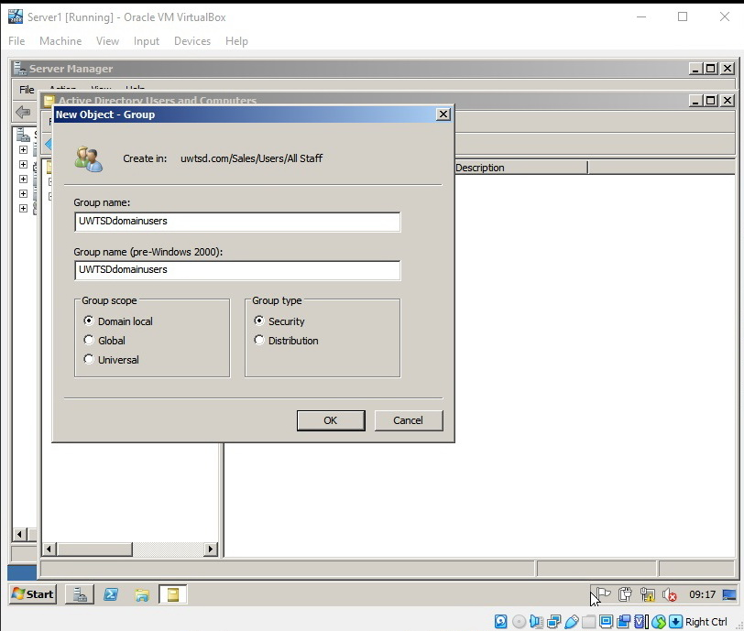
Figure 30
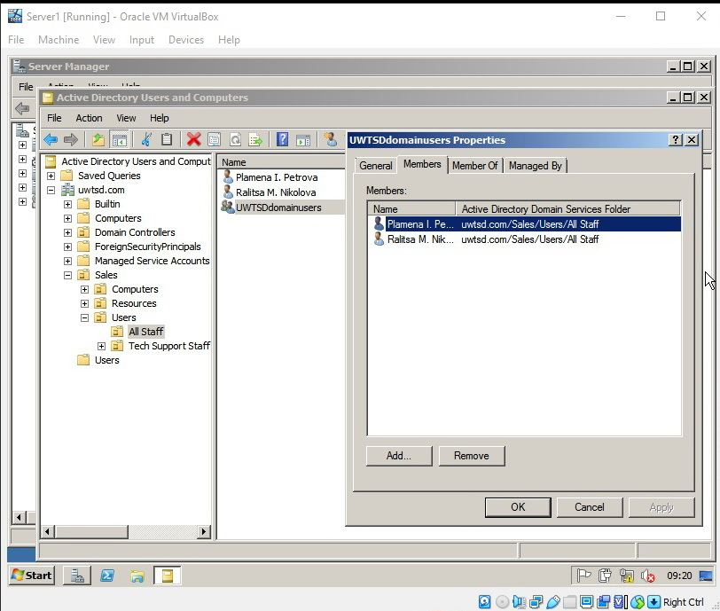
Figure 31
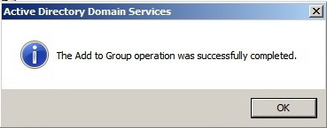
Figure 32
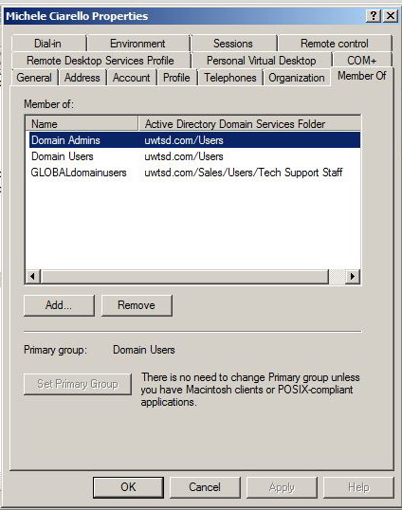
Figure 33
The user accounts from the OU – All Staff were added to the new group UWTSDdomainusers (Figure 31). The user named Michele Ciarello was added to the newly created group - GLOBALdomainusers, which is visible on Figure 33.

WS 3: Resource Management in AD: Managing Access to Files and Folders, and Controlling Domain User Environments

Task 1
- Creating a folder on the desktop of Server1 and configuring its share permissions. The following figures show the kind of permissions assigned to the groups GLOBALdomainusers and UWTSDdomainusers for this folder.
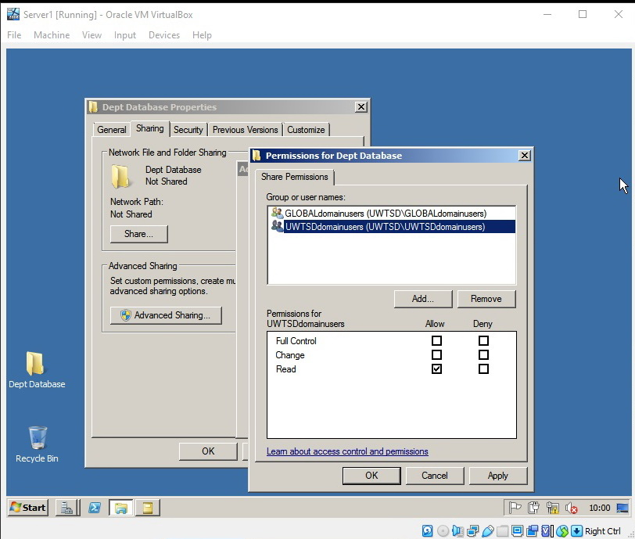
Figure 34
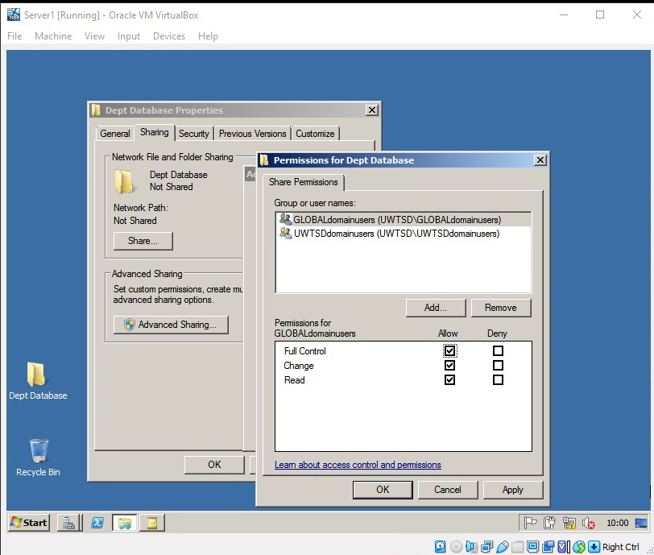
Figure 35
- Configuring NTFS permissions for the content of the created folder.
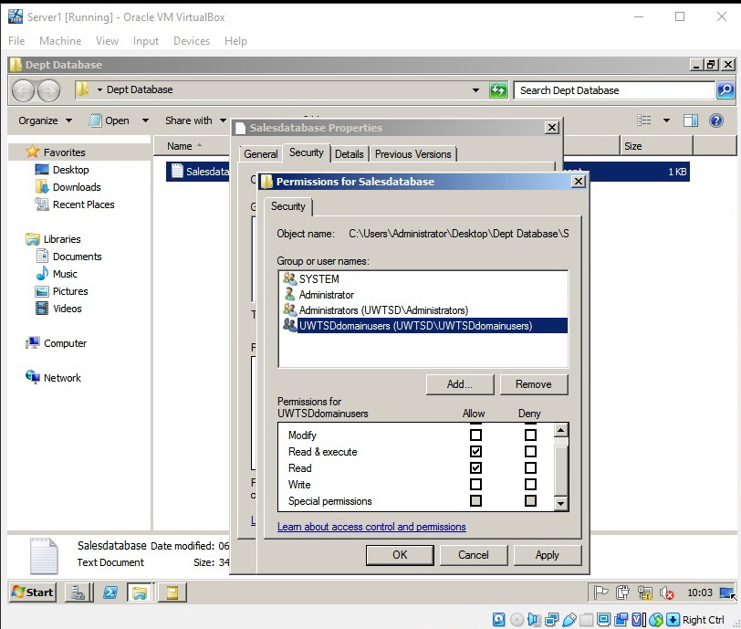
Figure 36
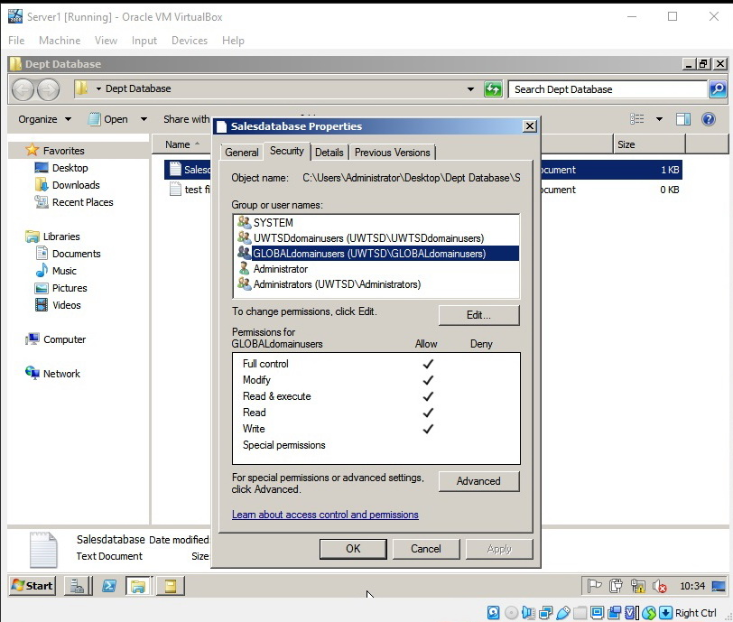
Figure 37

- Mapping the network drive and attempting to access the created folder and its content.
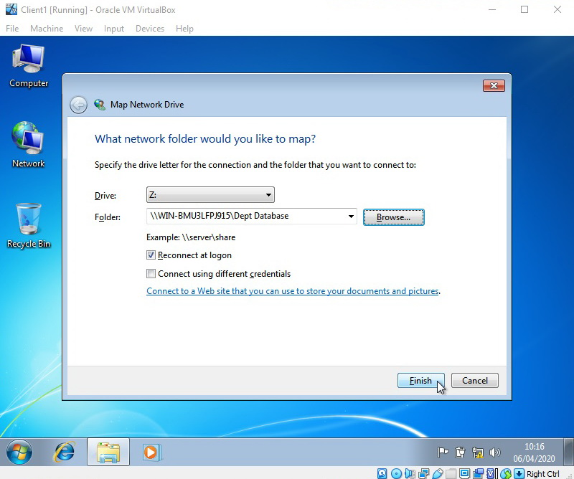
Figure 38
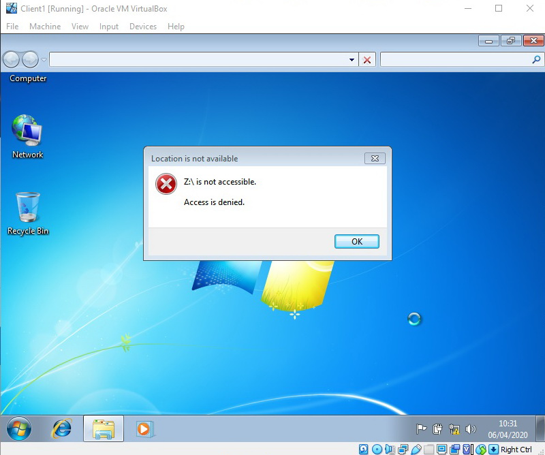
Figure 39 – Access with read permissions
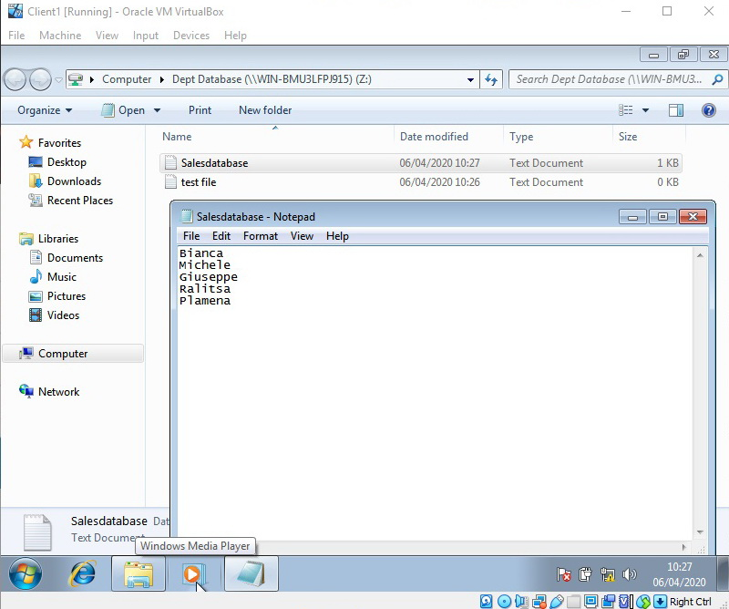
Figure 40 – Access with full permissions
After trying to access the folder with both read permissions and full permissions, the results are visible from Figure 39 and Figure 40.

Task 2
Task A was done in Worksheet 2.
Task B. Configuring group policy.
- Creating a new Group Policy Object which will disable the ability of the user to use the right click functionalities.
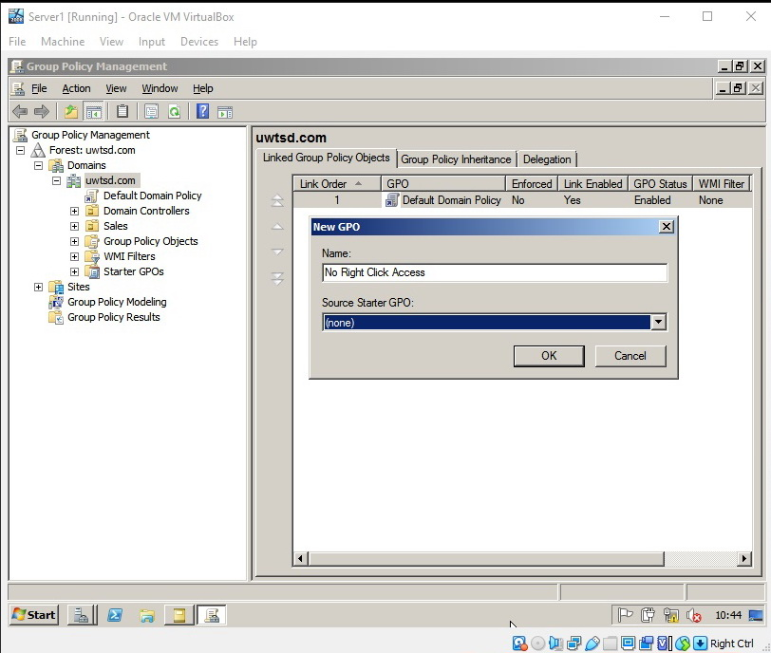
Figure 41
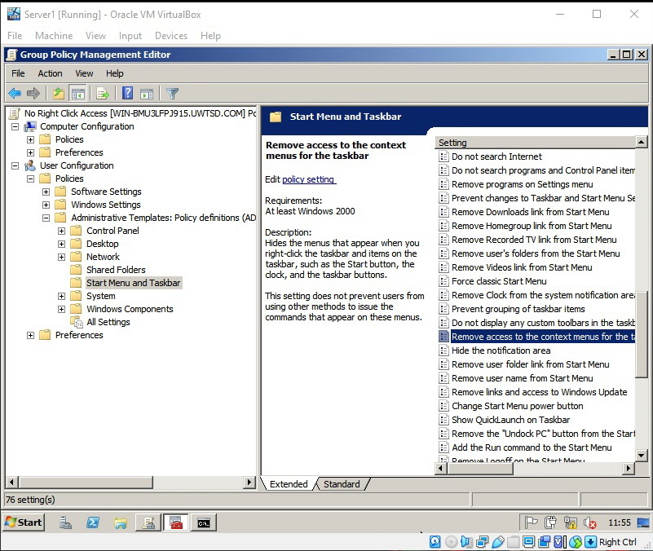
Figure 42
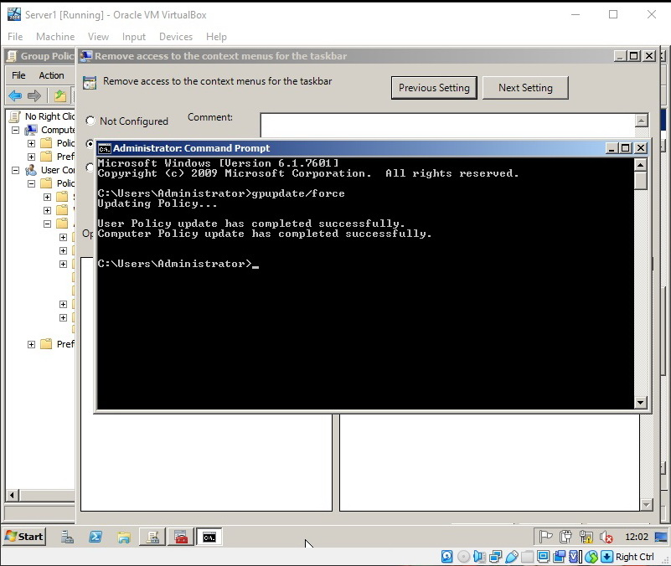
Figure 43
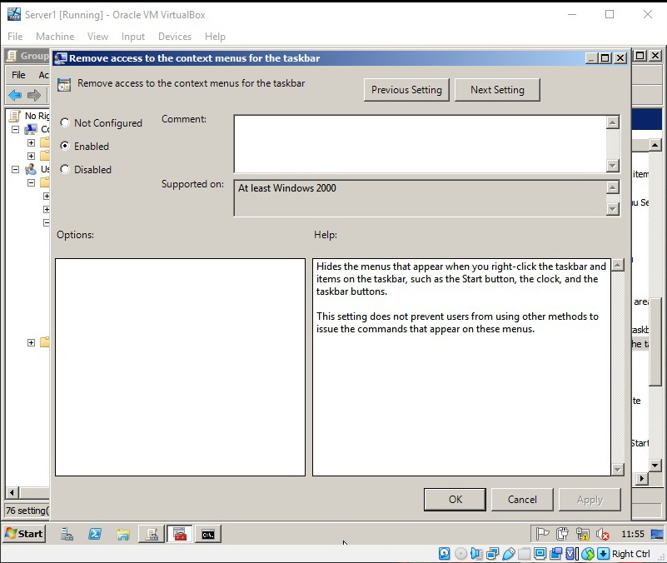
Figure 44
After completing the task, a test was conducted and the result was that only the right click on the taskbar was disabled. The right click on the desktop still worked.

WS 4: Network Administration Using DHCP

Task 1
- Installing DHCP Service on Server1.
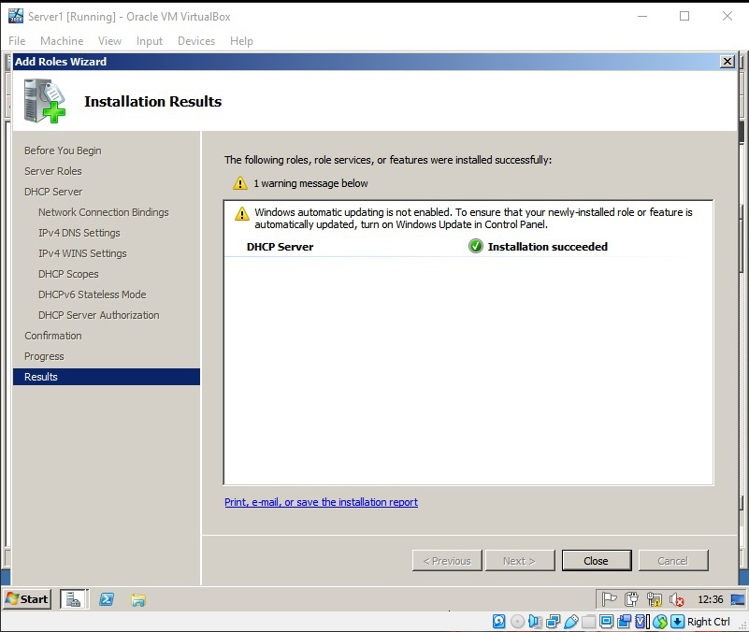
Figure 45
- Creating and activating a DHCP scope called SalesClient
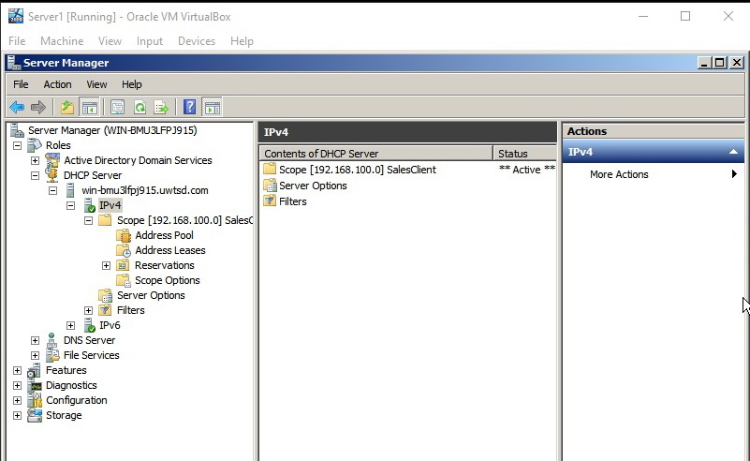
Figure 46
- Configuring the client’s IP settings to automatically obtain IP addresses from the DHCP service.
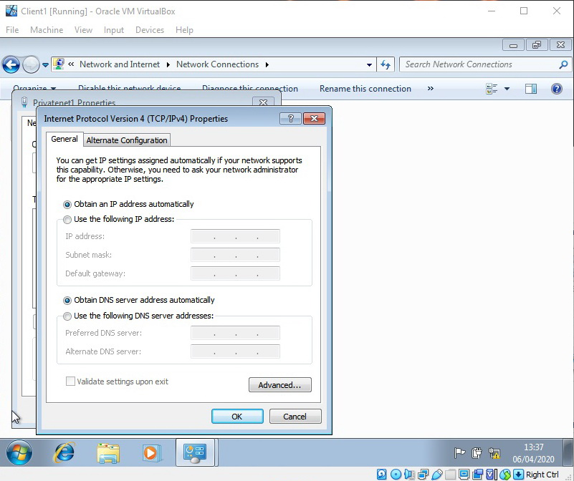
Figure 47
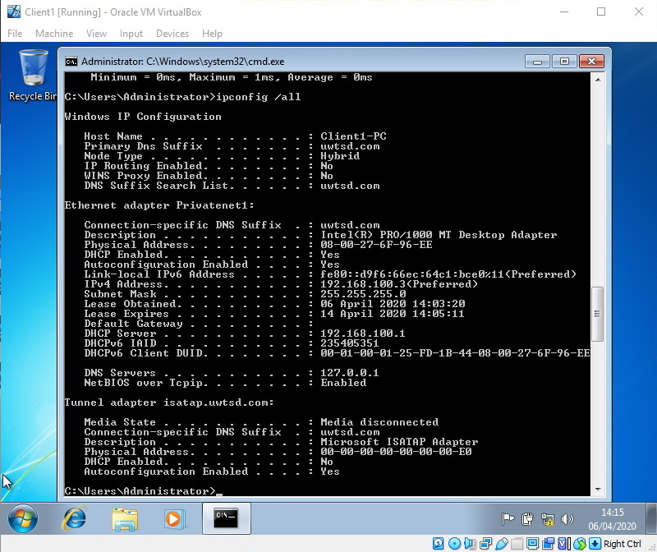
Figure 48
From the above figure is visible that the DHCP Server IP address is the same as the Server1’s IP address, where the DHCP services were installed.

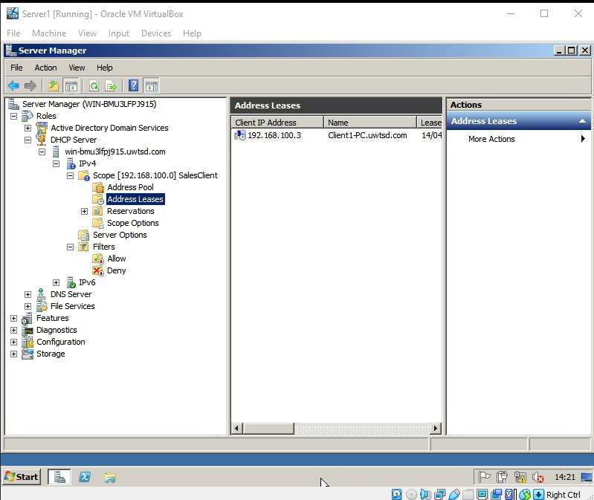
Figure 49
From the above figure is visible that the Computer name is that of the client.

- Configuring DHCP Scope options:
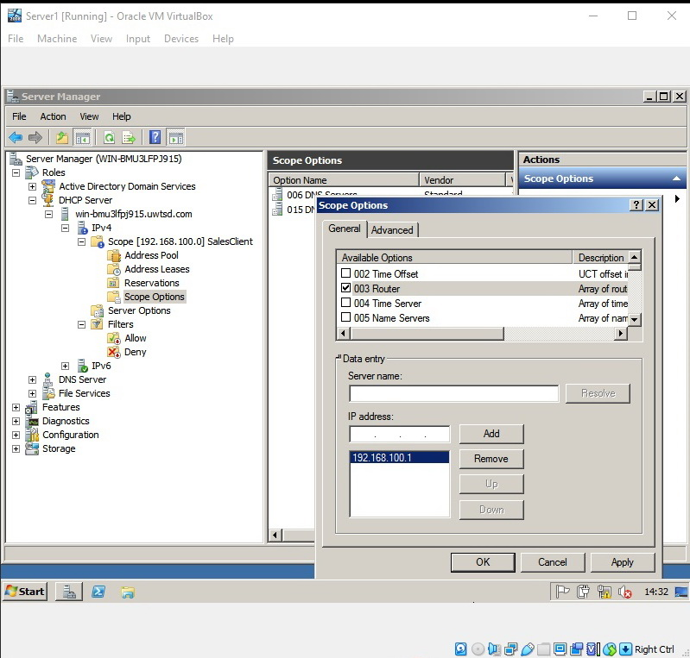
Figure 50
- Testing DHCP Options: Figure 48

WS 5: Planning and Deploying DNS in the Network Infrastructure

Task 1
It should be noted that at the beginning of the exercise, the virtual machines were called Server1 and Server2, but the names were not changed through the operating system, so they remained WIN-BMU3LFPJ915 for both of the servers (the reason is, because they were created by cloning). This is shown in the following screenshot:
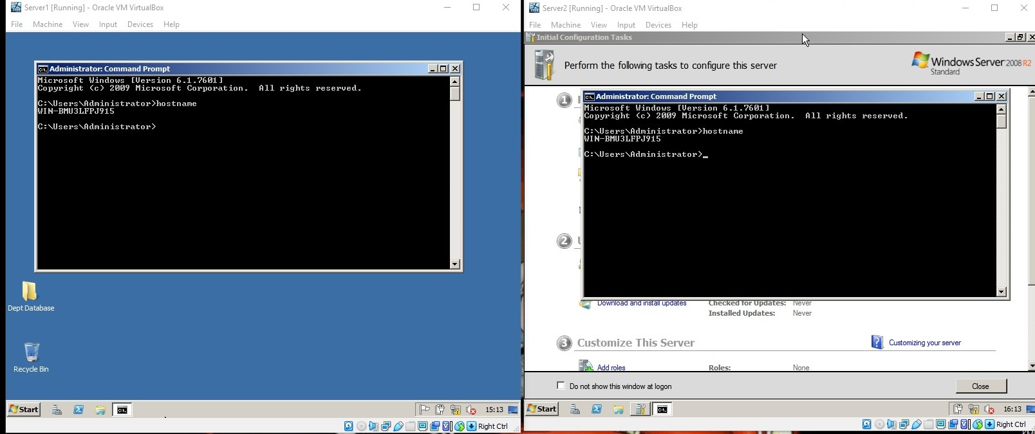
Figure 51

The next screenshot shows the Full Qualified Domain Names of both machines, where is visible that Server1 is a part of uwtsd.com domain.

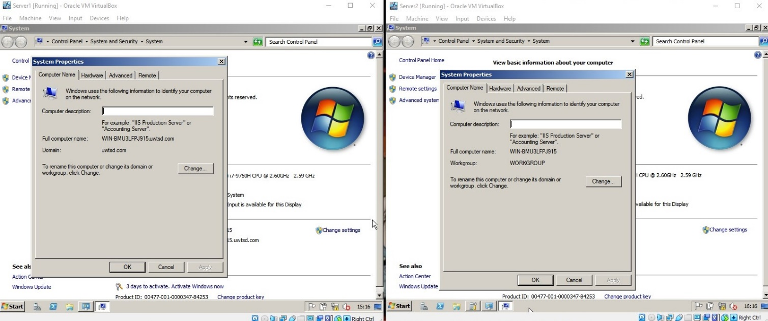
Figure 52

Task 2A
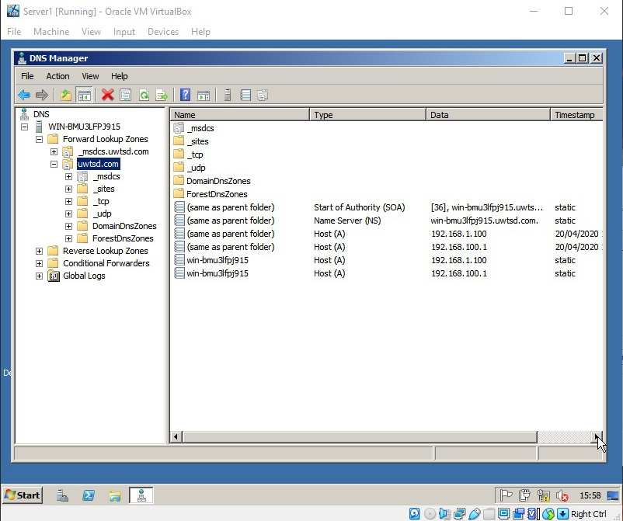
Figure 53

Task 3
- Installing a Web Server – IIS
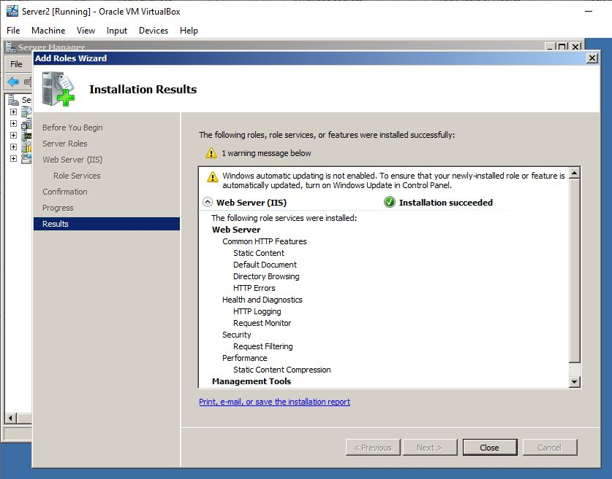
Figure 54
- Configuring the web server’s default folder:
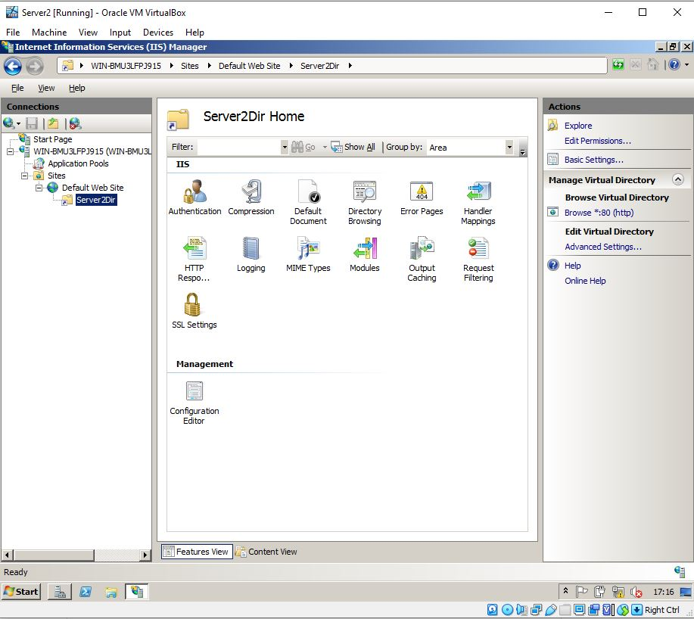
Figure 55
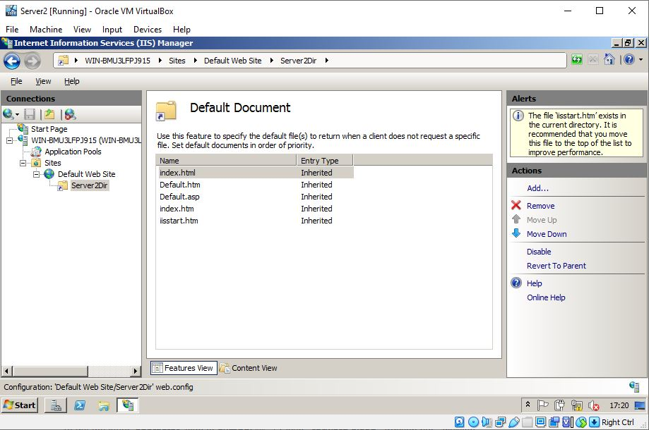
Figure 56
- Creating a web content and testing the web service through the browser.
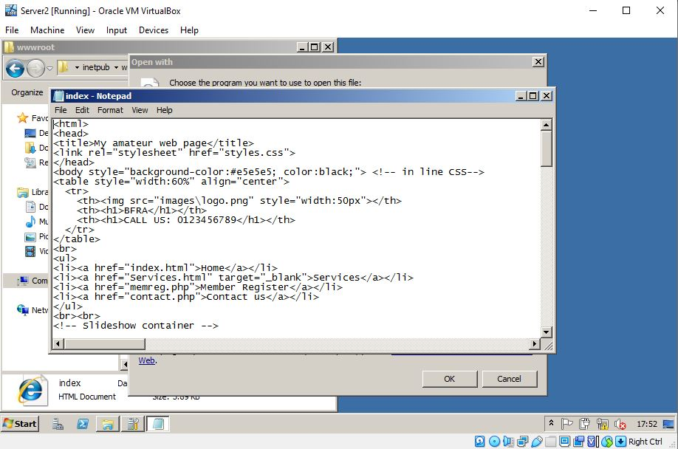
Figure 57
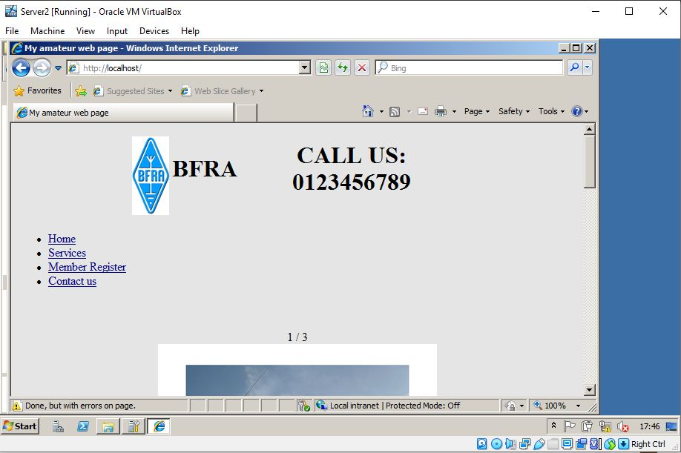
Figure 58

- Testing the access to the web page from the remote server, by typing the Ip address of the host server:


