

Student name: | SRAVANTHI SILVERU | Student ID | 2228080
Programme: | MSc Cyber Security and Digital Forensics Analysis
Module: | Data Security, Governance and Compliance
Module code: | ACCA7028 | Contribution to Overall Module Assessment (%): | 50%
Lecturer: | Assoc. Prof. Carlene Campbel | Internal Verifier: | Munyaradzi N Murira
Assignment Title: | Apply the principles and practices of Data security, Governance and Compliance based on a given scenario | Word count (or equivalent): | 3,000
Submission deadline: | 9/01/2024 | Return date of provisional marks & written feedback:

TABLE OF CONTENTS
ABSTRACT 3
INTRODUCTION 4
LIST OF FIGURES AND TABLES 5
TASK 1 6
SECURITY FRAMEWORK OR MODELS 6
INFORMATION TECHNOLOGY INFRASTRUCTURE LIBRARY (ITIL) 6
INTERNATIONAL ORGANIZATION FOR STANDARDIZATION. 8
ISO 27000 SERIES 8
COBIT (Control Objectives for Information and related Technology) 11
NIST 11
PCI DSS (Payment Card Industry Data Security Standard) 12
Basel II 12
BELL-LAPADULA MODEL 13
BIBA MODEL 14
TASK 2 15
INFORMATION SYSTEM SECURITY DESIGN COMPANY 15
IT COMPLIANCE (Law and Ethics) 15
GOVERNANCE AND STRATEGIC PLANNING FOR SECURITY 15
SECURITY POLICIES 16
RISK MANAGEMENT 17
SECURITY MANAGEMENT MODELS AND PRACTICES 17
CRITICAL ANALYSIS ON GOOD PRACTICE 17
CONCLUSION 19
REFERENCES 20

ABSTRACT

The purpose of the work is to examine various security frameworks and models and highlight how they apply to the security, governance, and compliance of NatureGarden's (NG) information system. We create a custom strategy for NG by examining ITIL, ISO 27001, NIST Cybersecurity Framework, and COBIT. The strategy integrates GDPR, HIPAA, and PCI DSS compliance with a governance framework that synchronizes security with business goals, addressing global operations and cloud reliance. NG is protected from threats by well-defined security models, risk management, and detailed security policies. The critical analysis highlights the need for regulations to be updated on a regular basis, emphasizing their role in keeping global consistency, responding to new threats, and keeping up with technological advancements. This synthesis of theory and practice acknowledges the dynamic nature of cybersecurity and offers NG a customized blueprint for information security, governance, and compliance.

INTRODUCTION
Securing information assets, especially in the internet-centric global business landscape like Nature Garden (NG), is paramount. Fiduciary duty recognizes information security as fundamental, safeguarding crucial assets like data. It aligns with IT governance, once a source of convenience, now presenting a formidable challenge in the digital landscape. NG faces vulnerabilities and opportunities online due to its extensive presence, necessitating immediate action to address information security issues, given reliance on cloud services, wireless networks, and pressure to incorporate personal devices.[1].
The information security management system focuses on confidentiality, integrity, availability, and damage control in vulnerability situations. It aids organizations in identifying controls, reducing risks, and managing them through technical and non-technical factors. [2]. For NG, safeguarding private information, intellectual property, and maintaining a billion-dollar brand is essential. Despite increased risks, NG lacks a comprehensive information security policy, leaving its digital infrastructure vulnerable. Information security is now crucial to protect both internal and customer data, becoming a strategic issue in company management.
Management uses ISMS for information security during regular operations, based on risk assessments. Organizations, like NG, relying on technology face threats, hacks, and data breaches. Urgency to safeguard data led to exploring protective measures, including security frameworks. This paper examines various ISMS frameworks in response to growing threats in the technology-dependent landscape (Posthumus and von Solms 2004).

LIST OF FIGURES AND TABLES

Figure 01: ITIL Framework………………………………………………………………8
Figure 02. Relationships within the family of ISO 27 K standards…………………….....9
Figure 03: Cobit Framework ………………………………………………………….....11
Figure 04: NIST Framework……………………………………………………………..12
Figure 05: PCI DSS Requirements………………………………………………………..12
Figure 06: Base II pillars…………………………………………………………………13
Figure 07: Bell-Lapadula Model…………………………………………………………..14
Figure 08: Biba Integrity model properties……………………………………………….14
Figure 09: IT Compliance process…………………………………………………………15
Figure 10: IT Governance steps……………………………………………………………16
Figure 11: Security Policies………………………………………………………………..16
Table 01: ITIL V4 management practices………………………………………………….6
Table 02: Annex A domain changes………………………………………………………..9
Table 03: Relevant Regulations and Standards……………………………………………15
Table 04: Comparing Frameworks for Information Security Management ……………….17

TASK 1

SECURITY FRAMEWORK OR MODELS
IT organizations compile best practices into security frameworks for handling cyber threats. These frameworks protect internal data, ensuring adaptability for compliance and addressing security issues. NG IT strategically manages risk by incorporating standards for effective information security management and continuous improvement

INFORMATION TECHNOLOGY INFRASTRUCTURE LIBRARY (ITIL)
The British Central Computer & Telecommunications Agency was the original home of ITIL, which merged with the UK Office of Government Commerce (OGC) in 2001. It is a widely accepted method for overseeing IT development, operations, and infrastructure that provides standardized best practices across the globe. Developed by the Central Computer and Telecommunication Agency (CCTA), the Government Information Technology Infrastructure Management Methodology (GITMM) was the first version. The foundation of ITSL is ITIL version 2, which addressed application, software asset management, security, support, and service delivery. The most recent version, ITIL version 4, was released in 2019. ITIL version 3 was first released in May 2007.[3].

ITIL V4 MANAGEMENT PRACTICES
S.NO | General  Management  Practices | Service Management Practices | Technical Management Practices
01 | Architecture supervision | Accessible | Management of deployment
02 | Constant development | Business evaluation | Platform administration and infrastructure
03 | Management of information security | Management of capacity and performance | Development and management of software
04 | Information handling | Alternate command
05 | Assessment and documentation | Management of incidents
06 | Management of organisational change | Asset management for IT
07 | Portfolio Administration | Event planning and observation
08 | Project oversight | Project oversight
09 | Relationship supervision | Release management
10 | Risk control | Management of service catalogues
11 | Financial management of services | Management of service configuration
12 | Management of strategies | Management of service continuity

Table 01: ITIL V4 management practices

The ITIL framework consists of five lifecycle phases—
- Service Strategy - Serves as a roadmap for developing and executing service management tactically. Ensures cost and risk management of the service portfolio, providing comprehensive and long-lasting services alongside operational effectiveness. [4].
- Service Design It guides the creation and design of processes and services, aiming to translate strategic goals into a service portfolio with design principles and methods. [5]
- Service Transition - Information about the creation and improvement of capabilities for putting new or altered services into production is included in this section [6].
- Service Operation. Emphasize the efficiency and effectiveness of IT service operation, actively delivering services to clients. This involves managing incidents, problems, changes, and service requests to ensure service availability, performance, and security.. [7]
- Continuous Service improvement - CSI acts as a catalyst for continuous improvement, focusing on assessing service performance, identifying areas for development, and implementing changes to maximize service quality, efficiency, and cost-effectiveness. [8].
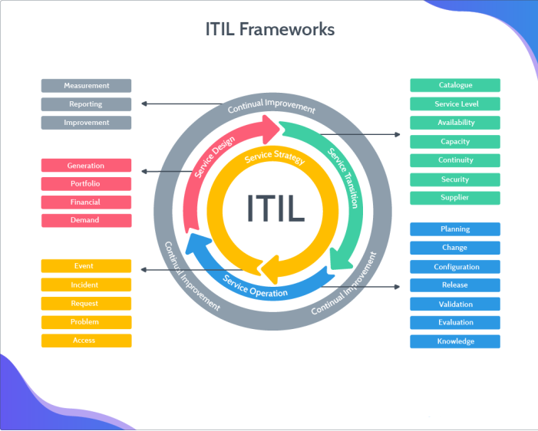
Figure 01: ITIL Framework

INTERNATIONAL ORGANIZATION FOR STANDARDIZATION.

ISO 27000 SERIES
Since security measurements differ depending on their business relevance, IT Companies like NG or other organizations view information security management systems (ISMS) differently. Having an established standard of compliance, like the ISO 27000 series, can help ensure that ISMS is being implemented correctly. A family of standards known as the ISO 27000 series provides a framework for best practice ISMS, which helps businesses safeguard their information assets.
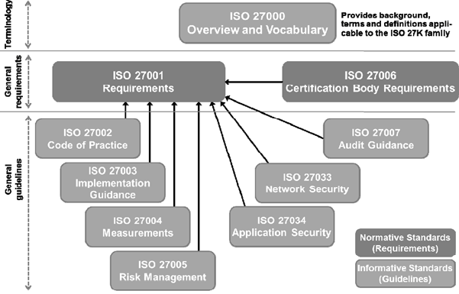
Figure 02. Relationships within the family of ISO 27 K standards

ISO/IEC 27001 standard
The goal of the standard is to specify requirements for companies looking to set up and keep up an information security management system (ISMS). Its goal is to guarantee that the right security controls are chosen to safeguard information assets. [9]. The "Plan-Do-Check-Act" (PDCA) framework, which is intended to develop, implement, oversee, and improve an organization's ISMS effectiveness, is introduced in the standard. There are four phases to the PDCA cycle.
- Do: carry out and run the ISMS
- Check: keep an eye on and evaluate the ISMS
- Act: maintain and enhance the ISMS
Annexe A defines control objectives and security controls. It provides a comprehensive list of controls and key information security measures. The updated ISO standard is ISO 27001:2013. In this revision, there are 114 controls across 14 categories, compared to 133 controls in 11 categories in the 2005 version of Annex A.. [10]
 | ISO 27001:2005 | Revised version of ISO 27001:2013[11]
A.5 | Security guidelines | Policies for information security
A.6 | Information Security Organisation | Information Security Organisation
A.7 | protection of human resources | protection of human resources
A.8 | Security of human resources | Asset administration
A.9 | Security in the Physical and Environmental Domains | Control of access
A.10 | Management of Operations and Communications | Encryption
A.11 | Control of access | Environmental and physical security
A.12 | Acquisition, Development, and Administration of IS | Security in operations
A.13 | Incident management for information security | Security of communication
A.14 | Management of business continuity | Acquisition, Development, and Upkeep of Systems
A.15 | Observance | Supplier-customer connection
A.16 | - | incident management for information security
A.17 | - | Aspects of business continuity management related to information security
A.18 | - | Observance

Table 02: Annex A domain changes

Further ISO 27000 series standards are:
- ISO 27002 - 2007 - Code of practice for information security management .
- ISO 27003 - 2010 - Information security management system implementation guidance
- ISO 27004 - 2009 - Information security management—Measurement
- ISO 27005 – 2011 - Information security risk management
- ISO 27006 – 2011 - Requirements for bodies providing audit and certification of ISMSs
- ISO 27007 – 2011 - Guidelines for ISMS auditing
- ISO 27008 – 2011 - Guidelines for auditors on ISMS controls
- ISO 27010 – 2012 - ISMSs for inter-sector and inter-organizational communications

COBIT (Control Objectives for Information and related Technology)
ISACA, as part of COSO, introduced the COBIT framework in 1996, offering IT governance best practices. It guides technology auditors, senior management, and users in managing technology risks, bridging the gap between technology and business requirements. COBIT's fourth edition came out in 2005, followed by the updated 4.1 edition in 2007. The latest version, COBIT 5, was released in 2012. [12]
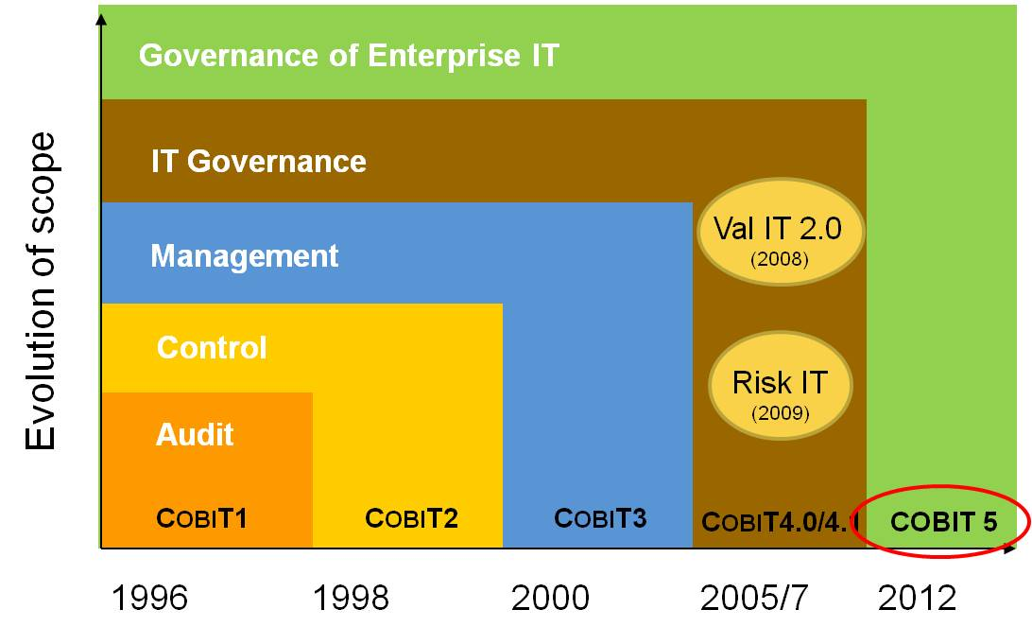
Figure 03: Cobit Framework
According to Devos and Van De Ginste (2012), COBIT is based on five main principles: satisfying stakeholder needs, addressing enterprise end-to-end, utilising a single integrated framework, facilitating a holistic approach, and separating governance from management. It focuses on establishing the required controls and defining goals for IT control. There are 215 specific control objectives spread among the 34 high-level IT processes that are managed by 34 processes. Four domains comprise these processes: [13]
1 Organise and Plan,
2 Obtain and Put into Practice.
3. Provide and Assist;
4. Observe and Assess.

NIST
To assist organisations in the critical infrastructure sectors in lowering cyber security risks, the National Institute of Standards and Technology (NIST) has published the NIST Cyber Security Framework for Critical Infrastructure (CSF). Three parts make up this risk-based framework: the framework core, the risk tiers, and the framework profile. The five fundamental functions of the NIST CSF are broken down into 23 categories and 108 subcategories. 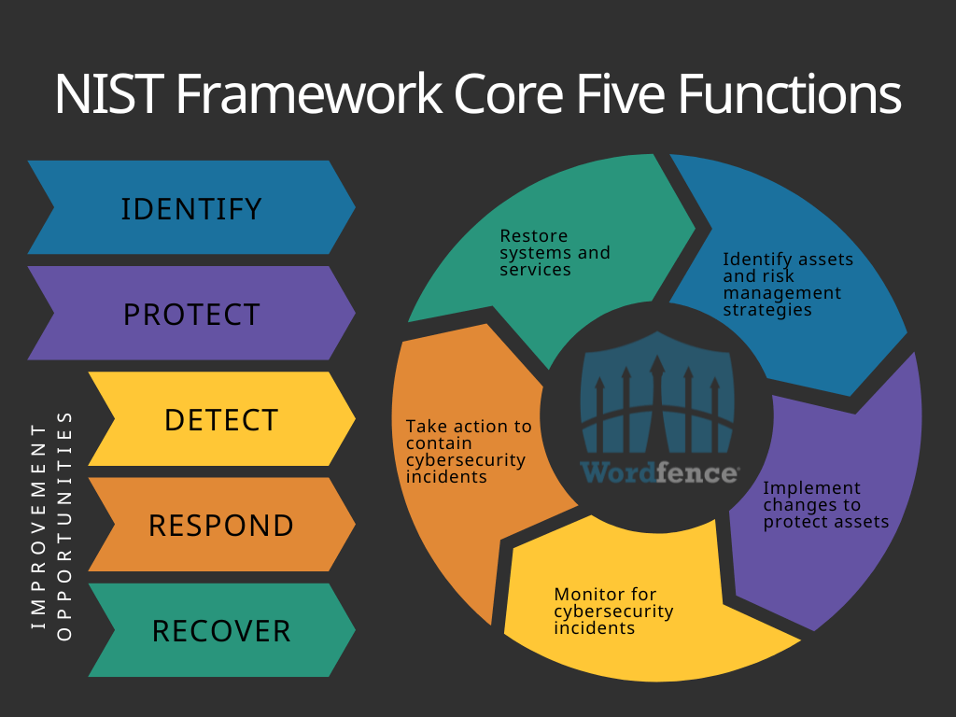
Figure 04: NIST Framework

PCI DSS (Payment Card Industry Data Security Standard)
PCI DSS is an info security standard reducing card fraud, developed by leading payment brands for global uniform data security. Its twelve domains enable secure networks, cardholder data protection, vulnerability management, and reliable access controls. Compliance is mandatory for any party handling credit or debit card data, reducing fraud losses and managing security risks. PCI DSS aims to secure customer data but isn't an information security risk management framework.. [14]
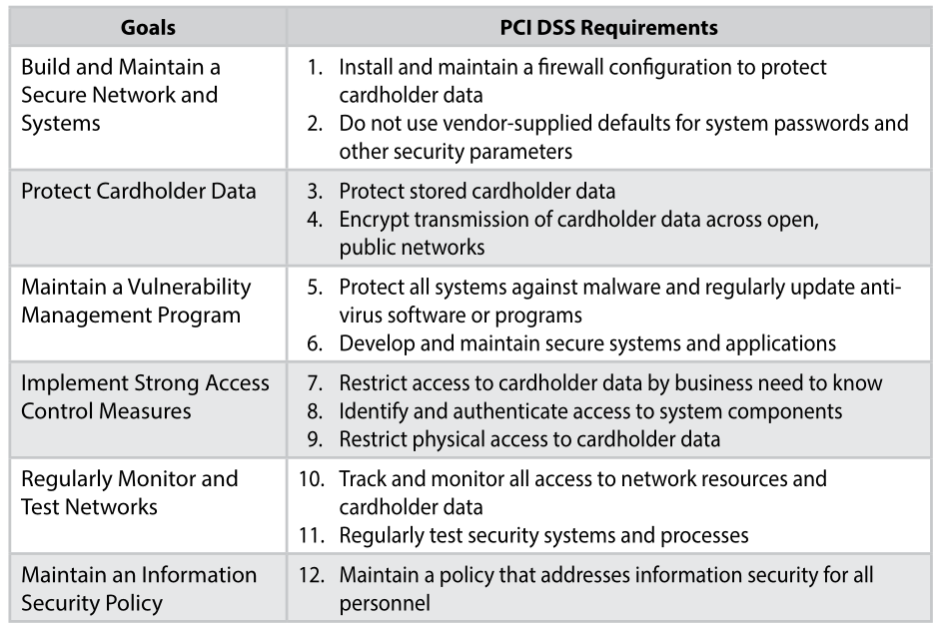

Figure 05: PCI DSS Requirements

Basel II
Basel II introduces a new framework for banking, replacing existing regulatory requirements. Its goals include making capital requirements more risk-sensitive and incentivizing banks to enhance risk-management procedures. Basel II, the second of the three Basel Accords, emphasizes market discipline, regulatory oversight, and minimum capital requirements as its primary pillars. The minimum capital requirements mandate specific capital-to-risk-weighted asset ratios, shaping the financial stability of banks.. [15].
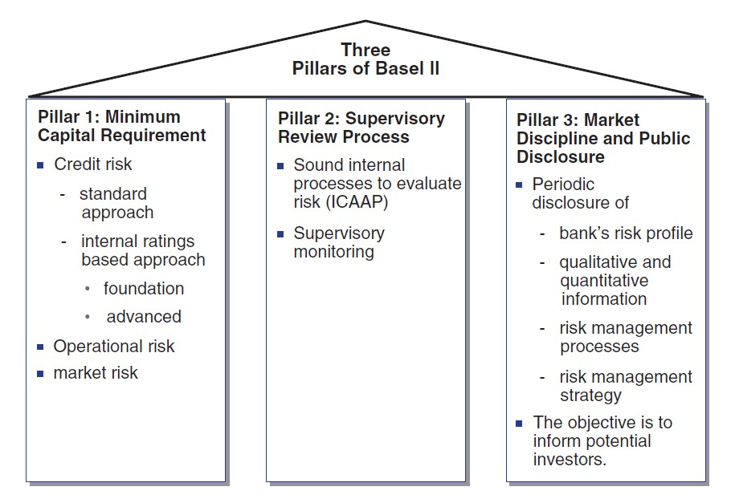
Figure 06: Base II pillars

BELL-LAPADULA MODEL
The Bell-LaPadula Model, introduced in 1973, is the first widely adopted multilevel security model, akin to military tactics. Developed by LaPadula and Bell, it addresses private access control, categorizing subjects and objects by security levels. This model prevents information flow from high to low security levels, commonly used in strict multilevel security hierarchies, gaining U.S. Department of Defense attention for military security strategy (Thorleuchter and Van den Poel, 2011).
The original Bell-LaPadula Model classifies information into top-secret, secret, confidential, and unclassified categories based on sensitivity levels (Cristiá and Rossi, 2021). While emphasizing confidentiality, it also influences integrity and availability principles.
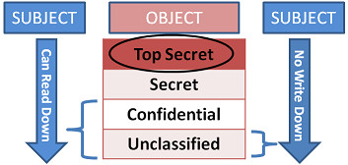
Figure 07: Bell-Lapadula Model

BIBA MODEL
In 1977, K. J. Biba introduced the Biba model, a pioneering computer integrity security model. It employs a lattice-based approach for multilevel sensitive information security, focusing on maintaining internal and external consistency and preventing unauthorized data alterations (Liu and Chen, 2004).
The Biba model proposes a set of employable integrity policies, ensuring information integrity with various policies. Unlike the Bell-LaPadula model, Biba uses labels for integrity levels, considering data with high integrity levels more trustworthy (Balon and Thabet, 2004).
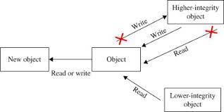
Figure 08: Biba Integrity model properties

TASK 2

INFORMATION SYSTEM SECURITY DESIGN COMPANY

IT COMPLIANCE (Law and Ethics)
Organizations turning legal issues into business opportunities require a guiding framework, often fulfilled by a code of ethics in law and ethics. Ethical codes and compliance programs are interdependent, with a code of ethics giving purpose to compliance programs (Peterson 2013). The corporate code of ethics guides behavior, emphasizing stakeholder responsibilities and legal adherence, while also ensuring ethical business practices. Studies reveal that codes of ethics, influenced by legal factors, shape employee behavior beyond defense, serving as a framework to foster a culture of ethical and legal conduct.[16].
 | Regulation/Standards | Description
01 | GDPR | European data protection regulation to protect the privacy and personal data of individuals.
02 | ISO 27001 | Information security management system
03 | PCI DSS | safeguarding the payment card data of individuals and businesses.

Table 03: Relevant Regulations and Standards

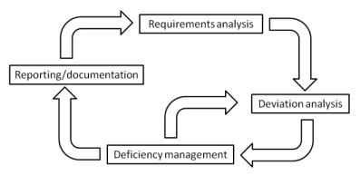
Figure 09: IT Compliance process

GOVERNANCE AND STRATEGIC PLANNING FOR SECURITY
Enhancing security governance is key to improving organizational security, leveraging the proven reliability and effectiveness of IT governance. At the operational level, security plans are implemented with prompt decision-making (Tan et al., 2017).
Quantifying and improving a robust security strategic context is a complex challenge requiring active participation and shared understanding among stakeholders. Developing security context solely at the top management level may lack diversity; hence, involvement of different people/committees at various organizational levels is crucial, similar to IT strategic context development.
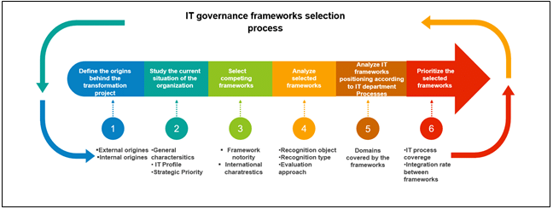
Figure 10: IT Governance steps

SECURITY POLICIES
This document outlines operational procedures for network and systems controls, change management, etc. Labeled as "information systems secure operations policies," these hold legal importance for compliance. Auditors verify their existence and adherence, offering protection under the Computer Fraud and Abuse Act. Security policies covering access control, device management, and data encryption must be communicated to all staff. Specificity and procedural requirements pose challenges for web developers, with a risk-exemption policy being beneficial. If absent, closely adhere to your company's policies.[17]
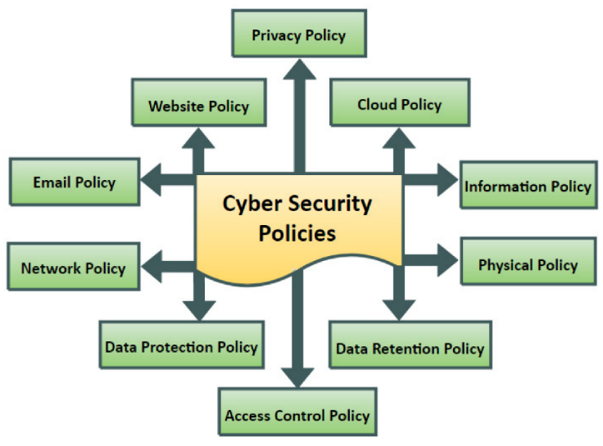
Figure 11: Security Policies

RISK MANAGEMENT
In IT, risk management identifies, evaluates, and reduces potential risks systematically. It involves risk identification, impact assessment, and implementing risk-reduction plans. Continuous monitoring ensures ongoing effectiveness, and incident response plans swiftly handle security incidents. Key principles include proactiveness, alignment with business goals, continuous improvement, collaboration, regulatory compliance, strategic resource allocation, and thorough documentation. Addressing changing cybersecurity threats requires an iterative approach. We chose the COSO ERM framework over a specific IT risk model due to the operational detail in the recently released Risk IT Framework not aligning with our needs.[18]

SECURITY MANAGEMENT MODELS AND PRACTICES
Organizations need security management models and procedures for private, accessible, and intact information and systems. Models like NIST Cybersecurity Framework and COBIT provide systematic approaches. NIST focuses on identifying, defending, detecting, reacting, and recovering from cybersecurity threats. COBIT emphasizes governance, control, and alignment with business needs. Common practices include strong access controls, data encryption, and monitoring intrusion detection systems. These models act as strategic guides, helping organizations manage risks, implement effective security measures, and adhere to rules and industry standards.[19].

CRITICAL ANALYSIS ON GOOD PRACTICE
Authors/ year | Main Objectives | Standard or frameworks | Factors of study | Cons and pros of framework | Result of study
H.Susanto (2012 | Assist stakeholders in determining their level of ISO 27001 compliance | ISO 27001 | The consumers, the organisation, technology and tools, policy, culture, and knowledge | Pros: Assisting consumers in comprehending security controls or involving them through compliance requirements  Cons: neglected to address the physical and environmental | ISolFramewor, a new ISMS framework
Munirul Ula(2011) | Creating policies and putting security measures in place to guard the bank's assets from dangers | FFIEC,  COBIT,  ISO 27002  and PCI | tactical, operational, strategic, and technical | Pros: framework with an emphasis on employee culture and behaviour  Cons: necessity  Additional elements like budget and outside parties might be needed. | A structure for the governance of information security
Abdellateef Lutfi (2014 | The primary goal  examining and assessing the state of Palestinian banks' information security management at the moment | PCIDSS,  ISO27001,  IT IL | Technologies, People, Process, Suppliers, and Data | Pros: all of the studies are thorough and involve the bank.  Cons: No budget for studies | A framework to assist Palestinian banks in developing the appropriate plans that ensure the success of information security management
Mahsa Mohseni(2015) | evaluates the ISMS compliance | NIST,  COBIT,  ITIL,  ISO27001 | Management of business continuity, adherence to law enforcement, access control, communication security, physical and environmental security, organisation, asset management, human security, and training | Pros: The study was thorough and based on multiple standards.  Cons: not doing research Additional impact variables include the budget and outside parties. | A framework for determining discrepancies between the actual implementation of ISMS and the security standards' requirements

Table 04: Comparing Frameworks for Information Security Management
Non-compliance with data security regulations can result in million-dollar fines for international companies like NatureGarden. Leaking confidential information poses legal and reputational damage risks. Reviewing regulations relevant to international businesses is crucial, with tailored updates considering factors like cloud technologies and corporate governance. NatureGarden, an international company, faces specific regulations related to its characteristics, such as the foreign exchange market. After the review, integrating risk evaluation into information management policies is essential, ensuring audit validation for regulatory compliance.[20]
Losing personal or credit card information can have severe consequences for both customers and companies. Companies should view information protection as an ethical necessity for customer safety. However, regulations enforce this, and company policies should be consistently updated, aligning with the company's risk level and needs.

CONCLUSION
In conclusion, as the need for Internet-based information keeps growing, NatureGarden (NG) has a difficult task ahead of it in securing its vast global operations. The present assignment delved into an examination of multiple security frameworks and models, such as ITIL, ISO 27001, NIST Cybersecurity Framework, and COBIT. The objective was to establish a comprehensive approach that is customised to meet the needs of NG.
The case study underscores the critical need to safeguard client and personal data, intellectual property, and NG's online presence. Despite its significant online footprint and reliance on cloud services, a lack of a cohesive information security policy poses risks to NG's valuable assets. The proposed strategy integrates key elements such as regulatory compliance, robust governance, risk management, security models, protection mechanisms, SLA metrics, and contingency planning. This comprehensive approach provides a roadmap for enhancing information system security, governance, and compliance, requiring a coordinated effort, continuous dedication, and a security-aware culture for successful implementation. These precautions enable NG to navigate the evolving cybersecurity landscape and protect its invaluable assets.

REFERENCES
[1] Alan P Calder, A Management Guide - Best Practice Information Security based on ISO 27001/ISO 27002. Van Haren Publishing, 2009.
[2] A. Ključnikov, L. Mura, and D. Sklenár, “Information security management in smes: Factors of success,” Entrepreneurship and Sustainability Issues, vol. 6, no. 4, pp. 2081–2094, Jun. 2019, doi: 10.9770/jesi.2019.6.4(37).
[3] R. Sheikhpour and N. Modiri, “A best practice approach for integration of ITIL and ISO/IEC 27001 services for information security management,” Indian J Sci Technol, vol. 5, no. 2, pp. 2170–2176, Feb. 2012, doi: 10.17485/ijst/2012/v5i3.1.
[4] “The Official Introduction to the ITIL Service Lifecycle - OGC - Office of Government Commerce - Google Books.” Accessed: Dec. 19, 2023. [Online]. Available: https://books.google.co.uk/books?hl=en&lr=&id=9uLkMMqRKrYC&oi=fnd&pg=PA19&dq=Office+of+Government+Commerce,+ITIL+v3+Service+Strategy.+London,+2007&ots=NbHi5QboKV&sig=QrlECkfP7K7JumLr8gZK2NoDeZA#v=onepage&q&f=false
[5] R. Pirinen and J. Rajamäki, “L A U R E A P U B L I C A T I O N S B•37 INTEGRATIVE STUDENT-CENTERED RESEARCH AND DEVELOPMENT WORK Sample of Evidence Series: Volume (1) Rescuing of Intelligence and Electronic Security Core Applications (RIESCA),” 2010.
[6] “The Official Introduction to the ITIL Service Lifecycle - OGC - Office of Government Commerce - Google Books.” Accessed: Dec. 19, 2023. [Online]. Available: https://books.google.co.uk/books?hl=en&lr=&id=9uLkMMqRKrYC&oi=fnd&pg=PA19&dq=Office+of+Government+Commerce,+ITIL+v3+Service+transition.+London,+2007&ots=NbHi5QbuQX&sig=oA1om5YNfduDvfPrXMRXu_JviIs#v=onepage&q&f=false
[7] “The Official Introduction to the ITIL Service Lifecycle - OGC - Office of Government Commerce - Google Books.” Accessed: Dec. 19, 2023. [Online]. Available: https://books.google.co.uk/books?hl=en&lr=&id=9uLkMMqRKrYC&oi=fnd&pg=PA19&dq=Office+of+Government+Commerce,+ITIL+v3+Service+operation.+London,+2007&ots=NbHi5KfnNT&sig=jvxMCLiVufOBaTPkWz1gCInrtvo#v=onepage&q&f=false
[8] E. N. Lamichhane and N. Lamichhane, “International Journal of Advanced Research and Publications Implementing Continual Service Improvement In Business Enterprises: A Proposal To Improve Business Effectiveness Of Nepal,” 2019, Accessed: Dec. 19, 2023. [Online]. Available: https://www.researchgate.net/publication/334400797
[9] “CAN A SINGLE SECURITY FRAMEWORK ADDRESS INFORMATION SECURITY RISKS ADEQUATELY?”
[10] Z. Hamdi, A. A. Norman, N. Nuha, A. Molok, and F. Hassandoust, “To cite this article: Zaidatulnajla Hamdi et al,” J. Phys.: Conf. Ser, 2019, doi: 10.1088/1742-6596/1339/1/012103.
[11] A. A. Nasser and A. A. Nasser, “Information security gap analysis based on ISO 27001: 2013 standard: A case study of the Yemeni Academy for Graduate Studies, Sana’a, Yemen,” International Journal of Scientific Research in _______________________________ Research Paper. Multidisciplinary Studies E, vol. 3, no. 11, pp. 4–13, 2017, doi: 10.26438/ijsrms/v3i11.413.
[12] S. Zhang and H. Le Fever, “An Examination of the Practicability of COBIT Framework and the Proposal of a COBIT-BSC Model,” Journal of Economics, Business and Management, pp. 391–395, 2013, doi: 10.7763/joebm.2013.v1.84.
[13] A. A. Abu-Musa Tanta, “Exploring COBIT Processes for ITG in Saudi Organizations: An empirical Study,” The International Journal of Digital Accounting Research, vol. 9, pp. 99–126, 2009, doi: 10.4192/1577-8517-v9_4.
[14] E. A. Morse and V. Raval, “PCI DSS: Payment card industry data security standards in context,” Computer Law & Security Review, vol. 24, no. 6, pp. 540–554, Jan. 2008, doi: 10.1016/J.CLSR.2008.07.001.
[15] Andrew Yeh, James Twaddle, and Mike Frith, “Basel II: A new capital framework,” pp. 1–12, 2005.
[16] “Law and Corporate Behaviour: Integrating Theories of Regulation, Enforcement ... - Christopher Hodges - Google Books.” Accessed: Jan. 06, 2024. [Online]. Available: https://books.google.co.uk/books?hl=en&lr=&id=c_miCgAAQBAJ&oi=fnd&pg=PT22&dq=IT++compliance+laws+and+ethics&ots=Geupt96JCG&sig=KYcdyOy9PKLXxGQVWVX-a_MYO0U#v=onepage&q=IT%20%20compliance%20laws%20and%20ethics&f=false
[17] D. Verdon, “Security policies and the software developer,” IEEE Security & Privacy Magazine, vol. 4, no. 4, pp. 42–49, Jul. 2006, doi: 10.1109/MSP.2006.103.
[18] P. Hopkin, “Fundamentals of risk management : understanding, evaluating and implementing effective risk management,” p. 453, Accessed: Jan. 06, 2024. [Online]. Available: https://books.google.com/books/about/Fundamentals_of_Risk_Management.html?id=bzFiDwAAQBAJ
[19] C.-C. Yang and W.-L. Hsu, “Evaluating the impact of security management practices on resilience capability in maritime firms—a relational perspective,” Transp Res Part A Policy Pract, vol. 110, pp. 220–233, Apr. 2018, doi: 10.1016/j.tra.2017.06.005.
[20] T. ABaqi Al-sofi, D. Ali Al-Shaibany, D. Ahmed Al-Khulaidi, and Y. Mohammed Almekhlafi, “ANALYSIS OF INFORMATION SECURITY MANAGEMENT SYSTEMS FRAMEWORKS IN ORGANIZATIONS.” [Online]. Available: www.irjmets.com

