HSBC GLOBAL BUSINESS

INDIVIDUAL PROJECT REPORT
Student Name: Ionela Dobrin
Student ID: 2111156
Lecturer name: Tarila Zuofa
Module code: LCBB4005 BIRM
Module name: Global Business Management

Table of Contents
Introduction 3
Overview of HSBC 3
Business environment 4
PESTEL 4
Economic 4
Technological 7
Porter 5 forces 9
Power of buyer 9
The threat of new entrant 9
Conclusion 11
References 12

Introduction
A global business is responsible for global development by operating within different countries in the world. The report aims to study global business management by evaluating the business environment of the UK nation. The report will help to gain an understanding of changing global business environment. The report will focus on two different global factors from the PESTEL and Porter’s Five Forces. The selected factors are Economics and Technological from the PESTEL Model. From Porter’s five forces, the power of buyers and threats of new entrants will be discussed in the report. To make the report possible, the research of the data will be taken from the Office of National Statistics. This way the study will focus on the quantitative data to critically evaluate the business environment.
The report will therefore focus on the business environment of the organization HSBC. The report will be oriented to study the environment of this organization as the organization is practising its operation in a global environment.

Overview of HSBC
HSBC was founded in the year 1991, and HSBC is considered one of the largest banking and finance service organizations in the world (HSBC Group. 2022). The organization have more than 40 million customers and provides global services with wealth and personal banking, commercial banking, global banking and markets. The company is presently headquartered in the UK, London. The organization is the British multinational universal bank and financial service holding in the UK. The company is the largest bank in Europe with total assets of US$2.953 trillion as of December 2021 (HSBC. 2022). The companies have on average 8.3% tangible equity, and the gross RWA reduction is $104bn. The process of operation is also under the control with a net-zero of 50.3% (HSBC group 2022).
The above detail on the company defines the global working performance of the company. This makes the company perform within a boundary with a major impact on the environment of the company. Thus, when the business environment is tempered, the business operation will also get affected.

Business environment
The environment of the company that defines the decision-making of the company is known as the business environment. The business environment is also considered as the defined forces that can be from the internal field or from the external field that affects the business and its environment. There are two major types of business environment, external environment and internal environment. The report has focused on the external environment of HSBC. For the study of the global factor of the company, the framework that will be used is the PESTEL framework and Porter’s five forces. The two selected factors are Economics and Technological from the PESTEL Model and the Power of buyers and threats of new entrants from Porter’s five forces.

PESTEL
The use of the PESTLE framework will help to study some of the global factors that impact the financial industry. The use of PESTEL will be defined all the different factors like Political, Economic, Social, Technological, Environment, and Legal factor. The consider two global factors is the Economic and Technological.

Economic
According to IBIS world 2022, the market size of the finance management industry in the UK is $5.6bn. The growth rate of the industry has been improved by a 5.3% margin. For this market size of the company, a total number of “98 thousand business enterprises in the finance & insurance sector” is responsible (Statista, 2022). These numbers are only from the UK itself, where the total number of 220 large enterprises have employed 500 or more people in the UK.
The given data is responsible for the development of the economy of the nation. Thus, the industry is one of the factors that are responsible for affecting the business environment within the global space.
Public Sector Banks: Gross operating surplus
According to the study that has been taken by the Office of national statistics, there has been a defining drop in the gross operating surplus in the last five years.
Gross operating can be defined as the excess of the interest and other incomes of the commercial bank over the interest and other operating expenses of the commercial bank in the UK (Statista, 2022).
Period (Year) | Value (Million Pounds)
2015 | 18606
2016 | 19318
2017 | 19542
2018 | 19804
2019 | 19090
2020 | 17880
2021 | 14640

Based on the evaluation that has been recorded, the drop within financial services is 6.33% for 2019-2022 and 18.12% for 2020-2021 (ONS. PS. GOS. 2022). The drop has been drastic. The major reason for the decline within its section is majorly due to the outbreak of the global pandemic. Many of the industries are effective; the previous drop is measured at 18.12% (ONS. PS. GOS. 2022).

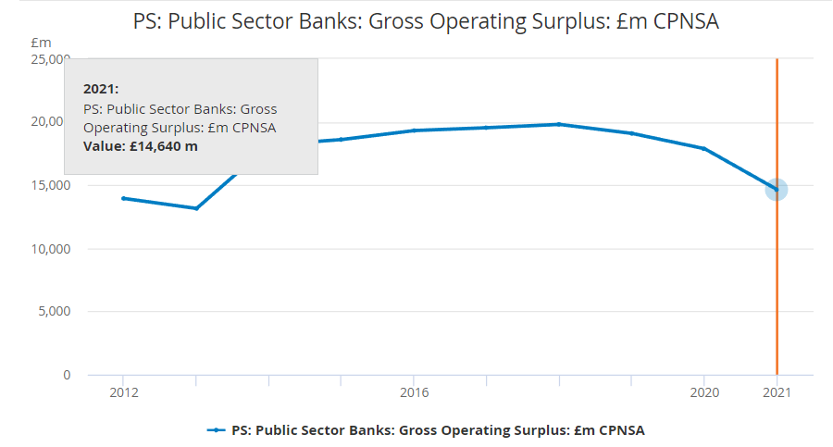
Figure 1: Public Sector Banks: Gross Operating Surplus
(ONS. PS. GOS. 2022)

Public sector bank debt interest ratio
DIR: The defined level of Debt Interest Ration developed by the Bank of England. The standard set level is 6.
DIR: The ratio of interest income to the interest expense of the public bank.

 | Debt Interest Ratio | DIR level
2015-16 | 4.8 | 6
2016-17 | 4.8 | 6
2017-18 | 5.2 | 6
2018-19 | 4.2 | 6
2019-20 | 3.7 | 6
Table 1: Debt Interest Ratio Actual and level
Based on the calculation that has been developed by the ONS, the DIR has been dropping significantly. This signifies that the economy of the nation is misbalance, and the expenses of the public sector bank are significantly increasing over the interest revenue.
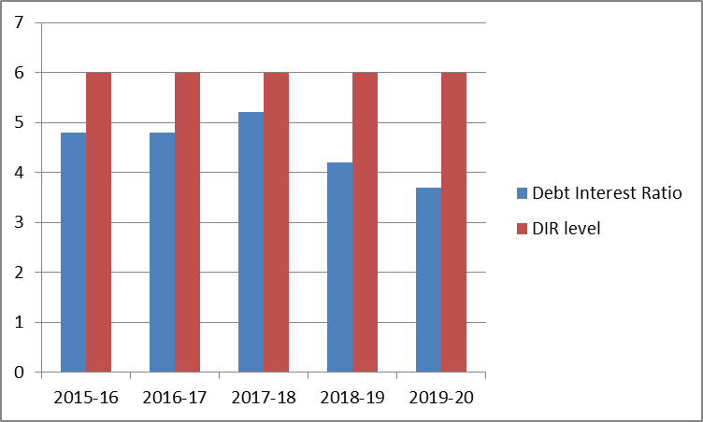
Figure 2: Graph(ONS. PS. GOS. 2022)

Technological
The other global factor that has been improving consecutively is technology. Within the development, the responsible factors are globalization and digitalization. Following are the facts to consider
- The development of technology has improved financial service, as the process is financial service are digitalized. This includes using the technology of blockchain, AI and MI.
- The process of working with technology has been able to improve the working of the industry. This includes the process of working with the latest technology that helps to save, cut down costs and save from human error. The process of wire transfer has been improved. This has enabled the process of working with the customer to save time processing process as well.
- The other development that can be monitored with this process is speed and security. At the same time, the company will be working on the development of blockchain technology for effective transparency of the business. This includes the use of payment applications, trade finance platforms etc.
- The future of the industry can be described as populated by the financial technology company. Based on the study within the global market, the present market size of this industry is estimated at $7.3 trillion in 2020 (Financier Worldwide Magazine. 2022). Based on the growth of the company (a CAGR) of 26.87 per cent up to 2026 has been projected.
Within the global space, there is a factor that is responsible for the creation of barriers. Some of the barriers that are affecting the growth of this industry are
- The major barrier that has been faced by the companies in the technological aspect is security. The global is well connected for the company by the technology that has to enable the system to be compromised under cyber hacking. The practice is very established, which has resulted in many companies losing money and facing the comprises in security.
- The other barrier is the lack of trained and skilled workforces on a global scale. A skilled workforce is highly significant for companies to be able to work on the development process. The lack of a skilled workforce is therefore effective for the industry to safeguard the system.
- The other barrier is digital transparency; the public is also less aware of the system and its working process. The lack of knowledge results in the lack of digital transparency of the company. To meet this gap, growth and development should focus on teaching and bringing transparency to the system.

Based on the evaluated data of economic and technology global factors, the highlights that can be considered are the
- With the decline of DIR and the Gross operating, HSBC should consider bringing changes within its process. The company revenue has been dropping from 56,098-50,429-49,552 ($m) for year 2019-20-21 (HSBC, 2022.). This indicates the increased expenses of the company. Thus, debt is increasing in the public sector bank, and the contribution of such banks to the GDP of the UK is declining year over year. HSBC need to take care of this factor and work down the process to meet these challenges.
- Based on the technical understanding and study, the global factor of technology has been effectively promoting the industry. There has been significant growth has been within digitalization. HSBC should have been adapting to changes by investing in technology. The company has “invested $6bn in technology in 2021” (HSBC. 2022). This has resulted in the company to “97% of transactions automated”. This way, the company is more active and online in the digital space.

Porter five forces
With the help of Porter’s five forces, the report will discuss the understanding competitive environment of the organization within its globe. Five major factors should be studied the company power of supplier, rivalry, power of buyer, the threat of new entrants and the threat of getting a substitute. For the global factors, the power of buyers and the threat of new entrants will be studied.

Power of buyer
Based on the study taken by the ONS 2022, the total receipts of the public bank in the UK for the last two years are 2020: 21580, 2021: 19864. There has been a significant drop in the receipts of the public bank (ONS. PS. TCR 2022).

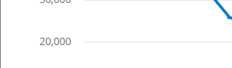
Figure 3: Public Sector Banks: Total current receipts
(ONS. PS. TCR 2022)
Based on the above figure, the customer is more focused on spending money rather than saving or investing the money. This describes the imbalance of the banking industry and its future. The bargaining power of customers of the UK has influenced the rate of receipt of the banks as they are not ready to block their funds in the bank in exchange for low-interest rates.

The threat of new entrant
The new industry that is revolving around the banking and finance sector is the Fintech companies. These are the new entrant that is taking advantage of the fluidity of the money. The banking groups are in collaboration with the Fintech companies, but it is impacting the industry as the major purpose of banking is the save, and collected funds are dropping. Also, the industry has competitors that are working on providing services at lower interest rates along with other benefits. Thus, within the global scenario, the impact due to the threat of new entrants is significantly high.

Based on the study with the help of the Porter five forces model, HSBC can be seen struggling as the total receipts of the public bank in the UK for the last two years has been dropped. At the same time, the entrant of the new banking and companies like Fintech have been creating issues as it is making money more fluid into the market.

Conclusion
The report aimed to study global business management by evaluating the business environment of the UK nation. The report has achieved an understanding of changing global business environment using two global factors using PESTEL and Porter five forces analysis. Based on the analysis, finding that can be highlighted are
HSBC revenue has been dropping from 56,098-50,429-49,552 ($m) for year 2019-20-21 (HSBC. 2022). This indicates the increase in expenses of the company. This indicated the increase of debt in the public sector bank and the contribution of HSBC to the GDP of the UK, and it is declining year over year.
The company has “invested $6bn in technology in 2021” (HSBC. 2022). This has resulted in the company to “97% of transactions automated” (HSBC. 2022). This way, the company is more active online in the digital space.
The company should take care of the entrant of new banking companies like Fintech. As it has been creating issues as it is making money more fluid into the market. Thus, the company should focus on collaboration and the expansion process.

References
Financier Worldwide Magazine. 2022. The future of FinTech — Financier Worldwide (2022). Available at: https://www.financierworldwide.com/the-future-of-fintech Accessed: 6 July 2022.
HSBC. 2022. Annual Report | HSBC Holdings plc. Available at: https://www.hsbc.com/investors/results-and-announcements/annual-report Accessed: 07 July 2022
HSBC Group. 2022. HSBC Group corporate website | HSBC Holdings plc. Available at: https://www.hsbc.com/ Accessed: 5 July 2022.
IBIS. 2022. IBISWorld - Industry Market Research, Reports, and Statistics (2022). Available at: https://www.ibisworld.com/united-kingdom/market-size/financial-management/ Accessed: 3 July 2022.
ONS. PS. GOS. 2022. PS: Public Sector Banks: Gross Operating Surplus: £m CPNSA - Office for National Statistics (2022). Available at: https://www.ons.gov.uk/economy/governmentpublicsectorandtaxes/publicsectorfinance/timeseries/il64/pusf Accessed: 6 July 2022.
ONS. PS. TCR 2022. PS: Public Sector Banks: Total current receipts: £m CPNSA - Office for National Statistics. (2022). Available at: https://www.ons.gov.uk/economy/governmentpublicsectorandtaxes/publicsectorfinance/timeseries/il65/pusf Accessed: 4 July 2022.
ONS. 2022. Public sector debt interest to revenue ratio: Appendix I - Office for National Statistics (2022). Available at: https://www.ons.gov.uk/economy/governmentpublicsectorandtaxes/publicsectorfinance/datasets/publicsectordebtinteresttorevenueratioappendixi Accessed: 6 July 2022.
Statista. 2022. UK finance & insurance businesses 2021, by size | Statista (2022). Available at: https://www.statista.com/statistics/678392/uk-finance-and-insurance-number-of-businesses-by-number-of-employees/ Accessed: 8 July 2022.

