

LOCATION: Swansea | LLEOLIAD: abertawe
LEVEL 7 | LEFEL 7
EXAMINATION PERIOD | CYFNOD ARHOLIADAU
JANUARY 2017 | IONAWR 2017

MODULE CODE: M7X01384
Structural Integrity and Materials Evaluation
TIME: 2 HOURS
answer all questions

Equipment or materials required – Calculator and Ruler
Formulae and Material Properties on last 3 pages

ANSWER ALL QUESTIONS

- Give a brief discussion regarding the Risk Based Inspection approach for the management of equipment and plant integrity. 10 Marks

- The table below provides hit-miss data for complimentary NDT methods used to inspect an aircraft component. The technicians were required to report defects detected or not on a location by location basis. Carry out a full PoD analysis using the ROC method. 10 Marks

- With reference to the eddy current method:

- With reference to induced eddy currents in a conductor, explain the skin effect and effective depth of penetration. 4 Marks

- A test coil is used to inspect a copper component 1mm in thickness. Assuming 0.5mm as the standard depth of penetration required and that the conductivity of copper is 98.6 %IACS:

- Calculate the required test frequency.
2 Marks
- What would be the maximum phase difference between the induced near and far surface eddy currents?
2 Marks
- If we were to increase the test frequency by an order of 2, what would the effects be regarding the depth of penetration and near and far surface phase differences?
2 Marks

- With reference to the ultrasonic method, where a 2.5MHz conventional ultrasonic transducer is to be used to gauge thickness in mild steel

- Determine the thickness required of a PZT crystal to produce a resonant frequency of 2.5MHz, given that the compression wave velocity for PZT is 3000 m/s.
2 Marks
- Assuming for the aforementioned crystal that it has a diameter of 10mm, determine the crystals near field distance when transmitting into Perspex.
2 Marks
- Assuming the crystal is in contact with a mild steel surface. Calculate the 6dB beam width for the crystal at a thickness in mild steel of 25mm.
2 Marks
- If a Perspex delay line is used to compensate for the near field zone, what would the resulting effect be in terms of the beam width?
2 Marks
- What are the implications with regard defect sensitivity in this application?
2 Marks

- With reference to radiographic methods

- A micro-focus 2D x-ray inspection is to be undertaken on a square (8mm x 8mm) mild steel plate of thickness 20mm. The source to detector distance is fixed at 0.5m. The focal spot size of the x-ray tube is 30µm. A geometric unsharpness value (U_{g}) of better than 0.01mm is required. Calculate the required source to object distance and resulting magnification factor.
5 Marks
- A technician is in an area for 10 minutes and the reading on an exposure meter is 5mR/hr. Determine the actual radiation dose received by the technician.
1 Mark
- A technician should not receive a radiation dose greater than 1mR. Based upon Q5 b) conditions determine the maximum time the technician can stay in the area.
1 Mark
- The intensity of an unshielded I-131 source is 32mR/hr. If the source is put into a lead shield 30mm thick what would be the intensity on the outside of the shield? Assume your distance from the source has not changed. The HVL of lead for I-131 is 0.178cm.
3 Marks

Snell’s Law:  $$\frac{sin i}{V_{1}}=\frac{sin r}{V_{1}}=\frac{sin R}{V_{2}}$$ | Reflected Energy Equation:  $$RE={\left(\frac{Z_{1}-Z_{2}}{Z_{1}+Z_{2}}\right)}^{2}×100\%$$
Ultrasonic Beam Formulae:  $$NF=\frac{d^{2}}{4λ}$$  Where:  NF = Near Field Distance  d = Crystal diameter or aperture width  λ = wavelength | Far Field Approximation:  $$A\left(θ\right)=\frac{sin(α)}{α}$$  Where  $$α=k\frac{d}{2}sin⁡(θ)$$  K is the wave number (2π/λ) and d is the aperture width.
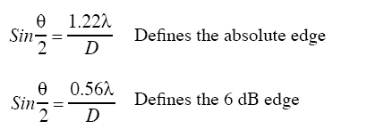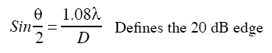
Q Factor
$$Q=\frac{f_{0}}{f_{2}-f_{1}}$$

Where:
f₀ = the centre frequency
f₂ = the upper -6dB frequency
f₁ = the lower -6dB frequency

Frequency thickness crystal constant:

f x t = V/2

Where,
- f = desired frequency
- t = crystal thickness, and
- V = compression wave velocity in the crystal material

General Formula and Constants
$$δ_{mm}=\frac{661}{\sqrt{fµ_{r}σ}}$$
$$θ=\frac{x}{δ}×57.3$$
$$B=µH$$
$$µ_{r}=\frac{µ}{µ_{o}}$$
$$µ_{o}=4π x {10}^{-7}$$
Current Loop Centre Flux Density
$$B=\frac{{µ_{r}µ}_{o}I}{2R}$$
Solenoid Centre Flux Density
$$B=μnI$$
$$n=\frac{N}{h}$$
Magnetic Circuit Equations
$$μ_{o}\iint{J.∂s}=\oint{\vec{B}.\vec{∂l}}$$

$$V_{L}=-L\frac{∂I}{∂t} V_{L}=-N\frac{∂Φ}{∂t}$$

$$mmf=H.l R_{m}=\frac{l}{μA} F_{m}=N.I R_{m}=\frac{mmf}{Φ} U_{g}=U_{f}\left(\frac{f_{2}-f_{1}}{f_{1}}\right)$$

$$I=I_{o}e^{-μx}$$

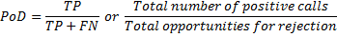

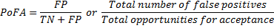

Material Properties.
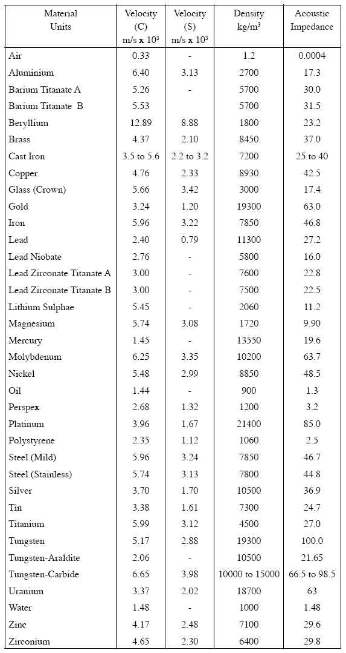

Diwedd/End

