University of Wales
Trinity Saint David

PROPOSAL
EFFECT OF MULTICULTURAL COMMUNICATION AND DIVERSITY IN THE WORKPLACE (A CASE STUDY OF HAIER COMPANY)

Student Supervisor

Manal Talharchet Husam Alharahsheh
1917140

September 2022
Table of Contents
1.0 Introduction 4
1.1 Purpose of Research Activity 4
1.2 Research Question 4
1.3 Aims of Research Activity 5
1.4 Objectives of Research Activity 5
2.0 Literature review 5
2.1 Definition 5
2.2 Characteristics 6
2.3 Importance 6
2.4 Models 6
2.5 Theories 7
2.6 Advantages 7
2.7 Disadvantages 8
2.8 Challenges 8
3.0 Research method 8
3.1 Research philosophy 8
3.2 Research paradigm 9
3.3 Research approach 9
3.4 Research methodology 9
3.5 Research strategy 9
3.6 Sampling methods 9
3.7 Data collection method 10
3.8 Data interpretation 10
3. 9 Ethical consideration 10
3.10 Time table of action plan 11
Location of research activity 12
Conclusion 12
Reference list 13

Introduction
Organisational and working cultural diversity within the Haier Company in China is impactful to encourage collaboration of employees to apply the supportive and cooperative employee management in terms of global scale to allow the better performance of each employee. The research analysis will be mainly based on the outcome of multicultural protocol in any organisation. Through this proposal all the methodology and the way of research will be discussed. Each section of the whole research is here shortly described which defines the whole work procedure.

1.1 Purpose of Research Activity
The analysis of multicultural communication and diversity in the workplace will be beneficial to measure the cultural diversity within a company to measure the stability and positivity of the workplaces by measuring the different kinds of cultural activity and communication aspect (Ng and Sears, 2020). On the other hand, cultural diversity has created some problems within the workplace and employee management.

1.2 Research Question
- What is the relationship between the Effect of multicultural communication and diversity in the workplace Direct and indirect communication take place within the Haier Company of Japan?
- What are the impacts of multicultural communication and diversity in the workplace on the Use of verbal and body language within Haier Company in Japan?
- Why is the contribution of multicultural communication and diversity in the workplace correlated with the Different cultural activities within Haier Company in Japan?
- What are the benefits and challenges of multicultural communication and diversity in the workplace within the process of employee behaviours within Haier Company in Japan?

1.3 Aims of Research Activity
The purpose of the research will be defined by the implication of knowledge about multicultural communication and diversity in the workplace (Shepherd, 2019). This approach will be beneficial to apply the process of the different working creativity within the workplace by measuring the diversity of employee culture in order to measure the key issues of the working diversity within the organisation.

1.4 Objectives of Research Activity
- To analyzes the relation between the Effect of multicultural communication and diversity in the workplace, the Direct and indirect communication within Haier Company in Japan
- To study the impacts of the multicultural communication and diversity in the workplace on the Use of verbal and body language within Haier Company in Japan
- To investigate the contribution of the multicultural communication and diversity in the workplace in order to measure the Different cultural activities within Haier Company in Japan
- To research the benefits and the challenges of the multicultural communication and diversity in the workplace within the process of employee behaviours within Haier Company in Japan.

2.0 Literature review

2.1 Definition
Multicultural communication and diversity in the workplace workers with various scenes have different variations of vocabularies, posters and other structures of contact. The effects of cultural diversity are beginning to measure how they chat, drive conclusions and close competition (Angouri, 2018). Based on the communication and transmission the cultural diversity within the workplace may be hampered. The analysis of employee management has been developed by the cultural diversity.

2.2 Characteristics
- The implication of the Direct and indirect communication process within the workplaces of the Haier Company in china to allocate the different cultural diversity.
- The ability of the different cultural diversity within the organisation is being supervised by the trouble with different accents and fluency of communication strategies (Ng and Sears, 2020).
- The process of the Different employee attitudes and employee behaviours within the organisation is effective to improve the hierarchy and applicability of betterment of authority aspects.
- The way of removing the Conflicting norms to the aspects of the decision-making process by the employee is also measured by the Effect of multicultural communication and diversity in the workplace

2.3 Importance
The importance of multicultural communication and diversity in a workplace is very huge. All credit goes to modern technologies and transport systems because our world is getting smaller by the help of these two factors. It is also leaving a lot of scope to businesses by spreading their products. Globalisation plays an important role for this. Nowadays employees are getting smarter for businesses so that is why they can easily develop good communication skills (Rakhra, 2018). Now people belong to two different cultures like “high context” and “low context” so people from both sides are communicating in a multicultural workplace.

2.4 Models
Interactive Communication Model
The Interactive Communication Model is popularly known as the convergence model. This model is useful for enhancing the effective ideas that are important for exchanging the message from one place to another (Misganu and Zewdie, 2018). This model helps to succeed in various ways for describing one thing to lots of people at one time. This process makes a good connection between senders to receivers in verbal and non-vertical ways.
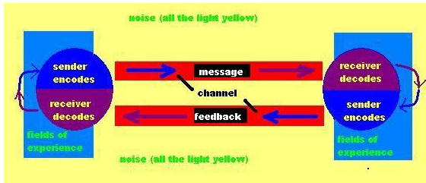
Figure 1: Interactive Communication Model
(Sourece:https://www.tutorialspoint.com/effective_communication/effective_communication_models.htm)

2.5 Theories
Cross cultural management
Cross cultural management is also popularly known as the linear concept multicultural diversity aspect. Cross-cultural theories are effective for managing the communication process in the workplace. This process will describe the practical wait for embracing inclusive managing ways to the civilization of associates’ countries, which have additional mortal races, artistic types and expansion phases of society in the multinational business (Wang et al. 2019). It is one of the popular management methods to adopt the local civilization.

2.6 Advantages
- Cultural Diversity within the workplace measures the cultural approaches can encourage the working creativity and help involvement the innovation (Dudin et al. 2019)
- Improves the analyses of the local market strategies implication within the workplace which is effective to make more business profit margin and proves the competitive advantages within the Haier Company in china.
- Bring the positive way of the cultural aspect and cultural diversity to implicate the ability of the local communication model and aspects (Denisova-Schmidt et al. 2020)
- Measures the perception of the diverse skill management to allow the growth and development of the organisation based on the retention of the talent and employee management.

2.7 Disadvantages
- Some cultures can face a lot of difficulties in the workplace.
- Communication problems may arise among employees.
- Language diversity also plays a key role as a disadvantage of multicultural (Romani et al. 2018)
- Communication and diversity in the workplace.
- It can increase conflict among employees due to poor conversation.

2.8 Challenges
The challenges of the multicultural communication and diversity in the workplace are “Direct versus indirect communication, Trouble with accents and fluency, Different attitudes toward hierarchy and authority, Conflicting norms for decision-making, Implication of Language Barrier, analysis the Stereotyping aspect, Ethnocentrism / Cultural Relativism, Cultural Shock process, Attitude toward Conflict Resolution, Approaches to Tasks’ Completion, Different Decision-Making Styles, Different Attitudes toward Privacy, Different Ways of Building Trust and Relationship, Non-Verbal Communication” and others (de Luis et al. 2019).

3.0 Research method

3.1 Research philosophy
The analyses of this Research philosophy is based on the ontology in order to measure the requirements with the "source, nature and development of knowledge" within the research papers to develop the research topic by the researchers (Rajhans and Hiray, 2022). Research philosophy will be beneficial to measure the simple "belief about the ways in which data about a phenomenon should be collected, analysed and used".

3.2 Research paradigm
The analysis of the positivism research paradigm within the research papers will be developed by the implication of the research model or method to apply the analysis. The dissertation will depend on the measure by a significant number of students in the area established on holding stands both demonstrated and rehearsed for a prolonged duration of period.

3.3 Research approach
The research approach will be conducted by the data interpretation based on the deductive research, describing the study design and the selection criteria and the population number chosen for this research topic. This research study will be helpful for discovering a good relationship between the three research objectives and the question of this research paper.

3.4 Research methodology
The research methodology will be based on the primary data analysis. The implication of the quantitative research approaches is effective to measure the possibility of better data interpretation to the research paper by the researchers.

3.5 Research strategy
The research strategy of these research papers has been developed by the “primary research study”. Here all the “research papers” will be based on the field study, and different journals and articles to interpret the research study about the direct variables (Rakhra, 2018). In the primary research, surveys and ethnographic research will be undertaken in this research. The total number of respondents is 30 customers from Haier Company.

3.6 Sampling methods
The “research paper will be based on the probability sampling” collected from the random respondents for the primary data analyses based on the employee and non-employee of the haier company in Japan (Park, 2020). The sampling techniques of the secondary data analysis will be developed by the knowledge of the different articles and joules.

3.7 Data collection method
Within the research papers the data collection process will be dependent on the primary data collection process (Wang et al. 2019). The primary data calculation process will be based on the questionnaire and survey schedule.

3.8 Data interpretation
The first step for data interpretation will be collecting the resources from the authentic resources, after that, the important data will be collected, and after that, the researchers need to set up the questionnaires based on the research topic (Angouri, 2018).

3.9 Ethical consideration
The "ethical thinking" of the research proposal will be acceptable to review the research will the "responsibility, commitment and the Integrity" established on an accounting topic. The investigation will be “based on the current overview” of the proper respondents (Kamales and Knorr, 2019). The ethical situation will be “focused on the initial analysis” of the analysis of the research study. Information must be collected properly and transparently. It must be collected for specified purposes. (GDPR,2018)

3.10 Time table of action plan
Time prospective (Gantt chart)

Task | Starting date | End date | Day
Executive summary | 5.10 | 10.10 | 5
Introduction | 11.10 | 20.10 | 15
Literature review | 20.10 | 30.10 | 10
Methodology | 30.10 | 7.11 | 7
Discussion | 7.11 | 10.11 | 3
Data analysis | 10.11 | 15.11 | 5
Recommendation | 15.11 | 18.11 | 3
Conclusion | 18.11 | 25.11 | 6

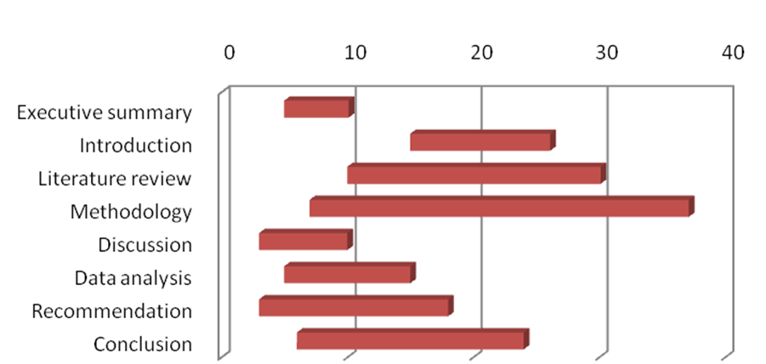
Figure: Gantt chart
(Source: Self-created)

Location of research activity
The location of the research activity is within the Haier Company of Japan.
The research work will be done remotely by looking for customers online (Dover et al. 2020). The basic issues of the research work is based on the research problem within the multicultural communication and diversity in the workplace will be mostly found in the lack of communication process, insufficient language acceptability, fluency berries within the transmission aspect.

Conclusion
With the implication of technology and more rapid transport, the planet is developing more miniatures every day, creating an abundance of possibilities for companies to develop their outcomes, benefits and teams on a transnational hierarchy. Within the Haier Company in Japan, the workplace diversity is most dependent on the employees who are from different countries throughout the world. For this reason, within the company the workplace diversity is highly measured. The stability and positivity of the workplaces is measuring the different kinds of cultural activity and communication aspects. The implication of the cultural diversity and different processes of the cultural activity within the workplace is affected to measure the employee management working progress review. This process is beneficial to encourage the employee within the Haier organisation in Japan to measure the employee's accessibility in the workplace. The research papers are based on the primary data analyses to implicate the possibility of the betterment of data interpretation within the research paper. Within the research papers the data interpretation has been allowed the survey and the questionnaire session.

Reference list
Angouri, J., 2018. Culture, discourse, and the workplace. Routledge.
Denisova-Schmidt, E., Markovina, I. and Nicolas-Kryzhko, L., 2020. The lacuna model: A new approach to cross-cultural management research. International Journal of Cross Cultural Management, 20(3), pp.329-344.
de Luis, Llopis‐Lorente, A., Rincón, P., Gadea, J., Sancenón, F., Aznar, E., Villalonga, R., Murguía, J.R. and Martínez‐Máñez, R., 2019. An interactive model of communication between abiotic nanodevices and microorganisms. Angewandte Chemie International Edition, 58(42), pp.14986-14990.
Dover, T.L., Kaiser, C.R. and Major, B., 2020. Mixed signals: The unintended effects of diversity initiatives. Social Issues and Policy Review, 14(1), pp.152-181.
Dudin, M.N., Pogrebinskaya, E.A., Sidorenko, V.N., Sukhova, E.I., Zubenko, N.Y. and Shishalova, J.S., 2019. Cross-cultural management in the system of harmonization of interests in the multi-confessional educational environment. European Journal of Science and Theology, 15(3), pp.191-199.
Ico.org.uk. 2018. Guide to the UK General Data Protection Regulation (UK GDPR). [online] Available at: https://ico.org.uk/for-organisations/guide-to-data-protection/guide-to-the-general-data-protection-regulation-gdpr/ [Accessed 3 August 2022]
Kamales, N. and Knorr, H., 2019. Leaders with managing cultural diversity and communication.
Misganu, G. and Zewdie, S., 2018. Workforce Diversity Management as a Key to ImproveProductivity: A review article.
Ng, E.S. and Sears, G.J., 2020. Walking the talk on diversity: CEO beliefs, moral values, and the implementation of workplace diversity practices. Journal of Business Ethics, 164(3), pp.437-450.
Park, J.S.Y., 2020. Translating culture in the global workplace: Language, communication, and diversity management. Applied Linguistics, 41(1), pp.109-128.
Rajhans, K. and Hiray, A., 2022. Cross-cultural communication barriers to managing workforce diversity in multicultural organisations. International Journal of Management Development, 2(2), pp.81-101.
Rakhra, H.K., 2018. Impact of Workplace Diversity on The Performance of The Organizations. ZENITH International Journal of Multidisciplinary Research, 8(4), pp.1-8.
Romani, L., Barmeyer, C., Primecz, H. and Pilhofer, K., 2018. Cross-cultural management studies: state of the field in the four research paradigms. International Studies of Management & Organization, 48(3), pp.247-263.
Shepherd, S.M., 2019. Cultural awareness workshops: limitations and practical consequences.
Wang, J., Cheng, G.H.L., Chen, T. and Leung, K., 2019. Team creativity/innovation in culturally diverse teams: A meta‐analysis. Journal of Organizational Behavior, 40(6), pp.693-708.

