

DELL TECHNOLOGIES INC.
Analysis and Evaluation

Student : Dimitar Gadov
Student Number : 1913486
Tutor’s Name : Tushara Balendran
Module : Marketing Fundamentals
Module Number : LCBB4004
2020

Content:
- Introduction
- Process and stages of marketing
- Situational Analysis
- Objectives
- Strategies
- Implementation
- Control

- Macro and Micro Environment- PESTLE Analysis
- Political factors
- Economical
- Socio-Culture factors
- Technological
- Environmental
- Legal
- SWOT Analysis
- Strengths
- Weaknesses
- Opportunities
- Threats
- Advantages and Disadvantages of PESTEL analysis
- Marketing Mix
- Segmentation, Targeting, Positioning
- 4Ps marketing mix model (product, price, place, promotion)

- Conclusion
- References

Introduction
Dell is an American worldwide technology company that makes, sells, repairs, and supports computers and related products. Dell was founded in 1984, by Michael Dell in Roundrock, Texas. Nowadays, Dell is that the third largest PC seller, which has presence in over than 180 countries. Also the corporate is one among the largest corporations, which provides jobs to quite 165,000 people round the world (Dell Annual report 2020).
Dell Technologies became a leading global contributor, with a awfully extensive portfolio of IT hardware, software and services solutions, covering both standard infrastructure and multi-cloud technologies that enable their consumers to make digital future and remodel their living style.
Processes and stages of marketing
Marketing is an organizational function and a group of processes for creating, communicating and delivering value to customers and for managing customer relationships in ways in which benefit the organization and its stakeholders (Edward Russell, the basics of marketing).
Marketing concept of Dell company may be established in a very series of steps, which presents the subsequent diagram.
2
Objectives
3
Strategies
1
Situational Analysis

4
Implementation
5
Control

Situational analysis is a foundation of a marketing plan. It's one in all the foremost used methods for collecting and analyzing marketing information. It includes a radical examination of external and internal factors, which affect the business. Objectives are specific result that a corporation aims to realize within a time-frame and with available assets. Strategy of the corporate is that the main plan intended to attain its goal for an extended period of time. Implementation is that the process of placing a decision and delivering a plan to completion (Kotler 1997). Control is that the set of practices and procedures, which monitor and regulate company’s marketing activities in achieving their main strategies.
Macro Environment – PESTEL analysis
The PESTEL analysis of Dell Technologies researches the numerous regulations they have to abide by, in addition as economic inflation, consumer opinion, and think about the incessant technological innovations in the industry (PEST Analysis of Dell Technologies, Kiesha Frue May 9, 2018). The microenvironment represents external factors, affecting the business activities like market structure, market trends, competition, clients and suppliers. (Pestle Analysis. (2013). Understanding PEST Analysis with Definitions and Examples)
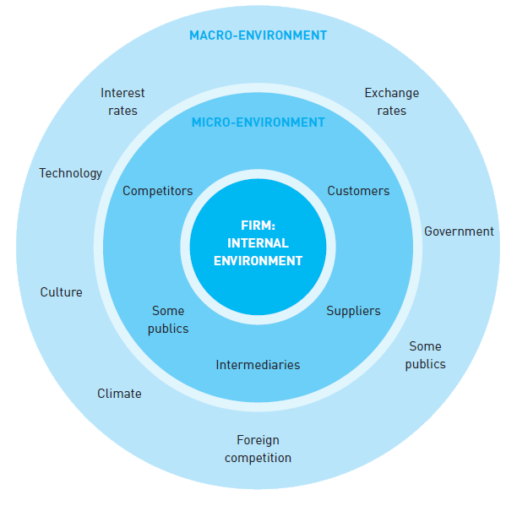
Source: Micro-and macro-environmental forces (Blythe, 2005)
Political
Political factors include government regulations and legal policies, dictating the conditions under which companies must operate. Dell should face irrefutable restrictions, while make business.
One of the regulations that Dell should follow is Waste from Electrical and equipment (WEEE) laws, comes from United States Congress. It aims to scale back waste from electrical equipment and to boost the environmental friendly (A.Oreskovic, 2010). During 2009, Dell banned the export of most of electronic waste, such as: chemical formations (Dell, 2010). Dell is operating globally and that’s why political forces and stability are favorable.
Economic
Economic stability is very important for world business growth. Every change in currency rate, for instance, might affect the ultimate price of Dell products. That’s why economic analysis is favorable.
Social
Socio-cultural factors are playing a significant role within the area of selling. Dell runs the business across a lot of countries. Culture is different in every region and that’s why Dell has to modify their business and strategies to outfit current markets and cultures. Nowadays, culture and the people are one of the most important factors in the technology world. That’s why this force is extremely favorable.
Technological
Technological force from PESTEL Analysis of Dell is favorable, because the company’s investments reached 4.4 Billion dollars in 2018 for brand new range of products.(Dell strategic Analysis,2018). The technological part covers the institutions and activities, which implied developing more knowledge into products, processes and materials. In computer industry, low cost leadership will be achieved by technological improvements and significant distinction to the corporation. The company’s website is able to reach 25 million visits in different regions in total. (Dell annual report).
Environmental
Environmental factors have also big importance recently. Dell invested in environmental issues in couple of regions , such as green packaging, renewable energy and cost-effective energy producing. That approach contributes better social position, higher trust and user’s loyalty. Governments and legal agencies round the world are always inspiring businesses to fund within the environment, that’s why this force is favorable. (Dell Strategic Analysis,2018)
Legal
Governments and legal agencies round the world have tightened their grip on businesses. Substantial worldwide businesses and technological giants, as Dell, have always perceived force in legal and financial aspect. Dell’s representation in this area remains reputable and uncontaminated, because company concentrates in compliance. This mean the legal force is unfavorable. (Dell strategic analysis 2018)

SWOT Analysis is a different type of technique to inspect organizational internal and external environment. This analysis presents the interior strengths and weaknesses of the business and its external opportunities and threats.
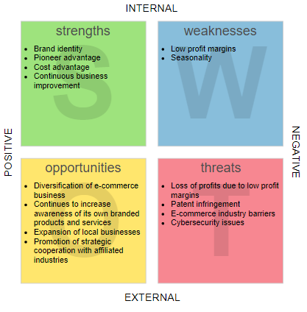
Source: Strategic Planning to Actionable Items: From SWOT to TOWS Analysis
Strengths
Dell Technologies have approved on the market as a world leader of computer systems and related products. The already famous name is incredibly beneficial for customer’s choice. Another major strengths of Dell company is direct selling business model. This allows customers to set their orders and receives its self-created computer commonly within few days. Based on the environmental record, Dell is involved in many green activities and has received a lot of awards for eco-friendly business. That is an enormous plus, when working with public agencies. (SWOT analysis of Dell, Ovidijus Jurevicius, February 16, 2013)
Weaknesses
Dell’s biggest weakness is low retail locations. Their customers can’t physically see the merchandise, which they might wish to buy. Selling products online saves money and allows for product customization but provides less visibility for the products. The client finds it difficult to trust the seller, if they can not touch it with hands. Another weakness is the bad customer services. Dell invested an outsized sum of cash in fixing deterioration due to outsourcing of call centers, but still couldn’t gained the reputation yet. (SWOT analysis of Dell, Ovidijus Jurevicius | February 16, 2013)
Opportunities
Countries with developing markets are growing extremely fast. Dell shows satisfactory presence for the electronic devices, such as tablets and laptops, but they should clear up their positions, because of supply exceeding demand. Tablet market is anticipated to grow in double digits for the subsequent few years and also the company features a great opportunity to release new tablet models shortly. Another opportunity is that the possibility for Dell to open and develop actual stores. (SWOT analysis of Dell, Ovidijus Jurevicius | February 16, 2013)
Threats
Nowadays, the non-public computer market is extremely unstable, thanks to the constantly changing industry. Consumers often choose tablets or smartphones rather than laptops, because of the faster adeptness and modernization. Dell should react quickly, adapt to the present-time and fight back to the competitors as create high-speed, classer and more qualitative laptop. Dell’s main earnings are from selling hardware products. The rising prices of them will boost costs for Dell and can cut the cash flow in the future. (SWOT analysis of Dell, Ovidijus Jurevicius | February 16, 2013)
Advantages and disadvantages of PESTEL analysis
The advantages demand being cost-beneficial, understanding business in deep and awareness threats.
The benefit of PESTLE analysis is time. Initially, everyone can make that analysis, because is simple. Despite of that, not to do PESTEL can affect the business directly and indirectly. The macro and micro analysis help to examine dominant factors when launching new product. (The Advantages of PESTEL Analysis: Kiesha Frue, June 6, 2016)
The disadvantage of PESTEL analysis is that only provides an outside perspective about business without internal factors. It uses primarily a strategic tool for planning which is extremely limited. When you do only PESTEL, you merely get one side of the story. It leaves gaps and holes, allowing assumptions to slither in. Also most of the data isn’t easily obtained online and also the factors can change dramatically in exactly a pair of hours. The analysis needs plenty of time and knowledge. Even after you get what you wish, isn’t up to date. (6 Frustrating disadvantages of PESTEL analysis, Kiesha Frue, Sept 17, 2018)
Marketing Mix
Marketing mix model analyses data from spread of sources, such as retailer scanner data, company shipment data, pricing, media and promotion spending data. Also marketing mix modelling separates effects, defines which is less productive and estimates how different marketing elements work together. (Philip Kotler, Al.J.,et , Marketing Management).
Segmentation, Targeting, Positioning
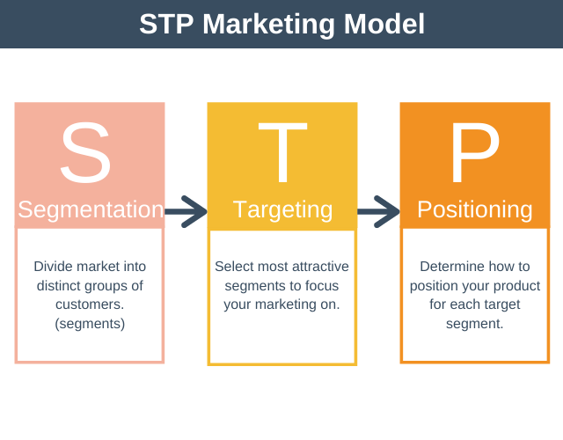
Source: STP Marketing Model, Expert program management

The process of defining and dividing an oversized heterogeneous market into clearly distinguishable segments having similar needs, wants, or required characteristics. The aim of it is to accurately matches the customer’s expectations with the targeted component. (Business dictionary). Market segmentation also reduces the chance of an unsuccessful or not very effective campaign. A marketer could endeavor different types of segmentation to look for the simplest approach to observe at the market structure. (Kotler, P. (1997) Marketing Management: Analysis, Planning, Implementation, and Control)
Marketing approach of Dell includes geographic, demographic, psychographic and behavioral segmentation.
Geographic
When the market is split into different geographical units like regions, nations, counties, states, cities or neighborhoods, this method is termed geographical segmentation (Stanley, 1992).
Dell has segmented the market into the US/Americas, EMEA and Asia-Pacific-Japan, where each specific area has various cost and marketing approach. (Segmentation, Targeting, Positioning of Dell, December 11, 2012, Sanjeev Kainwal)
Demographic and Gender segmentation
Age and maturation segmentation indicates to dividing a market with into distinct ages and life-cycle groups (McCarthy, 1960). Gender segmentation specifieswith deviding the market into categories defers in gender. (Kotler, 2002). On the opposite hand, when hence the product offers and exploring customers’ needs, there is no age or gender, race or wages, education or occupation. (Segmentation, Targeting and Positioning of Dell, December 11, 2012, Sanjeev Kainwal)
Behavioral segmentation
It can be defined into segments, which sustain customers’ knowledge, use, attitude, or response to a product (Gatignon, 1993). Dell concentrates on the advantages requested by consumers as low price, better quality and maintains. Also it giving a chance to improve a main specialization in targeting and keeping a particular data base for potential customers. (Segmentation, Targeting and Positioning of Dell, December 11, 2012, Sanjeev Kainwal)
4Ps model
The definition 'marketing mix' is a core model for businesses around product, price, place, and promotion - known as the "4 Ps". It has been described as the "set of marketing tools” that a particular company uses to track its marketing objectives in the target market. (Kotler, P., Marketing Management,2000)
Promotion
Place
Price
Product
4 Ps of Marketing Mix Model

Product
Dell supplies large type of the business category and residential consumer category products and services. Some samples of the products of individual and occupation customers are Dell accurate workstations, Pcs, OptiPlex and parallel notebooks.

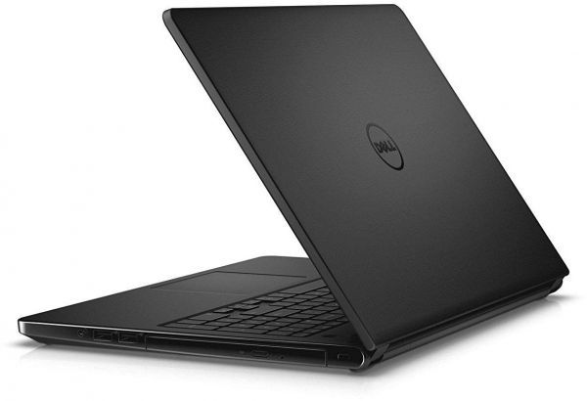
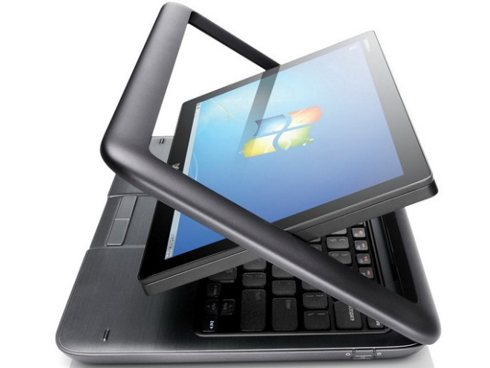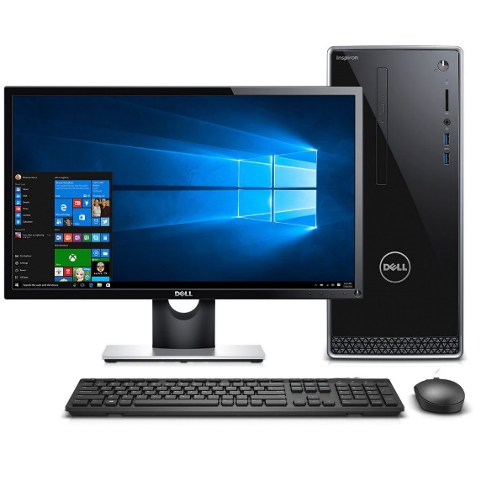


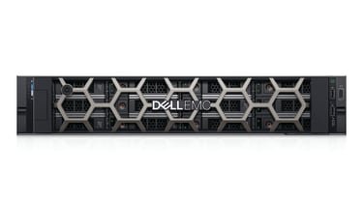
Dell is often with the power particularly to form their products and services around an oversized selection of the shoppers, including individual consumers, corporate businesses and retail merchandising. Some samples of products, which are usually sold at resourcefulness clients, are Dell power edge servers, power vault, Dell EMC memory systems, and power connect switches.

Dell’s branding strategy is to supply quality products to its consumers and business providers. They launched a tool, called Dell Connect, which permits the technician to access user’s computer and resolve the systems problems quickly. That helped company to attracted many new customers. (Dell Marketing Mix (4ps) Strategy, 2020)
Price
Price is that the amount of cash charged for a product or service, or the sum of the values consumers exchange for the advantages of getting or using the merchandise or service. Dell uses top quality computer systems at rock bottom price to match the customer’s expectation useful for money. Tt's also ready to supply products at low price by operation all costs of producing parts moreover as costs related to retailers and distributors. (Dell Marketing Mix (4ps) Strategy, 2020)
They use penetration pricing strategy when introducing the new products and therefore the low price remains the identical during the maturity stage. The cheaper price helps a brand new product or service get through the market and allure customers from the rivals. (Penetration pricing, what's penetration pricing, by W.Kenton, Updated Jul 28, 2020)
Place
The place or channel of supply is one among Dell’s noticeable advantage in their marketing mix. This can be because Dell uses a direct channel model- the customer buys a product straight from the website, without middle department. Also customers can call free of charge and purchase a product over the telephone.
The direct channel model allowed Dell to scale back costs and minimize inventories and that’s why they save money, time and lower the final product price. (Dell Marketing Mix (4ps) Strategy, 2020)
Promotion
Promotion is that the most vital part of the four P’s, so it's significant to grasp and be able to advertise a product. Dell uses many various promotional methods to popularize their products, such as: TV adverts, on the net, in newspapers and also personal mail ad campaigns. They use also sponsorships in professional sports and films. (Dell Marketing Mix (4ps) Strategy, 2020)
From the beyond details it's clear, that Dell’s present marketing mix is one among the most factors that put up to its competitive advantage. The way the corporate is in a position to use its marketing strategy should allow the firm to rank its competitive advantage in the based market component. Dell should make the most of the market possibilities that would potentially grow the business profits and stabilized its place on the market field. That could lead to different strategy and meet the market requirements, hence rising earnings and trade share. (Dell Marketing Mix (4ps) Strategy, 2020)
Conclusion
Despite of competition and some weaknesses, Dell is a very adaptive and prosperous company, which presents the newest technology, stays strong on the IT market and adapts much more quickly than other similar companies. Because of its direct sales model, limit retailer and provides the high quality products directly to the customers for reasonable price and increase the brand loyalty and customer satisfaction. (A New Channel Strategy for Dell, by Sunil Chopra, OCT 9, 2007)
Dell might use Market development strategy to adapt its present product line to developing countries. It can be used for creating a new product as a smartphone or e-reader, similar to Kindle.

References:
Dell annual report 2019
Dell website- www.dell.com
The fundamentals of marketing, by Edward Russell
PEST Analysis of Dell Technologies, Kiesha Frue May 9, 2018
Wikipedia (2013). PEST analysis. Available at: http://en.wikipedia.org/wiki/PEST_analysis
Pestle Analysis. (2013). Understanding PEST Analysis with Definitions and Examples
Source diagram : Micro-and macro-environmental forces (Blythe, 2005)
Dell and HP shake off slowdown fears, A.Oreskovic Aug 19, 2010 https://mobile.reuters.com/article/amp/idUSTRE67I5MK20100820
Analysts raise Dell price targets, 28 Aug 2009, Reuters,https://www.reuters.com/article/idUSBNG48799720090828
Dell Strategic Analysis, Abhijeet Pratap, November 9 2018| Updated: July 10 2019
Source diagram SWOT: Strategic Planning to Actionable Items: From SWOT to TOWS Analysis https://medium.com/@warren2lynch/from-swot-to-tows-analysis-55ac394064b7
SWOT analysis of Dell, Ovidijus Jurevicius | February 16, 2013, https://strategicmanagementinsight.com/swot-analyses/dell-swot-analysis.html
The Advantages of PESTEL Analysis: Kiesha Frue, June 6, 2016
6 Frustrating disadvantages of PESTEL analysis : Kiesha Frue, Sept 17, 2018
Source SPT diagram: Source: STP Marketing Model, Expert program management https://expertprogrammanagement.com/2019/11/stp-marketing-model/
Marketing Management, by Philip Kotler and Kevin Lane Keller, 15th Edition (Global Edition), Pearson
Kotler, P. (1997) Marketing Management: Analysis, Planning, Implementation, and Control.
Business Dictionary, Segmentation : http://www.businessdictionary.com/definition/market-segmentation.html
Segmentation, Targeting and Positioning of Dell, December 11, 2012 , by Sanjeev Kainwal https://sanjeevkainwal.wordpress.com/2012/12/11/segmentation-targeting-and-positioning-of-dell/
4Ps : Kotler, P., Marketing Management, (Millennium Edition), 2000, p. 9
Dell Marketing Mix (4ps) Strategy : MBA Skool team, April 19, 2020
Penetration pricing, What is penetration pricing?,By WILL KENTON, Updated Jul 28, 2020
A New Channel Strategy for Dell, by Sunil Chopra, OCT 9, 2007, https://insight.kellogg.northwestern.edu/article/a_new_channel_strategy_for_dell
Ansoff, H. I. (1957). Strategies for Diversification. Harvard Business Review. (Vol. 35 Issue 5, Sep/Oct).

