COVER PAGE
NAME
STUDENT ID
MODULE CODE
TITLE

Task 1
This concept map demonstrates how creativity leads to value creation, which in turn drives improvement in health and social care services. As outlined in Week 1, creativity involves generating innovative ideas to address complex care needs and adapting services to meet diverse individual requirements. In practice, this includes using reflective practice to challenge traditional ways of working and promoting person-centred and inclusive approaches to care. Creativity is not simply about new ideas, but about applying divergent thinking to explore possibilities and convergent thinking to refine solutions into practical actions.

When creativity is effectively applied, it results in value creation. As shown in the concept map, value creation involves improving outcomes and wellbeing for service users, enhancing safety and quality of care, and ensuring efficient and ethical use of resources. This reflects the importance of delivering care that benefits not only service users but also families, carers, staff, and organisations.

Value creation then contributes directly to improvement in health and social care. Continuous improvement in care quality and service delivery reduces inequalities and unmet needs while increasing service user satisfaction and engagement. Sustainable, evidence-based practice and workforce development are also strengthened.

Importantly, the process is cyclical. As improvements are made, new challenges emerge, which require further creative thinking. Therefore, creativity, value creation, and improvement are interconnected and essential for maintaining responsive and high-quality health and social care services.

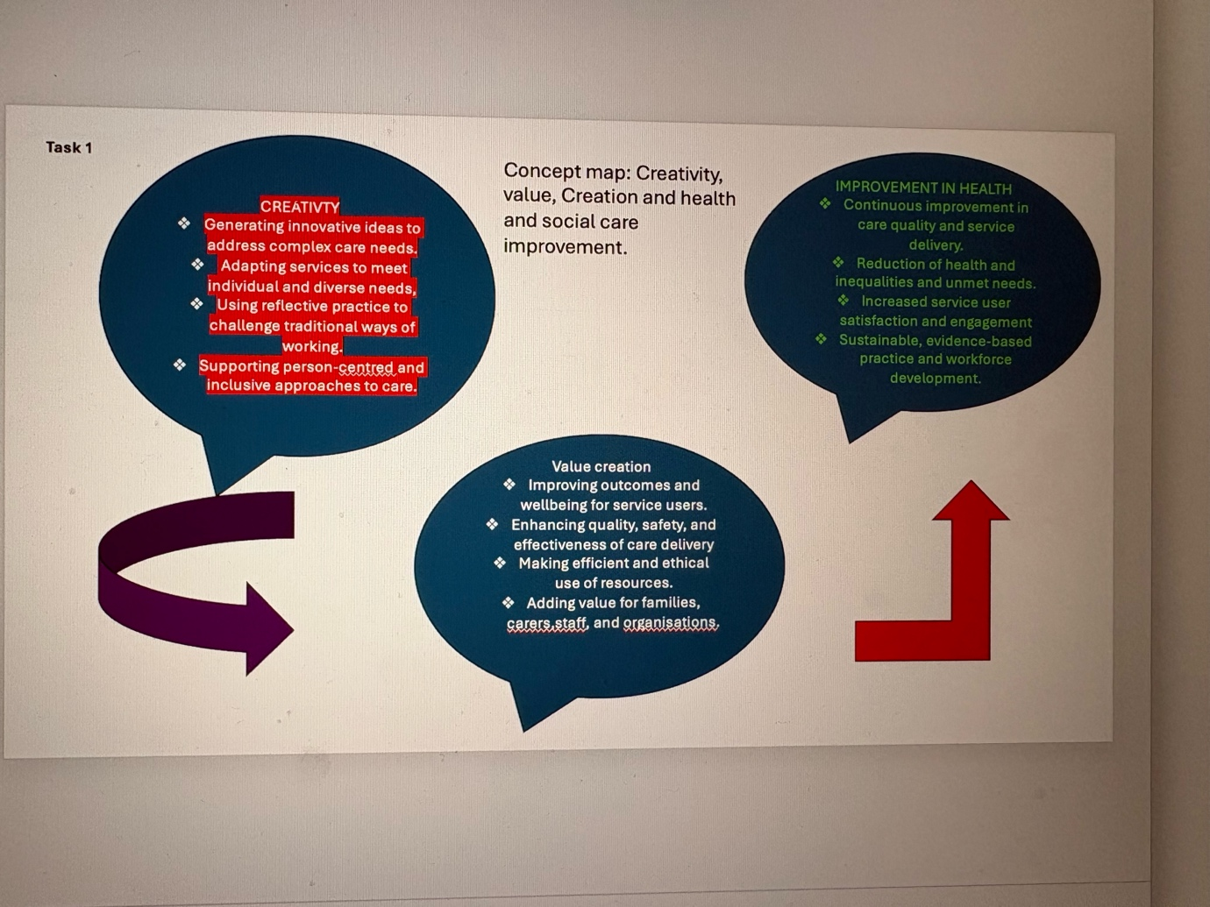

Task 2
Self-Reflection on the Convergent and Divergent Paperclip Thinking Activity
This reflection uses Gibbs’ Reflective Cycle (1988) to reflect on my experience of the convergent and divergent paperclip thinking group activity completed in Week 2.
Description:
During the activity, I worked in a group to explore different ways a paperclip could be transformed. In the divergent thinking stage, I created a figure of a lady using paperclips, shaping the body, arms, and legs, and adding a red-coated paperclip to represent hair. This allowed me to think creatively beyond the paperclip’s original purpose. In the convergent stage, the group discussed which ideas were most effective and meaningful.
Feelings:
At first, I felt unsure about sharing my idea, as it felt more artistic than practical. However, once I shared it with the group, I felt more confident and encouraged. Seeing others respond positively made me feel more comfortable contributing my ideas.
Evaluation:
A positive aspect of the activity was the freedom to explore creativity without judgement during divergent thinking. Creating the paperclip figure helped me engage more actively in the task. One challenge was narrowing ideas down during the convergent stage, as it was difficult to let go of creative concepts.
Analysis:
This activity helped me understand how divergent thinking supports creativity and imagination, while convergent thinking helps structure and evaluate ideas. Working as a group allowed me to learn from others and appreciate different ways of thinking.
Conclusion and Action Plan:
I learned that confidence is important when sharing ideas. In future group work, I will contribute more openly and support the transition from creative exploration to focused decision-making.

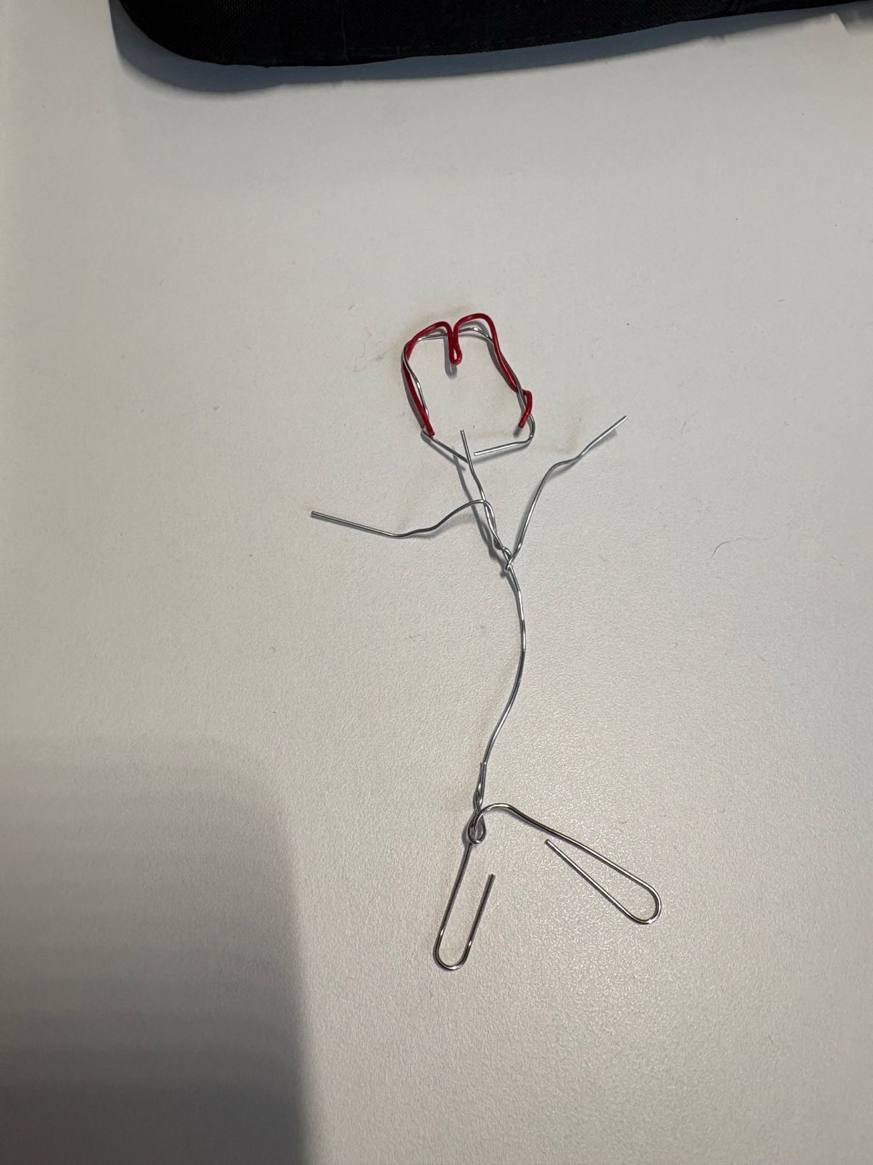
This is what I made in week 1 in class with the paper clips we was given.

Task 3
Case Study Analysis: Social Prescribing in NHS Primary Care and Community Social Care

An innovative initiative within the NHS and wider UK social care context is social prescribing, particularly the introduction of Link Workers through the NHS Long Term Plan. Social prescribing enables GPs and other health professionals to refer patients to non-clinical community-based support, such as debt advice, befriending services, exercise groups, housing support, and voluntary sector activities. This initiative reflects a creative shift from a purely biomedical model to a holistic, person-centred approach addressing social determinants of health.

Creativity within social prescribing lies in reimagining what “treatment” means. Instead of defaulting to medication or medical interventions, practitioners recognise loneliness, unemployment, poor housing, and financial stress as root causes of ill health. Link Workers co-produce personalised care plans with service users, empowering them to identify goals and connect with local resources. This collaborative and strengths-based model demonstrates creative problem-solving by integrating statutory health services with voluntary and community organisations. It breaks down traditional silos between health and social care systems, promoting integrated working.

The NHS Long Term Plan committed to recruiting over 1,000 social prescribing link workers to work across Primary Care Networks (NHS England, 2019). This system-level innovation reflects creativity not only in frontline practice but in workforce design and commissioning. By embedding Link Workers into GP practices, the initiative normalised non-clinical referrals and legitimised community assets as part of formal care pathways.

The value created for patients and service users is significant. Evidence suggests that social prescribing improves wellbeing, reduces loneliness, and enhances self-efficacy (Bickerdike et al., 2017). Service users often report feeling listened to and supported in a more holistic way, which strengthens therapeutic relationships. For individuals with complex social needs, this model can prevent escalation to crisis services by addressing issues earlier, aligning with preventative principles central to UK social care policy. Furthermore, emerging evaluations indicate potential reductions in GP appointments and pressure on secondary care, generating system-wide efficiency.

In a health and social care setting, social prescribing exemplifies how creativity—through partnership working, co-production, and reframing care—can drive meaningful change. Rather than creating new medical technologies, it innovates by reshaping relationships and pathways. The initiative demonstrates that value in health and social care is not only measured in clinical outcomes but also in improved quality of life, empowerment, and community connectedness. By embedding social context into care delivery, social prescribing represents a sustainable, person-centred model aligned with integrated care ambitions across the UK.

References

Bickerdike, L., Booth, A., Wilson, P.M., Farley, K. and Wright, K. (2017) ‘Social prescribing: less rhetoric and more reality. A systematic review of the evidence’, BMJ Open, 7(4), e013384.

NHS England (2019) The NHS Long Term Plan. London: NHS England

TASK 4
Current Issue: Mental Health Stigma as a Barrier to Accessing Care

One significant issue in health and social care is stigma surrounding mental health, which prevents many people from seeking the help they need. This stigma includes negative beliefs, misunderstandings, and fear of discrimination, and it affects individuals on both personal and systemic levels.

⸻

Source 1: Mental Health Stigma Reduces Help-Seeking Attitudes

Research shows that stigma has a clear negative impact on people’s willingness to seek professional support for mental health problems. A systematic review of quantitative and qualitative studies found that stigma has a small-to-moderate negative effect on help-seeking behaviour, meaning that as stigma increases, people are significantly less likely to access care. Stigma operates through several routes — including internalised shame, fear of judgement, and expectations of discrimination — which all contribute to individuals avoiding or delaying professional support. This can have serious consequences, such as worsening symptoms, longer recovery time, and lower overall quality of life because people do not get timely help. The review also suggests that understanding how stigma works can help design interventions that encourage help-seeking behaviour and improve service uptake.

⸻

Source 2: Stigma in Healthcare Settings Also Blocks Access

Another article explains that stigma is not just a social attitude but can exist within the healthcare system itself, creating additional barriers. This research highlights that even when people decide to seek help, negative stereotypes and prejudicial behaviour from healthcare providers can stop them from accessing care effectively. Stigma among health professionals can lead to poorer patient-provider interactions, lower treatment quality, and a healthcare environment that feels unsafe or discriminatory. As a result, patients may either disengage from services or avoid returning for future care, which contributes to ongoing unmet needs and health inequalities. This kind of systemic stigma reinforces the idea that mental health problems are less legitimate than physical health, making recovery harder for people needing support.

Clement, S., Schauman, O., Graham, T., Maggioni, F., Evans-Lacko, S., Bezborodovs, N., Morgan, C., Rüsch, N., Brown, J.S.L. and Thornicroft, G. (2015) ‘What is the impact of mental health-related stigma on help-seeking? A systematic review of quantitative and qualitative studies’, Psychological Medicine, 45(1), pp. 11–27.

Knaak, S., Mantler, E. and Szeto, A. (2017) ‘Mental illness-related stigma in healthcare: Barriers to access and care and evidence-based solutions’, Healthcare Management Forum, 30(2), pp. 111–116.

Task 5



