

Programme: Certificate in Higher Education Business Skills for the Workplace
Module: Enterprise and Entrepreneurship
Module code: LCLM4006
Lecturer: Fouziya Farheen
Student name: Vasile Cristian Cantur
Student ID number: 2413037
Table of Contents
Introduction 3
Overview of the business idea 3
Legal format and management structure of the startup enterprise 4
PESTEL analysis 4
Explanation of the market strategies the enterprise will adopt to reach its customers 6
Funding required and its allocation with some future financial projection 7
Conclusion 8
References 9

Introduction
Developing a suitable business plan is important for entrepreneurs so that they are able to establish a long-term business plan. The current study will consider developing a business plan for a start-up company, which will be called "The Green Habit". The study will provide a proper overview of the business idea, which will elaborate on the product or the service of the company. The legal format and management structure of the start-up will be elaborated in this study. The study will also consider a PESTEL analysis that will help to evaluate the overall external environment of the company..

Overview of the business idea

Figure 1: Company Logo
(Source: Created by author)
The current business idea considered is an online sustainable retail business that focuses on selling everyday products. The name of the business will be considered “The Green Habit” as the company makes everyday usable products using sustainable products. The main products sold by the company will be kitchen and food storage appliances, household and cleaning materials, hygiene and personal care and so on. With respect to the product offered by the organisation, there is a high chance that the business will be able to expand its financial efficiency as the demand for everyday sustainable products is high. Moreover, the company will use materials such as wooden toothbrushes, natural deodorant, refillable cleaning products, compostable sponges and so on. In this regard, more people will be focusing on purchasing the products of the company as they include sustainable materials. According to Agrawal et al. (2022), sustainable business practices are constantly gaining importance among companies, researchers and experts in industries for ensuring global commitment to greenhouse gas reduction, waste management and proper resource utilisation.

Legal format and management structure of the startup enterprise
The legal format and management structure of start-ups in the UK need to be understood in order to consider the business plan. There are currently 5.5 million private sector companies in the UK, including small, medium and large (Government of the UK, 2024). Proper legal format, such as a sole trader, a publicly listed company or a partnership firm, is necessary to survive in the competitive market. A partnership firm is the most common legal business format used in the UK (Korchak, 2024). In the United Kingdom, the partnership business structure has fewer legal obligations, which helps the business partners to easily establish the business and start their business activities efficiently without any unnecessary delays. Based on the legal structure, it is important that the proposed business consider a partnership legal format for the business.
Concerning the management structure, a hierarchical managerial structure is the most suitable for the companies. In a business, hierarchical structures are extremely common with well-defined roles and clear elaboration of authority (Lazarus, 2025). For that, it is essential that the current start-up company consider a hierarchical managerial structure in the current times. With the assistance of the hierarchical managerial structure, the co-founders will be at the top of the management. After that, the co-founders of the company will define the role of each management staff, such as Chief Operating Officer, Chief Financial Officer, Chief Marketing Officer, Managing Director and so on. Regarding that, the power distribution of the company can be conducted efficiently, and the risk of power misuse can be mitigated by the business. In addition to that, a proper managerial structure and managerial activity can be maintained efficiently.

PESTEL analysis
Political factor: Even though the political stability of the UK has fluctuated after Brexit, it has currently stabilised. However, in July 2024, the centre-left Labour Party of the UK won the most seats in the country in their general victory after 14 years (Clark, 2025a). This win will help to establish a suitable government structure, and the business may receive the proper support of the government. This can help the start-up company to receive tax benefits and other financial support from the government of the UK.
Economic factor: In the year 2024, the GDP of the UK was 2.56 trillion GBP (Clark, 2025b). The massive growth of GDP has clearly helped to confirm that the company has been able to enhance its financial performance, as the purchasing power of customers has expanded in the UK. In this respect, there is a high chance that the company can be able to gather the attention of numerous customers in the UK, which may help to expand the potential number of customers.
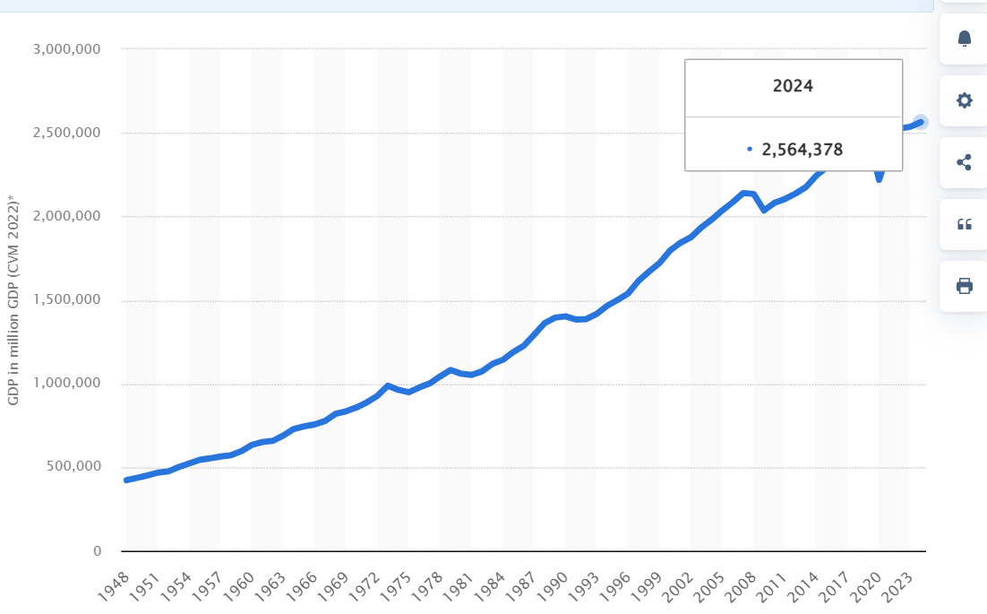
Figure 2: GDP of the UK
(Source: Clark, 2025b)
Social factor: It is seen that in the middle of 2025, the population of the UK will be approximately 69,551,332 (Worldometers, 2025). With the assistance of the high population, the demand for everyday products such as cleaning, personal care, hygiene and kitchen appliances has expanded in the UK market. In this respect, the company can easily identify its target market and offer high-quality products to the customers.
Technological factor: The UK chancellor has stated that the government has invested almost 3.5 billion GBP to make the country scientifically and technologically developed (Government of UK, 2025). This will help the organisation to enhance managerial efficiency by introducing the latest AI technologies in the future, which will eventually lead to major business development.
Environmental factor: The environmental condition of the United Kingdom is pleasant, and it can help the business to conduct the managerial activities efficiently. However, strict rules of the government regarding environmental policy such as waste management and reduction of carbon emissions, need to be followed. The government of the UK has included a mandatory policy called Sustainable Development Management Plan that is followed by companies to mitigate carbon emissions (Government of UK, 2022).
Legal factor: A strict legal framework needs to be followed by the company based on the corporate laws, employee laws and customer regulations of the UK. An important legal policy considered is the health and safety policy for workers that forces the company to consider a health and safety plan (HSE, 2025).

Explanation of the market strategies the enterprise will adopt to reach its customers
In order to conduct The Green Habit performance efficiently, it is important that its considers a social media marketing strategy. As per the opinions of Koay et al. (2021), social media marketing can be defined as a process in which firms can create, communicate and provide online marketing offerings through social media platforms. The social media platforms can allow the company to create direct advertisement content that can help attract a potential number of customers in the current times. With the assistance of that, the business can be able to directly interact with the customers in the comment section of the social media content, which eventually can help to increase potential customer engagement. Therefore, considering the social media marketing strategy, the company can be able to gain a competitive advantage and generate a high amount of profit in the current times. For those customers who are not highly active in social media, The Green Habit can use digital media and offline media such as TV, radio and newspaper to connect with them.

Funding required and its allocation with some future financial projection
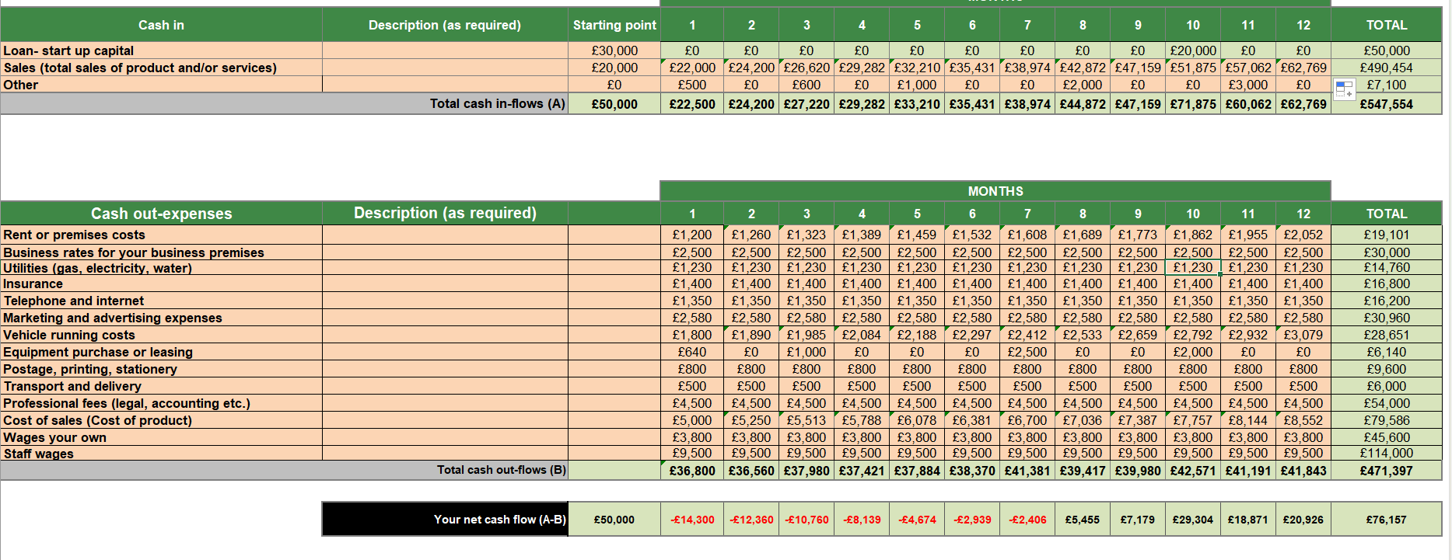
Figure 3: Cash flow
(Source: Created by author)
The above cash flow statement has been presented, which has helped to show the company has a fund of 50,000 GBP. With the assistance of the affordable investment amount, the company can be able to complete the potential activities such as social media marketing and advertisement, content creation and so on to increase sales. The sales are expected to be 20,000 GBP at the beginning, and it is expected to grow by 10% per month. This may lead to a negative cash flow for a few months; however, at the end of the year, the company will be able to collect a significant amount of profit that may help the business to gain competition. However, it has been identified that the cost has expanded by 5% per month, which has helped to gain the financial stability of the business. As a result, the financial risk can be mitigated and the business performance can be improved. This is important that the company restrain its cost to 5 per cent or less in order to avoid a financial dilemma. In order to expand the revenue, it is important that the management utilises its marketing strategies so that the potential number of customers expands.

Conclusion
The key products that the company will market are kitchen and food storage appliances, household and cleaning materials, hygiene and personal care and so on. Partnership business structure in the United Kingdom is less legally demanding and as such, the business partners find it relatively easy to get the business set up and be operational in their business activities within the required time frame. According to the legal structure, it should be noted that the proposed business will take the legal form of partnership structure of the business to be considered. Further on, it is imperative that the given start-up company take into consideration a hierarchical structure of management in the times of the current period.

References
Agrawal, R., Wankhede, V.A., Kumar, A., Upadhyay, A. and Garza-Reyes, J.A., 2022. Nexus of circular economy and sustainable business performance in the era of digitalization. International Journal of Productivity and Performance Management, 71(3), pp.748–774.
Clark, D., 2025a. UK politics – statistics & facts. [online] Statista. Available at: https://www.statista.com/topics/4666/british-politics/ [Accessed 27 Jun. 2025].
Clark, D., 2025b. Gross domestic product of the United Kingdom from 1948 to 2024. [online] Statista. Available at: https://www.statista.com/statistics/281744/gdp-of-the-united-kingdom/ [Accessed 27 Jun. 2025].
Government of UK, 2022. Environmental policy. [online] GOV.UK. Available at: https://www.gov.uk/government/publications/sustainability-in-ukhsa/environmental-policy [Accessed 27 Jun. 2025].
Government of UK, 2024. Business population estimates for the UK and regions 2024: statistical release. [online] GOV.UK. Available at: https://www.gov.uk/government/statistics/business-population-estimates-2024/business-population-estimates-for-the-uk-and-regions-2024-statistical-release [Accessed 27 Jun. 2025].
Government of UK, 2025. Government commits up to £3.5 billion to future of tech and science. [online] GOV.UK. Available at: https://www.gov.uk/government/news/government-commits-up-to-35-billion-to-future-of-tech-and-science [Accessed 27 Jun. 2025].
HSE, 2025. Prepare a health and safety policy. [online] Available at: https://www.hse.gov.uk/simple-health-safety/policy/index.htm [Accessed 27 Jun. 2025].
Koay, K.Y., Teoh, C.W. and Soh, P.C.H., 2021. Instagram influencer marketing: Perceived social media marketing activities and online impulse buying. First Monday. [online] Available at: https://firstmonday.org/ojs/index.php/fm/article/view/11228 [Accessed 27 Jun. 2025].
Korchak, J., 2024. Advantages and disadvantages of a partnership business. [online] Inform Direct. Available at: https://www.informdirect.co.uk/business-management/partnership-business-advantages-and-disadvantages/ [Accessed 27 Jun. 2025].
Lazarus, S., 2025. Cybercriminal networks and operational dynamics of business email compromise (BEC) scammers: Insights from the “black Axe” confraternity. Deviant Behavior, 46(4), pp.456–480.
Worldometers, 2025. U.K. population. [online] Available at: https://www.worldometers.info/world-population/uk-population/ [Accessed 27 Jun. 2025].

