Jordan Mitchell

Section One

(AC 1.1) Evaluate the advantages and disadvantages of the organisation structure in your organisation (or an organisation with which you are familiar) and evaluate the advantages and disadvantages of one other organisation structure. Within the evaluation, you should include the reasons underpinning the structure.

Goldstone Books is an organisation which has adopted the Functional Structure, this is where employees with similar skills are grouped together into departments based on their functional roles (Robbins and Coulter, 2020). The majority of the workforce is split based on their skills into the following teams: Listing, Sorting, Warehouse, Packing and Customer Service, each team with it’s own supervisor responsible for the assignment of tasks.
By using the functional structure, Goldstone Books clearly defines the roles and responsibilities of it’s employees, which ensures understanding of the assigned tasks and reporting relationships within the organisation (Taylor and Woodhams, 2022a).
As the team is comprised of employees with a similar skillset, it allows for specialized training to be carried out which leads to further proficiency and higher performance (Taylor and Woodhams, 2022a).
A drawback to this approach is that the workforce can be narrow minded. In set teams supervisors and employees will focus on their own performance and team objectives which may not always align with the organisations goals.
Due to the growth of the organisation, there are times where teams need to adapt and change their methods. Goldstone Books has started supplying DVDs and games, as these have to be sorted, and listed differently there was resistance to change within the teams, and employees had been slow to adapt to a new method.

The Matrix Structure combines elements found in both Functional and Projectised structures (in a projectised structure, employees are assigned to specific projects, and not permanent roles, allowing for reallocation upon completion) (Taylor and Woodhams, 2022a). The matrix structure has a dual chain of command, in which employees can report to two different managers, their functional manager, and their project manager.
The strength behind the matrix structure is in the flexibility of available employees. Employees can be assigned to projects which best matches their skills, and can move between projects when needed (Robbins and Coulter, 2020).
The dual chain of command provided by the matrix structure can lead to better decision-making, as both functional and project perspectives are taken into consideration.
An environment without a traditional chain of command can lead to confusion among employees as there may not be a clear understanding of reporting lines (Robbins and Coulter, 2020). There is also risk for conflict among the two managers who share authority, this can happen if their goals or methods differ, and can lead to a challenging work environment if the managers are not on the same page.

While Goldstone Books benefits from the clarity and specialised training offered by its functional structure, it faces challenges in adaptability and potential misalignment with organisational goals. The matrix structure offers flexibility and balanced decision-making which would be effective for Goldstone Books but could introduce complexities in management and communication that would need to navigated carefully.

(AC 1.2) Analyse connections between your organisation’s strategy (or an organisation with which you are familiar) and its products or services, and customers.
Goldstone Books sell second hand products on online marketplaces, which includes books, CDs, DVDs, and Video Games, all of which have been sourced from either charity shops, or book/media banks at recycling centres.
To stay competitive in a sales market, marketing strategies have been developed in order to advertise, and to identify which online marketplaces generates the most sales for their products. By using search engine optimisation (SEO) Goldstone Books have placed themselves at the forefront of Google adverts, allowing potential customers who are searching for books to find Goldstone Books with ease. SEO plays an important part in marketing for the organisation, as many potential customers will not take time to explore websites, and will instead choose the search which appears first (Enge, 2012).
A large part of the organisation’s strategy revolves around pricing products competitively in order to survive in a market full of retailers. In online retail, dynamic pricing strategies are essential due to the ever-changing demand and competition, by employing a pricing strategy organisations can respond quickly to market changes and optimise revenue (Gerpott and Berends, 2022). Goldstone Books use e-commerce tools to set parameters in order to always have the price of their products the same (or cheaper) as their top competitors. Financial performance measurements have been employed to keep a close watch on the return of investment (ROI), this tracks how much profit is being made on their sales without selling products too cheaply.
The ethos of the organisation is to ensure products are reused, and not wasted. A large portion of the organisation revolves around sourcing second-hand products through the means of book banks and charity shops. Studies indicate that eco-friendly products have a positive impact on the way consumers perceive the organisation, leading to further marketing, however consumers can be weary if products are not of high quality (van Doorn, Risselada and Verhoef, 2021). In order to ensure products are of the highest quality, each product for sale goes through multiple steps of quality control. Goldstone Books employ a customer feedback loop to ensure customers are satisfied with the condition of the products received.
Goldstone Books effectively combines strategic marketing, competitive pricing strategy, and quality assurance to excel in an online retail market. SEO enhances online visibility, while dynamic pricing ensures products are not undercut by competitors. The emphasis on eco-friendly products, while taking care to ensure products go through a rigorous quality control maintains customer satisfaction and loyalty.

AC 1.3 Analyse three external factors or trends currently impacting your organisation (or one with which you are familiar). The impact of these factors or trends could be positive, neutral or negative, some are short-lived whilst others are long-lasting. Identify organisational priorities arising from the factors or trends analysed.

There has been a major increase in the popularity of digital media such as e-books, and streaming services for music, tv and movies. This has a serious impact on a organisation dealing with only physical copies of books, DVDs, and CDs. As more consumers shift towards using these streaming platforms, the demand for physical copies may decline as well.
Goldstone Books have to prioritise further diversifying their product range if they are to stay successful, niche market categories such as collectable books or rare vinyls should be promoted. By negotiating with publishers, Goldstone Books could obtain the rights to sell e-books which may further increase sales.
Economic factors play a big part in the success of Goldstone Books, according to research (Price, 2023) sales have dropped both in online retail and on the high street to the lowest since 2021. This has a varied impact on the organisation as this can be either long-term, or short-term depending on economic conditions. This potentially may not be all bad, as consumers start to be aware of how much money is being spent, there is a possibility many may turn to buying second-hand products as a substitute.
By maintaining a flexible pricing strategy, Goldstone Books can adapt to changing economic conditions by monitoring market trends and spending habits. A focus on marketing a cheaper price for a product of similar quality of a new product, may attract further cost-conscious consumers.
There is a growing trend towards environmentally sustainable products, and as mindsets begin to change on how to protect the environment, it is likely to have a long-lasting effect. In the UK, eight in ten individuals have said they have changed parts of their lifestyle to be more environmentally friendly (Office for National Statistics, 2023). By being environmentally conscious with a focus on reusing and recycling books and media, Goldstone Books is positioned to capitalise on this trend.
Goldstone Books should further strengthen marketing strategies around the environmental benefit of purchasing second hand products in a world with so much waste, from 2001 to 2019 there was a reported loss of 10% of total trees due to deforestation, with a total of 42% of global wood harvest resulting in the creation of paper (The World Counts, 2023).
Goldstone Books need to continuously monitor these external factors and adjust the organisation’s strategies to maintain competitiveness and sustainability.

(AC 1.4) When setting out its view on automation, AI and technology, the CIPD states, ‘Automation, artificial intelligence (AI) and other workplace technologies are bringing major changes to work and employment.’ Assess the scale of technology within organisations and how it impacts work.
The advances of technology has had a major impact on the workplace, and has forced organisations to evolve in order to compete with competitors. Two examples which highlight this trend is the introduction of automation in the workplace, and the rise of artificial intelligence.
Self-service checkout represents a significant shift in the retail environment, it moves away from the traditional cashier based transactions to an automated customer-led transaction. The process allows customers to scan, bag and pay for their items without the need for human assistance. This type of automation reduces the need for human labour in the workplace, as less staff are needed to serve customers.
While self-service checkouts enhance cost efficiency and redirect employee focus to other areas, they have also been associated with a notable reduction in retail jobs in Britain (approximately 75,000) and an increase in supermarket thefts (Badham, 2023).
Artificial intelligence (AI) is computers engaging in human thought processes, such as learning, reasoning and self-correction (Mohdzaini, 2021). The integration of AI in the workplace has been transformative, and the scale and impact is continuously growing. According to Government research, 68% of large, 33% of medium and 15% of small companies in the UK have at least one AI technology (Hooson, 2023).
AI technologies such as virtual assistants and chatbots can aid customer services processes by answering frequently asked questions and anticipate customer needs, this can help customers save time and allow customer service agents to be more productive by focusing on other tasks (Microsoft 365, 2018). However surveys show that many customers prefer speaking with a live person, rather than AI (Drenik, 2023) which may lead to a decrease in customer satisfaction.
AI used in recruitment can help automate tedious tasks such as sifting through large number of applications, and has the potential to reduce hiring bias in the recruiting process if correctly designed and implemented (CIPD, 2023a).
Self-service checkouts in retail can illustrate automation’s role in reducing labour requirements, but can lead to concerns over job losses. AI's integration in various sectors enhances services and recruitment but not without challenges in customer satisfaction and potential biases if not designed correctly. These advancements call for a reassessment of workforce structures, their implementation and ethical considerations, which shows the complex two-sided nature of technological advancements in the workplace.

(AC 2.1) Explain Edgar Schein’s model of organisational culture and explain one theory or model which examines human behaviour.
Psychologist Edgar Schein’s model of organisational culture is a tool used to understand and analyse the dynamics within an organisation. Schien’s model describes three levels of organisational culture, these are:
- Artifacts
- Espoused values
- Underlying assumptions and beliefs (Young, 2023b).

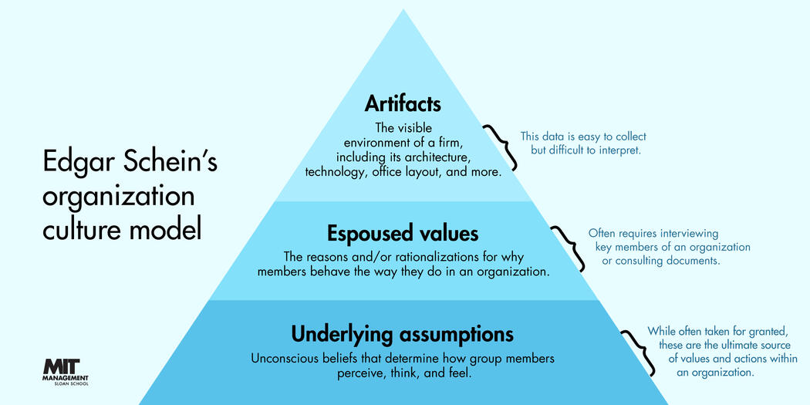
Figure 1: Edgar Schein's Organisation Culture Model, shown as a pyramid (MIT Management, 2023)
Artifacts are the surface level of culture, it includes visible behaviours of people, the way things are done in an organisation. It’s something that is observable but may be difficult to decipher without further knowledge of the organisation.
Espoused values are the stated rules (written, or unwritten) in an organisation, it also includes the goals and ideas held by the organisation. Espoused values represents what the organisation believes its values are.
Underlying assumptions refers to what the employees (or members) thoughts and beliefs in the organisation are, which can determine how they perceive, think and feel about their environment. This is typically the core of the organisation, and can be challenging to change if needed.
The understanding of these three levels can help in diagnosing organisational culture, implement change and ensure the culture of the organisation aligns with its organisations strategic goals.

Operant conditioning is a method developed by B. F Skinner which involves using positive reinforcement and rewards or negative reinforcement and punishment following an action or behaviour (Hayden, 2023). The theory behind this idea is that individual are more likely to repeat behaviours with a positive outcome, and the opposite is true for negative outcomes.
- Positive Reinforcement
  - A reward or praise is given to increase the behaviour
- Positive Punishment
  - Something is added, or given to decrease the behaviour (for example, a warning)
- Negative Reinforcement
  - Something is removed to increase the behaviour
    - For example, getting up to turn the alarm off (the alarm sound will stop as soon as you turn it off)
- Negative Punishment
  - Something is removed to decrease the chance of the behaviour happening again
    - Example, employees always on their phone will have their phone removed
(OpenStaxCollege, 2014)
Operant conditioning is useful in understanding how behaviours are acquired, and how they can be modified by altering the surrounding environment.

(AC 2.2) Assess how people practices in your organisation (or one with which you are familiar) impact both on organisational culture and behaviour, drawing on examples to support your arguments.
One of the main people practice tools used by Goldstone Books is key performance indicators (KPI). The purpose of KPI’s are to measure individuals and their teams targets within the organisation (CIPD, 2022). KPI’s play an important role in shaping the organisations culture and behaviour by influencing how employees perceive their roles and the organisations priorities. The main use of KPI’s within Goldstone Books is to measure listing scan rate, sorting speed and dispatch efficiency.
- Impact on culture.
By having set targets within the organisation, employees can understand what is expected from them which creates a shared understanding of what is important. The theory behind this is that targets give employees something to work towards, it can prevent burnout and promote continuous improvement which has a positive effect on employee engagement and workplace culture (Reynolds, 2023).
In Goldstone Books, KPIs are transparent among team members, which can help build trust. Due to the fair nature this provides, employees who are achieving or surpassing targets are praised. On the other hand, those who are not able to hit set targets may be subject to blame which can have a negative impact on the employee and the organisations culture (D. Ellis, 2019).

- Impact on behaviour
While Goldstone Books sets out to create achievable realistic targets based on past averages, when an employee feels that the target is unachievable or unrealistic, it can cause unethical behaviour (Franco-Santos and Bourne, 2008). An example of this, in the past an employee had been spoken to regarding their decreasing performance and inability to hit their require target. While the employee had surpassed their target in the past, due to external factors the employee was no longer able to achieve it, this led to the employee falsifying data in order to be seen as hitting their targets.
Another issue Goldstone Books have found is by using these targets, members of a team can often be blind to the long term effects in order to see the short term impact on their target goal. For example, Goldstone Books sorting team are required to grade books ‘very good’ ‘good’ or ‘unacceptable’ in which case the book is recycled. There have been times where sorters have not graded the books properly in order to increase their speed, the long-term effect of this customers receiving wrongly graded books which has a negative effect on business.

KPI’s help to promote employee engagement and clarity in job roles, but can also be a driving factor in unethical actions and short term focus, which impacts customer satisfaction. Goldstone Books have to strive to balance these metrics, with ethical and long-term considerations in mind in order to continue the organisations success.

(AC 2.3) Explain two different models or theories to managing change.

To facilitate a healthy lifespan of an organisation, there will be times when change is needed. This could be because of external or internal factors (Roberts, 2023). It is vital for the organisation to properly manage the change needed in order to not upset the balance of culture or employee welfare. Two models which have seen success when implemented in change management is Lewin’s Change Model and McKinsey 7S model.
Lewin’s Change Model
Kurt Lewin developed a three step change model: Unfreeze, Move, Refreeze (Roberts, 2023).
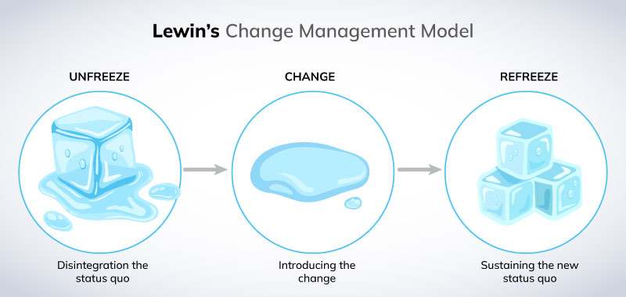
Figure 2: An image of ice cubes depicting Lewi's Change Management Model (Miller, 2022a)

- The ‘Unfreeze’ Stage
In this initial phase, the focus is on assessing the current situation within the organisation. It relies on amplifying the factors that support the change while minimizing those who oppose the change (Roberts, 2023). This step is important to show the stakeholders the current problems that the organisation faces in order to develop change.
- The ‘Move’ Stage
The second stage continues on from the first stage, once the stakeholders are aware of the necessity of change, the positive impact of the change can be highlighted (Miller, 2022b). This step also focuses on developing change by taking concrete actions and involving others in the process (Roberts, 2023).
- The ‘Refreeze’ Stage
The final stage focuses on implementing new operational methods and ensuring that the change is recognised and understood (Roberts, 2023). The focus on this stage is for the change to become normalised into every day procedures, and become the new standard.

McKinsey 7S
The McKinsey 7S model aims to evaluate and improve organisational effectiveness by aligning seven key internal elements within an organisation, these are categorised in two groups, tangible ‘hard’ elements and abstract ‘soft’ elements (Kenton, 2022).
- Hard Elements
  - Strategy
    - This is the organisation’s plan to address challenges and achieve its goals in order to ensure it remains competitive within its industry or market.
  - Structure
    - This focuses on the organisations hierarchy and divisional arrangement.
  - Systems
    - The daily operations and activities within the organisation which shapes the decision-making process.
- Soft Elements
  - Shared Values
    - This is the core beliefs and accepted standard by management and staff which is often reflected in the organisation’s policies.
  - Skills
    - This focuses on staff capabilities which can determine what an organisation is able to achieve when setting out tasks and change.
  - Style
    - How the approach in leadership by management impacts organisational culture, performance and employee productivity.
  - Staff
    - The number of employees, where motivation lies, and how well they are trained in order to effectively accomplish tasks.
(Kenton, 2022).

The effectiveness of the McKinsey model is to diagnose problems the organisation can run into when developing change, once change has been implemented it can be used to monitor the capability of the change (Roberts, 2023).

(AC 2.4) A variety of models have been developed to explain how change is experienced. Discuss one model that explains how change is experienced.
Elisabeth Kübler-Ross, renowned for her work in understanding how individuals cope with grief, the end of relationships and loss, created a model known as ‘the five stages of grief’ (Taylor and Woodhams, 2022b) which has been used in various fields including an organisational setting. The five stages of grief outlines the stages people commonly experience when faced with significant change.
- Denial
In the denial phase, the individual refuses to acknowledge the change believing that it cannot or will not happen. In organisational change, this phase is often attributed to a decline in employee productivity (Malik, 2022).
- Anger
Once the reality of the change has sunk in, the individual may experience levels of frustration or anger, whether it be toward the change itself or those implementing the change.
- Bargaining
After the anger stage, the individual may try negotiation tactics in order to stop or lessen the impact of change.
- Depression
When the individual realises the inevitability of the change, they may experience feelings of sadness, uncertainty and demotivation (Malik, 2022).
- Acceptance
The final stage, acceptance is where the individual comes to terms with and adjusts to the change. They reduce their resistance, embrace the change and begin investigating new advantageous possibilities that can emerge from the change (Malik, 2022).

The five stages of grief model is useful for decision-makers when implementing change, it can provide valuable insights into how individuals may react to change and can allow for the introduction of support systems. During the denial phase, transparent communication can help individuals understand the change and the plan for its implementation (Malik, 2022). In stages like anger or bargaining, listening and addressing concerns plays an important role in minimizing the problems experienced.
While the model helps decision makers prepare for emotional reactions to change, it does not offer practical solutions for guiding the individuals through the change process (Roberts, 2023). The model fails to effectively define the interconnection between the stages, since not every individual goes through all of the steps (Malik, 2022).
There are valuable insights in understanding emotional responses to change in an organisation, highlighting the stages from denial to acceptance will allow practitioners to create support systems in order to guide individuals through the stages. However, its linear structure limits applicability as individuals may not go through stages at the same pace, or in the same way which may call for a more individual centric approach to change management.

(AC 2.5) Assess the importance of wellbeing at work and factors which impact wellbeing.
Wellbeing has a direct impact on employees and therefore the organisation as a whole. Wellbeing at work encompasses various aspects, including physical health, mental and emotional health, work-life balance and financial health of employees (Suff, 2023).
Employees who are mentally and physically healthy are typically more productive, have an increased focus on tasks, and are able to contribute more innovative ideas (Levington, 2022). Poor wellbeing has a direct impact on absenteeism, according to research one of the main reasons for long term sickness is contributed to mental health (CIPD, 2023b).
An organisation which supports mental health not only helps in reducing stress and anxiety but reduces burnout and has higher employee engagement, which creates a culture of support (Wu et al., 2021). Organisations can achieve this by introducing workplace policies and training directed to management to help those who need mental health support.
Workplace stress is often contributed to poor job design, excessive workload or lack of communication of what is expected from management (Wilton, 2019). By focusing on job design, balancing workload and incorporating employee feedback, organisations can reduce employee stress which has a positive effect on wellbeing.
Rent-A-Car who employs 82,000 employees, has found success in making mental health a priority at the organisation and found that by identifying and acting on the early signs of poor mental health can significantly reduce absenteeism (Wilton, 2019).
Organisations who provide physical health support can see the benefits of employees wanting to, or being able to work longer and at a higher capacity, this is crucial for an aging workforce and retention strategies (Brassey et al., 2023). Organisations can help with this by promoting healthier lifestyles, introducing fitness programs or hold health screenings.
Effective work-life balance plays an important part in wellbeing, this is the understanding that employees have commitments outside of work. Flexible work arrangements and respect of employees personal time can improve their work-life balance, which has shown to improve job satisfaction and reduce burnout (Brassey et al., 2023).
By shifting a focus to wellbeing, organisations can yield results in the form of job satisfaction, lower burnout and absenteeism rates which leads to a more engaged, happier and productive workforce.

(AC 3.1) Discuss the links between the employee lifecycle and different people practice roles.

The employee lifecycle is the relationship between the employees and employer, it can be defined with seven key steps: Attraction, Recruitment, Onboarding, Retention, Development, Offboarding, Happy Leavers (Verlinden, 2020).

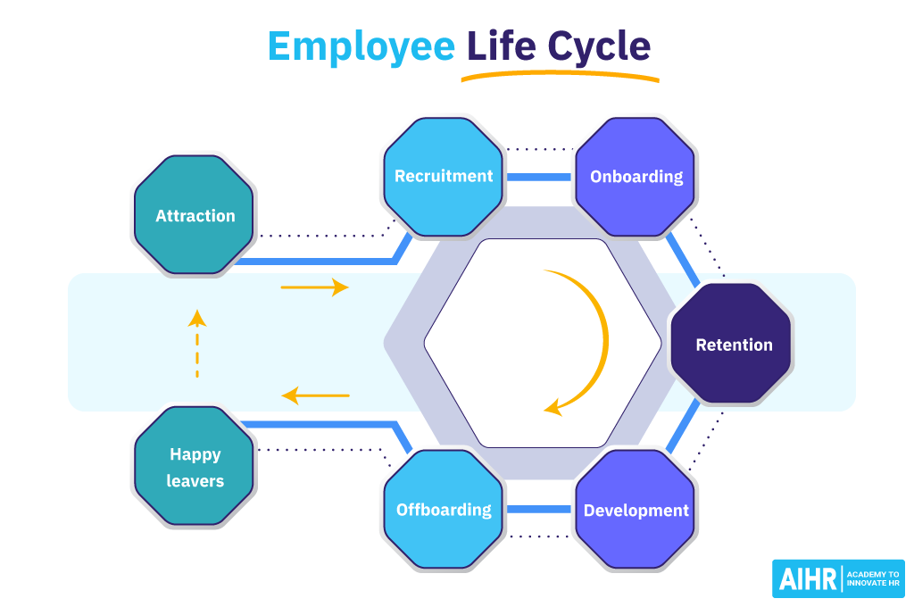
Figure 3: An image depicting the model of the employee life cycle (Verlinden, 2020).
Attraction – The initial phase involves around selling the organisation to potential candidates, this can be achieved by strategic HR marketing which promotes the organisations culture, values and opportunities.
Recruitment – This stage selects the most suitable candidate(s) to the job role. People practice plays an important part in this by creating detailed and inclusive job descriptions while ensuring that a straightforward application process is in place (Verlinden, 2020). The selected candidate should be one which has the required skills and can fit into the organisations culture.
Onboarding – Effective onboarding is crucial for integrating new employees into an organisation. People practice plays a part in familiarising new employees with workplace policies, their role and what is expected of them, along with the organisations culture. By having a well-structured onboarding process, people practice can have an immediate effect on the employees sense of belonging and productivity (Verlinden, 2020).
Retention – The purpose of retention strategies is to retain talented employees, in a study conducted in 2017, turnover can cost around 33% of the salary of the employee who left (Hall, 2019), this is due to recruitment and training costs. People practice can improve retention by creating a positive and engaging work environment, offering career development and ensuring overall wellbeing (Verlinden, 2020). This can be achieved by conducting regular engagement surveys, employee wellbeing programs and feedback sessions.
Development – This stage is centred around growing the talents in the organisation. People practice can look to identify areas for development and provide access to training programs to employees who wish to progress their career at the organisation (Verlinden, 2020). Development programs can ensure employees feel valued and have the necessary skills for their roles.
Offborarding – It can be a natural progression in an employees lifecycle for them to move on from an organisation, however it is important to understand the reasons why employees leave. Exit interviews can gain insight into the employees experience with the organisation (Verlinden, 2020), this can lead to the identification of any potential issues in the workplace.
Happy Leavers – Maintaining a positive relationship with past employees can lead to beneficial connections and enhances the organisations brand (Verlinden, 2020). Engaging with former employees can lead to benefits such as positive reviews, or potentially re-hiring employees in a different role in the future.
Each stage of the employee life cycle offers the chance for people practice to improve the employee-employer relationship, and if done correctly can add value and greatly benefit the organisation.

(AC 3.2) Analyse how people practice connects with other areas of an organisation and supports wider people and organisational strategies.
People practice is a multifunctional role which offers support to employees as seen in the employee lifecycle, another main role is to understand and enhance the organisations strategies and goals.
Performance Management
People practice is responsible for developing, implementing and maintaining performance management systems. An example of this is key performance indicators (KPIs), which can be used to measure both employee performance and the organisation’s performance. KPIs can be used in a wide range of areas. Some of the areas KPIs work well is to view and understand customer based, financial, marketing and sales based metrics (Twin, 2023). Employee based KPIs can be grounds for fair rewards systems, or disciplinaries if needed.
Reward Systems and Employee Motivation
People practice can add value to the organisation by setting up fair reward systems. This can be by using either monetary rewards, such as bonuses for hitting targets or non-monetary rewards such as recognition and opportunities for development. Research shows that 86 percent of employees who receive some form of recognition feel happier, and 85 percent are more satisfied with their job (Hamlin, 2019). Financial or non-financial rewards are an important motivator for employees, which can lead to higher job satisfaction and engagement.
Legal Conformity
People practice benefits the organisation by ensuring it follows the working standards set by UK employment law. Organisations have a responsibility to meet legal obligations and failure to do so whether our of neglect, or misunderstanding can lead to tribunal cases, or potentially criminal cases if not handled correctly (Brougham-Chandler, 2021).
Change Management
People practice can support the organisation through change by encouraging open dialogue, reframing employee concerns as legitimate voice rather than resistance, and by introducing change champions (Roberts, 2023). People practice initiatives are key in maintaining energy and momentum throughout the change process.

People practice plays a significant role in aligning employee performance with organisational goals through effective performance management systems such as KPIs, fostering motivation and satisfaction with reward systems and ensuring the organisation is legally compliant. These highlight a few ways in which people practice contributes to the overall health and success of an organisation.

(AC 3.3) Discuss processes you have, or could use, for consulting and engaging with internal customers of the people function in order to understand their needs.
One of the ways used to identify internal customers is by performing a stakeholder analysis. A stakeholder analysis is a process used to identify and understand the priorities and influences of stakeholders within an organisation (CMI, 2022). This involves categorising stakeholders based on their level of interest, influence and impact on the organisation. After performing this analysis, people practice can ensure that the concerns and needs of the most influential and affected stakeholders can be addressed. This helps to prioritise any actions taken, and can allow tailored communication strategies to effectively engage with different stakeholders, leading to informed decision-making and policy development. The stakeholder analysis can be evaluated on its effectiveness by assessing the alignment of the organisations strategies and initiatives with stakeholders interests and needs.
A needs analysis can be conducted in order to identify and asses the specific requirements and expectations of internal customers. This can be done through various methods, such as conducting surveys, interviews and performance data analysis (Indeed, 2022a). This clarifies the gap between the current conditions and the desired outcomes. This information is useful for people practice in order to develop targeted initiatives that address the issues. The effectiveness of this can be judged based on well people practice design solutions to meet identified needs. By conducting pre-analysis and post-implementation metrics, such as performance and engagement levels, people practice can evaluate the effectiveness of the initiatives.
People practice can engage with internal customers by developing effective communication channels. This can include one-on-one meetings, focus groups and surveys. These are designed to gather feedback, ideas and concerns from stakeholders, employees and senior management (Indeed, 2022b). By maintaining regular communication, people practice can ensure all view points within an organisation are heard and considered. This open dialogue can build trust, and creates and positive organisational culture which ensures decisions are made with an understanding of the internal environment (Indeed, 2022b). The effectiveness of the communication channels can be monitored through metrics such as participation rates in surveys and meetings, and the satisfaction levels of participants with the communication process.

Effectively consulting and communicating with internal customers involves a strategic approach which can encompass stakeholder analysis, needs analysis and proper communication channels. Regularly evaluating these processes through performance metrics and stakeholder feedback can ensure the organisations goals are aligned with the internal customers needs.

(Word Count: 4937)

References:
Badham, V. (2023). Supermarkets are ditching self-checkouts in a sign that we can push back against the technofuturist tide. The Guardian. [online] 22 Nov. Available at: https://www.theguardian.com/commentisfree/2023/nov/23/supermarkets-are-ditching-self-checkouts-in-a-sign-that-we-can-push-back-against-the-technofuturist-tide [Accessed 20 Jan. 2024].
Bitner, M.J., Ostrom, A.L., Meuter, M.L. and Clancy, J.A. (2002). Implementing Successful Self-Service Technologies [and Executive Commentary]. The Academy of Management Executive (1993-2005), [online] 16(4), pp.96–109. Available at: https://www.jstor.org/stable/4165906 [Accessed 20 Jan. 2024].
Brand, A. (2023). Hundreds of Christmas jobs will be wiped out by self-checkouts. [online] HRreview. Available at: https://hrreview.co.uk/hr-news/future-of-work-hr-news/hundreds-of-christmas-jobs-will-be-wiped-out-by-self-checkouts/373286 [Accessed 20 Jan. 2024].
Brassey, J., Herbig, B., Jeffery, B. and Ungerman, D. (2023). Reframing employee health: Moving beyond burnout to achieving physical, mental, social, and spiritual health | McKinsey. [online] www.mckinsey.com. Available at: https://www.mckinsey.com/mhi/our-insights/reframing-employee-health-moving-beyond-burnout-to-holistic-health [Accessed 25 Jan. 2024].
Brougham-Chandler, A. (2021). What is HR compliance and why is it important? [online] www.breathehr.com. Available at: https://www.breathehr.com/en-gb/blog/topic/employment-law/what-is-hr-compliance-and-why-is-it-important [Accessed 27 Jan. 2024].
CIPD (2022). CIPD | Performance Management | Factsheets. [online] CIPD. Available at: https://www.cipd.org/uk/knowledge/factsheets/performance-factsheet/ (Accessed 21 Jan. 2024).
CIPD (2023a). CIPD | Using AI responsibly in people management. [online] CIPD. Available at: https://www.cipd.org/uk/views-and-insights/thought-leadership/insight/ai-people-management/ [Accessed 20 Jan. 2024].
CIPD (2023b). CIPD | Health and wellbeing at work. [online] CIPD. Available at: https://www.cipd.org/uk/knowledge/reports/health-well-being-work/ [Accessed 24 Jan. 2024].
CMI (2022) Stakeholder analysis and Management. Available at: https://www.managers.org.uk/knowledge-and-insights/resource/stakeholder-analysis-and-management/ [Accessed: 27 January 2024].
D. Ellis, C. (2019). How to fix a stagnant culture. [online] www.peoplemanagement.co.uk. Available at: https://www.peoplemanagement.co.uk/article/1743984/how-to-fix-a-stagnant-culture [Accessed 21 Jan. 2024].
Drenik, G. (2023). How AI Is Revolutionizing Customer Service With Human-Like Responses. [online] Forbes. Available at: https://www.forbes.com/sites/garydrenik/2023/12/06/how-ai-is-revolutionizing-customer-service-with-human-like-responses/ [Accessed 20 Jan. 2024].
Enge, E. (2012). The Art of SEO. Beijing: O’reilly, pp.1–5.
Franco-Santos, M. and Bourne, M. (2008). The impact of performance targets on behaviour: A close look at sales force contexts Centre for Business Performance Cranfield School of Management. [online] Available at: https://dspace.lib.cranfield.ac.uk/bitstream/handle/1826/4222/Impact_of_performance_targets_on_behaviour.pdf?sequence=1&isAllowed=y [Accessed 21 Jan. 2024].
Gerpott, T.J. and Berends, J. (2022). Competitive pricing on online markets: a literature review. Journal of Revenue and Pricing Management, [online] 21(21). doi:https://doi.org/10.1057/s41272-022-00390-x.
Hall, J. (2019). The Cost Of Turnover Can Kill Your Business And Make Things Less Fun. [online] Forbes. Available at: https://www.forbes.com/sites/johnhall/2019/05/09/the-cost-of-turnover-can-kill-your-business-and-make-things-less-fun/ [Accessed 25 Jan. 2024].
Hamlin, K. (2019). The Role of a Reward in Employee Motivation. [online] Chron. Available at: https://smallbusiness.chron.com/role-reward-employee-motivation-18814.html [Accessed 27 Jan. 2024].
Hayden, D. (2023). CIPD | On this page. [online] CIPD. Available at: https://www.cipd.org/uk/knowledge/factsheets/learning-theories/ [Accessed 21 Jan. 2024].
Hooson, M. (2023). UK Artificial Intelligence (AI) Statistics and Trends in 2023. [online] Forbes Advisor UK. Available at: https://www.forbes.com/uk/advisor/business/software/uk-artificial-intelligence-ai-statistics-2023/ [Accessed 20 Jan. 2024].
Indeed (2022a). Needs Assessment: Definition, Overview and Examples. [online] Indeed Career Guide. Available at: https://www.indeed.com/career-advice/career-development/needs-assessment [Accessed 27 Jan. 2024].
Indeed (2022b). The importance of internal communication, with examples. [online]. Available at : https://uk.indeed.com/career-advice/career-development/internal-communication-examples [Accessed 27 Jan. 2024].
Kenton, W. (2022). McKinsey 7S Model. [online] Investopedia. Available at: https://www.investopedia.com/terms/m/mckinsey-7s-model.asp [Accessed 21 Jan. 2024].
Levington, M. (2022). The positive impact of quality leadership on employee wellbeing and performance. Available at: https://www.cipd.org/uk/knowledge/bitesize-research/quality-leadership/ [Accessed 24 Jan. 2024].
Malik, P. (2022). The Kübler Ross Change Curve in the Workplace (2022) - Whatfix. [online] The Whatfix Blog | Drive Digital Adoption. Available at: https://whatfix.com/blog/kubler-ross-change-curve/ [Accessed 23 Jan. 2024].
Microsoft 365 (2018). Work Smarter, Not Harder: 10 Benefits of AI in Your Workplace. [online] Microsoft.com. Available at: https://www.microsoft.com/en-us/microsoft-365/business-insights-ideas/resources/benefits-of-ai-in-your-workplace [Accessed 20 Jan. 2024].
Miller, K. (2022a). Description and application of Lewin’s change management model. [Image] Crowjack. Available at: https://crowjack.com/blog/strategy/change-management-models/lewins-model [Accessed 21 Jan. 2024].
Miller, K. (2022b). Description and application of Lewin’s change management model. [Online] Crowjack. Available at: https://crowjack.com/blog/strategy/change-management-models/lewins-model [Accessed 21 Jan. 2024].
MIT Management (2023). 5 enduring management ideas from MIT Sloan’s Edgar Schein. [Image] MIT Sloan. Available at: https://mitsloan.mit.edu/ideas-made-to-matter/5-enduring-management-ideas-mit-sloans-edgar-schein [Accessed 20 Jan. 2024].
Mohdzaini, H. (2021). CIPD | Technology and the Future of Work | Factsheets. [online] CIPD. Available at: https://www.cipd.org/uk/knowledge/factsheets/emerging-future-work-factsheet/ [Accessed 20 Jan. 2024].
Office for National Statistics (2023). Most Adults Report Making Some Changes to Their Lifestyle for Environmental Reasons - Office for National Statistics. [online] www.ons.gov.uk. Available at: https://www.ons.gov.uk/peoplepopulationandcommunity/wellbeing/articles/mostadultsreportmakingsomechangestotheirlifestyleforenvironmentalreasons/2023-07-05 [Accessed 10 Jan. 2024].
OpenStaxCollege (2014). Operant Conditioning. pressbooks-dev.oer.hawaii.edu. [online] Available at: https://pressbooks-dev.oer.hawaii.edu/psychology/chapter/operant-conditioning/ [Accessed 21 Jan. 2024].
Price, C. (2023). Retail sales fall to lowest since lockdown in unexpected slump. The Telegraph. [online] 17 Nov. Available at: https://www.telegraph.co.uk/business/2023/11/17/retail-sales-fall-lowest-since-lockdown-unexpected-slump/ [Accessed 10 Jan. 2024].
Robbins, S.P. and Coulter, M. (2020). Management. 15th ed. Pearson Education, pp.317–323.
Roberts, A. (2023). CIPD | Change management: A guide for people professionals. [online] CIPD. Available at: https://www.cipd.org/uk/knowledge/guides/change-management/ [Accessed 21 Jan. 2024].
Suff, R. (2023). Wellbeing at Work. [online] CIPD. Available at: https://www.cipd.org/uk/knowledge/factsheets/well-being-factsheet/ [Accessed 24 Jan. 2024].
Taylor, S. and Woodhams, C. (2022a). STUDYING HUMAN RESOURCE MANAGEMENT : a Guide to the study, Context and Practice of hr. Kogan Page, pp.54–63.
Taylor, S. and Woodhams, C. (2022b). STUDYING HUMAN RESOURCE MANAGEMENT : a Guide to the study, Context and Practice of hr. 3rd ed. S.L.: Kogan Page, pp.69–70.
The World Counts (2023). Paper Waste Facts. [online] The World Counts. Available at: https://www.theworldcounts.com/stories/Paper-Waste-Facts [Accessed 10 Jan. 2024].
Twin, A. (2023). Key Performance Indicator (KPI): Definition, Types, and Examples. [online] Investopedia. Available at: https://www.investopedia.com/terms/k/kpi.asp [Accessed 26 Jan. 2024].
van Doorn, J., Risselada, H. and Verhoef, P.C. (2021). Does sustainability sell? The impact of sustainability claims on the success of national brands’ new product introductions. Journal of Business Research, [online] 137, pp.182–193. doi:https://doi.org/10.1016/j.jbusres.2021.08.032.
Verlinden, N. (2020). Employee Life Cycle: The Ultimate Guide for HR. [Image] AIHR. Available at: https://www.aihr.com/blog/employee-life-cycle/ [Accessed 25 Jan. 2024].
Verlinden, N. (2020). Employee Life Cycle: The Ultimate Guide for HR. [online] AIHR. Available at: https://www.aihr.com/blog/employee-life-cycle/ [Accessed 25 Jan. 2024].
Wilton, N. (2019) An Introduction to Human Resource Management. 4th edn. London, UK: SAGE, pp. 464-468
Wu, A., Roemer, E.C., Kent, K.B., Ballard, D.W. and Goetzel, R.Z. (2021). Organizational Best Practices Supporting Mental Health in the Workplace. Journal of Occupational & Environmental Medicine, [online] 63(12), pp.e925–e931. Available at: https://www.ncbi.nlm.nih.gov/pmc/articles/PMC8631150/ [Accessed 25 Jan. 2024].
Young, J. (2023b). Organisational climate and culture. [online] CIPD. Available at: https://www.cipd.org/uk/knowledge/factsheets/organisation-culture-change-factsheet/ [Accessed 20 Jan. 2024].

