By Courtney Smith
Student Number: 2008158
Is there a difference in the public perception of rehabilitative verses punitive prisons

Contents
1. Introduction (1200) 3
Objectives 2
Scope 2
2. Literature Review (2500) 2
Objective 1 2
Objective 2 2
Objective 3 2
3. Research Methods (1500) 2
Subheading 2
Subheading 2
Subheading 2
4. Findings (2000) 2
5. Conclusion (800) 2

Introduction (1200)

Objectives:

Literature Review (2500)

Objective 1

Objective 2

Objective 3

Research Methods (1500)

Subheading

Subheading

Subheading

Findings (2000)

Conclusion (800)

Declaration
This work has not previously been accepted in substance for any degree and is not being concurrently submitted in candidature for any degree.
STATEMENT 1
This dissertation is being submitted in partial fulfilment of the requirements for the degree of BA/BSc.
STATEMENT 2
This dissertation is the result of my own independent work/investigation, except where otherwise stated.
Other sources are acknowledged in the Reference Section.
STATEMENT 3
I hereby give consent for my dissertation, if accepted, to be available for photocopying and for interlibrary loan, and for the title and summary to be made available to outside organisations.
STATEMENT 4
I hereby give consent for my dissertation, if accepted, to be available on the university’s IT system to those who have consent to use the system.

Background
Prisons are expected to be a form of punishment; this is because they have transgressed against the rules of society. Research shows that most western jurisdictions in the UK have experienced a punitive turn in the Criminal Justice System. The main reason behind this is the rise in the prison population in the UK. This is including the European restitution, which has historically been able to sustain relatively low rates of incarceration. Even though some crimes may have fallen or remained steady, there is a lack of evidence to show that punishment has had a positive impact on crime rates (Hutton 2005). Between 1980 and 2010, the prison population doubled in England and Wales. Penal populism had resulted in harsher sentences, more restrictive community orders and increased use of imprisonment. For example, since the urban riots across Britain in 2011, custodial sentences for riots compared to other offences in the previous years had increased which has resulted in the population increasing. This had suggested a punitive turn in the UK (Jennings et al, 2017).

The Gladstone Report (1985) was introduced to move away from a punitive era. This meant that the CJS improved prison conditions around the UK. The purpose of the Gladstone Report was to make prisoners into better people than they went in. The Gladstone Report had outlined a more reformative system of imprisonment. For instance, in the 1920’s, prisons were cruel to enlightenment and technological bias (Harding, 1988). In the 18th century, several offences were regarded as serve. This was enough to be punishable by death (UK Parliament, 2022).

Furthermore, the UK aims to focus on a rehabilitative culture. This is where prisons aim to focus on rehabilitation rather than punishment (Bennett, 2018). However, there is evidence to show that rehabilitation is somewhat not effective in the UK and the public perception believes that the UK has a punitive approach to sentencing. There is still a high percentage of the re-offending rates compared to Nordic counties (BBC News, 2019). The public has highly debated on whether criminals should be helped in the Criminal Justice System, society generally wants criminals to pay for the crimes they commit but to a certain extent (Wood and Viki, 2001). The public's perception of the Criminal Justice System is essential because the system depends on publics participation as the public participates in jury services, they witness a crime and are responsible for reporting it (Wood and Viki, 2001). To add to this, public perception is important because the public opinion of the CJS is essential to the functioning of the system (Ministry of Justice, 2015). Therefore, this influences policy because it restrains government officials from making unpopular actions and laws (Burstein, 2003).

In this thesis, a comparative analysis will be used to analyse the public's perception of punitive prisons in the UK and Scandinavian Countries, with the focus being on Norway prisons. Throughout the research of this paper, rehabilitation schemes in Scandinavian prisons will be compared, which will help discover the different ways in which offenders are treated and how this compares with the UK. This topic is important because it compares prisons in the UK and other counties across the world. This will help distinguish the core problems in prisons today. This will provide an analysis on the public perception of rehabilitative versus punitive prisons. By gathering primary and secondary research, it will help identify some recommendations to improve prisons.

Around twenty years ago, Scandinavian prisons have moved away from a punitive approach. For instance, Norway moved away from a punitive approach of 'locking up', which had reduced the re-offending rates significantly (BBC, 2019). Norway prisons now focus on rehabilitation rather than punishment and aims to turn criminals into good neighbours. The prisoners in Norway are treated like normal, they believe that treating prisoners like normal people will help rehabilitate them and prevent them from re-offending. There is evidence to suggest that this system in Scandinavian prisons is effective as Norway has one of the lowest recidivism rates in the world, this being 20% (Denny, 2016). However, In the UK the overall re-offending rate for adults was 29% and for juveniles it was 33%, this is a significant difference compared to Norway (Taylor, 2022). Prisons in the UK are also portraited as 'violent, unsafe and overcrowded' according to the European Committee for the Prevention of Torture. They believe the system is in a deep crisis (O'driscoll, 2022).

Aims and Objectives
The key aim of this study is to compare the public perception of prisons in the UK with Scandinavian prisons with the main focus being Norway. This will determine whether the publics opinion supports the idea that prisons in the UK should be places of rehabilitation, not punishment. The objectives are:
1. Explore existing literature to identify the key differences in the treatment of offenders within prisons in the UK and Scandinavian prisons with the focus being on Norway and how these fits within a rehabilitative culture.
2. To analyse public perception of the rehabilitative approach used in Scandinavian prisons compared to UK prisons (penal populism).
3. To identify recommendations for prison reform to aid rehabilitation of adult offenders in the UK. - maybe narrow down the type of offender here?
This area of law is important because in England and Wales, there is still 23.1% of individuals that re-offend. Adult offenders that are released from custody have a proven re-offending rate of 29.5%, and those who have been released from custodial sentences for less than 12 months had a proven re-offending rate of 54.9%. This is relevant because the UK has significantly lower re-offending rates than Norway. Scandinavian countries have a very low recidivism rate compared to the UK. Norway has the lowest rate of 20% (Denny, 2016).

Methodology
The methodology that will be used in this paper is going to be a questionnaire. A questionnaire allows respondents the opportunity to answer it anonymously, which will allow the respondent to truly express how they feel (Cambridge Dictionary, 2022). This will lead to a better understanding of what the research is about. The purpose of the questionnaire is for participants to be able to express their opinion through the use of open and closed questions. This will enable the researcher to understand the respondents' true feelings.
The target area is the younger generation, between 18-35 and the older generation 35-60. Targeting the different age groups will show the differences in how young people and older generations perceive the Criminal Justice System.

Chapter Two- Literature Review
This chapter aims to explore current literature to identify the key differences in the treatment of offenders within prions in the UK and how these fit within a rehabilitative culture. It will look at the comparison of what UK prisons are like and how they differ from Scandinavian prisons.
The aim of rehabilitation is to prevent re-offending. Prisons aim to reform and rehabilitate prisoners to reintegrate prisoners back into society after they have completed their sentence (HM Inspector of Prisons, 2022). A rehabilitative culture is a concept used in the UK. In order to be successful in preventing crime using rehabilitation interventions, prisons must be safe, hopeful, decent and supportive towards prisoners. All these factors will contribute to preventing re-offending (Mann, Howard and Tew, (2018). The UK is facing issues of overcrowding and safe and supportive prisons.

Problems with Prisons in the UK
Prisons in the UK are plagued with violence, appalling living conditions, drugs, and lack of access to rehabilitation (Portal, 2019). This has a negative impact on prisoners and resulting in prisoners not receiving the support they need. For instance, overcrowding in prisons is a consequence of the Criminal Justice policy, it undermines the ability of prison systems meeting basic human needs, such as accommodation, healthcare, and food. It also compromises the provision and effectiveness of educational and vocational training, rehabilitation programmes and recreational activities (Penal Reform International, 2022). Overcrowding in prisons, as well as problems of lack of privacy, can cause or exacerbate mental health problems, substance issues, violence, suicide, and self-harm (Heard, 2019). Self-harm in prisons has historically high levels. Throughout UK Prisons, the requirements for crowded prisons are less than the requirements for uncrowded prisons. For example, in uncrowded accommodation a prisoner should be able to use a toilet in private with full body screening and ventilation, whereas in a crowded accommodation there is only partial privacy screening and separate ventilation is not required (The Prison Reform Trust, 2022). Overcrowding in prisons are leading to prisoners suffering with mental health problems. In 2022, there were 52,972 self-harm incidents reported in prisons. This figure has not changed within a 12-month period (UK Government, 2022). This shows that there is a lack of support provided in prisons and indicates that prisons in the UK do not focus on a rehabilitative culture, as prisoners are lacking safe environments and support.
To add to this, mental health issues need to be addressed in prisons. For example, an offender called Molly was raped as an adult and had developed mental health issues prior to her imprisonment. Molly had said that imprisonment had stripped away everything that makes her. Molly was unable to see her son unsupervised due to her mental health issues after she was released. This illustrates that prisoner shoes grow out of despair rather than opportunity. This suggests that prisoners are treated as criminals rather than normal people. The impact of this has long term effects leading up until prisoner’s release date (Laursen, 2022). This illustrates the lack of support prisoners in the UK are faced with, the idea of a rehabilitative culture is to support prisoners, the UK seem to be moving away from the idea of a ‘rehabilitative culture’ to more of a failed system.

Recent research suggests that prisons in Britain are becoming more like 'the failed US system' (Campbell, 2021). The Chair of the Justice Committee, Bob Neill stated that the Ministry of Justice has been failing for the past five years. The CJS is failing to meet the needs of prisoners, prisoners are not receiving the correct amount of support and accommodation. For instance, the mental health crisis in prisons is not treated with the focus it needs (UK Parliament, 2023). The Government have also been throwing money at prisons by taking funding away from rehabilitative programmes. By having proper investment in rehabilitation services, it would have an effective approach to tackle all these issues in prisons. Poor access to rehabilitation in prisons causes boredom which is resulting in violence in prisons (UK Parliament, 2019). Norway prisons are seen to be controversial in terms of their treatment in prisons. However, the way they treat offenders seems to be the most effective way to prevent re-offending.

Statistics on UK and Scandinavia Prisons
Prisons around the world should be places of justice. This will make society safer in terms of rehabilitating prisoners. Some prisons in England and Wales are not places of justice. They are places of conflict. To support this, in 2022, there were 20,551 assault incidents during a 12-month period, this was a 12% increase from the previous year. This indicates that there were 260 incidents per 1,000 prisoners (UK Government, 2022). This suggests that UK prisons are plagued with violence and lack of control.
In comparison, Norway developed their prison system in the 1990s, their recidivism rate has decreased by around 60/70% in recent years. Norway prisons are said to be one of the best prisons worldwide. This is because they have changed their ways of approaching prisoners (Dorjsuren, 2020). For example, in Norway, around 2,932 of the country's population were behind bars in 2022 (World Prison Brief, 2022). This makes the incarceration rate just 75,000 per 100,000 people. Norway has one of the lowest recidivism rates at 20% (Sterbenz, 2014). Whereas, in England and Wales, 25.6% of offenders went on to re-offending after being released from prison (UK Government, 2020). This indicates that Norway's rehabilitation scheme is the best way to rehabilitate prisoners.

Furthermore, the prison population in England and Wales is approximately 81,309. This quadrupled in size between 1900 and 2018 (UK Parliament, 2022). There was 15,944 first reception into prisons between April and June 2022. This is a five percent rise compared to 2021. Prisoners are treated the same in terms of healthcare and treatment. It is free but it must be approved by a prison doctor (UK Government, 2022). When arriving at prisons, prisoners will be placed on a wing. They will have to share with another prisoner or sometimes more. There have been many issues of prisoners sharing cells in England and Wales, this is due to prisons being overcrowded in England and Wales. As of 2022, 52% of prison establishments were overcrowded, this meant that prisons were holding 7,834 more prisoners than they were supposed to. It was identified that Leeds was the most crowded prison in the UK, which had a capacity of 171% (Sturge (2022). This illustrates that there are no safe and comfortable environments for prisoners in the UK which illustrates that the UK to not have a rehabilitative culture (Khan, 2020),

Additionally, In Norway, around two-thirds of prison beds are open prisons. These institutions act as socialisation mechanisms. One of the rules in Norway is that offenders are first sentenced to a closed prison and then later transferred to an open prison if they have met the criteria of risk, which is paid off after rehabilitation (Shammas, 2014). The criteria of risk in Scandinavian prisons, such as Norway, is where offenders who are on good behaviour will be placed in an open prison which has low-security imprisonment and has more of a humane approach to punishment. However, those prisoners that are at risk will be placed in closed prisons which will have high levels of punishment (Mijaland, 2021).

In contrast, In England and Wales, prisoners are placed in cells with other prisoners. In overcrowded prisons, there could be more than two prisoners in one cell (Prison Reform, 2022). This has caused many issues due to many prisoners sharing small cells that are only designed for one (HM Chief Inspector of Prisons for England and Wales, 2021-22). In comparison, in Halden Prison in Norway, inmates have private cells, which include an end suite toilet, shower room, desk and a flat screen tv. They don't have bars; they don't like making prisoners feel like monsters as if they are human. This has been questioned as to whether this is a luxury for prisoners. Prison guards often join in on activities, eat with prisoners, do leisure activities, and really interact with prisoners (BBC News, 2019). The aim of Norway prisons is to rehabilitate prisoners. Despite the criticism that Norway prisons face for being too comfortable with prisoners, they do have the lowest re-offending rates in the world (BBC News, 2022). This shows that rehabilitation in Norway is successful, Norway uses principles of normality to help rehabilitate individuals (Denny, 2016). The principle of normality is the idea that, like in prisons should be as normal as possible. This means that prisoners should feel some normality in prisons (Federal Sentencing Reporter, 2018). For example, it can include making their own food, cooking, cleaning, playing sports and having friendships with other inmates and members of staff. Norway prisons have no issues of violence. They treat prisoners like normal people which prevents prisoners from acting out (James, 2013). Whereas, in the UK, prisons work on a strict timetable where majority of prisons lock sells at six pm at night which will remain shut until eight am. Prisoners in the UK have to earn privileges and rights. These privileges are seeing family members or having game time. This can be just by following the rules which is called the 'incentives and Earned Privileges Scheme'. However, if these rules are not followed it can result in prisoners being kept in their sell for up to 21 days and given 42 extra days in prison on top of their original sentence (UK Government, 2022).

Rehabilitation in UK Prisons
To conclude, prisons in the UK do attempt to rehabilitate prisoners. Each prisoner in England and Wales are allocated their own case manager to address their needs; they all help prevent them from re-offending. Prisons provide a range of services like academic programmes, vocational courses, and employment opportunities. Additionally, there are offending behaviour programmes which are available to prisons (Taylor, 2022). The rehabilitation in prisons in somewhat working, in 2020 there was a 2.1% decrease compared to 2019 (UK Government, 2022). Although, there are some records that contain mixed or insufficient evidence in relation to habitation, there is some evidence that shows behaviour programmes and drug intervention have a positive impact on the re-offending rates (Taylor, 2022). This current research illustrates that prisons are unsafe in the UK, the European Committee for the Prevention of torture described prisons in the UK as violent and unsafe (O’Driscoll, 2022). This goes against the rehabilitative culture that the UK thrive on. This indicates that they are failing to rehabilitate prisoners because of how prisons in the UK are ran.

Objective 2: To analyse public perception of the rehabilitative approach used in Scandinavian prisons compared to UK prisons (penal populism).
The legal system cannot function effectively without support off the public. Kaukinen and Colavecchia (1999) had noted that the public perception of the Criminal Justice is System is vital. This is because the public relies on law enforcement agencies to punish and arrest offenders to prevent further victimization (Wood and Viki, 2001). If the public does not have a positive attitude towards the CJS, this will result in the public not complying with the law. For the past 20 years, the nature of the public's perception to crime and punishment has substantially grown (Jacoby and Cullen, 1999).

Media reports and political speeches have led to idea that the British public favours punitive measures on criminals. The media often contains articles that the CJS is 'getting tough on crime' (Hough et al, 2013). However, although the public in the UK favour a punitive approach. The publics knowledge and crime and sentencing had remailed poor, they believed the CJS were too lenient in 2019 (UK Government, 2019). The public's perception is influenced by the media, according to the British crime survey, 75% of people found out information about the CJS from the media. News reports persuade, misinform, and manipulate the public, they contribute to the growth of penal populism, this is not driven democratically by the people, it is often constructed by the media (Mason, 2008).

Penal Populism
The term Penal populism in the UK, is a form of governance whereby lawmakers chose criminal penalties by their popularity amongst voters. It has been held that penal populism is not a form of policy. Tony Bottoms (1995) had referred to penal populism as 'populist punitiveness' which meant that the CJS is leading towards punitive measures (Garland, 2021). The British public favour punitive approaches as the media and politicians are indicating that the CJS focuses on 'being tough on crime'. The UK tend to overuse prison for petty and persistent crimes. In 2021, over 42,000 short prison sentences were given to offenders, 62% of those had committed non-violent offences and 38% were sentenced to serve six months or less (Prison Reform Trust, 2022). This illustrates that the UK are still tough on crime. Freiberg (2001) had suggested that popular punitiveness enables politicians to effectively shape the public opinion, which allows vote buying (Monterosso, 2009).

Attitudes are becoming less punitive, the public seem to favour prison more than any other Western Europeans (Ministry of Justice Analytical Series, 2013). The public believe that sentencing is not harsh enough in the UK. A survey that was conducted by the Prison Reform Trust (2022) had showed that two thirds of people believed that sentencing isn't harsh enough in the UK. Even though the average prison sentence is much longer now than it was years ago, two thirds of the public still believe the sentencing is not harsh enough in the Criminal Justice System (Prison Reform Trust, 2022).

A former director of the Prison Service in the UK, Martin Narey had stated that rehabilitation of offender in prisons does not work and should be scrapped. He was certain that all rehabilitation courses the Government put prisoners on, a makes little or no difference. This shows the failure of rehabilitation in the UK, and the lack of confidence in the Prison Services (Taylor, 2019). This could have a negative impact on prisoners as if the CJS and the directors of prison services have no faith in rehabilitation schemes in prisons, it is likely to encourage bad behaviour in prisons and the likely hood of re-offending.

Scandinavian Exceptionalism
Since 2013, the World Happiness Report had published the annual ranking of countries. The five Nordic countries that were listed were Finland, Norway, Sweden, Iceland, and Demark. All these countries were listed in terms of effectiveness of prisons. However, even though these Nordic countries are doing something right to prevent re-offending rates (Grave, Rothstein and Saari, 2020). Norwegian prisons are praised for their enhanced social services, conditions, and humane treatment of prisons. This approach is part of the 'Scandinavian exceptionalism'. The past few years, this approach has started to unwind. Shammas (2018) established that politicians are now enacting legislative changes that increases sentencing levels and results in harsher penal sanctions. Therefore, there has been some major changes that have taken pace in Norwegian prisons system since 2018 (Andvig et al, 2021).

Nordic countries have the lowest level of fear and the highted level of solidarity and trust for the government. In Norway according to Pratt, he claims the public do not face fear when media reports are released about prisoners. This goes to show the public in Norway trust the government (Wepsalainen & Anna Wikstrom, 2014).

Public's Perception of Norway Prisons
Norway and Finland, they have belief in the humanity of all people. They believe treating prisoners like normal people will make a difference. They believe the purpose of prison is to rehabilitate people. For example, they believe prison is a learning environment (Johnson, 2020). The standard of facilities in Nordic prisons are seen to be very controversial, especially in Nordic societies. Some of the public debates are that prisons in Norway are far too good for prisoners. This is because Norway prisons are considered to be more like spar hotels or cruise ships. This makes the punishment element of prisons non-existent (Ugelvik and Dullum, 2012).

Objective: 3 To identify recommendations for prison reform to aid rehabilitation of adult offenders in the UK. - maybe narrow down the type of offender here? (NOT FINISHED)
The UK Government released a White paper which sets out a path to modern jails and reform prisons. Modern jails aim to cut re-offending and protect the public by providing prisons with more educative programmes, addiction support and skills. This will help them live crime-free lives. This White Paper set out the prison's strategy, which plans to deliver the most effective prison-building programme in more than 100 years (Ministry of Justice, 2021).

The Government has put together a comprehensive plan to support offenders. This will help those who have addictions. Prisons will be more secure, meaning they will have increased security, and this will prevent offenders from committing criminal activity inside. There will also be more educative programmes such as maths and English. Finally, the prisons will create a personal passport for offenders, containing all their personal details, including a cv, so that they can look for a job immediately after being released (Ministry of Justice, 2021).

(Questionnaire findings to be included in this section)

Chapter 3: Methodology
The previous chapter had evaluated a wide range of research that focuses on the idea that UK have punitive prisons. It specifically looked at whether prisons in the UK should be places for punishment or rehabilitation. This was then compared to Scandinavia prisons which had illustrated that prisoners are treated differently in Scandinavian prisons than those in the UK. The methodology part of this research project will help establish the publics perception on prisons in the UK.
This third chapter attempts to examine the decision-making process that goes on to develop techniques of collecting data about the UK prisons and Scandinavian prisons. To process of collecting data will be essential In the decision making process in order to reach the goal of the research. This chapter will cover validly, reliability and any ethnic concerns throughout the research process selecting which approach is best while developing these methods. The research onion was introduced by Saunders (2007), it shows the decisions that will need to be made while developing a research methodology (Alamgeer, 2022).

Research Onion
Raithantha (2017) explains the research onion in that it shows several layers or steps that must be followed to develop a successful research methodology (Melnikovas, 2018). The diagram below was created by Saunders et al (2016), which helps organise research and develop a study sign by working through the layers of the onion (Melnikovas, 2018).

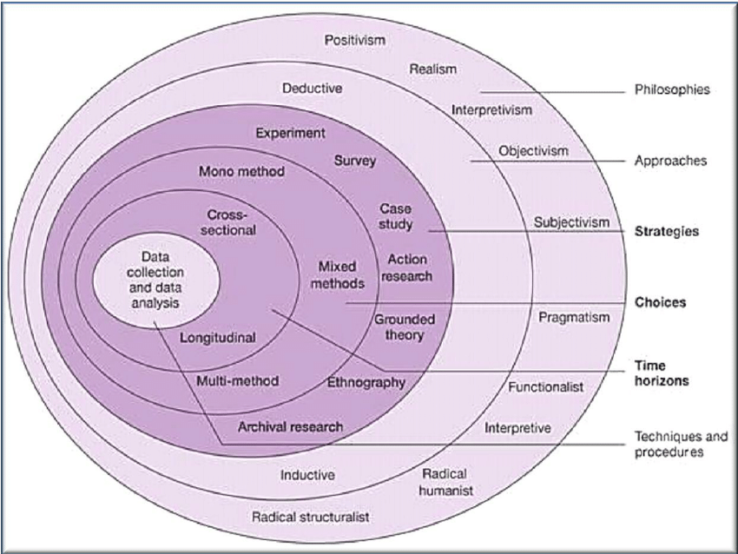
The outer layer is the research philosophy, the research philosophy refers to a set of beliefs concerning the nature of the research. It is the underlying definition of the nature of knowledge. There are three types of philosophies that are essential in the research process. These are defined as:
Ontology- this is the researchers view of nature of reality.
Axiology- This is the researchers view of the role of values in research.
Epistemology- This is where the researcher will ask what constitutes to acceptable knowledge (Alamgeer, 2022).
Additionally, this research approach has decided to focus on an interpretivist epistemology. This approach was chosen as the researcher will be a part of the research, they will be interpreting data.

Approach
The research philosophy might include a theory development approach, which normally includes:
Deductive: This is where researchers try to improve or test their hypotheses through research
Inductive: This is where the researcher will formulate the hypothesis based on research
Qualitative and quantitative research holds important roles in the field of research. The researcher in this project has chosen to use a qualitative method that seeks to analyse the causes of changes of social facts through objectives measurements and qualitative analysis. It focuses on gathering data through conversational and open-ended communication (Arghode, 2012). Quantitative research method would not be appropriate for this research project because numerical data would not be approached to meet the objectives of this research. The approach chosen for this research is the inductive approach, this approach provided a systematic set of procedures for analysing qualitative data that will produce valid and reliable findings (Thomas, 2006). The researcher had collected data relevant to UK prisons and Scandinavian prisons as part of their secondary research. The inductive approach allows the researcher to look at their primary research, to identify pattens in the data. The researcher is looking at the public’s perception of rehabilitation and punitive prisons which requires interpretivist qualitative view.

Strategies
As part of the researchers study it was decided that a questionnaire would be used as it allows respondents the opportunity to answer it anonymously, which will allow the respondents to truly express how they feel. This will lead to a better understanding of what the research is about. The purpose of the questionnaire is for participants to be able to express their opinion through open and closed questions. This will enable the researcher to understand the respondents’ true feelings. A research method provides readers with findings and legitimacy. It helps provide evidence of a particular area. The research methodology is important because it finalises research, it will illustrate how valid the research is collected (SkilFul Academy, 2022). The importance of a questionnaire is that participants can anonymously give their opinion about this particular area of research which will provide the researcher with more valid statistics. This is pragmatic and logistically useful because it allows the researcher to target a certain audience in a short period of time.

Choice
In comparison, the researcher has chosen to use mixed methods. Office for Health Improvement and Disparities states that mixed methods allow the researcher to use qualitative and quantitative data. This will enable the researcher to combine both quantitative and qualitative data to provide the researcher with more in-depth findings (UK Government, 2020).

Time Horizon
Time horizon defined a time frame for the research, there are two types:
Cross-sectional- This is where data is collected at one point of time.
Longitudinal- This is where the researcher will be collecting data continuously over a period of time (Melnikovas, 2018).
A cross section was chosen for this research project as it is more appropriate for this research. Research may be collected over a long period over times, but due to this research project looking at the public perception of prisons, this method would be practical in terms of the questionnaire. The questionnaire was released January 30th and participants who chose to be involved had until March 20th to complete it, this will provide the researcher with more information and valid findings from a cross section of people.

Data Collection
To gather the primary data, the researcher has chosen to use a questionnaire. The benefit of a questionnaire is the ability for the participants to answer the question anonymously (Cleave, 2021). Another benefit is that a questionnaire provided open and closed questions which allows the participants to express their opinion anonymously without their identity being identified. Additionally, the questionnaire will be able to target a large number of participants. However, there are some disadvantages to a questionnaire as it allows respondents to change their previous thought if it contradicts the after answers. It can also result in respondents ignoring certain questions.

Sampling
The purpose of a questionnaire is to gather data from a certain target audience. The targeted audience for this research project is students at UWTSD and individuals around the local area. The target area for this research project is the younger generation, between the ages of 18-35 and the older generation 35-60. By targeting the different age groups, it will show the differences in how young people and the older generation perceive the Criminal Justice System. The findings of this questionnaire will be generated into graphs to illiterate the results of the primary research. The sampling method that was chosen for this research project was purposive sampling, this is where the researcher has chosen a particular setting. The researcher had targeted 18-35- and 35–60-year-olds for a particular purpose. The researcher targeted these different age groups because it will provide more realistic and reliable findings. Also, the researcher also considered non-probability and convenience sampling. The reason for this is because the researcher had decided to target students and the local area, this is an easy option and inexpensive compared to other sampling techniques (Malaysia, 2016).
The questions that will be displayed in the questionnaire is going to help the researcher establish the public perception of prisons in the UK. This questionnaire will contain open and closed questions, open and closed questions are a quick and easy method in allowing the participants to express and reflect on their thoughts (Farrell, 2016).

Method of Analysis
The researcher has chosen thematic analysis for this chapter, it is a powerful method of analysing qualitative data that helps the researcher understand experiences, thoughts, and behaviours (Kiger and Varpio, 2020). The researcher had chosen this method of analysis because it is a method that helps identify, analyse, and interpret patterns within qualitative data (Clarke and Braun, 2015). For instance, the researcher chose to do a questionnaire, all the data collected from that questionnaire was looked at and the researcher used thematic analysis to identify themes which enabled them to compare with other findings.

Reliability and Validity
The purpose of identifying reliability and validity in research it is important in ensuring that data is replicable, and the results are accurate. Validity and reliability increase transparency and decrease opportunities to inset researcher bias in qualitative research (Haradhan, 2017).

Limitations
Limitations can be considered a weakness within research as it may influence the outcome and the conclusion of the research (Ross and Zaidi, 2019). By clarifying limitations in every research study, it will allow the researcher to have a better understanding on the approach taken in the methodology chapter. The limitations which affected this research was time, money and access to certain materials, people, and resources. The researcher had limited time to carry out this research, interviewing prisoners and prison staff would be time consuming and would require a lot of paperwork. To target prisoners and professionals within prisons would have been beneficial to compare those thoughts with those of the public.

Ethical Considerations
This study is carried out in accordance with the UWTSD’S ethical standards, the researcher had been granted permission from the research supervisor and coordinator received via an ethics approval form. The ethnical consideration is aimed at confidentiality, identification and data privacy which addresses any ethnical concerns. The participants in this research project were over the age of 18 and it was optional to take part.

Conclusion
The relevant methodologies for this study were selected in this chapter. The researcher’s decision was so using both qualitative and quantitative technique in the form of a questionnaire which would be completed by UWTSD and the members of the public. The data from the questionnaire will be analysed and evaluated in the next chapter.

Chapter Four- Findings
4.1 Introduction
This chapter is to present the finding the researcher had collected from their questionnaire, this had provided the reader with the public’s opinion on rehabilitation in UK prisons compared to Scandinavian prisons. This primary research will expand and present new opinions to the research that has already been identified in the literature review.

4.2 Research Data Analysis
The data will be reviewed on Microsoft forms, this provided the researcher with pie charts and percentages to analysis the data collected. The questionnaire contains open and closed questions which enabled the respondents to express their opinion on this topic matter. The researcher asked the respondents to provide a reasoning for their answer which has provided a better understanding of their opinions on prisons in the UK and prisons in Scandinavia.
4.3 Methods
The importance of demographic information in research is essential, it allows the researcher to examine the qualifiable statistics of a particular population. These statistics are used to identify subsets of the population and characterised them at that point of time (Connelly, 2013). For instance, by age, ethnicity and educational attainment were used within this study.
4.3 Demographics.
This survey consisted of 24 questions and a total of 81 responses were collected. Questions 1-5 focused on the demographics of the participants; this provides the researcher with some background information on their participants. By asking for demographic information, it allows the researcher to analysis the data more effectively. Researchers will be able to look at the different patterns of answers as a person’s knowledge, experiences and options about a specific topic or subject could often be determined by their age.
against different ages and genders.

4.3.1 Gender and Age

From the 81 respondents, 41 identified as ‘female’ (53%), 34 identified as ‘male’ (44%), 1 identified transgender (1%) and one selected ‘prefer not to say’(1%). Gender was included to gain some demographic information because gender is culturally driven and has been defined as attitudes, behaviours, and feelings. This suggests that gender plays a vital role in how an individual interacts and how this can influence their perspective on a topic (Hughes et al, 2016). Participants was also categorised into 7 groups based on their age. Out of all 81 participants, 6 of them were between the ages 16-18 , 25 of them were between 19-25, 15 of them were between 26-34 (19%), 15 of them were between 46-54, 6 of them were between 55-65, and 2 were 66+. This had provided a wide variety of responses from different age groups, seen in Table 4.3.2 below.

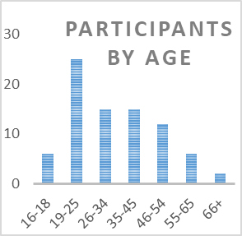
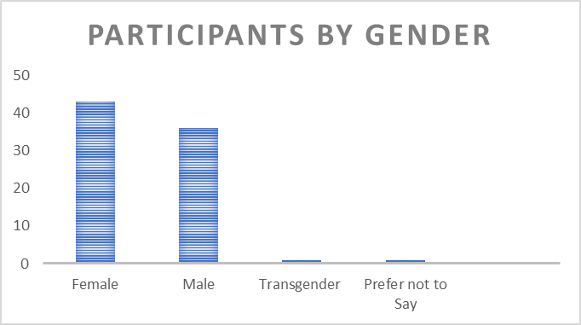
Table 4.3.2: Participants by Age and Gender

4.3.3 Target Audience
One question the researcher had asked participants, was whether they are a student or not. The target audience that was selected for this research project was students at UWTSD and the general public, by targeting two different audiences, it will show the differences in how students view the CJS compared to the public.52% of the participants were students which meant 48& wasn’t. See table 4.3.4
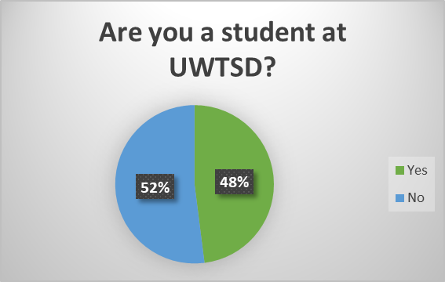

Question 6: To start the questionnaire off the researcher had asked an open-ended question which allowed the respondents to write their opinion on the topic area. The question had asked:
‘What does rehabilitation mean to you?’
The reason why the researcher had started with an open-ended question was to see peoples understanding of rehabilitation and whether they have heard of the term before. See below some of the responses the researcher had received.

‘Getting help to be a better person.’

‘The action of restoring someone to health or normal life through training and therapy after imprisonment, addiction, or illness.’

‘Rehabilitation of the whole person addressing all their needs their education requirements holistic, psychological, moral values and a true understanding of their crime and impact it has on others’.

This question illustrated that everyone had some kind of knowledge of what rehabilitation is. As discussed in the literature chapter rehabilitation is to help prevent prisoners from re-offending. Prisons aim to reform and rehabilitate prisoners to reintegrate prisoners back into society after they have completed their sentence. This question stems onto question 8 which will be later discussed.

Question 7:

Question 7 askes participants what punishment means to them; this is to see what participants think punishment is. Below are some of the responses:


The 81 participants that completed this questionnaire have the same kind of view as to what punishment means to them. Punishment is a problematic concept; it is defined in many ways. However, punishment is where an individual is sentenced or has a legal sanction (Esther and Ginneken, 2016), Participants share the same thoughts and feelings in terms of what punishment means to them.

Question 8:
Do you believe prisons in the UK have a successful rehabilitation scheme?
Question 8 had asked participants if they think the UK has a successful rehabilitation scheme. 7% of 81 participants strongly agree that the UK has a successful rehabilitation scheme, 14% of participants just agree, 17% neither agree or disagree, 35% disagree and 19% strongly disagree. See below the results of this question.
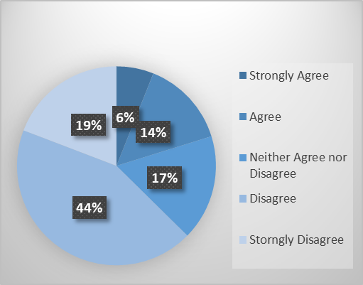

The finding of this question shows that 17 of 81 participants believe that the UK have a successful rehabilitation scheme, 14 of them neither agree nor disagree and the other 50 believe that the prisons in the UK do not have a successful rehabilitation scheme. This illustrates that the public lack confidence in the rehabilitation of prisoners. This stems back to the research that was carried out in chapter two, objective 1, where the researcher gathered secondary research on whether UK prisons have a successful rehabilitation scheme. The secondary research that was identified indicates that that the UK fail to achieve the rehabilitative culture that they thrive on.

Question 9:
Do you think overcrowding in UK prisons has a negative impact on rehabilitation of prisoners?
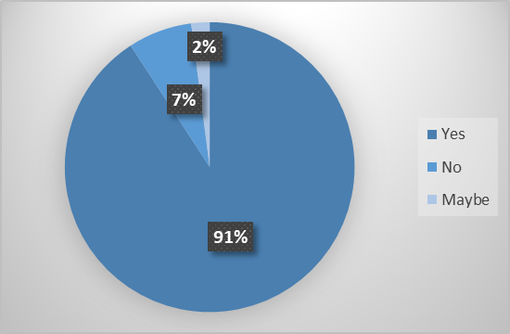
The secondary research that was carried out in chapter two illustrates that overcrowding has a negative impact on the rehabilitation of prisoners, this was due to prisons being plagued with violence, appalling living conditions, drugs, and lack of access to rehabilitation (Portal, 2019). This has a negative impact on prisoners and resulting in prisoners not receiving the support they need. The researcher had asked participants if they think overcrowding in prisons has a negative impact on the rehabilitation of prisons, 72 of participants said yes (89%), 2 said no (2%) and 7 said maybe (9%). This shows that the public think that overcrowded prisons have a negative impact on the rehabilitation of prisoners.

Question 10:
‘Could you provide a reasoning for your answer?’
Question 10 was a follow up questions from question 9, asking participants to explain their previous answer in regard to why they think overcrowded prisons has a negative impact on the rehabilitation of prisoners. These were some of the respondent’s responses:

‘Because there isn’t enough staff in prisons to deal with every person in that prison and not enough time is being spent fairly on everyone’.

‘Not enough resources and support for prisoners due to overcrowded prisons. Overcrowded prisons can result in violence and bad mental health issues.’

These responses illustrate that participants believe overcrowding has a negative impact on prisoners because it can lead to poor living conditions, violence, lack of resources and support.

Question 11:
Do you believe the Criminal Justice System is fair in the UK?
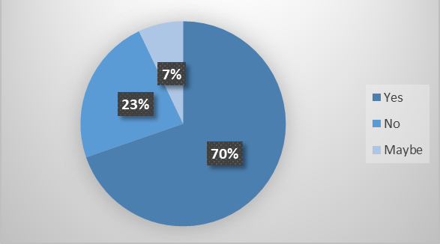

Question 11 asked respondents whether they believe the Criminal Justice System is fair in the UK. 19 of the participants said yes (23%), 56 of participants said no (69%) and 6 said maybe (7%). This shows that majority of the participants do not think the CJS is fair.

Question 12:
What is the reason for your answer?
Question 12 is a follow up question from question 11 which asks participants if they think the CJS is fair. 69% of participants think the CJS is not fair, this is over half of the respondents. The researcher asked the respondents to provide a reasoning for their answer. Participants who believe the CJS is fair said:

‘I believe the system is fair as people are punished fairly’.

‘It delivers justice for all’

These are some of the resources that don’t think the criminal justice system is fair:

‘It’s not fair as some people are doubly wronged in the prison system and sent down for less serious acts.’

‘Critical Evidence is often not disclosed’.

‘People who break the law should have tougher punishments. Especially when the sentence is life, it should mean life. Too many are given a shorter sentence or parole who have done disgusting crimes in life.’

‘Some crimes are not as serious as others, but the lesser crime sometimes gets more punishment’.
This illustrates that the public has strong views on the CJS, majority of people think the CJS isn’t fair. In chapter two, the publics perception on the CJS in recent years has shown that the CJS is failing as it lacks the required resources. Today, it seems that this view still stands.

Question 13:
‘What do you think should be the main priority of the CJS in England and Wales?’
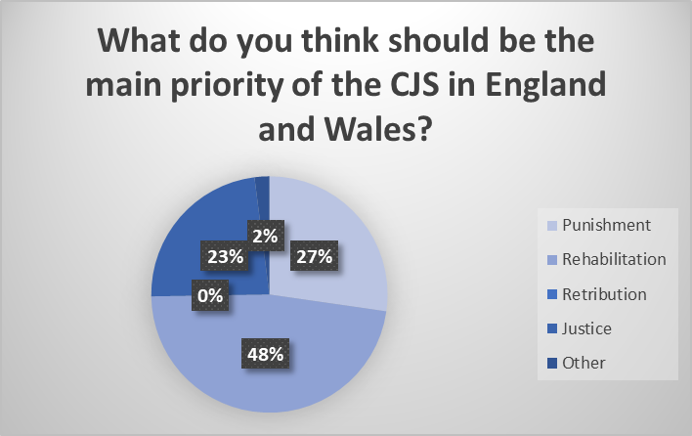
The researcher asked participants what they think the main priority should be in the CJS. 27% of participants said punishment, 47% said rehabilitation, 23% said Justice, and 2% said other.

The results of this question show that 47% think that the CJS should focus on rehabilitation. The UK try and rely on the rehabilitative culture concept, they believe by having prisons that are safe, hopeful, decent and supportive towards prisoners will help prevent re-offending. However, research shows that prisons in the UK lack the rehabilitative culture.

Question 14:
Could you provide a reasoning for the previous question?

NEED TO COMPLETE


Question 14 is a follow up question from question 13. The researcher asked participants to provide a reasoning for their answer for what should be the CJS main focus. These are some of the responses below:

Question 15
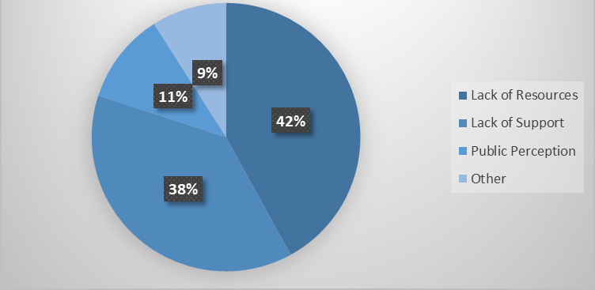
Do you think the prison system is failing? if so, please select the relevant option as to why below?

The researcher had asked participants the reason why they think the prison system is failing by selectin the relevant option as to why, these options were lack of resources, lack of support, public perception and other. 42% of participants said lack of resources, 38% said lack of support, 11% said the public perception and 9% said other. This shows a wide variety of options, lack of resources and lack of sport are the main two that were selected.

Question 16:
What is the reasoning for your answer?
Question 16 is a follow up question from question 15, the researcher asked participants to provide a reason to their answer based on the option they had selected.
Need to Finish


Question 17:
What other alternatives could there be instead of prisons?
Question 17 is an open-ended question which allows the participants to put their own ideas and options in. The question asked participants what other alternatives there could be instead of prisons. Here are some of the responses below:
NOT FINISHED


Question 18:
Do you believe prisons should be places of punishment?
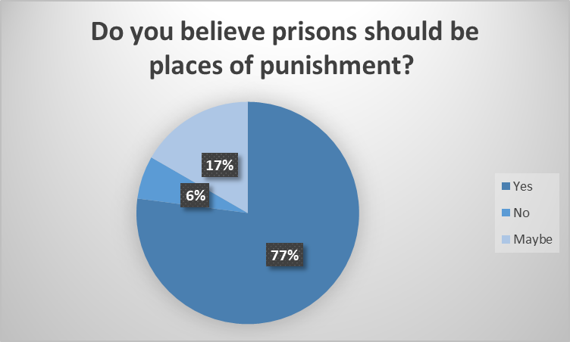
The researcher had asked participants their opinion on whether prisons should be places of punishment. 74% of participants said yes, 6% said no and 20% said maybe.

This illustrates that majority of participants think that prisoners should be punished.

Question 19:
‘What is the reasoning for your answer?’.

Question 19 was a follow up question from question 18, asking participants to provide a reasoning for their previous answer. These are some of the responses received that are listed below:
NEED TO FINISH


Question 20:
Scandinavian prisons treat prisoners like ordinary people, do you agree with this?

This part of the questionnaire moves on to Scandinavian prisons, this provided the researcher with the public opinion on how Scandinavian prisons treat their prisoners and how it differs to the UK. Question 20 asked participants if they agree with prisoners being treated like normal people, 32% of participants said yes, 40% said no and 9% said maybe. This shows a strong comparison In terms of participants agreeing and disagreeing, it indicates that many people do not agree with the fact that prisoners are treated like normal people. Below shows a pie chart illustrating the results from this question.
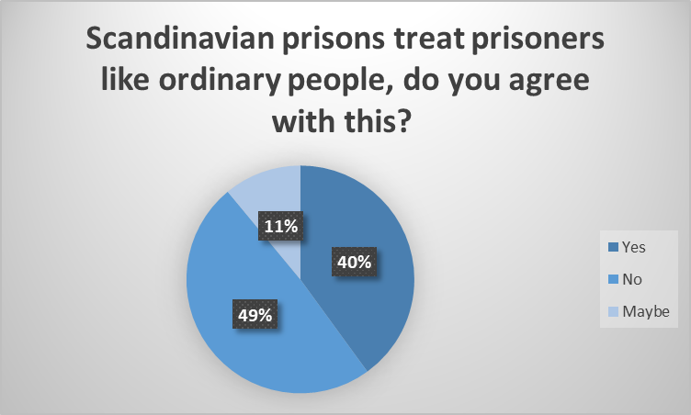

Question 21:
‘What is the reasoning for your answer?’
The researcher asked participants to provide a reasoning as to why they agree or disagree to Scandinavian prisoners being treated like normal people. Here are some of the responses:
NOT FINISHED


Question 22:
Prisoners in Scandinavia are treated like normal people, they have they own cell, toilet facilitates, able to cook and clean for themselves, have close relationships with the guards and they have daily activities to participate in. This is very different to prisoners in the UK, prisoners in the UK have to share cells, have no privacy and are locked in cell during certain hours of the day.
What is your opinion on this?
Question 22 was an open-ended question to allow respondents to give their personal opinion on this particular top. The question contained some information and participants had to say whether they agreed or disagreed with the information and had to justify their reason. Here are some of the participants responses:

NEED TO FINISH

Question 23:
Do you think prisons in the UK should treat prisoners like prisoners in Scandinavia?
The researcher had asked the participants of the questionnaire on whether prisoners in the UK should be treated like prisoners in Scandinavia. 14 of the participants said they strongly agree, 26 said they agree, 18 said they neither agree nor disagree, 9 said they disagree and 14 said they strongly disagree. These responses have provided a wide range of answers, 26 participants think prisoners in the UK should be treated the same as Scandinavians, however 21 think they shouldn’t. This also indicates that participants opinion on this matter had changed while carrying out the research as question 20 asked participants if they agree with prisoners being treated like normal people and 40% said no but now majority of participants think the UK should adopt this prison system.

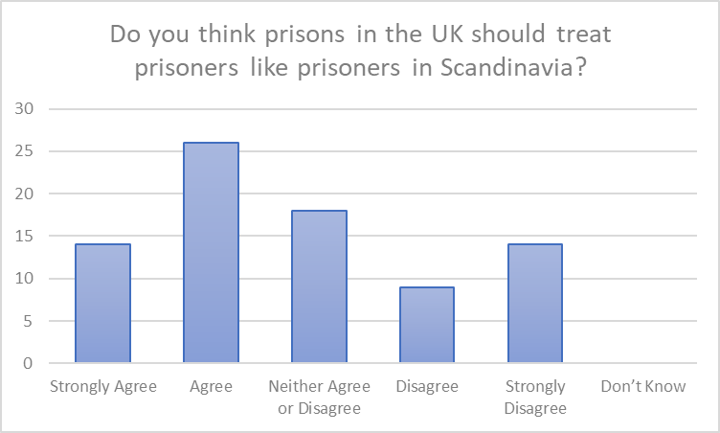

Question 24:
What is the reasoning for your answer?


Not finished

Question 25
How do you think prisoners should be treated?
Not finished


.

Abstract

References
- Andvig, E. Hamidane, KS. Hanson, L. and Karlsson, B (2020). ‘Inmates’ perceptions and experiences of how they were prepared for release from a Norwegian open prison’, Nordic Journal of Criminology, Volume: 22(1), p.204-220, Available at: https://www.tandfonline.com/doi/full/10.1080/2578983X.2020.1847954#:~:text=Norwegian%20prisons%20are%20often%20praised,(2014) , (Accessed date: 21/10/22).
- Bernard, J. Haas, K. Siler, B. and Weatherby, AG. (2017). ‘Perceptions of Rehabilitation and Retribution in the Criminal Justice System: A Comparison of Public Opinion and Previous Literature’, Journal of Forensic Sciences and Criminal Investigation, Volume: 5(3), p. 1-14, (Accessed date: 24/10/22).
- Cambridge Dictionary (2022). ‘Questionnaire’, Available at: https://dictionary.cambridge.org/dictionary/english/questionnaire , (Accessed date: 14/11/22).
- Chamberlen, and Carvalho, H. (2019). ‘The Thrill of the Chase: Punishment, Hostility and the Prison Crisis’, Social & Legal Studies, Volume: 28(1), p.100-117, Available at: https://journals.sagepub.com/doi/pdf/10.1177/0964663918759820 , (Accessed date: 01/11/22).
- Denny, M. (2016). ‘Norway's Prison System: Inv s Prison System: Investigating Recidivism and estigating Recidivism and Reintegration’, Bridges: A Journal of Student Research, Volume: 10(10), p. 21-37, Available at: https://digitalcommons.coastal.edu/cgi/viewcontent.cgi?article=1032&context=bridges , (Accessed date: 01/11/22).
- Gul,R. (2018). ‘Our Prisons Punitive or Rehabilitative? An Analysis of Theory and Practice’, Policy Perspectives, Volume:15(3), p.67-83, Available at: https://www.jstor.org/stable/10.13169/polipers.15.3.0067#metadata_info_tab_contents , (Accessed date: 21/10/22).
- HM Inspectorate of Prisons, (2017). ‘Life in prison: Living conditions’, Available at: https://www.justiceinspectorates.gov.uk/hmiprisons/wp-content/uploads/sites/4/2017/10/Findings-paper-Living-conditions-FINAL-.pdf , (Accessed date: 16/10/22).
- Hutton, N. (2005). ‘Beyond populist punitiveness?’, Punishment & Society, Volume: 7(3), p.243-258, Available at: https://journals.sagepub.com/doi/abs/10.1177/1462474505053828?casa_token=Kmv-HoEeOjsAAAAA:tP8KbfhJdJhVw9PXw43uB3-mLymuQu9H4tw-mqPsXrgsg-vPjOYQnnvT5JjHH45wlTO1PMBdRLU , (Accessed date: 18/11/2022).
- James, E. (2013). ‘The Norwegian prison where inmates are treated like people’, The Guardian, Available at: https://www.theguardian.com/society/2013/feb/25/norwegian-prison-inmates-treated-like-people , (Accessed date: 22/10/22)
- Jennings, W. Gray, F. Farrall, S. and Hay, C. (2017). ‘Penal Populism and the Public Thermostat: Crime, Public Punitiveness and Public Policy’, The University of Sheffiled, Volume:30(3), p.463-481, Available at: https://eprints.whiterose.ac.uk/97893/6/PenalPopulismThermostat_Governance_Preprint.pdf , (Accessed date: 03/11/22).
- Mann, DR and Howard, FF. (2018). ‘What is a rehabilitative prison culture?’, Prison Service Journal, Volume: 235, p. 1-44, Available at: https://www.crimeandjustice.org.uk/sites/crimeandjustice.org.uk/files/PSJ%20235%20January%202018.pdf , (Accessed date: 02/11/22).
- Ministry of Justice, (2015)( Kristia Jansson). ‘Public confidence in the Criminal Justice System – findings from the Crime Survey for England and Wales (2013/14)’, Available at: https://assets.publishing.service.gov.uk/government/uploads/system/uploads/attachment_data/file/449444/public-confidence.pdf , (Accessed date: 04/11/22).
- Wood, LJ and Viki, TG (2001). ‘Public Attitudes to Crime and Punishment: A Review of the Research.’, Available at: https://core.ac.uk/download/pdf/322997.pdf , (Accessed date: 21/10/22).
Main body- Objective 1
- BBC News, (2018). ‘Is this a 'luxury prison'?’, Available at: https://www.bbc.co.uk/news/av/world-43261564 , (Accessed date: 19/11/22).
- BBC News, (2019). ‘How Norway turns criminals into good neighbours’, Available at: https://www.bbc.co.uk/news/stories-48885846 , (Accessed date: 20/11/22.
- Campbell, D. (2021). ‘Britain’s prisons are becoming ever more like the failed US system’, The Guardian, Available at: https://www.theguardian.com/commentisfree/2021/nov/01/britain-prisons-us-system , (Accessed date: 25/10/22).
- Government UK (2020). ‘Proven reoffending statistics: October to December 2020’, Available at: https://www.gov.uk/government/statistics/proven-reoffending-statistics-october-to-december-2020/proven-reoffending-statistics-october-to-september-2020 , (Accessed date: 12/11/22).
- Government UK (2020). ‘Proven Re-offending Statistics: October to December 2020’, Available at: https://www.gov.uk/government/statistics/proven-reoffending-statistics-october-to-december-2020/proven-reoffending-statistics-october-to-september-2020, (Accessed date: 11/11/22).
- Government UK. (2022). ‘Prison Life’, Available at: https://www.gov.uk/life-in-prison/healthcare-in-prison , (Accessed date: 11/11/22).
- Hale, J. (2000??). ‘Does Prison Work? A Comparative Analysis on Contemporary Prison Systems in England and Wales and Finland, 2000 to Present’, Available at: https://www.wlv.ac.uk/media/departments/faculty-of-social-sciences/documents/wolverhampton-law-journal/edition-4/(2020)-4-WLJ-64.pdf , (Accessed date: 12/11/22).
- Heard, C. (2019). ‘Prison overcrowding and the risks for public health: a global time-bomb?’, Available at: https://www.fairtrials.org/articles/news/prison-overcrowding-and-risks-public-health-global-time-bomb/#:~:text=Overcrowded%20prison%20conditions%20lead%20to,and%20staff%2C%20and%20wider%20communities. , (Accessed date: 12/11/22).
- Howard League for Penal Reform, (2019). ‘Revealed: The scale of prison overcrowding in England and Wales’ , Available at: https://howardleague.org/news/revealed-the-scale-of-prison-overcrowding-in-england-and-wales/ , (Accessed date: 09/11/22).
- Howard League for Penal Reform, (2022). ‘Justice and Fairness in Prisons’, Available at: https://howardleague.org/our-work/transform-prisons/justice-and-fairness-in-prisons/ , (Accessed date: 12/11/22).
- https://borgenproject.org/norways-prison-system/#:~:text=Norway%20has%20consistently%20ranked%20number,represent%20comfort%2C%20healing%20and%20inclusivity.
- James, E. (2013). ‘ The Norwegian prison where inmates are treated like people’ , Available at: https://www.theguardian.com/society/2013/feb/25/norwegian-prison-inmates-treated-like-people , (Accessed date: 11/11/22).
- Khan, AJ. (2020). ‘Overcrowded prisons ‘could run out of space’ in next three years’, Available at: https://metro.co.uk/2020/09/11/overcrowded-prisons-could-run-out-of-space-in-next-three-years-13254996/ , (Accessed date: 21/11/22).
- Portal, G. (2019). ‘How dangerous are prisons in England and Wales?’, https://www.bbc.co.uk/news/uk-49324718 , (Accessed date: 22/11/22).
- Struge, G. and Tunnicliffe, R. (2022). ‘UK Prison Population Statistics’, Available at: https://commonslibrary.parliament.uk/research-briefings/sn04334/ , (Accessed date: 18/11/22).
- Taylor, R. (2022). ‘Crime and rehabilitation: An overview’, Available at: https://lordslibrary.parliament.uk/crime-and-rehabilitation-an-overview/#:~:text=Making%20sure%20prisoners%20gain%20basic,including%20construction%20and%20coding%E2%80%94improving , (Accessed date: 12/11/22).
- The Prison Reform Truest, (2022). ‘Prison: the facts’, Available at: https://prisonreformtrust.org.uk/wp-content/uploads/2022/07/Prison-the-facts-2022.pdf , (Accessed date: 13/11/22).
- UK Parliament, (2019). ‘ Prisons crisis: Government's current approach inefficient, ineffective and unsustainable’, Available at: https://committees.parliament.uk/committee/102/justice-committee/news/99437/prisons-crisis-governments-current-approach-inefficient-ineffective-and-unsustainable/ , (Accessed date: 12/11/22).

Objective 2
- Andvig, E, Hamidane, SK. Ausland, LH. And Karlsson, B. (2020). ‘Inmates’ perceptions and experiences of how they were prepared for release from a Norwegian open prison’, Nordic Journal of Criminology, Volume: 22(2), p.203-220, Available at: https://www.tandfonline.com/doi/pdf/10.1080/2578983X.2020.1847954?needAccess=true , (Accessed date: 15/11/22).
- Garland, D. (2021). ‘What’s Wrong with Penal Populism? Politics, the Public, and Criminological Expertise’, Volume: 16(257), p.258-277, Available at: https://link.springer.com/content/pdf/10.1007/s11417-021-09354-3.pdf , (Accessed date: 12/11/22).
- Government UK. (2021). ‘New prison strategy to rehabilitate offenders and cut crime’, Available at: https://www.gov.uk/government/news/new-prison-strategy-to-rehabilitate-offenders-and-cut-crime , (Accessed date: 12/11/22).
- Hough, M. Bradford, B. Jackson, J. and Roberts, VJ. (2013). ‘Attitudes to Sentencing and Trust in Justice’, Available at: https://assets.publishing.service.gov.uk/government/uploads/system/uploads/attachment_data/file/230186/Attitudes_to_Sentencing_and_Trust_in_Justice__web_.pdf , (Accessed date: 21/11/22).
- Hough, M. Radford, B. Jackson, J. and Roberts, JR. (2014). ‘Attitudes to Sentencing and Trust in Justice’, Available at: http://eprints.lse.ac.uk/50440/1/Jackson_Attitudes_sentencing_trust_2013.pdf , (Accessed date: 13/11/22).
- Jacoby, JE. and Cullen, TF. (1998). ‘The Structure of Punishment Norms: Applying the Rossi-Berk Model’, Journal of Criminal Law and Criminology, Volume: 89(1), p. 245-306, Available at: https://scholarlycommons.law.northwestern.edu/cgi/viewcontent.cgi?article=6991&context=jclc , (Accessed date: 01/10/22).
- Johnson, AM. (2020). ‘What I Learned Touring Prisons in Finland and Norway’, Available at: https://www.calwellness.org/stories/lessons-prisons-finland-norway/ , (Accessed date: 09/11/22).
- Martela, F. Greve, B. Rothstein, Bo. And Saari, J. (2020). ‘The Nordic Exceptionalism: What Explains Why the Nordic Countries Are Constantly Among the Happiest in the World’, Chapter 7, Available at: https://worldhappiness.report/ed/2020/the-nordic-exceptionalism-what-explains-why-the-nordic-countries-are-constantly-among-the-happiest-in-the-world/ , (Accessed date: 11/10/22).
- Mason, P. (2008). ‘The media’s distorting lens’, The Guardian, Available at: https://www.theguardian.com/commentisfree/2008/jul/29/prisonsandprobation.justice#:~:text=Present%20news%20coverage%20means%20that,but%20constructed%20by%20the%20media. , (Accessed date: 12/11/22).
- Monterosso, S. (2009). ‘PUNITIVE CRIMINAL JUSTICE AND POLICY IN CONTEMPORARY SOCIET’, Available at: https://lr.law.qut.edu.au/article/download/39/38/39-1-78-1-10-20120525.pdf , (Accessed date: 13/11/22).
- Shammas, VL. (2014). ‘The pains of freedom: Assessing the ambiguity of Scandinavian penal exceptionalism on Norway’s Prison Island, Punishment & Society, Volume: 16(1), p.104-123, Available at: https://journals.sagepub.com/doi/pdf/10.1177/1462474513504799?casa_token=3fi_gAkErIsAAAAA:ampmEr7NKZWy0i4vVMMQv44F0w3zBqSfK9Ydy2n-y-MX5oeqB_z_FKIyXdS2v9aP6kCrowBOr9M , (Accessed date: 11/11/22).
- Ugelvik, T. and Dullum, J. (2012). ‘Penal Exceptionalism?’, Routledge, Available a: file:///C:/Users/Court/Downloads/10.4324_9780203813270_previewpdf.pdf , (Accessed date: 12/11/22).
- Wepsalainen, E. and Wikstrom, A. (2014). ‘The Scandinavian Exceptionalism Thesis And Penal Policy Making’, Available at: https://lup.lub.lu.se/luur/download?func=downloadFile&recordOId=4463472&fileOId=4463505 , (Accessed date: 21/11/22).
- HM Inspectorate of Prisons (2021). ‘Rehabilitation and release planning’, Available at: https://www.justiceinspectorates.gov.uk/hmiprisons/our-expectations/prison-expectations/rehabilitation-and-release-planning/#:~:text=Prisoners%20are%20supported%20to%20maintain,release%20back%20into%20the%20com , (Accessed date: 21/11/22).
- Bennet, J. (2018). ‘Rehabilitative Culture’, Prison Service Journal, Issue.235, p.4-44, Available at:https://www.crimeandjustice.org.uk/sites/crimeandjustice.org.uk/files/PSJ%20235%20January%202018.pdf , (Accessed date: 21/11/22).
- UK Government, (2019). ‘Public given power to question ‘lenient’ prison sentences’, Available at: https://www.gov.uk/government/news/public-given-power-to-question-lenient-prison-sentences , (Accessed date: 22/11/22).
- Taylor, D. (2019). ‘Prisoner rehabilitation does not work, says former prisons boss’, The Guardian, Available at: https://www.theguardian.com/society/2019/oct/29/prisoner-rehabilitation-does-not-work-says-former-prisons-boss , (Accessed date: 21/11/22).
- UK Governemnt, (2022). ‘Safety in Custody Statistics, England and Wales: Deaths in Prison Custody to September 2022 Assaults and Self-harm to June 2022’, Availble at: https://www.gov.uk/government/statistics/safety-in-custody-quarterly-update-to-june-2022/safety-in-custody-statistics-england-and-wales-deaths-in-prison-custody-to-september-2022-assaults-and-self-harm-to-june-2022 , (Accessed date: 20/11/22).
- Mjaland, K. Laursen, J. Schliehe, A. and Larmour, S. (2021). ‘Contrasts in freedom: Comparing the experiences of imprisonment in open and closed prisons in England and Wales and Norway’, European Journal of Criminology, Volume: 0(0), p.1-22, Available at: https://journals.sagepub.com/doi/full/10.1177/14773708211065905 , (Accessed date: 23/11/22).
- HM Chief Inspector of Prisons for England and Wales, (2021-22). ‘HM Chief Inspector of Prisons for England and Wales Annual Report 2021–22’, Available at: https://www.justiceinspectorates.gov.uk/hmiprisons/wp-content/uploads/sites/4/2022/07/HMIP-Annual-Report-large-print-2021-22.pdf , (Accessed date: 22/11/22).
- https://krus.brage.unit.no/krus- xmlui/bitstream/handle/11250/2577862/Normality%20behind%20the%20walls.pdf?isAllowed=y&sequence=1
- Prison Reform Trust (2022). ‘Prison: the facts’, Available at: https://prisonreformtrust.org.uk/wp-content/uploads/2022/07/Prison-the-facts-2022.pdf , (Accessed date: 21/11/22).
- https://www.prisonstudies.org/country/norway
- https://dictionary.cambridge.org/dictionary/english/research
- UK Government, (2022). ‘Safety in Custody Statistics, England and Wales: Deaths in Prison Custody to September 2022 Assaults and Self-harm to June 2022’, Available at: https://www.gov.uk/government/statistics/safety-in-custody-quarterly-update-to-june-2022/safety-in-custody-statistics-england-and-wales-deaths-in-prison-custody-to-september-2022-assaults-and-self-harm-to-june-2022#:~:text=In%20the%2012%20months%20to%20June%202022%2C%20there%20were%202%2C225,12%20months%20to%20June%202022. (Accessed date: 02/01/23).
- Penal Reform International, (2023). ‘Overcrowding’, Available at: https://www.penalreform.org/issues/prison-conditions/key-facts/overcrowding/ , (Accessed date: 02/01/23).
- https://www.emerald.com/insight/content/doi/10.1108/IJPH-04-2018-0014/full/html
- Prison Reform Trust, (2023). ‘Accommodation and Living Conditions in Prisons’ , Available at: https://prisonreformtrust.org.uk/adviceguide/accommodation-and-living-conditions-in-prison/ , (Accessed date: 01/01/23).
- Laursen, J. (2022). ‘Radical hope and processes of becoming: Examining short-term prisoners’ imagined futures in England & Wales and Norway’, Theoretical Criminology, Volume: 0(0), p.1-18, Available at: https://journals-sagepub-com.ezproxy.uwtsd.ac.uk/doi/epub/10.1177/13624806211069545 , (Accessed date: 20/10/22).
- UK Parliament, (2021). ‘ Justice Committee calls for root and branch reform of prison mental health support’, Available at: https://committees.parliament.uk/committee/102/justice-committee/news/157821/justice-committee-calls-for-root-and-branch-reform-of-prison-mental-health-support/ , (Accessed date: 01/01/23).
- O’Driscoll, J. (2022). ‘How safe are UK prisons?’. The Week, 12 January, Available at: https://www.theweek.co.uk/news/crime/955378/how-safe-are-uk-prisons
- Alamgeer, Z. (2022). ‘Understanding Research Onion for Research Methodology’, Available at: https://theinnovidea.com/understanding-research-onion-for-research-methodology/ , (Accessed date: 12/01/23).
- Melnikovas, A. (2018).’ Towards an Explicit Research Methodology: Adapting Research Onion Model for Futures Studies’, Journal of Futures Studies, Volume: 23(2), p.29-44, Available at: https://jfsdigital.org/wp-content/uploads/2019/01/03-Melnikovas-Onion-Research-Model.pdf , (Accessed date: 11/01/23).
- https://web.s.ebscohost.com/abstract?direct=true&profile=ehost&scope=site&authtype=crawler&jrnl=21523622&AN=85678192&h=iO7G8dYydfllO129HZiE4k6KwLf1Bb2NQElxg1a8bFw5EH45cWIQY6nGHnZ2kTZHKQ5p%2faBdHqNE0rsbMt9c2w%3d%3d&crl=c&casa_token=sqCPRmyu1bMAAAAA%3an-dkBOynyXcH6GH1mg4ohcCjnmQQwsXIVbKL7rWkH0YDinWUUs9GIX0xPohfwzTn4ikF30KFZesG&resultNs=AdminWebAuth&resultLocal=ErrCrlNotAuth&crlhashurl=login.aspx%3fdirect%3dtrue%26profile%3dehost%26scope%3dsite%26authtype%3dcrawler%26jrnl%3d21523622%26AN%3d85678192
- Cleave, P. (2021). ‘Advantages Of Questionnaires In Online Research’, Availble at: https://www.smartsurvey.co.uk/blog/advantages-of-questionnaires-in-online-research , (Accessed date: 01/01/23).
- Farrell, S. (2016). ‘Open-Ended vs. Closed-Ended Questions in User Research’, Available at: https://www.nngroup.com/articles/open-ended-questions/#:~:text=Open%2Dended%20questions%20are%20questions,or%20All%20of%20the%20Above) , (Accessed date: 28/11/22).
- Haradhan, M. (2017). ‘Two Criteria for Good Measurements in Research: Validity and Reliability’, Annals of Spiru Haret University, Volume: 17(3), p.58-82, Available at: https://mpra.ub.uni-muenchen.de/83458/1/MPRA_paper_83458.pdf , (Accessed date: 12/01/23).
- Ross, TP. And Zaidi, BLN. (2019). ‘Limited by our limitations’, Perspectives on Medical Education, Volume: 8(4), p,261-264, Available at: https://www.ncbi.nlm.nih.gov/pmc/articles/PMC6684501/#:~:text=Limitations%20represent%20weaknesses%20within%20the,and%20conclusions%20of%20the%20research. , (Accessed date: 10/01/23).
- https://www.gov.uk/guidance/mixed-methods-study#content
- https://journals.sagepub.com/doi/abs/10.1177/1098214005283748?journalCode=ajec
- file:///C:/Users/Court/Downloads/SSRN-id3205035%20(1).pdf
- https://www.plymouth.ac.uk/uploads/production/document/path/18/18247/Kiger_and_Varpio__2020__Thematic_analysis_of_qualitative_data_AMEE_Guide_No_131.pdf
- Clarke, V. and Briaun, V. (2015). ‘ What is Thematic Analysis?’
- https://researchspace.auckland.ac.nz/bitstream/handle/2292/43968/Thematic%20analysis_Journal%20Positive%20Psychology_ACCEPTED..pdf?sequence=4&isAllowed=y
- Connelly, ML. (2013). ‘Demographic Data in Research Studies’, Medsurg Nursing, Volume: 22(4), P.1-3, Available at: https://www.proquest.com/docview/1432298824?pq-origsite=gscholar&fromopenview=true , (Accessed date: 10/03/23).
- https://cdn.ymaws.com/sites/www.psichi.org/resource/resmgr/journal_2016/21_3Fall16JN-Hughes.pdf
- https://howardleague.org/wp-content/uploads/2016/04/HLWP-22-2016.pdf

