
Technological Impact on Retail Industry
SID: 1807021

May 13, 2019
Usman Rasheed

Vision for Future: LCDB7006

Technological Impact on Retail Industry

Executive Summary
There are several types of traditional organisational structures and theories such as Mintzberg organisational structure, mechanistic and organic organisational structure, functional departmentalisation, Geographical departmentalisation, customers’ departmentalisation, multidivisional structure, multinational structure, matrix organisations etc. These types of organisational structure have been popular to several areas. Due to the inventions of technology and other modern needs, these kinds of structures are not creating appeal as much as previous. Thus, there is the need to comply with the emerging trends of technology and other devices.
There are several management theories applied by the organisations working both in local and international market areas. Management theories are understood and applied by the managers in order to increase the productivity and performance by the organisations.
From the analysis of UK retail industry especially in case of the structure followed by them, it has been observed that a mix type of structure is followed where most of the firms are following the hierarchical structure and others are following flat or decentralised in most of the cases. Technology has a greater impact on the current structure followed by the firms where a typical change in the structure is recommended for the firms.
In this era especially in the contexts of e commerce and web 2.0 technologies, hierarchical structure has a little value as it hinders the growth for the firms and limit the learning opportunities for the employees at several key areas. Flat organisations are suggested to the next decades and firms who are responsive to the changes will become successful in the contexts of next eras. Decentralised management system allows to quick decision making with the help of technologies and skills by them.

Table of Contents
Executive Summary 2
1.0: Introduction: 4
2.0: Literature review: 4
3.0: Traditional structures of organisations: 5
4.0: Technology’s impact on the retail industry in UK 17
5.0: Technological advances and the traditional organisational structure: 21
6.0: Organisational structure at the UK retail industry and impact of technology on the industry 22
7.0: Conclusion: 25
8.0: References: 26

1.0: Introduction:
Today there are several innovations and technological advances in the areas of businesses and other daily lives. Due to the innovation of technology and its devices, the way business functions are executed has changed a lot. Compared to the previous centuries, functions by the business enterprises have become automated and it has increased the efficiency of services. Both the organisations and customers are benefitted a lot through the use of technology. Ecommerce and e-business 2.0 have changed the styles of operational contexts in almost all the functional areas. The aim of this assignment is to analyse how these technological advances have rendered traditional models of organisational structures and theories obsolete in the context of 21st century organisations. Not necessarily, the traditional models of organisational structures and theories have become obsolete rather there are lots of amendments in those theories to be applicable in the context of modern organisational contexts.
The retail industry of UK is one of the prominent industries where technology has impacted a lot to the smoother operations. Several organisations are rendering various automated services to the target consumers. The specific objective of this report is to analyse how technology has been being used in this: industry to flourish the services.

2.0: Literature review:
Drucker (2013) argued that E-commerce and e-business are two main components of the modern transaction and operation system. E-commerce that is also known as electronic commerce and Internet commerce refers to the process where the physical products are sold online and the trade is facilitated through the use of several electronic devices. Once goods are sold manually where both the consumers and retailers got physical interaction. But nowadays there is no requirement to have physical substance from both the parties to have the transactions being executed (Arvinen-Muondoand Perkins, 2013).
E-business on the other hand refers to the whole process of continuing of an online business. Thus, it can be argued that e-commerce is a subset of e-business (Arvinen-Muondo and Perkins, 2013).
According to Chen (2018), there are four types of e business such as B2B which is Business to Business indicating the selling of goods between businesses to business. Selling of raw materials to Tesco, the retail giant in UK constitutes B2B types of transaction. The second type is B2C which is business to consumers indicating the selling of goods and services to the consumers. The selling of goods and services to the consumers of Tesco is an example of B2C. C2C is another type of e-business where consumers sell goods and services to the business organisations. C2B is consumers to businesses in where several consumers sell goods and services to the business organisations using the online and other supportive flat forms (Drucker, 2013).
There are several types of traditional organisational structures and theories such as Mintzberg organisational structure, mechanistic and organic organisational structure, functional departmentalisation, Geographical departmentalisation, customers’ departmentalisation, multidivisional structure, multinational structure, matrix organisations etc (Farmer et.al 2013). These types of organisational structure have been popular to several areas. Due to the inventions of technology and other modern needs, these kinds of structures are not creating appeal as much as previous. Thus, there is the need to comply with the emerging trends of technology and other devices.
According to Taylor (2015) advancement of technology especially in the areas of e commerce and web 2.0 has rendered businesses to change the current structure they are following. On the other hand, organisations need to comply with the changing trends of technology to utilise the structure fully. Flat or decentralised organisational structure has a greater appeal in the present days and has a greater impact on the all the sectors especially in the retail industry where IT and IT enabled services have a greater impact.

3.0: Traditional structures of organisations:
Gilmoreand Williams (2017) argued that traditional organisational structures have the stems back in two centuries. Several scholars of management and other scientific areas developed several organisational structures those are used in several organisational contexts. Whenever these models were introduced by the scholars of several areas according to the needs of trends, technology was not so advanced as today. Thus, there is the need to incorporate the use of technology to make this model workable. However, among several structures, Mintzberg model is popular which is based on five core areas as follows
Mintzberg's Org. Structure and Configurat
Operating core: This segment is assigned to the productions of necessary goods and services to the target consumers (Anthony et.al 2017).
Strategic apex: This is the top-level management of any organisation.
Middle line: This segment is composed of the managers who are situated in the middle of operating core and strategic apex (Carpenter and Sanders2014).
Techno structure: This department is liable to the designing and processing of outputs to the target market so that the objectives by the firms are met successfully.
Support staffs: There are various staffs outside the organisations that provide supports except for the production of goods and services.
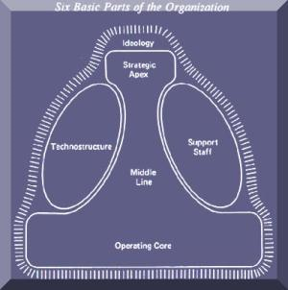
Figure: Mintzberg Organisational structure
Source: Farmer et.al (2013)
According to Mintzberg there are five types of organisational structures as follows
Blend of strategy, environmental forces and the organizational structure define the types and nature of organisations.
Machine bureaucratic organisation:
In this type of structure, a large hierarchy of management is found. Most of the cases for government and other big firms, this management style is followed. The two main strengths of this type of management style is consistency and longevity (Carpenter and Sanders 2014). There is low scope to express opinion by the others and there is low scope of innovation in the service areas.
The divisional or diversified organisational structure:
According to Drucker (2013), there are so many firms following a diversified product portfolio in the operations where several product departments are managed from a single authority. There are several MNCs and other geographically diversified organisations follow this kind of organisational structure.
There are several product line managers who are in full control with the management activities and take the accountability of the actions by them. The centralized management always focus on the big pictures and make long term plans for the operations in the other areas.
Among several weaknesses, one is duplication of the resources. Moreover, there is the propensity to have conflicts among the managers regarding the allocation of resources from the headquarters. This kind of organisational structure is effective when the organisations are large in nature and have the continuity in the development of products and services in several areas (Carpenter and Sanders 2014). Moreover, effective centralised decision making is done through the proper management functions.
The innovative organisations (Adhocracy)
Filmmaking, pharmaceuticals and several other industries always look for individuals and processes that are enough dynamic to cope up with the changing trends. In this form of organisational structure, decentralized decision-making process is applicable and power of authority is delegated to several parties whatever needed (Drucker, 2013).
Experts move from projects to projects as they become completed. This kind of organisational structure is flexible enough to the employees and they can freely cope with the changing trends of innovation in several areas (Taylor, 2015).
Despite several advantages, there are several drawbacks of the system such as the delegation of authority, conflicts of interests, and experts’ availability for all the time being etc.
So far by the discussion, several organisational structures are revealed. With the emergence of technology and other web-based tools and Medias, the natures of the structure by the organisations are changing (Drucker and Maciariello, 2017). For example, there is the emergence of virtual organisations where downsizing is a common issue. There is no more presence of traditional organisational structures rather a flat structureis followed. Intense innovation in this era has led to the obsolete of several models of traditional organisational management and activities.
Mechanistic and organic structure
Arvinen-Muondo and Perkins (2013) argued that Mechanistic and organic structures are two popular ways for managing the structures by the organisations. In case of mechanistic structure, employees are required to follow a routine work that may be rigorous in nature and they all will be held as responsible for the works done. This kind of structure is not so far effective in this technology led areas. There is the resistance to change in this type of structure. On the other hand, organic structure is responsive to changes and employees feel flexibility in working in this kind of structure (Drucker and Maciariello, 2017).
There are several characteristics of both mechanistic and organic types of structures. Firstly, characteristics of mechanistic organisations are as follows
There is low level of authority decentralisation
- Higher specialisation is focused
- Higher formalisation of each activity
- There is the emergence of rapid departmentalisation
- Decisions are made in the centralised ways there the span of control is limited only to the top-levelauthority.
- There is the strong chain of command followed among the structure.
Secondly, organic structure follows several characteristic as follows
- Teams are made within the experts from several functional areas
- There is the wider span of control compared to the low span
- Decisions are made in the decentralised ways
- Lower chain of command\
- Higher level of flexibility while working among several groups and geographical areas
- Information is being transmitted in free flow of manner
From the comparison of these two types of organisations, it has been revealed that the later one is more adaptive to the emerging trends of technologies and change responsive environment. Employees seek to learn on a continuous manner and through a process where higher freedom of activities is existed. Thus, the organic structure is useful to the functions conducted by the present types of needs and demands in the markets.

Organisational culture:
Drucker(2013) argued that culture is made up of shared values, beliefs, the ways decisions are made etc. Culture plays a crucial role to the successes in several key areas. The culture by the organisations is largely dependent on the structures of different types followed by the organisations. The culture developed through mechanistic structure is totally different from that of organic structure.
Being too much cautious, obeying a strong layer of management, being obedient to the decisions and authorities by one is typically stressed in the form of mechanistic organisational structure (Farmer et.al 2013). On the other hand, being creative and responsive to changes, flexibilities in the decision-making process, being a risk taker, handing of the risks is always promoted in case of the organic structure.

Functional departmentalisation:
In this kind of organisational structures, jobs are allocated to different functions such as finance, accounts, marketing, management etc. there is the divisional head in each area and others are working under the head of the functional areas. The heads of several departments are under the control of Chief Executive Officer in this kind of structure (Arvinen-Muondo and Perkins 2013). There are several advantages and disadvantages for following this kind of organisational structure as follows:
Advantage of functional departmentalisation:
In case of the organisations following functional departmentalisation there is the positioning of all the experts in several functional areas such as accounting, finance and other common areas and jobs are done in more arranged ways (Armstrong and Armstrong 2014). There is the better coordination of the activities and acts are rooted to achieve functional advantages. Centralisation of activities is focused here. There are several advantages for operating under the functional departmentalisation as follows
- Firstly, there is the logical reflection of functions and activities where power and prestige of the departments is core to perform
- Occupational specialisations’ principles are followed strictly
- There are the arrangements for proper training and supervision to the subordinates from the top level authority so that functions can be done in the most accurate and coherent manner
- So that works is done within the prescribed time limit strong command for activities and tight of control are prevailed at the organisation
- There is the scope that departments are furnished with skilled employees at that special fields such as personnel from finance under the finance department and such at the other departments
- There is the ease of co-ordination among the functional areas

Disadvantages of functional departmentalisation:
Such as the benefits, there are several disadvantages of operating under the functional departmentalisation as follows
- Firstly, the operation and the decision-making process through the bureaucratic system which time consuming and costly in nature
- In most of the cases it has been found that focus is strongly made on the achievements of functional objectives rather on the corporate goals which is a major drawback of operating under the system
- It has become tough to monitor accountability and performance by the employees
- Overspecialisation is focused and the key personnel are underestimated in various times thus leading to dissatisfaction among the employees
- In achieving the goals of organisations there is the requirement to have a cross functional activities which is lack under the management thus in most of the cases organisational achievements are not fulfilled
- The top-level authority is held as responsible for earning and meeting the profit target where there is the low or fewer involvement by the juniors and others who to become the next leaders at the organisational contexts
- Under the management system there is tardiness to adopt changes as when required. Because in most of the cases aged personnel belong at the top of the authority and they are unlikely to adopt changes in several areas despite the importance of that (Armstrong and Armstrong 2014). Modern environment always prefers to adopt changes as it is the demand of the current trends.
- In most of the cases employees are promoted to next level based on years of experience rather the performance by them each point of time which is a major obstacle for general managers for growth and sustain at the organisations
Both advantages and disadvantages happen under the functional departmentalisation. Several manufacturing and government organisations follow the management where this approach is no more used in case of technology-based firms and in the firms growing rapidly in several areas of operations (King and Lawley 2013). This management is more suitable where there is one or very few products and services to be developed and in small organisations.
Product departmentalisation:
Product departmentalisation is based on the premise that all the activities are aimed to develop and offer a specified product under the one manager (King and Lawley 2013). Grouping of activities aims to furnish excellences in the specific products or services.
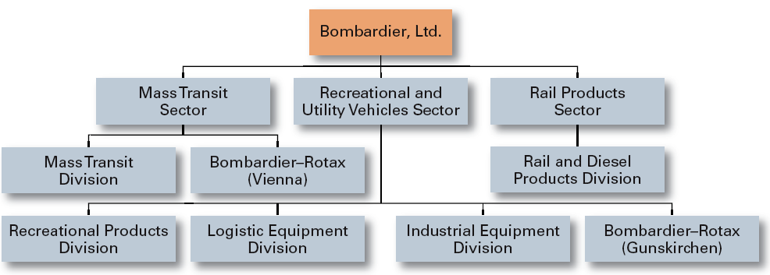
Figure: Product departmentalisation, Source: Chen (2018)
Advantages of product departmentalisation:
There are several advantages of product departmentalisation as follows
- Firstly, principles of specialisation of the products and services are followed strictly which ensures the quality goods and services in the market areas
- Because there is the focus of activities on only one product or services the full utilisation of human and non-human resources can be happened in most of the cases
- Because the products are the main of operation, the large manufacturing firms can be benefitted well through the operation system. There shall be various products and allocation of employees at several product areas
- There is the ease of controlling each department as they will be evaluated through the specific products and services, they develop in the market areas
- Enough time can be consumed by the top-level managers for planning and designing of activities as each department will be held as responsible for the actions to that department only
- Flexibility is ensured under the management system. Moreover, new products or services can be developed easily under the management system
- Through operation at this system, managers and other related employees get skilled in the specific product areas and there is the greater scope of learning and development by those
Disadvantages of product departmentalisation:
Such as advantages exist; there are several disadvantages of product departmentalisation as follows
- Chances are high that conflict of interests happen among the several product departments
- If there are the lower demands for the products or services in specific field, resources are utilised at lower level in that product department
- It is difficult for the top-level management to observe the activities by several product departments at a time and several lacking in the co-ordination of activities among the several product departments
- May be the overall goals by the organisation are not focused by the product managers as they are busy only with the products and services, they plan to execute in the market areas
Customer departmentalisation:
King and Lawley (2013) argued that Customer departmentalisation is based on the principle that grouping of activities shall be made according to the several types of customers organisations like to serve. If the customers are at several territories then grouping of activities shall be done in those territorial areas.
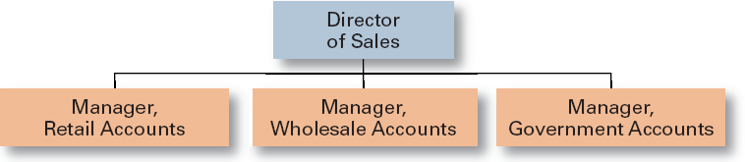
Figure: Customer departmentalisation
Source: King and Lawley (2013)
Advantages of customer departmentalisation:
There are several advantages of customer departmentalisation as follows
- Firstly, it is possible by the firms to meet the special and specific needs and demands by the customers
- If the customers can be served well there shall the possibility of maintaining long lasting relationships with those customers
Disadvantages of customer departmentalisation
There are several disadvantages of customer departmentalisation as follows
- There is the higher possibility that duplication of services in several areas will be made
- As there is the higher emphasize on customer satisfaction related programs less emphasize will be made in other areas where there is significant investment by the organisations

Multinational structure:
In case of multinational organisation, several offices are factories are set by such corporation at least in one country other than the parent location from where the global management is controlled.
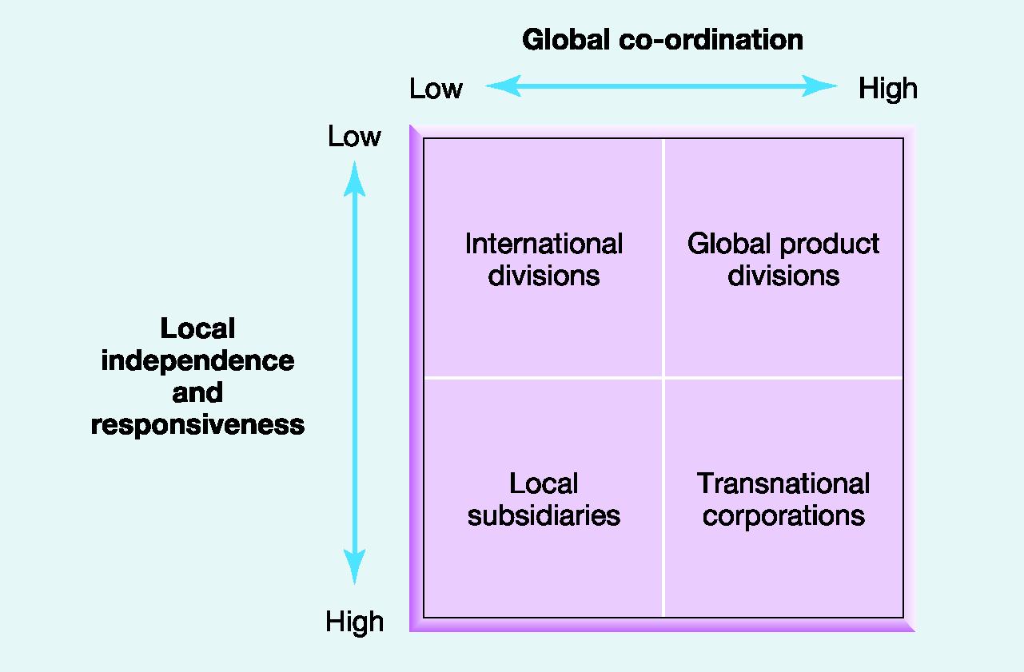
Figure: Multinational structure, Source: Chen (2018)

There are four basic choices when firms wish to operate in the international premises such as
- International strategy
- Transnational strategy
- Global strategy and
- Multi domestic strategy
These are described shortly
International strategy: Works better where there is low skill by the locals. Strong marketing operation and centralised management are important.
Multi domestic strategy: In order to satisfy the local needs by the consumers, there is the immense customisation of the products and offerings by the international players.
Global strategy: It is focused on standardisation and low costs structure. However, if the responsiveness by the locals is low then the strategy is not much effective.
Transnational strategy: Transnational strategy differs from the global strategy is the sense that it puts importance on the personalized marketing and selling approaches in order to sell and attract target market.
While firms operate in the international market there is the continuous pressure to cut costs so that more market share can be gripped. On the other hand, responsiveness is important to have success in the given areas. These both criteria make the firms learning organisation while operating in the international market areas.

Project based structure:
According to (Saloner et.al (2018), in a typical project-based structure, firms are created form the personnel from several departments with project specific skills for a certain time period. For a specific time period, projects remain valid and get dissolved as soon as projects end.
Comparison of organisational structures:
Though there are several organisational structures, not necessarily all the structures are useful for a typical organisation rather based on the operation and nature of works the suitability of the
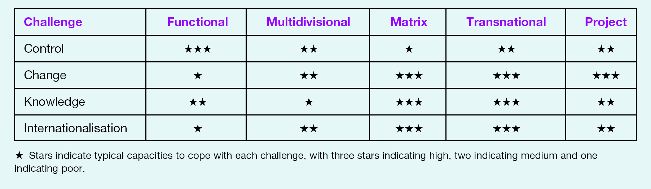
Figure: Comparison of organisational structure, Source: Saloner et.al (2018)
From the perspectives of the organisations that wish to operate in the global market place translation structure of the organisation is best for them. Because under this form of structure, several key dimensions to become successful can be achieved easily and the dimensions are knowledge gathering, proper internationalisation, control of activities and success in the international market areas (Saloner et.al 2018). On the other hand, in case of the organisations that just exist to execute specific projects both nationally and internationally there is the higher suitability of project based organisational structure. Not always these two types of organisational structure work better rather in some areas where functional structure of the organisation works better. As an example, the government organisations can be explained where divisions or functional team are accomplished and these are ready to serve the needs of the organisations.

4.0: Technological impact on the UK’s retail industry
The impact of technology in the retail industry of UK seems to be becoming heavier in the existing structure of the organisations. The effectiveness of the retail market largely depends on the ability of the retailer to reach the customers and communicate with them about their products and services (Nadimpalli, 2017). The CEO of verification Technology Company SheerID stated that the retail businesses are supposed to spend more on the teams designed to serve the customers and new technologies to understand consumer preferences and behaviour.

The UK retail market is dominated by some of the big names of retail industry such as Tesco, Sainsbury,s, Asda, Morrison’s, Marks & Spencer etc. who holds 27% of the total retail market in UK. But recently, the online retail giant, Amazon GMV has taken fifth place in the UK retail market (Stevens, 2018). Statistics show that in the year 2018, people of the UK has spent £4 on buying products from Amazon out of every £100 retail shopping. The online spending has increased from 29.6% to 33.5% in 2017 where the physical stores are losing their customers at an alarming rate (Stevens, 2018). The online stores are occupying the place of physical stores as some retail giants such as Alibaba, eBay and Amazon are becoming more popular day by day. The customers are offered home services and convenient shopping experience staying at home. So, it can be said that by utilising technological advancement and providing satisfactory service to the customers, the retail business can optimise the business return (Nadimpalli, 2017). It can be easily identified that the consumer preference is shifting to online market from the physical market in UK. Thus, technology is affecting the UK retail market quite seriously. Despite these statistics, 17% of the total sales in UK in 2016 are online according to the Office of National Statistics. But in the year 2017, the percentage became 21.4% and it is expected to rise in the forthcoming time (The Telegraph, 2018).
The global share of e-commerce stands 10% of the total market (Forbes.com, 2018). The traditional retail business is not doing well recently as some of the giant retailers has been bankrupted due to failing to keep pace with the latest technology. The retail giant Tesco suffered a huge loss of £6.33 billion in the year 2015 in the form of underwriting its assets.
Recently, they have introduced RFID, IFTTT that is supposed to allow the consumers to shop automatically, BYOD for the staffs that will allow them to know information about the availability of a certain product (Sillitoe, 2017). The head of online business of Tesco, Mr Adrian Letts stated that they are thinking of using video content, multiple images and 360-degree image to enhance the customer experience. All this action proves that the company is adopting new technologies to stay in the business. The traditional physical store retailers are trying to keep pace with the online giants such as Amazon, Alibaba etc. and Tesco has introduced `Shop and Go’ technology where customers are not required to stand on a queue to pay the bills. Only an app will do all the works for the customers. The impact of the technology has given the customer the power to choose and they have grown unforgiving when faults found. Previously, the consumers suffered from a long line in the stores that would result in leaving the store without buying. The new technology such as handheld computers and scanners ease the process of payment and etc.
The UK retail industry is facing many challenging factors and the gravest of them is changing consumer behaviour. The consumers can choose, compare, give or get feedback about a product online which they did not previously get in bricks and mortars store. High street retailers are facing a challenge due to the increase in wage. The new hourly wage rate is £7.83 that is a heavy burden for the retailers and that is why the retailers are moving forward towards an online-based platform where the physical employee does not require. Currently, Amazon has a fleet of 45000 robots working in warehouses around the world that has been a powerful alternative to employees (Retail Dive, 2017). Successful feedback experience with robots used by Amazon, it start using Artificial intelligence in retail industry.
Artificial intelligence is another tool by which retailers can save around £2 trillion worldwide. Amazon has introduced Amazon Go shop where the shoppers can pick products and just come out from the shop with automatic bill and shopping system. To face these types of technologies, the UK retailer Tesco and Sainsbury’s have taken a project to start smarter stores that contain augmented reality smart mirrors also called Holo-room (Retail Dive, 2017). The UK retailers are taking a different approach to fighting the online giant retailers and they are planning to blend online and offline shopping (The Telegraph, 2018).
Many retailers are going for the acquisition of online platforms to boost their sale online. Not all the digitalisation process eliminates employees. Sainsbury’s recently announced to build an in-house digital and technology team and it will create 480 jobs around the UK. The subsidiary of Sainsbury’s, Argos Ltd. has become a pioneer in a short period of time in the online retailing market in UK. Argos Ltd. comes second after Amazon as the most profitable online retail platform where Tesco stands fifth in the list. Sainsbury’s is going to save £500 million over three years by creating online platforms more efficient and the savings are intended to invest in the technology side in the near future (The Drum, 2015). ASDA has taken a new initiative to transform its IT application services by selecting HCL tech as its technology partner. The versatile services provided by ASDA include efficient search capacity to online customers, EPOS system in their stores, using a mobile app to connect with customers, introducing a click and collect market etc. Voice shopping technology is a recent addition to the digitalisation process of the business of ASDA. They have collaborated with Google to land this dream into reality. It can be said that the retailers of UK market are taking various initiatives to tackle down the online giants.
Innovation is a common trend in the retail business in UK market. After technology becoming a key element in the retail market, it is obvious that modern innovation will take place throughout the UK especially in the retail market. Amazon becomes successful on their first drone delivery in the UK market in 2016 (Retail Dive, 2017).
Though blockchain is considered as a recent phenomenon, it can be used widely in the business process to accurately manage the complex business transaction system. Walmart started using it first and many UK giants like Morrison’s, ASDA are planning to use this technology (Insidertrends.com, 2016). In some stores of US, virtual reality rooms have begun its journey and this technology can help the UK retailers to provide the customers with an amazing experience of shopping and choosing (The Telegraph, 2018). Marks and Spencer have signed a deal with Tata consultancy services ltd. to make the company a `digital first retailer’.
INNOVATION TIMELINE - APPENDIX
The prime focus will be improving APIs and blockchain system to provide first services to its customers. Tesco introduced click and collect programme in 2011 that will offer the customers to place online orders and have the freedom to choose collection point. eBay UK has started image recognition technology in its app where it will provide the consumer with the ability to search a particular product in their app. The heat map technology is a recent addition to the retailing sector as it can be very helpful to understand the likeliness and dislike of the customers. The heat map will track customers and provide information about their buying pattern that can be very useful to offer the perfect product for the customers. The giant retailer Tesco uses heat map technology to market their products perfectly and understanding customer pattern (Nadimpalli, 2017). According to Richard Potter, CEO of Peak, artificial intelligence can add up to £27 billion per year in the retail market of UK. This statement provides evidence that technology has a huge impact on UK market and it will continue in the future which will be supported by innovation.

The technology has a huge impact on the UK market by adding new payment trends. The age of paper money is likely to be substituted by wallet apps or the online payment method. Almost 99% of the retailers have introduced online payment system throughout the UK. New businesses have adapted online payment system from the beginning. According to the CEO of eBay UK, future retail stores will provide experience to the customers rather than just selling products and services. Target’s mobile wallet launched in 2017 was designed to make the payment procedure faster and easier.

Almost all of the giant retailers such as Tesco, Sainsbury’s, Marks & Spencer, and ASDA have their own payment app for their customers. It is expected that Amazon will introduce a voice-activated payment system by the year 2022 (Stevens, 2018). PayPal is a very popular online payment method and it is expected that by the year 2025, the UK transaction process will be taken over by online payment system like Wechat in China.
With the trend of technology occupying the retail market in UK, most of the new businesses are solely starting their businesses as online stores only. Popular fastest growing online retail stores in UK are Misguided, Farftech, Asos etc. that are running its business successfully (Trotter, 2018). Misguided is valued at £700 million in 2018 and its sale has increased by 49.7% from the year 2017. Farftech has been faced with a 70% rise in its revenue in the year 2017. The entrepreneurs of the retail industry are now concentrated more on online platform for marketing rather than physical marketing. The retail giants of UK now concentrate on online platforms rather than opening new brick-stores. To guard them against the threat of Amazon or other online retail giants, the retail market of UK should take adequate steps to keep them up-to-date with the recent innovations and technologies to ensure the surviving of the brands and business.

5.0: Technological advances impact on traditional organisational structure:
According to Arvinen-Muondoand Perkins (2013), structure is designed in such a way that the resources by the organisations are best utilized under several systems and ways. On the other hand, with the advances of technologies and application of those in the given work areas, there has been dramatic accomplishments by the organisations. Technologies change the viewpoints and the ways works are to be completed. There is a greater importance of technology on the structures by the organisations (King and Lawley 2013). For example, it can be said that when there is the greater availability of computerized operations, groups can accomplish their tasks virtually. It is not necessary that all the members of the group to be present visibly in order to accomplish a task. Not necessarily all the people to be in a single room or place to execute a meeting or to deliver an important piece of information.
Due to the impact of technology positions can be either created or lost.Once there was the requirement for several file clerks to accomplish the activities which is less common in the context of modern organisations (Sinha, 2013). Files are not transferred electronically and there are the fewer requirements for clerks to bear files. Thus, the layers of management have been shirking compared to the traditional layers of management. It is important that all the persons working in the modern organisations are technically advanced. Because the technology changes of ways the works need to be completed, there is the ongoing pressure to change the structure by the organisations to be fit in the modern workforce.

6.0: Organisational structure at the UK retail industry and impact of technology on the industry
From the analysis of the UK retail sector and organisations in this respective sector, it has been observed that several organisations follow several types of organisational structure and there is a huge impact of technology on the structures designed by those. Companies in this sector are becoming successful due to the following of technology supportive structure (King and Lawley 2013).
Firstly, the case of Tesco comes into focus that a multinational leading grocery store having headquartered at England. The organisational structure shows that it follows hierarchical structure. So as to smoother functioning of activities several layers of management are assigned to specific departmental tasks (Easterby-Smith et.al 2013). The board of directors remain top of authority and has assigned the top-level executives to be responsible for most of the activities. However, in case of the stores there are the evidences of lacking of coordination among the managers’ activities due to the four layers of management. Flow of smoother transmission of information is hampered and finally the quality of servicing has been deteriorating a lot. The innovation of technological advances and proper functioning of those seem less need of such several layers of management to conduct the operations (Sinha, 2013).

The technological advances require less layers of management in order to conduct the operational activities smoothly. Thus it can be argued that advancement of technology impacts largely on the structure currently followed by the organisation. Moreover, technology argues fewer employees to have completed the tasks smoothly at several key areas. In case of bureaucratic structure followed by Tesco, there is the requirement of more employees than the case of technology based less layer structure. Ultimately cost structure is impacted by the technology positively which urges for low cost operation. In near future, Tesco has already planned to change the current level of layers and would adopt the new technology. It will both impact services positively and reduce the costs of operation through cutting the numbers of employees.
According to Easterby-Smith et.al (2013), from the organisational structure followed by Sainsbury’s it has also shown that the organisation follows the hierarchical structure where several levels of management are held to perform the key functions of the organisation. Each level of controlled by the level next to that from the top of the organisational chart. Formula one racing car technology has been installed to smoother functioning of activities such as saving energy, time, costs and making the shoppers chill while operations are continued. The impact of technology on the structure is such that it puts pressure to accelerate the functions to the customers (King and Lawley 2013). There is the requirement of skilled employees so as to continue the operations smoothly at the organisation. In near future the organisation has planned to reduce the layers of management and taking innovative strategies in the structural designs at the organisational level.
From the analysis of organisational structure at Aldi it has been learnt that the organisation follows decentralised management system. The current structure followed by the organisation allows several regional levels of managers to take time effective strategies to meet the needs of the customers at different times. Aldi has been experiencing both advantages and disadvantages for operating under the current structure followed at several regional and city areas. For the operations in several other geographical areas such as at other and US the organisation follows a different strategy where the functions and key activities are headed by the chief executive officer at those areas. Aldi has already well known regarding the impact of technology and has installed activities especially in the areas of structural designs such as reducing the layers of management in the operational context (Hersey et.al 2017). It has benefitted both to earn operational excellences as well as reducing the burden of over employees at the organisational levels. At a flat organisational structure like followed by Aldi, accurate decisions can be easily taken as the employees engaged at different ground level activities are given the authority to take the decisions. In most the cases, it has happened that bureaucratic organisational structure requires more time to execute any decision in the key functional and cross functional areas whereas technology-based structures allow less time to execute the decisions as involvement of fewer layers of management (Saloner et.al 2018). The speed of accurate services increases the performance of the organisations.
Asda another leading supermarket in the UK follows the hierarchical organisational structure. The management is convinced that experienced and senior level managers can take accurate decisions and mangers are held as responsible for the motivation and learning of the other levels of employees at the organisation. Technology has impacted a lot on the current level of organisational structure (Sinha, 2013). Technology argues less employees being employed can earn superior operational excellences if they are properly trained and take the time to time actions important for the organisation. In the supermarket areas, almost all the activities are controlled through the efficient technology-based services where more layers of management do not create any extra value to both decision-making areas and to earn operational excellences. In case of higher layers of management at the organisational structure, communication is affected negatively and in most of the times important decisions are taken at later end which hampers growth and potentiality to sustain in these competitive market areas.
Mark and Spencer who is another big player in the retail industry of UK have been following a flat organisational structure. There are both advantages and disadvantages for operating under the structure system. Information is flown timely to the required levels of mangers quickly as there are fewer layers of management in the structure. The current structure is supportive to technology-based operations. In typical technology supportive functions, everything is controlled and monitored through the use of online and other IT enabled services.
From the analysis of UK retail industry especially in case of the structure followed by them, it has been observed that a mix type of structure is followed where most of the firms are following the hierarchical structure and others are following flat or decentralised in most of the cases. Technology has a greater impact on the current structure followed by the firms where a typical change in the structure is recommended for the firms (Easterby-Smith et.al 2013). It is easily predicted that in the near future technology will lead the business where retail sector is one of the key sectors to capitalise the advantage of technology. In this era especially in the contexts of e commerce and web 2.0 technologies, hierarchical structure has a little value as it hinders the growth for the firms and limit the learning opportunities for the employees at several key areas. Flat organisations are suggested to the next decades and firms who are responsive to the changes will become successful in the contexts of next eras. Decentralised management system allows to quick decision making with the help of technologies and skills by them (Hersey et.al 2017). Both learning opportunities and earning potentiality shall be boosted through the use of flat organisations in the next areas where decentralised management structure shall be focused.
7.0: Conclusion:
With the advancement of time and technologies, the environment for operations in several areas is changing rapidly. The contexts of old and new eras are totally different. There are so many traditional organisational structures and designs which though have a lot of appeal in several organisational may not be as effective as supposed to due to the technological advances. Several industries require several types of organisational structure. Technology argues for a flatter organisational structure where decentralised management system enhances the efficiency of the employees through continuous learning and development. In today’s world, it is possible to operate smoothly with fewer skilled employees and application of technology enabled services.

8.0: References:
Anthony, R.N., Govindarajan, V. and Dearden, J., 2017. Management control systems (Vol. 9). Boston, MA: Irwin McGraw-Hill.
Armstrong, M. and Armstrong, M. (2014). Armstrong's handbook of strategic human resource management. London: Kogan Page.
Arvinen-Muondo, R. and Perkins, S. (2013). Organizational behaviour. London: Kogan Page.
Bondarouk T, Ruël H and Looise J, Electronic HRM In Theory And Practice (Emerald 2015)
Bhaskar, A.U. & Mishra, B., 2017. Exploring relationship between learning organizations dimensions and organizational performance. International Journal of Emerging Markets, 12(3), pp.593–609.
Candyindustry.com (2017).Technology[online] Available at: https://www.candyindustry.com/topics/2667-technology [Accessed 11 Oct. 2017].
Carpenter, M. and Sanders, G. (2014). Strategic Management. Harlow: Pearson Education Limited.
Chanda A and Shen J, HRM Strategic Integration And Organizational Performance (Response Books 2018)
Chen, C. (2018). Strategic human resource practices and innovation performance: the mediating role of knowledge management capacity. Strategic Direction, 25(6).
Drucker, P. and Maciariello, J. (2017).Management. London: Collins.
Drucker, P., 2013. Management. Routledge.
Easterby-Smith, M., Thorpe, R. and Jackson, P.R., 2013. Management research. Sage.
Editorial Board. (2014). Human Resource Management Review, 24(3), p.IFC.
Farmer, M., Yellowley, W. and Smith, P. (2013).Organizational Behaviour. London: Taylor & Francis Ltd.
Gilmore, S. and Williams, S. (2017). Human resource management. Oxford: Oxford University Press.
Hayter, C. (2017). Overview of the UK population - Office for National Statistics. [online] Ons.gov.uk. Available at: https://www.ons.gov.uk/peoplepopulationandcommunity/populationandmigration/populationestimates/articles/overviewoftheukpopulation/mar2017 [Accessed 14 April. 2019].
Hersey, P., Blanchard, K.H. and Johnson, D.E., 2017. Management of organizational behavior (Vol. 9). Upper Saddle River, NJ: Prentice hall.
Ibisworld.co.uk. (2017).Chocolate& Confectionery Production in the UK Market Research | IBISWorld. [online] Available at: https://www.ibisworld.co.uk/industry-trends/market-research-reports/manufacturing/manufacture-of-food-products/chocolate-confectionery-production.html [Accessed 12 Oct. 2017].
Jeffs, C. (2015). Strategic management. Los Angeles: SAGE.
King, D. and Lawley, S. (2013). Organisational behaviour. Oxford: Oxford University Press.
Nadimpalli, M. (2017). Technology in Retail Market. International Journal of Innovative Research in Science, Engineering and Technology, 6(6).
Palmer, G. (2017). UK firms 'failing to prepare' for regulation changes after Brexit. [online] The Telegraph. Available at: http://www.telegraph.co.uk/business/2017/06/29/uk-firms-failing-prepare-regulation-changes-brexit/ [Accessed 14 Oct. 2017].
Retail Dive. (2017). 5 technologies reshaping retail in 2017. [online] Available at: https://www.retaildive.com/news/5-technologies-reshaping-retail-in-2017/433954/# [Accessed 8 May 2019].
Saloner, G., Shepard, A. and Podolny, J. (2018).Strategic management. New York, N.Y.: Wiley.
SHRM 2012-2013 Health Care Benchmarking (Society for Human Resource Management 2012)
SHRM 2015-2016 Human Capital Benchmarking
Sillitoe, B. (2017). Five ways Tesco is approaching retail technology. [online] Essential Retail. Available at: https://www.essentialretail.com/analysis/five-ways-tesco/ [Accessed 8 May 2019].
Sinha, J. (2013). Culture and organisational behaviour. New Delhi: SAGE.
Statista. (2017). UK: number of social network users 2015-2022 | Forecast. [online] Available at: https://www.statista.com/statistics/553530/predicted-number-of-social-network-users-in-the-united-kingdom-uk/ [Accessed 11 Oct. 2017].
Stevens, B. (2018). Amazon now 5th largest retailer in UK - Retail Gazette. [online] Retail Gazette. Available at: https://www.retailgazette.co.uk/blog/2018/04/amazon-now-5th-largest-retailer-uk/ [Accessed 8 May 2019].
Taylor, F.W., 2015. Scientific management.Routledge.
The Drum. (2015). Sainsbury’s creates digital lab in latest effort to keep up with consumers. [online] Available at: https://www.thedrum.com/news/2015/04/01/sainsbury-s-creates-digital-lab-latest-effort-keep-consumers [Accessed 8 May 2019].
The Telegraph. (2018). Retail in the UK. [online] Available at: https://www.telegraph.co.uk/business/tips-for-the-future/future-of-retail/ [Accessed 8 May 2019].
Trotter, C. (2018). 15 of the UK’s fastest-growing retailers - Insider Trends. [online] Insider Trends. Available at: https://www.insider-trends.com/15-of-the-uks-fastest-growing-retailers/ [Accessed 8 May 2019].
Tsui A and Lai K, Professional Practices Of Human Resource Management In Hong Kong(Hong Kong University Press 2013)

Appendix:
Figure 1
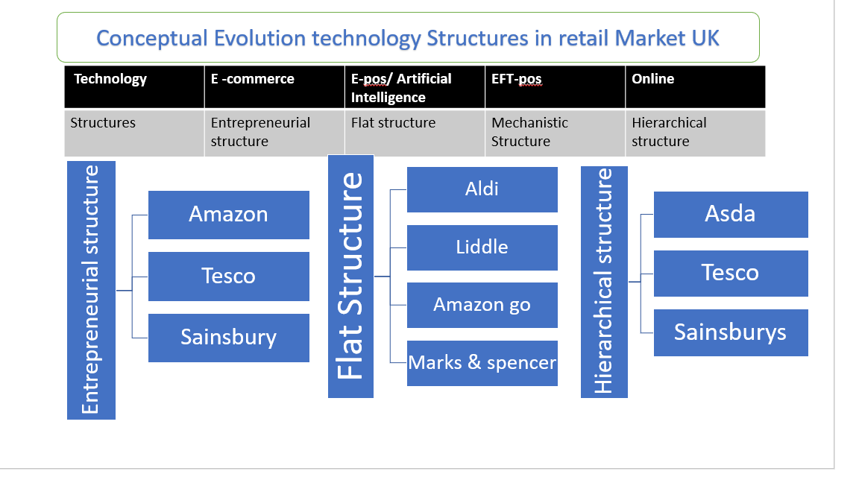
Figure 2


