Tamzyn Briggs:1803883
Surface pattern design

research in context-ADAD5003

Outline a current environmental,political,or social issue that requires redesign.Explain how you will solve this issue over the duration of your future design career.Underline the tools and approaches will you use and discuss how and why.

Word count:
Julia Lockhart

Since 1880 the global temperature has risen by 1.9℉, They are at their highest since records began. As a result of our planets increasing temperature the arctic ice is decreasing by 12.8% per decade and our sea levels are increasing by 3.3 millimetres per year.
If we limit our carbon emissions to no more than 2.9 tonnes then we can avoid the global temperature rising 2℃, if this happens then people begin to die and life on earth becomes extinct, at the rate the global warming is going now, the emissions could increase to more than 2.9 in the next 20 years, us as humans living on this planet need to do something about it, we need to prepare for the worst.

Global warming is largely a result of human activity. A major current issue is plastic pollution, it’s the accumulation of plastic object like bags and bottles. Plastic can take a long time to decompose and can leak toxic chemicals into our soil and water. It’s especially bad for our wildlife, they can get tangled in the plastic or even try and eat it. Everyday around 8 million pieces of plastic end up in our oceans, plastics make up 60-90% of all marine debris that have been studied. People are starting to do something about this , restaurants like McDonalds have started to reduce the plastic in their restaurants, they’ve started using paper straws and ice creams no longer have lids. They’re noticing the harsh reality of using so much plastic , the affect its having on our wildlife, and the slow decomposition of the plastic, just getting rid of straws and lids isn’t going to make a huge difference considering the amount of plastic pollution there is but it is definitely a start.

Human emissions and activities have caused around 100% of the global warming that has been observed since 1950 it’s a very serious issue now as humans do not take care of the earth. When we buy mobile phones, they are made by machines and machines use fossil fuels, during this process co2 is being released into the earth’s atmosphere.

Greenhouse gasses are having a major effect on global warming, such as burning oil or gas. The greenhouse effect works exactly like a greenhouse. Gases like carbon dioxide are in the earth’s atmosphere and they trap heat just like a greenhouse and that’s why they’re known as greenhouse gases. During the day the sun warms the earth’s surface as it shines through the atmosphere, at night the heat gets released back into the air but the greenhouse gasses trap heat. People must use less transport and eat less red meat if the UK is to make a big change to the greenhouse gas emissions. There are ways that we can reduce the gases in the atmosphere, plants can help balance the effect of the greenhouse gases on earth, plants absorb the carbon dioxide and they produce oxygen.
The ocean absorbs co2 but increasing the co2 in the ocean means that it will be more acidic which means the oceans water can be harmful to the creatures and also the reefs.
The effect it has on the reefs are that the warming temperatures causes coral bleaching which if its severe it kills the coral.

One of the most common issues is deforestation. This is mainly a human influence. Approximately 15.3 billion trees are cut down every year and 46% of the world’s trees have been cleared over the past 12,000 years. It happens for many reasons such as logging, agriculture and natural disasters. Deforestation is the second leading cause of global warming and it produces 24% of global greenhouse gas emissions. It releases more carbon dioxide into the atmosphere than the sum total of all the cars and trucks on the earth’s roads. A strong forest has great capacity to re generate but with a masses of deforestation will reduce species that are necessary to keep the forest regenerating, or it will just happen really slowly.

There are many ways we can help deforestation. Planting trees, us planting a tree in our garden wont make much of a difference but if people start replacing the old forest with thousands of new ones there will be hope. And there are people doing this. The African nation has started its tree planting campaign, officials say an estimate of over 350 million trees have been planted in Ethiopia within a 12 hour period.
Not buying meats that have been sourced from forest have that been cleared, encouraging people to live in a way that doesn’t hurt the environment, we are living on this earth and if we don’t do something about the global warming issue its only going to get much worse. We caused these issues and we must do something to resolve the issue.

Climate change is an existing threat. Cities, inevitably, are a big part of why it is happening. In Swansea we have a steelworks which is producing a large amount of co2 and people are concerned about their health in that area. People living in the area continue to say that black soot falls onto their homes and cars. Although it is difficult to prove that it is a cause of any health problems, welsh government statistics show that Neath port Talbot was above the welsh average for deaths and new cancer registrations, women are ranked the third highest for deaths from lung cancer. Something needs to be done about this.
Tata steel say there is no evidence that the dust is causing any long nor short term health problems.

People are protesting around the world to try and make a change to the global warming issue, luckily there are people taking this seriously.
There was a climate change protest on the 20th of September 2019 that “protesters across continents waved placards and chanted slogans” in what is said to be one of the biggest demonstrations over global warming caused by us humans.
Pacific islands such as kinbati, the Solomon islands and Vanuatu are all currently at risk of the rising sea levels and will continue to be until something big is done to change it, some posts have showed citizens shouting “ we are not sinking, we are fighting” they know that they need to change the way the working and thinking otherwise their lives are at risk.
Greenland is home to the second largest ice sheet on the planet after Antarctica.In 2012 Greenland has one of its hottest summers recorded, melting about 97% of its ice sheets, it created enough extra water that the sea levels rose over a millimetre. Studies suggest that’s only a fraction of what we should be expecting in the future.
Making small changes can really make a difference because together they can add up.
Using less energy is definitely another way that you can start to help. The road towards changing that and starting to make a difference, starting to make decisions like driving and flying less, switching to a green energy provider.

Some artists are already trying to make a change and show messages in their artwork. As artists and designers, we are more free to do and say a lot more things or I think it may be a lot easier for us to say things without being judged.

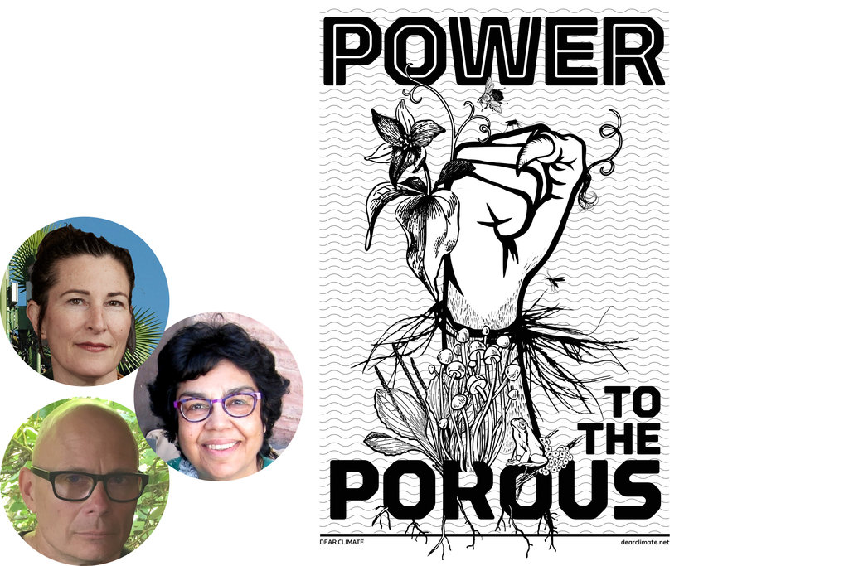

Marina Zurkow , Una Chaudhuri and Olver Kellhammer created a project called dear climate: power to the porous , with a desire to expand the social conversation about climate change, they wanted to engage people’s imaginations and feelings about the nonhuman worlds

Forman is an artist that documents climate change with pastel drawings. She travels to remote regions to collect pictures and for inspiration for her work which is shown worldwide. She has flown with NASA many times on operation iceberg over Greenland, arctic Canada and Antarctica.

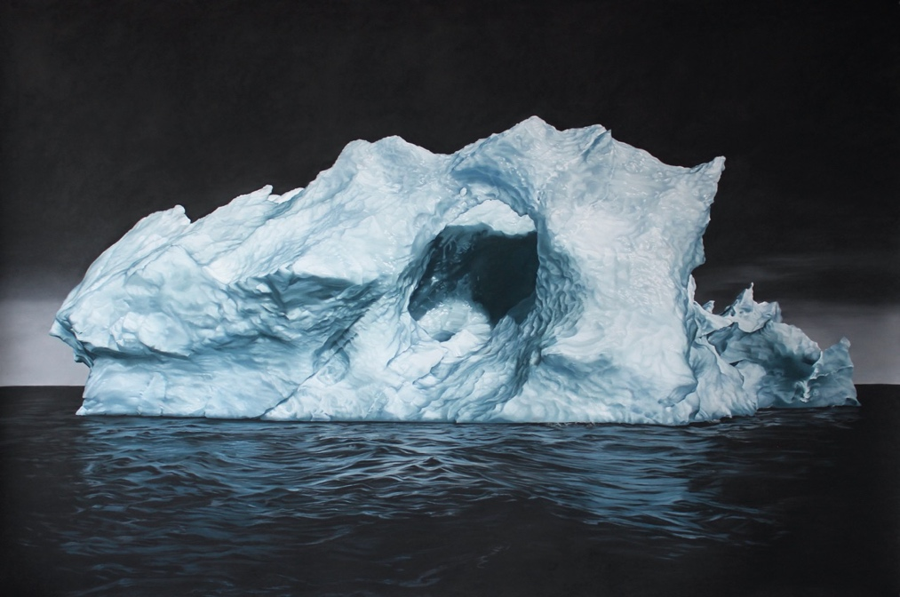

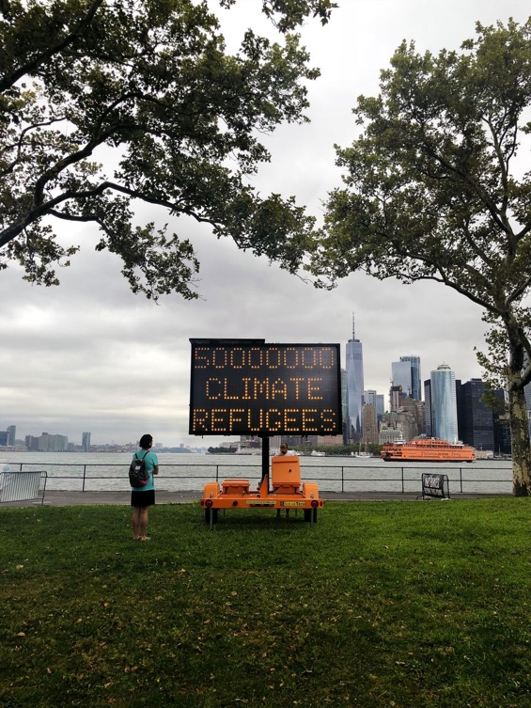
ten solar powered road signs appeared in New York city, created by artist Justin Brice Guariglia as a part of a project for the climate museum. The signs are placed in areas that are vulnerable to climate change and change to languages that are spoken in that particular city. The signs show different messaged like “climate change at work” and fossil fuelling inequality.”
It’s really amazing to see people taking action and showing the world what is happening.

As a future artist/designer, in the next 10 years of my career I would like to show people the effects of their everyday choices, and how they can really start making a difference.
If we all work together, slowly but surely, we could make a change. I think realistically not everyone cares strongly enough about the matter to do something but being able to show the impact and how the world will end up will certainly help. The way I would like to show people is by creating artwork from pieces of rubbish like plastic bottles, nets and other pieces of rubbish that I will collect from our beaches in Swansea. I feel like this would be a great start as our beaches in Swansea are amazing but there is quite a significant amount of rubbish on them. By making artwork out of the rubbish collected people will see how much rubbish is on our beaches, they will see what they are doing, maybe they will think twice about throwing litter onto the ground.
Also, by making this artwork from rubbish I have collected it will be helping out a by clearing some of the rubbish off the beaches. It’s possible to also get together a group of volunteers to try and do a beach clean-up because I think that could be really helpful, and to document it all and ask people what they feel whilst looking at the rubbish on our beaches. Hopefully in the future of my design career I would love to have the opportunity to travel to some of the worst effected countries by pollution and global warming. I personally wouldn’t say Swansea is really affected much therefore I don’t exactly know how it feels to be in a situation where you have to live everyday life in such a way. It would be great if I documented what I find, what I see and find out how the residents feel about living there and what their fears are about the future and what their hopes are.
From the images and videos, I would have taken from the different countries I would do some paintings and I would like to do an exhibition of the work and images. The exhibition would be in the UK where maybe people don’t know the major effects its having on remote countries and more poor countries. Living in a country where it’s not exactly effected badly people don’t really think much about it so being able to show them will definitely make a change to how they think and act. This is our world and we need to do something about It. We need to start getting the message out to people online across the world, it would be amazing and if we could get everyone to start cutting their carbon footprint. If I am successful enough doing these things, reaching out to businesses to join the movement would be amazing because they’re the worlds largest energy users. Changing the behaviour of companies is so important to the clean energy transition and to reduce the co2 emissions on a scale that’s needed to make a big change to the global climate change.

I really think it’s important that people start recognizing what is happening to the world and that’s why I want to show people. We need to educate younger people about what is actually going on and what us as individuals can do to help save the future of our planet. As a younger generation we need to think about how we will live in the future and how our children will have to live.
We really have to about how other people are being affected by the things we are doing , people aren’t going to know exactly how it feels unless it happens to them and where they live and if it affects their lives. But it’s something that needs to change before that happens, before it’s too late.

How do we stop a change that’s been happening from the beginning? how can we successfully make a big change to something that’s been happening for so long? Climate change is obviously a major challenge for our global society. There is doubt that climate change will improve in the next century. The climate is in a constant swirl , its constantly changing. In the future, whether it’s in 10 years or 50 years, the climate will be different to how it is now , we don’t know how it will be or even how and if we will be able to control it.
We should all individually be doing what we think is best for us and for the world , we can’t force anyone to think and act the way we do but we can certainly make them think about it.
We can clearly see that people want to do something about the issue and are trying but we need a lot to happen for the change we need, in the meantime we can be great citizens of our planet and try to reduce as much waste and pollution we can. But we must prepare for the worst and adapt.

Bibliography

Olafur Eliasson (2016). Why art has the power to change the world. [online] World Economic Forum. Available at: https://www.weforum.org/agenda/2016/01/why-art-has-the-power-to-change-the-world/.
Wikipedia Contributors (2018). Greenhouse effect. [online] Wikipedia. Available at: https://en.wikipedia.org/wiki/Greenhouse_effect.
Pachamama.org. (2017). Effects of Deforestation | The Pachamama Alliance. [online] Available at: https://www.pachamama.org/effects-of-deforestation.
Ncas.ac.uk. (2019). Why is climate important? - National Centre for Atmospheric Science. [online] Available at: https://www.ncas.ac.uk/en/why-is-climate-important#how-will-changes-in-climate-affect-our-lives.
ActionAid UK. (2019). Climate change. [online] Available at: https://www.actionaid.org.uk/about-us/what-we-do/emergencies-disasters-humanitarian-response/climate-change?src=ppc&utm_content=&gclsrc=aw.ds&gclid=CjwKCAiAxMLvBRBNEiwAKhr-nN3Q1sElOqhKc0BxpWJz5h5ak_RuZeKceSBvzPhy6tW1_2Id2ylg1RoCTxsQAvD_BwE
Australian Marine Conservation Society. (2018). What is Coral Bleaching and What Causes It - Fight For Our Reef. [online] Available at: https://www.marineconservation.org.au/coral-bleaching/.

‌

‌

‌

