2215303– Emily Evans

Inclusive education

ECIE5004 - Celebrating Language and Culture Belonging to Wales

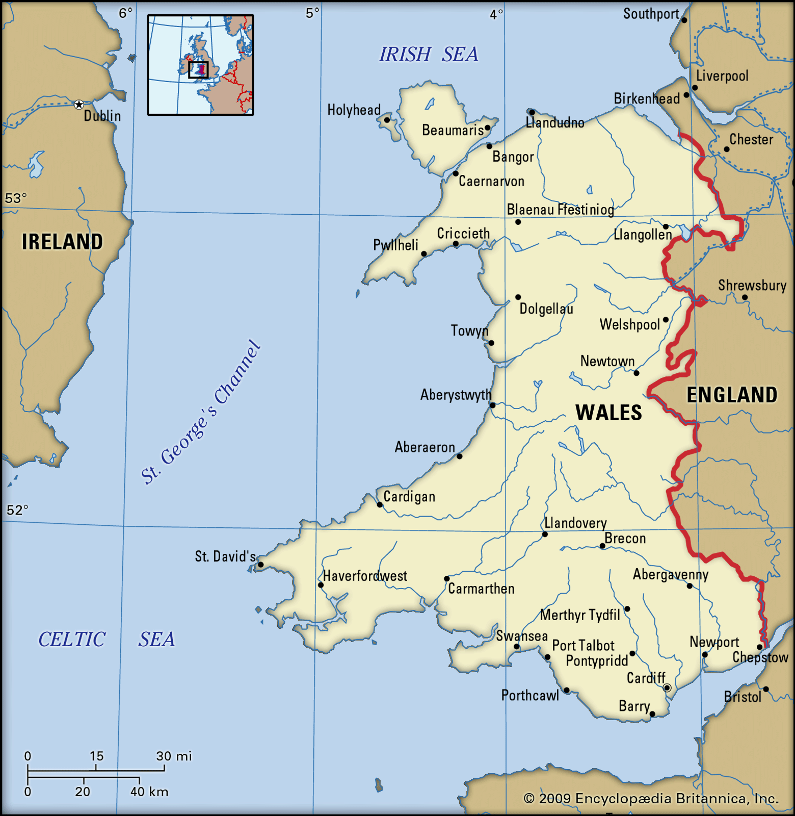

(Pyrs Gruffudd and J(enkyn) Beverley Smith, 2019)



Contents

(NW Flags, 2022)

- Rationale – pages 3-4

- Overview of activities – pages 4-6

- Evaluation – pages 6-8

- Appendices – pages 9-10

- References – pages 11-12

Rationale –
The Welsh language is among the oldest in Europe and the most ancient in Britain, having evolved for over 4,000 years (Visit Wales, n.d.). It is believed to have been formed and utilised for more than 1,400 years. Despite being perceived as a 'dying' language, local councils have made significant efforts to fund initiatives aimed at reintroducing Welsh into schools across Wales. In my local area, two new Welsh schools have been established to rekindle interest and enthusiasm for the Welsh language.
Welsh is now compulsory in all Welsh schools under the Welsh curriculum, however this has not always been the case, it became a compulsory subject for key stage 1,2 and 3 students in 1990, ‘The Welsh Language Board is a statutory organisation, funded by public money. It is a public body sponsored by the National Assembly for Wales, with the function of “promoting and facilitating the use of the Welsh language”. In 1999-00 it received £5.9 million of grant-inaid, of which over £4.4 million was distributed by the board to other organisations in the form of grants to promote and facilitate the use of the Welsh language and to support Welsh language education.’ (DG: Culture and Education).
In the past there has been attempts made to eliminate the Welsh language not just from education but from society, and this is a big factor in to why the Welsh language isn’t as commonly used anymore , for example the ‘Welsh not’ was brought into schools in Wales by the information found in ‘the blue books’ , it was a wooden block designed to be work around the neck of any Welsh child that spoke Welsh in a way to embarrass them and bring shame to them when they spoke in their native tongue, this would be worn until another child spoke Welsh and then at the end of the day the last child to be wearing the Welsh not would have to be punished, this could be anything from the cane to detentions or any punishment the teacher deemed fit. ‘It was a practice which began at a time when the Welsh language was regarded as a kind of sickness which was damaging the country. The existence of the Welsh Not was criticised in the Blue Books - an 1847 report into the state of Welsh education - as arbitrary and cruel.’ (Evans, 2022) The Welsh not was used in schools until the early 20th century(refer to appendix 1), and not only did this happen in schools but it was also made illegal to speak Welsh in court, ‘The Laws in Wales Acts 1535–1542 made speaking Welsh in court illegal (in a country at a time where most people only spoke Welsh). Welsh was not a valid form of pleading in court until the Welsh Courts Act in 1942.’ (Fisher, 2020). These are some of the events in Wales that are believed to have hindered the popularity and use of the Welsh language in Wales, however with the current push from the Welsh government to get Welsh speaking back up in Wales there has been a rise in Welsh speakers in Wales and it is believed to continue to rise, ‘As of 2024, there were estimated to be 862,700 people in Wales who could speak Welsh, or approximately 28 percent of the population.’ (Statista, n.d.) , the Welsh government has started a scheme called Cymraeg 2050, And they are hoping to reach one million Welsh speakers by 2050 in Wales (Welsh Government, 2024), (refer to appendix 2)

Overview of activities –
A key element in keeping the Welsh language alive is teaching it from a young age, in ways that are fun and engaging, starting from as early as nursery and early years, adding simple words or phrases into daily conversations and tasks , and repeating them every day is a simple way to get the Welsh language into young people’s vocabulary , without needing to use much effort, Lev Vygotsky believed that repetition is a crucial part of learning and his theory supports this strategy, as he believed repeating things daily in school is the best way to learn and keep it ingrained in the brain, he is believed to have said “through repeated experiences…children learn covertly (mentally) to plan their activities” (Vygotsky, 1978, p. 29). This is a simple but effective activity that most schools partake in without even realising it, however as students get older and more words and phrases can be brought into their vocabulary , its important to keep it engaging and interesting to them so using educational games to do this is a good way ,in a school setting I have worked in previously we have played games like ‘Welsh bingo’ ( see appendix 3).The brightly coloured and nice looking cartoon images of animals and other various items are eye catching and fun for the students to look and this will initially catch their attention, this game was often used as a reward for at the end of lessons, if satisfactory work was done , or if a few students finished their work in a fast time, this game was used as an incentive and this alone made it more appealing, B.F Skinner did not believe in using punishments in school, he believed it was more effective to use positive reinforcement for example a game as a reward or incentive, from my personal experience I believe that this is a very effective strategy and have seen first-hand from students of all ages that having a goal or a reward to look forward to often encouraged good behaviour and work being done. Welsh bingo is a simple game where the students have a board with the pictures , and the caller will read out the Welsh words, the students will have to use their knowledge to translate the Welsh word into English to know if they have the picture to match the word being called out, the more this game is played, the more words they will learn, every game they play they will have a different board of pictures so this will also broaden the amount of words they can learn, and once the game has been played quite a few times the teacher can then print off a set of new boards with completely new pictures and words , so the amount of words to be learnt is endless.
In my current setting we do ‘circle time’ daily, where we sing songs to say good morning to everyone in class, during circle time we have a section where we discuss the weather that day, and then once this has been discussed we will ask the class if anyone knows what the weather is in Welsh, I currently work in a special needs school, in a class with mostly non or limited verbal students, communication is limited however , from doing this every day, there are 3 students in the class who have picked up the Welsh terms for the weather and they are able to correctly tell you the weather in English and then in Welsh, this is something the new teacher in our class has done since September and its taken until around December time but it proves the point that repetition is very useful way of learning a new language even if it may take longer, its information that is sticking.
Activities on a larger scale in schools include an eisteddfod, this is a day dedicated to celebrating the Welsh culture and Welsh language in school, different activities are done over the day and they usually have about of a month of preparation and build up to prepare competition entries for the eisteddfod, there’s activities like Welsh poetry competitions, Welsh dancing, art competitions of Welsh scenery, making traditional Welsh food, singing Welsh songs, and even drama sequences, and it’s a day to celebrate all the great work and hard efforts the students have made in the Welsh department that year, it’s a great day for bringing a patriotic feeling to school, on this day staff and pupils are encouraged to wear the traditional Welsh clothing, rugby shirts, or any Welsh clothing they own, daffodils and leeks are also symbols of Wales that are commonly worn on this day, the eisteddfods are typically held in the spring time in schools, and also on St Davids day on march the 1st it is encouraged for pupils and staff to wear these Welsh costumes and symbols. There are eisteddfods celebrated on even larger scales all over Wales including the Urdd national eisteddfod, it’s one of the largest youth festivals in Europe and the national eisteddfod of Wales. (see appendix 4). Celebrating eisteddfod is a brilliant way to celebrate the history of Wales and encourages the patriotism, ‘The National Eisteddfod of Wales dates back to 1176 when it is said that the first Eisteddfod was held. Lord Rhys invited poets and musicians from all over Wales to a grand gathering at his castle in Cardigan.’ (Johnson, n.d.).
Evaluation –
The activities used daily in the classroom, such as using basic phrases or words and adding them into the daily tasks, is an easy way of pushing Welsh language into schools, and praising this will help encourage students to use it daily, this is a easy and simple way of learning new words and keeping the Welsh language alive in school, it can start with feelings, colours, the days of the week etc and build up to longer phrases like the day of the week and what the weather is like outside on that day, and repeating these activities will help ensure that It becomes a frequent part of their daily vocabulary, something as simple as this is great as it doesn’t add too much pressure onto the students and it still remains light hearted and fun, encouraging these phrases to be used at home also will help them to stick in their vocabulary. Similarly, to the previous statement, the activity of playing games to incorporate Welsh language into schools, is fun and light-hearted and using incentives is a good way to encourage work or good behaviour in school.
Eisteddfod’s in school is a brilliant way to encourage the use of not only the Welsh language but it encourages the Welsh culture, it celebrates Wales and everything about it, the traditions, the history and the culture, it promotes creativity, education about Wales and brings the school together for one big project, where everyone can see the end result of what they’ve worked hard on, every year teachers from different departments will set their pupils with a task to complete that they can bring forward to the eisteddfod and showcase their work. For example the art department could set their class an art task , to paint a picture of an iconic Welsh scenery, the drama department could set the task of a group of students reciting a drama sequence of an old Welsh legend, the English department could set the task of writing a sonnet or poem and PE could do a dance routine, all of these tasks could be set around a month or two in advance, the students would have time to discuss, plan and execute a few attempts and drafts of their work before showcasing their final product and then displaying it for it to be judged and then there are winners in every department , and key stage/ year group, this will teach students about working hard towards something and being proud to showcase it, and even if they don’t win, they worked hard on something from start to finish and presented it, it would be down to the department to ensure that the medium of Welsh would be incorporated throughout all of these activities , for example the poem from the English department could be spoken in English and then spoken again but translated into Welsh, the dance routine could be done to a Welsh song and the drama sequence spoken in Welsh, the eisteddfod is a fun and positive way to really delve into the Welsh culture and teach students about where they came from, or if pupils aren’t Welsh it really helps the student to learn about where they now live, not only for students but for teachers too.
The goal for the Welsh government to ensure there will be at least 1 million Welsh speakers by 2050 is ambitious but by partaking in activities such as these daily in schools or yearly, its not impossible, as the government isn’t hoping for one million people to be fluent in Welsh but just hoping that they will be able to understand greetings, phrases and basic Welsh, and starting from as early as nursery is a crucial way to make sure it will be ingrained into the future of Wales whilst they’re in their most influential years, there are many other schemes that the Welsh government have worked on , the Welsh in education strategic plans (WESPs) being one of them , their goal is also to get Welsh speaking more encouraged across all schools, there’s also charities across Wales that promote the preservation of Welsh language including Cymdeithas yr Iaith, who work tirelessly to promote and encourage Welsh speaking across Wales. (refer to appendix 5).
Overall, I believe that all of these activities are really valuable tools to use in the school setting to promote the Welsh language, although all are not perfect, and the daily phrases and games might become predictable and boring for some students, and some students aren’t encouraged by incentives or rewards, its not a one shoe fits all activities, and the eisteddfod, if a student has confidence issues, attendance problems , they might miss out on the planning of the activities and not feel like they’re confident to contribute so again, what might work for one student may not always work for all students.
Appendix 1 –
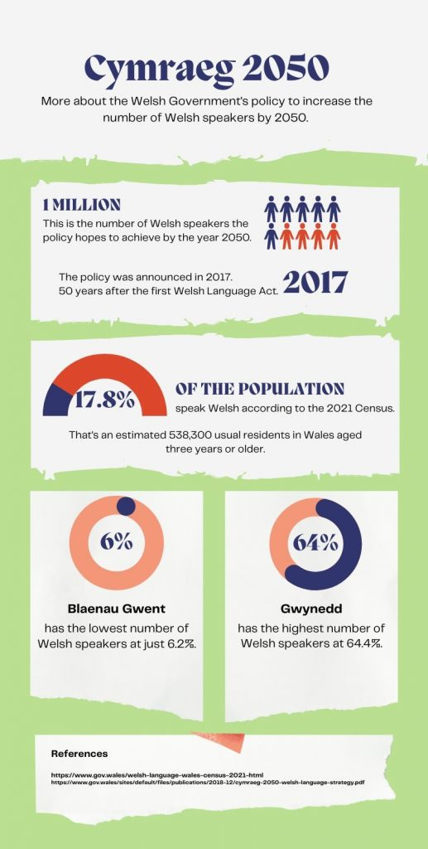
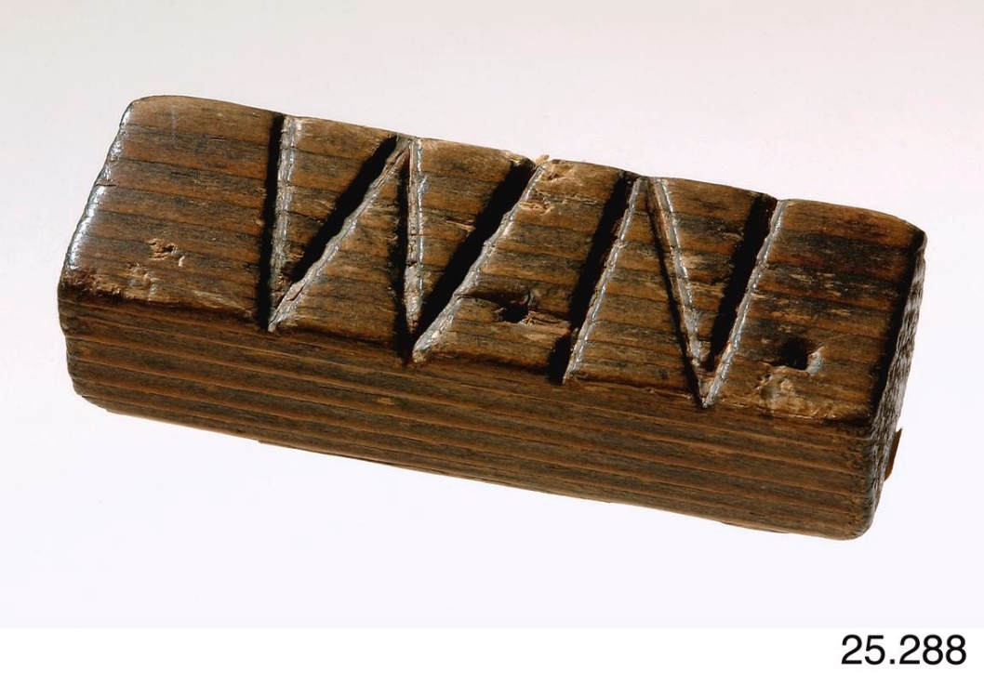
(Janes, 2023)
Appendix 2-
(National Museum Wales, n.d.)
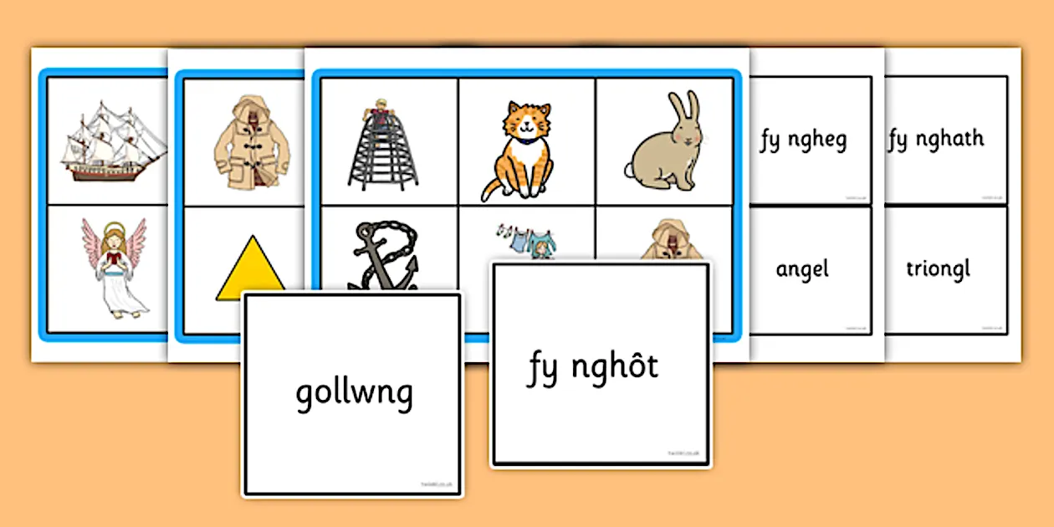
Appendix 3 –


(Swyddle.cymru, 2025)
Appendix 5 -
(Twinkl.co.uk, 2025)
(Swansea.ac.uk, 2024)
Appendix 4 -

Evans, M. (2022). Cruel history of the Welsh Not which tried to stop kids speaking their language. [online] North Wales Live. Available at: https://www.dailypost.co.uk/news/north-wales-news/cruel-history-welsh-not-tried-24916977.

Fisher, M. (2020). Understanding Welsh Language Laws. [online] Golley Slater. Available at: https://www.golleyslater.com/curiosityhub/understanding-welsh-language-laws/.

https://linguae-celticae.de/dateien/Welsh_in_Education.pdf

Janes, E. (2023). Cymraeg 2050: what role do adult learners have to play in preserving Welsh - Life360. [online] Life360. Available at: https://cardiffjournalism.co.uk/life360/cymraeg-2050-what-role-do-adult-learners-have-to-play-in-preserving-welsh/

Johnson, B. (n.d.). The National Eisteddfod of Wales. [online] Historic UK. Available at: https://www.historic-uk.com/HistoryUK/HistoryofWales/The-National-Eisteddfod-of-Wales/.

National Museum Wales. (n.d.). Welsh not. [online] Available at: https://museum.wales/collections/online/object/7ea8f0b9-6293-3c66-b56a-a85b7181e7af/Welsh-not/.

NW Flags. (2022). Wales 5ft x 3ft Flag. [online] Available at: https://www.nwflags.co.uk/wales-5ft-x-3ft-flag-968-p.asp

Pyrs Gruffudd and J(enkyn) Beverley Smith (2019). Wales | History, Geography, Facts, & Points of Interest. In: Encyclopædia Britannica. [online] Available at: https://www.britannica.com/place/Wales.

Statista. (n.d.). Welsh language speakers 2023. [online] Available at: https://www.statista.com/statistics/383043/welsh-language-speakers/.
Principles of Learning. (2011). Repetition. [online] Available at: https://principlesoflearning.wordpress.com/dissertation/chapter-4-results/themes-identified/repetition/.

Swansea.ac.uk. (2024). National Eisteddfod of Wales - Swansea University. [online] Available at: https://www.swansea.ac.uk/academi-hywel-teifi/celebrate/events/national-eisteddfod/

Swyddle.cymru. (2025). Cymdeithas yr Iaith. [online] Available at: https://www.swyddle.cymru/clients/view/5e6f8f7b2ac00?lang=english

Twinkl.co.uk. (2025). Available at: https://www.twinkl.co.uk/resource/wl-l-009-welsh-ng-bingo-game

VisitWales. (n.d.). The history of the Welsh language. [online] Available at: https://www.visitwales.com/info/language/poetry-motion-discover-language-wales.

