Assignment 2
L5 - Network Operating Systems and Services (ACCA5023)
Jon Morgan - 2218940
2025
Contents
Introduction 3
Task 1: Technical Report and Demonstration (1500-word limit) 3
Swansea Network 3
Cardiff Network 3
Test the network for Connectivity. 4
Sharing Disk Drive 4
Configure IIS Server 4
Remote Desktop Services 4
Note on networks and addressing 4
Networks 4
Nodes 4
Swansea Network 5
Installation of Active Directory Domain Services 5
Create appropriate A records in DNS for all servers 7
Create a Reverse-Lookup Zone and records for all servers 8
Installation of Routing & Remote Access Services 8
Updating Firewall Settings to allow ICMP 9
Configuring a Persistent Site-to-Site VPN to Cardiff LAN 10
Create domain User accounts from CSV source 14
Mount Second Disk 16
DHCP – Previously configured in assignment 1 but needs reconfiguration 17
Join client machine “ClientS1” to the active directory domain network 19
Update Firewall settings on ClientS1 to allow ICMP 20
Cardiff Network 21
Installing RRAS equivalent on Ubuntu Server – StrongSwan and xL2TPd 21
Configuring a Persistent Site-to-Site VPN to Swansea LAN 23
Create a child domain or join devices to Jon.acca - Justify 25
Reconfigure DHCP on Ubuntu server for Cardiff network clients 26
Test the networks for connectivity 27
Sharing the Disk Drive 28
Configure IIS Server 34
Remote Desktop Services 40
Installing Remote Desktop Services 40

Introduction
This document is my submission for the second assignment as given in L5 - Network Operating Systems and Services (ACCA5023). This document aims to convey the appropriate responses to the following tasks:

Task 1: Technical Report and Demonstration (1500-word limit)
- Complete the task below and Submit the Screenshots for each task as a Report.
- Demonstration: In-Person (One-to-One) – 100 Marks Maximum
- Submit the outcomes via Moodle
  - The task completion will be tested by executing scripts by the Marker during the scheduled time.
  - The screenshots of the executed scripts need to be submitted in Moodle during the demo.

Swansea Network
- Install Routing and Remote access Service and modify firewall rules to allow ICMP Traffic.
- Configure Site-to-Site VPN to London Network. Set the connection type to “persistent connection”.
- Create a forest named yourname.acca (For example: nitheesh.acca)
- Create all appropriate A records for all servers on 10.1.1.0/24 and 172.16.1.0/24.
- Create a reverse lookup zone creating PTR records for all servers.
- Create user accounts for yourname.acca domain with all the parameters defined in the users_list_updated.xlsx document. This document will be shared by your lecturer. You must use first letter from first name with a dot and last name as SAM Account Name. Eg: First Name: Nitheesh Last Name: Kaliyamurthy. → n.kaliyamurthy.
- Mount second disk drive to D:\SwanseaFiles.
- Configure DHCP Services. The range is 172.16.1.10 – 172.16.1.20. Determine other DHCP options as per the infrastructure.
- Join the ClientS1 to yourname.acca domain.
- Assign ClientS1 with DHCP IP Address.

Cardiff Network
- Install Routing and Remote access Service (equivalent) and modify firewall rules to allow ICMP Traffic.
- Configure Site-to-Site VPN to Swansea Network. Set the connection type to “persistent connection”.
- Create a child domain named car.yourname.acca in yourname.acca tree (Eg: car.nitheesh.acca) or Join devices in this network to the yourname.acca domain. Justify your action.
- Configure DHCP Services. The range is 10.1.1.10 – 10.1.1.20. Determine other DHCP options as per the infrastructure.
- Depending on step no. 2.3, join the ClientC1 to appropriate domain and assign DHCP IP address.

Test the network for Connectivity.
Note that at this stage, the Swansea and Cardiff networks are connected and fully operational. If not, Troubleshoot.

Sharing Disk Drive
To the earlier created D:\SwanseaFiles, set access permissions to allow users in the users_list_updated.xlsx has full control permissions and other network users have only read access. Share the drive to both Cardiff and Swansea network. - DONE

Configure IIS Server
- Create https://webs. yourname.acca website and enable windows internal authentication.
- All the users can be authenticated.
- All authenticated users should be presented a text “Welcome to Swansea Website”.

Remote Desktop Services
Configure remote access for S-DC from any other machines in the network. Make sure that the Remote Desktop Services login page should be accessed via https://rds.yourname.acca and necessary certificates are signed.

Note on networks and addressing
This assignment builds on the previous work from assignment 1. In that assignment, we were encouraged to build our own network addressing scheme if we so wished, so my networks and IP addressing scheme will not exactly match the above ‘tasks’ that prescribe them specifically.

Here is my addressing scheme, for reference:

Networks
Description | Hosts Required | Net ID / Mask Length | Subnet size | 1st Usable IP | Last Usable IP
Swansea LAN | 32 | 192.168.1.0/26 | 64 | 192.168.1.1 | 192.168.1.62
Cardiff LAN | 19 | 192.168.1.64/27 | 32 | 192.168.1.65 | 192.168.1.94
INTER LAN | 2 | 192.168.1.96/30 | 4 | 192.168.1.97 | 192.168.1.98

Nodes
Device | Interface | IP Address | Subnet Mask
S-DC | S LAN NIC | 192.168.1.1 | 255.255.255.192
S-DC | INTER LAN NIC | 192.168.1.97 | 255.255.255.252
ClientS1 | S LAN NIC | DHCP | DHCP
C-Server | C LAN NIC | 192.168.1.65 | 255.255.255.224
C-Server | INTER LAN NIC | 192.168.1.98 | 255.255.255.252
ClientC1 | C LAN NIC | DHCP | DHCP

Swansea Network

Installation of Active Directory Domain Services
Domain named as “jon.acca”.
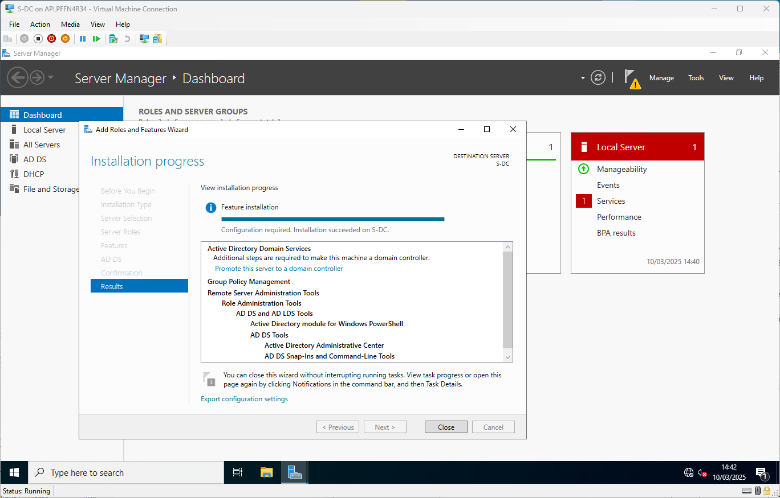
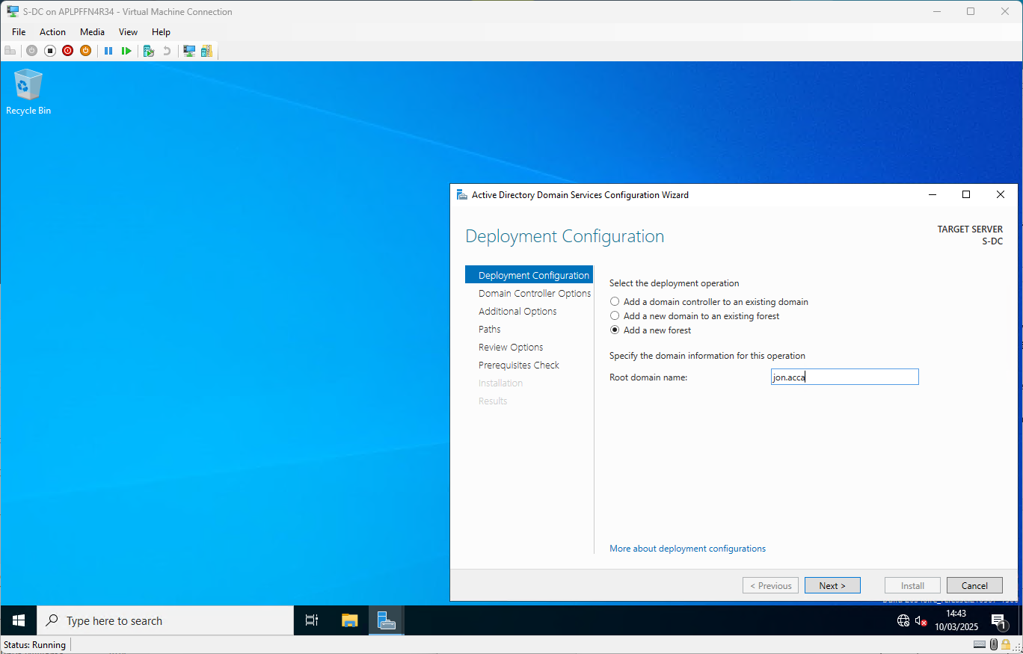
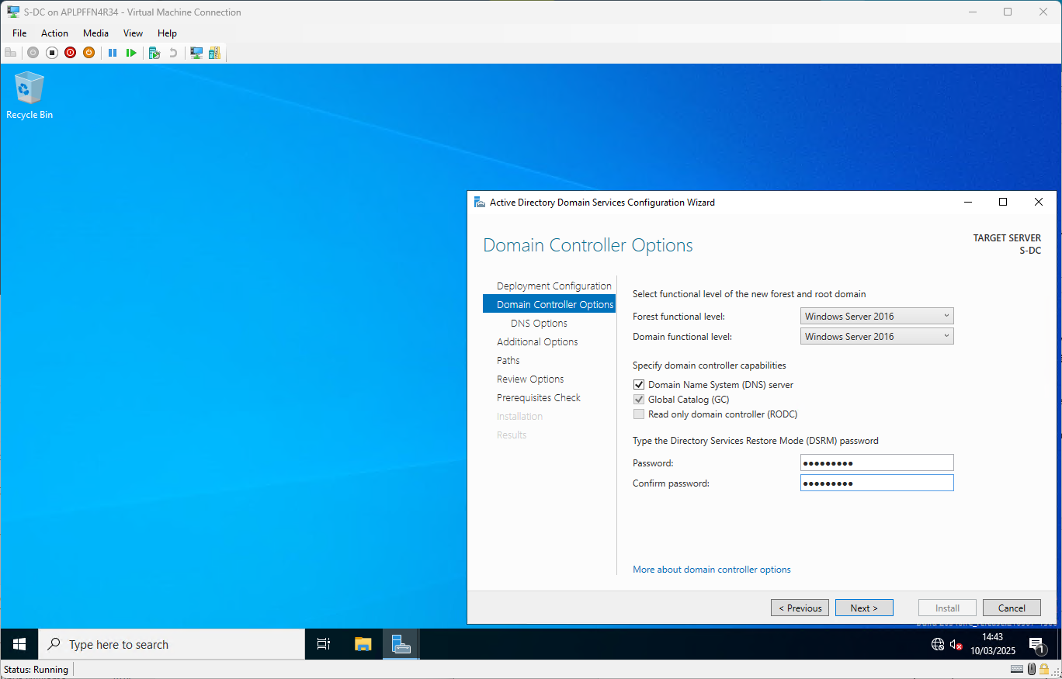
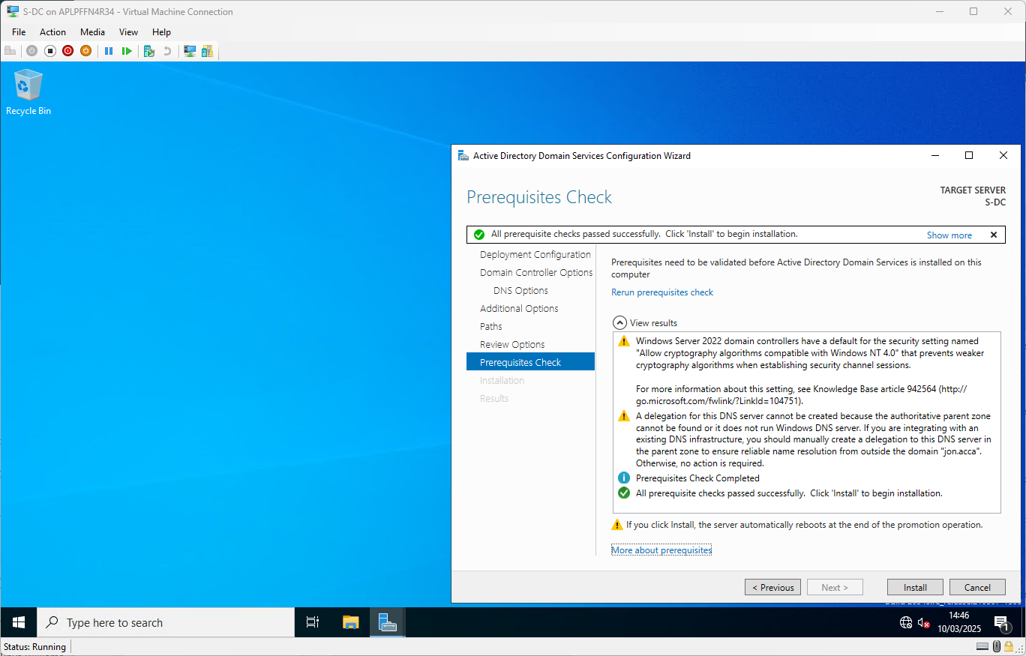
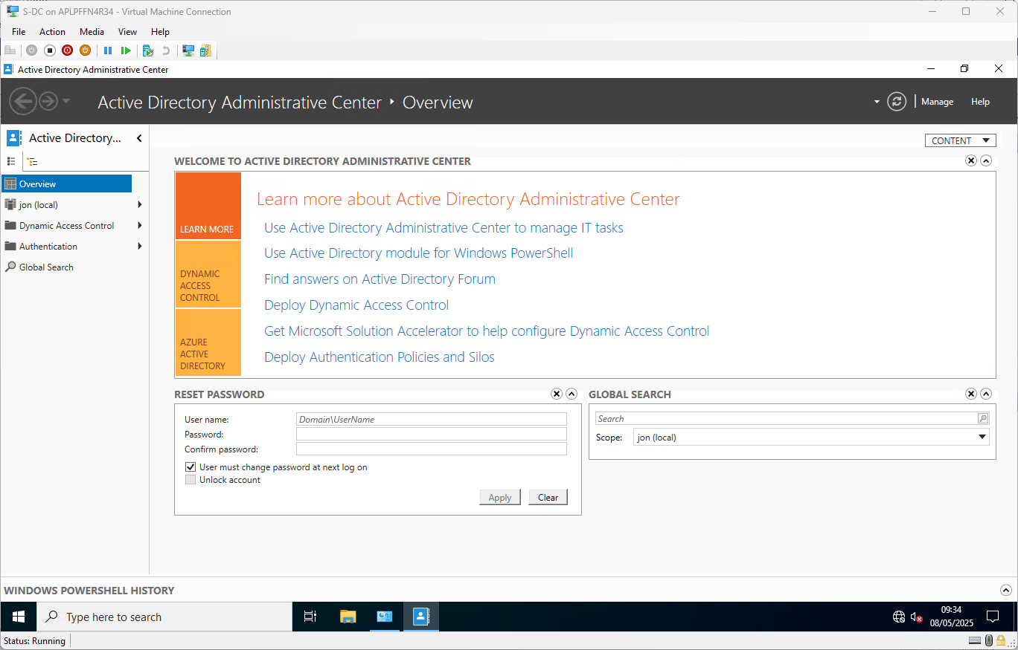

Create appropriate A records in DNS for all servers
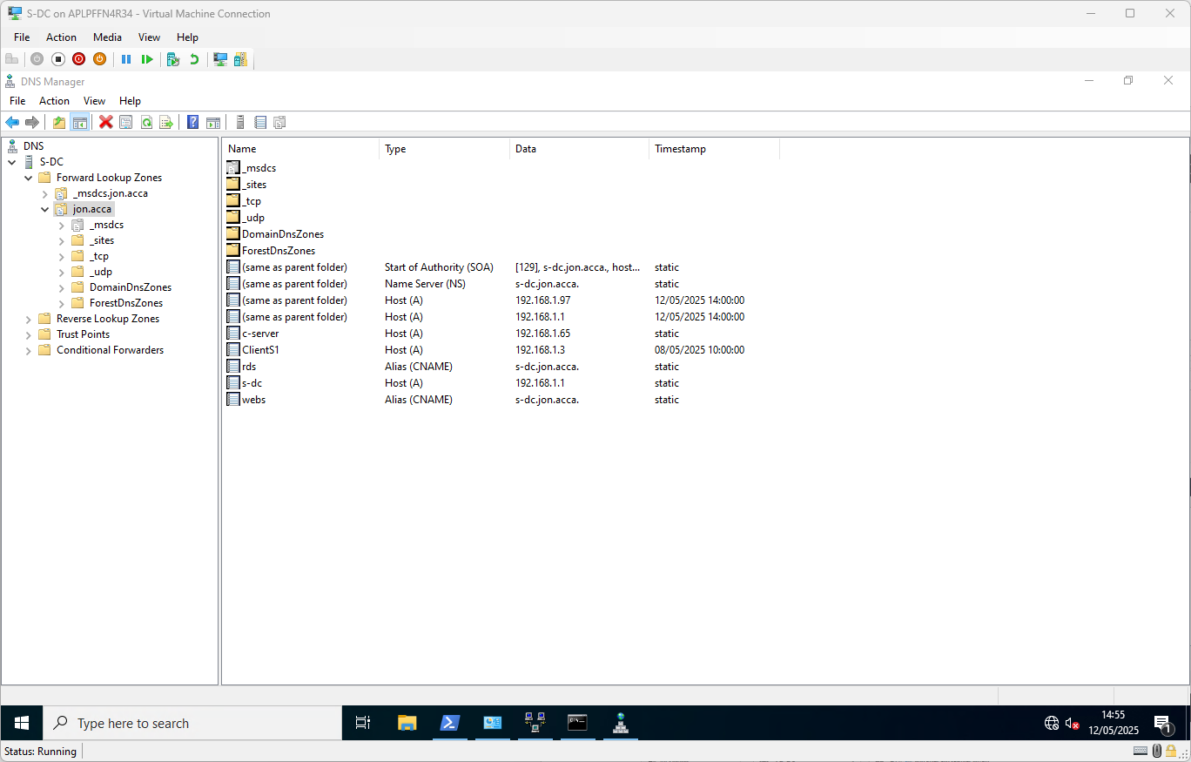

Create a Reverse-Lookup Zone and records for all servers
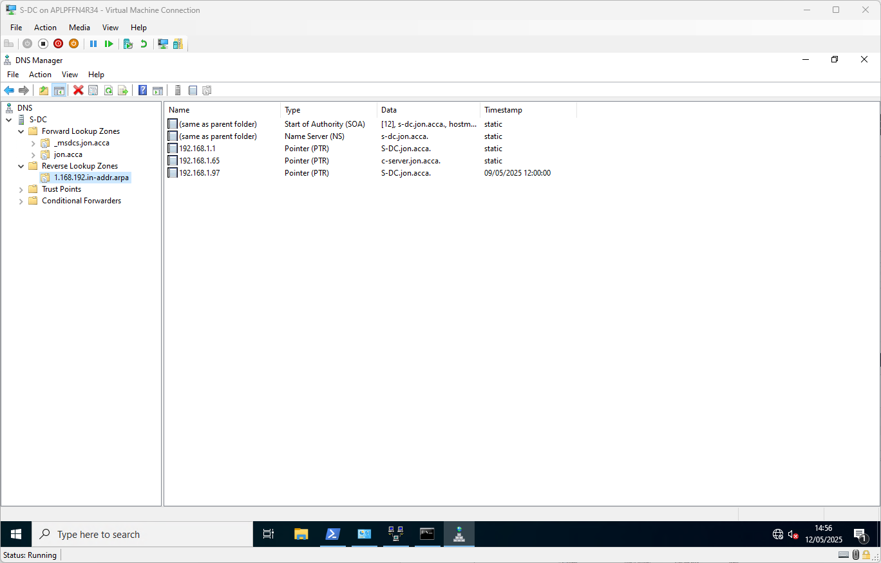

Installation of Routing & Remote Access Services
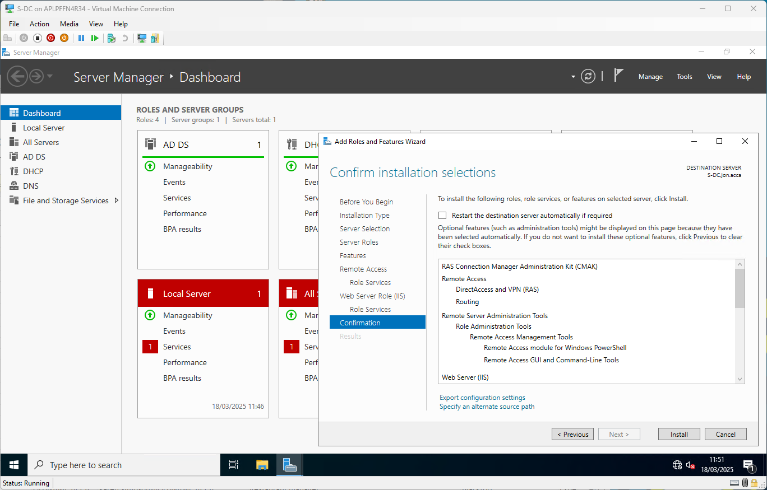
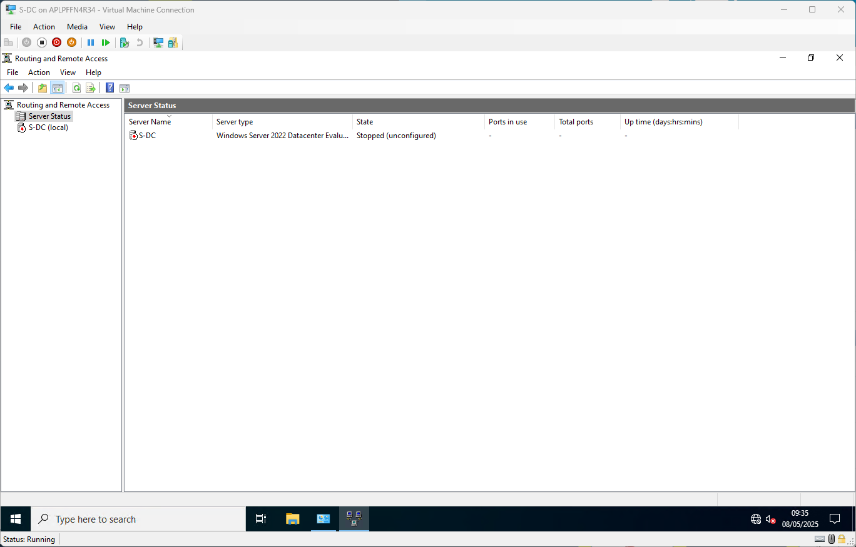

Updating Firewall Settings to allow ICMP
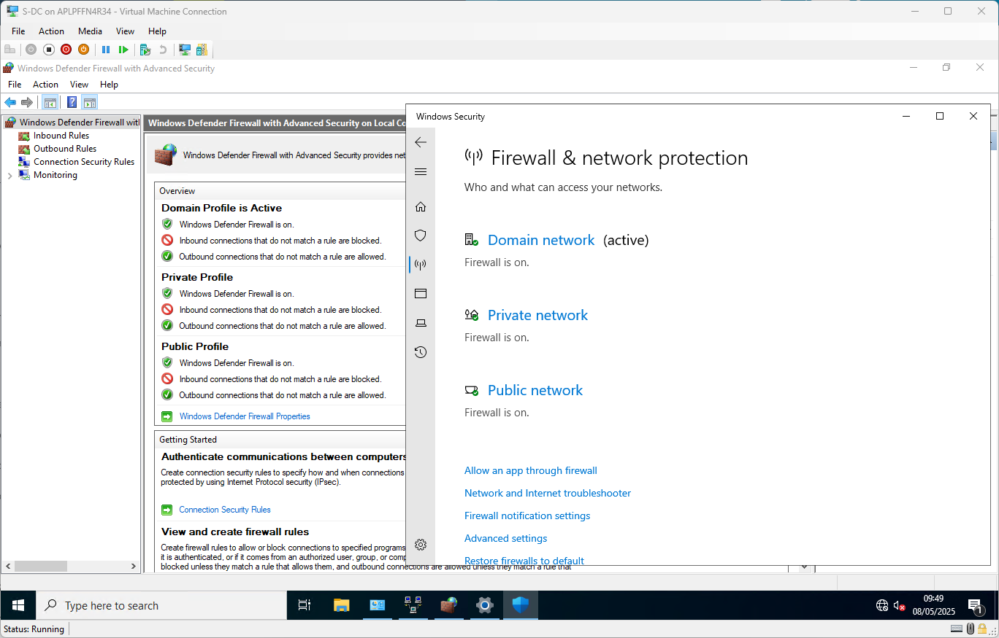
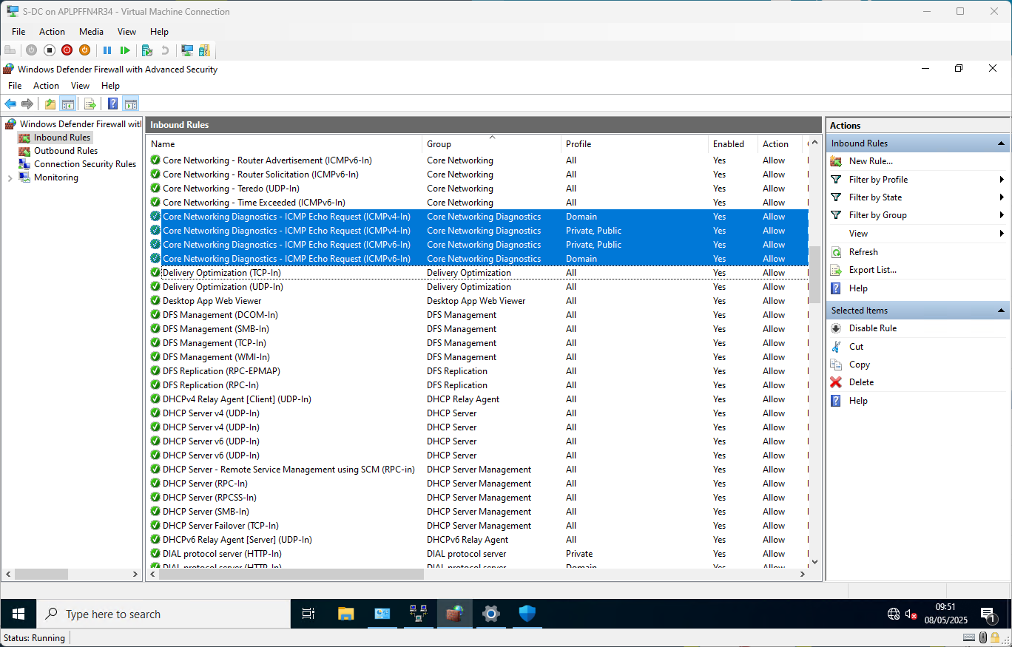

Configuring a Persistent Site-to-Site VPN to Cardiff LAN
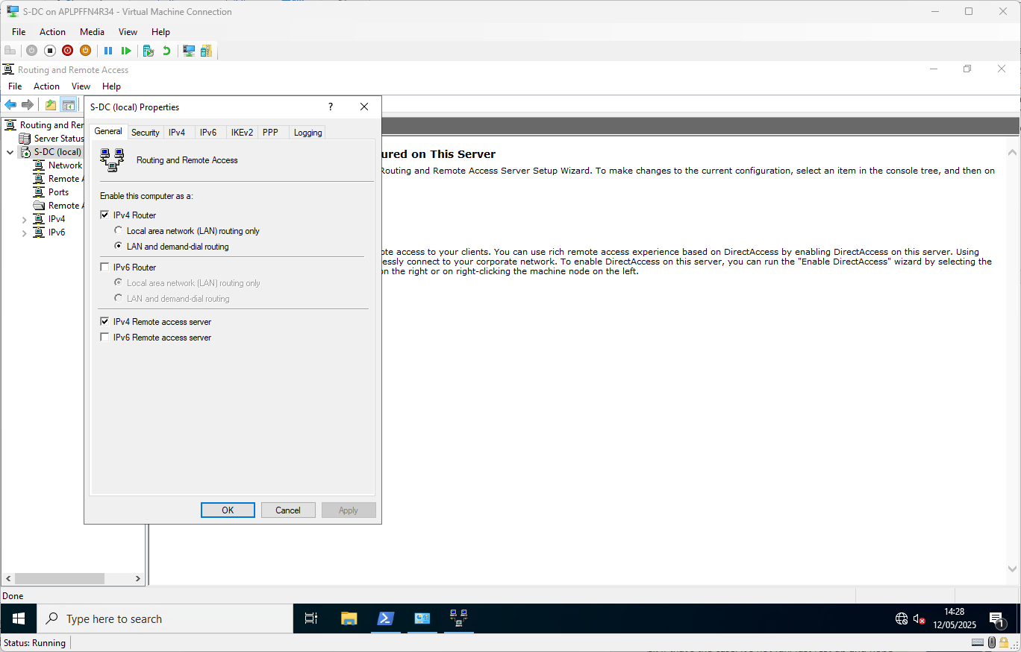
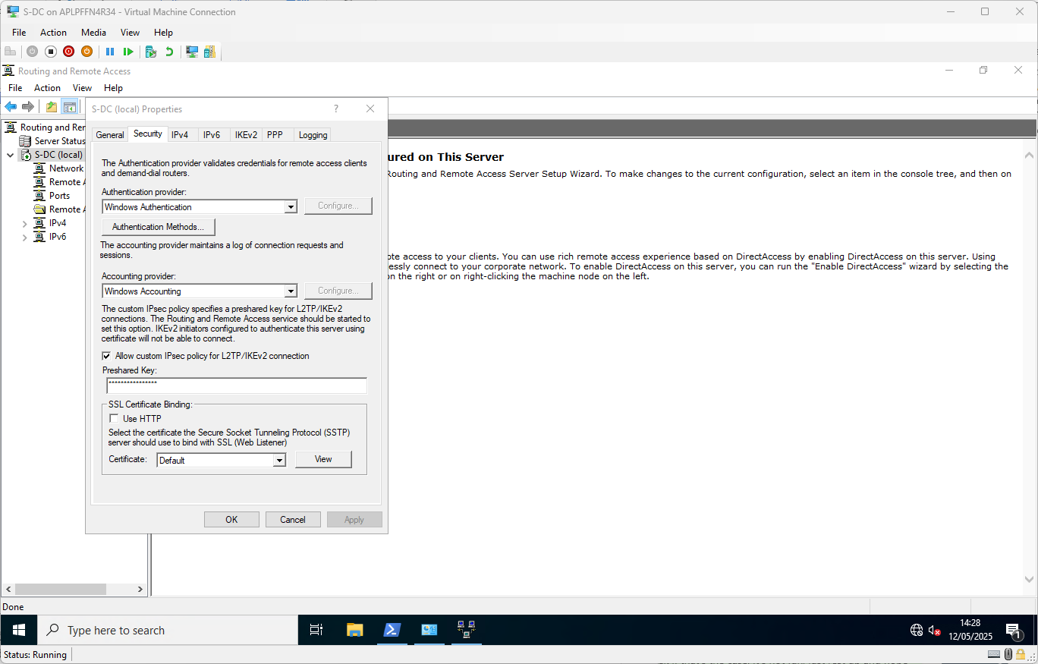
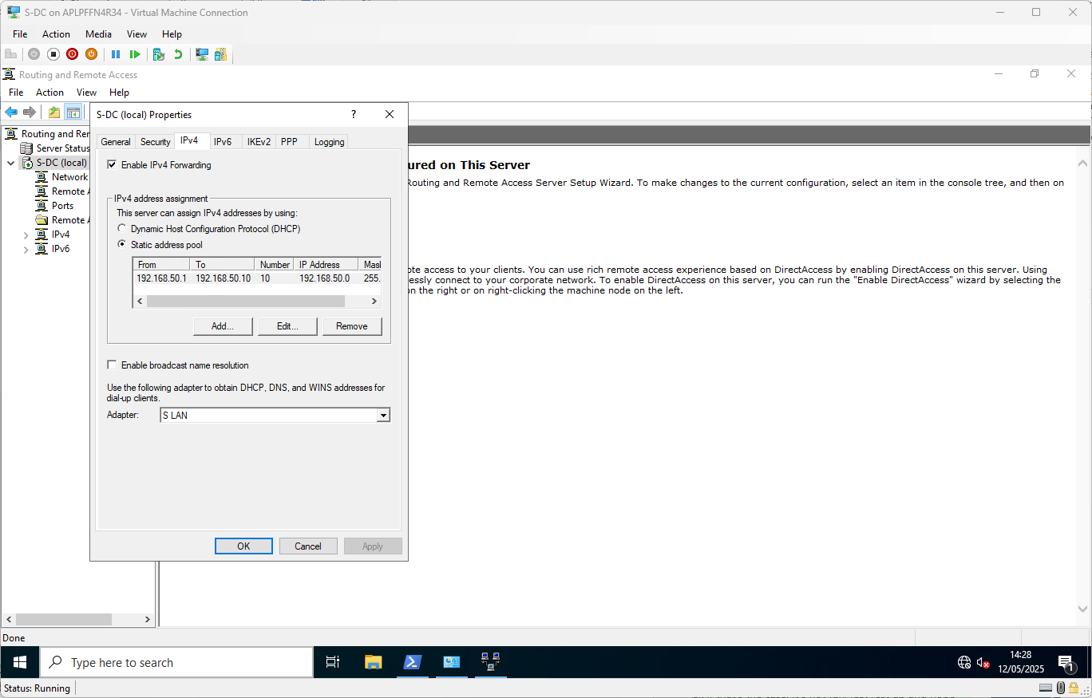
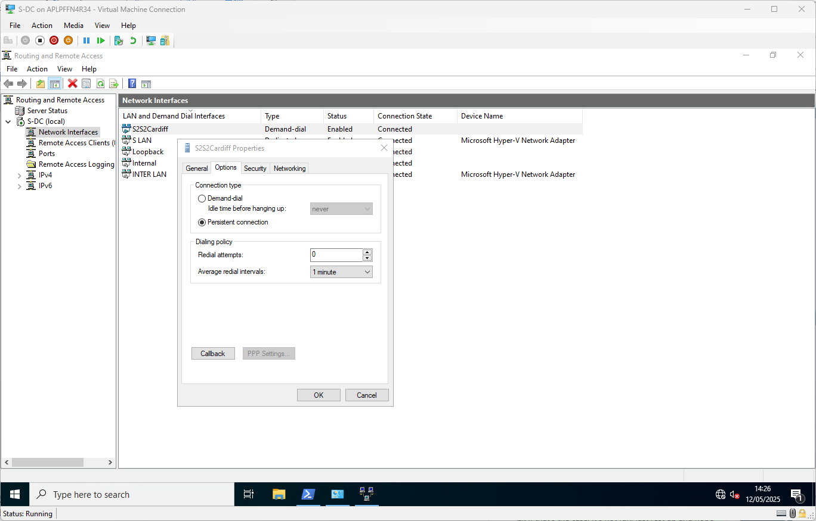
A ‘Persistent’ connection.
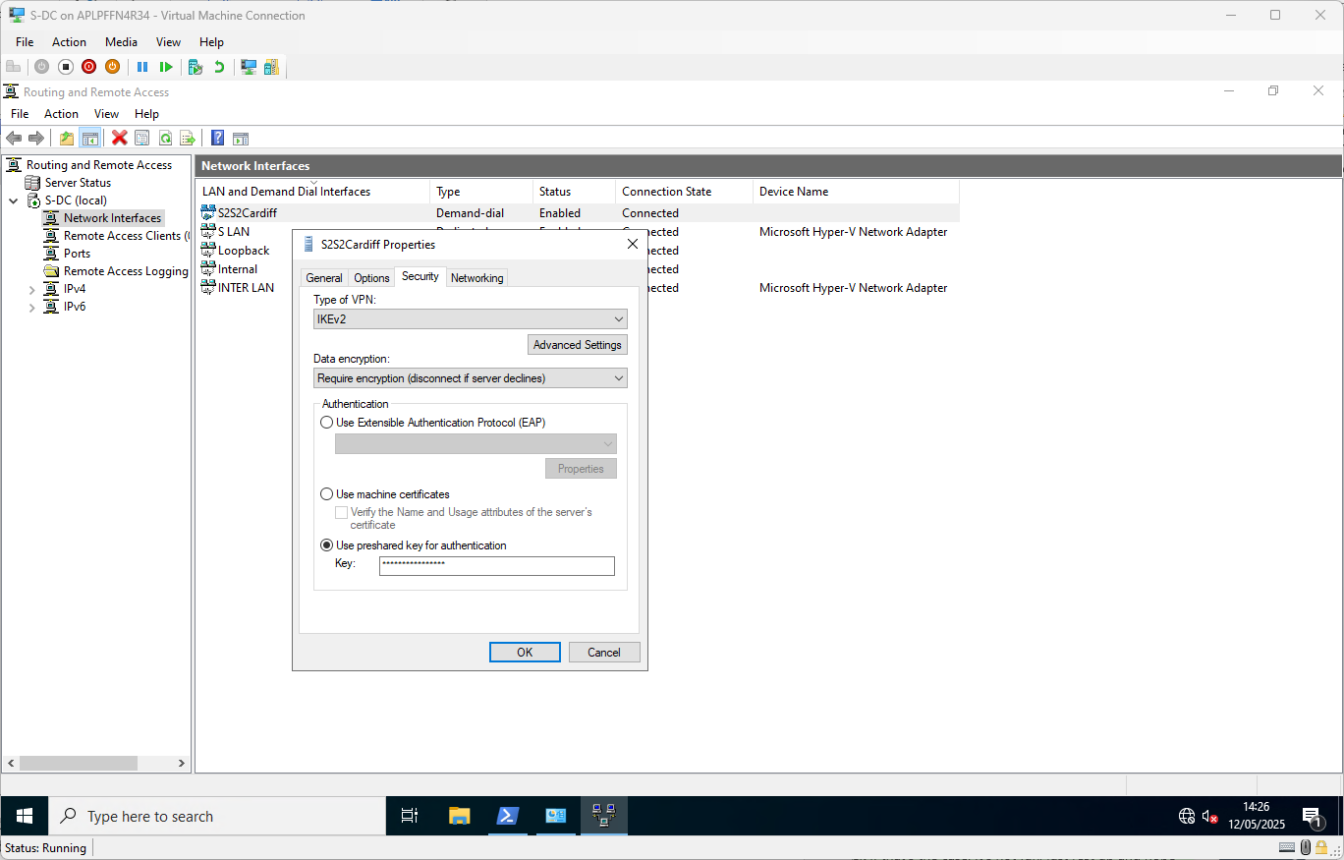
Using a ‘Pre-Shared Key’
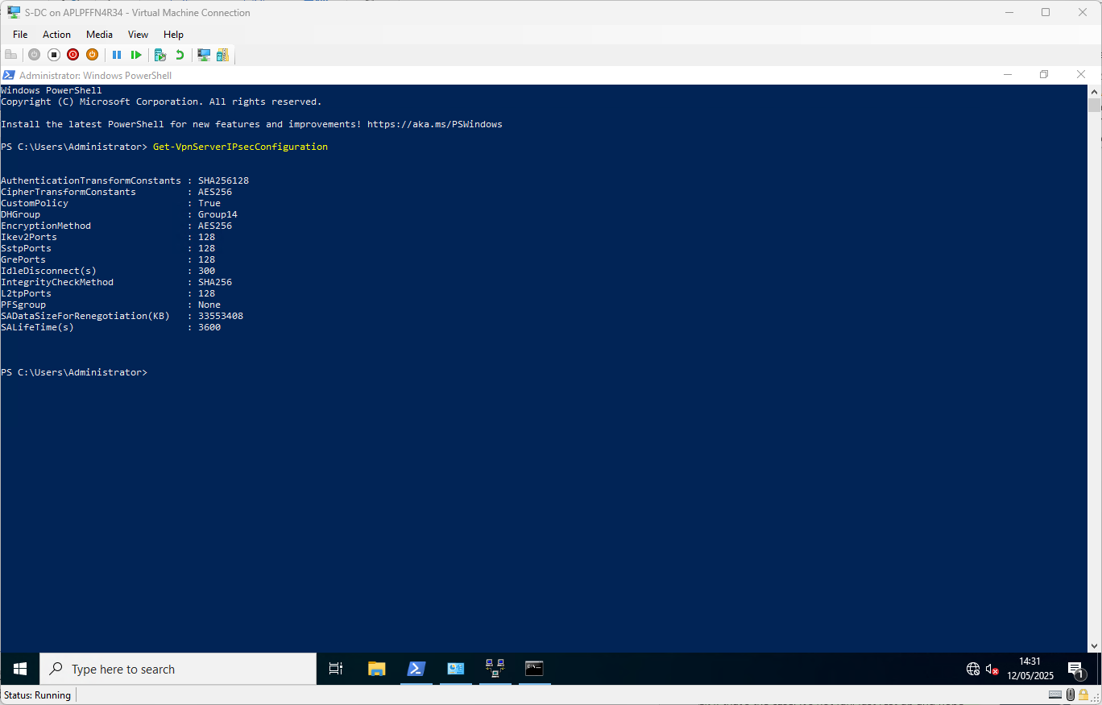
Showing the custom IPsec policy settings applied to strengthen the VPN security – these need to be matched on the Cardiff Server.

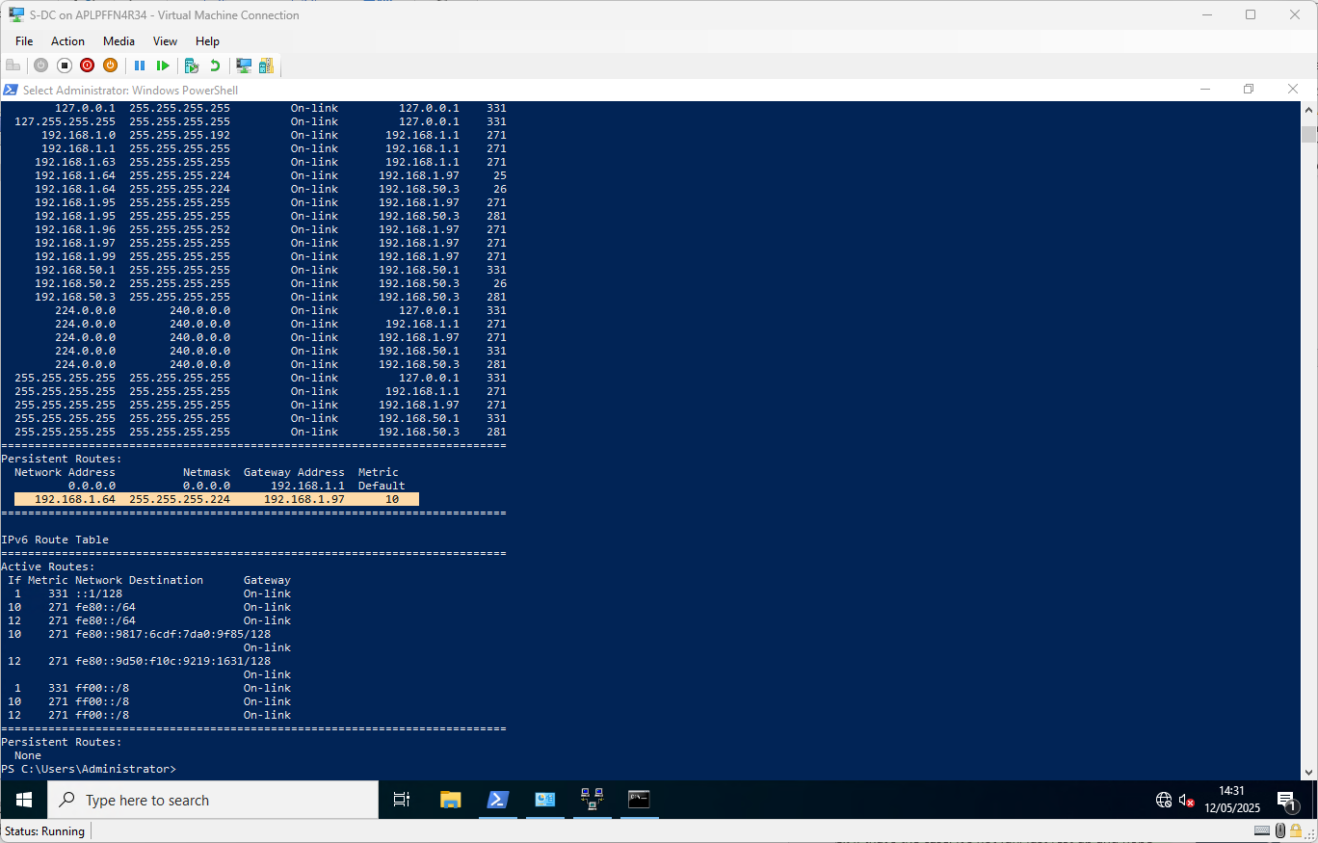Showing the addition of a persistent route addition

Create domain User accounts from CSV source
A CSV file has been supplied, here’s a sample of the contents:
first_name,last_name,company,domain,email,job,city,department
Brian,White,"Jones, Miller and Collins",JON.ACCA,brian.white@JON.ACCA,Private music teacher,Townsendborough,Managers
Luis,Terry,"Lopez, Castro and Nelson",OLDNAME.ACCA,luis.terry@OLDNAME.ACCA,Agricultural engineer,Staffordmouth,Competitors
Susan,Jackson,Sanchez-Powers,JON.ACCA,susan.jackson@JON.ACCA,Water quality scientist,South Ashleyfurt,Experts
Sherri,Carney,"Thomas, Davis and Perry",JON.ACCA,sherri.carney@JON.ACCA,Maintenance engineer,Lake Bradley,Competitors

Originally, all the “JON.ACCA” values were “yourname.acca” – the find and replace function in Excel was used to update them all to “JON.ACCA”, matching the newly created ADDS domain name. Also note the presence of “OLDNAME.ACCA” against some of the users – on consulting with my lecturer, I was informed I should ‘filter out’ these users and not create accounts for them and only create accounts for those with “yourname.acca” (now “jon.acca”) against them.

A PowerShell script in conjunction with the pre-installed “ActiveDirectory” PowerShell module was then drafted, tested, modified and tested until it performed as desired. Due to the given SAM account name format – “Firstletteroffirstname.Surname” – it became possible for users with similar names to have SAM account name conflicts. A scheme in the script was constructed to add incrementing numbers for these conflicts – M.Baker, M.Baker1, M.Baker2 etc.

The final script used:

# Import Active Directory module
Import-Module ActiveDirectory

# Define the path to the CSV file
$csvPath = "C:\Scripts\Users.csv"

# Define path for where in the AD tree to create the account objects
$ouPath = "OU=Domain Users,DC=jon,DC=acca"

# Import the CSV file, filtering out "oldname.acca" entries
$users = Import-Csv $csvPath | Where-Object { $_.domain -eq "jon.acca" }

#Loop through each row of the imported CSV
foreach ($user in $users) {
# Initial SAMAccountName (first initial + "." + last name)
$baseSamAccountName = "$($user.first_name[0]).$($user.last_name)"
$samAccountName = $baseSamAccountName
$counter = 1

# Ensure uniqueness by appending a number if needed
while (Get-ADUser -Filter {SamAccountName -eq $samAccountName} -ErrorAction SilentlyContinue) {
$samAccountName = "$baseSamAccountName$counter"
$counter++
}

# Generate User Principal Name (full first name + "." + last name + "@jon.acca")
$upn = "$($user.first_name).$($user.last_name)@jon.acca"

# Set user email (same as UPN)
$email = $upn

try {
# Create the user account
New-ADUser `
-Name "$($user.first_name) $($user.last_name)" `
-GivenName $user.first_name `
-Surname $user.last_name `
-SamAccountName $samAccountName `
-UserPrincipalName $upn `
-EmailAddress $email `
-Title $user.job `
-Department $user.department `
-Company $user.company `
-City $user.city `
-Path $ouPath `
-AccountPassword (ConvertTo-SecureString "P@55w0rd123!" -AsPlainText -Force) `
-Enabled $true

Write-Host "User $samAccountName created successfully!"
} catch {
Write-Host "ERROR creating $samAccountName : $_"
}
}

Which resulted in the creation of 483 user accounts in a new Organisational Unit called “Domain Users”:
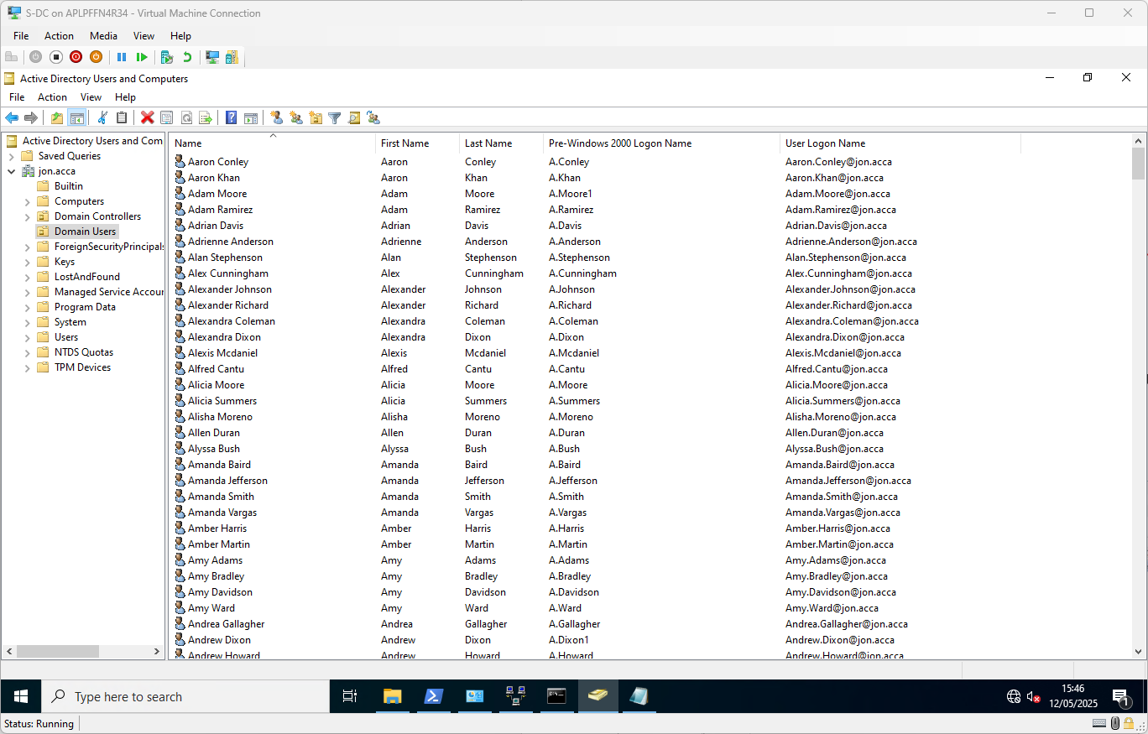

Mount Second Disk
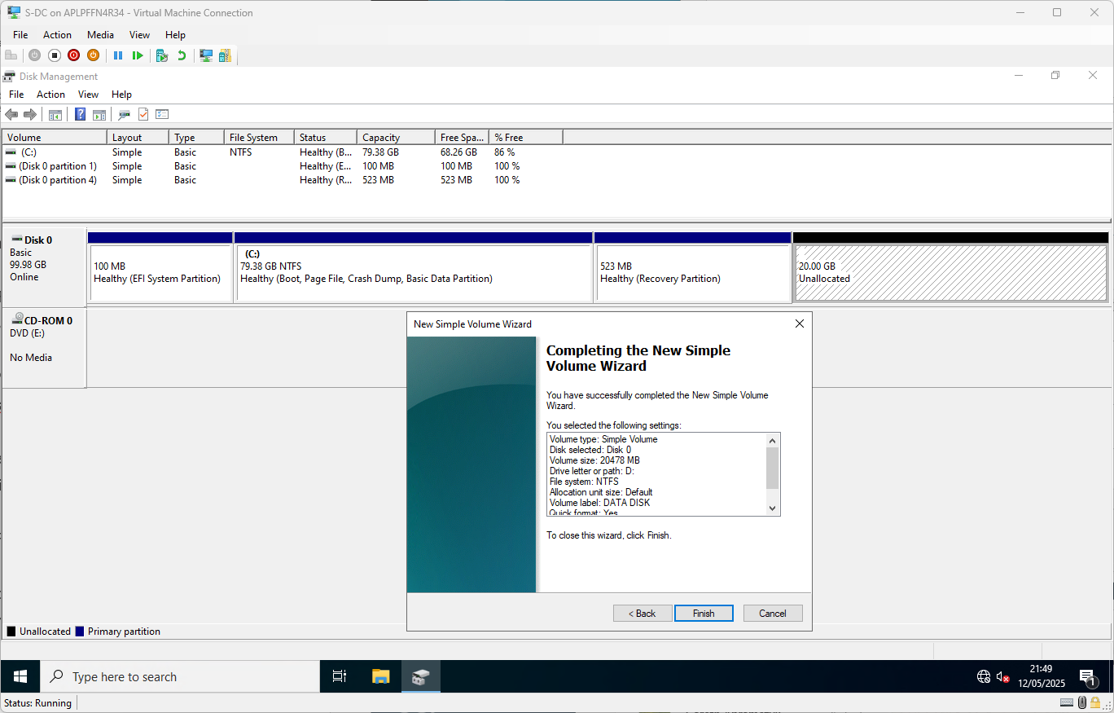
Create and format the volume
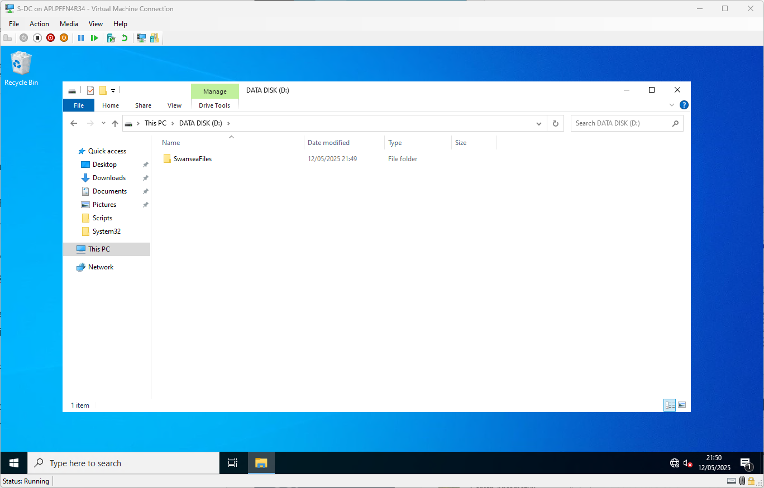
Create the folder for future sharing over the network

DHCP – Previously configured in assignment 1 but needs reconfiguration
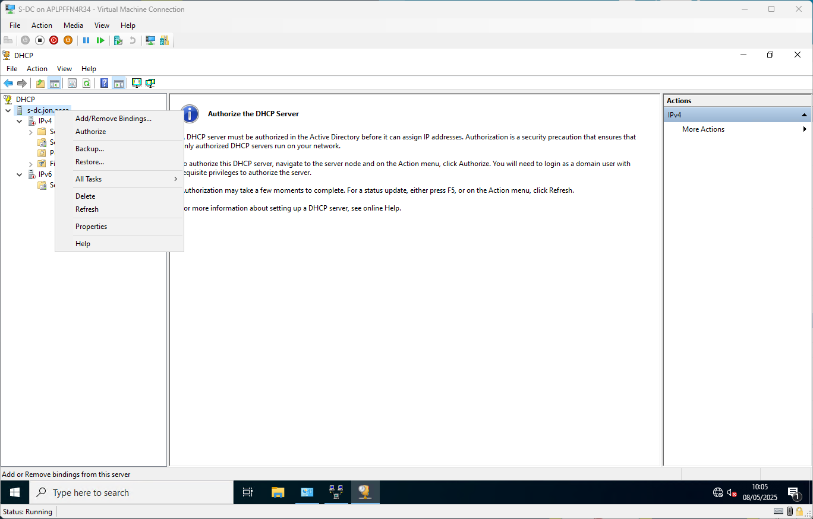
Needs to be ‘Authorised’ to serve clients in the new Domain Network setting
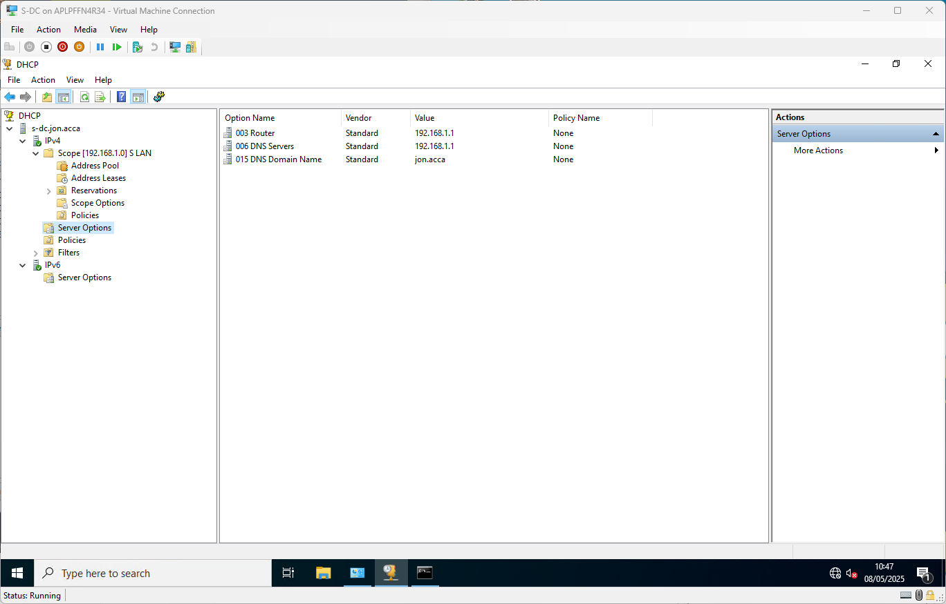
Additional ‘options’ to give DHCP clients a router/gateway address, a DNS address and the local domain name
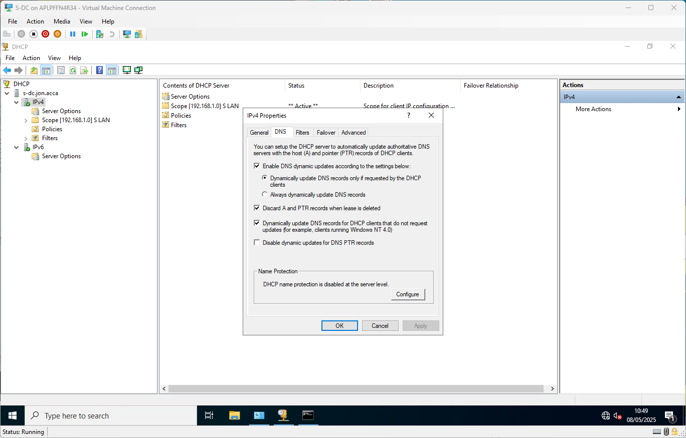
Updating DNS records dynamically at all times.
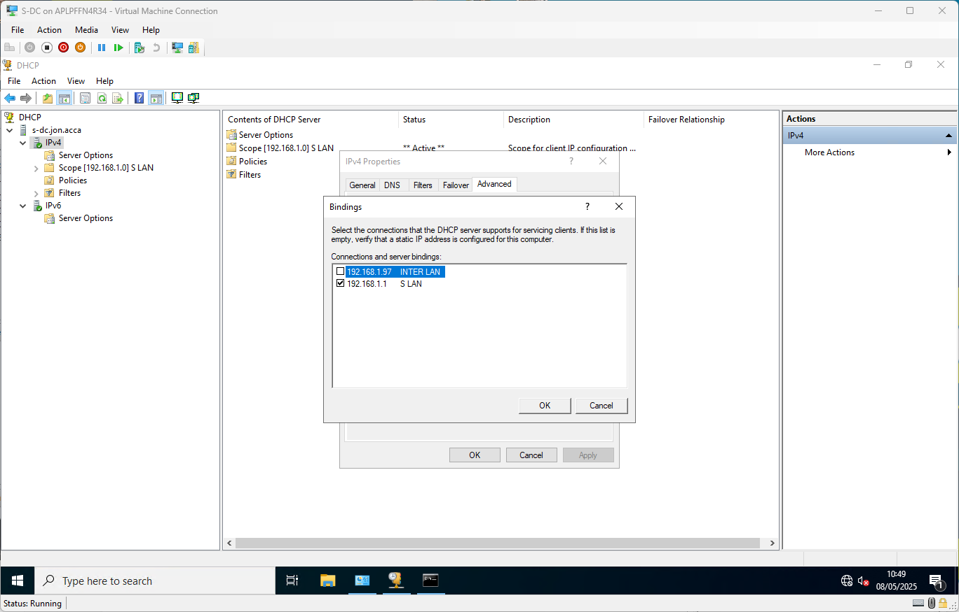
Binding the DHCP Server service to listen and serve clients on the Swansea network only

Join client machine “ClientS1” to the active directory domain network
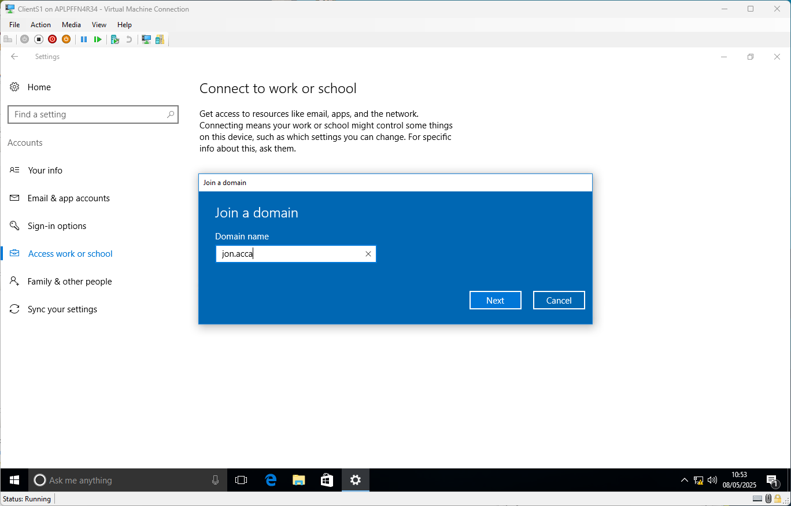
Starting the Domain Join process
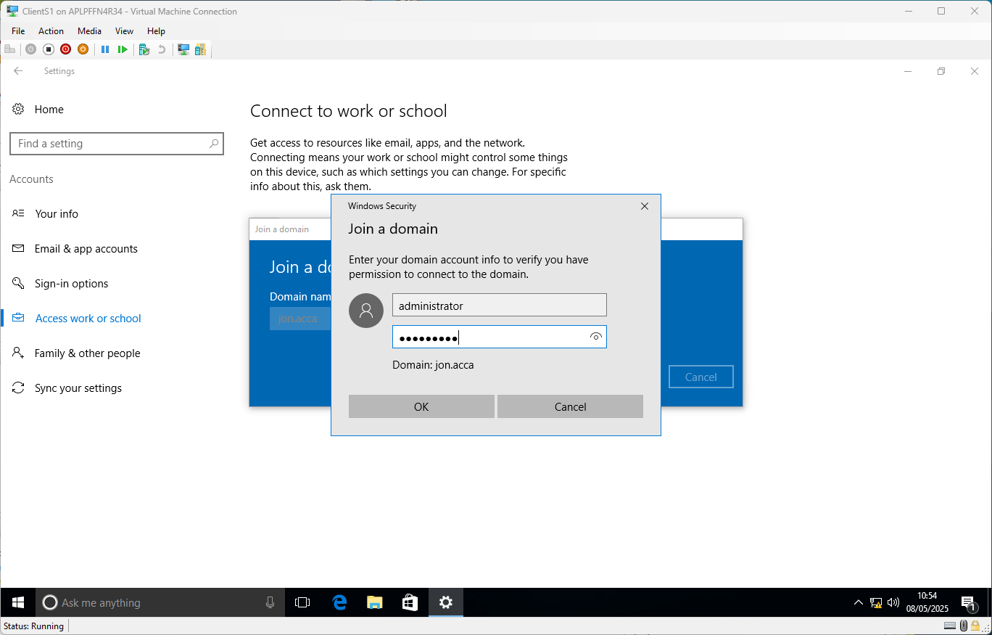
Supplying credentials to authorise the join. You must reboot when completed.

Update Firewall settings on ClientS1 to allow ICMP
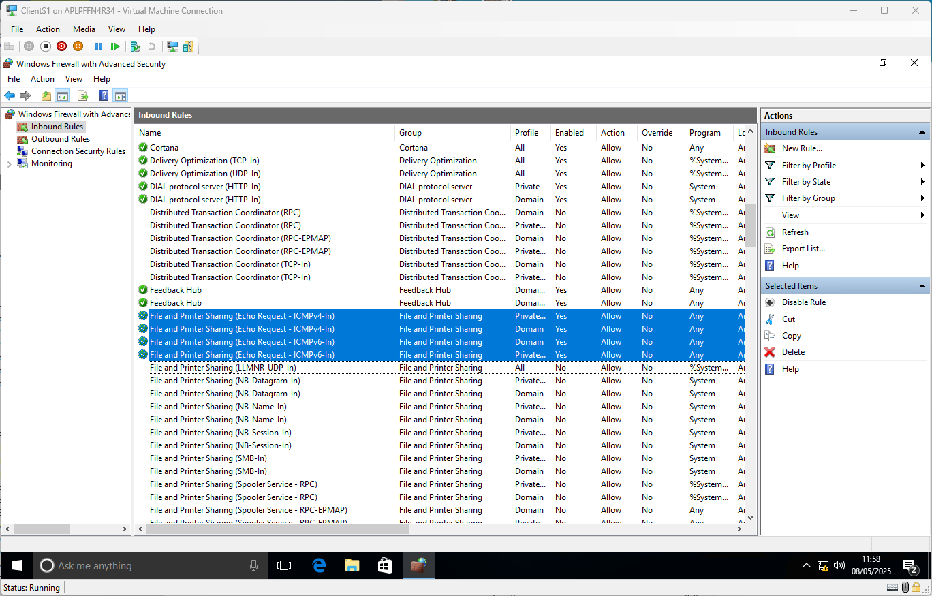

Cardiff Network

Installing RRAS equivalent on Ubuntu Server – StrongSwan and xL2TPd
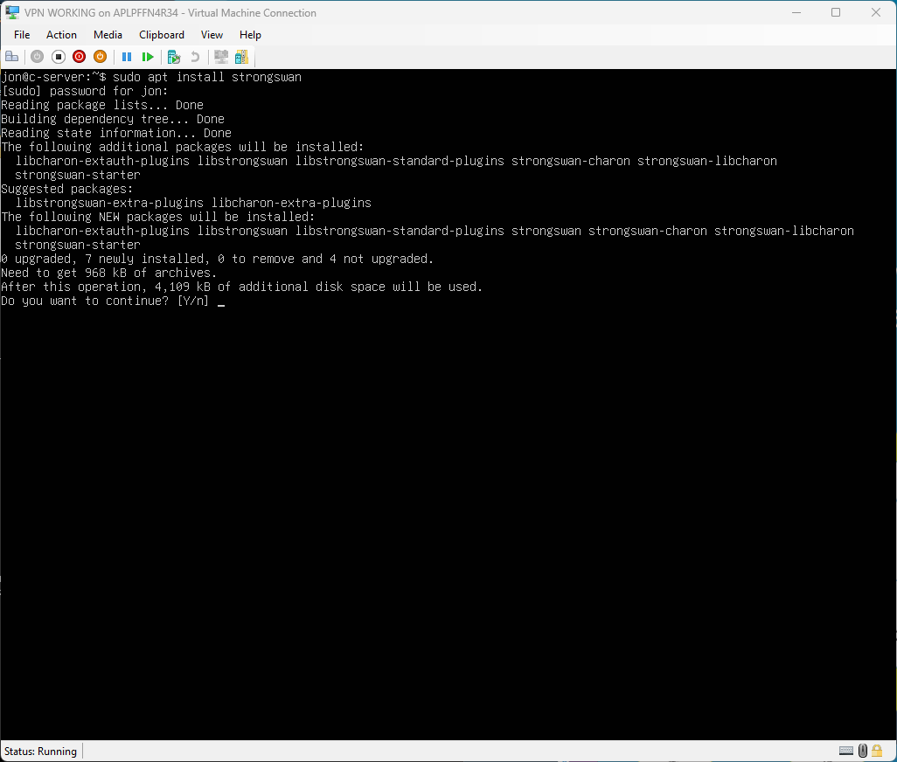
Installing the StrongSwan package
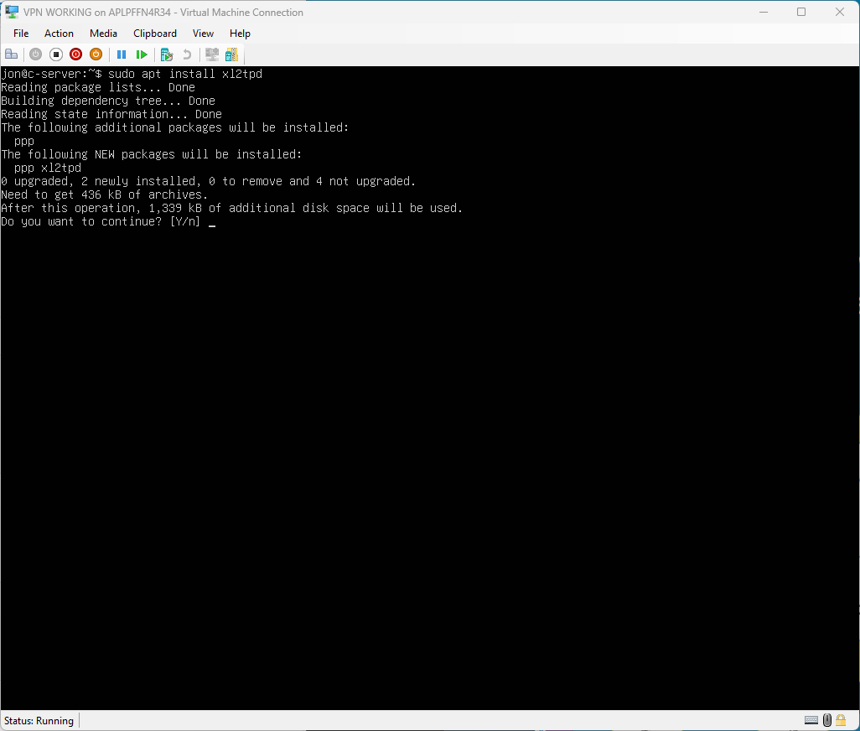
Installing the xL2TPd package

Configuring a Persistent Site-to-Site VPN to Swansea LAN
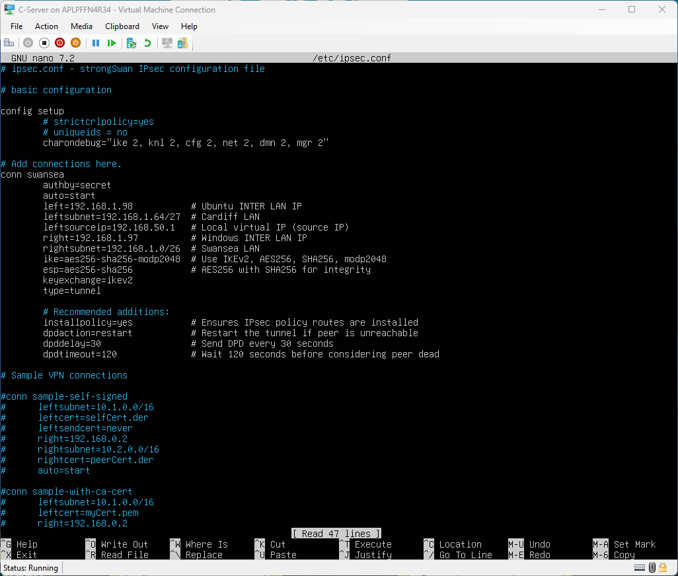
IPSec connection configuration, matching the security settings used on the Windows RRAS server configuration.

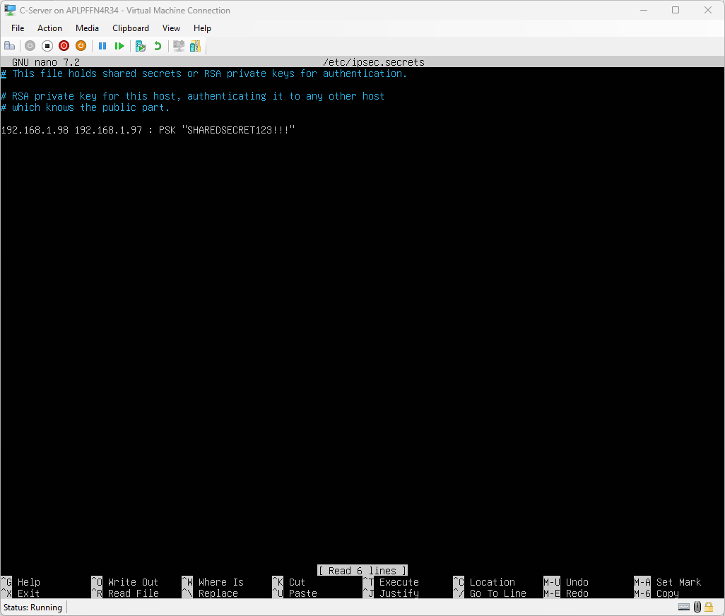
IPSec secrets file, storing the Pre-Shared Key, again matching what was used on the Windows RRAS server.
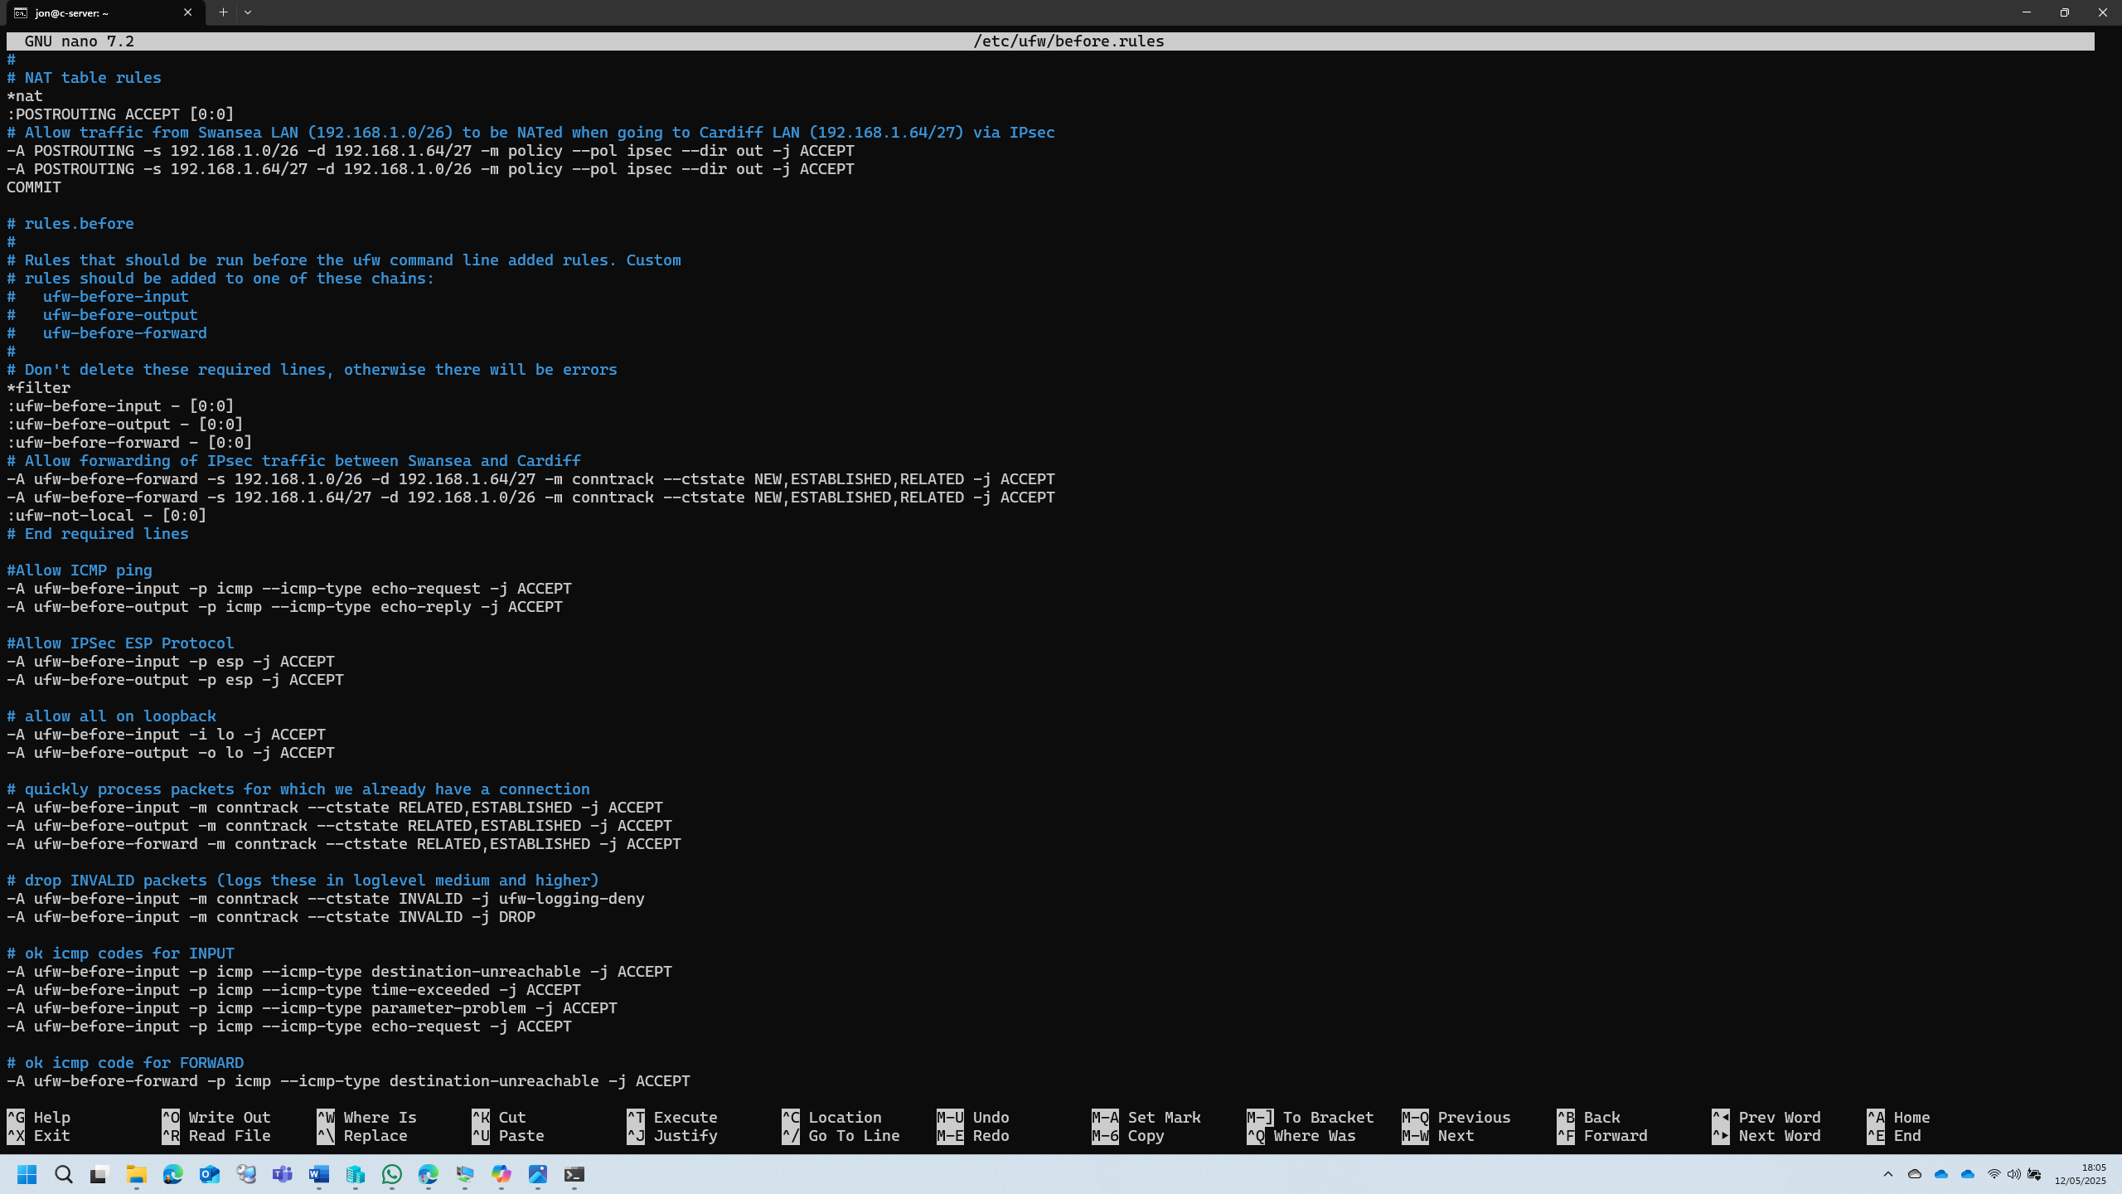
Some adjustments to the UFW (Uncomplicated FireWall) configuration to allow ICMP and IPSec protocols, and to allow NAT and forwarding of traffic from Swansea to Cardiff networks and vice versa.
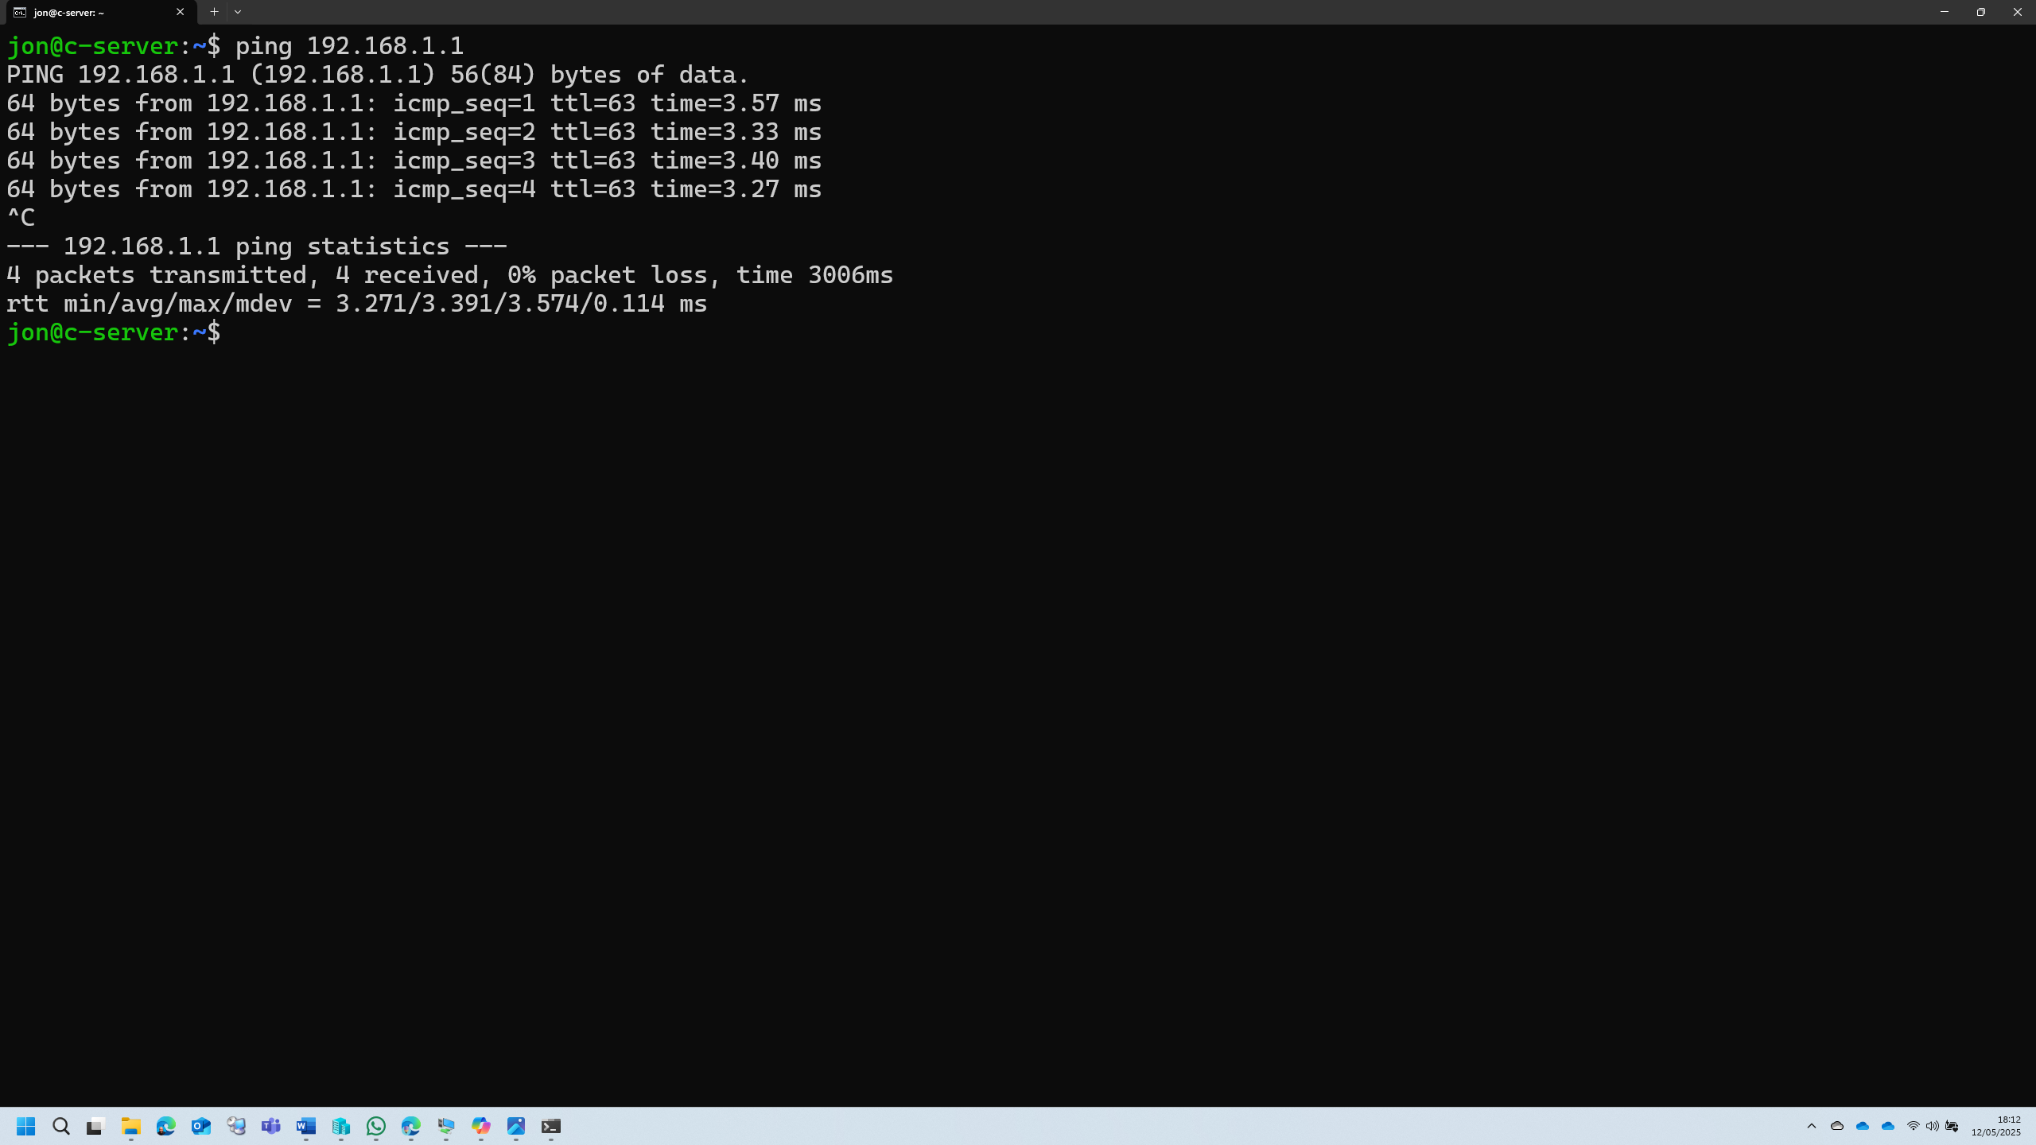
Ping test to S-DC Windows server IP address, routing across the VPN tunnel

Create a child domain or join devices to Jon.acca - Justify
I chose not to create a child domain called car.jon.acca. Implementing a fully managed child domain within the Active Directory Domain Services (AD DS) structure would require provisioning an additional Windows Server virtual machine. This server would need to be configured with the AD DS role and then promoted as a Domain Controller for the new child domain under the existing forest (e.g., jon.acca).
However, due to resource constraints on my local machine, which is already running four virtual machines concurrently, adding a fifth VM is not feasible. Running another server would exceed the available system memory and CPU capacity, either leading to severe performance degradation or just an outright refusal to run by the Hypervisor manager.
Instead, joining devices to the existing jon.acca domain allows for centralized management using the already existing infrastructure and avoiding unnecessary resource or administrative overhead. This decision balances functionality with resource availability and adheres to best practices in environments with limited hardware resources.

Reconfigure DHCP on Ubuntu server for Cardiff network clients
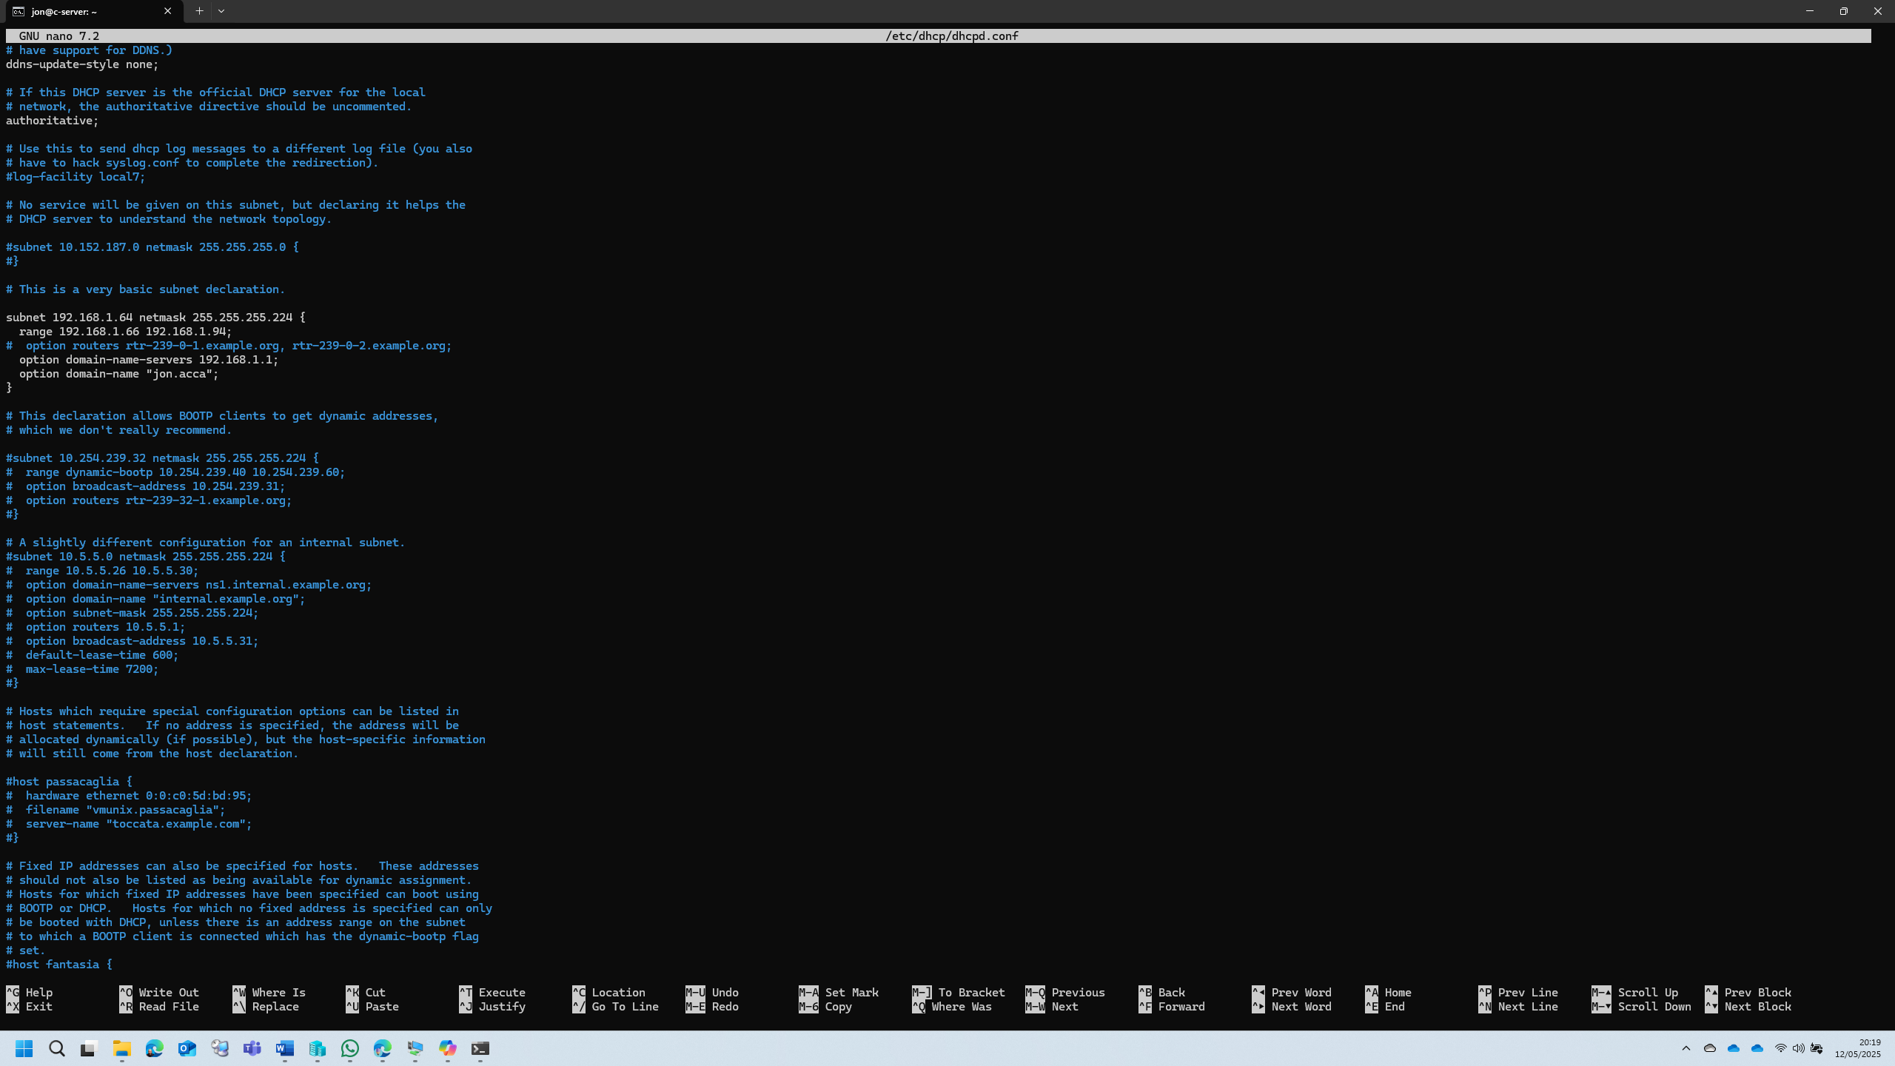
Add ‘options’ for DNS server and local DNS domain name.
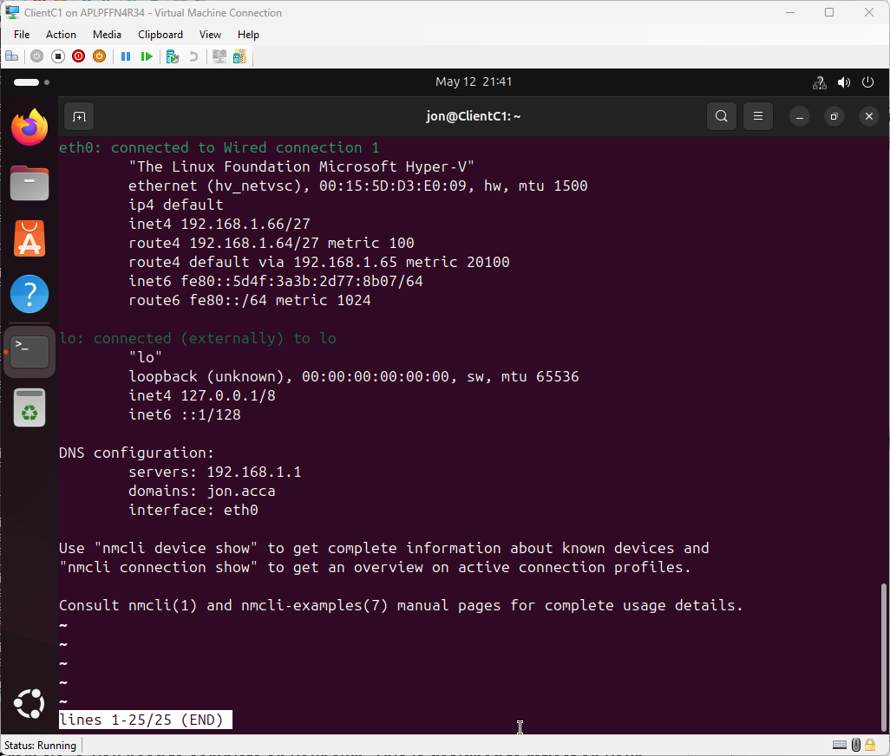
The result on the client.

Test the networks for connectivity
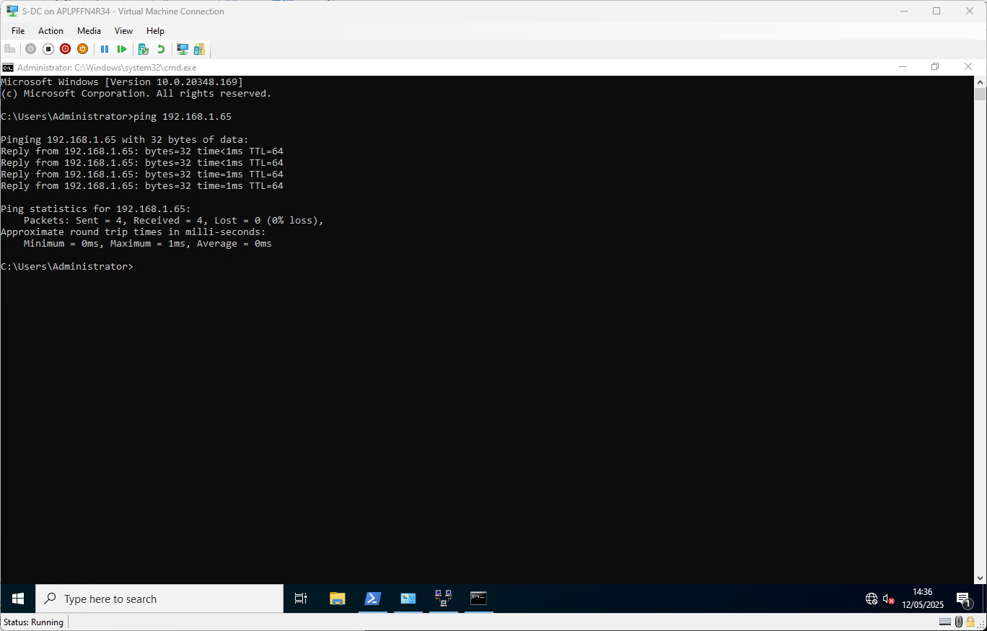
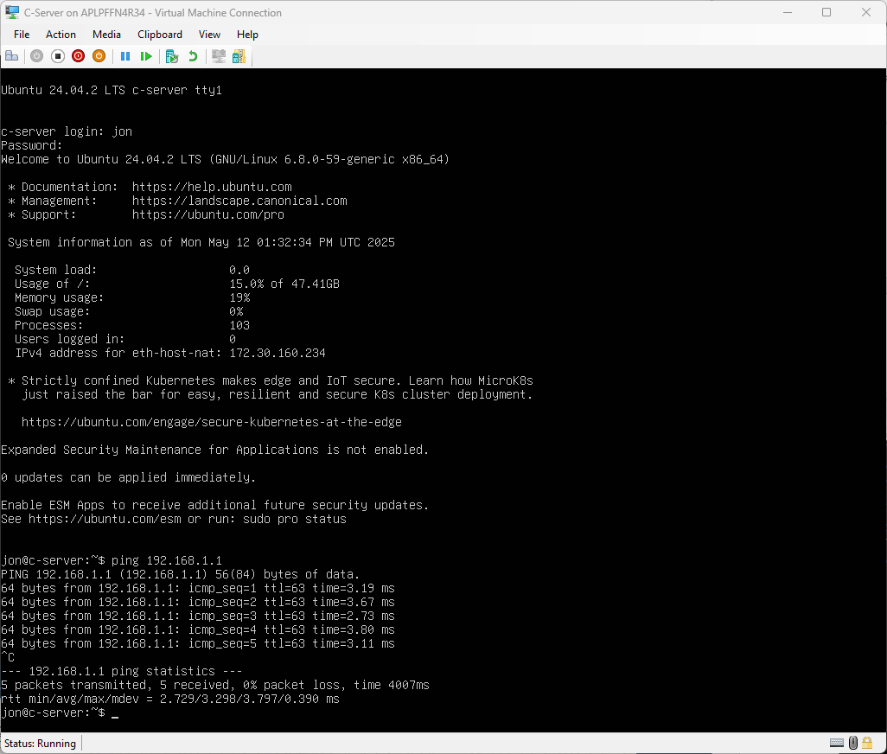

Sharing the Disk Drive
“Set access permissions to allow users in the users_list_updated.xlsx has full control permissions and other network users have only read access.”
To more easily achieve this, we first create a new security group, and add in all the users created from the CSV import earlier, which all reside in one specific OU called ‘Domain Users’:
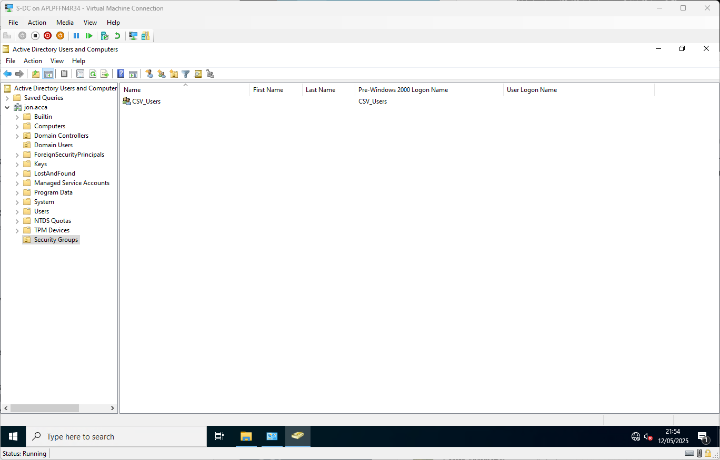
Create a new security group called “CSV_Users”, in a new Organisational Unit (OU) called “Security Groups”
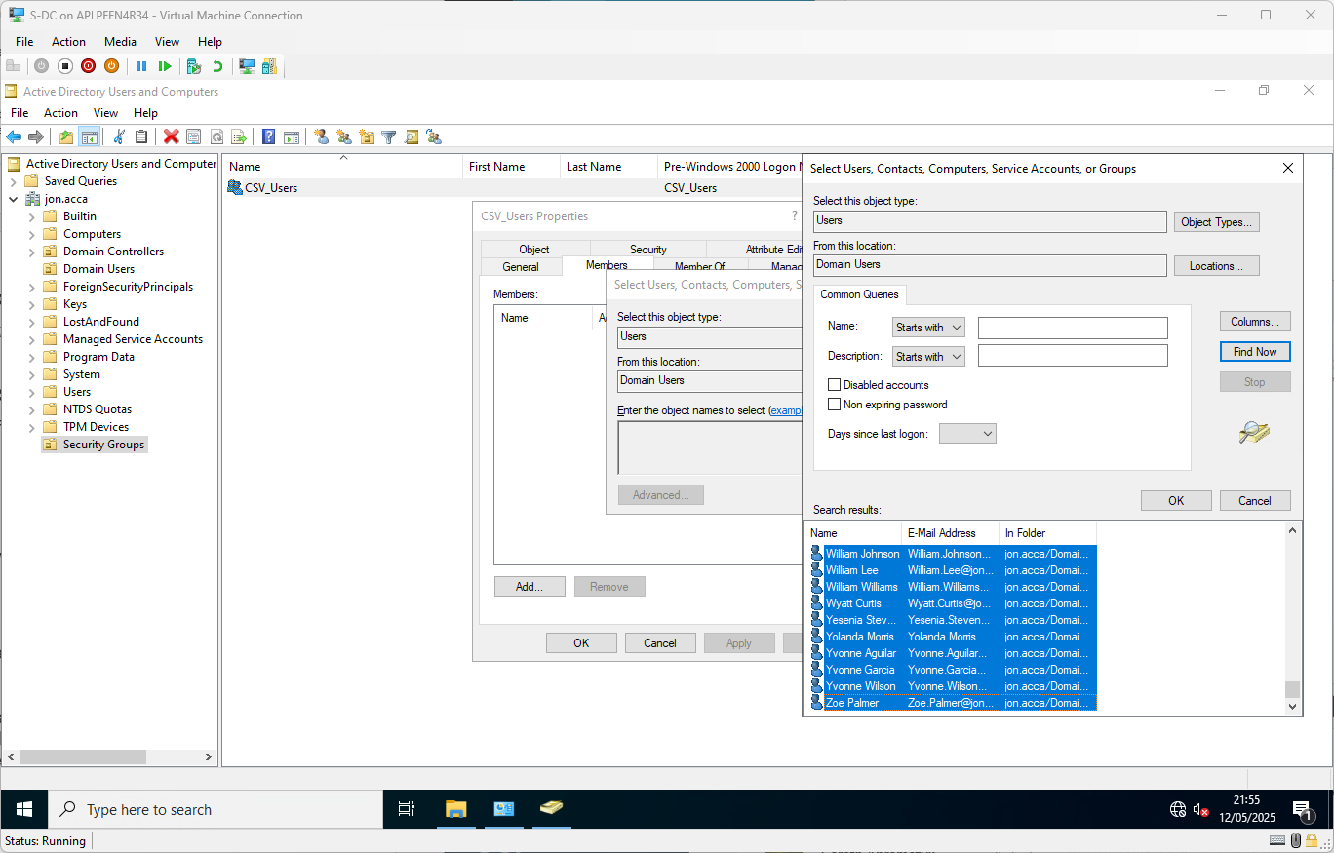
Selecting all the users specifically residing in the OU ‘Domain Users’

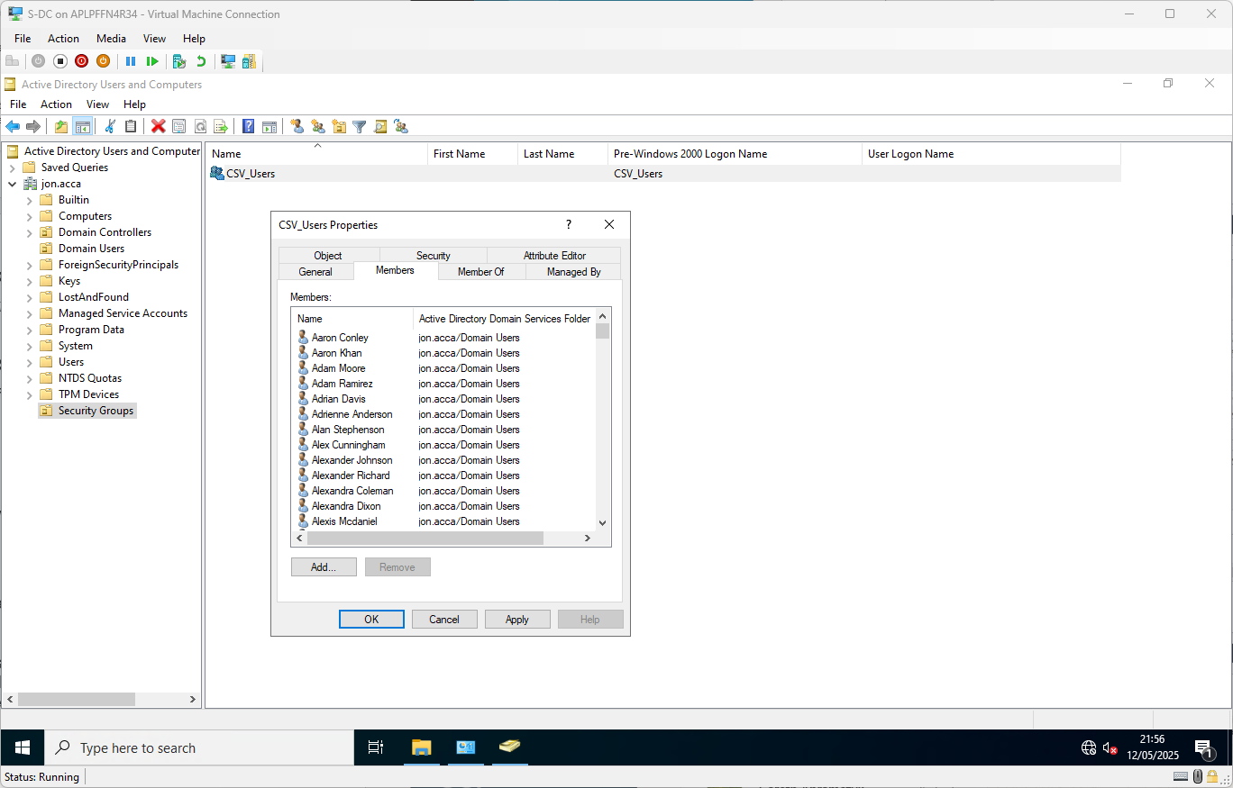
Added all the users to the new security group
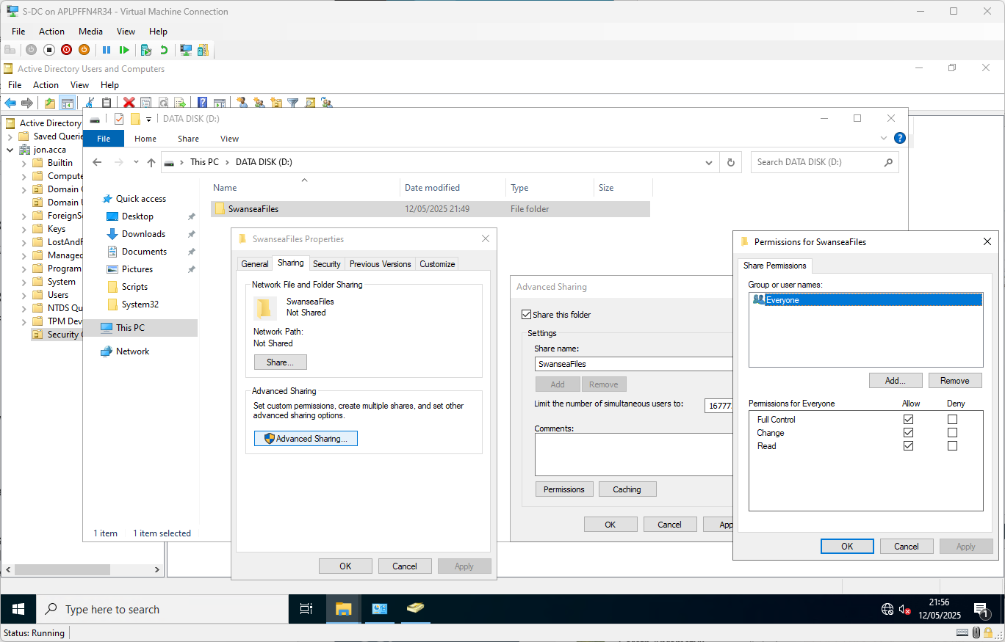
Enable the ‘Sharing’ of the folder on the network – grant ‘Everyone’ full control at this layer.
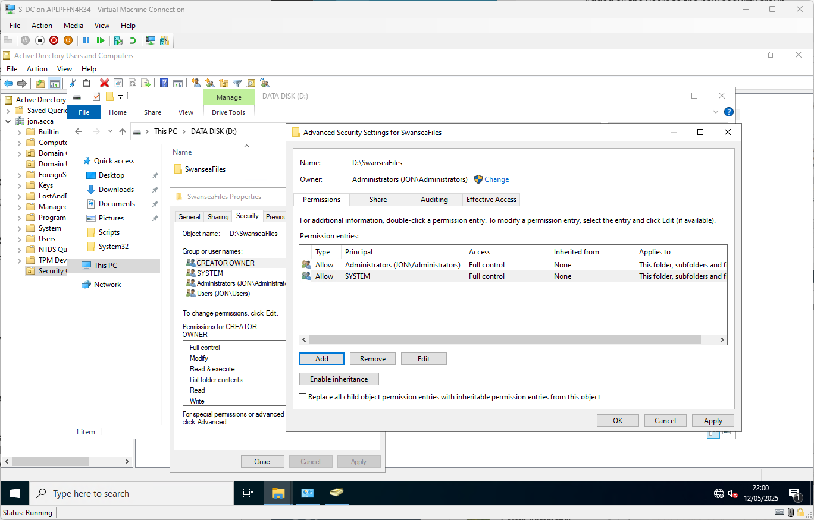
In the ‘Security’ tab, the NTFS file system permissions can be used for much more granular application of access controls.
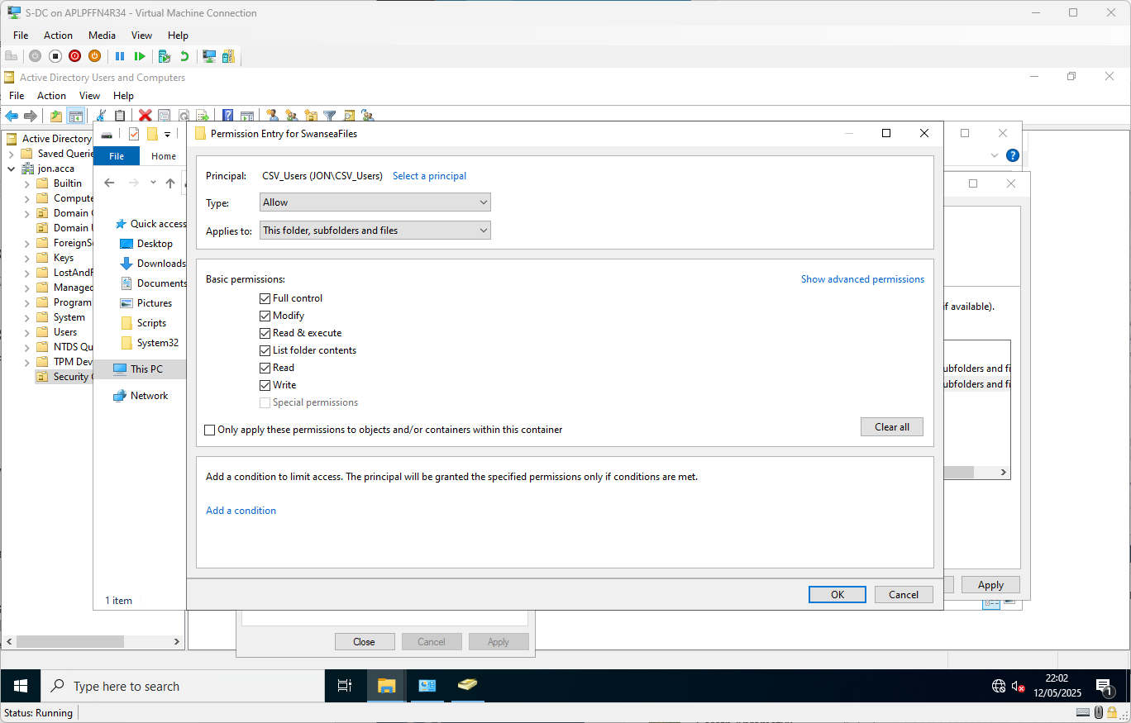
Adding the new “CSV_Users” security group as a principal for permissions, granting ‘Full Control’, applying to “this folder, subfolders, and files”
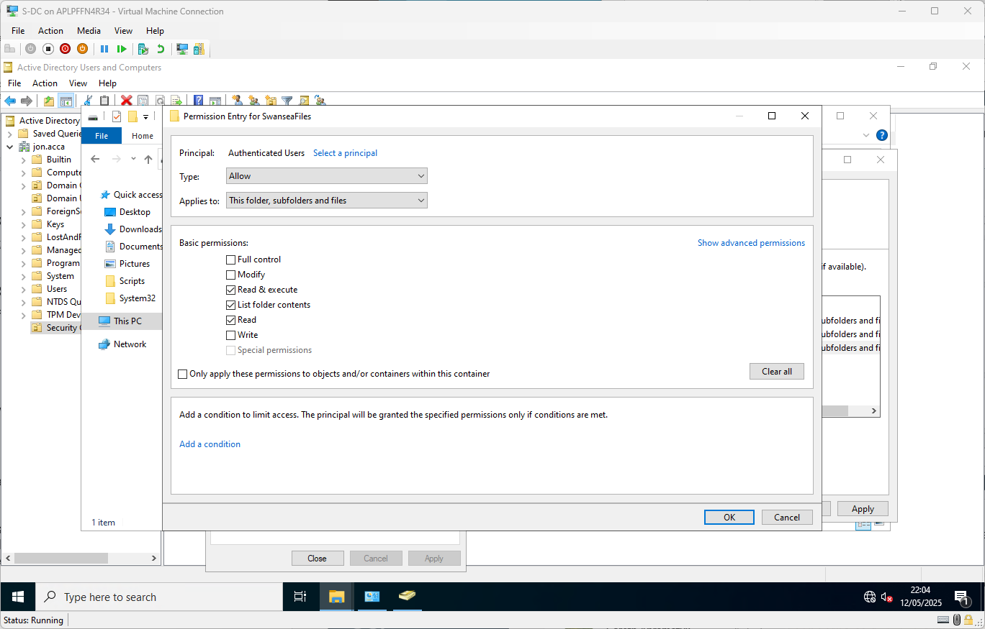
Adding the ADDS native “Authenticated Users” entity as a principal for permissions, granting ‘Read Only’ access, applying to “this folder, subfolders, and files”
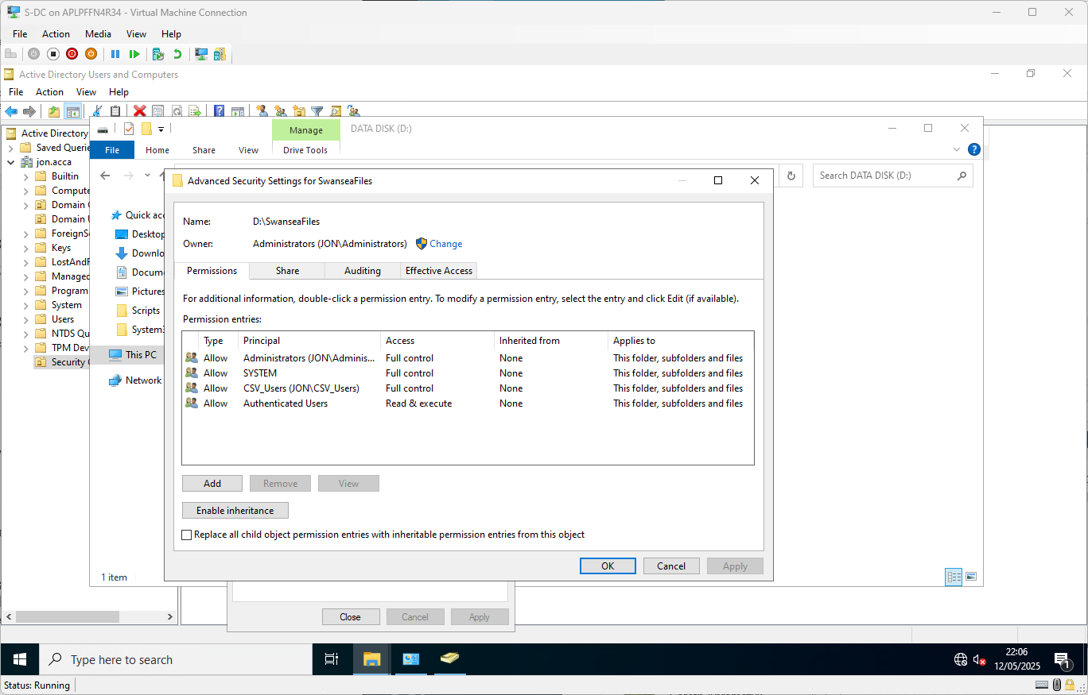
Final permissions setup
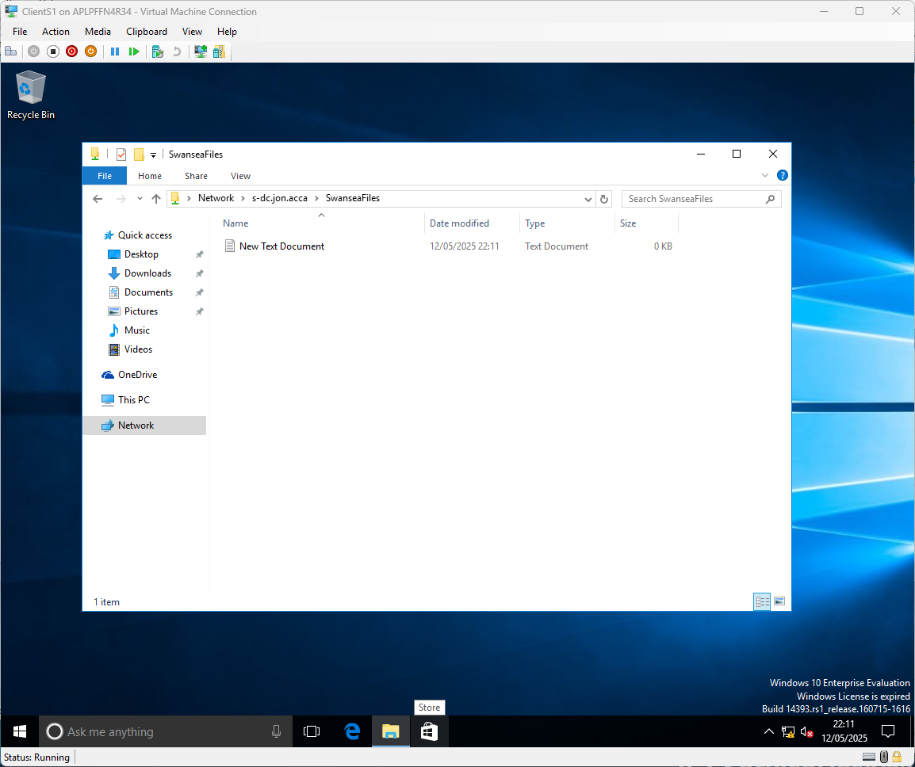
Testing Shared Folder from ClientS1

Configure IIS Server
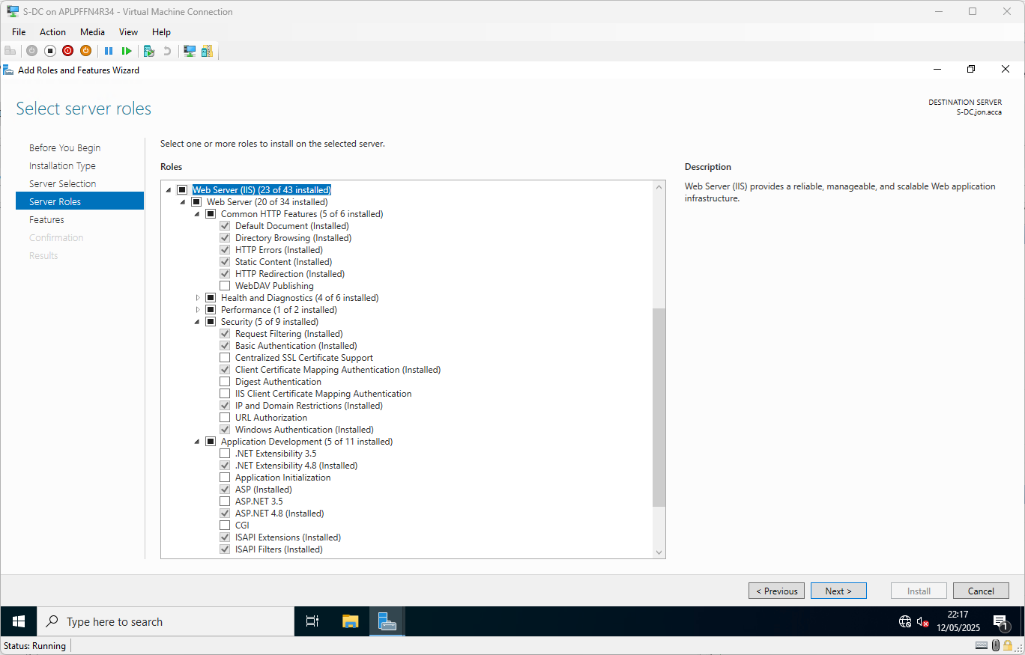
Many components of IIS have already been installed.
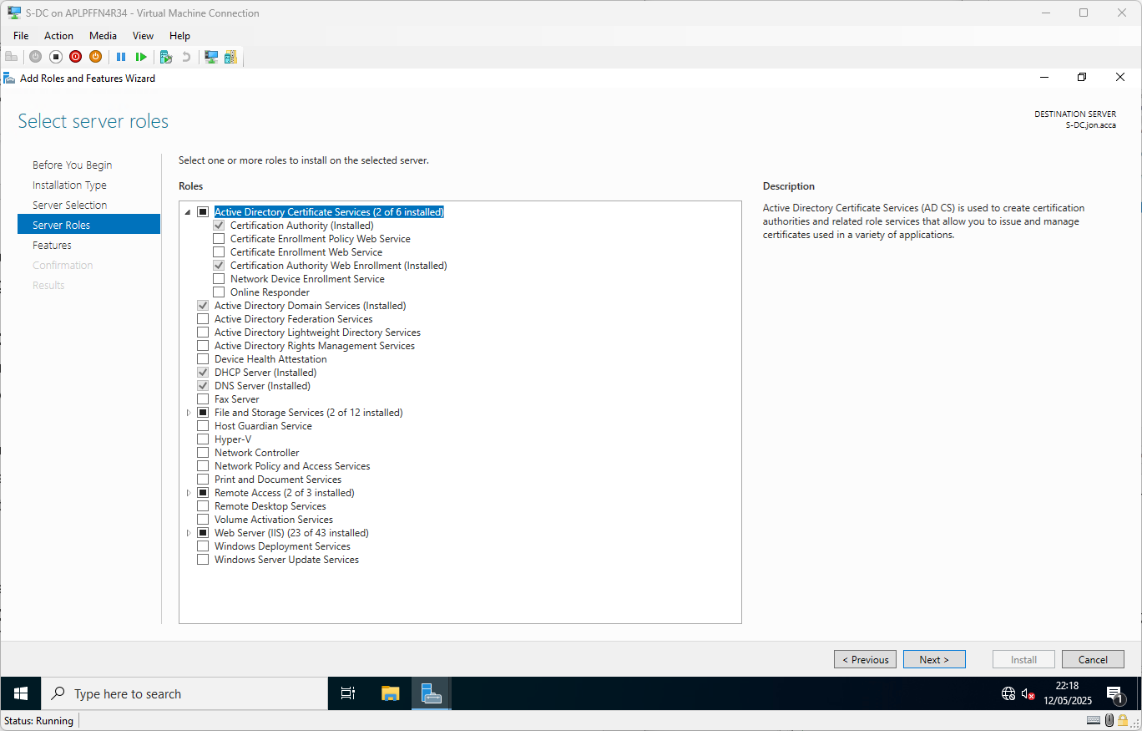
To be able to create functioning certificates to properly support HTTPS connections without all the warnings and red crosses about ‘insecure’ connections (within the boundary of the ADDS domain at least) an Active Directory Integrated Enterprise Certificate Authority was installed, along with the ‘Web Enrollment’ feature (which runs on IIS) to process certificate requests more easily.
A “Certificate Request Config” file was built and named “cert_request.inf”, containing:
[Version]
Signature="$Windows NT$"

[NewRequest]
Subject = "CN=rds.jon.acca"
KeySpec = 1
KeyLength = 2048
HashAlgorithm = SHA256
Exportable = TRUE

[Extensions]
2.5.29.17 = "{text}dns=rds.jon.acca&dns=www.rds.jon.acca&dns=www.webs.jon.acca&dns=webs.jon.acca"

The “Certreq” utility is then called on to create a CSR (Certificate Signing Request) file based on the INF file fed into it. A Public/Private key pair is created – the private key is stored securely on the computer creating the CSR – the CSR has encoded into the public key.
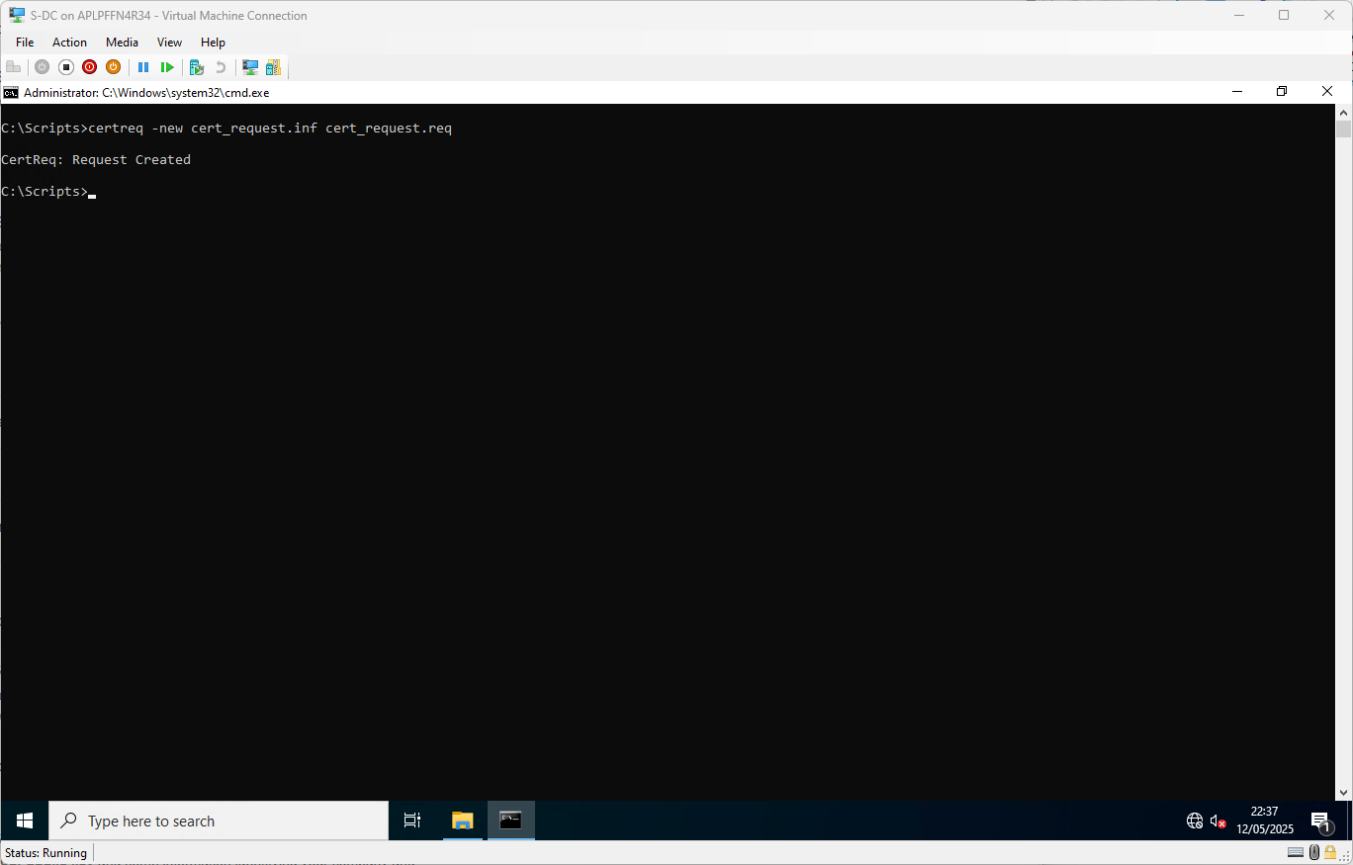
This file is opened and the contents fed into the Web Enrollment service.
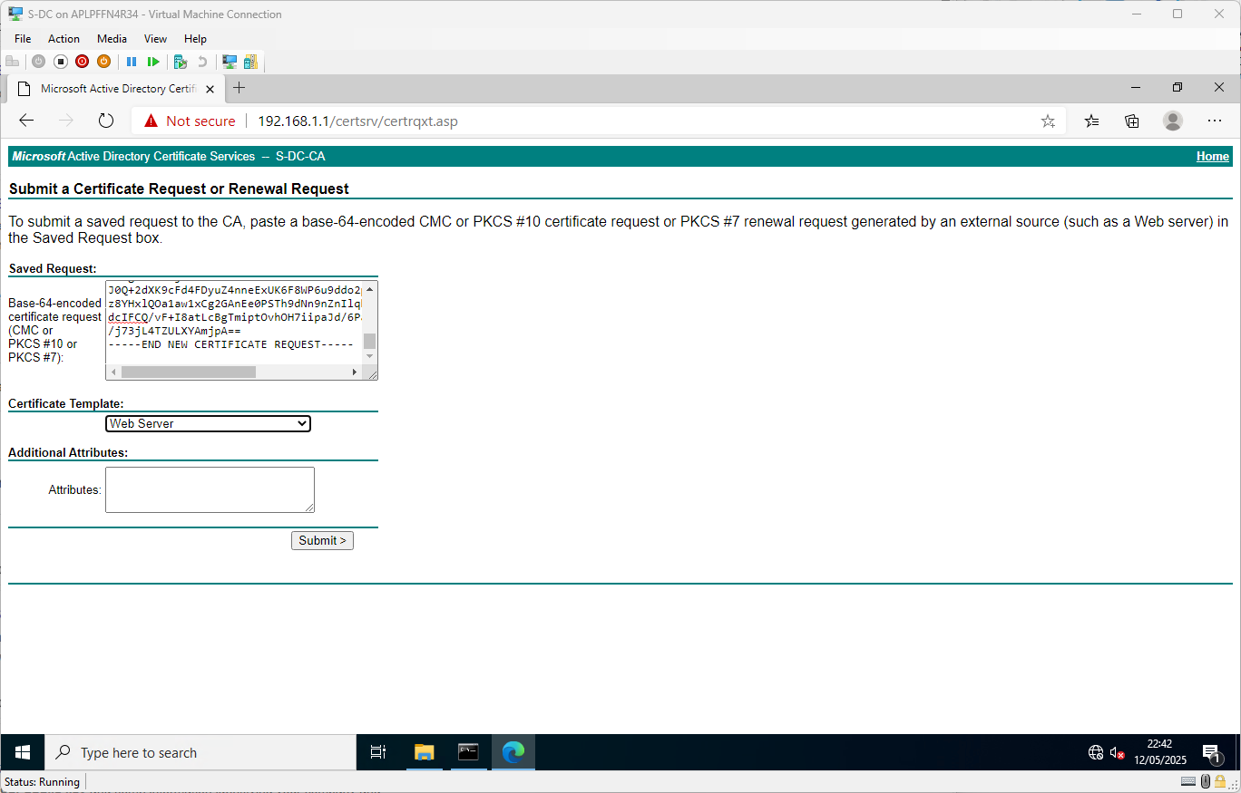
A signed certificate is created, which must be married up to its’ private key on the originating computer used to create the CSR.
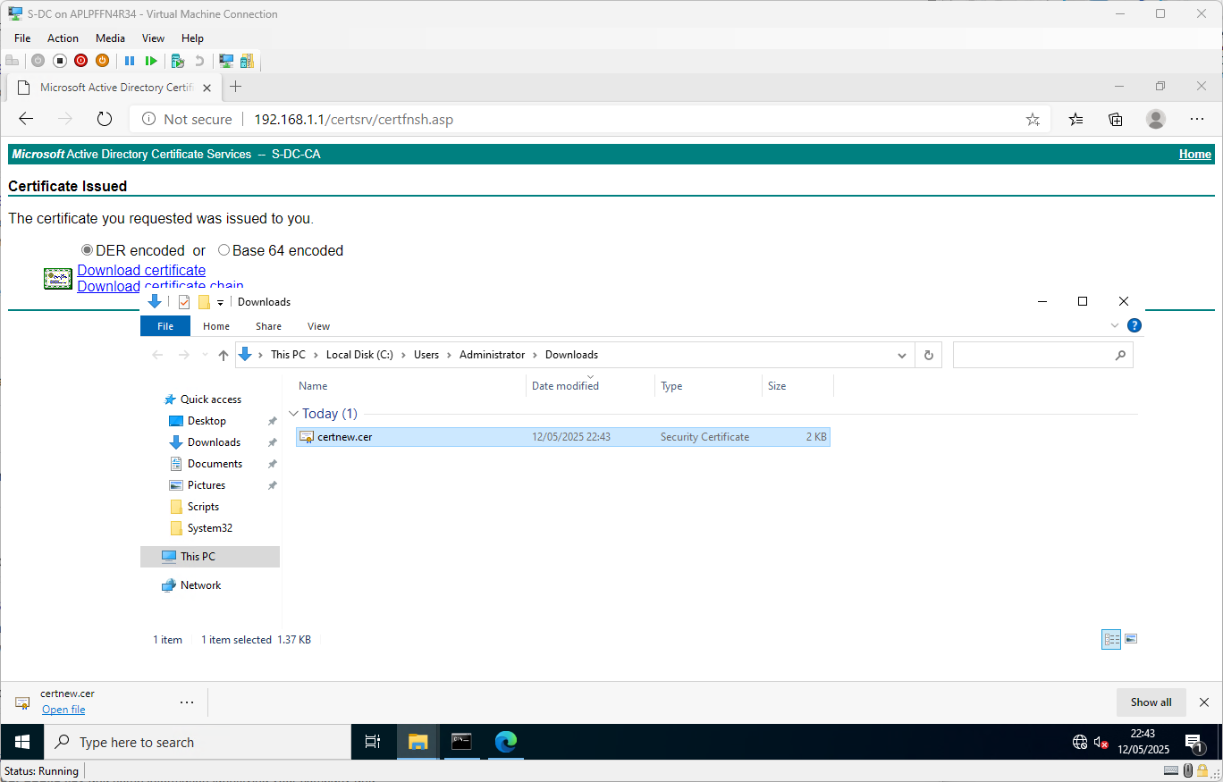
The “Certreq” utility can then again be used to “accept” the new certificate and ‘Complete’ the certificate signing request process.
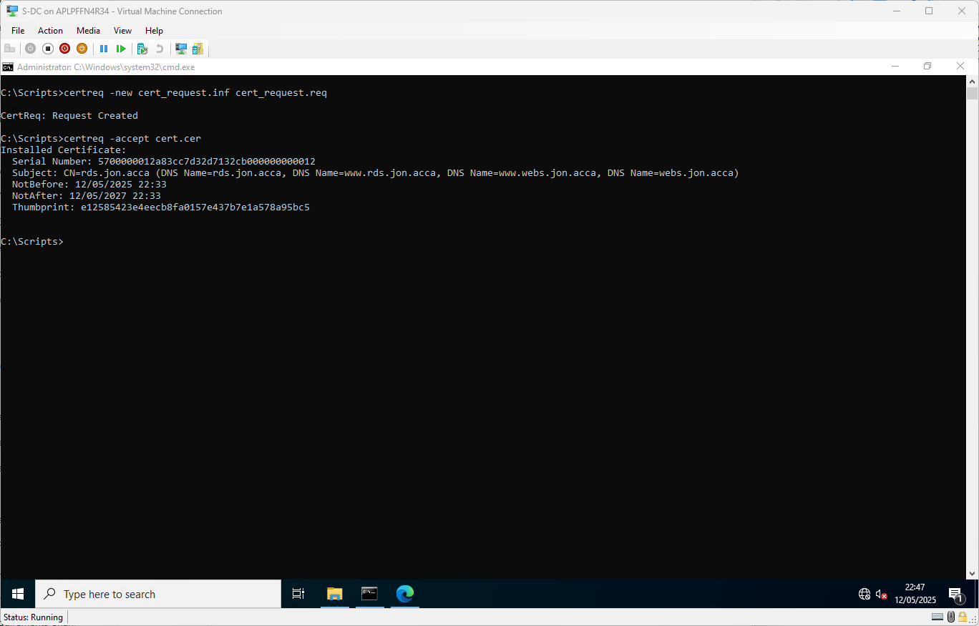
However, this was all carried out in the ‘context’ of the logged in user, so the cert has been stored, with its private key, in the ‘user certificate store’. We must export it from there (with the private key) and then re-import it into the ‘Computer Certificate Store’.
Once that is done, we can easily make use of the new certificate for machine/computer-based services, such as IIS.
Opening IIS Manager and heading to the Default Site, we look at the “Bindings” configuration, and update it to add some https bindings, on port 443 (the default TCP port for SSL/TLS https connections) bound to the Swansea network interface. When using https, you must pick a certificate to ‘present’ to clients.
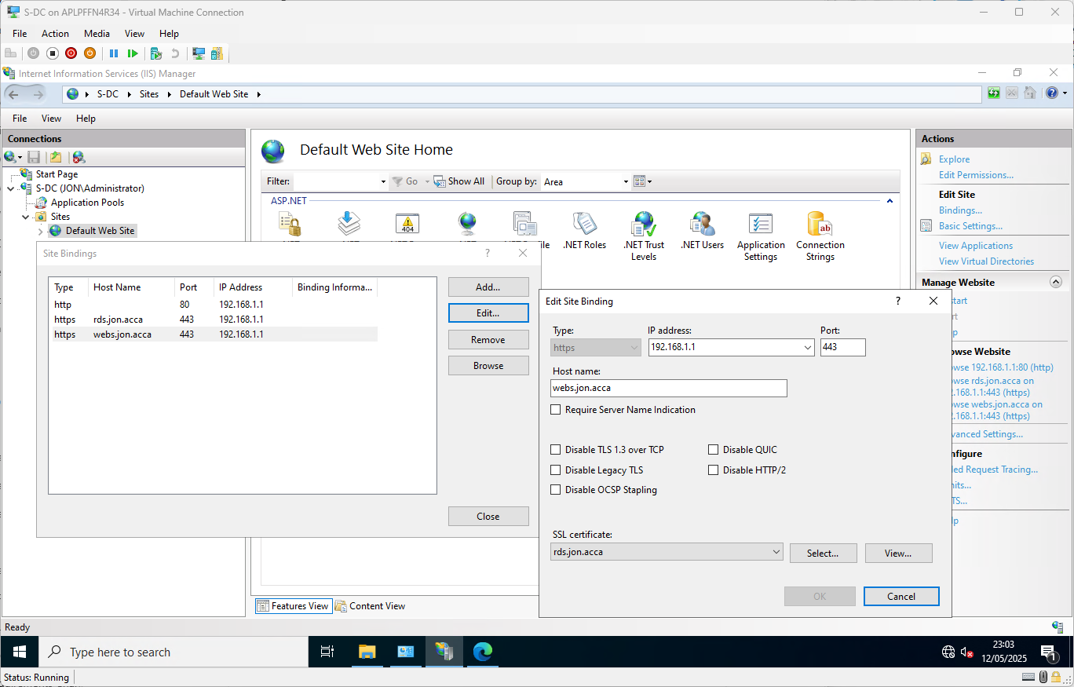
Showing the bindings configuration for the required ‘webs.jon.acca’ site.

For the IIS authentication requirements given, the IIS Security feature “Windows Authentication” was installed and then enabled for the default site, allowing domain users to natively authenticate to IIS with their domain tokens/tickets (SSO). Kernel-mode authentication was also disabled.
Additionally, because of the given requirement that ‘all users can (must?) be authenticated’, anonymous authentication was disabled also.
This caused some issues with Kerberos authentication, which the modern Edge browser tries to use by default. This was solved by adding a custom Service Principal Name (SPN) for the ‘webs.jon.acca’ hostname, via the command:

setspn -S HTTP/webs.jon.acca jon\s-dc$
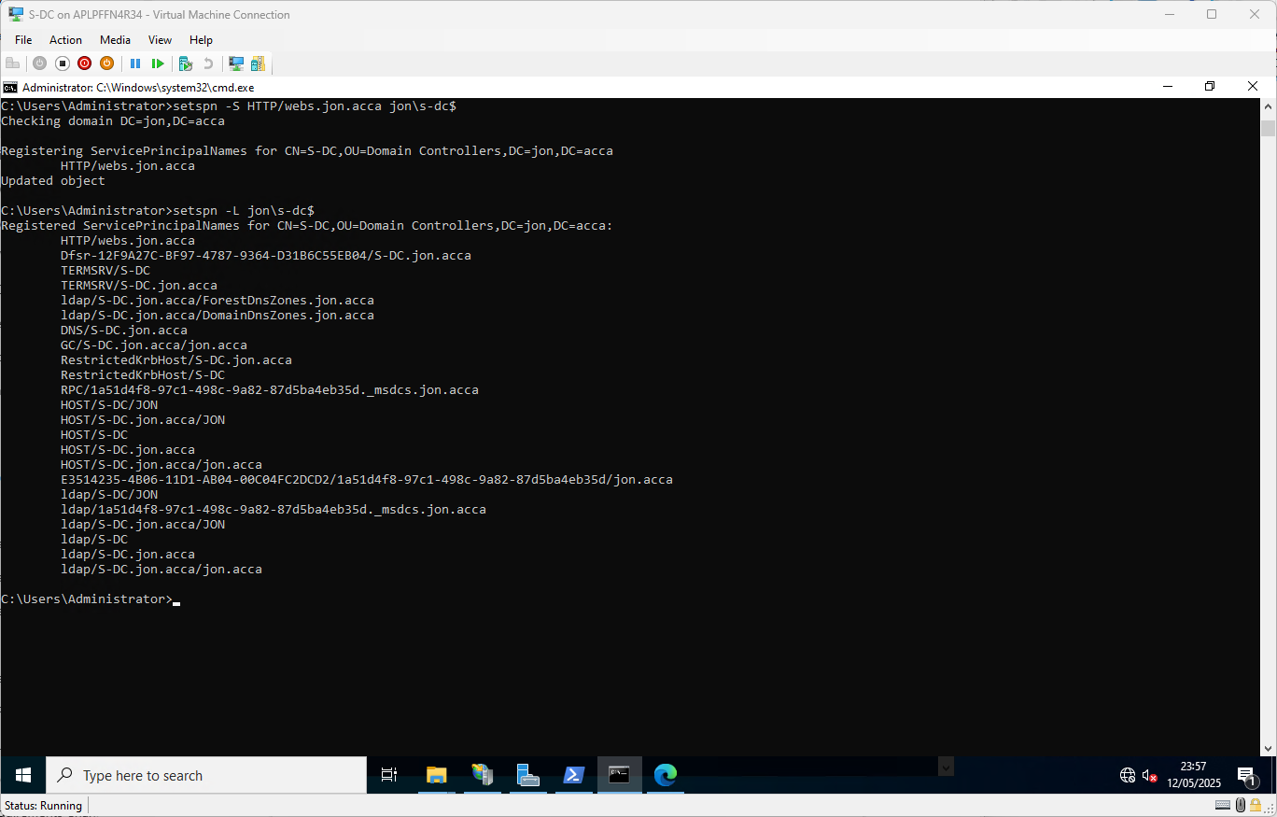
We can additionally add the URL or whole domain as a ‘Trusted Site’ in the browser (manually in this case, but could also be done via Group Policy across all domain computers), like so:
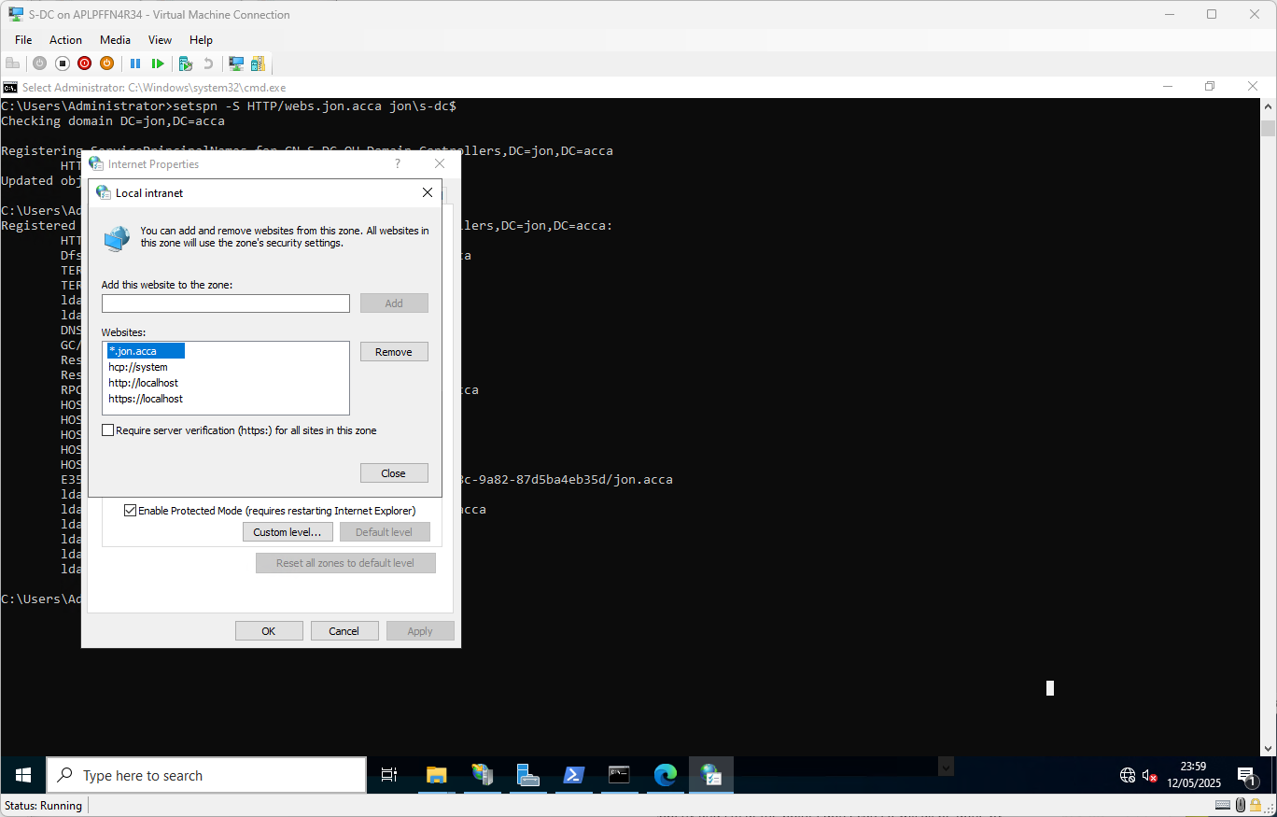
This causes the browser to automatically present the logged on user’s domain token/ticket to the site for immediate native windows authentication, otherwise known as Single Sign-On (SSO).
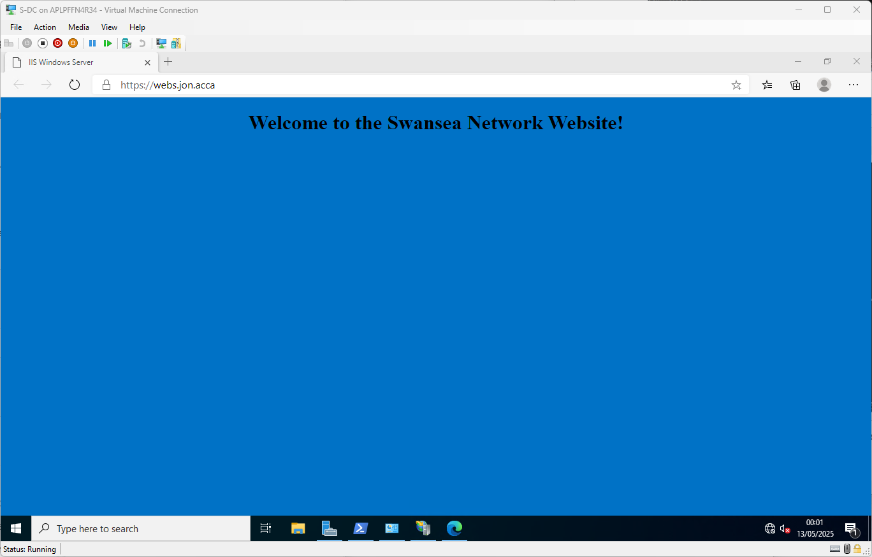

Remote Desktop Services

Installing Remote Desktop Services
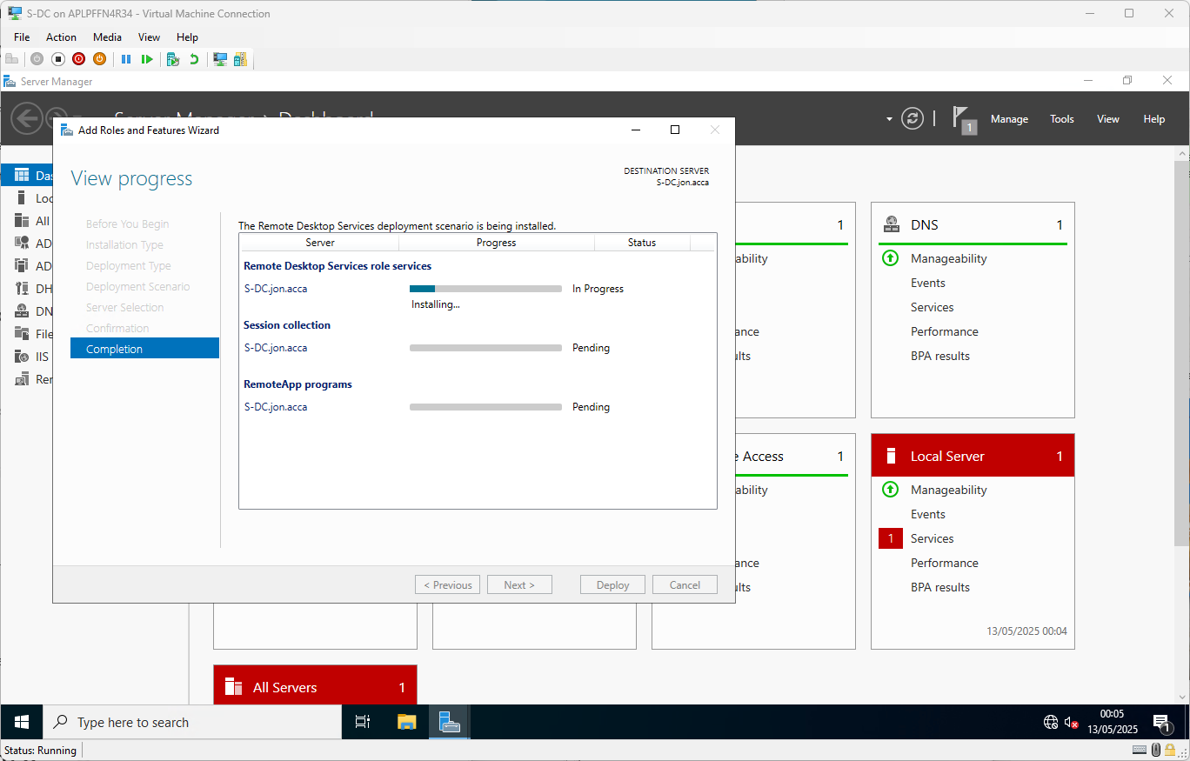
Ran the following command again to add another custom SPN to support proper Kerberos authentication to the new URL:
setspn -S HTTP/rds.jon.acca jon\s-dc$
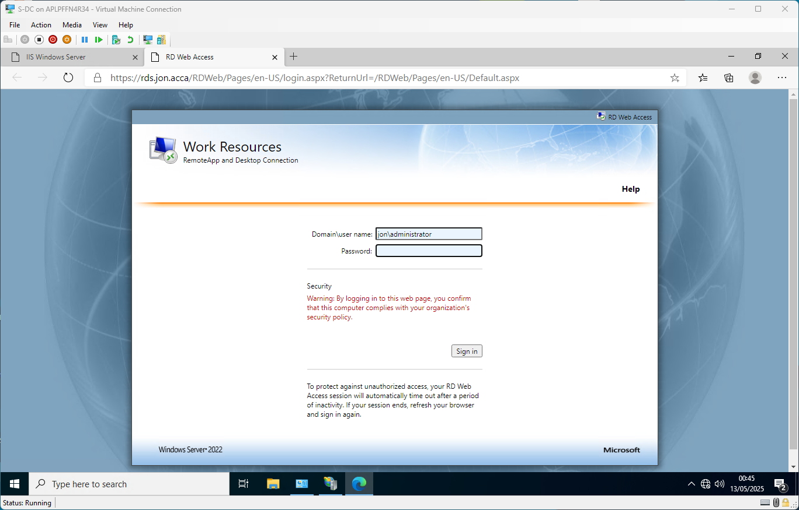
Successfully accessing RDWeb!

