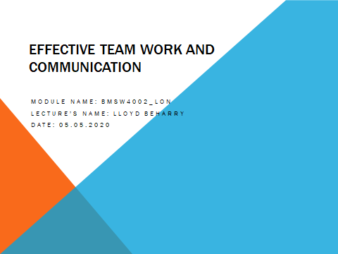
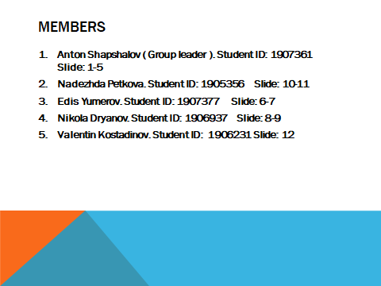
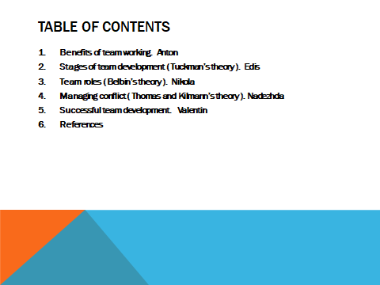
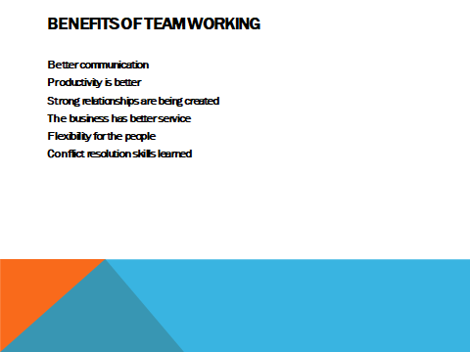
Talking about teamwork it’s a common topic and many things can be included here. At this presentation I will talk only for some of them. But in general team working always results in good way for the business and the people in it. It is important for every environment to has a good team working. Where there is good team working, there is good communication which helps to the job in a business to run smoothly. Another thing is better productivity, which means business and its people make more than the usual and in the same time what they do is more effective. Also people have better relation between each other. In a place where the people have good relationship with each other there is positive environment and negativity is less which results as a plus for the business. When there is a problem in the business, the team can discuss it all together and decide what is the best that they can do to solve it and this is also is a big benefit of the team working. People can focus more on the company goal and do better what they usually do. Every team has different people. Different people are good in different things. When working as a team, every person can do the thing that he/she is the best in it and this we give much better result than normal. Doesn’t matter the number of a people, if they don’t work as a team they can’t do nothing.
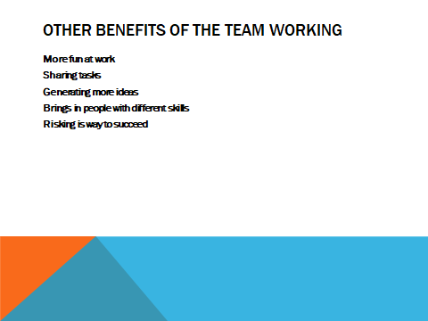
People as a team can succeed more than if they are individual. Even for this presentation we are team of five people and we all work as a team. This makes our job much easier. Sharing the task between all of us and following to achieve the same goal and being communicative with each other make us good team. Fun at work is something important, because creates positive atmosphere and help the people be better at what they do. Sharing tasks in the team with the other members makes the goal easy reachable and the result is better as everybody has less to do and focus more on the task to reach the main goal. People working as a team for the same purpose generate more ideas. They can discuss all the ideas and choose the best one, which again bring the best for the main goal.. Another benefit of the team working is that risking is easier. When people work as a team risking is much more easier. Five head are better than one. People working as a team can analyze the risk better and decide what is the best they can do, minimizing the risk to zero . Basically team working always is better than individual work. (ProofHub, 2018)
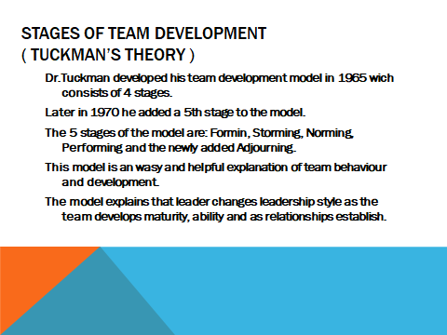
In 1965 Dr.Bruce Tuckman introduced him 4 stage team development model, but later in 1970 he added a 5th stage . The original 4 stages were: Forming, Storming, Norming and Performing and the newly found 5th stage Adjourning. This theory is a easy and helpful explanation of team behavior and development. The main point to take from Tuckman's theory is that you cannot expect a new team to perform well when it first comes together as it is a time consuming process. Team members frequently go trough recognizable stages as they begin to change from being a group of strangers trying to work together to a united group with common goals. Tuckman’s Forming, Storming, Norming and Performing theory describes these exact stages. The quicker you understand this model, the quicker you can help your new team to become more effective. (Elsey, 2014)
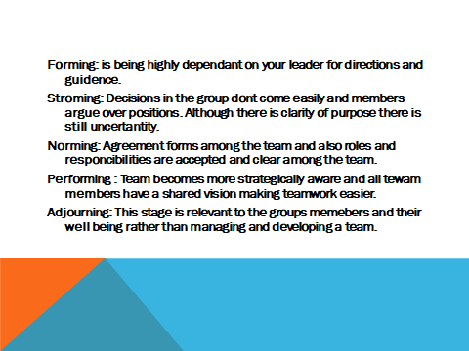
I’m going to go trough each stage and describe it in more detail. Forming: in this stage most team members are polite and very positive and others are a little anxious as they haven’t fully understood what their team will be doing and others will just be exited about the work that they will be doing and look forward to the tasks ahead. As the leader, you play a very important and dominant tool at this stage because team members' responsibilities and roles are unclear and yet to be decided. This stage can last for some time as team members begin to work together and as they begin to make effort to get to know their fellow colleagues.
Storming: This is where most teams fail as this is the stage where teams members start to push against the boundaries that were established in the stage before. Storming usually occurs when there is conflict between team members' which can be caused because members might have different working styles, member challenges your authority, If you haven’t defined how exactly the team will work or others might be overwhelmed by the amount of work that they are getting. There are many reasons. (Businessballs, n.d.)
Norming: Eventually the tem moves onto the thirst stage, which is Norming. This is the stage where team members start to resolve their differences and issues, respect colleagues' strengths and many respect your authority as a leader. Now that eventually your team members know each other, they start to socialize and are able to ask each other for help or for constructive feedback if needed. As a result member develop a stronger commitment to the set goal and start to see good progress.
Performing: The team reaches the performing stage. This is the stage where hard work leads with no friction between the team members and everyone is set on the teams' goal, and the structure and process that you have set up works well for everyone. This means that you as a leader can delegate much more of your work and can concentrate on developing team members rather than having to worry about other things. Teamwork starts to feel easier and people eho leave or join the team do not disrupt it in any way. (Team, n.d.)
Adjourning: This is the stage where team members finish off the set task and eventually the team breaking up. It may be a difficult stage for many who enjoy the routine or for those who have made good friendships> The leader can help by working with team members to plan their futures and what comes next.
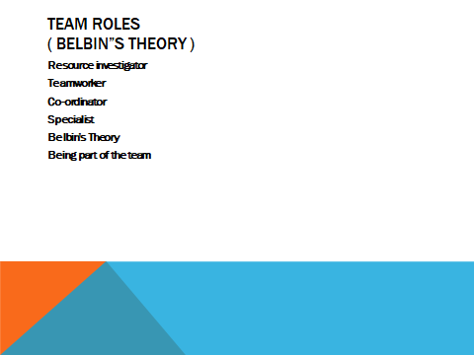

Resource Investigator
Uses their inquisitive nature to find ideas to bring back to the team.
Strengths: Outgoing, enthusiastic. Explores opportunities and develops contacts.
Weaknesses: Might be over-optimistic, and can lose interest once the initial enthusiasm has passed.
They might forget to follow up on a lead.
Teamworker
Helps the team to gel, using their versatility to identify the work required and complete it on behalf of the team.
Strengths: Co-operative, perceptive and diplomatic. Listens and averts friction.
Weaknesses: Can be indecisive in crunch situations and tends to avoid confrontation.
They might be hesitant to make unpopular decisions.
Co-ordinator
Needed to focus on the team's objectives, draw out team members and delegate work appropriately.
Strengths: Mature, confident, identifies talent. Clarifies goals.
Weaknesses: Can be seen as manipulative and might offload their own share of the work.
They might over-delegate, leaving themselves little work to do.
Specialist
Brings in-depth knowledge of a key area to the team.
Strengths: Single-minded, self-starting and dedicated. They provide specialist knowledge and skills.
Weaknesses: Tends to contribute on a narrow front and can dwell on the technicalities.
Don’t be surprised to find that they overload you with information.
What are Belbin Team Role Strengths and Weaknesses?
Many years of research into team behaviour and performance identified nine different clusters of behaviours - we call these the nine Belbin Team Roles. Each of us has our own Team Role profile. The most successful teams have access to all nine Belbin Team Roles.
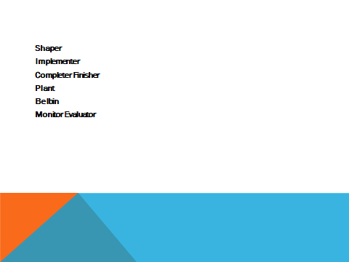
Shaper
Provides the necessary drive to ensure that the team keeps moving and does not lose focus or momentum.
Strengths: Challenging, dynamic, thrives on pressure. Has the drive and courage to overcome obstacles.
weaknesses: Can be prone to provocation, and may sometimes offend people's feelings.
They could risk becoming aggressive and bad-humoured in their attempts to get things done.
Implementer
Needed to plan a workable strategy and carry it out as efficiently as possible.
Strengths: Practical, reliable, efficient. Turns ideas into actions and organises work that needs to be done.
Weaknesses: Can be a bit inflexible and slow to respond to new possibilities.
They might be slow to relinquish their plans in favour of positive changes.
Completer Finisher
Most effectively used at the end of tasks to polish and scrutinise the work for errors, subjecting it to the highest standards of quality control.
Strengths: Painstaking, conscientious, anxious. Searches out errors. Polishes and perfects.
Weaknesses: Can be inclined to worry unduly, and reluctant to delegate.
They could be accused of taking their perfectionism to extremes.
Plant
Tends to be highly creative and good at solving problems in unconventional ways.
Strengths: Creative, imaginative, free-thinking, generates ideas and solves difficult problems.
Weaknesses: Might ignore incidentals, and may be too preoccupied to communicate effectively.
They could be absent-minded or forgetful.
Monitor Evaluator
Provides a logical eye, making impartial judgements where required and weighs up the team's options in a dispassionate way.
Strengths: Sober, strategic and discerning. Sees all options and judges accurately.
Weaknesses: Sometimes lacks the drive and ability to inspire others and can be overly critical.
They could be slow to come to decisions.
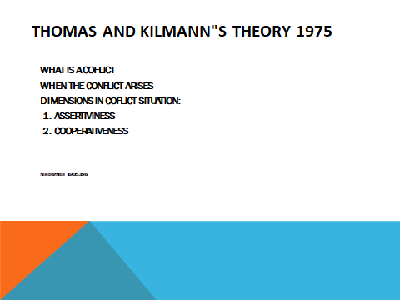
The Thomas-Kilmann Conflict Mode Instrument assesses an individual’s conduct in conflict situations—at work or at home, often times are just inevitable.
Conflicts happen when there is a dispute about goals, resources, ideas, ways of working, or just different perspectives. In such situations, it is useful to know how to manage conflicts when they arise.
Concerned about results and concern about people, the Thomas and Kilmann”s model uses two main dimensions
(1). Assertiveness and (2) Cooperativeness
Orientation to personal goals - the extent to which one focuses on achieving one's personal goals in a conflict situation.
Relationship orientation - the degree to which a person focuses on maintaining a good relationship with the other party in a conflict situation.
In a conflict with someone, the person may be highly or lowly oriented towards their personal goals and at the same time highly or lowly oriented towards the relationship with the other party.
Depending on how these two dimensions of behavior manifest, the five styles of conflict management are formed. (Team, n.d.)
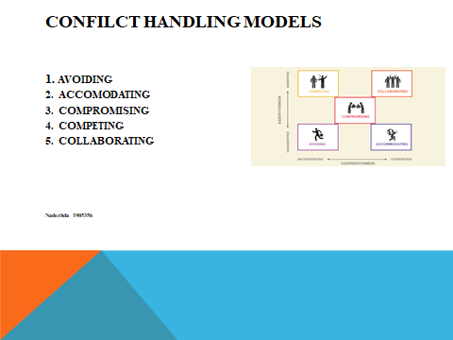
1.Avoiding -sidestepping the conflict. You simply avoid the issue. Works when it is unimportant. Effective when the issue will be very costly. Sometimes the problems resolve by themselves. In general it is not a good long term strategy.
2.Accomodating –trying to satisfy the other persons concerns at expense of your own. Actually you work against your own goals and desires. Effective, when the other part is an expert or has better solution. Also effective for presenting future relation with the other part.
3. Compromising –trying to find an acceptable settlement that only partially indulges both people concerns. This is "lose-lose" situation. Neither part really achieves what they want. May be suitable where both sides have equally important goals.
4. Competing – whereby one is better oriented toward the whole and less oriented towards the relationship with the other party. Will only see their point of view, competes to dominate and win, cares little about impact of their win, has an uncooperative and assertive attitude.
5. Collaborating- is an appropriate style for dealing with conflict when:there are different perspectives that need to be taken into account;
the involvement of all parties must be gained;
the topic is strategically important to everyone at its best and it is not desirable to have heavy commissions. trying to find a win-win solution . Here all sides co-operate to achieve the goals. This requires a high degrees of trust and reaching consensus , but could take a lot of time and effort to get everybody to agree.
Conclusions: Conflict is not a bag think. It can contribute to effective problem solving and decision making. (Partnerships, n.d.)
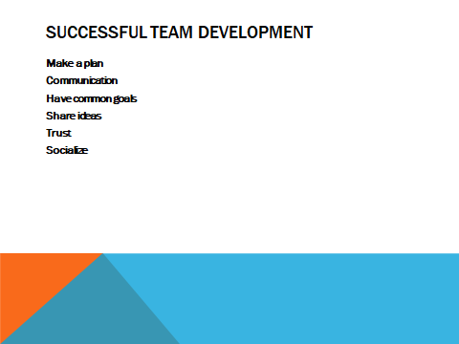
The team needs a clear and measurable goal for what you want to accomplish.
The team needs to communicate openly with each other, sharing their thoughts, opinions and ideas with members of their team, as well as taking into consideration what others have to say. Communication is essential for keeping track of progress and working together efficiently on tasks.
Be sure each team member shares the same objectives
Be transparent with information between the team. The more each team member understands the needs and circumstances of other members within the group, the easier it is for the team to be successful
This is the most important thing. Keeping the team focused on the goal, so they can constantly work on earning the trust of other team members.
Teams who work particularly well together enjoy each others company and get together outside of the office from time to time to socialise and have some fun! Building a positive relationship with your colleagues can make for a much more relaxed environment and reduce conflict.

Works Cited
BusinessBalls, n.d. BusinessBalls. [Online]
Available at: https://www.businessballs.com/team-management/tuckman-forming-storming-norming-performing-model/
[Accessed 30 04 2020].
Elsey, E.-L., 2014. The Coaching Tools Company. [Online]
Available at: https://www.thecoachingtoolscompany.com/get-your-team-performing-beautifully-with-this-powerful-group-development-model/
[Accessed 30 04 2020].
PARTNERSHIPS, M.-S., n.d. MULTI-STAKEHOLDER. [Online]
Available at: http://www.mspguide.org/sites/default/files/tool/37msp_tools_conflict_styles_37.pdf
[Accessed 01 05 2020].
Team, M. T. C., n.d. Mind Tools. [Online]
Available at: https://www.mindtools.com/pages/article/newLDR_86.htm
[Accessed 30 04 2020].
Team, M. T. C., n.d. Mind Tools. [Online]
Available at: https://www.mindtools.com/pages/article/newLDR_83.htm
[Accessed 02 05 2020].

