Student Name: Olufemi Idowu Afolabi Odubitan
Student Number: 2321211
Module Code: BMHP5015
Module Title: Changemakers: Building your Personal Brand for Sustainable Employment
Assignment Title: Component 1 - Online Portfolio of Set Exercises

Task 1. Personal Brand
Introduction
Personal brand is the impression I create in others due to my behaviour, skills and professional attitude (Philbrick and Cleveland, 2015). It is relevant to health and social care since employers appreciate employees that can be relied upon, show empathy and work with confidence in challenging situations (Montoya and Vandehey, 2008; Kam, 2020).
Reflection on My Current Brand and Areas for Growth
Working as a care assistant for seven years has shaped how people see me at work. I am often described as calm, dependable and someone that gets things done without need for constant supervision. I take pride in being patient with service users and being warm and respectful even on busy shifts. These qualities make up a large part of my personal brand.
Even though I have developed a solid foundation, I realise that I need to develop in some areas. I want to be able to communicate more confidently, especially when I am in a situation where I need to make a quick decision. I also want to develop leadership skills to take on more responsibility in the future. To do this, I intend to go on training sessions, learn from senior colleagues, and work better on how I present myself professionally which includes updating my CV and LinkedIn profile (NHS Leadership Academy, 2021).
Conclusion
By enhancing my communication skills, confidence, and leadership skills, I can establish a clearer professional identity. These improvements will help me in my long-term goal of advancing within the health and social care field and getting more ready for the opportunities ahead of me.

Task 2. Network Map and Rationale
Rationale
My current network can best be described as a hybrid network because I have a mix of close relationships, selective professional contacts and a few open connections. Most of my strongest ties are due to bonding social capital, such as my family, close friends, and a few long-term colleagues. These people provide me with emotional support, practical support and encouragement which is important for my wellbeing and motivation at work (Fan et al, 2024).
However, what I have noticed is that my bridge and linking social capital is weaker. I do not relate frequently with professionals outside of my immediate working environment and I do not normally relate with individuals from different organisations or who are in higher-level roles. This restricts my access to new opportunities, information and career avenues (Toth et al, 2022). To improve on this, I will need to increase my professional relationships by attending training sessions, participating in healthcare forums, and connecting with people working in different care settings. Increasing linking social capital or interacting more with managers and external agencies will also help me to get knowledge about the developmental pathways and get career guidance (Letnar & Sirok, 2025).
Strengthening these areas will allow me to build a more balanced and supportive network that can help me progress further in the health and social care sector.
Network Map
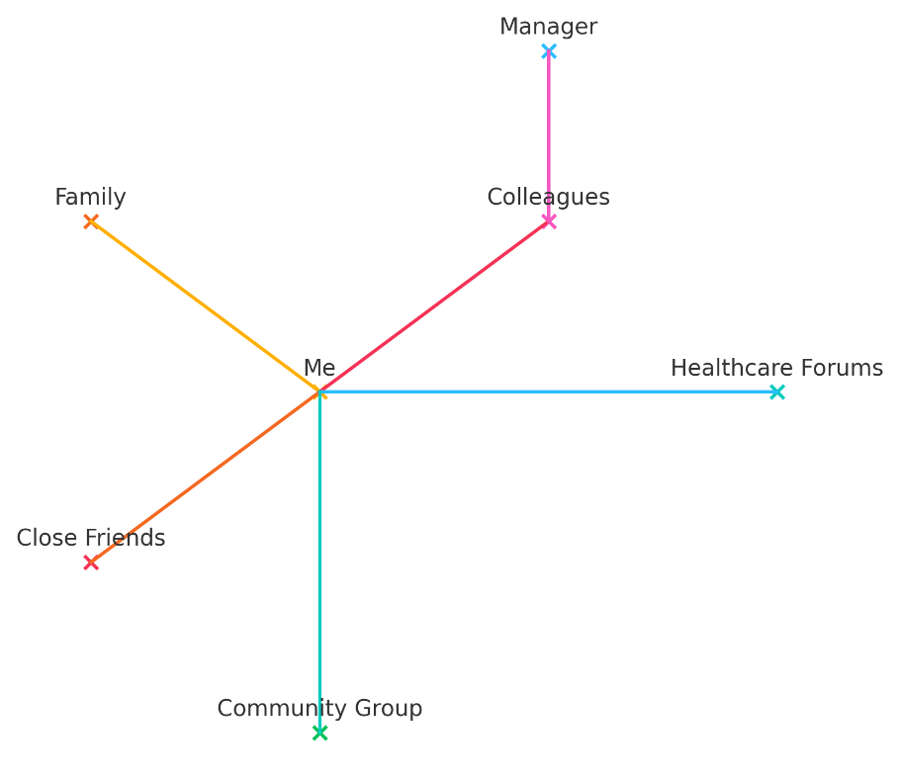

Task 3. Blog
Title: Virtual Wards: The New Home-Based Care Changing the NHS
Introduction
More people are discovering that recovery does not always have to happen in a hospital bed. Imagine resting in your own room, making your own tea, speaking with nurses through a video call, and still receiving proper clinical support. That is the idea behind virtual wards, a new approach the NHS hopes will make care feel more personal, more comfortable, and a lot less overwhelming for patients and families (NHS England, 2024).
Inside the Virtual Ward Experience
Virtual wards allow patients to stay at home while being monitored by a clinical team through digital tools (as shown in fig 1).
Fig 1 Virtual Ward Prototype
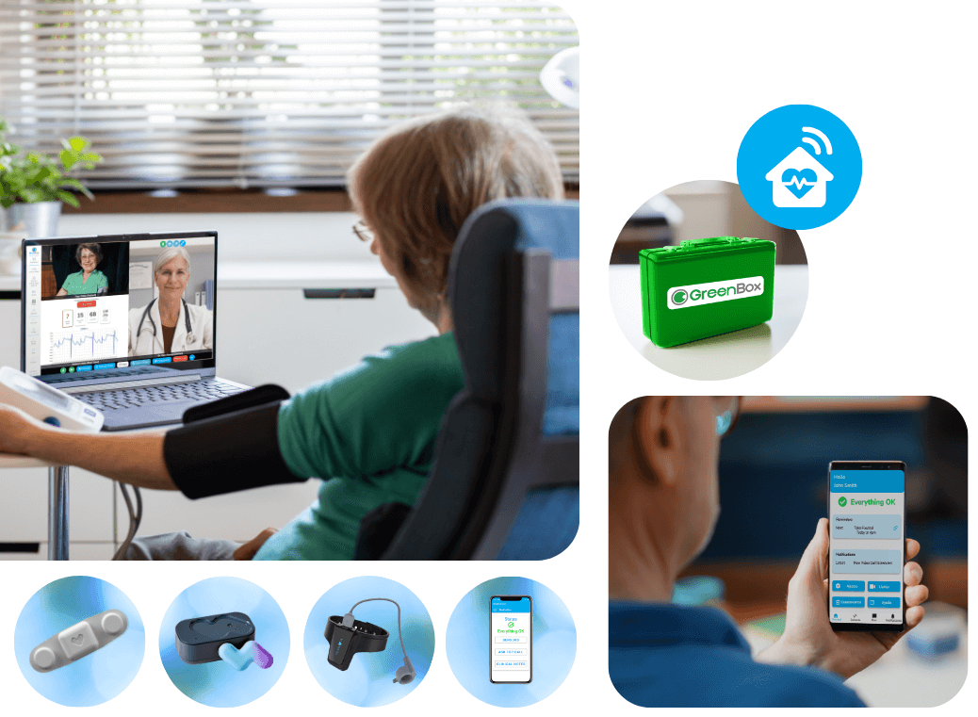
Extracted from RedZinc Services Ltd - https://redzinc.net/blueeye/blueeye-virtual-ward/
A pulse oximeter might track oxygen levels, an app might send reminders, and scheduled calls help nurses check progress (Fig 1). When it works well, the entire experience is more calming than staying in the hospital. Many patients state that they sleep better, are less stressed, and feel good to have loved ones near them, which makes their recovery path a smoother one (Lyndon et al, 2025).
The NHS had planned to extend these services across England although progress has not been equal everywhere. Some areas are well resourced with digital support and trained staff while other areas struggle with internet access, old devices, or patients who feel lost about technology (NHS England, 2024). Digital exclusion remains one of the biggest barriers particularly for older people who may not feel confident using apps or monitoring equipment (UK Parliamentary Office of Science and Technology, 2025).
Despite the difficulties, there is still promise in virtual wards. They ease the pressure on hospitals, speed up discharges and assist clinical teams to focus on patients that require in-person care (see fig 2 on examples of pressures on NHS services). For many people, the opportunity to get well at home is a breath of fresh air.
Fig 2. Examples of pressures on NHS services
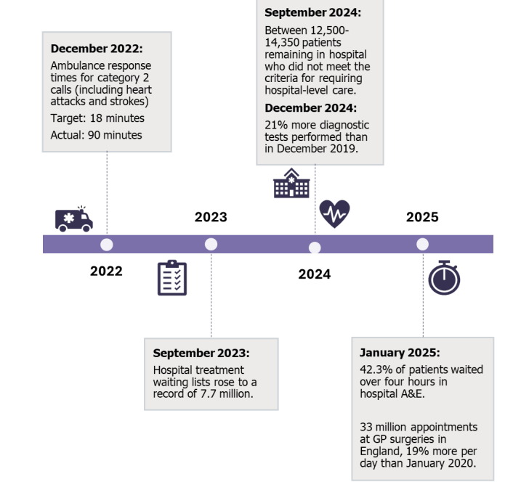
Extracted from UK Parliamentary Office of Science and Technology - https://researchbriefings.files.parliament.uk/documents/POST-PN-0744/POST-PN-0744.pdf
Conclusion
Virtual wards are not perfect yet, although they offer a kinder and more flexible way for people to heal. With better digital support and more equal access, they could become a meaningful part of everyday healthcare. It might be worth keeping an eye on how this service continues to grow.

Task 4- Equality and Diversity Quiz
- What is the primary goal of the NHS Equality, Diversity, and Inclusion Improvement Plan?
To stop discrimination in the NHS workforce and create workplaces where everyone feels they belong and can perform safely and fairly. The plan sets out actions and accountability to make that cultural change happens.
- How does the NHS EDI Improvement Plan propose to tackle the gender pay gap?
The plan asks organisations to analyse pay by protected characteristic, apply recommendations such as those from Mend the Gap, and put in place actions and monitoring to close gaps over time. It also promotes flexible working to support parity (NHS England, 2023).
- What is meant by the term ‘intersectionality’ as used in the NHS EDI Improvement Plan?
Intersectionality means people have multiple linked identities that can combine to create unique barriers, so the plan treats inequalities as overlapping rather than separate (NHS England, 2023). This helps target actions where disadvantage is compounded.
- Why is it important for the NHS to create a psychologically safe work environment?
Psychological safety lets staff speak up, learn from mistakes and work together effectively, which improves wellbeing and patient safety (O’Donovan & McAuliffe, 2020). Inclusive teams that feel safe are more likely to deliver better care.
- How does the NHS EDI Improvement Plan suggest improving the experience of internationally recruited staff?
The plan recommends clear pre-arrival information, strong induction, pastoral support and equal access to training so international staff feel welcomed and can progress. Line managers should also be culturally aware to build inclusive teams (NHS England, 2023).

- What role does leadership play in advancing EDI objectives according to the NHS Improvement Plan?
Leaders must model inclusive behaviour, be held accountable for EDI objectives and make decisions that embed fairness across the organisation. Board level commitment is central to driving lasting change.
- Identify one way the NHS EDI Improvement Plan aims to reduce health inequalities within the workforce.
Reduce bullying and increase civility so that those most affected by poor treatment do not suffer worse health, absence or turnover. This improves staff wellbeing and helps retain a diverse workforce (NHS England, 2023).
- Why does the NHS EDI Improvement Plan emphasise the importance of collecting and analysing data on protected characteristics?
Good quality data reveals where inequalities exist, shows whether interventions work, and helps target resources where they are most needed. Reliable evidence is needed for accountable change.
- Explain how flexible working policies can contribute to equality and inclusion in the NHS workforce.
Flexible working helps staff balance caring duties, health needs or study commitments so more people can join, stay and progress in the NHS. This reduces barriers that otherwise limit opportunity for some groups (Iacobucci, 2023).
- What is one strategy mentioned in the NHS EDI Improvement Plan to combat bullying and harassment in the workplace?
The plan requires trusts to review bullying data, set reduction targets and use early, proactive interventions rather than relying only on formal complaints. This approach aims to prevent harm and protect those who raise concerns (NHS England, 2023).

Task 5- A Letter to Yourself
Dear Younger Me,
I recall the time when you were struggling in silence in your early years as a care assistant. You were working long shifts, trying to please everybody and carrying the emotional weight of the people you cared for. You pushed yourself because you believed that if you showed the slightest sign of tiredness you were not strong enough to do the job. Looking back now, I can see how low your wellbeing was even though you tried to hide it.
If I could get you at that moment, I would tell you that emotional intelligence is not about pretending everything is fine. It is about noticing your own emotions and knowing when you are feeling drained and giving yourself permission to pause. You were often able to pick up on the emotions of those around you, but you did not pay attention to your own. Developing self-awareness would have helped you recognise the early signs of burnout instead of pushing through every day as if nothing was wrong.
I would also remind you that you do not build resiliency by suffering in silence. It grows by support, reflection and small habits which protect your mental and physical health. Taking short breaks, asking for help, talking to a colleague or allowing yourself to step back for a moment would not have made you weak. It would have made you stronger and more balanced.
Most of all, I want you to know that looking after yourself is part of caring for others. You deserved the same compassion you gave to everyone else.
With kindness,
Your Older Self.

Task 6 - Gantt Chart
Goal: Becoming a Nursing Associate
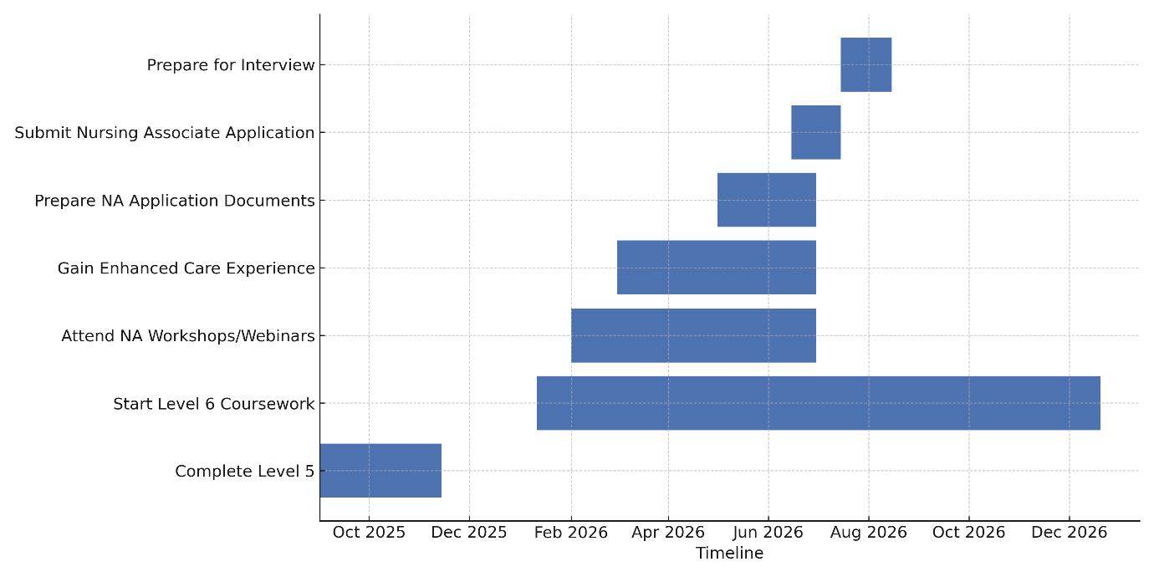
The above Gantt chart outlines the main steps I need to complete on my pathway to becoming a Nursing Associate. Level 5 ends in November 2025, and Level 6 begins in January 2026, so the chart starts by showing my transition into Level 6, which will run throughout the year. This is an essential dependency because I must complete Level 6 before I can progress into a Nursing Associate role.
From February 2026, I included Nursing Associate workshops and webinars to increase my understanding of the role and strengthen my application. At the same time, I plan to take on enhanced care duties within my workplace to gain experience that matches the Nursing Associate competencies. These two activities run alongside my Level 6 studies, which is realistic because many students in health and social care balance coursework with work-based learning.
From May-July 2026, I will work on my application documents, including my personal statement, references and evidence of skills. The chart then indicates the period of application submissions in June, followed by preparation for the interviews from mid-July through mid-August. These final tasks depend on completing the earlier preparation stages.
In summary, the timeline can help me to stay organised, manage overlapping tasks and track my progress towards becoming a Nursing Associate.

Task 7 – Change Management Plan
Introduction
As a care home manager, I plan to introduce a small Staff Wellbeing Corner to support emotional and mental wellbeing during busy shifts. This space will provide a quiet area for short breaks, helping staff manage stress more effectively.
Planning the Change
Using Lewin's change model, I will start with "unfreezing" current habits and explaining why a well-being space is needed especially as many staff are reporting feelings of fatigue and stress (Lewin 1947; Kotter 2011). I will engage with some of the senior carers to help design the space and choose resources such as a hydration station, calming music and simple tools for relaxing. Once created, staff will be encouraged to take short wellbeing breaks in quiet times. Feedback will be collected monthly as the space is refined.
Skills Required
This change needs leadership, empathy and clear communication for staff to understand that wellbeing is a priority (Issah, 2018). I will also need organisational skills to organise space, resources, scheduling and monitor how the change impacts morale and performance over time.
Barriers and Solutions
A common barrier could be that staff may perceive that they "do not have time" for short breaks. To overcome this, I will communicate evidence that shows that short restorative pauses improve focus and reduce errors. Another barrier is limited space so I will reuse an unused storage corner. Staff resistance may also occur so early involvement and reassurance that the wellbeing corner is for everyone will help to build trust and acceptance.
Conclusion
Creating a Staff Wellbeing Corner is a simple but meaningful change that can increase morale, reduce stress and support for safer and more compassionate care delivery.

Task 8 – Self-Reflection (Using Gibbs’ Reflective Cycle)
Description
A moment that really made me think during this module was when I had to plan my career path properly and plan my steps towards being a Nursing Associate. I have been working in care for years, but I have never sat down and looked at my future in a structured way.
Feelings
At first, I was unsure and a bit intimidated since it made all this feel "real." I also felt slightly stressed because I wasn't sure if I was doing it right. As I went further down I began to feel that I was more focused and even relieved because what I was to do helped me organise my thoughts.
Evaluation
I believe I did a good job of being honest with myself as to my strengths and areas I need to work on. I also got involved much more than I thought I would. The part that I struggled with was admitting there were gaps in my skills which was uncomfortable for me.
Analysis
Looking back, the task was important because it forced me to stop working on autopilot and think about the type of professional I want to be. It also taught me how important emotional intelligence is in health and social care as well as planning and self-awareness. I realised that I am always supporting everyone else but rarely check in with myself.
Conclusion
If I were to do this again, I would allow more time for myself and not rush at the beginning stages because reflection is much more effective when I slow down.
Action Plan
I am planning to continue to reflect on short weekly practices, to build on my confidence through training, and to use the knowledge I have gained to make more conscious choices about my future.

References
Fan, J., Chang, Y., Li, L., Jiang, N., Qu, Z., Zhang, J., Li, M., Liang, B., & Qu, D. (2024). The relationship between medical staff burnout and subjective wellbeing: the chain mediating role of psychological capital and perceived social support. Frontiers in Public Health, 12. https://doi.org/10.3389/fpubh.2024.1408006
Gibbs, G. (1988) Learning by Doing: A Guide to Teaching and Learning Methods. Oxford: Oxford Polytechnic.
Iacobucci, G. (2023). Improving flexible working in the NHS. BMJ, 380. https://doi.org/10.1136/bmj.p618
Issah, M. (2018). Change Leadership: The Role of Emotional Intelligence. SAGE Open, 8. https://doi.org/10.1177/2158244018800910
Kam, P. (2020). ‘Social work is not just a job’: The qualities of social workers from the perspective of service users. Journal of Social Work, 20, 775 - 796. https://doi.org/10.1177/1468017319848109
Kotter, J. P. (2011) Leading Change. Harvard Business Review Press.
Letnar, M., & Širok, K. (2025). The Role of Social Capital in Employability Models: A Systematic Review and Suggestions for Future Research. Sustainability, 17(5), 1782. https://doi.org/10.3390/su17051782
Lewin, K. (1947). Frontiers in group dynamics: Concept, method and reality in social science; social equilibria and social change. Human Relations, 1(1), 5–41. https://doi.org/10.1177/001872674700100103
Lyndon, H., Viney, T., & Slade, V. (2025). A service evaluation of virtual wards in Cornwall, UK. Oxford Open Digital Health, 3. https://doi.org/10.1093/oodh/oqaf008
Montoya, P. and Vandehey, T. (2008) The Brand Called You: Create a Personal Brand That Wins Attention and Grows Your Business. McGraw-Hill, New York.
NHS England. (2023). NHS equality, diversity and inclusion improvement plan. NHS England.
NHS England. (2024). Virtual wards operational framework (Publication No. PRN01289). https://www.england.nhs.uk/long-read/virtual-wards-operational-framework/
NHS Leadership Academy (2021) Healthcare leadership model. Available at: https://www.leadershipacademy.nhs.uk (Accessed: 1 November 2025).
O’Donovan, R., & McAuliffe, E. (2020). Exploring psychological safety in healthcare teams to inform the development of interventions: Combining observational, survey and interview data. BMC Health Services Research, 20, 810. https://doi.org/10.1186/s12913-020-05646-z
Philbrick, J., & Cleveland, A. (2015). Personal Branding: Building Your Pathway to Professional Success. Medical Reference Services Quarterly, 34, 181 - 189. https://doi.org/10.1080/02763869.2015.1019324
RedZinc Services Ltd. (2025, March 31). BlueEye Virtual Ward. https://redzinc.net/blueeye/blueeye-virtual-ward/
Tóth, Z., Nemkova, E., Hizsák, G., & Naudé, P. (2022). Social capital creation on professional sharing economy platforms: The problems of rating dependency and the non-transferability of social capital. Journal of Business Research, 144, 450–460. https://doi.org/10.1016/j.jbusres.2022.01.090
UK Parliamentary Office of Science and Technology (POST). (2025). Virtual wards and hospital at home (POSTnote 744). Parliamentary Office of Science & Technology. https://researchbriefings.files.parliament.uk/documents/POST-PN-0744/POST-PN-0744.pdf
Walby, S., Armstrong, J., & Strid, S. (2012). Intersectionality: Multiple Inequalities in Social Theory. Sociology, 46, 224 - 240. https://doi.org/10.1177/0038038511416164

