Student name- Carys Lewis-Hopkins

Number- 2403919

Programme of Study- Level 4 Surface Pattern and Textile Design

Module- ADDA4023 Ways Of Perceiving

Lecturer- Julia Lockheart

Word count- 1382

.

I intend to curate an exhibition featuring five pieces of work. In an world that is controlled by fast fashion and batch production, my exhibition of fashion reimagined looks at the shift to sustainable acts with the fashion world. Fashion is the one of the main contributors of material waste and environmental damage, however could also be a massive factor to help improve the health of out planet. My exhibition aims to stand against the traditional fashion practices by exhibit innovative designs that make sure that the sustainable methods, materials are a priority. Focusing on theorists like Kate fletcher, Tim Jackson and Daniel miller. For example miller’s theory of how objects carry meaning and social memory. Looking at how fashion is not just a piece of clothing and actually carry an individual story to each person.
The exhibition will concentrate on crucial questions. How will/can the world of fashion adapt without endangering the planets health even more ? The idea of using recycled materials to create a new form of something that is just as aesthetically pleasing helps push the idea that fashion doesn’t need to be new to have a meaning. Influenced by artists like Stella McCartney who often recycle materials her work to draw attention to waster and the over consumption in the world of fashion, she creates pieces that emphasise the need for sustainable practices is art and everyday life.

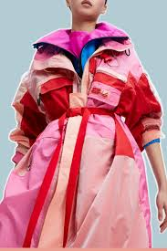
Upcycled Couture by Stella McCartney
Fig 1.
An innovative and avant-garde dress, crafted from entirely repurposed and unused textiles, reflecting a bold departure from conventional fashion design. This piece embodies the philosophy of zero waste, transforming what would typically be considered waste materials into beautiful, wearable art. It symbolises a shift toward sustainability by showcasing how fashion can evolve from a disposable mindset to one that values resourcefulness and creativity. Stella McCartney’s up-cycled couture serves as a brilliant fusion of high fashion and environmental responsibility. As a pioneer in the sustainable fashion movement, McCartney has consistently pushed the boundaries of the industry, challenging the status quo of using virgin materials for luxury garments. By reimagining waste textiles as the foundation for her couture pieces, she not only helps combat textile waste but also redefines what materials are deemed valuable in the world of fashion. Her designs continue to uphold the standards of elegance and quality that are synonymous with couture, proving that sustainability does not have to compromise on style, craftsmanship, or luxury. Through her work, McCartney highlights the hidden beauty of repurposed fabrics, offering a stark critique of the fast fashion industry’s culture of overconsumption and disposability. The dress exemplifies how thoughtful design and responsible sourcing can merge to create pieces that are not only fashion-forward but also contribute to a more sustainable and ethical fashion landscape. Her upcycled couture demonstrates that high-end fashion can be both artful and conscientious, providing a solution to the pressing issue of waste in the fashion industry.
McCartney’s upcycled couture challenges the pervasive disposable culture that has come to dominate the fashion industry by championing the value of reuse and highlighting that luxury and sustainability are not mutually exclusive. Through her visionary approach, she proves that it’s possible to have both elegance and environmental consciousness, paving the way for a future where the fashion industry is more mindful of its ecological impact while maintaining its standards of creativity and luxury.

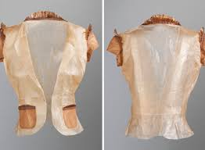
Bio fabricated Textiles by Suzanne Lee
Fig 2.
A blouse that is handcrafted and grown from bacterial cellulose. This is a great piece to show through my production by harnessing biology as a design partner. Suzanne Lee’s groundbreaking bio fabricated textiles showcase the intersection of biology and fashion, using microbial cellulose to create sustainable fabrics. The process involves fermenting bacteria to produce a cellulose layer, which is then processed into textile material. This innovative approach minimises the environmental footprint compared to conventional textile manufacturing, which often relies on intensive water, energy, and chemical use. By growing garments rather than producing them from conventional fibres, Lee’s work challenges the traditional fashion cycle and opens up new possibilities for circularity and biodegradability. These living fabrics question the permanence of garments, as they can decompose and return to the earth after use, embodying a radical shift toward closed-loop fashion systems. The significance of this being a part of my exhibition is that it starts questions about living materials, biodegradability, and correct sustainable design practices.

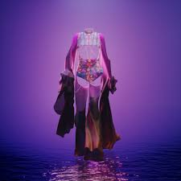
Digital Fashion by The Fabricant
Fig 3.
A series of virtual garments designed for the digital realm. Eliminates material waste by existing solely in virtual environments. The Fabricant’s digital fashion pioneers a new paradigm where garments are created entirely in the digital space, eliminating the physical waste associated with traditional fashion. These virtual garments are designed for social media, virtual worlds, and augmented reality, appealing to a generation increasingly invested in their online presence. By challenging the necessity of physical production, The Fabricant’s work questions fashion’s materiality while offering a sustainable alternative. The creativity unleashed by digital fashion highlights a future where fashion exists without fabric, addressing the industry’s environmental impact by focusing on data rather than textiles. Challenges the traditional concept of garments and promotes a digital-first approach to sustainable fashion.

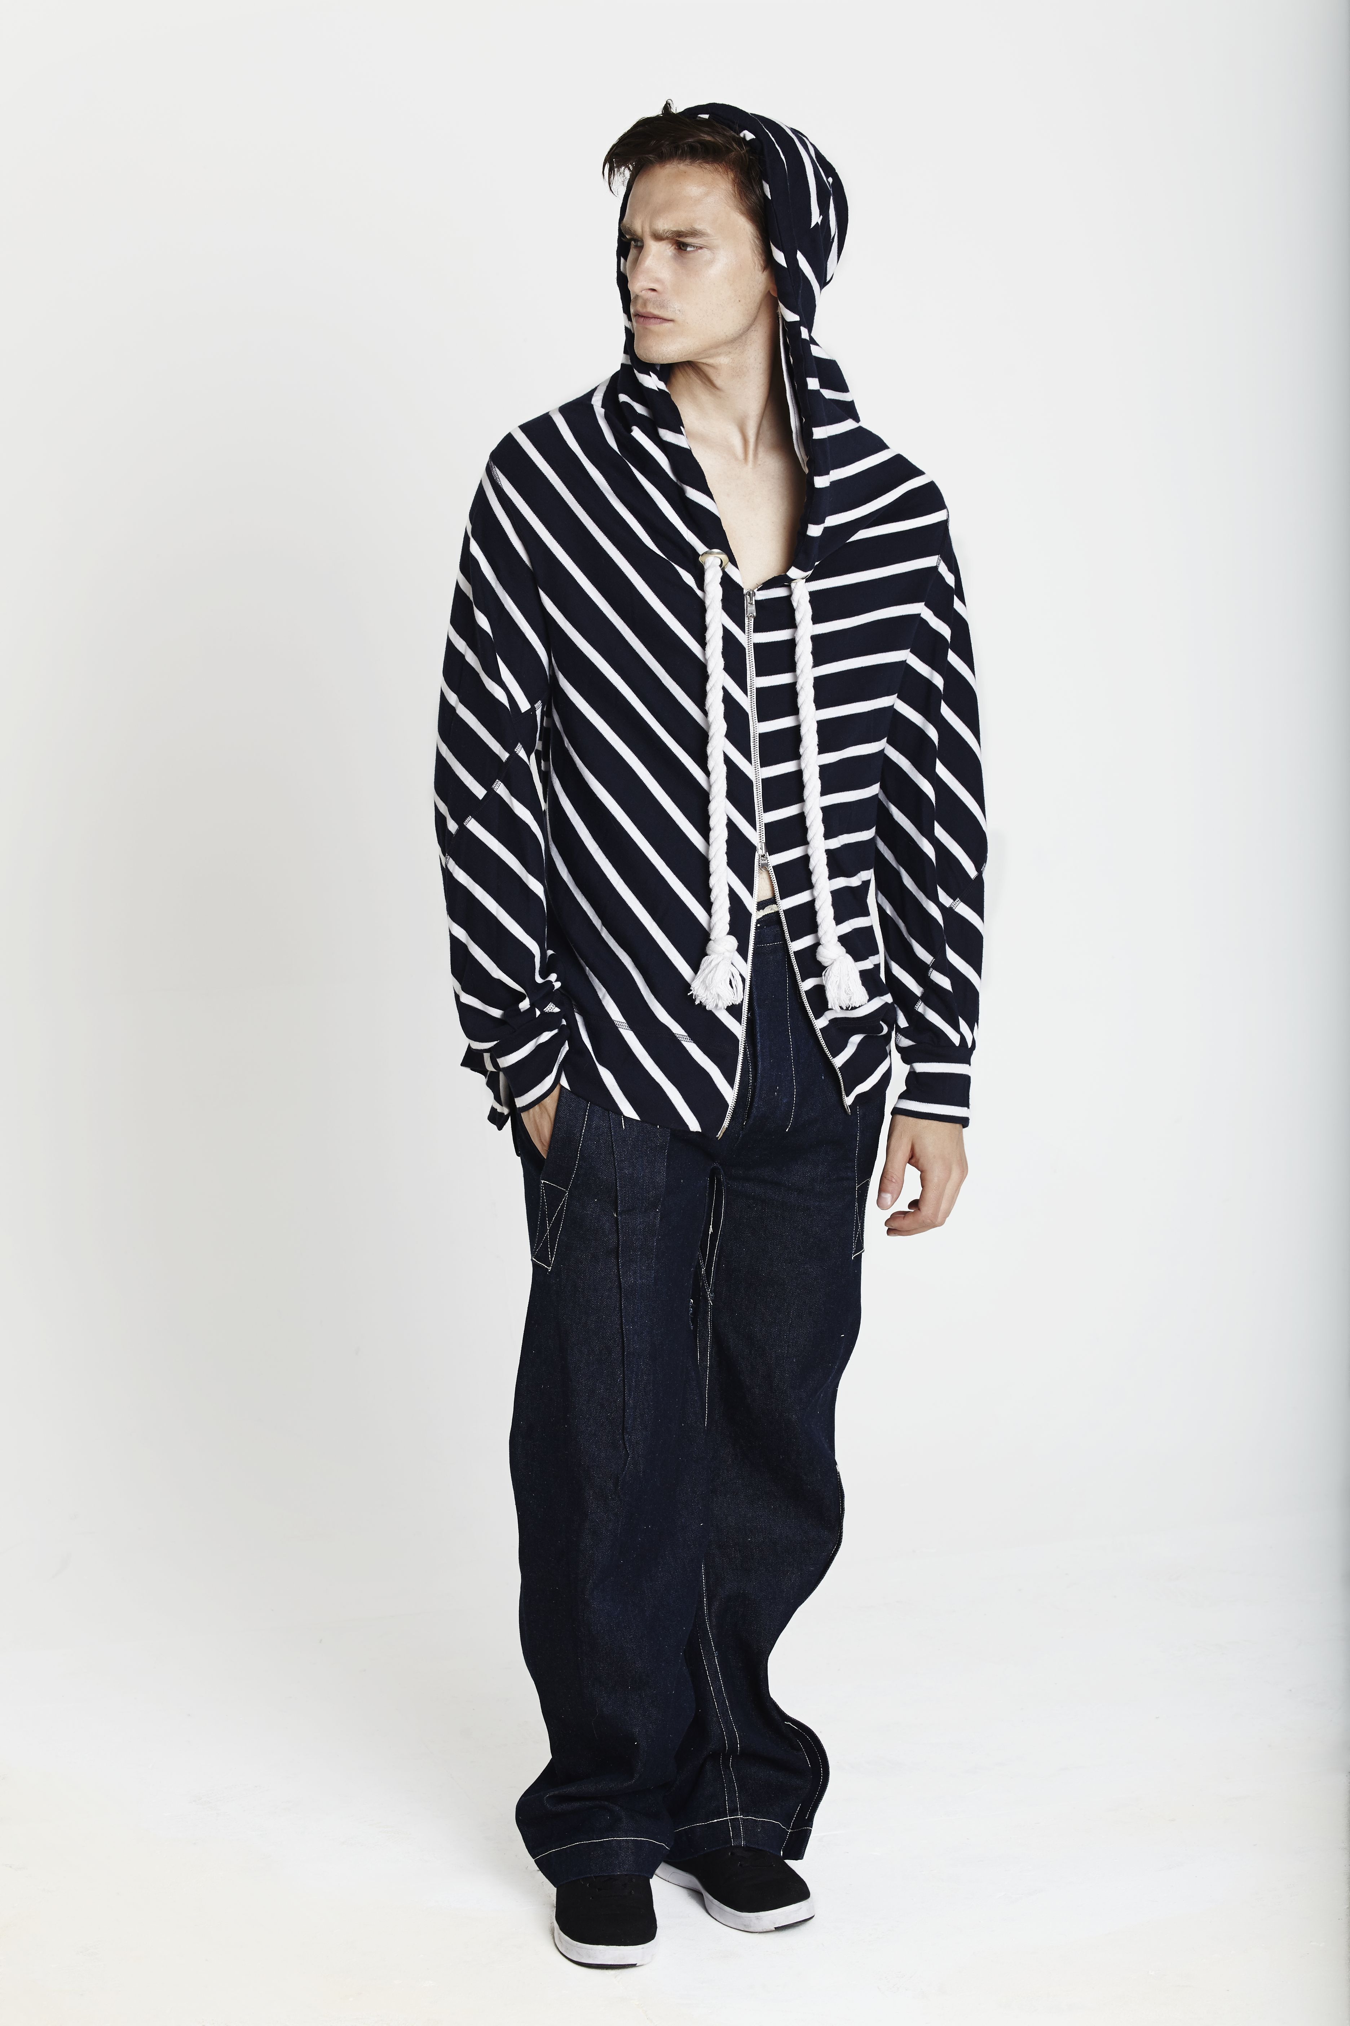
Zero-Waste Pattern Hoodie by Timo Rissanen

Garments designed using a method that completely eliminates fabric waste during the cutting process, ensuring that every piece of fabric is fully utilised. This technique challenges traditional garment construction by minimising waste right from the early stages of design, specifically at the pattern stage, where fabric is typically cut and discarded. Timo Rissanen’s zero-waste pattern designs directly address one of fashion’s most critical issues: textile waste. The fashion industry is notorious for generating large amounts of waste during the cutting process, where excess fabric is often discarded. Rissanen’s approach, however, uses every inch of the fabric by designing patterns that fit together in a way that eliminates waste. This method not only reduces material loss but also exemplifies a more intentional and sustainable approach to fashion design. His garments retain both aesthetic appeal and functional quality, demonstrating that sustainability need not come at the cost of style or wearability. Rissanen’s work pushes the boundaries of traditional garment production, encouraging the fashion industry to rethink its reliance on conventional cutting and sewing methods. By promoting this zero-waste practice, he advocates for more efficient and environmentally-conscious production processes that can be adopted on a larger scale.
Rissanen’s innovative approach to pattern-making illustrates the significant potential of design innovation to reduce textile waste and improve sustainability in the fashion industry. His work proves that by rethinking traditional techniques, designers can play a crucial role in mitigating the environmental impact of fashion, all while maintaining the elegance and quality that consumers expect. Through this approach, Rissanen not only pioneers a more sustainable future for garment construction but also sets an example for other designers to follow.

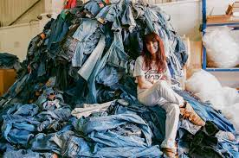
Reclaimed Denim Collection by E.L.V. Denim
Fig 5.
Denim garments reimagined through deconstruction and reconstruction. Comments on denim’s environmental impact and the potential for renewal. E.L.V. Denim’s reclaimed denim collection exemplifies sustainable fashion by reworking vintage and discarded denim into innovative new pieces. By deconstructing old garments and creatively combining materials, E.L.V. Denim highlights the potential of up-cycling to minimise textile waste. This process challenges the disposable nature of fashion, presenting reclaimed denim as both a statement on sustainability and a stylish, contemporary alternative to mass-produced jeans. The brand’s commitment to transparency and ethical production further reinforces its role as a leader in circular fashion. The collection not only preserves the character and story of each piece but also challenges consumers to value quality, creativity, and reuse over convenience and consumption. Reflects on the circular economy in fashion and the importance of creative reuse.

Conclusion
Fashion Reimagined illustrates that sustainability is not just a passing trend but a pivotal transformation in the way fashion should function. Through innovative practices such as up-cycling, bio fabrication, and sustainable design, these works urge us to rethink our relationship with clothing and its broader environmental impact. They challenge the traditional model of consumption, advocating for a more circular and mindful approach. As the fashion industry evolves, exhibitions like this spark crucial conversations and inspire both critical reflection and responsible consumer choices. Ultimately, they contribute to a shift towards a more sustainable, ethical, and future-conscious fashion landscape.

Bibliography

- Fletcher, K. (2014). Sustainable Fashion and Textiles: Design Journeys.
- Jackson, T. (2009). Prosperity without Growth: Economics for a Finite Planet.
- Lee, S. (2015). Fashioning the Future: Tomorrow’s Wardrobe.
- The Fabricant. (2020). Virtual Fashion: The Next Frontier.
- E.L.V. Denim. (2021). Sustainable Denim Practices.

Figs
1. Conti, S. (2021). Luxury Is Wasting Away, Says Stella McCartney Who’s Celebrating Scraps. [online] WWD. Available at: https://wwd.com/feature/luxury-is-wasting-away-says-stella-mccartney-whos-celebrating-scraps-1234725790/ [Accessed 13 May 2025].
2. CLOT Magazine | An online publishing platform dedicated to the most experimental art forms. (2014). SUZANNE LEE, exploring the frontiers of BioCouture. [online] Available at: https://clotmag.com/design/suzanne-lee-exploring-biocouture.
3. www.showstudio.com. (n.d.). Can The Fabricant Convince The Industry Fashion’s Future Is Online? | SHOWstudio. [online] Available at: https://www.showstudio.com/news/can-the-fabricant-convince-the-industry-fashions-future-is-online.
4. Addresspublications.com. (2016). with Timo Rissanen «ADDRESS. [online] Available at: https://www.addresspublications.com/with-timo-rissanen/ [Accessed 13 May 2025].
5. Cockerell, C. (2025). From landfill to London Fashion Week: meet E.L.V. Denim, the brand that wants your old jeans. [online] The Standard. Available at: https://www.standard.co.uk/lifestyle/fashion/elv-denim-sustainable-jeans-upcycling-london-vintage-b1221816.html.

