

Methods and Search Strategy Academic Poster

Student name: Bianca Vili
Student ID: 2210551

Module name: Independent Project
Module code: BMHP6020

h
A Search strategy in secondary research is a planned and structured approach to identifying relevant existing studies or data with the appropriate keywords, databases, and applying specific criteria to efficiently locate pertinent information (Qualtrics, 2021).
In this dissertation, the search component was in Population, Intervention, Outcome, Location, Combined Search, and the Key topics are “Adults, middle-aged +18” “Behaviour change, lifestyle intervention, health promotion, behavioural therapy” and “Obesity, weight loss, overweight, BMI reduction” with focused in UK, United Kingdom, England, Scotland, Wales”. and The Boolean Operators as “OR” and “AND”
Data base used: PubMed, Google Scholar, NHS Digital, NICE, GOV.UK, WHO and UWTSD library.

- Peer-reviewed articles,
- UK based adult studies,
- Behaviour change focus,
- English language,
- With 10 years of research (2015-2025)

- Animal studies,
- Children and adolescents,
- Interventions unrelated to behaviour change.

While doing this dissertation, I made sure to follow ethical guidelines for secondary research, as defined by the National Institute of Environmental Health Sciences (2024). I only used trusted sources like NHS Digital, GOV.UK, WHO, NICE and made sure the properly reference everything to avoid plagiarism. The data I used didn’t include any personal or identifiable information, so privacy was respected. I also checked that all my sources were reliable and up-to-data and followed legal rules like GDPR. If any data required informed consent, I made sure it was clearly stated in the original research. This helped me keep my work responsible and trustworthy.

 Ethical Considerations
 Exclusion Criteria
 Inclusive Criteria

Data collection and analysis are crucial in research, as high-quality data allows for accurate findings and credibility. Errors can occur, making data integrity vital to protect reputation (Elsevier, 2024). The data what I used in this research has been sourced from official, peer-reviewed, and government-backed publications, including NHS Digital, GOV.UK, NICE, WHO and UK Health Security Agency. These sources ensure reliability and accuracy through nationality representative sampling and consistent annual reporting. This validated evidence supports the evaluation of behaviour change interventions, showing that despite growing awareness, obesity rates remain hight and highlighting the need for more targeted and sustainable approaches.

 Research Validation and Analysis
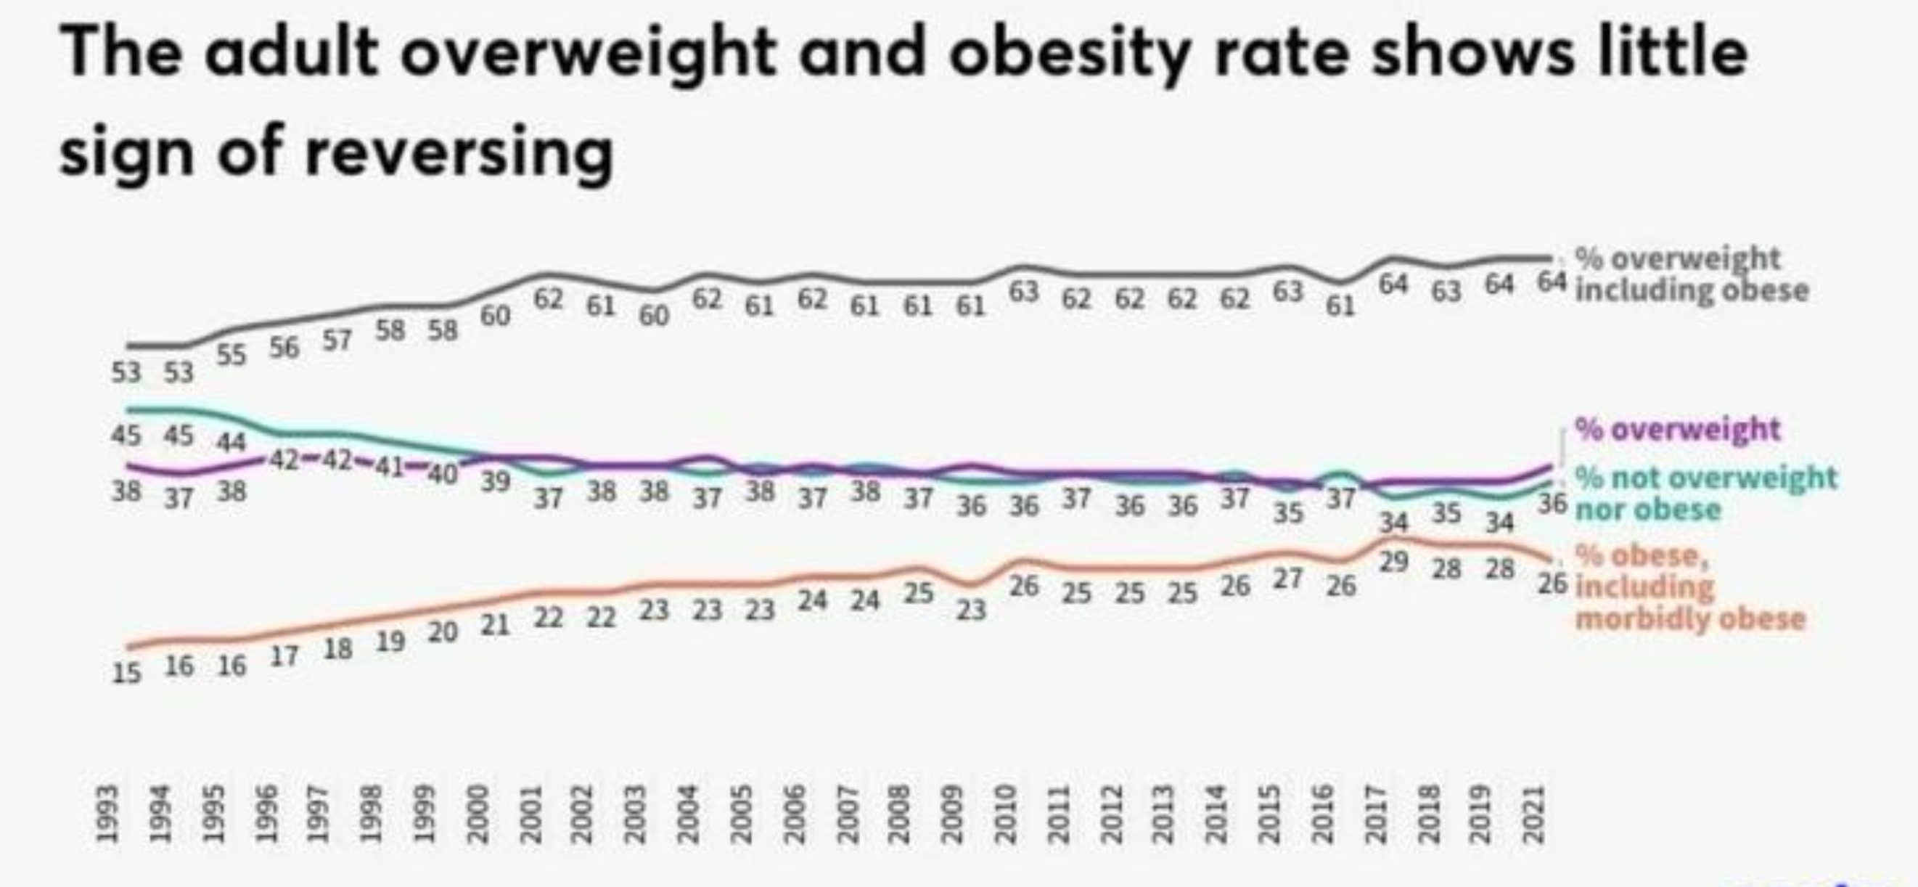

This graphic highlight that obesity was rare in the 1980s but has steadily risen over time, especially among older adults. Today, around two-thirds of adults are overweight or obese.

(Health Survey for England,2021)

Rising Rates: Overweight and Obesity in England’s Adult Population
 Searching for Information

The Methods Chapter outlines the procedures and strategies used to conduct the study and provides a detailed explanation of the research design, data collection, and analysis methods, offering the study’s validity and reliability (GradCoach n.d)
This poster includes research design, search strategy, inclusion and exclusion criteria, screening process, data extraction and analysis, ethical consideration.
The aim of this research is to evaluate the effectiveness of behaviour change interventions in reducing obesity among adults in the UK. The study will assess the impact of different interventions on weight reduction, maintenance, and overall health outcomes while identifying the key factors influencing their success or failure.

 Search Strategy
 Introduction and Research Aim
Are Behaviour Change Interventions Effective in Reducing Adult Obesity in UK?
References
I used a Secondary Research Approach trough a structured literature review to assess the effectiveness of behaviour change interventions in reducing adult obesity in the UK. The key sources used are PubMed, Google Scholar, NICE Evidence, WHO, NHS Digital, Science Direct and UWTSD library. For a accuracy and clarity in my searching was used CRAAP and PRISMA.

Elsevier (2024)’Why is data validation important in research?’ Available at: https://scientific-publishing.webshop.elsevier.com/research-process/why-is-data-validation-important-in-research/#:~:text=Data%20validation%20is%20the%20process,the%20completeness%20of%20your%20data.

GOV.UK (2024)’ Obesity Profile: Short Statistical Commentary’, Office for Health Improvement & Disparities, Available at: https://www.gov.uk/government/statistics/update-to-the-obesity-profile-on-fingertips/obesity-profile-short-statistical-commentary-may-2024?utm_source=chatgpt.com

GradCoach (n.d.) How to write the methodology chapter (with examples). Available at: https://gradcoach.com/how-to-write-the-methodology-chapter/ (Accessed: 12 March 2025)

Qualtrics (2021) Secondary research: Definition, methods & examples. Available at: https://www.qualtrics.com/experience-management/research/secondary-research/ (Accessed 18 March 2025)

NHS England Digital (2024)’Health Survey for England’, Adult overweight and obesity Available at: https://digitalnhs.uk/data-and-information/publications/statistical/health-survey-for-england/2022-part-2/adult-overweight-and-obesity?utm_source=chatgpt.com

NHS Digital (2022)’NHS Health Survey for England2021: Overweight and Obesity in Adults’ [online] Available at:
https://digital.nhs.uk/data-and-information/publications/statistical/health-survey-for-england/2021/overweight-and-obesity-in-adults
(Accessed 12 May 2025)

PRISMA Flow Diagram Generator (n.d.) Available at: https://www.prisma-statement.org/. https://prisma-statement.org/PRISMAStatement/FlowDiagram.aspx (Accessed: 5 January 2025)

