Cover Page

Contents
Introduction 1
Task 1. e-Commerce Website builders/software solutions 1
1.1 Google side 1
1.2 WooCommerce 1
Task 2. Mind-map of contemporary software applications 1
2.1 Describe mind mapping and explain the benefits of using mind mapping 1
2.2 Create a mind map of contemporary software applications 2
Task 3. Office Applications 2
3.1 Four office software solutions for business operations 2
Ms Word 2
Ms Excel 3
Ms PowerPoint 3
Ms Access 3
3.2 Test any two features 3
Mail Merge 3
IF Statement 3
Task 4. Communication and Collaboration applications 3
4.1 One contemporary Communication and one Online Collaboration 3
Gmail 3
Zoom 4
4.2 Test one feature of a freely available Communication (1) and one feature of a Collaboration (1) application 4
Gmail 4
Zoom 4
Conclusion 4
References 4

Introduction
E-commerce website builders are software platforms that enable businesses to create, manage, and maintain online stores without requiring advanced programming knowledge. These platforms provide tools for designing websites, managing products, processing payments, and tracking customer orders. They have become essential for businesses of all sizes because they reduce the cost and complexity of establishing an online presence. Two of the most widely used contemporary e-commerce website builders are Shopify and Wix eCommerce.

Task 1. e-Commerce Website builders/software solutions

1.1 Google side
<Insert info for ecommerce 1 here>

1.2 WooCommerce
<Insert info for ecommerce 2 here>

Task 2. Mind-map of contemporary software applications

2.1 Describe mind mapping and explain the benefits of using mind mapping
<Mind mapping information here>

2.2 Create a mind map of contemporary software applications

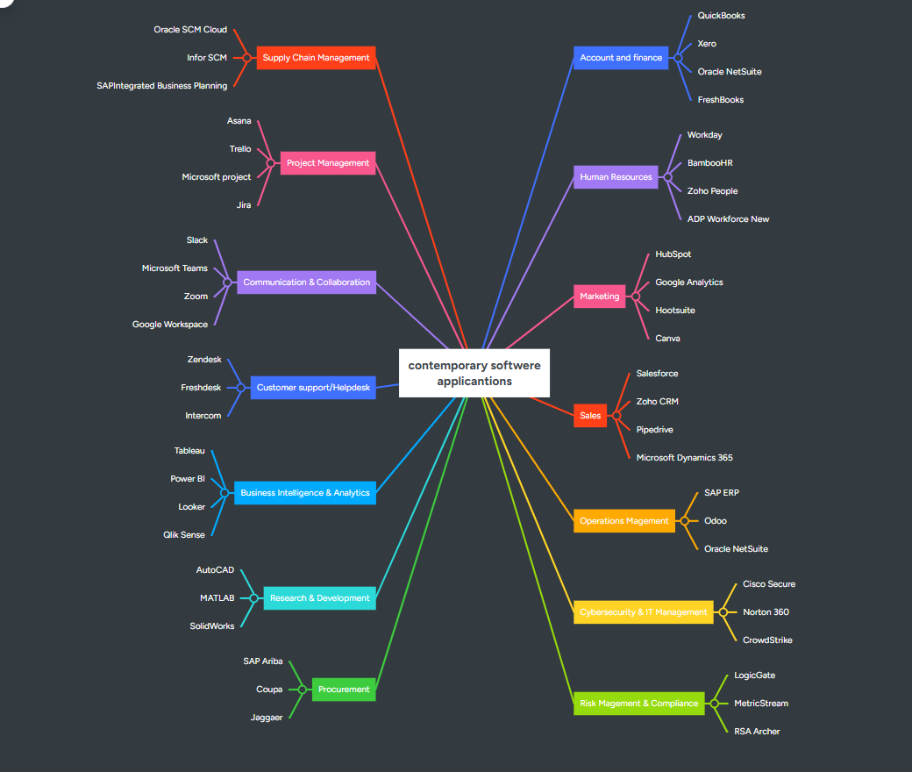

Task 3. Office Applications

3.1 Four office software solutions for business operations

Ms Word
<Word information here>

Ms Excel
<Excel information here>

Ms PowerPoint
<PowerPoint information here>

Ms Access
<Access information here>

3.2 Test any two features

Mail Merge
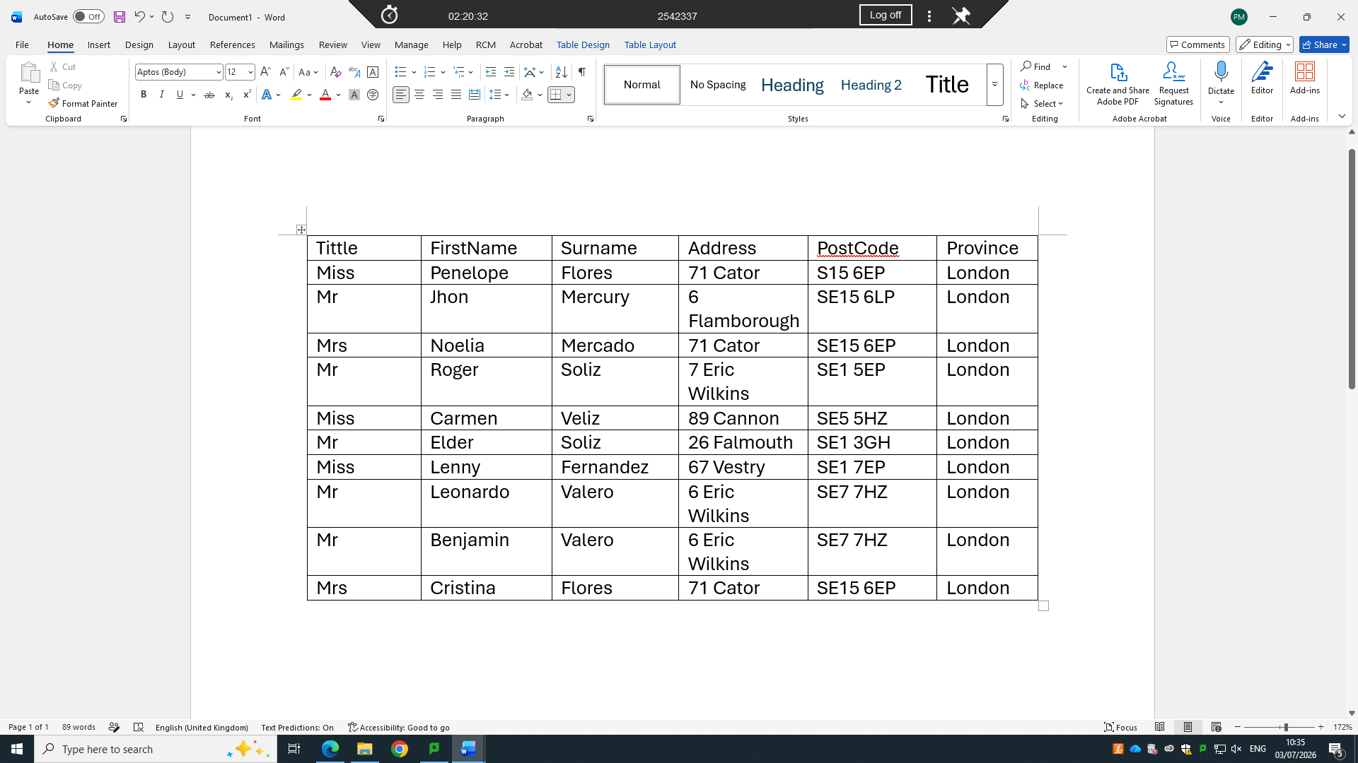
This is the list for the letters.
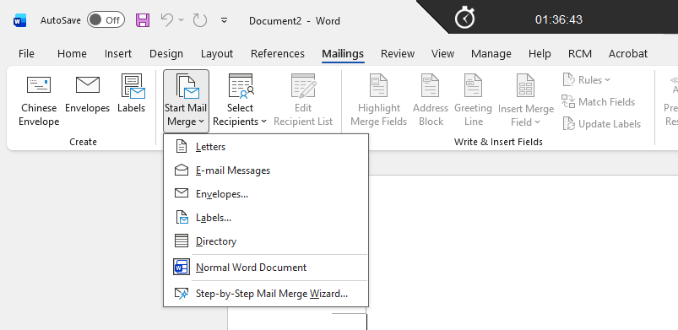
Click on Letters
Click On Start Mail Marge
Click on the Mailing Tab

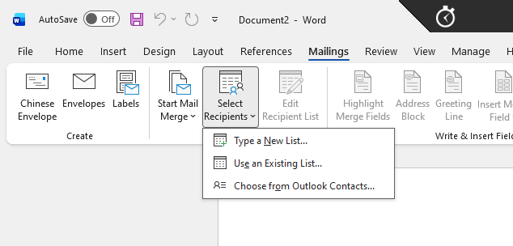
Click on Existing List
Click on the mailing Tab
Click on start mail Marge

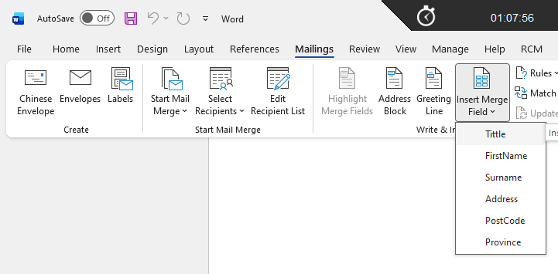
Click on insert Marge Field and select title, first name, surname…

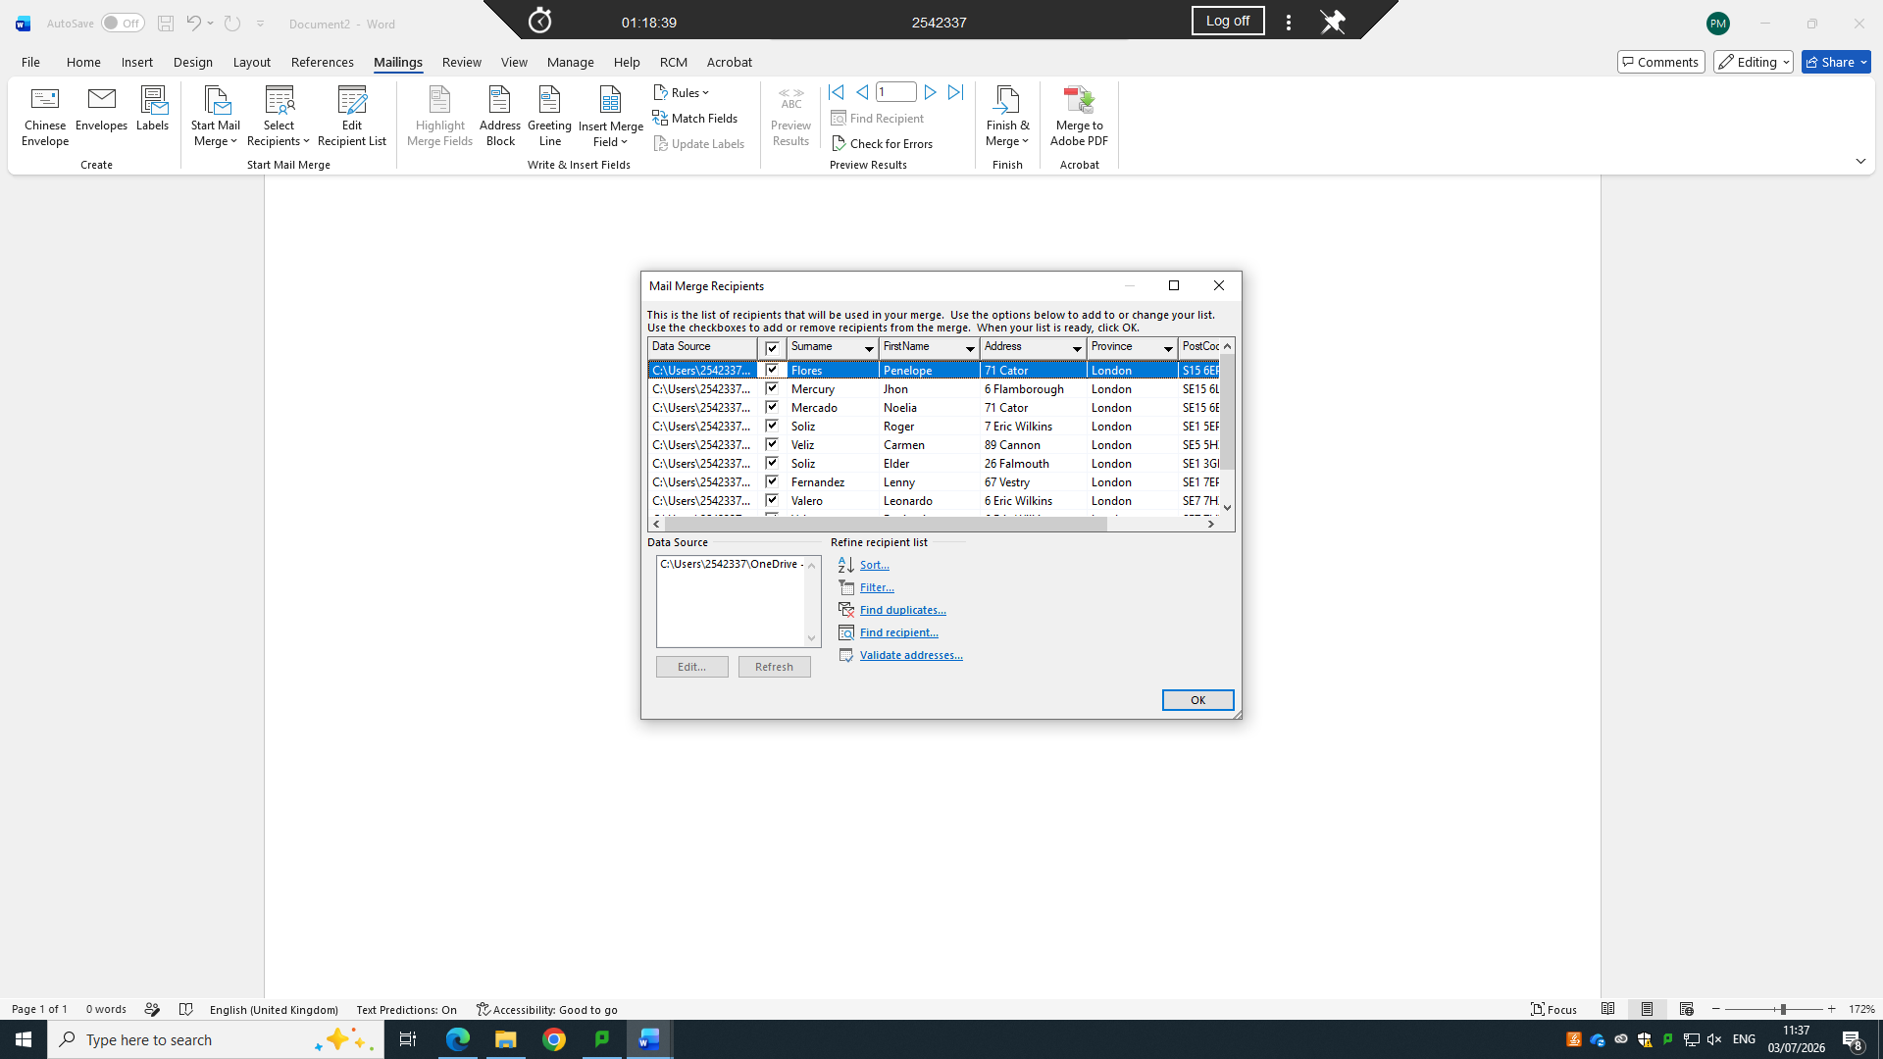
Click on Finish & Marge and click on edit individual documents and Click on All and click Ok.

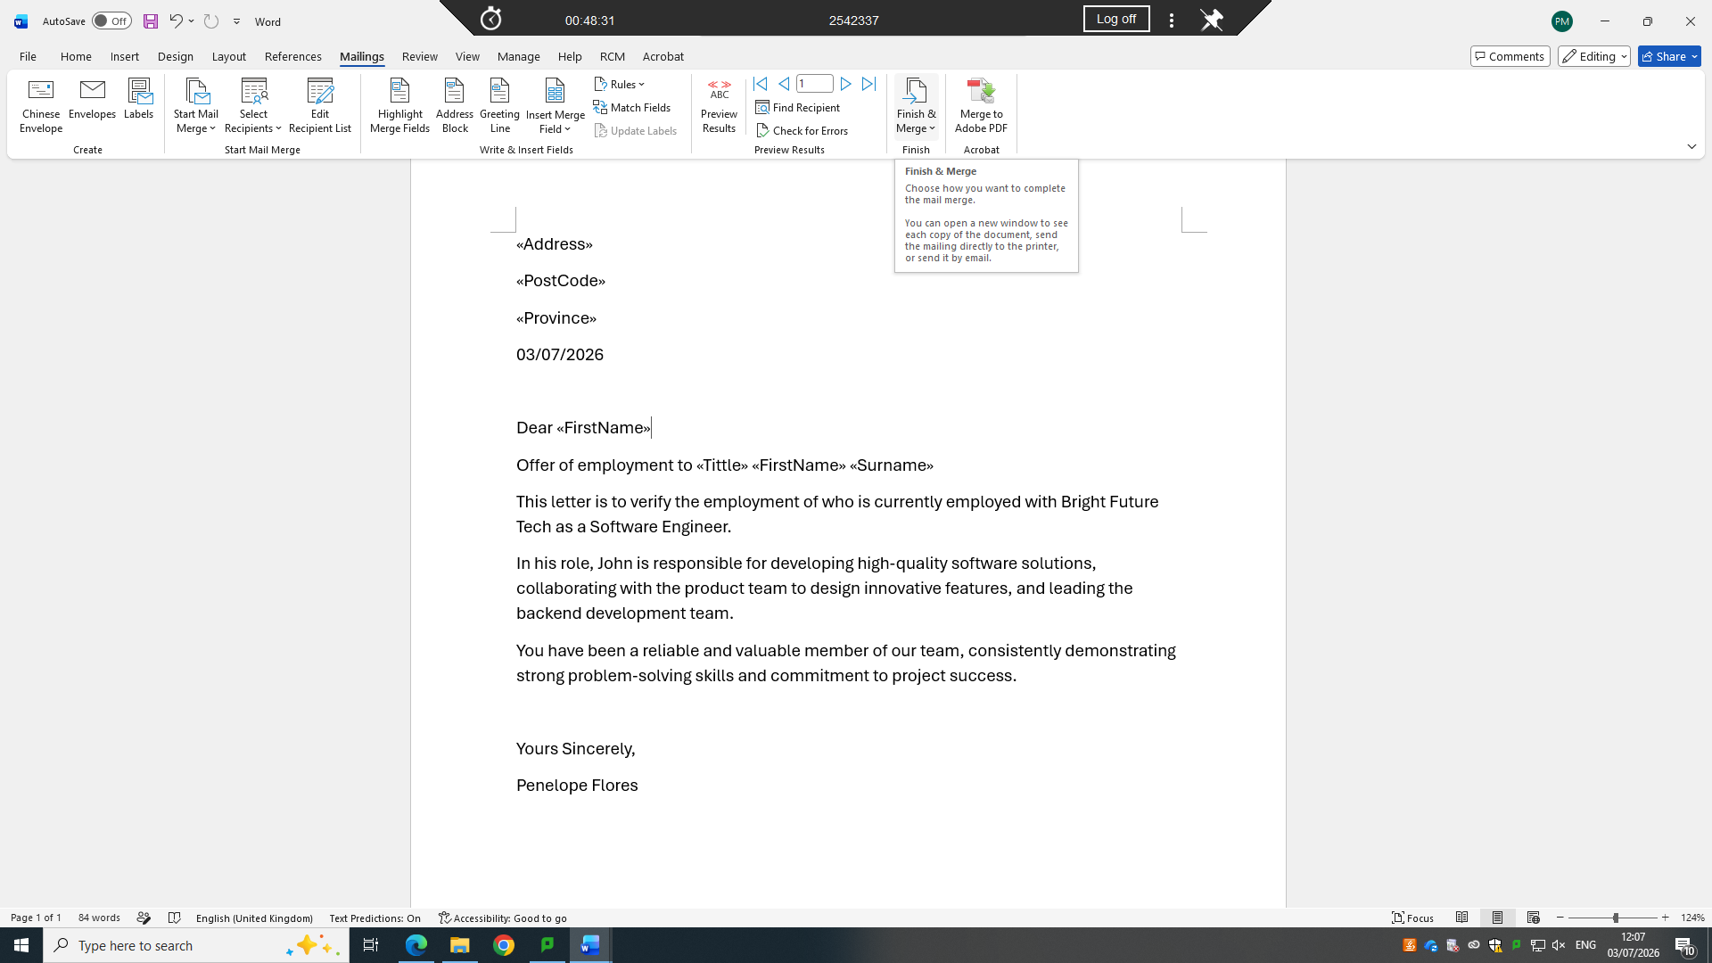
This is the letter generate same for all of them.
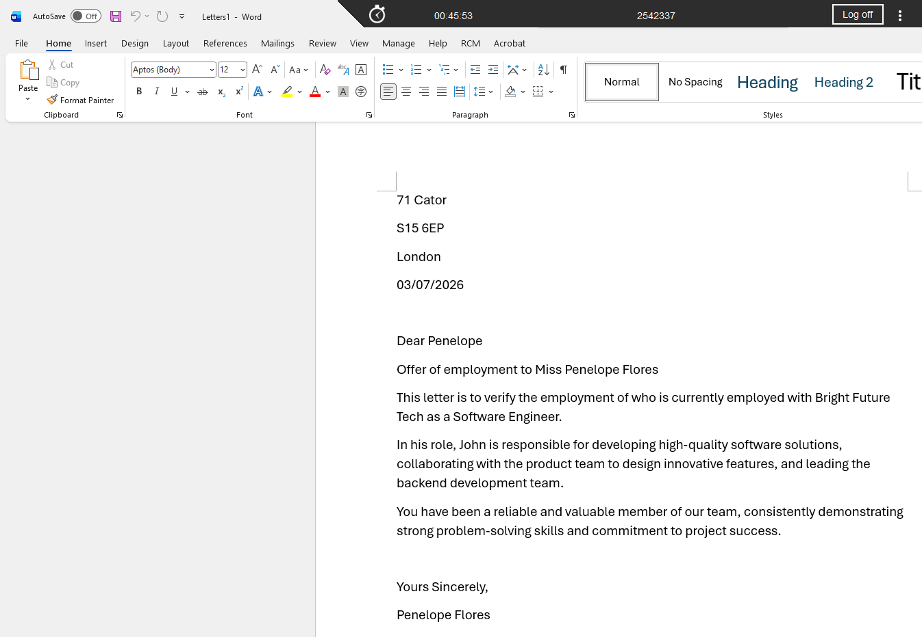
This is one of the letters with all the details.
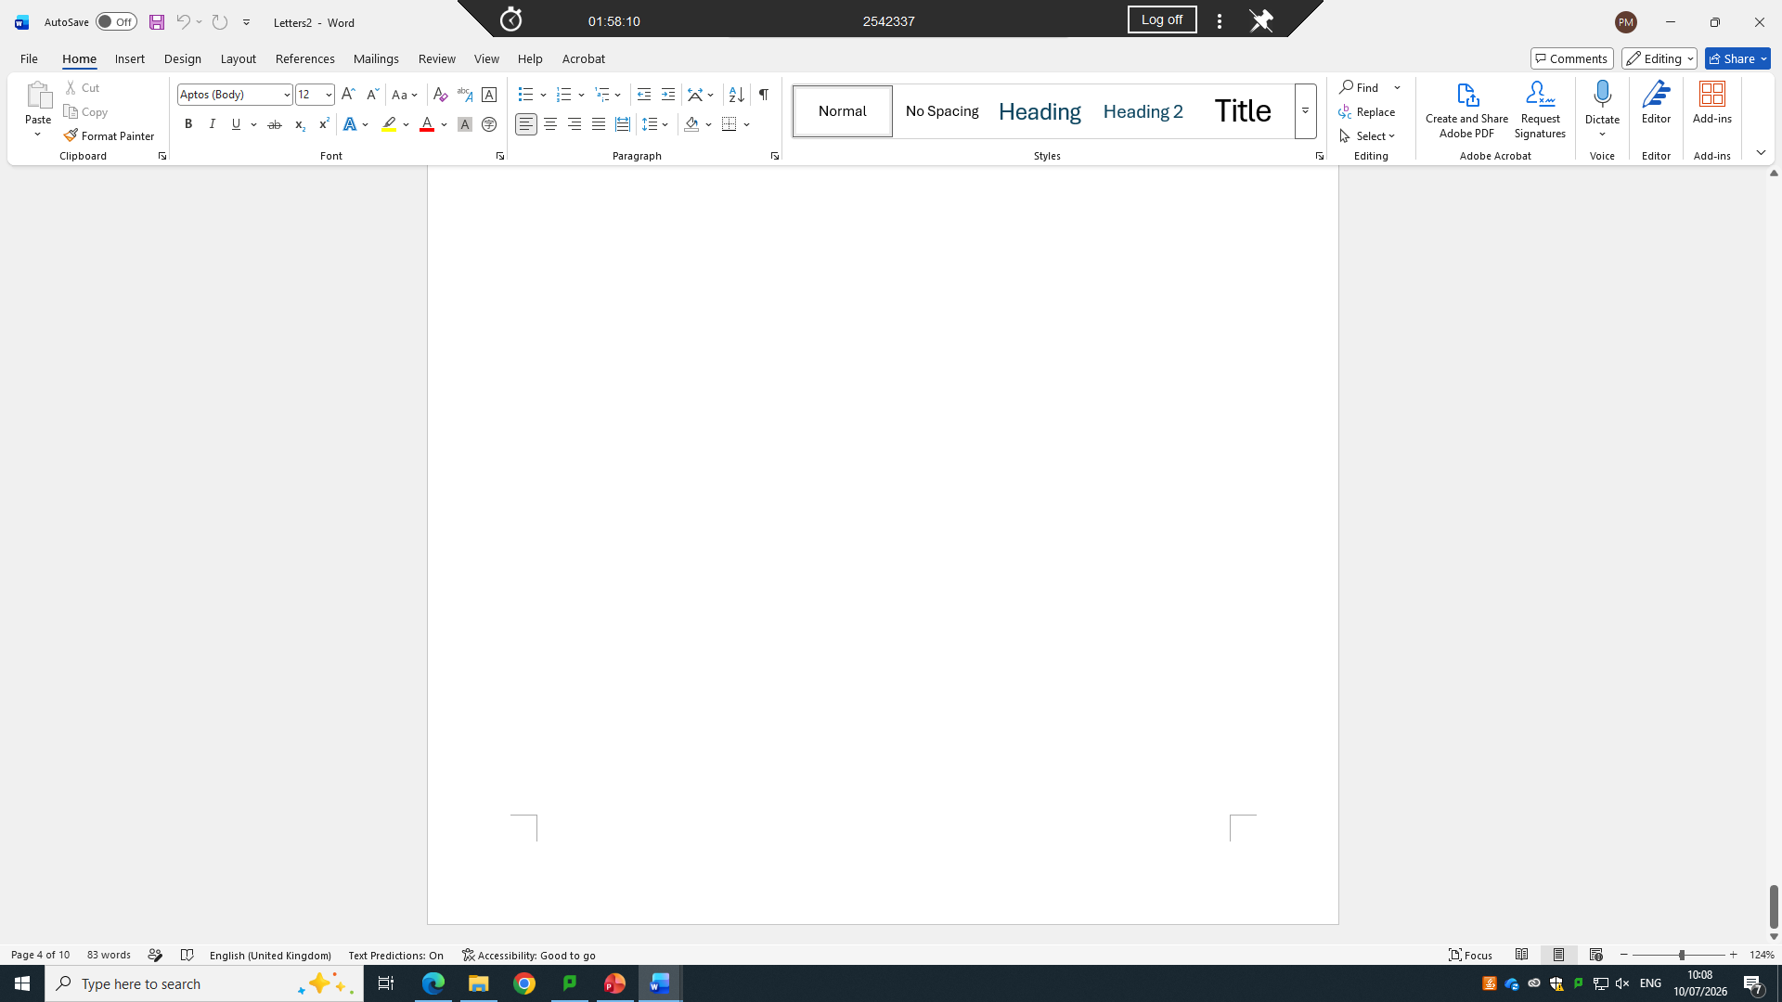
There is Showing the total of letters I did generate.

IF Statement
<Practical demonstration here>
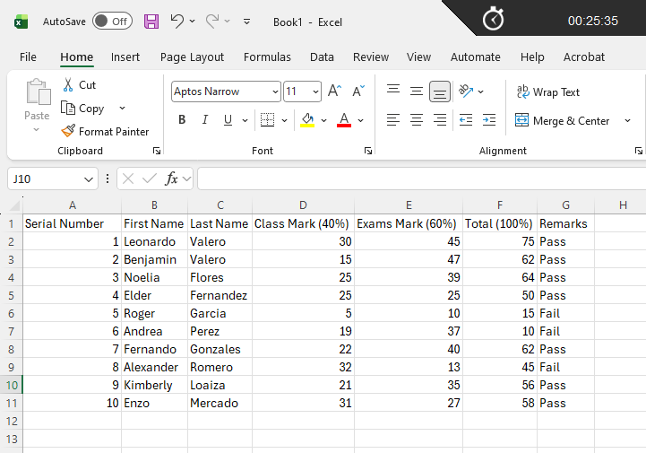
Click on Formulas
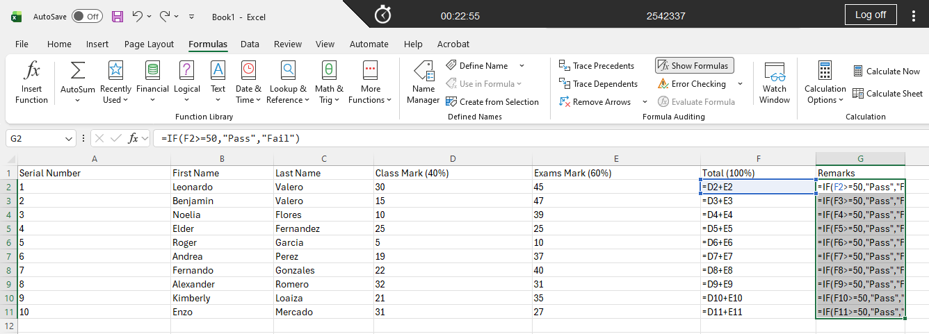
Click on Show Formulas

Task 4. Communication and Collaboration applications

4.1 One contemporary Communication and one Online Collaboration

Gmail
<Gmail information here>

Zoom
<Zoom information here>

4.2 Test one feature of a freely available Communication (1) and one feature of a Collaboration (1) application

Gmail
<Practical demonstration here>

Zoom
<Practical demonstration here>

Conclusion
<Conclusion information here>

References
<List of reference – IEEE style here>

