University Of Wales
Trinity Saint David

MSc Property and Facilities Management

Research Methods and Professional Development

Lecturer: Chris House Created By: Allyn Pritchard
Submission Deadline: 18th April 2023 Student No.: 1101011

Contents
1.0 Introduction 4
1.1 National Drivers 6
1.2 Housing Industry Drivers 6
1.3 Relevance of the Research 6
2.0 Aims & Objectives Outline 7
2.1 Main Aim 7
2.2 Objectives 7
3.0 Literature Review 8
3.1 Legislation 8
3.2 Guidance & Standards Documentation 9
3.2.1 Welsh Quality Housing Standards 9
3.2.2 PAS 2035 & PAS 2038 9
3.3 Academic Literature 10
3.3.1 Retrofit & Whole Home Assessments 10
3.3.2 Customer Communication in Retrofit 11
3.4 Research Gap 13
4.0 Methodology 13
4.1 Selection of Participants 13
4.2 Data Collection Methods 14
4.3 Housing Stock Data 14
4.3.1 Limitations 15
4.4 Interviews 15
4.4.1 Limitations 15
4.5 Questionnaires 16
4.5.1 Limitations 16
4.6 Data Analysis & Results 16
5.0 Conclusion 17
5.1 Timeline 17
6.0 References 18
7.0 List of Figures 20
8.0 Appendixes 21
8.1 Appendix 1 21
8.2 Appendix 2 22
8.3 Appendix 3 23

Introduction
This proposal aims to address the pathway to net zero within social housing homes within Wales, the challenge of achieving a net zero home is extremely difficult especially given that the UK and Wales has the oldest housing stock in Europe and is in the top 3 of oldest housing stocks in the world. The main reasoning for this is the industrial revolution, the demand for cheap housing was at its highest to help with the labour demands of the age and to this day the housing stocks of the industrial era are still the cornerstone of the UKs hosing stock (Justine Piddington, 2020). The Welsh housing stock is some of the most thermally ineffective in Europe and the world, with around 32% of homes build before 1900. The average standard assessment procedure (SAP) score for homes in Wales is currently 61 points, this is roughly equivalent to EPC D (Jofeh, 2019).

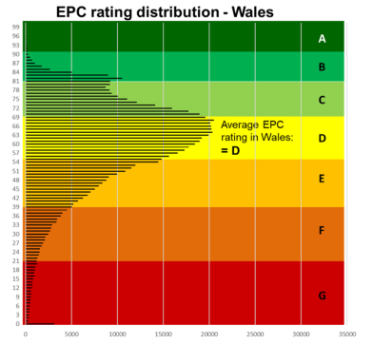

(Jofeh, 2019)
Fig. 1
It is estimated the total number of homes in Wales is 1.36 million (Welsh Government, 2020) with around 1.1 million of these home reliant on fossil fuels for heating. Welsh housing stock as a whole can be categorised into 14 housing types with over 50% of these falling into just 4 dwelling types, and only around 10% of homes were built post 2000 (Jofeh, 2019).

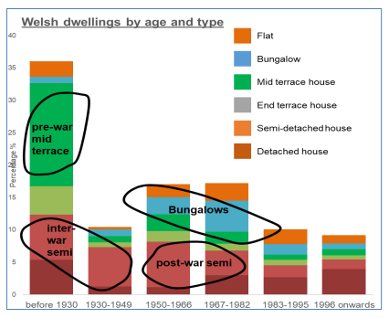

(Jofeh, 2019)
Fig. 2
Looking at the problem holistically having both thermally ineffective homes and older more traditionally build homes this inevitability leads to higher-than-average fuel costs for people within Wales. Currently National Energy Action estimates at around 45% (614,000) households are in some degree of fuel poverty (National Energy Action , 2022) but this is currently exacerbated by the ongoing energy crisis caused by the ongoing war in Ukraine. The war in Ukraine has pushed an estimated 20% of additional households into fuel poverty when they otherwise wouldn’t have been.
Net zero cannot be achieved alone by one single organisation nor by one person, it will require short, medium & long term retrofit plans which need to include a wide range of fabric, heating, energy, and social changes to ensure buildings are “net zero”. Undertaking building upgrades alone will not achieve net zero, social and infrastructure changes will be needed, currently the UK Government have set an ambitious target for 2035 for the electrical grid to be decarbonised (UK Government, 2021). The current energy crisis has brought the UK energy security sharply into focus, and off the back of this the UK government look like they are about to announced that nuclear energy is to be classified as “Green”, this would do two things, firstly help with how the electricity grid is classifying net zero and secondly it would help the UK and Wales safeguard our countries energy security.

National Drivers
The Main driver behind the net zero agenda is the UK Governments ambitious target for the whole of the UK to be net zero by 2050 (legislation.gov.uk, 2019). The Welsh Government also have set a target of 2050 (Welsh Government , 2023) , both governments are monitoring their respective net zero goals using the carbon budgets and we are currently coming to the end of the 3rd carbon budget, both the UK and Welsh Governments are on track (See Appendix 1.). The amended Climate Change Act imposes legal obligations/penalties on the Government, but it is still not clear how this will be enforced.

Housing Industry Drivers
Within the housing sector in Wales there are two forms of social housing provider.
Local Authorities (LAs) – Local Authorities providing low-cost affordable homes, 100% funded by Welsh and/or UK Governments
Registered Social Landlords (RSLs) – Registered social housing provider with a “not for profit” status within Wales, fully regulated by Welsh government.
Both LAs & RSLs are required to undertake housing stock condition surveys every five years or at change of tenancy under the Housing Stock Condition Survey’s: Guidance for Local Authorities, 2008 & the Welsh Housing Quality Standard (WHQS), 2008. Within both guidance documents there is very little reference to retrofit or net zero but since then we there has been two updates which are.
WHQS23 (Draft) – Updated version more focused more on decarbonisation and increasing SAP scores. Also sets out standards around component replacement and minimum levels of comfort.
Rented Homes Wales Act 2022 – new legislation setting out 29 new matters of concern around areas such as damp and mould, electrical safety testing, structural safety, and security. Also strengthens tenants/customers rights so ensure landlords are keeping their properties in good state.

Relevance of the Research
The outcome of this research will help with the overall goal of achieving net zero within social housing homes throughout Wales and the wider UK. It will provide a baseline for both social housing and private rented sector homes around retrofit assessment and will help ensure both private and public sector capital is spent wisely on building performance measures. Finally, it will outline recommendations and parameters for whole home/retrofit assessments, which will allow social housing providers to accurately forecast both labour requirements and capital expenditure on building performance measures. Looking at the customer element it will set out new approaches to engage with customers to ensure they are brought on the net zero journey.

Aims & Objectives Outline
The aims and objectives and of the research is to understand how building performance measures and social factors effect retrofit of social housing within Wales. It is already clearly accepted while undertaking retrofit there can be unintended consequences, a case study of this is the Arbed 1 National Domestic Energy Efficiency Programme (Bridgend County Borough Council, 2020). Currently whole home assessments are focused on the initial assessment but reassessment of both, building performance measures and social factors need to be made a critical element to ensure unintended consequences like Arbed 1 are not replicated on mass across Wales’s social housing sector.

Main Aim
Define the arbitrary frequency of a Whole Home Reassessment and at what point do you reassess and what elements do you reassess.

Objectives
Primary 1- Identify what gaps exist within current guidance documents and legislation to support reassessment.
Secondary 1 - Evaluate PAS 2035/2038 and its role in reassessment.
Primary 2 - Assess customers understanding of reassessment.
Secondary 2 - Consider the role of communication in best practice/legislation reassessment.
Secondary 3 - Assess what social markers are fit for reassessment.
Primary 3 - Propose a best practice set of recommendations (or decision-making tool) for reassessment.

Literature Review
Given the complexity of the housing sector within Wales, the sector is driven by three separate elements, legislation, best practice/guidance standards and academic reports/literature. looking at whole home assessment/reassessment there are reports, standards and legislation that specifically look at stock condition surveys like the Housing Stock Condition Survey’s: Guidance for Local Authorities, 2008 guidance document but information is more patchwork and less coherent around retrofit assessment and is extremely limited around reassessment.

Legislation
Within the UK and Wales, the main piece of legislation which is driving the net zero agenda is the Climate Change Act 2008, 2050 Target Amendment (legislation.gov.uk, 2019). Since the amendment of the legislation in 2019 RSLs and LAs in Wales have undertaken case studies at scale to help inform their decarbonisation plans with initiatives like Active Homes in Neath and Hydrogen Heating initiative in Milford Haven. Welsh Government are using the 2050 target date set out in the climate change act as the definitive deadline but are embedding sub deadlines to the public and housing sectors. The Welsh public sector aims to have net zero behaviours fully embedded and the norm by 2030.

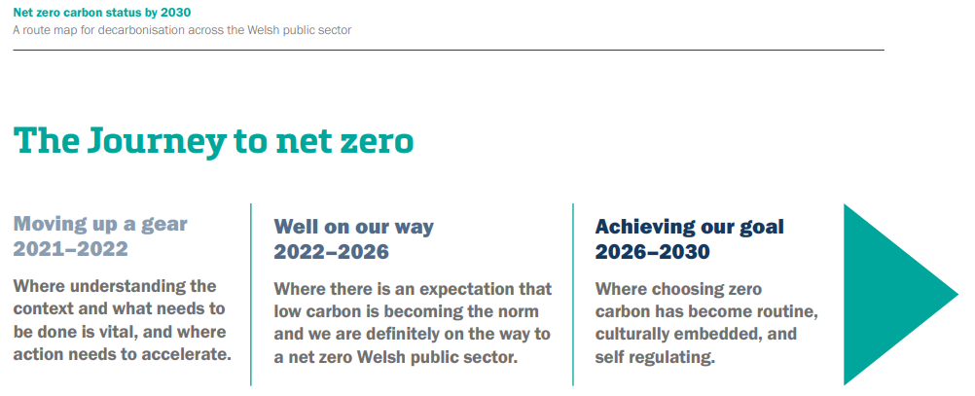

(Welsh Government , 2021)
Fig. 3

The next piece of legislation that dominates the Welsh housing sector is the Rented Homes Wales Act 2022, the aim of this legislation is one of prevention, to ensure landlords maintain there housing stocks to prevent them from becoming unfit for human habitation. The legislation sets out 29 matters or circumstances in which the landlords have a responsibility to ensure does not fall into an unfit condition (legislation.gov.uk, 2022), a full list of the 29 matters or circumstances can be seen in Appendix 2.

Guidance & Standards Documentation

Welsh Quality Housing Standards
Welsh Housing Quality Standard (WHQS) 2008 was the first iteration of the homes standard set is Wales, England’s version is called the Decent Homes Standard, this standard set out what is acceptable and not accepted (fail) which a socially rented home. As of the start of 2022 WHQS has been updated to WHQS23 (still in draft form) which adds additional requirements around decarbonisation, full details are in Appendix 3. Within the new version of WHQS there is now a requirement to undertake whole home surveys and targeted energy pathways for each property individually, both are key to ensure that housing stocks in Wales achieve an EPC rating of A thus achieving a net zero in terms of energy consumption (Welsh Government, 2022). The homes themselves will not become fully net zero until the electrical and heating grids have fully decarbonised.

PAS 2035 & PAS 2038
There are two versions of PAS, one for domestic properties and one for commercial properties, both are a set of guidelines which sets out a framework of how to achieve the best possible energy efficiency rating and ultimately achieve net zero. both use the whole homes approach utilising the fabric first approach (elmhurst energy , 2021). In the Welsh social housing context both PAS and WHQS are to be used in conjunction to produce the whole home assessments and targeted energy pathways for properties. The PAS approach considers the home, environment, occupancy and the overall strategic objective, this process helps in determining the most suitable measures to install and in what order. Undertaking retrofit in this way will eliminate issues connected to retrofit and helps to avoid unintentionally consequences.
PAS 2035:2019 Retrofitting dwellings for improved energy efficiency – PAS 2035 applies to domestic buildings and aims help achieve their energy efficiency potential, through a whole house approach to retrofit.
PAS 2038:2019 Retrofitting non-domestic buildings for improved energy efficiency – PAS 2038 applies to non-domestic buildings (commercial) that are less than 500 square metres in internal size and have similar construction types to buildings of a more domestic nature.

(elmhurst energy , 2021)

Academic Literature

Retrofit & Whole Home Assessments
Retrofit at scale is challenging but can lead to huge positives for both landlords and customers, Joanne Patterson states “whole house deep approach can provide huge financial, comfort, carbon and social benefits but that costs to undertake the retrofit works were still prohibitively high to undertake at scale” (Patterson, 2016). So, to be able to undertake domestic retrofit in the most unintrusive and cost-effective way, we will need to phase the works on an individual scale applicable to each individual property which follows the proposed WHQS23 (Welsh Government, 2022). PAS 2035 will be the best guidance document to achieve this phasing approach as it sets out clear and proper assessment criteria, design concepts and implementation methods (Edwards, 2020). PAS was created to deal with the energy efficiency problems the UK has within its homes and also as a mechanism to enable the Government to trust that public funding is being spent in the most cost-effective way possible (elmhurst energy , 2021). By undertaking this pathway of phasing there is flexibility for the pathway to change and stops a potential “lock-in” of the path, also this form of delivery will allow for collaboration with other social housing providers which would achieve economies of scale (Green, 2020). Whole Home Assessments that are undertaken while on site within social housing can be challenging due to social factors and ensuring that the information that is collected is viable and accurate is one of the biggest challenges asset managers face (Welsh Government, 2022) and the influence of how people live and what effects that has on retrofit is the least understood aspect of the retrofit process (Van Den Brom, et al., 2019). During these initial assessments the Targeted Energy Pathway data is collected and compiled ready to form the net zero pathway, but as Zeifman states “Specific retrofit opportunities are identified via on-site home energy assessments that can be inconvenient to homeowners, expensive, and of variable accuracy” (Zeifman, 2020). Given how difficulty in ensuring accurate net zero pathways it is vitally important that we have suitable skilled and experienced surveyors to undertake these initial surveys, unfortunately the sector currently has a skill shortage of suitable surveyors to undertake these surveys and that its actually hampering economic growth (Rogers, 2018).

Customer Communication in Retrofit
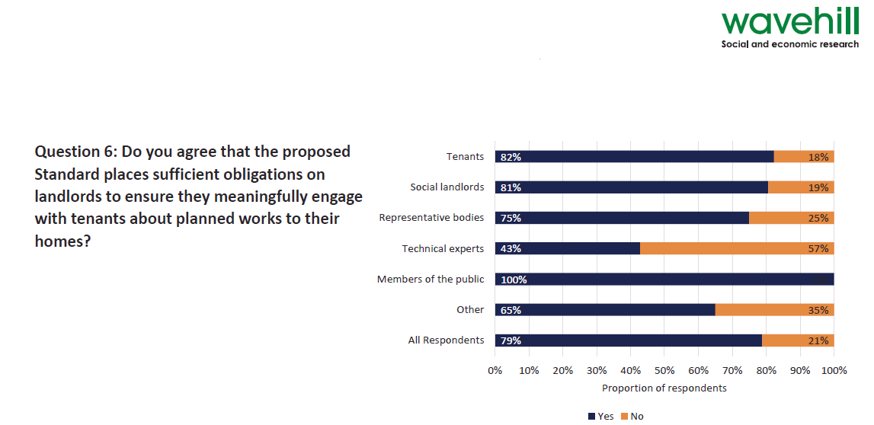
Communication within the social housing sector is vitally important not just for the customer but for the housing provider themselves, a recent study undertaken by Wavehill (social & economic research body) on behalf of the Welsh Government on the updated version of WHQS23 found that the new standards place significant obligations on social housing providers to meaningfully engage with their customers around any planned upgrade works to their home (Wavehill, 2022).

(Wavehill, 2022)
Fig. 4
So, to undertake retrofit at scale and looking particularly at the retrofit assessment process two-way communication will be the most effective strategy with buy in from both parties’ being key (Campbell & Finch, 2004), which by looking at the study above the drive for communication in there within the sector. Given that Welsh RSLs & LAs are at the start of their retrofit journeys it will be important that standardised customer engagement benchmarking is established to help clearly identify tends with customer engagement, this process is already adopted within the facilities management sector, “The benchmarks identify trends between key variables of criticality, efficiency and service provision, including general variables regarding the performance of the FM team” (Tucker & Pitt, 2009). There is clear evidence that when customer communication/engagement is placed at the heart of retrofit projects the outcomes are more positive for both customers and clients and a recent study looking at energy customer engagement during retrofit works helped decrease energy consumption, “It was found that education, social norms, and self-awareness are all key components when it comes to initiating environmentally responsible behaviours. The three approaches complemented each other” (Cathrine V. Jansson-Boyd, 2017).
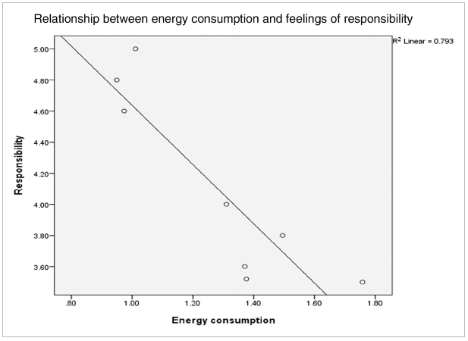

(Cathrine V. Jansson-Boyd, 2017)
Fig. 5
The evidence is clear that customers must be included within the retrofit process, this is to better understand the retrofit action required, this is key to ensure the goal of net zero is achieved (Ben & Steemers, 2018). Engagement with customers’ needs to be flexible and adaptable to the individual and be able to find that balance being critical in carrying out good initial assessments and then reassessments (Professor Fionn Stevenson 2023, personal communication, 28 March).

Research Gap
Looking at legislation, guidance documents and the academic research holistically, we have a situation where all the literature is extremely relevant around the border retrofit subject and is very much focused on the initial retrofit assessment, but the research doesn’t focus in on reassessment and the customers role. All the current research around reassessment and customer influence seems to be a light touch without ever going into the detail. Firstly, reassessment is not mentioned once with either WHQS23 or PAS2035 so local RSLs & LAs have no requirement to undertake it in the first place, this is in stark contrast to the old stock condition surveys in which required RSLs & LAs to undertake housing stock condition surveys every five years or at change of tenancy under the Housing Stock Condition Survey’s: Guidance for Local Authorities, 2008. But narrowing the subject down to the academic literature we have a clear understanding that we have a missing piece of the puzzle in the role of the customer, with the customer being the least understood element of retrofit (Van Den Brom, et al., 2019). The two contrasting stand points clearly shows an almost disconnect between academia and political agenda/policy.

Methodology
This research will use a pragmatic approach based on real world problem solving and this will be coupled with grounded theory using mixed methods to help formulate new approaches to the issues (Creswell, 2009). The gap within the literature has demonstrated a need for new and creative ways of thinking about retrofit based not only on scientific necessity but on human factors and how they both interlink.

Selection of Participants
This research will focus on two groups of participants within the social housing sector, unbiased and balanced experts, and customers within the social housing sector. Both sets of participants will take part in a detailed retrofit interviews and broader topics within the questionnaire. The industry experts and customers will be sampled from the current 39 RSLs and 22 LAs in Wales which cover all the three major property locations in Wales as classified by Ed Green, which are Urban, Rural & Heritage (Green, 2020).

Data Collection Methods
Probability sampling will be used for this research, and this will allow for precise results but only relying on a fraction of the population (Quinlan, 2023). The table below sets out each sampling method, sample size and what aims and objectives are related.

 | Sampling Method | Sampling Size | Aims & Objectives
Housing Stock Data | Random | building components, life cycles and attributed costs | Secondary 1  Secondary 3
Interviews | Random | Customers – 30  Experts - 20 | Primary 1  Secondary 1  Primary 2  Primary 3
Questionnaires | Random | Customers – 70  Experts - 30 | Primary 2  Secondary 2  Secondary 3

The interviews will be conducted first with the questionnaires sent out shortly after, once the initial data have been analysed then follow up interviews and questionnaires will be carried out if further clarifications are needed and they will follow the same process for their respective method.

Housing Stock Data
Housing stock data is key to ensuring retrofit plans and assessments are kept accurate and are carried out properly, so having strong asset management data is key to making informed decisions (María Carmen Carnero, 2017) to avoid unintended consequences. The research will sample stock data from various RSLs & LAs to ensure firstly that the information being stored is relevant to the assessments required and secondly weather there are any gaps within data. PAS2035 sets out what data sets are required to ensure retrofit coordination can be carried out effectively. This data will be collected randomly from asset managers and organisations via there annual WHQs submissions which are made available via the Welsh Government. The data will then be compared like for like (where able to) to understand what missing information the sector has.

Limitations
Data might not be comparable as there is no set standards for data collection and storage within the social housing sector. Each organisation will have a different way of collecting data (in-house, contractors, consultants, etc) so information might be incomplete in some instances.

Interviews
Interviews provide great holistic information from a diverse population and helps understand the root cause of a problem, these interviews will be bespoke to both customers and industry experts. The interviews will be semi structured; this approach will allow flexibility as both sets of samples will have different experiences dealing with interviews so the idea will be to keep them flexible, Brinkmann states “semi structured interviews can make better use of the knowledge-producing potentials of dialogues by allowing much more leeway for following up on whatever angles are deemed important by the interviewee.” (Brinkmann, 2022). The interviews will consist of 12 questions with 2 sub questions, these sub questions will allow further explanation for some of the more pressing questions (Rowley, 2012). Each interviewee will be offered to undertake the interview either online or in person and will be recorded with there permission, the recording will prove the validity of the data collected.

Limitations
The data gathered from the interviews may be biased given that a large number of customers will be interviewed, and these customers may have other agendas based on there experiences with there current housing provider. An example of this is housing disrepair claims for non-completed repairs works. Also, some experts may be biased towards certain processes around assessments due to long standing ways of working with their current employer.

Questionnaires
Two form of questionnaires will be produced, one for customers and one for the industry experts, but both questionnaires will look at the wider landscape of retrofit and whole home assessment. The questionnaire will need to achieve three things, firstly assess what the baseline of knowledge for retrofit and reassessment, second gain an understanding around what communication is best and what legislation/guidance is there to support this form of communication and finally help understand what markers are able to be reassessed and how this can be developed into a decision-making tool.
For both questionnaire sets a mixture of checklists and ranking questions will be used in conjunction with the Likert scale, the Likert scale is particularly useful in the cross-cultural research where different groups of people are being surveyed (Weijters, et al., 2016). Both question set will be provided via an online tool such as survey monkey, MS forms, survey planet etc.

Limitations
The process to collect data via questionnaires is time consuming with participates potentially taking longer periods of time to complete and if the question sets are complicated or long the data sets can require a significant amount of time to analyse. Participants could less likely be engaged than other forms of data collection and poorly chosen distribution methods would lead to low response rates.

Data Analysis & Results
Once the data is collected and properly organised and stored, the researcher must then analyse the significance of the information (Creswell, 2009), this can be an arduous task. When analysing the data, it is important to consider the research objectives and the data will need to be produced into a format whereby it can be easy to identify key themes.
There are some expected results which can already be predicted easily around the customer element of reassessment, it is expected that customer knowledge of reassessment to be low and customer expectation of communication and need for participation to be high in retrofit. This is extremely predictable given the current energy crisis that the world is currently going through.

Conclusion
Retrofit within the social housing sector is essentially Welsh Governments test pilot for the roll out of retrofit to privately owned homes, so if the process can be refined and made viable, they we have the answer to net zero within Wales’s housing sector. Reassessment within this process will be key as net zero is a moving target with key technologies and construction methods constantly being developed, add to this the unpredictability of people. This research will focus in on the one remaining key area which the sector currently has no answers for and in doing so will develop processes and decision-making tools to help with the reassessment process.

Timeline
Below sets out a draft timeline of the completion of the research, both time for review of outcomes and further data gathering has been incorporated to ensure any clarifications are sort and answered.
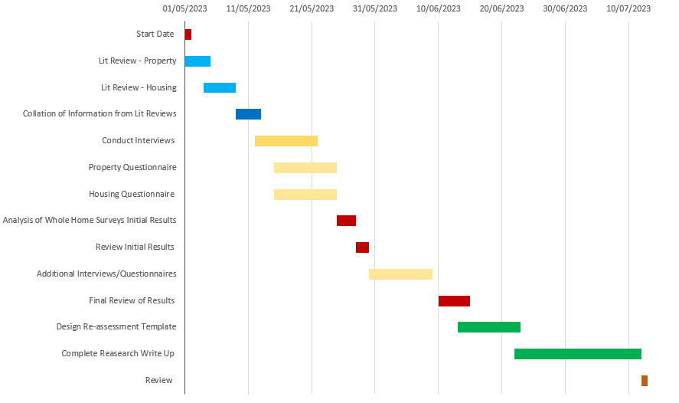

Fig. 6

References
Ben, H. & Steemers, K., 2018. Household archetypes and behavioural patterns in UK domestic energy use. Energy efficiency, 11(3), pp. 761-771.
Bridgend County Borough Council, 2020. Bridgend County Borough Council. [Online]
Available at: https://www.bridgend.gov.uk/media/12649/arbed-scheme-caerau-findings-of-internal-audit.pdf
[Accessed 10 April 2023].
Brinkmann, S., 2022. Qualitative interviewing : conversational knowledge through research interviews. 2nd ed. London: Oxford University Press .
Campbell, L. & Finch, E., 2004. Customer satisfaction and organisational justice. Facilities, Volume 22, pp. 178-189.
Cathrine V. Jansson-Boyd, R. A. V. R. R. C. C. J.-B., 2017. Complementing retrofit with engagement: exploring energy consumption with social housing tenants. International journal of Energy Research , 41(8), pp. 1150-1163.
Creswell, J. W., 2009. Research Design: Qualitative, Quantitative, and Mixed Methods Approaches. 3rd ed. London : Sage Publications Ltd.
Edwards, J., 2020. New Standards in Retrofit. Property Journal, pp. 20-21.
elmhurst energy , 2021. elmhurst energy. [Online]
Available at: https://www.elmhurstenergy.co.uk/blog/2022/07/04/what-is-pas-2035/
[Accessed 3 April 2023].
Green, E., 2020. Decarbonising the Welsh housing stock: from practice to policy. Buildings & Cities, 1(1), pp. 277-292.
Jofeh, C., 2019. Better Homes, Better Wales, Better World - Decarbonising existing homes in Wales, Cardiff: Decarbonisation of Homes in Wales Advisory Group.
Justine Piddington, S. N. H. G. M. C., 2020. The Housing Stock of The United Kingdom, Watford : BRE Trust .
legislation.gov.uk, 2019. legislation.gov.uk. [Online]
Available at: https://www.legislation.gov.uk/ukdsi/2019/9780111187654
[Accessed 1 April 2023].
legislation.gov.uk, 2022. legislation.gov.uk. [Online]
Available at: https://www.legislation.gov.uk/wsi/2022/244/contents/made
[Accessed 4 April 2023].
María Carmen Carnero, V. G.-P., 2017. Optimum decision making in asset management. Hershey: IGI Global.
National Energy Action , 2022. National Energy Action. [Online]
Available at: https://www.nea.org.uk/fuel-poverty-map/fuel-poverty-in-wales/#:~:text=How%20many%20people%20in%20Wales,cap%20increase%20of%20April%202022.
[Accessed 3 April 2023].
Patterson, J. L., 2016. Evaluation of a Regional Retrofit Programme to Upgrade Existing Housing Stock to Reduce Carbon Emissions, Fuel Poverty and Support the Local Supply Chain. Sustainability , 6(12), pp. 1261-1261.
Quinlan, C., 2023. Populations, samples, and sampling methods. Dublin : The Business & Management Collection.
Rogers, K., 2018. Careering on course. Building Surveying Journal, Volume 11, pp. 9-9.
Rowley, J., 2012. Conducting research interviews. Management Research Review, 35(3), pp. 260-271.
Shepheard, M., 2020. Institute for Government. [Online]
Available at: https://www.instituteforgovernment.org.uk/article/explainer/uk-net-zero-target
[Accessed 2 April 2023].
Tucker, M. & Pitt, M., 2009. National standards of customer satisfaction in facilities management. Facilities, Volume 27, pp. 497-514.
UK Government, 2021. gov.co.uk. [Online]
Available at: https://www.gov.uk/government/news/plans-unveiled-to-decarbonise-uk-power-system-by-2035
[Accessed 30 March 2023].
Van Den Brom, P., Meijer, A. & Visscher, H., 2019. Actual energy saving effects of thermal renovations in dwellings—longitudinal data analysis including building and occupant characteristics. Energy and Buildings , Volume 182, pp. 251-263.
Wavehill, 2022. Welsh Housing Quality Standard 2023 - Summary of consultation responses, Cardiff: Wavehill.
Weijters, B., Baumgartner, H. & Geuens, M., 2016. The calibrated sigma method: An efficient remedy for between-group differences in response category use on Likert scales. nternational journal of research in marketing, 33(4), pp. 944-960.
Welsh Government , 2021. Net zero carbon status by 2030 - A route map for decarbonisation across the Welsh public sector, Cardiff: Crown .
Welsh Government , 2023. gov.wales. [Online]
Available at: https://www.gov.wales/net-zero-wales
[Accessed 3 April 2023].
Welsh Government, 2020. Gov.wales. [Online]
Available at: https://gov.wales/household-estimates-mid-2019
[Accessed 21 january 2023].
Welsh Government, 2022. Fitness of homes for human habitation: guidance for landlords, Cardiff: Welsh Government.
Welsh Government, 2022. gov.wales. [Online]
Available at: https://www.gov.wales/sites/default/files/consultations/2022-05/draft-whqs_1.pdf
[Accessed 20 February 2023].
Welsh Government, 2022. Sector Risk Overview - Challenges, Risks and Regulatory Expectations, Cardiff: Welsh Government.
Zeifman, M., 2020. Residential retrofits at scale: opportunity identification, saving estimation, and personalized messaging based on communicating thermostat data. Energy efficiency, 12(3), pp. 393-405.

List of Figures
Figure 1 - Welsh EPC Average Scores Pg. 4
Figure 2 - Welsh Property Breakdown Pg. 5
Figure 3 - Welsh Journey to Net Zero Pg. 8
Figure 4 - Wavehill Study Extract Pg.11
Figure 5 - Energy Consumption Chart Pg.12
Figure 6 - Research Timeframe Pg.17

Appendixes

Appendix 1
The UK Governments current position with the carbon budget tracking process.

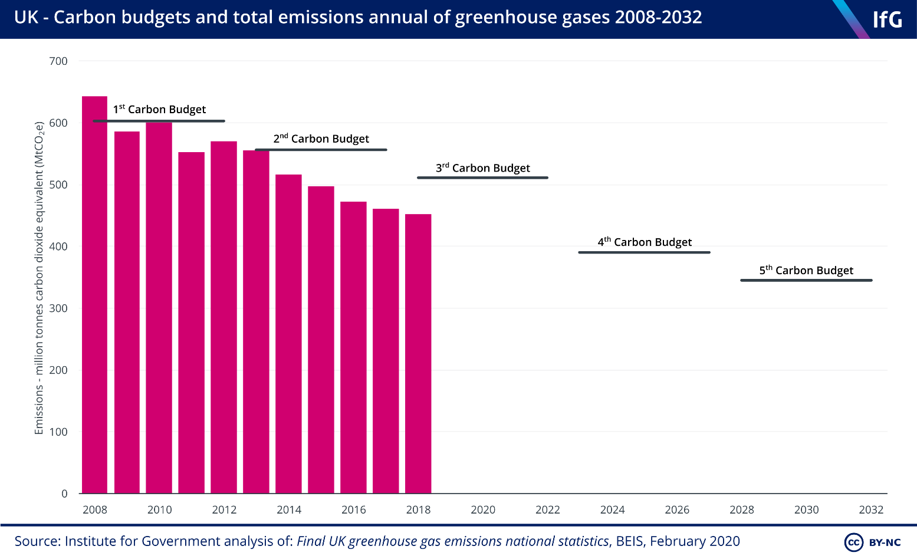

(Shepheard, 2020)

Appendix 2
Below sets out the full list of 29 matters or circumstances with the Rented Homes Wales Act 2022
- Damp and mould growth
- Cold
- Heat
- Asbestos and Manufactured Mineral Fibres
- Biocides
- Carbon monoxide and fuel combustion products
(nitrogen dioxide, sulphur dioxide and smoke)

- Lead
- Radiation
- Uncombusted fuel gas
- Volatile organic compounds (VOCs)
- Crowding and space
- Entry by intruders
- Lighting
- Noise
- Domestic hygiene, pests and refuse
- Food safety
- Personal hygiene, sanitation and drainage
- Water supply
- Falls associate with baths etc
- Falling on surfaces
- Falling on stairs etc
- Falling between levels
- Electrical hazards
- Fire
- Flames, hot surfaces etc
- Collision and entrapment
- Explosions
- Position and operability of amenities etc
- Structural collapse and falling elements.

(Welsh Government, 2022)

Appendix 3
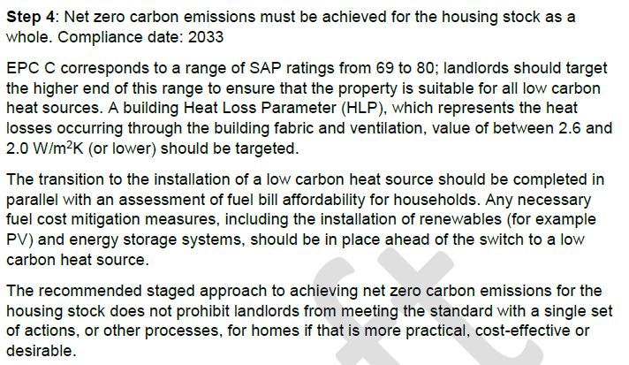
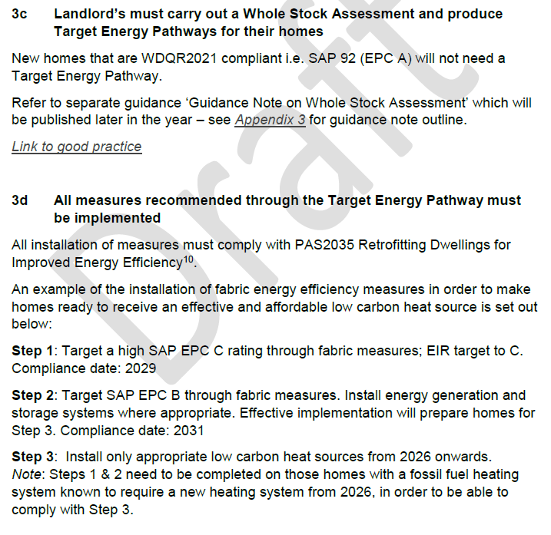
Below sets out the new additions to WHQS for decarbonisation.

(Welsh Government, 2022)

