Workshop skills logbook
Stefan-Cristian Daitoiu
2317310

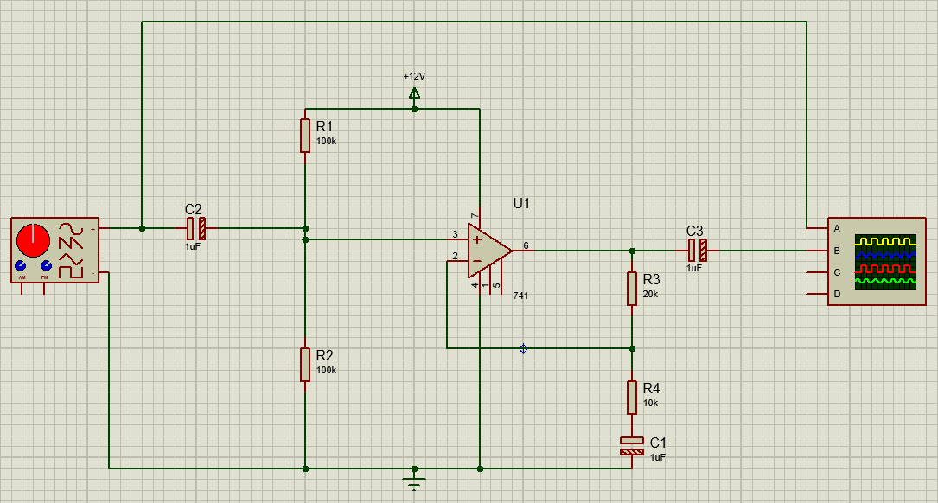Figure 1: Circuit I have drawn in Proteus using the lab instructions. It is an operational amplifier.

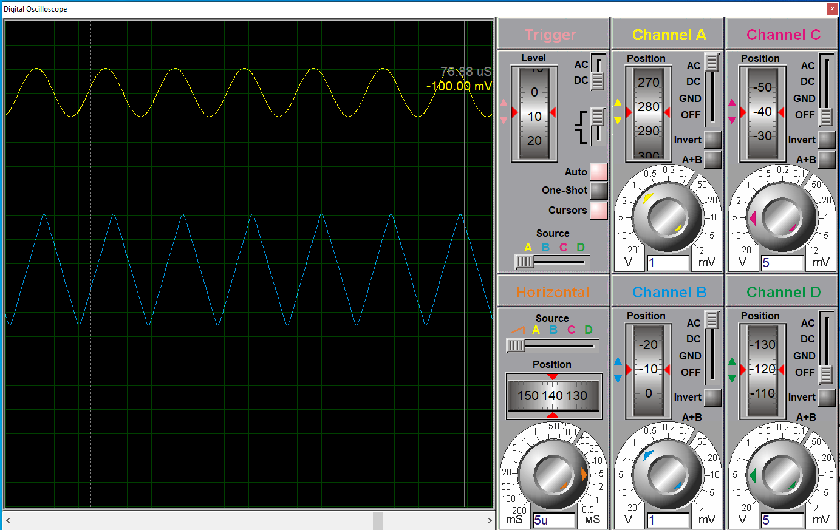
Figure 2: Digital oscilloscope to take readings at different frequencies for simulated circuit.

Frequency (Hz) | Vin (V) | Vout (V) | Gain (dB)
10 | 2 | 3.46 | 4.76
20 | 2 | 4.8 | 7.60
50 | 2 | 5.76 | 9.19
100 | 2 | 5.96 | 9.48
200 | 2 | 6 | 9.54
500 | 2 | 6 | 9.54
1000 | 2 | 6 | 9.54
2000 | 2 | 6 | 9.54
5000 | 2 | 6 | 9.54
10000 | 2 | 6 | 9.54
20000 | 2 | 6 | 9.54
50000 | 2 | 5.76 | 9.19
100000 | 2 | 3.3 | 4.35
200000 | 2 | 1.65 | -1.67
300000 | 2 | 1.1 | -5.19

Table 1: Table showing results for Vout and Gain at different frequencies up until 30kHz for simulated circuit

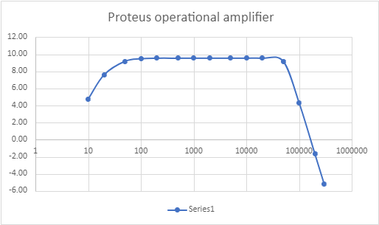

Figure 3: Graphic representation of Table 1
The formula that was used to calculate gain for this circuit is:
$$gain = 20\log\left(\frac{Vout}{Vin}\right)$$
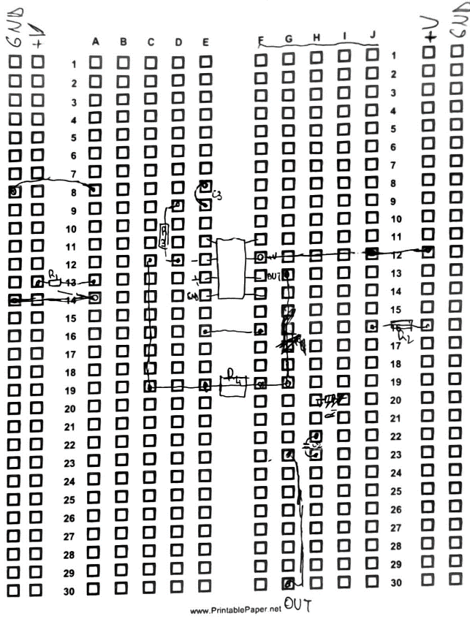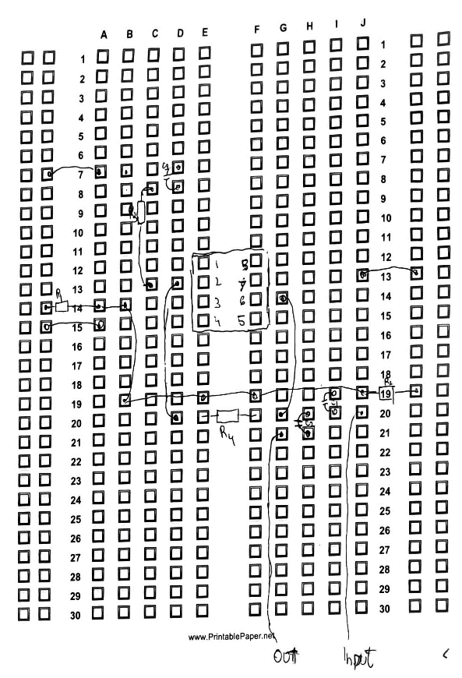
Figure 4: First attempt (on the left) to design the circuit on a breadboard planning sheet. Second attempt (on the right) to design the circuit as first attempt was messy and unclear.
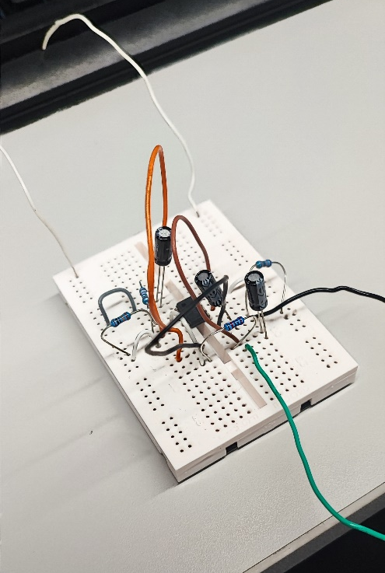
Figure 5: Actual breadboard circuit. I needed to spread out the components a bit as it wasn’t outputting any voltage at first.
Frequency (Hz) | Vin (V) | Vout (V) | Gain (dB)
1 | 2 | 2.3 | 1.21
2 | 2 | 4.08 | 6.19
5 | 2 | 5.6 | 8.94
10 | 2 | 6 | 9.54
20 | 2 | 6.16 | 9.77
50 | 2 | 6.16 | 9.77
100 | 2 | 6.16 | 9.77
200 | 2 | 6.16 | 9.77
500 | 2 | 6.16 | 9.77
1000 | 2 | 6.16 | 9.77
2000 | 2 | 6.16 | 9.77
5000 | 2 | 6.16 | 9.77
10000 | 2 | 6.16 | 9.77
20000 | 2 | 6.16 | 9.77
50000 | 2 | 4.64 | 7.31
100000 | 2 | 2.36 | 1.44
200000 | 2 | 1.2 | -4.44
300000 | 2 | 0.8 | -7.96
Table 2: Breadboard Vout and Gain values at different frequencies up until 30kHz

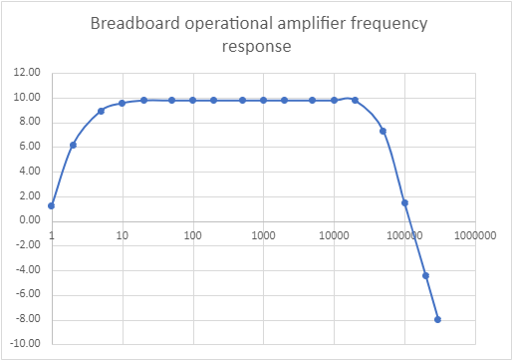
Figure 6: Semi log graph representing gain (dB) against frequency (Hz), from Table 2.

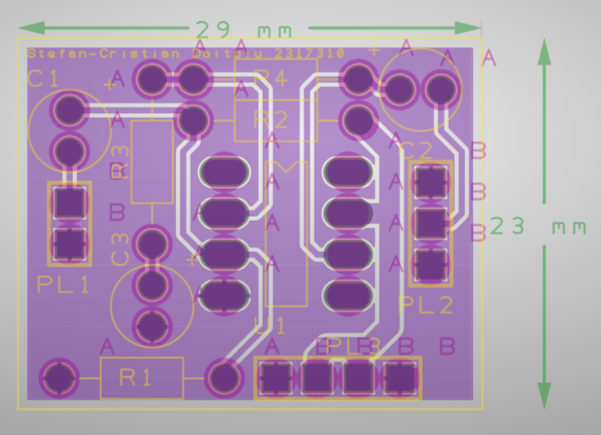
Figure 6: Gerber file of PCB that I have designed in Easy-PC. I have managed to make it as small as 29x23mm.

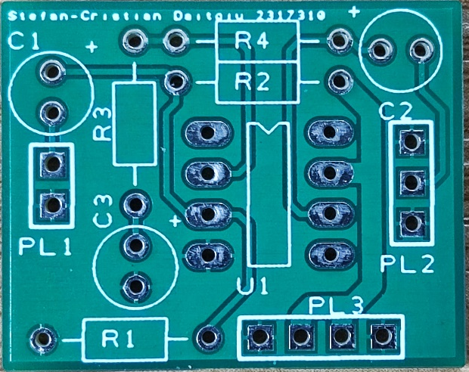
Figure 7: Actual PCB printed out.

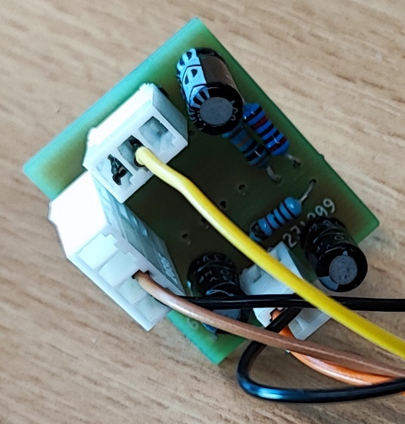

Figure 8: PCB completed, with all components soldered on; it is connected to oscilloscope in figure 9

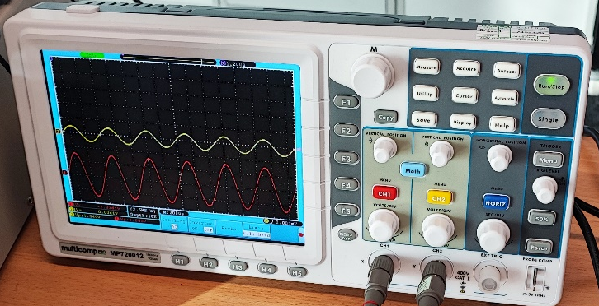
Figure 9: Oscilloscope showing that PCB is working as it should.
Unfortunately, I didn’t manage to perform the same tests for the PCB circuit that I did for the previous two circuit, however, figure 9 does demonstrate the circuit working as it should.

Discussion
These are some of the difficulties I ran into throughout the whole process:
- Proteus’ oscilloscope was not showing me any signals whatsoever; it was just the fact that the sensitivity was not set correctly.
- I had trouble trying to design my breadboard circuit, I made it messy on paper too, which lead to me attempting it a second time, which lead to a much more successful design, as seen in figure 4.
- When I put together the components on the breadboard, the amplification was not working at all, even though I have arranged them in the exact configuration as on the design sheet. After a bit of guidance, I have managed to fix it. It turned out that the components were too close together, causing interference, hence why it didn’t work.
- I did not know how to solder components on a PCB board before this, thankfully with a bit of practice on a draft board I have managed to get this skill up to an acceptable standard.
- When I soldered the components on the actual board I have designed, when tested there was no amplification happening. The problem was that the power pins were soldered to the board, however, there was no contact being made with the trace ring on one of the pins from the power supply. The fix was to quickly re-solder the pin so contact was made, then the board worked as it should.
- Another problem with the PCB board was that there were no trace rings on the opposite side of the board, meaning that I had to flip over all the components apart from the chip, it would’ve been the wrong orientation otherwise.

When comparing the values from the simulated circuit and breadboard circuit, the gain is a bit different even though I have used the same components. Several factors account for the differences:
The virtual circuit uses perfect components, not considering real-world imperfections found in resistors, capacitors and the actual chip itself. External influences such as stray capacitance and inductance, common in breadboard setups, are typically not there in virtual circuits, meaning that a simulation will always perform better than a real circuit when no real-world factors are considered. Furthermore, the use of a breadboard can introduce inconsistent contact resistance and imperfect connections; the physical layout can also lead to interference, which can further cause differences in gain between the a simulated circuit and a real-world circuit.

