

A critical analysis of how national ‘Conducted Energy Device’ training standards are accepted and implemented as fit for operational purpose by Specially Trained Officers in Dyfed Powys police service.

Student: Marcus Taylor

Student Number: 2011241


MSc Policing (Operational & Strategic Leadership)

July 16th 2023

Word count : 14,619

Declarations.

This work has not previously been accepted in substance for any degree and is not being concurrently submitted in candidature for any degree.
Signed: M Taylor
Date: 13th July 2023

This dissertation is being submitted in partial fulfilment of the requirements for the degree of MSc Policing (Operational & Strategic Leadership)
Signed: M Taylor
Date: 13th July 2023

This dissertation is the result of my own independent work/investigation, except where otherwise stated.
Other sources are acknowledged by footnotes giving explicit references. A bibliography/reference list is appended.
Signed: M Taylor
Date: 13th July 2023

I hereby give consent for my dissertation, if accepted, to be available for photocopying and for interlibrary loan, and for the title and summary to be made available to outside organisations.
Signed: M Taylor
Date: 13th July 2023

I hereby give consent for my dissertation, if accepted, to be available on the University’s IT system to those who have consent to use the system.
Signed: M Taylor
Date: 13th July 2023

Acknowledgements.
I would like to thank my supervisor Alison Cooke for her consistent support and guidance during the final year’s delivery of lectures, and especially her guidance through this dissertation. Without this support I would have really struggled to complete this course and I am very grateful for her understanding and compassion and willingness to help. Furthermore, I would like to thank the specially trained officers within Dyfed Powys Police for their effort and participation during data collection, and Dyfed Powys police as an organisation for their support.

Abstract.

The use of Conducted Energy Devices (CED), known as Tasers, in UK policing has been the subject of significant debate and scrutiny, revealing gaps in research regarding operational use, its training and governance. This dissertation aims to evaluate the academic knowledge surrounding Taser use in UK policing and provide valuable outcomes.
The chapters explore the controversial nature of Tasers in policing, as well as medical concerns and subsequent developments with the device. Training and the role of the College of Policing (COP) in providing guidance and expertise is explored, and potential conflicts of interest investigated. The importance of threat and risk assessments, funding, and the role of chief officers, and commissioners in decision-making are also discussed.
The rationale for this research stems from the lack of academic literature on Taser use in UK policing, which raises concerns around accountability and practices. The researcher aims to critically analyse, identify gaps in training and operational procedures to ensure they are suitable for Specially Trained Officers (STOs).
This research project will contribute to existing knowledge and literature by addressing concerns around decision-making and their impacts on uses of force (UOF) operationally. The study will conclude with recommendations to enhance Taser practices within UK policing.
Subsequent chapters, including relevant academic literature involving Taser will be reviewed, and research methodology and data collection methods will be presented. The paper will conclude with practical recommendations for improving Taser practices in UK policing and aims to address the identified gaps highlighted. Some of which include the need for improvements in training methodologies with more time on tasks, and more emphasis on police officer de-escalation techniques. The question around officer suitability for such a specialist role was also explored and discussed. Taser Incident reviewing processes were deemed inadequate, and strengthened support mechanisms for STO’s wellbeing was highlighted as an area requiring review.
The study will contribute to the ongoing debate and scrutiny surrounding its use. The research will draw on academic sources, reports including medical studies, police uses of Taser, and the role of the COP.

Contents.

Declarations. 1
Acknowledgements. 2
Abstract. 3
Contents. 4
List of figures 6
List of Tables. 7
List of Appendices. 8
Chapter One - Introduction. 9
1.1. Background. 9
1.2. CED Police Training. 12
1.3. Knowledge gaps / Rationale for research. 13
1.4. Research Aim and Objectives. 13
1.4.1. Aim. 13
1.4.2. Objective one. 14
1.4.3. Objective two. 14
1.4.4. Objective three. 14
1.4.5. Objective four. 14
1.5. Conclusion. 14
Chapter Two - Literature Review. 15
2.1. Introduction. 15
2.2. Defining a CED/Taser. 15
2.3. Procedures and standards. 17
2.4. Training. 18
2.5. STO - Operational Policing. 21
2.5.1. Use of Force (UOF). 21
2.5.2. National Decision Model (NDM). 26
2.5.3. Taser, Vulnerable groups, and Ethical considerations. 28
2.5.4. Officer welfare and support. 30
2.5.5. Conclusion. 30
Chapter Three - Research Methodology. 32
3.1. Introduction. 32
3.2. Research Philosophy. 32
3.3. Research Approach. 34
3.4. Research Design. 34
3.5. Data Collection. 35
3.5.1. Online Questionnaire. 36
3.5.2. Interviews. 36
3.6. Data Analysis. 37
3.6.1. Limitations to research. 38
3.6.2. Ethical Considerations. 39
Chapter Four - Analysis and Results. 40
4.1. - Introduction. 40
4.1.1. Online Questionnarie. 40
4.1.2. One to One Interviews. 40
4.2. - Research Findings. 41
4.2.1. Online Questionnaire. 41
4.2. One to One Interviews. 50
Chapter Five - Conclusion. 54
5.1. - Introduction. 54
5.2. - Summary of Findings. 54
5.4. - Limitations. 56
5.5. - Recommendations. 56
5.6. - Closing Summary. 57
Bibliography 58
Appendices. 74

List of figures

Figure 1. 1 – The Advanced Taser. 9
Figure 1. 2 – Taser X26. 10
Figure 1. 3 – Taser X2, Taser T7. 11

Figure 2. 1 – less lethal Taser X26. 16
Figure 2. 2 – COP Units. 18
Figure 2. 3 – Behavioural and Decision training in Police UOF training. 20
Figure 2. 4 – Top 5 reasons for using force, England, and Wales. 22
Figure 2. 5 – Arrests. 23
Figure 2. 6 – CED use 31 December 2010 – Year ending March 2022. 23
Figure 2. 7 – Reasonable Officer Responses. 24
Figure 2. 8 – Las Vegas UOF Model (all available models are poor resolution, limiting clarity of text) 25
Figure 2. 9 – Ontario UOF Model. 25
Figure 2. 10 – The National Decision Model. 26
Figure 2. 11 – TENR Model. 27
Figure 2. 12 – Assessment Model. 27
Figure 2. 13 – Shocks Administered. 29

Figure 3. 1 – The Research Onion. 32
Figure 3. 2 – Methods for improving responses rates in electronic questionnaries. 34
Figure 3. 3 – six phases of thematic analysis. 38

Figure 4. 1 – Question One 41
Figure 4. 3 – Question Twelve 48
Figure 4. 4 – Question / Recommendations 50

List of Tables.

Table 4. 1 – Question Two 41

Table 4. 2 – Question Three 42

Table 4. 3 – Question Four 44

Table 4. 4 – Question Five 45

Table 4. 5 – Question Seven 45

Table 4. 6 – Question Eight 46

Table 4. 7 – Question Ten 46

Table 4. 8 – Question Fourteen 49

List of Appendices.

Appendix A 1 - Taser Significant Discharges / Timeline. 74

Appendix A 2 - Article 1, 2, 3 and 4 ECHR (Full document can be reviewed on demand) 75

Appendix A 3 – UOF details for DPP 76

Appendix A 4 - National Decison Making Model 77

Appendix A 5 - New Zealand Police – TENR - Operational threat assessment 78

Appendix A 6 - New Zealand Police - Tactical Options Card 79

Appendix A 7 – Online Questionnaire (questionnaire replies available on request) 80

Appendix A 8 – Online Questionnaire participation request email sent to all STO’S. 86

Appendix A 9 – Email sent for One-to-One Interviews. 87

Appendix A 10 – PG2E1 Ethical approval form. (Completed form available on request) 88

Appendix A 11 – Participant Information Sheet. (Transcripts available on request) 89

Appendix A 12 – Participant Information Sheet. (Transcripts available on request) 90

Chapter One - Introduction.

Conducted energy devices (CED), better known as Taser in UK Policing, have been heavily scrutinised, highlighting potential gaps in research around uses, including training, governance. With thousands of UK and international police officers now carrying Taser, and an additional ten million investment given by government in 2019, will add thousands more (Home Office, 2019), and has highlighted the need for a review in procedures. This research project will address, evaluate gaps in academic knowledge around CED, providing outcomes. For the remainder of the project, CED will be written as its better-known name, Taser.

Background.

Taser, was introduced to policing in the United States (U.S.) in 1999. Brewer & Kroll, (2009) conducted early statistical studies, with their research showing that almost one and a half million taser firings occured, positively arguing that a more lethal use of force would have taken place if not for its incorporation.
Taser within British policing is one of the most controversial appointments given to officers, with public perception, one of concern (De Angelis & Wolf, 2013). The UK scrutiny of Taser is ongoing, reviewing processes involve investigations around statistics and transparent publishing (Home Office, 2022).
Introduced in 2003 to UK policing as a non-lethal alternative to firearms by the Home Office, its use to mitigate serious threats, violence towards officers (Donnelly, 2001).
The first model introduced to the UK was the M26 supplied by Axon, a U.S. corporation. The authority for use, given only to authorised firearms officers (AFO) from five pilot police forces, namely the Metropolitan, Thames Valley, Northamptonshire, Lincolnshire, and North Wales.
Figure 1. 1 – The Advanced Taser.
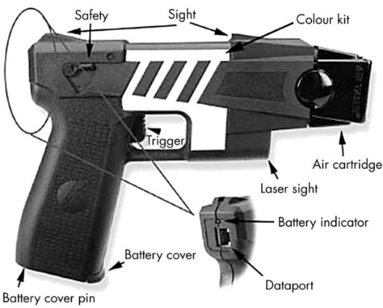 (Bleetman, et al., 2004)

Starting in April 2003, it was given strict parameters around use, and only at spontaneous or pre-planned firearms incidents. During the trial, it was deployed 58 times, where weapons were involved. In 26 of the deployments red dots were utilised tactically, with two red-dots on the persons chest, bringing the incident to a non-violent resolution. The Taser was fired fourteen times. 53/58 incidents ended in the suspect being arrested which gave over 90% arrest rate.
The officers took part in questionnaires, interviews as part of the pilot following any Taser deployment, and the replies produced for public opinion in questionnaires. Over 1000 public responses were received, with public showing little awareness of the device, however they were supportive, with 80-90% of respondents stating officers should have Taser, but wanted them tactically trained, AFO’s or specially trained officers (STO’s) (Price Waterhouse Coopers and ACPO, 2004).
The medical governing body responsible for testing and monitoring Taser is the Defence Scientific Advisory Committee on the Medical Implications of Less Lethal Weapons (DOMILL). Cardiac arrest, intoxication and substance abuse were early concerns around the device, but it was concluded that the device posed low threat to life (DOMILL, 2005)
In 2005 following the trial, the Home Office declared all UK police services could benefit from Taser and issued it to all AFO’s within forces and was rolled out Nationally. The device on roll out was upgraded to the new Taser X26, deemed more accurate (AXON, 2005).
Figure 1. 2 – Taser X26.
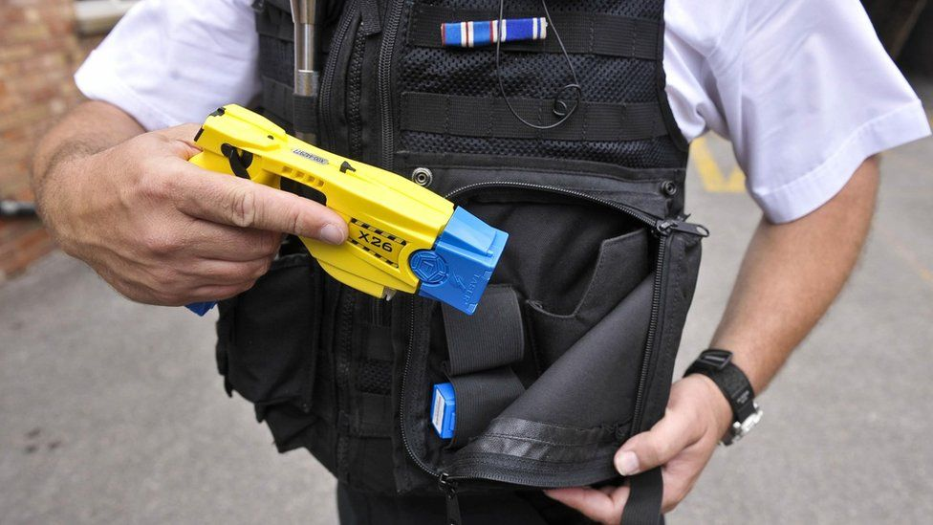 (BBC News, 2017)
Following this the Association of Chief Police Officers (ACPO) declared there was benefit in Taser being used by response officers. Ten forces suggested potential response officers to become STO’s and were given access to Taser for twelve months (Bebbington, 2007).
This proved successful, and 2008 saw then home secretary announced an increase in Taser use by STO’s, rolling out ten thousand devices at a cost of £8 million (ACPO, 2008). Greater scrutiny resulted from a scientific point of view, DOMILL concluded that although an increase in the number of Tasers being carried, the training and implementation to officers was adequate, mitigating increases in risk (DOMILL, 2008). Statistics from 2009-2016 historically were collected by the home office (Home Office, 2017), but a more detailed procedure was required, and annual collection of data would now take place, stipulating forces must record better, more transparently. Policing would be held to account, giving confidence to public communities (Home Office, 2018).
The Independent Police Complaints Commission (IPCC) released recommendations that tasers should only be used as a last resort (IPCC, 2014). A choice of words, signifying potentially there will be repercussions to use.
Statistically, the term ‘used’ becomes important around use, as stated by McGuiness, (2016) below:
- Drawn from the holster.
- Aimed.
- Arced, whereby electricity is forced through the device.
- If the laser red dots are placed on suspect’s body.
- Whereby the device is placed on the person in different locations having fired one cartridge. Previously known as a drive stun.
- Fired.
There is still a recurring opposition to arming all police officers, so this less lethal approach may be a comprise (Turner, 2017). The Home Office continues to approve upgrades. The X2 Model, T7 in 2018 were adopted.
Figure 1. 3 – Taser X2, Taser T7.
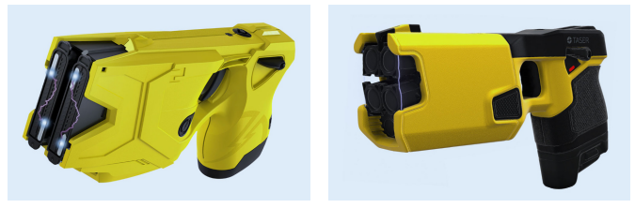 (Kunz & Krys, 2022)
Medically deemed to be more effective (Scientific Advisory Committee on the Medical Implications of Less-Lethal Weapons, 2016). The question here is the necessity of more powerful devices, however Ho, et al. (2020), concluded that the X2 and T7 are similar in effects to the X26. A weakness of the research was that only a small number of enrolled subjects took part and only firings to the back were made.
An opposing thought here are incidents where people have lost their lives following police interaction. Cases of taser use by police officers, and their subsequent investigation, outcomes are reviewed, (Appendix A 1).

1.2. CED Police Training.

The College of Policing (COP) presides over police taser training (COP, 2022). Described as an experienced group of Taser trainers and practitioners, developing standardised curriculum, packages that are subject to review and update (NPCC, 2020).
Taser has brought heightened attention to operational policing around national decision making (NDM) and uses of force (UOF). The importance of effective training to STO’s is vital. The COP develops training content for police officers, including guidance on Taser use, which can be found on their Authorised Professional Practice (APP) website (COP, 2013). It should be mentioned here that most officers working within the COP in Taser management are civilian and no longer operationally competent, also with a strong link towards Axon. You could argue the ethical suitability here, conflict of interests. Highlighted further at a recent International Taser conference for UK policing held by the National Police Chiefs Council (NPCC) and COP, sponsored by Axon (NPCC, 2023).
Chief officers are required to provide an annual strategic threat and risk assessment (STRA) around Taser. Within it, stipulating operational needs, capacity, deployments, and policies around training. This governs its funding due to perceived risks/threat (Dyfed Powys Police and Crime Commisioner, 2020). The chief constable (CC) and police crime commissioner (PCC) rely heavily on UOF statistics. Any STO increases, costs attributed with increases could be debated as a publicity stunt to appease the public wanting protection from its officers carrying (Dyfed Powys Police , 2023).
The COP disseminates training materials through conferences, online knowledge hubs and cascades to forces. Suitability of the staff managing this specialism could be questioned and the recruitment processes, with limited jobs advertised. Gallagher (2023) explores the notion of what you know is key and not who you know, and a culture of jobs for mates being unhealthy.
Individual forces nominate a Taser lead trainer, having previously attended an accredited one-week lead national course. They are responsible for cascading information from COP to their force. The use of local police specialist trainers is utilised at this stage to assist cascading to new STO’s (COP, 2013).
There are set times for police attendance on courses, known as contact time. The minimum contact time for Taser initial courses is eighteen hours. Re-accreditation must take place to continue as an STO and a minimum requirement of 6 hours contact time. Silveira Jr (2021), states that muscle memory is achieved by repeated physical actions, usually around 20 days of repetition so if you took current COP practices of eighteen, or six-hour timescales, it seems limited.
During training, assessments and scenario training is used to challenge officers, making the course taxing and only when completed successfully can officers become known as STO’s (McGuiness, 2016). Continually tested in critical stress situations. The physiological impacts on their own decision-making capability can be affected by stimulation which can have adverse effects on stress, performance of the officers being tested (Arble, et al., 2019).

1.3. Knowledge gaps / Rationale for research.

The rationale for the researcher to undertake this dissertation on Taser stems from a lack of research literature, especially surrounding UK policing. Taser is now a key part of policing, its training practices, implications operationally have a lack of in-depth studies addressing it, and this gap raises concerns around accountability, and effectiveness of the device.
The researcher currently works within Specialist Operations in Dyfed Powys Police (DPP) and has interest in the effectiveness of current Taser practices, both training and operationally and is looking to critically analyse and highlight gaps within procedures to establish if they are fit for purpose to current STO’s.
Considering these, this study will address and highlight concerns by critical analysis of training, officer’s decision making and impacts of Taser operationally, concluding with recommendations.

1.4. Research Aim and Objectives.

1.4.1. Aim.

A critical analysis of how national ‘Conducted Energy Device’ training standards are accepted and implemented as fit for operational purpose by Specially Trained Officers in Dyfed Powys police service.
To achieve this, the objectives are as follows:

1.4.2. Objective one.

Explore the current practices and processes of national conducted energy device training and analyse how this is managed and delivered locally by individual forces around standardisation, quality assurance and effectiveness for their specialist police officers.

1.4.3. Objective two.

Explain how conducted energy devices are utilised operationally and explore how effective the national decision model is around safety considerations and use of force, and how police officer welfare and support is managed.

1.4.4. Objective three.

Investigate if training, and operational use is ethical, paying due regard to protecting vulnerable categories within local areas of Dyfed Powys.

1.4.5. Objective four.

Propose any improvements to training products, delivery, and operational application to ensure that specially trained officers are developed to the required standards.

1.5. Conclusion.

This introduction phase has set out an overview of the research topic, highlighted some gaps in literature around Taser especially within UK policing. Increases in Taser use and continued investment, shows requirement for critical examination of training and procedures. Addressing this knowledge gap, the aim and objectives will contribute to existing knowledge, literature and provide some valuable insight in potential improvement.
The subsequent chapters will, critically review the literature around Taser, and present research methodology and data collection for analysis. The paper will conclude, providing recommendations for Taser practices within UK policing.

Chapter Two - Literature Review.

2.1. Introduction.

This chapter will look to review existing research literature and articles around Taser, training and procedures within UK policing. Secondary data will be gathered from sources including UWTSD library catalogue, Police national library, peer reviewed data, journals, and articles to identify the knowledge gaps.
In relation to Taser there is a general lack of research information, data within academia (Dymond, 2014; Dymond & Rappert, 2014; Mosher, et al., 2010). The aim of the project is to critically analyse the effectiveness of current national Taser training, standards, and their suitability for STO’s in DPP.
This paper will explore practices, procedures for police training including standards, processes, and effectiveness. Determining how Tasers are utilised in policing around NDM and UOF, evaluating local training and operational use, concerns.
literature reviewed will cover a range of topics relating to Taser, it will not delve into the workings of the device’s technological specifications or specific engineering aspects.

2.2. Defining a CED/Taser.

Developed by Jack Cover in 1969, a NASA researcher who named the device as Taser from his favourite book and character, namely Thomas A Swifts Electric Rifle. It is sold today by Axon Enterprises (Axon, 2020).
The COP defines Taser as a Less lethal weapon designed to incapacitate a subject through use of an electrical current (COP, 2013). Haskins (2019) disagrees with the COP, describing the U.S. Taser as a weapon that stuns and usually immobilises subjects, making it easier for officers to subdue. The American National Institute of Justice (NIJ) (2008), differs and summarises CED’s as a stun gun, incapacitating subjects with 50,000 volts causing involuntary muscle contractions, in contradiction with Axon, who describing their devices as, energy weapons and not stun guns (Axon, 2022). A weakness for such a scrutinised device is the lack of singularity around its definition.
With few competitors to its use, Stinger was developed in 2008, producing S200 (SIW, 2008), unfortunately though, deemed less reliable (Mesloh, et al., 2008) and subsequently stoped trading. Another company, Tasertron being bought out by Taser in 2003 (Taser International, 2003). Axon monopolises the Taser market in over 80 countries. The shortage of competitors potentially a weakness in UK policing, holding forces to ransom with economists suggesting potential shortages, price increases, however governments can regulate better, with one larger company (Pettinger, 2020). Price issues have impacted West Midlands police, resulting in retracting Taser from sergeant ranks. Deemed nonsensical by the police federation (West Midlands Police Federation, 2021).
Labelled as less lethal, bridging the gap between appointments such as chemical spray, batons, Kinetic Impact projectiles (KIP) better known as rubber bullets, and firearms (Bleetman, et al., 2022).
Figure 2. 1 – less lethal Taser X26.
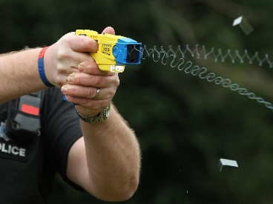 (Minchin, 2015)
The term less lethal suggests positivity against the more negative connotations surrounding lethal force language. Less lethal suggests no loss of life however in opposition to this, American research in 2017 showed 53 deaths occurring from KIP’s, showing a weakness in the language and terminology being used here (Kaske, et al., 2022). Weakness in terminology continues, and kinetic devices, batons should be labelled as non-lethal, as devices specifically used to disable rather than subdue (Less-Lethal, 2021).
Proponents to Taser hail their quick access to safely incapacitate, while opponents argue its effectiveness and safety (Adams & Jennison, 2007), fuelling further research that concluded there was limited data of serious injuries (MacDonald, et al., 2009). There is disagreement here around effectiveness, as Gilbert et al. (2019) states a 40% failure with Taser in U.S. studies between 2015–2017, following the review of 3,000 incidents, 258 escalated as a result of the device malfunctioning and lethal force ensued.
Rigorous live testing on adults to determine the safety of the device has been done. These earlier tests, conducted on volunteers and given a five second exposure of electrical current, to ascertain impacts on the body (Ho, et al., 2006). Supported more recently by research conducted on swine’s, deemed more ethical and showed no cardiovascular irregularities (Dawes, et al., 2021).
Amnesty international have voiced real concern with UK policing acquiring Taser, demanding reassurances on rollout. These include, STO’s carry the device and no pain compliance uses (Sprague, 2007). Use as a pain compliance tool would infringe the European Convention of Human Rights (ECHR) adhered to within UK, Article (2 and 3) (ECHR, 2021) (Appendix A 2).
Devon and Cornwall Police opposed Amnesty’s suggestion to only issue to STO’s and Taser was rolled out to all front-line officers due to its perceived risks around demographics (NPCC, 2019). Similarly, New Zealand (NZ) took the decision for routine carriage of Taser by first responders, showing a confidence in having the device (New Zeland Police, 2015).

2.3. Procedures and standards.

The foundations of Taser, National expectations of being an STO are set out by the COP. Taser materials are provided annually for delivery to police officers on initial/refresher courses. These include classroom and scenario training. The strengths of scenarios being realism, with an ability to highlight areas for development (Jenkins, et al., 2020). Kolb (2015) suggests that learning is done through experiences and reflections, which would suggest current practices delivered by the COP around Taser follows similar methodology. Known as J modules (COP, 2019), a framework, controlled and disseminated electronically to trainers through a web portal known as Knowledge Hub (Police Digital Service, 2019).
COP Being a single point of contact (SPOC), contrasts to U.S. practices of individual force led training, but these can be less favourable, exampled by Minnesota’s Taser deaths rising due to lack of national standards, policies around its use, with heavy reliability on Axon itself to govern their training, which poses the question of conflicts of interest (ACLU, 2011).
UK Taser, managed by a small team of operational but mainly retired police officers, civilian staff working out of the COP (McGuiness, 2016). Seen by other countries as a weakness, preffering occupationally competant trainers, for example the US marines using serving practitioners in delivery, claiming this as more effective (Estrada, 2014).
The strengths of a SPOC around delivery, ensures standardisation for all UK forces, with packages written with developer updates, science and national statistics updated from one point. Mirrored by New Zeland policing who manage a similar system, this reinforces this as a strong model of management (New Zeland Police, 2009). U.S. policing delivery of Taser aquires its materials and training directly from the manufacturuer, with little focus on current trends, issues, but more on the mechanical workings of devices and how good they are. More a marketing model that has little benefit operationally to officers. Could be seen as dissadvantagious (Parker & Schoonover, 2009).
Medical governance is managed by the Centre for Apllied Science Technology (CAST) and DOMILL, now known as SACMILL. Several medical documents, statements have been published on Taser by these bodies on suitability (CAST, 2016). A weakness potentially here is conflicts of interest, with both medical bodies put in place by the Home Office who have vested interest, however they state they act independently. Recent reviews of Taser 7 by SACMILL recommended STO’s be instructed around a safety concern, and they welcomed the COP incorporating this advice into their training practices (SACMILL, 2020).

2.4. Training.

The key objective to police specialist training is to prepare officers for the demands of being a STO. Within DPP, the CC has responsibility of selection of STOs, record keeping and training (College of Policing, 2020). Governed by the elected PCC, holding CC’s to account (PCC, 2023). The professionalism of policing and the introduction of the Police Education Qualifications Framework (PEQF) in 2016, saw new officers recruited mainly from academic backgrounds and not the more historic industry and military professionals’ pathway (Pepper & McGrath, 2019). Not supported by Fleming & Rhodes (2018), claiming learning is multifaceted and achieved through experience, especially in policing. Supported by Broomfield (2006), stating that previous experiences, knowledge are very relevant within a learning environment.
These experiential skills are very much applicable within specialist training, which relies heavily on decision making, and they argue an academic background, doesn’t have the real-life experiences. Angleman, et al. (2009) discusses the importance of transferable skills from a learning to performance environment. COP Taser training curriculums are divided into modules and units. STO Training uses the first five.
Figure 2. 2 – COP Units.
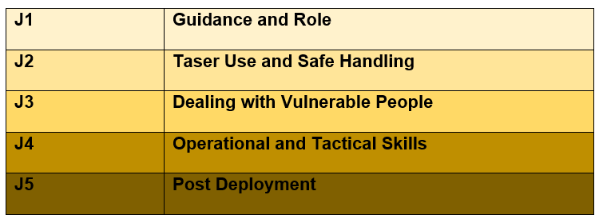 (COP, 2019)
Key to this programme and training delivery system is the force lead instructor. Having completed a national lead course, enabling them to cascade Taser training to their force. They will require assistance, and following course completion they are authorised to develop local force trainers to assist with delivery. This method supported in international policing, adopting similar methods with over a thousand master instructors worldwide responsible for Taser (Kroll, et al., 2022).
It is important that new trainers don’t give their own STO experiences during sessions (Miles-Johnson, 2019), sticking to the prepared literature from the more glorified ‘war story’ approach, as creates misinformation (Miles-Johnson & Fay, 2022). Peer assessment is key here, and the lead trainer will use it to mitigate this approach (Alt & Raichel, 2022).
STO courses are known as initials or refreshers. Receiving what is known as contact time, initials getting 18 hours over 3-days. There is limited information on the background to this number and the success of this timescale being adopted. Following initial course, re-accreditation is done annually. Refreshers, having contact time of 6 hours, or one day must be completed. There is debate here around contact hours and suitability, and this could result in officers experiencing stress, mental health issues if too short, too long (Howatt, et al., 2018).In contrast, a report by the U.S. government reported seven of their larger departments contact times fluctuated from four to eight hours, with some departments doing annual reaccreditation and some not. Stated as not enough hours, too varied force to force (GAO, 2005). Similarly, UK Taser is managed by each police services, the question of standardisation is raised, standards, qualifications of trainers. Limited research data is to be had around training products, standards, and internal quality assurance processes (Woodhouse, 1999).
Elements of Taser UOF training is classroom based presentations including National Decision Making (NDM) (COP, 2023), and also by scenario. There is minimal information passed from the COP around specific training methodologies, and lead trainers are left to manage processes, which poses the question around experiences in learning and development, the ability to design, train this methodology . The COP have addressed this recently in a positive way by creating a Taser quality assurance role to accredit UK police forces, around standardisation (COP, 2021). Blumberg, et al. (2019), argues that this academic, practical training doesnt offer the skills to officers in complex environments, and expansion is needed, moving away from legislative, procedural training and incorporating cognitive, emotional, phychological skills training, claiming a stregnthened relationship within communities. More research questioning the effectiveness of current police training for conflict management is required (Renden, et al., 2015).
A German study on police training showed similarities, but deemed too linear in structure of isolated training, tactics and techniques being taught. Weaknesses highlighted around recruits limited contact time practicing activities, especially problem solving (Korner & Staller, 2019).
Vickers (2011) states the importance of designing specific UOF learning environments, discussing behavioural training and decision training, the latter utilising higher levels of performance and promoted as more effective, emphasised below.
Figure 2. 3 – Behavioural and Decision training in Police UOF training.
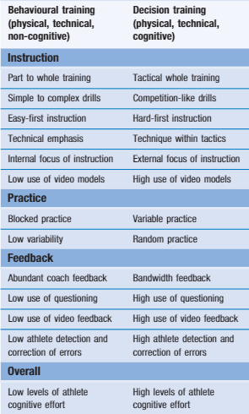 (Vickers, 2011)
De escalation training is a key strategy for policing, an officers communications are essential in bringing conflicts to peacefull conclusions (Burgoon, et al., 1987). In relation to UK Taser and UOF there is limited De Escalation training if any within its national packages supplied by COP. Evident in practical assessments, with firing the device being part of the competant or non-competant criteria. Assessors are asked to check the Taser control of the student, can they hit a moving target so de-escalation is never an option and if infact, if they did this they would fail, as not demonstarting effective use (Knowledge Hub, 2023). This goes against principles of de-escalation, suggesting to officers that firing is the best option. Todak & James (2018) concluded in recent research that De-escalation training must be enhanced within policing, and would decrese police/public violence, repairing lost trust. Cotton (2023), states that there should be more de-escalation training given to officers to mitigate conflict, as its currently lacking throughout.
To assist with concerns surrounding dealing with vulnerability, COP training packages are produced. Acute Behavioural Disturbance (ABD) is one such input. Better known as excited delirium. McGuiness & Lipsedge (2022), suggest that it would be easy for police officers to think persons are showing aggression towards them, when in fact they are having a medical episode, disorientated, and agitated, needing help. This type of incident has been linked with a number of deaths in custody so it is imperative for the STO’s to have a greater understanding and national bodies have recognised this (College of Policing, 2023), also including best medical guidelines (Faculty of Forensic & Legal Medicine, 2022).

2.5. STO - Operational Policing.

2.5.1. Use of Force (UOF).

Carrying out police duties places high demands on officers around public engagement and can result in UOF. Bittner, largily responsible for concepts in UOF studies, argues that the role of the police is a mechanism for distribution of non-negotiably coercive force (Bittner, 1970). Police UOF and decision making go hand in hand with officers decision to use force, directly impacts police organisations around misconduct, costs and reputations (Elinson & Frosch, 2015), also public perceptions (Anderson & Gustafsberg, 2016).
Police training, officer experiences are key factors in which to deal with conflict. Boulton & Cole (2016), conducted studies into experienced and less experienced officers from AFO’s, asking them to recall a challenging AFO experience, with resulting data highlighted more experienced officers dealt better with greater ability to deal independantly. This is supported by Todak & James (2018), who argue the more experienced you are the calmer, resulting in better de-escalation. Interesting points of view, which highlights a key debate in UK Taser training around officer selection and time served, experience levels.
Physiological stress is one of the fundamental reasons for good or bad performance in critical situations (Arnetz, et al., 2009). UOF Research by Bayley & Garofalo (1989), monitored police habits, and summised certain types of street encounters linked into UOF such as weapons, verbal abuse. Drawbacks to this research included, the use of one agency which limited data. Worden (1995), researched 1,528 incidents of UOF, classifying factors within as predictors for use. Similarily to Bayley & Garofalo, seriousness of offence, intoxication was highlighted as a primary factor. Garner, et al. (1995) surveyed 1,585 police officers, and 185 suspect interviews around coercive encounters. Results showing one in five encounters included force utilising appointments, with the most reliable predictor for police UOF being, force against the officer.
Less lethal force is heavily scruitinised within police UOF. Designed to offer a tactic for decreasing injuries, peaceful conclusions (Lin & Jones, 2010), and is seen as a better alternative to lethal options (White & Ready, 2007).
Taser was used 34,276 in UK incidents between March 2021- March 2022 (Home Office, 2022). Carried on the non dominant side of the body, holstered securely as to not be mistaken with a firearm (Martin, 2016). However with Tasers appearance seemingly similar to a firearm, weapon confusion becomes apparent, especially when an AFO. Between 2001 and 2021 in the U.S., eighteen live firearm discharges by officers were made, causing death, confusing it with what they belived was a Taser (Kroll, et al., 2022). Statistically speaking Taser is used and appears to be a key tactic in policing, however UK research is limited, or written for practitioners and not necessarily academia and contains little empiracal data (Dymond, 2014). Adams & Jennison (2007), similarirly state that U.S. research around Taser was sketchy, this even though being far in advance of UK research. With minimal UK data, academics preffered to concentrate on uses in America, Canada (Oriola, et al., 2012) and Australia (Ryan, 2008).
An early empirical study, Jenkinson, et al. (2006) looked at the injury risk when a Taser is deployed in comparison to other less lethal options. Data was gathered from UOF forms submitted through police forces over a twelve month period and was compared to 2050 taser deployments in the U.S. over a three year period. The results showed that it was more likely that officers faced injury from deploying irritant spray (+12.6%) or extendable batons (+ 23.7%) than Taser. It also showed that suspects were less likely to be injured by Taser. These conclusions supported the use of Taser, however showed limitations due to responder recall and bias from the officers. 608,164 conflict incidents occurred between April 2021 to March 2022 that involved a UOF, in comparison to 562,277 the previous year ending March 2021, an 8% increase with 45,887 more incidents of violence faced. Primarily, uses of force being used for officer protection as shown below:
Figure 2. 4 – Top 5 reasons for using force, England, and Wales.
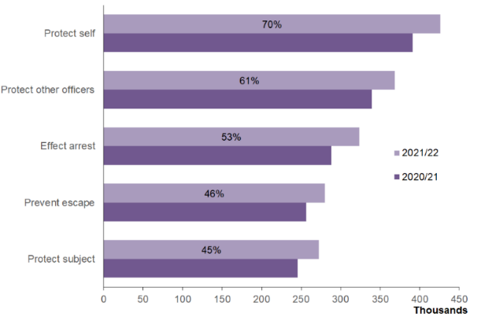 (Home Office, 2022)

With 73%, or 442,363 of persons being arrested whom UOF was necessary on:
Figure 2. 5 – Arrests.
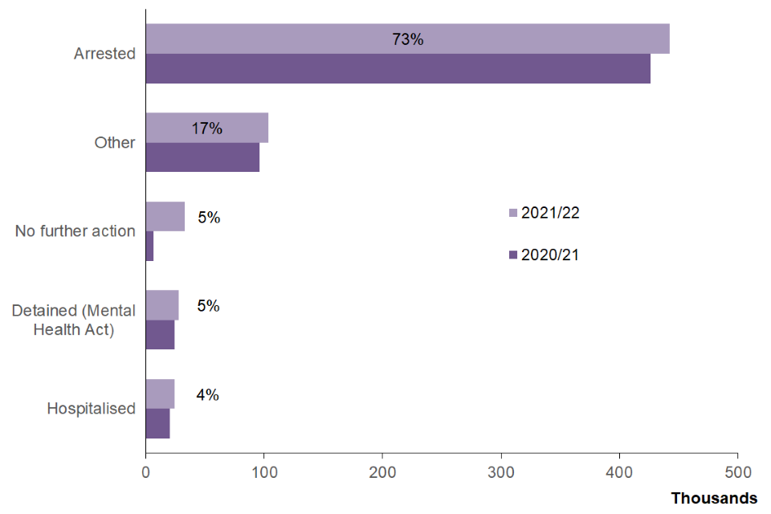 (Home Office, 2022)
Tasers were used in situations involving UOF almost 34,276 times up to 31 March 2022. It was discharged in 10% of cases (3,212) showing that officers merely having the device, utilising its functions, meant a peaceful resolution.
Illustrated below:
Figure 2. 6 – CED use 31 December 2010 – Year ending March 2022.
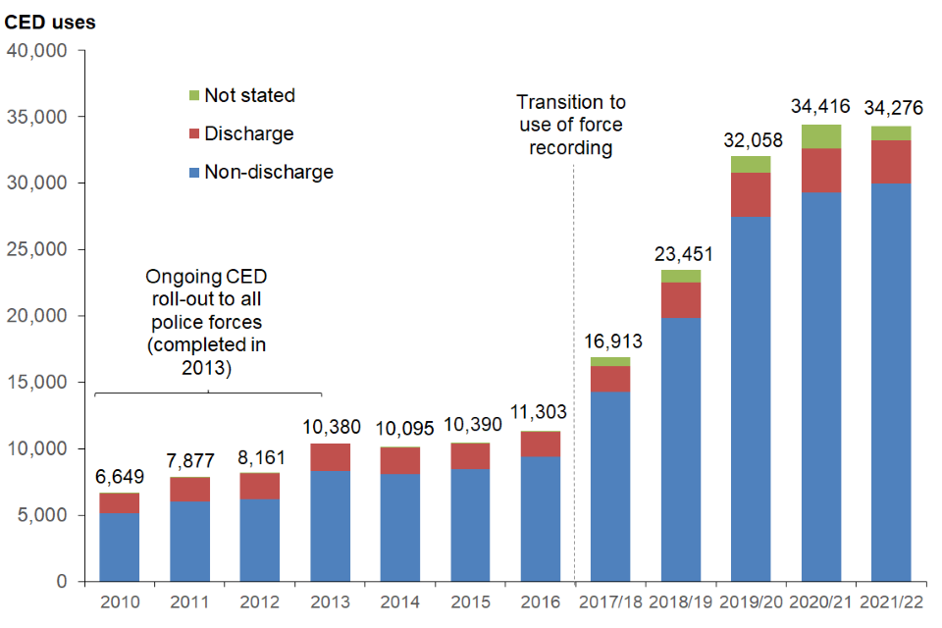 (Home Office, 2022)
Statistically, showing the device as an effective crime control method.
New processes have helped UK policing around reviews, including reviewing body worn footage (Police Federation, 2023), supported by the IOPC (IOPC, 2021), and has been shown positively in reducing false UOF claims against officers (University of Cambridge, 2016).
More locally DPP released its UOF data for the period October to December 2022 showing 149 uses of Taser from a total of 3346 (DPP, 2023). See (Appendix A 3), showing that even in more rural settings Taser is utilised substantially.
The COP have provided clarity on its UOF policy, giving ten principles governing its use following a review of disorder following UK riots in 2011 (Her Majesty's Inspectorate of Constabulary, 2011). UOF continuum, is a term, guide used in policing to aid decision making, depicted as visual diagrams of levels of police responses (Peters & Brave, 2006). Known as reasonable officer responses in the UK, showing proportionate responses available in conflict. A weakness to the model is that it isn’t prescriptive, and open to interpretation.
Figure 2. 7 – Reasonable Officer Responses.
(College of Policing, 2017)
In contrast, the Las Vegas UOF model, has been deemed not suitable, as too prescriptive, extremely detailed, confusing, and difficult to read (Di Nota, et al., 2021). A staircase model, and like the UK model, escalates as appropriate, progressing up the continuum. Officers are given detailed examples of when and where to utilise force at each stair/level.

Figure 2. 8 – Las Vegas UOF Model (all available models are poor resolution, limiting clarity of text)
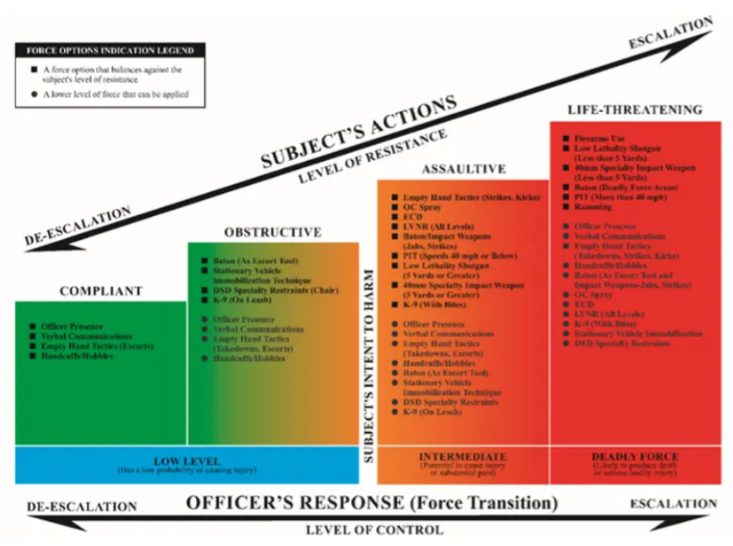 (Di Nota, et al., 2021)
Ontario’s UOF Model was brought in to assist officer’s, but also criticised heavily due to its complicated layers, again difficult to recall during incidents of extreme stress (Di Nota, et al., 2021) Dube, (2016), goes a step further by claiming deaths resulted from police interactions, linking the highly critised model as a factor, as too complicated to understand.
Figure 2. 9 – Ontario UOF Model.
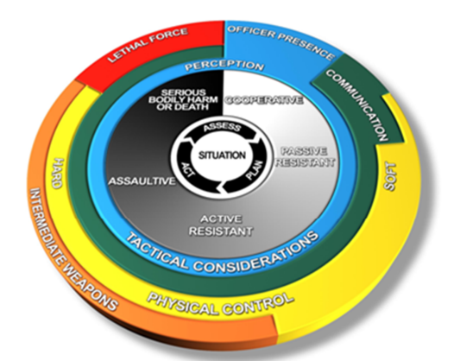 (Ontario Provinsional Police , 2004)
Thomas, et al. (2010), researched over 100 U.S. police forces, their officers and asked them to reflect on where Taser sat on a simple continum scale one (No UOF) to ten (lethal force). Results showed 61% placed the taser between 5 and 6.

2.5.2. National Decision Model (NDM).

With such Taser scruitiny, effective policie decision making is essential. A model used is the NDM, set out to assist in conflict situations (COP, 2019).
A pentagon in design, five sections around an inner core, code of ethics (COE). A model designed for officers to reflect dynamically during conflict. Within its core, policing principles central to all decision-making, taken from Nolans principles including fairness, honesty, accountability, integrity, leadership, openness, objectivity and respect and selflessness (COP, 2014; Home Office, 1995; Committee on Standards in Public Life, 1995).
Its goal to assist spontaneous and pre planned police actions, by reflecting and acting. Referred to as the Double loop model of learning by Argyris & Schon (1974), positively arguing that reflection in action, being far more dynamic and spontaneous, reflecting where critical thinking is essential.
Figure 2. 10 – The National Decision Model.
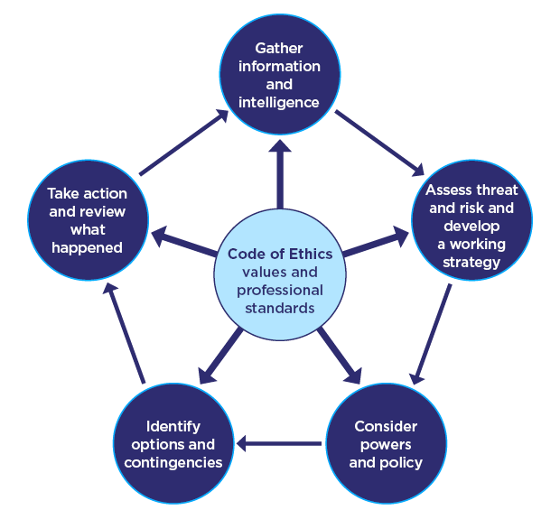 (College of Policing, 2014) (Appendix A 4)

The only conflict decision making tool within UK policing, it is not seen positively by other countries, instead chosing their own models as NZ’s TENR and assessment models show;

Figure 2. 11 – TENR Model.
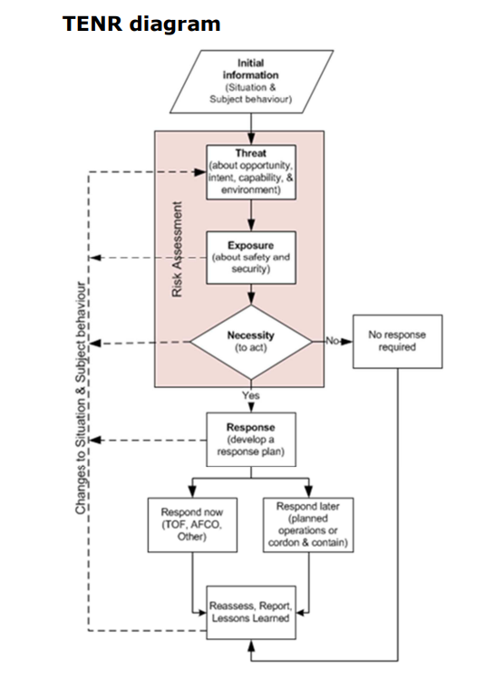 (New Zeland Police, 2023) (Appendix A 5)
Figure 2. 12 – Assessment Model.
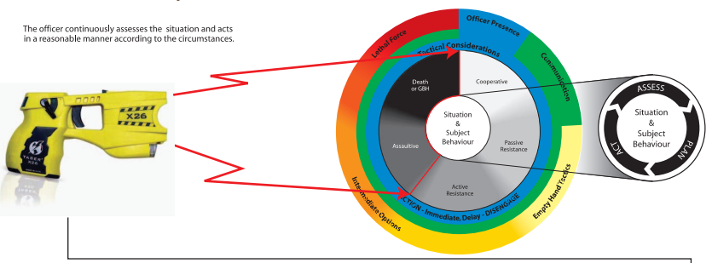 (New Zeland Police, 2006) (Appendix 2. 5)

Interstingly even though there have been no calls for the UK NDM to be replaced as a model of learning, NZ Police have adopted the Ontario model for its service which seems a weakness due to negativity surrounding its use within Canada (New Zeland Police, 2006).
In specialist Taser training, the NDM is critiqued, and tested stringently. With a stand alone module delivered in a one-hour classroom presentation, and tested, assessed in summative scenarios (COP, 2023), with such a key element, is this long enough with limited hours put aside.
Interestingly the NPCC stated in 2016 that Taser, due to its scruitiny and requirement for sound judgements would not be issued to Probabtionary Officers or Special Constable (SC) due to lack of experience (National Police Chiefs Council, 2016), they have since retracted this, allowing them to become STO’s (NPCC, 2020; Home Office, 2019). British Transport police in fact being the first force to allow Taser to be carried by its SC’s (BTP, 2022).
The scruitiny surrounding the firing of a taser can have serious reprocussions on officer welfare and the question here is fairness, to place this type of pressure on newer members of staff with limited experience. Komarovskaya, et al. (2011), states that this type of stress can be linked to post traumatic stress disorder (PTSD). Supported by Liakopoulou, et al (2020), who declares constant exposure to aggression, violent situations results in poor mental health.

2.5.3. Taser, Vulnerable groups, and Ethical considerations.

When explaining vulnerability, DOMILL have categorised children as being persons under eighteen and vulnerable adults as being over eighteen and falling into one of the below categories:
- Pregnant women.
- Small, thin with a low body weight.
- Adults under the influence of drink or drugs.
- Suffering mental health.
- Neurological condition.
- Conditions including heart disease, Acute behavioural disturbance (ABD).
- Adults with pacemakers
(DOMILL, 2012). Cao, et al., (2007), presented a case study on a Taserd patient with a Pacemaker. Contrary to assumption, the taser firing showed little effect in arythmia.
A South Wales Police officer in 2020 used Taser with negative connatations as he fired at a pregnant woman when attacked. Hitting the female, she fell to the ground and subsequently lost her unborn child. Although a devastating consequence, there was no medical evidence linking the Taser to the loss of life. Secondary injury by falling was argued as a factor. No discipinary action was taken against the officer. Human Rights group Liberty, disagreed and stated that Taser was too easily used and accessible within policing since its inception, putting people at risk. Amnesty International supported this, stating that Taser was a direct threat to pregnant women (Morris & Dodd, 2020).
Taser use on children has minimal data. In 2015 U.S. research shows that despite African/Americans making-up 2% of U.S. populations, 15% of this demographic between 15 - 34 had a taser discharged on them resulting in death, the youngest being 15 (Swaine, et al., 2015). Highlighted as a concern in UK policing also by the IOPC (2021), claiming dissproportionality in Taser use on minority groups, and an unconscious bias in policing. Children rights organisations called for Taser on children to be eliminated, and agrees with dissproportionality in the use of Taser against Black, minority groups. They recommended better training, national guidance around the subject as not currently part of the COP Taser package (CRAE, 2019).
It has been shown that people experiencing mental distress who encounter STO’s are more likely to have a Taser deployed on them (O'Brien & Thom, 2014).
There is requirement for increased involvement from medical professionals in Taser, and STO’s (Hallett, et al., 2020). This is shown to be further evident and concerning by Marsh (2018), who states there have been a number of Taser firings within hospitals and care institutions on patients, with several other studies claiming that people experiencing mental distress are more likely to be subjected to multiple exposures (Bailey, et al., 2016). Depicted below:
Figure 2. 13 – Shocks Administered.
(Bailey, et al., 2016)
The death of a civilian (Mark Cole) in 2017, where Taser was deemed a contributing factor as fired on 3 times, and Mr Cole deemed to be suffering from mental health and intoxication at this time. The IOPC criticised officers, claiming Taser was the norm now and not a last resort, directly linked the firing, his mental health and intoxication to his death. Families cited an overall lack of transparency around firings (IOPC, 2021)
As the investigating body IOPC stated that Police forces must justify to the public all circumstances where Taser is used, particularly incidents around children, vulnerable and respond to disproportionate use against Black people (IOPC, 2021). The IOPC has been criticised however by the NPCC (2021), claiming that the reports were vague, lacking detail with no evidence, with only 0.1% Taser uses being reviewed which was concerning.

2.5.4. Officer welfare and support.

Few occupations are as intense as policing. The constant alertness, shift work, and physiological stamina required takes its toll (O'Neill & Cushing, 1991). Mental health, wellbeing of officers can be affected adversely by the wide demands, and the stressful environment of being an STO (Clements, et al., 2020; Phythian, et al., 2022). With the police federation claiming between 2015-2017, 66 officers took their own life because of mental health, work related issues (ONS, 2018), showing a clear need for action.
The National Police Wellbeing Service (NPWS) was launched to give support and guidance to policing within England and Wales, better known as Oscar Kilo (NPWS, 2023) . The national wellbeing survey continues to show high anxiety levels and depression (Durham University, 2022). DPP has taken this on board and provides its staff with counsellors, Trauma support and an occupational health unit (DPP, 2023). The U.S. have seemingly gone one step further by creating wellbeing legislation, namely the Law Enforcement Mental Health and Wellness Act (LEMHWA), where results from eleven cases saw improved performance due to good mental health (U.S. Department of Justice, 2019).

2.5.5. Conclusion.

This literature review highlights gaps regarding Taser, training, procedures in UK policing and internationally, with limited data indicating a lack of understanding. Whilst scenario-based training is praised for its realism and developmental benefits, lack of practice time for developing skillsets, debriefing and discussion raises concerns.
The contrast between the UK's national model and the US's force-led approach raises questions about standardisation and conflicts of interest. Concerns risen around the effectiveness, safety of Taser, as well as the dominance of Axon in the market are highlighted.
The reliance on the NDM as a conflict decision-making tool is seen positively within UK policing yet not universally accepted, leaving room for subjective interpretations and potential bias. The lack of clarity around the term "less lethal" raises further issues, and activist groups highlight the importance of human rights compliance, and need for clear guidelines, research, and the effective training required to address critical issues. While Tasers have been touted as a less lethal alternative, the potential for misuse and weapon confusion raises serious doubts about their effectiveness in achieving peaceful resolutions.
The varying contact hours for initial and refresher courses, require further investigation. The absence of de-escalation training in packages provided by COP is a significant drawback, undermining the principles of peaceful resolution. This would benefit and alleviate concerns regarding taser use against vulnerable groups, with special attention needed here for transparency, accountability.
Disturbingly, a significant number of officers have taken their own lives due to work-related mental health issues. Although initiatives of support by forces show some progress, the persistently high levels of anxiety and depression among officers indicate the need for more comprehensive action.

Chapter Three - Research Methodology.

3.1. Introduction.

The Cambridge dictionary (2023) defines research as “a detailed study of a subject, especially in order to discover new information or reach a new understanding” (Para 1).
This chapter will explore the chosen research methodology, providing details of how this research was conducted, its design and strategies used for the aims and objectives of this paper to be met. Highlighting the collection and gathering processes of data (qualitative) and its analysis (thematic) and interpretations of results. The rationale for methods chosen will be explained, showing a clear structure to ensure reliability of findings and highlighting limitations and any problems that occurred during this phase.

3.2. Research Philosophy.

Described by Saunders et al. (2018), as the foundation of any study and depicted by his Research Onion methodology, as the various decisions taken when developing research methodology.
Figure 3. 1 – The Research Onion.
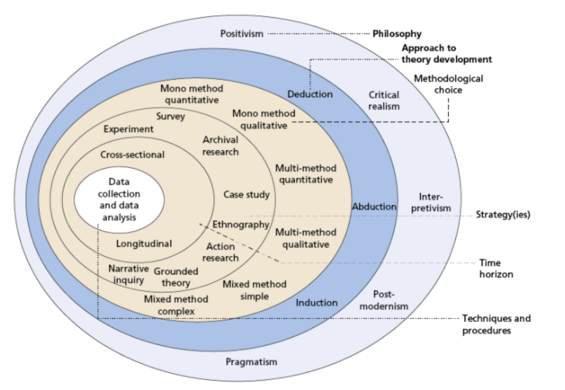 (Saunders, et al., 2018)
A theory consisting of six layers, working from the outside layer of the onion to the inner core, and facing various choices as you progress, ranging from philosophical to more tactical, practical ones, and this theory mimics the structure of this chapter for this research.
There are five philosophies within the onions first layer, Positivism, Critical realism, Interpretivism, Postmodernism and Pragmatism (Saunders, et al., 2018). So, what is the best philosophy and is there such a thing. Difficult to classify one philosophy to fit all as differing beliefs, assumptions would clash with a defined best philosophy, and this is agreed by Knudsen & Tsoukas (2005), claiming that there is disagreement academically around such a claim of a best philosophy.
Although not a definitive list, this research paper will concentrate on the below three most common philosophies Positivism, Interpretivism and Pragmatism (GradCoach, 2021).
Positivism is the belief in using scientific facts and methods to gain knowledge. Stating that knowledge comes from observations and measurements, focusing on finding general laws and reasoning, in essence a cause-and-effect relationship. This has been criticised however as being too simplistic, ignoring personal experiences, personal viewpoints, and opinions with no interpretation, and difficult to utilise when dealing with a small sample of police officer as is the case in this paper. With empirical data being the only research method here, there is little human reasoning as it is mainly a true or false or ultimately meaningless conclusion, meaning that if a true or false conclusion is not found then it essentially does not hold any ground and dismissed (Kluwer, 2020).
Interpretivism, is the other side of the scale to positivism, with influences from social and cultural factors, influencing individuals. Focussing on thoughts and ideas and in this philosophy the researcher is actively involved in the study, being very holistic in drawing out thoughts, actions, and their meanings from the participant, interpretating points of view when assessing the data (Alharahsheh & Pius, 2020).
Pragmatism is the practical approach to research, where knowledge is not fixed, but questioned, clarified and interpretated. This does rely on some involvement from the researcher, and subjectivity around drawing some conclusions, alterations because of data responses from participants. Within this philosophy you are not limited to one specific philosophy (Kelly & Cordeiro, 2020).
Following careful consideration, an Interpretivism philosophy was chosen as it meets the needs of the project, due to its more empathetic nature around the research subjects, sample i.e., DPP officer’s views, their working environments, and practices. Also, with the project being based around a small sample of specialised officers, including some emotive and contextual discussion, it highlighted interpretivism as a theory to be the most beneficial.

3.3. Research Approach.

The broader research approach to develop this paper will adopt an inductive approach, mainly due to the lack of information currently held around Taser, policing, and the specialist officer. Qualitative research will be utilised with the textual, visual, and audio-based nature of the dataset sought for sampling and analysis being utilised.

3.4. Research Design.

To develop and further enhance knowledge of how national Taser training standards are accepted and fit for operational purposes in DPP, the proposed research will be of a Survey design method primarily. Advantages to this type of design approach is its practicality when gathering data, by targeting a large demographic for example, STO’s within DPP by means of polls, questionnaires where feedback can be sought quickly, with the ability to compare the results (Gaille, 2020). This approach does have its cynics with Ball (2019), stating that the lack of an interviewer can be a problem as responses are not explored fully, and no scope to clear up any ambiguities for the respondent. Concurred by Jones, et al. (2011), in addition, who states further disadvantages around the possibility of non responses and subject accessibility. Jones does go on to suggest methods for improving responses, as shown below.
Figure 3. 2 – Methods for improving responses rates in electronic questionnaries.
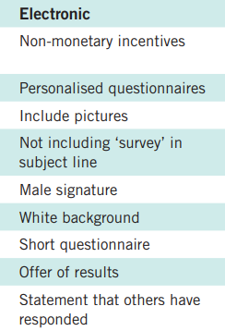 (Jones, et al., 2011)

Having considered all factors (Gaille 2020; Jones, et al., 2011) and due to excellent IT systems within DPP and access to them by STO’s, Online surveys/questionnaires will be utilised for data collection and the use of one-to-one interviews to a selected smaller demographic of STO’s who supervise staff will gain a rounded insight towards achieving the aim and objectives of this research paper.

3.5. Data Collection.

To answer the aim and objective of this paper it is important to have the correct strategy in relation to sampling and data collection. As the paper is looking to identify Taser suitability both in a training and operational environment the process of identifying the best individuals from which to achieve the best findings and results was key. Described as purposive sampling where enhancement of individuals, groups knowledge and understanding of experiences is often a qualitative method used in line with its goal (Devers & Frankel, 2000). The criteria set out by the researcher for inclusion in the research project was,
- Be a nationally accredited STO.
- Be a willing participant.
- Be employed by DPP organisation.
As the project focuses on the national and local issues surrounding Taser, and with a national survey being complex in its application, the researcher identified that DPP STO’s are suitable candidates as they are involved in both training and operational phases and should show similar characteristics to other UK police forces STO’s due to the standardisation of the training packages and tiered system, this sometimes described as probability sampling (Scribbr, 2022).
Web based questionnaires and one to one interview were chosen as the methods of research, with questionnaires given to the STO Constables, known as the response, and the one-to-one interviews held with their STO supervisors. This to gain insight around potential discrepancies in data within differing ranks. The term Qualitative research has been described as generating findings that can ultimately inform practice (Lochmiller, 2015), and providing descriptions of a given problem, and offering insights and context to them (Honig, 2006; O'Reilly, et al., 2015). The elements of these academic descriptors reinforce the researchers use of qualitative methods in gaining best outcomes to the aim of the research. Khankeh, et al. (2015), argues that qualitative research requires interpretation and analysis of observations and for this reason can be difficult to quantify and measure, with influence being given to results from their own bias. Something the researcher must reflect on during the analysis phase.

3.5.1. Online Questionnaire.

Robson & McCartan (2015) claim that online questionnaires work best when using standardised questions that you are confident will be interpretated the same way by the respondents. The researcher agreed with this thought process, using questionnaire for DPP STO’s as they would have a common interest in the subject matter. This was done utilising Microsoft Forms where the build of the questionnaire was done, (Appendix A 7).
The researcher wanted to keep the design simple, concise, and clear with minimal use of jargon, setting out a clear goal (SmartSurvey, 2023). Keeping the survey short, 20 questions ranging from multi choice to free narrative text were used, and included to answer the researchers aim and objectives formed from themes highlighted in the literature review. Questionnaires were emailed to all STO’s within DPP at the constable level, almost 240 in total (Appendix A 8). Within the email was a brief introductory paragraph of the work and a consent paragraph that was to be read also. This consent email and explanatory phase was also sent in email format to the respondents participating in the one-to-one interviews (Appendix A 9). Mothersbaugh, et al., (2012) states that online questionnairees offer greater control and customisation of the information required, and with its ease of production, costs also a positive, it is clear to see why they are adopted by many organisations (Denscombe, 2021).
There are some though who oppose this methodology. Nayak & Narayan (2019) claim a potential for survey fraud where false information or multiple completions by the same respondent are completed giving false results. The topic of ethics is also highlighted as a concern, due to the privacy and confidentiality concerns arising from the survey along with the informed consent (Regmi, et al., 2016). In light of the researcher giving anominity to respondents, they must be aware of the above negative connatations when reviewing, analysing data.

3.5.2. Interviews.

The second qualitative research methodology chosen by the researcher for this project is interviews. Kvale (1983, p.174) in summary describes interviews purpose, as gathering descriptions of the life-world of the interviewee in respect of interpretation of described phenomena. Interviews are catergorised into 3 groups for qualitative research namely structured, semi-structured and unstructured (Neergaard & Leitch, 2015; Nicholls, 2009). Multiple scholars have stated the imprortance of interviews for data capture, especially in qualitative studies (Barrett & Twycross, 2018; De Fina & Perrino, 2011; Denzin, et al., 2023).
Opdenakker (2006), states that one of the positives to face to face interviewing is the ability to record, transcribe with no apparent delay to question and answers, giving spontaneous answers rather than reflective ones. There is the issue of interviewee permission here to consider though. With advances in technology it becomes even easier to interview one to one by use of virtual methods, with no difficulties in arranging a time, place to meet and also gives participants more comfort if slightly nervous meeting in person (Bryman, 2002).
Wengraf (2001) is cautious to this methodology, especially unstructured and semi-structured interviews as he argues that there is the need for the interviewer to dynamically formulate questions due to the interviews interactive nature, speaking of double attention where you must listen and respond and understand simultaneously, which could be confusing.
The researcher has highlighted superviosrs from DPP who are also STO’s to take part in the semi structured interviews, this method has been chosen as it does give the participants the chance to answer set questions, but allowing for creativity and expression within their replies. There is benefits to the researcher with this methodology as the discussion can veer off and it does allow for additional questions to be asked, to be more facilitative and probing within the interview (Flick, 2023). A supervisors point of view may differ from the more response led STO replies gained from the questionaries and the researcher will compare the data and look for themes within it.

3.6. Data Analysis.

Described by Thorne (2000), as one of the most complex phases of any qualitative research, the researcher has used a thematic theme in relation to analysis of the projects data. There is significant confusion within academic circles around what thematic analysis means (Braun & Clarke, 2006).
Described as a process of analyssis, to find and identify patterns known as codes or themes that repeat themselves within the data-set (Braun & Clarke, 2022). Due to the researcher dealing with DPP STO’s experiences, behaviours and thoughts within the specified research design questions and interviews, this form of analysis is recommended (Braun & Clarke 2006, 2012).
The researcher followed Braun and Clarke’s (2006), six phases of thematic analysis as indicated below,

Figure 3. 3 – six phases of thematic analysis.
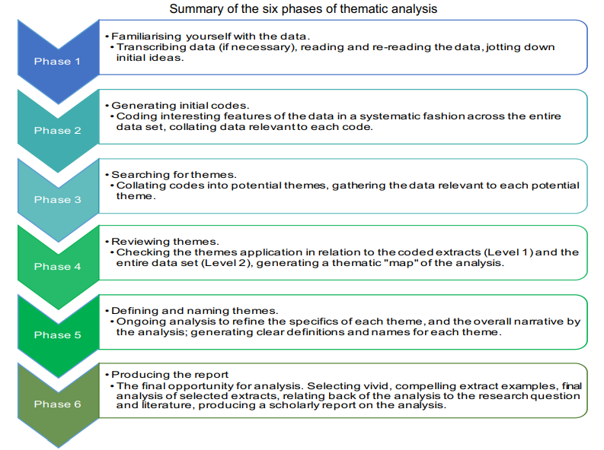 (Braun & Clarke, 2006)
As in phase one above, all participants responses were read and re-read to familiarise, IT systems and programs were utilised to assist the researcher and all data from the Microsoft Forms questionaries were fed into excel for further analysis, so specific trends, coding and themes could be sought.
Transcripts from 3 one to one interview’s with STO supervisors were read and familiarised by the researcher, again any difference to questionnaire responses and themes were sought. Free text quotations from participant’s were utilised by the researcher to show specific codes and themes gained from the analysis.

3.6.1. Limitations to research.

Some potential limitations to this research project are,
- Potential for non or low responses to questionnaires.
- Small demographic of officers used from one force.
- Potential bias of DPP staff and researcher.
Nayak & Narayan (2019) claim that a significant issue within online/web based questionnaiess is the lack of participation. Another non response component is where participants only fill out some of the questions. To mitigate this, the researcher can force responding when designing their online questionnaire so they cannot leave a question blank. Baker (2013), argues that this is seen by respondents as violating their research rights and is an ethical concern. To counter concerns, the researcher designed the form to be short with only 20 questions to ease the time consumption, and also the design of the questions would be mixed, some free text, some multi choice and some simply yes or no. This designed to keep the respondent engaged.
Due to time and costs, a small demographic of officers from DPP STO’s would be used by the researcher. As Taser is nationally governed by the COP, it can be assumed that responses from DPP would show some similarity to other UK police force STO’s. Having access to unique groups is seen as a posititve by Wright (2006), however he does offer a counter arguement, suggesting the potential of bias and repeadedly submitting the same opinion may alter results.

3.6.2. Ethical Considerations.

Throughout this project the researcher has adhered to the UWTSD research ethics and integrity code of practice, and a copy of the PG2-E1 was completed (Appendix A 10). All participants during the research phase were given anonymity when completing the online questionnaire, and a brief account and consent paragraph were included explaining their role and explaining their right not to partake.
For the one-to-one interviews, participants were given an information leaflet and consent form detailing their role within this project, again explaining that they could not take part, and leave if felt uncomfortable. All transcripts have been edited and all personal details have been redacted.
The following analysis chapter will present all details and findings of this research project.

Chapter Four - Analysis and Results.

4.1. - Introduction.

The purpose of this research study is to critically analyse national Taser training, their standards and how these are implemented to be fit for use operationally to STO’s in DPP. Data was collated and analysed to address the papers aim and objectives, and qualitative research methodology was adopted to test the research question. Primary data was used, giving confidence and reliability as it is gained specifically for this project undertaken, supported by Saunders, et al. (2018).
The chapter will cover and present the research data collected during this study.

4.1.1. Online Questionnarie.

The online questionnaire was distributed within DPP to all response STO’s (Constables), consisting of 220 in total. Gaining 20 responses agreeing to participate, which must be considered for the overall findings, and this is supported by Andrews, et al. (2003), who states that nonresponse is one of the major disadvantages to online surveys. The questionnaire included information detailing the purpose of the research project and all relevant details and sent online through DPP email systems with a 6-week closing date ending the 8^{th of} May 2023 (Appendix A 11).
The researcher utilised a thematic approach to the data collection, a widely utilised qualitative research and analysis method (Boyatzis, 1998). This consisted of identifying patterns within the for similarity, code words and phrases highlighted into themes within respondents replies (Crosley, 2021). Thematic analysis has been described as beneficial to researchers due to its flexibility (Braun & Clarke, 2006), however the use of an independent reviewer to assist with reliability in recognising themes, any coding is deemed essential (Alhojailan, 2012), which the researcher did not do on this project.

4.1.2. One to One Interviews.
Directed interviews were selected as the second part of the data collection phase. Described by the University of Plymouth (2023), as a prepared set of questions, with video and audio capability that can be held anywhere. The researcher sent out 12 invitations by email to supervisory STO’s (Sergeants) within DPP. They are responsible for managing police constable response STO’s operationally. The emails contents specified the details of the project to them, and requested their participation, and a response was requested from them by email around their availability by April 17th, 2023. Four respondents volunteered to take part in the interviews, 3 from operational response and one from a ten-year firearms background (Appendix A 12).

4.2. - Research Findings.

4.2.1. Online Questionnaire.

20 responses to the Questionnaire were collated, resulting in the breakdown demographically within DPP below, from question one,

Figure 4. 1 – Question One
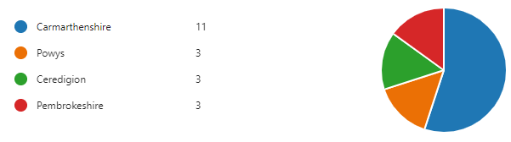
When respondents were asked question two, around Taser training and delivery, and had it given an awareness, confidence in its use. The emphatic response was yes, however some did caveat these answers with a themed lack of time, which is in contrast to Kolb’s (2015), methodology from the literature review stating that learning is done through experiences and reflection. This would appear to be lacking with some of the cohort, from replies.
Sample replies as below.
Table 4. 1 – Question Two
Participant | 4 | 6 | 20
Sample Officer Responses Question Two (Training / Confidence) | ‘Yes, the training is full and regarding the refresher training is a lot of content to fit into one day and can sometimes feel that it is going at a fast pace. However, the way the training is delivered is very well done with the tight timescales.’ | ‘Yes. The training is often adapted to reflect issues that have arisen during incidents across England and Wales. Thus, utilising varied training scenarios raises confidence. Awareness of the device's functions is achieved through the classroom-based learning.’ | ‘Suitable training however confidence is limited due to only having minimal time.’

When addressing the issue of assessment and fitness for use to STO’s, most of the respondents did state that it was fit for their role, especially highlighting the scenarios as one area of preference, benefitting from the realistic nature of the training. This concurs with Jenkins, et al. (2020), who stated that the strength of scenarios lay within their realism and areas to develop being highlighted.
One of the respondents interestingly stated that previous year’s training consisted of de-escalation within its scenarios, but this wasn’t to their liking. They stated they preferred to fire the Taser to pass the assessment, which is the case today (Officer 15). This directly contradicts Cotton’s (2023) and Burgoon, et al. (1987), previously reviewed articles where the use of de-escalation was deemed necessary in training to mitigate conflict. When assessing the impact of de-escalation training on police officer behaviours around UOF, many policies for training incorporates this communicative tactic (Engel, et al., 2022). It is argued that there is little research data to demonstrate this type of training reduces force however and this is supported by the officer 15’s preference (Engel, et al., 2020).
A section of the respondents felt there were issues around timings. The course was too condensed, and they wanted more time on task. One respondent stated there were integrity issues around being told information prior to the assessment by peers, which is against guidance and policies within the International Center for Academic Integrity (2021), and COP’s code of ethics (COP, 2014), as the integrity of officers highlighted could result in disciplinary action.
Sample replies as below.
Table 4. 2 – Question Three
Participant | 1 | 11 | 15 | 19 | 20
Sample Officer Responses Question Three (Assessment) | ‘I think the assessment process is difficult, but I do feel the scenario-based training is realistic which tests our decision-making utilising the NDM.’ | ‘I feel that there is sufficient time during the initial taser course, allowing officers time to learn the various settings, handling options and allows officers time to build muscle memory while using the device. It gives officers knowledge, skills, and confidence to use taser. The taser refresher course is also fit for purpose and the one-day refresher is sufficient and builds on the skills gained during the initial taser course. The only thing I would suggest is that the assessment should be through the day and build on weapon handling, knowledge as well as the final assessment. I feel that when doing the final scenario, I put a lot of strain on myself as I know it is pass or fail.’ | ‘I have had taser for a few years and have seen the training change in that time for the better. It has improved in that when we were initially given the training most of the scenarios were based around an encouragement for you not to use the taser and use verbal tactical communication instead of deploying and deploying or firing the taser. I never quite understood this as you should know when and when not to fire a taser from your policing experience and the classroom input you receive around powers and procedures. The training is much better now as you are regularly deploying the taser and keeping people under power to remove any weapons and provide the after care in a training environment.’ | ‘Sufficient, more time.’ | ‘Difficult and prone to others telling you what to expect.’

When participants were asked if the Taser training package was consistent and effective around standardisation within DPP, all the cohort answered yes as below,
Table 4. 3 – Question Four
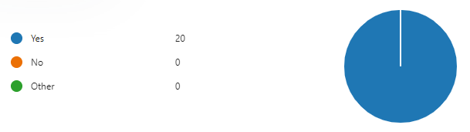
When the discussion around ethics and vulnerable groups within training, and operational environments within DPP was broached, unanimously all respondents stated they were happy with the content. They stated it put them in good stead operationally, supporting the COP’s (2023), and medical guidelines previously set out and reviewed (Faculty of Forensic & Legal Medicine, 2022; DOMILL, 2012; Cao, et al., 2007).
Sample replies as below.
Table 4. 4 – Question Five
Participant | 4 | 8 | 15 | 19
Sample Officer Responses Question Five (Vulnerable Groups) | ‘Yes, during the training there is strong emphasis on EMD persons and the use of taser on when dealing with people with mental health and the use of taser surrounding under 18-year-olds.’ | ‘Yes, there's a large focus on expanding knowledge of the NDM which was hugely beneficial.’ | ‘The training highlights the issues surrounding taser and its use on vulnerable groups. This emphasises issues which may be caused using the CED on certain groups. Regarding the training, I believe that it is conducted in an ethical manner.’ | ‘Yes, in the past few years there has been a vast increase in awareness with regards to the identification and treatment of vulnerable groups.’

When analysing the ethical considerations following a Taser deployment. The review process was deemed to be unclear to many of the respondents, with differences in their replies, showing confusion. Mirrored by reports reviewed earlier in this project, showing a similar lack of structured reviews done on police incidents, highlighted by the NPCC when overseeing the IOPC as the nationally governing body in investigation when reviewing police misconduct (NPCC, 2021).
Sample replies as below.
Table 4. 5 – Question Seven
Participant | 4 | 5 | 9 | 13 | 20
Sample Officer Responses Question 7 (Taser Review) | ‘I am not sure of the review process following the use of taser.’ | ‘Review of the incident and paperwork by specific OST staff.’ | ‘If concerns are raised Taser deployment is reviewed by Specialist Operational Training and PSD.’ | ‘Not known.’ | ‘Not clear.’

In relation to the NDM (Q8, Q10), the respondents were positive on its use within training and their role operationally. All twenty respondents stated it was valuable and an essential policing tool, concurring with previous literature during the review (COP, 2013; Committee on Standards in Public Life, 1995).
Some respondents stated that use of the NDM around Taser tactics was key in relation to de-escalation in many of the incidents they attended operationally. This agrees with Argyris & Schon’s (1974), double loop spontaneous reflection in action theory, where the use of critical thinking is essential.
Sample replies as below.
Table 4. 6 – Question Eight
Participant | 1 | 4 | 11
Sample Officer Responses Question Eight (NDM) | ‘I think it is the best policing model that I use when writing my notes and use of force forms.’ | ‘In my opinion the NDM is one of the best models that the police employ and is a strong and effective way of directing your thought process when dealing with anything in the police not just the use of CEDs.’ | ‘NDM is massively important, and I feel that CED training is one of the few courses whereby you can physically see officers "spinning the wheel," such as moving their hand from their Pava, to handcuffs, back to Pava and then onto their CED.’

Table 4. 7 – Question Ten
Participant | 2 | 6 | 12
Sample Officer Responses Question Ten (NDM) | ‘Effective UOF resulting in deployment of taser for red dot/arc of taser without requiring it to be fired.’ | ‘I have used the device many times, I have never discharged it. I have used the NDM to aid the decision-making process of drawing the device and whether to discharge it.’ | ‘There are numerous situations whereby I have been able to utilise taser whilst out on patrol. On one such occasion I was faced with a subject brandishing a knife. I have red-dotted the male and the situation has instantly been de-escalated. Other times, the taser option although considered was not utilised as there were other, less intrusive means by which to escalate the situation. In my opinion, the more experienced an officer is with dealing with a variety of situations and the more "STREET-WISE" an officer is with his approach, will determine the proper use of taser. I have been in numerous situations whereby conflict has been at the forefront. If an officer is unable to deal with conflict sufficiently, then taser, in my opinion should not issue to them.’

When discussing the training of Taser and UOF, the replies were mixed with some believing the training was adequate, with others wanting extra days, and more scenario training. This concurs with academic research in relation to the valuable nature of more training hours to aide officers’ development, claiming that insufficient training hours saw officers lose out, with some experiencing stress and anxiety because of limited confidence (Howatt, et al., 2018; GAO, 2005).
The question of officer experience is raised here, and when the correct time is to become an STO. This in agreement with the initial thoughts of NPCC (2016). Some mentioned a minimum length of service prior to attending a Taser course, with some suggesting passing prior conflict training, which falls within the recommendations of Komarovskaya, et al. (2011) and Liakopoulou, et al. (2020), who claim that such exposures at early stages of a new police officer’s career, with limited experience could have adverse effects on wellbeing and health.
De-escalation training was explored, and contrasts previously mentioned replies as highlighted as a negative aspect of the training, due to its non-requirement to pass the course. This supports Todak & James (2018), who claim that de-escalation training must be enhanced resulting in decreases to violence and gains better trust with communities. This however appears to be lost within the assessment processess of the COP as within their course materials, a pass to the current criteria can only be achieved by deploying/firing your Taser, with no de-escalation apparent (Knowledge Hub, 2023). This could be deemed as escalation rather than de-escalation
Sample replies as below.
Figure 4. 3 – Question Twelve

Wellbeing received a mixed, somewhat negative response when asked around mechanisms for support and ease of access to it. All respondents shared different replies showing confusion within the cohort, as some suggested support was from Occy (Occupational Health), some SPOC (Single Point of Contact), some naming TRIM (Trauma Risk Management) and some stating PIM (Professional Investigation Manager). Alarmingly, clarity on what support was there for STO’s is lacking. This conflicted with the police federation’s review of figures, who suggest officers are aware of support projects and the work they are doing to remedy, by roadshows, sharing information to officers, but this appears to need reviewing (ONS, 2018). This is also highlighted by the lack of knowledge within the cohort around wellbeing and the efforts of the national wellbeing services, and their work to address officer mental health (NPWS, 2023). Within DPP it is clear from replies, that there is work to be done around messaging to officers, on available support within the force and more importantly how they gain access to it (DPP, 2023). For a device so scrutinised globally it seems that clarity here would be beneficial.
Sample replies as below.
Table 4. 8 – Question Fourteen
Participant | 10 | 6 | 9 | 13 | 17
Sample Officer Responses Question Fourteen (wellbeing / Support) | ‘To be honest I'm not sure.’ | ‘TRIM Police federation.’ | ‘Supervisor, SPOC or Specialist Operations Training Department.’ | ‘PIM procedure, occy health.’ | ‘I do not know and am unaware of what mechanisms exist. I work alongside a taser downloader and can approach them for advice, but following a taser deployment the only contact I normally have is an email criticising me for some part of my deployment.’

To conclude the questionnaire the STO’s were asked to suggest recommendations for improvements in training and use. With only two of the twenty officers stating they were happy with the training and operational side of Taser, it clearly highlights that there is room for improvement, with some clear themes returned from their results as depicted below.

Figure 4. 4 – Question / Recommendations

4.2. One to One Interviews.

The researcher conducted 4 semi-structured, one-to-one interviews with STO supervisors, stated as one of the most beneficial ways of collating qualitative data, that permits focus led questions, as well as giving the interviewer the autonomy to explore answers and narratives to replies (Adeoye-Olatunde & Olenik, 2021).
Three of the respondents were response STO supervisors, and one was from a firearms background. Utilising first line managers was done to explore whether the perspectives from a management of STO’s point of view differed from the general first response users of Taser on front lines. The semi-structured interviews consisted of the same questions from the online questionnaire and the researcher highlighted themes from all four respondents replies as per previous analysis.

4.2.1. Insufficient Training Time.

It was clear from all four interviews and their transcripts that the issue of time and lack of it in relation to practice, drills, scenarios were an issue. This is supported by Porter (2019), who stipulates practice as essential, through scenarios, exercises to master concepts. Ericsson (2019), agrees, claiming that to be elite requires longer periods of practice. Insufficient time within Taser training would suggest that a lack of excellence on its use is happening. The issue of STO’s annual refresher training posed the biggest issue to all supervisors who suggested the current one day package was too much detail and activity for one days learning, and a two-day course would be better, giving more time for practice with one respondent stating how tiring and stressful the entire day was, claiming that they were ‘shattered’ by the time they got home due to the stress and quantity of learning in the day’s activities (Supervisor three). This is supported by Glaveski (2019), who suggests applying lean learning as a best practice, where bite sized inputs are easier to digest by students.
The question around the current twelve-monthly cycle of re-accreditation of Taser use, caused concerns and the issues of some never picking up their Taser annually other than daily checks, so skill fade was a real problem. Concurred by Mace (1968), who states spreading learning out over a period of time, known as phycological spacing, adds to retention of information by students and claims an 80% improvement in knowledge retention, and this would support the suggestions of a training day being done every six months (Supervisor one).

4.2.2. NDM.

On a positive note, the NDM and its delivery in training and the application of it operationally was highlighted as essential to the role of the STO. Its use and delivery within the classroom were deemed good, standards were commented as high when facilitated by the training staff. It was suggested by all four supervisors how good its use within scenarios was in the practical phases, and how this use and application assisted them to complete Taser assessments better. This is corroborated by Fenton-O'Creevy, et al. (2022), who stated that the NDM is beneficial and provides a basis for balanced decisions. However they do also suggest its limitations as it may in fact delegitimise any officers experience based decisions. The respondents commented that use of the NDM gave them confidence in critical high threat, operational situations where they had used the NDM successfully. Agreed by Jang, et al. (2010), who summises that confidence in policing is very important to communities and police officers use of the NDM effectively can be beneficial.

4.2.3. De-Escalation Training.

There was discussion around Taser in conflict situations, and its use as a tactical option for de-escalation. However, during training this wasn’t the case as you must fire the Taser successfully during scenarios to pass the course in line with COP guidance and procedures (COP, 2019). If no de-escalation tactics are to be used, as is currently always the case, then officers may replicate this same mentality operationally by always deploying taser in conflict. As stated by (Elinson & Frosch, 2015; Anderson & Gustafsberg, 2016), this would raise concerns around misconduct, costs and public perception.
Two supervisors (one and four) agreed with the above academic thoughts and saw this within Taser training as conflicting, as they appreciated that you needed to fire the device to show competence, but also the necessity to utilise the device functions, such as red dots to de-escalate. If firing was the only available option to them, then this de-escalation tactic wasn’t viable in the training environment, even though statistically COP state within their documentation that 90% of all operational incidents are ended by merely pointing the Taser at the person and red dotting (COP, 2023).
They linked this issue directly to previously discussed timing issues, arguing that with the potential of two days for training, the incorporation of de-escalation and firings could be factored into the delivery to negate non-proportionate responses.

4.2.4. Suitability of Officers as STO’s.

The issue of suitability was highlighted as previously mentioned within the online questionnaires. They discussed that the demographic of DPP is very young with officers being inexperienced, both operationally, and with limited conflict experience. It was deemed unfair placing these officers on Taser courses, and with insufficient skills to deal with conflict, it was potentially harmful to the officers, organisation, and the communities they policed. This is in line with Boulton & Cole (2016), previously reviewed studies showing less experienced officers had less capability of dealing with conflict than their more experienced counterparts. Supported by Todak & James (2018), who argued the more experienced you are the calmer, which results in better de-escalation within conflict.

4.2.5. Vulnerable Groups.

Vulnerability training was deemed appropriate by all four supervisors, and all stated there was sufficient input, both theoretically and practically within scenarios. They felt this also assisted them operationally when dealing with persons suffering mental health and children, ensuring that they dealt with those persons proportionately. This however is in direct conflict to the literature reviewed with O'Brien & Thom (2014), stating that people suffering mental distress are more likely to have a Taser deployed on them when encountering STO’s, which does show a breakdown from the supervisors responses who claim that the training was adequate. Key here could be the increased involvement of medical professionals within the training and operational arenas as promoted in the review by (Hallett, et al., 2020). This is supported by Marsh (2018) who voiced concern over Taser being deployed on patients within hospitals and care homes.

4.2.6. Reviewing Taser Incidents.

There were clear differences in each of the four respondents around reviewing incidents. This is something that they stated posed concern, as their role as the STO supervisor is to manage their staff who carry a Taser, yet all four of the respondents gave differing answers to the question with no clear guidance being described, as one of the issues to reviewing. This would explain officer investigations, recommendations around reviewing being highlighted by investigating bodies as poor (IOPC, 2021; IPCC, 2014). Supported by Symonds (2021), who reported concerns in relation to reviews and use of Taser.

4.2.7. Wellbeing and Support.

The researcher highlighted some big differences here around support and wellbeing. All four STO’s, sharing differing responses to support mechanisms for staff following a Taser deployment. More worryingly, two of the supervisors didn’t know where or how to get this support if required for their STO’s being managed (Supervisor three and four). With their staff potentially suffering high anxiety following conflict, this could be seen as problematic, as awareness around signs, symptoms of stress is key as the first line manager, and this is supported by (O'Neill & Cushing, 1991; Clements, et al., 2020; Phythian, et al., 2022).
This lack of knowledge demonstrated by the respondents showed that national wellbeing services being pushed by various organisations within policing (ONS, 2018; NPWS, 2023; DPP, 2023), are failing with their communication, media strategies.

Chapter Five - Conclusion.

5.1. - Introduction.

The overall aim of this research was to,
Critically analyse how national ‘Conducted Energy Device’ training standards are accepted and implemented as fit for operational purpose by Specially Trained Officers in Dyfed Powys police service.
The objectives were to,
- Explore the current practices and processes of national CED training and analyse how this is managed and delivered locally by individual forces around standardisation, quality assurance and effectiveness for their STO’s.
- Explain how CED are utilised operationally and explore how effective the national decision model is around safety considerations and use of force, and how police officer welfare and support is managed.
- Investigate if training, and operational use is ethical, paying due regard to protecting vulnerable categories within local areas of Dyfed Powys.
- Propose any improvements to training products, delivery, and operational application to ensure that STO’s are developed to the required standards.
This chapter will revisit the above research aim and objectives, providing an overview of the key findings and their implications towards the research question posed. The chapter will discuss the limitations of the study and give recommendations for future research.

5.2. - Summary of Findings.

Objective One.
The current processes of national Taser training in the UK are managed by the COP. They set national expectations, policies and provide annual training packages to lead instructors, through tiered approaches within forces when providing Taser initial and annual refresher courses.
The training of STO’s is overseen by the CC, but with police officer recruitment now predominantly from academic backgrounds, suitability and effectiveness of these inexperienced officers has raised concerns about the potential lack of real-life experiences and relevant skills they possess to be effective in the role as an STO. Overall, whilst the model ensures standardisation, there are concerns about the effectiveness of current training methodologies. There are obvious concerns within the research regarding limited time within course curriculums, with varying contact hours and a lack of emphasis on de-escalation training.
Objective Two.
To surmise, the NDM provides a framework for decision-making, ensuring safety and appropriate UOF, and is designed to guide officers dynamically, whilst reflecting on ethical principles and making dynamic choices in conflict situations. The effectiveness of the NDM and its application in relation to Taser remains a subject of debate. Whilst the NDM promotes a proportionate response and minimises risks, there are academic concerns about the NDM's interpretive nature and the potential for variations in its implementation by officers, resulting in excessive UOF, however the STO’s themselves saw it as a very necessary tool to aide them in their roles. Police training and officer experience play crucial roles in managing conflict incidents. More experienced officers are said to exhibit better decision-making and de-escalation skills. However, physiological stress can significantly impact an officer's performance in conflict.
The well-being of officers is a pressing issue, with a significant number of suicides nationally attributed to mental health and work-related issues. Efforts within mental health have been addressed locally within DPP’s policing circles, however the challenge of officer welfare and support remains ongoing, as shown from replies to qualitative data suggesting there was a clear lack of knowledge and understanding in this area by participants.
Objective Three.
The use of Tasers raises ethical concerns, especially when it comes to safeguarding vulnerable groups. Consideration on the impact on children and vulnerable adults must always be considered. Alarming reports highlighting a disproportionate use of Tasers on minority groups, and a potential unconscious bias within policing. A concerning aspect is Taser deployments on individuals experiencing mental distress, and in such situations, there is a higher likelihood of Taser use. Disturbingly, there have been cases of Taser firings within hospitals and care institutions, raising questions around appropriate UOF, with multiple exposures of Taser on individuals experiencing mental distress reported.
Considering the local context of DPP, it is crucial to investigate if the training and operational use of Tasers adhere to ethical considerations and effectively protect vulnerable categories and the primary data showed that STO’s within DPP felt that vulnerability was covered well within training environments, which assisted them with de-escalation in those incidents of dealing with vulnerable groups operationally.

5.3. - Limitations.
The primary research has some notable limitations. One drawback is its exclusive focus on one organisation, namely DPP. This overlooked the perspectives and practices of the other 42 police forces STO’s in the UK, however with standardised national packages being utilised within Taser, the outlook of DPP STO’s should show some similar comparisons with other forces STO’s. By limiting the sample data, the study fails to capture the broader landscape.
To overcome this, future research should strive to incorporate a larger range of police forces from across the country. This would help researchers gather a comprehensive dataset, improving generalisability and bolster the validity of findings. Time constraints would be a factor to consider here however due to the large number of officers within the UK so maybe a more regional view (3-4 forces) would be a better option.
Another significant limitation revolves around the issue of non-responses. The response rate to the online questionnaires was low, with only twenty replies received out of 220 sent out. This implies that the views of only 11% of STOs within DPP were captured. Similarly, while the one-to-one interviews were better, with four participants out of twelve taking part, it still encountered a non-response rate of 67%. This impacted the data, potentially leading to skewed findings. Future research should consider strategies to improve participant engagement.
One area of improvement could be to enhance the relevance and clarity of the questionnaires and invitations, ensuring they resonate with participants, with better emphasis on the significance of their contributions and value to the project. Measures such as these would help mitigate issues around non-responses and give validity to the findings.

5.4. - Recommendations.
Based on the study, several recommendations can be made to address identified issues. Regarding the issue of insufficient training time, it is imperative to allocate more time for practice, drills, and scenario-based exercises in Taser training. The current one-day refresher course does not give adequate time for STO’s to practice and improve their skills. Consideration around implementing a two-day training course to allow STO’s more time to practice with the device, thus becoming more confident and proficient in its use.
The study highlights the importance of incorporating de-escalation tactics into Taser training. While the requirement to fire the device during scenarios to demonstrate competence is necessary, it is equally important to emphasise the use of de-escalation techniques and the device's non-firing functions when being trained. This can be achieved through specific training and scenarios focussing on de-escalation strategies, highlighting the effectiveness of non-firing options such as red dotting. This would align with the statistical evidence that a significant percentage of operational incidents can be resolved through non-firing actions.
To ensure officers suitability in becoming STO’s, consideration around the level of operational experience and conflict management skills when selecting candidates for Taser training is important. Placing inexperienced officers on Taser courses without adequate experiences could be harmful. Better selection processes for Initial Taser courses need to be in place, with officers who have demonstrated better conflict resolution capabilities would provide potentially better operational outcomes.
In reviewing Taser incidents, clear guidelines and protocols should be established to ensure consistency. Standardising processes around review and providing better guidance would help supervisors effectively manage their staff who carry a Taser. This will contribute to transparency, accountability, and improved future decision-making from reviewing procedures.
Support mechanisms for STO’s following Taser deployments needs strengthening. First-line managers should receive appropriate training on recognising signs and symptoms of stress and anxiety in their staff. All STO’s should be provided with clear information and resources on accessing wellbeing services. National wellbeing services within policing need improvement around their communication, media strategies to ensure that officers are well-informed about available support.

5.5. - Closing Summary.
In conclusion, this research has highlighted various aspects of national CED training standards, implementation, and the operational use of Tasers by STO’s. The findings show the need for improvements in training methodologies and tactics, and selection processes. Standardisation around Taser is required along with strengthened mechanisms for STO’s wellbeing.
By addressing these recommendations, the study contributes to enhancing the effectiveness, safety, and ethical practices surrounding the use of Tasers within DPP, with implications for policing agencies nationwide. Further research in this area can build upon these findings and continue to advance the understanding of Conducted Energy Devices, better known as Taser.

Bibliography

ACLU, 2011. ACLU Study Finds Minnesota Lacks Legal Standard on Taser Use. [Online]
Available at: https://www.aclu.org/press-releases/aclu-study-finds-minnesota-lacks-legal-standard-taser-use
[Accessed 3 June 2023].
ACPO, 2008. Extended operational Deployment of Taser for Specially Trained Units, London: ACPO.
Adams, K. & Jennison, V., 2007. What we do not know about police use of Tasers. Policing: An International Journal of Police Strategies & Management, 30(3), pp. 447-465.
Adams, K. & Jennison, V., 2007. What we do not know about police use of Tasers.. Policing an International Journal., 30(3), pp. 447-465.
Adeoye-Olatunde, O. A. & Olenik, N. L., 2021. Research and scholarly methods: Semi-structured interviews. Journal of the American College of Clinical Pharmacy, Volume 4, pp. 1358-1367.
Alharahsheh, H. H. & Pius, A., 2020. A Review of key paradigms: positivism VS interpretivism. Global Academic Journal of Humanities and Social Sciences, 2(3), pp. 39-43.
Alhojailan, M. I., 2012. THEMATIC ANALYSIS: A CRITICAL REVIEW OF ITS PROCESS AND EVALUATION. West East Journal of Social Sciences, 1(1), pp. 39-47.
Alt, D. & Raichel, N., 2022. Problem-based learning, self- and peer assessment in higher education: towards advancing lifelong learning skills. Research Papers in Education, 37(3), pp. 370-394.
Amnesty International UK, 2006. UK: Amnesty concern as man dies following taser and baton round shooting. [Online]
Available at: https://www.amnesty.org.uk/press-releases/uk-amnesty-concern-man-dies-following-taser-and-baton-round-shooting
Anderson, J. P. & Gustafsberg, H., 2016. A Training Method to Improve Police Use of Force Decision Making: A Randomized Controlled Trial. SAGE Journals, 6(2), pp. 1-13.
Andrews, D., Nonnecke, B. & Preece, J., 2003. Electronic Survey Methodology: A Case Study in. International Journal of Human-Computer Interaction, 16(2), pp. 185-210.
Angleman, A. J., Shinzato, Y., Van Hasselt, V. B. & Russo, S. A., 2009. Traditional martial arts versus modern self-defense training for women: Some comments. Aggression and Violent Behavior, 14(2), pp. 89-93.
Arble, E., Daugherty, A. M. & Arnetz, B., 2019. Differential Effects of Physiological Arousal following Acute Stress of police Officer Performance in a simulated critical incident. Frontiers in Psycology, pp. 7-15.
Argyris, C. & Schon, D. A., 1974. Theory in practice: Increasing professional effectiveness. 1 ed. San Fransisco: Jossey-Bass.
Arnetz, B. B. et al., 2009. Trauma Resilience Training for Police: Psychophysiological and Performance Effects. Journal of Police and Criminal Psychology, Volume 24, pp. 1-9.
AXON, 2005. TASER X26 User Manual, Seattle: AXON.
Axon, 2020. Introducing Axon Enterprise. [Online]
Available at: https://www.axon.com/news/article-introducing-axon-enterprise
[Accessed 25 April 2023].
Axon, 2022. The truth about Taser. [Online]
Available at: https://www.axon.com/news/truth-about-taser
[Accessed 2 June 2023].
Azadani, P. N. et al., 2011. Funding source and author affiliation in TASER research are strongly associated with a conclusion of device safety. American Heart Journal, 162(3), pp. 533-537.
Bailey, C. A., Smock, W. S., Melendez, A. M. & El-Mallakh, R. S., 2016. Conducted-Energy Device (Taser) Usage in Subjects With Mental Illness. Journal of the American Academy, 44(2), pp. 213-217.
Baker, R., 2013. Summary report of the AAPOR task force on non-probability sampling. Journal of Survey Statistics and Methodology , 1(2), pp. 90-143.
Ball, H. L., 2019. Conducting Online Surveys. Journal of Human Lactation, 35(3), pp. 413-417.
Barrett, D. & Twycross, A., 2018. Data collection in qualitative research. Evidence-Based Nursing , 21(3), pp. 63-64.
Bayley, D. H. & Garofalo, J., 1989. The management of violence by police patrol officers. Criminology, 27(1), p. 1.
BBC News, 2017. Upgraded Taser authorised for England and Wales police. [Online]
Available at: https://www.bbc.co.uk/news/uk-39143967
[Accessed 21 May 2023].
Bebbington, S., 2007. Taser on trial: new squads of Taser officers. Police Review, pp. 16-17.
Bittner, E., 1970. Crime and Delinquency Issues : The functions of the police in modern society. National Institute of Mental Health., pp. 46-49.
Bleetman, A., Hepper, A. E. & Sheridan, R. D., 2022. The use of TASER devices in UK policing: an update. Emergency Medical Journal, 19 July, pp. 147-150.
Bleetman, A., Steyn, R. & Lee, C., 2004. Introduction of the Taser into British policing. Implications for UK emergency departments: an overview of electronic weaponry. Emergeny Medical Journal, Volume 21, pp. 136-140.
Blumberg, D. M. et al., 2019. New Directions in Police Academy Training: A Call to Action. International Journal of Environmental Research and Public Health, November, 16(24), pp. 1-14.
Boulton, L. & Cole, J., 2016. Adaptive Flexibility: Examining the Role of Expertise in the Decision Making of Authorized Firearms Officers During Armed Confrontation. Journal of Cognitive Engineering and Decision Making, 10(3), pp. 291-308.
Boyatzis, R. E., 1998. Transforming qualitative information: Thematic analysis and code development.. London: Sage Publications.
Braun, V. & Clarke, V., 2006. Using thematic analysis in psychology. Journal of Chemical Information and Modeling, 3(2), pp. 77-101.
Braun, V. & Clarke, V., 2006. Using thematic analysis in psychology. Qualitative Research in Psychology, 3(2), pp. 77-101.
Braun, V. & Clarke, V., 2012. Thematic analysis. In: H. Cooper, ed. APA handbook of research methods in psychology. Washington: American Psychological Association.
Braun, V. & Clarke, V., 2022. Thematic analysis:a practical guide. 11th ed. London: Sage .
Brewer, J. & Kroll, M., 2009. Field Statistics Overview. In: J. Ho & M. Kroll, eds. TASER® Conducted Electrical Weapons: Physiology, Pathology, and Law. Boston: Springer, pp. 283-300.
Broomfield, C., 2006. PGCE Secondary Trainee Teachers & Effective Behaviour Management: an evaluation and commentary.. Support for Learning., 21(4), pp. 188-193.
Bryman, A., 2002. Social research methods. 2nd ed. Oxford: Oxford University Press.
BTP, 2022. BTP becomes the first UK force to equip Special Officers with Tasers. [Online]
Available at: https://www.btp.police.uk/news/btp/news/england/btp-becomes-the-first-uk-force-to-equip-special-officers-with-tasers/#:~:text=British%20Transport%20Police%20(BTP)%20will,and%20Wales%20with%20Taser%20devices.
[Accessed 13 May 2023].
Burgoon, J. K. et al., 1987. Relational communication, satisfaction, compliance-gaining strategies, and compliance in communication between physicians and patients. Communications Monographs, 54(3), pp. 307-324.
Cambridge Dictionary, 2023. Research. [Online]
Available at: https://dictionary.cambridge.org/dictionary/english/research
[Accessed 23 June 2023].
Cao, M., Shinbane, J. S., Gillberg, J. M. & Saxon, L. A., 2007. Taser-induced rapid ventricular myocardial capture demonstrated by pacemaker intracardiac electrograms. J Cardiovasc Electrophysiol, Volume 18, pp. 876-879.
CAST, 2016. CED Replacement Project Assessment of the Taser X2 against the police operational requirements, London: Home Office.
Ciavaglia, J., Salman, J. & Wedell, K., 2021. The April 11 shooting death of Daunte Wright highlights problems with police use of Tasers that have contributed to at least 500 deaths since 2010.. [Online]
Available at: https://eu.usatoday.com/in-depth/news/investigations/2021/04/23/police-use-tasers-ends-hundreds-deaths-like-daunte-wright/7221153002/
[Accessed 21 May 2023].
Clements, A. J., Sharples, A. & Kinman, G., 2020. Identifying well-being challenges and solutions in the police service: a World Cafe approach. The Police Journal: Theory, Practice and Principles, Volume 94, pp. 81-101.
College of Policing, 2014. Code of Ethics , Coventry: College of Policing.
College of Policing, 2014. National decision model, Coventry: College of Policing.
College of Policing, 2017. Personal Safety Manual, Coventry: College of Policing.
College of Policing, 2020. Code of Practice on Armed Policing and Police use of Less Lethal Weapons, London: Home Office.
College of Policing, 2020. Policing education qualifications framework (PEQF). [Online]
Available at: https://www.college.police.uk/career-learning/policing-education-qualifications-framework-peqf
[Accessed 13 May 2023].
College of Policing, 2022. National Decision Model for Policing. [Online]
Available at: https://www.learn.college.police.uk/CL/Content/Summary/44305
[Accessed 13 May 2023].
College of Policing, 2023. Module_J3_Dealing_with_Vulnerable_People_. [Online]
Available at: https://knowledgehub.group/group/taser-training/group-library/-/document_library/zDEf080TMPAR/view_file/189432351?_com_liferay_document_library_web_portlet_DLPortlet_INSTANCE_zDEf080TMPAR_redirect=https%3A%2F%2Fknowledgehub.group%3A443%2Fgroup%2Ftaser-tra
[Accessed 21 May 2023].
Committee on Standards in Public Life, 1995. Standards in Public Life, London: Home Office.
COP, 2013. Conducted energy devices (Taser). [Online]
Available at: https://www.college.police.uk/app/armed-policing/conducted-energy-devices-taser
[Accessed 12 April 2023].
COP, 2013. National decision model. [Online]
Available at: https://www.college.police.uk/app/national-decision-model/national-decision-model
[Accessed 10 July 2023].
COP, 2014. Code Of Ethics, Coventry: COP.
COP, 2019. Module of Learning J8, London: Home Office.
COP, 2021. Taser QA and licensing jobs with the College. [Online]
Available at: https://knowledgehub.group/group/taser-training/group-forum/-/message_boards/message/116102583
[Accessed 4 June 2023].
COP, 2022. Conducted energy devices (Taser). [Online]
Available at: https://www.college.police.uk/app/armed-policing/conducted-energy-devices-taser
[Accessed 11 April 2023].
COP, 2023. Module of Learning J1 - Taser guidance and roles. [Online]
Available at: file:///C:/Users/thebo/Downloads/Module_J1_Guidance_and_Roles_v6.2_06.03.2023.pdf
[Accessed 13 May 2023].
Cotton, B. W., 2023. Police Use of Force. In: J. F. Albrecht & G. Den Heyer, eds. Police Training Options to Reduce Violence in Police-Suspect Encounters. New York: Springer, pp. 85-109.
CRAE, 2019. New report outlines systematic failures to protect children in England. [Online]
Available at: https://crae.org.uk/news/new-report-outlines-systematic-failures-protect-children-england
[Accessed 5 June 2023].
Crosley, J., 2021. What (Exactly) Is Thematic Analysis?. [Online]
Available at: https://gradcoach.com/what-is-thematic-analysis/
[Accessed 6 July 2023].
Dawes, D. M. et al., 2021. A comparison of three conducted electrical weapons in a surrogate swine cardiac safety model. Journal of Forensic and Legal Medicine, Volume 77, pp. 1-7.
De Angelis, J. & Wolf, B., 2013. Tasers and Community Controversy : Investigating Training Officer Perceptions of Public Concern Over Conducted Energy Weapons.. The Qualitative Report, pp. 1-20.
De Fina, A. & Perrino, S., 2011. Introduction: Interviews vs. ‘natural’ contexts: A false dilemma. Language in Society, 40(1), pp. 1-11.
Denscombe, M., 2021. The good research guide: research methods for small - scale social research projects. 7th ed. London: Open University Press.
Denzin, N. K., Lincoln, Y. S., Giardina, M. D. & Cannella, G. S., 2023. The SAGE Handbook of Qualitative Research. 6th ed. London: Sage Publications Ltd.
Devers, K. J. & Frankel, R. M., 2000. Study design in qualitative research--2: Sampling and data collection strategies. Education for Health, 13(2), pp. 263-271.
Di Nota, P. M. et al., 2021. Critical Review of Visual Models for Police Use of Force Decision‐Making. Vision, 5(6), pp. 1-20.
DOMILL, 2005. Statement on the comparative medical implications of use of the X26 Taser, London: Association of Chief Police Officers.
DOMILL, 2008. Statement on the Medical Implications of M26 and X26 Taser use at Incidents where Firearms Authority has not been Granted, London: ACPO.
DOMILL, 2012. Statement on the Medical Implications of Use of the Taser X26 and M26 Less-Lethal Systems on Children and Vulnerable Adults, Salisbury: DSTL.
Donnelly, T., 2001. Less Lethal TechnologiesInitial Prioritisation and Evaluation, Sandridge: Home OfficePolice Scientific Development Branch.
DPP , 2023. Health and Wellbeing Guidance and Support Information, Carmarthen: DPP.
DPP, 2023. Health and Wellbeing Guidance and Support Information, Carmarthen: DPP.
DPP, 2023. Use of Force, Carmarthen: DPP.
Dube, P., 2016. A matter of Life and death, Ontario : Ontario Ombudsman.
Durham University, 2022. National Policing Wellbeing Survey 2021/22 Summary of Evidence and Insights, Durham: Durham University.
Dyfed Powys Police , 2023. Use of Force , Carmarthen: Dyfed Powys Police .
Dyfed Powys Police and Crime Commisioner, 2020. Dyfed-Powys Police and Crime Commissioner secures Home Office funding for 120 new Tasers for force area. [Online]
Available at: https://www.dyfedpowys-pcc.org.uk/en/news/press-releases/dyfed-powys-police-and-crime-commissioner-secures-home-office-funding-for-120-new-tasers-for-force-area/
[Accessed 12 April 2023].
Dymond, A., 2014. "The Flaw in the Taser Debate is the Taser Debate’: What do We Know about Taser in the UK, and How Significant are the Gaps in Our Knowledge?. Policing: A Journal of Policy and Practice, 8(2), pp. 165-173.
Dymond, A., 2014. ‘The Flaw in the Taser Debate is the Taser Debate’:WhatdoWeKnowaboutTaserin the UK, and How Significant are the Gaps in Our Knowledge?. Policing, 8(2), pp. 165-173.
Dymond, A., 2021. Electric-Shock Weapons, Tasers and Policing. 1 ed. London: Routledge.
Dymond, A. & Rappert, B., 2014. Policing Science: The Lessons of Taser. Policing: A Journal of Policy and Practice, 8(4), pp. 330-338.
ECHR, 2021. European Convention of Human rights. [Online]
Available at: https://www.echr.coe.int/documents/convention_eng.pdf
[Accessed 3 June 2023].
Elinson, Z. & Frosch, D., 2015. Cost of Police-Misconduct Cases Soars in Big U.S. Cities. [Online]
Available at: https://www.wsj.com/articles/cost-of-police-misconduct-cases-soars-in-big-u-s-cities-1437013834
[Accessed 4 June 2023].
Engel, R. S., Corsaro, N. & Isaza, G. T., 2022. Assessing the impact of de-escalation training on police behavior: Reducing police use of force in the Louisville, KY Metro Police Department. Criminology and Public Policy, 21(2), pp. 199-233.
Engel, R. S., McManus, H. D. & Herold, T. D., 2020. Does de-escalation training work? A systematic review and call for evidence in police use-of-force reform. Criminology & Public Policy, 19(3), pp. 721-759.
Ericsson, K., 2019. Towards a science of the acquisition of expert performance in sports: Clarifying the differences between deliberate practice and other types of practice. Journal of Sports Sciences, 38(2), pp. 1-18.
Estrada, E., 2014. U.S. Marines train AFP and PNP on Taser Techniques. [Online]
Available at: https://www.dvidshub.net/news/138715/us-marines-train-afp-and-pnp-taser-techniques
[Accessed 3 June 2023].
Faculty of Forensic & Legal Medicine, 2022. Acute behavioural disturbance (ABD): guidelines on management in police custody, London: The Royal College of Emergency Medicine.
Fenton-O'Creevy, M., Miller, N., Selby-Fell, H. & Bowles, B., 2022. Policing Uncertainty, Decisions and Actions in a National Emergency, Milton Keynes: The Open University.
Fleming, J. & Rhodes, R., 2018. Can Experience be Evidence? Craft Knowledge and Evidence-Based Policing.. Policy & Politics., 46(1), pp. 3-26.
Flick, U., 2023. An introduction to qualitative research. 7th ed. London: Sage.
Gaille, L., 2020. 20 Advantages and Disadvantages of Survey Research. [Online]
Available at: https://vittana.org/20-advantages-and-disadvantages-of-survey-research
[Accessed 25 June 2023].
Gallagher, K., 2023. Labor says public sector board review will end ‘jobs for mates culture’. [Online]
Available at: https://www.theguardian.com/australia-news/2023/feb/05/labor-says-public-sector-board-review-will-end-jobs-for-mates-culture
[Accessed 21 May 2023].
GAO, 2005. “Taser weapons: use of Tasers by selected agencies”, Report to the Chairman, Subcommittee in National Security, Emerging Threats and International Relations, Committee on Government Reform, House of Representatives, Washington: US Government Printing Office.
Garner, J. H., Maxwell, C. D. & Heraux, C. G., 2002. Characteristics associated with the prevalence and severity of force used by the police. Justice Quarterly, 19(4), pp. 705-746.
Garner, J. H., Schade, T. & Buchanan, J., 1995. Measuring the Continuum of Force Used by and Against the Police. Criminal justice Review, 20(2), pp. 146-168.
Gilbert, C., Caputo, A. & Hing, G., 2019. When Tasers Fail. [Online]
Available at: https://www.apmreports.org/episode/2019/05/09/when-tasers-fail
[Accessed 3 June 2023].
Glaveski, S., 2019. Where Companies Go Wrong with Learning and Development. [Online]
Available at: Where Companies Go Wrong with Learning and Development
[Accessed 10 July 2023].
GradCoach, 2021. Saunders’ Research Onion: Explained Simply. [Online]
Available at: https://gradcoach.com/saunders-research-onion/
[Accessed 23 June 2023].
Hallett, N. et al., 2020. Taser use on individuals experiencing mental distress: An integrative literature review. The Journal of Psychiatric and Mental Health Nursing, 28(1), pp. 56-71.
Haskins, P. A., 2019. COnducted Energy Devices: Policies on use evolve to reflect research and field deployment experience. National Institute of Justice, Volume 281, pp. 1-9.
Her Majesty's Inspectorate of Constabulary, 2011. The rules of engagement, London: HMIC.
Ho, J. D. et al., 2020. The physiologic effects of a new generation conducted electrical weapon on human volunteers at rest. Forensic Science, Medicine and Pathology, Volume 16, pp. 406-414.
Ho, J. D. et al., 2006. Cardiovascular and Physiologic Effects of Conducted Electrical Weapon Discharge in Resting Adults. Academin Emergency Medicine, 13(6), pp. 589-595.
Home Office, 1995. The Seven Principles of Public Life. [Online]
Available at: https://www.gov.uk/government/publications/the-7-principles-of-public-life/the-7-principles-of-public-life--2
[Accessed 13 May 2023].
Home Office, 2017. Police use of TASER ® X26 conducted energy devices statistics, England and Wales, 1 January to 31 December 2016. [Online]
Available at: https://www.gov.uk/government/statistics/police-use-of-taser-x26-conducted-energy-devices-statistics-england-and-wales-1-january-to-31-december-2016/police-use-of-taser-x26-conducted-energy-devices-statistics-england-and-wales-1-january-to-31-december-201
[Accessed 11 April 2023].
Home Office, 2018. Police use of force statistics. [Online]
Available at: https://www.gov.uk/government/collections/police-use-of-force-statistics
[Accessed 11 April 2023].
Home Office, 2019. Home Office announces £10 million for Taser uplift. [Online]
Available at: https://www.gov.uk/government/news/home-office-announces-10-million-for-taser-uplift
[Accessed 1 June 2023].
Home Office, 2019. Selected student police officers to receive Taser training. [Online]
Available at: https://www.gov.uk/government/news/selected-student-police-officers-to-receive-taser-training#:~:text=Student%20police%20officers%20working%20on,forward%20for%20the%20specialist%20training.
[Accessed 13 May 2023].
Home Office, 2021. Official Statistics Police use of force statistics, England and Wales: April 2020 to March 2021, London: Home Office.
Home Office, 2022. Police use of force statistics, England and Wales: April 2021 to March 2022. [Online]
Available at: https://www.gov.uk/government/statistics/police-use-of-force-statistics-england-and-wales-april-2021-to-march-2022/police-use-of-force-statistics-england-and-wales-april-2021-to-march-2022
Home Office, 2022. Police use of force statistics, England and Wales: April 2021 to March 2022. [Online]
Available at: https://www.gov.uk/government/statistics/police-use-of-force-statistics-england-and-wales-april-2021-to-march-2022/police-use-of-force-statistics-england-and-wales-april-2021-to-march-2022#introduction
[Accessed 12 May 2023].
Honig, M. I., 2006. Street-Level Bureaucracy Revisited: Frontline District Central-Office Administrators as Boundary Spanners in Education Policy Implementation. Educational Evaluation and Policy Analysis, 28(4), pp. 287-383.
Howatt, B. et al., 2018. Understanding Mental Health, Mental Illness, and Their Impacts in the Workplace, Ottawa: Mental Health Commission of Canada & Morneau Shepell.
Independent Office for Police Conduct, 2017. Update on investigation into the death of Dalian Atkinson. [Online]
Available at: https://www.policeconduct.gov.uk/news/update-investigation-death-dalian-atkinson
Independent Police Complaints Commission, 2017. Investigation into a complaint that officers from Avon and Somerset Constabulary used excessive force and acted in a racially discriminatory manner during an incident on 14 January 2017, Cardiff: IPCC.
International Center for Academic Integrity, 2021. The Fundamental Values of Academic Integrity, Illinois: International Center for Academic Integrity.
IOPC, 2021. Review of IOPC cases involving the use of Taser 2015-2020, London: IOPC.
IOPC, 2021. Review of IOPC cases involving the use of Taser 2015-2020, London: IOPC.
IOPC, 2021. Review of IOPC cases involving the use of Taser 2015-2020. [Online]
Available at: https://www.policeconduct.gov.uk/review-iopc-cases-involving-use-taser-2015-2020
IPCC, 2014. IPCC review of Taser complaints and incidents, London: Independent police complaints commission.
Jang, H., Joo, H.-J. & Zhao, J., 2010. Determinants of public confidence in police: An international perspective. Journal of Criminal Justice, Volume 38, pp. 57-68.
Jenkins, b., Semple, T. & Bennell, C., 2020. An evidence-based approach to critical incident scenario development. Policing: An International Journal, 44(3), pp. 437-454.
Jenkinson, E., Neeson, C. & Bleetman, A., 2006. The relative risk of police use-of-force options: evaluating the potential for deployment of electronic weaponry. Clinical Forensic Medicine, 13(5), pp. 229-241.
Jones, T. L., Baxter, M. A. & Khanduja, V., 2011. A quick guide to survey research. Advancing Surgical Standards, Volume 95, pp. 5-7.
Kaminski, R. J. et al., 2015. A Quantum of Force: The Consequences ofCounting Routine Conducted EnergyWeapon Punctures as Injuries. Justice Quarterly, 32(4), pp. 598-625.
Kaske, E. A. et al., 2022. The language of less-lethal weapons. PNAS, 119(17), pp. 1-2.
Kelly, L. M. & Cordeiro, M., 2020. Three principles of pragmatism for research on organizational processes. Methodological Innovations, 13(2).
Khankeh, H. et al., 2015. Challenges in conducting qualitative research in health: A conceptual paper. Iranian Journal of Nursing and Midwifery Research, 20(6), pp. 635-641.
Kluwer, W., 2020. The Positivism Paradigm of Research. Academic Medicine, 95(5), pp. 690-694.
Knight, P. T., 2002. Summative Assessment in HigherEducation: practices in disarray. Studies in Higher Education, 27(3), pp. 275-286.
Knowledge Hub, 2023. Taser Assessment Material. [Online]
Available at: https://knowledgehub.group/group/taser-training/group-library
[Accessed 5 June 2023].
Knudsen, C. & Tsoukas, H., 2005. Pluralism, Scientic Progress, and the Structure of Organization Theory. In: C. Knudsen & H. Tsoukas, eds. The Oxford Handbook of Organization Theory. Oxford: Oxford University Press, pp. 262-286.
Kolb, D. A., 2015. Experiential Learning: Experience as the Source of Learning and Development. 2nd ed. New Jersey: Pearson FT Press.
Komarovskaya, I. et al., 2011. The impact of killing and injuring others on mental health symptoms among police officers. Journal of Psychiatric Research, 45(10), pp. 1332-1336.
Korner, S. & Staller, M. S., 2019. ‘It's always a different situation." - Conflict- versus training experiences of police officers. In: M. Meyer & M. S. Staller, eds. Teaching is learning: Methods, contents and role models in the didactics of martial arts - 8th Annual Symposion of the dvs Komission. Vechta: s.n., pp. 21-22.
Kroll, M., Luceri, R. & Calkins, H., 2007. To The Editor. Journal of Cardiovascular Electrophysiology, Volume 18.
Kroll, M. W. et al., 2022. Confusion between firearms and electrical weapons as a factor in police shootings. Forensic Science, Medicine and Pathology, Volume 18, pp. 280-287.
Kunz, S. N. & Krys, L. F., 2022. Conducted electrical weapons Taser® X2 and T7. Notfall Rettungsmed, Volume 25, pp. 1-9.
Kvale, S., 1983. The qualitative research interview: A phenomenological and a hermeneutical mode of understanding. Journal of Phenomenological Psychology, Volume 14, pp. 171-196.
Less-Lethal, 2021. The Difference Between Less Lethal and Non-Lethal. [Online]
Available at: https://www.less-lethal.org/the-difference-between-less-lethal-and-non-lethal/
[Accessed 3 June 2023].
Liakopoulou, D. et al., 2020. Stress management and health promotion intervention program for police forces. Police Science and Management, 22(2), pp. 148-158.
Lin, S.-Y. & Jones, T. R., 2010. lectronic control devices and use of force outcomesIncidence and severity of use of force, and frequency of injuries to arrestees and police officers. Policing: An international Journal, 33(1), pp. 152-178.
Lochmiller, C. R., 2015. Examining Administrators’ Instructional Feedback to High School Math and Science Teachers. Educational Administration Quarterly, 52(1), pp. 75-109.
MacDonald, J. M., Kaminski, R. J. & Smith, M. R., 2009. The Effect of Less-Lethal Weapons on Injuries in Police Use-of-Force Events. American Journal of Public Health, 99(12), pp. 2117-2301.
Mace, C. A., 1968. The psychology of study. 1 ed. London: Penguin.
Marsh, S., 2018. Police used stun guns on mentally ill patients 96 times in a year. [Online]
Available at: https://www.theguardian.com/world/2018/oct/01/police-stun-guns-mentally-ill-patients-health-uk#:~:text=Mental%20health%20patients%20have%20had,year%2C%20the%20Guardian%20can%20reveal.
[Accessed 21 May 2023].
Martin, J., 2016. Applied Human Error Theory: A Police Taser-Confusion Shooting Case Study. Proceedings of the human factors and ergonomics society annual meeting, pp. 475-479.
Martin, J., 2016. Applied Human Error Theory: A Police Taser-Confusion Shooting Case Study. Proceedings of the human factors and ergonomins society annual meeting, 60(1), pp. 475-479.
McGuiness, T., 2016. Taser use in England and Wales, London: House of Commons.
McGuiness, T. & Lipsedge, M., 2022. ‘Excited Delirium’, acute behavioural disturbance, death and diagnosis. Psychological Medicine, 52(9), pp. 1601-1611.
Mesloh, C., Henych, M., Thompson, F. & Wolf, R., 2008. A Qualitative & Quantitative Analysis of Conducted Energy Devices: TASER X26 vs. Stinger S200 , Washington: National Institute of Justice .
Miles-Johnson, T., 2019. Policing diverse people: How occupational attitudes and background characteristics shape police Recruits’ perceptions.. SAGE open, 9(3), pp. 1-13.
Miles-Johnson, T. & Fay, S., 2022. Being diverse and being included, don’t go together in policing”: Diversity, inclusion, and Australian constables. Societies, 12(4), pp. 1-19.
Minchin, R., 2015. Police taser 'most likely' cause of fire that killed petrol-soaked man. [Online]
Available at: https://www.independent.co.uk/news/uk/police-taser-most-likely-cause-of-fire-that-killed-petrolsoaked-man-a6675851.html
[Accessed 22 May 2023].
Morris, S. & Dodd, V., 2020. South Wales police defend use of Taser on pregnant woman. [Online]
Available at: https://www.theguardian.com/uk-news/2020/oct/21/south-wales-police-defend-use-of-taser-on-pregnant-woman
[Accessed 5 June 2023].
Mosher, C., Pratt, T. C. & Gau, J. M., 2010. An Inquiry Into the Impact of Suspect Race on Police Use of Tasers. Police Quarterly, 13(1), pp. 27-48.
Mothersbaugh, D., Foxx, W. K., Beatty, S. & Wang, S., 2012. Disclosure Antecedents in an Online Service Context The Role of Sensitivity of Information. Journal of Service Research, 15(1), pp. 76-98.
National Institute of Justce, 2008. A Qualitative & Quantitative Analysis of Conducted Energy Devices: TASER X26 vs. Stinger S200, Washington: National Institute of Justice.
National Institute of Justice, 2008. How Conducted Energy Devices Work. [Online]
Available at: https://nij.ojp.gov/topics/articles/how-conducted-energy-devices-work
[Accessed 2 June 2023].
National Police Chiefs Council, 2016. Proportionate approach to the number of Taser trained officers. [Online]
Available at: https://news.npcc.police.uk/releases/proportionate-approach-to-the-number-of-taser-trained-officers
[Accessed 13 May 2023].
National Police Chiefs Council, 2020. Special Constables use of Taser. [Online]
Available at: https://www.npcc.police.uk/SysSiteAssets/media/downloads/publications/disclosure-logs/operations-coordination-committee/083-2022-special-constables-use-of-taser_cover-paper.pdf
[Accessed 13 May 2023].
Nayak, M. S. D. P. & Narayan, K. A., 2019. Strengths and Weakness of Online Surveys. IOSR Journal of Humanities and Social Sciences, 24(5), pp. 31-38.
Neergaard, H. & Leitch, C., 2015. Handbook of Qualitative Research Techniques and Analysis in Entrepreneurship. Cheltenham: Edward Elgar Publishing Ltd.
New Zeland Police, 2006. TASER - As a Tactical Option for NZ Police, Auckland: New Zeland Police.
New Zeland Police, 2009. Police update instructions on Taser training. [Online]
Available at: https://www.police.govt.nz/news/release/21323
[Accessed 3 June 2023].
New Zeland Police, 2015. Commissioner announces routine carriage of Taser by first response staff. [Online]
Available at: https://www.police.govt.nz/news/release/commissioner-announces-routine-carriage-taser-first-response-staff
[Accessed 3 June 2023].
New Zeland Police, 2023. TENR-Operational threat assessment, Auckland: New Zeland Police.
Nicholls, D., 2009. Qualitative research: Part three – Methods. International Journal of Therapy and Rehabilitation, 16(12), pp. 638-647.
Nota, P. M. D. et al., 2021. Critical Review of Visual Models for Police Use of Force Decision-Making. Vision 5, 5(1).
NPCC, 2019. An analysis of TASER® use in British Policing, London: National Police Chiefs Council.
NPCC, 2020. Frequently Asked Questions about TASER. [Online]
Available at: https://www.npcc.police.uk/
[Accessed 10 July 2023].
NPCC, 2021. Police Chiefs' blog: IOPC Taser review is "vague, lacks detail and ignores extensive pieces of work already underway". [Online]
Available at: https://news.npcc.police.uk/releases/police-chiefs-blog-iopc-taser-review-is-vague-lacks-detail-and-ignores-extensive-pieces-of-work-already-underway
[Accessed 5 June 2023].
NPCC, 2023. NPCC International Taser Conference. London, NPCC.
NPWS, 2023. NPWS - About us. [Online]
Available at: https://www.oscarkilo.org.uk/about-us
[Accessed 5 June 2023].
O'Brien, A. J. & Thom, K., 2014. Police use of TASER devices in mental health emergencies: A review. International Journal of Law and Psychiatry, 20 March, 37(4), pp. 420-426.
O'Neill, J. L. & Cushing, M. A., 1991. The impact of shift work on police officers. police Executive Research Forum.
ONS, 2018. Number of police officers that died by suicide in England and Wales, ages 20 to 64, 2015 to 2017, London: Office for National Statistics.
Ontario Provinsional Police , 2004. Use of Force Model, Ontario: Ontario Provinsional Police.
Opdenakker, R., 2006. Advantages and Disadvantages of Four Interview Techniques in Qualitative Research. Qualitative Social Research, 7(4), pp. 1-11.
O'Reilly, M. K., Karim, K., Stafford, V. & Hutchby, I., 2015. Identifying the interactional processes in the firstassessments in child mental health. Child and Adolescent Mental Health, 20(4), pp. 195-201.
Oriola, T., Neverson, N. & Adeyanju, C. T., 2012. ‘They should have just taken a gun and shot my son’: Taser deployment and the downtrodden in Canada. Social Identities, 18(1), pp. 65-83.
Parker, A. D. & Schoonover, S., 2009. Conducted Energy Device Program Performance Audit, Houston: City of Houston, City Controller.
PCC, 2023. Role of the Police & Crime Commissioner. [Online]
Available at: https://www.dyfedpowys-pcc.org.uk/en/the-commissioner/role-of-the-police-crime-commissioner/
[Accessed 3 June 2023].
Pepper, I. & McGrath, R., 2019. Embedding employability within higher education for the profession of policing.. Higher Education, Skills and Work-Based Learning., 9(3), pp. 319-328.
Peters, J. & Brave, M., 2006. Force Continuums: Are they still needed. Police and Security News, 22(1), pp. 1-5.
Pettinger, T., 2020. Advantages and disadvantages of monopolies. [Online]
Available at: https://www.economicshelp.org/blog/265/economics/are-monopolies-always-bad/
[Accessed 2 June 2023].
Phythian, R. et al., 2022. Developments in UK police wellbeing: A review of blue light wellbeing frameworks. Police Journal: Theory, Practice and Principles, 95(1), pp. 24-49.
Police Digital Service, 2019. Taser - Training. [Online]
Available at: https://knowledgehub.group/group/taser-training
[Accessed 25 April 2023].
Police Federation, 2023. Body-worn video. [Online]
Available at: https://www.polfed.org/our-work/operational-policing/body-worn-video/
[Accessed 5 June 2023].
Porter, J. C., 2019. Beyond debits and credits: Using integrated projects to improve students’ understanding of financial accounting. Journal of Accounting Education, Volume 46, pp. 53-71.
Price Waterhouse Coopers and ACPO, 2004. Association of Chief Police: Independent Evaluation of the Operational Trial of Taser. Final Report, London: Association of Chief Police Officers.
Regmi, P. P. et al., 2016. Guide to the design and application of online questionnaire surveys. Nepal Journal of Epidemiology, 6(4), pp. 640-644.
Renden, P. G., Landman, A., Savelsbergh, G. J. & Oudenjans, r. R., 2015. Police arrest and self-defence skills: performance under anxiety of officers withand without additional experience in martial arts. Ergonomics, 58(9), pp. 1496-1506.
Robson, C. & McCartan, K., 2015. Real World Research. 4th ed. Chichester: Wiley.
Ryan, E., 2008. Shocked and Stunned: A Consideration of the Implications of Tasers in Australia. Current Issues in Criminal Justice, 20(2), pp. 293-300.
SACMILL, 2020. Policy paper SACMILL medical statement, London: Home Office.
Saunders, M., Lewis, P. & Thornhill, A., 2018. Research Methods for Business Students. 8th ed. Harlow: Pearson.
Scientific Advisory Committee on the Medical Implications of Less-Lethal Weapons, 2016. Statement on the Medical Implications of Use of the TASER X2 Conducted Energy Device System, London: SACMILL.
Scribbr, 2022. What Is Probability Sampling? | Types & Examples. [Online]
Available at: https://www.scribbr.com/methodology/probability-sampling/
[Accessed 25 June 2023].
Silveira Jr, A. S., 2021. The Power of Repetition in : Building and Managing High-Performance Distributed Teams. Berkeley: Apress.
SIW, 2008. Stinger Systems Releases New S-200 AT Stun Gun. [Online]
Available at: https://www.securityinfowatch.com/home/news/10486708/stinger-systems-releases-new-s200-at-stun-gun
[Accessed 2 June 2023].
SmartSurvey, 2023. 10 Tips For Creating An Effective Online Survey. [Online]
Available at: https://www.smartsurvey.co.uk/articles/10-tips-for-designing-an-effective-online-survey
[Accessed 25 June 2023].
Sprague, O., 2007. The Deployment of Taser Weapons to UK Law Enforcement Officials: An Amnesty International Perspective. Policing, July, 1(3), pp. 309-315.
Swaine, J., Laughland, O., Lartey, J. & McCarthy, C., 2015. Young black men killed by US police at highest rate in year of 1,134 deaths. [Online]
Available at: https://www.theguardian.com/us-news/2015/dec/31/the-counted-police-killings-2015-young-black-men.
[Accessed 5 June 2023].
Symonds, T., 2021. Police need clearer guidance on Tasers - watchdog. [Online]
Available at: https://www.bbc.co.uk/news/uk-58330668
[Accessed 11 July 2023].
Taser International, 2003. ASER® International, Inc. Acquires Assets of Taser Technologies, Inc. and Electronic Medical Research Laboratories, d.b.a. Tasertron, Arizona: Taser International Inc.
The Guardian, 2016. Timeline of Taser controversies in the UK. [Online]
Available at: https://www.theguardian.com/world/2016/aug/16/timeline-of-taser-controversies-in-the-uk
Thomas, K. J., Collins, P. A. & Lovrich, N. P., 2010. Conducted Energy Device Use in Municipal Policing: Results of a National Survey on Policy and Effectiveness Assessments. Police Quarterly, 13(3), pp. 290-315.
Thorne, S., 2000. Data analysis in qualitative research. Evidence Based Nursing, Volume 3, pp. 68-70.
Todak, N. & James, L., 2018. A Systematic Social Observation Study of Police De-Escalation Tactics. Sage Journals, 21(4), pp. 509-543.
Todak, N. & James, L., 2018. A Systematic Social Observation Study of Police De-Escalation Tactics. Police Quarterly, 21(4), pp. 509-543.
Turner, I., 2017. Arming the police in Britain: A human rights analysis. Policing Journal Theory, Practice and Principles, pp. 107-127.
U.S. Department of Justice, 2019. Law Enforcement Mental Health and Wellness Programs ELEVEN CASE STUDIES, Washington: U.S. Department of Justice.
University of Cambridge, 2016. Use of body-worn cameras sees complaints against police ‘virtually vanish’, study finds. [Online]
Available at: https://www.cam.ac.uk/research/news/use-of-body-worn-cameras-sees-complaints-against-police-virtually-vanish-study-finds
[Accessed 5 June 2023].
University of Plymouth, 2023. Interviews : one-to-one. [Online]
Available at: https://www.plymouth.ac.uk/research/peninsula-research-in-outdoor-learning/good-from-woods/methods/interviews
[Accessed 6 July 2023].
Vickers, J. N., 2011. Skill acquisition: designingoptimal learning environments. In: D. J. Collins, A. Abbott & H. Richards, eds. Performance Psychology. Edinburgh: Churchill Livingstone, pp. 187-201.
Watson, J., 2010. Dangers on Tasers. [Online]
Available at: https://www.amnesty.org.uk/files/herald_tasar_article__14_1.pdf?VersionId=7leEEu7.0qTV30SBW6zl.VGGUw_HUsLl
[Accessed 3 June 2023].
Wengraf, T., 2001. Qualitative research interviewing. London: Sage.
West Midlands Police Federation, 2021. Serious concerns over approach to Taser training for sergeants. [Online]
Available at: https://www.polfed.org/westmids/latest-news/2021/serious-concerns-over-approach-to-taser-training-for-sergeants/
[Accessed 3 June 2023].
White, M. D. & Ready, J., 2007. The TASER as a Less LethalForce Alternative. Findings on Use and Effectiveness ina Large Metropolitan Police Agency. Police Quarterly, 10(2), pp. 170-191.
Woodhouse, D., 1999. Quality and Quality Assurance. Quality and Internationalisation In Higher Education, pp. 29-49.
Worden, R. E., 1995. The ‘Causes’ of Police Brutality: Theory and Evidence on Police Use of Force. In: W. A. Geller & H. Toch, eds. And Justice for All: Understanding and Controlling Police Abuse of Force. Washington: Police Executive Research Forum, pp. 23-51.
Wright, K. B., 2006. Researching Internet-Based Populations: Advantages and Disadvantages of Online Survey Research, Online Questionnaire Authoring Software Packages, and Web Survey Services. Journal of computer-mediated communication, 10(3).
Yambi, T., 2018. Assessment and Evaluation in education. [Online]
Available at: https://www.academia.edu/35685843/ASSESSMENT_AND_EVALUATION_IN_EDUCATION
[Accessed 24 May 2023].

Appendices.

Appendix A 1 - Taser Significant Discharges / Timeline.

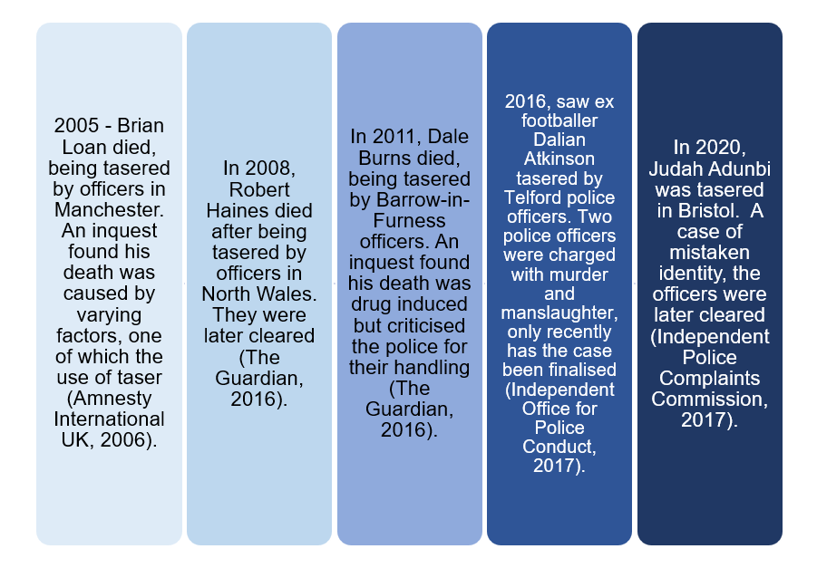

Appendix A 2 - Article 1, 2, 3 and 4 ECHR (Full document can be reviewed on demand)

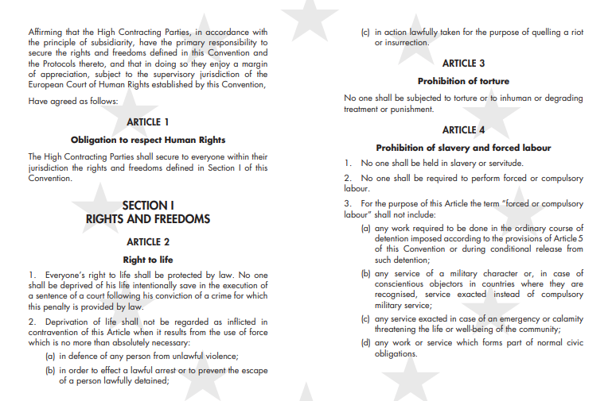

Appendix A 3 – UOF details for DPP

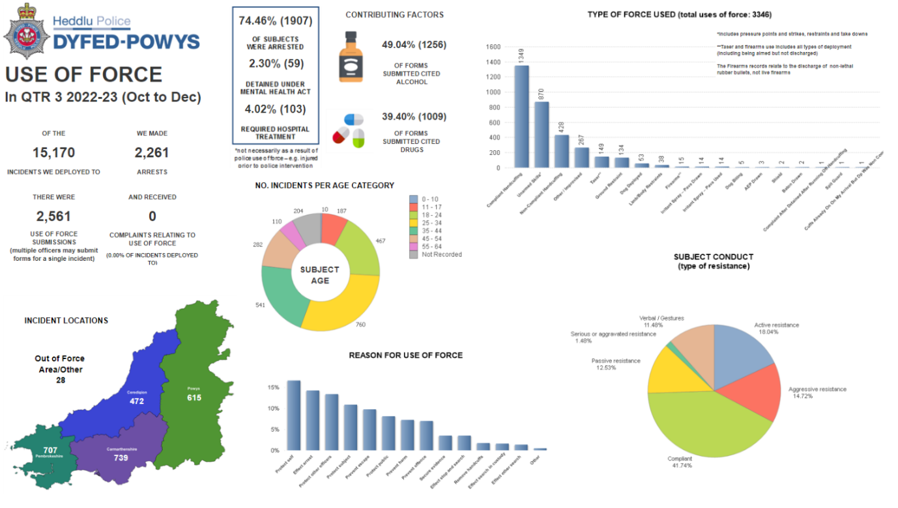

Appendix A 4 - National Decison Making Model

Explantion, Steps flowing clockwise:
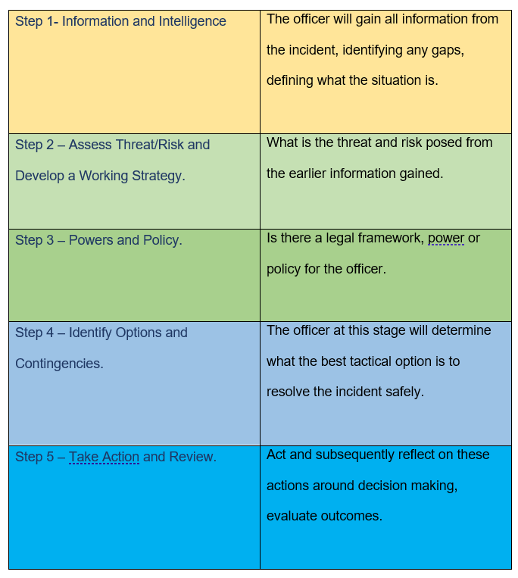

Appendix A 5 - New Zealand Police – TENR - Operational threat assessment

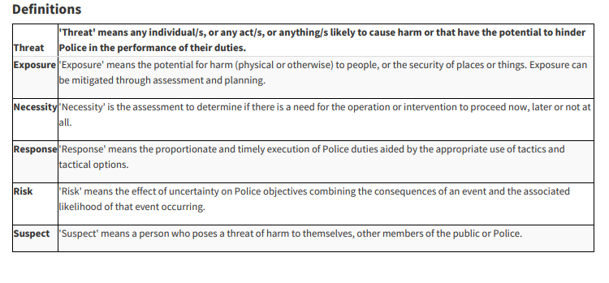

Appendix A 6 - New Zealand Police - Tactical Options Card

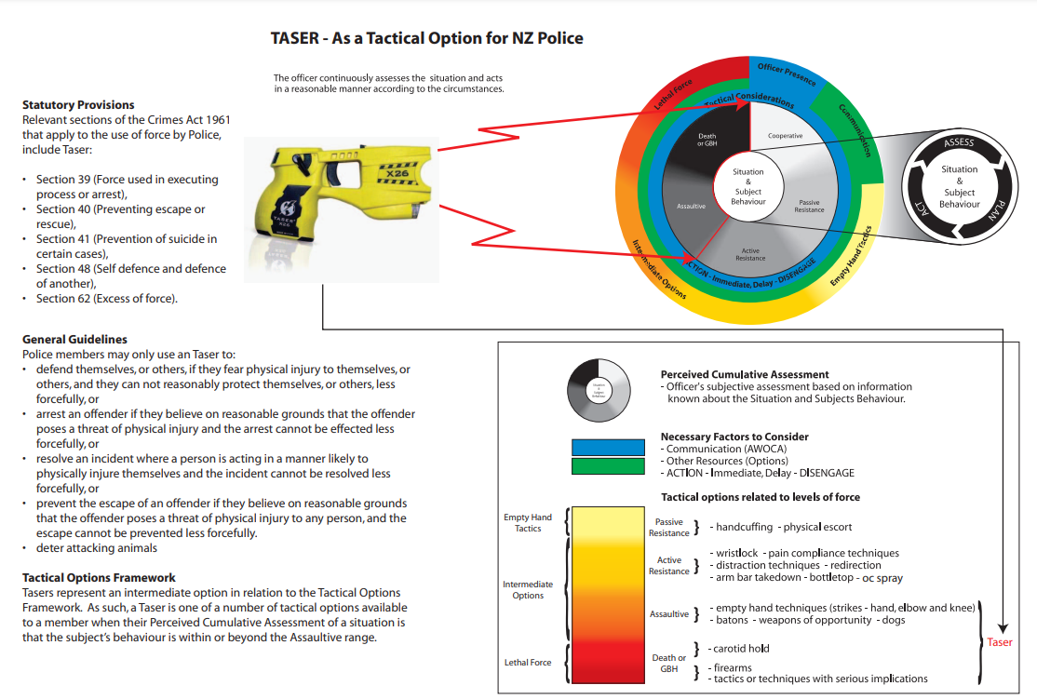

Appendix A 7 – Online Questionnaire (questionnaire replies available on request)

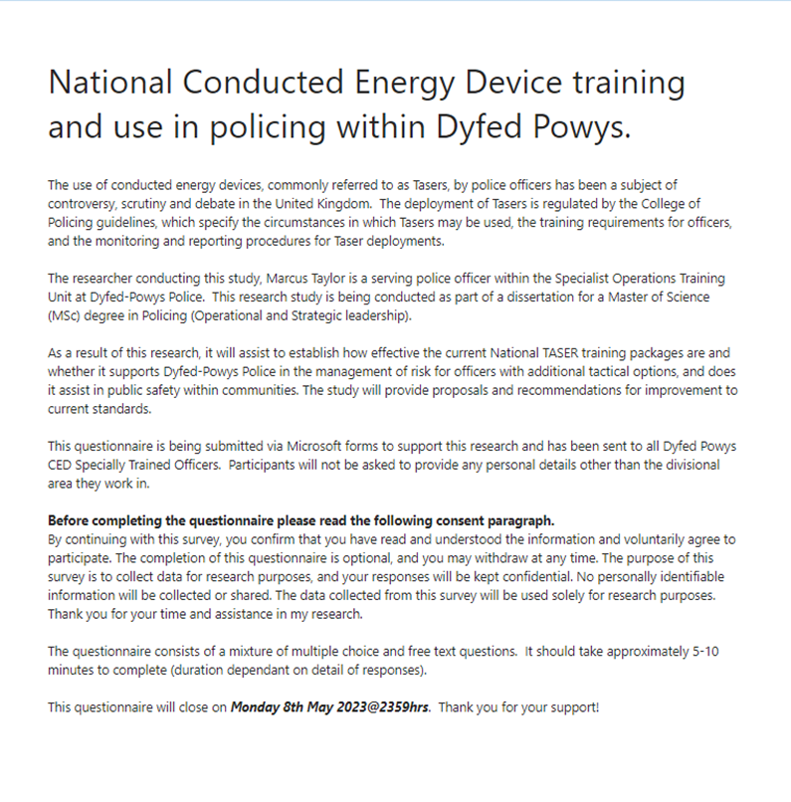
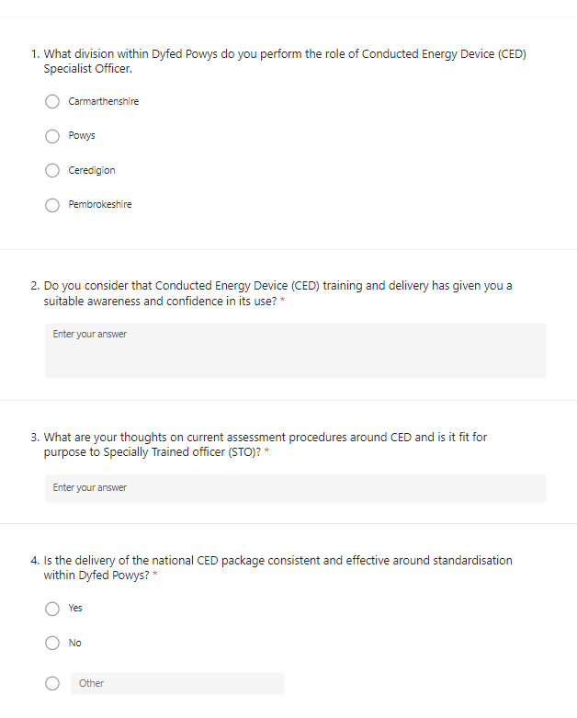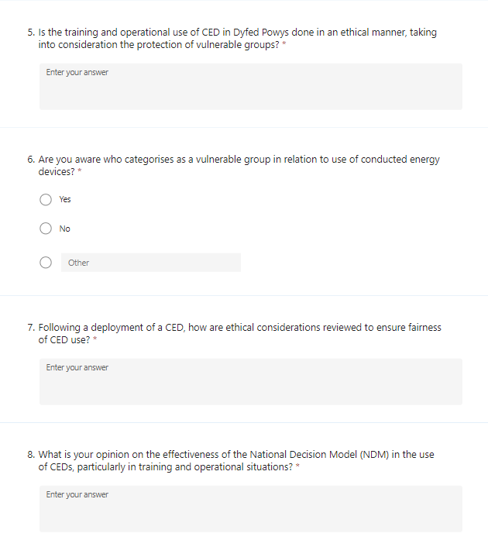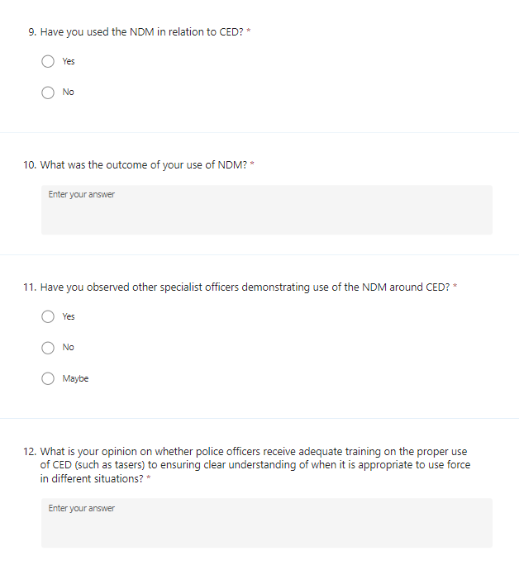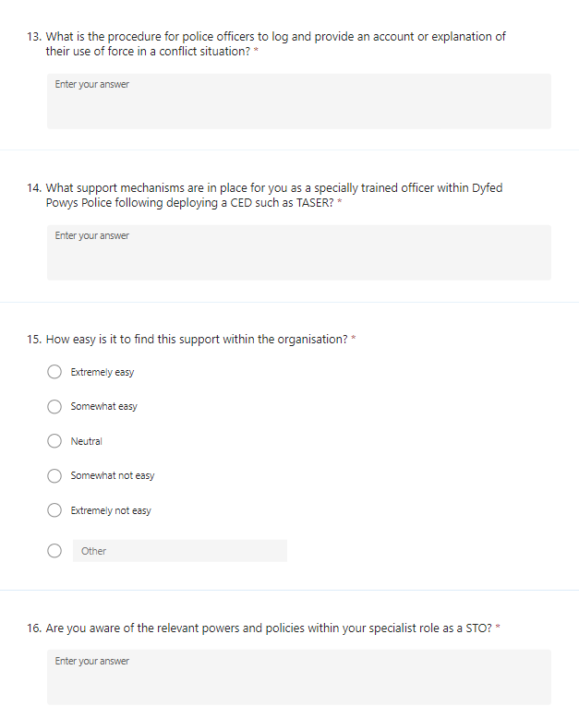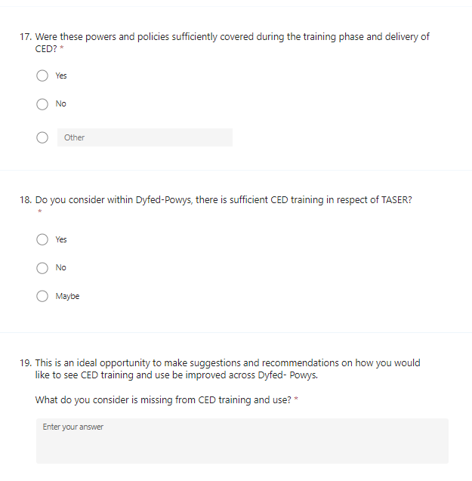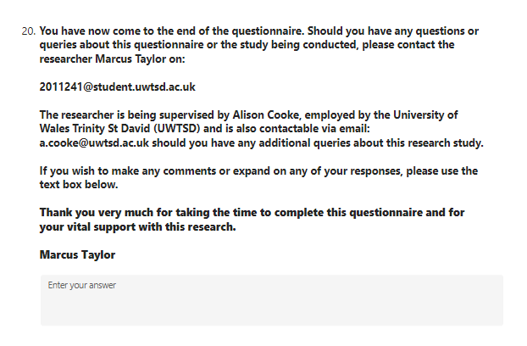
Appendix A 8 – Online Questionnaire participation request email sent to all STO’S.

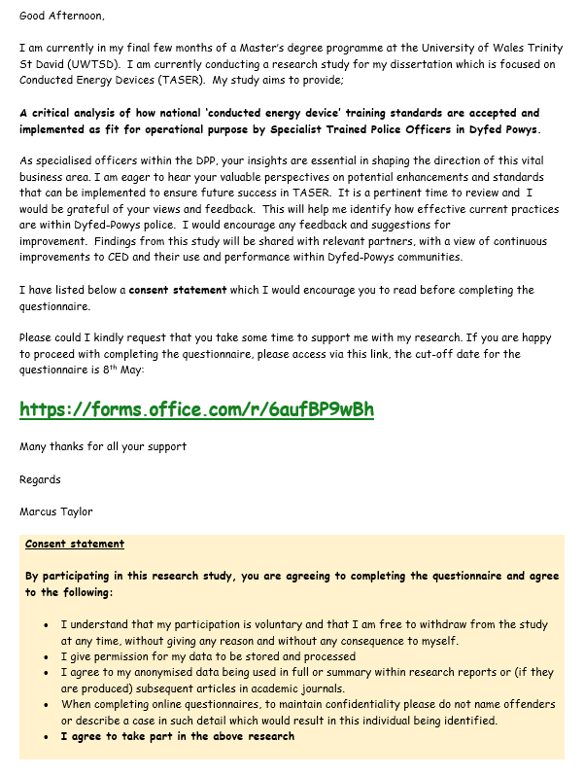

Appendix A 9 – Email sent for One-to-One Interviews.

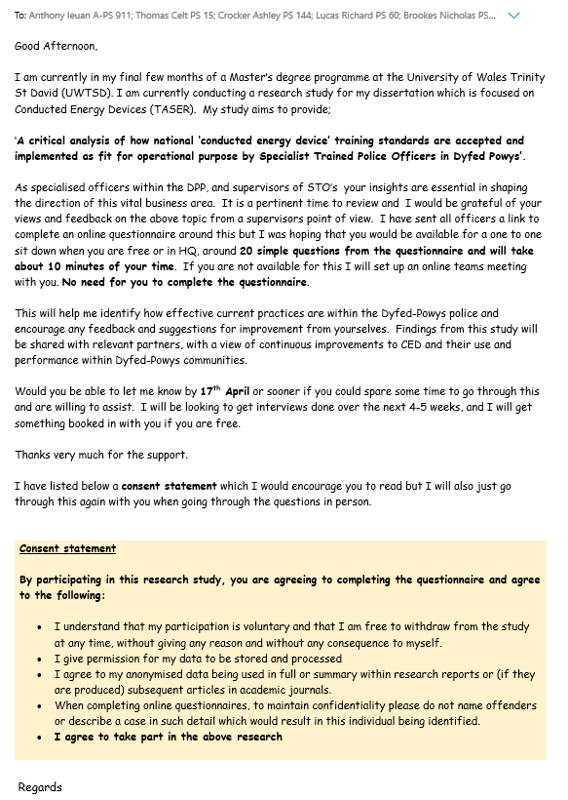
Appendix A 10 – PG2E1 Ethical approval form. (Completed form available on request)

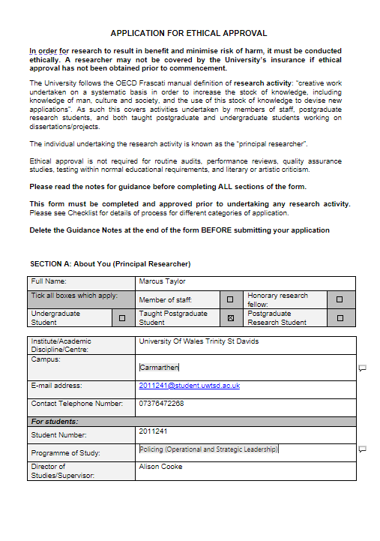

Appendix A 11 – Participant Information Sheet. (Transcripts available on request)

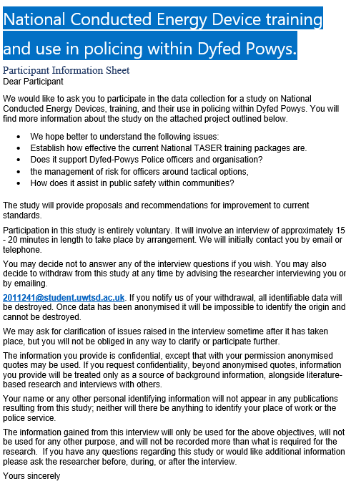

Appendix A 12 – Participant Information Sheet. (Transcripts available on request)


