TASK 1:
Code Functions
- Creating the Matrix
- The code initializes an empty 26x26 matrix named vigenere. The matrix is set to have 26 rows and 26 columns, and it's initially filled with NA (Not Available) values.
- In the second step, row and column labels are assigned the values of ‘LETTERS’, which is a built-in constant in R that represents the uppercase English alphabet characters.
- The third step consists of two nested for-loops to fill in the values of the matrix, and for each cell, calculates the index based on the row and column indices. The letters ‘i’ and ‘j’ is used to iterate over each cell in the matrix. The formula ‘(i + j - 2) %% 26 + 1’, calculates the index by adding the row and column indices and subtracting 2. This adjustment is due to the fact the matrix indices in R start from 1. This is then used to determine the value to place in that cell. The modulus operator wraps around the values, preventing them from exceeding the range of 1 to 26. Adding ‘1’ ensures that the result is shifted to the range of 1 to 26. Finally, the letter corresponding to the calculated index is assigned to the matrix cell at position [i, j].
- Afterwards, the row and column names of the matrix are set to the corresponding labels from A to Z.
- This last line prints the resulting Vigenère cipher matrix ‘vigenere’.
In summary, this code generates a 26x26 Vigenère cipher matrix where each row and column are labelled A to Z, and the matrix is filled according to the Vigenère cipher rules, preventing wrapping around of characters. The resulting matrix is then printed. The flowchart for this code is shown in Figure 1.

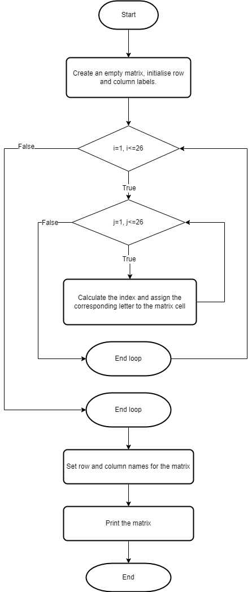
Figure 1: Flowchart for matrix creation

- Encrypting the message ‘CAPTURETHEFLAG’
- The first step involves assigning the values for keyphrase and plaintext. The keyphrase is set to "UWTSDSWANSEA" and plaintext is set to "CAPTURETHEFLAG". ciphertext is initialized as an empty character vector to store the encrypted message.
- A loop iterates through each letter in the plaintext. For each letter:
current_letter is set to the current letter in the plaintext.
key_column is determined by matching the corresponding letter in the keyphrase.
vigenere_row is found by matching the current_letter in the vigenere matrix.
The encrypted letter is obtained from the vigenere matrix and appended to ciphertext.
- In the final steps, the plaintext and ciphertext vectors are combined into single strings using paste.
- Then the original plaintext, keyphrase, and the ciphertext are printed.
In summary, the process involves iterating through each letter of the plaintext, determining the corresponding key column, finding the vigenere matrix row, and appending the encrypted letter to the result vector. The final output includes information about the original plaintext, the keyphrase used, and the encrypted message. The flowchart for this code is shown in Figure 2.

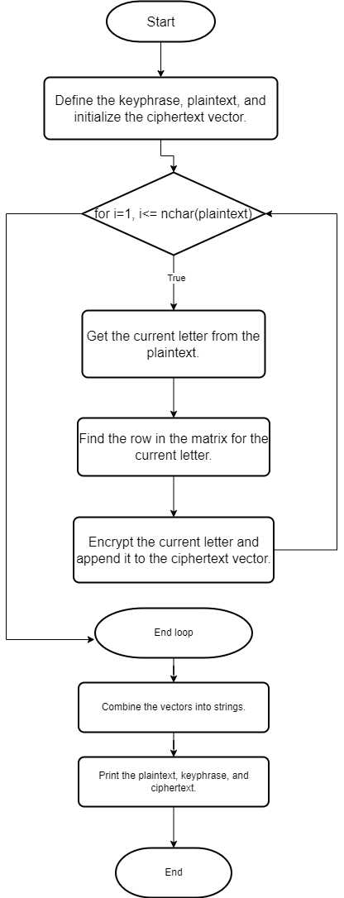
False
Figure 2: Flowchart for message encryption
- Decrypting the ciphertext ‘ETMSXWISTBNHRIKZKKHMFGBAUDECZEEQPBBCZC’
- The ciphertext and keyphrase variables are defined. The ciphertext_to_decrypt is set to the ciphertext that needs to be decrypted.
decryption_keyphrase is set to "RPROGRAMMING".
decrypted_message is initialized as an empty character vector to store the decrypted message.
- A loop iterates through each letter in ciphertext_to_decrypt. For each letter:
current_letter is set to the current letter in ciphertext_to_decrypt.
decryption_key_column is determined by matching the corresponding letter in decryption_keyphrase.
vigenere_row is found by matching the current_letter in the vigenere matrix.
The decrypted letter is obtained from the vigenere matrix and appended to decrypted_message.
- The decrypted_message vector is combined into a single string using paste.
- Finally, the original ciphertext_to_decrypt, decryption_keyphrase, and the decrypted_message are printed.
In summary, this code decrypts the given ciphertext using the keyphrase "RPROGRAMMING" and prints both the original ciphertext and the resulting decrypted message. The decryption involves finding the corresponding column in the keyphrase, determining the vigenere matrix row, and obtaining the decrypted letter for each character in the ciphertext. The flowchart for the code is depicted in Figure 3.

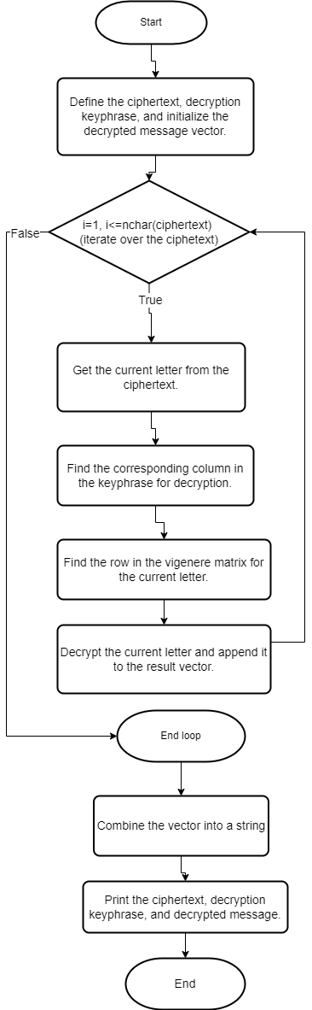
Figure 3: Flowchart for message decryption
Also, the code involves the use of ‘cat’ instead of ‘print’ to output results. To explain their use, The print function in R is a function that is used to print the content of an object. With the ‘print()’ function, R automatically converts the object to a character representation and prints it.
The cat() function (concatenate) is often used when you want to print multiple values or strings in a single line without additional formatting.

Code Testing
Assuming that the keyphrase for encryption can also be used for decryption, the code was tested in the following ways:
- Encryption and Decryption of given example:
This involved testing based on example given with keyphrase: UWTSD and ATTACKATDAWN as the plain text. I was able to get the expected ciphertext ‘UPMSFEWMVDQJ’ as output. To test decryption, I made use of the output ciphertext and generated the plaintext ‘ATTACKATDAWN’.
- Manual Encryption and Decryption:
The plaintext ‘FLAG’ was selected with the keyphrase ‘TWD’. The results were manually cross-checked with the vigenere matrix, as well as the table in the assignment brief to determine whether the encryption and decryption results were accurate.
- Encryption and Decryption with RPROGRAMMING and UWTSDDWANSEA:
This part involved cross-checking the results. The result of the previously encrypted ‘CAPTURETHEFLAG’ was decrypted using the same UWTSDSWANSEA keyphrase. While the result of the previously decrypted ‘ETMSXWISTBNHRIKZKKHMFGBAUDECZEEQPBBCZC’ was encrypted using RPROGRAMMING as the keyphrase.

Task 2:
Reflection
Challenge: It was a challenge trying to write less code for the tasks without writing functions. I had to seek out new ways to come up with the solutions. I also discovered ‘LETTERS’, a built-in constant in R while looking for a faster way to specify the English alphabet. I learned about the cat() function used to output multiple pieces of text on a single line, and its differences with the print function. Overall, I learned about the Vigenère cipher, and basic encryption and decryption with it.
Future Work: In future works with the data or similar data, I will look for ways to enhance the code, reducing the lines of code and facilitating readability with and without the use of functions, for comparison.

