
The Traitors: UWTSD Edition
A Mobile Social Deduction Game
Name: Rita Zambito
Student Number: 2245801
Module Code: ACCB6017
Module Title: Usability Engineering
Assignment Title: Full Interface & Testing
Lecturer Name: Dr Osman Elgawi
Campus: IICL, Birmingham
Date of Submission: 24/03/2026

Table of Contents
1. Introduction 2
2. Full-Colour Storyboards 2
2.1 Visual Design Rationale 2
2.2 Storyboard Walkthrough 3
3. Prototype Feedback Collection 8
3.1 Method 9
3.2 Feedback Results 9
3.3 Analysis 11
4. Data Collection in a Working Version 11
4.1 What Data Would Be Collected and Why 11
4.2 Emotional Response Data 12
4.3 Privacy and Ethical Considerations 12
5. Usability vs User Experience: Design Tensions 13
5.1 Atmospheric Imagery vs Information Clarity 13
5.2 Traitor Language: Authenticity vs Neutrality 13
5.3 Traitor Chat: Narrative Immersion vs Transparency 13
5.4 Accessibility as a Usability Foundation 14
6. Conclusion 14
References 15

1. Introduction
This report documents the development of The Traitors: UWTSD Edition, a mobile social deduction game designed for students and staff at the University of Wales Trinity Saint David. Building on the black-and-white wireframes, persona definitions, and initial feedback collection carried out in Component 1, this report presents a complete set of full-colour storyboards, an evaluation of prototype feedback collected from ten participants, a data collection strategy for a working version of the application, and a critical reflection on the tensions between usability and user experience that shaped the design process.

2. Full-Colour Storyboards

2.1 Visual Design Rationale
The interface is built on a dark navy background that establishes an atmospheric, cinematic quality consistent with the dramatic tone of the source material, while satisfying WCAG 2.2 contrast requirements for text legibility [1]. A single amber-orange accent colour is applied consistently to all interactive elements throughout: buttons, active navigation icons, selected states, room codes and role labels, creating an unambiguous visual hierarchy where anything the user can act upon is immediately distinguishable from static content. The navy and amber pairing also avoids the red-green combination that would disadvantage users with colour vision deficiency, ensuring that role identification, vote selection and status indicators remain accessible to all players without relying on hue alone [1].
The typeface Inter is used throughout. Inter is a humanist sans-serif designed specifically for screen legibility at small sizes, with open letterforms and generous spacing that benefit users with dyslexia compared to narrower or decorative alternatives [2]. Body text is set at a minimum of 16px with generous line spacing. Headings use bold weight and increased size to establish hierarchy without introducing a second typeface, maintaining visual consistency across all storyboards. Icon-based navigation supplements text labels across all screens, and a persistent settings gear icon in the in-game header allows users with accessibility needs to adjust options mid-session without leaving the game.

2.2 Storyboard Walkthrough
The following twelve storyboards present the complete user journey for The Traitors: UWTSD Edition, from application launch to game completion. Developed in Figma, each screen reflects the visual identity, accessibility requirements and usability principles outlined in section 2.1, and incorporates design improvements informed by feedback collected on the initial black-and-white wireframes.

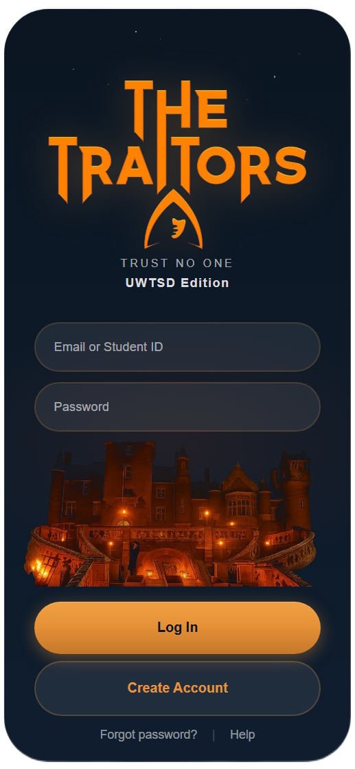  Figure 1: Login Screen | 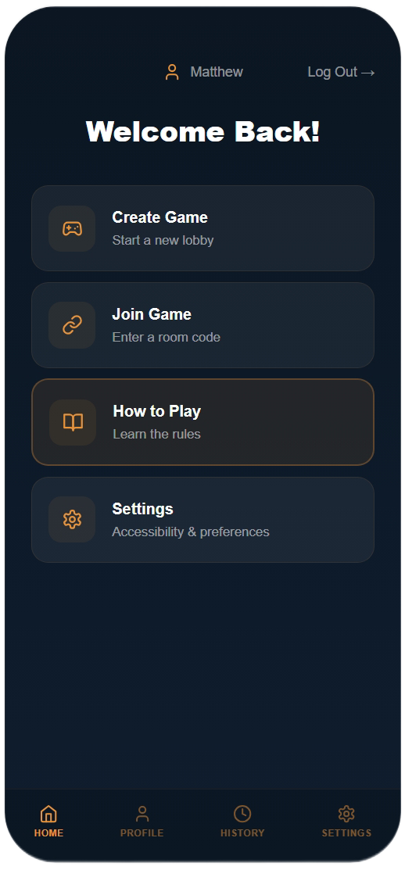  Figure 2: Main Menu
The Login screen (Figure 1) anchors the game's identity through the branded castle photograph and Trust No One tagline, establishing the dramatic tone before any interaction takes place. The Main Menu (Figure 2) presents four clearly labelled navigation cards, with the How to Play option highlighted in amber to guide first-time users directly to onboarding. The persistent header now displays the logged-in player's name, confirming identity throughout the session, an improvement over the initial wireframe where this context was absent.

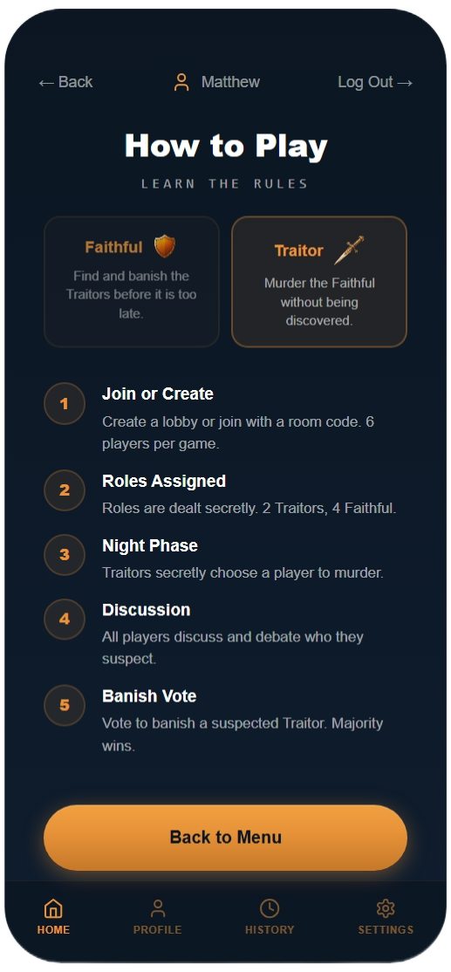  Figure 3: How to Play | 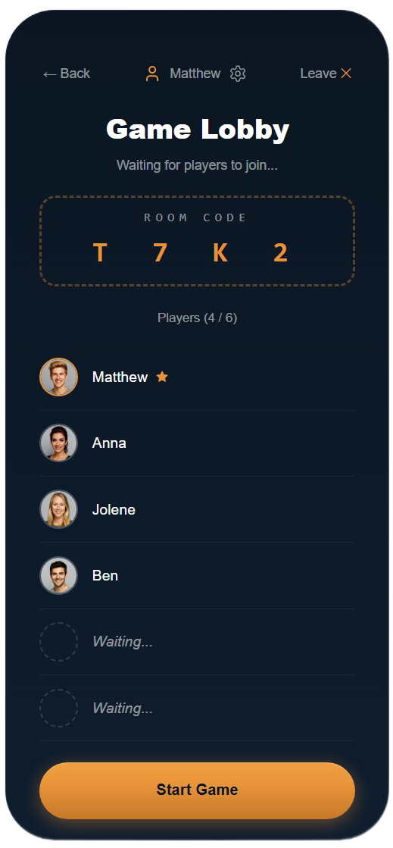  Figure 4: Game Lobby
The How to Play screen (Figure 3) introduces roles and game phases through a structured numbered list with role cards for Traitor and Faithful, ensuring all players understand the mechanics before committing to a session. The Game Lobby (Figure 4) displays the room code prominently in a large, legible format for easy sharing, with a live player list that updates as participants join and a host-controlled Start Game button.

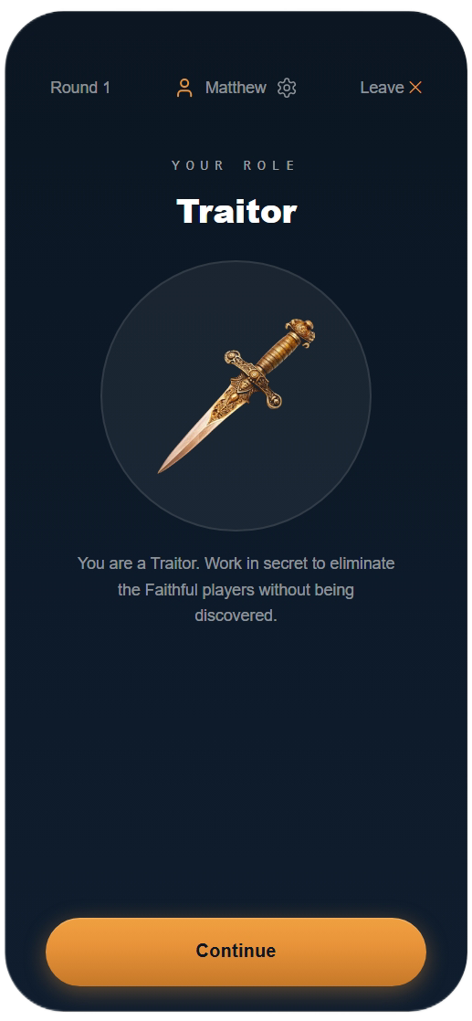  Figure 5: Role Assignment | 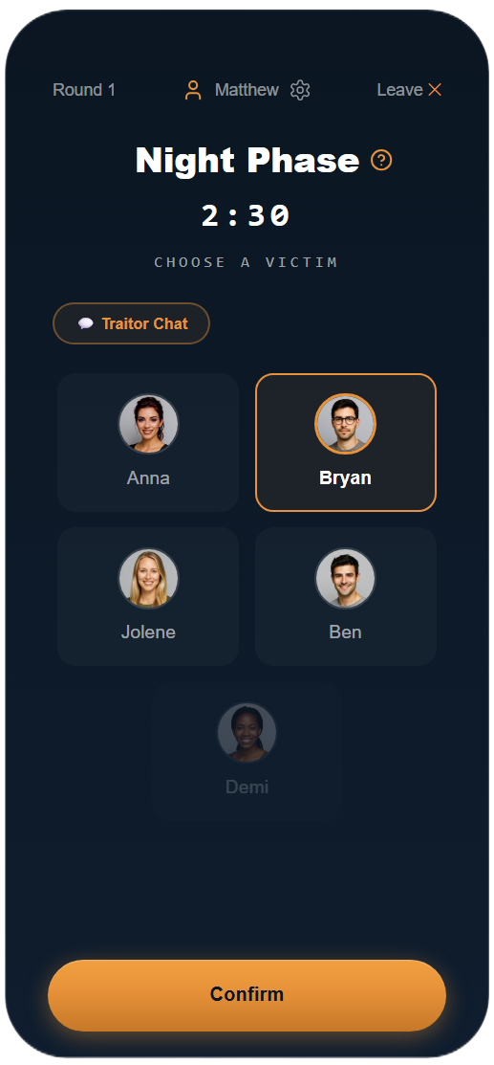  Figure 6: Night Phase
The Role Assignment screen (Figure 5) presents each player's secret role against a deep navy background with a large central icon (a dagger for the Traitor role) and no distracting elements, creating a moment of deliberate drama at the point of role reveal [3]. The Night Phase screen (Figure 6) shows the victim selection grid labelled in spaced capitals, with the Traitor Chat pill button and countdown timer visible, giving Traitors full coordination context without navigating away.

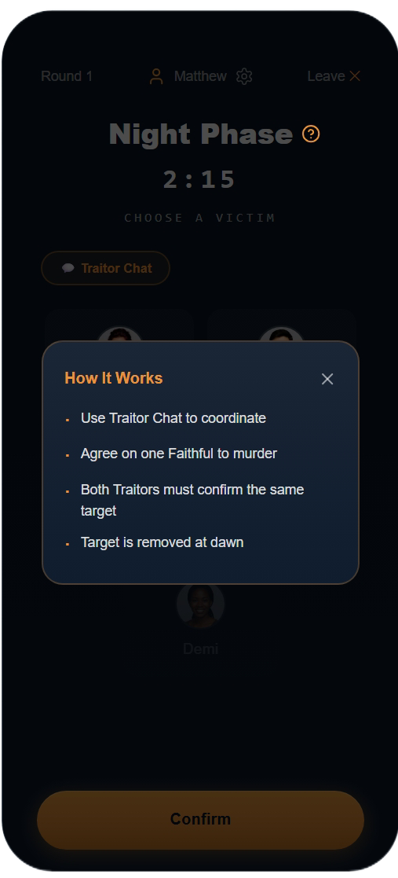  Figure 7: Night Phase Tooltip | 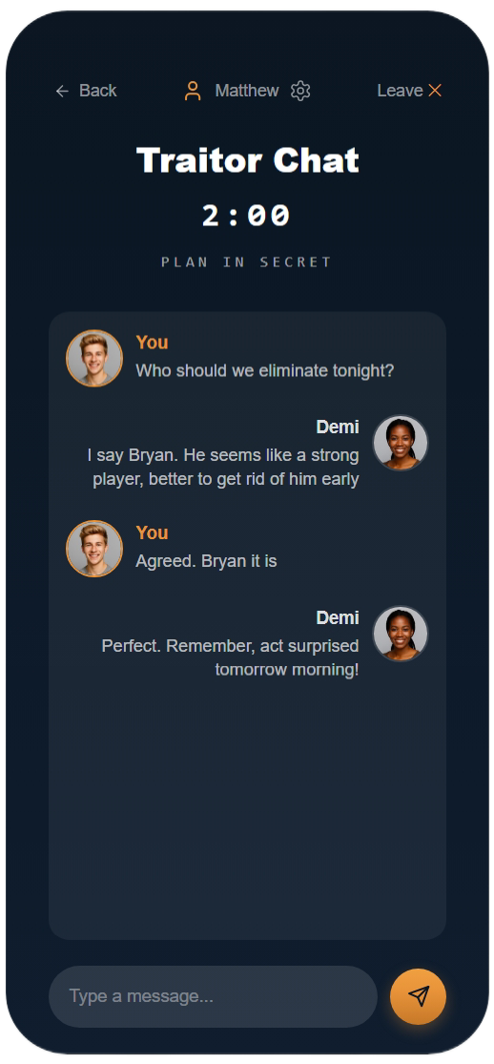  Figure 8: Traitor Chat
The Night Phase tooltip (Figure 7) is a new addition to the interface, providing contextual guidance in bullet-list format to improve scannability under time pressure [4]. The Traitor Chat screen (Figure 8) was also introduced in response to consistent feedback identifying private Traitor coordination as a critical missing mechanic. It provides a real-time messaging channel with conversational bubbles, photographic avatars and a shared countdown timer, accessible exclusively to Traitor-role players via a persistent pill button [5].
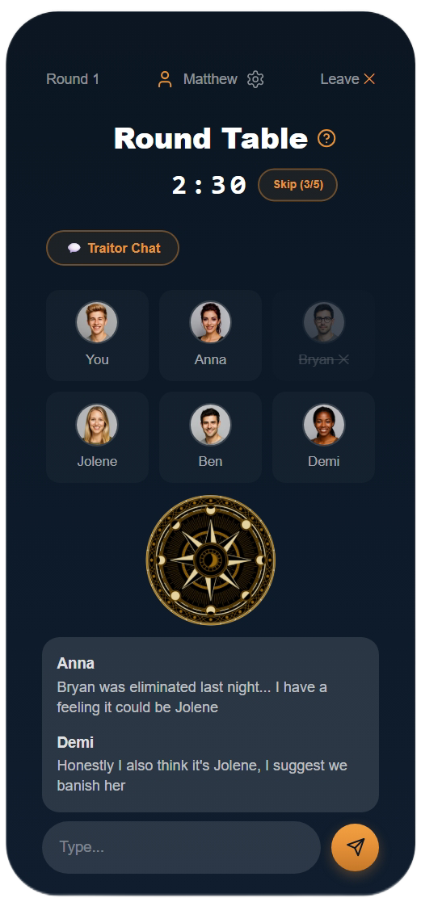  Figure 9: Round Table Discussion | 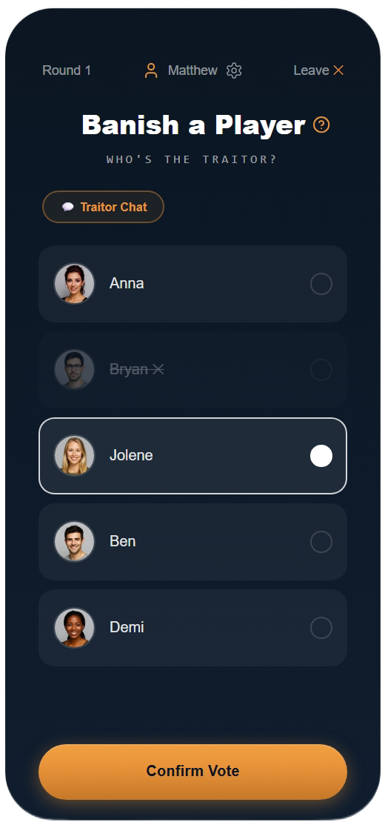  Figure 10: Banish a Player
The Round Table Discussion screen (Figure 9) features the iconic round table imagery from the show as a central visual anchor, giving the Discussion phase a distinct identity that differentiates it from the other game phases. A Skip (X/5) button beside the countdown timer allows players to collectively advance to the voting phase before the timer expires. The Banish a Player screen (Figure 10) uses radio-button row selection with an amber border highlight and a Confirm Vote button to prevent accidental submissions. Eliminated players are shown with strikethrough styling as a non-colour accessibility indicator, communicating status through multiple visual channels simultaneously [1].

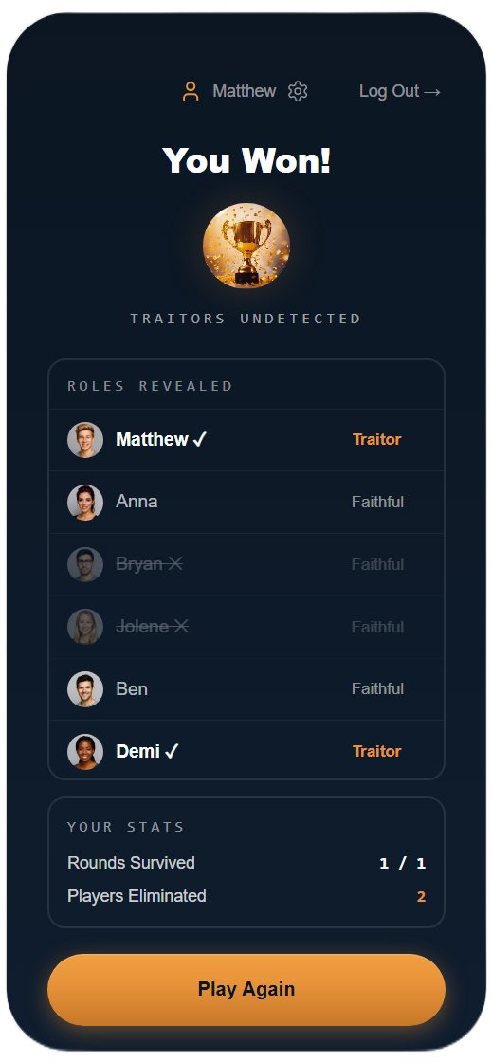  Figure 11: Game Over (You Won) | 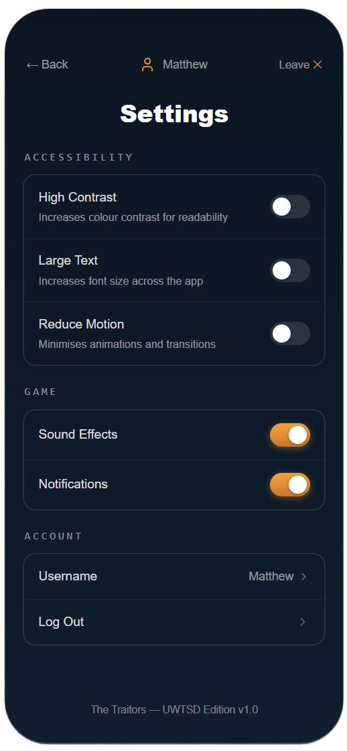  Figure 12: Settings
The Game Over screen (Figure 11) reveals all player roles, with winners marked by an amber label and a personal statistics panel providing closure and encouraging replayability. The Settings screen (Figure 12) is divided into Accessibility, Game and Account sections and is accessible from the in-game header gear icon on every gameplay screen, ensuring that players with accessibility requirements can adjust options at any point during a session without interrupting play [1], [6].

3. Prototype Feedback Collection

3.1 Method
Feedback was collected via a think-aloud protocol combined with a five-item post-task Likert questionnaire [5]. Ten participants were recruited purposively to ensure all six user personas defined in the previous phase were represented: two each mapped to Matthew (experienced gamer) and Anna (casual user with dyslexia) as the primary target audience, and one each to Bryan (non-gaming staff), Jolene (colour vision deficiency), Demi (time-poor mature student), and Ben (motor impairment). This purposive mapping ensured that every persona-specific design decision, the Inter typeface for Anna, non-colour indicators for Jolene, 44px touch targets for Ben, and step-by-step onboarding for Bryan, was evaluated by at least one participant whose profile it was designed to serve. Each session followed three scenarios: navigating from login to game start, walking through a full game round on the storyboards, and locating accessibility settings. Sessions lasted approximately 20 minutes.

3.2 Feedback Results
Ten participants evaluated the full-colour prototype across three scenarios. The quantitative Likert results are summarised in Table 1 and the qualitative feedback in Table 2 below.

Table 1: Post-Task Likert Results
Statement | Mean (n=10)
The interface was visually appealing | 4.5
The interface was easy to navigate | 4.2
I understood my role and objectives clearly | 4.3
Interactive elements were easy to identify | 4.1
I would enjoy playing this game | 4.4

Table 2: Colour Prototype Feedback Summary
Tester | Persona | Positive Feedback | Negative / Unexpected Feedback
T1 | Matthew | Login atmosphere immediate and on-brand. Room code large and readable. | Wanted a quick rematch button on Game Over screen alongside Play Again.
T2 | Anna | Icon navigation and card layout easy to follow. Font size comfortable. | Settings toggle labels could be slightly larger. Did not notice tooltip icon on first pass.
T3 | Bryan | How to Play screen very clear. Step numbering and role cards reduced confusion. | Wanted a brief role reminder visible during Banish Vote, not just at role reveal.
T4 | Jolene | Amber border on selected vote row clear without colour dependency. Role labels text-based. | Shield and dagger icons on How to Play screen small; requested larger icon targets.
T5 | Demi | Skip button on Discussion screen appreciated. Session felt completable within 15 minutes. | Navigation after game slightly unclear with only one button on Game Over screen.
T6 | Ben | Button sizes comfortable throughout. Confirm Vote prevents accidental taps. | Traitor Chat send button felt slightly small. Suggested a larger tap target.
T7 | Matthew | Traitor Chat dramatically improves gameplay cohesion. Round Table screen visually strong. | Wished chat history persisted after leaving Traitor Chat and returning during same phase.
T8 | Anna | Colour scheme emotionally engaging. Role reveal screen impactful. | High Contrast toggle not visible until Settings opened; wanted shortcut in-game.
T9 | Demi | Join game flow fast and clear. Settings screen well-organised. | Wanted a persistent round counter visible throughout all game phases.
T10 | Ben | In-game settings gear icon appreciated, accessibility reachable without leaving game. | Reduce Motion toggle welcomed but noted should also be discoverable from login screen.

3.3 Analysis
As shown in Table 1, all ten participants rated visual appeal at 4 or 5 out of 5, and eight rated ease of use at 4 or above. The most praised elements were the Traitor Chat screen, the Skip mechanism, and the in-game settings gear icon. The atmospheric colour palette and avatar photographs were cited positively by six participants, suggesting the hedonic design decisions were well received by the intended audience [7], [3]. The positive reception of the Traitor Chat, the in-game settings icon and the Skip mechanism were broadly expected, as these features were introduced specifically to address issues identified in the previous evaluation. Several unexpected findings emerged: requests for a persistent round counter suggest context-switching between phases disrupts the player's sense of progression more than anticipated. Feedback on the single Play Again button indicates that while it reduces decision burden, it may have removed a useful exit path for players who do not wish to continue.
The send button tap target raised a minor accessibility concern consistent with WCAG 2.2's 44×44px minimum [1]; the icon-only circular design may reduce perceived tap area. A request for persistent Traitor Chat history revealed an embedded assumption that Traitors complete coordination in a single visit to the chat screen, which state-persistence would resolve in a future iteration. These findings suggest that once participants were engaged with the storyboard sequence, continuity of context became more important than the initial design anticipated.

4. Data Collection in a Working Version

4.1 What Data Would Be Collected and Why
A working version would generate two categories of data: usage data (collected automatically via event logging) and emotional response data (requiring direct user interaction) [5]. Automatic logging would capture screen transitions, button taps, timer completions, session durations, abandonment points, and tooltip activation frequency. Within-game data, such as vote nominations and Traitor win rates, would enable server-side game balance adjustments without requiring an app update [8]. Crash reports and error logs can be collected via Firebase Crashlytics [9]. For behavioural analytics, commercial platforms such as Mixpanel [10] offer event-based tracking with funnel analysis and retention reports, removing the need to build bespoke analytics infrastructure and allowing design decisions to be driven by real usage patterns.

4.2 Emotional Response Data
Emotional response data requires continued direct interaction. Post-session micro-surveys embedded on the Game Over screen, asking how enjoyable the session was, how fair the outcome felt, and whether the player would play again, provide lightweight satisfaction measures correlatable with behavioural logs [5]. Longer-form feedback can be gathered via an optional in-app button, and periodic diary studies with a small panel of regular users would capture longer-term attitude change.
Usage data is continuous and objective but cannot explain motivation; event logs cannot distinguish between a player who abandoned the Night Phase due to a crash and one who lost interest. Emotional response data fills this gap but is subject to recall bias. A mixed-methods approach triangulating both sources is therefore the most robust strategy for iterative design decisions [5], [8].

4.3 Privacy and Ethical Considerations
As a UWTSD-branded application used by students and staff, data collection must comply with UK GDPR. Users must provide informed consent before any data beyond technical crash logs is collected, and data minimisation principles require that only data directly relevant to improving the application is retained [11]. In practice this means storing anonymised behavioural logs rather than personally identifiable session data. Role assignments carry no real-world sensitivity, but combining them with persistent identifiers could reveal patterns the user would not expect to be visible. Retention periods should be defined at registration and reviewed annually. An in-app privacy notice accessible from the Settings screen would allow users to review, export, or delete their data in compliance with UK GDPR Article 17 [11].

5. Usability vs User Experience: Design Tensions

Usability, as defined by ISO 9241-11, concerns effectiveness, efficiency, and satisfaction in a specified context of use [12]. User experience is broader, encompassing emotional response, aesthetic pleasure, and long-term attitude [6], [7]. The design of The Traitors surfaced several tensions between these two goals.

5.1 Atmospheric Imagery vs Information Clarity
The login screen illustrates this tension directly. A purely usability-focused design would position the input fields higher on screen to minimise Fitts's Law travel distance [4]. The atmospheric castle photograph and large logo push the fields below the midpoint, marginally increasing task time. The decision was justified by Hassenzahl's concept of hedonic quality, the degree to which a product communicates identity and evokes positive affect independently of its instrumental quality [6], [7]. Multiple testers confirmed the atmospheric first impression as valuable, and the compromise ensures both fields remain within thumb reach on a standard mobile screen.

5.2 Traitor Language: Authenticity vs Neutrality
A subtler tension arose from the use of murder rather than the more neutral eliminate. From a usability perspective, eliminate is unambiguous for any user. However, murder is used consistently in the television programme, and retaining it aligns the interface vocabulary with the user's existing mental model of the source material, a form of natural mapping that reduces cognitive load for familiar players and adds dramatic weight for newcomers [13]. The How to Play tutorial introduces the term in a structured context that mitigates confusion for first-time players, an approach consistent with the principle that game-specific vocabulary should be taught within the interface rather than assumed [14].

5.3 Traitor Chat: Narrative Immersion vs Transparency
The Traitor Chat button visibility introduced a further tension. A usability heuristic would favour making the button visible to all players, inactive for Faithful, to improve system transparency [4]. However, hiding it from Faithful players was a deliberate UX decision: a visible greyed-out button would confirm that Traitors are actively coordinating, undermining the social deduction mechanic. This is a case where following a usability heuristic would have damaged the user experience [7], [3]. The resolution was to display the button only to Traitor-role players, treating the information asymmetry as a feature.

5.4 Accessibility as a Usability Foundation
One area where usability and UX aligned was accessibility. WCAG 2.2 requirements, minimum 44px touch targets, no colour-only indicators, readable fonts, sufficient contrast, were all preserved and strengthened in the colour prototype [1]. The persistent in-game settings icon demonstrates that inclusive design and emotional engagement are not in conflict when accessibility is treated as a design foundation rather than a compliance checklist [11].

6. Conclusion
This report has presented the full-colour prototype of The Traitors: UWTSD Edition, demonstrating how an iterative, user-centred process shaped each design decision. Improvements introduced in response to feedback from the previous wireframes, including the Traitor Chat screen, contextual tooltips, Skip mechanism, and accessible in-game settings, were each validated positively in the colour prototype evaluation, confirming that incorporating user input between design iterations produced measurable usability gains. The proposed data collection framework illustrates how evidence-based iteration could inform future development if a working version were to be built, and the design tensions discussed illustrate that usability and user experience, though related, require separate and sometimes competing design decisions that must be resolved through considered, user-centred judgement.

References
[1] W3C, "Web Content Accessibility Guidelines (WCAG) 2.2," 2023. [Online]. Available: https://www.w3.org/TR/WCAG22/. Accessed: Mar. 5, 2026.
[2] S. Wallace, Z. Bylinskii, J. Dobres, B. Kerr, S. Berlow, R. Treitman, N. Kumawat, K. Arpin, D. B. Miller, J. Huang, and B. D. Sawyer, “Towards Individuated Reading Experiences: Different Fonts Increase Reading Speed for Different Individuals,” ACM Transactions on Computer-Human Interaction, vol. 29, no. 4, 2022. doi: 10.1145/3502222.
[3] L. Buley and J. Natoli, The User Experience Team of One: A Research and Design Survival Guide, 2nd ed. New York: Rosenfeld Media, 2024.
[4] B. Shneiderman, C. Plaisant, M. Cohen, S. Jacobs, and N. Elmqvist, Designing the User Interface: Strategies for Effective Human-Computer Interaction, 6th ed. Harlow: Pearson, 2018.
[5] J. Preece, Y. Rogers, and H. Sharp, Interaction Design: Beyond Human-Computer Interaction, 5th ed. Chichester: Wiley, 2019.
[6] International Organisation for Standardisation, ISO 9241-11:2018 Ergonomics of Human-System Interaction — Part 11: Usability: Definitions and Concepts. Geneva: ISO, 2018.
[7] M. Hassenzahl, Experience Design: Technology for All the Right Reasons. San Rafael: Morgan & Claypool, 2010.
[8] C. Hodent, What UX Is Really About: Understanding the User Experience. Boca Raton: CRC Press, 2021.
[9] Google, Firebase Crashlytics. Google LLC, 2024. [Online]. Available: https://firebase.google.com/products/crashlytics. Accessed: Mar. 9, 2026.
[10] Mixpanel, Mixpanel: Product Analytics. Mixpanel Inc., 2024. [Online]. Available: https://mixpanel.com. Accessed: Mar. 9, 2026.
[11] Information Commissioner’s Office (ICO), “Data Protection by Design and by Default,” UK GDPR Guidance. ICO, 2021. [Online]. Available: https://ico.org.uk/for-organisations/uk-gdpr-guidance-and-resources/accountability-and-governance/data-protection-by-design-and-by-default/. Accessed: Mar. 5, 2026.
[12] R. Hartson and P. Pyla, The UX Book: Agile UX Development, 2nd ed. Cambridge: Morgan Kaufmann, 2019.
[13] D. A. Norman, The Design of Everyday Things, Revised ed. New York: Basic Books, 2023.
[14] K. Isbister and C. Hodent, Eds., Game Usability: Advice from the Experts for Advancing UX Strategy and Practice in Videogames, 2nd ed. Boca Raton: CRC Press, 2022.

