The Making and Production of Hyper

Charlotte Preston
P145222
cpreston.145222@student.uwtsd.ac.uk
cpreston076@gmail.com

Hyper Website: https://www.charlottehpreston.com/hyper/
(See Appendix A)

Index:

Introducing Hyper! ________________________________________________________________p3

Nikki Nitrous Character Concept Art __________________________________________________p3

Soon Me Character Concept Art _____________________________________________________p7

Roman Character Concept Art _______________________________________________________p9

Muscle Fit for Heroes _____________________________________________________________p10

Script Writing ___________________________________________________________________p12

Storyboarding and Animatic ________________________________________________________p18

Matte Painting __________________________________________________________________p20

The Pipeline ____________________________________________________________________p22

Production Schedules _____________________________________________________________p23

References _____________________________________________________________________p25

Appendices _____________________________________________________________________p25

Introducing Hyper!
“Nikki Nitrous a lionhearted 17 year old, thundering through life’s challenges chasing every impulse and leaping at every chance to compete in illegal street races, is wrenched from the comforts of her Uncle Lunk’s garage, encompassed by pistons and gears galore, to face off intergalactic threats representing Earth in the high stakes digital multiverse of intergalactic racing, where she must learn to go faster means to go slower.”

The Journey of Hyper, is a Sci-fi animated TV show, with it’s current team working to produce a trailer to gather interest of potential investors and studios.
The initial project started out as an idea by Al Kang, with the intention of taking it further, and gathering an interest, which personally, the idea caught my attention and gave the opportunity to producing a large bulk of work for the on-going project.
The project itself in centred around the emotional intensity of the teenage years that’s an adrenaline pumped confection, essentially where every life experience is dialled up to ten. The series is framed in a universe of high-speed intergalactic racing and exotic cars with its story revolving around Nikki Nitrous, who’s a representation of the certain teenage idealism that ultimately gets put to the test. Exploring the means in how Nikki’s outgoing personality is challenged in this interstellar adventure.
At its core, the team set out to produce Hyper as a young girl’s coming-of-age story that’s set deep in the heart of the lion’s den of the male dominated universe of racing. Especially at current times with the ever-shifting definitions of what modern feminism means to the millennial generation, as it’s becoming increasingly more difficult to define both girlhood and boyhood, both with direct correlation.
Over the past few months, what we imagined grew. Then we reimagined everything continuously, expanding and compacting, ultimately, until all the singular elements fused together. The project is a design gig that intends to reverberate to last forever, as it continues onward.
Nikki Nitrous Character Concept Art
Nikki’s character shape language needed to be explored especially considering the large theme of intergalactic racing that gave a new design aspect to incorporate. As shown, the silhouettes that I’d started out to create explored the type of shape language the clothing could possibly give experimentation for. Although these silhouettes were a starting point and took the character from a young woman’s body and slowly explored how to better translate a teenage girl’s body into silhouette with the far right’s design number 7 and 9 being the closest starting point for what the team had envisioned from the start.
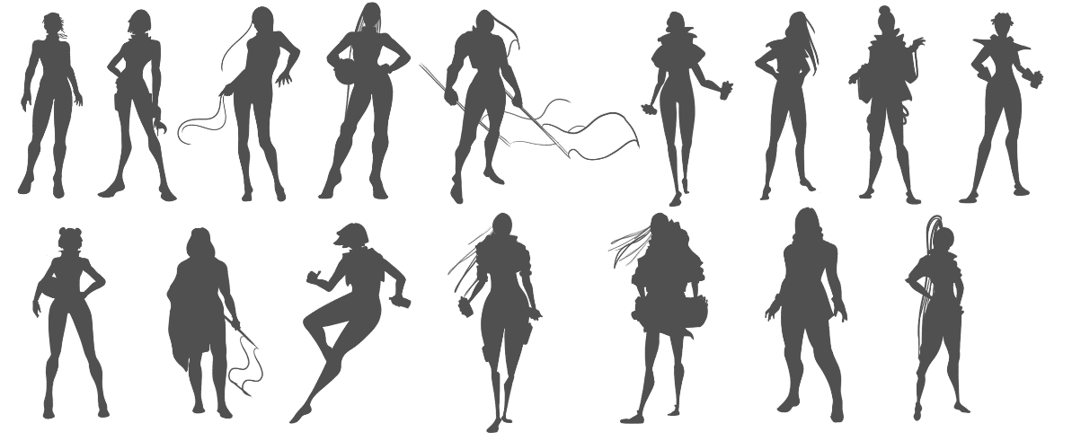
Nikki went through many different facial designs trying to find what the character would equate to.
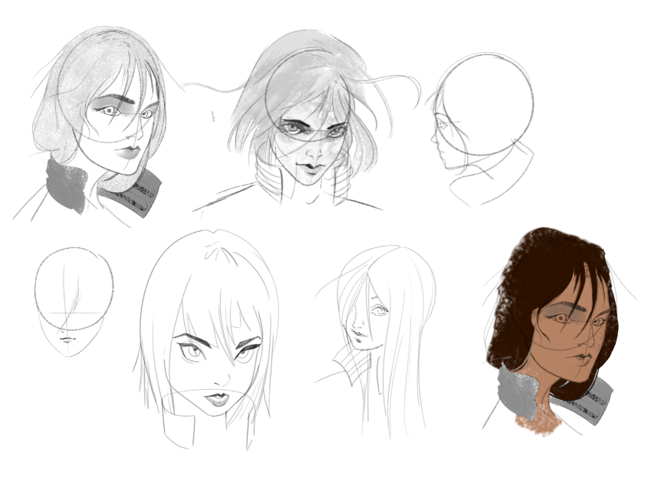
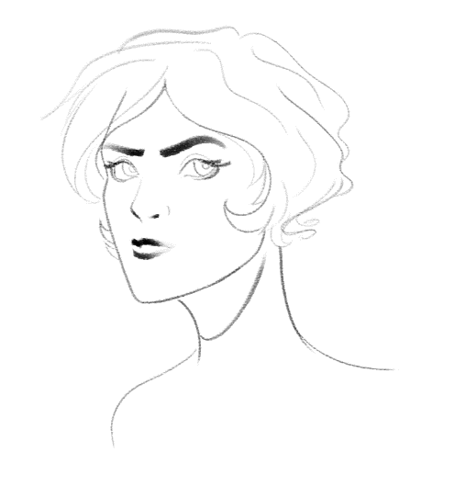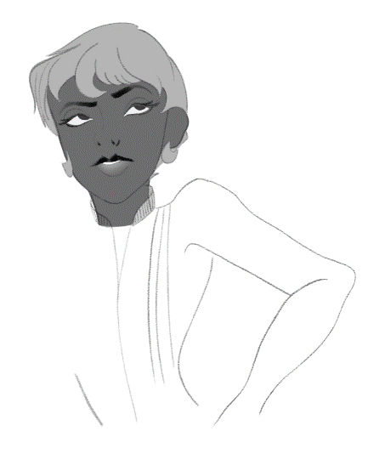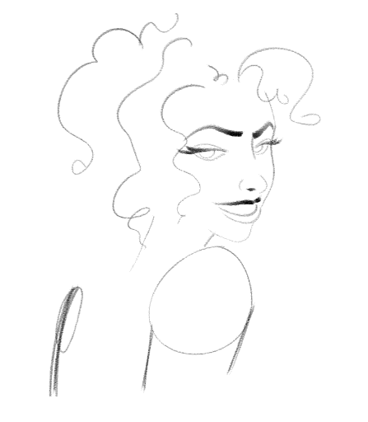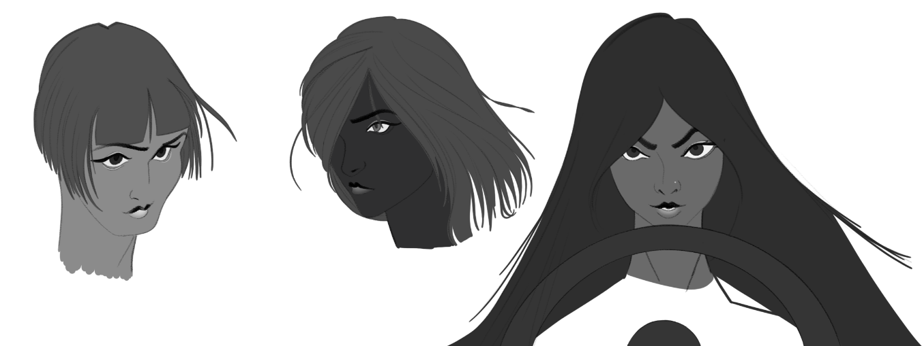
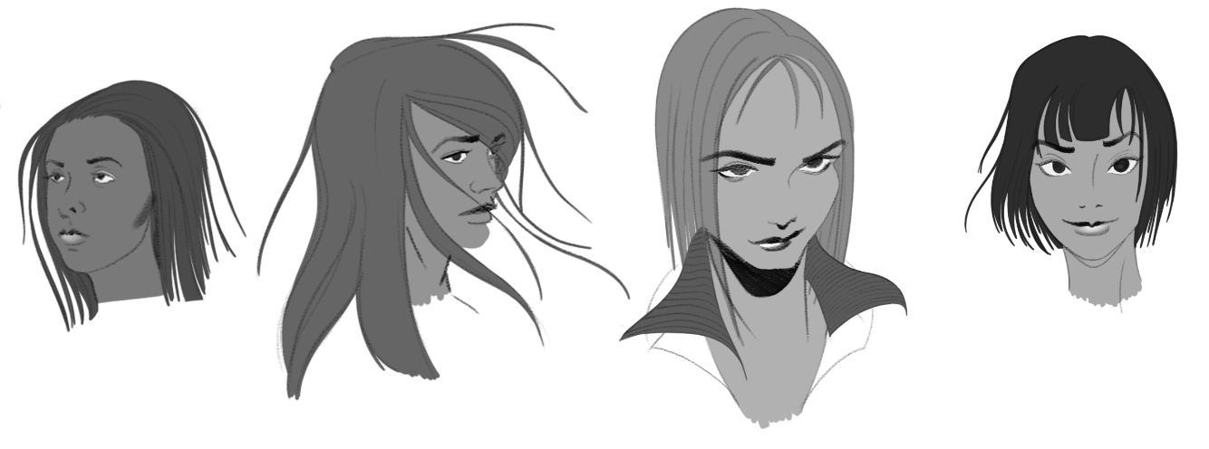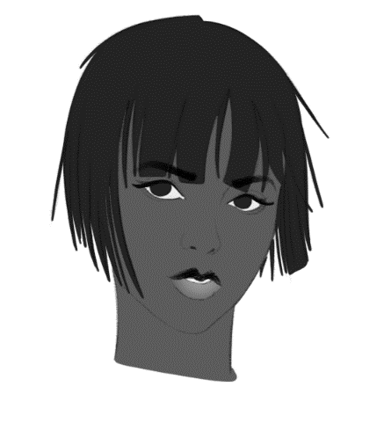
Originally while exploring Nikki’s shape language there was an early decision to have her be a usual teenager, who dresses in garage overalls and with her clothing to focus less on the intergalactic and more around the Earthen underdog feel. Transitioning over from the more fashion based over-all designs to plain and simple baggy overalls started to allow the audience to relate to Nikki Nitrous’ character as previous designs had evoked.
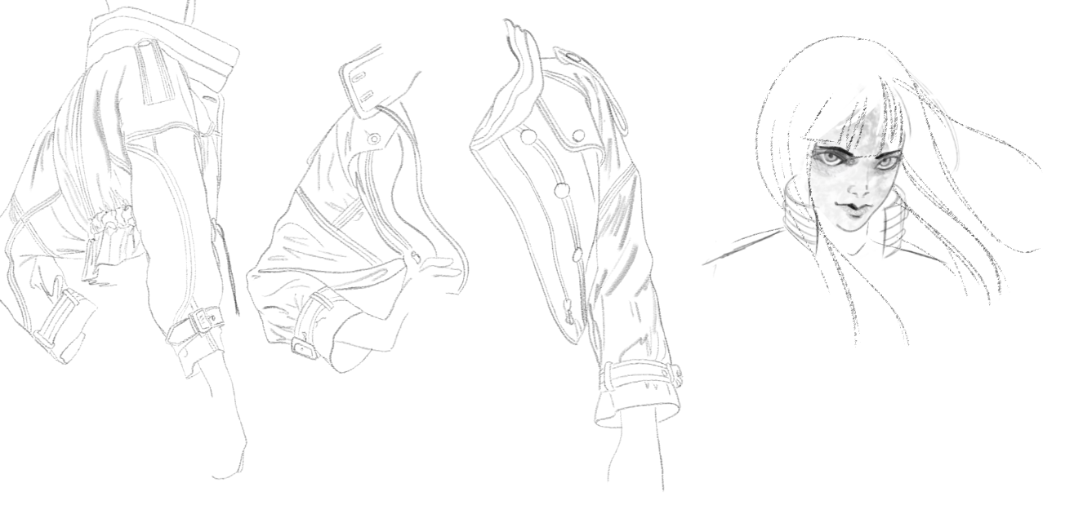
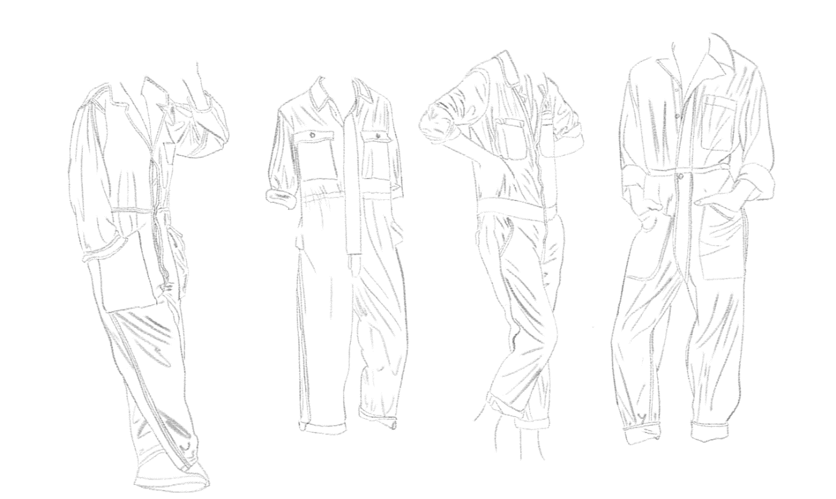
Nikki Nitrous’ concept art went through many different iterations that are currently carrying through to the 3D modelling section of the project. The proxy model that’s currently in place for Nikki is a previous model I’ve worked on that’s being used as an LOD_4 and with the directory set out so the characters’ model is being referenced in as an object to the rigged version of the model that’s also being referenced into the Unreal Engine. (See Appendix C)

While in previous projects I’ve opted for creating the entire rig from start to finish, this project utilises the human ik rig that’s easy to use and make. Essentially this project had my personal work focusing on character concept art, storyboards and now character modelling, largely being due to these subjects’ matters being the strong points and for focusing on the industry in the next coming months. The Unreal Engine is the programme of choice for building the animatic inside, not only does this cut a considerable amount of time when rendering, it also produces a clean workflow when exporting renders out of UE4 over to Hiero and into Premiere.
Considering the characters’ clothing is a simple idea, more time was needed to figure out how Nikki would look facially. More experimentations with full body illustrations are currently in production. A few rough ideas of Nikki’s racing number, 9 had been briefly sketched out to further develop in the coming weeks.
Soon Me Character Concept Art
Another character’s concept designs that were explored is Soon Me, a character who’s set to replace the position of Bach as Nikki’s mentor role in her life. Being ex-military personnel she’s a stern and no-nonsense woman who’s all about achieving the goal, or in this case gold. Soon Me is a personal favourite character that gives plenty of room for experimentation, especially considering a personality with more edge. Some of the designs produced had taken some inspiration from both Captain Harlock (Character Design References, 2019) and Lars of the Stars (Sugar, 2019) with the eye patch and a slightly over-sized leather jacket, or in some cases a bomber jacket.
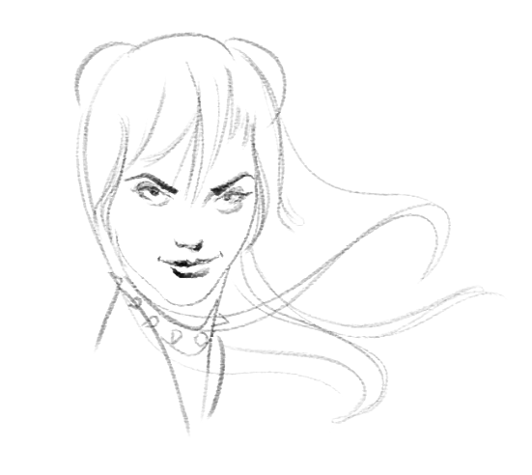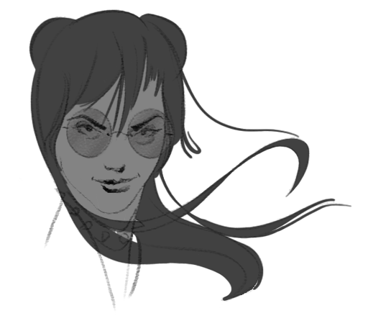
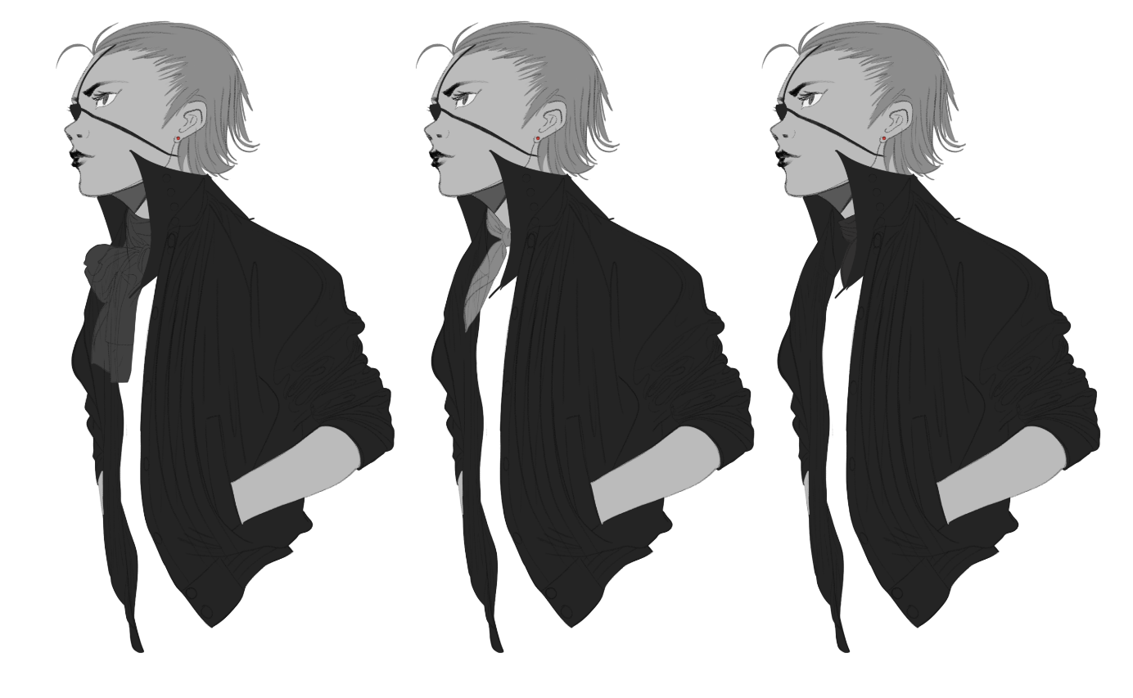
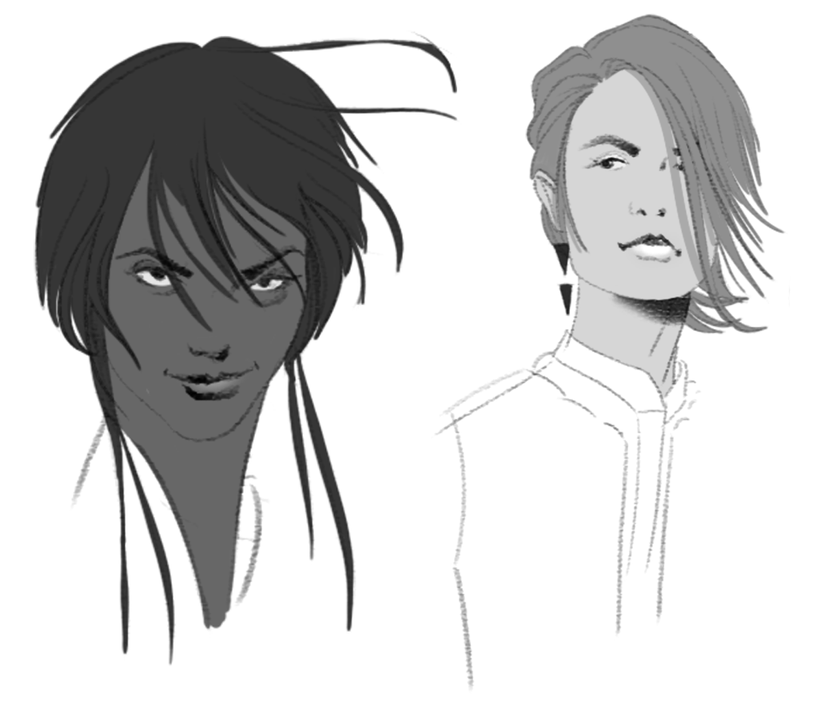
While Soon Me’s character isn’t in the trailer that the team is currently producing, I personally liked to explore her designs. Ultimately exploring her character helped with the design of Nikki considering they’d need to become a sort of dynamic duo. So, their designs need to work in harmony together while staying their own character designs. Bringing both characters together in a small design helped with bringing these personalities together.
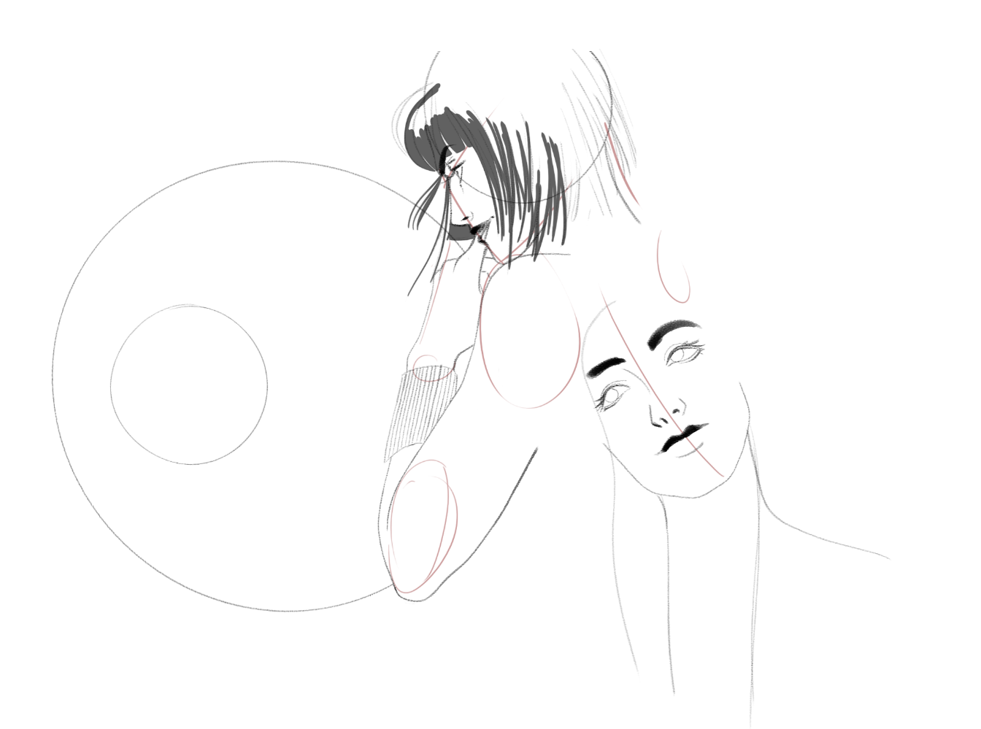

Roman Character Concept Art
One of the prominent male characters that acts as a sort of foil to Nikki is Roman, who she forms a rivalry with to prove that she can be just as good if not better than Roman could ever dream. The first few concepts had a slightly softer shape language over the preferred design. Considering Roman’s character and being Nikki’s foil, he needed to incorporate design features that promoted his background and personality. Some of the design choices were to give him a single earring and to sharpen his facial features emphasising that youthful “edginess” that he’s designed around. Roman and Soon Me’s characters both retain that unapproachable edge while still retaining either a heroic or villainous quality. Most of this is due to subtilties in the shape language, using slightly more rounded lines for Soon Me’s designs over Roman’s preferred concept.
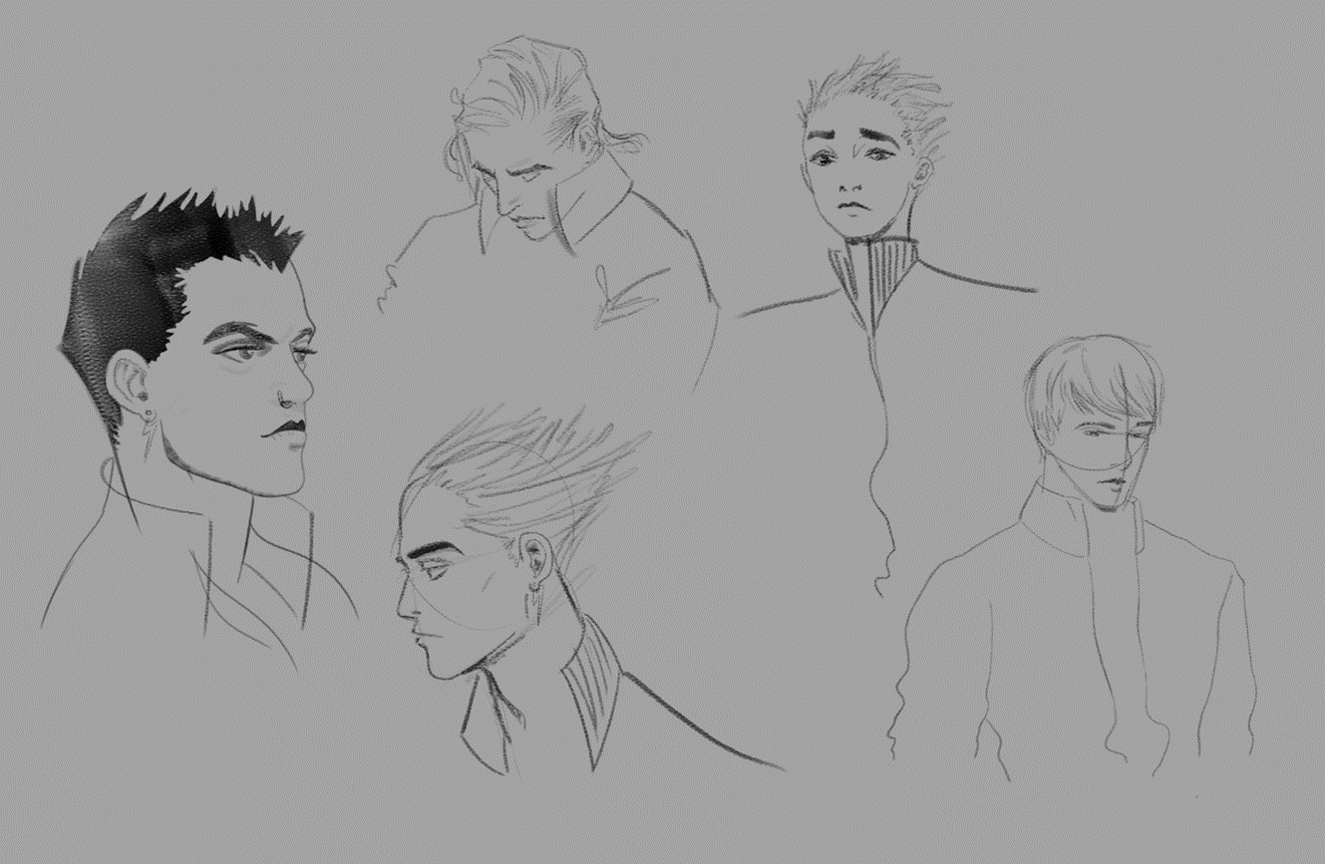
Muscle Fit for Heroes
Originally during the project, the decision was to have Nikki’s hero car to be a modern Mustang, although after feedback from an outside source and from further research into American muscle culture, it became apparent that the Mustang wasn’t what was held in high appraise.
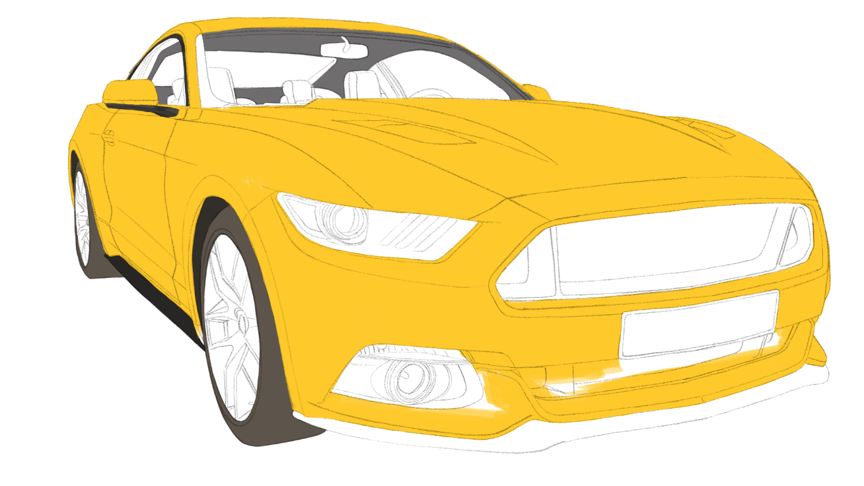
The hero car changed between Nikki jumping into a Bugatti Veyron or choosing to race in her Uncle Lunk’s Dodge Challenger. It was quickly decided upon to have the Dodge Challenger as the main hero car that Nikki would represent Earth in these intergalactic races. The idea of a young female lead being the underdog of the racers with a modified Dodge caught on quickly.
Currently, progress is being made on the Dodge Challenger’s texture, by working inside of Substance Painter and referencing in the files it gives for a clear workflow, that’s vital for projects of a larger scale. While in production conversations it was decided upon to go for a navy/royal blue for the hero car, partly due to colour theory but also due to the shape of the car, as the blue compliments the slight aggressive feel of the muscle car.
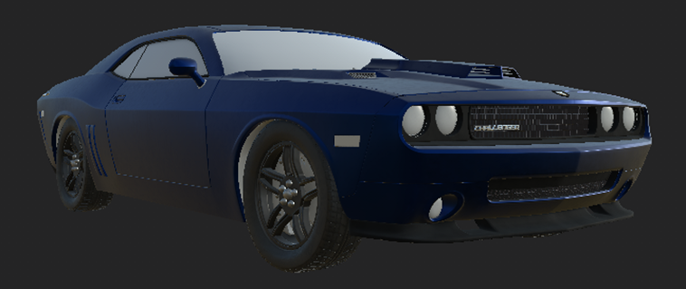
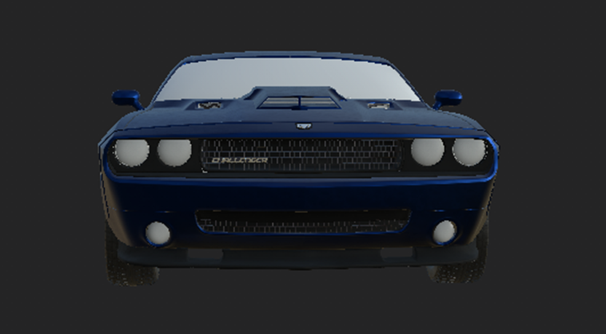
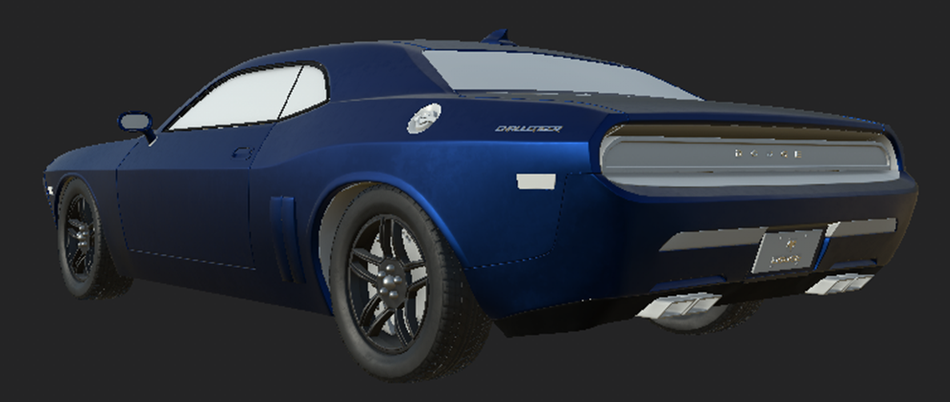

Script Writing
Script writing had been a joint effort between both members where multiple passes were worked on by utilising Writers Duet an online scripting writing programme that allows for multiple people to work on the script in real time. Which greatly helped with production time, being able to work and collaborate elsewhere. The script had been written alongside boarding out ideas for potential shot ideas and plot points, which ultimately helped in the creative process.
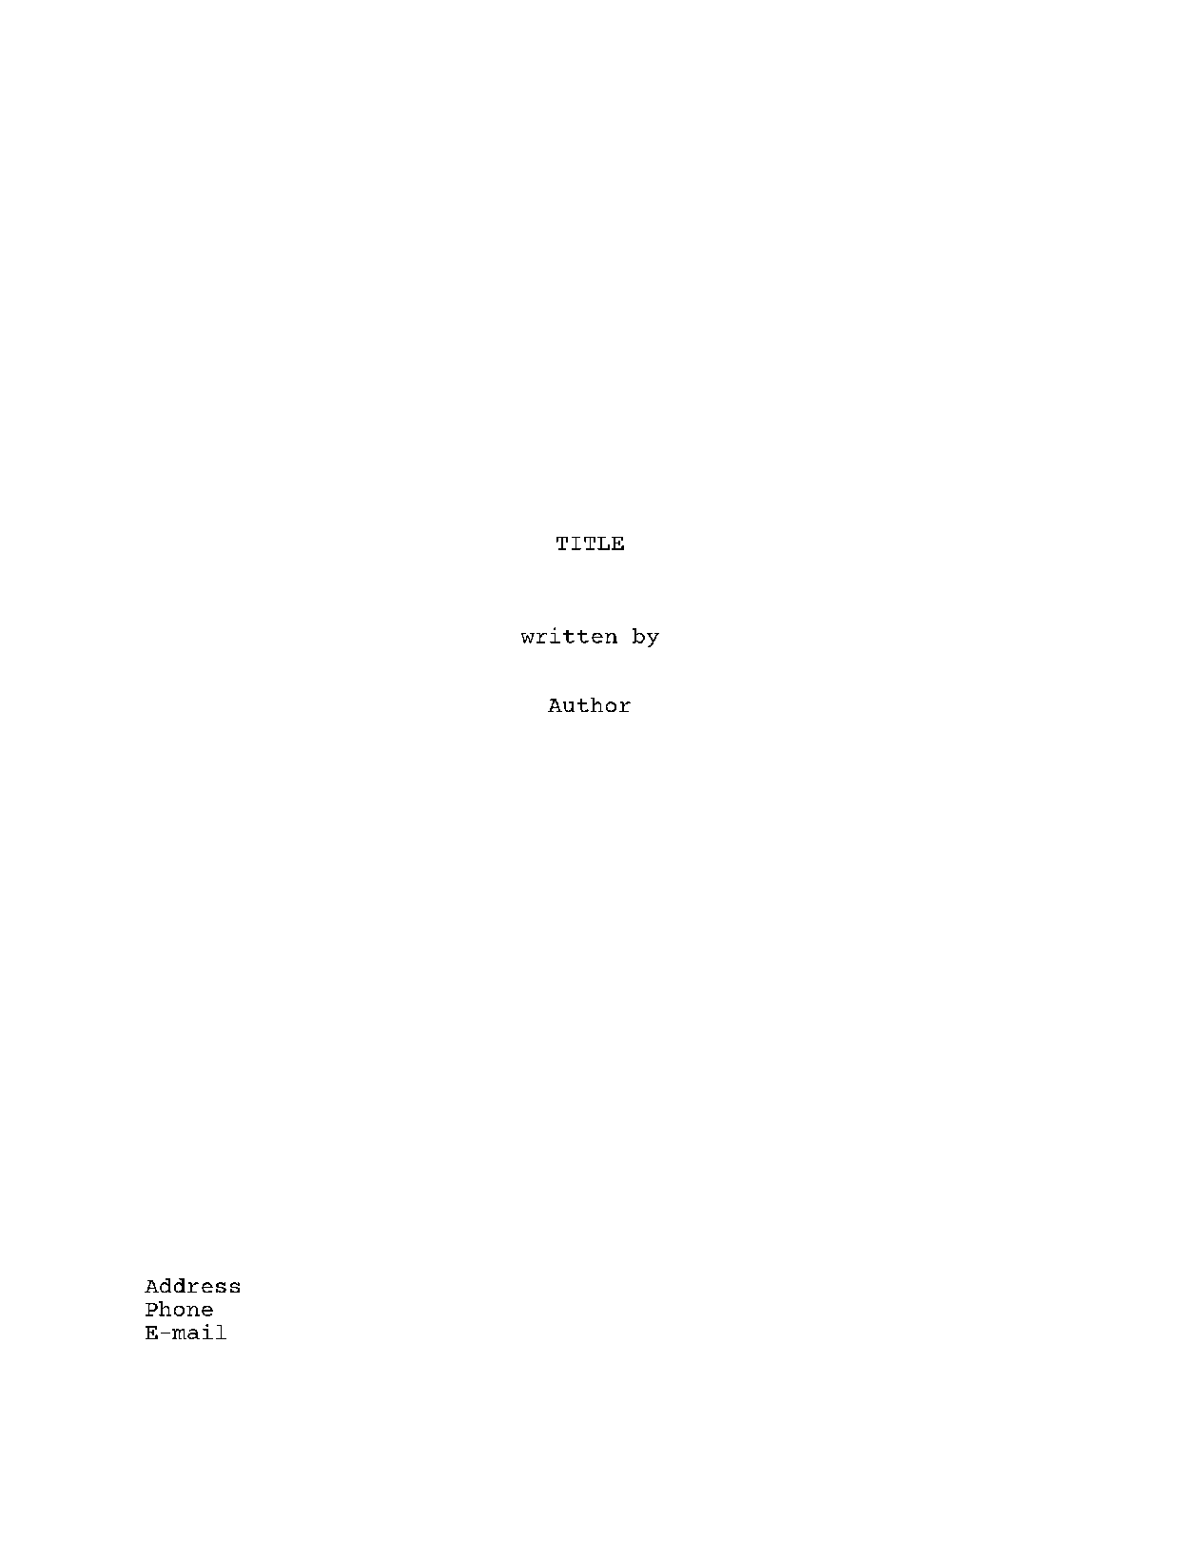
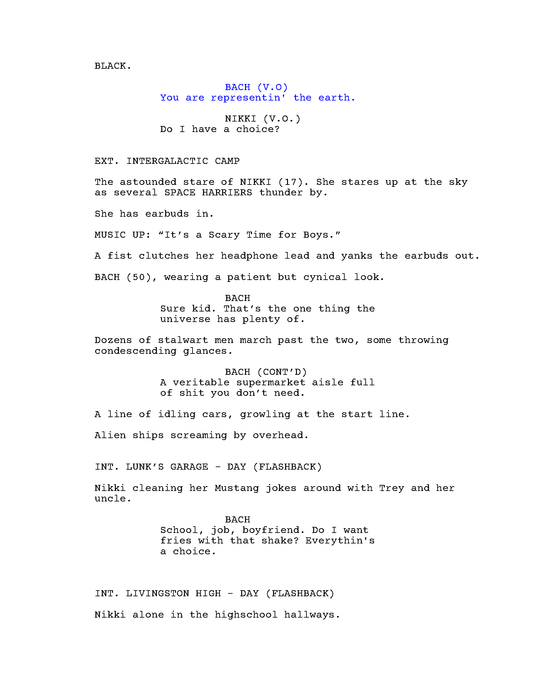
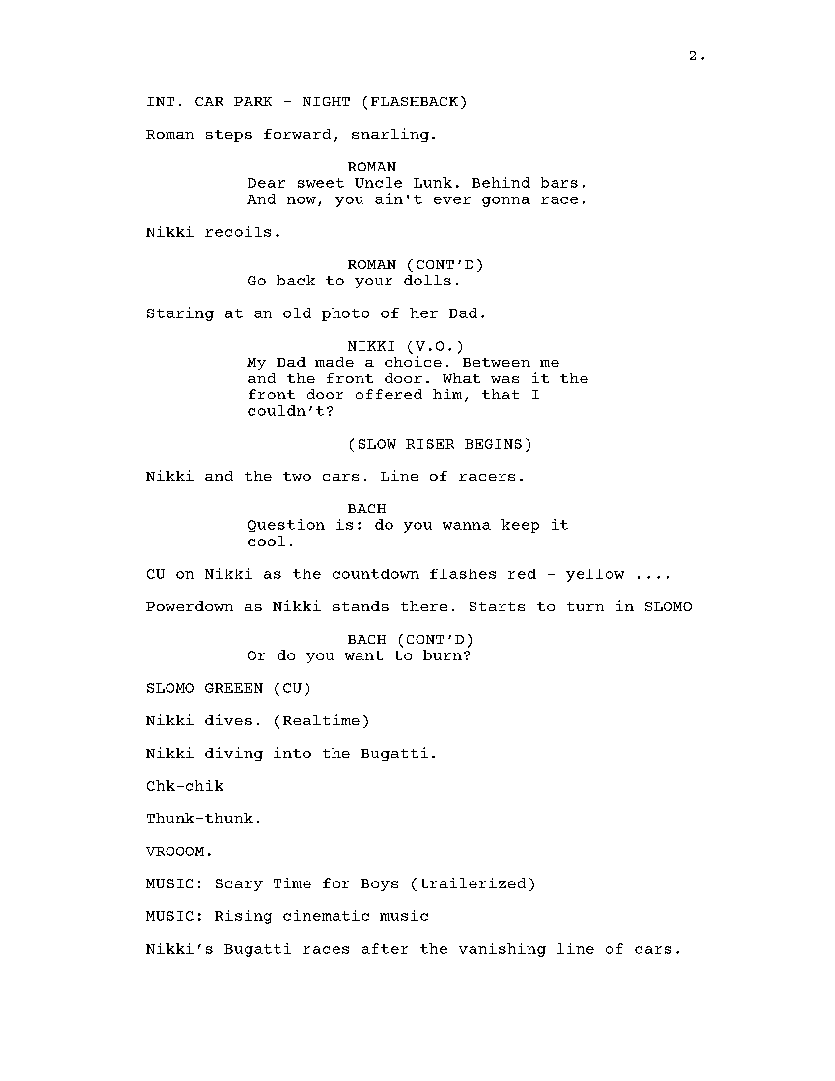
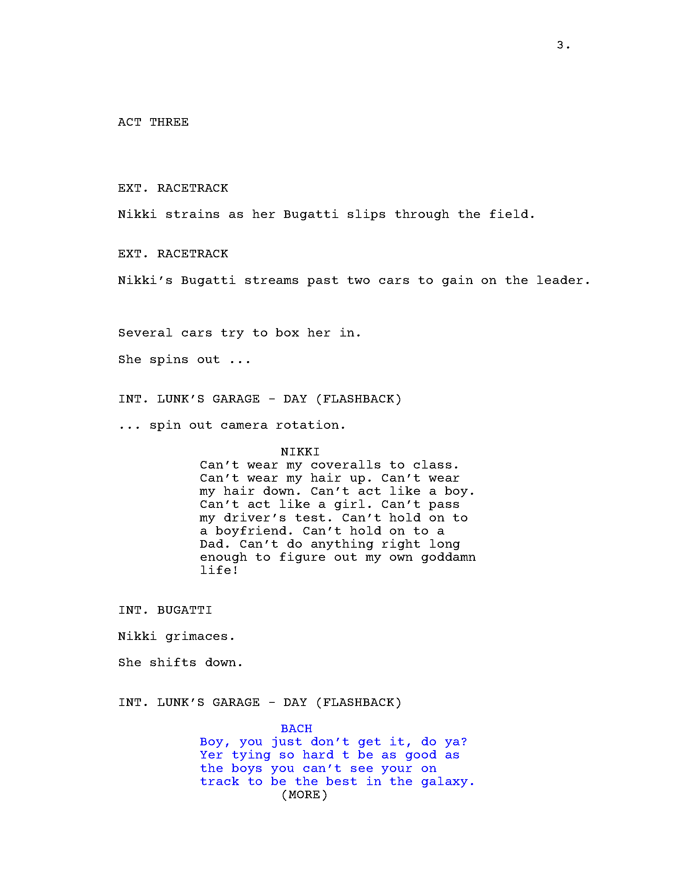
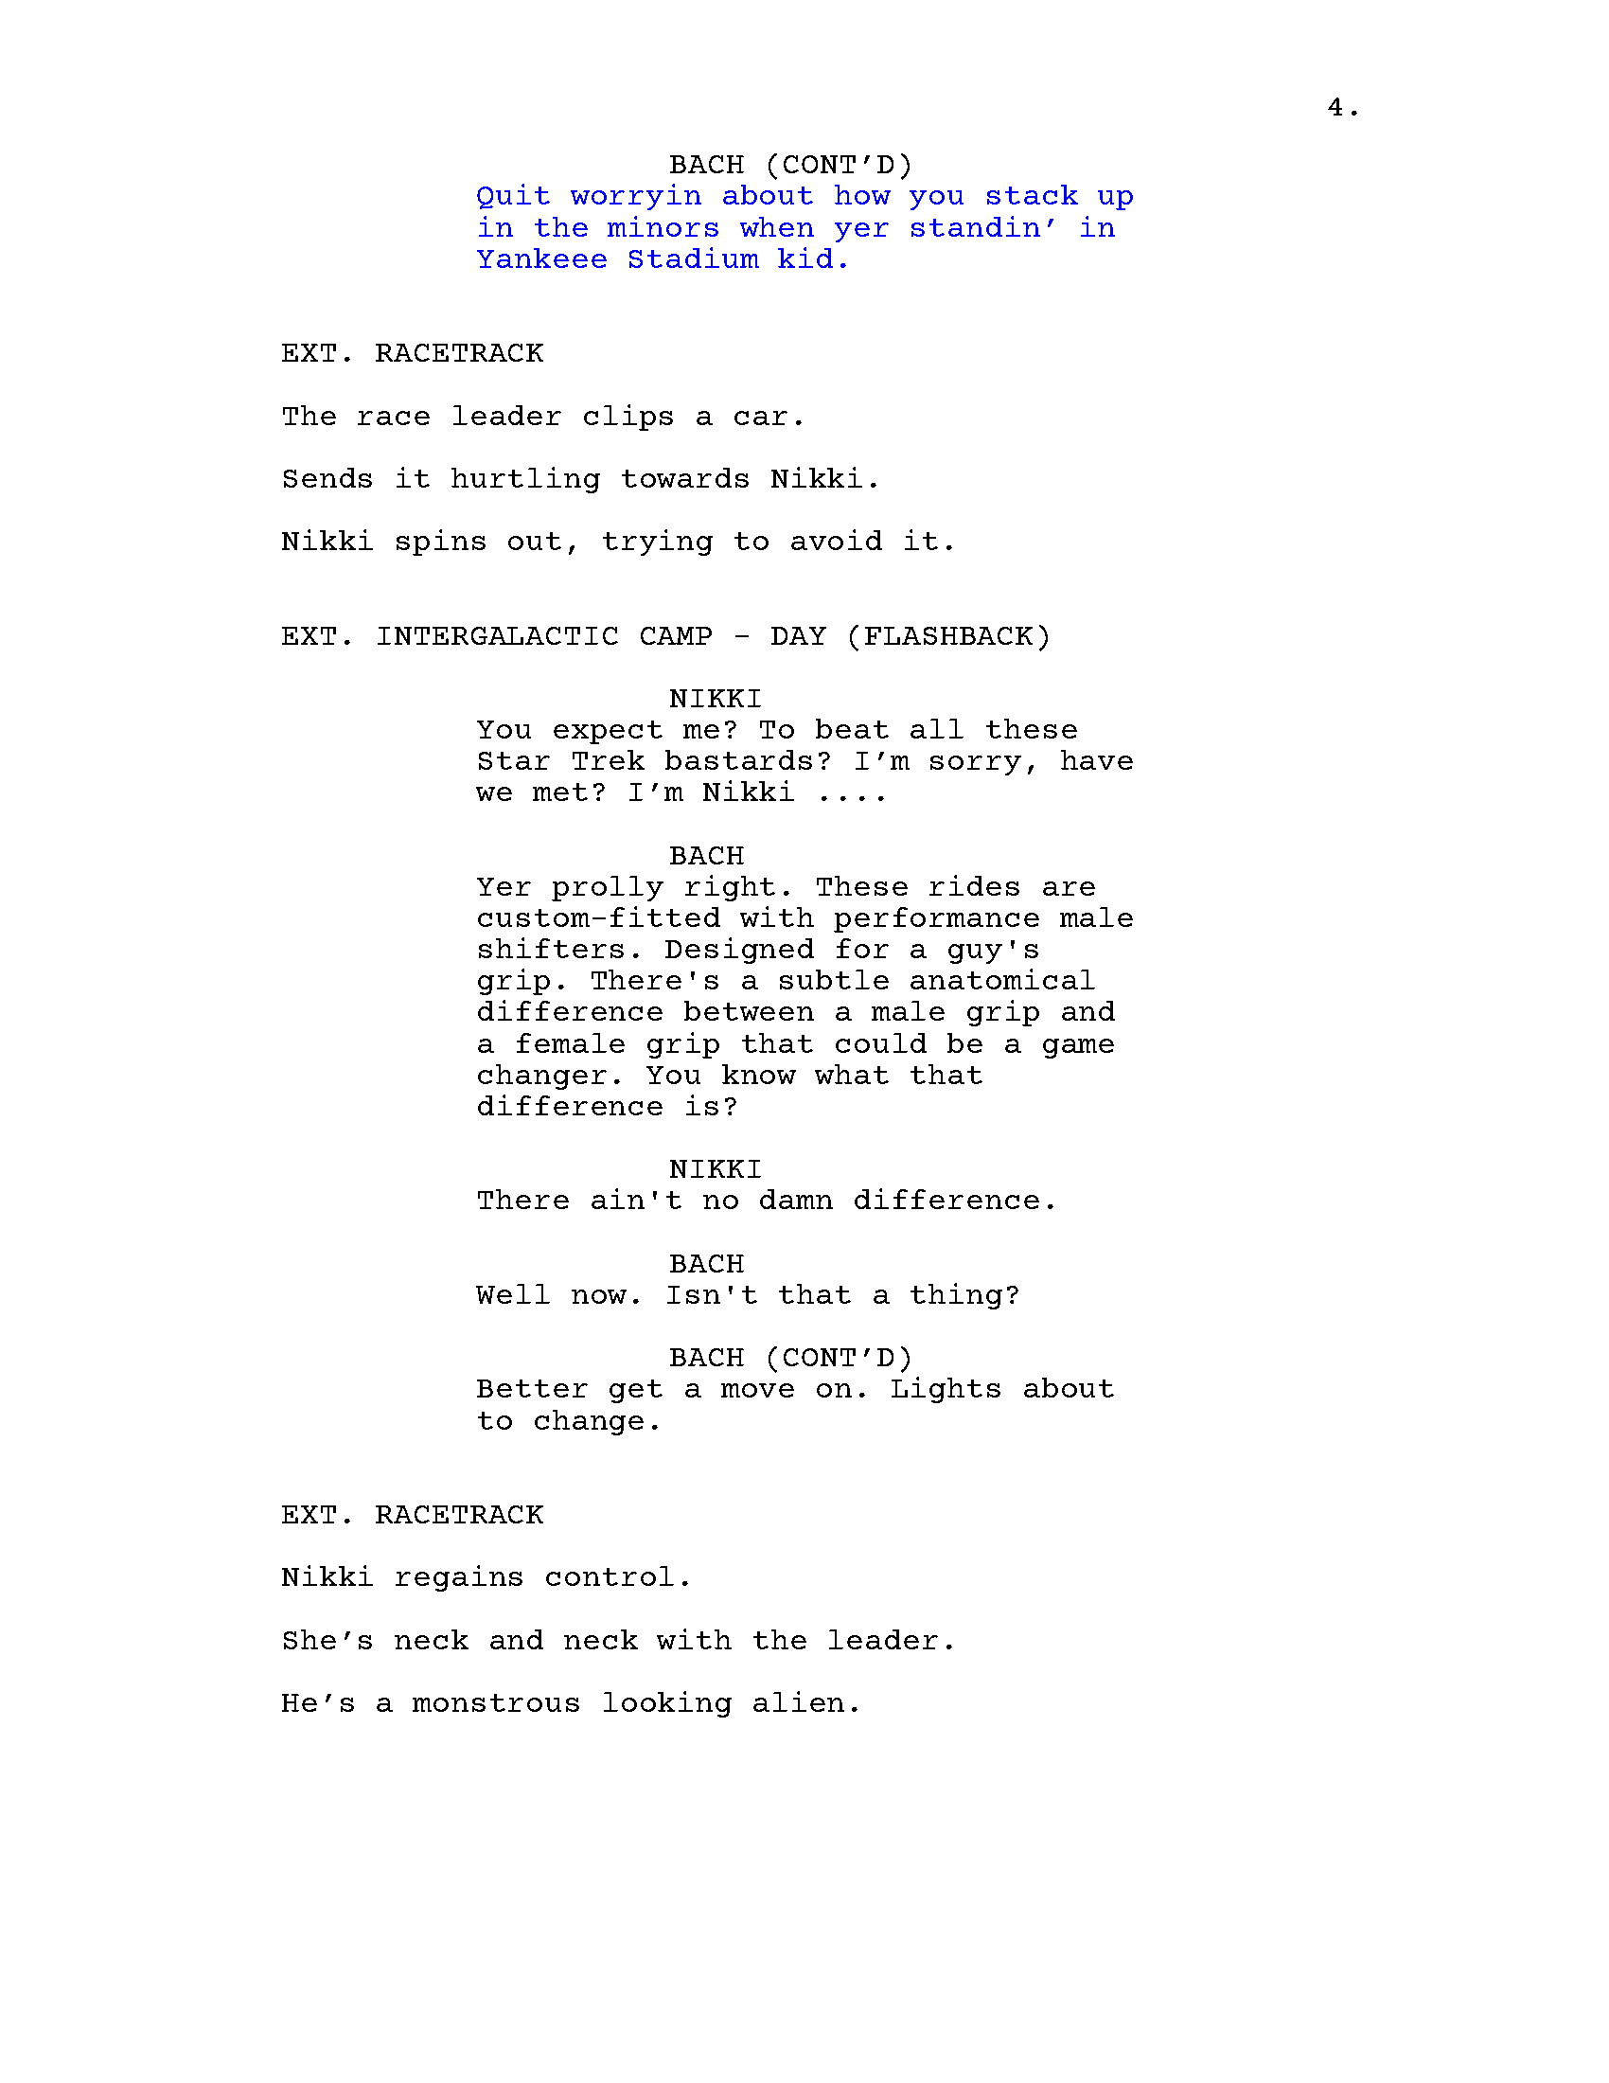
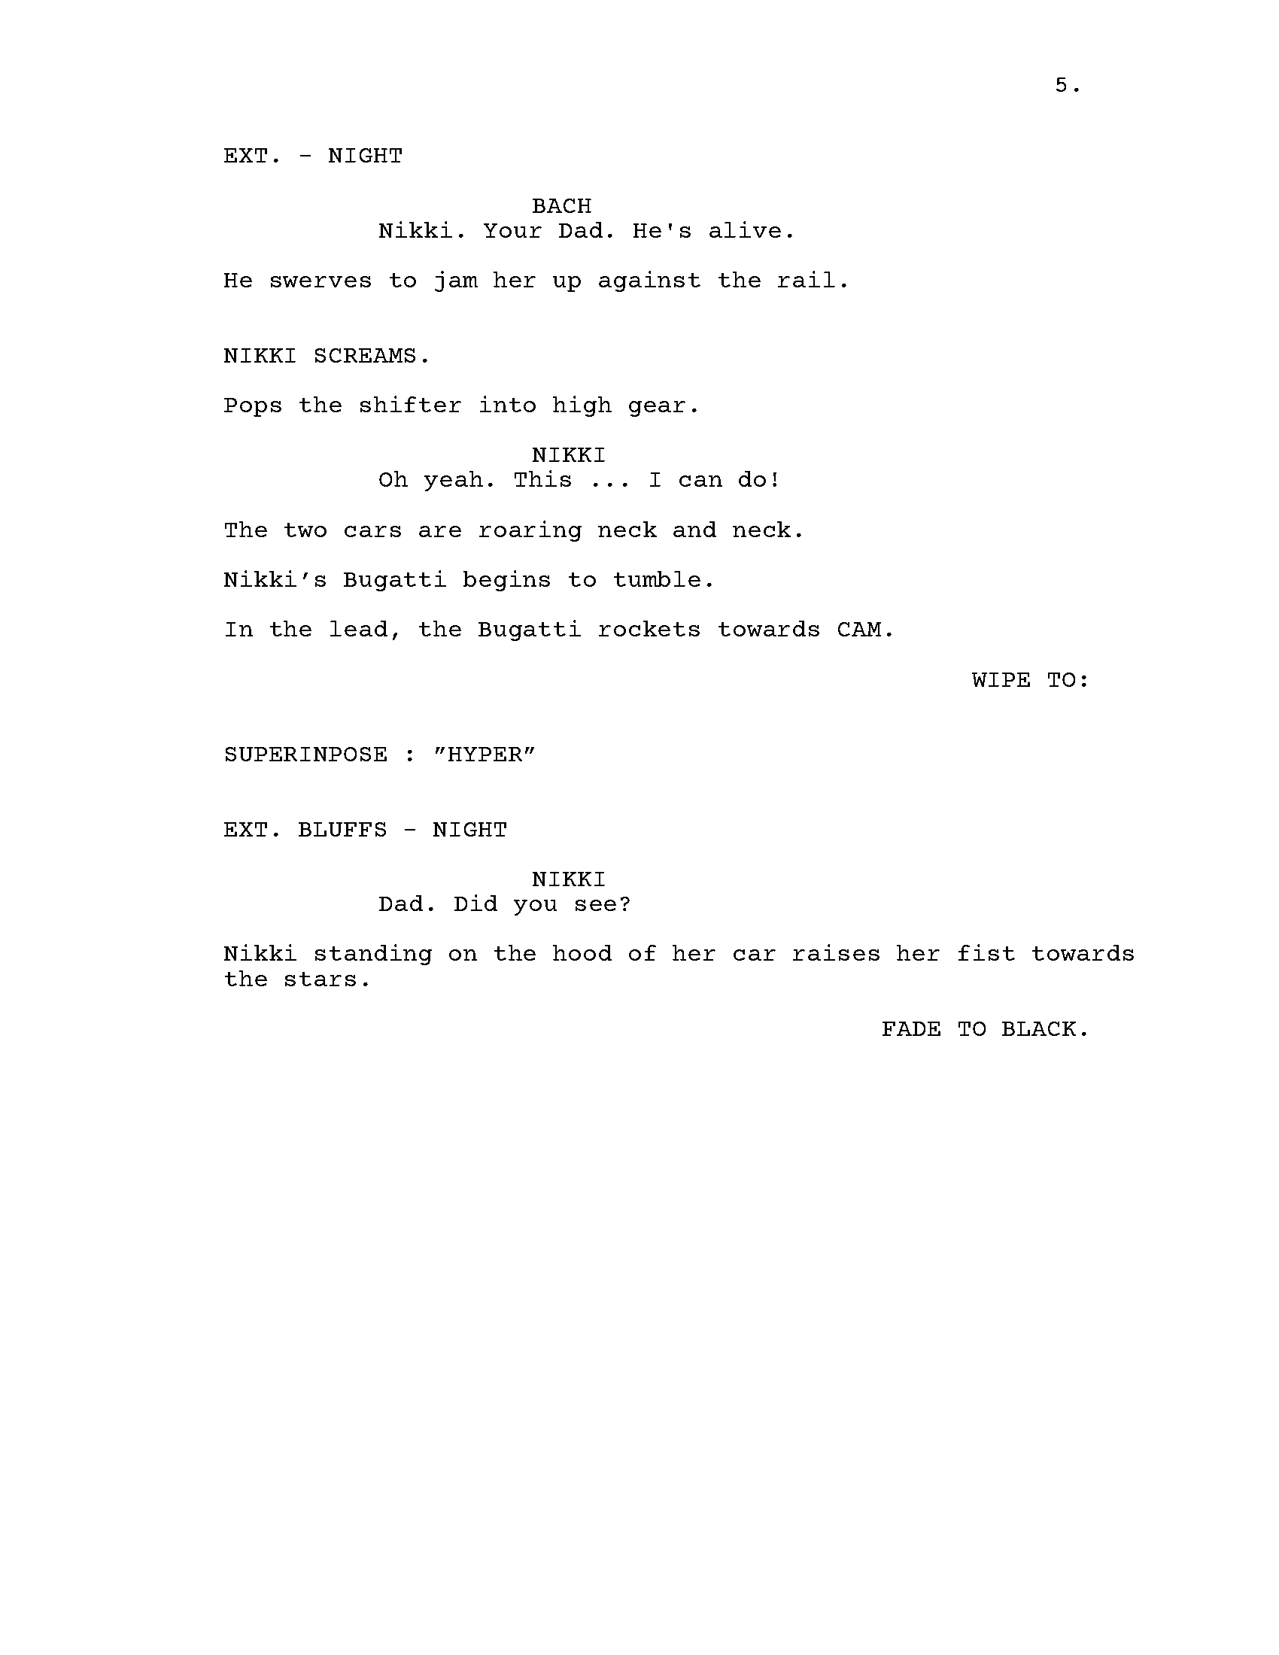

Storyboarding and Animatic
The animatic (Appendix B) went through many changes from the original episodic script to the final trailer script that both team members worked on writing. As shown these storyboards are the first iteration of the original script before starting to board out the final script, I especially had a fondness for creating the racing and action scenes that were to be expected in the script.
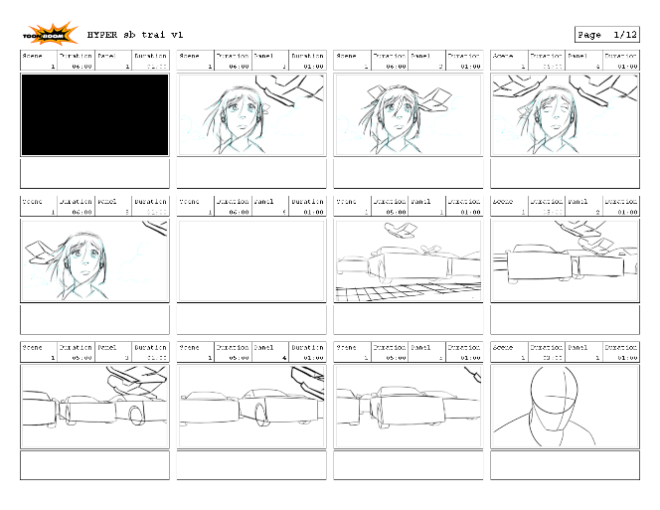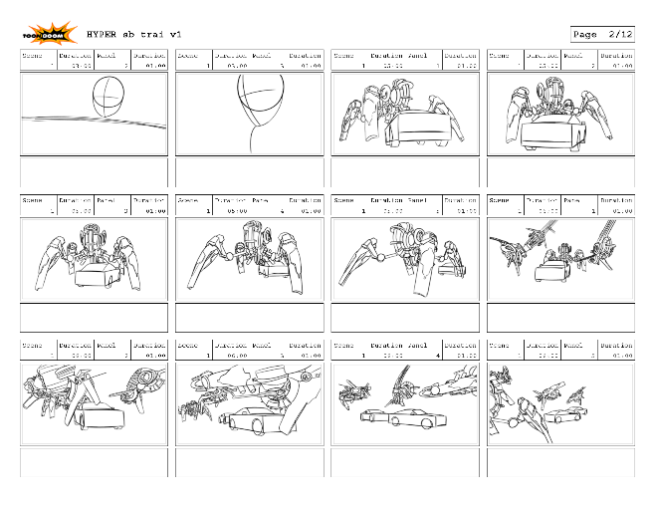
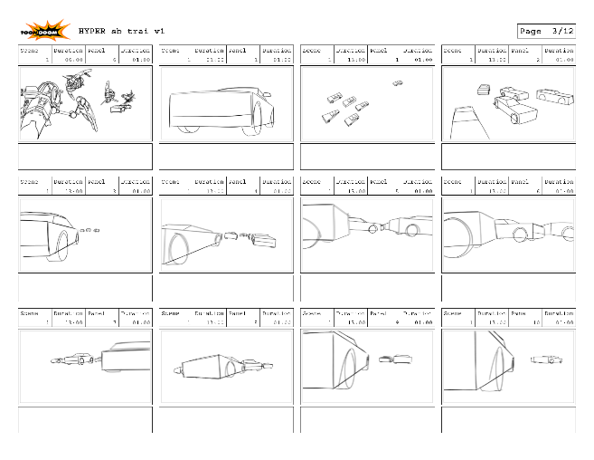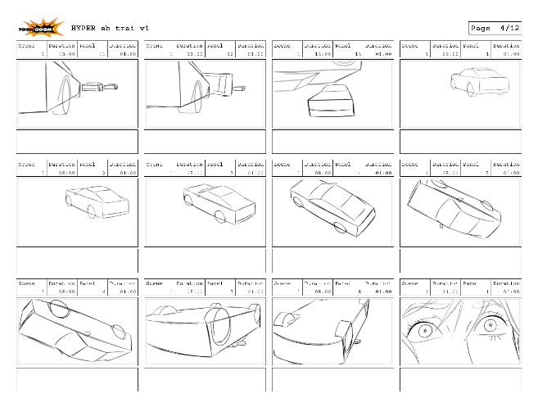
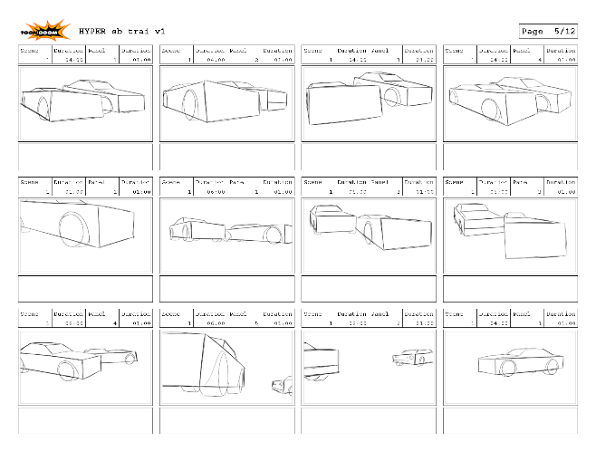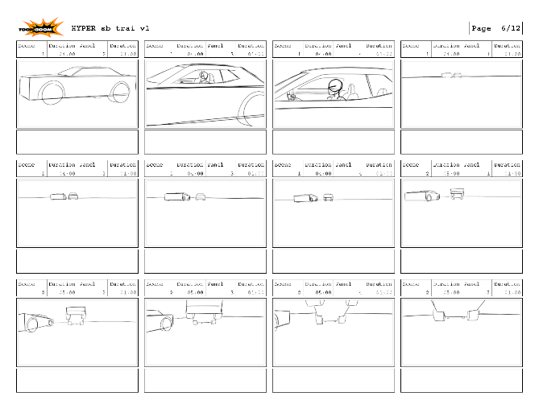
Nikki’s car screeches out of the race and onto the side-lines, resulting in an adrenaline boost of speed off screen.
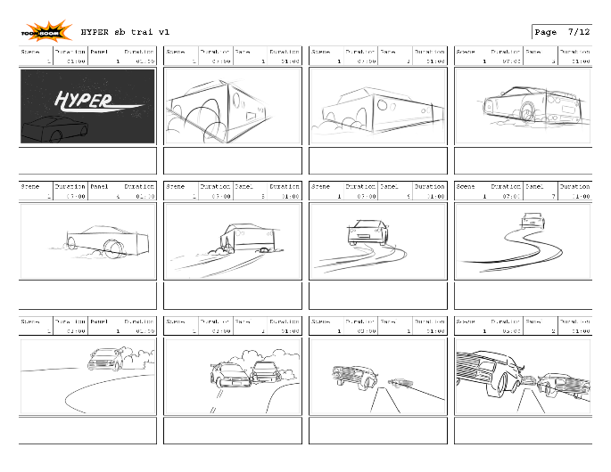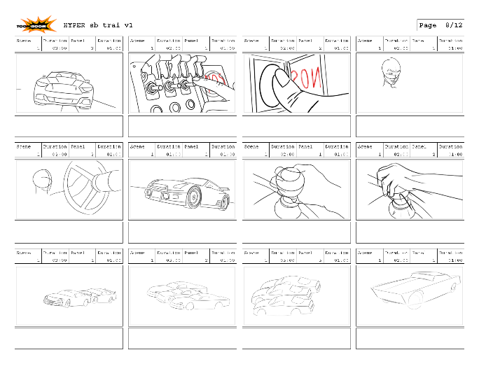
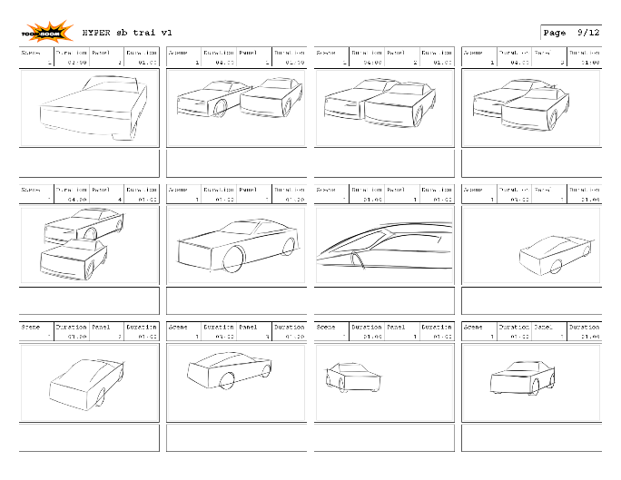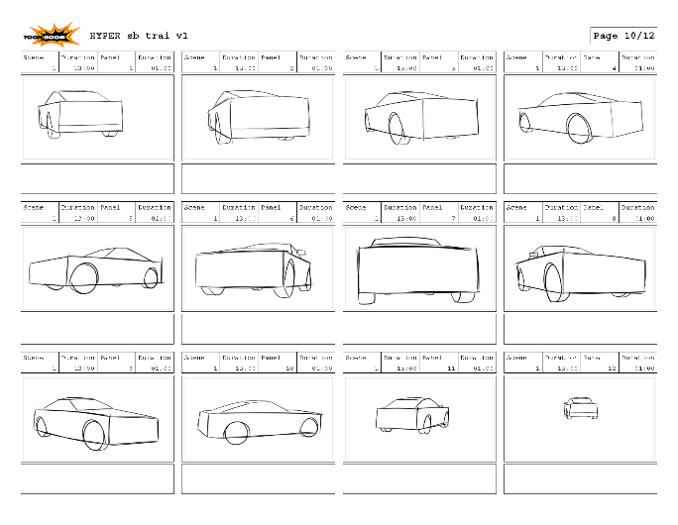
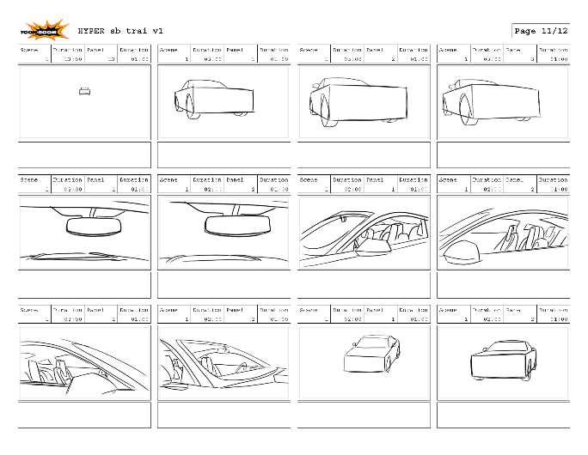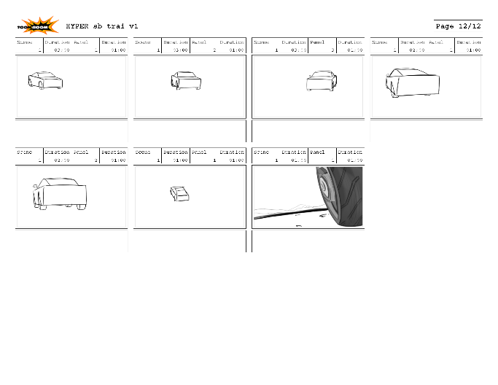
During the first rough pass of storyboarding for the original script, the main focus had been on the race sequence, a battle between the winners, underdog Nikki and gang brazen Roman against defining odds. The earliest storyboards mirror the story written by Al Kang, which were later developed into the updated and final draft of the script.
Not every sequence in the final animatic is represented, mainly the scenes that needed extreme planning and largely action orientated scenes and shots.

Matte Painting
When concepting a scene of the race the early version had to be redone, adjusting the perspective to really push those values for a dynamic scene. While this piece is still currently being worked on while switching over onto character modelling, it gave the opportunity to better study perspective especially with vehicle placement and how the silhouettes originally clashed against each other. Working in a team is an essential part of this project, and with help and feedback, was then able to apply this newly found knowledge for shot design when redoing this race painting that’s currently ongoing.

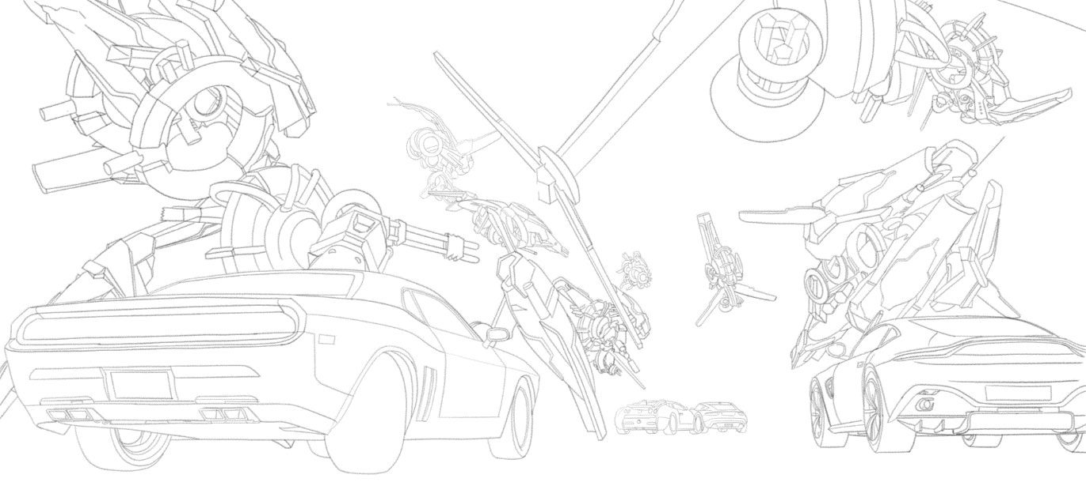
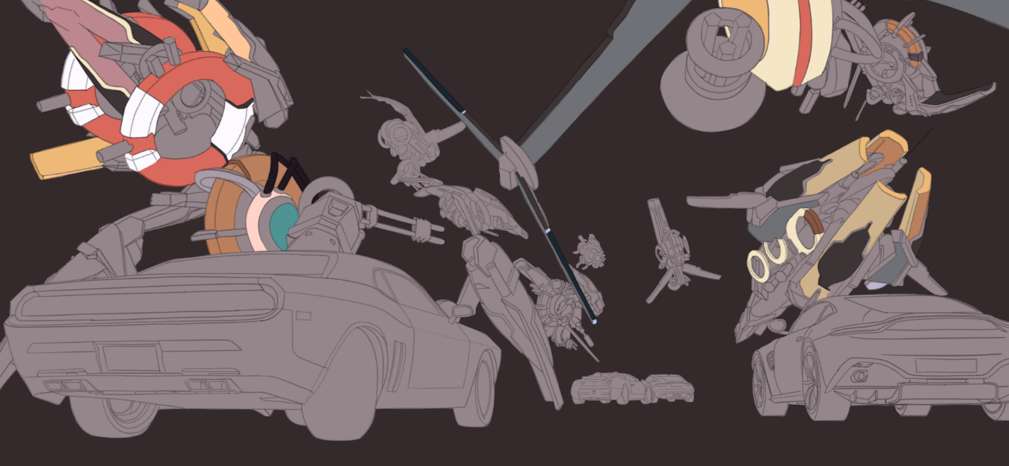
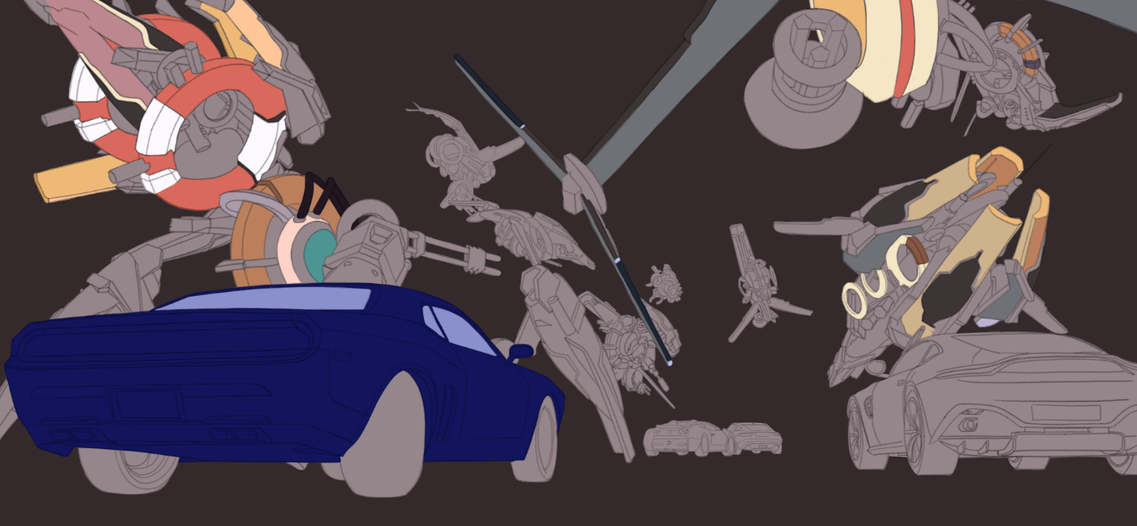
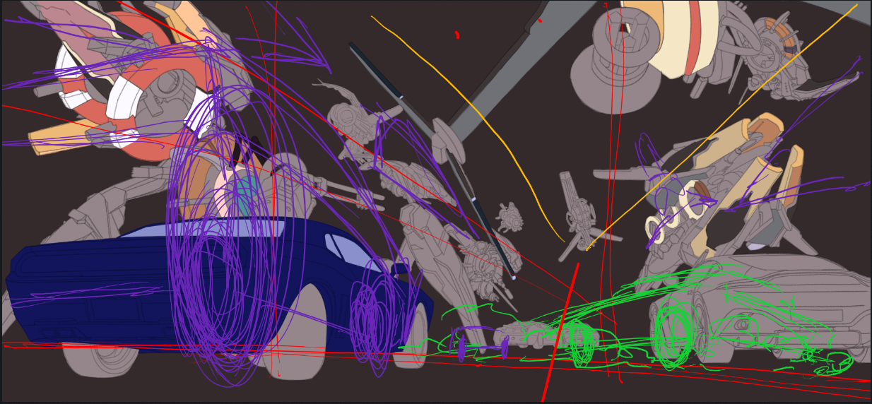
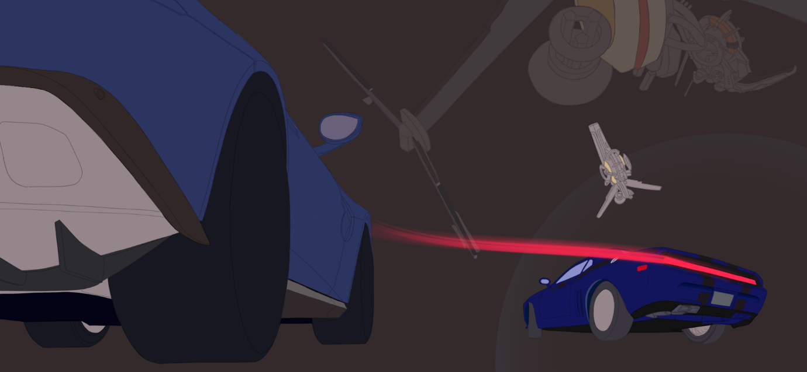
The alien ships that are currently concepted in this piece are placeholder designs, to give an idea of what the final will look like. The designs were used from free alien ship assets that the team is using as animatic placeholders.
While starting to explore colour theory and what palettes’ work with specific mood lightning and such, I had taken a look at Steven Stalenhag’s work (Simonstalenhag (2018).) and how he uses colour and light. Using a piece of his work and adding a simple filter to get a colour palette that doesn’t have over saturated colours to use for the race scene. As previously seen.
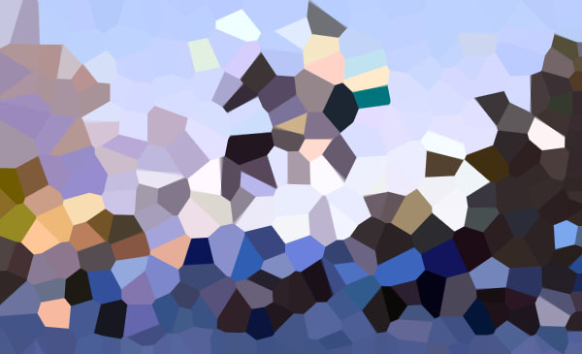
(Stalenhag, 2018)
Considering most action sequences have its audience in the action, the camera angles really needed to push the perspective, as part of tackling this the team took photos of HotWheels cars from a range of angles to get a better idea of planning out the storyboards while working on the 3d lay out inside of UE4.
The Pipeline
The pipeline that’s currently being utilised for the Unreal workflow is by rendering the UE4 footage out of Unreal and into it’s footage (renders) folder, have Hiero reference in these renders with nuke referencing the hiero files and finally rendering out of Nuke and into the frames (shots) folder that gets read by Premiere pro. Ensuring the same naming conventions so as the renders are updated the animatic naturally updates itself from the referencing structure.
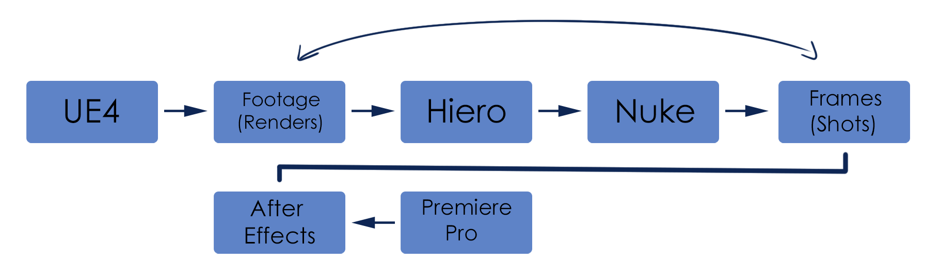
Something that needed to be figured out was a work around from using Storyboard pro for the animatic’s storyboards and referencing these panels into UE4. Although there isn’t any way of properly referencing the boards, there is a secondary system the team has been utilising.
The newest animatic is currently being updated to incorporate the reworked 3D shots from UE4, with other ongoing work including other character sculpts such as, Bach, Roman and Uncle Lunk being blocked out, with Nikki’s character being taken from LOD_4 to an LOD_3 and focusing more on detail and further character concept design from 2D into 3D. This way by being open to further experimentation to the characters it further develops the character’s personality.
Production Schedules
The team kept track of production schedules by setting key objectives for specific dates and for these objectives to be met to move onto the next focus. As seen, a large utility being used is Microsoft’s Planner, being easier to use and navigate for tasks and for quick feedback on the task at hand, over a traditional Gantt chart, both this method and a production Gantt chart are currently being used and are frequently updated.
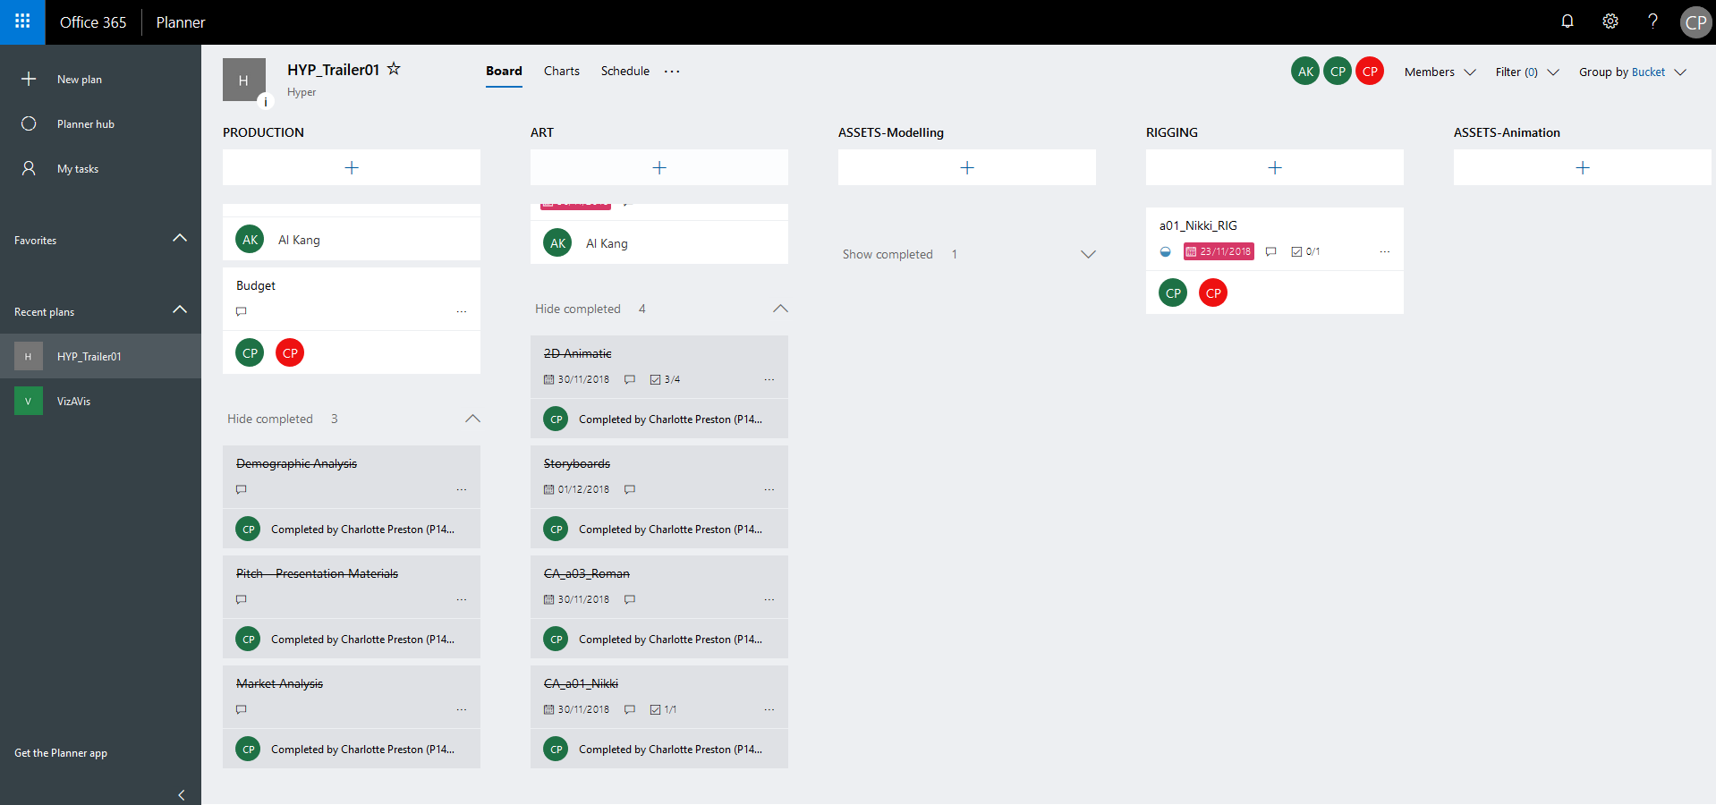
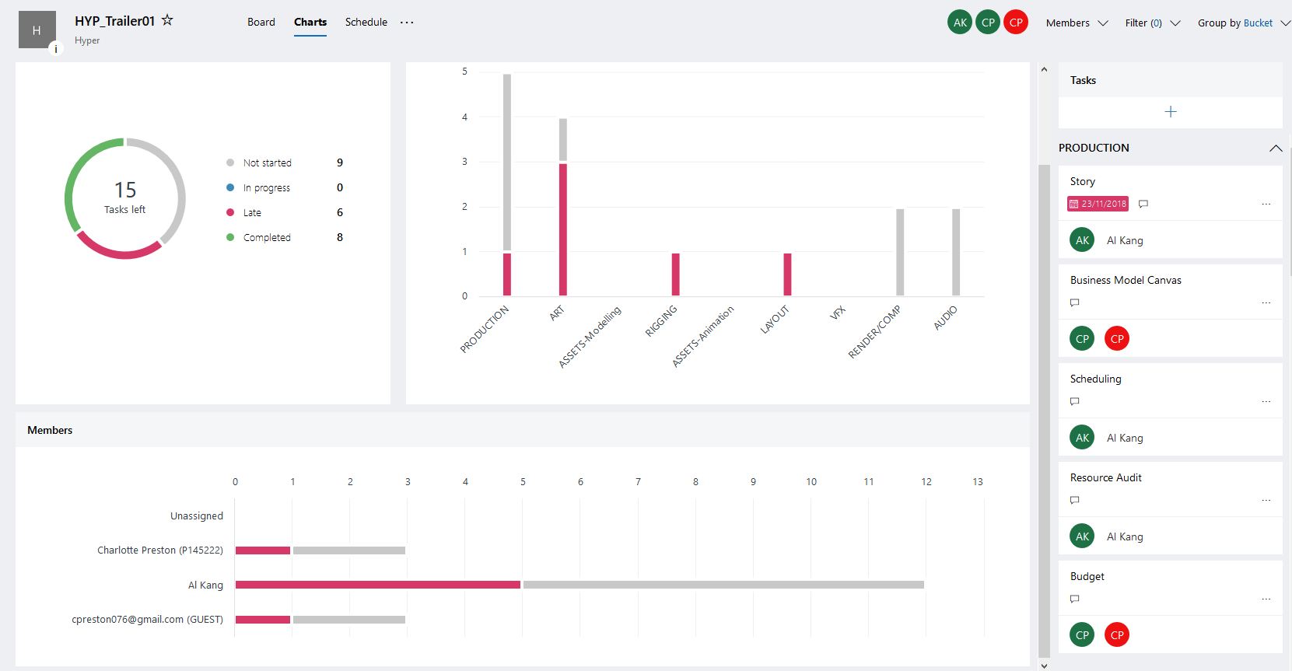

References:
- Character Design References. (2019). Art of Space Pirate Captain Harlock. [online] Available at: https://characterdesignreferences.com/art-of-animation-2/space-pirate-captain-harlock [Accessed 5 January. 2019].
- Sugar, R. (2018). Rebecca Sugar on Instagram: “I drew this first sketch of Lars of the Stars for a flyer for a BBQ at my place, I believe it was 2013... @ghostdigits still has this copy…”. [online] Instagram. Available at: https://www.instagram.com/p/Bd4Ox1mgTBc/ [Accessed 14 Dec. 2018].
- Stalenhag, S. (2018). Simon Stålenhag | Concept Art World. [online] Concept Art World. Available at: http://conceptartworld.com/artists/simon-stalenhag/ [Accessed 10 Dec. 2018].
- Simonstalenhag.se. (2018). Simon Stålenhag Art Gallery. [online] Available at: https://www.simonstalenhag.se/ [Accessed 8 Dec. 2018].
Appendices:

Appendix A : https://www.charlottehpreston.com/hyper/
Appendix B: DVD/Animatic/HYPER_Current
Appendix C: DVD/Turntables anim tests/Nikki_LOD4

