Piotr Czubinski
2237463
Submission deadline: Friday 28th March 2025 23.59pm

Evidence of Learning (E Portfolio)
Digital Skills for Personal Development and Business Growth (BMSW4008_SWAN)
Module Lead: Philippa Fitzgerald

Contents
Task 1. Questionnaire analysis 3
Task 2. Design of the website and marketing materials. 6
Task 3. Microsoft Excel 13
Task 4. Video advertising 15
References 16

Task 1. Questionnaire analysis

The data shows that a lot of people (10 out of 21) thought their partner was cheating on them, and another five were not sure (Figure 1). According to the BBC, 75% of men and 68% of women who were in a partnership said they had cheated on their partner at some point (BBC,2019). This suggests that worries about cheating are common, which could increase the need for private detective services that focus on these kinds of cases. The high level of suspicion means that people are ready to find out more about their partner's behaviour, which is in line with research from the private detective business that says most of their work is investigating cheating spouses (Vilcol,2025). A World Population Review study from 2025 found that about 36% of people in the UK have admitted to cheating on their partners. Concerns about cheating are quite common, which shows that there is a need for a specialised service that investigates cheating partners. Marketing should be focused on this specific sector, and extra services like background checks and monitoring for other personal or business cases should also be available.
Photographic and video evidence (20 votes) is by far the most popular type of proof, beating out other types like GPS tracking (11 votes) and phone records (10 votes) Figure 2. There were no votes for witness statements, which suggests that clients would rather have solid proof than speculation. This trend makes buying good surveillance tools and teaching agents how to conduct covert operations even more important. Also, the fact that clients are interested in GPS tracking and contact records shows that they value digital forensics as an investigation tool. Investments in technology: Due to the high demand for photographic and video proof, it is important to give investigators high-quality cameras, tools for night vision, and small recording devices. For complete evidence gathering, GPS tracking and digital forensic analysis should be built into research packages. The company will be able to offer agents lower prices because of improvements in Chinese manufacturing that have recently made surveillance devices cheaper (Mordor Intelligence,2025)

Eleven of the people who answered said they would use a search engine like Google or Bing to find an investigator. Only one person said they would rely on suggestions from other people. Referrals from lawyers or police (6 votes) and social media searches (3 votes) were not the first choices (Figure 3). This finding shows how important it is to have a strong online footprint, which includes a website that is well-optimized, customer reviews, and search engine marketing plans (Ok,2024). Because word-of-mouth is not very important, digital marketing and managing online image will be very important. Plan for digital marketing: Search engine optimisation (SEO) and Google Ads would help businesses get more visibility since most people who need a private investigator find them online. Making a professional website with recommendations, case studies, and an easy-to-use contact form would make it more credible and easier for people to get in touch. This market is huge. The most important thing is to show ourselves to the customer so that he can reach us (Wuisan and Handra, 2023).

With fourteen votes, in-person meetings were the most popular way to talk, followed by calls (8 votes). Using digital tools for contacts, like emails and safe online chat rooms (2 votes each), was not as popular (Figure 4). This means that clients want a specific, face-to-face approach when dealing with sensitive investigations. The business needs an office space in Swansea that is out of sight and out of mind. Gaining the client's trust and providing him with the chance to discuss the entire matter in detail during the first appointment is crucial in helping him feel like he is not the only one dealing with his difficulties.
Given that half of the customers preferred phone conversations, it might be wise to establish a separate line for new customers and another for existing customers. This way, you can promptly inform existing clients about the case's progress and foster a pleasant and trustworthy relationship, which can help establish a base of loyal clients for the future.

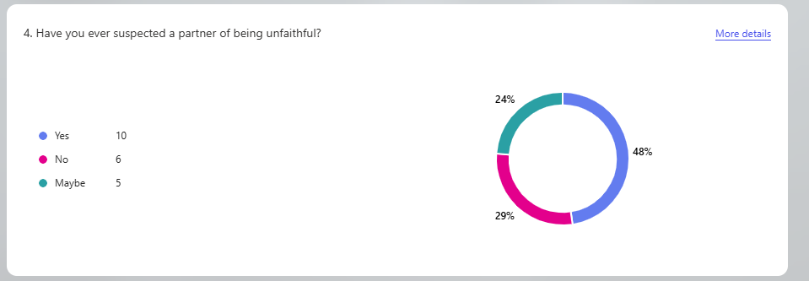
Fig.1.
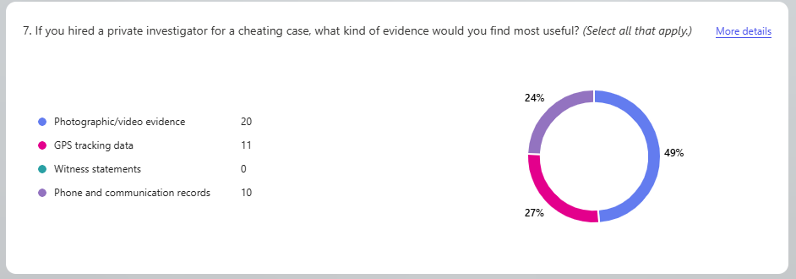
Fig. 2.
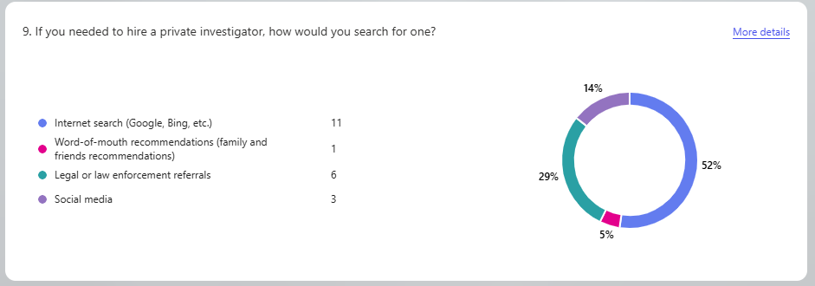
Fig.3.
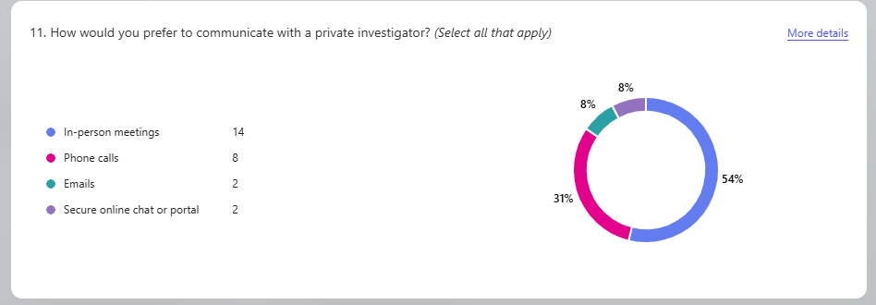
Fig.4.

Task 2. Design of the website and marketing materials.
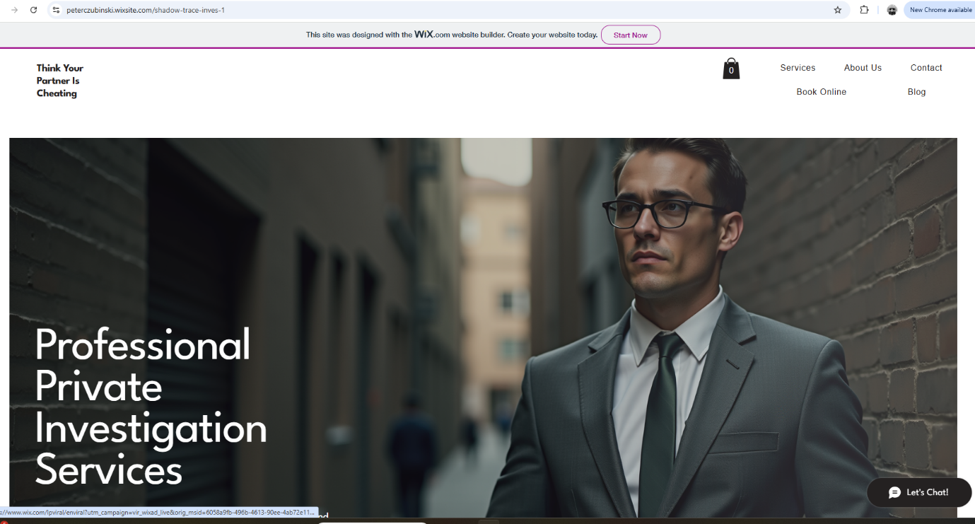

I used the information I got from a questionnaire to help me make a website and marketing tools for my private investigation company, as well as business cards (Fig.5), social media posts (Fig.6) and flyers (Fig.7). That helped me figure out what kind of people use this service most often, what they are looking for, and how they look for it. This information helped me focus my marketing better and make it work better.

Segmentation: Figuring Out Who You Want to Reach (Park,2020)
When you segment a market, you divide it into smaller groups of people who have similar wants or needs. Dadval (2020) say that segmentation tells companies how to give the right goods to the right person. Based on my assessment, I was able to focus on a few clear groups.

Men and women ages 35 to 54 are an important group. Eleven of the twenty-one people were between the ages of 35 and 44, and seven were between the ages of 45 and 54 (Fig.8). That is 86% of all those who replied. This shows that most people who want to hire a private detective are between the ages of 25 and 50. My website and marketing tools are made to appeal to people this age by using clear, business-like language and a serious tone.

I also found a group of people who are having problems in their relationships. When asked if they thought their partner was cheating, ten said yes and five said maybe. That is 71% of those who answered who might need help with probes into cheating. Also, thirteen people need help gathering proof for a court case, and fifteen want to be sure of their thoughts before they decide. I learnt from these answers that the main reasons people hire a private detective are for legal and emotional reasons.

This is why the main page of my website is all about investigating cheating and giving legal help. "Get the truth you deserve” (Fig.3) and "Discreet and confidential help when you need it most" were some of the words I used. The flyer also includes statistics that show cheating is common (75% of men and 68% of women admitted to cheating at some point – BBC) to make potential clients feel more understood. Many people (12 out of 21) said they did not know much about investigation services, and four said they did not know anything about them. I added testimonials and a frequently asked questions (FAQ) section to build trust.

SEO stands for making it easy to find. Das, S. (2021).
Our job is to make it easier for people to find our websites on Google and other search engines. Roumeliotis 2024 say that good SEO means using the right keywords, making sure your website is fast, and making sure it works well on mobile devices.

Eleven of the people I asked said they would look for a private detective online. That is more than half of the group. So, SEO was a big part of my plan for my website. I used things that people said they thought were important in the answers, like "private investigator near me," "evidence for divorce," and "infidelity investigation." These words are used in the names of pages, headers, and images. I also added a blog area where I can write helpful posts like "What to Expect from a Private Investigator" or "5 Signs Your Partner May Be Cheating." This content can help the site rank higher in search results and instruct people who come. People trust businesses that feel personal and responsive (Tijjang et al.,2023). That is why I kept the language on the website simple and honest, like speaking to a friend.
Using what customers want to help design a website.
Another interesting thing that came out of the survey was how people liked to communicate. Fourteen people said they would rather meet in person, and eight said they would rather talk on the phone. Not many people picked email or safe online chat. So, I put a button on the home page that says, "Book a free consultation" and links to a phone number and contact form. I also put a page with information about where our office is and how to set up meetings in person. It feels more personal and trustworthy now that this is there.
Expectations for Prices and Service
Out of 21 people asked, eleven thought the price range of £500 to £1000 was fair. This helped me figure out how much to charge for my services and what to write on my website about prices. I made a page with prices that makes it easy to see choices like:
-Basic Package for Dishonesty: £650
-£950 for a legal evidence package
-Custom Investigation: Get a price quote from us
I also put a note saying that we are flexible and willing to talk about each person's needs. Being clear about prices helps customers believe you and makes it easier for them to make choices (Mohammadi et al., 2024).
Materials for marketing In Light of Data.
I also made simple but successful marketing materials based on what I learnt. The headline on the website, "Think Your Partner Is Cheating? "Is what most people were worried about. There is also a list of services on it, such as:
Discreet investigations into cheating
-Collecting Legal Proof
-Identity check
-Monitoring with GPS and video
There is a QR code on the flyer with the phone number and website for quick access. I also made posts for Facebook and Instagram that were aimed at people 35 to 54 years old. I put in some client reviews and words like "Trust your gut—we'll find the truth." That is why I kept this part of my campaign small: only three people said they would use social media to find a private detective.
In conclusion, the questionnaire helped me a lot in making a targeted website and marketing tools. I was able to divide my audience into groups, focus on cheating and legal help, and make the site for people who do not know much about private investigations. I used SEO strategies that were based on how people look and made sure that the site had key features like trust signals, clear pricing, and ways to communicate. It became clear to me through this project how important it is to use data when making a business plan. It is important to know what your customers want, as Mandal (2025) said.
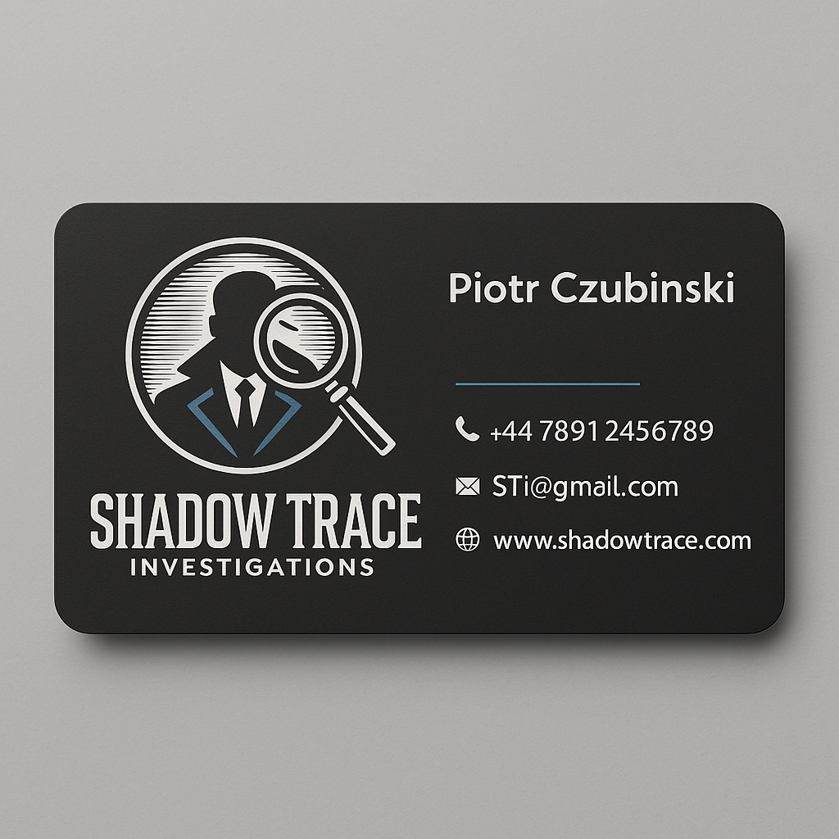
Fig.4.
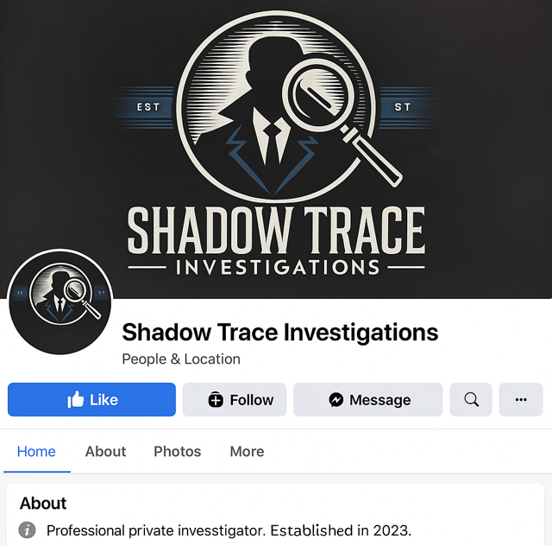
Fig.5.
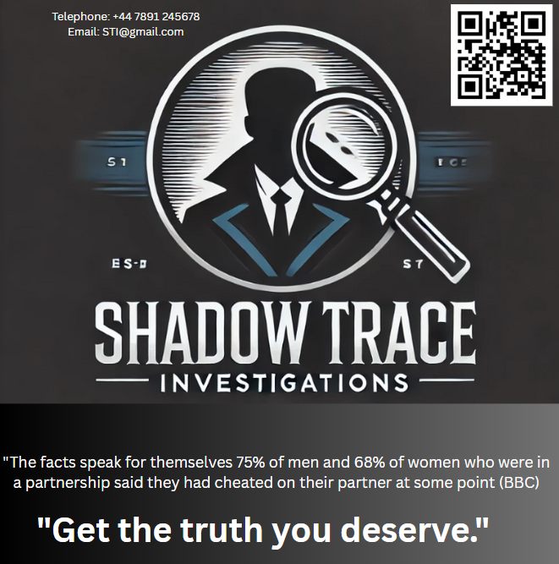
Fig.6.
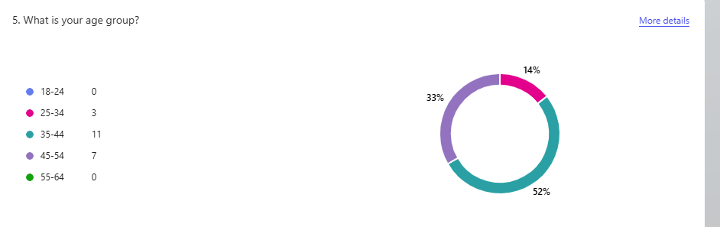
Fig.7.

Task 3. Microsoft Excel

Business is no different in this day of digital living when everything else is. Big corporations, as well as small firms, are using data to guide decisions. Microsoft Excel then becomes important. Despite years of existence, it is still the most effective tool available for organising and understanding data (Mount,2024). Learning Excel is not only useful but also necessary for business students like me.
Excel is, first, very useful for data organisation. Business is full of facts that one must constantly manage. Apart from many other things, this can include consumer names, sales figures, staff hours, and so on. Excel lets you arrange all of your data into tidy tables rather than writing everything down or using arbitrary notes. You can quickly update, filter, and organise the data (McFedries, 2022). Excel can reveal a store's information right away, for instance, which product sold the most last month.
The formulas used in Excel also contribute to its great capability. Though it has more complex formulas like VLOOKUP and IF statements (Anderson,2024), it can perform basic arithmetic such as adding and averaging. These enable individuals to accomplish chores requiring a lot of time by hand. Excel can quickly let you figure, for instance, how much profit you made following spending. This reduces errors and saves time. Still another useful tool are graphs and charts. Although reading numbers on a screen can be difficult, putting those figures into a bar graph or line chart helps people understand them. Excel has several ways to create visualisations, like trend lines, column graphs, and pie charts (Alcaraz-Martinez et al., 2024). Including an Excel chart will assist your audience in grasping your point of view, whether you are presenting a class project or a report. Excel also facilitates working with vast amounts of data. Pivot tables and other tools help to summarise data without requiring one row by one reading through. For instance, a PivotTable will let a corporation quickly compare sales in several areas (Fragale,2024). In business, this type of study is crucial since it enables businesses to identify areas needing development and what is working. The fact that Excel can save so much time is one thing I truly value. Many boring and repetitious tasks can be completed automatically. If you are tracking weekly spending, for example, Excel can do it with a formula and even update the total every time you enter fresh numbers. Excel does not require you to add them all yourself. Particularly when you work with a lot of data, this form of automation simplifies life. Excel's importance also stems from its ability to enable individuals to make wiser judgements. Choosing the correct course is simpler when data is unambiguous and understandable. Using Excel, a company may, for instance, compare two marketing initiatives to see which one attracted more business. Making such decisions can boost profitability and save money (Wild and Ortega-Gutierrez, 2024). Apart from all that, Excel is a skill that looks good on a resume. Many employment adverts, especially for entry-level roles, ask for Excel experience. Companies seek employees who can handle data, provide reports, and tackle challenges. Knowing Excel can give you an edge over other applicants, even if you are still a student (Davies and Sparkes,2024). It indicates that you consider working smart and being organised particularly important. Excel is quite adaptable as well. You need not be a major in accounting to apply for it. Management students can create budgets, HR students can arrange personnel data, and marketing students can monitor social media numbers. One instrument is used in every aspect of business. That is why our lectures keep pushing us to learn it early on and apply it in assessments. All things considered, Excel remains among the most valuable instruments available in the digital age. It facilitates data organisation, fast and accurate computation, creation of helpful graphics, and analysis of intricate material. It saves time, advances decision-making, and creates opportunities for greater employment. One of the best things business students like me can do to get ready for the real world is to get at ease with Excel.

Task 4. Video advertising

https://youtu.be/Ur9Zvb1PO2A
“Storytelling is the most powerful way to put ideas into the world” (Mckee,1997)
The video uses story-telling methods to connect with viewers on an emotional level and build suspense. A happy couple at the start of the story sets a calm and caring mood. Then there are slight changes, like the wife coming home late and being cold. These are methods of foreshadowing which make you think something is wrong and make you want to know more (Andrews,2020). People can feel the husband's pain as he starts to feel lost and hurt, which makes the story stronger. This rise in emotion is part of the rising action, which is an important part of the classic story framework (Matei and Flesch,2023). The most important part of the story is when it is revealed that she is cheating. At the same time, this moment shocks and calms down. When the movie is over, the investigation company sends a clear message about how they can help people find the truth. The video keeps people interested and sends a message they will not forget by using strong feelings, suspense, and a clear beginning, middle, and end.

References
Alcaraz-Martinez, R., Ribera, M., Roig Marcelino, J. and Pascual-Almenara, A., (2024). Can we create accessible charts with Microsoft Excel: a review of possibilities and limits, with a special focus to users with low vision. In Proceedings of the XXIV International Conference on Human Computer Interaction (pp. 1-13).

Anderson, S., (2024). Expanding data literacy to include data preparation: building a sound marketing analytics foundation. Journal of Marketing Analytics, 12(2), pp.227-234
Andrews, E., (2020). Representing visual foreshadowing in audio description (Doctoral dissertation, University of Huddersfield).

BBC. (2019) Why we need to talk about cheating.
https://www.bbc.co.uk/future/article/20190625-why-we-need-to-talk-about-cheating
(Accessed:28 March 2025)

Dadwal, S. S. (Ed.). (2020). Handbook of Research on Innovations in Technology and Marketing for the Connected Consumer. IGI Global.
Das, S. (2021). Search Engine Optimization and Marketing: A Recipe for Success in Digital Marketing (1st ed.). Chapman and Hall/CRC. https://doi.org/10.1201/9780429298509

Davies, M. and Sparkes, D., (2024). Employability Skills Development for Undergraduate Accounting Students Using a Business Simulation Game: A Case Study of the Use of Accounting BISSIM. In Developments in Business Simulation and Experiential Learning: Proceedings of the Annual ABSEL conference (Vol. 51).

Fragale, T. (2024). Getting Great Results with Excel Pivot Tables, PowerQuery and PowerPivot. John Wiley & Sons.
Mandal, P.C., (2025). Management of Marketing Information: Generation of Customer Insights with Competitive Intelligence. In Knowledge Sharing and Fostering Collaborative Business Culture (pp. 467-484). IGI Global Scientific Publishing

Matei, O. and Flesch, M., (2023). Introduction to Scriptwriting-Unveiling the Art of Storytelling: Teacher booklet. Olivier Matei & Mireille Flesch.

McFedries, P. (2022). Excel data analysis for dummies. 5th ed. Hoboken, New Jersey: John Wiley & Sons, Inc.
McKee, R. (1997). Story: Substance, Structure, Style and the Principles of Screenwriting. HarperCollins.
Mohammadi, H., Mohammadalipour, N., et al. (2024).
A Model for Implementing New FinTechs in the Banking Industry.
Journal of Value Creating for Banking and Management. https://www.jvcbm.ir/article_195932.html
Mordor Intelligence. (2025). China Video Surveillance Market Size & Share Analysis - Growth Trends & Forecasts (2025 - 2030).
Source: https://www.mordorintelligence.com/industry-reports/china-video-surveillance-market (Accessed:28 March 2025)

Mount, G. (2024). Modern Data Analytics in Excel: Using Power Query, Power Pivot, and More for Enhanced Data Analytics. " O'Reilly Media, Inc.".

Ok, E. (2024). Attaining Branding Excellence in the Digital Era through Strategic Search Engine Optimization.
Park, S. (2020). Marketing management (Vol. 3). Seohee Academy.

Tijjang, B., Junaidi, J., Nurfadhilah, N. and Putra, P., (2023). The role of brand love, trust, and commitment in fostering consumer satisfaction and loyalty. FWU Journal of Social Sciences, 17(1).

Wild Ali, M.M. and Ortega-Gutierrez, J., (2025). Digital Marketing: Strategies, Challenges, and Opportunities in the Digital Technology. Global Journal of Economics and Business, 15(1), pp.40-52.

World Population Review. (2025). Infidelity Rates by Country 2025.
https://worldpopulationreview.com/country-rankings/infidelity-rates-by-country

Wuisan, D.S. and Handra, T. (2023). Maximizing online marketing strategy with digital advertising. Startupreneur Business Digital (SABDA Journal)
Vilcol. (2025).
https://vilcol.com/uk-private-investigator-service#:~:text=Award%2DWinning%20UK%20Private%20Investigators,Beneficiary%20traces

