Task 1: Locating Sources
Identify and locate three different sources (a report, a journal article, and a website) related to the question
“What employability skills do university graduates need to succeed in the workplace?”
Show how you used keywords, search terms, and Boolean operators to find them, and explain how you know which type of source each one is and why it is appropriate for the research question.

Source Type & Why It Is Appropriate | URL/DOI | What search engine did you use? Google/Online Library/Library AI Assistant | Keywords/Boolean Operators Used
Source Type & Why It Is Appropriate
Article its appropriate because it is discussing employability skills amongst business students | ISSN;2249-9040 | Online library | Employability skills  Graduates  Succeed  workplace

Task 2: Evaluating Information (CRAAP Test)
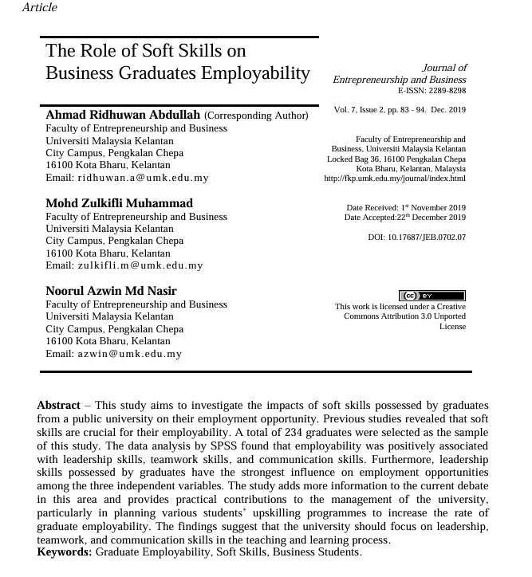
Your colleague has forwarded you a source from a peer reviewed journal, and they are not sure whether it is appropriate to use and has asked for your help. Your task is to evaluate the source by using the CRAAP Test to assess its appropriateness for the following question “What employability skills do business university graduates need to succeed in the workplace?”

CRAAP Test
Currency | NOT CURRENT AS IT WAS PUBLISHED IN 2019 NOT IN THE LAST 5 YEARS
Relevance | IT IS RELEVENT AS ITS DISCUSSING THE UNIVERISITY SHOULD FOCUS ON LEADERSHIP TEAMWORK AND COMMUNICATION SKILLS WHICH IS WHAT WILL HELP GRADUATES SUCCEED IN THE WORKPLACE
Authority | AHMAD RIDHUWAN ABDULLAH  MOHD ZULKIFLI MUHAMMAD  NOORUL AZWIN MD NASIR
Accuracy | ITS ACCURATE AS IT HAS A DOI NUMBER BUT THERE IS ALSO NO REFERNENCES
Purpose | THE PURPOSE OF THIS ARTICLE IS TO INVESTIGATE THE IMPACT OF SOFT SKILLS POSSESSED BY GRADUATES FROM A PUBLIC UNIVERISTY ON THEIR EMPLOYMENT OPPORTUNITIES
Task 3: Source Analysis
Your manager has provided you with a short extract from a source and has asked you to analyse the source by Identifying one strength, one weakness, and providing a brief explanation of the strength and weakness identified.
If you want to read the article online, please click the following link: https://www.universitiesuk.ac.uk/latest/news/strong-demand-graduates-employers

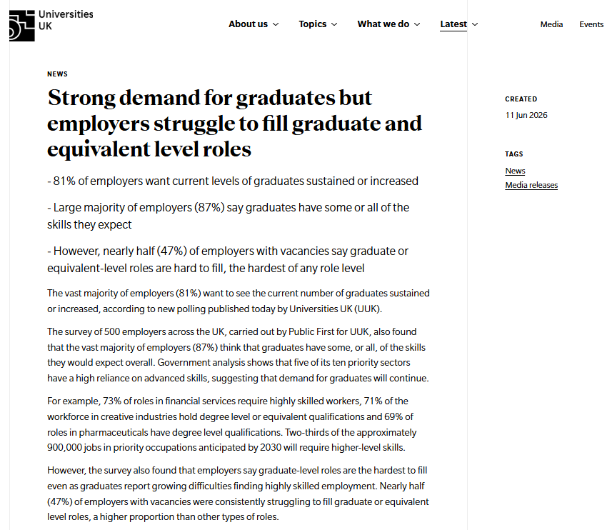
.

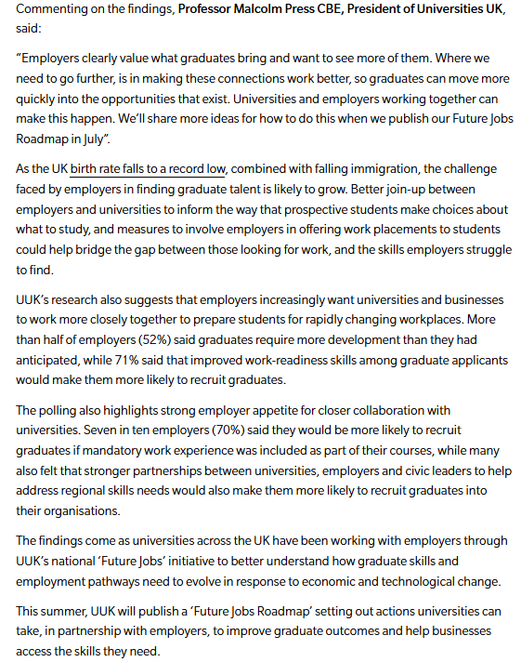

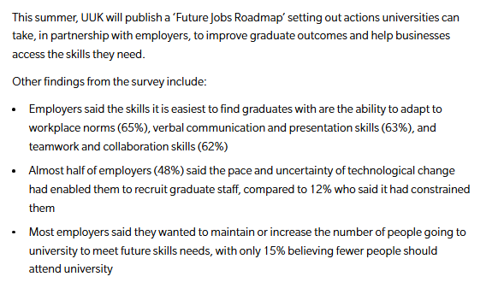

Strength of the Source:

THERE ARE LOTS OF STATISTICS AND THERE IS A PROFFESSOR WHO HAS COMMENTED ON THESE FINDINGS
THE ARTICLE IS CURRENT AS IT WAS MADE IN 2026

Weakness of the Source:

THERE ARE NO REFERENCES TO HELP IDENTIFY THE ACCURACY OF THE SOURCE
THERE WAS A SURVEY COMPLETED BUT THAT COULD BE BIASED DEPENDING ON WHO COMPLETED IT

