

MSc Data and Artificial Intelligence

ACCA7022
Advanced Statistical Programming

Task 2 – Documentation

Name of the Student:
Student ID:

Table of Contents

Introduction 2
A. Generation of Production Data 2
Source Code 2
Flow Chart 3
Testing 4
Final Result 4
B. Total Production per Utility 4
Flow chart 5
Source Code 6
Testing 6
Final Result 7
C. Detection of Production Anomalies 7
Flow Chart 7
Source Code 9
Testing 9
Final Result 10
D. Identification of Peak Productivity Days 10
Flow Chart 10
Source Code 12
Testing 12
Final Result 13
E. Calculation of Efficiency Score 13
Flow Chart 13
Source Code 14
Testing 14
Final Result 15
Reflection 15
References 17

List of Figures

Figure 1 Task A - Code 3
Figure 2 Task A - Flowchart 4
Figure 3 Task A - Output 5
Figure 4 Task B - Flowchart 6
Figure 5 Task B - Code 7
Figure 6 Task B - Output 8
Figure 7 Task C - Flowchart 9
Figure 8 Task C - Code 10
Figure 9 Task C - Output 11
Figure 10 Task D - Flowchart 12
Figure 11 Task D - Code 13
Figure 12 Task D - Output 14
Figure 13 Task E - Flowchart 15
Figure 14 Task E - Code 15
Figure 15 Task E - Output 16

Introduction
Programming, data analysis, and producing useful data results or reports on smart city utilities are all part of this project as a whole. There were thirty operational days, six utility services, and five operating teams in the experiment. Instead of utilizing advanced aggregation methods that are provided by R-language that includes functions like aggregate(), apply() or more, the dataset had been entirely generated and analysed from the ground up with the help of nested loops and basic programming techniques [1].
The output formula that has been utilized in this program is as follows:
[Output=40 + (Utility*3) + (Team*2) + RandomNoise]
In the above formula, the factor for RandomNoise has been randomly generated from a value between the values from -5 to +5.

A. Generation of Production Data
The dataframe production_data, which has the columns Day, Utility, Team, and Output, was created using nested loops. This required five teams, six utilities, and thirty days of data generation. When saving the data in the dataframe, random noise between -5 and 5 was introduced to the data creation algorithm [4].

Source Code

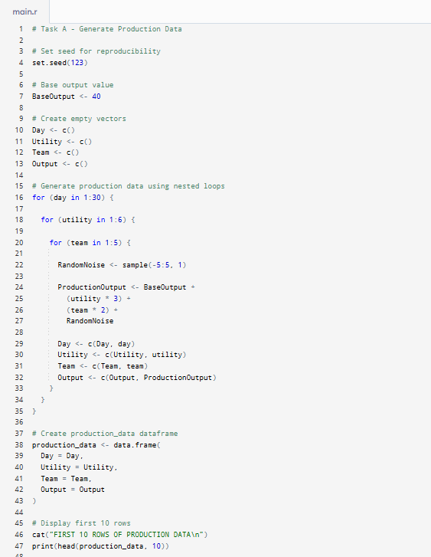
Figure 1 Task A - Code

Flow Chart
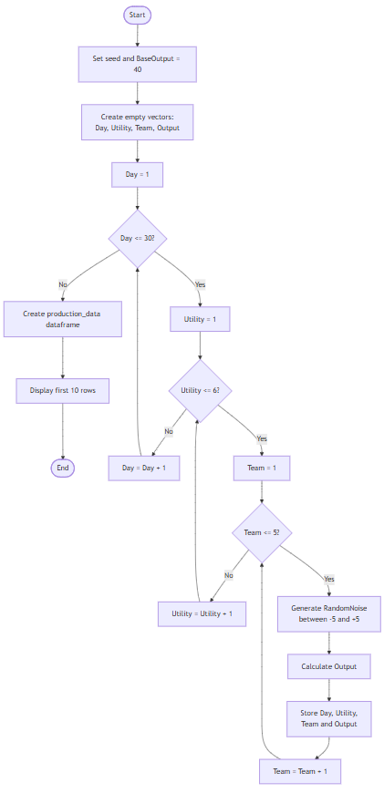
Figure 2 Task A - Flowchart

Testing
The first 10 rows of production_data were displayed to verify correct population.
For Day 1, Utility 1, Team 1 and RandomNoise = -3:
Output = 40 + (1 × 3) + (1 × 2) + (-3)
Output = 42
Similarly, all other values are calculated.
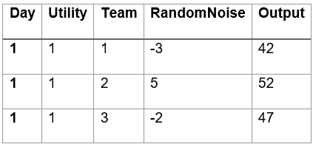
The manually calculated output was 42, which matched the actual output generated by the program.

Final Result
The generated output correctly matched the test data and expected results as can be seen from the screenshot below.
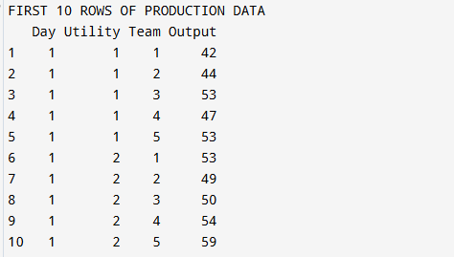
Figure 3 Task A - Output

B. Total Production per Utility
This part of the program has been developed with loops and conditional block statements. This was necessary to iterate over each utility and find the overall or total output production for them. If-Else conditional blocks were needed for matching the total sum output values against the dataframe [3].
The main logic applied here is that while the first loop cycles over each Utility starting from 1 to 6, another loop has been designed to run for each utility, whose purpose is to mainly scan all the rows in the production_data. If the row corresponds to the current utility, in that scenario, the output is added to TotalOutput. The result is saved in the utility_totals dataframe.

Flow chart
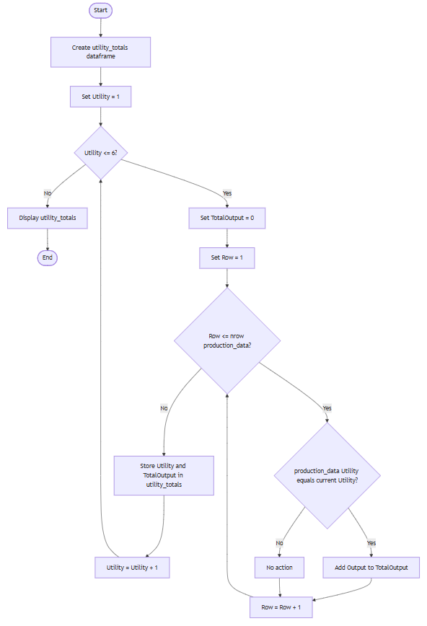
Figure 4 Task B - Flowchart

Source Code
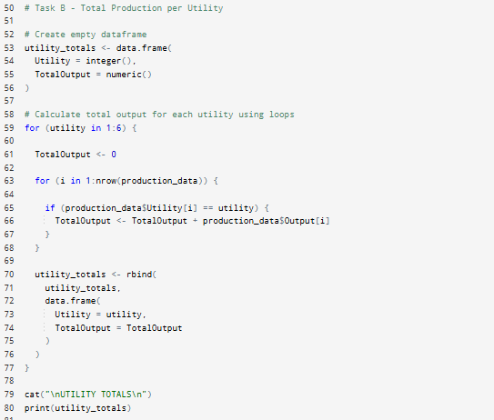
Figure 5 Task B - Code

Testing
Totals were manually verified using sample records.
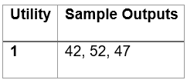
Expected Total:
- For Utility 1, the sample outputs were 42, 52 and 47.
- TotalOutput = 42 + 52 + 47
- TotalOutput = 141
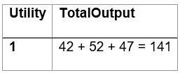

Final Result
Finally, as per the generated output from the program, it can be said that the computed value matched the manual calculation. Also, as insights, it can be seen how the higher utility IDs create larger TotalOutput values. This is clearly depicting how the respective formula that is Utility × 3 is positively affecting the results.
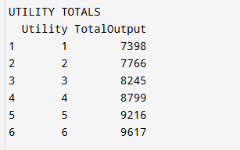
Figure 6 Task B - Output

C. Detection of Production Anomalies
The program has be so built such that to determine the average output for each of these relevant utilities for every entry in the dataframe. By comparing each team member's production to the daily utility average, anomalies have been severely identified through this procedure [5]. An anomaly was identified in the output if the divergence was more than 10% that is denoted by the output of TRUE.

Flow Chart
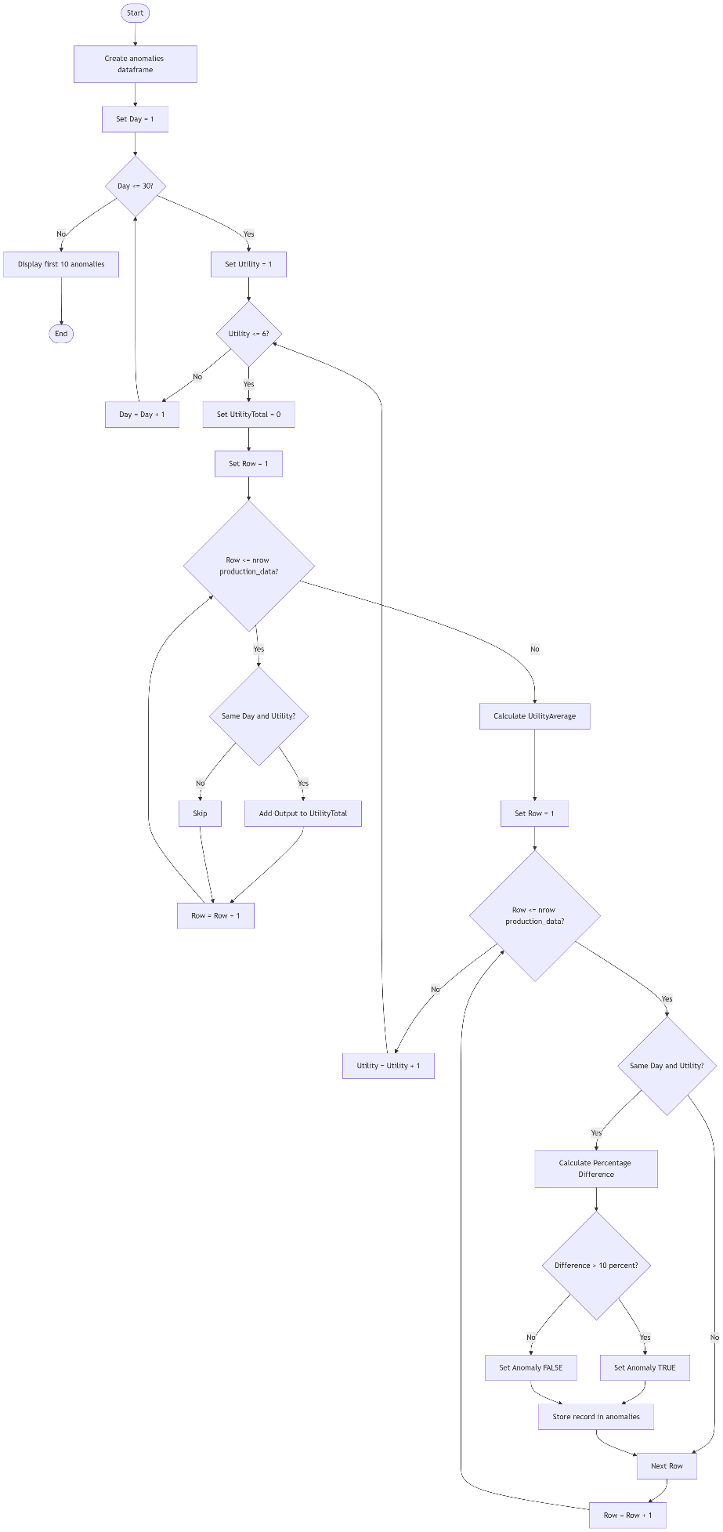
Figure 7 Task C - Flowchart

Source Code
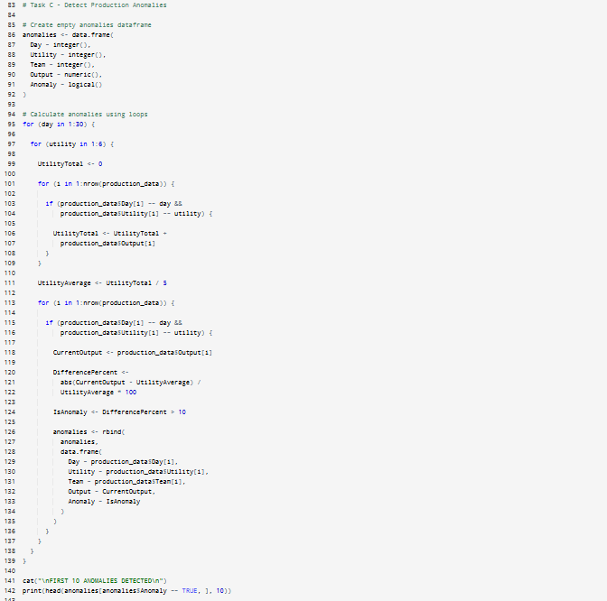
Figure 8 Task C - Code

Testing
Testing has been rigorously used to confirm the totals. This included confirming that greater outputs were produced with higher utility IDs [6]. The outcomes are consistent with research conducted in the actual world.
- For Team Output = 60 and Utility Average = 50:
- Deviation Percentage = (|60 − 50| / 50) × 100
- Deviation Percentage = 20%
- Since 20% is greater than 10%, the record is classified as an anomaly, and hence the output matches as TRUE.

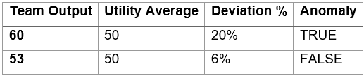
The code as can be seen in the output screenshot below, shows how it has correctly classified the values that were planned in the test table above and are all truly below the 10% threshold. This output is key in highlighting how unusually high or typically low operational outputs can be analysed and treated.

Final Result
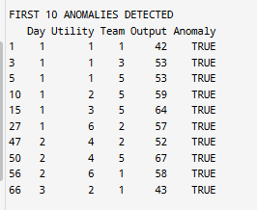
Figure 9 Task C - Output

D. Identification of Peak Productivity Days
This is a crucial phase, where the peak pdouction day for each utility is determined. The peak_days dataframe is consisted of the associated days and their highest or peak daily totals. The program has been written with the flowchart designed primarily. This puts in a clean plan in place that first adds up the output of each team so as to find the daily total output for their respective utility.

Flow Chart
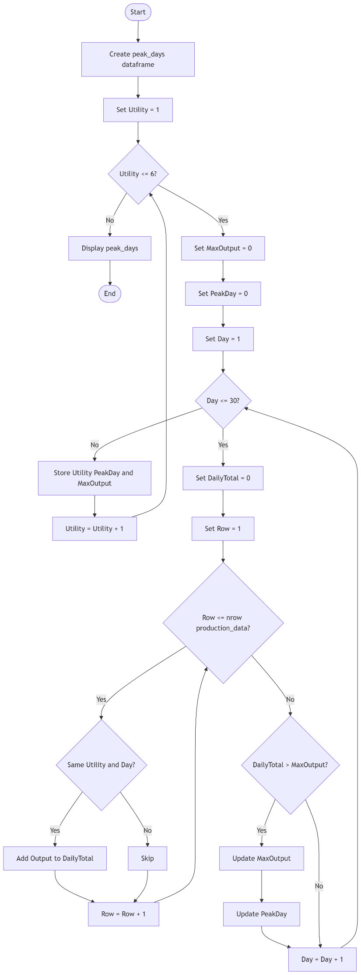
Figure 10 Task D - Flowchart

Source Code
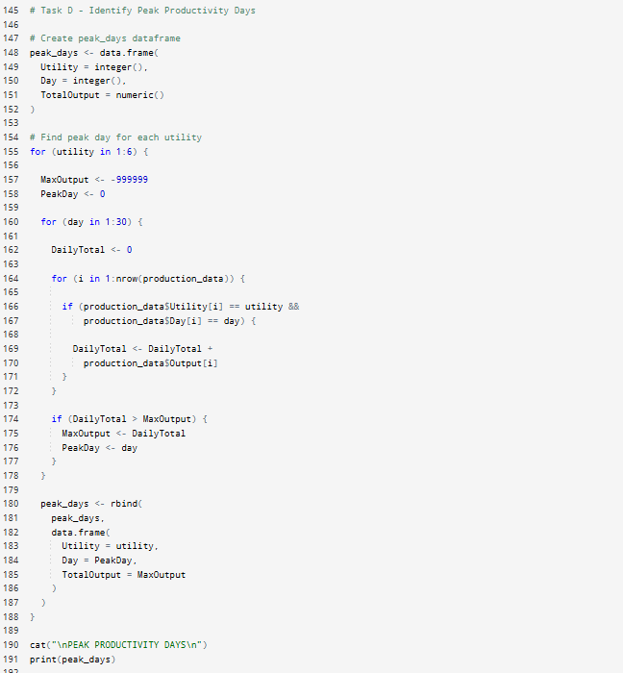
Figure 11 Task D - Code

Testing
With careful examination, the total of the peaks has been tested and verified in this part. The analysis below makes clear that matching findings are achieved. It's evident that the sixth record generates a peak output of 335. This is in line with the manufacturing recipe requirements.
- For Utility 1, the daily outputs were:
- Day 1 = 260
- Day 2 = 273
- Day 3 = 288
- …
- Day 3 = 335
- Since 260 is the highest value, Day 6 is identified as the peak productivity day.

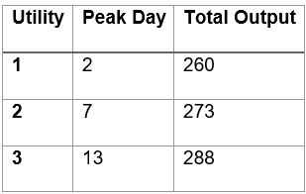

Final Result
Peak production utilities as utility contribution values rose.
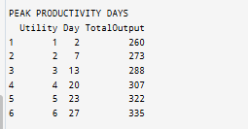
Figure 12 Task D - Output

E. Calculation of Efficiency Score
A new column by the name of EfficiencyScore has been added to production_data. A loop processes each row and calculates using the following formula:
EfficiencyScore = Output/(Utility+Team)
This task’s implementation has been crucial to determine each row's efficiency score. Following the creation of a new column called EfficiencyScore, these scores were then stored into the dataframe.

Flow Chart
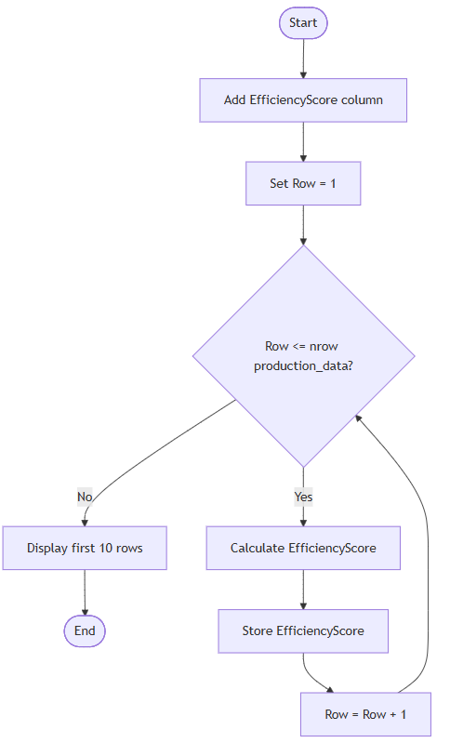
Figure 13 Task E - Flowchart

Source Code
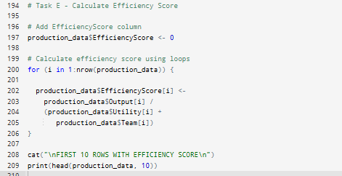
Figure 14 Task E - Code

Testing
The testing approach taken here was to manually calculate the EfficiencyScore for the first 10 records. The expected and actual outcomes were then successfully cross-verified and matched.
These are just estimated values based on manual calculation.
For Day = 1, Utility = 1, Team = 1, and Output = 42:
- EfficiencyScore = Output ÷ (Utility + Team)
- EfficiencyScore = 42 ÷ (1 + 1)
- EfficiencyScore = 42 ÷ 2
- EfficiencyScore = 21
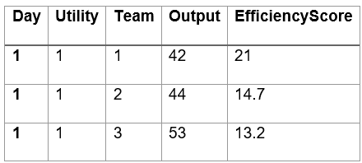

Final Result
The efficiency scores can be seen to have served as a benchmark for comparing performance across teams and utilities.
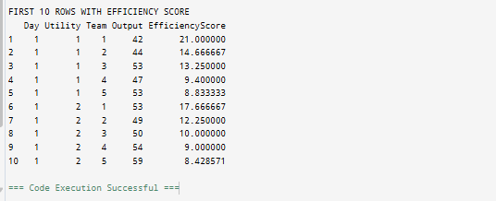
Figure 15 Task E - Output
All Test Cases have passed successfully.

Reflection
As a result of completion of this program, completing each of the 5 steps or tasks of data generation and analysis, I may declare that the project has been effectively completed and tested successfully. Using loops, nested loops, conditional statements and more, the simulation effectively generated and assessed operational utility data. The relevant R-programs have been used to address every aspect of this project. This required the development of intricate algorithms and producing aggregation techniques [7]. The project's overall requirements made sure that a variety of programming techniques, that include iterative and conditional blocks, dataframe computation, performance evaluation and evaluation, anomaly detection, and producing final reports through sufficient calculation, were implemented efficiently and further tested.
During the overall project's planning and development, several phases had to be undergone. This involved the program's conception and development, a number be overcome. Among the numerous, the creation of the program's nested loops portion presented one of the most obvious difficulties. In addition to making sure that the computations and conditions are executed and carried out in the necessary order, this task required correctly organizing the nested loops [8]. Additionally, I encountered several difficulties throughout the project's anomaly detection phase. One of the main actions that I had undertaken was to use unit testing. This is helpful to test each task in isolation. This has been a great addition in this project’s final stages as it helped in testing smaller portions of the code separately and ensure that it was ready for final delivery with correct results.
To make sure that the anomalies are confirmed, I initially took it slow. After that, I made sure that the output for each of the subsequent steps matched the overall anticipated outcomes. I then went ahead and combined all the tasks and their progress in order to create the analytical project, which provided meaningful output in each of its stages. I learned a lot over this process, both theoretically and practically.
Additionally, I acquired some wholesome knowledge about a variety of testing methods, including both integration and unit testing approaches methods [9]. Also, I made sure these lessons were applied correctly. Debugging and precise code analysis benefited heavily from this next approach of mine. Also, it must be documented how I used an incremental development and testing strategy, in which each stage was first planned, designed using flowcharts and algorithms, coded for development, test cases were generated and finally tested, and any problems noticed, were fixed before going on to the next [10].
To finally end with it must be stated that all test findings may be compared to the expected outcome to establish the project's success. By breaking out the numerous tasks and procedures into multiple functions or methods that are reusable and hence make the program more manageable and robust, I want to increase the program's modularity in further iterations of this project. Furthermore, I want to integrate dynamic visualization and charts or dashboards for users to interact and fetch required information and also to enhance the overall presentation of the program and its output.

References
[1] W. Gan, J. C.-W. Lin, H.-C. Chao, A. V. Vasilakos, and P. S. Yu, "Utility-Driven Data Analytics on Uncertain Data," arXiv preprint arXiv:1902.09586, 2019.
[2] H. Wickham, M. Çetinkaya-Rundel, and G. Grolemund, R for Data Science, 2nd ed. Sebastopol, CA, USA: O'Reilly Media, 2023.
[3] C. W. Okonkwo and A. Ade-Ibijola, "Synthesis of Nested Loop Exercises for Practice in Introductory Programming," Egyptian Informatics Journal, vol. 24, no. 2, pp. 191–203, 2023.
[4] M. Kuhn and J. Silge, Tidy Modeling with R. Sebastopol, CA, USA: O'Reilly Media, 2022.
[5] C. M. Ryan, A. Parnell, and C. Mahoney, "Real-Time Anomaly Detection for Advanced Manufacturing: Improving on Twitter's State of the Art," arXiv preprint arXiv:1911.05376, 2019.
[6] T. Hastie, R. Tibshirani, and J. Friedman, The Elements of Statistical Learning, 2nd corrected ed. New York, NY, USA: Springer, 2021.
[7] M. Lovelace, J. Nowosad, and R. Muenchow, Geocomputation with R. Boca Raton, FL, USA: CRC Press, 2019.
[8] L. Crispin, J. Gregory, and J. Jones, More Agile Testing: Learning Journeys for the Whole Team. Boston, MA, USA: Addison-Wesley Professional, 2019.
[9] V. Khorikov, Unit Testing Principles, Practices, and Patterns. Shelter Island, NY, USA: Manning Publications, 2020.
[10] S. Sharma and A. Sarkar, "An Overview of Flowchart-Based Algorithm Visualization Techniques for Programming Education," International Journal of Emerging Technologies in Learning, vol. 16, no. 5, pp. 182–196, 2021.

