Supichchaya Kongyim
2406077
Network operating system and services
ACCA5023
Research, build and deploy a virtualised enterprise network

Task 1- research report
this report will centre on designing and developing a virtualised enterprise network for an organisation that operates across two locations: Swansea and London. It needs a secure and scalable network that can support communication between both sites, allow resource sharing and provide management ability for users and services, creating the environment will need a careful planning of IP addresses, routing, network services and security within a virtualised setup.
This report will combine research with practical implementation. Academic and industry sources are used to evaluate hypervisor types, IP addressing structures, routing methods and core services such as active directory and DHCP. These will guide the decisions made during the practical set up, including the configuration of windows server and Debian systems within a virtual environment.
The topology created in this coursework is not just a one-time setup but a foundation for further development in coursework 2. The network will later be expanded with additional services and configuration, followed a structured approach like real work enterprise network development. In this report will outlines the purpose and long-term importance of the virtualised enterprise network designed for this scenario.

Hypervisor
Hypervisor is a software layer that allows multiple virtual machines to run on a single physical computer. It manages how hardware resources such as CPU, memory and storage are shared between different operating systems, making it possible to run systems like windows server and Debian at the same time.[1] A hypervisor allows testing, development and network simulation without needing separate physical machines.
There are two types of hypervisors:
Type 1 hypervisors sit directly on the hardware and manage virtual machines without needing a host operating system. which gives them stronger isolation and better performance under heavy workloads as they do not rely on a host OS[1][2]. However, they also reduce the overall attack surface which can improve security in enterprise environments. Whereas, type 2 hypervisors run on tip of an existing operating system, so they benefit some performance overhead from the host. The down upper side is that they are much easier to install, configure and manager for day-to-day use[1]. In practise type 1 are more common in enterprise data centres where efficiency, stability and security are priorities. While type 2 are often used for learning, development and testing where flexibility and convenience needed more than maximum performance.
we are using type 2 to setup as everything is being built on a single physical machine with limited RAM and CPU resources and the goal is to setup a small enterprise network rather than creating a real server system. Although a type 1 hypervisor would be more suitable in a real corporate setting, implementing it on personal hardware would take up a lot of space and reduce flexibility. A type 2 is better suited for this task because it allows students to set it up in lab or personal device without taking huge amounts of space. Plus, it allows quick reconfiguration, simpler troubleshooting and easier integration with the host operating system.[2]
I chose to work on VMware workstation for this coursework because it easy to navigate, provides stable performance, plus it allows the creation of multi-subnet lab environments. Its snapshot functionality is super useful when performing task and evidence for the coursework.

IP addressing
Role of ip address
Ip address is fundamental to how data is transported across interconnected networks. [3]When information is sent, it is divided into packets that contain both a source and destination ip address.[3] These addresses allow routers to determine the correct path, particularly when traffic moves between separate networks like Swansea and London. While switches manage communication within a single local network, routers operate across different subnets and ensure that packets reach the correct remote destination. Without a structured addressing, communication between sites would be unreliable and difficult to manage.
IPv4 and IPv6 in network
IPv4 and IPv6 represent two different addressing formats. IPv4 uses a 32-bit structure, which limits the number of available addresses and has led to address exhaustion over time. [3]This is when IPv6 are introduced, it increases to 128 bits, providing a much larger address space and supporting future network growth.[4] Even though IPv6 solves the limitations issue, IPv4 are widely used in enterprise labs and educational environments, this is because it simpler to configure and fully compatible with most systems. This is important when designing networks that may need to scale or connect with more modern frameworks in the future.
Subnetting and topologies
Subnetting helps organise a network by providing a larger address range into smaller more manageable segments.[5] This reduces unnecessary traffic, improves overall performance and adds a layer of separation between groups of devices. In a multi-site topology, subnetting allows Swansea and London server to function as distinct networks while still supporting controlled communication between them. it is important to have a well-planned addressing structure as it will be easier to manages the network, more scalable and expansion.
Routing
Routing controls how traffic moves between different networks. Static routing required a manual configuration, giving the administrator full control over traffic paths. [6]Dynamic routing, on the other hand, uses protocols such as OSPF to automatically exchange routing information between routers. [6]
In our coursework topology, routing is needed to allow communication between the Swansea and London networks. However, the environment is small and contains only a limited number of subnets with predictable traffic flows. Static routing provides a simpler and more controlled solution, making troubleshooting easier during deployment.
Network services
Enterprise networks depend on core services to maintain security, control and reliability. A virtual private network enables encrypted communication between sites, ensuring that data exchanged between locations such as Swansea and London remains protected.[7] In real world environments, VPNs are essential when extending services across networks.
Dynamic host configuration protocol improves efficiency by automatically assigning IP addresses to devices, reducing configuration errors and preventing address conflicts. [8]This strengthens security and simplifies network administration.
Task 2
2.1 hypervisor selection
VMware workstation was selected as the hypervisor for building the virtual network. The entire setup was done on a single physical machine with limited RAM and CPU resources, so virtual machines had to be configured carefully to avoid performance issues. VMware provides a stable and flexible environment that support both windows server 2022 and Debian without compatibility problems, while also offering detailed virtual networking options needed for a multi-site topology. The snapshot in a coursework environment, allows me to show the configuration I did. Although Type 1 hypervisors are more common in production enterprise infrastructures, VMware Workstation provides the right balance of control, performance and simplicity for this simulated network and allows the topology to be extended further in Coursework 2.

2.2 installtion

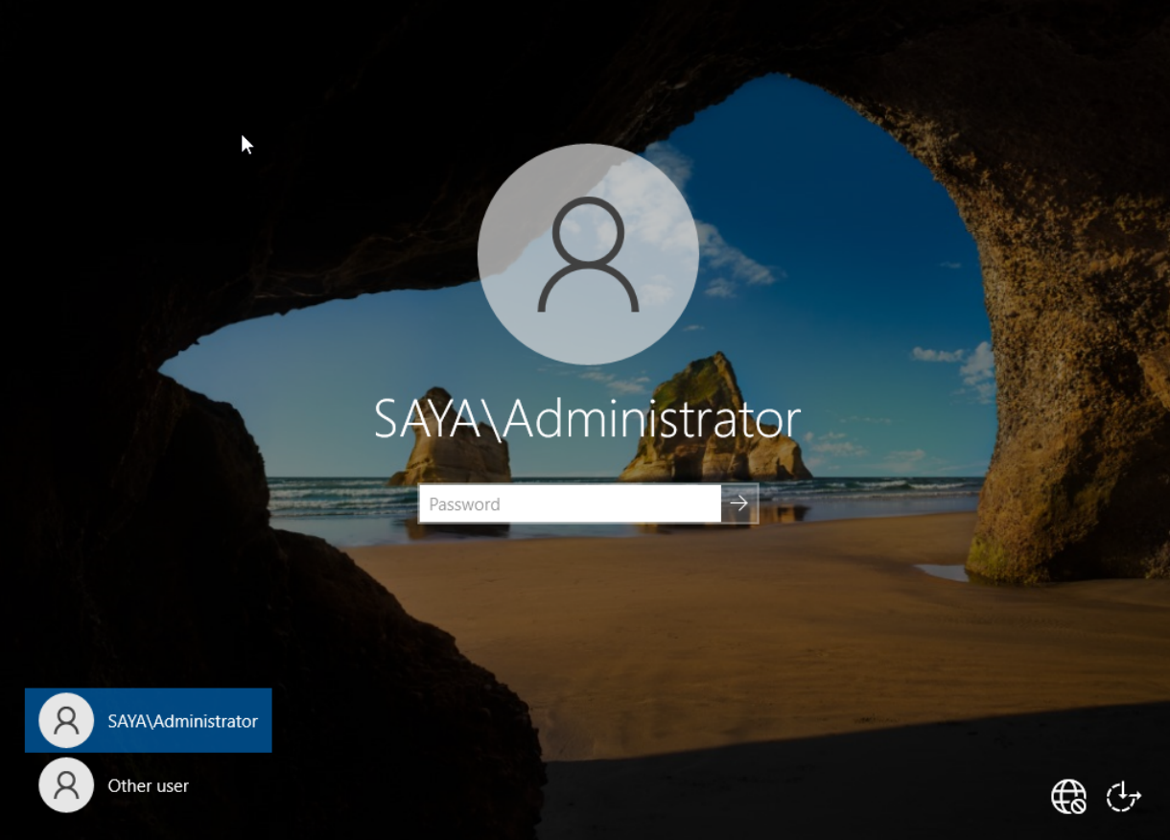
The installation for windows server 2022, window and Debian 12 were downloaded. The ISO files were stored locally and attached to each VM during setup. Using official installation images ensures system compatibility and reduces the risk of corrupted or unsupported configurations.

2.3Virtual network deployment
Virtual machines were created using VMware Workstation to simulate the two-site network environment for Swansea and London. The server virtual machines were allocated 4GB of RAM and 4 virtual processors to ensure they could reliably run services such as Active Directory, DNS and routing without performance issues. This setup provides a good balance between performance and the hardware limitations of the host system.
The client machines were configured with 2GB of RAM because they do not host core services and require fewer system resources. This reflects a more realistic enterprise setup, where infrastructure servers are allocated more resources than end-user devices.
Custom virtual network adapters were used to represent separate network segments for each site. VMnet2 and VMnet3 were configured to simulate the Swansea and London networks, allowing each site to operate within its own subnet while still enabling controlled communication between them. This approach supports a structured multi-site topology within the virtual lab environment.
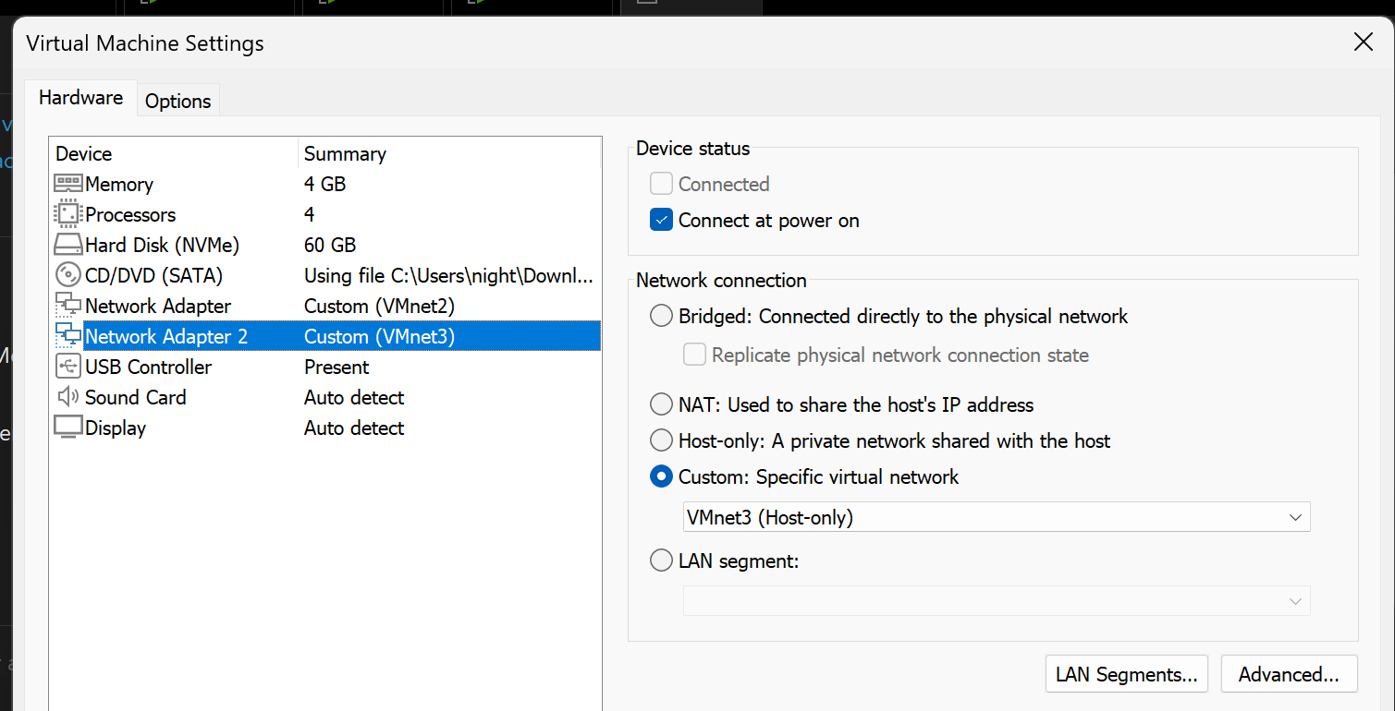
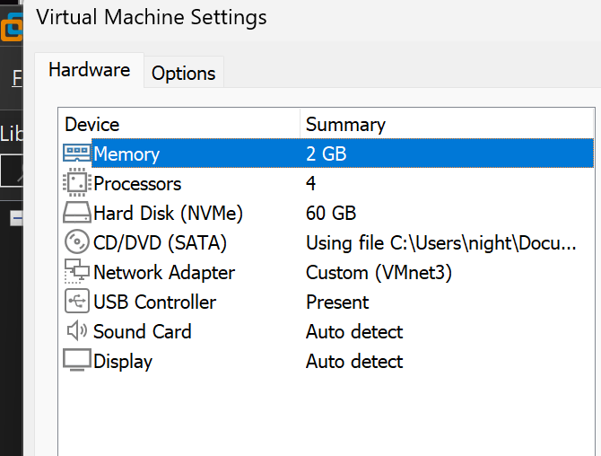
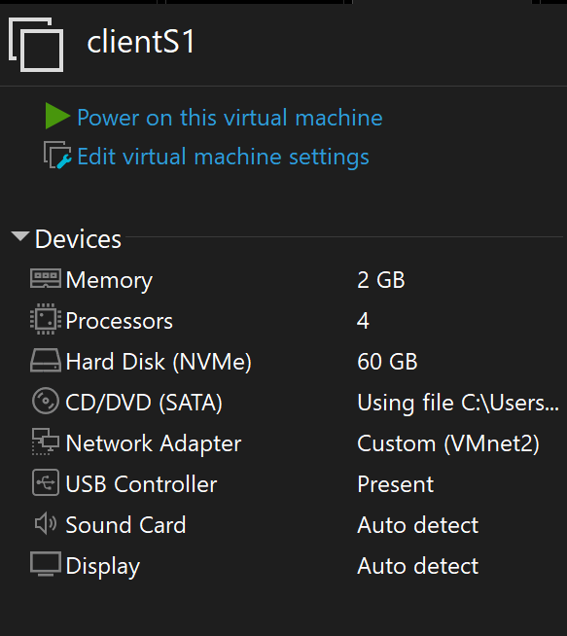
2.4 ip address configuration
2.4.1 Swansea domain
The Swansea Domain Controller (S-DC) was configured with a static IPv4 address to ensure consistent network identification. A static configuration is essential for servers providing services such as Active Directory and DNS, as dynamic addressing could disrupt domain communication. The subnet mask defines the local network boundary, while the default gateway enables communication beyond the local subnet. DNS was configured to reference the domain controller itself to support internal name resolution.[9]
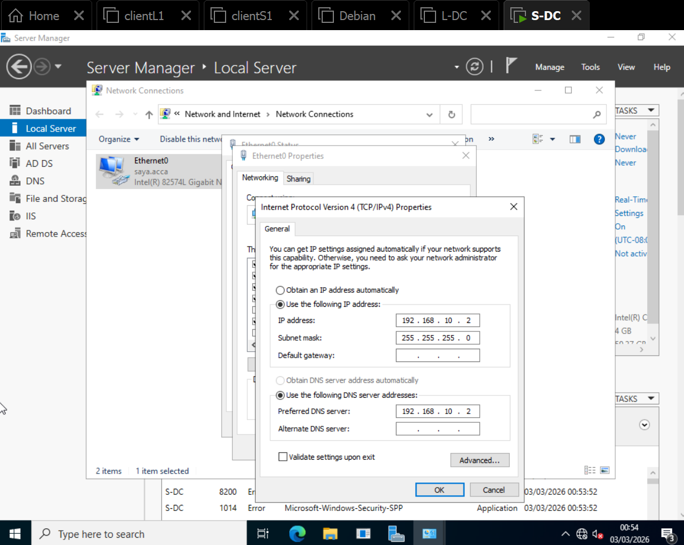

2.4.2 london domain
The London Domain Controller (L-DC) was configured with a static IPv4 address within the 192.168.20.0/24 subnet. The default gateway (192.168.20.1) allows traffic to be routed outside the local London network, enabling communication with the Swansea site. The DNS server was configured to reference the Swansea domain controller (192.168.10.2) to ensure centralised name resolution and domain consistency across both sites
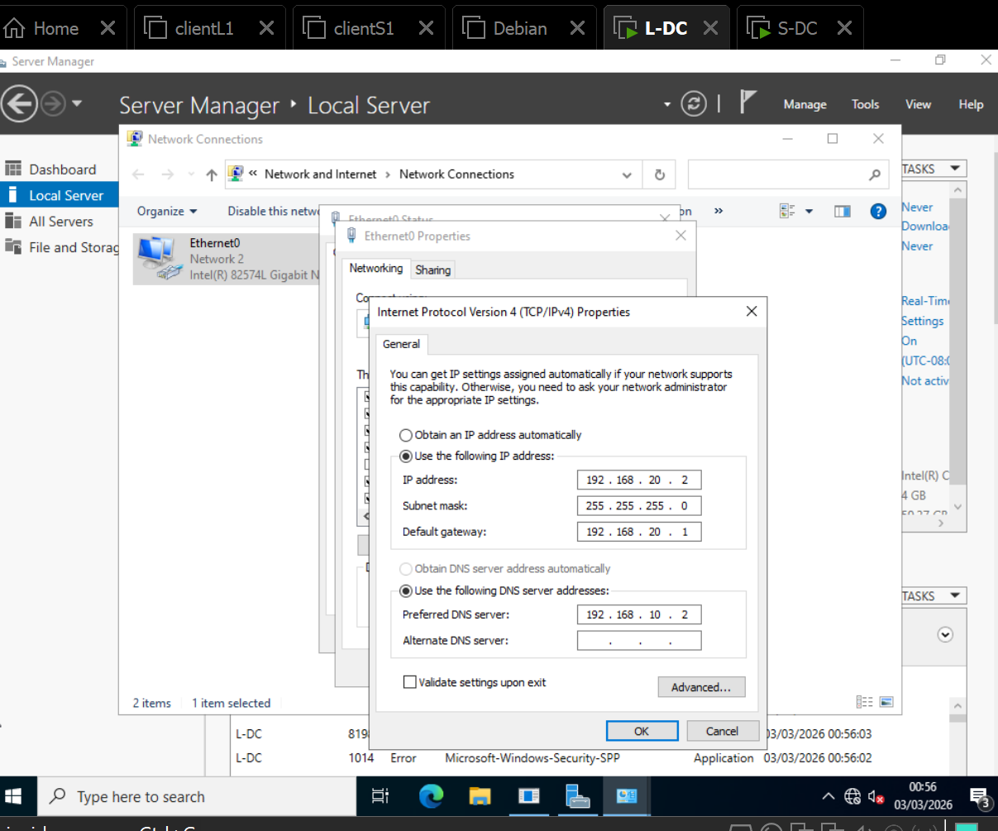

2.4.3 London client
The London client was configured with a static IP address (192.168.20.10) within the 192.168.20.0/24 subnet. This ensures stable connectivity for domain testing. The DNS server was set to the London Domain Controller (192.168.20.2) allowing the client to communicate with the domain and resolve internal network resources correctly.
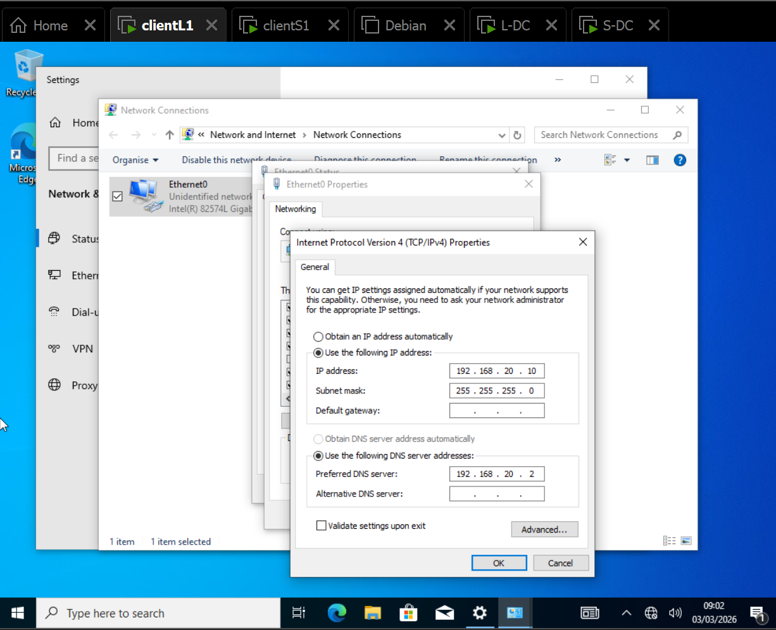

2.4.4 Swansea client
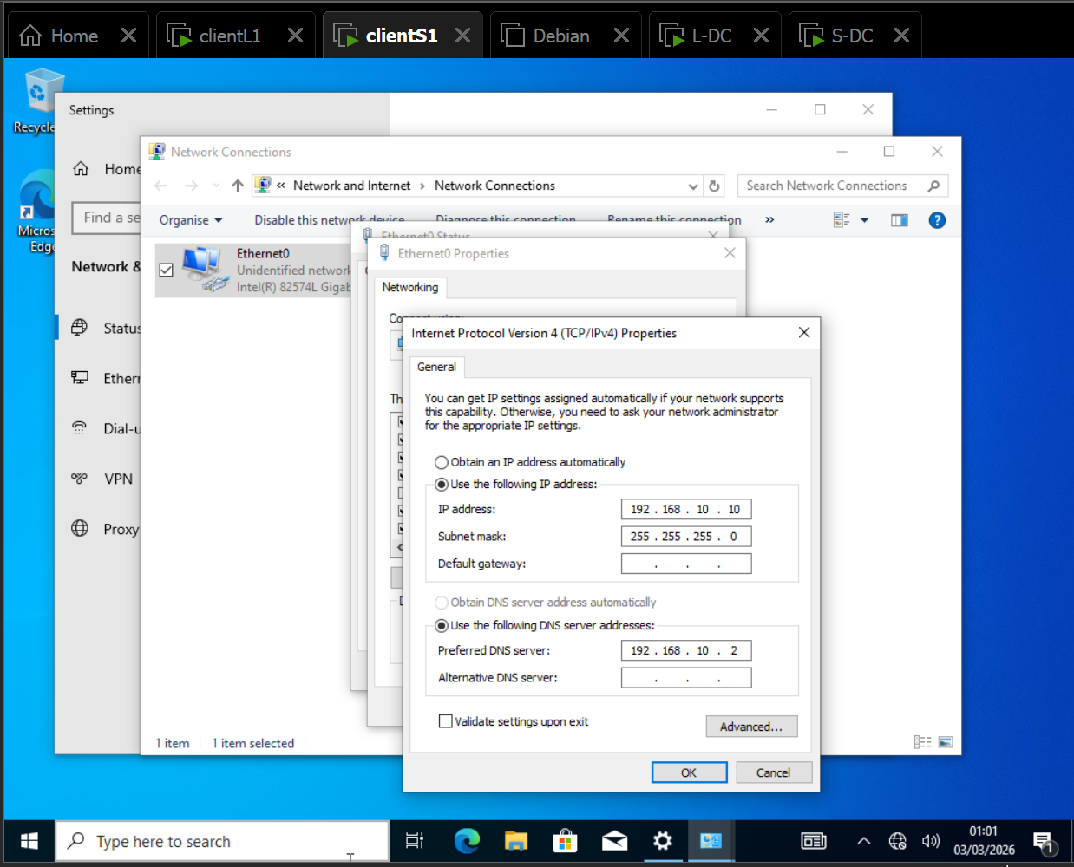

2.4.5 s-dc ping test to clientS1
To verify connectivity between devices, ping tests were performed from the Swansea Domain Controller (S-DC) to the Swansea client (192.168.10.10) The results show successful replies with 0% packet loss, confirming correct IP configuration and network communication within the subnet. The ipconfig command was also used to verify that the assigned IP address, subnet mask, and DNS settings were correctly applied.
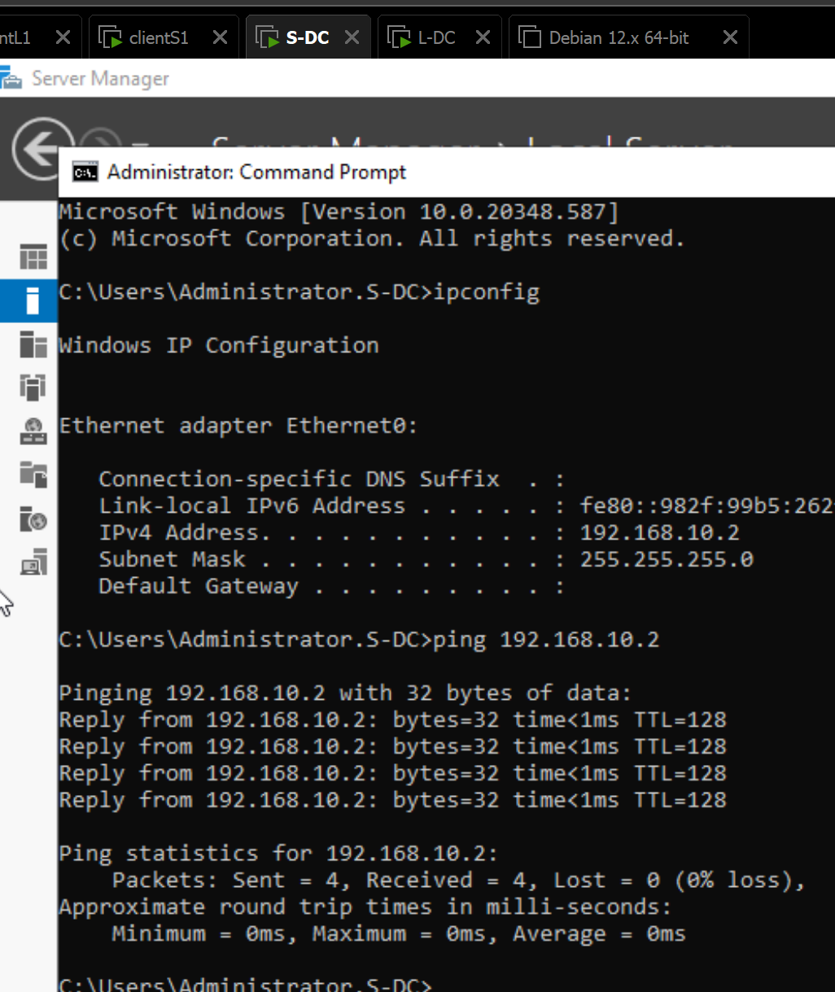
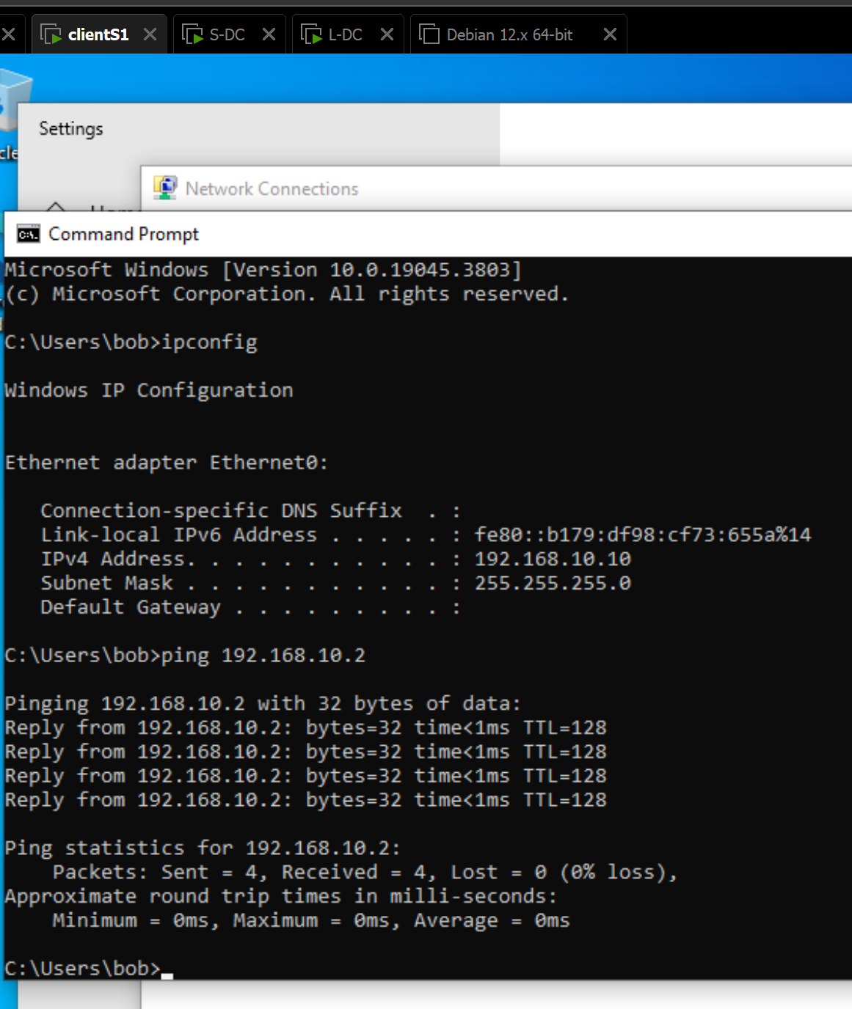
London ping & troubleshooting
Connectivity testing was performed within the London subnet using the ping command. Initial ping attempts from the London Domain Controller to the London client resulted in 100% packet loss, indicating a connectivity issue. The ipconfig command was used to verify that the IP configuration was correct and within the 192.168.20.0/24 subnet.
Further investigation identified that the Windows Firewall was blocking ICMP traffic[10]. A firewall rule was created to allow inbound ICMPv4 requests, enabling ping responses. [10][11]After applying the rule, subsequent ping tests were successful with 0% packet loss. This confirms that network connectivity within the London site was correctly restored.
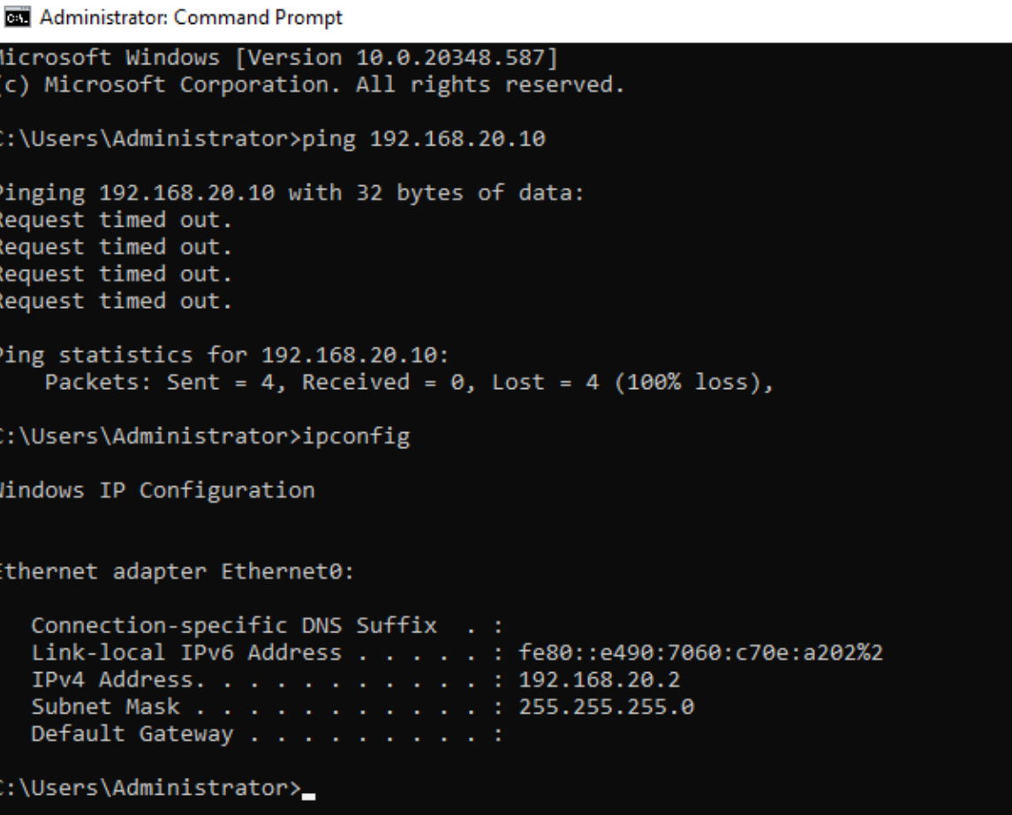
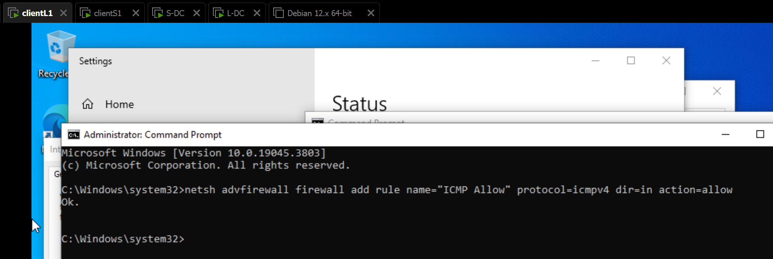
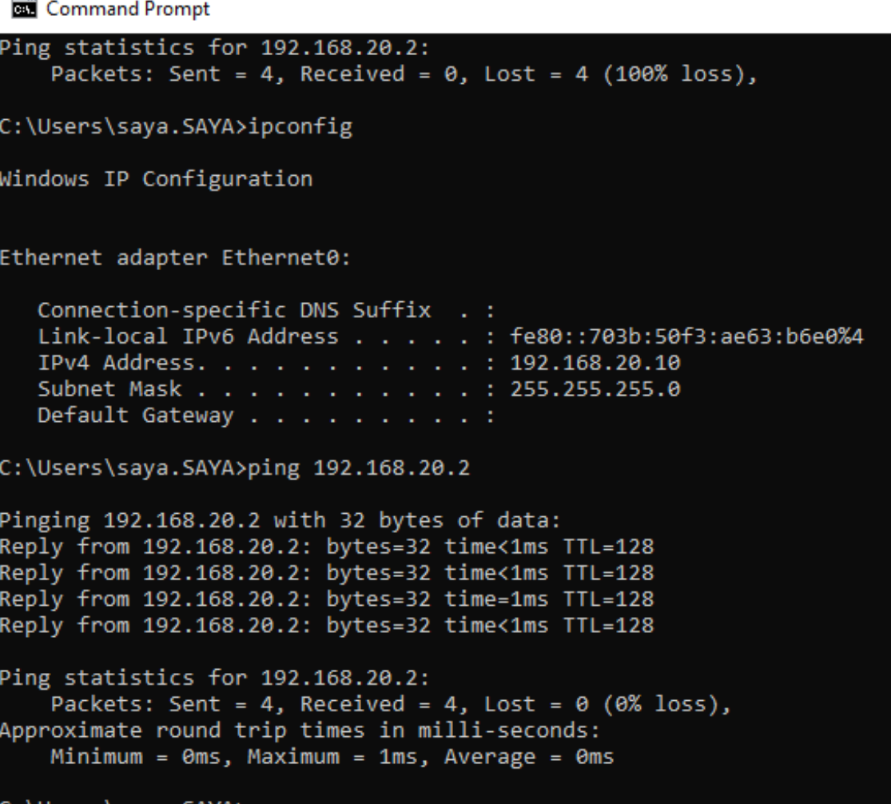
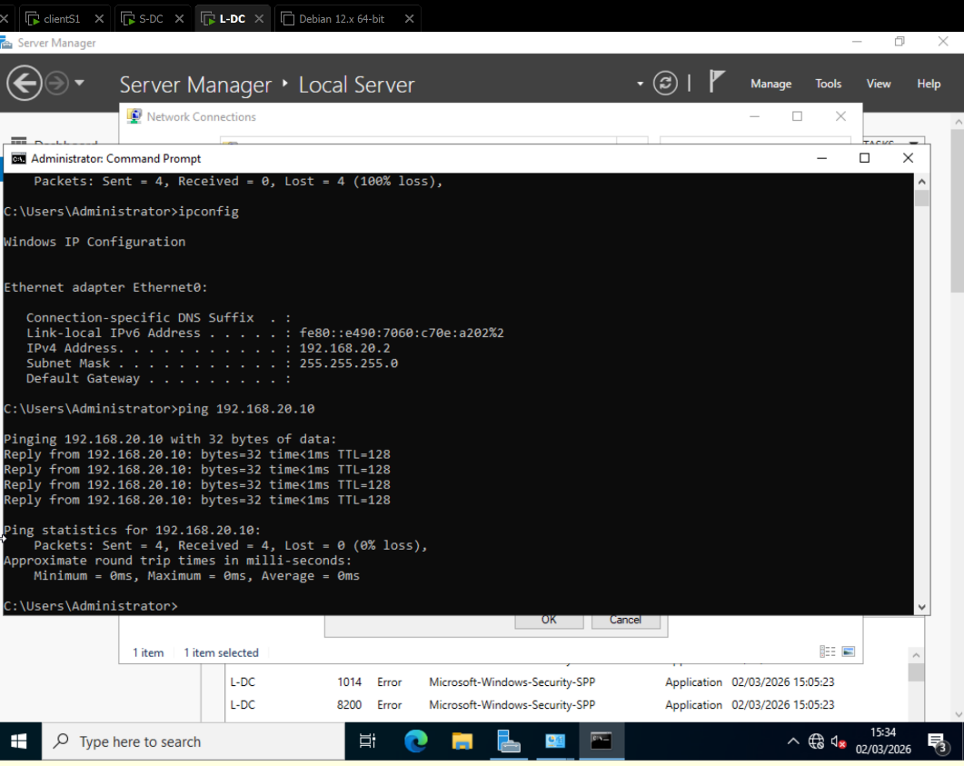

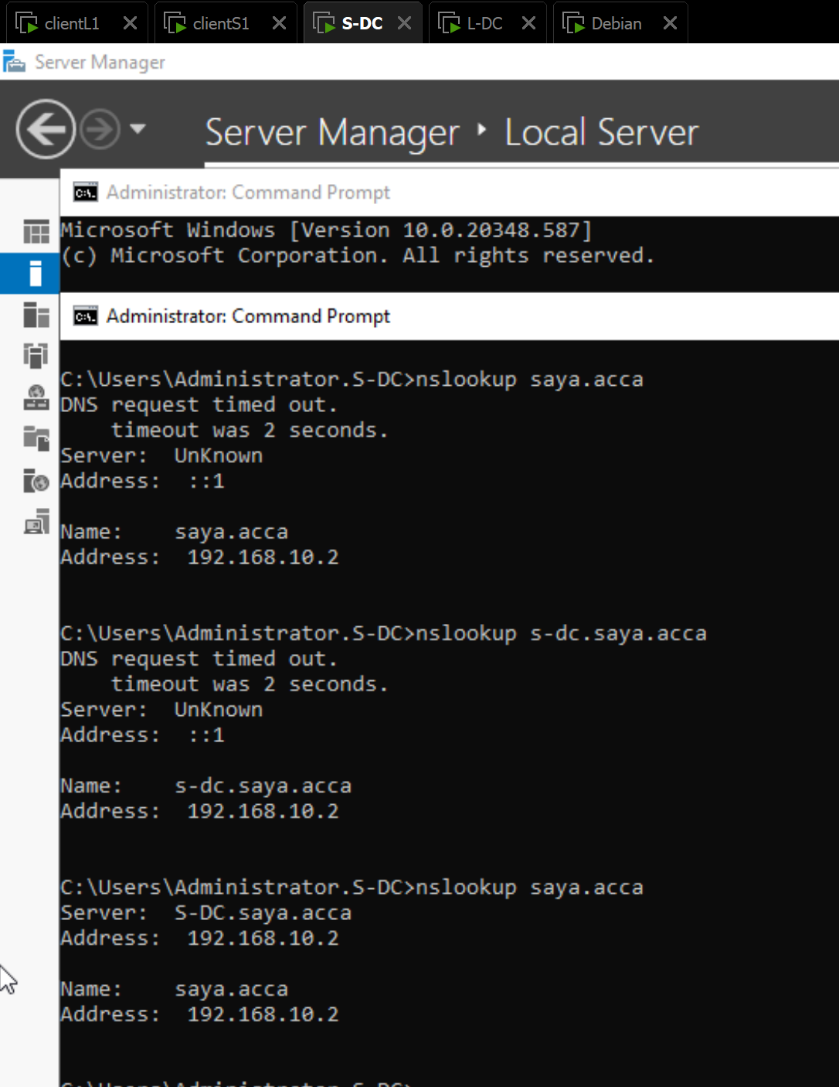
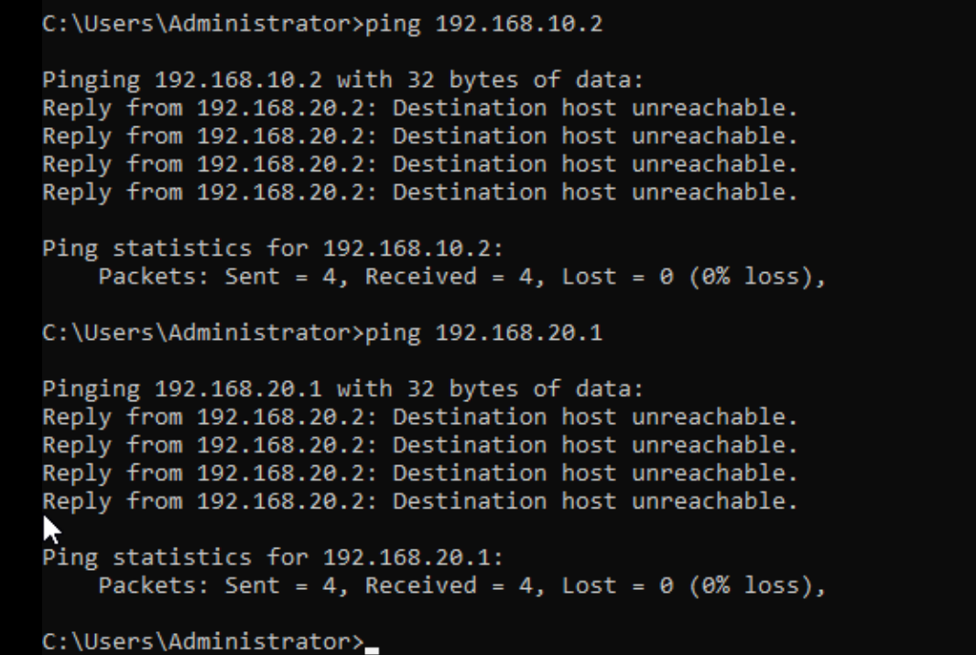

3.1.1 technical reflection
During the deployment of the virtual enterprise network, several configuration challenges were encountered, particularly during IP addressing and connectivity testing. While devices within the same subnet communicated successfully, initial tests between different subnets resulted in “Destination host unreachable” errors. This highlighted the importance of understanding subnet separation and the need for proper routing configuration.[5][6]
One significant issue occurred during connectivity testing within the London subnet, where ping requests resulted in 100% packet loss. After verifying the IP configuration using the ipconfig command, it was confirmed that the addressing scheme was correct. Further investigation identified that Windows Firewall was blocking ICMP traffic. A firewall rule was then created to allow inbound ICMPv4 requests, after which connectivity was successfully restored.
DNS resolution was also tested using the nslookup command. [12]Initial timeouts occurred due to configuration delays; however, subsequent tests confirmed correct name resolution to the configured domain controller IP address. This demonstrated the importance of verifying both network-layer and application-layer services during deployment.
Overall, the troubleshooting process required systematic testing, including validating IP settings, verifying subnet alignment, checking firewall policies, and retesting connectivity. These steps ensured that the network operated as designed and reinforced the importance of structured diagnostic procedures in enterprise environments.
3.1.2 personal reflection
This coursework significantly improved my understanding of how enterprise networks are designed and deployed. Before completing this task, I understood IP addressing and routing conceptually; however, implementing the configuration practically within a virtual environment helped me better understand how subnet separation, DNS configuration, and firewall rules impact connectivity.
The troubleshooting process was particularly valuable, as it required logical thinking rather than simply following instructions. Encountering connectivity failures and diagnosing the cause improved my confidence in identifying configuration errors and understanding how different network components interact.
Overall, this task strengthened both my technical skills and problem-solving ability. It also demonstrated the importance of testing and verification at each stage of deployment to ensure reliability in a networked environment.

References
[1] "What's the difference between Type 1 vs. Type 2 hypervisor? | TechTarget." Accessed: Mar 3 2026. [Online]. Available: https://www.techtarget.com/searchitoperations/tip/Whats-the-difference-between-Type-1-vs-Type-2-hypervisor
[2] Amazon Web Services, "Italicised full title of the article as it appears on the AWS comparison page," n.d. Available at: https://aws.amazon.com/compare/the-difference-between-type-1-and-type-2-hypervisors/.
[3] "RFC 791: Internet Protocol," Accessed: Mar 3, 2026. Available at: https://www.rfc-editor.org/rfc/rfc791.
[4] "RFC 8200: Internet Protocol, Version 6 (IPv6) Specification," Accessed: Mar 3, 2026. Available at: https://www.rfc-editor.org/rfc/rfc8200.
[5] "AIX." Accessed: Mar 3 2026. [Online]. Available: https://www.ibm.com/docs/en/aix/7.2.0?topic=tuning-static-routes
[6] "Static and Dynamic Routing." Accessed: Mar 3 2026. [Online]. Available: https://www.geeksforgeeks.org/computer-networks/difference-between-static-and-dynamic-routing/
[7] I. Amazon Web Services. "AWS Site-to-Site VPN overview." amazon. [Online]. Available: https://docs.aws.amazon.com/vpn/latest/s2svpn/VPC_VPN.html
[8] "How to Install and Configure DHCP Server on Windows." Accessed: Mar 3 2026. [Online]. Available: https://www.databasemart.com/kb/install-and-configure-dhcp-server-on-windows
[9] "Allow Ping (ICMP Echo) Responses in Windows Firewall." Accessed: Mar 3 2026. [Online]. Available: https://woshub.com/allow-ping-icmp-echo-windows-firewall/
[10] "RFC 792: Internet Control Message Protocol," Accessed: Mar 3, 2026. Available at: https://www.rfc-editor.org/rfc/rfc792.html.
[11] Microsoft. "DNS (Domain Name System) overview." Microsoft Learn. [Online]. Available: https://learn.microsoft.com/en-us/windows-server/networking/dns/dns-overview

