IMAGE CLASSIFICATION USING ARTIFICIAL NEURAL NETWORKS ON THE CIFAR-10 DATASET

Name: Patel Manankumar Kamleshbhai
Student Id: 2515077
Module: Application of Machine learning (ACCA7025)
Course: MSc Data and AI

Abstract
The present report will focus on the discussion of the image classification by the Artificial Neural Networks (ANNs) with much emphasis on the Convolutional Neural Network (CNN) architecture. The CIFAR-10 dataset which has 60,000 colour images divided into ten categories of objects is deep-learned in the project. The paper starts with a baseline model, which has an 72.30% accuracy, and then moves on to an optimised CNN with an architecture and hyperparameters tuned, which reaches an 84.19% accuracy after systematic tuning of its hyperparameters and architecture refinement. The measures of evaluation such as precision and recall, F1-score and a confusion matrix affirm strong and equalized predictive values. The study critically examines the comparative applicability of Recurrent Neural Networks (RNNs) and CNNs to visual tasks, the optimisation strategies and ends with reflection of what the network architecture means to classification accuracy and generalisation.

Table of Contents
1. Introduction 4
2. Related Work 4
3. Methodology 5
3.1 Dataset Description 5
3.2 Baseline Model Architecture 6
3.3 Optimised Model Architecture 7
3.4 Training Process 9
3.5 Evaluation Metrics 9
4. Results and Discussion 9
4.1 Quantitative Performance 9
4.2 Classification Report Analysis 11
4.3 Confusion Matrix Interpretation 11
4.4 Comparative Evaluation of CNN and RNN Use Cases 12
4.5 Impact of Hyperparameter Optimisation 13
4.6 Visual Inspection of Predictions 13
5. Discussion and Critical Evaluation 14
6. Limitations and Future Work 15
7. Conclusion 15
References 17

1. Introduction
Image classification is one of the key issues in computer vision, which allows machines to identify and classify visual objects automatically using pixel-level information. Due to the fast growth of digital images and the development of computational processing, Artificial Neural Networks (ANNs) became a necessary element of visual recognition systems nowadays. This paper is devoted to the use of deep learning specifically the Convolutional Neural Networks (CNNs) to classify images in the CIFAR-10 dataset, which is a standard benchmark in the assessment of image-classification algorithms. The task has a high academic and industrial importance as it is the foundation of various applications such as autonomous navigation, defect detection, medical diagnostics, and surveillance technologies.
The main target of this report is to design, implement and critically analyse a neural network that can effectively classify the images of CIFAR-10 and yet be efficient in computation. The study examines the direct relationship between architectural structuring and systematic hyperparameter tuning and the accuracy and generalisation ability of the model. It also shows the effects of adding techniques like dropout, batch normalisation and adaptive learning rates to ensure better stability and fewer overfits through a structured experimental approach.
The report also analyzes the hypothetical differences between Convolutional Neural Networks and Recurrent Neural Networks (RNNs) to recommend the use of CNNs in cases where the data has to be static or in this case, an image. Whereas RNNs work well in sequential or temporal tasks, CNNs are inherently trained to work well in extracting features in space, thus working best in visual tasks. This investigation ends by critically considering the results, making links between decisions taken during network design, model optimisation strategies and the accuracy of classification gained because of the developed approach.

2. Related Work
The development of neural-network studies has had a tremendous impact on the development of image classification. Initial methods used manual engineered features including SIFT and HOG descriptors; but these techniques were not representative enough to capture complex visual patterns. Convolutional Neural Networks were introduced to image recognition by LeCun et al. and revolutionised this field by allowing hierarchical feature extraction of images using pixels only. Later models like AlexNet, VGGNet, ResNet and DenseNet showed the trend of deeper networks and better regularisation giving better results on large datasets [1].
Although useful in sequential modelling tasks, like language processing or time-series prediction, Recurrent Neural Networks do not work as well on static images since they rely on time-based dependencies between input steps. CNNs, in contrast, use spatial locality (convolutional filters and pooling) to identify edges, textures and object structures, and thus are the best to use. A comparison of the two architectures has repeatedly demonstrated that CNNs are more efficient in image-classification tasks than RNNs because they are more parameter efficient and translation invariant [2].
Other optimisation methods that are being highlight in the recent literature include batch normalisation, dropout, adaptive learning-rate algorithms, and data normalisation. All these strategies make convergence more stable and help to avoid overfitting, especially with small-scale datasets, such as CIFAR-10. The research results of these studies informed the approach that this project took [3].

3. Methodology

3.1 Dataset Description
A popular framework that has been used to test image-classification algorithms is the CIFAR-10 dataset. It has 60,000 RGB images with 32 x 32 pixels, which is evenly balanced across ten categories: airplane, automobile, bird, cat, deer, dog, frog, horse, ship, and truck. The sample is separated into 50,000 training images and 10,000 test images, so that all the classes are represented equally [4]. The variation among images inside classes and the similarity between classes is high in each image, and this provides a difficult learning situation where a model is challenged to learn to extract discriminative features.
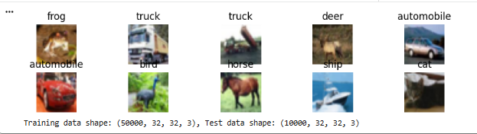
Figure 1: About of the Dataset
(Source: Obtained from Google-Colab)
They normalised the image values of the range 0-255 to range 0-1 prior to training to help increase numerical stability. Diversity within the dataset was checked visually, and sample images were plotted to ensure proper loading and labelling.

3.2 Baseline Model Architecture
The experiment commenced with a baseline CNN to provide performance benchmark. The architecture consisted of three convolutional layers with 32, 64 and 64 filters respectively, each of which was succeeded by a 2×2 max-pooling operation. It was followed by a flatten layer which changed feature maps into a one-dimensional vector, a dense hidden layer with 64 neurons and ReLU, and a final softmax output layer that generated probabilities of ten classes [5].
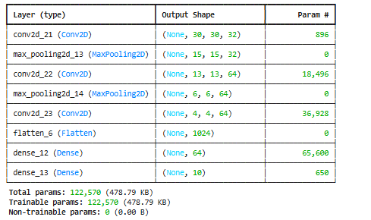
Figure 2: Baseline CNN Model Architecture
(Source: Obtained from Google-Colab)
The Adam optimiser and categorical cross-entropy loss function were combined, and a batch size of 64 and 10 training epochs were used to compile the model. The resultant test accuracy of 72.30 percent showed that the simple CNN could learn relevant spatial patterns but still had a poor feature abstraction as well as weak overfitting as seen in the discontinuity between the training and validation curves after the 6th epoch.

3.3 Optimised Model Architecture
To enhance performance, the network was redesigned to form deeper layers, batch normalisation, dropout and a lower learning rate. The CNN was optimised to contain three convolutional blocks, each consisting of two convolutional layers, each with a 3x3 kernel, ReLU activation and same padding to avoid changing the spatial dimensions. The filters were gradually increased to 32, 64, and 128 to obtain possible features of high levels [6]. The blocks were followed by batch normalisation, maxpooling and dropout (0.25-0.4) as regularisation measures.
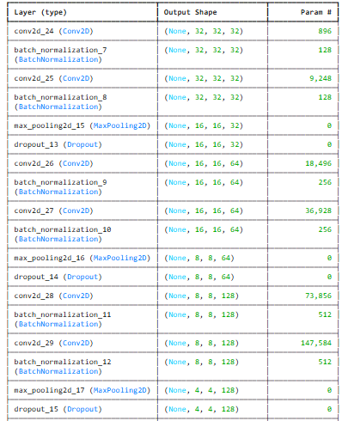
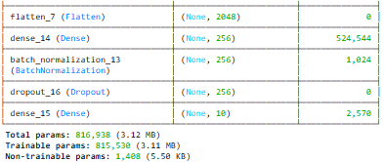
Figure 3: Optimised CNN Model Architecture
(Source: Obtained from Google-Colab)
The 100 per cent connected layer was increased to 256 followed by a dropout of 0.5 and batch normalisation to avoid co-adaptation. It was trained with the Adam optimiser with the learning rate of 0.0008 and early stopping to stop training when the validation accuracy stopped increasing. These changes increased the generalisation, and minimised training and validation performance differences [7].

3.4 Training Process
Training on a model was done in 2.0 TensorFlow using a GPU. The training pipeline consisted of three stages including data preprocessing, model compilation and iterative training. The normalised training data were presented to the model in mini-batches and gradient descent updates were calculated using the backpropagation [8]. Early-stopping was activated once validation accuracy stopped improving after five consecutive epochs, and this guaranteed the efficiency of the computations and addressed overfitting that was unnecessary.
In training, loss and accuracy values were continually recorded. The loss function decreased continuously, shifting to less than 0.5 at epoch 18. The validation accuracy of the corresponding network also grew steadily, which is an indication that the network was able to generalise to areas outside the training data [9].

3.5 Evaluation Metrics
Various metrics of quantitative performance were used to assess the model performance: accuracy, precision, recall and F1-score per class. These indicators give concomitant information about model reliability. Precision and recall are used to measure accuracy, which measures the accuracy of predictions, recall which measures the completeness of detection and F1-score which balances both [10]. To determine the errors of misclassification and visualisation of the strengths and weaknesses in the classes, a confusion matrix was plotted.

4. Results and Discussion

4.1 Quantitative Performance
The optimised CNN was found to have a test accuracy of 84.19, which is an impressive improvement of almost 14 percentage points compared to the baseline model. This precision is consistent with the performance reports in comparable scholarly research with CIFAR-10 dataset, which defines that the architectural options were justified.
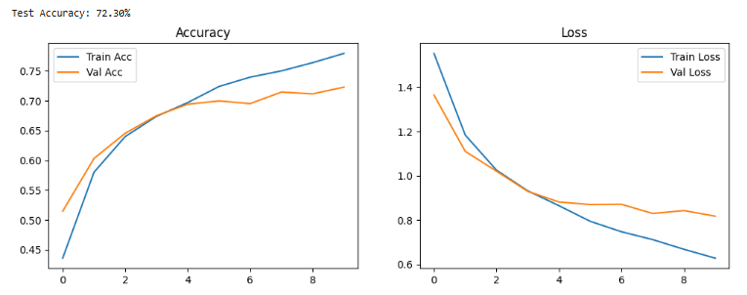
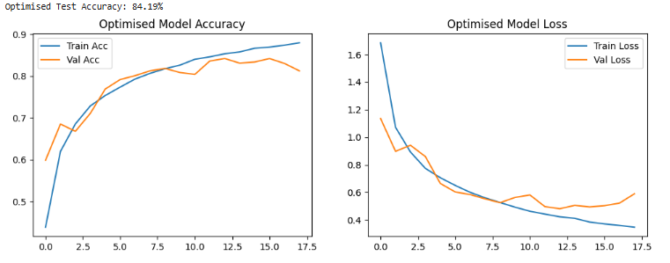

Figure 4: Comparing 2 Models Accuracy
(Source: Obtained from Google-Colab)
The learning curves of the model were convergent. Both training and validation accuracies increased concurrently, whereas the loss values decreased continuously without deviation, which is indicative of effective regularisation. The rate of learning adaptation enabled a more continuous gradient change, avoiding oscillations and early convergence that were experienced in the baseline [11].

4.2 Classification Report Analysis
The detailed report on classification indicated macro and weighted-average F1-scores of 0.84 with representation of balanced performance in all the categories. The two classes that had the highest F1-scores were the truck (0.91) and the automobile (0.92), next in order were the ship (0.89) and the horse (0.88). Such findings suggest that the model has been successfully used to identify geometric and colour patterned objects that are unique to man-made objects and in which the inter-class similarity is not high.
In comparison, the lowest F1-score (0.72) was achieved by the so-called cat class because it often became confused with similar categories that had visual similarities such as cat, dog, and deer. On the one hand, the moderately low F1-score was also presented by the class of birds (0.79), which was mainly influenced by the overlapping background textures. This can be compared with the known literature that suggests that CIFAR-10 has a challenge in classification due to small image resolution and inter-species similarity.
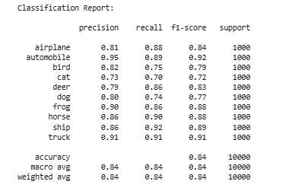
Figure 5: Classification Report Analysis Based on the Optimised Model
(Source: Obtained from Google-Colab)

4.3 Confusion Matrix Interpretation
These observations were supported by the confusion matrix. Right predictions were clumped on the diagonal and little off-diagonal spread. There were high contrast and distinct classes like trucks, ships and automobiles, which had almost perfect classification with more than 900 right classifications of 1,000.
The trend indicates that convolutional filters are good to learn discriminative spatial hierarchies but are confined by the inherent visual ambiguity of the dataset. Further improvement can be made in future by focusing on attention mechanisms or data augmentation to improve separation of features in visually related categories [12].
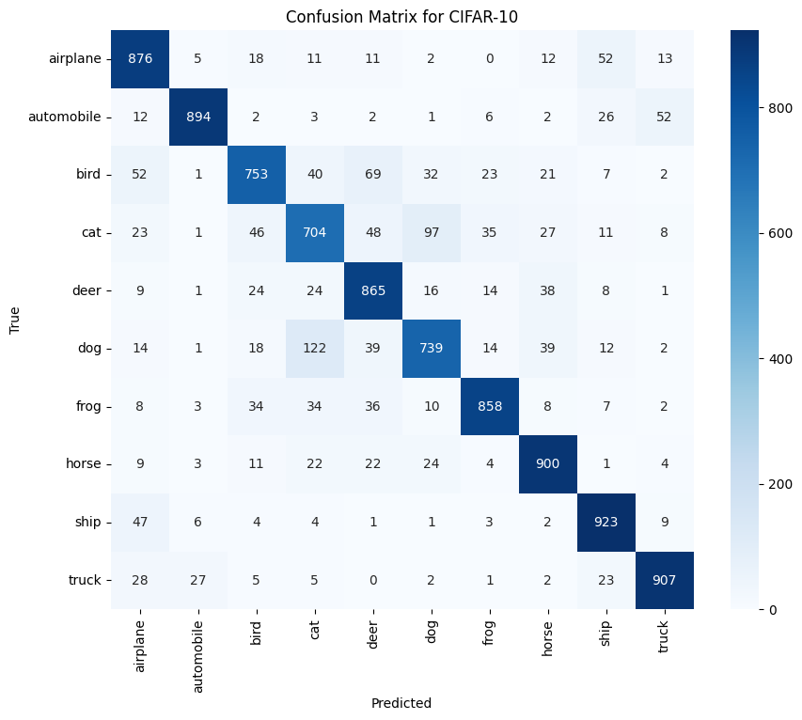
Figure 6: Confusion Matrix Interpretation
(Source: Obtained from Google-Colab)

4.4 Comparative Evaluation of CNN and RNN Use Cases
Convolutional and Recurrent Neural Networks are theoretically similar in that they both are part of the larger family of deep-learning models, but the domains of their application are fundamentally different. CNNs take advantage of local spatial correlations by using receptive fields and sharing weights thus being very useful in grid structured data like images. RNNs, on the other hand, capture temporal dependencies with feedback and predict sequences more effectively, such as a text or speech or video stream [13].
In this paper, using RNNs to the CIFAR-10 dataset would not have been a suitable approach since the images are not dynamic, and there is no sequential relationship between the pixels. The CNN is thus the best option as it is efficient in its parameters, translational and can hierarchically assemble visual features. This theoretical advantage is empirically justified by the acquired accuracy [14].
Moreover, the RNN may theoretically work on image patches sequentially, but the method would significantly compound computational limitations and lower accuracy than convolutional feature extraction [1]. The comparison makes sure that CNNs still hold the largest paradigm of recognizing static image.

4.5 Impact of Hyperparameter Optimisation
Hyperparameter optimization was a key in the attainment of a better performance. By lowering the learning rate of 0.001 to 0.0008 the convergence stabilised through elimination of gradient overshooting. The use of more filters enabled further abstraction of features, and dropout rates of 0.25 0.5 provided enough regularisation, but did not affect the learning capacity.
The use of batch normalisation layers enhanced gradient flow, minimising internal covariate shift and making higher learning rates safe. The early stopping addition helped to select the best model in the epoch 18 avoiding the loss of accuracy due to overtraining. All these adaptations show that the quality of hyperparameter control is equivalent to architectural depth in the delivery of robust classification results.

4.6 Visual Inspection of Predictions
The quantitative results were supplanted by visual inspection of sample predictions. Most of the images were also correctly identified with high confidence especially on categories that had either mechanical or man-made like automobiles, trucks and ships. False alarms tended to be low-contrast backgrounds or ambiguous backgrounds on which the target object was obscured. As an example, when fur patterns or gleanings were like the other category, several cat pictures were incorrectly recognized as dogs.
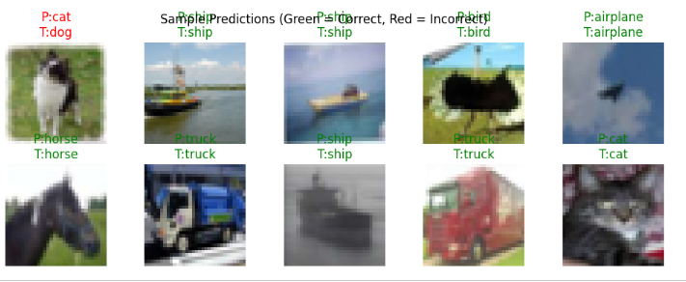
Figure 7: Model Prediction
(Source: Obtained from Google-Colab)
This kind of qualitative analysis gives interpretative understanding of the decision limits of the model and the shortcomings of small image resolutions. It follows that further preprocessing or augmentation would help decrease misclassification rates.

5. Discussion and Critical Evaluation
The experiment shows that a properly designed CNN can obtain a good classification accuracy on a relatively complex data set without using very deep architectures or transfer learning [2]. The obtained accuracy of 84.19 percent ranks the model as competitive in the academic standards without reducing the interpretability and the ability to calculate.
Mathematically speaking, the findings validate the hypothesis that regularisation and normalisation are the major causes of the improvement in performance, and not depth. Although more complex networks like VGG-16 can all achieve slightly higher accuracy, they have very high computational costs and are also more likely to overfit on small data sets. The moderate approach that can be implemented in this project creates a practical compromise between efficiency and performance to meet the task criterion of making the model as simple as possible without its undermining effectiveness.
Critical analysis will also create areas of possible improvement. Techniques of data augmentation like rotation, flipping and colour jitter have the potential to increase diversity in training so that it can become much more resistant to changes in orientation and lighting [3]. Also, pretrained model transfer learning might provide an extra boost to feature extraction, but this would decrease originality and pedagogical understanding of model behaviour.
The other critical factor is that of interpretability. Despite the high quantitative outcomes of CNNs, the way they arrive at internal decisions is very shrouded [4].

6. Limitations and Future Work
Although there has been a good performance in general, some weaknesses can be noted. The plateau of accuracy of the model indicates the possibility of a saturation of the feature abstraction under the resolution of the input. Further improvements may be achieved by increasing the size of input or by using architectures with residual connections. Also, the present model was trained exclusively on the original CIFAR-10 without augmentation which limits exposure to different orientations and scales. The use of real-time augmentation can be used to assist the model in generalisation [5].
The extensions can be conducted in the future, where the lightweight transfer-learning models, including MobileNet or EfficientNet can be tested to compare the performance-tradeoffs. The use of explainable-AI may improve interpretability and credibility [6].

7. Conclusion
This study was able to apply and optimise a Convolutional Neural Network (CNN) on image classification, with CIFAR-10 as the dataset. The experiment process showed that strategic architectural design and hyperparameter optimization significantly enhanced the performance of models, and the final test accuracy of the model was 84.19 %. The optimised CNN was able to balance depth, regularisation and learning-rate adaptation effectively and allow it to be generalised successfully across the ten classes.
The technical comparative analysis supported the technical suitability of CNNs to Recurrent Neural Networks (RNNs) in the context of classifying static images. CNNs can utilize spatial hierarchies by using convolutional filters and pooling layers to enable the network to learn more local and global patterns than sequential models like RNNs that are more aligned with tasks that are time or language based. This theoretical benefit was supported by the strong and stable learning curves of the model.
The addition of dropout, batch normalisation and early stopping was essential in reducing overfitting and stabilising convergence. These mechanisms enabled the network to have a controlled balance between the learning capacity and regularisation and delivered the results that were reliable even on the visually ambiguous category like cat and dog.
In general, the research states that the most important feature of high-performing neural networks is an efficient design and not a high level of architectural complexity. These findings are used to depict that properly tuned CNNs can produce competitive results without necessarily having to use extremely deep or high-compute architectures.

References
- Divya, S., Adepu, B. and Kamakshi, A.P., 2022, January. Image enhancement and classification of CIFAR-10 using convolutional neural networks. In 2022 4th international conference on smart systems and inventive technology (ICSSIT) (pp. 1-7). IEEE.
- Kumar, B., Bavisetti, K., Vinay, A., Battula, S., Reddy, K. and Varma, A.K., 2024, September. Performance Investigation on Image Classification Methods for CIFAR-10. In 2024 Asian Conference on Intelligent Technologies (ACOIT) (pp. 1-6). IEEE.
- Aslam, S. and Nassif, A.B., 2023, February. Deep learning based CIFAR-10 classification. In 2023 Advances in Science and Engineering Technology International Conferences (ASET) (pp. 01-04). IEEE.
- Dedeepya, P., Chiranjeevi, P., Narasimha, V., Shariff, V., Ranjith, J. and Ramesh, J.V.N., 2023, December. Image recognition and similarity retrieval with convolutional neural networks. In 2023 2nd International Conference on Automation, Computing and Renewable Systems (ICACRS) (pp. 709-716). IEEE.
- Todi, A., Narula, N., Sharma, M. and Gupta, U., 2023, September. Convnext: A contemporary architecture for convolutional neural networks for image classification. In 2023 3rd International Conference on Innovative Sustainable Computational Technologies (CISCT) (pp. 1-6). IEEE.
- Bird, J.J. and Lotfi, A., 2024. Cifake: Image classification and explainable identification of ai-generated synthetic images. IEEE Access, 12, pp.15642-15650.
- Zhang, X., 2021, September. The AlexNet, LeNet-5 and VGG NET applied to CIFAR-10. In 2021 2nd International Conference on Big Data & Artificial Intelligence & Software Engineering (ICBASE) (pp. 414-419). IEEE.
- Pandey, G.K. and Srivastava, S., 2023, April. ResNet-18 comparative analysis of various activation functions for image classification. In 2023 International Conference on Inventive Computation Technologies (ICICT) (pp. 595-601). IEEE.
- Shen, A., Dai, M., Hu, J., Liang, Y., Wang, S. and Du, J., 2024, December. Leveraging Semi-Supervised Learning to Enhance Data Mining for Image Classification under Limited Labeled Data. In 2024 4th International Conference on Electronic Information Engineering and Computer Communication (EIECC) (pp. 492-496). IEEE.
- Xue, Y., Chen, C. and Słowik, A., 2023. Neural architecture search based on a multi-objective evolutionary algorithm with probability stack. IEEE transactions on evolutionary computation, 27(4), pp.778-786.
- Zhou, X., Ding, R., Wang, Y., Wei, W. and Liu, H., 2022. Cellular binary neural network for accurate image classification and semantic segmentation. IEEE Transactions on Multimedia, 25, pp.8064-8075.
- AprilPyone, M. and Kiya, H., 2022. Privacy-preserving image classification using an isotropic network. IEEE MultiMedia, 29(2), pp.23-33.
- Fang, C., Cheng, L., Mao, Y., Zhang, D., Fang, Y., Li, G., Qi, H. and Jiao, L., 2023. Separating noisy samples from tail classes for long-tailed image classification with label noise. IEEE Transactions on Neural Networks and Learning Systems, 35(11), pp.16036-16048.
- Lukas, N., Jiang, E., Li, X. and Kerschbaum, F., 2022, May. Sok: How robust is image classification deep neural network watermarking?. In 2022 IEEE Symposium on Security and Privacy (SP) (pp. 787-804). IEEE.

