

Assignment
Reflective report (Part 1 & 2)
Managing Behaviour and Supporting Learner Engagement (ECPT6005)
PGCE/PCE in Post Compulsory Education and Training (PCET)

Redhwan Al-amri
2218136

24/04/2023

Table of Contents
Part 1 2
Part 2 6
References 11
Appendices 14
Appendix A: Teachers Observation Forms 14
Appendix B: Lesson Plan 16
Appendix C: Action Plan 18

Part 1
Student behaviour management remains among the most challenging components of teaching for educators (Main and Hammond, 2008). It is the tactics and approaches that educators use to guarantee that learners get the greatest value out of their education by empowering learners beyond the concept of being 'well-behaved', to push them to achieve their accomplishments. (Robinson, 2019). It happens when educators set clear, consistent guidelines for classroom behaviour and take steps to encourage good, pro-social behaviour (Gentrup et al., 2020). Educators' professional development in classroom behaviour management is constantly required to help educators adopt and use evidence-based classroom management techniques (Paramita, Sharma and Anderson, 2020). It is a necessary skill for educators, yet numerous educators confess to being unprepared to deal with student behaviour efficiently (Lebor, 2017). Hence, several behaviour management theories have been proposed. For instance, Fred Jones, stated, for teaching to be pleasant, educators should teach comfortably. Classroom management needs to be designed in a bottom-up manner to eliminate most difficulties (Jones, Jones and Jones, 2007). Similarly, Harry Wong, looked at behaviour management issues as the result of the absence of classroom facilitating. He emphasized organising courses and establishing a safe atmosphere for all learners (Wong, 2007). Likewise, Jeanne Gibbs, proposed a theory designed as an educational effort to boost learners' self-esteem in the learning environment (Gibbs, 2001). Moreover, Jere Brophy, focused on the necessity to provide solutions to assist students who have been dissatisfied with their previous educational experiences (Brophy, Alleman and Knighton, 2010). Mendler and Curwin on the other hand, built the theory based on three dimensions namely, prevention, action, and resolution to ensure 'discipline with dignity’(Curwin, Mendler and Mendler, 2008). Furthermore, William Glasser, focused on the requirement for educators to concentrate on the learners' intrinsic needs (Glasser, 1986).
Classroom behaviour issues elevate the workload for both the educators and the learners, interrupt the progress of lessons, and interfere with both learning objectives and procedures (Parsonson, 2012). Such issues also disrupt the classroom structure by diverting attention away from the educational responsibilities at hand and towards the distractions made by disruptive behaviours (Parsonson, 2012). Disruption is typically characterised as behaviours which are perceived to prevent learning from occurring. However, excellent classroom management and a positive educator-learner relationship can help to avoid classroom disruptions (Lebor, 2017). It also encourages pro-social and responsible behaviour among learners, as well as academic engagement (Scherzinger and Wettstein, 2019). Learners' engagement is defined as the time, energy, and other resources that learners and their educators commit to maximising the learning experience and improving learners' learning outcomes and growth (Axelson and Flick, 2010). It is commonly believed that engagement is directly related to learning (Halverson and Graham, 2019). Yet, it is not entirely clear how engagement and learning are related. Some extremely motivated learners barely gain any knowledge because their classes are poorly planned or badly instructed, which leaves little significant learning happening to them (Hamit and Yildirim, 2020).
Engagement can be merely an outcome of a learning environment that is comfortable for the learner (Conrad, 2002). On the contrary, possibly the enigmatic and little-understood motivational (and cognitive) reasons that lead some learners to more obvious displays of engagement are a greater cause for learning than engagement itself. In either of the preceding instances, an intervention at the "engagement" node would most likely not deliver the desired educational outcomes (Axelson and Flick, 2010). Effective learning requires learners to become actively involved in classrooms, and effective engagement requires learners to be interested in the classroom. As a result, educators’ methods must be geared towards having their teaching-learning techniques more learner-centred (Sharma and Chachra, 2020).
A successful educator must communicate efficiently with the learners, which is heavily reliant on engaging tactics. Engaging tactics are a way for educators to communicate with their learners. Several tactics have been discovered by researchers that educators and educational institutions feel contribute to successful learner engagement (Martin and Bolliger, 2018). Firstly, educators must establish clear learning objectives, as it has been discovered that learners perform more effectively if they understand precisely what is expected of them, this also includes setting standards of acceptable behaviour (Cwikla, 2003). Among the most important learner engagement tactics for attracting learners' attention is to set and communicate specific objectives for learning (Culajara et al., 2022). Furthermore, becoming innovative in the presenting curriculum is important considering boredom is a main driver for learners becoming disengaged. Active engagement tactics must be used by educators to prevent students from losing interest in a course, by providing creative and enjoyable learning content to interact with (Plucker et al., 2023). Moreover, instructors ought to acknowledge learners for their participation, as it is critical to recognise learners' efforts (Seechaliao, 2017). Finally, educators must establish transparent channels of communication with their learners. Most of the typical educational hurdles might be overcome with better communication. Educators ought to prioritise transparent communication channels in their courses from the outset and ensure the learners know how to utilise them effectively (Asrar, Tariq and Rashid, 2018).
Several pieces of legislation govern behaviour management within the classroom. Legislation like the United Nations Convention on the Rights of the Child (UNCRC), the Health and Safety at Work Act, and the Equality Act are wide in scope, yet have an immediate effect on behaviour management (Machin et al., 2023). Educational institutions must take the appropriate legislation and reflect it, across many institutional policies (Chitty, 2014). Although educators may depend upon institutional policy, they must remain conscious of any specific legal obligations relevant to their field of expertise". For instance, the Copyright, Designs and Patents Act is crucial for instructors who teach web development as it applies to learners who afterwards begin working in the business world because copyright violation is typical and frequently leads to expensive lawsuits (Carty and Hodkinson, 1989).
The health and safety act is another example which is relevant in nearly all educational institutions since it is extremely unsafe for learners for instance to try to swing on office chairs, which is a typical health and safety problem (Government, 1974). This is an instance of how the risk to the learners’ health and safety can turn a seemingly little interruption into an extremely serious risk resulting from poor classroom behaviour management. The Health and Safety at Work Act turn increasingly crucial within practical sessions since learners will be dealing with objects that, if used poorly, can be highly potentially life-threatening. In such a situation, behavioural management is critical as poor behaviour management may result harmfully (DiBerardinis et al., 2013).
Furthermore, understanding the Equality Act is important since learners might need training regarding why their behaviour is unacceptable because of their injustice or discriminatory behaviour towards other learners (Zallio and Clarkson, 2021). There are protected characteristics that educators should be mindful of to assist and avoid discrimination (directly or indirectly), victimisation, and harassment of learners and staff members. The protected characteristics are: ‘age, disability, gender reassignment, pregnancy or maternity, race, religion or belief, sex, sexual orientation and marriage and civil partnership’ (Government, 2010).
In conclusion, the study of behaviour is essential because of the diverse nature of people, individual differences, assorted cultural backgrounds etc. Classroom behaviour management strategies play a significant role in designing positive educator-learner relationships that lead to effective learner engagement. The duty of educators extends considerably beyond simply conveying curriculum to their learners: they must support and assist learners in managing their behaviour and in achieving their social and behavioural targets both in and outside the classroom. Educators must promote caring, supportive relationships with and among learners, establish and apply the teaching in ways that improve learners’ access to learning and use behaviour management strategies that encourage effective learners’ engagement with academic tasks. Several legislations exist to manage and govern behaviour management from both educators and learners. Educational institutions’ policies are also aligned with that to ensure best practices of classroom behaviour management.

Part 2
Description
 | Teacher 1 | Teacher 2 | Me
Date | Friday 24th February 2023 | Monday 27th February 2023 | Monday 20th February 2023
Location | UWTSD IQ Building | Online | UWTSD IQ Building
Group | Level 4 | Level 4 | Level 4
Number of learners | 4 learners | 17 leaners | 7 leaners
Topic | Rewilding | Hotel Administration and Front Office | Computer Security
Course | BSc. Environment, Sustainability and Climate Change | BSc. International Hotel Management | BSc. Computer Science
Reflection model | Gibbs reflection model is used to build these reflections as it offers an approach for analysing incidents, enabling educators to gain insight and improve from incidents that went either well or poorly during their time as educators. (Gibbs, 1988).
Feelings
- Teacher 1:
The lesson was well-planned, and the lecturer managed to get the learners engaged throughout the lesson. There were some occasions when the learners were not so active but with the use of some strategies, the lecturer managed to pull out some answers from the learners and get them involved with the lesson.
- Teacher 2:
The lesson began smoothly with some warm-up activities that managed to get the learners engaged and devoted from the beginning. The lecturer introduced himself and got to know the learners as an ice-breaking strategy. The lecturer then set clear learning goals and behaviour requirements during the lesson such as keeping the learners’ cameras turned on at all times during the session. This has been shown to have a substantial influence on increasing the learners' engagement (Schwenck and Pryor, 2021). Throughout the lesson, the lecturer incorporated student discussion time into activities and made the students part of the learning process by engaging them with some activities that improve the overall learning process.
- Me:
The lesson was so enthusiastic that the learners were actively engaging with the lesson and participating in the reflection activities we had in the previous lecture. Throughout the lesson, technology was seen as a tool, not as a distraction, so I included some engagement activities online that required students to use their mobile phones to patriciate at it. Yet, an event occurred when one of the learners was found to be playing with his phone causing a distraction to the rest of the learners.
Evaluation
- Teacher 1:
The lecturer started by asking the learners about their knowledge background on the topic before instruction. To truly engage in learning, students need to work at an appropriately challenging level. Students become bored when an activity is too easy and discouraged when it's too hard (Acee et al., 2010). Hence, it is important to determine the ideal level at which to begin instructing. In addition, the lecturer used another strategy of asking open-ended questions to promote engagement among the students (Tan et al., 2022). Furthermore, the lecturer had students model / explain to their peers which helped them engage more with the content of the lesson (Gamlath, 2022).
- Teacher 2:
The lecturer begins the lesson with a warm-up activity as it was found that embarking on a lecture straightaway is never easy (Rusman, 2022). Learners take some time to settle to realise what is happening. Starting with a warm-up activity can assist learners to get engaged and focused right away (Loliyana, 2022). Moreover, setting clear learning goals and behaviour requirement is significantly important (Fessl et al., 2021). Learners work more effectively if they are aware of what is expected of them (Wade and Kidd, 2019). Furthermore, the lecturer incorporated learners' discussion time into activities, which is aligned with the UK professional standards in designing and planning learning activities (Advance-He, 2011). Instead of having the learners solve a problem on their own, he asked them to form small groups and join online private discussion rooms to try activities such as think-pair-share to work through it (Adawiyah, 2021). Finally, throughout the lesson, the lecturer made the students part of the learning process by engaging them with some activities that improves the overall learning process.
- Me:
I started the lesson with a reflection on the previous lecture, in which the learners had the chance to review what they have learned, in which areas they have succeeded, where they still need to improve, and what their aims are. Generally, the use of technology was seen as a tool during my lesson, not as a distraction, where I included some engagement activities online that required the students to use their mobile phones to patriciate at it. Yet, there was an occasion when I had to deal with disruptive behaviour in the classroom because of using technology.
Analysis
- Teacher 1:
A Background Knowledge probe is very beneficial as it helps the lecturer choose precisely what to address in a limited time, guaranteeing that the following sessions will more effectively engage the learners (Hattan and Alexander, 2020). Moreover, open-ended questions can promote lively discussions as they allow for several correct responses or valid opinions. (Tan et al., 2022). For example, the lecturer could begin with an open-ended question to encourage participation. Then, to verify the learners' understanding of the topic, the lecturer then could ask further "fact-finding" follow-up questions. Furthermore, having the students’ modelling / explain to other students is a great chance to ask learners to explain what they understood to their peers (Gamlath, 2022).
- Teacher 2:
Icebreakers of any kind can be an ideal way of starting a lesson as they offer the lecturer the opportunity to get to know the learners and ask any type of question (Rusman, 2022). Such activities encourage learners to take on the responsibility of the classroom learning environment and equip them for collaborative group work (Loliyana, 2022). Similarly, investing some time in clarifying the unique course behaviour requirement is another essential step to be taking at the beginning. In any educational programme, there should be some behaviour requirements of the course that determined what is considered acceptable behaviour and what is labelled as disruptive behaviour (Franklin and Harrington, 2019). Furthermore, a discussion is essential for learning across numerous disciplines as it allows learners to process knowledge rather than just receive it. Incorporating student discussion time into activities gets the learners to engage with the course material (Lewis-Kipkulei et al., 2021). Finally, including learners in the learning process improves their ability to concentrate and encourages them to engage in higher-level critical thinking (Kiran, 2020).
- Me:
The use of reflection has been found to be among the most efficient methods for engaging learners from the beginning of the lesson (Nuci et al., 2021). This can be incorporated using some digital tools to deliver the most important content of the course upfront. Technology can be a nightmare for educators if it is not used properly (Selwyn, 2016). Yet, incorporating the use of technology as part of the lesson plan can improve the overall learners’ engagement (Henderson et al., 2015). Furthermore, even when educators have taken steps to use technology in the learning process, disruption may arise. Disruption behaviour is viewed here as an interference with normal academic functions (Cox, Clutterbuck and Bachkirova, 2017). Therefore, it is very important to set clear rules with the learners on acceptable behaviour during the lesson.
Conclusion
- Teacher 1:
Overall, it is important to ask the learners what they know about a topic before instructing as it will help in managing the lesson time and get the learners engaged with the lesson. Moreover, asking open-ended questions help in promoting engagement among the learners. Another important technique to improve engagement is to have learners model / explain to their peers as it is a great opportunity to involve the learners in a discussion.
- Teacher 2:
The use of warm-up activities is very important as it helps to get everyone engaged and focused, together with setting clear learning goals and behaviour requirements during the lesson. Furthermore, incorporating learners’ discussion time into activities is also essential. Finally, it is necessary to include the learners in the learning process and benefit from this in understanding what motivates them, what they enjoy, and what they dislike about the lessons.
- Me:
Generally, the use of a reflective method before starting any lesson is useful for engagement, but it is also important to find a way to make it more fun. Furthermore, incorporating the use of technology is very beneficial for the learners and it can improve their overall engagement level. Yet, looking into more ways to govern the use of technology during class is essential. Finally, rules with the learners on acceptable behaviour during the lesson will help improve overall classroom behaviour management.
Action Plan
As shown in Appendix C.

References
Acee, T. W. et al. (2010) ‘Academic boredom in under-and over-challenging situations’, Contemporary Educational Psychology, 35(1), pp. 17–27. doi: 10.1016/j.cedpsych.2009.08.002.
Adawiyah, J. (2021) ‘IMPROVING STUDENTS’ENGAGEMENT IN SPEAKING THROUGH THINK-PAIR-SHARE TECHNIQUE (A Classroom Action Research at Ma’had al-Jami’ah IAIN Pontianak)’, JOEEL: Journal of English Education and Literature, 2(2), pp. 117–122. doi: 10.38114/joeel.v2i2.94.
Advance-He (2011) ‘The UK Professional Standards Framework for teaching and supporting learning in higher education’, Learning, p. 8. Available at: http://www.heacademy.ac.uk/ukpsf.
Asrar, Z., Tariq, N. and Rashid, H. (2018) ‘The impact of communication between teachers and students: A case study of the Faculty of Management Sciences, University of Karachi, Pakistan’, European Scientific Journal, 14(16), pp. 32–39. doi: 10.19044/esj.2018.v14n16p32.
Axelson, R. D. and Flick, A. (2010) ‘Defining student engagement’, Change: The magazine of higher learning, 43(1), pp. 38–43. doi: 10.1080/00091383.2011.533096.
Brophy, J., Alleman, J. and Knighton, B. (2010) A learning community in the primary classroom. Routledge.
Carty, H. and Hodkinson, K. (1989) ‘Copyright, designs and patents act 1988’, The Modern Law Review, 52(3), pp. 369–379.
Chitty, C. (2014) Education policy in Britain. Edited by 3rd Edition. Bloomsbury Publishing.
Conrad, D. L. (2002) ‘Engagement, excitement, anxiety, and fear: Learners’ experiences of starting an online course’, The American journal of distance education, 16(4), pp. 205–226. doi: 10.1207/S15389286AJDE1604_2.
Cox, E., Clutterbuck, D. A. and Bachkirova, T. (2017) ‘The complete handbook of coaching’, The Complete Handbook of Coaching, pp. 1–504.
Culajara, C. J. et al. (2022) ‘Digitalization of Modules and Learning Tasks for Flexible, Convenient, And Safe Learning Experience of Students’, International Journal of Social Learning (IJSL), 2(3), pp. 350–365. doi: 10.47134/ijsl.v2i3.172.
Curwin, R. L., Mendler, A. N. and Mendler, B. D. (2008) Discipline with dignity: New challenges, new solutions. Edited by A. for S. and C. Development. ASCD.
Cwikla, J. (2003) ‘The importance of setting learning goals to investigate the effectiveness of teacher professional development’, Educational Research Quarterly, 27(2), p. 43.
DiBerardinis, L. J. et al. (2013) Guidelines for laboratory design: health, safety, and environmental considerations. John Wiley \& Sons.
Fessl, A. et al. (2021) ‘The Impact of Explicating Learning Goals on Teaching and Learning in Higher Education: Evaluating a Learning Goal Visualization’, in Technology-Enhanced Learning for a Free, Safe, and Sustainable World: 16th European Conference on Technology Enhanced Learning, EC-TEL 2021, Bolzano, Italy, September 20-24, 2021, Proceedings 16, pp. 1–15. doi: 10.1007/978-3-030-86436-1_1.
Franklin, H. and Harrington, I. (2019) ‘A review into effective classroom management and strategies for student engagement: Teacher and student roles in today’s classrooms’, Journal of Education and Training Studies. doi: 10.11114/jets.v7i12.4491.
Gamlath, S. (2022) ‘Peer learning and the undergraduate journey: a framework for student success’, Higher Education Research \& Development, 41(3), pp. 699–713. doi: 10.1080/07294360.2021.1877625.
Gentrup, S. et al. (2020) ‘Self-fulfilling prophecies in the classroom: Teacher expectations, teacher feedback and student achievement’, Learning and Instruction, 66, p. 101296. doi: 10.1016/j.learninstruc.2019.101296.
Gibbs, G. (1988) ‘Learning by doing: A guide to teaching and learning methods’, Further Education Unit.
Gibbs, J. (2001) ‘Tribes : a new way of learning and being together’, p. 432.
Glasser, W. (1986) The Quality School Teacher. ERIC.
Government, U. (1974) Health and Safety at Work etc. Act 1974. Available at: https://www.legislation.gov.uk/ukpga/1974/37/contents (Accessed: 21 April 2023).
Government, W. A. (2010) Equality Act 2010: guidance - GOV.UK. Available at: https://www.gov.uk/guidance/equality-act-2010-guidance (Accessed: 3 March 2023).
Halverson, L. R. and Graham, C. R. (2019) ‘Learner engagement in blended learning environments: A conceptual framework.’, Online Learning, 23(2), pp. 145–178. doi: 10.24059/olj.v23i2.1481.
Hamit, O. and Yildirim, R. (2020) ‘Teacher perspectives on classroom management’, International Journal of Contemporary Educational Research, 7(1), pp. 99–113.
Hattan, C. and Alexander, P. A. (2020) ‘Prior knowledge and its activation in elementary classroom discourse’, Reading and Writing, 33, pp. 1617–1647. doi: 10.1007/s11145-020-10022-8.
Henderson, M. et al. (2015) ‘Students’ everyday engagement with digital technology in university: exploring patterns of use and “usefulness”’, Journal of Higher Education Policy and Management, 37(3), pp. 308–319. doi: 10.1080/1360080X.2015.1034424.
Jones, F. H., Jones, P. and Jones, J. L. T. (2007) Tools for teaching: Discipline, instruction, motivation. Fredjones. com.
Kiran, S. (2020) ‘Learner-Centered Approach: Engaging Students in Learning Activities.’, IUP Journal of Soft Skills, 14(1).
Lebor, M. (2017) Classroom Behaviour Management in the Post-School Sector: Student and Teacher Perspectives on the Battle Against Being Educated. Springer. doi: 10.1007/978-3-319-57051-8.
Lewis-Kipkulei, P. et al. (2021) ‘Increasing student engagement via a combined roundtable discussion and flipped classroom curriculum model in an OT and special education classroom’, Cogent Education, 8(1), p. 1911284. doi: 10.1080/2331186X.2021.1911284.
Loliyana, L. (2022) ‘The Effects of Rewards and Ice-Breaking on Students’ Learning Motivation at a Rural Public Elementary School in Lampung, Indonesia’, Journal of Advances in Education and Philosophy, 6(9), pp. 450–454. doi: 10.36348/jaep.2022.v06i09.002.
Machin, L. et al. (2023) A complete guide to the level 5 diploma in education and training. 4th editio. Critical Publishing.
Main, S. and Hammond, L. (2008) ‘Best practice or most practiced? pre-service teachers’ beliefs about effective behaviour management strategies and reported self-efficacy’, Australian Journal of Teacher Education (Online), 33(4), pp. 28–39.
Martin, F. and Bolliger, D. U. (2018) ‘Engagement matters: Student perceptions on the importance of engagement strategies in the online learning environment.’, Online learning, 22(1), pp. 205–222.
Nuci, K. P. et al. (2021) ‘Game-based digital quiz as a tool for improving students’ engagement and learning in online lectures’, Ieee Access, 9, pp. 91220–91234. doi: 10.1109/ACCESS.2021.3088583.
Paramita, P. P., Sharma, U. and Anderson, A. (2020) ‘Effective teacher professional learning on classroom behaviour management: A review of literature.’, Australian Journal of Teacher Education, 45(1), pp. 61–81.
Parsonson, B. S. (2012) ‘Evidence-Based Classroom Behaviour Management Strategies.’, Kairaranga, 13(1), pp. 16–23.
Plucker, J. A. et al. (2023) ‘Room to Run: Using Technology to Move Creativity into the Classroom’, in Creative Provocations: Speculations on the Future of Creativity, Technology \& Learning. Springer, pp. 65–80. doi: 10.1007/978-3-031-14549-0_5.
Robinson, D. (2019) Classroom Behaviour Management in Further, Adult and Vocational Education: Moving Beyond Control? Bloomsbury Publishing.
Rusman, K. B. (2022) ‘Implementation and Benefits of Learning through Ice Breaking’, International Linguistics and TESOL Journal, 1(1), pp. 1–4. doi: 10.55637/iltes.1.1.5785.1-4.
Scherzinger, M. and Wettstein, A. (2019) ‘Classroom disruptions, the teacher--student relationship and classroom management from the perspective of teachers, students and external observers: a multimethod approach’, Learning Environments Research, 22(1), pp. 101–116.
Schwenck, C. M. and Pryor, J. D. (2021) ‘Student perspectives on camera usage to engage and connect in foundational education classes: It’s time to turn your cameras on’, International Journal of Educational Research Open, 2, p. 100079.
Seechaliao, T. (2017) ‘Instructional strategies to support creativity and innovation in education.’, Journal of education and learning, 6(4), pp. 201–208.
Selwyn, N. (2016) Education and technology: Key issues and debates. Bloomsbury Publishing.
Sharma, D. H. and Chachra, A. (2020) ‘Effective learners’ engagement for learning’, Journal of Engineering Education Transformations, 33(Special Issue), pp. 150–152. doi: 10.16920/jeet/2020/v33i0/150084.
Tan, S. H. S. et al. (2022) ‘Enabling open-ended questions in team-based learning using automated marking: Impact on student achievement, learning and engagement’, Journal of Computer Assisted Learning, 38(5), pp. 1347–1359. doi: 10.1111/jcal.12680.
Wade, S. and Kidd, C. (2019) ‘The role of prior knowledge and curiosity in learning’, Psychonomic bulletin \& review, 26, pp. 1377–1387. doi: 10.3758/s13423-019-01598-6.
Wong, H. K. (2007) ‘The well-managed classroom’, Excerpt from The First Days of School. Available online: http://go. hrw. com/resources/go\_sc/gen/HSTPR034. PDF.
Zallio, M. and Clarkson, P. J. (2021) ‘Inclusion, diversity, equity and accessibility in the built environment: A study of architectural design practice’, Building and Environment, 206, p. 108352. doi: 10.1016/j.buildenv.2021.108352.

Appendices

Appendix A: Teachers Observation Forms
Teacher 1:
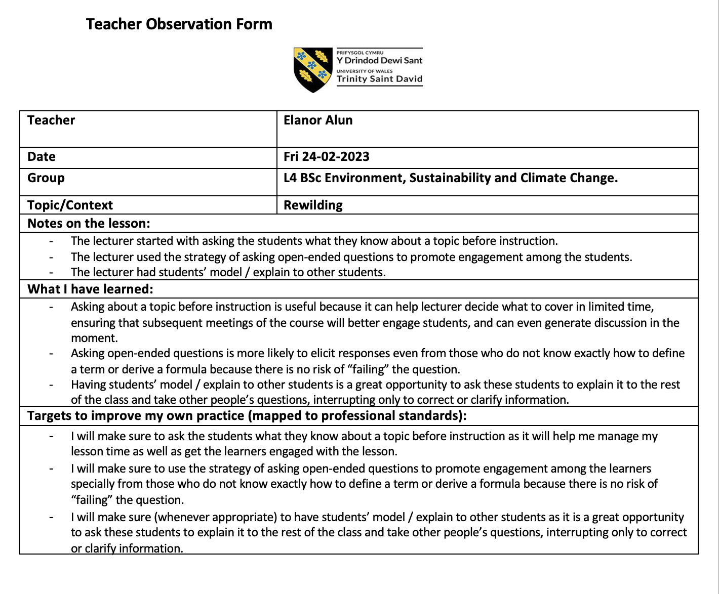

Teacher 2:
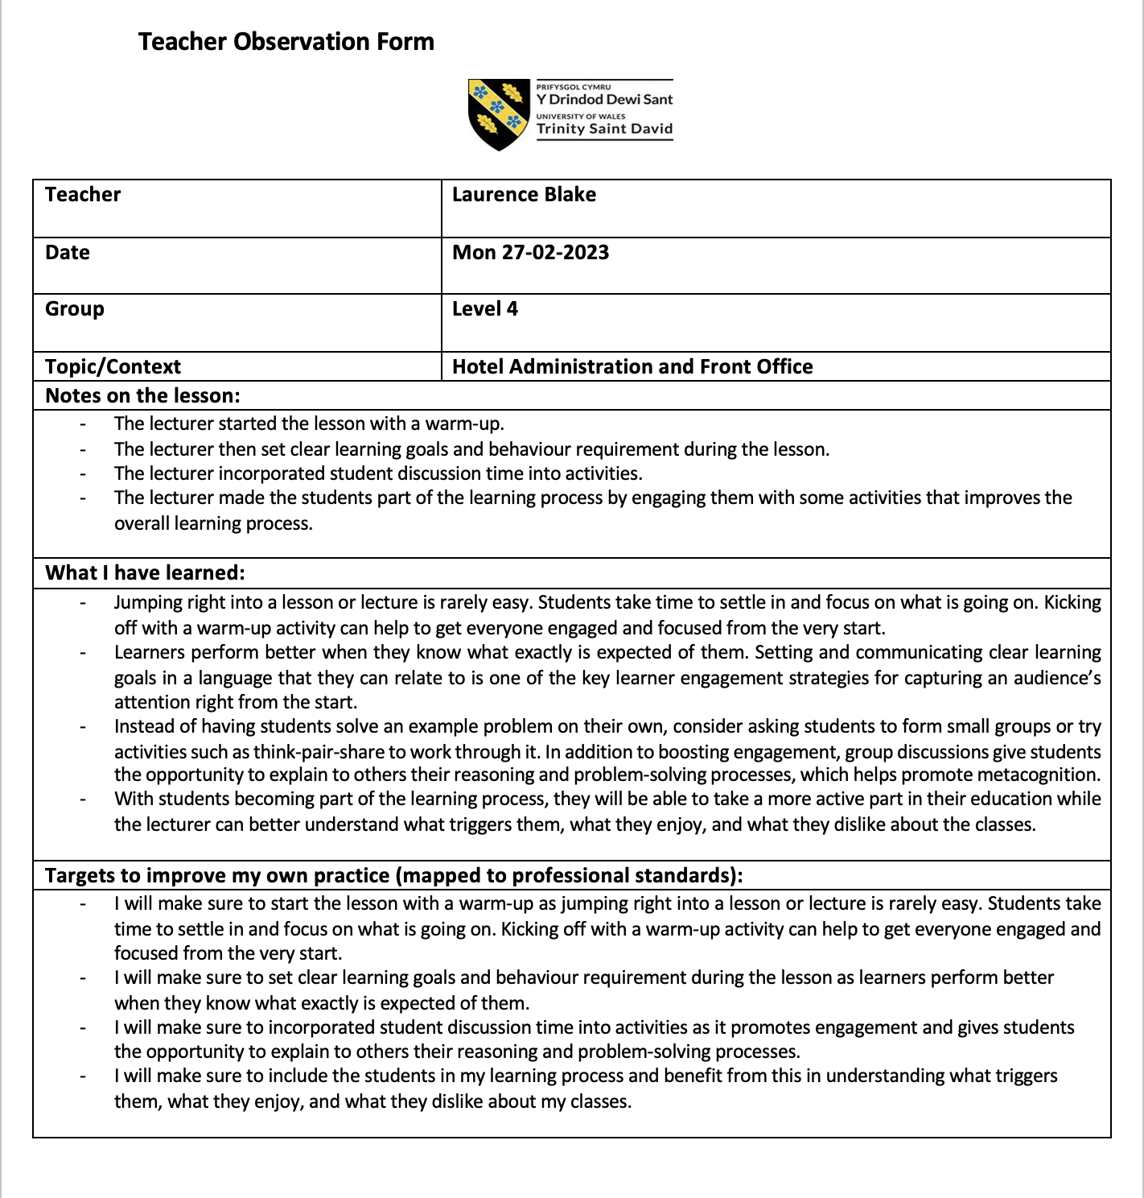

Appendix B: Lesson plan



Lesson Plan

Topic: Computer Security |  | Class: Level 4
Date: 20 /03/ 2022 | Length of lesson: 2 Hours |  | Number of students: 7
Resources required:
- PowerPoint Slides
- Internet connection
- Smartphone/IPad
Aim of Lesson
Upon completion of this lesson, students should be able to:
- Introduce the basic concepts of Computer Security including (Computer viruses & Network security)
Learning Outcomes – The Learners Should Be Able To:
- Describe computer security concepts.
- Describe computer security terminology.
- Differentiate between types of computer viruses.
- Defined Vulnerability and Attacks
- Defined Countermeasure.
- Defined the purpose of security and Firewalls.
- Describe the components of the Firewall.
- Explain the architecture of the Firewall.
Previous student knowledge required for the session:
Understanding of the following:
- Types of Computers
- Basic Concepts of Computing
- Computer Networks and Internet
Anticipated difficulties (if applicable):
Demonstrating the Firewall Architecture

Professional Standards (where are these being met within the session)
Areas of Activity
- A1: By designing an online interactive quiz using https://www.quizizz.com/.
- A2: By creating a Q&A session to support learners.
- A3: By providing feedback on the online quiz taken.
Core Knowledge
- K2: By designing PowerPoint slides that include the theory as well as some visualization to elaborate the concept.
- K5: By creating an online quiz to test and evaluate the learners’ understanding of the lesson.
Professional Values
- V1: By respecting the learning of different opinions about the subject materials.
- V2: By giving the learners equal chances in participating and asking questions.

Lesson Detail:

Stage | Focus | Strategy | Time
Introduction | - Reviewing the previous lecturer  - Introducing the topic  - Defining new terms | - Reviewing the previous lecturer by asking the student what they remember.  - Introducing the new topic and highlighting its impact and importance.  - Defining the terms as provided by previous researchers and elaborating the definition with examples. | 15 Minutes
Development | - Teaching the content of the lesson  - Engage the students with the lesson content. | - By explaining and elaborating the definition with examples some of which include examples.  Use of some videos to illustrate the content of the lesson  - Engage the students during the lesson by asking them questions and giving them the chance to participate and elaborate on what they understand about the topic.  - Assessing the student’s understanding via online quiz games. | 75 Minutes
Break |  |  | 15 Minutes
Plenary/conclusion | - Summary and evaluation  - Q&A | - Summaries the whole lesson and have an online quiz to test the understanding of the learners.  - Address the learners’ questions | 15 Minutes

Assessment Strategies: when and how are they included within the lesson?

Toward the end of the lesson, the learners will undergo an online quiz to test their understanding of the lesson. Feedback is to be provided to the learners to improve their understanding.

Informal reflection (to be completed after the session)
Generally, the use of a reflective method before starting any lesson is useful for engagement, but it is also important to find a way to make it more fun. Furthermore, incorporating the use of technology is very beneficial for the learners and it can improve their overall engagement level. Yet, looking into more ways to govern the use of technology during class is essential. Finally, rules with the learners on acceptable behaviour during the lesson will help improve overall classroom behaviour management.

Appendix C: Action Plan
I will create SMART learning outcomes to help me achieve my learning goals, manage the learners’ behaviour efficiently and to align my practices with the UK professional standards. Throughout my lesson, I will incorporate some activities that will improve the learners’ engagement with the lesson contents. This includes the use of technology and online tools for creating academic activities which will get the learners engaged with the lesson.
The SMART learning outcomes of the lesson are as below:

S | - I will set clear learning goals and behaviour requirements, as when learners understand precisely what is required of them, they perform better. One of the most important engagement tactics for grabbing the learners' attention right from the beginning is to set and communicate clear learning goals in a language that the learners can relate to.  - I will make sure to set clear rules on acceptable behaviour and what can be labelled as disruption, as disruptive behaviour interferes the normal academic functions.  - I will make sure to incorporate student discussion time into activities as it promotes engagement and allows students to explain to others their reasoning and problem-solving processes.  - I will make sure to see technology as a tool, not as a distraction, where I included some engagement activities online that required the students to use their mobile phones to patriciate at it.
M | - Throughout the session, I will be measuring the learners’ performance based on the learning goals and behaviour requirements.  - I will measure the learners’ engagement based on the activities created and their participation level.  - I will also be monitoring the use of technology during the lesson and ensure it is not to be seen as distracting for the learners.
A | - I will make sure my learning goals are achievable, the behaviour requirement is realistic, and they pose no discomfort to the learners.  - I will ensure that the created activities are achievable, and the learners have the ort enough for them to participate fully in these activities.  - I will ensure the strategy to monitor the learners’ use of the technology is possible.
R | - I will ensure to my learning goals are realistic, and that the behaviour requirement is manageable, as this will help me manage my lesson time and get the learner to engage gaged with the lesson.  - I will ensure creating realistic academic activities that are achievable and the learners have all the facilities they required to engage in those activities.  - I will ensure to set realistic strategies for monitoring the use of technology during the lesson to avoid seeing it as distracting for the learners.
T | - I will ensure when setting my learning goals that they are time-bound and that I will have the time to measure and evaluate the achievement of those goals.  - I will make sure to set the right time for each activity I will create to ensure utilizing my lesson time efficiently.  - I will ensure to set the right time for using technology during the lesson and that usage will not overtake the other learning goals time.

