Rebecca Porter

2320044

Module 5, BMPF 7074D

Word count- 7562

Title:
Vocal Health at Sea: Developing an Accessible Handbook for Cruise Ship Singers

Table of Contents
SECTION 1- Portfolio
1.1 Introduction……………………………………………………………………………………………3
1.2 Theoretical Influences……………………………………………………………………………4
Aim and Objectives…………………………………………………………………………………...5
Expected Learning Outcomes……………………………………………………………………….5
Methodology…………………………………………………………………………………………..7
Study Timeline………………………………………………………………………………………...9
SECTION 2- Project Report
2.1 Introduction………………………………………………………………………………………..9
2.2 Literature Review (Know-That, Know-How, Know-What) …..……………………………..10
2.3 Critical Reflection (Kolb Cycle) ……………………...….…………………………………….24
Conclusion…………………………………………………………….……………………………..28
FINAL SECTIONS
Reference List……………………………………………………………………………………….29
Appendix – Artefact (Vocal Health at Sea) …………………………………………………….38

Portfolio
1.1 Introduction
This project addresses a persistent gap in vocal-health support for cruise-ship singers. Unlike land-based performers, shipboard vocalists live and work within continuously air-conditioned environments, with limited control over rest, hydration, or recovery. Existing cruise-ship research highlights environmental strain including poor air quality, irregular schedules, and elevated fatigue among performers and crew (Cooper, 2020; Zhao & Amelung, 2022). Yet despite increasing awareness of these occupational pressures, there remains little accessible, evidence-based guidance designed for singers at sea.
The project produces two outputs: a research-informed report and a practical vocal-health handbook for cruise-ship performers. Together, these support an underserved workforce by promoting sustainable, evidence-informed approaches to vocal care in maritime environments.
As the most-booked female European act for a world-leading cruise entertainment agency, I have spent seventeen years working across major cruise lines as a solo guest entertainer. This lived experience consistently reveals a lack of structured vocal-health guidance onboard. Drawing on this professional background and my PGCE/PCET qualification, I am developing a handbook intended for a wide range of cruise-ship singers from guest entertainers to cast members while also offering value for other voice-dependent roles such as entertainment hosts and cruise directors.
The handbook will be produced in both downloadable and print formats, enabling access during travel, rehearsals, and onboard life. Its content is informed by vocal-pedagogy research (Simberg et al., 2009; Toki et al., 2021), occupational and environmental health findings, adult-learning principles (Knowles et al., 2020; Collins, 2004), and lived experience within the cruise industry. My training in adult education ensures the resource remains accessible across diverse learning styles (Russell, 2006).

1.2 Theoretical Influences
Three theoretical areas inform this project: vocal pedagogy, occupational/environmental health, and adult-learning theory.
Vocal-pedagogy literature emphasises hydration, mucosal integrity, and sustainable voice use (Sataloff, 2017a; Ware, 2018). Environmental and occupational studies demonstrate the role of HVAC systems, low humidity, and fatigue in shaping vocal comfort and function. These insights are vital for cruise-ship performers who have limited control over their working environment.
Knowles’ andragogy (Merriam, Caffarella & Baumgartner, 2020) shapes the handbook’s design, ensuring it supports self-directed learning and problem-solving essential for adult performers working independently at sea. These theoretical strands underpin both the artefact and the critical analysis developed in Component 2.

Best Practice Influences
The handbook synthesises evidence-based and experience-led strategies that reflect the everyday realities of cruise-ship performance. Rather than offering technical vocal instruction, it focuses on the environmental and occupational factors most affecting shipboard singer’s hydration, mucosal balance, dry-air exposure, pacing vocal load, and emotional resilience in isolating conditions.
This continues research from earlier modules, particularly concerning hydration, mucus regulation, and air-conditioning effects on the upper respiratory tract. Studies by Sataloff (2017a), Sundberg (2018), and Traser et al. (2017) highlight the importance of mucosal integrity, while Al-Waili (2011) and Samarghandian et al. (2017) demonstrate honey’s soothing and antimicrobial properties findings directly shaping the practical guidance.

Informal practitioner knowledge is also central in cruise contexts, where access to specialist vocal support is often limited (Rosenberg, 2022). By integrating practitioner wisdom with academic research, the project creates a credible, cruise-specific framework designed to empower performers to protect and sustain their voices.
Aim and Objectives
Aim:
To provide cruise-ship singers with a comprehensive, evidence-informed handbook that synthesises existing and emerging research on vocal health within maritime environments. Building on earlier module findings on honey’s therapeutic properties, the project integrates research on hydration, mucosal balance, air-conditioning impacts, alcohol use, gender, ageing, essential oils, and ear protection. The aim is to create a practical, research-backed resource that explains the “why” behind vocal-care strategies and supports sustainable voice use at sea.
Objectives:
• Through reflective practice, autoethnographic observation, and systematic literature review, identify and critically analyse the environmental, occupational, and emotional challenges affecting cruise-ship vocalists.
• Extend earlier findings on hydration, mucosal balance, honey, and air-conditioning by integrating new research on alcohol, recovery, the female and ageing voice, essential oils, and ear protection, creating a cohesive evidence base for the handbook.
• Using adult-learning principles and iterative design methods, develop a downloadable and print-ready handbook translating academic and practitioner research into clear, cruise-specific guidance for diverse performer backgrounds.

Expected Learning Outcomes
This project aims to:
• Deepen understanding of how environmental and occupational conditions affect vocal health at sea through applied research and reflection.
• Strengthen my ability to design accessible, evidence-informed learning resources for performers in demanding, isolated contexts.
• Critically reflect on my development as both a touring performer and an educator, considering how academic theory can shape practical guidance.
• Explore the resource’s potential to influence wider industry awareness and future advocacy.
Research Questions
- How do cruise-ship environmental and occupational conditions affect vocal health and daily functioning?
- Which evidence-informed strategies best support hydration, mucosal balance, and vocal resilience at sea?
- How can adult-learning principles translate research into accessible, practical guidance for cruise-ship vocalists?

Activities and Assessment Criteria
Research and Development Activities:
• Applied literature review on hydration, mucosal health, honey’s therapeutic role, alcohol, recovery, gender/ageing voice, essential oils, cabin air quality, and noise exposure.
• Reflective observation of lived experience across multiple cruise contracts to identify recurring challenges.
• Integration of practitioner insight shared informally among performers.
• Design and curation of the handbook using adult-learning principles and accessible language.
• Organisational use of AI as a supportive reflective tool (Ford et al., 2023).

Assessment-Criteria Alignment:
The project aims to:
• Demonstrate synthesis of research, reflection, and lived professional experience.
• Translate complex academic knowledge into accessible guidance for cruise singers.
• Evidence professional and pedagogical growth through theory and reflective practice.
• Contribute meaningfully to discussions around vocal health in maritime contexts.

Target Audience and Accessibility
The handbook is designed primarily for cruise-ship singers (guest entertainers, resident vocalists, band singers, solo lounge acts, cast members) who often lack access to vocal specialists (Sataloff, 2017b; Niemeier & Larsen, 2020). Cruise-ship employment can function as a “total institution,” where organisational structures override individual needs (Parkman, 2022). In this context, accessible, evidence-based self-care resources become essential.
The handbook adopts clear language and inclusive design to support performers from varied educational backgrounds. It explains key concepts without oversimplifying them and encourages readers to adapt strategies to their own routines. Recognising lived experience as a valid form of evidence (Overby, Constance & Quenzer, 2022) supports the handbook’s ethos of empowerment rather than prescription.

Methodology
This practice-based project is supported by autoethnographic reflection. Over seventeen years of cruise-ship performance provided foundational insight, supported by systematic literature review. Searches across Google Scholar, PubMed, Semantic Scholar, JSTOR, ResearchGate, and UWTSD Discover revealed no peer-reviewed research specifically addressing cruise-ship singers a clear gap justifying adaptation of adjacent research on hydration, HVAC, and occupational voice health.
Key themes were developed through reflective practice and refined using academic literature (Nathan et al., 2023). Rather than aiming for generalisable findings, the project focuses on creating practitioner-usable guidance. Literature informs three domains:
• Environmental and occupational influences (Alves et al., 2019; Sandage et al., 2017; Levine & Finnegan, 1987)
• Voice care in isolated work settings (Roll & Goffi-Fynne, 2021; Srinivas et al., 2023)
• Adult-learning and independent resource design (Kelly & Young, 2017)
AI was used to support organisation, clarity, and structural refinement but not to generate ideas or research, maintaining academic integrity. Generated material was reviewed for accuracy and alignment with the literature.
The methodology aims to demonstrate how academic insight, creative application, and practitioner experience can coexist to inform practical, real-world solutions (Gross et al., 2017; Young, 1985).

Study Timeline
Due to the realities of cruise-ship performance frequent travel, limited internet access, and fatigue deep academic work is rarely achievable onboard. The project has therefore been structured around periods at home, where consistent focus is possible. Travel time is used for reflection, note-taking, and preliminary organisation, while writing and synthesis take place during stable periods ashore.
This flexible structure reflects the realities of my professional life and aims to support sustainable academic progress alongside a demanding touring schedule.
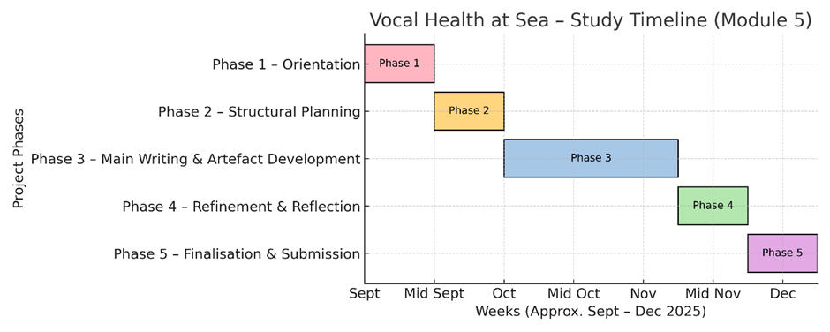
This phased, flexible structure mirrors both my working style and the realities of cruise-ship performance life, where time and focus are often determined by touring demands. It is hoped that this reflective approach may allow the project to evolve authentically and sustainably, while acknowledging the balance required between professional performance and academic growth.

Component 2

2.1 Introduction

Cruise-ship singers work within an environment fundamentally different from land-based performance settings. Air-conditioned, low-humidity spaces quietly dehydrate the upper airway, while irregular sleep, constant travel, and demanding schedules elevate baseline vocal effort. Research in vocal pedagogy highlights the foundational role of hydration and mucosal integrity in healthy phonation (Sataloff, 2017; Ware, 2018), while environmental and occupational studies demonstrate how continuous exposure to dehumidified or recycled air can impair airway comfort and vocal efficiency (Sandage et al., 2017; D’Amato et al., 2018). Yet these insights are typically presented in isolation. What is missing in the literature is a synthesis of how these factors interact within the cruise-ship context, where dryness, noise, fatigue, disturbed circadian rhythms, and restricted recovery occur simultaneously. This fragmentation contributes to an underdeveloped evidence base for maritime performers, who often rely on intuition, peer advice, or trial-and-error remedies in the absence of tailored guidance.

This project aims to respond directly to that gap by framing cruise-ship vocal strain as a systemic issue rather than a purely technical or behavioural one. By integrating academic research with lived professional experience, it argues that the cruise environment forms an interdependent ecology in which environmental, physiological, and behavioural pressures reinforce one another. Understanding this ecology allows for the development of practical, low-risk strategies such as humidity control, saline vapour, and balanced sound monitoring that singers can apply in real time.

The accompanying artefact, Vocal Health at Sea, is designed for adult learners and is informed by Knowles’ principles of andragogy (Merriam, Caffarella & Baumgartner, 2020). Concise, accessible pages pair “what to do” with clear explanations of “why it helps,” enabling performers to make informed decisions under challenging conditions. The handbook functions as a Practice-as-Research output, aligning with Nelson’s (2013) Know That / Know How / Know What framework by translating evidence and practitioner knowledge into context-specific support. Rather than offering fixed conclusions, the project contributes a credible, experience-led perspective to ongoing discussions surrounding sustainable vocal performance in maritime environments.

2.2.1 Theoretical and Contextual Research (Know-That)
A. Introduction
This section outlines the professional understanding that has emerged through engaging with the theoretical and contextual literature relevant to Vocal Health at Sea. In reviewing research across vocal pedagogy, environmental science, and occupational health, I developed a clearer practitioner-level understanding of how these domains intersect within cruise-ship performance.
Although substantial literature exists on vocal care for performers on land, these studies rarely address the cruise-ship environment, where mechanical airflow, humidity reduction, noise, and cumulative fatigue coexist in ways that create distinctive physiological strain. Through the process of analysing this literature as a working practitioner, I came to understand that the existing evidence base provides fragments of a larger picture: individual mechanisms of dryness, inflammation, or fatigue are well documented, but their real-world interactions remain underexplored.
This reflective engagement with the literature revealed that cruise-ship vocal strain is not a matter of isolated irritants, but an integrated system of environmental, behavioural, and demographic pressures. This practitioner insight forms the theoretical grounding for the strategies presented in the handbook.

B. Environmental and Respiratory Context
Through reviewing environmental science and relating it to lived shipboard experience, I developed a more detailed understanding of how cruise ships operate as sealed, mechanically regulated micro-environments. Unlike land-based performance settings, these vessels depend almost entirely on centralised HVAC systems that continually filter, cool, dehumidify, and recirculate air. This produces a consistently low-humidity atmosphere far more extreme than typical performance spaces.
The literature helped explain physiological mechanisms I had previously experienced but not yet been able to account for.
- D’Amato et al. (2018) demonstrate that prolonged exposure to artificially cooled, dehumidified air inflames the upper airway and heightens sensitivity.
- Sandage et al. (2017) identify how forced-air ventilation can disrupt the mucosal layer before dryness is consciously perceived, increasing phonatory effort even in routine speech.
Reflecting on these studies within the realities of cruise life made a pivotal insight clear: cruise-ship singers do not merely perform in dry air- they live in it continuously. Importantly, the environments intended for rest and recovery, such as cabins, often intensify this exposure. This creates a paradoxical dynamic in which the very spaces designed to support recovery are those that deepen dehydration, limiting the mucosa’s capacity to repair between performances. This shifted my understanding from isolated sensations of dryness to an awareness of an ongoing, structural environmental load embedded in shipboard living.
Further clarity came from Borelli et al. (2021), whose research on low-frequency HVAC noise demonstrates that the same systems responsible for drying the airway also contribute to persistent background noise capable of disturbing sleep. This reframed dryness and sleep disruption not as separate inconveniences, but as interconnected outcomes of the ship’s environmental infrastructure each undermining the body’s capacity for vocal recovery.
Taken together, these studies reveal a more integrated theoretical picture: air quality, environmental noise, and recovery conditions function as linked contributors to vocal strain at sea. This strengthened the “know-that” dimension of the project by showing that sustainable vocal health in cruise contexts requires not only technical skill, but an ecological understanding of how living conditions continually shape respiratory and vocal function.
C. Behavioural and Physiological Factors
Engaging with literature on behaviour and physiology helped me understand why singers respond differently to the same environment. This moved my perspective from personal insight to evidence-informed insight.
Alcohol and Recovery:
Alcohol use is common within performance culture and is frequently positioned as part of post-show relaxation, bonding with colleagues, or connecting socially with audiences. On cruise ships, this behaviour sits within a wider tourism context in which alcohol consumption is actively promoted as part of the holiday experience; passengers drink more liberally, and performers often find themselves navigating these expectations as part of their working environment (Carlisle & Ritchie, 2020; Toubes & Vargas-Sanchez, 2021). However, research suggests that alcohol use within performance communities is not driven solely by leisure or socialising. Harris et al. (2022) show that in group-based performance cultures, drinking alcohol can function as a mechanism for maintaining cohesion, signalling belonging, and negotiating status often persisting even when individuals would prefer not to drink. This provides a valuable lens for understanding cruise-ship contexts, where performers may feel pressured to join colleagues, band members, or passengers for drinks as a way of demonstrating availability, sociability, or professionalism.
Physiologically, alcohol contributes to dehydration and irritation of the mucosal tissues, effects that can intensify the dryness already caused by air-conditioning, irregular rest, and continuous workload at sea (Rasmussen et al., 2023). These challenges are compounded within the cruise environment, where singers are routinely managing reduced humidity, disrupted circadian rhythms, and cumulative environmental load. Breitenfeld et al. (2024) further demonstrate that alcohol undermines fine motor control, neuromuscular coordination, and breath stability factors central to efficient phonation. Importantly, alcohol can create a misleading sense of relaxation, masking early signs of vocal fatigue and delaying recovery.
Taken together, these findings show that alcohol is not a minor or isolated factor, but part of a broader ecological pattern in which social culture and environmental strain interact to heighten vocal vulnerability. This insight shaped the handbook’s approach: offering realistic, non-judgemental guidance that acknowledges the social dynamics of cruise life while emphasising moderation, structured hydration, and intentional recovery planning to support sustainable vocal function at sea.
Gender and Age:
Engaging with research by Sataloff (2017a; 2017b) and Vigil (2015) significantly deepened my understanding of how physiological factors shape a singer’s vulnerability to dryness, fatigue, and environmental strain. Sataloff’s work outlines how the vocal mechanism changes across adulthood, noting reductions in mucosal pliability, shifts in respiratory efficiency, and age-related alterations in neuromuscular control that can increase a singer’s effort levels under demanding conditions. Vigil’s (2015) discussion of hormonal change across the menstrual cycle, perimenopause, and menopause further highlights how fluctuations in oestrogen and progesterone impact lubrication, tissue viscosity, and vocal stability making some adult female singers more susceptible to dryness or reduced stamina at predictable times.
Importantly, these vulnerabilities are compounded by the intrinsic workload differences between male and female voices. Normative data show that female vocal folds vibrate almost twice as quickly as male vocal folds typically 180–220 Hz for women compared with 100–130 Hz for men (Baken & Orlikoff, 2000). Over the duration of a show, this results in millions more vibratory cycles for the same length of performance, creating a significantly greater cumulative physical load for female singers. This contextualises why hormonal shifts, dehydration, or environmental dryness may disproportionately affect women in particular.
This research reframed my earlier assumption that “some singers simply struggle more” into a more precise understanding: physiological ageing, hormonal transitions, and baseline vibratory workload create evidence-based differences in vulnerability. Rather than being a matter of technique or personal resilience, these variations are rooted in the way the adult voice evolves over time. Recognising this has reshaped my approach to vocal health at sea, revealing why performers of different ages or hormonal profiles may experience the same environment in unequal ways.
This insight directly informed the handbook’s personalised approach. Instead of offering uniform guidance, the resource encourages singers to anticipate age-related changes in recovery time, monitor hydration more strategically during periods of hormonal fluctuation, and adopt tailored strategies that respect the biological realities of the adult and ageing voice. This moves vocal care away from one-size-fits-all recommendations and toward a more compassionate, physiologically grounded model of support one that validates lived experience and acknowledges diversity within the professional singing community.

D. Recovery and Holistic Adaptation

Recovery, Rest, and Environmental Stability:
The literature on recovery, combined with my lived experience, deepened my understanding of how vocal rest is shaped by environmental instability. Research by Oliveira Lemos et al. (2023) and Vermeulen et al. (2024) clarified why short, structured recovery periods can restore stamina even within challenging conditions such as low humidity, disrupted sleep, or heightened performance load. Their findings reinforced the idea that fatigue is often a consequence of inadequate rest cycles rather than technical insufficiency alone. This is particularly relevant to cruise-ship performance, where some singers work nightly for six-month contracts with only occasional rest days. In this context, recovery cannot rely on extended breaks; it depends on consistent, strategic restoration embedded into everyday routines.

Engaging with Ware (2018) helped me to contextualise why reducing physical tension and supporting overall ease contributes meaningfully to vocal recovery. Ware’s focus on minimising unnecessary muscular load reinforced the project’s emphasis on rest, environmental management, and nervous-system regulation rather than technique-based interventions. This provided a pedagogical foundation for prioritising adequate sleep, recovery time, and comfort-focused strategies within the handbook practices that become essential, rather than optional, for performers navigating long-duration, high-frequency contracts at sea.

Environmental Adjustments and Air Quality:
Research on essential-oil diffusion has provided useful insight into how small environmental adjustments may influence cabin comfort for performers. Su et al. (2007) demonstrated that evaporating essential oils in enclosed indoor spaces can reduce airborne microbial presence and modify the chemical profile of the air, producing a measurable shift in indoor air quality. Their findings do not position essential oils as clinical disinfectants, but they indicate that diffusion can reduce the environmental load of airborne microbes, contributing to a cleaner feeling breathing environment.
Building on this, Díaz-Alonso et al. (2021) examined cold-diffusion systems in cultural-heritage spaces and observed improvements in perceived air freshness and atmospheric comfort. Although their study centres on environmental management rather than health, it highlights how diffusion technologies can alter the sensory qualities of stale or recycled air, an effect directly relevant to cruise-ship cabins that operate on continuous artificial ventilation.
More recently, Angulo-Milhem et al. (2023) conducted a full-scale indoor study showing that essential-oil dispersion influenced particle behaviour and enhanced indoor air performance under ventilated conditions. Their findings reinforce the idea that, when used sparingly and with airflow, diffusion can support a more comfortable micro-environment by reducing stagnation and improving perceived air quality.
Together, these studies help explain why some performers report greater comfort when using essential-oil diffusion in their cabins. By reducing airborne microbial load and offering light respiratory support, certain oils may help performers keep sickness at bay while also adding moisture to the circulated air. Within the handbook, this is framed not as a vocal remedy but as an optional environmental comfort strategy.
This stage of the project strengthened my know-that understanding that vocal recovery is a multidimensional process- environmental, physiological, behavioural, and emotional not simply technical. Recognising this complexity is essential for supporting sustainable vocal health in unstable or high-demand environments such as cruise-ship work.

E. Summary
Through engaging deeply with these theoretical perspectives, I developed a practitioner-level understanding of vocal health at sea as an interplay of environmental, behavioural, and physiological forces. The literature helped me recognise the cruise ship not as a passive backdrop, but as an ecological system that can undermine vocal stability unless actively managed.
This knows that insight emerging from synthesising research with lived experience forms the conceptual foundation of Vocal Health at Sea. It explains why hydration, humidity management, acoustic awareness, alcohol moderation, hormonal awareness, and recovery planning must be integrated rather than treated as isolated tips.
By understanding why these pressures accumulate, I can now articulate and justify the evidence-informed strategies included in the handbook.

2.2.2 Applied and Practical Research (Know-How)

The Handbook as a Performing Artefact
Vocal Health at Sea operates not merely as a written document but as a performing artefact: a resource that enacts knowledge in real time. In Nelson’s (2013) terms, its function is to mediate between research and practice by enabling singers to do something with evidence to modify their environment, adapt their behaviour, and manage cumulative load within the demanding ecology of cruise-ship performance. The handbook’s Know-How therefore lies in its day-to-day operation: how it supports decision-making, facilitates self-management, and translates interdisciplinary findings into actions that can be performed before, during and after shows.
Rather than presenting vocal health theory abstractly, the handbook positions research as a sequence of practical routines. Hydration science, for example, is not delivered through dense explanation but through an applied pre-show protocol using isotonic saline vapour. This embeds the osmotic principles described by Dhulkhed et al. (2013) and Donaldson et al. (2006) directly into embodied experience where singers do not simply understand the evidence but feel its effects when they use a handheld saline vaporiser before stepping on stage.

Andragogy and Accessible Structure
The structure of Vocal Health at Sea applies Knowles’ (1980) principles of andragogy by presenting each topic through a clear sequence of issue, mechanism, and action. This mirrors the “problem-first” approach of the handbook itself, where sections such as Hydration: Going Beyond “Enough” and Cabin Humidity and Respiratory Comfort begin with recognisable shipboard scenarios before moving into explanation and practical tools. The design supports singers who must manage high cognitive load, irregular sleep, continual shifts between performance spaces, and the daily change in geographical context that characterises cruise-ship work. By foregrounding clarity and immediacy, the handbook scaffolds decision-making under pressure, enabling performers to access essential guidance before warm-ups, between rehearsals, or during recovery days at sea.
Drawing on my PCET background, the language throughout is intentionally direct and inclusive, reflecting the diverse linguistic backgrounds across the global cruise workforce. Photographs of practical tools humidifiers, handheld vaporisers, hydration aids function as visual anchors for learners who process information visually. Reflective prompts at the end of each section echo Kolb’s experiential learning cycle by prompting singers to track bodily responses over time, cultivating metacognitive awareness, and promoting personalised strategies rather than generic advice.
Autonomy remains central. As Bouchrika (2024) and Merriam, Caffarella and Baumgartner (2020) note, adult learning flourishes when resources offer relevance, immediacy, and opportunities for self-directed engagement. The handbook’s modular layout, which can be “dipped in and out of,” mirrors these principles by breaking down information into problem-centred, contextually relevant units aligned to the lived demands of shipboard life.

Operationalising Environmental and Physiological Evidence
Environmental and physiological research is woven throughout the handbook as actionable practice. Findings on humidity from Feng et al. (2018) and Yao (2016) are transformed into realistic guidance for maintaining approximately 40–60% humidity in small cruise-ship cabins, using portable cool-mist ultrasonic devices, damp-towel methods and airflow adjustment strategies that can be implemented in real cabins. In this way, the evidence is not merely cited but performed, enabling singers to counteract air-conditioning dryness proactively.
Hydration is operationalised through a tiered approach. Evidence from Gerosa and Kenny (2022) is translated into a clear distinction between steam inhalation, which offers short-term relief from discomfort, effort, and fatigue after periods of vocal loading, and isotonic saline nebulisation, which provides deeper, physiologically meaningful mucosal hydration capable of counteracting HVAC dryness. Within the handbook, steam appears as part of simple “steam tent” strategies and recovery routines, while saline vapour is framed as a quiet, discrete backstage and post-haze tool that singers can use whenever the air feels particularly dry, uncomfortable, or the voice begins to struggle. Presenting these interventions as complementary rather than interchangeable enables singers to select appropriate tools for both immediate ease and longer-term vocal resilience.
Evidence supporting isotonic saline (Dhulkhed et al., 2013; Donaldson, 2006) is translated into a practical, time-efficient routine using pre-filled sterile saline pods that can be transported easily between ships. Practitioner knowledge is also synthesised with academic literature: the informal use of virgin coconut oil and honey among performers gains theoretical grounding from Enig (1999), Wallace (2019), Al-Waili (2011), Samarghandian et al. (2017) and Quimby et al. (2020), whose work highlights antimicrobial, emollient and soothing properties. In this way, peer practices described in sections such as “The Golden Remedy: How Honey Can Help Singers at Sea” and “Coconut Oil: A Gentle Alternative for Throat Comfort” are validated through evidence rather than left at the level of anecdote.
Essential-oil diffusion follows the same ethical framing. Research demonstrating antimicrobial potential and perceived air-quality benefits (Su et al., 2007; Díaz-Alonso et al., 2021; Angulo-Milhem et al., 2023) is contextualised into cautious guidance encouraging ventilated, occasional use, reflected in the “Essential Oils and Diffusers” section. This aligns with Nelson’s (2013) insistence that Know-How must incorporate contextual responsibility and avoid uncritical transfer of laboratory findings into complex real-world settings.

Acoustic Awareness, Social Load and Fatigue Management
Noise and monitoring research is similarly operationalised. Borelli et al. (2021) identify HVAC and background noise as contributors to vocal fatigue, while Norrgård (2023) highlights the protective benefits of in-ear monitoring for consistent auditory feedback. The handbook encourages singers to advocate confidently for adequate vocal presence in in-ear mixes or wedge monitors an essential, yet often overlooked, factor in preventing over-singing. This is particularly important within hierarchical ship environments where performers may feel reluctant to request adjustments.
Offstage, the artefact extends Oliveira Lemos et al.’s (2023) findings on cumulative load by recommending acoustic-filter earplugs during social hours, corridor movement or time spent in busy crew areas. The “Social Life at Sea” and “Sound and Vocal Load” sections translate this into specific examples, such as Loop® earplugs, which demystify the advice and support singers in participating socially without compromising recovery. Here, noise research is reframed into tangible, contract-ready strategies that can be implemented from the first sailing.
The handbook also integrates literature on alcohol and performance culture (Breitenfeld et al., 2024; Carlisle & Ritchie, 2020), presenting alcohol not as a moral issue but as a physiological, psychological, and cultural factor. The “Alcohol and the Singing Voice” section uses this evidence to encourage informed, self-directed choices about drinking in an environment where tourism culture normalises excess, and where the voice continues to work long after the show has finished.

Integrating Practitioner Voice, Gendered Physiology and Ethical Practice
Practitioner experience remains central to the handbook’s design. Schön’s (1983) concept of reflection-in-action mirrors the way cruise-ship singers continually respond to dryness, fatigue, airflow, noise, and fluctuating performance environments. The handbook supports these instinctive adjustments by offering simple environmental and behavioural tools such as humidity management, saline vapour, airflow control, noise reduction, and pacing that singers can apply immediately within their working context. In doing so, the artefact positions lived experience as a valid and essential knowledge source, rather than a secondary or informal counterpart to academic research. Sections such as “The Female Voice” operationalise research on hormonal influence and age-related vocal change (Afsah, 2021; Prakup, 2011; Dehqan & Scherer, 2020), helping singers understand why dryness, range and stamina may fluctuate across the menstrual cycle or with age. Framing these changes as physiological rather than personal weakness supports both self-compassion and more realistic pacing decisions at sea.
Ethical considerations underpin every recommendation. Following Sataloff’s (2017) and Martin’s (2020) cautionary stance, the handbook avoids prescriptive medical claims, instead presenting options that performers can adapt based on personal physiology and in consultation with health professionals where needed. The prominent “Disclaimer” section reinforces these boundaries. Equity-oriented guidance draws on Hockings et al. (2012), prioritising affordable, accessible interventions over specialised or cost-prohibitive tools. Tiered suggestions for example, from travel humidifiers to improvised damp-towel or steam methods ensure that singers are not excluded by cost or geography.

Summary: Know-How in Action
Vocal Health at Sea functions as a pedagogical and practical technology that structures learning, supports reflective practice, and transforms interdisciplinary research into embodied action. Its Know-How lies in what it does: enabling singers to enact evidence-based strategies relating to environmental control, physiological maintenance, and behavioural awareness within the demanding ecology of cruise-ship work.
By synthesising environmental science (Feng et al., 2018; Yao, 2016; Hemler et al., 1997, 2002), hydration research (Dhulkhed et al., 2013; Donaldson, 2006), adult-learning theory (Knowles, 1980; Merriam et al., 2020; Bouchrika, 2024), practitioner insight (Schön, 1983; Ware, 2019; Bozeman, 2022) and emerging work on natural remedies, alcohol and gender (Al-Waili, 2011; Samarghandian et al., 2017; Carlisle & Ritchie, 2020; Breitenfeld et al., 2024; Afsah, 2021), the artefact performs the role of Nelson’s (2013) applied research: evidence that becomes action, and action that becomes sustainable practice for singers at sea.

2.2.3 Professional Understanding and Application at Sea (Know What)

Understanding Vocal Health as an Ecological System
This phase of the project clarifies what is now understood about maintaining vocal health within the complex realities of cruise-ship performance. It distils what began as scattered experiential discoveries into an integrated body of professional understanding one that balances academic research with the lived wisdom of performers working at sea. A central insight emerging from Vocal Health at Sea is that shipboard vocal strain is best understood as a cumulative, ecological phenomenon rather than a series of isolated irritants. Synthesising evidence from D’Amato et al. (2018), Sandage et al. (2017) and Borelli et al. (2021) with autoethnographic reflection reveals that dryness, fatigue and loss of vocal ease arise from the interaction of multiple stressors: dry, recycled air, long-haul travel, disrupted sleep cycles, emotional load, fluctuating humidity and continuous noise exposure. Together, these factors create a sustained environmental burden that undermines the mucosa’s ability to self-regulate over time.
This analysis directly addresses the project’s objective of identifying and critically evaluating the environmental, occupational, and emotional pressures that define vocal work at sea, showing how they interact to create a distinct set of performance demands.
This framing is largely absent from existing literature and represents a key conceptual contribution of the project, shifting vocal care away from narrow “drink more water” narratives toward ongoing management of environmental and behavioural load across the whole contract.

New Insights into Practice, Physiology, and Learning
A second strand of understanding concerns why long-held performer habits work. Practices such as humidity management, saline inhalation and the careful use of honey had historically functioned as instinctive routines whose mechanisms were poorly understood. Engaging with research on humidity and mucosal physiology clarified that maintaining relative humidity around 40–60% supports mucosal elasticity and resonance stability (Hemler et al., 1997; Donaldson et al., 2006; Feng et al., 2018), while isotonic saline helps preserve osmotic balance and healthy vibration in dry conditions (Dhulkhed et al., 2013). Relating these findings back to practice shows that performers were not merely relying on superstition but intuitively adapting in ways that align with current scientific understanding.
In line with the project’s objective to integrate earlier findings with new research domains, this synthesis brings together evidence on hydration, mucosal balance, honey use, alcohol, gendered and ageing voices, essential oils, and noise-related fatigue, forming a cohesive foundation for the handbook’s guidance.
The project also exposes how gender and ageing shape vulnerability to environmental strain in ways that generic advice often overlooks. Research from Sataloff (2017), Dehqan and Scherer (2020) and Afsah (2024) demonstrate that hormonal change and age-related reductions in tissue elasticity alter baseline vocal resilience, affecting fatigue thresholds, recovery time, and susceptibility to dryness. Prior to this work, these factors were not systematically integrated into my own routines or into informal peer guidance at sea. By drawing these strands together, the project identifies a need for more tailored support that recognises different baselines of risk.
Equally significant is a reframing of cruise performers as a decentralised learning community. Peer-led discoveries such as experimenting with saline vapour, honey, coconut oil, or humidity devices emerge as more than anecdotal “tips;” they operate as an informal practice-based research process. This dynamic resonates with Schön’s (1983) concept of reflection-in-action and Benjamins et al.’s (2021) account of experiential learning, in which knowledge is generated through doing, adapting, and sharing within real-world performance contexts. Adult-learning principles from Knowles (1980) and Bouchrika (2024) further clarify why performers engage more deeply when information is problem-centred, immediately applicable and accompanied by a clear rationale.
This approach reflects the project’s aim to create an accessible, cruise-specific resource grounded in adult-learning principles, enabling performers to engage in self-directed, context-responsive vocal care.

Evaluating the Artefact’s Function and Contribution
Evaluating how the handbook is likely to function in real contexts highlights both its strengths and its boundaries. Its accessibility plain language, contextual scenarios, and concise visuals support performers with varied educational backgrounds, while its recommendations focus on achievable adaptation within shipboard constraints rather than idealised studio conditions. Each strategy is explicitly linked to research, strengthening credibility and enabling singers to make informed decisions. The reflective prompts embedded throughout the resource further encourage self-monitoring, aligning with research on adult learning and adaptive practice.
By pairing strategies with clear physiological explanations, the handbook fulfils its overarching aim of helping singers understand the ‘why’ behind effective vocal-care rituals, strengthening both confidence and agency in challenging environments.
However, the project also recognises limitations. Performers cannot control structural conditions such as HVAC design, ship-wide humidity, or background noise; the resource can only support mitigation rather than elimination of these stressors. Access to equipment such as humidifiers or saline products may vary by financial means, and these items are not always available when travelling internationally or docking in ports where familiar supplies cannot be sourced. This lack of reliable access reinforces the value of preparation and supports the handbook’s role in helping singers board with what they need, rather than relying on unpredictable availability while at sea. The current English-only version also limits immediate reach among multilingual colleagues. Recognition of these constraints ensures a grounded understanding of what the artefact can deliver.
Taken together, these strands define the “know-what” of the project. Vocal Health at Sea consolidates a new ecological understanding of shipboard strain, clarifies the physiological basis for intuitive performer strategies, foregrounds demographic differences in vulnerability, and reframes cruise singers as an active learning community. For practitioners, educators, and industry stakeholders, this offers both a conceptual framework and a practical tool for rethinking duty of care in maritime entertainment settings. For me as a practitioner-researcher, it marks a shift in how I understand, teach, and sustain my own voice at sea, an evolution explored further in the following Critical Reflection.

Critical Reflection
Stage 1: Concrete Experience
Throughout my career, I have consistently battled sensations of dryness and catching in the back of the throat when singing on cruise ships, but these issues have intensified as I have matured and taken on more vocally demanding contracts and heightened travel. My repertoire now spans multiple vocal styles and emotional ranges, often requiring intense high belting and long periods of sustained power. The combination of long-haul travel, air-conditioned performance venues, shifting humidity levels, and my own medical history has made vocal maintenance an ever-present challenge rather than an occasional concern.
I first recognised how strongly the environment shaped my voice when dryness woke me during the night specifically when my cabin humidifier ran out of water. The onset of discomfort was immediate. During double-show nights the second performance frequently became difficult; my voice dried rapidly, phrases shortened, and agility required noticeably more effort. A simple intervention keeping honey and water beside me on stage became a turning point. This was not a stylistic preference but a physiological necessity responding to shipboard conditions.
Speaking with colleagues revealed that these issues were not personal or isolated. Younger singers are beginning to use and depend on handheld vaporisers backstage, while seasoned West End and Broadway performers share similar symptoms despite their training. Yet all of these strategies existed in fragmented, informal networks. Performers were largely self-managing without reliable guidance, experimenting with word-of-mouth remedies that could be ineffective or unsafe (such as adding water to vaporisers). Recognising that my personal struggle reflected a collective, unaddressed need marked the moment I began to see myself not only as a performer but as someone positioned to articulate this overlooked problem. This shift was foundational to my practitioner-researcher identity: it reframed my lived experience as legitimate data and made the creation of a structured, evidence-informed resource feel like both a professional obligation and an ethical responsibility.

Stage 2: Reflective Observation
At the outset of this project, I knew from earlier modules that a vocal-health handbook could be valuable for cruise-ship performers. However, I also became acutely aware of my difficulties with academic writing. Expressing ideas clearly, finding appropriate vocabulary, and aligning with academic expectations all felt unfamiliar and slow. Simendinger et al. (2000) describe this experience as part of the cultural transition practitioners undergo when entering academic spaces, a shift that requires learning new norms and developing confidence. Apps and Mamchur (2009) similarly highlight how creative practitioners often experience a sense of overwhelm because academic writing contrasts strongly with embodied artistic work. Encountering these difficulties forced me to recognise that the discomfort I felt was typical rather than a personal failing and that perseverance through these tensions is part of developing a scholarly voice.
My use of AI became an important part of this learning process. It supported clarity, organisation, and structure, but I became increasingly aware of the ethical line between assistance and authorship. Scholars such as Li et al. (2024) warn that overreliance on generative tools can weaken authenticity and blur responsibility for intellectual work. Because this project sits within an under-researched performance environment, it was important that the analysis and perspectives came from lived professional experience. For this reason, I limited AI to refining my writing rather than generating ideas or conducting research, ensuring that the material remained rooted in genuine industry insight.
A further insight emerged around my working patterns. I discovered that I work far more effectively at home, where stability, routine, and resources allow deeper concentration. On board ships, “entertainer mode” narrows my cognitive bandwidth due to performance demands, social expectations, and limited internet access. Instead of framing this as a weakness, I began to interpret it through Knowles’ (1980) model of adult learning, in which self-directed learners organise their environments around their needs. This recognition enabled me to plan study blocks more realistically and transition from frustration to strategic awareness.
A major challenge during this stage was managing the scope of the project. The breadth of vocal health literature made it easy for the project to drift toward a general “singer’s guide.” Returning repeatedly to the specificity of the cruise-ship environment forced me to refine the project boundaries and strengthened my understanding of focus, relevance, and clarity core aspects of scholarly writing. This stage made me more aware of the discipline required to maintain a coherent research identity amidst competing possibilities.

Stage 3: Abstract Conceptualisation
Reflecting on the integration of practice and theory has deepened my understanding of how practitioner research operates. Kolb’s (2014) experiential learning cycle became evident throughout this project: my lived performance challenges (concrete experience) stimulated reflection, which in turn prompted academic investigation, eventually reshaping my practice. This cyclical movement showed me that my intuitive responses on stage were not random but formed part of a valid learning loop that could be articulated, analysed, and applied.
Understanding myself as an adult learner in Knowles’ (1980) sense also proved essential. Recognising the relationship between my environment, energy cycles, and ability to focus helped me stop judging my fluctuating productivity and instead approach research with greater compassion and strategic planning. This reframing transformed my identity from someone “struggling to keep up” to someone actively designing a learning process that respects the rhythm of my profession.
Schön’s (1987) concepts of reflection-in-action and reflection-on-action further clarified how I naturally work as an artist. My onstage adjustments to airflow, hydration, and pacing exemplify reflection-in-action, while analysing these decisions during my academic writing represents reflection-on-action. Naming these processes confirmed that I was already engaging in complex adaptive thinking. Recognising this strengthened my confidence as a researcher and validated my capacity to contribute meaningful insight from within the profession.
This stage also involved ethical reflection on the role of technology. Brookfield (2017) notes that critical reflection requires examining the assumptions behind our decisions, which led me to consider where AI genuinely supports learning and where it risks diluting practitioner-led insight. Establishing boundaries around its use ensured that the work remained rooted in authentic, experience-driven understanding of cruise-ship performance rather than automated output. This process reinforced my position not simply as a vocalist, but as a highly active international practitioner working within a specialised, under-documented environment someone able to analyse, articulate, and contribute meaningful knowledge rather than being confined to a performer-only identity.

Stage 4: Active Experimentation
Looking ahead, I plan to apply the insights gained from this module to create a more sustainable relationship between my academic work and my professional life. The increasing stability of my post-COVID schedule, with contracts booked months and years in advance, gives me the foundation to plan study periods proactively. McKenzie and Gow (2004) note that mature students experience substantial benefits when they are able to structure their learning environments, and this research resonates strongly with my own experience of balancing study with contract-based work.
I now intend to reserve home periods for deeper academic writing while using travel and onboard time for idea generation, reflective journalling, observations, and capturing conversations with other singers. This pattern aligns with Knowles’ (1980) emphasis on self-directed learning and acknowledges my dual identity as both performer and researcher. Ships become spaces of data and lived experience; home becomes the site of analysis and synthesis.
I also plan to continue networking within the cruise-ship community. Every contract brings new performers, new environmental challenges, and new stories. Schön (1987) describes this ongoing dialogue with professional practice as “a reflective conversation,” and I see these exchanges as vital to the ongoing development of both my artefact and future research. They also reinforce the idea that practitioner knowledge is communal, relational, and continually evolving.
Most significantly, I no longer feel overwhelmed by the academic process. Learning to set boundaries including ethical boundaries around digital tools has allowed me to integrate academic work into my professional rhythm rather than see it as a competing burden. This shift reflects Brookfield’s (2017) notion of a maturing reflective stance: learning becomes meaningful, contextual, and personally grounded. I now feel able to speak with increasing authority both as a cruise-ship vocalist and as a practitioner-researcher contributing to an underdeveloped field of knowledge.

Conclusion
This project has enabled me to integrate academic research, practitioner knowledge, and lived experience to address a significant gap in vocal-health support for cruise-ship performers. Through developing the Vocal Health at Sea handbook, I have gained a deeper understanding of the environmental, physiological, and practical pressures that shape vocal performance at sea.
The combination of contextual research and autoethnographic insight has demonstrated that cruise-ship singers operate in conditions not well represented in the literature. By responding to this gap, the handbook offers practical, research-informed guidance designed specifically for maritime performers. This process reflects the principles of adult learning and self-directed education (Knowles, 1980), showing how relevance and personal experience can drive effective knowledge creation. Given the scale of the cruise entertainment sector and the absence of tailored vocal-health frameworks, this work also contributes to wider industry understanding and performer wellbeing.
On a personal level, the project has helped me refine my academic voice, strengthen my time-management strategies, and adopt a more ethical, self-aware approach to digital tools. I now view academic work not as a competing demand but as an integrated part of my artistic and professional identity.
Moving forward, this project lays a foundation for continued exploration of environmental vocal health and performer wellbeing. It has also encouraged me to maintain a reflective, collaborative approach to future research, continually updating the handbook as new insights emerge. Ultimately, this work has allowed me to bridge artistry and academia, demonstrating that performers can make meaningful contributions to research within their field. I now progress with greater confidence, clarity, and self-direction, equipped to sustain both my creative and scholarly growth.
Reference List
Afsah, O. (2024). Effects of Hormonal Changes on the Human voice: a Review. The Egyptian Journal of Otolaryngology, 40(1). doi:https://doi.org/10.1186/s43163-024-00578-5.
Al-Waili, N.S. (2003). Topical Application of Natural honey, Beeswax and Olive Oil Mixture for Atopic Dermatitis or psoriasis: Partially controlled, single-blinded Study. Complementary Therapies in Medicine, 11(4), pp.226–234. doi:https://doi.org/10.1016/s0965-2299(03)00120-1.
Alan, J. (2014). MLA Style Citation Guide Modern Language Association, 8 Th Edition. Inclusive Education and the Arts, [online] 1(1). doi:https://doi.org/10.1080/0305764X.2014.921282.
Angulo-Milhem, S., Verriele, M., Nicolas, M., and Thevenet, F. (2023). Full-scale Determination of Essential Oil diffusion: Impact on Indoor Air Quality. Atmospheric Environment, 315(1), pp.120141–120141. doi:https://doi.org/10.1016/j.atmosenv.2023.120141.
Apps, L. and Mamchur, C. (2009). Artful Language: Academic Writing for the Art Student. International Journal of Art & Design Education, 28(3), pp.269–278. doi:https://doi.org/10.1111/j.1476-8070.2009.01622.x.
Bagheri, M., Bozchaloii, S.A. and Poor, M. (2018). The Effect of Applying Pebble in the Pond Model on Students’ Problem-Solving Skills. Journal of Research in Educational Systems, [online] 12(43), pp.217–232. doi:https://doi.org/10.22034/jiera.2019.144952.1596.
Benjamins, L., Roland, S.L. and Bylica, K. (2021). The Complexities of Meaningful Experiential learning: Exploring Reflective Practice in Music Performance Studies. International Journal of Music Education, 40(2), p.025576142110432. doi:https://doi.org/10.1177/02557614211043224.
Borelli, D., Gaggero, T., Rizzuto, E., and Schenone, C. (2021). Onboard Ship noise: Acoustic Comfort in Cabins. Applied Acoustics, [online] 177(1), p.107912. doi:https://doi.org/10.1016/j.apacoust.2021.107912.
Bouchrika, I. (2024). The Andragogy Approach: Knowles’ Adult Learning Theory Principles. [online] Research.com. Available at: https://research.com/education/the-andragogy-approach.
Breitenfeld, D., Thaller, V., Peric, B., Jagetic, N., Hadzic, D. and Breitenfeld, T. (2024). Substance Abuse in Performing Musicians - ProQuest. [online] Proquest.com. Available at: https://www.proquest.com/docview/203168464?pq-origsite=gscholar&fromopenview=true&sourcetype=Scholarly%20Journals.
Brookfield, S. (2017). Becoming a Critically Reflective Teacher. 2nd ed. San Francisco: Jossey-Bass, pp.61–77.
Candy, L., and Edmonds, E. (2018). Practice-Based Research in the Creative Arts: Foundations and Futures from the Front Line. Leonardo, [online] 51(1), pp.63–69. doi:https://doi.org/10.1162/leon_a_01471.
Carlisle, S., and Ritchie, C. (2020). Permission to Rebel: a Critical Evaluation of Alcohol Consumption and Party Tourism. International Journal of the Sociology of Leisure, 4(1). doi:https://doi.org/10.1007/s41978-020-00061-4.
Castillo‐Allendes, A., Guzmán‐Ferrada, D., Hunter, E.J. and Fuentes‐López, E. (2022). Tracking Occupational Voice State with a Visual Analog Scale: Voice Quality, Vocal Fatigue, and Effort. The Laryngoscope, 1(1). doi:https://doi.org/10.1002/lary.30398.
Catherine, L. and Cutiva, C. (2021). 4th International Conference Advances in Quantative Laryngology, Voice And Speech Research (AQL) BOGOTÁ, COLOMBIA (ONLINE) CONFERENCE PROCEEDINGS EDITED BY. [online] Available at: https://aql2021.sciencesconf.org/data/pages/210624_BOOK_OF_ABSTRACTS_complete_2.pdf#page=37 [Accessed 21 Oct. 2025].
Collins, J. (2004). Education Techniques for Lifelong Learning. RadioGraphics, 24(5), pp.1483–1489. doi:https://doi.org/10.1148/rg.245045020.
D’Amato, M., Molino, A., Calabrese, G., Cecchi, L., Annesi-Maesano, I. and D’Amato, G. (2018). The Impact of Cold on the Respiratory Tract and Its Consequences to Respiratory Health. Clinical and Translational Allergy, [online] 8(1). doi:https://doi.org/10.1186/s13601-018-0208-9.
Davis, S., Grainger Clemson, H., Ferholt, B., Jansson, S.-M. and Marjanovic-Shane, A. (2015). Dramatic Interactions in Education : Vygotskian and Sociocultural Approaches to drama, Education and Research. London: Bloomsbury Academic.
de Oliveira Lemos, I., Picanço Marchand, D.L., Oliveira Cunha, E., Alves Silvério, K.C. and Cassol, M. (2023). What Are the Symptoms That Characterize the Clinical Condition of Vocal Fatigue? a Scoping Review and Meta-Analysis. Journal of Voice, [online] 1(1). doi:https://doi.org/10.1016/j.jvoice.2022.12.018.
Dhulkhed, V., Shetti, A., Naik, S. and Dhulkhed, P. (2013). Vapourisers: Physical Principles and Classification. Indian Journal of Anaesthesia, 57(5), p.455. doi:https://doi.org/10.4103/0019-5049.120141.
Díaz-Alonso, J., Bernardos, A., Regidor-Ros, J.L., Martínez-Máñez, R. and Bosch-Roig, P. (2021). Innovative Use of Essential Oil Cold Diffusion System for Improving Air Quality on Indoor Cultural Heritage Spaces. International Biodeterioration & Biodegradation, [online] 162, p.105251. doi:https://doi.org/10.1016/j.ibiod.2021.105251.
Donaldson, S.H., Bennett, W.D., Zeman, K.L., Knowles, M.R., Tarran, R. and Boucher, R.C. (2006). Mucus Clearance and Lung Function in Cystic Fibrosis with Hypertonic Saline. New England Journal of Medicine, 354(3), pp.241–250. doi:https://doi.org/10.1056/nejmoa043891.
Eller, N., Skylv, G., Ostri, B., Dahlin, E., Suadicani, P. and Gyntelberg, F. (1992). Health and Lifestyle Characteristics of Professional Singers and Instrumentalists. Occupational medicine (Oxford, England), [online] 42(2), pp.89–92. doi:https://doi.org/10.1093/occmed/42.2.89.
Enig, M.G. (1999). Coconut Oil AntiMicrobial Properties. [online] Rubysemporium.org. Available at: https://www.rubysemporium.org/family/water-food/coconut-oil.html [Accessed 10 Nov. 2025].
Every, V. (2016). The Effects of Atmospheric Conditions on the Singer. [online] Shareok.org. Available at: https://shareok.org/items/e502e234-fa95-4d7c-a0ed-7c7f217d371b [Accessed 10 Nov. 2025].
Feng, Z., Zhou, X., Xu, S., Ding, J., and Cao, S.-J. (2018). Impacts of Humidification Process on Indoor Thermal Comfort and Air Quality Using Portable Ultrasonic Humidifier. Building and Environment, 133(1), pp.62–72. doi:https://doi.org/10.1016/j.buildenv.2018.02.011.
Ford, C., Bryan-Kinns, N. and CHI (2023). On the Role of Reflection and Digital Tool Design for Creative Practitioners. Qmul.ac.uk, [online] 1(1). doi:https://qmro.qmul.ac.uk/xmlui/handle/123456789/88820.
Gerosa, M. and Kenny, C. (2022). The Effects of Vocal Loading and Steam Inhalation on Acoustic, Aerodynamic and Vocal Tract Discomfort Measures in Adults. Journal of Voice, 39(2). doi:https://doi.org/10.1016/j.jvoice.2022.09.027.
Gulay Ozturk (2014). Handbook of Research on the Impact of Culture and Society on the Entertainment Industry. Hershey, Pa: Information Science Reference.
Harris, M., Jones, C., and Brown, D. (2022). Alcohol Use by Athletes: Hierarchy, status, and Reciprocity. Journal of Sport and Social Issues, 47(3), p.019372352211444. doi:https://doi.org/10.1177/01937235221144432.
Hemler, R.J.B. (2002). Air Humidity and Vocal Fold Vibration. Utrecht University: Grafisch Bedrijf Ponsen & Looijen BV (Wageningen).
Hemler, R.J.B., Wieneke, G.H. and Dejonckere, P.H. (1997). The Effect of Relative Humidity of Inhaled Air Onacoustic Parameters of Voice in Normal Subjects. Journal of Voice, 11(3), pp.295–300. doi:https://doi.org/10.1016/s0892-1997(97)80007-0.
Hinkamp, D., Morton, J., Krasnow, D.H., Wilmerding, M.V., Dawson, W.J., Stewart, M.G., Sims, H.S., Reed, J.P., Duvall, K., and McCann, M. (2017). Occupational Health and the Performing Arts. Journal of Occupational and Environmental Medicine, 59(9), pp.843–858. doi:https://doi.org/10.1097/jom.0000000000001052.
Hockings, C., Brett, P. and Terentjevs, M. (2012). Making a Differenceinclusive Learning and Teaching in Higher Education through Open Educational Resources. Distance Education, 33(2), pp.237–252. doi:https://doi.org/10.1080/01587919.2012.692066.
Holmes, S. (2016). Autoethnography and Voicework. Voice and Speech Review, 10(2-3), pp.190–202. doi:https://doi.org/10.1080/23268263.2016.1337552.
İlayda Kıncal and Furkan Ali Irklı (2024). Vocal Fatigue and Its Relationship with Vocal Hygiene and Work-Related Factors in Professional and Nonprofessional Voice Users: a Multiple Linear Regression Model Study. Journal of Voice. doi:https://doi.org/10.1016/j.jvoice.2024.05.001.
International Monetary Fund (2017). Back to Basics : Economic Concepts explained. [online] Washington, Dc: International Monetary Fund, p.2. Available at: https://www.elibrary.imf.org/view/IMF073/24615-9781484320921/24615-9781484320921/ch33.xml.
Johan Sundberg (1987). The Science of the Singing Voice. Dekalb, Ill: Northern Illinois University Press.
Khair, S., Brenner, L.A., Koval, M., Samuelson, D., Cucinello-Regland, J.A., Anton, P., Piano, M.R., Simon, L., Crotty, K., Sharieh, F., Travers, J.B., Singh, V., Cannon, A., Kim, A., McCullough, R.L., Yeligar, S.M., Wyatt, T.A., McMahan, R.H., Choudhry, M.A. and Kovacs, E.J. (2022). New insights into the mechanism of alcohol-mediated organ damage via its impact on immunity, metabolism, and repair pathways: A summary of the 2021 Alcohol and Immunology Research Interest Group (AIRIG) meeting. Alcohol, 103, pp.1–7. doi:https://doi.org/10.1016/j.alcohol.2022.05.004.
Knowles, M.S. (1980). The Modern Practice of Adult Education. [Wilton, Conn.] : Association Press ; Chicago : Follett Publishing Company.
Knowles, M.S., Holton III, E.F., Swanson, R.A., and Robinson, P.A. (2020). The Adult Learner : the Definitive Classic in Adult Education and Human Resource Development. Milton: Taylor & Francis Group.
Kolb, D.A. (2014). Experiential Learning. Pearson Education.
Li, Z., Dhruv, A., and Jain, V. (2024). Ethical Considerations in the Use of AI for Higher Education: a Comprehensive Guide. Ethical Considerations in the Use of AI for Higher Education: a Comprehensive Guide, 1(1). doi:https://doi.org/10.1109/icsc59802.2024.00041.
Machynska, N. and Boiko, H. (2020). Andragogy -The Science of Adult Education: Theoretical Aspects. Journal of Innovation in Psychology, Education and Didactics, [online] 24(1), pp.25–34. Available at: https://jiped.ub.ro/wp-content/uploads/2020/03/JIPED_24_1_2020_2.pdf.
Martin, S.A. (2020). Working with Voice Disorders : Theory and Practice. London: Routledge.
McIntosh, P. (2010). Action Research and Reflective Practice. Routledge. doi:https://doi.org/10.4324/9780203860113.
McKenzie, K., and Gow, K. (2004). Exploring the First Year Academic Achievement of School Leavers and mature-age Students through Structural Equation Modelling. Learning and Individual Differences, 14(2), pp.107–123. doi:https://doi.org/10.1016/j.lindif.2003.10.002.
Merriam, S.B., Caffarella, R.S. and Baumgartner, L.M. (2020). Learning in adulthood: a Comprehensive Guide. Hoboken, N.J.: John Wiley & Sons.
Nathan, S., Hodgins, M., Wirth, J., Ramirez, J., Walker, N., and Cullen, P. (2023). The Use of Arts‐based Methodologies and Methods with Young People with Complex Psychosocial needs: a Systematic Narrative Review. Health Expectations, 26(2). doi:https://doi.org/10.1111/hex.13705.
Nelson, R. (2022). Practice as Research in the Arts (and beyond) : principles, protocols, pedagogies, Resistances. Basingstoke: Palgrave Macmillan.
Niemeier, B.S. and Larsen, D. (2020). Current Health Issues of Performing Artists: Implications for Health Promotion. Springer eBooks, 1(1), pp.37–45. doi:https://doi.org/10.1007/978-3-030-37480-8_4.
Norrgård, H. (2023). In-ear Monitoring for Vocalists in Live Sound : User Defined issues, Proposed solutions, monitoring’s Impact on Musical Performance and Comparisons to Loudspeaker Monitors. [online] DIVA. Available at: https://www.diva-portal.org/smash/record.jsf?pid=diva2%3A1758786&dswid=-5844 [Accessed 12 Nov. 2025].
O’Dair, M. (2016). ‘Pardon me, I’m Very drunk’: alcohol, Creativity and Performance Anxiety in the Case of Robert Wyatt. Popular Music, 35(2), pp.207–221. doi:https://doi.org/10.1017/s0261143016000039.
Overby, A., Constance, J. and Quenzer, B. (2022). Reimagining Art Education: Moving toward Culturally Sustaining Pedagogies in the Arts with Funds of Knowledge and Lived Experiences. Art Education, 75(1), pp.20–25. doi:https://doi.org/10.1080/00043125.2021.1984759.
Parkman, R. (2020). How Power and Control Drive Behaviour & Identity Modification among Cruise Ship Workers: a Qualitative Study. [online] PEARL. Available at: https://pearl.plymouth.ac.uk/pbs-theses/30/.
Quimby, A.E., Hogan, D., Khalil, D., Hearn, M., Nault, C. and Johnson-Obaseki, S. (2020). Coconut Oil as a Novel Approach to Managing Radiation-Induced Xerostomia: a Primary Feasibility Study. International Journal of Otolaryngology, 2020(1), pp.1–6. doi:https://doi.org/10.1155/2020/8537643.
Rasmussen, L., Stafford, D., LaFontaine, J., Antony, L., Allen, A., Kim, H. and Raju, S.Vamsee. (2023). Alcohol-Induced Mucociliary Dysfunction: Role of Defective CFTR Channel Function. BioRxiv (Cold Spring Harbor Laboratory). [online] doi:https://doi.org/10.1101/2023.07.17.548927.
Richter, B. and Wolf, E.L. (2000). Working Conditions on stage: Climatic Considerations. Logopedics Phoniatrics Vocology, 25(2), pp.80–86. doi:https://doi.org/10.1080/14015430050175932.
Rosenberg, M. (2022). To Sing or Not to Sing? the Performer’s Guide to Managing Illness and Performance Demands. Journal of Singing, 79(2), pp.207–211. doi:https://doi.org/10.53830/zuno7695.
Russell, S.S. (2006). An Overview of adult-learning Processes ’, Urologic Nursing. 5th ed. United States: Kellen.
Samarghandian, S., Farkhondeh, T. and Samini, F. (2017). Honey and Health: a Review of Recent Clinical Research. Pharmacognosy research, [online] 9(2), pp.121–127. doi:https://doi.org/10.4103/0974-8490.204647.
Sandage, M.J., Rahn, K.A. and Smith, A.G. (2017). Vocal Ergonomics in the Workplace: Heating, Ventilation, and Air-Conditioning Method Influences on Vocal Comfort and Function. Journal of Speech Language and Hearing Research, 60(2), pp.355–363. doi:https://doi.org/10.1044/2016_jslhr-s-16-0081.
Sandgren, M. (2022). Health Anxiety Instead of Performance Anxiety among Opera Singers. [online] ESCOM 2009. Available at: https://jyx.jyu.fi/jyx/Record/jyx_123456789_20915# [Accessed 21 Oct. 2025].
Santa Maria, C., Sung, C.-K., Baird, B.J. and Erickson-DiRenzo, E. (2020). Vocal Hygiene in Collegiate Singers- Does Formal Training Relate to Practices? Journal of Voice, 35(6). doi:https://doi.org/10.1016/j.jvoice.2020.03.014.
Santos, S.S., Montagner, T., Bastilha, G.R., Frigo, L.F. and Cielo, C.A. (2019). Singing Style, Vocal Habits, and General Health of Professional Singers. International Archives of Otorhinolaryngology, 23(04), pp.e445–e450. doi:https://doi.org/10.1055/s-0039-1693140.
Sataloff, R.T. (1981). Professional singers: the Science and Art of Clinical Care. American Journal of Otolaryngology, 2(3), pp.251–266. doi:https://doi.org/10.1016/s0196-0709(81)80022-1.
Sataloff, R.T. (2017a). Professional Voice : the Science and Art of Clinical Care. San Diego, CA: Plural Publishing, Inc.
Sataloff, R.T. (2017b). Vocal Health and Pedagogy : science, assessment, and Treatment. San Diego, CA: Plural Publishing, Inc.
Schön, D. (1987). A Review of Educating the Reflective Practitioner. [online] Available at: http://www.thecommonwealthpractice.com/reflectivepractitionerreview.pdf.
Seren Düzenli-Öztürk, Elif Meryem Ünsal, Kübra Tetik-Hacıtahiroğlu and Sema Uz-Hasırcı (2023). Investigation of the Relationship between Vocal Fatigue, Quality of Life, and Compliance with Vocal Hygiene in Professional Voice Users. Journal of Voice, 1(1). doi:https://doi.org/10.1016/j.jvoice.2023.10.013.
Sigismondi, G. (2013). Personal Monitor Systems. Routledge eBooks, 4(1), pp.1392–1414. doi:https://doi.org/10.4324/9780080927619-49.
Simberg, S., Santtila, P., Soveri, A., Varjonen, M., Sala, E., and Sandnabba, N.K. (2009). Exploring Genetic and Environmental Effects in Dysphonia: A Twin Study. Journal of Speech, Language, and Hearing Research, 52(1), pp.153–163. doi:https://doi.org/10.1044/1092-4388(2008/07-0095).
Simendinger, E., Puia, G.M., Kraft, K., and Jasperson, M. (2000). The Career Transition from Practitioner to Academic. Career Development International, 5(2), pp.106–111. doi:https://doi.org/10.1108/13620430010318990.
Simpson, K., and Freeman, R. (2004). Reflective Practice and Experiential Learning: Tools for Continuing Professional Development. Dental Update, 31(5), pp.281–284. doi:https://doi.org/10.12968/denu.2004.31.5.281.
Spahn, C., Krampe, F. and Nusseck, M. (2021). Live Music Performance: the Relationship between Flow and Music Performance Anxiety. Frontiers in Psychology, 12(1). doi:https://doi.org/10.3389/fpsyg.2021.725569.
Stockman, T., Zhu, S., Kumar, A., Wang, L., Patel, S., Weaver, J., Spede, M., Milton, D.K., Hertzberg, J., Toohey, D., Vance, M., Srebric, J. and Miller, S.L. (2021). Measurements and Simulations of Aerosol Released While Singing and Playing Wind Instruments. ACS Environmental Au, 1(1). doi:https://doi.org/10.1021/acsenvironau.1c00007.
Su, H.-J., Chao, C.-J., Chang, H.-Y., and Wu, P.-C. (2007). The Effects of Evaporating Essential Oils on Indoor Air Quality. Atmospheric Environment, [online] 41(6), pp.1230–1236. doi:https://doi.org/10.1016/j.atmosenv.2006.09.044.
Tan, L., Kocsis, A. and Burry, J. (2021). Advancing Donald Schön’s Reflective Practitioner: Where to Next? | MIT Press Journals & Magazine | IEEE Xplore. [online] ieeexplore.ieee.org. Available at: https://ieeexplore.ieee.org/abstract/document/10301939.
Toki, E.I., Fakitsa, P., Plachouras, K., Vlachopoulos, K., Kalaitzidis, N. and Pange, J. (2021). How Does Noise Pollution Exposure Affect Vocal behavior? a Systematic Review. AIMS Medical Science, 8(2), pp.116–137. doi:https://doi.org/10.3934/medsci.2021012.
Toubes, D.R. and Vargas-Sanchez, A. (2021). Nightlife Entertainment management: Social Sustainability and Conflict in Tourist destinations. Ebsco.com, [online] 1(36), p.21. doi:https://doi.org/10.34624/rtd.v1i36.8939.
Traser, L., Knab, J., Echternach, M., Fuhrer, H., Richter, B., Buerkle, H. and Schumann, S. (2017). Regional Ventilation during Phonation in Professional Male and Female Singers. Respiratory Physiology & Neurobiology, [online] 239(1), pp.26–33. doi:https://doi.org/10.1016/j.resp.2017.01.006.
Traunmüller, H. and Eriksson, A. (1993). The Frequency Range of the Voice Fundamental in the Speech of Male and Female Adults. The Frequency Range of the Voice Fundamental in the Speech of Male and Female Adults.
Vermeulen, R., Toit, M. du, van Lierde, K., Graham, M.A. and van der Linde, J. (2024). The Outcomes of the Voice Use Reduction Program on Voice Quality and Vocal Fatigue in Occupational Voice Users. Communication Disorders Quarterly, 1(1). doi:https://doi.org/10.1177/15257401241292588.
Vermeulen, R., van der Linde, J., Abdoola, S., van Lierde, K. and Graham, M.A. (2020). The Effect of Superficial Hydration, with or without Systemic Hydration, on Voice Quality in Future Female Professional Singers. Journal of Voice, 35(5). doi:https://doi.org/10.1016/j.jvoice.2020.01.008.
Vigil, P. (2015). Hormones and the Female Voice. ProQuest LLC.
Wallace, T.C. (2019). Health Effects of Coconut Oil-A Narrative Review of Current Evidence. Journal of the American College of Nutrition, [online] 38(2), pp.97–107. doi:https://doi.org/10.1080/07315724.2018.1497562.
Ware, C. (2018). Basics of Vocal Pedagogy. McGraw-Hill Companies.
Yao, Y. (2016). Research and Applications of Ultrasound in HVAC field: a Review. Renewable and Sustainable Energy Reviews, 58(1), pp.52–68. doi:https://doi.org/10.1016/j.rser.2015.12.222.
Yiu, E.M.-L. and Chan, R.M.M. (2003). Effect of Hydration and Vocal Rest on the Vocal Fatigue in Amateur Karaoke Singers. Journal of Voice, 17(2), pp.216–227. doi:https://doi.org/10.1016/s0892-1997(03)00038-9.
Zhou, Z., Lyu, Y., Yang, M., Yan, M., and Ke, Z. (2025). Knowledge, attitude, and Practice toward Vocal Fatigue among Occupational Voice users: a cross-sectional Study. BMC Public Health, 25(1). doi:https://doi.org/10.1186/s12889-024-21218-w.

Appendix- (artefact, on next page)
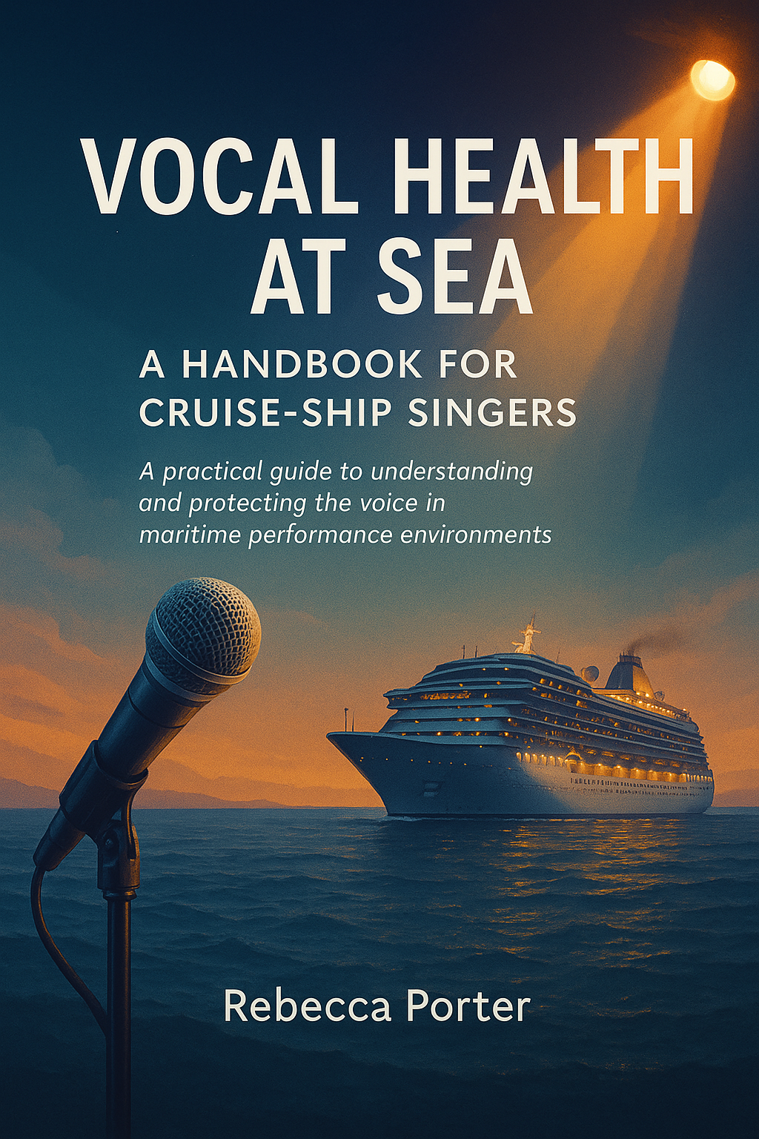About This Handbook
Vocal Health at Sea was created to support professional singers working within the cruise industry- a unique and demanding environment where the voice is both an instrument and a livelihood. Life on board offers extraordinary opportunities, but it also brings hidden challenges that can quietly affect vocal health and stamina.
This handbook is grounded in truth, research, and lived experience. It explores the realities of singing in cruise environments where factors such as air conditioning, humidity changes, background noise, irregular schedules, and heavy performance demands can create strain on even the most experienced voice users. Every singer is different, and that individuality matters. What affects one performer may not affect another, yet all are exposed to similar environmental pressures.
The guidance in these pages combines evidence-informed ideas with honest reflection from working professionals. It is designed to raise awareness of how the cruise environment can impact the voice and to offer practical, achievable tools for maintaining vocal strength, balance, and recovery.
You can dip in and out of the pages as needed, using it as a quick reference or a deeper guide. Written by a cruise professional for cruise professionals, this handbook is practical, honest, and rooted in genuine experience helping singers recognise the impact of their environment and feel empowered to protect their most valuable asset: their voice.

Disclaimer
This handbook is designed as an educational and informational resource for professional singers and voice users working in cruise-ship environments. It does not replace medical assessment, diagnosis, or treatment. The information presented is intended to support awareness and self-care within the performer’s professional scope and should not be interpreted as clinical advice.
Readers are encouraged to seek guidance from qualified medical or allied health professionals such as an ENT specialist, speech, and language therapist, or registered vocal health practitioner if they experience persistent or worsening vocal symptoms.
All recommendations within this handbook are offered in good faith and are based on available research, practitioner experience, and current best practice in vocal pedagogy. Individual results may vary depending on personal health status, environment, and working conditions. The author and contributors accept no responsibility for injury, illness, or adverse effects arising from the application or interpretation of the material contained herein.

Why I Wrote This
After twenty years performing at sea and over two decades immersed in the tourism and entertainment industry, I have seen first-hand the extraordinary dedication it takes to sustain a singing career within the cruise world. My work has taken me from high-energy resident duos on bustling party ships to the solitude and discipline of headlining solo contracts that demand powerful, consistent vocal delivery for months on end. Over time, I developed and performed my own full-scale productions, requiring not only stamina and vocal endurance, but emotional range, artistry, and self-management in an environment that never stands still.
Through these experiences, I’ve witnessed both the beauty and the strain of life at sea. The friendships formed among crew and cast members are unforgettable, yet the long hours, irregular routines, and environmental challenges can quietly wear down even the most experienced performers. As the industry has evolved, expectations have grown higher while recovery time and vocal awareness have often decreased. I have seen brilliant singers who are confident, capable, and enthusiastic pushed to their limits by an environment that demands excellence every night but rarely acknowledges the toll it takes on the voice.
This handbook was created from that understanding. It brings together professional experience and real-life insight to offer practical, compassionate support for singers working at sea. It exists to bridge the gap between performance and wellbeing to raise awareness, provide tools for resilience, and remind those who use their voice for a living that their instrument deserves the same respect as any other. My hope is that this guide becomes a trusted companion for performers at every stage of their journey.

Welcome & Purpose
Performing at sea is one of the most rewarding yet demanding environments for a professional singer. The glamour and travel often mask the physical reality: recycled air, variable humidity, late-night schedules, and minimal control over rest and recovery. Over time, these subtle environmental strains can have a profound effect on the voice even for experienced artists.
Vocal Health at Sea was created to close that gap. It offers practical, evidence-informed strategies that help cruise-ship performers understand how their surroundings shape vocal wellbeing and how to manage those factors proactively. It is not a rule book or medical manual, but a professional guide built from lived experience and the shared wisdom of working artists.

The aim is simple:
• To raise awareness of how shipboard conditions influence vocal health.
• To provide realistic, low-risk strategies for prevention and recovery.
• To empower singers to take ownership of their wellbeing with confidence and clarity.

General vocal-hygiene habits such as avoiding smoking, moderating alcohol, and resting the voice after shouting in loud environments are considered standard professional responsibilities and are therefore beyond the scope of this handbook. The focus here is on ship-specific environmental challenges that passively affect the voice: air-conditioning systems, humidity control, travel fatigue, and the lack of natural recovery time.
Every performer’s voice is unique, and no single routine works for all. This handbook invites curiosity and self-reflection, encouraging you to experiment safely, observe how your body responds, and adapt strategies that suit your own physiology and schedule. Whether this is your first sailing or one of many, these pages are designed to support you offering calm, practical guidance so that your voice remains dependable, expressive, and ready for the stage, wherever the sea may take you.

Hydration: Going Beyond “Enough”
On a cruise ship, the average daily water intake that might sustain you on land is not enough. The constant flow of dry, air-conditioned air is continually pulling moisture from your body not just during performances, but while you sleep, rest, and interact with passengers. Even at rest, the ship’s recycled air continues to draw moisture from your body, hour by hour.
You might notice that what usually feels like enough hydration on land simply doesn’t have the same effect at sea. This is because the air you breathe on board is far drier and constantly circulating so moisture leaves your body faster than it can be replaced. The result is that you can be drinking regularly and still feel tired, dry, or vocally sluggish if your overall intake hasn’t increased.
To stay genuinely hydrated, you need to drink more than you think you need. Most performers find they require at least one to two litres of water per day to maintain balance in a dehydrating environment so they can sing freely. 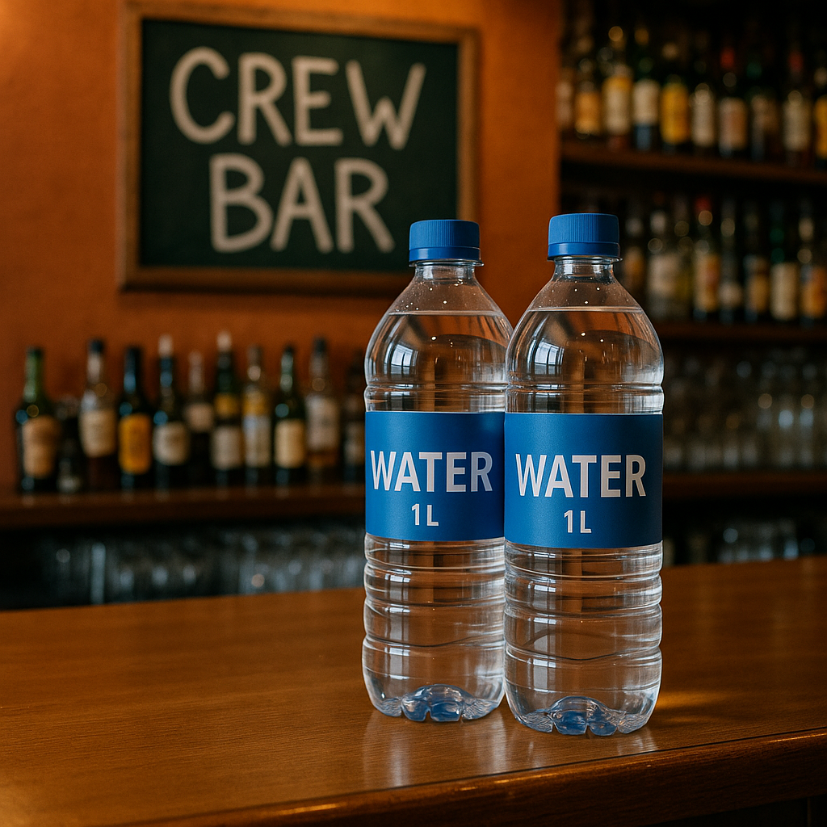
It’s also important to remember that tap water on board is not for drinking. Crew and guest areas run on desalinated water, which can contain minerals or treatment chemicals that are unsuitable for regular consumption. Many crew bars limit water distribution to ensure fairness typically two one-litre bottles per person, per day so make sure you always collect yours. Where possible, stock up ashore so you have an extra supply on hand for show days or longer voyages.

Why Is Hydration So Important for Singing?
For singers, hydration is far more than a wellness habit, it’s a fundamental part of how the voice works. The vocal folds rely on a thin layer of surface moisture to vibrate freely and create sound. When that moisture is reduced, friction increases, making phonation less efficient and more effortful.
Good hydration keeps the mucosal lining flexible, allowing the vocal folds to meet cleanly and move smoothly. This reduces the risk of irritation, strain, or swelling all of which can build up quietly over time in dry environments like cruise ships. When the body and tissues are well hydrated, the sound feels freer, the tone rings more easily, and stamina lasts longer.

Cabin Humidity and Respiratory Comfort
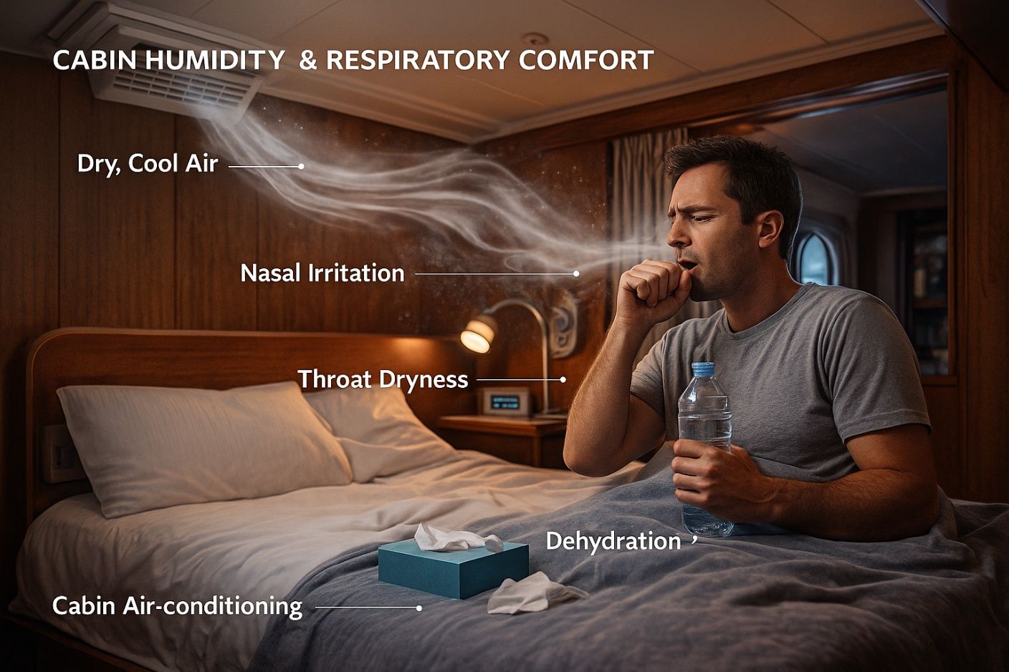
The air-conditioning system on a cruise ship is one of the most common causes of throat dryness, nasal irritation, and respiratory discomfort reported by both crew members and guest entertainers. Many singers describe waking with sore throats, congested sinuses, or even small scabs inside the nose after several days of cabin air exposure. These symptoms are not signs of illness they are the result of continuous dehydration caused by the ship’s recycled, artificially cooled air.
Air-conditioning on board works by removing moisture from the air before it’s redistributed through the ventilation system. This process keeps the ship’s temperature stable and prevents condensation, but it also removes the natural humidity the human body relies on to keep the airways and vocal folds comfortable. Over time, breathing this cold, dry air irritates the mucosal lining of the nose, throat, and trachea the soft tissue that normally protects and lubricates your respiratory tract.
When the airways dry out, tiny cracks can form in the nasal passages, leading to scabbing or light bleeding. The same dryness affects the throat, leaving it scratchy or tender and making phonation feel effortful. For singers, this can build up quietly, leading to reduced stamina and a higher risk of inflammation or infection.
Pathogens can also spread more easily in this kind of environment. Dry air allows fine dust and microscopic particles to remain suspended longer, which means potential irritants or germs can circulate within enclosed cabin spaces. Maintaining even a small amount of moisture in the air helps to weigh these particles down, improving air comfort and reducing irritation.
Cabin types vary across ships, which means airflow and temperature control differ from one contract to another. Some cabins have temperature gauges or adjustable vents, allowing a degree of control. Others particularly older or smaller crew cabins have fixed systems where airflow cannot be redirected or shut off completely. In these spaces, the air may feel constantly cool and forceful, often blowing directly toward the bed or seating area. For singers sensitive to air conditioning, this can quickly become uncomfortable.
Creating a more humid, voice-friendly cabin environment makes a significant difference to both comfort and vocal performance. You don’t need complicated equipment even simple adjustments can help restore balance to the air you breathe.

Practical Ways to Improve Cabin Humidity

Portable Humidifiers: Small Tools, Big Difference
These devices use sound waves to disperse a fine, cool mist into the air, increasing moisture without heat. In small spaces like cabins, they can stabilise comfort noticeably. Clean the unit regularly to prevent bacteria buildup.
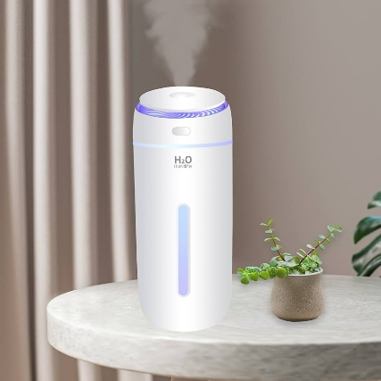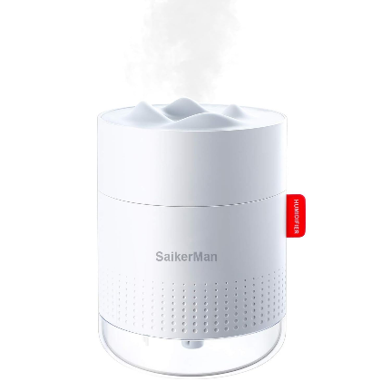

The Damp-Towel Method: A Simple Way to Add Moisture
This traditional method still works remarkably well. Hang a damp towel near the air vent overnight or while relaxing in your cabin. The towel gradually releases moisture into the air as it dries, providing a natural boost to humidity. In cabins with strong airflow, you’ll often find the towel completely crisp and dry by morning unmistakable evidence of how dehydrating the environment really is.
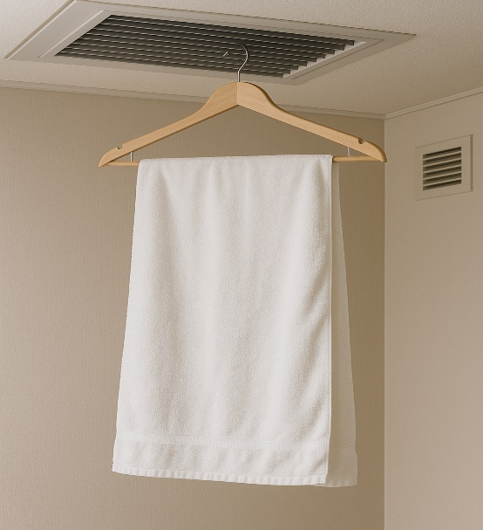
Redirect or Block Direct Airflow While You Sleep or Rest
Cold air blowing onto your face, throat, or chest can dry the mucosa and trigger irritation. Use clothing, a towel, or a small barrier to divert the stream of air away from your bed if you cannot adjust the vent itself.

Vaporisers and Nebulisers: Why Saline Matters
It is neither practical nor effective to bring a humidifier or a damp towel into the wings of a theatre or the corner of a music lounge. In large performance spaces, such methods have minor impact on overall humidity and would look out of place. This is where a small, handheld vaporiser becomes invaluable. Quiet, discreet, and easy to use, it provides targeted hydration moments before you perform, helping your voice feel supple and responsive when you step on stage.
Many professional singers now travel with compact vaporisers or nebulisers, which deliver a fine mist directly into the nose or mouth. These devices are invaluable for counteracting dryness, particularly in environments where air-conditioning and
recycled air are unavoidable. However, what you put inside them matters just as much as how often you use them.
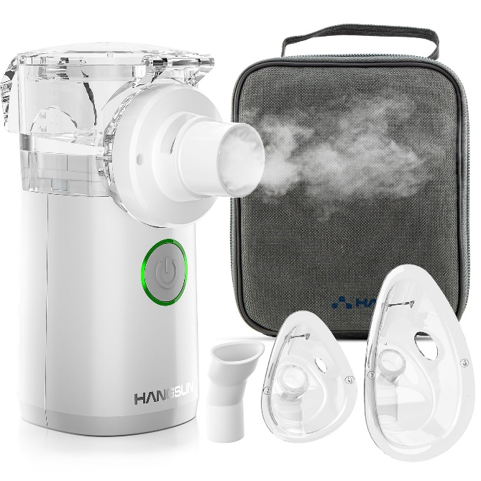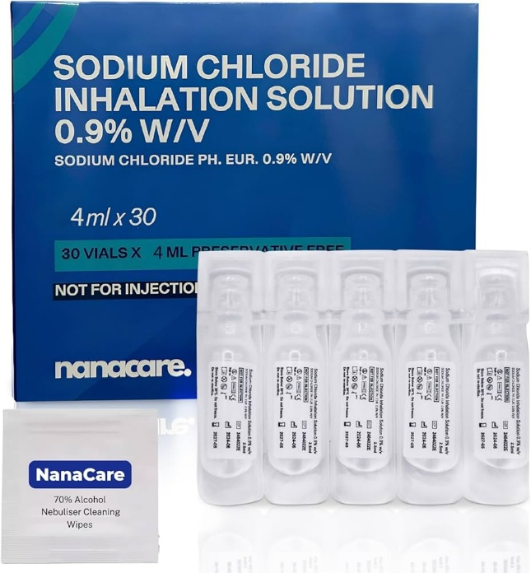
Never use plain water!
Water alone does not match the body’s natural salt balance and can intensify dryness. When water droplets contact already-dehydrated tissue, the imbalance draws additional moisture out of the mucosa, leaving the throat feeling tighter or irritated after use. Because the vapour is being directly inhaled for extended periods, rather than simply humidifying the surrounding air, this imbalance can have a stronger drying effect on the airways and sinuses.
Instead, always use isotonic saline a sterile salt-water solution formulated to mirror the body’s own hydration level. Saline vapour gently restores moisture to the upper airways and vocal folds without shocking the tissues. It supports the mucosal lining’s natural lubrication and eases sensations of tightness, raspiness, or postnasal drip that often develop after prolonged exposure to dry air.
Why saline can feel better:
• It matches the body’s fluid composition, allowing tissues to absorb it comfortably.
• It hydrates without causing swelling, keeping vocal-fold vibration smooth and efficient.
• It helps clear airborne particles and irritants, soothing the nose and throat after performing in dry or dusty venues.
• It may reduce irritation caused by air-conditioning, travel fatigue, or exposure to stage haze.

After Haze Exposure
If you perform in venues that use haze or smoke effects, a few minutes of saline vapour can help clear the residue that coats the throat and nasal passages. This gentle rinse supports recovery, restores comfort, and helps the voice feel freer and more responsive after a performance.
Many performers notice that after singing in venues using smoke or haze machines, the voice can feel restricted as though the output of sound is diminished or the throat simply resists vibration. This can occur because haze particles coat and dry the mucosal surface of the vocal folds, reducing flexibility. A few minutes of saline vapour after exposure helps clear residue, calm irritation, and restore a sense of freedom to the sound.
Compact, travel-friendly, and fast-acting, a handheld vaporiser is one of the most effective pieces of equipment a cruise performer can carry. It bridges the gap between environmental dryness and professional reliability, offering immediate relief whenever the air feels against you.

Steam vs Saline: What Actually Helps the Voice at Sea

Steam Inhalation: What It Really Does
Steam inhalation is a traditional comfort technique, often used by singers to “open” the throat or ease tightness. Steam warms and humidifies the surface of the upper airway mainly the nose, mouth, and throat creating a temporary feeling of relief.
Steam does not reach the vocal folds. The particles are too large and settle before entering the larynx.
However, research shows that steam is still useful because it can:
- reduce sensations of dryness and tightness
- ease vocal tract discomfort
- lower feelings of effort or fatigue after intense vocal use
- help singers feel more comfortable and relaxed before a performance
Steam works on how the throat feels, not on the deeper structures that actually vibrate when you sing. Its effects are short-lived but can be immediately soothing, especially after a heavy vocal day or a demanding show.

Saline Nebulisers and Vaporisers: Deeper, Targeted Hydration
Saline devices work differently. They produce fine particles that can travel deeper into the upper respiratory tract and actually support the moisture balance of the tissues involved in phonation.
Why saline works better than plain water:
- the salt content matches the body’s natural environment
- it prevents the tissue-tightening effect caused by plain water
- it hydrates the surface lining (mucosa) more effectively
- it supports the nasal and oral passages, which directly influence resonance and comfort
Saline does not “fix” the vocal folds, but it hydrates the areas that matter for smooth, efficient voice use especially in environments with dry, recycled air.
On a cruise ship, where air-conditioning runs constantly and humidity is low, saline offers a functional and physiologically meaningful boost to comfort and vocal efficiency.
What This Means for Singers at Sea
Both steam and saline have a place in a singer’s toolkit- they simply serve different purposes.

Steam
- Comfort
- Warmth
- Reduced surface tension
- Relief after strain
- Quick and soothing

Saline Nebulisers
- True mucosal hydration
- Helps counteract air-conditioning dryness
- Supports long-term vocal comfort
- More targeted, more effective

In Simple Terms
Steam makes you feel better.
Saline helps you function better.
Most cruise-ship singers will benefit from using both: steam for quick comfort, saline for deeper moisture and resilience on long, dry contracts.
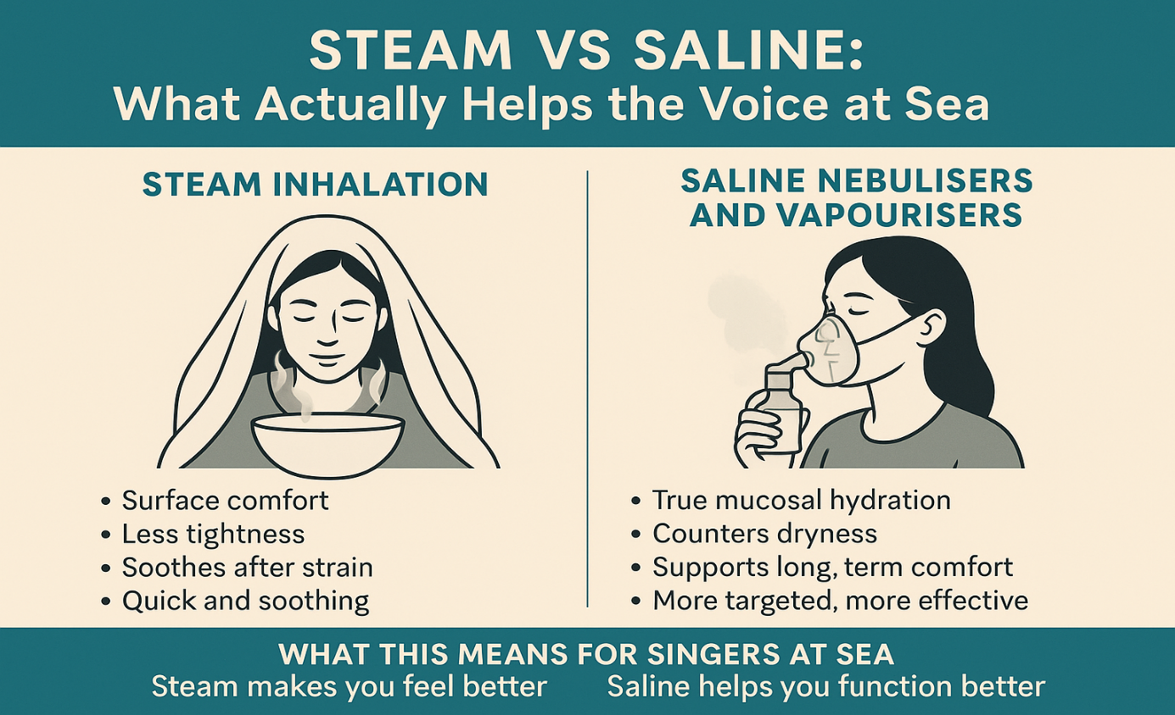
Essential Oils and Diffusers: Supporting Respiratory Comfort at Sea:
Some singers find comfort in using essential oils in a diffuser in their cabin. A diffuser gently releases scented mist into the air, which can make the space feel fresher, cleaner, and more comfortable to breathe in. It also adds a little moisture to the air, helping to ease the dryness caused by constant air conditioning.
Modern studies suggest that certain essential oils especially tea tree, eucalyptus, and lavender can support the feeling of a cleaner indoor environment when used thoughtfully. Tea tree oil is often found to be particularly strong, with notable germ-fighting qualities in vapour form; eucalyptus and lavender can add a sense of openness and calm. Because oils release natural aromatic compounds into the air, lighter, short diffusion sessions are generally best in a small cabin. As with any product, allow fresh air in when possible, and choose good-quality oils that agree with you.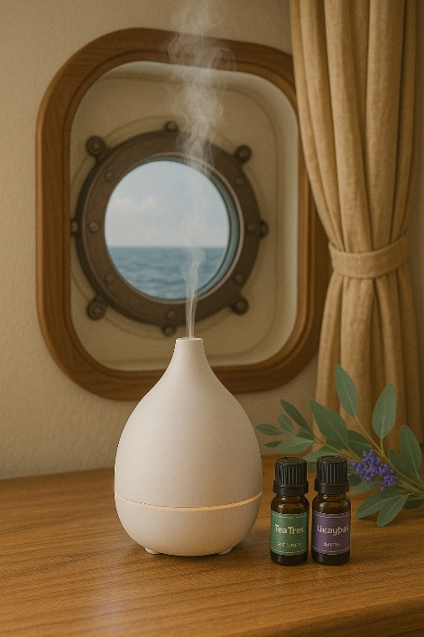
For singers, a diffuser can bring both comfort and atmosphere to the cabin transforming a small space into a place of calm. The gentle scent, soft mist, and quiet hum can help you wind down after a show or prepare to perform with focus and ease. Some singers enjoy eucalyptus before warm-ups, lavender before rest, or a bright citrus blend to lift their energy on long sea days.
Used thoughtfully, essential oils can bring both cleanliness and calm to your space a simple reminder that caring for your voice begins with caring for the air you breathe.
The Golden Remedy: How Honey Can Help Singers at Sea
There is more to honey than meets the eye. Professional singers working at sea face constant environmental strain dry air, recycled ventilation, allergens, and fatigue all of which can leave the voice vulnerable. Honey, long valued in both traditional practices and modern wellbeing, offers a simple, natural way to support the body in these conditions.

Understanding Honey’s Supportive Role
Honey’s value lies in its soothing, gently antimicrobial, and moisture-holding properties. These qualities help calm irritation and maintain comfort in the upper throat the area that air first passes over as you breathe and sing.

Clarifying the Science
Honey cannot physically reach the vocal folds. The folds sit within the airway, while any swallowed substance travels down the oesophagus instead. Only inhaled moisture such as vapour from a humidifier, steam inhalation, or saline mist can directly hydrate the vocal folds themselves.
However, this does not diminish honey’s usefulness. By coating the upper throat and oral cavity, honey soothes the tissues that protect the larynx, encourages saliva flow, and eases irritation caused by dryness or air-conditioning. In this way, it supports overall comfort, which in turn supports easier, freer vocal production.

Surface Comfort and Protective Coating
When allowed to melt slowly and settle in the back of the throat, honey forms a light, natural barrier that calms irritation where dryness often begins.
Both Manuka and thyme honey are popular choices. Manuka’s distinctive compounds provide strong antimicrobial support and tissue comfort, while thyme honey’s naturally aromatic elements can feel clearing and restorative after cooled or hazy venues. These varieties illustrate how traditional options can sit alongside modern tools like saline vapour in a balanced approach to vocal care.

Hydration and the Mucosal Lining
Air-conditioning, haze, and long performance days can quickly deplete the mucosal moisture that keeps the voice flexible. Honey draws and retains moisture, creating a light coating that helps stabilise tissues. Regular use in small amounts such as adding it to tea or letting a little soften in the mouth can support ongoing comfort from the inside out.

Manuka Honey: Natural Defence for Demanding Environments
Manuka honey is renowned for its exceptional antibacterial and soothing qualities. Its distinctive compound, methylglyoxal, allows it to inhibit harmful microbes and calm irritation. For singers performing on cruise ships where exposure to new environments, recycled air, and varying hygiene standards is constant Manuka can function as a natural shield during long contracts when illness is not an option.
However, genuine, high-grade Manuka honey is often expensive. It may therefore be best used as an occasional investment something to keep on hand for periods of heavy workload, illness, or recovery rather than for daily use. Even small amounts of authentic Manuka can provide noticeable comfort when the throat feels inflamed or under strain.

Thyme Honey: Traditional Wisdom and Respiratory Relief
Thyme honey has been valued for generations across the Mediterranean for its ability to soothe the throat and support respiratory comfort. It contains naturally aromatic oils and antioxidants that may help ease dryness and irritation after performing in cooled or hazy theatres.
Compared with Manuka, thyme honey is usually more affordable and widely available, particularly in local honey shops throughout Greece, France, and other Mediterranean regions. Visiting these small producers can be a rewarding way to source fresh, high-quality honey while supporting traditional artisanry.

Everyday Honey: Simple Support for Moisture and Balance
Even standard, good-quality honey provides gentle hydration and encourages natural saliva flow vital for keeping the throat supple. It offers a longer-lasting sense of relief than lozenges or sweets, without the artificial additives that can cause further dryness. For singers managing long days, travel fatigue, or hormonal changes that affect moisture balance, it provides a naturally sustaining boost.

Why Honey Helps Singers at Sea
For cruise-ship performers, honey represents a form of preventative care that bridges tradition and science. It cannot reach the vocal folds directly, but it supports every structure that surrounds and protects them the oral cavity, the pharynx, and the mucosal lining of the throat. Whether through its hydrating, soothing, or antimicrobial qualities, honey helps the body maintain balance in an environment designed to do the opposite.
Honey is not a miracle cure, although many singers find its effects particularly those of high-grade Manuka to be remarkable during times of illness or recovery. It remains one of the most accessible and effective natural aids available to performers at sea, reflecting an important principle at the heart of this handbook: that small, consistent, evidence-informed choices can sustain the voice and the performer behind it through the most demanding of journeys.

Not Everyone’s Cup of Tea (or Honey)
While honey has earned its place as a singer’s standby, not everyone enjoys its sweetness or sticky texture and that’s perfectly fine. The good news is that honey isn’t the only natural option for supporting the throat. Coconut oil, for instance, could possibly offer similar soothing and protective qualities without the sugar content or strong flavour. For those who prefer a lighter, neutral alternative, it can serve as a gentle, plant-based companion to the principles already explored here.


Coconut Oil: A Gentle Alternative for Throat Comfort
For singers who dislike the sweetness of honey or prefer a lighter texture, coconut oil offers a simple, natural alternative. While research on its direct effects on the voice remains limited, its soothing and anti-inflammatory properties have made it a popular choice among performers seeking comfort from dryness and irritation.
Coconut oil is naturally rich in medium-chain fatty acids, particularly lauric acid, which has mild antimicrobial qualities and can help calm irritated tissues. When taken in lesser amounts such as a teaspoon allowed to melt slowly in the mouth it coats the oral cavity and upper throat with a light, protective layer. This lubrication can ease friction and dryness, helping the throat feel more comfortable before or after heavy vocal use.
Unlike honey, coconut oil contains no sugar, making it a suitable choice for those who are managing their sugar intake or sensitive to sweetness. Its neutral, creamy texture may also feel more palatable to those who find honey too thick or sticky.
In dry, air-conditioned environments such as cruise ships, coconut oil’s natural emollient qualities can help offset the effects of continuous dehydration. Although it does not hydrate the mucosa in the same way that water or steam does, it helps maintain a sense of smoothness and flexibility in the throat, reducing irritation from recycled air or haze.
Some singers also use coconut oil as part of “oil pulling,” an Ayurvedic practice believed to cleanse and balance the mouth and throat. While evidence for vocal-specific benefits is anecdotal, performers often report a feeling of freshness and comfort afterwards particularly helpful after a night of dry air, air travel, or back-to-back performances.
Used thoughtfully, coconut oil can complement other forms of vocal care rather than replace them. When paired with good hydration, rest, and proper technique, it can form part of a small, supportive toolkit that keeps the throat comfortable and performance-ready throughout long contracts at sea.

Social Life at Sea: Connection, Culture, and Vocal Survival
Performing at sea is more than a job it’s a way of life. The ship is both home and workplace, audience, and family. Singers are not just expected to perform on stage but also to be part of the social fabric that keeps guests entertained and crew spirits high. For many, this constant visibility the smiling, chatting, mingling, and “always on” energy can be as exhausting as the singing itself.
While some roles allow a degree of privacy on show days, others require vocalists to engage throughout the day, hosting, rehearsing, or performing multiple sets with little to no recovery time. In recent years, cruise contracts have changed dramatically. Many now state “up to five sets a day” a sharp increase from more balanced schedules of two decades ago. This shift reflects the growing demand for live entertainment across venues, but it also places immense pressure on the voice, body, and mental health of those performing.

The Performer’s Paradox
Cruise life is intensely social, yet true solitude is rare. After a high-energy show, many performers may find themselves moving straight into conversations, photos, drink offers, and heartfelt stories. These moments can be rewarding and exciting, but they may also extend the working day far beyond the stage.
There are times when connection could feel uplifting and others when silence may become essential for recovery. Both responses are valid. The paradox lies in recognising when to engage and when to withdraw. Resident solo artists often experience this most strongly: flexible, highly visible, and frequently scheduled for multiple daily sets, they carry the full front-line demand without a band to share the load. Over time, the expectation of being constantly “on” could blur boundaries, leading to fatigue, frustration, or the sense of having to choose between vocal preservation and belonging.
On ships, balance rarely happens by accident it may require conscious awareness and small, intentional choices. Selecting lower-noise venues for social time, allowing for “off-voice” moments in the day, or politely stepping away when the instrument requires silence can all contribute to long-term sustainability. Protecting the voice should never be seen as antisocial; it could instead be viewed as a sustainable act of professionalism and care.

Sound and Vocal Load
Cruise ships are noisy by nature. Air-conditioning systems, background music, clinking glasses, and conversation all merge into a continuous hum that can quietly wear down the voice. In these acoustically “live” environments, people unconsciously raise their speaking volume to compete with the background noise a reflex known as the Lombard effect. Over time, this subtle habit increases vocal effort, tension, and fatigue, especially when combined with performance demands.
Many singers find that using acoustic-filter earplugs, such as Loop-style designs, helps them stay aware of their own volume and avoid over-speaking in social settings. Rather than cutting them off from conversation, these earplugs preserve sound clarity while reducing the need to shout perfect for enjoying a crew-bar celebration or soaking up the atmosphere on deck during party time, without sacrificing vocal recovery. Loop earplugs can be found at www.loopearplugs.com.
In performance settings, adequate monitoring is equally vital. In loud environments, ensure that stage wedges or in-ear monitors are set at an appropriate level to provide clear feedback of your own voice. Without sufficient monitoring, singers may unintentionally over-project or strain to hear themselves, increasing the risk of fatigue or imbalance in vocal production. Having full auditory control allows for more precise technique, consistent tone, and sustainable vocal use across demanding performance schedules.

Alcohol and the Singing Voice
This section is not written to discourage drinking. Alcohol is an accepted part of tourism culture, and for many performers, it becomes naturally woven into life at sea through afterglows, guest generosity, social rituals, or the simple need to unwind after a demanding day. For those who enjoy a drink, it can serve multiple purposes: connection, relaxation, celebration, or comfort. The intention here is not to judge these choices but to provide information, so performers can make informed decisions whether that means choosing to drink less often or simply hydrating more effectively before and after.
From a physiological perspective, alcohol acts as both a diuretic and a local irritant. It accelerates dehydration, reduces neuromuscular coordination, and irritates the mucosal tissue that protects the vocal folds and upper airways. These effects may seem minor at first but can accumulate over time, dulling sensory feedback and masking early signs of fatigue. Even lesser amounts can create a temporary sense of ease while slowing recovery, leaving the voice more vulnerable to dryness, inflammation, and delayed tissue repair.
For many performers, the draw of alcohol is psychological as much as physical. Studies exploring musicians’ habits suggest that drinking can temporarily relieve anxiety, lower self-consciousness, or enhance the feeling of social belonging. Within the cruise environment where work and leisure merge and performers are constantly visible these factors can make alcohol use particularly tempting. What begins as a way to relax or connect may, over time, interfere with true rest and recovery.
Cultural and tourism research also highlights alcohol’s broader social role. Within leisure industries, drinking often represents freedom, inclusion, and participation values that closely mirror cruise entertainment culture. Performers may therefore find themselves navigating a dual identity: maintaining professionalism while existing in an environment that celebrates indulgence. Awareness of this wider context helps explain why even informed singers may continue to drink despite understanding its impact on the voice.
The evidence across clinical, psychological, and tourism research paints a consistent picture: alcohol can dehydrate, irritate, and delay healing, yet its social and emotional appeal remains strong. Understanding both sides allows performers to find their own balance whether that means mindful moderation, improved hydration, or more intentional recovery. It is also worth noting that the body’s ability to process and recover from alcohol changes with age. Younger singers may bounce back more quickly after a late night, whereas mature performers often find the effects on hydration, sleep, and vocal stamina more pronounced. Recognising this natural variation supports realistic self-management and respect for the body’s evolving needs.
As the voice matures, these differences become increasingly significant a reminder that vocal care at sea is not static but adaptive, evolving with experience, environment, and age.
As with any aspect of vocal health, these changes are also influenced by biology. Hormonal balance, particularly in female performers, can interact with age and environment in ways that shape vocal texture, range, and endurance. Understanding these connections forms the basis of the next section, which explores the unique physiology and resilience of the female voice within the cruise-ship context.

The Female Voice
This section is included because it highlights a key area of understanding that is often overlooked. Female singers have frequently compared their stamina, range, and recovery to that of male performers, sometimes wondering why men seem to last longer or recover faster. It’s easy to assume these differences are about strength or training, but science shows they are largely biological. The female voice functions differently and recognising that difference helps singers manage themselves more effectively while also helping colleagues appreciate how varied voices work under pressure.
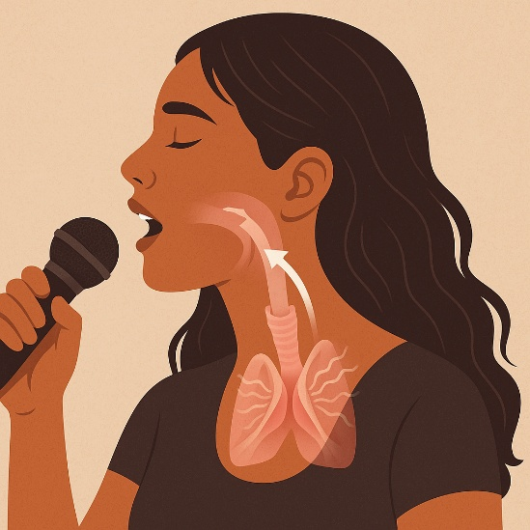

Hormonal Influence on the Voice
Recent studies confirm that oestrogen, progesterone, and testosterone receptors are found within the vocal folds. This means hormonal changes can directly affect the way the folds move, vibrate, and recover. At certain times, the voice may feel slightly heavier or less flexible; at others, it may feel freer and more resonant. These shifts are normal and temporary not a sign of poor technique or inconsistency.
Recognising how hormones subtly influence hydration and vocal fold movement helps female singers manage their workload, recovery, and rest with greater confidence. It also reminds musical colleagues that voices respond differently under the same conditions not because of effort or attitude, but because of physiology.

Frequency and Vocal Fold Demand
Another key difference between male and female voices lies in the number of vibrations the vocal folds make. On average, female vocal folds vibrate around 200 times per second, while male folds vibrate roughly 120 times per second. Over the course of a show, this means the female voice produces millions more vibrations a far greater physical workload for the same length of performance.
This difference matters in live entertainment, especially at sea. Female singers may experience dryness or fatigue sooner in dry, air-conditioned environments simply because their voices are working harder on a mechanical level. It’s not a sign of weakness or poor conditioning- it’s biology.
For musical directors, bandmates, and sound engineers, understanding this helps foster respect rather than assumption. When a female vocalist needs to pace her voice or rest between shows, it is not being “soft” it’s recognising that her instrument endures a higher frequency of vibration and therefore requires balanced care. Awareness of these differences allows the whole team to support performance quality rather than push through preventable strain.

Final Note
Many people dream of travelling the world, doing what they love, and being paid to sing in extraordinary places. It’s a lifestyle filled with adventure, culture, and unforgettable moments. But while cruise life offers incredible opportunities, it also places unique demands on your body and voice. Constant travel, changing climates, late nights, and the expectation to always be at your best can gradually take their toll if left unmanaged.
Vocal health is a personal responsibility. All the guidance, science, and good intentions in the world only have an influence when they are applied with consistency and awareness. No technique or product can replace the daily habit of listening to your body. Learning to rest, hydrate, and pace yourself is not about restriction it’s about protecting your longevity and ensuring you can continue to perform at your best.
Cruise ship singing is both a privilege and a test of endurance. The more you invest in your wellbeing, the more your voice will give back in clarity, stability, and freedom. This handbook was created not to dictate, but to inform and empower: to help you understand why your voice responds the way it does, and how to support it through every environment and stage of your career.
Hopefully, something within these pages has given you the tools to manage any challenges you may face or perhaps prepared you a little better for the cruising ahead. Keep travelling, keep performing, and continue learning from your experience. The stronger your awareness, the more confidently and sustainably you can carry your voice through every ship, every show, and every season at sea.

Further Reading and Resources
The following sources offer deeper insight into vocal health, environmental care, and performer wellbeing. They can help you continue exploring areas that feel most relevant to your own voice and working environment.

Vocal Health and Pedagogy
- Sataloff, R. T. (2017) – Professional Voice: The Science and Art of Clinical Care (4th ed.). Plural Publishing.
A foundational text on professional voice use, anatomy, and clinical care.
- Ware, C. (2018) – Basics of Vocal Pedagogy: The Foundations and Process of Singing. McGraw-Hill.
Clear explanations of healthy technique and vocal function.
- Bozeman, K. W. (2022) – Practical Vocal Acoustics: Pedagogic Applications for Teachers and Singers.
A modern look at resonance and sound production in real-world settings.

Environment, Hydration, and Recovery
- Hemler, R. J. et al. (1997, 2002) – Research on humidity and the vibration characteristics of human vocal folds.
- Feng, X. et al. (2018) – “Impact of Humidity on Airway Comfort in Controlled Environments.”
- Donaldson, S. (2006) – Findings on saline vapour and mucosal health.
- Yao, M. (2016) – Ultrasonic humidifiers and controlled humidity in confined spaces.

Natural Remedies and Preventative Care
- Al-Waili, N. (2011) – “Therapeutic and Antimicrobial Properties of Honey.” Journal of Medicinal Food.
- Samarghandian, S. et al. (2017) – “Protective Effects of Honey on the Respiratory System.” Pharmacognosy Research.
- Wallace, L. (2019) – Research on the protective and soothing properties of virgin coconut oil.

Behaviour, Alcohol, and Performance Culture
- Breitenfeld, D. et al. (2024) – “Alcohol Consumption and Vocal Fatigue in Professional Voice Users.”
- Carlisle, S. & Ritchie, B. (2020) – “Alcohol, Tourism, and Performance Culture.” Tourism Management Perspectives.
- Santa Maria, A. et al. (2020) – Study on awareness versus behaviour among trained and untrained singers.

Gender and the Ageing Voice
- Afsah, M. (2021) – “Hormonal Influence on Female Vocal Physiology.” Clinical Otolaryngology.
- Prakup, B. (2011) – “Acoustic Measures of the Voices of Older Singers and Nonsingers.” Journal of Voice.
- Dehqan, A. & Scherer, R. (2020) – “Age-Related Changes in the Vocal Folds and Their Acoustic Outcomes.”

Professional Support and Organisations
- BAPAM (British Association for Performing Arts Medicine) – www.bapam.org.uk
Free clinical assessments and specialist referrals for UK-based performers.
- Help Musicians UK – www.helpmusicians.org.uk
Financial, mental-health, and medical support for working musicians.
- Voice Study Centre – www.voicestudycentre.com
Professional training and research in contemporary vocal pedagogy.

