LCLM5003: Project Management
(Resit)
Student name: Moazzem hossain
Student ID: 2416062
Moudle : Project Management
Resit Submission date:14 August
Lecturer: Nishi Ramsurrun
Word count: 3544 Words.

Table of Contents

Part A- Project proposal poster 4
Context & Scenario 5
Project Aim 5
Key Objectives 5
Sustainability & Environmental Impact 5
Methodology 6
Stakeholder Map (Power/Interest Matrix) 6
Part B: Reflection 8
What? 8
So What? 8
Now What? 9
Part C: Project Management Plan 10
Introduction 10
Project Description 10
Project Management Methodology 11
Scope Management 11
Work Breakdown Structure (WBS) 12
Quad Chart 13
Gantt Chart & Schedule 15
Stakeholder Involvement 16
Allocation of Resources 17
Risk Analysis 18
Conclusion 20
Reference list 21

Part A- Project proposal poster
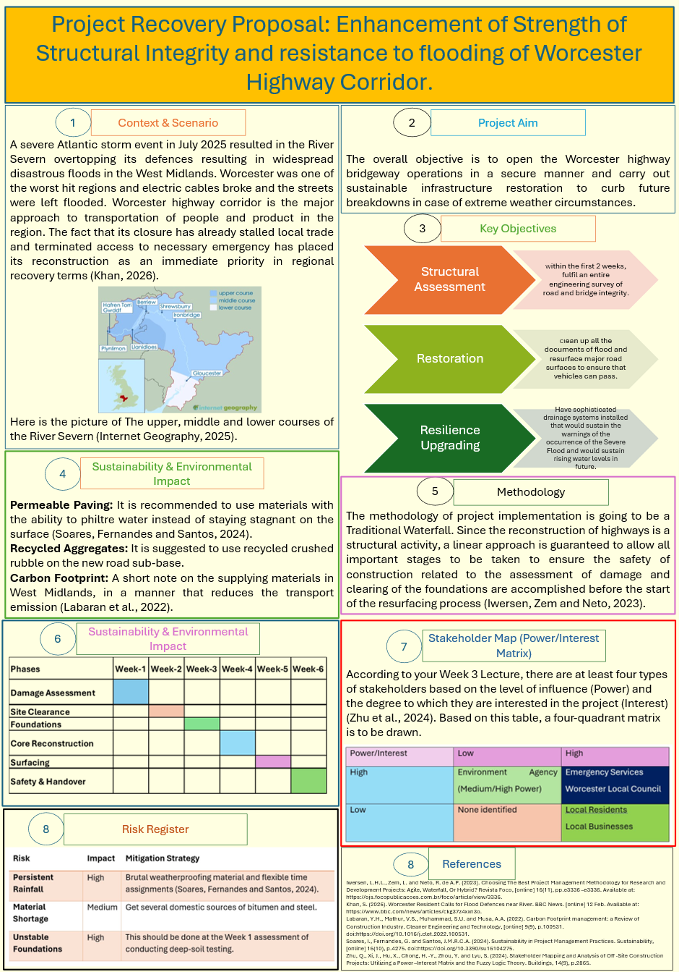

Context & Scenario
A severe Atlantic storm event in July 2025 resulted in the River Severn overtopping its defences resulting in widespread disastrous floods in the West Midlands. Worcester was one of the worst hit regions and electric cables broke and the streets were left flooded. Worcester highway corridor is the major approach to transportation of people and product in the region. The fact that its closure has already stalled local trade and terminated access to necessary emergency has placed its reconstruction as an immediate priority in regional recovery terms (Khan, 2026).

Project Aim
The overall objective is to open the Worcester highway bridgeway operations in a secure manner and carry out sustainable infrastructure restoration to curb future breakdowns in case of extreme weather circumstances.

Key Objectives
- Structural Assessment: Within the first 2 weeks, fulfil an entire engineering survey of road and bridge integrity.
- Restoration: Clean up all the documents of flood and resurface major road surfaces to ensure that vehicles can pass.
- Resilience Upgrading: Have sophisticated drainage systems installed that would sustain the warnings of the occurrence of the Severe Flood and would sustain rising water levels in future.

Sustainability & Environmental Impact
Permeable Paving: It is recommended to use materials with the ability to philtre water instead of staying stagnant on the surface (Soares, Fernandes and Santos, 2024).
Recycled Aggregates: It is suggested to use recycled crushed rubble on the new road sub-base.
Carbon Footprint: A short note on the supplying materials in West Midlands, in a manner that reduces the transport emission (Labaran et al., 2022).

Methodology
The methodology of project implementation is going to be a Traditional Waterfall. Since the reconstruction of highways is a structural activity, a linear approach is guaranteed to allow all important stages to be taken to ensure the safety of construction related to the assessment of damage and clearing of the foundations are accomplished before the start of the resurfacing process (Iwersen, Zem and Neto, 2023).
High-Level Project Timeline (Weeks 1–6)
Phases | Week-1 | Week-2 | Week-3 | Week-4 | Week-5 | Week-6
Damage Assessment
Site Clearance
Foundations
Core Reconstruction
Surfacing
Safety & Handover

Stakeholder Map (Power/Interest Matrix)
According to your Week 3 Lecture, there are at least four types of stakeholders based on the level of influence (Power) and the degree to which they are interested in the project (Interest) (Zhu et al., 2024). Based on this table, a four-quadrant matrix is to be drawn.
Power/Interest | Low | High
High | Environment Agency (Medium/High Power) | Emergency Services  Worcester Local Council
Low | None identified | Local Residents  Local Businesses

Risk Register
Risk | Impact | Mitigation Strategy
Persistent Rainfall | High | Brutal weatherproofing material and flexible time assignments (Soares, Fernandes and Santos, 2024).
Material Shortage | Medium | Get several domestic sources of bitumen and steel.
Unstable Foundations | High | This should be done at the Week 1 assessment of conducting deep-soil testing.

Part B: Reflection

What?
The tutor and the peers both made positive and encouraging feedback about the project proposal poster. The tutor pointed out that the project scenario was realistic, and clearly connected to the situation of the flood in July 2025, and relevant to the assessment brief. The project aim and objectives were stated as being clear, achievable, and regional recovery relevant. The peers also positively referenced to the transparent structure of the poster, especially the references to essential project management tools, i.e. the stakeholder power-interest matrix, the risk register, and the high-level timeline. Based on the sustainability section, they mentioned that it was a strong section particularly the emphasis on permeable paving, recycled aggregates, and minimized carbon emission.
Nevertheless, there was some positive feedback. An idea was raised that the project timeline might be more detailed and with a clearer sequencing out of the activities. Moreover, peers reported that despite the relevance of the risk register, the ownership of risks and contingency actions could have been added. Another suggestion made by the tutor was to improve the defense of the selected approach of project management and establish stronger connections between theory and practice of the finished project management plan.

So What?
The significance of this feedback is that it will confirm that the fundamental framework and path taken by the project are right, which is an indicator of effective knowledge of the management principles of projects in Level 5. The advantages of the project in clarity, relevance, and sustainability imply that the learning outcomes are being achieved, especially in relation to applying the theory to the actual real-life situation (Ásvanyi and Gedeon, 2025). Meanwhile, the improvement recommendations refer to the spheres where further analysis is needed. By enhancing the methodology justification and increasing the planning tools, the scholarly soundness of the project will be enhanced, and the project will cease being a description but will be a critical application of it. This feedback hence offers explicit suggestions on the ways to improve the quality and credibility of the final project management plan (Đajetic et al., 2024).

Now What?
According to the feedback, some of them will be improved in the final project. The project schedule shall be prepared into a elaborate Gantt chart, with dependencies of tasks and milestones. The risk register will be extended to cover risk owners, risk likelihood ratings, and contingency plans. More reasons will be given in justification of the application of the Waterfall methodology, which will be supported by the academic literature and comparison with other methods. Also, more direct correlations between the theory of project management and its application to the case of the highway recovery in Worcester will be established. With this feedback addressed, the final project plan would be more analytical, in details, and professionally strong (Đajić et al., 2024).

Part C: Project Management Plan

Introduction
In July 2025 a terrible weather phenomenon of the Atlantic took place over the United Kingdom. Such a system came with record rainfall in the West Midlands. Consequently, the River Severn had broken its banks and flooded the city of Worcester disastrously. The waters of the flood devastated the complete breakdown of the local electrical grid and disrupted the main transportation connections (Johnson, 2025).
This project is a critical Danger to Life recovery project as defined after the "Project Importance" theme. The main emergency service route is the Worcester highway. Now the ambulances and fire engines are not effective in barely accessible regions. Moreover, lorries with necessary food and medical goods come to the local population through this road, which is the primary one. Reconstruction of this infrastructure is not a normal exercise; it is a special project that should be done to guarantee the safety and survival of the citizens. This project plays a key role in the recovery and stability of the region.

Project Description
The project is aimed at the regeneration of a 5 mile section of the A449 highway. This route passes through the Worcester city centre to the north towards the crossroads where it meets M5 motorway. The employment involves the maintenance of the principle bridge above the Barbourne Brook and stabilization of the embankments surrounding. This infrastructure went under a few days, which resulted in serious erosion and superficial damages (Deeprose, 2021).
The economic worth of this highway to the West Midlands economy is enormous. It is also a major route which links local manufacturers with the national distribution channels. A lot of companies of Worcester base their operations on the use of the just-in-time delivery of parts and products (UK Parliament, 2026). As the road is still closed, these businesses are costing a lot of revenue on a daily basis. The local supply chain is now destroyed, which results in empty shelves in stores and possible loss of jobs in the transport sector. The reopening of this corridor will stabilize the regions economy and revert the trading activities to normalcy, and labor could be moved back into the city (BBC, 2022). With this particular part being restored, the project will allow the greater West Midlands region to get up to full operational capabilities. This project can fit into the definition of a unique venture, which has a start, finish, and particular performance criteria (Iwersen, Zem and Neto, 2023).

Project Management Methodology
The project will use the traditional Waterfall approach where it was initially explained in the proposal poster. The use of waterfall can be explained by the fact that the scope of the project is fixed, the security of the project is critical, and the project needs strict checks of the regulatory regulators at the specific moments (Iwersen, Zem and Neto, 2023). By the fact that the process of infrastructure reconstruction needs successive accomplishment of assessment, foundation works, and resurfacing before moving forward, iterative change cannot be real (Deeprose, 2021). Agile methodologies, conversely, cannot be ideal because their scope is not flexible and their compliance is very stringent. Waterfall approach allows good control by offering stage gates, formal approvals, and structured handover to hold people accountable and ensure quality assurance during the recovery process of the emergency (Carroll, 2019).

Scope Management
After the principles, this project has some well defined outlines that would help in its effective delivery. This is done by defining what is In-Scope and what is Out-of-Scope This helps in avoiding Scope Creep as a project becomes too large to handle effectively.
In-Scope: The project involves the clearance of all the flood debris and hazardous materials on the highway surface. It will entail the structural integrity of the Barbourne Brook bridge to be tested in order to be safe. The crew will be engaged in complete asphalt repair of damaged areas, and install missing safety barriers (Carroll, 2019). Moreover, the project will also improve the drainage culverts to enhance future flood resilience so that the infrastructure meets the current safety standards (Deeprose, 2021).
Out-of-Scope: The project will not include any long term dredging or widening of the river Severn. It is not applied in terms of repairing domestic dwellings owned by individual households or commercial properties that are affected by the flood. It is not proposed to build permanent new flood walls since it is the prerogative of the Environment Agency (Iwersen, Zem and Neto, 2023). Last but not least, maintenance of the local side streets that are not directly related to A449 route is out of scope. These strict boundaries will allow the project team to direct all of the resources toward achieving the main goal of safely reopening the highway (Johnson, 2025).

Work Breakdown Structure (WBS)
A Work Breakdown Structure (WBS) is a deliverables based structure of project items. WBS assists in specifying the overall extent of the project since it divides it into work packages which are manageable. This chain of command helps to guarantee that no task goes unaccounted and the task is properly assigned (Narvaez et al., 2020).
In the case of Worcester highway restoration, the project is separated into four primary step procedures: Initiation, Planning, Execution and Closing. The phase of the with depiction on the most detailed is the stage of the implementation, which concerns actual rehabilitation of the infrastructure. It is good to divide this stage into smaller parts such as Damage Assessment and Surface Layering which will enable the project manager to follow the progress made and use resources optimally (Testorelli, Tiso and Verbano, 2024).
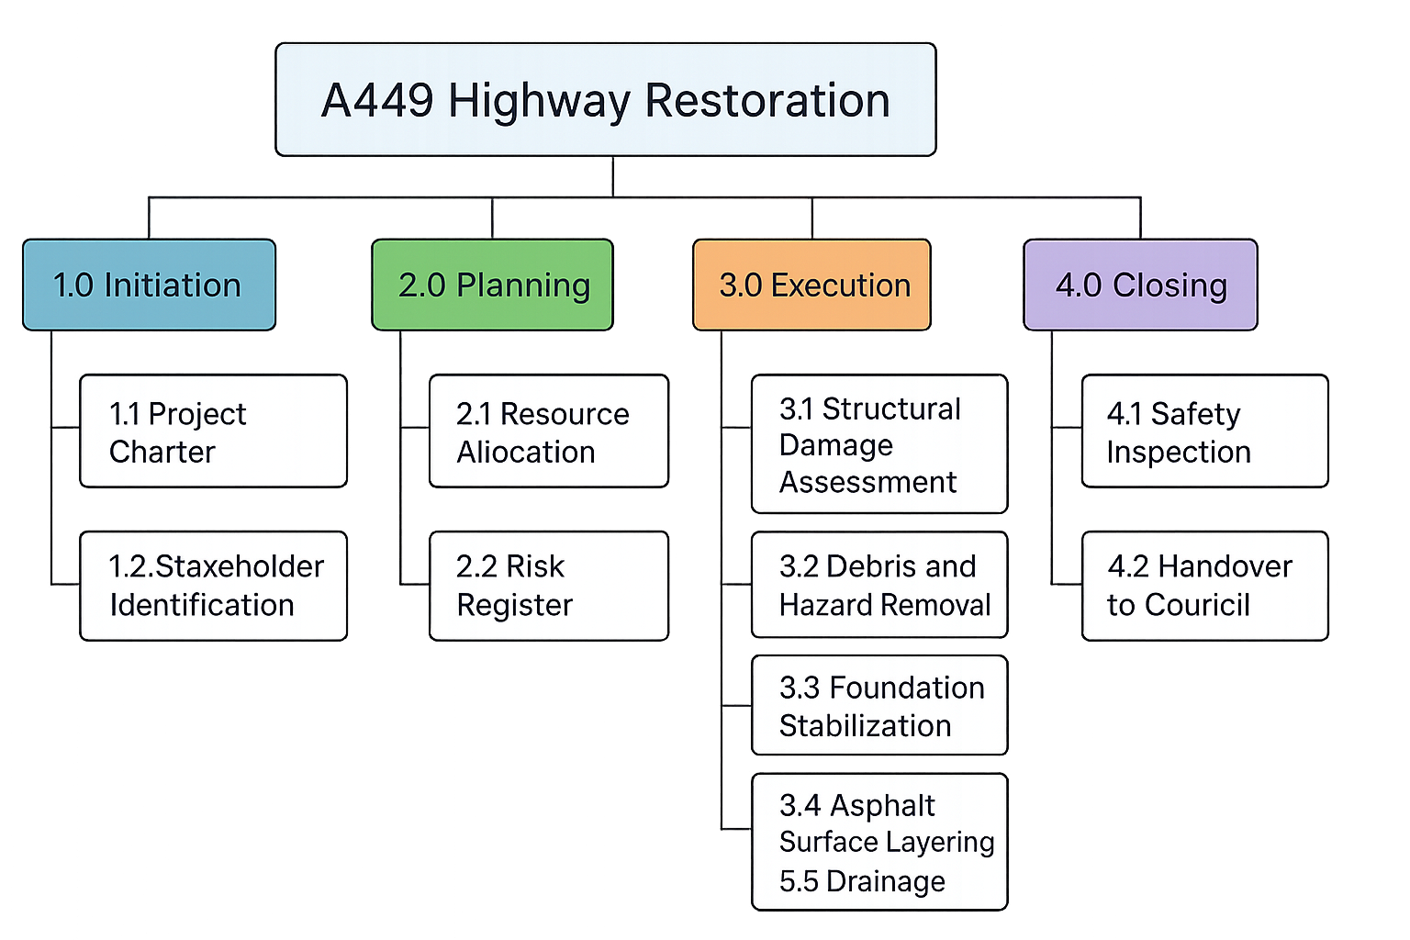
Figure 1: Work Breakdown Structure (WBS). Source: Author.

Quad Chart
A Quad Chart is the potent tool that helps to understand what precisely the project can be. It is a one-page summary, which is both visual and description-oriented. It is useful to plan an idea into bits that are easy to manage prior to the execution stage (Alam et al., 2025).
Purpose (Aims and Objectives) | The main goal of the project is to reopen the A449 highway corridor after the disastrous July 2025 West Midlands floods. The project will seek to fix the structural damages, regain safe connectivity in transport, and enhance flood resilience of the corridor (Johnson, 2025). Considerable goals entail the achievement of a structural integrity audit of the Barbourne Brook bridge. This elimination of dangerous waste on the road and the restoration of emergency access in the first two weeks (Khan, 2026). Another objective of the project will be to bolster the drainage infrastructure and mend damaged sections of roads to provide operational safety in the long run.
Stakeholders | These key stakeholders are Worcester Local Council, the project sponsor and provider of funds and approvals. The stakeholders, the West Midlands Emergency Services, are twenty-high-ho power, twenty-high-interest as they rely on the corridor to respond to the emergency in a short period of time (Khan, 2026). The Environment Agency is the control body that makes sure that construction activities are in line with environmental and flood-resilience regulations. The secondary stakeholders are the local citizens, commuters, and business owners. They use the A449 as their means of transport, business, and mobility (Testorelli, Tiso and Verbano, 2024). Contractors and engineering teams also constitute the key stakeholders of the reconstruction work implementation (Deeprose, 2021).
Desired Results (Success Criteria) | The project shall be available to be said successful in case the A449 highway corridor is safely opened to normal traffic in less than six weeks. The essential success criteria are ensuring that the Barbourne Brook bridge passes all the necessary structural and loading tests, the loss of flood debris, and installation of a better drainage system, which would be able to handle heavy rains (Labaran et al., 2022). Furthermore, the road has to comply with all the transportation safety requirements and be inspected by the final engineering standards before opening (Soares, Fernandes and Santos, 2024). These deliverables will be a win to allow the region to move more freely and increase its resilience against future floods.
Measures of Success (Timeline and Budget) | The project will be Scheduled success will be determined by whether the budget of efficiency in emergency recovery is upheld and whether the project will be completed based on the 42-day project schedule of completion. The milestones are the completion of damage assessment and the clearing of rubbish during the second and third week (Pinilla et al., 2022). This completes the principal reconstruction and drainage construction during Week 5 of execution and performing some final inspections on undertaking the project. It is estimated that by the end of Week 6, the project will be completed by safe reopening of the highway and handing over the local authorities (Đajić et al., 2024).

Gantt Chart & Schedule
Project time planning is one of the key components of the project life cycle. A Gantt Chart is used to visualize the project- schedule to know what should be done and when. This chart not only provides the series of activities but also makes sure that the project does not exceed its assigned life period (Đajic et al., 2024).
Dependencies in this schedule is a critical aspect that is to be managed. There is a finish to start dependency between the drainage infrastructure and the road surface within this project. In particular, before "Road Resurfacing" could start, it will have to be preceded by full completion of "Drainage Repairs." In the event that the surface is installed even before the drainage is installed, there are high chances that the new road would fail during the subsequent rainfall. Such a logical flow is what guarantees that the stages of the project such as Realisation are of high quality (Testorelli, Tiso and Verbano, 2024).
The table below presents the data needed to create the Gantt Chart and there is the linear flow of the project initiation to handover.
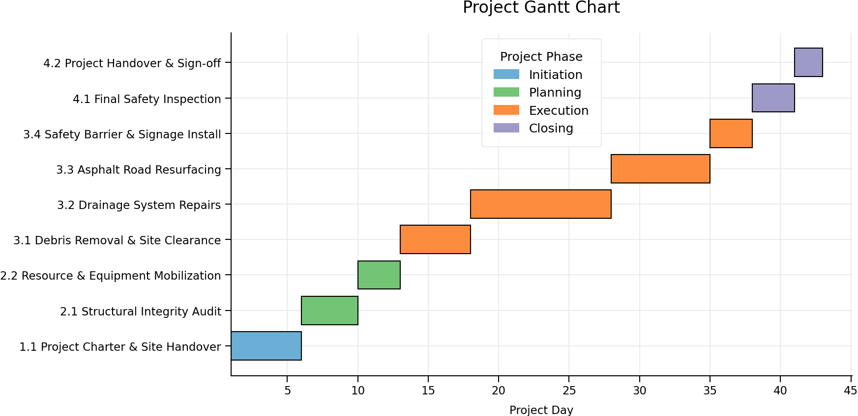
Figure 2: Project Gantt Chart. Source: Author.

Stakeholder Involvement
Stakeholders are people or groups of people who are interested in the project or group which are influenced by the outcome. In the case of the Worcester highway restoration, it is important to recognize and control these groups to achieve success. A stakeholder analysis will assist the project team learn about the authors of power and those who need communication the most (Zhu et al., 2024).
Stakeholder Analysis:
- Environment Agency (High Power/Medium Interest): They issue the required permits of working along the river Severn. They are supposed to ensure that the project comes to the standards of environmental and flood-resilience (Zhu et al., 2024).
- Emergencies (High Power / High Interest): This category covers the police, ambulance and fire services. They need the reopening of the road to help to respond to life-threatening calls (Brewster et al., 2024).
- Local Businesses (Low Power / High Interest): These stakeholders depend on the highway when making deliveries and getting customers. Although they cannot manage the project, their survival is linked to their pace of economic survival (Deeprose, 2021).
Communication Strategy:
The project will employ various communication levels using Power/Interest Matrix. Managed Closely will be applied to groups that are high in power with high interest. As an example, the project manager will conduct briefings with Emergency Services on a daily basis to update the access with real-time access (Testorelli, Tiso and Verbano, 2024). The Environment Agency will be given weekly reports on technical matters to check compliance. These local businesses and residents will be informed regularly through social media a few times a month and a specific project web site. This organization will make expectations controlled and minimize risks in the project (Đajic et al., 2024).

Allocation of Resources
Resource planning refers to the procedure of determining all the individuals, equipment and materials required to complete the project. Efficient resource planning is the key to making sure that the project is completed when the emergency budget has not been consumed (Deeprose, 2021).
Human Resources:
The multi-disciplinary team is needed in the project as the recovery environment is complex. Key personnel include:
- Civil engineers: The structural testing and drainage designing done by 2 senior engineers would be required.
- Site Managers: Two managers to facilitate the day to day activities and ensure that health and safety standards are being achieved at the site.
- Manual Labor Teams: There will be 20 skilled laborers separated into two shifts, which will ensure that work proceeds 16 hours daily.
- Administrative Support: The assistant will have one project coordinator who will handle documentation and stakeholder communications.
Physical Resources:
The rebuilding will need post-flood conditions of heavy materials and machineries.
- Heavy Machinery: This consists of 2 massively used excavators to remove the rubble and 3 steamrollers to spread the asphalt.
- Materials: The asphalt used to cover the 5-mile road was of high quality, and the lengthy drainage pipes were reinforced concrete, which was to replace broken culverts (Brewster et al., 2024).
- Safety Gear: Temporary signs and road barriers, high viewability signs of the construction area.
Budget Projection:
This emergency restoration is estimated to cost a total of 2500,000. According to the resource planning models in Week 2, the budget is budgeted in the following way:
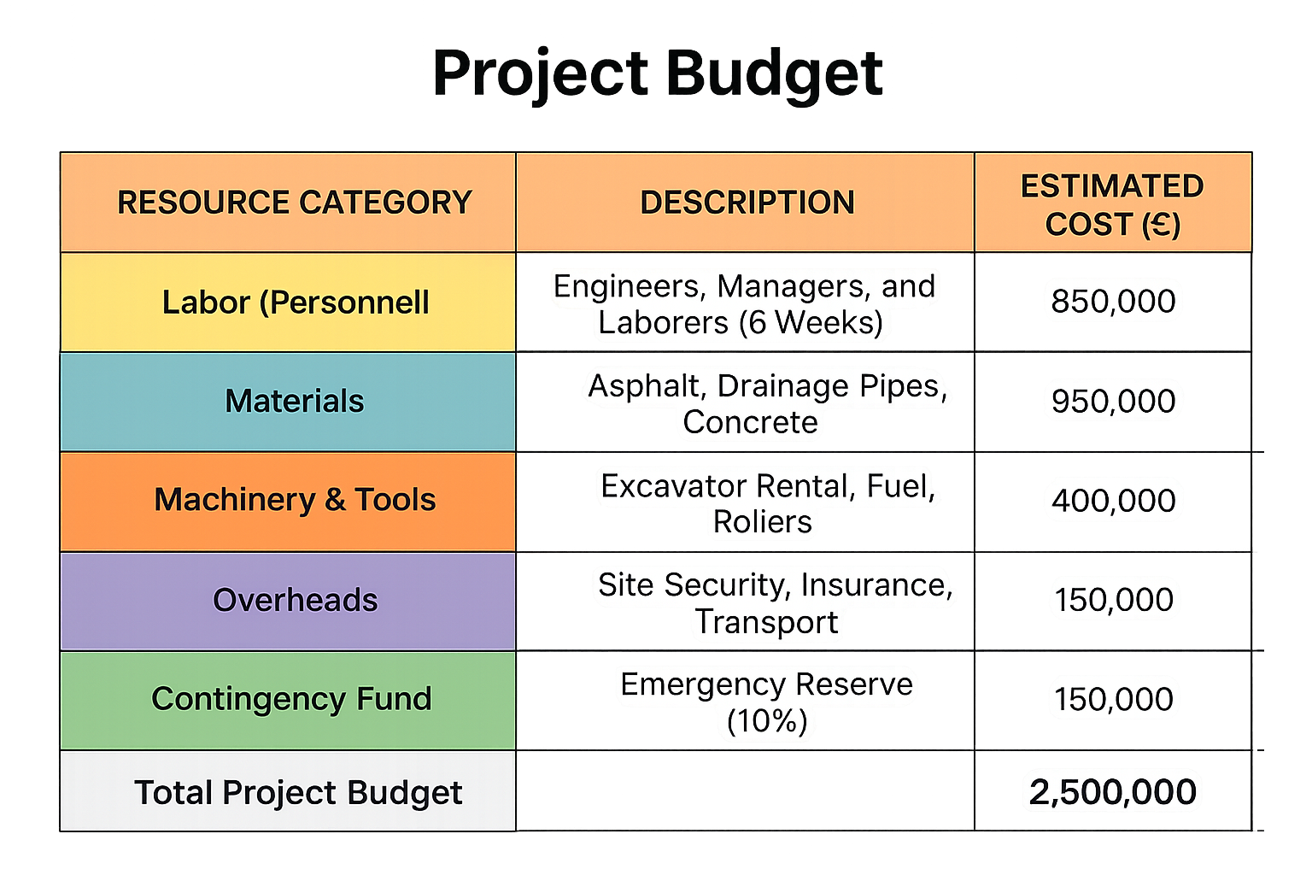
Figure 3: Project Budget. Source: Author.

Risk Analysis
Risk is a constant characteristic of any project since its novelty and uncertainty. In the case of the Worcester highway restoration, these risks are to be identified and analyzed as an ongoing process that determines the project to satisfy its performance requirements (Deeprose, 2021).
The standard risk assessment formula is given on the project: Consequence = Impact x Likelihood. Both categories assign each risk a score ranging between 1 and 5 to define the priority level of each risk.
Risk Register:
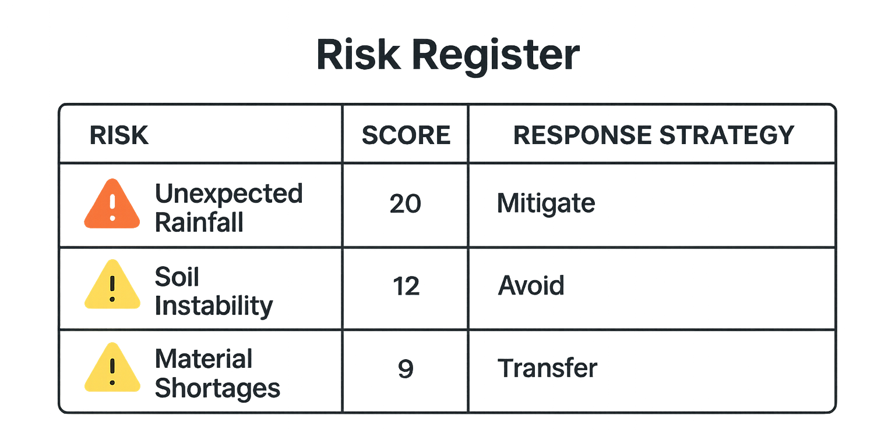
Figure 4: Risk Register of the project. Source: Author.
There are three major risks in the project that may slow down the project. The greatest threat is an unforeseen rainfall which poses a high probability of stalling asphalt work and further flooding. The stability of the soil is also under consideration since erosion in the underground area can expose the road base to instability. Lastly, material shortages may halt the implementation phase where certain drainage pipes fail to delivery in a timely manner. These factors have to be managed to ensure that the timeline is put in check.
Reduction Strategies: In order to prevent these risks, operative precautions are going to be implemented by the team. In order to prevent delays in the supply chain, we will maintain backup materials on-site. To mitigate the risk of weather, we will adopt the met-office tracking and plan high-sensitivity activities on dry days. In the case of soil instability, ground-penetrating radar will be deployed in the initial inspection to detect the presence of underground voids prior to the arrival of heavy machinery at the location (Johnson, 2025).

Conclusion
Finally, the A449 Worcester highway restoration is a solid Project Management Plan that entails providing a framework towards the restoration. The principles of scope management and its inclusion, the stakeholder analysis, and the allocation of resources in a structured manner have helped the project to have a quick and strengthened recovery. The plan does not only stop at repairing the city but improves the infrastructure of the city to be in a position to handle the climate challenges in future. The reopening of this main route will not only reestablish the local supply chain in the region, but also benefit the local companies, as well as safeguard the area residents in the long run. During this project, we were able to observe how a crisis can be transformed into a long term healing when we are able to be disciplined.

Reference list
Alam, S., Islam, K.A., Miah, R., Afrin, S., Islam, Md.A., Hoque, Md.R. and Mahmud, I. (2025). Key Success Factors of Knowledge Management Systems for Optimizing Organizational performance: a PRISMA-based Systematic Literature Review. Heliyon, [online] 11(16), p.e44097. doi:https://doi.org/10.1016/j.heliyon.2025.e44097.
Ásványi, K. and Gedeon, E. (2025). Enhancing Sustainability Consciousness in Higher Education: Short- and long-term Impacts of a project-based Learning Approach. The International Journal of Management Education, 23(3), pp.101235–101235. doi:https://doi.org/10.1016/j.ijme.2025.101235.
BBC (2022). River Severn Flooding aftermath: ‘What a Difference a Week makes’. BBC News. [online] 3 Mar. Available at: https://www.bbc.com/news/uk-england-hereford-worcester-60574762.
Brewster, L., Rae, J., Maria, S. and Jones, D. (2024). Beyond the sirens: a Scoping Review on Paramedic Safety during Response and Transportation. Journal of Transport & Health, 39(1), pp.101922–101922. doi:https://doi.org/10.1016/j.jth.2024.101922.
Carroll, J. (2019). Project Management. Southam, Warwickshire, England: Easy Steps Ltd.
Đajić, M.J., Ciric Lalic, D., Vujičić, M.D., Stankov, U., Petrovic, M. and Đurić, Ž. (2024). Development and Validation of the Project Manager Skills Scale (PMSS): an Empirical Approach. Heliyon, 10(3), p.e25055. doi:https://doi.org/10.1016/j.heliyon.2024.e25055.
Deeprose, D. (2021). Project Management. Oxford: Capstone.
Iwersen, L.H.L., Zem, L. and Neto, R. de A.P. (2023). Choosing The Best Project Management Methodology For Research and Development Projects: Agile, Waterfall, Or Hybrid? Revista Foco, [online] 16(11), pp.e3336–e3336. Available at: https://ojs.focopublicacoes.com.br/foco/article/view/3336.
Johnson, T. (2025). Record-breaking Extreme Weather New ‘norm’ in UK Set to Affect Infrastructure | New Civil Engineer. [online] New Civil Engineer. Available at: https://www.newcivilengineer.com/latest/record-breaking-extreme-weather-new-norm-in-uk-set-to-affect-infrastructure-15-07-2025/ [Accessed 6 Apr. 2026].
Khan, S. (2026). Worcester Resident Calls for Flood Defences near River. BBC News. [online] 12 Feb. Available at: https://www.bbc.com/news/articles/ckg37z4xxn3o.
Labaran, Y.H., Mathur, V.S., Muhammad, S.U. and Musa, A.A. (2022). Carbon Footprint management: a Review of Construction Industry. Cleaner Engineering and Technology, [online] 9(9), p.100531. doi:https://doi.org/10.1016/j.clet.2022.100531.
Narvaez, A.C., Fernández, A.P., Mateo, M.O. and Pérez, P.B. (2020). Integration of Cost and Work Breakdown Structures in the Management of Construction Projects. Applied Sciences, [online] 10(4), p.1386. Available at: https://www.mdpi.com/2076-3417/10/4/1386.
Pinilla, L.S., Artelt, S., Burimova, A., Lopez de Lacalle, N. and Toledo-Gandarias, N. (2022). Project Success Criteria Evaluation for a Project-Based Organization and Its Stakeholders—A Q-Methodology Approach. Applied Sciences, [online] 12(21), p.11090. doi:https://doi.org/10.3390/app122111090.
Soares, I., Fernandes, G. and Santos, J.M.R.C.A. (2024). Sustainability in Project Management Practices. Sustainability, [online] 16(10), p.4275. doi:https://doi.org/10.3390/su16104275.
Testorelli, R., Tiso, A. and Verbano, C. (2024). Value Creation with Project Risk Management: a Holistic Framework. Sustainability, [online] 16(2), pp.753–753. doi:https://doi.org/10.3390/su16020753.
UK Parliament (2026). SRN0028 - Evidence on Better roads: Improving England’s Strategic Road Network. [online] Parliament.uk. Available at: https://committees.parliament.uk/writtenevidence/46293/html/ [Accessed 6 Apr. 2026].
Zhu, Q., Xi, J., Hu, X., Chong, H.-Y., Zhou, Y. and Lyu, S. (2024). Stakeholder Mapping and Analysis of Off-Site Construction Projects: Utilizing a Power–Interest Matrix and the Fuzzy Logic Theory. Buildings, 14(9), p.2865.

