Name of the Team: BCRD
Team Members
Student Name | Student ID
Benjamin | 2003557
charlie wilkinson | 2104032
rhys davies | 2104756
dylan jones | 2106499

Team Evaluation (Self Evaluate your Team) (1 – Worst, 5 – Best)
 | 1 | 2 |  | 3 |  | 4 |  | 5
Benjamin |  |  |  |  | x
Charlie |  |  |  |  | x
Rhys |  |  |  |  |  |  | x
Dylan |  |  | x
N/A
Rate your Teams Contribution with a scale of 1 to 5 (1 No Contribution and 5 Excellent Contribution)
Add your comments on Team Evaluation: (Justify your evaluation)
N/A:
Rhys: will contribute with the screenshots and writing
Dylan: will help with the screenshots
Charlie: will contribute to the work and help out
Benjamin: highly motivated and will get his work done

Table of Contents
Abstract 4
Introduction 4
Task 1 4
Task 2 11
Task 3: OBSERVATIONAL TASK 15
On a SOHO (Small Office/ Home Office) Network, if you want to consider enhancing security, what actions could you do? Write on your own words in the context of your worksheet activities to demonstrate security policies. 15
Failover Clustering for high availability systems/services 16
Completing the worksheets 1 and 2 as a Team, use your knowledge and understanding to draft a network policy for an Enterprise Network which operates in multiple locations, considering critical business applications high availability practices and security practices. State all assumptions made. 17
Write a brief reflection on the tasks completed in this worksheet. (Not more than 200 words) 20
References 20

Figure 1 This screenshot shows the windows computer accessing the local drive 5
Figure 2 This screenshot shows the folder being created in the local drive 5
Figure 3 This image shows the confidential file having its permissions changed 6
Figure 4 This image shows the full list of permissions and what permissions each user has for that specific file 6
Figure 5 This screenshot shows the user having their permissions changed 7
Figure 6 This screenshot shows the inside of the text document 7
Figure 7 This screenshot shows a user setting up a server in server manager 8
Figure 8 This screenshot shows the group policy management application being used to manage different policies for each user so they don’t access stuff they are not supposed to 8
Figure 9 This image proves that the main user cannot access the control panel after having their permissions revoked 9
Figure 10 This image shows the user adding a new organisational unit to the folder in the group policy managment program 9
Figure 11 This shows that the PC is the domain controller 10
Figure 12 This image shows the folder for the active directory and computer program being created 10
Figure 13 This shows the folder being moved 11
Figure 14 This image proves that the main PC cannot install programs onto the computer itself becuase there were restrictions put in place 11
Figure 15 This image shows the network cards information 12
Figure 16 This image shows the route the network traffic will take 12
Figure 17 This image shows an additional server being created 13
Figure 18 This image shows the computer management software on server 2 13
Figure 19 This image shows the internet information services manager options 14
Figure 20 This shows a successful ping has been completed 14

Abstract
a

Introduction
a

Task 1
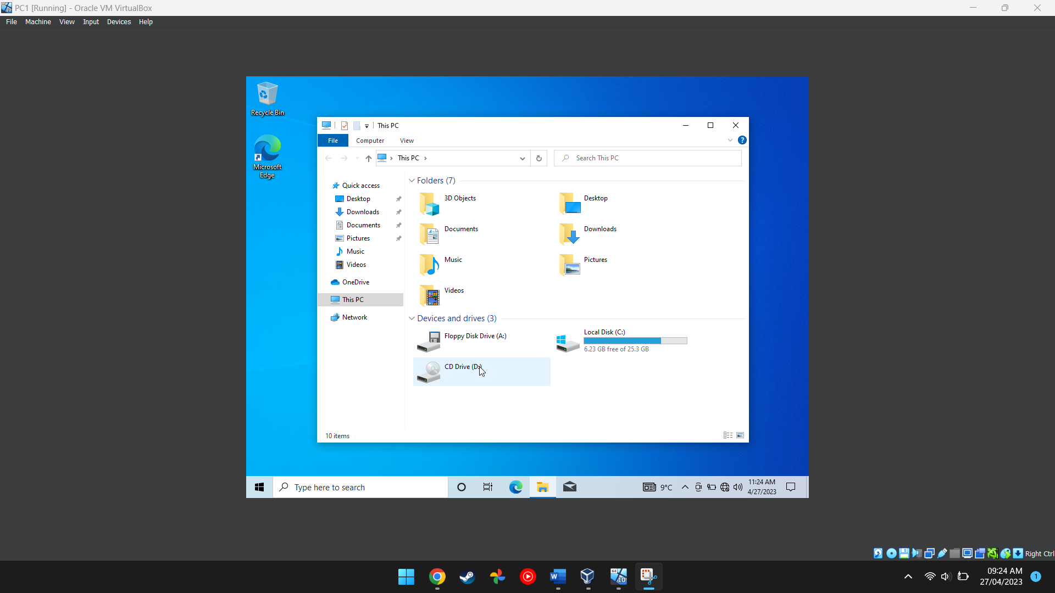
Figure 1 This screenshot shows the windows computer accessing the local drive
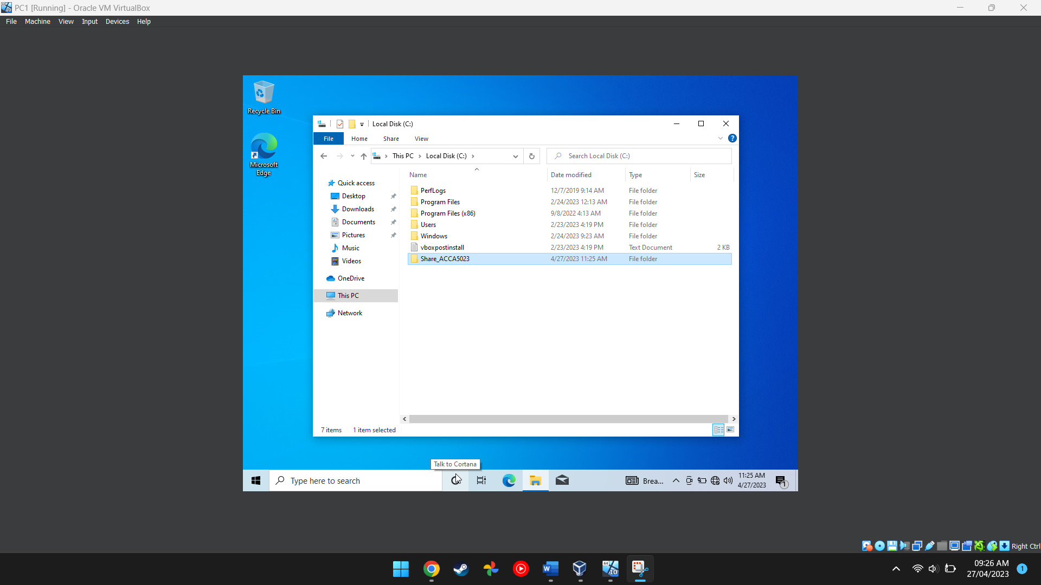
Figure 2 This screenshot shows the folder being created in the local drive
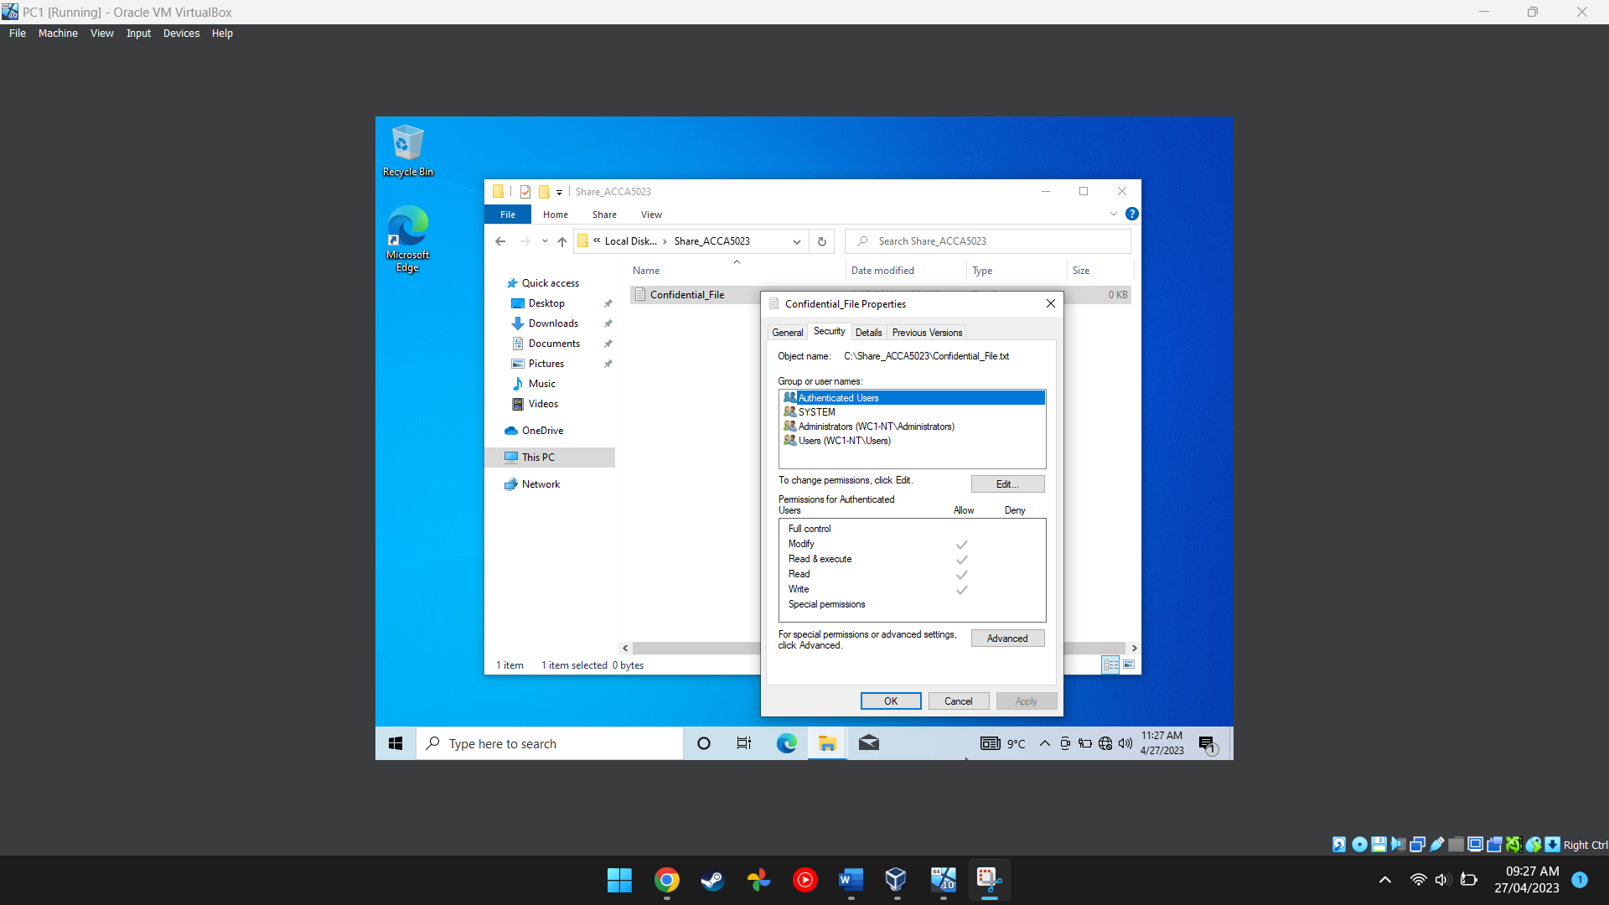
Figure 3 This image shows the confidential file having its permissions changed
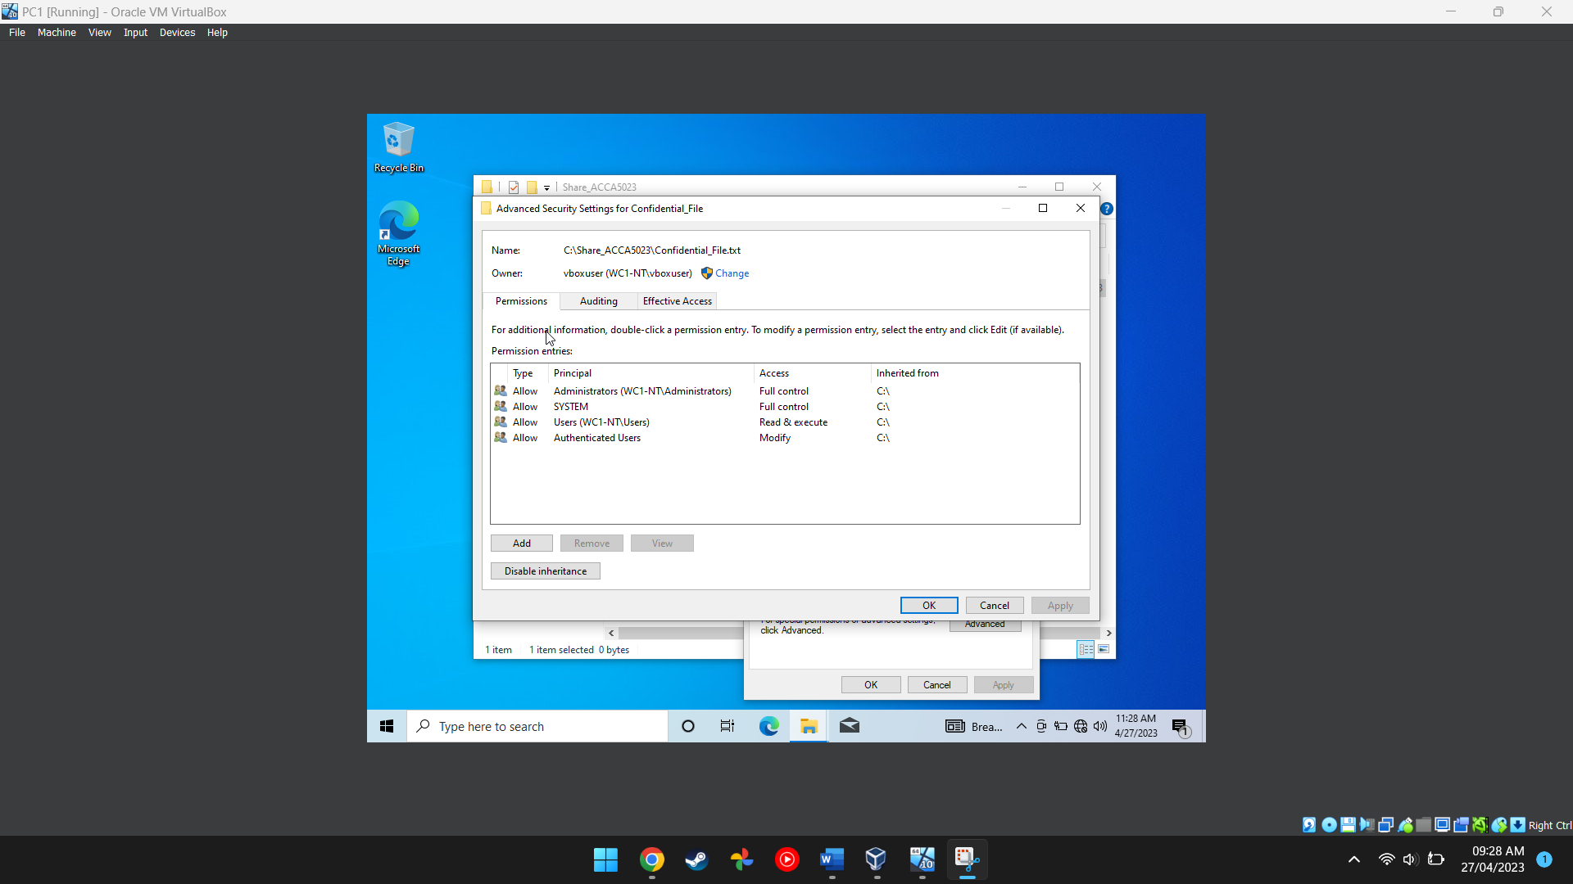
Figure 4 This image shows the full list of permissions and what permissions each user has for that specific file
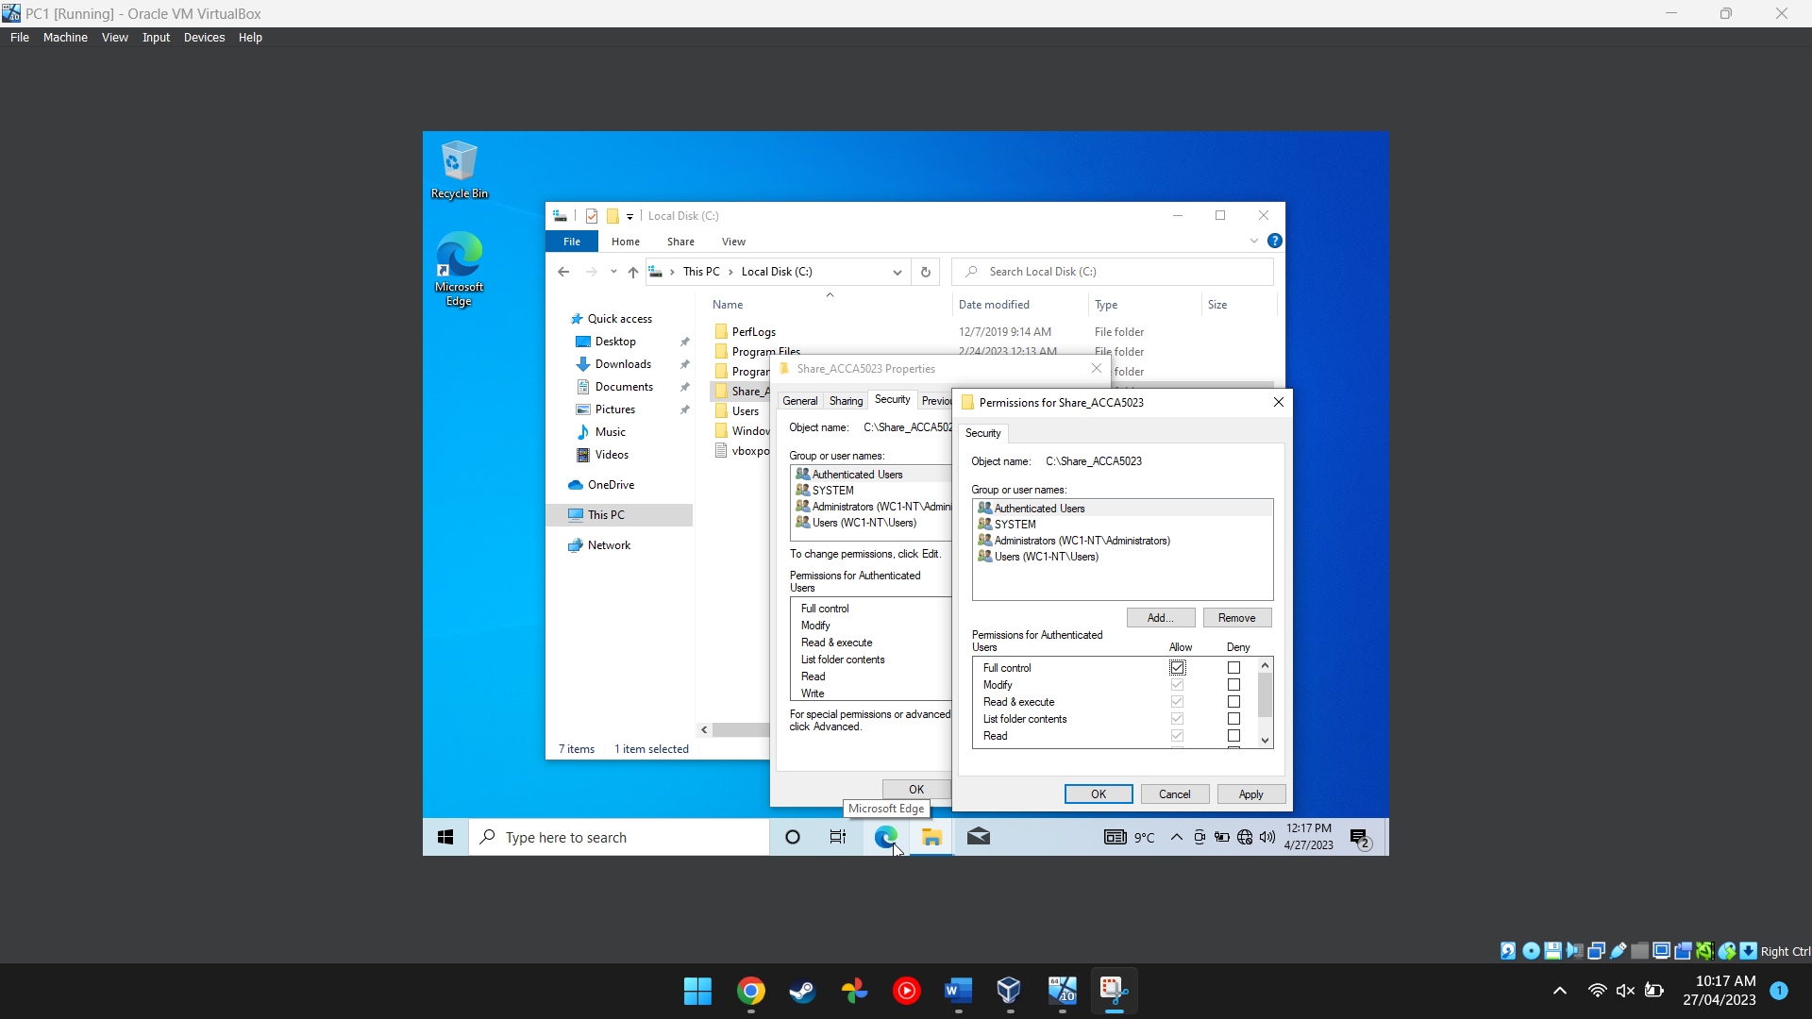
Figure 5 This screenshot shows the user having their permissions changed
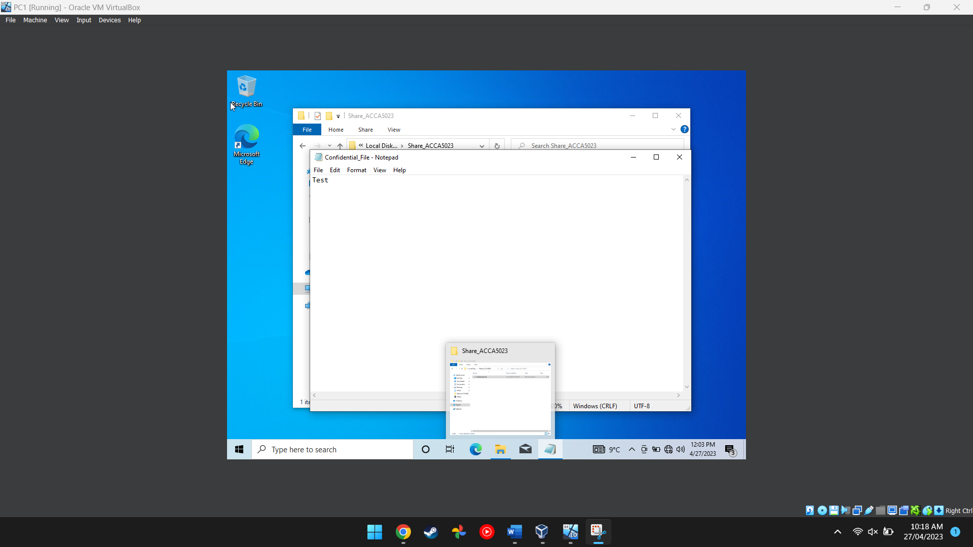
Figure 6 This screenshot shows the inside of the text document
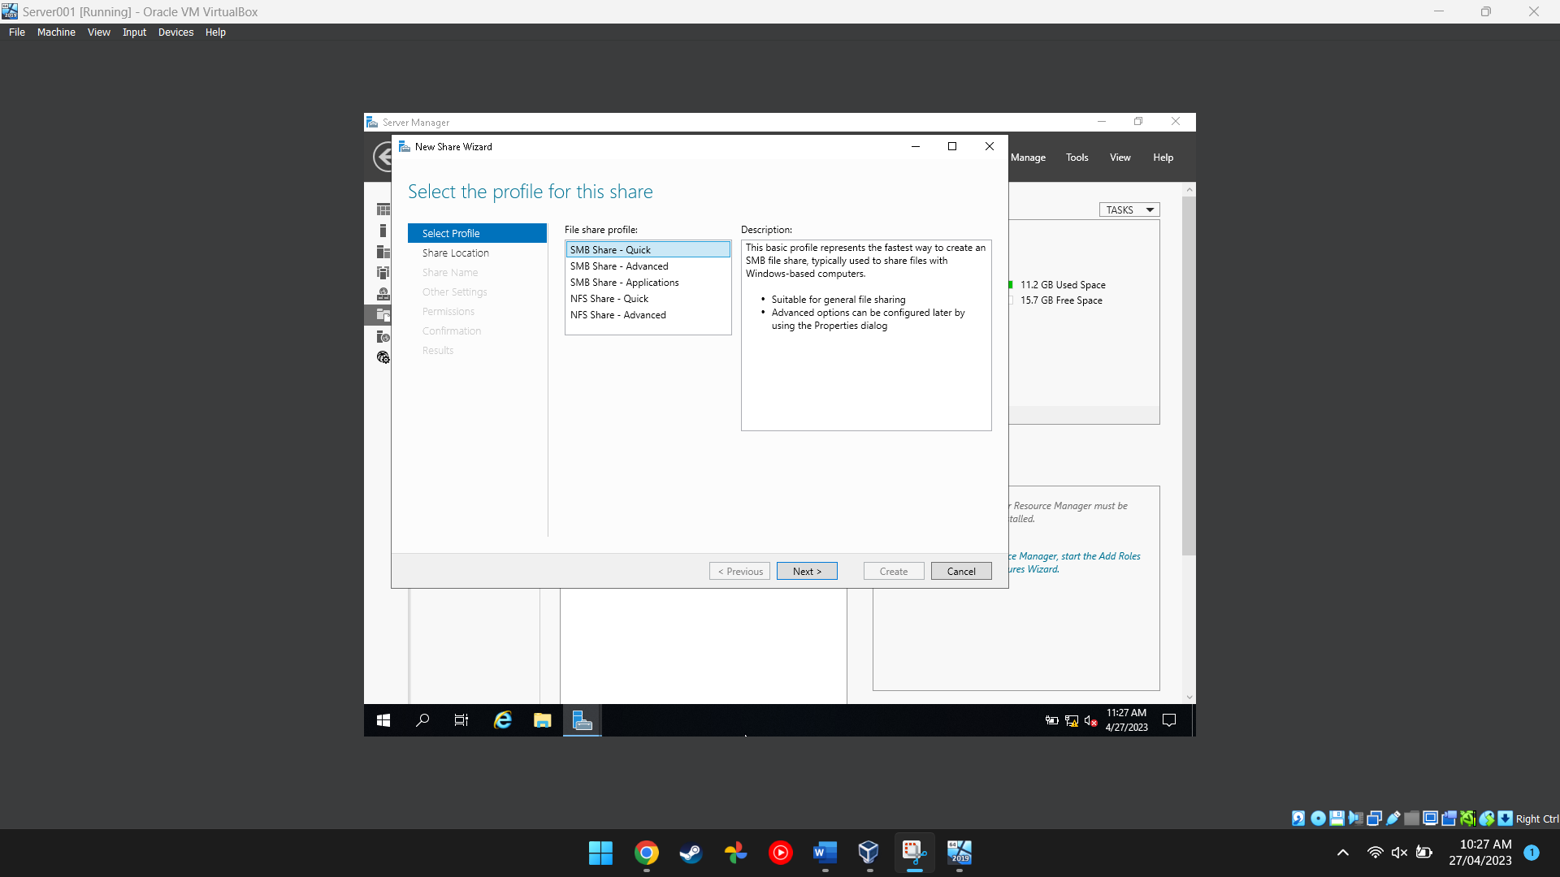
Figure 7 This screenshot shows a user setting up a server in server manager
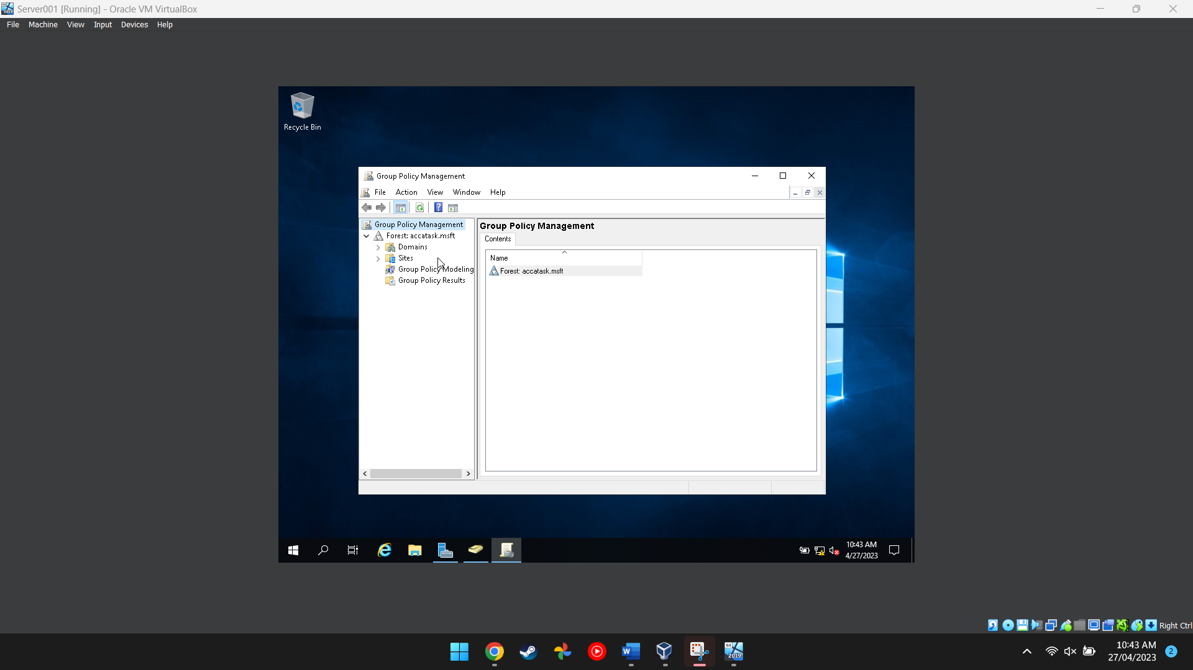
Figure 8 This screenshot shows the group policy management application being used to manage different policies for each user so they don’t access stuff they are not supposed to

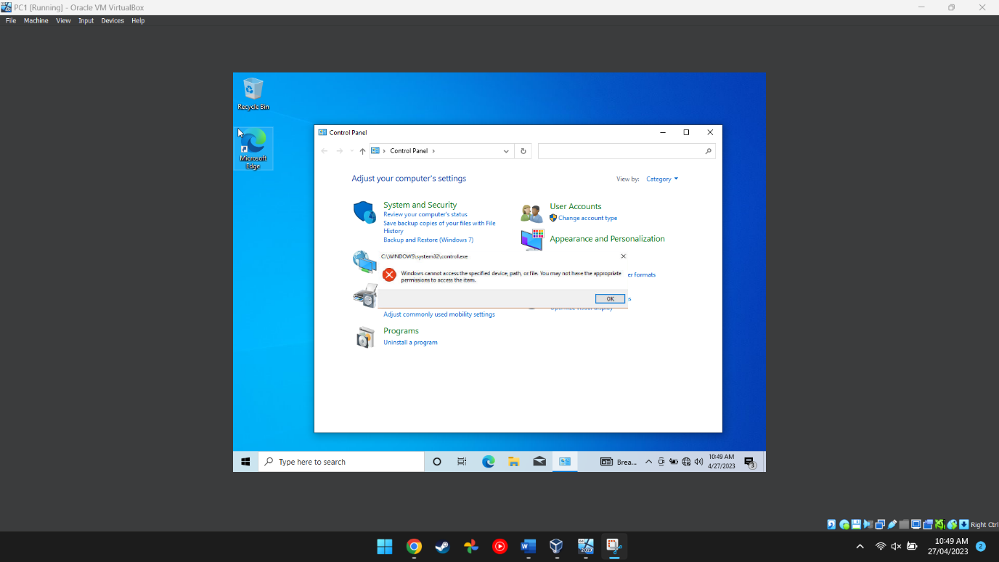
Figure 9 This image proves that the main user cannot access the control panel after having their permissions revoked

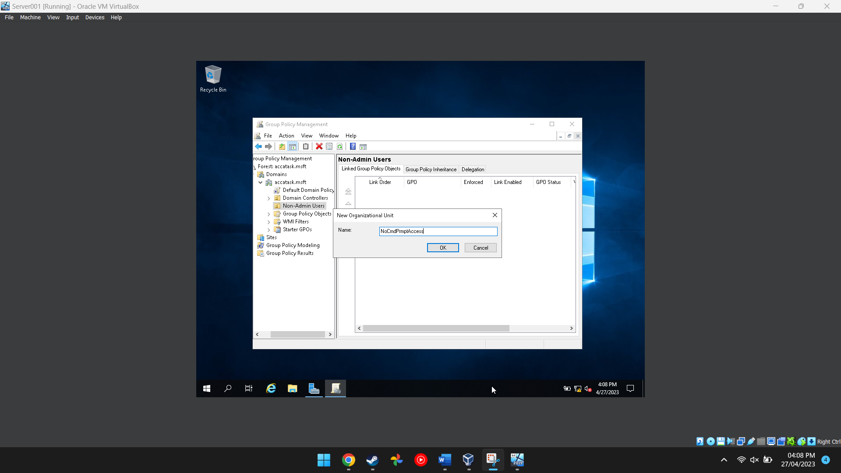
Figure 10 This image shows the user adding a new organisational unit to the folder in the group policy managment program
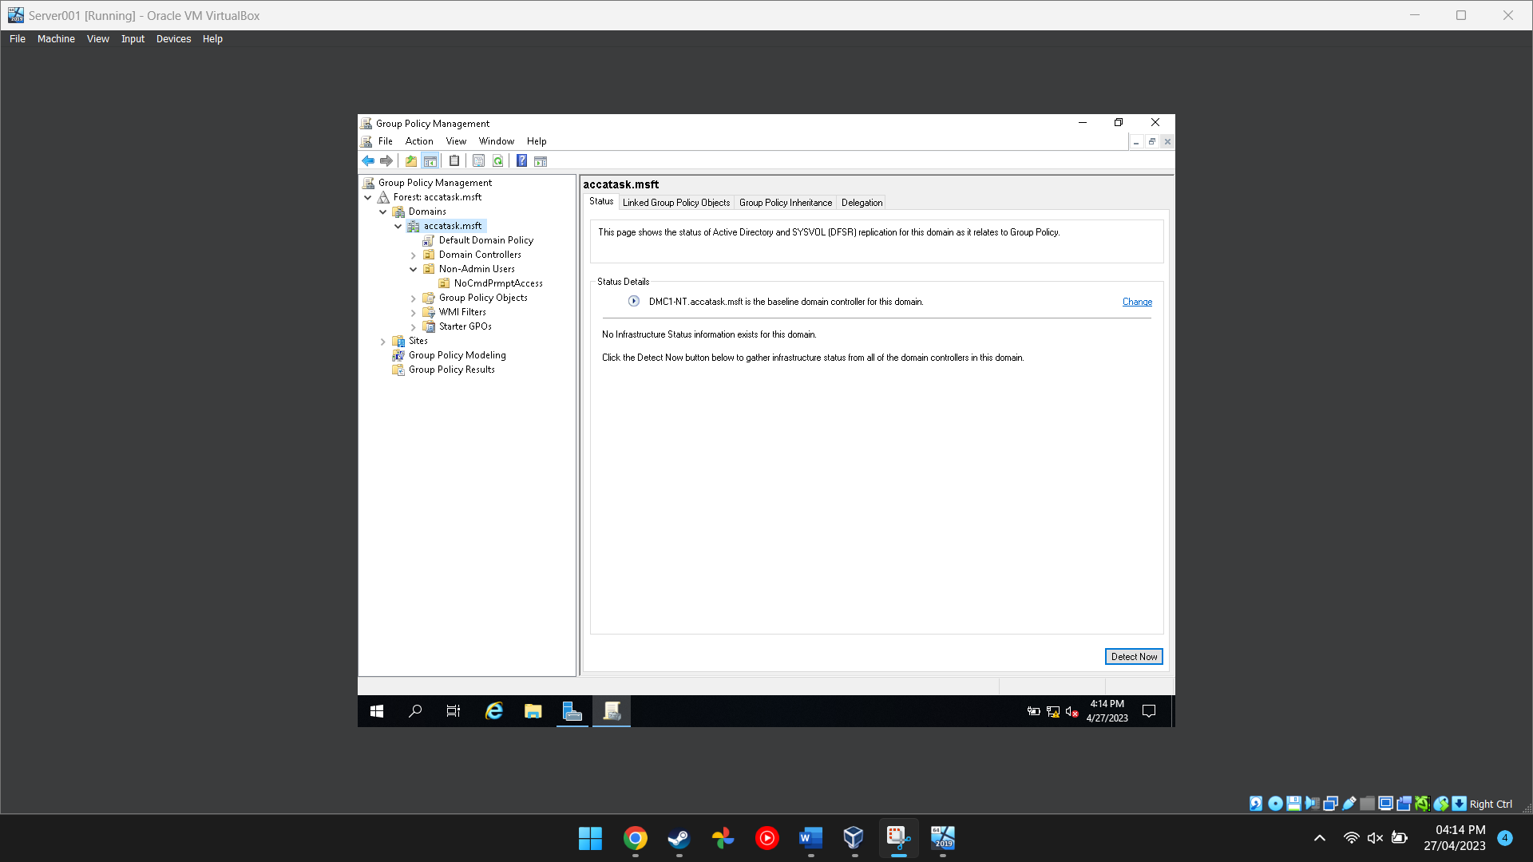
Figure 11 This shows that the PC is the domain controller

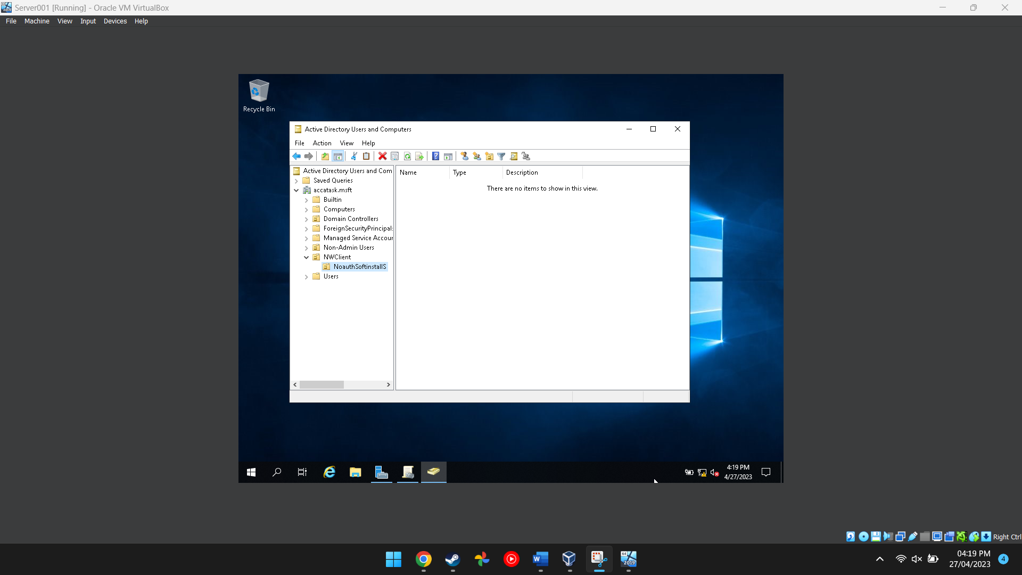
Figure 12 This image shows the folder for the active directory and computer program being created

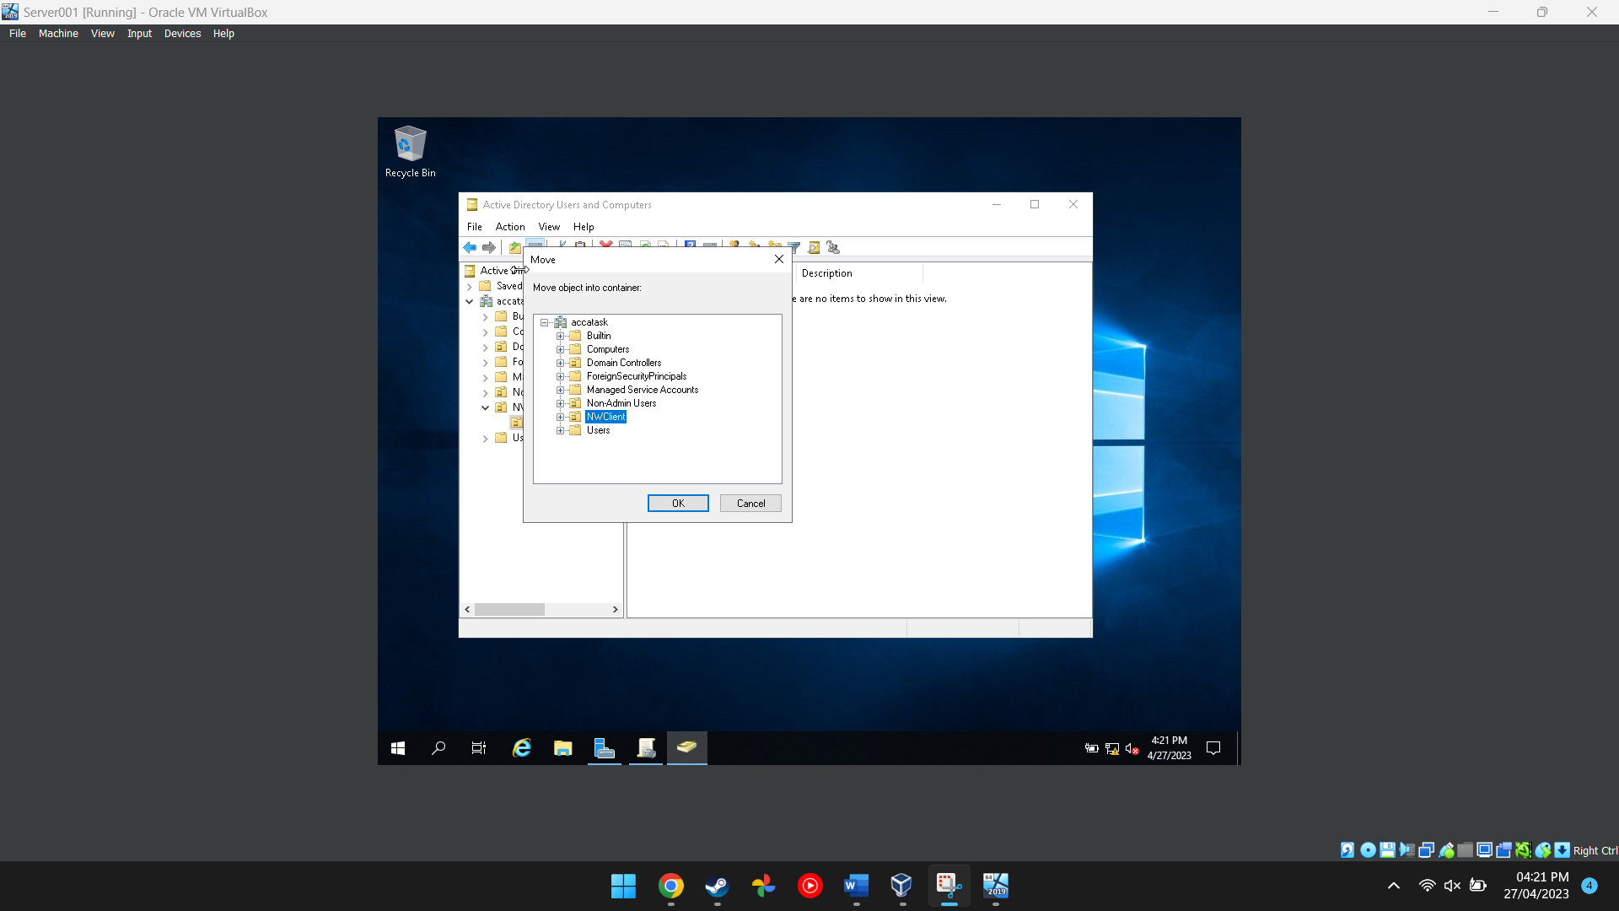
Figure 13 This shows the folder being moved

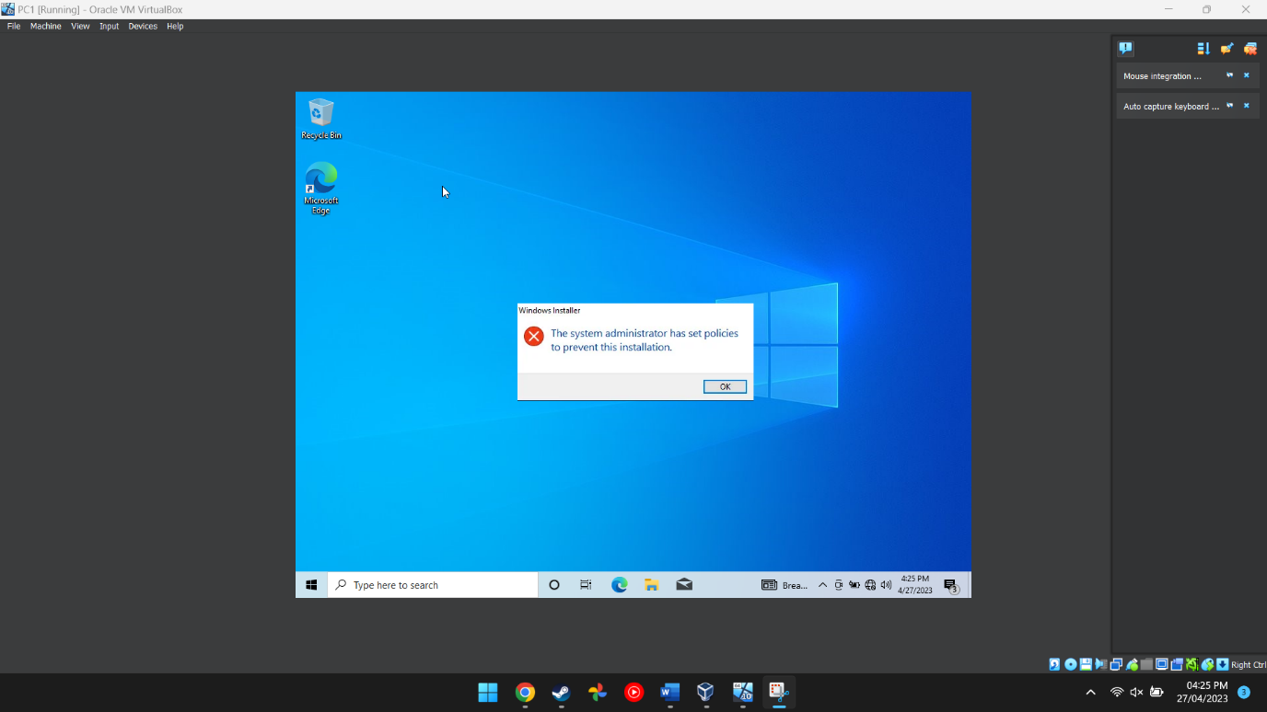
Figure 14 This image proves that the main PC cannot install programs onto the computer itself becuase there were restrictions put in place

Task 2
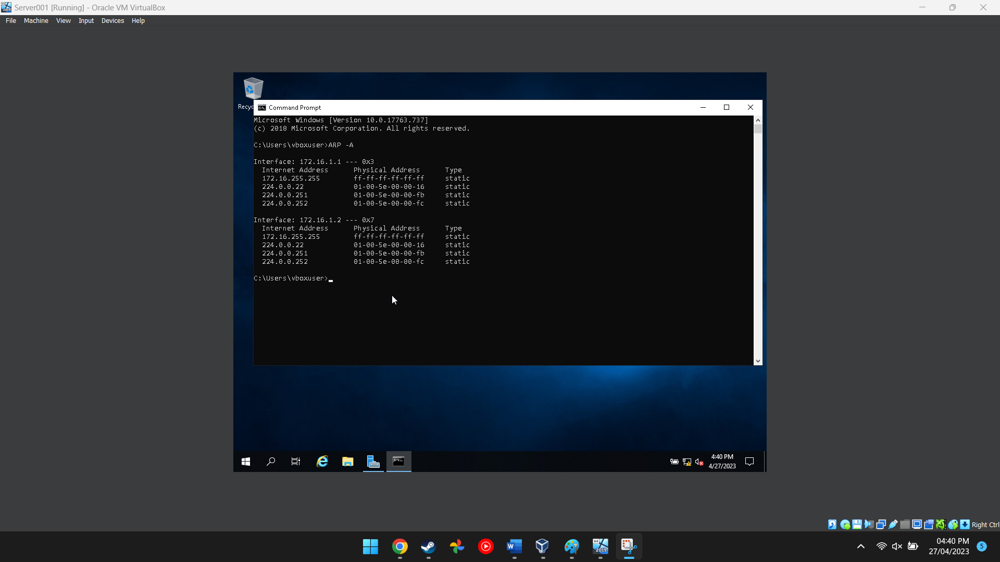
Figure 15 This image shows the network cards information
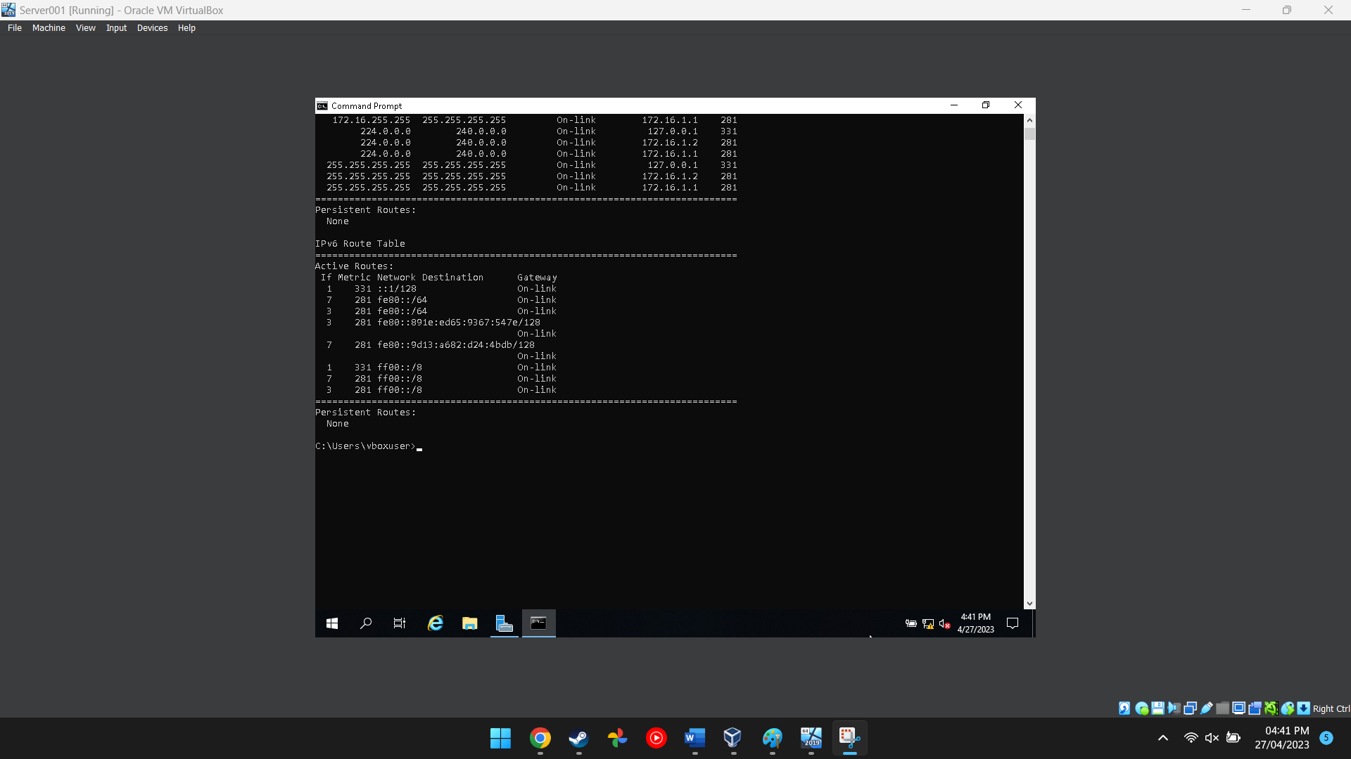
Figure 16 This image shows the route the network traffic will take
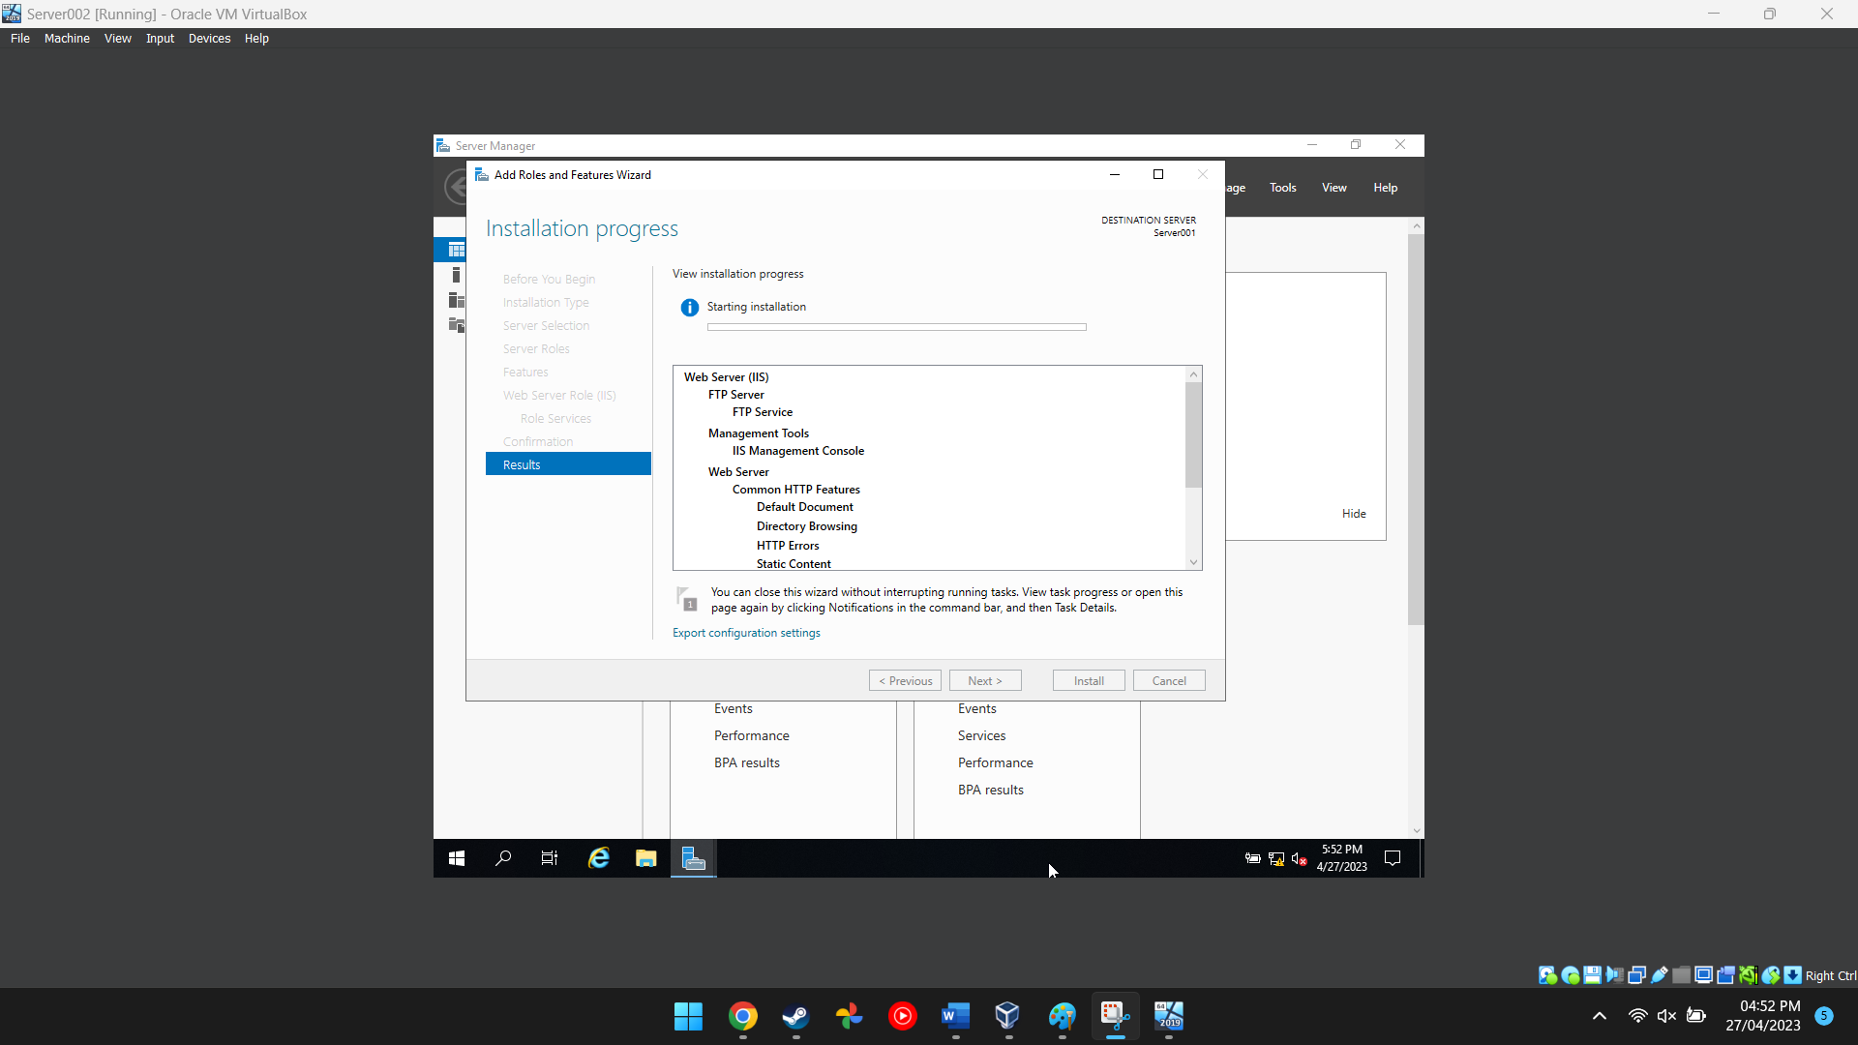
Figure 17 This image shows an additional server being created
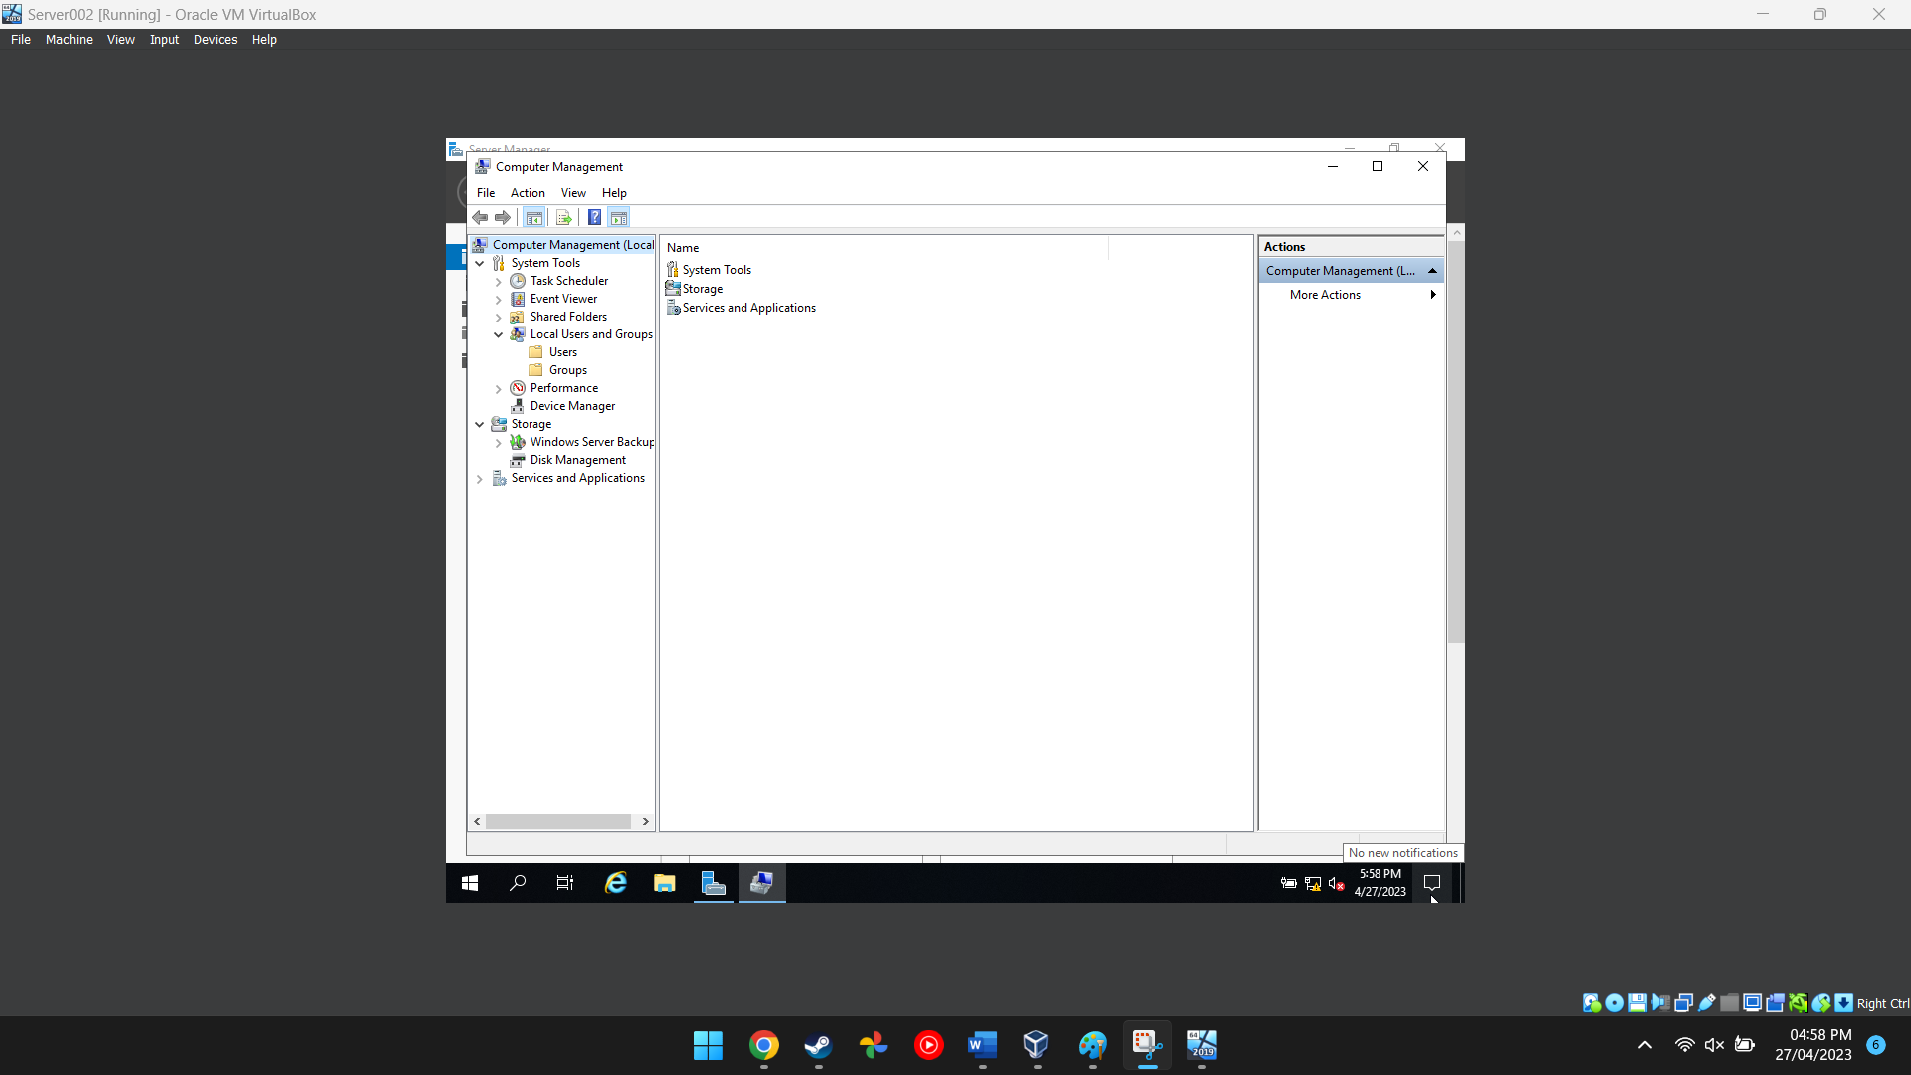
Figure 18 This image shows the computer management software on server 2
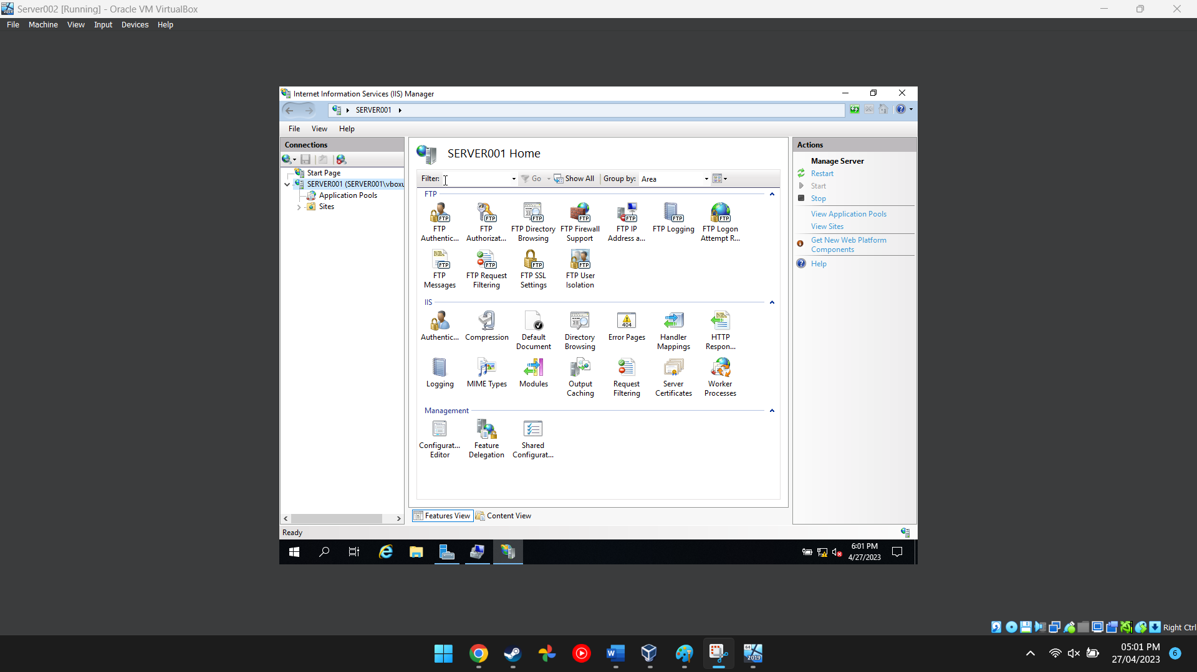
Figure 19 This image shows the internet information services manager options
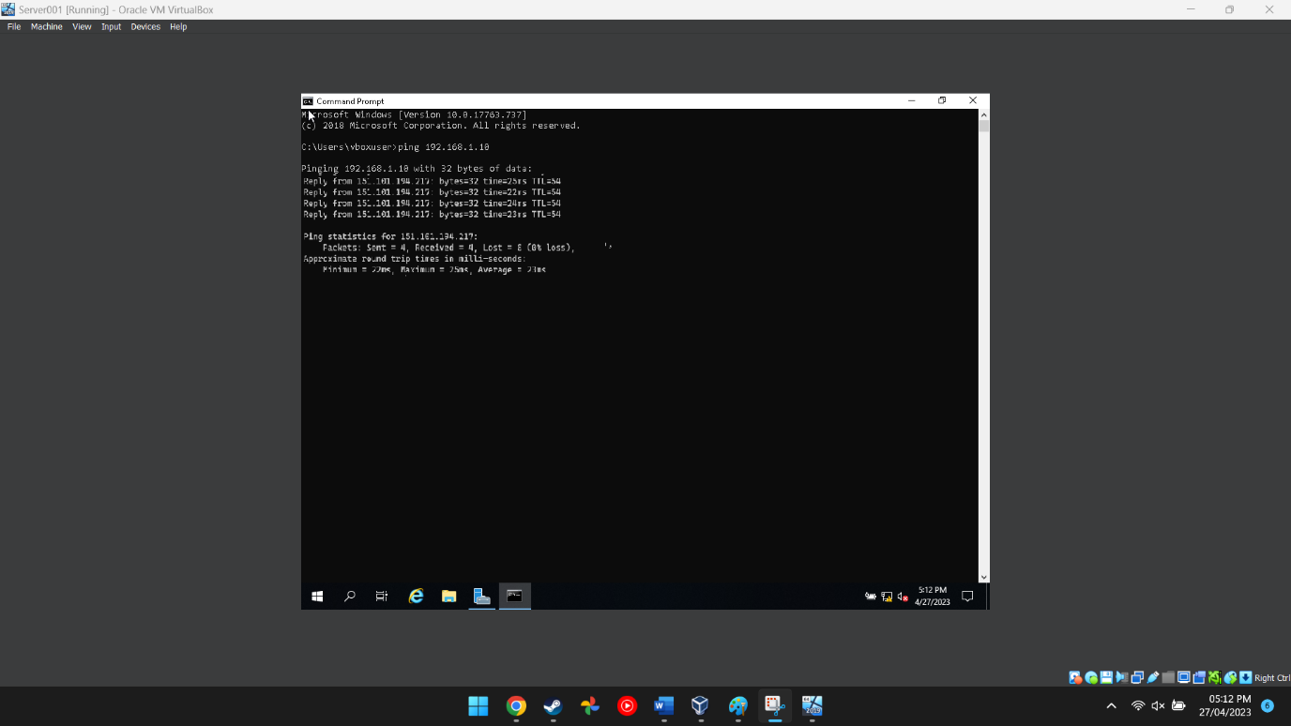
Figure 20 This shows a successful ping has been completed

Task 3: OBSERVATIONAL TASK

On a SOHO (Small Office/ Home Office) Network

if you want to consider enhancing security, what actions could you do? Write on your own words in the context of your worksheet activities to demonstrate security policies.
[1] [2] [3] [4] [5]
To safeguard sensitive data and stop unauthorised access to the network, a SOHO network's security must be improved. A SOHO network may be made more secure by taking the following steps:

- 1. Protect the wireless network: Modify the router's default login information and create a strong password. To protect the wireless network, use WPA2 or WPA3 encryption, and turn off WPS (Wi-Fi Protected Setup) to prevent unauthorised access.
- Install antivirus software: Install antivirus software and keep it updated on all networked computers and gadgets. Run regular virus scans to detect and remove any malware.
- Implement a firewall: To stop unauthorised access to the network, set one up. Use the default settings or set it up to just permit a certain type of traffic.
- Enable network encryption to protect private information while it's being sent across the network. Use SSL or TLS to encrypt data sent over the internet. SSL stands for Secure Sockets Layer.
- Use secure passwords: Ensure that all networked devices and accounts have passwords that are secure. Consider employing a mixture of capital and lowercase characters, digits, and symbols instead of well-known words or phrases.
- Performing routine software and firmware updates will ensure that all networked devices have the most recent security updates and bug fixes.Limit network access: Restrict network access to only authorized users. Use MAC filtering or set up a guest network to prevent unauthorized access.
- Implement a backup system: In the event of a security breach or hardware failure, prevent data loss by implementing a backup system.
By putting these security measures into place, a SOHO network may be better safeguarded against security risks and guarantee the protection of critical data.

Failover Clustering for high-availability systems/services
A failover cluster, which is a group of actual or virtual computer servers, enables the multiple applications and services that make up a business network to function in a High Availability (HA) or Continuous Availability (CA) environment.
Clearly state the concepts to be carefully thought about before considering the usage of such a system.Also show one possible role within the Window Server OS environment that could provision these requirements. You should breakdown the aspects that need consideration when attempting to deploy this role/service NB: You are not expected to demonstrate a fully working Failover Cluster, but you are however expected to provide as much detail as possible as to ‘how’ this role can be implemented into the network. Also, why it is of such critical importance.
[6] [7] [8] [9] [10]
When considering the usage of a failover cluster for high availability systems/services, there are several concepts that need careful consideration. Some of these concepts include:
- Hardware Redundancy: It is important to ensure that all hardware components used in the failover cluster have redundant counterparts. This means having duplicate network adapters, power supplies, storage controllers, and other critical hardware components.
- Network Configuration: Failover clusters rely on the network to ensure continuous availability of services. It is important to have a robust network configuration with redundant switches, routers, and firewalls to avoid network downtime.
- Storage Configuration: Storage is a critical component of failover clusters as it stores the data that is needed for the services to function. It is important to ensure that the storage subsystem has redundant controllers, disks, and paths to avoid data loss and ensure continuous availability.
- Failover Configuration: Failover clustering involves configuring the failover behavior of services and applications in the event of a failure. It is important to ensure that failover settings are properly configured to avoid service interruption and data loss.
- Failover clusters need to be continuously monitored and maintained to make sure all of its components are operating properly. This comprises frequent health checks, patching, and upgrading of hardware and software components. It also includes testing of failover situations on a regular basis.

One potential solution that might meet these requirements inside the Windows Server OS environment is the failover clustering functionality. Using this capability, which also gives you the resources you need to manage and administer it, you may build a failover cluster. The following methods can be used to configure the Windows Server Failover Clustering feature:

  - After opening the Server Manager interface and choosing the Features option, click Add function to install the Failover Clustering function. Install your selected Failover Clustering option.
  - Establish a Failover Cluster: After installing the Failover Clustering feature, open the Failover Cluster Manager interface, and establish a fresh failover cluster.
  - Configure Networks: Select the Networks option in the Failover Cluster Manager console, and then configure the cluster's network settings.
  - Configure storage by selecting the Storage option in the Failover Cluster Manager console, then entering the cluster's storage specifications.
  - Add Nodes: Select Nodes from the Failover Cluster Manager console, then enter the nodes you want to be a part of the cluster.
  - Configure Applications/Services: Select the Roles option in the Failover Cluster Manager console and set the failover settings for the applications/services that will be running on the cluster.
  - Test Failover Scenarios: Test failover scenarios to make that the cluster is operating effectively and that failover behaviour is set up correctly.

The establishment of a cluster that offers both continuous availability and failover capabilities in the case of a breakdown is made possible by the failover clustering feature, which is crucial for high availability systems and services. Organisations may make sure that users always have access to crucial services and apps by correctly configuring and maintaining the failover cluster.

Completing the worksheets 1 and 2 as a Team

use your knowledge and understanding to draft a network policy for an Enterprise Network which operates in multiple locations, considering critical business applications high availability practices and security practices. State all assumptions made.
[11] [12] [13]
- Network Access Control: 1.1. All network access must be authorized and authenticated using strong passwords or multi-factor authentication 1.2. Permissions and access privileges for users must be assigned in accordance with their job descriptions. When an employee, contractor, or vendor leaves the company or no longer needs access, network access must be immediately terminated.
- Second, network security 2.1. All network communication must be encrypted using the SSL or TLS protocols. 2.2. Firewalls, intrusion detection and prevention systems, and antivirus software must be installed and kept up to date. 2.3. The IT security team must be notified immediately of any suspicious activity or unauthorised attempts to access the network.Data Protection: 3.1. Data must be classified according to its sensitivity level and access must be restricted accordingly. 3.2. Regular data backups must be taken and stored in a secure location offsite. 3.3. Encryption must be used to protect data at rest and in transit.
- Device Management: 4.1. All devices connected to the network must be registered, monitored, and updated regularly. 4.2. Only authorized devices must be allowed to connect to the network. 4.3. Unapproved software installations or modifications must not be permitted.
- 5Incident Management: 5.1. Security incidents must be reported immediately to the IT security team. 5.2. The IT security team must investigate incidents and respond promptly to mitigate the impact. 5.3. Incident reports must be generated and documented to improve future incident response.
- User Awareness: 6.1. All users must receive regular training and awareness programs on network security policies and best practices. 6.2. Users must be informed about their responsibilities and obligations when accessing the network. 6.3. Users must be encouraged to report any security incidents or suspicious activity to the IT security team.
- Compliance: 7.1. The network team must comply with all relevant laws, regulations, and industry standards. 7.2. All network changes must be approved and documented in compliance with change management procedures. 7.3. The network team must perform regular security risk assessments and audits to identify and mitigate potential threats.

Assumptions:
- The Enterprise Network is designed to connect all locations using a hub-and-spoke topology.
- The network is designed using industry-standard security protocols and technologies.
- The network team consists of experienced network administrators, security analysts, and engineers.
- The network team will perform regular security risk assessments and audits to identify and mitigate potential threats.
- The network team will enforce security policies and procedures to prevent unauthorized access, data loss, and other security incidents.
- The network team will monitor network operations to detect and respond to security incidents promptly.
- The network team will provide training and awareness programs to educate employees about network security policies and best practices.

Scope of Security improvements: To address identified risks and vulnerabilities, the network team will deploy security improvements as needed. The implementation of new security measures, modifying access controls, updating software and hardware are all examples of security modifications. To make sure that all security modifications are evaluated, authorised, and tested prior to deployment, the network team will adhere to a rigorous change management approach.
Monitoring Security Operations: The network team will keep an eye on security operations to quickly identify and address security problems.

reflection

Write a brief on the tasks completed in this worksheet. (Not more than 200 words)
[14] [15]

This network policy is necessary to safeguard the company's network and guarantee the privacy, accuracy, and accessibility of crucial business applications, data, and systems. This policy shall apply to all employees, independent contractors, suppliers, and visitors for the purpose of preserving the security and accessibility of the network.

References

[1] | [Online]. Available: https://www.techtarget.com/whatis/definition/syntax. [Accessed 31 3 2023].
[2] | [Online]. Available: https://learn.microsoft.com/en-us/azure/architecture/best-practices/api-implementation. [Accessed 31 3 2023].
[3] | [Online]. Available: https://www.tricentis.com/state-of-open-source-2020/. [Accessed 31 3 2023].
[4] | [Online]. Available: https://www.lambdatest.com/blog/what-is-continuous-integration-and-continuous-delivery/. [Accessed 31 3 2023].
[5] | [Online]. Available: https://www.cisco.com/c/en/us/solutions/collateral/executive-perspectives/network-automation-strategy-wp.html#_ftn10. [Accessed 31 3 2023].
[6] | [Online]. Available: https://blogs.cisco.com/networking/defining-network-programmability. [Accessed 31 3 2023].
[7] | [Online]. Available: https://developer.cisco.com. [Accessed 31 3 2023].
[8] | [Online]. Available: https://developer.cisco.com. [Accessed 31 3 2023].
[9] | [Online]. Available: https://developer.cisco.com. [Accessed 31 3 2023].
[10] | [Online]. Available: https://www.clariontech.com/blog/author/bhavana-bhavar. [Accessed 31 3 2023].
[11] | [Online]. Available: https://www.theserverside.com/definition/HTML-Hypertext-Markup-Language. [Accessed 1 3 2023].
[12] | [Online]. Available: https://www.techtarget.com/iotagenda/definition/Internet-of-Things-IoT. [Accessed 31 3 2023].
[13] | [Online]. Available: https://learn.microsoft.com/en-us/azure/architecture/best-practices/api-design. [Accessed 31 3 2023].
[14] | [Online]. Available: https://42crunch.com/automate-api-protection-with-security-as-code-webinar-recording/. [Accessed 31 3 2023].
[15] | [Online]. Available: https://www.lambdatest.com/automation-testing. [Accessed 31 3 2023].

