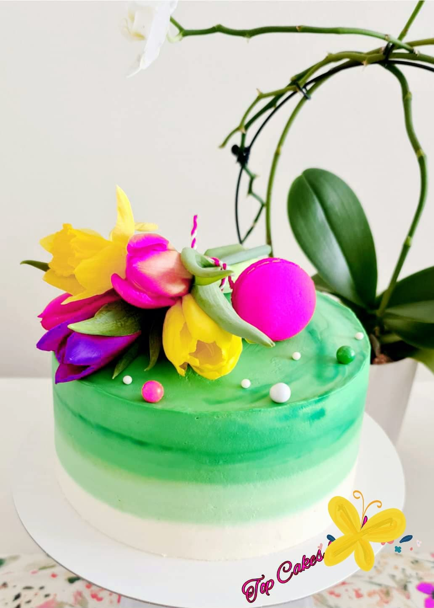  “Prajituri ca la mama acasa”  (Mama’s Homemade Cake) Business Plan | Elena Constanta Paraiciuc (1905195)  Managing in the 21st Century  BMSW4006_CARD

Executive Summary:
In this report you will find my business plan for a sole trader business, a baking business run from home. “Prajituri ca la mama acasa”( Mama’s Homemade Cake’s.)
-Business Overview
-Company Summary
-Mission Statement
-Company History
-Market and Products
-Product Description
-Location and Facilities
-Market Analysis
-Market Segmentation
-Marketing and Sales Plan
-Financial Plan
-Swot Analysis
-Cash Flow
BUSINESS OVERVIEW
"Prajituri ca la mama acasa" (Mama's home-baked cakes) is a solo trader enterprise, a home-baked bakery with traditional and original recipes from your motherland, as well as the taste of your youth. Our traditional recipes from old books, recipes that only our grandmothers used to make in the kitchen, are the Unique Selling Point. Every day, fresh ingredients, new cake themes, and new decorating styles are delivered to your door. Will be a small business run from home, located in our beautiful town Newport.
- Company Summary:
"Prajituri ca la mama acasa" (Mama's home-baked cakes) is intended to bring you joy, make your life sweeter, and reduce the burden of baking a cake for your child's birthday or spending a lot of time in the kitchen for Easter, Christmas, and New Year. So, spend time with your family while we bake for you and deliver the precise flavor you choose directly to your home. One of the objectives is in the first 3 months to let the people know me, let them taste my cakes and have 10 customers.
p
- Stress reduction
- Brings back old memories
- Creative
- Improves your appetite

Benifits
- Cakes will be fluffy,spongy and moist
- Baked properly
- A nice appearance
- Exquisite taste
- Chocolate, vanilla, butterscotch, salted caramel, and many more flavours

Features
- Provide goods and services to our customers with professionalism.
- To provide customers with affordable products profitably.
- To customize our products to the need of our customers.
Aims
- 10 customers in three months
- To become the finest business in town in one year
- To use only fresh ingredients
- Create fresh recipes and styling for decoration every month.

Objectives

Mission Statement:
Priorities, strategies, plans, and job assignment are all built around company’s mission. It serves as the foundation for the creation of managerial positions and, more importantly managerial structures. Strategy comes first, and then structure. The primary action in any firm is determined by the strategy. And knowing “what our business is and should be” is necessary for strategy. (Drucker, p.75.)
- -We are a bakery that knows you can’t beat home cooking.
- -We bake sweet treats using homemade and old family recipes.
- -We stand for good home cooking.
- -We bring your childhood taste right at your door.
- -We are trying to make the world a sweeter place.
- -We looking to become the finest business in town with regular customers.

Company History:
I've been backing with my mother since I was a small child, and I've always had a passion for it. I create cakes for my son birthday, my mother birthday, or a family member's birthday. I enjoy decorating cakes with various themes, backing is the most soothing thing for me, and I start playing with the ingredients in my kitchen with loud music playing.
In one day, I pulled out my mother's notebook for old cake and cookie recipes and was looking through it when I had an idea.
Why don’t I share my passion with everyone? Why don’t I share the taste of my childhood with the people that love cakes? So, I decide to start a business, homemade cake and cookies, traditional cakes with old recipes from my homeland and I will name my business “Prajituri ca la mama acasa”. (Mama’s home-baked cakes.)
When you first start your home baking business, you must inform HMRC that you are self-employed so that they are aware that you must pay tax via the Self-Assessment system. Even if you're going to run your home baking business as a side hustle, part-time, or if you have another work, you should do this.

To register your business as a sole trader – the simplest business structure – all you must do is tell HMRC. The process of forming a limited corporation, on the other hand, is a little more difficult.
So, I register my firm, and I have my HMRC unique code reference, since when I first started working, my jobs were kitchen assistant, catering assistant, and chef, and I had a variety of certificates to work in a kitchen.
My company was already set up, with Romanian bakeries as suppliers, because my cakes and cookies would be traditional cakes made from old recipes. It will be a modest business, and I am aware that there will be many competitors, but my USP will be old recipes, childhood tastes, cookies created years ago, and the distinct flavour of your grandmother's kitchen.
Markets and Products:
There are several people in our town, Newport, and Cardiff, who run businesses like this, selling homemade baked cakes, platters with various sorts of cookies. Prices vary as well, but as our Romanian community grows, I believe there is a place for everyone.
Consumers choose foods in the context of their whole diet to get more expected utility from their food in real-world scenarios. Part of its utility stems from the ability to use food to maintain or improve one's health. Consumers with varying risk preferences rationally select different meal bundles. If, on the other hand, their perceptions of food quality are inaccurate. Consumers' utility is diminished. (Caswell, J. A., & Mojduszka, E. M.1996.)
The process of bringing a product to market, promoting it, and selling it to a customer is known as product marketing. Understanding the target audience for a product and employing strategic positioning and messaging to increase income and demand are both important aspects of product marketing.

To make my business successful, I'll apply my Unique selling point my old and authentic recipes, the taste of childhood, fresh ingredients, and a healthy diet. When I receive a fresh cake order, I will be inspired and imaginative, and there will be new recipes to test every month.
PRODUCT DESCRIPTION:
What we offer?
-Cakes, birthday cakes.
-Special occasion cakes.
-Platers with different types of cookies.
-Cakes for people with different allergies.
-Cakes with all kinds of flavours.
-All cakes and cookies made with fresh ingredients.
-New recipes every month.
-Taste from your childhood right at your door.
-Croissants, macarons, and muffins.
-Free delivery for all orders from Newport and around Newport.
-Refund to your product if doesn’t fit to the require.

-10% off if you order more than two platers of cookies.
Kitchen is designed with professional equipment for baking.

-Mixers and blenders.
- 57 Littre Commercial Convection Over with 4 Baking Trays
-Bakeware, mixing bowls.
-Rolling pins
-Baking Cases &Parchment
-Piping bags
-Sieves, brushes, knives & cutters.
-Cake boards & Cake boxes.
-Cakes stands & Display.
-Chef Blow Touches.

Locations and Facilities:
The business will be managed from home, the house is rented, the kitchen currently has baking equipment, modern kit for decorate all kind of themes ,when you run a professional baking or catering company, it is very important to have reliable equipment, the entire range of professional pastry and baking equipment, it is less stressful to know you can have all what you need ,right in your kitchen to bake from home while spending time with your family.(Alliance, 2022,online). We are right in the heart of Newport, we deliver around Newport and Cardiff, we come every month with new recipes, our suppliers bring all the ingredients from Romania, everything is authentic and traditional, just all we need is our customers to be happy and satisfied.
You can find us on Facebook, Instagram, Twitter, Tik-Tok, just a click and your order will be right with us.

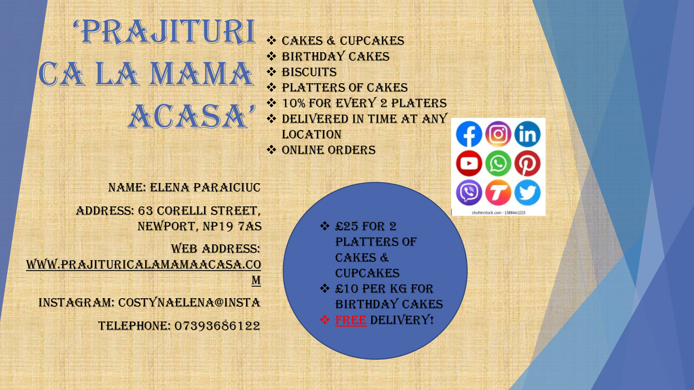

MARKET ANALYSIS:
What is market analysis?
A market study reveals details about industries, customers, competitors, and
other market factors. You can also find out how supply and demand for a certain
product or service are related. You can make better decisions about marketing
strategy based on these insights.
Market Segmentation:
The concept of segmentation is strongly related to the core normative notion in marketing that all corporate action should begin with a thorough examination of client needs and desires. Understanding variances in requirements and wants across national or cultural boundaries is a top marketing concern when targeting potential clients in different markets separated by national or cultural boundaries. As a result, when marketing guru Theodore Levitt proposed in 1983 that marketers ignore any differences that may exist between consumers in different parts of the world and instead provide similar products to everyone because consumer needs are converging as globalization advances, it caused quite a stir (Levitt, 1983).
There are two types of market research, primary and secondary research.
Primary research is more expensive and takes longer to do than secondary
research, but the results are more conclusive. Secondary research is research
that has been assembled, gathered, organized, and published previously by
others.
According to a market research, primary research by baking cakes and cookies
for friends and ask the opinion, baking cookies for my son school projects,
who prefer homemade cakes and cookies are mostly women’s and kids. I
create questionnaires too and based on the analysis of the questionnaire women from Cardiff will buy most of the products.
According to secondary research about how to set up a business from home there are few steps that I need to follow.
When you first start your home baking business, you must inform HMRC that you are self-employed so that they are aware that you must pay tax via the Self-Assessment system. Even if you're going to run your home baking business as a side hustle, part-time, or if you have another work, you should do this.

To register your business as a sole trader – the simplest business structure – all you must do is tell HMRC. The process of forming a limited corporation, on the other hand, is a little more difficult.

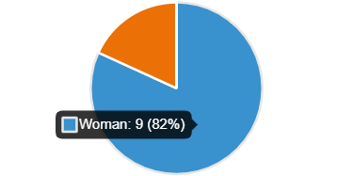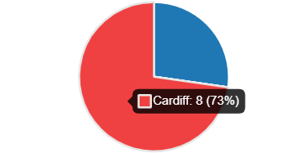
MARKETING AND SALES PLAN:
Promote the business, flyers thru the mailbox for my neighbours, posts on Facebook, Instagram, twitter, share photos thru WhatsApp and Viber. Bake for my colleagues at work and share with them. 10% off if you order more than two platters with cookies. Free delivery for customers from Newport and around Newport.

FINANCIAL PLAN:
I will use my savings £6,600 to start up my business.
Cost fall in 3 categories:
- Fixed cost
-Utility bills, gas, electricity-£130 monthly
-Advertising -£35 for 1000 flyers monthly
-Insurance-£45 monthly
-Travel-£25 monthly
-Rent -£575 monthly
-Internet- £33
- Direct or Variable Cost

-Raw materials
-Packaging supplies-£60
-Delivery charges -£50
-Credit card fees -£125

- Capital Cost

-Machinery -£427
-Equipment-£250
-Business vehicles

SWOT Analysis:
A bakery is a business that sells flour-based baked goods such as pies, pastries, cakes, and cookies to the public. Some tea rooms, coffee shops, and cafés in their establishments sell baked goods from the bakery. Confectionery items are also included in the bakery category.
-Strength of the business:
-Qualified and experience
As I bake almost for all my life that will help me and this will be my strength, few certificate that qualify my ability is a plus for my business.
-Offer big Orders
The ability of deliver big orders for parties and events on short notice is the key strength of the business.
-Latest Equipment
I have in my kitchen the best and professional equipment to help me bake and do all kind of shapes for cakes.
-Art Design
The professional kit for decorating and my ability to draw and create wonderful themes for cakes is my strength.
-Variety of Products.
I have all kind of platters with many different cookies, mixed flavors for cakes, all flavors that you like.
Weaknesses of the business:
-High Prices
-New in the Market
Opportunities of the Business:
-Healthy Diet Trends
-Product Expansion
Threats of the Business:
-Economic Recession
-Competitors

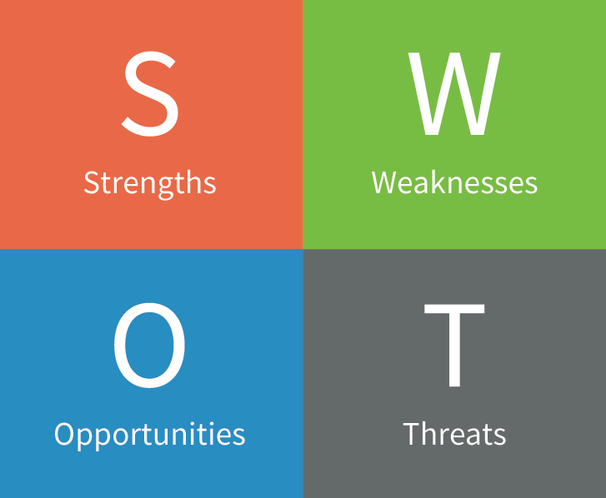

Cash Flow
Mama’s Homemade Cake |  |  |  |  |  |  |  |  |  |  |  |  | January 1, 2022
REVENUE | JAN | FEB | MAR | APR | MAY | JUN | JUL | AUG | SEP | OCT | NOV | DEC |  | YTD
Estimated Product Sales | £580 | £615 | £730 | £730 | £580 | £580 | £200 | £0 | £730 | £580 | £580 | £1200 |  | £7105
Less Sales Returns & Discounts | £58 | £61,5 | £73 | £0 | £0 | £0 | £0 | £0 | £0 | £0 | £0 | £120 |  | £312,5
Personal Investment | £550 | £550 | £550 | £550 | £550 | £550 | £550 | £550 | £550 | £550 | £550 | £550 |  | £6,600
Number of Expected customers | 16 | 17 | 21 | 21 | 16 | 16 | 8 | 0 | 21 | 16 | 16 | 36 |  | 204
Net Sales | £1,130 | £1,165 | £1,280 | £1,280 | £1,130 | £1,130 | £750 | £550 | £1,280 | £1,130 | £1,130 | £1,750 |  | £13,705
Cost of Goods Sold | £220 | £230 | £310 | £310 | £220 | £220 | £50 | £0 | £310 | £220 | £220 | £480 |  | 2,790
Gross profit | £302 | £323,5 | £347 | £420 | £360 | £360 | £150 | £0 | £420 | £360 | £360 | £600 |  | £4,002.5
EXPENSES | JAN | FEB | MAR | APR | MAY | JUN | JUL | AUG | SEP | OCT | NOV | DEC |  | YTD
 | £302 | £323,5 | £347 | £420 | £360 | £360 | £150 | £0 | £420 | £360 | £360 | £600 |  | £4,002.5
Marketing/Advertising | £35 | £35 | £35 | £35 | £35 | £35 | £35 | £35 | £35 | £35 | £35 | £35 |  | £420
Rent | £575 | £575 | £575 | £575 | £575 | £575 | £575 | £575 | £575 | £575 | £575 | £575 |  | £6,900
Utilities | £175 | £175 | £175 | £175 | £175 | £175 | £175 | £175 | £175 | £175 | £175 | £175 |  | £2,100
Website Expenses | £15 | £15 | £15 | £15 | £15 | £15 | £15 | £15 | £15 | £15 | £15 | £15 |  | £180
Internet/Phone | £33 | £33 | £33 | £33 | £33 | £33 | £33 | £33 | £33 | £33 | £33 | £33 |  | £396
Insurance | £45 | £45 | £45 | £45 | £45 | £45 | £45 | £45 | £45 | £45 | £45 | £45 |  | £540
Travel | £25 | £30 | £35 | £35 | £25 | £25 | £15 | £0 | £35 | £25 | £25 | £50 |  | £325
Legal/Accounting | £0 | £0 | £0 | £0 | £0 | £0 | £0 | £0 | £0 | £0 | £0 | £0 |  | £0
Raw Materials | £45 | £50 | £60 | £60 | £45 | £45 | £15 | £0 | £60 | £45 | £45 | £80 |  | £490
Interest Expense | £0 | £0 | £0 | £0 | £0 | £0 | £0 | £0 | £0 | £0 | £0 | £0 |  | £0
Other 1 | £20 | £20 | £20 | £20 | £20 | £20 | £10 | £0 | £20 | £20 | £20 | £20 |  | £210
Total Expenses | £968 | £978 | £993 | £993 | £968 | £968 | £918 | £878 | £993 | £968 | £968 | £1,028 |  | £11,621
Income Before Taxes | £1,130 | £1,165 | £1,280 | £1,280 | £1,130 | £1,130 | £750 | £550 | £1,280 | £1,130 | £1,130 | £1,750 |  | £13,705
Income Tax Expense | £0 | £0 | £0 | £0 | £0 | £0 | £0 | £0 | £0 | £0 | £0 | £0 |  | £0
NET INCOME | £162 | £187 | £287 | £287 | £162 | £162 | £0 | £0 | £287 | £162 | £162 | £722 |  | £2,580

References
DAY, G.S., 1981. Strategic Market Analysis and Definition: An Integrated Approach: SUMMARY. Strategic Management Journal (pre-1986), 2(3), pp. 281.
I.B. Baalbaki, N.K. Malhotra
Marketing management bases for international market segmentation: An alternate look at the standardization/customization debate
International Marketing Review, 10 (1993), pp. 19-44
Klaus G. Grunert
Caswell, Julie A., and Eliza M. Mojduszka. “Using Informational Labeling to Influence the Market for Quality in Food Products.” American Journal of Agricultural Economics, vol. 78, no. 5, [Agricultural & Applied Economics Association, Oxford University Press], 1996, pp. 1248–53, https://doi.org/10.2307/1243501.
https://planbuildr.com/bakery-business-plan/executive-summary/
https://doi.org/10.2307/1243501

Bibliography
Anon., 2018. https://business.gov.au/guide/starting. [Online]
Available at: https://business.gov.au/guide/starting
[Accessed 19 March 2022].
Anon., 2019. https://planbuildr.com/bakery-business-plan/executive-summary/. [Online]
Available at: https://planbuildr.com/bakery-business-plan/executive-summary/
[Accessed 16 March 2022].
Anon., 2019. https://www.google.com/search?q=equipment+for+baking+cake&tbm=isch&ved=2ahUKEwjO2-igh7L2AhWN77sIHTHkCUMQ2-cCegQIABAA&oq=Equipment+for+baking+&gs_lcp=CgNpbWcQARgAMgUIABCABDIFCAAQgAQyBQgAEIAEMgUIABCABDIFCAAQgAQyBAgAEB4yBggAEAUQHjIGCAAQBRAeMgYIABAFEB4yBggAEA. [Online]
Available at: https://www.google.com/search?q=equipment+for+baking+cake&tbm=isch&ved=2ahUKEwjO2-igh7L2AhWN77sIHTHkCUMQ2-cCegQIABAA&oq=Equipment+for+baking+&gs_lcp=CgNpbWcQARgAMgUIABCABDIFCAAQgAQyBQgAEIAEMgUIABCABDIFCAAQgAQyBAgAEB4yBggAEAUQHjIGCAAQBRAeMgYIABAFEB4yBggAEA
[Accessed 20 March 2022].
Anon., 2020. https://www.simplybusiness.co.uk/knowledge/articles/2021/06/starting-a-cake-business-from-home-guide/. [Online]
Available at: https://www.simplybusiness.co.uk/knowledge/articles/2021/06/starting-a-cake-business-from-home-guide/
[Accessed 18 March 2022].
Anon., n.d. https://blog.hubspot.com/marketing/product-marketing. [Online]
Available at: https://blog.hubspot.com/marketing/product-marketing
[Accessed 19 March 2022].
Drucker, 2018. A Framework for Developing an Effective Mission Statement. Journal of Business Strategy, p. 10.

,
International segmentation in the food domain: Issues and approaches,
Food Research International,
Volume 115,
2019,
Pages 311-318,
ISSN 0963-9969,
https://doi.org/10.1016/j.foodres.2018.11.050.
(https://www.sciencedirect.com/science/article/pii/S0963996918309359)

