
Programme: Master of Business Administration
Module: International Marketing: Principles and Practices
Module code: LCMB7026

Title: Evaluating the Global Marketing Strategy of IKEA across the United States (USA) and China

Lecturer: Tushara Balendran

Student Name:Mohmedkaif Hamidail Mansuri
Student ID:2321459

Table of Contents
SECTION 1-Report 2
1. Introduction 2
2. Company background and mission vision 2
3. Market Analysis using PESTEL 3
3. STP Analysis 8
4. International Marketing Mix (7Ps) Comparison 10
People 13
5. Directional Development Strategy for USA 14
6. Ethical Issues 16
7. Conclusion and Recommendations 17
SECTION 2- Reflection 18
Introduction 18
Description 18
Feelings 18
Evaluation 18
Analysis 19
Conclusion 19
Action Plan 19
References 20

SECTION 1-Report

1. Introduction
This report aims to provide an in-depth analysis of the international marketing strategies of IKEA in the United States (USA) and China. IKEA operates its brand across driver culture. economic and social regions, which influence the brand to adopt different strategies for different countries. Based on this context, this study plays a significant role in assessing IKEA’s strategic adoption and makes a comparison of adopted strategies across China and the USA. Further, by comparing purchasing patterns, cultural values and market conditions using PESTLE, STP and marketing mix, this study highlights how IKEA balances its standards and localisation to maintain a competitive business position in the international market.

2. Company background and mission vision
IKEA was founded in 1943 in Sweden by Ingvar Kamprad. IKEA is a well-known, popular brand for providing affordable, flexible, and ready-to-assemble furniture (IKEA, 2023). IKEA is operating across 32 countries, managing 411 stores around the globe (Ingka, 2025). IKEA’s business model focuses on providing quality furniture to customers, boosting customer satisfaction by offering cost-effective and well-designed products, supported by a strong global supply chain and large warehouse-style stores.
IKEA's vision is to make people’s everyday life better by offering quality, sustainable, and well-designed furniture (IKEA, 2025). Its vision strategically aligns with long-term sustainability impact and innovation, aiming to perform a climate-positive business. By using environmentally friendly materials, energy-efficient operations and ethical sourcing, IKEA attracts local markets and maintains strong leadership. The vision is aligned with the mission, where IKEA intends to offer functional and well-designed home furnishing to people at a possible affordable price range (IKEA, 2024). This mission allows more customers to buy IKEA furniture and maintain a daily comfortable routine.

3. Market Analysis using PESTEL
A PESTLE analysis provides a strategic framework to evaluate external market factors, including political, social, and technological. legal, environmental and economic impact on business performance (Zaurez Afshar and Hussain Shah, 2025).
Political Factor
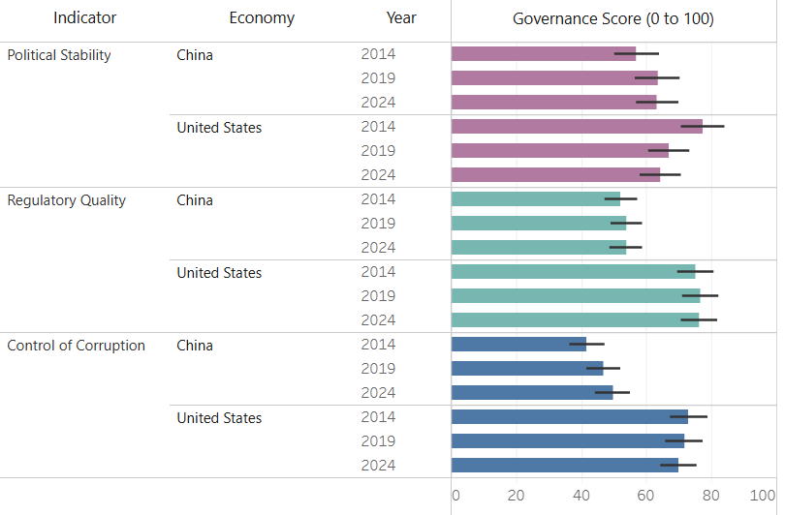
Figure 1: Political factors across the USA and China
(Source: World Bank, 2024)
Figure 1 shows the political factors like political stability, regulatory quality and corruption control rate across the USA and China. In terms of political stability, the USA scores higher, around 70 to 80, as compared to China, around 55 to 65. However, the USA’s political stability significantly decreased to 64.27 in 2024 from 66.83 in 2019; it remains higher compared to China, which was around 63.28 in 2024 (World Bank, 2024). Along with this, the US scores higher, 75-80, than China, 45-55, in terms of managing corruption. This shows IKEA can get more political stability and support from the US government, which promotes long-term investment, reduces operational risks due to low corruption and stable expansion. In contrast, China’s political stability is good but is slightly lower, which can allow IKEA to make strategic planning for business growth, but IKEA can face issues due to tight government control. However, it is recommended to adhere to regulations and a strategic partnership to maintain growing business activity in China (Kalinin and Gonchar, 2024).
Economical Factor
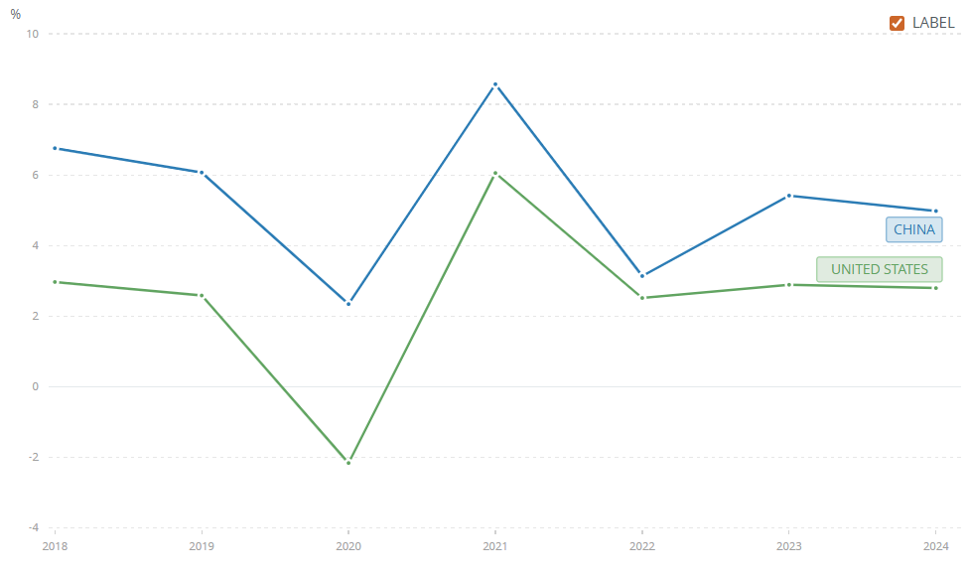
Figure 2: GDP Growth Rate USA vs. China
(Source: World Bank, 2024a)
The GDP growth rate significantly affects business growth and expansion opportunities. For example, in terms of the GDP growth rate, China will remain at a higher 5% in 2024 as compared to ISA, which is around 2.8% in 2024. In 2021, China’s GDP growth peaked at 8.6%, while the USA remained 6.1% in 2021. Thus, this proves that China’s economy is growing faster than that of the USA. In China, IKEA can spread its brand as a premium brand due to increasing income levels and GDP growth. On the other hand, in the USA, IKEA maintains its brand as an affordable brand.
Apart from the GDP growth rate, inflation also impacts business expansion and growth. As per the latest data, March 2026, the inflation rate for China was 1%, while the USA stands for 3.3% (Trading Economics, 2025). As the USA is a developed country, the inflation rate of 3.3 is significantly high, which is driven by geopolitical energy shock, rising energy prices, and increasing consumer demand. Increasing inflation creates difficulties in running IKEA’s business operations and generating desired profitability, due to the increasing cost of raw materials and operational costs. Thus, as compared to the USA, China is a preferred country to generate higher profitability for IKEA.
Social Factor
Business performance and growth are critically influenced by social factors like population, culture and purchasing power, and other important factors. For example, the population of China was around 1.4 billion as per the latest data, while the population of the USA is around 349 million (Worldometer, 2025). Tabianan, Velu and Ravi (2022) stated that an increased population indicates increasing customers and product selling capacity. China has a large urban population as compared to the USA, which indicates the product demand for IKEA is high in China, which indicates high business profit generation and growth opportunity.
Apart from this, other social factors can be analysed using the Hofstede cultural dimensions theory. Hofstede's cultural dimensions theory is a framework which helps to understand cultural differences between two or more countries, analysing how values influence society and organisational behaviour (Żemojtel-Piotrowska and Piotrowski, 2023).
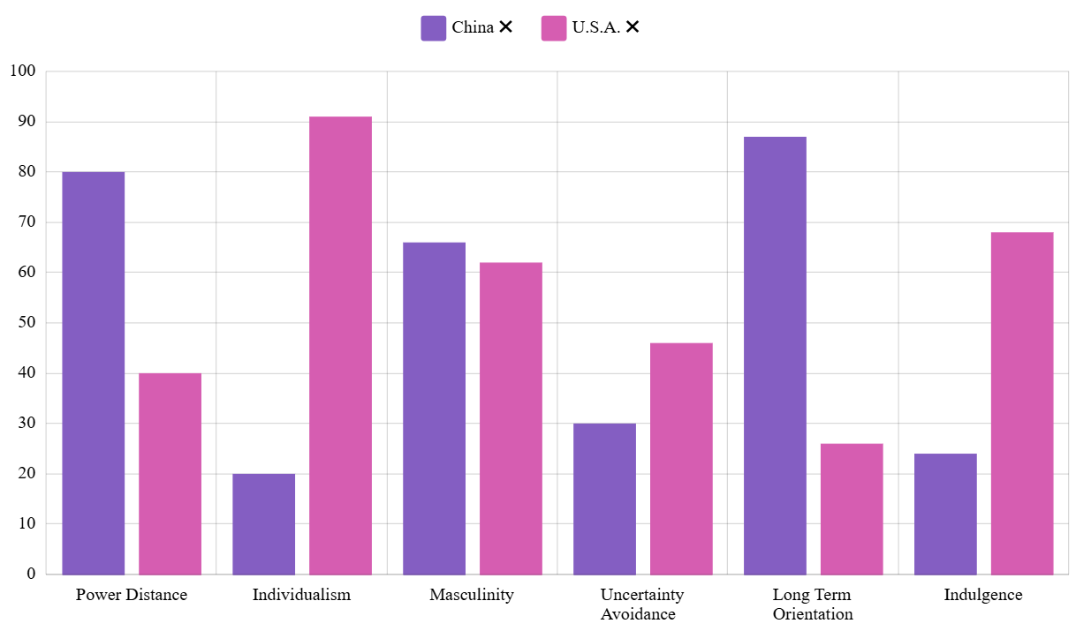
Figure 3: Hofstede cultural dimensions comparison between China and the USA
(Source: Hofstede, 2025)
Power Distance
Power distance deals with the fact that in society, all people are equal, and power is not equally distributed (Fang, 2025). Interns of power distance China score a high 80, which shows people accept a strong hierarchy and authority in China. In contrast, the USA scores lower, 40, which indicates a preference for equal power distribution.
Thus, in the case of China, IKEA can generate a strong brand reputation and lead the market with perceived authority, which enhances organisational credibility and market growth. On the other hand, in the USA market, customers prefer self-service and independence, which is well aligned with IKEA’s flat-pack concept, which maintains a stable business growth and performance in the USA.
Individualism
Individualism determinants help to determine people’s opportunities towards individual goals or family goals. In terms of individualism, the USA scored a high 91, and China scored a low 20. The high individualism score of the USA shows a highly individualistic society, where a low score indicates a collectivist cultural society (CHEN and TAO, 2023).
In the USA, IKEA uses product design to express self-expression, lifestyle customisation and personal identity, which attracts more customers to its products. On the other hand, in China, IKEA showcases complete family room settings, which align well with the collectivism values of China.
Masculinity
Masculinity shows social values in terms of achievements, success and competitiveness (Xiaoweimi, 2023). Both the USA and China score high, 66 and 62, respectively, which indicates a high value towards competitiveness, achievement and success. Thus, in the country, IKEA maintains an efficiency-driven business model, which drives high functionality and value for money products, maintaining its competitive position in these two markets.
Uncertainty Avoidance
Uncertainty avoidance helps to measure society's acceptance of risk, uncertainty and ambiguity. In this context, China scores low, 30 and the USA scores moderate, 46. Low uncertainty avoidance indicates high tolerance for change and ambiguity, where a moderate value suggests some level of tolerance (Svenson et al., 2025).
Thus, in China, IKEA can focus more on business expertise, make changes in its products and services, and digital platforms. Here, in the USA, there seems to be a clear protective line regarding information, return policies and structured business activities.
Long-term orientation
Long-term or short-term rewards reflect whether a society requires short-term benefits or long-term rewards (Fang, 2025). In this context, Chin scored high, 87, which reflects a strong long-term orientation. On the other hand, the USA scores low, 26, indicating a short-term benefit focus.
Thus, based on these intentions, in China, IKEA focused on sustainability, durability and value oriented products. In contrast, in the USA, IKEA focuses on trends, flexible products, which provide immediate satisfaction for the customers. These efforts help IKEA to maintain a balanced business performance in China and the USA.
Indulgence
Indulgence reflects people’s intention to fulfil their desires and enjoy life (Svenson et al.,2025). In this context, the USA scores high, 68, and China scores low, 24. This reflects that the people of the USA value their desires and maintain a comfortable lifestyle and purchase desired products, whereas in China, people focus on affordability and necessity.
Thus, aligning with these characteristics, IKEA focuses on lifestyle-based, comfortable product lines for home design in the USA. On the other hand, in China, IKEA maintains affordability, necessity and functionality.
Technological Factor
Adewusi et al. (2024) stated that having high technology support provides better business growth productivity with modern commerce and business analytics advantages. In China, R&D spending is moderate 2.4%, while US spending on R&D was moderate 3.5% (OECD, 2025). This increased R&D indicates technology advancements and innovation support, which can grow IKEA’s product line diversity and capability to fulfil more customer needs in the USA. However, in terms of e-commerce penetration rate, China scores high 47%, where the USA scores 15.8%, which suggests China leads in mobile e-commerce and digital platforms (Netguru, 2025). Thus, in China, IKEA can get more e-commerce and digital business growth opportunities as compared to the USA.
Legal Factor
In the Chinese market, consumer protection is developing, whereas in the USA market, there is a strong Consumer Protection Act. In the USA, IKEA needs to comply with the Federal Trade Commission Act of 1914, which ensures fair business practices within the country (Ftc.gov, 2023). However, in the Chinese market, the Foreign Investment Law 2020 is strict, and can regain full control over the country's resource usage, which may slow down IKEA’s growth opportunity (UNCTAD, 2024). Thus, in both countries, IKEA needs to maintain government acts and regulations to maintain business expansion and growth.
Environmental Factor
Chen et al. (2024 stated that in both the Chinese and the US markets, sustainability initiatives are high and environmental regulations are also strict. However, with the growing environmental awareness in China, IKEA needs to stay focused on promoting sustainability and ethical sourcing of products to attract more customers. In the USA, there is high pressure from the government to adhere to strong environmental regulations, and consumer demand for sustainable products is high in the USA market. Thus, it seems more difficult to maintain business sustainability in the USA market as compared to the China market.

3. STP Analysis
STP Element | China | United States
Segmentation
Demographic | Middle-class; young families; urban population; age 25–45 | Middle-income; families; young professionals; students
Geographic | Tier 1 & Tier 2 cities, urban apartments | Suburban & urban areas; nationwide presence
Psychographic | Family-oriented, value-conscious, aspirational, practical | Individualistic, lifestyle-focused, convenience-seeking
Behavioural | Price-sensitive, brand-conscious, infrequent bulk buying | DIY-oriented, frequent buyers, convenience-driven
Targeting
 | Urban middle-class families  Young professionals seeking modern, affordable furniture | Broad middle-class market  DIY consumers; cost-conscious households
Positioning
 | Aspirational global brand  Modern lifestyle  Affordable luxury | Affordable, functional, stylish furniture  Everyday low price
Table 1: STP table
(Source: Self-created)
Table 1 shows the STP table, which has identified segmentation, targeting and positioning in both the Chinese and US countries. The Segmentation is further divided into demographic, geographic, psychographic, and behavioural. Interns of segmentation in the China market, IKEA focuses on middle-class young females living in urban areas aged between 25 to 45 years old. It has been identified that the Chinese population's consumption rate is around 40% of its total GDP of the country's total GDP, which indicates a low consumption level (Statista, 2025). Despite the significant strategy used by the government, it is low as compared to the international average of 60%. Thus, to maintain business growth and protect sales efficiency, IKTA targets the urban population who have moderate income customers. Zhong et al. (2024) stated that in China, people are more family-oriented and believe in a long-term productivity life cycle. Aligning with these requirements, IKEA maintains a well-established brand, where it provides value-oriented, sustainable, and durable furniture, which ensures business positioning effectively. However, considering the price sensitivity of the Chinese population and brand consciousness, IKA maintains ethical business performance, aligning with ethical sourcing and focusing on providing products at affordable rates. Thus, being a global brand, IKEA aligns with local requirements of China and positions its brand as a modern lifestyle and affordable luxury brand in the Chinese market.
On the other hand, in the USA, IKEA targets middle-income families and young individuals as its target demographic customers from suburban and urban areas. It has been identified that the USA average household income is around $80000 to $83730 as per 2024 data. Additionally, customer income ranges from $35046 to $150342 (Bls.gov, 2024). Further, the ISA people are more lifestyle-focused, convenience-seeking, and individualistic. Thus, in the USA, IKEA shifts focus to promoting individual customers’ requirements and making products according to the customer's choice. Thus, in the USA market, IKEA targets the middle-income household customers, who are seeking DIY household furniture to show off personal status and individualism. Based on these characteristics, IKEA must maintain its brand position as an affordable, functional, stylish furniture-making company in the USA.
Overall, IKEA maintains a significantly different business approach to attract customers, gain brand recognition and maintain its competitive position in the market. For example, in the China context, IKEA maintains its position as a global brand, which values local customer needs. On the other hand, in the USA, IKEA aligns its business value with customer choices, offering affordable, everyday solutions, which fulfil customer household furniture needs and maintain satisfaction level. This highlights organisational adaptation and standardisation strategy, where IKEA maintains more adaptation in China and focuses on more standardisation in the USA market.

4. International Marketing Mix (7Ps) Comparison
4Ps | China | United States
Product | Compact, multifunctional furniture; space-saving designs; family-oriented layouts | Larger furniture; DIY assembly; individualised designs
Price | Relatively premium pricing; higher due to import costs and perception | Affordable pricing; strong cost leadership strategy
Place | Stores in major cities; experiential showrooms; strong e-commerce integration | Extensive store network; warehouse-style outlets; omnichannel retail
Promotion | Digital marketing, like WeChat, apps, minimal traditional ads, and aspirational branding | Catalogue, website, social media; lifestyle-focused promotion
People | High staff support, Guided shopping experience, Relationship-focused service, Assistance with product use | Self-service model, Minimal staff interaction, Customer independence , Cost-efficient staffing
Process | Strong e-commerce integration, Mobile-first purchasing, Delivery & assembly services | Standardised store process, DIY product selection, Warehouse pick-up system
Physical Evidence | Localised showroom layouts, Small-space living displays, Family-oriented setups | Large warehouse stores, Standardised layouts, Functional product displays
Table 2: 4Ps marketing mix
(Source: Self-created)
Table 2 depicts the 7Ps marketing mix for both China and the USA. The 4Ps marketing mix consists of product, price, place, promotion, people, process and physical evidence. Selection of an appropriate strategy is important to achieve business growth and maximise business profitability.
Product
The product strategy adopted by IKEA is based on affordability, flat-pack furniture and functional design (Walia, 2025). However, with respect to different countries, the product strategy changes. For example, in terms of the Chinese market, there is a high population density. It is evident that in China, around 1.4 billion people are living with a population growth rate 0.22% (Worldometer, 2025). Considering this characteristic of the Chinese market, customers are seeking small living furniture spaces. Thus, addressing this requirement, IKEA needs to make a product design which satisfies customer demand. Apart from this, there is a high demand for multifunctional functionality in China. Thus, IKEA’s innovation and product design requirements are high in the Chinese market (Yu, 2019). Providing foldable beds and space-efficient furniture fulfils customer requirements and attracts most customers in China. At the same time, IKEA’s showroom focuses on the family living environment, which also adheres to the collectivist culture of China, which improves the business success of IKEA in China.
On the other hand, in the USA market, IKEA's product design focuses on larger homes and suburban lifestyles (Amworldgroup, 2025). USA customers are seeking DIY assembly furniture, which aligns with individualist culture. Adhering to these population characteristics, IKEA focuses on maintaining product design which fulfil customer demand. Thus, adhering to the affordability, DIY focused furniture IKRA created a product strategy to make diverse product ranges, which fulfil individual customers’ needs and preferences.
Price
As a global brand, IKEA is using a price leadership strategy, which helps the brand to offer quality household furniture at 30% to 50% more cheaper than other market competitors (CNBC, 2025). However, the pricing strategy adoption also differs across different countries. For example, a high GDP growth rate and increasing customer household income create an opportunity for IKEA to adopt a promotional strategy. GDP per capita of China is around $12700, which is lower than that of the USA, $76000, which also increases the demand for affordable prices of products (World Bank, 2024b). Thus, balancing these two aspects, IKEA has the space to continue offering an affordable pricing strategy and make the availability of premium options for some customers.
On the other hand, in the USA market, IKEA maintains a low-cost marketing strategy, which targets middle income country customers. Additionally, the high piercing power of customers allows the brand to promote product diversity and fulfil customer needs and preferences (Vanathi and Raj, 2023). It has been identified that with the increasing inflation rate, the supply chain cost and tariffs are increasing in the USA market. Based on this economic condition, IKEA faces challenges in maintaining low prices and maintaining affordability.
Place
IKEA focused on selling products in large warehouse-style stores and strong supply chain performance (Rutuja Gaikwad, 2026). In the case of China, initially IKEA used the large stores, but aligning with the changing consumer behaviour, IKEA shifted to smaller urban stores. Additionally, the Chinese market has higher e-commerce market potential. This creates further opportunity for IKEA to sell products on online e-commerce stores like JD.com and WeChat. It is evidence that in China, more than 1.1 billion potential consumers are using digital platforms for shopping for products ( Xinhua, 2025). Thus, aligning with the digital-first consumer behaviour, IKEA has changed its offline store-based product selling to an online platform-based product selling approach.
In the context of the USA market, IKEA maintains a large warehouse-based product-selling strategy, which maintains its aesthetic business activities and market dominance. Additionally, IKEA also invested $2.2 billion for partnership and business expansion as a place strategy, which improves organisational accessibility in the USA market (Tyko, 2025). Additionally, to attract more customers, IKEA also adopted an omnichannel strategy, which helps to increase customer accessibility in both online and offline stores, increasing sales and revenue.
Promotion
IKEA strongly relied on brand image, traditional style experience and catalogues. However, in a different country, IKEA adopted different promotional approaches (Jonwal, 2025). For example, in the Chinese market, IKEA uses social media, WeChat, and e-commerce applications like Alibaba, which can help to promote brand awareness and engagement (Ikea, 2023). Further, customer data insights from different online platforms can help make decisions to adopt the best marketing strategy that improves business sales and performance.
On the other hand, in the USA market, IKRA solely relied on catalogues, traditional in style, and expertise (Jonwal, 2025). Minimal use of social media platforms, however, may impact brand awareness and sales value. It can be improved by using social media platforms like Facebook and Instagram to increase brand awareness and attract more customers. Further, offering online personalised experience will also align with individualism and increase a high rate of customer satisfaction and loyalty.

People
IKEA has not adopted the DIY concept in China, as Chinese people were not so familiar with these concepts in the first place. Additionally, focusing on collectivist culture, IKUA focused on relationship building, enhancing the quality of service provided in the Chinese market. In contrast, based on the people's request, IKEA focuses on DIY product development concepts. Focus on customer preferences. IKEA’s flat-pack package is well-learned with the people who frequent the USA (Tyko, 2025).
Process
In China, perform business processes using mobile apps and online ordering websites. Considering the increasing demand for online purchasing, IKEA adopted a mobile-first approach in China (Vanathi and Raj, 2023). On the other hand, in the USA, IKEA maintains a standardisation principle followed by warehouse pickup and online stores. The balance between online and offline selling has improved business growth.
Physical Evidence
IKEA focused on store design to provide customer-weak expertise and align with family lifestyle showrooms that reflect local living conditions. This approach allows customers to visualise real-life living and increase the product sales rate. On the other hand, in the USA, IKEA, a warehouse which provides efficiency, brand consistency, and finality, improves customer trust and satisfaction (Rutuja Gaikwad, 2026).

5. Directional Development Strategy for USA
Market Penetration  (Existing Products, Existing Market)  - Expansion of physical stores across major U.S. cities  - Growth in e-commerce and omnichannel sales  - Price reductions to remain competitive during inflation  - Strengthening customer loyalty (IKEA Family programme) | Product Development  (New Products, Existing Market)  - Introduction of smaller urban store formats  - Expansion into densely populated city centres  - “Plan & Order Points” for accessibility and convenience  - Targeting younger, urban consumers
Market Development  (Existing Products, New Markets)  - Localised furniture designs tailored to U.S. preferences  - Smart home and modular furniture innovations  - Sustainable product lines (eco-friendly materials)  - Affordable product bundles for small apartments | Diversification  (New Products, New Markets)  - Limited diversification strategy  - Investment in circular economy (recycling, resale services)  - Exploration of services (assembly, delivery solutions)  - Partnerships for sustainability and innovation
Table 3: IKEA’s Development Strategy in the USA with the Ansiff matrix
(Source: Self-created)
Table 3 depicts IKEA’s development strategy in the USA with the help of the Ansoff matrix. Ansoff matrix is a powerful framework that helps to identify business directional developmental growth strategy and evolve new business plans for business growth. Ansoff matrix consists of four core approaches, such as market penetration, market development, product development and diversification.
Market Penetration
The market penetration strategy allows brands to use the existing same products or services to sell on the existing market, and improve business growth by increasing store expansion, e-commerce growth and adopting collective strategies. IKEA took the decision to open new stores across major US cities. It is evident that IKEA has invested 2.2 billion to promote omnichannel business growth in the USA, which aims to develop supply chain efficiency, increase people accessibility, and achieve high customer satisfaction (IKEA, 2025a). Additionally, IKEA’s activity to promote sustainability in the USA market suggests a strong intention for long-term business development and success. It is evident that IKEA has taken a commitment to be climate positive by 2030 through solar and geothermal technology adoption. Thus, these large investments and strong sustainable commitments can also help to maintain a strong competitive business position in the USA market.
Market Development
The market development strategy intends to use the same products or services and enter into new markets for business development and expansion. IKEA shifts from traditional large warehouse stores to small suburban stores at different locations in the USA, known as “Plan & Order points”, aiming to increase accessibility and penetrate densely populated cities (IKEA, 2025b). This strategy is aligned with organisational development in the existing US market. Additionally, by promoting price affordability by 3% to 50%, IKEA targets more customers to purchase business products and increase business growth. Using an e-commerce platform, IKEA shows a strong strategic approach to increase its business online sales by reaching more customers at different US locations. It is evidence that IKEA invested around $1.9 billion in e-commerce. Considering the increasing e-commerce online sales trend, this investment was justified and has potential strength to strengthen business growth and operational efficiency. More than 457 million customers visit IKEA stores from online sites, and IKEA family reward membership reaches 25 million by 2025 (IKEA, 2025c). These success rates show the strategic growth opportunity of e-commerce investment, which supports long-term business growth.
Product Development
In the product development strategy concept, organisations create new products to sell in the existing market. Along with this strategy, IKEA focused on local customer demand. Offers innovative, flexible and eco-friendly products which suited well with the individualistic characteristics of the culture (IKEA, 2025b). To improve customer experience, the organisation has invested in automation, remote planning services and the use of digital tools in promoting supply chain efficiency, which increases prompt delivery and return services. These approaches seem to be innovative as it attracts more customers and provides competitive positions in the US market.
Diversification
Diversification tends to use new products in new markets. In terms of diversification, IKEA does not focus much. However, to fulfil each customer's requirements, innovation and R&D help to diversify product ranges, which will align with customer choice. Further, circular economy investment is also a new approach, which promotes sustainability and increases awareness in new markets, and creates long-term growth opportunities.

6. Ethical Issues
IKEA intends to promote sustainability and affordability across countries for rugs. However, in terms of product and promotional strategy adoption, several ethical concerns arise. For example, in the Chinese market, IKEA was associated with promoting “sexist advertisement”, where it creates social pressure on women to marry, which was highlighted as a cultural issue (BBC, 2020). Additionally, there was a claim to use an illegal source of supply of wood for furniture making in China (NBC News, 2021). Additionally, questions have been raised about greenwashing, where organisations show high sustainability value in reports, but in real life, it differs. Further, anti-union practice and labour issues are increasing concerns about the practice of IKEA. Thus, it was evident that, despite being a responsible brand, ethical issues still exist at IKEA’s core business activities.

7. Conclusion and Recommendations
Overall, the report critically identified business categories and the performance of IKEA in both the US and China. In China, IKRA adopts adaptation; in the USA, it adopts standardisation, which well aligns with business growth and performance. However, IKEA must focus on strengthening its localisation strategy by adopting new products, pricing and promotional strategies. Aligning with the cultural preferences of the USA and China, new product line development and selling offers a great strategic option to attract more customers and improve business growth. Along with this, it is recommended to strengthen digital capabilities and omnichannel product selling. From the improved customer engagement from both the online and offline platforms, investing in omnichannel performance will be a great strategy for IKEA to develop business growth and performance. Additionally, focus more on ethical business categories and maintain transparency. The rising ethical challenges hamper trust and customer engagement. Thus, IKEA needs to maintain its focus on performing ethically to strengthen its business position as a global leader.

SECTION 2- Reflection

Introduction
For writing this reflection, I have used Gibbs Reflective Cycle. Gibbs Reflective Cycle comprises description, feelings, evaluation, analysis, and an action plan (Adeani, Febriani, and Syafryadin, 2020). Following these steps helped me to demonstrate the overall journey which I have followed to complete the assessment.

Description
Throughout this assessment, I was engaged in in-depth research on IKEA’s international marketing approaches. I was selected from two countries, the United States and China. Based on research, I realised that selecting these countries will provide me with critical insights, as in these two countries, IKEA has adopted different marketing strategies due to cultural, behavioural, and other characteristics of the market. I have used the PESTLE framework to evaluate different marketing factors’ impact on business performance in both China and the USA. The PESTLE framework evaluates political, social, economic, environmental, technological, and legal factors on business performance and growth (Eierle et al., 2022). However, I focused more on social factors by applying the Hofstede cultural model.

Feelings
When starting this assessment, I slightly felt overwhelmed, as the assessment seemed to be complex to meet the task requirements. However, as I proceed, I have identified new business approaches, business growth strategies, and solutions to business problems adopted by IKEA. This incentive and motivation to complete the assessment. I became more confident about my research skills, and I have reviewed IKEA’s business reports, posts and blogs to collect statistical data and use those data as evidence of the claims.

Evaluation
I have used credible, updated sources to take the information and statistical data insights about the company, which enhanced the quality and credibility. I deeply studied different frameworks like PESTLE, Hofstede model,4Ps marketing mix, and the Ansoff matrix and successfully applied them to explain IKEA’s growth and developmental strategies with reference to China and the USA. However, I faced challenges in critically evaluating the information, as it required more effort. I also faced difficulties in managing time, as getting the data and writing the report at the same time was a complex and challenging task for me.

Analysis
This assessment developed my strategic skills, analytical skills, and knowledge of international business strategies adopted by organisations like IKEA. Additionally, I have realised how external factors like political, economic, social, legal, technological, and environmental factors influence business growth and decision-making. Collecting relevant data and supporting it as evidence to justify the claims has improved my analytical skills. Apart from this, I have relied on the importance of ethical activity in business practice to stay competitive in a dynamic market.

Conclusion
Overall, through the assignment, I have gained exceptional expertise and developed my academic and professional skills. I became more aware of how international businesses operate their business across multiple countries by adopting different marketing strategies. I have applied theoretical models, which helped me to structure my writing approach and deliver quality outcomes. I also recognise the need for quality referencing to maintain the authenticity and validity of the findings.

Action Plan
Based on the expertise gained from this assessment, I plan to allocate more time for future assessments to study, collect and perform critical analysis to improve writing quality. Further, I will join online sessions and take guidance from mentors to improve my critical thinking skills. Further, I will continue to apply different theoretical frameworks to real world business scenarios to find current business activities, challenges, and strategies to improve business growth.

References
Adeani, I.S., Febriani, R.B. and Syafryadin, S., (2020). Using GIBBS’reflective cycle in making reflections of literary analysis. Indonesian EFL Journal, 6(2), pp.139-148.https://journal.uniku.ac.id/index.php/IEFLJ/article/download/3382/2034/0
Adewusi, A.O., Okoli, U.I., Adaga, E., Olorunsogo, T., Asuzu, O.F. and Daraojimba, D.O., (2024). Business intelligence in the era of big data: A review of analytical tools and competitive advantage. Computer Science & IT Research Journal, 5(2), pp.415-431.https://www.researchgate.net/profile/Adebunmi-Adewusi/publication/378208076_BUSINESS_INTELLIGENCE_IN_THE_ERA_OF_BIG_DATA_A_REVIEW_OF_ANALYTICAL_TOOLS_AND_COMPETITIVE_ADVANTAGE/links/65cd3b9f1e1ec12eff9bea3f/BUSINESS-INTELLIGENCE-IN-THE-ERA-OF-BIG-DATA-A-REVIEW-OF-ANALYTICAL-TOOLS-AND-COMPETITIVE-ADVANTAGE.pdf
Amworldgroup (2025). IKEA US and the Redefinition of Affordable Design | AMW®. [online] Amworldgroup.com. Available at: https://amworldgroup.com/blog/ikea-us [Accessed 19 Apr. 2026].
BBC (2020). Ikea apologises for ‘sexist’ China advert. BBC News. [online] 26 Oct. Available at: https://www.bbc.com/news/world-asia-china-41757971 [Accessed 21 Apr. 2026].
Bls.gov (2024). Consumer Expenditure Survey. [online] Bls.gov. Available at: https://www.bls.gov/cex/ [Accessed 17 Apr. 2026].
Chen, L., Kenjayeva, U., Mu, G., Iqbal, N. and Chin, F. (2024). Evaluating the influence of environmental regulations on green economic growth in China: A focus on renewable energy and energy efficiency guidelines. Energy Strategy Reviews, [online] 56, p.101544. doi: https://doi.org/10.1016/j.esr.2024.101544.
CHEN, Y.H. and TAO, Y.F., (2023). Analysis of Sino-US Cultural Differences From the Perspective of Hofstede’s Cultural Dimension Theory—A Case Study of Saving Face. US-China Foreign Language, 21(10), pp.389-393.https://www.davidpublisher.com/Public/uploads/Contribute/65434eceebdc3.pdf
CNBC (2025). How Ikea is doubling down on price cuts to attract cost-conscious customers. [online] CNBC. Available at: https://www.cnbc.com/2025/06/26/how-ikea-is-doubling-down-on-price-cuts-to-attract-cost-conscious-customers.html [Accessed 18 Apr. 2026].
Eierle, B., Hartlieb, S., Hay, D.C., Niemi, L. and Ojala, H., (2022). External factors and the pricing of audit services: A systematic review of the archival literature using a PESTLE analysis. Auditing: A Journal of Practice & Theory, 41(3), pp.95-119.https://papers.ssrn.com/sol3/Delivery.cfm?abstractid=3816385
Fang, Q., (2022), June. Similarities and Differences of Primary Education between China and the United States from the Perspective of Cross-cultural Communication–Based on Hofstede’s Cultural Dimensions Theory. In 2022 8th International Conference on Humanities and Social Science Research (ICHSSR 2022) (pp. 2372-2376). Atlantis Press.https://www.atlantis-press.com/article/125974957.pdf
Ftc.gov (2023). Consumer Protection. [online] Federal Trade Commission. Available at: https://www.ftc.gov/consumer-protection [Accessed 17 Apr. 2026].
Hofstede, G. (2025). Country Comparison Bar Charts - Geert Hofstede. [online] Geert Hofstede. Available at: https://geerthofstede.com/country-comparison-bar-charts/ [Accessed 17 Apr. 2026].
IKEA (2023). IKEA partners with Alibaba for first virtual IKEA store on Tmall - IKEA Global. [online] IKEA. Available at: https://www.ikea.com/global/en/newsroom/retail/ikea-partners-with-alibaba-to-open-the-first-virtual-ikea-store-on-tmall-210408/ [Accessed 20 Apr. 2026].
IKEA (2023). Our history. [online] Ikea.com. Available at: https://www.ikea.com/us/en/this-is-ikea/about-us/from-humble-origins-to-global-brand-a-brief-history-of-ikea-pubad29a981/ [Accessed 16 Apr. 2026].
IKEA (2024). What is IKEA’s aim? - IKEA United Kingdom. [online] www.ikea.com. Available at: https://www.ikea.com/gb/en/customer-service/knowledge/articles/42fd8273-63c7-41e4-b3b8-41962449d39e.html [Accessed 16 Apr. 2026].
IKEA (2025). The IKEA vision, values and business idea. [online] IKEA. Available at: https://www.ikea.com/us/en/this-is-ikea/about-us/the-ikea-vision-and-values-pub9aa779d0/ [Accessed 16 Apr. 2026].
IKEA (2025a). IKEA invests $2.2 billion in the U.S. [online] Ikea.com. Available at: https://www.ikea.com/us/en/newsroom/corporate-news/ikea-announces-usd2-2-billion-investment-to-grow-in-the-u-s-pub50be6e70/ [Accessed 20 Apr. 2026].
IKEA (2025b). IKEA Plan and Order points. [online] www.ikea.com. Available at: https://www.ikea.com/gb/en/stores/plan-and-order-points/ [Accessed 20 Apr. 2026].
IKEA (2025c). IKEA U.S. releases FY25 Annual Summary. [online] Ikea.com. Available at: https://www.ikea.com/us/en/newsroom/corporate-news/ikea-u-s-releases-fy25-annual-summary-and-announces-four-new-stores-planned-for-2026-pubf0e047b0/?msockid=21511de6de026fb800490ae3df856ee2&utm [Accessed 20 Apr. 2026].
Ingka (2025). FAQ | Ingka Group. [online] Ingka Group. Available at: https://www.ingka.com/newsroom/faq/ [Accessed 16 Apr. 2026].
Jonwal, S. (2025). IKEA Case Study 2025: Strategy, Marketing, & Business Model. [online] Young Urban Project. Available at: https://www.youngurbanproject.com/ikea-case-study/ [Accessed 20 Apr. 2026].
Kalinin, O. and Gonchar, V., (2024). Strategic Partnership as a Factor in Sustainable Development and Compliance Adherence.https://dspace.luguniv.edu.ua/xmlui/bitstream/handle/123456789/11092/14.%20Gonchar,%20Kalinin.pdf?sequence=1
NBC News (2021). Ikea kids’ furniture may be tied to illegal Russian logging, report says. [online] NBC News. Available at: https://www.nbcnews.com/science/environment/ikea-likely-sold-furniture-linked-illegal-logging-forests-crucial-earth-n1273745 [Accessed 21 Apr. 2026].
Netguru (2025). The Biggest Ecommerce Markets: Country-Wise Penetration Rates for 2025. [online] Netguru.com. Available at: https://www.netguru.com/blog/e-commerce-top-countries [Accessed 18 Apr. 2026].
OECD (2025). R&D spending growth slows in OECD, surges in China; government support for energy and defence R&D rises sharply. [online] Oecd.org. Available at: https://www.oecd.org/en/data/insights/statistical-releases/2025/03/rd-spending-growth-slows-in-oecd-surges-in-china-government-support-for-energy-and-defence-rd-rises-sharply.html [Accessed 18 Apr. 2026].
Rutuja Gaikwad (2026). Business Model of IKEA: Strategy & Revenue Breakdown. [online] Miracuves Solutions. Available at: https://miracuves.com/blog/business-model-of-ikea/ [Accessed 19 Apr. 2026].
Statista (2025). China: total consumption as share of GDP. [online] Statista. Available at: https://www.statista.com/statistics/1197099/china-final-consumption-as-share-of-gdp/ [Accessed 18 Apr. 2026].
Svenson, F., Ermasova, N., Çetin, F. and Launer, M.A., (2025). Preferences for intuition and deliberation in decision-making in the public sector: Cross-cultural comparison of China, Taiwan, the Philippines, and the USA. International Journal of Public Administration, 48(1), pp.14-29.https://www.researchgate.net/profile/Frithiof-Svenson/publication/377634505_Preferences_for_intuition_and_deliberation_in_decision-making_in_the_public_sector_Cross-cultural_comparison_of_China_Taiwan_the_Philippines_and_the_USA/links/65b0be2c8c1a4a6d1d1c472e/Preferences-for-intuition-and-deliberation-in-decision-making-in-the-public-sector-Cross-cultural-comparison-of-China-Taiwan-the-Philippines-and-the-USA.pdf
Tabianan, K., Velu, S. and Ravi, V., (2022). K-means clustering approach for intelligent customer segmentation using customer purchase behavior data. Sustainability, 14(12), p.7243.https://www.mdpi.com/2071-1050/14/12/7243
Trading Economics (2025). Inflation Rate - Countries - List. [online] Trading Economics. Available at: https://tradingeconomics.com/country-list/inflation-rate [Accessed 17 Apr. 2026].
Tyko, K. (2025). IKEA moves into Best Buy as part of $2.2 billion U.S. expansion. [online] Axios. Available at: https://www.axios.com/2025/11/05/best-buy-ikea-opening-shops-furniture-kitchen [Accessed 19 Apr. 2026].
UNCTAD (2024). China - Foreign Investment Law of the People’s Republic of China | Investment Laws Navigator | UNCTAD Investment Policy Hub. [online] investmentpolicy.unctad.org. Available at: https://investmentpolicy.unctad.org/investment-laws/laws/317/china-foreign-investment-law-of-the-people-s-republic-of-china [Accessed 18 Apr. 2026].
Vanathi, A. and Raj, A. (2023). INTERNATIONAL JOURNAL OF LAW MANAGEMENT & HUMANITIES An Analysis of IKEA’s Global Positioning. International Journal of Law Management & Humanities, [online] 6(2). doi: https://doi.org/10.10000/IJLMH.114498.
Walia, K. (2025). IKEA Success Formula: How Innovation & Affordability Built a Global Giant - Believers Destination. [online] Believers Destination - Believe. Dream. Achieve. Available at: https://believersdestination.com/ikea-success-formula-how-innovation-affordability-built-a-global-giant/ [Accessed 19 Apr. 2026].
World Bank (2024). Worldwide Governance Indicators. [online] World Bank. Available at: https://www.worldbank.org/en/publication/worldwide-governance-indicators/interactive-data-access [Accessed 17 Apr. 2026].
World Bank (2024a). GDP growth (annual %) - China, United States. [online] World Bank. Available at:https://data.worldbank.org/indicator/NY.GDP.MKTP.KD.ZG?end=2024&locations=CN-US&start=2018 [Accessed 17 Apr. 2026].
World Bank (2024b). GDP per capita (current US$). [online] World Bank. Available at: https://data.worldbank.org/indicator/NY.GDP.PCAP.CD [Accessed 19 Apr. 2026].
Worldometer (2025). China Population. [online] Worldometers.info. Available at: https://www.worldometers.info/world-population/china-population/ [Accessed 18 Apr. 2026].
Worldometer (2025). Countries in the World by Population (2025). [online] WorldoMeters. Available at: https://www.worldometers.info/world-population/population-by-country/ [Accessed 17 Apr. 2026].
Xiaowei, L., (2023). Exploration of the cultural differences and fusion between China and America from the movie a grandson from America based on Hofstede’s Value Dimension. Acad. J. Hum. Soc. Sci, 6, pp.35-39.https://www.francis-press.com/uploads/papers/JGnIt1SbWe77m87cuv9IzGwksfh2unxCufvuy0la.pdf
Xinhua (2025). China’s internet users surpass 1.1 billion, powering digital economy and innovation. [online] Www.gov.cn. Available at: https://english.www.gov.cn/archive/statistics/202501/18/content_WS678ae7f6c6d0868f4e8eef08.html [Accessed 19 Apr. 2026].
Yu, R. (2019). Core Elements of IKEA’s Successful Product Design. Journal of Physics: Conference Series, [online] 1168(3), p.032118. doi: https://doi.org/10.1088/1742-6596/1168/3/032118.
Zaurez Afshar, M. and Hussain Shah, D.M., (2025). Strategic Evaluation Using PESTLE and SWOT Frameworks: Public Sector Perspective. Mutahir, Strategic Evaluation Using PESTLE and SWOT Frameworks: Public Sector Perspective (February 12, 2025).https://papers.ssrn.com/sol3/Delivery.cfm?abstractid=5141505
Żemojtel-Piotrowska, M. and Piotrowski, J., (2023). Hofstede’s cultural dimensions theory. In Encyclopedia of sexual psychology and behavior (pp. 1-4). Cham: Springer International Publishing.https://www.researchgate.net/profile/Magdalena-Zemojtel-Piotrowska/publication/371822907_Hofstede%27s_Cultural_Dimensions_Theory/links/65ba71e434bbff5ba7db3ff0/Hofstedes-Cultural-Dimensions-Theory.pdf
Zhong, X., Li, B., Fang, Q. and Deng, Z., (2024). Short-term gains versus long-term strains: productivist policies and family resilience in China. The Journal of Chinese Sociology, 11(1), p.10.https://link.springer.com/content/pdf/10.1186/s40711-024-00207-x.pdf

