Cert HE Business Skills for the Workplace
Employability and Career Development
Component 1

Job Advert – Car Sales Executive
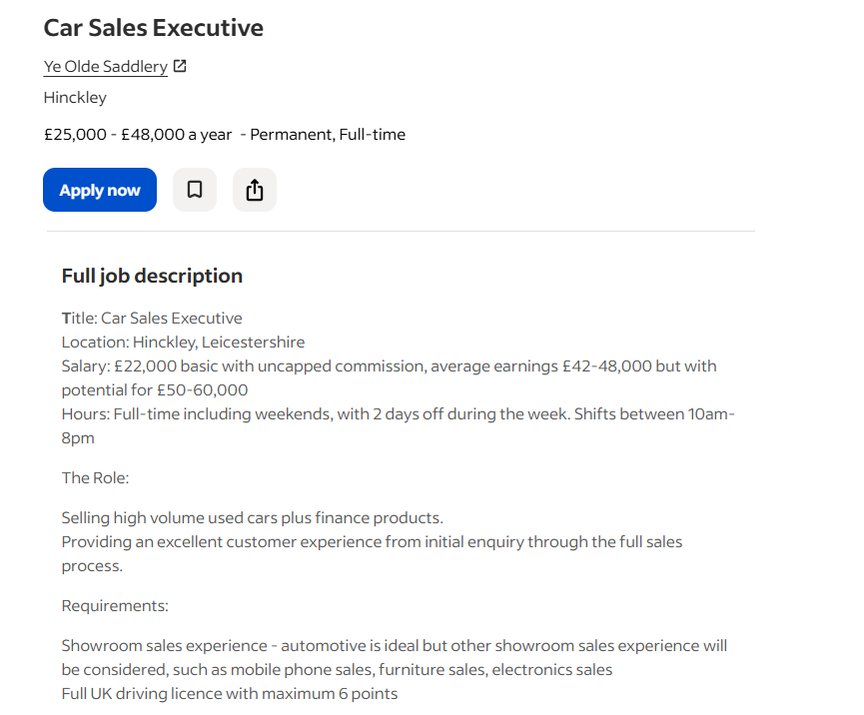

Personal CV

Ionut Vasile
Automotive Sales Professional
Hinckley, Leicestershire • +44 7901 284300 • 2333625@student.uwtsd.ac.uk

PERSONAL STATEMENT
Motivated and results-driven automotive sales professional with hands-on experience in vehicle trading within a prestige BMW environment. Skilled at identifying customer needs, matching buyers to the right vehicles, and guiding customers through the full purchase process. Currently studying a Certificate in Higher Education (CertHE) in Business Skills for the Workplace, demonstrating a commitment to ongoing professional development. Holds a full UK driving licence and thrives in fast-paced, target-driven sales environments.
WORK EXPERIENCE
Vehicle Trader – Buy & Sell | BMW Feb 2025 – Present
• Sourced, evaluated, and priced used vehicles within a prestige automotive environment, applying strong market knowledge to maximise margins.
• Managed the end-to-end process of vehicle acquisition and resale, ensuring accurate appraisals and competitive pricing.
• Built and maintained strong relationships with customers and trade contacts, delivering a professional experience at every touchpoint.
• Developed in-depth knowledge of used car valuations, vehicle condition assessment, and the wider automotive market.
• Consistently worked to volume targets, demonstrating the commercial drive and self-motivation required in a sales environment.
EDUCATION & TRAINING
CertHE – Business Skills for the Workplace | Currently Studying In Progress
Covering professional communication, customer relationship management, business operations, and workplace skills.
KEY SKILLS
• Used car sales and vehicle valuation
• Customer relationship building and consultative selling
• Finance product awareness and upselling
• Target-driven with strong commercial acumen
• Full UK driving licence (maximum 6 points)
• Excellent communication and negotiation skills
• Professional, well-presented, and customer-focused

Cover Letter Supporting Job

Ionut Vasile
+44 7901 284300
2333625@student.uwtsd.ac.uk
20 March 2026

Hiring Manager
Ye Olde Saddlery
Hinckley, Leicestershire

Re: Application for Car Sales Executive

Dear Manager,

I am writing to apply for the Car Sales Executive position based in Hinckley, Leicestershire. With hands-on experience in the automotive industry and a strong passion for delivering outstanding customer experiences, I am confident that I can make a meaningful contribution to your sales team and help drive the exceptional results your dealership is known for.

My background in buying and selling cars at BMW has given me a solid grounding in the used car market, including vehicle valuation, stock management, and understanding what customers look for when making a purchase. Working within a prestige automotive environment, I developed a keen eye for matching the right vehicle to the right customer. A skill that translates directly to high-volume used car sales. I understand the full sales journey, from building rapport at first contact through to closing the deal, and I appreciate the importance of finance products in maximising both customer satisfaction and revenue.
Alongside my practical experience, I am currently studying the Certificate in Higher Education (CertHE) in Business Skills for the Workplace, which has strengthened my understanding of professional communication, customer relationship management, and business operations.
I hold a full UK driving licence and am fully flexible to work the required hours, including weekends, understanding that availability and commitment are essential in a customer-facing sales role. I am a confident communicator, a natural relationship builder, and I genuinely enjoy helping customers find the right vehicle for their needs.

I would welcome the opportunity to discuss my application further and demonstrate how my automotive background and drive for results make me an excellent fit for your team. Thank you sincerely for considering my application.

Yours sincerely,
Ionut Vasile

