
Intercultural competence report
Module code: BMIH5003
Lecturer: Heidi Prosser
Words: 1120

Student name: Sonia-Lorena Porumb (2233341) | 2/1/24 | Module: Foreign Languages & Cultural Awareness

Executive summary

This report offers a comprehensive analysis of the cultural, custom, and business practice disparities between England and Italy, utilising data from the GLOBE Project's culture and leadership study. Notable differences were found in areas such as punctuality, communication styles, and leadership preferences, reflecting divergent societal norms and values. Key findings include England's stronger emphasis on punctuality, efficiency, and individualism, contrasting with Italy's more relaxed approach to work and collectivist culture. While both countries exhibit varying degrees of societal emphasis on performance, future orientation, and human orientation, they differ in power distance acceptance and uncertainty avoidance practices. The analysis extends to leadership styles, where Italy demonstrates a slight edge in charismatic and team-oriented leadership, while England exhibits strengths in participative and human-oriented leadership. However, both countries share similar inclinations towards autonomous leadership. The report also highlights the challenges of intercultural leadership in the hospitality industry, including communication barriers, decision-making disparities, and conflicting time management practices. To address these challenges, recommendations are provided, including implementing cross-cultural training, fostering inclusivity, and establishing clear performance expectations aligned with cultural values. By adopting these strategies, the Hotel Management Team of Inclusivity Hotel & Spa can effectively navigate intercultural differences, fostering a collaborative and productive work environment for improved team performance and guest satisfaction.

Table of Contents

Executive summary 1
Introduction 3
Main body 3
Conclusion 9
Recommendations 10
References 11

Introduction

This report aims to analyse and discuss the key differences between England and Italy in terms of culture, customs, and business practices. Furthermore, it will utilise the GLOBE Project's culture and leadership study to compare the two countries. The report will also critically examine the challenges of intercultural leadership in the hospitality industry, specifically in managing a team comprising employees from distinct cultural backgrounds. Finally, three realistic recommendations will be provided to the Hotel Management Team of Inclusivity Hotel & Spa to overcome these challenges.

Main body

England and Italy exhibit significant differences in culture, customs, and business practices. In England, punctuality, efficiency, and professionalism are highly valued, while in Italy, a more relaxed and flexible approach to time and work is common (Hofstede Insights, 2021). Additionally, English culture emphasises individualism and direct communication, whereas Italian culture highlights collectivism and indirect communication (Hofstede Insights, 2021).
The Global Project 2020 has reported that there are significant differences between England and Italy when it comes to their country value and practice scores based on Table 1 and Table 2:
Compared to Italy, England has a better performance orientation when it comes to assessing the country's performance in 2020, with a score of 4.08. Conversely, when it comes to country value scores, the difference between the two countries is that Italy's emphasis on societal performance is higher than that of England.
Compared to Italy, England has a higher future orientation practice score, 4.28. However, it trails behind in terms of country value, with 5.91, while it holds 5.06. This suggests that despite its lower score, Italy places more emphasis on the future orientation of its citizens.
The Human Orientation score of England was higher than that of Italy, with a score of 3.72. However, the country value score of Italy was 5.58, indicating that it has a greater societal emphasis on being human-oriented.
Although England's power distance practice score is lower than that of Italy, it still has a considerable advantage over its neighbour when it comes to societal acceptance of distance. Alternately, Italy's value score of 2.47 shows that the two countries have a high power distance when it comes to practice.
The country practice score of England for uncertainty avoidance was higher than that of Italy, with a score of 4.65. However, its value score of 4.47 is higher than that of England, which indicates that while it practices more uncertainty avoidance, Italy upholds norms that prioritise avoidance.

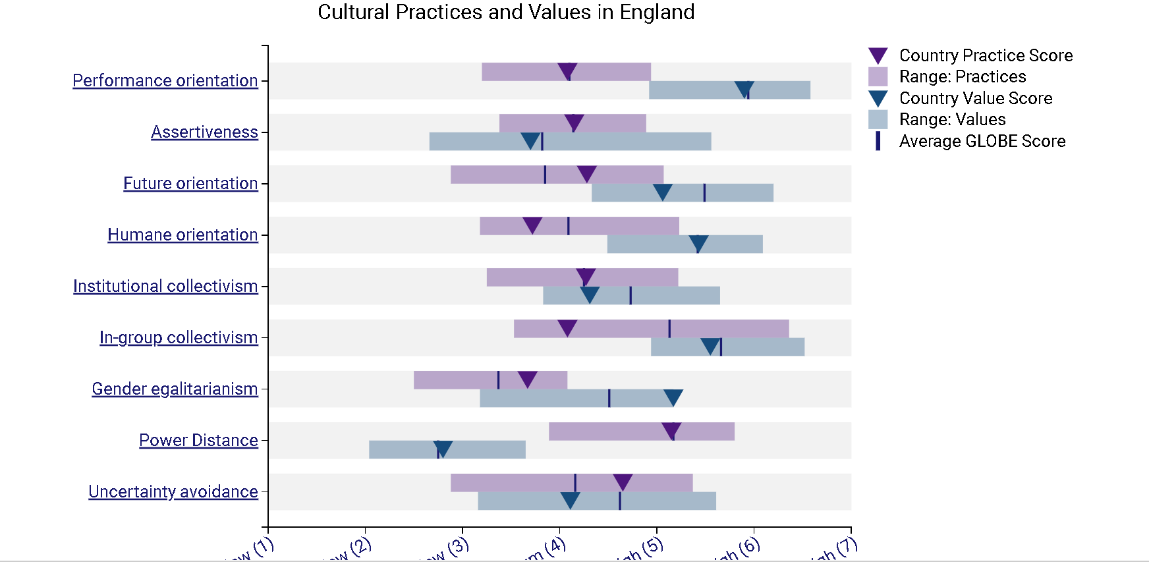
Table 1
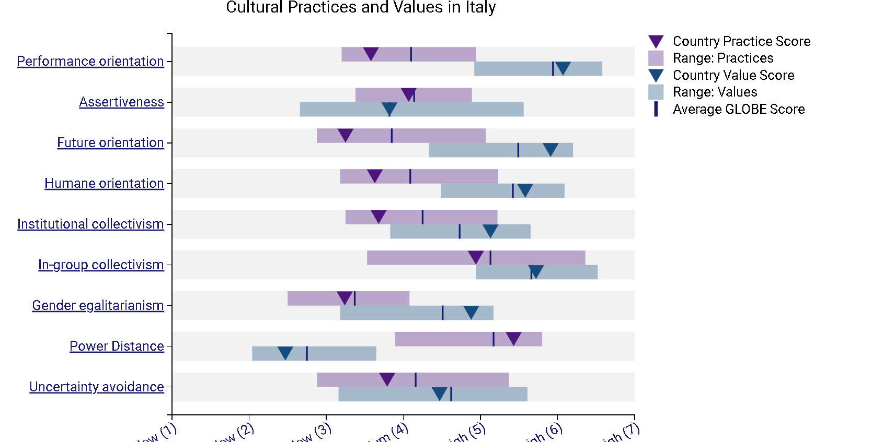
Table 2
Based on Table 3 and Table 4 the Global Project's assessment of leadership capabilities found that Italy and England have a strong tendency toward charismatic leadership. However, the former's score is higher than the latter's.
For instance, Italy's score of 5.87 on the team-oriented leadership assessment is higher than that of England. This suggests that the country places more emphasis on team cooperation and collaboration in its leadership practices.
For participative leadership, Italy earned a score of 5.47, while England managed to score 5.57. This indicates that both nations value their employees' involvement in the decision-making process. Conversely, England is more focused on this type of leadership.
For human-oriented leadership, Italy earned a score of 4.38, while England managed to achieve a score of 4.9. This suggests that the former places more emphasis on the well-being and needs of its employees when it comes to leadership practices.
For autonomous leadership, Italy earned a score of 3.62, while England managed to achieve a score of 3.92. This indicates that both countries value autonomy and independence when it comes to leadership practices.
In terms of self-protective leadership, Italy scored a high of 3.25, while England managed to get a score of 3.04. The difference between these two countries' scores shows that Italy places more emphasis on safeguarding its interests than England.

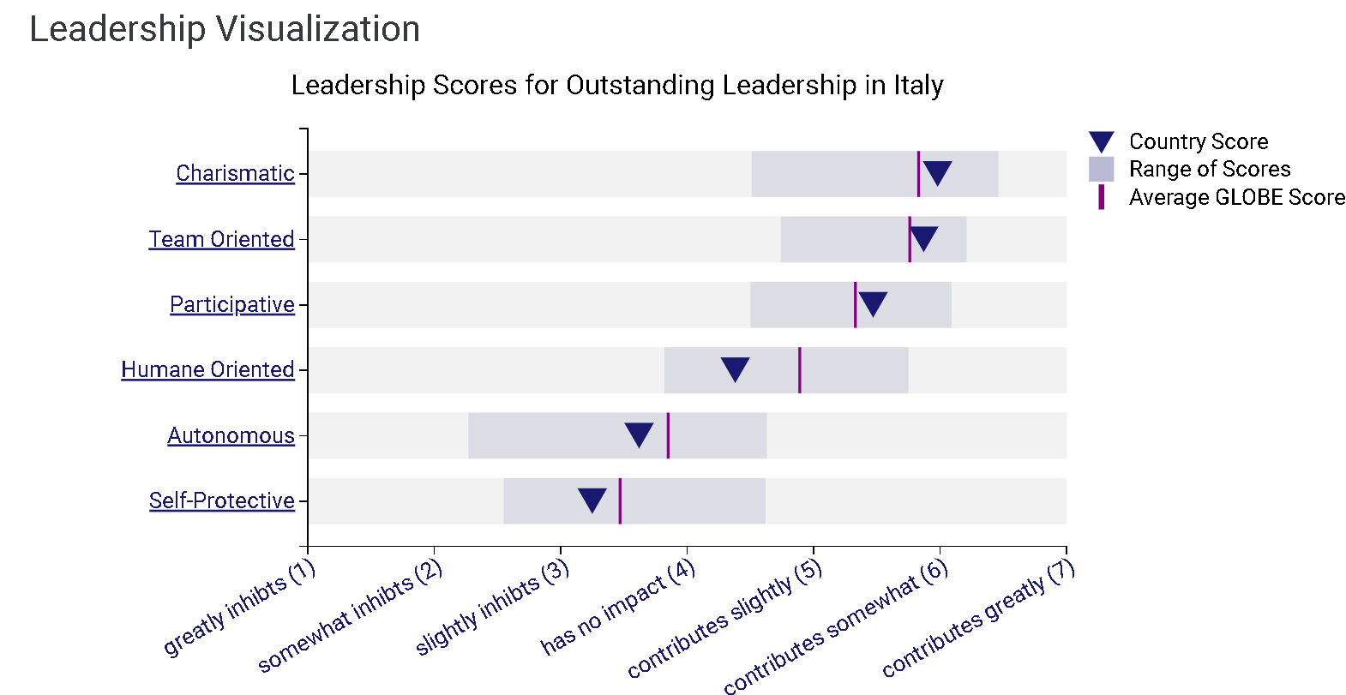
Table 3
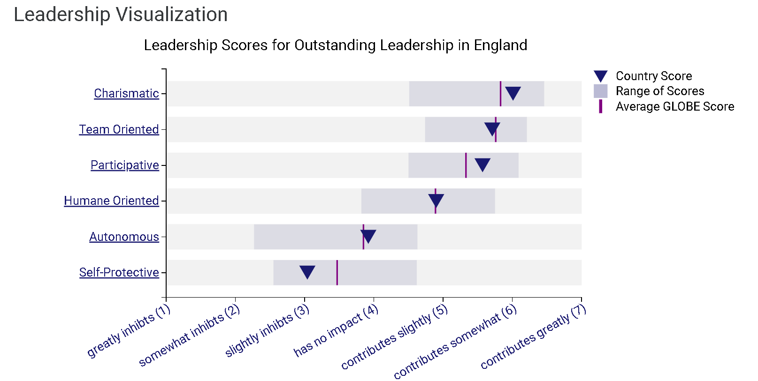
Table 4

Intercultural leadership in the hospitality industry presents unique challenges due to the diverse backgrounds and cultural differences of team members. These challenges can impact communication, teamwork, decision-making, and overall team dynamics. In the given scenario of managing an intercultural team at Inclusivity Hotel & Spa, several potential areas of conflict can arise:

- Communication Styles: Different communication styles can lead to misunderstandings and conflicts within the team. For example, employees from England may have a more direct and assertive communication style, while employees from Italy may prefer a more indirect and harmonious approach. These differences can create tensions and hinder effective collaboration (Mariani and Visani, 2019).

- Decision-Making Approaches: Cultural differences in decision-making can also lead to conflicts within the team. In England, decision-making may be more individualistic and focused on achieving goals, while in Italy, a more participatory and consensus-based approach may be preferred. Differing expectations and preferences in decision-making processes can create challenges and hinder team cohesion (Minoja, Kocollari, and Cavicchioli, 2022).

- Time Management: Differences in time management practices can create conflicts and impact team productivity. In England, there may be a greater emphasis on punctuality and adherence to schedules, while in Italy, a more flexible and relaxed approach to time may be common. These differences can lead to misunderstandings and frustration within the team (Lee, Teng and Chen, 2015).

- Cultural Norms and Values: Cultural norms and values, such as attitudes towards hierarchy, authority, and work-life balance, can also create potential areas of conflict. For instance, if employees from England value a more hierarchical structure and clear authority, while employees from Italy prefer a more egalitarian and flexible approach, conflicts may arise in decision-making and power dynamics within the team (Trompenaars and Hampden-Turner, 2011).

To address these challenges, intercultural leaders in the hospitality industry must be aware of cultural differences, promote open communication, and foster a culture of inclusivity and respect. Providing cross-cultural training and education to team members can enhance their understanding of diverse cultural practices and values, reducing misunderstandings and conflicts (Wang & Sun, 2023). Additionally, actively promoting diversity and inclusion within the team can help create a supportive and collaborative work environment (Lee, Teng and Chen, 2015).

Conclusion

This report explores the cultural disparities between England and Italy, highlighting differences in values and practices. England emphasises punctuality, efficiency, and individualism, while Italy leans towards a more relaxed approach and collectivism. The analysis reveals variations in performance, future orientation, human orientation, power distance, and uncertainty avoidance. Italy prioritises societal performance and future orientation slightly more, while England has a stronger human orientation but lesser power distance acceptance. Both countries exhibit charismatic leadership, with Italy excelling in team-oriented leadership and England in participative and human-oriented styles. Intercultural leadership in the hospitality industry faces challenges in communication, decision-making, time management, and cultural norms.

Recommendations

- Implementing cross-cultural training and development programs can enhance employees' understanding of distinct cultures and improve intercultural collaboration (Mariani and Visani, 2019).

- Creating an inclusive and open work environment fosters trust, understanding, and collaboration among team members from diverse cultural backgrounds (Shore et al. 2011).

- Establishing clear performance expectations and goals, aligned with the values and practices of both cultures, helps employees thrive and contribute effectively. Regular feedback and performance evaluations provide guidance and support (Armstrong and Baron, 2005).

References

Armstrong, M. and Baron, A. (2005) Managing performance: performance management in action. London: Chartered Institute of Personnel and Development.
Globe Project (2020) Cultural Practices and Values in England [Table 1]. Available at: https://globeproject.com/results/countries/GBR%3Fmenu=list.html#list (Accessed 16 February 2024).
Globe Project (2020) Cultural Practices and Values in Italy [Table 2]. Available at: https://globeproject.com/results/countries/ITA%3Fmenu=list.html#list (Accessed 16 February 2024).
Globe Project (2020) Leadership Scores for Outstanding Leadership in Italy [Table 3]. Available at: https://globeproject.com/results/countries/ITA%3Fmenu=list.html#list (Accessed 16 February 2024).
Global Project (2020) Leadership Scores for Outstanding Leadership in England [Table 4]. Available at: https://globeproject.com/results/countries/GBR%3Fmenu=list.html#list (Accessed 16 February 2024).
Hall, E.T. (1973) The silent language. [New ed.]. New York: Anchor Press.
Hofstede Insights (2021) Country Comparison: England vs. Italy. Available at: https://www.hofstede-insights.com/country-comparison-tool?countries=england,italy (Accessed: 10 February 2024).
Lee, A.P., Teng, H.-Y. and Chen, C.-Y. (2015) ‘Workplace Relationship Quality and Employee Job Outcomes in Hotel Firms’, Journal of Human Resources in Hospitality & Tourism, 14(4), pp. 398–422. DOI:10.1080/15332845.2015.1002068.
Mariani, M.M. and Visani, F. (2019) “Embedding eWOM into efficiency DEA modelling: An application to the hospitality sector,” International Journal of Hospitality Management, 80, pp. 1–12. Available at: https://doi.org/10.1016/j.ijhm.2019.01.002.
Minoja, M., Kocollari, U. and Cavicchioli, M. (2022) “Exploring differences of corporate social responsibility perceptions and expectations between eastern and western countries: Emerging patterns and managerial implications,” International journal of cross-cultural management: CCM, 22(2), pp. 327–347. Available at: https://doi.org/10.1177/14705958221112253.
Shore, L.M. et al. (2011) “Inclusion and Diversity in Work Groups: A Review and Model for Future Research,” Journal of Management, 37(4), pp. 1262–1289. Available at: https://doi.org/10.1177/0149206310385943.
Trompenaars, F. and Hampden-Turner, C (2011) Riding the Waves of Culture Understanding Diversity in Global Business. 3rd edn. London: Nicholas Brealey Publishing.
Wang, S. and Sun, Z. (2023) “Research on the impact of leadership empowerment behaviour on task performance - Based on the moderation of employee maturity,” SHS Web of Conferences, 166, pp. 1005-. Available at: https://doi.org/10.1051/shsconf/202316601005.

